

APT REPORT ON

WIRELESS POWER TRANSMISSION (WPT)

Edition: September 2026

The 37th Meeting of APT Wireless Group
7 – 11 September 2026
Dhaka, Bangladesh (Hybrid)

(Source: AWG-37/OUT-15)

No. APT/AWG/REP-62(Rev.2)

APT REPORT ON
WIRELESS POWER TRANSMISSION (WPT)

Contents

1. Introduction
2. Terminologies and definitions
3. WPT technologies overview

3.1 For portable and mobile devices
3.1.1 Tightly Coupled WPT
3.1.2 Loosely Coupled WPT
3.1.3 Capacitive Coupling WPT

3.2 For home appliances

3.3 For EV
4. Standardization status

4.1 Some APT countries
4.1.1 China
4.1.2 Japan
4.1.3 Korea

4.2 International organizations

5. Frequency bands studies for WPT in some APT member countries
5.1 Non-ISM bands

5.2 ISM bands
6. Technical regulation issues for WPT

6.1 Some APT Countries

6.2 International organizations

7. Status of co-existence studies in some APT member countries

7.1 Japan

8. Summary

Reference

Appendix

A1. Use case considerations

A1.1 Loosely Coupled WPT for mobile and portable devices

A1.2Capacitive Coupling WPT for potable and mobile devices

A1.3WPT for EV

A2. RF exposure assessment methodologies

1. Introduction

ITU-R SG1 WP 1A in June 2013 formed a Correspondence Group for WPT (CG-WPT) to develop content for possible Preliminary Draft New Report(s) and Preliminary Draft New Recommendation(s) [3][4][5][6][7] regarding the ITU-R Studies on Questions ITU-R 210-3/1 [8] [9]. Given these WP 1A outcomes, the Task Group on Wireless Power Transmission (TG-WPT) at the AWG-15 meeting discussed a work plan[9] and its framework on developing new APT Report on WPT in preparation for next ITU-R SG1 meeting on June 2014. TG-WPT agreed to develop APT Report on WPT for contribution for ITU-R SG1 WP 1A in timely manner.

During its June 2014 meeting, WP 1A updated “WORKING DOCUMENT TOWARDS A PRELIMINARY NEW REPORT ITU-R SM.[WPT.NON-BEAM]” and “WORKING DOCUMENT TOWARDS A PRELIMINARY DRAFT NEW RECOMMENDATION ITU-R SM.[WPT]”. The draft new report was submitted to SG1 and approved and published as the Report ITU-R SM.2303-0. And also, the continuation of the CG-WPT was approved.

Prior to this development of APT Report on WPT, another development of APT Survey Report on WPT was completed in AWG-16 meeting. The Survey Report consists of the information given in the APT Questionnaire Responses [10].
Chapter 2 provides terminology and definitions. Chapter 3 outlines WPT technologies Chapter 4 introduces the latest WPT standardization activities found in the some APT countries and international organizations. Chapter 5 discusses spectrum category studies in some APT member countries. Chapter 6 introduces status of regulations in some APT member countries. Chapter 7 introduces co-existence studies in some APT member countries. In addition to the main contents, Appendix provides various WPT topics including use case considerations and RF exposure assessment methodologies.

2. Terminologies and definitions

2.1 Definitions

1) | Wireless Power Transfer/Transmission | The transfer/transmission of power from a power source to an electrical load without using wires.
2) | Tightly Coupled WPT | Wireless power transfer/transmission through magnetic induction between a transmitter coil and a receiver coil where the coupling factor (k) between them is high.
3) | Loosely Coupled WPT | Resonant wireless power transfer/transmission through magnetic induction between a transmitter coil and receiver coil(s) with the coupling factor (k) that can be low, though values up to 1 may also be supported.
4) | Power Transmitter | A device that is able to provide wireless power to other devices. A Power Transmitter carries a logo to visually indicate to a user that the Power Transmitter complies with a certain technology.
5) | Power Receiver | A device that is able to capture wireless power that is supplied by the Wireless Power Transmitter.
6) | Primary device | A device which transmits electric power to the secondary device through magnetic flux/field, electric field or electromagnetic wave
7) | Secondary device | A device which receives electric power from the primary device through magnetic flux/field, electric field or electromagnetic wave
8) | Electric Vehicle | A vehicle driven by an electric motor or electric motors drawing current from a rechargeable energy storage system such as batteries, capacitors and any other electric storage device which may be charged from electric outlet at residential and/or public electric service
9) | Plug in Hybrid Electric Vehicle | A kind of Electric Vehicle which has an internal combustion engine for the use of traction and/or generation of electricity
10) | Capacitive Coupling WPT | Capacitive Coupling WPT is also called Electric field coupling WPT. About Capacitive Coupling system, power is transmitted through the electric field generated by coupling the two sets of electrodes.
11) | Online Electric Vehicle | Electric Vehicle charging while in motion including stopping and parking using Shaped Magnetic Field in Resonance(SMFIR) WPT technology.

2.2 Abbreviations and acronyms

A4WP | Alliance for Wireless Power
ACMA | Australian Communications and Media Authority
ARIB | Association of Radio Industries and Businesses (Japan)
ARPANSA | Australian Radiation Protection and Nuclear Safety Agency
APT | Asia Pacific Telecommunity
AWG | APT Wireless Group
BWF | Broadband Wireless Forum (Japan)
CATR | China Academy of Telecommunication Research
CCSA | China Communications Standards Association
CE | Consumer Electronics
CJK | China Japan Korea
EMC | Electromagnetic Compatibility
EMF | Electromagnetic Field
EMI | Electromagnetic Interference
EV | Electric Vehicle
ICNIRP | International Commission on Non-Ionizing Radiation Protection
ICPT | Inductively Coupled Power Transmission
IEC | International Electrotechnical Commission
IEEE | Institute of Electrical and Electronics Engineers
IGBT | Insulated Gate Bipolar Transistor
IPR | Intellectual Property Right
ISM | Industrial, Scientific, and Medical
ISO | International Organization for Standardization
ITU | International Telecommunication Union
ITU-R | ITU Radiocommunication Sector
JARI | Japan Automobile Research Institute
KATS | Korea Agency for Technology and Standards
KWPF | Korea Wireless Power Forum
MF-WPT | Magnetic Field Wireless Power Transmission / Transfer
MP3 | MPEG-1 Audio Layer 3
MIC | Ministry of Internal Affairs and Communications (Japan)
MIIT | Ministry of Industry and Information Technology (China)
MSIP | Ministry of Science, ICT and future Planning (Korea)
NAVTEX | Navigation Telex
OLEV | OnLine Electric Vehicle
PHEV | Plug-in Hybrid Electric Vehicle
RRA | Radio Research Agency (Korea)
RF | Radio Frequency
SAE | Society of Automobile Engineers
SDO | Standards Development Organization
SRD | Short Range Devices
TG | Task Group
TTA | Telecommunications Technology Association (Korea)
WG | Working Group
WPC | Wireless Power Consortium
WPS | Wireless Power Supply
WPT | Wireless Power Transmission / Transfer

3. WPT technologies overview

3.1 For portable and mobile devices

3.1.1 Tightly Coupled WPT

The WPT by magnetic inductance is a well-known technology, applied for a very long time in transformers where primary and secondary coils are tightly coupled, e.g. by the use of a shared magnetic permeable core. Inductive power transfer through the air with primary and secondary coils physically separated is also a known technology for more than a century, called as Tightly Coupled WPT. A fundamental problem in this technology is that the efficiency of the power transfer drops dramatically if the distance through the air is larger than the coil diameter. The efficiency of the power transfer depends on the coupling factor (k) between the inductors and their quality (Q). This technology has been commercialized for 1:1 charging of smart phones. With a coil array, this technology also offers flexibility in the receiver coil location of the transmitter. See Appendix for detailed description.

3.1.2 Loosely Coupled WPT

The WPT by magnetic resonance is called Loosely Coupled WPT. The theoretical basis of this magnetic resonance method was first developed in 2005 by Massachusetts Institute of Technology, and their theories were validated experimentally in 2007 [20]. The method uses a coil and capacitor as a resonator, transmitting electric power through the electromagnetic resonance between transmitter coil and receiver coil. By matching the resonance frequency of both coils with high Q factor, electric power can be transmitted over a long distance where magnetic coupling between two coils is low. The Loosely Coupled WPT can transmit electric power over a range of up to several meters. This technology also offers flexibility in the receiver coil location of the transmission coil. Practical technical details can be found in many technical papers, for example, those in [20] and [21]. Inherent features and application examples are shown in Appendix.

3.1.3 Capacitive Coupling WPT

Capacitive Coupling WPT system has two sets of electrodes, and doesn’t use coils as magnetic type of WPT systems. Power is transmitted via an induction field generated by coupling the two sets of electrodes. The Capacitive Coupling system has some merits as follows. Figure 3.1 and Figure 3.2 show system block diagram and typical structure, respectively.
- Capacitive Coupling system provides horizontal position freedom with an easy-to-use charging system for end customers.
- Very thin electrode can be used between transmitter and receiver in the system. Then, it’s easy to integrate into slim mobile devices.
- No heat generation in the wireless power transmission area. This means the temperature does not rise in the wireless power transmission area, which protects the battery from heating even when the unit is placed nearby.
- The emission level of the electric field is quite low because of the structure of its coupling system. The electric field is emitted from electrodes for power transmission. Since the electric field is shielded by two ground electrodes, the leak level of the electric field is suppressed to very low; and radiated emission to neighboring systems is very small.
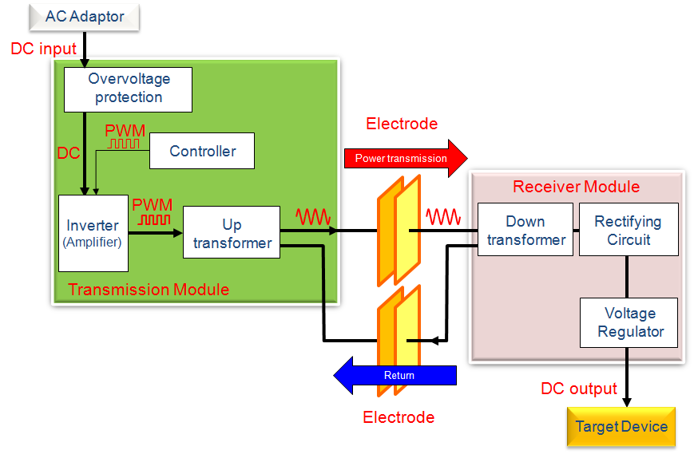

Figure 3.1 Capacitive Coupling WPT system block diagram

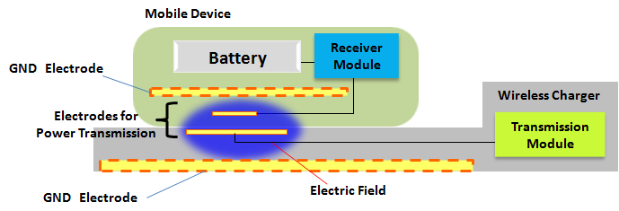

Figure 3.2 Typical structure of the Capacitive Coupling system

3.2 For home appliances

For the purpose of enabling a whole new class of cordless appliances, the kitchen appliance has aroused widespread interest. Inductive power sources (transmitters) may stand alone or be integrated in the kitchen counter tops or dining tables. These transmitters could combine the Wireless Power Transfer to an appliance with conventional Inductive Heating.

For the home appliance application, the power level is usually up to several kilowatts, and the load maybe motor-driven or heating type. Considering the high power usage in home, lower frequency is preferred to restrict relative electromagnetic exposure to human bodies. And high reliable devices such as IGBTs are usually used and these devices are working in 10 kHz- 100 kHz frequency range.

Future products will support more than 2 kW power and some new design proposal for cordless kitchen appliances is being investigated.

The product applied in the kitchen must meet the safety and EMF requirement. And it is a key issue that transmitter should be light and small size to fit the kitchen in addition to being low cost. The distance between Tx and Rx is intended less than 10 cm.

The following pictures show examples of wireless power kitchen appliances that will come to the market soon.
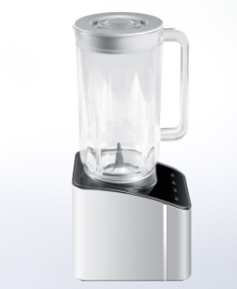 | 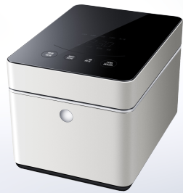
Tightly Coupled mixer | Tightly Coupled rice cooker
Figure 3.3 Wireless Power Kitchen Appliances

3.3 For EV

Magnetic Field Wireless Power Transfer (MF-WPT) is one of the focus points in standardization discussion such as IEC PT61980, ISO PAS19363 and SAE J2954TF regarding WPT for EV and PHEV though there are several types of WPT methods. MF-WPT for EV and PHEV contains both inductive type and magnetic resonance type. Electric power can be transmitted from the primary coil to the secondary coil efficiently via magnetic field by using resonance between the coil and the capacitor.

Expected applications assume the following aspects.
- WPT application : Electric power transmission from electric outlet at a residence and/or public electric service to EVs and PHEVs
- WPT usage scene: at residential, apartment, public parking etc.
- Electricity use in vehicles: All electric systems such as charging batteries, computers, air conditioners etc.
- Examples of WPT usage scene: Shown in the following figure.
- WPT method: AWPT system for EV/PHEV has at least two coils. One is in the primary device and the other is in the secondary device. The electric power will be transmitted from primary device to secondary device through magnetic flux/field.
- Device location (Coil location)
    - Primary device: On ground or/and in ground
    - Secondary device: Lower surface of vehicle
- Air gap between primary and secondary coils: Less than 30cm
- Transmission power class example : 3kW, 7kW, and, 20kW
- Safety: Primary device can start power transmission only if secondary device is located in the proper area for WPT. In addition, the system may operate foreign object detection between the primary and secondary devices before and during transmitting power. Primary device needs to stop transmission if it is difficult to maintain safe transmission.

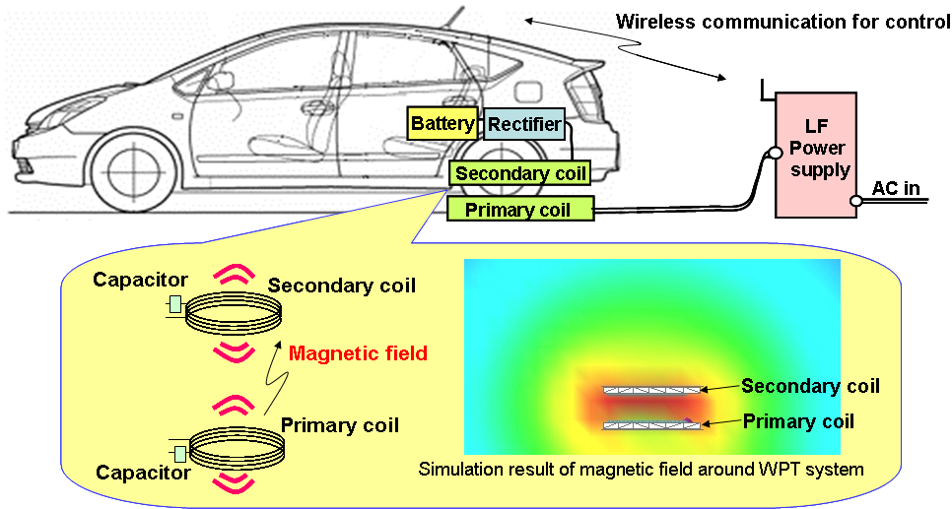

Figure 3.4 Example of a WPT system for EV/PHEV

4. Standardization status

4.1 Some APT countries

China, Japan, and Korea have provided information specifically regarding this subject.

4.1.1 China

This section is excerpted from the APT Survey Report on WPT [10].

In China, CCSA (China Communication Standard Association) has been creating WPT standards for portable devices, such as Mobile Stations. In 2009, CCSA TC9 set up one new research report project “Research on Near-field Wireless Power Supply Technology”. This project was finished in March, 2012 and developed the report on the wireless power supply technology research. In 2011, CCSA TC9 created two standard projects: (1).EMF Evaluation Methods for Wireless Power Supply (WPS); (2).EMC Limits and Measurement Methods for WPS. These two standards will be published soon.

Now, there are three new standards related to the technical requirements and test methods (part1: General; part2: Tightly Coupled; part3: Resonance wireless power) and the development of safety requirements have been in the final draft status. More and more standard projects related to wireless power transmission will be created. The target products are audio, video, and multimedia devices, information technology equipment, and telecommunication devices.

These standards focus on performance, radio spectrum, and interface. It is planned that this standard will not involve IPRs. Generally the possibility for these standards to become mandatory is low.

The standards may define new Logos to identify which Part of standard (Part2/3) the product belongs to.

China National Standardization Administration Commission (SAC) is planning to set up a National Standardization Technical Committee (TC) on WPS. China Academy of Telecommunication Research (CATR) of MIIT has been promoting it. This TC is responsible for creating national standards on WPS for mobile phones, information technology equipment, audio, video, and multimedia devices.

Considering the plan and/or timeline of standard/guideline/regulation development at CCSA, EMC and EMF standards will be published soon. Part 1 of the Technical requirements standards has been approved，and part 2，part3 and safety requirements standards will be completed in 2014.

In China, a national SDO oriented to wireless-powered home appliance was set up in Nov. 2013 and it has a plan to make the national standards. Moreover, other issues such as safety and performances are also discussed there.

4.1.2 Japan

The WPT-Working Group of BWF (Broadband Wireless Forum, Japan) is taking responsibility for drafting WPT technical standards utilizing the ARIB (Association of Radio Industries and Businesses) drafting protocols. A draft standard developed by BWF will be sent to ARIB for approval. BWF has mostly completed technical studies for WPT spectrum for all the proposed applications and technologies. New rulemaking works for Capacitive Coupling WPT and magnetic resonant WPT using 6.78 MHz have been completed and that for WPT for EV/PHEV and are in progress at MIC’s Subcommittee on Electromagnetic Environment for Radio-wave Utilization. Some new regulations and rulemaking status for WPT are introduced in Chapters 5, 6, and 7. Currently the following WPT technologies are put in pipeline with timelines for standardization. The first three with less than 50W transmission power are intended for approvals in 2015. The others with higher power (> 50W) are expected in 2015 and later.
- Capacitive Coupling WPT,
- WPT using microwave two-dimensional waveguide sheet,
- Magnetic resonance WPT using 6.78 MHz for mobile/portable devices,
- Magnetic induction WPT for home appliances and office equipment,
- WPT for EV/PHEV

In addition to developing and evaluating power-transmission radio wave specifications, control-signaling-transmission mechanisms are taken into account. Global harmonization on spectrum is carefully considered for those intended for global market.

4.1.3 Korea

This section was excerpted from the APT Survey Report on WPT [10].

MSIP (Ministry of Science, ICT and future Planning) and its RRA (National Radio Research Agency) are government agencies in charge of WPT Regulations in Korea. And the main standardization organizations developing the standards for WPT are shown in the table below.

Table 4.1 Standardization activities status in Korea
Name | URL | Status
KATS | http://www.kats.go.kr/en_kats/ | On-going  - Multi-device charging management
KWPF | http://www.kwpf.org | On-going  - spectrum related to WPT  - regulatory related to WPT  - WPT based on magnetic resonance  - WPT based on magnetic induction  Completed  - Use Case  - Service Scenario  - Functional Requirement  - In-band communication for WPT  - Control for management of WPT
TTA | http://www.tta.or.kr/English/index.jsp | Completed  - Use Case  - Service Scenario  - Efficiency  - Evaluation  - In-band communication for WPT  - Control for management of WPT  On-going  - WPT based on magnetic resonance  - WPT based on magnetic induction

4.2 International organizations

This section is excerpted from the APT Survey Report on WPT [10].

International organizations dealing with WPT standardization and their relevant activities are summarized in the table below.

Table 4.2 WPT related international organizations
Name of Organization | Activities
CISPR (Comite International Special des Perturbations Radioelectriques) | WPT is taken by CISPR SC-B (Interference relating to ISM radio frequency apparatus, and to overhead power lines, etc.) for discussion. The other SCs are considering WPT if they take.  SC-B formed a Task Force in June 2014 intended for specification development
IEC TC 100 | Survey for Technical Reports regarding WPT  - IEC TC 100 Stage 0 Project  - Survey Completed: July. 2012  - Under Drafting Technical Reports
IEC 61980 (IEC TC 69) | IEC TC 69 (Electric road vehicles and electric industrial trucks) WG4, together with ISO TC22 (Road Vehicles), discusses WPT for automotive.  - IEC 61980-1: General Requirements  - IEC 61980-2: Communication  - IEC 61980-3: Magnetic Field Power Transfer
ISO 19363 (ISO (TC22/SC21)) | ISO 19363: Magnetic field wireless power transfer -- Safety and interoperability requirements (Publicly Available Specification, PAS)  - Established in early 2014  - Target is to develop a standard which specifies requirements for the vehicle-side parts  - - A close synchronization with IEC 61980 and SAE J2954
ISO/IEC JTC 1 SC 6 | In-band PHY and MAC Layer Protocol of WPT  - ISO/IEC JTC 1 SC 6- Working Item was approved in Jan. 2012.  - On Circulation with WD (Working Document)
ITU-R SG1 WP1A | ITU-R Report SM.2303 (WPT NON-BEAM) for the study on Question ITU-R 210-3/1 was approved in June 2014.  The Working Document of Preliminary Draft New Recommendation on WPT was carried forward to the next meeting in June 2015.  - CG-WPT was extended its deadline to report the progress of work to the next meeting of WP 1A one month prior to start of the WP1A meeting in 2015.
CEA (Consumer Electronics Association) | CEA R6-TG1 (Wireless Charging Task Group) discusses WPT and related issues.
SAE (Society of Automotive Engineers) | WPT standardization has been getting active since 2010. Proposed specifications by OEMs are reviewed. Standardization is to complete in 2013-2014 as IEC plans.  - In November 2013, SAE International J2954™ Task Force for Wireless Power Transfer (WPT) of Light Duty, Electric and Plug-in Electric Vehicles, agreed on “85 kHz band” operation and three power classes for light duty vehicles
A4WP | Non-radiative near- and mid-range magnetic resonant coupling (highly resonant coupling) (loosely-coupled WPT) using the 6.78 MHz ISM band.  - Baseline Technical Specification completed 2012  - Released its technical specification (ver.1.2) in January 2013
WPC | Tightly coupled inductive coupling solutions across a range of power levels.  Website lists more than 120 members and 80 certified products including accessories,  chargers and devices  - Released technical specification (ver.1) in July 2010
CJK WPT WG | The working group on WPT of the CJK Information Technology Meeting.  Shares information in the region to study and survey on low power and high power WPT  - Released CJK WPT Technical Report 1 in April 2013  - Released CJK WPT Technical Report 2 in Spring 2014  - Agreed on Technical Report 3 development to release in Spring 2015

5. Frequency bands studies for WPT in some APT member countries

5.1 Non-ISM bands

19 kHz – 21 kHz

42 kHz- 48 kHz:

52 kHz – 58 kHz

59 kHz - 61 kHz:

79 kHz - 90 kHz

110 kHz - 205 kHz:

425 kHz - 524 kHz

(i) Tightly Coupled

The Tightly Coupled WPT technology is referred to magnetic induction which is applied to contactless power transfer between a power transmitter and a receiver. It is reported today in Japan and Korea that the Tightly Coupled technology can be found in mobile and portable devices adopting the Qi low power specification specified by the Wireless Power Consortium (WPC) [13]. Nominal frequency range is 110 kHz to 205 kHz. Nominal transmission/transfer power level is 5 W or less. Given the current use cases and technical conditions in market, the technology can be operated well while keeping compliance to the existing domestic and international rules and guidelines for radiated emission limits and RF exposure limits. As a result, coexistence with the incumbent systems can be achieved.

In Japan, WPC products based on the Tightly Coupled technologies using the frequency range of 110 kHz to 205 kHz are already spread on market under the existing regulations.

In Korea, WPC products are on the market and they’re using the frequency band of 100 kHz to 205 kHz. For the related regulations in Korea, please refer to the section 6.1.4

(ii) Tightly Coupled (Inductive; high power)

Some parties in Japan and Korea consider that 10s of kHz range and 110kHz– 205 kHz range (i.e., WPC Qi spectrum) may be advantageous for Tightly Coupled WPT technology using up to 1.5 kW intended for home appliances and office equipment. This is because of power efficiency in high power circuit designated regulatory aspects such as EMI/EMF conditions.

The frequency range is similar to those for EV applications. There are many concerned incumbent devices and systems including standard clock radios and railway radio systems such in Japan. However, this proposal in Japan faces domestic coexistence study issues unresolved with a few concerned incumbent devices and systems. See Chapter 7 for details. Intensive survey and further study for coexistence will be necessary.

High power application using loosely coupled technology has been appeared in Japan and Korea. Spectrum availability studies are in progress in Japan and Korea. There found no common spectrum under the current studies among these countries.

(iii) Capacitive Coupling

The Capacitive Coupling WPT systems are originally designed for the use of frequency range of 425 kHz to 524 kHz in Japan. Transmission power level is less than 100W. A couple of reasons of the frequency selection are provided as follows.
The1st reason why it selects this frequency is to achieve balancing very high efficiency and downsizing for module. Many types of generalized well-designed electric components and modules for the use in this band for inverter, rectifier etc., are available for product design in this frequency range, which leads to broader variety of selection of components and expands opportunity to optimize design to realize required performance.. The transformers are key parts of Capacitive Coupling WPT system in particular. The transformer performance depends on the Q-value of ferrite material, which can be optimized in this frequency range. Consequently, expected total efficiency of Capacitive Coupling system is about 70% to 85% using the small and optimized module integrated in the devices.

The 2nd reason is capability to suppress unwanted emission in electric field in order to co-exist with the neighboring incumbents such as AM broadcast. The spectrum mask of capacitive coupling WPT systems assuming candidate frequency range of 425 kHz to 524 kHz is now examined to meet the coexistence conditions with AM broadcast and other conditions of the current Japan Radio Law.

Seeing frequency conditions written above, frequency bands under study and key parameters for these applications are summarized in Table 5.1. Concerned incumbent systems for coexistence per each technology with frequency are also provided. Coexistence with them has been demonstrated; and details can be found in Chapter 7.

(iv) Electric passenger vehicles

In this section, the word “EV” means electric passenger vehicles and Plug-in Hybrid electric passenger vehicles (PHEV).

In Japan, WPT for EV while parking is a hot topic in the WPT new rule making process. BWF has been playing a key function for candidate spectrum survey, coexistence study, and global frequency harmonization talks among international automotive standard organizations including JARI, IEC, and SAE.

A few specific frequency ranges, namely 79 kHz - 90 kHz, 52 kHz - 58 kHz, and 42 kHz-48 kHz were proposed, reviewed, and evaluated to coexist with the incumbent devices and systems by BWF. These candidate frequency ranges were selected from 20 kHz - 200 kHz frequency range considered at IEC PT61980, ISO PAS19363 and SAE J2954TF for EV WPT. These frequency ranges have advantages to achieve high energy transfer efficiency in higher power circuit design. In addition, there found less number of incumbent systems globally.

In the spectrum studies in BWF, global spectrum harmonization for WPT was taken into account. As the result of the study of global spectrum harmonization, a frequency range of 140.91 kHz – 148.5 kHz was added to the three frequency ranges shown above.

Intensive survey of the current spectrum usage in the world was carried out to narrow down candidate spectrums so that possible interference to the standard clock radio devices and the existing applications can be minimized. BWF prioritized the 79 kHz - 90 kHz range and shared its survey results with the concerned organizations.

Following above activities, in November 2013, SAE announced agreement on frequency of operation and power classes for “WPT for EV. LIGHT DUTY VEHICLE WPT FREQUENCY 85 kHz BAND: (81.38 - 90.00) kHz” was agreed. 140.91 kHz – 148.5 kHz was not supported [17]. One of the reasons is the low emission limit in the European Norm (EN300-330-1) for SRD as a similar magnetic system with MF-WPT.

In Japan, spectrum sharing studies and coexistence talks with the incumbent including standards clock radios and railway radio systems. 79 kHz – 90 kHz (85 kHz band) is assumed to be the primary frequency range from IEC and SAE discussions and coexistence study results. Further assessment is in progress. See Chapter 7 for details.

(v) Heavy duty electric vehicles

In Korea, both WPT modes on driving and stopping have been developed by OLEV (OnLine EV) and are now in commercial stage. For introduction of OLEV in Korea, Korea Communications Commission (now MSIP) reviewed relevant regulations and frequency bands from 2010 to 2011. In May 2011, Korea government allocated the frequencies for OLEV to 20 kHz (19 kHz - 21 kHz) and 60 kHz (59 kHz - 61 kHz). These frequencies can be used for any type of vehicle whether it is heavy duty or light duty vehicle in Korea.
Frequency bands under study and key parameters for WPT for electric passenger vehicles and heavy duty vehicles are summarized in Table 5.1. Concerned incumbent systems for coexistence per each technology with frequency are also provided.

Table 5.1 Frequency ranges under study, key parameters, incumbent systems on WPT systems for mobile/portable devices and home/office equipment
 | Tightly Coupled (Inductive; low power) | Loosely Coupled  (Resonant) | Tightly Coupled  (Inductive; high power) | Capacitive Coupling
Application types | Mobile/ portable devices, tablets, note-PCs (e.g., WPC/Qi) | Mobile devices, tablets, note-PCs (e.g.,A4WP[20]) | Home appliances, office equipment (incl. higher power applications) | Mobile devices, Tablets, note-PCs
Technology Principle | Magnetic induction | High resonance | Magnetic induction | Electric field induction
Names of countries considering | Commercially available in Japan, Korea | Japan, Korea | Japan | Japan
Frequency Ranges under considerations | Japan:  110kHz–205kHz.  Korea:  100kHz–205kHz | Japan, Korea :  6.765 MHz -6.795 MHz | Japan:  20.05 kHz - 38 kHz,  42 kHz - 58 kHz,  62 kHz – 100 kHz | Japan: 425 kHz-524 kHz
Power Range under considerations |  | Japan:  Several W – up to 100W  Korea:  Unlimited in-band emission limit | Japan:  Several W – 1.5kW | Japan:  Up to 100 W
Advantage | Global harmonized spectrum  Higher power transfer efficiency | - Global spectrum availability possible  - Flexibility for placement and distance of receiving end  - Transmitter can supply power for several receivers within a wide range contemporary. | - Increased power  - Flexibility for placement and distance of receiving end  - Transmitter can supply power for several receivers within a wide range contemporary. | High efficiency (70-85%)  -No heat generation at the electrode  - Low emission level  - horizontal position freedom
Application Areas | Mobile devices, portable devices, CE,  Industrial Fields, Specific Areas | Mobile devices, tablets, note-PCs, home appliances (low power) | Home appliance (high power), office equipment | Portable devices, tablets, note-PCs, home and office equipment
Related Alliances / international standards | Wireless Power Consortium (WPC)[13] | A4WP [20]
Concerned incumbents for spectrum sharing |  | China: 100–148.5 kHz, 6765–6795 kHz, and 13553–13567 kHz  Japan:  mobile/fixed radio systems  Korea:  ISM band | Japan:  Standard clock radios (40 kHz, 60 kHz)  Railway radio systems (10kHz – 250 kHz)  Coexistence has not been demonstrated for some incumbent cases (as of March 2015). | Japan:  AM Broadcast (526.5kHz - 1606.5 kHz), Maritime/NAVTEX (405kHz -526.5 kHz),and  Amateur radio (472kHz - 479 kHz).

5.2 ISM bands

6.78 MHz band: 6 765kHz – 6 795 kHz

13.56 MHz band: 13 553kHz – 13 567kHz

(i) Loosely Coupled (Resonant)

6.78 MHz (6.765 MHz – 6.795 MHz) is commonly supported in the Loosely Coupled low power (less than 100W) WPT frequency considerations in China, Japan, and Korea. 6.78 MHz is designated as an ISM band in Rec. ITU-R SM.1056. Unrestricted emission is allowed in ISM bands. In China, 6.78 MHz can be assigned to the ISM application with the special approval from relevant departments firstly. In Japan, it is not designated as an ISM band and a transmitted RF power limit such as not exceeding 50W for operation without administrator’s permission exists. However, the regulations’ provisions allow the use for WPT applications in the band. A new type-approval rule for WPT products is now considered, which may allow higher transmission power of those in 6.78 MHz. In Korea, it is designated as an ISM band and ISM applications.

The reasons why 6.78 MHz is expected for Loosely Coupled WPT technology are summarized as follows:

- International ISM band; unrestricted emission limit (Japan and Korea have different rule.)
- Relatively a vacant spectrum; the incumbent devices and systems using this frequency band are few.
- It can maintain greater harmonization globally since several standardization organizations are making WPT standards using 6.78MHz.
- Devices such as power transmitter coil and receiver coil for WPT can be formed small and thin by using this frequency band.

Currently 6.78 MHz is used for the ISM applications and specific purpose radio systems in these countries while the duty and density of the systems are much lighter than the other bands under considerations. Coexistence studies are ongoing. And the 13.56MHz band in Korea is used for 3D glasses WPT.

The 13 553-13 567 kHz frequency band is an international ISM frequency band. ITU-R has listed it as the recommended frequency band for wireless charging. Some countries also consider 13.56 MHz as a usable wireless charging band. In addition, IEC TC100 is also in the process of transferring the IEC 63562 NFC (Part 1 and Part 2) specification adopted from the NFC Forum.

From the perspective of spectrum coexistence, international organizations such as NFC Forum and ECC have completed a lot of research and analysis, which proves that 13.56 MHz frequency band does not have harmful effects on incumbent wireless communication systems.

Regarding Global trends of Non-Beam Wireless Charging applications using 13553-13567kHz, with the rapid growth of IoT and smart wearable devices in recent years, 13.56 MHz NFC-based wireless charging has also entered the market, such as Huawei smart glasses, Microsoft stylus pen, and Samsung smart band. At the end of 2020, the number of 13.56 MHz NFC charging devices has exceeded the number of AirFuel Alliance's 6.78 MHz wireless charging devices. According to the ETSI research report (TR 103 493) released in February 2019, 13.56 MHz is applicable to IoT devices with less than 1 W and is recommended to be included in the wireless charging standard. In November 2020, USI has begun working with NFC Forum to promote the application of NFC wireless charging on stylus pens. In September 2024, ITU-R released SM.2129-1, which specifies the 13 553-13 567 kHz band using magnetic induction or magnetic resonance technology as the recommended band for non-beam wireless charging. European Telecommunications Standards Institute ETSI TR 103 493 V1.1.1 (2019-02) stated that 13.56 MHz is recommended for wireless charging devices with a power of less than 1 W.

13.56 MHz wireless charging is a mature solution in high-frequency. For wearable and IoT products, the wireless charging frequency needs to be increased to achieve charging freedom and coil miniaturization. In the existing high-frequency wireless charging, the ISM can select 6.78 MHz and 13.56 MHz frequency bands. The 6.78 MHz frequency band in the AirFuel alliance is unavailable currently. Samsung, Qualcomm, and Intel stopped the R&D of 6.78 MHz wireless charging products, and related industry resources decreased sharply. The 13.56 MHz bandwidth is evolved from the standard NFC communication solution. The related market space, R&D investment, and industry chain resources are relatively perfect. Currently, 13.56 MHz is one of the key alternatives for high-frequency and low-power products.

In addition to using this band as point-to-point near field communication, NFC Wireless Charging is growing fastly relying on the popularity of NFC products worldwide. It is adopting the electromagnetic resonance technology to transmit the power from the transmitter unit to the receiver unit, at the central frequency of this band 13.56MHz. Maximum charging distance between the two units can reach 15mm.

Solution suppliers, such as NXP, ROHM, and ST, and device manufacturers, such as Huawei and Samsung developed several NFC products that are charged wirelessly after the launch of NFC Forum. The wireless charging NFC transmitter is a universal NFC card reader, and the communication circuit at the receiver end is a universal NFC tag chip. A mature solution has been developed and widely used in scenarios such as payment and public transportation. Wireless charging EMC, certification, and coil magnets used are also common to standard NFC solutions.

In China, in May 2023, the Ministry of Industry and Information Technology issued the Interim Regulations on Radio Management of Wireless Charging (Power Transmission) Equipment to regulate and manage wireless charging of mobile, portable consumer electronic devices and electric vehicles or motors. Article 4 stipulates that the operating frequency range of mobile and portable wireless charging equipment is 100-148.5 kHz, 6765-6795 kHz and 13553-13567 kHz, and the rated transmission power shall not exceed 80 W. The regulations took effect on September 1, 2024. After that, the production or import of wireless charging equipment sold or used in China that does not meet the prescribed requirements shall be stopped, and the wireless charging equipment produced or imported before may continue to be sold and used until scrapped.

The spectrum mask analysis of NFC 13.56 MHz band has been demonstrated by many parties. In addition, NFC charging, which is one of the NFC applications, does not require repeated interference/spurious emission analysis because NFC charging does not require modification of the current spectral mask. A report on the latest 13.56 MHz wireless charging application can be found in ETSI TR 103 059.

The following are the reports that ITU-R refers to when making recommendations on wireless power transmission:

ITU-R SM.2449-1(09/2024): It is revised based on the SM.2449 version and covers the frequency bands of 100-148.5 kHz, 315-405 kHz, 1700-1800 kHz, and 2005-2170 kHz, 6 765-6 795 kHz, 13 553-13 567 kHz.

ITU-R SM.2303-2 report (06/2017): It analyzes the current state of spectrum related to new WPT applications.

EN 300 330, and EN 303 417 have been referenced in this report. In addition, it mentions the WPT system used in South Korea, which operates at 13.56 MHz. EN 303 417 is released simultaneously with the ITU-R SM.2303-2 report. At the same time, the technical report work for ETSI TR 103 493 was completed, with the aim of including the new content of ETSI TR 103 493 in EN 303 417.

ETSI TR 103 493, v1.1.1 (02/2019): It analyzes the market and frequency bands required for WPT use cases. For 13 553-13 567 kHz, it states: "For WPT systems used in consumer devices, the power transfer is typically < 5W; Planned for worldwide use".

Based on the preceding ITU-R and ETSI EN/TR reports and the analysis and research on the 13.56 MHz spectrum, it can be highlighted that:

ITU-R and ECC consider that 13.56 MHz WPT system operates in a well-defined frequency band with sufficiently low power, which does not pose any new challenge for regulators.
NFC WLC and any other NFC-based use cases (eID, payment, transmission, access, and RFID) both operate with the same transmit power level and the same communication method.

Example for compliance and safety test of 13.56MHz wireless charging devices.

This section uses Huawei wireless charging smart glasses as an example. The NFC contactless charging technology is used to wirelessly charge the smart glasses using a glasses case, where the glasses case serves as a transmit end of NFC wireless charging, and the smart glasses serve as a receive end of wireless charging. The transmitting coil is located on the side wall of the glasses case, and the receiving coil is located inside the glasses leg. When the glasses are placed in the case, the two coils approach and establish magnetic field coupling. The glasses case has two indicators. The green indicator outside the case indicates the power supply of the glasses case, and the indicator inside the case indicates the power level of the glasses and the pairing and connection process. (The battery level is displayed according to the color and the white light blinks.)

Tests are classified into radiation tests and spurious tests. They are done in the band 9KHz-1GHz, in a certified anechoic chamber, at different receiving antenna polarizations (Horizontal and Vertical). The Device Under Test is tested in 2 working modes:

a) In idle mode, the device to be tested is a glasses case, which is connected to an external power supply for charging.

b) Charging mode: The devices to be tested are glasses and glasses case. The glasses are placed in the glasses case, and the glasses case is connected to an external power supply for charging.
As test results, the wireless charging glasses meet the limit standards specified in EN 300 330 V2.1.1. The wireless charging frequency and power meet the requirements of the Interim Regulations on Radio Management of Wireless Charging (Power Transmission) Equipment of the Ministry of Industry and Information Technology of China.

Table 5.2 Frequency ranges under study, key parameters, and incumbents systems on WPT systems for EV applications
 | Resonant magnetic induction (for EV) | Shaped Magnetic Field in Resonance  (SMFIR) WPT
Application types | EV charging in parking (Static) | On-line Electric Vehicle (OLEV) (EV charging while in motion including stopping /parking)
Technology Principle | Resonant magnetic induction | Resonant magnetic induction
Countries under consideration | Japan | Korea
Frequency Range | 79 kHz – 90 kHz (85 kHz band) is assumed to be the frequency range from IEC and SAE discussions and coexistence study results. Further assessment is in progress.  Note) Systems operating in 42 kHz – 48 kHz, 52 kHz – 58 kHz, 79 kHz – 90 kHz, or 140.91 kHz – 148.5 kHz have shown issues unresolved to meet all the coexistence requirements. | 19kHz - 21 kHz,  59kHz - 61 kHz
Power Range | 3 kW and 7.7 kW; Classes are assumed for passenger vehicle | - Minimum power: 75 kW  - Normal Power : 100 kW  - Maximum Power : On developing  - Air gap : 20 cm  - Time and cost saving
Advantage | Global harmonized spectrum  Higher power transfer efficiency | - Increased power transfer efficiency  - Maximized air gap  - Reduced audible noise  - Effective shield design  - Time and cost saving
Related Alliance / international standards | IEC 61980 (TC69)  ISO 19363 (ISO TC22) | IEC 61980 (TC 69)
Domestic concerned incumbents for spectrum sharing | - Standard clock radios (40 kHz, 60 kHz)  - Railway radio systems (10kHz – 250 kHz)  - Amateur radio (135.7kHz– 137.8 kHz)  - AM Broadcast (526.5 kHz - 1606.5 kHz)  Frequency range of 79 kHz – 90 kHz met with the coexistence condition except the specific case with certain railway radio systems. Further assessment is in progress. | Fixed Maritime Mobile (20.25kHz – 70 kHz) → Ship Station for Radio-telegraphy  Restricted to Hyperbolic Curve Radio-navigation(DECCA) (84kHz – 86 kHz)

6. Technical regulation issues for WPT

This section refers to [10] for detailed descriptions in order to keep consistency with the APT WPT Questionnaire Responses. In addition, each description updated with the latest information.

6.1 Some APT Countries

6.1.1 Australia

The ACMA (Australian Communications and Media Authority) is a statutory authority regulating broadcasting, the internet, radio communications and telecommunications in Australia. Under Australian regulatory arrangements, radio communications devices must comply with any applicable standards and radio communications transmitters must not be operated without a license. ACMA regulates EMC through Radiocommunications Labelling Notice 2008.

Australian regulatory status on RF exposure and RF assessment is shown as follows.

(i) RF exposure
- The ACMA is responsible for the management of the mandatory Radiocommunications (Electromagnetic Radiation – Human Exposure) Standard 2003 (incorporating amendments to Radiocommunications (Electromagnetic Radiation - Human Exposure) Amendment Standard 2011 (No. 2)),: specifying the RF exposure limits for most mobile and portable radiocommunication transmitters with integral antenna operating 100kHz ~ 300GHz
- Radiation Protection Standard for Maximum Exposure Levels to Radiofrequency Fields - 3 kHz to 300 GHz (RPS3): set by ARPANSA (Australian Radiation Protection and Nuclear Safety Agency)

(ii) RF assessment
- Such devices are required to show compliance using test methods such as EN 62209-2
- (Human exposure to radio frequency fields from hand-held and body-mounted wireless communication devices – Human models, instrumentation, and procedures – Part 2: Procedure to determine the specific absorption rate (SAR) for wireless communication devices used in close proximity to the human body (frequency range of 30 MHz to 6 GHz) http://infostore.saiglobal.com/store/details.aspx?ProductID=1465960.The ACMA mandates the limits for RF and EMR exposure set by the Australian Radiation Protection and Nuclear Safety Agency (ARPANSA). The primary source of RF exposure limit information is ARPANSA’s Radiation Protection Standard for Maximum Exposure Levels to Radiofrequency Fields - 3 kHz to 300 GHz (RPS3) - http://www.arpansa.gov.au/Publications/codes/rps3.cfm

6.1.2 China

About radio regulation files in China, there are many WPT related radio regulations. The following are main regulations which manage the issue of WPT radio emission.

(1) People's Republic of China Ministry of Industry and Information Technology, the 16th Order (2010): People's Republic of China Regulations on the Radio Frequency Allocation. This ensures the normal operation of the radio business, and prevents mutual interference between the various radio services, radio stations and WPT system.

(2) People's Republic of China State Council, the People's Republic of China the Central Military Commission, the 128th Order (1993): People's Republic of China Regulations on Radio. This regulation strengthens radio management and maintenances airwaves order. According to varieties of WPT technology and control communications part, WPT devices may be same as normal radio system and under control of such regulations.

(3) People's Republic of China State Council, People's Republic of China the Central Military Commission, No. 579 Order (2010): People's Republic of China Radio Control Requirements. This is the latest regulation about restrictions on radio stations, radio transmitting equipment, and radiation of radio waves of non-use of radio equipment, technical blocking measures, as well as the implementation of a specific radio frequency emission of radio waves, radiation and dissemination mandatory management.

(4) People’s Republic of China Ministry of Industry and Information Technology, the 62nd order(2023): ‌ Interim Regulations on Radio Management of Wireless Charging (Power Transmission) Equipment. This regulation governs the radio management of wireless charging equipment and maintains radio wave order. The operating frequency bands for mobile/portable devices are 100-148.5 kHz, 6765-6795 kHz, and 13553-13567 kHz, with a rated transmission power not exceeding 80 watts. Wireless charging for electric vehicles is managed by frequency bands based on power levels. The equipment that is manufactured or imported for sale and use in China is granted license exempt status, on condition of compliance with relevant technical requirements and absence of harmful interference.

6.1.3 Japan

(1) Technical rulemaking status update
In June 2013, the MIC WPT-Working Group (WG) was formed under MIC’s Subcommittee on Electromagnetic Environment for Radio-wave Utilization. The Broadband Wireless Forum (BWF) proposed a few WPT application fields and technologies and asked for WPT new rulemaking. Candidate frequency ranges, emission limits, spectrum sharing with the incumbent radio systems, RF exposure assessment methodology, and other necessary conditions were discussed as primary subjects to specify in the technical conditions for the use of the technologies.
In January 2015, Japan’s first rulemaking report (the Report, hereafter in section 6.1.3) was approved by the MIC council, which specifies technical conditions for the use of magnetic coupling WPT technology using 6.765 – 6.795 MHz (6.78 MHz band) and those for capacitive coupling WPT technology using 425 – 524 kHz. Emission rules have been provided in the Report, which the CISPR standards were referred to in determining the limits. Coexistence study results have been reflected in the rules.
Candidate WPT frequency ranges intended for EV applications have been converged to the 79 – 90 kHz range (85 kHz band) in 2014. Upcoming Report including technical conditions of WPT technology for EV applications is expected to be approved in the middle of 2015.
The new and first rules for WPT may become effective in 2015, which is first targeted for mobile device applications using 6.78 MHz magnetic resonance technology or Capacitive Coupling technology. Those targeted for electric vehicles (EVs) applications may follow in the mid of or later 2015.

BWF proposed the following WPT application fields.
- WPT for EVs (including Plug-in Hybrid EVs)
- WPT for Home Appliances (mobile devices, home/office equipment)
- WPT for mobile devices

Candidate frequency ranges under consideration and the target WPT systems with fundamental parameters are summarized in the following table.

Table 6.1 WPT technologies under Japan MIC WPT WG discussion
Target WPT | (a) WPT for EV | (b) WPT for mobile devices | (c) WPT for home/office equipment | (d) WPT for mobile devices 2
WPT technology | Magnetic coupling (induction or resonance) |  |  | Capacitive Coupling (Electric field coupling)
Transmitted power | - approx.3 kW  (max 7.7 kW) | Several W - approx.100 W  (130W at peak) | Several W - 1.5 kW | - approx.100 W  (130W at peak)
Candidate WPT frequency  ranges | 42 kHz - 48 kHz,  52kHz - 58 kHz,  79 kHz - 90 kHz,  140.91 kHz -148.5 kHz | 6765 kHz - 6795 kHz | 20.05kHz - 38 kHz,  42 kHz - 58 kHz,  62 kHz - 100 kHz | 425kHz – 524kHz
Power Trans-mission distance | 0 - approx. 30 cm | 0 - approx. 30 cm | 0 - approx. 10 cm | 0 - approx. 1 cm
This table may be changed by the domestic and global standardization trend of WPT.

(2) Emission limits
In the WG discussion, WPT performance simulation and measurement data were provided for assessment. For performance survey and regulatory considerations, emission measurement models and measurement methodologies were agreed. Radiated and conductive emission measurement and assessment were executed from Q4 2013 to Q3 2014. Referring to simulated and measured data, coexistence (spectrum sharing) studies with the incumbents were performed and the results were summarized. The results and ongoing considerations derived from simulation, measurement, and coexistence studies have been delivered to ITU-R SG1 WP 1A in 2014. WPT technologies for mobile devices (b) and (d) in Table 6.1 have demonstrated coexistence availability with the incumbents. Further assessments for WPT technology for EVs and an incumbent have been addressed by the WG to demonstrate coexistence by Q2 2015.
The WG has been discussing conductive and radiated emission limits of WPT devices to introduce. The WG referred mainly to CISPR standards in light of international regulatory harmonization. Table 6.2 shows the reference conditions to which the WG referred and assessed in emission limit decisions. In principle, the CISPR standards were referenced. For some specific cases, additional domestic coexistence conditions agreed at the WG were also referenced.
For emission limits of WPTs for mobile devices (b) and (d), CISPR 11 Class B is taken into consideration as the primary reference limit; and CISPR 32 can be taken in the case a comprehensive multimedia device emission evaluation is necessary.
For wireless EV charging discussions, Japan actively participates in CISPR B discussions which Japan have been presenting the WG discussion results. The latest CISPR discussion results may be referenced and incorporated into the Japan’s WPT emission limits.
In Japan’s regulation, any devices with transmission power not exceeding 50 W do not require any permission by the administrator for operation. The proposed technologies of (b) and (d) in Table 6.1 have been assumed for mobile devices charging with transmission power not exceeding 50 W so far. These technologies are expected to increase transmission power greater than 50 W once the new rule becomes effective possibly in 2015.

Table 6.2 Referenced standards and conditions for specifying emission limits
WPT target application | Conductive emission |  | Radiated emission
WPT target application | 9 kHz – 150 kHz | 150 kHz - 30 MHz | 9 kHz - 150 kHz | 150 kHz – 30 MHz | 30 MHz – 1 GHz | 1 GHz – 6 GHz
(a) WPT for EVs | Not specify for the near term (*1) | CISPR 11 Group 2 (Ed. 5.1) | WG coexistence condition (*1) | CISPR 11 Group 2 (Ed. 5.1) (*4)  WG coexistence condition | CISPR 11 Group 2 (Ed. 5.1) | Not specify.
(b) WPT for mobile devices using 6.78 MHz | Not specify as the range not meet the frequency bands concerned | - CISPR 11 Group 2 (Ed.5.1)(*2)  - CISPR 32 (Ed.1.0) | Not specified | CISPR 11 Group 2 (Ed.5.1) (*2) (*3)(*4)  WG coexistence conditions | CISPR 11 Group 2 (Ed.5.1)(*2)  CISPR 32 (Ed.1.0) WG coexistence conditions | CISPR 32 (Ed.1.0)
(c) WPT for home/office equipment | CISPR 14-1 Annex B (Ed. 5.2) | - CISPR 11 Group 2 (Ed.5.1)  - CISPR 14-1 Annex B (Ed. 5.2) | CISPR 14-1 Annex B (Ed. 5.2)  WG coexistence conditions | CISPR 11 Group 2 (Ed.5.1) (*2) (*3)(*4)  CISPR 14-1 Annex B (Ed. 5.2)  WG coexistence conditions | CISPR 11 Group 2 (Ed.5.1) (*2)  CISPR 14-1 (Ed. 5.2) | Not specify
(d) WPT for mobile devices 2 (capacitive coupling) | Not specify as the range not meet the frequency bands concerned | CISPR 11 Group 2 (Ed.5.1)(*2)  CISPR 32 (Ed.1.0) | Not specify | CISPR 11 Group 2 (Ed.5.1) (*2) (*3)(*4)  WG coexistence conditions | CISPR 11 Group 2 (Ed.5.1)(*2)  CISPR 32 (Ed.1.0) | CISPR 32 (Ed.1.0)
Notes)
- When specified in CISPR 11 in future, discuss for specification again.
- In case the WPT function device works without the host device, CISPR 11 shall be applied as primary; then the others as secondary.
- Unless otherwise specified on the specific frequency for the use, CISPR 11 shall be applied as primary; then the others as secondary.
- For CISPR 11 Group-2 Class-B, emission limits at 10 m distance is specified based on the emission limit at 3 m distance.
- Class A/B classification is compliant with the CISPR definition.
- For the cases specified as CISPR 32 in (b) and (d), CISPR 32 is applied when necessary as CISPR 32 is appropriate.

(3) RF exposure assessment to human bodies
Methodologies for conformity assessment of human body protection from WPT RF exposure of the WPT technologies were discussed and defined.
A special ad hoc group was formed to address appropriate assessment methodologies to demonstrate compliance to the human body protection guidelines. No changes have been presupposed in the current compliance regulation but the group reviewed concerned domestic regulations, international standards, and the recent research findings from academic research faculties and WPT R&D companies. The Report includes directions for assessment methodologies for conformity assessment on human body protection from WPT RF exposure of the WPT technologies (a), (b), (c), and (d) in Table 6.1. The following summarizes the results. For the readers who are interested in Japan’s regulatory aspects relating to WPT, the BWF technical report “GUIDELINES FOR THE USE OF WIRELESS POWER TRANSMISSION TECHNOLOGIES Edition 2.0” in April 2013 (http://bwf-yrp.net/english/update/2013/10/guidelines-for-the-use-of-wireless-power-transmission-technologies.html) is a very good textbook.
In Japan, the Radio-radiation Protection Guidelines (Report of the Telecommunications Technology Council of the Ministry of Posts and Telecommunications, June 1990: Inquiry No. 38 “Human Body Protection Guidelines for the Use of Radio Waves”) (The Guideline, hereafter in this section) is applied to conformity assessment on RF exposure to human bodies from the WPT systems. The Guideline provides recommended guidelines used when a person uses radio waves and whose body is exposed to an electromagnetic field (in a frequency range of 10 kHz through 300 GHz) to ensure that the electromagnetic field is safe without producing an unnecessary biological effect on the human body; and these guidelines consist of numeric values related to electromagnetic strength, the method of evaluating the electromagnetic field, and the protection method to reduce electromagnetic field irradiation.
The protection guideline values applied to the WPT systems are of the administrative guidelines in the Guideline of the general environment in which a state where the human body is exposed to an electromagnetic field cannot be recognized, appropriate control cannot be expected, and uncertain factors exist; for example, the state where residents are exposed to the electromagnetic field in general residential environment falls under this case.
However, in the case a human body is located within 20 cm from the WPT system operating in the frequency range of 10 kHz to 100 kHz, for which the partial body absorption guidelines cannot be applied, the basic guidelines in the Guideline is applied
The basic guidelines do not discriminate the general environment and the professional environment; therefore, in case of applying the general guidelines, the values counting safety factor of 1/5 (1/√5 in electromagnetic field strength and electric current density) which is applied in the administrative guidelines.
The methodologies are defined by the patterns of the selection of the guideline values and the guidelines which are required parameters and methodologies intended for conformity assessment to the Guideline. The methodologies for the target WPT technologies (a), (b), (c), and (d) in Table 6.1 contain 6, 5, 6, and 3 patterns, respectively. Some of these patterns needs further definition of conditions to apply. Each pattern is defined by the selection of the following parameters.
1) Possibility of human body located < 20 cm from the WPT system or located between the transmitting and receiving coils,
2) Contact hazard protection,
3) Ungrounded condition,
4) Whole body average SAR,
5) Partial body SAR,
6) Induced current density,
7) Contact current,
8) Outer electric field, and
9) Outer magnetic field
The simplest assessment patterns of all the target WPT technologies (a), (b), (c), and (d) consists of 8) and 9) above, which is the minimum number of parameters adopted. In the evaluation, this simplest pattern is assumed to derive the worst (maximum) radio wave energy absorption to the human body. In other words, much larger excess RF exposure than actual exposure value to the human body is derived; and then the assessment would result in much lower allowable emission power from the WPT system.
The other patterns consist of more number of parameters adopted. As the number of parameter in adoption increases, assessment methodology requires more detailed evaluation, which results in more accurate RF exposure estimation.
If one demonstrated conformity of a system using one of the target WPT technologies, to the guideline values defined in any one of the patterns, the system is deemed conforming to the Guideline.
If a new assessment methodology which is intended for an assessment pattern is qualified by appropriate engineering approaches in the future or it can narrow down the applicable assessment methodologies as appropriate, it can be applied for this purpose.

6.1.4 Korea

Korea provides more detailed and broad-range of information in the response than the summary below. For details, please refer to AWG-14/INP-68 [12] and AWG-16/INP-98 [13].

EMC/EMI: CISPR-11 has been applied to WPT, but RRA revised the existing relevant regulation to classify WPT as domestic devices in June 2013.

General Regulations: All radio communications equipment including WPT devices should comply with three regulations under Radio Waves Act, 1)Technical regulation, 2)EMC Regulation, 3)EMF Regulation. The followings are the further explanation regarding technical regulations in Korea. Regarding explanation about EMC and EMF Regulation in Korea, please see AWG-14/INP-68 [12].

License: WPT equipment over 50W is classified as ISM equipment and needs a governmental approval for operation. Those under 50W, “Registration of conformity” including weak electric field strength and EMC testing has been applied for operation. Recently, RRA revised the compliance requirements and the operating characteristics as follows, where all WPT devices are classified as ISM equipment.

  - In the range of 100kHz- 205 kHz, the electric field strength of the WPT device is less than or equal to 500 μV/m.
  - This value should be obtained by multiplying the measurement value and 6 π/λ.
  - The spurious emission should be lower than electric field strength of in-band.
  - In the range of 6765kHz- 6795 kHz, the electric field strength of the spurious emission should be satisfied with the below table.

Table 6.3 Applied field strength limits for WPT
Frequency range | Field strength limit  (Quasi-peak) | Measurement bandwidth | Measuring distance
9kHz-150kHz | 78.5-10log(f in kHz / 9) dB μV/m | 200Hz | 10m
150kHz -10MHz | 78.5-10log(f in kHz / 9) dB μV/m | 9kHz | 10m
10MHz-30MHz | 48dB μV/m | 9kHz | 10m

Table 6.4 Applied regulations to WPT
Power level | Name of application | Applied technical regulations | Concerned WPT technology
Low power  (≤50W) | ISM Equipment – WPT device using the frequency range of 100kHz - 205 kHz | Weak Electric Field Strength | - Commercial products using tightly-coupled technology
Low power  (≤50W) | ISM Equipment – WPT device using the frequency range of 6765kHz - 6795 kHz | ISM | - Considering products using loosely-coupled technology
High power  (≥50W) | ISM Equipment | ISM | - Installed in a specific area  - SMFIR

6.1.5 Thailand
The regulatory framework and operational requirements for WPT technology in Thailand is to be developed based on joint contributions among regulatory authorities and consultation with relevant manufacturers. The related regulatory bodies include the NBTC (National Broadcasting and Telecommunications Commission) regulating broadcasting, telecommunications, and radio communications and the TISI (Thai Industrial Standards Institute), the regulator of industrial standards in Thailand.
The regulatory framework is divided into phases. At the first phase Thailand only focuses on establishing a regulatory guideline for WPT technology for a mobile charging application due to the maturity of international agreements. The provisional guidelines for the first phase are discussed below.

6.1.5.1 Candidate frequency bands
Thailand has been considering frequency range listed in the following table with specific WPT applications and technologies used.

Table 6.5 Frequency ranges for operation of WPT in Thailand
Frequency ranges | Agreeable WPT technologies and applications
6.765 – 6.795 MHz  (Center frequency at 6.780 MHz) | Magnetic resonant technology for mobile devices

The 6.765-6.795 MHz band is chosen because it is internationally recognized as the most suitable candidate band for magnetic resonant or loosely coupled WTP technologies. In particular, Report ITU-R SM.2303 and the studies from ITU-R SG1 WP 1A, APT (AWG WG-Technology Aspects, TG-WPT), CISPR SC-B/F/I, and IEC 61980 (TC 69) are referenced for the selected option. The candidate bands for home appliances, EVs, and other WPT applications are under consideration and require conclusive study results.

6.1.5.2 Operational and technical requirements
Thailand is in the process of developing operational and technical requirements based on the following consideration:
- For any frequency band used for WPT technology, devices without intercommunication function shall be treated as industrial, scientific, and medical (ISM) equipment. The use of those devices must comply with technical requirements for ISM. The devices with communication functions must comply with requirements for both ISM equipment and short-range radio communication devices.
- Transmission power received by WPT devices is considered as conductive emission and the rest of power is considered as radiated emission.
- Radiation outside the designated bands for WPT should be minimized in order to maintain electromagnetic compatibility (EMC) of the WPT equipment and other devices in neighboring bands.
- The use of WPT in ISM bands shall not claim interference protection and not cause interference to radiocommunication services.
- Emission with absence of the load shall be minimized.
- Human body protection from WPT RF exposure shall be justified.

In order to satisfy the above guideline Thailand has a consideration on technical standards in two major aspects.

6.1.5.2.1 Radiation limit
The radiation limit for WPT equipment in Thailand is developed to protect existing radiocommunication systems from unwanted interference and to comply with requirements for ISM devices. The summary of relevant standards and guidelines to be considered for adoption is shown in Table 6.6.

Table 6.6 References for determining radiation limit for WPT equipment in Thailand
Case | Essential references and standards
Case | Domestic standards | International guidelines
WPT system with no communication function | - TIS 2237-2548 [14] | - IEC/CISPR 11 Group 2 Class B  - CISPR 32
WPT system with a communication function outside the designated power transfer band. | - TIS 2237-2548 [14]  - NBTC regulation for radio communication equipment with license exemption [15]. | - IEC/CISPR 11 Group 2 Class B  - CISPR 32  - ITU-R SM.2153-5  - ITU-R SM.1056-1  - FCC Part 15B and Part 18

6.1.5.2.2 RF Exposure

Since RF human hazard are global and not differentiated among countries, Thailand follows ICNIRP international guidelines to create domestic requirements for RF exposure to WPT devices. In particular, ICNIRP 1998 and ICNIRP 2010 are to be adopted.

6.2 International organizations

Regarding safety measures for equipment or systems using WPT technologies, for example, the following can be referred as guidelines [11].
- IEC 60335 “Household and similar electrical appliances – Safety –”
- IEC 60950 “Information Technology Equipment – Safety –.”

Regarding RF exposure and assessment methodologies, for example, ICNIRP and IEEE provide guidelines in detail. Useful introductory information can be found section 8.3 in [11].

7. Status of co-existence studies in some APT member countries

Figure 7.1 and Figure 7.2 show the WPT spectrum under considerations in Japan and Korea. Spectrum sharing studies should be performed between the concerned systems with WPT systems to clarify the availability of coexistence. Some WPT equipment are classified into ISM equipment which shall not cause harmful nor claim protection from other stations.
Japan has already identified the domestic incumbent systems that might suffer from WPT emission in/out of the operating frequency bands. MIC’s WPT WG has directed the concerned parties to investigate possible unwanted effects (e.g. system performance degradation) by WPT emission and necessary talks to find appropriate conditions to coexist. There found many incumbent systems in / around WPT spectrum under considerations. Typical ones are listed in Table 5.1 and Table 5.2. Those include standard clock radios, amateur radios, railway radio systems, maritime/NAVTEX, and AM broadcast services, which are also illustrated in Figure 7.1 and Figure 7.2 which were provided by Korea and Japan.

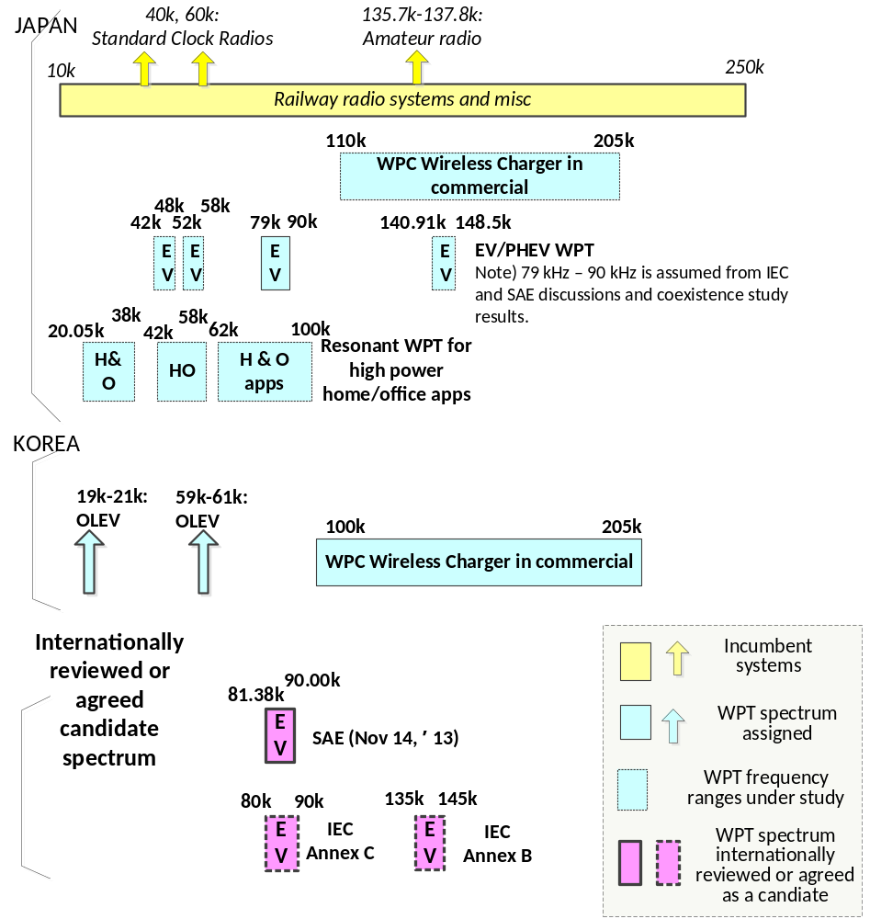

Figure 7.1 WPT spectrum considered and incumbent systems (10 kHz-300 kHz)

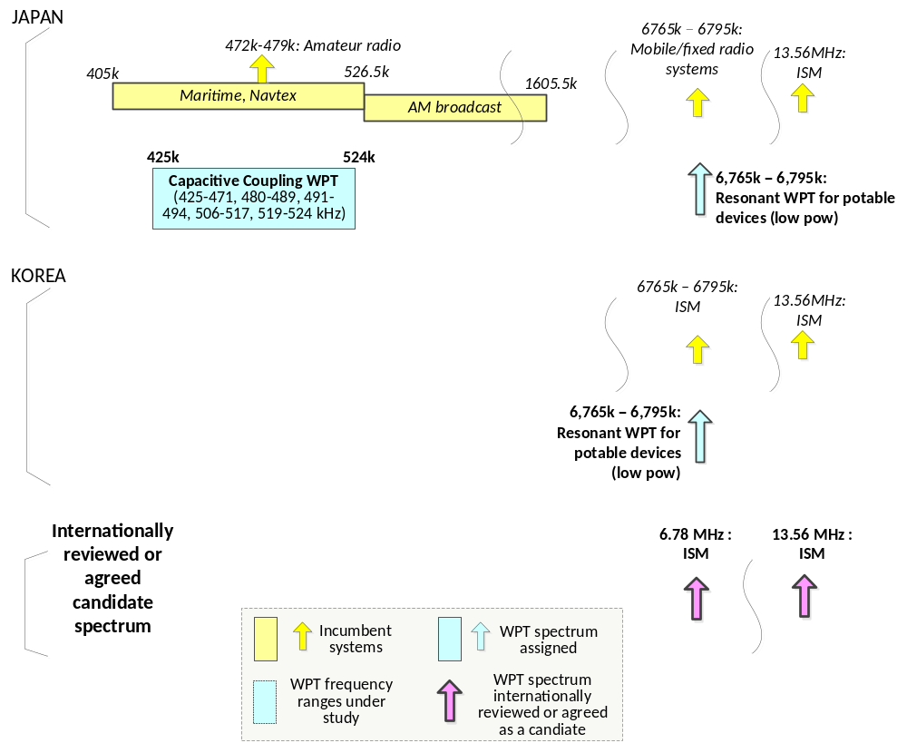Figure 7.2 WPT spectrum considered and incumbent systems (400 kHz-13.56 MHz)

7.1 Japan
Japan is discussing WPT technologies shown in Table 7.1. Candidate frequency ranges under consideration and the target WPT systems with fundamental parameters are summarized in it.
For spectrum sharing and coexistence studies, the WG picked up many possible and practical combinations of the incumbent radio systems and the target WPT systems which might cause a harmful interference event in specific use cases. In such an event, the fundamental WPT radio wave may be using the same spectrum to the incumbent radio systems when minimum required separation distance is not kept off from the WPT device or when an appropriate power attenuation measure is not taken. In another case, a harmonic WPT radio wave might fall into the spectrum of the incumbent radio system to cause degradation of signal quality at the incumbent radio receiver. There must be so many varieties of the events. The WG had BWF and the concerned incumbents define the worst case conditions to coexist. Simulations, field experiments, and usage scenario reviews have been performed.
As of December 2014, 6.78 MHz magnetic coupling WPT and Capacitive Coupling WPT have demonstrated coexistence.
6.78 MHz magnetic coupling WPT assessments against public radio systems using small frequency segments in the range of 6.765- 6.795 kHz were carefully performed and specific emission limits were specified to meet coexistence requirements. The maximum transmission power of 100 W is assumed.
Capacitive Coupling WPT assessments by theoretical calculation and field experiments showed much lower magnetic emission strength than the emission limit requirement to coexist with the concerned incumbents; therefore, coexistence for Capacitive Coupling WPT with transmission power less than 100W was proved. It should be noted that, however, frequency ranges used for maritime radio devices and amateur radio devices are excluded from the frequency range as international spectrum usage is taken into consideration.
Another magnetic coupling WPT technology using kHz range for home appliance has still not demonstrated coexistence for all cases in the assessment.
WPT for EV using 79 – 90 kHz demonstrated coexistence with Standard Clock Radio devices, AM broadcast devices, and Amateur radios. Candidate frequency ranges for EV have converged to the 79 kHz - 90 kHz range. It was addressed by the WG to perform further assessment to prove coexistence with railway wireless systems, namely Automatic Train Stop Systems and Inductive Train Radio Systems, intended for very specific actual use cases. The WG extends timeline to Q2 2015 for additional assessments to come to a possible agreement on the proof of coexistence.
Table 7.1 (A), (B), (C) and Table 7.2 summarize results of coexistence studies and ongoing considerations.

Table 7.1(A) Summary of WPT for mobile and home appliance coexistence study results and ongoing considerations in Japan

WPT for mobile and home appliances |  | Incumbent systems
Technologies | Candidate frequency ranges | Standard Clock Radio Devices (SCRD)  (40kHz, 60 kHz) | ATS (Automatic Train Stop) Systems  (10 kHz – 250 k Hz) | ITRS (Inductive Train Radio Systems)  (10 kHz – 250 k Hz)
Magnetic resonance (low power for mobile devices) | 6,765-6,795 kHz | NA | NA | NA
Magnetic resonance (low-high power for home appliances) | 20.05 – 38 kHz | Meets coexistence conditions.  •The 2nd harmonics falling in the SCRD operation bands shall not be used.  •Inviting users’ attention to the possibility of interference to the SCRD devices. | Further assessment necessary for coexistence.  •Derive the required separation distance not to cause harmful interference. | Meets coexistence conditions.
Magnetic resonance (low-high power for home appliances) | 42 – 58 kHz |  |  | Meets coexistence conditions.
Magnetic resonance (low-high power for home appliances) | 62 – 100 kHz |  |  | Further assessment necessary  •Derive the required separation distance not to cause harmful interference.
Capacitive Coupling (low power for mobile devices) | 425 – 524 kHz | NA | Meets coexistence conditions.  •Reducing magnetic field strength by 12 dB | NA

Table 7.1(B) Summary of WPT for mobile and home appliance coexistence study results and ongoing considerations in Japan

WPT for mobile and home appliances |  | Incumbent systems
Technologies | Candidate frequency ranges | AM broadcast  (526.5 kHz – 1606.5 kHz) | Maritime radio devices  (405 kHz – 526.5 kHz)
Magnetic resonance (low power for mobile devices) | 6,765-6,795 kHz | NA | NA
Magnetic resonance (low-high power for home appliances) | 20.05 – 38 kHz | Not meet coexistence conditions  •Required separation distance far exceeds 10m as the target requirement. | NA
Magnetic resonance (low-high power for home appliances) | 42 – 58 kHz |  | NA
Magnetic resonance (low-high power for home appliances) | 62 – 100 kHz |  | Meets coexistence conditions.  •Avoiding the use of WPT systems emitting power in the LORAN-C frequency range
Capacitive Coupling (low power for mobile devices) | 425 – 524 kHz | Meets coexistence conditions.  •Inviting users’ attention to the possibility of interference to the AM radio devices  •If harmful interference observed, WPT devices shall take appropriate measures. | Meets coexistence conditions.  •Avoiding the use of WPT systems emitting power in the frequency ranges of NAVTEX and NAVDAT

Table 7.1(C) Summary of WPT for mobile and home appliance coexistence study results and ongoing considerations in Japan
WPT for mobile and home appliances |  | Incumbent systems
Technologies | Candidate frequency ranges | Amateur radio devices (135.7– 137.8 kHz, 472 – 479 kHz) | Public radio systems (6,765 – 6,795 kHz)
Magnetic resonance (low power for mobile devices) | 6,765-6,795 kHz | Meets coexistence conditions.  •Avoiding the use of WPT systems transmitting power in the amateur radio frequency ranges | Meets coexistence conditions.
Magnetic resonance (low-high power for home appliances) | 20.05 – 38 kHz |  | NA
Magnetic resonance (low-high power for home appliances) | 42 – 58 kHz |  | NA
Magnetic resonance (low-high power for home appliances) | 62 – 100 kHz |  | NA
Capacitive Coupling (low power for mobile devices) | 425 – 524 kHz |  | NA

Table 7.2 Summary of WPT for EV coexistence study results and ongoing considerations in Japan
WPT for EV | Incumbent systems
Candidate frequency ranges | Standard Clock Radio Devices (40 kHz, 60 kHz) | ATS (Automatic Train Stop) Systems (10 kHz – 250 kHz) | ITRS (Inductive Train Radio Systems) (10 kHz – 250 kHz) | AM broadcast (525.5 kHz – 1606.5 kHz) | Amateur radio devices (135.7 kHz – 137.8 kHz)
42 – 48 kHz | Not meet coexistence conditions | Further specific evaluation in progress.  •Calculating required separation distances not to cause harmful interference to ATS.  •Undertaking detailed simulations and field experiments as practical measures. | Meets coexistence conditions. | Meets coexistence conditions.  •Inviting user’s attention to the possibility of interference to AM broadcast radio receivers.  •Taking measures against WPT systems causing interference that exceeds acceptable received power levels. | Meets coexistence conditions.  •Avoiding the use of WPT systems transmitting power in the amateur radio frequency ranges
52 – 58 kHz | Not meet coexistence conditions |  | Meets coexistence conditions.
79 – 90 kHz | Meets coexistence conditions.  •Inviting user’s attention to the possibility of interference to Standard Clock radio devices. |  | Further specific evaluation in progress.  •Calculating required separation distances not to cause harmful interference to ITRS.  •Undertaking detailed simulations and field experiments as practical measures.
140.91 – 148.5 kHz |  |  | Not meet coexistence conditions

8. Summary

This report introduces the latest status of WPT technologies, standardization status, spectrum category studies, and regulatory considerations in some APT countries specifically Australia, China, Japan and Korea. In addition, ongoing Japan’s WPT coexistence studies with the incumbent systems are provided.

This report is prepared to provide information to ITU-R WP 1A on Question ITU-R 210-3/1. Since the WPT technology studies and deployments are in early stage in APT countries, the AWG continues to work on the subjects shown in the Questionnaire for facilitating studies of WPT.

References

- TTA, AWG-14/INP-23(Rev.1) “CJK WIRELESS POWER TRANSMISSION/TRANSFER (WPT) TECHNICAL REPORT 1” 18 March, 2013
- ARIB, AWG-15/INP-19 “CJK WIRELESS POWER TRANSMISSION/TRANSFER (WPT) TECHNICAL REPORT 1 (FULL VERSION)” 9 August, 2013
- ITU-R Annex 9 to Doc. 1A/105-E 14 June 2013, “TERMS OF REFERENCE (TOR) FOR A CORRESPONDENCE GROUP (CG-WPT) ON DEVELOPING CONTENT FOR POSSIBLE PRELIMINARY DRAFT NEW REPORT AND RECOMMENDATION ON WPT”
- ITU-R Question ITU-R 210-3/1,
- ITU-R Annex 6 to Doc. 1A/105-E 14 June 2013, “WORKING DOCUMENT TOWARDS A PRELIMINARY DRAFT NEW RECOMMENDATION ITU-R SM.[WPT]"
- ITU-R Annex 7 to Doc. 1A/105-E 14 June 2013, “WORKING DOCUMENT TOWARDS A PRELIMINARY DRAFT NEW REPORT ITU-R SM.[WPT.NON-BEAM]"
- ITU-R Annex 8 to Doc. 1A/105-E 14 June 2013, “WORKING DOCUMENT TOWARDS A PRELIMINARY DRAFT NEW REPORT ITU-R SM. [WPT.BEAM] "
- AWG-15/INP-07, [1], WP 1A “REPLY LIAISON STATEMENT TO APT STUDY ON QUESTION ITU-R 210-3/1 "WIRELESS POWER TRANSMISSION"” August, 2013
- AWG-15/TMP-52, Task Group on Wireless Power Transmission “WORK PLAN FOR APT REPORT ON“WIRELESS POWER TRANSMISSION (WPT)”FOR CONTRIBUTION TO ITU-R STUDIES ON QUESTION ITU-R 210-3/1”August, 2013
- AWG-15/TMP-06 REV2, Task Group on Wireless Power Transmission “PRELIMINARY DRAFT APT SURVEY REPORT ON “WIRELESS POWER TRANSMISSIOIN (WPT)”” August 2013
- BWF “GUIDELINES FOR THE USE OF WIRELESS POWER TRANSMISSION TECHNOLOGIES Edition 2.0” in April 2013.http://bwf-yrp.net/english/update/docs/guidelines.pdf
- Republic of Korea, AWG-14/INP-68“RESPONSE TO APT QUESTIONNAIRE ON WIRELESS POWER TRANSMISSION” 18 March, 2013
- Republic of Korea, AWG-16/INP-98 “MODIFICATION TO WORKING DOCUMENT TOWARDS A PRELIMINARY DRAFT APT SURVEY REPORT ON “WIRELESS POWER TRANSMISSION (WPT)” 11 March 2014
- TIS 2237-2548, “Industrial, scientific and medical (ISM) radio frequency equipment : electromagnetic disturbance limits”, 2005
- NBTC Regulation, “Radio communication equipment with license exemption”, 2009 (In Thai)
- http://www.wirelesspowerconsortium.com/
- M. Hunsicker “Taking Wireless Power Mainstream –How to meet consumer needs-“ Wireless Power World 2012, Shanghai, September 2012
- SAE International J2954 Wireless Charging Task Force http://www.sae.org/works/committeeHome.do?comtID=TEVHYB10
- http://www.qualcommhalo.com/
- http://www.mit.edu/~soljacic/wireless_power.html
- http://www.rezence.com/
- ARIB, AWG-16/INF-02, “CJK Wireless Power Transfer/Transmission (WPT)
Technical Report 2”, CJK WPT-WG of the CJK IT Standards Meeting

Appendix

A1. Use case considerations

A1.1 Loosely Coupled WPT for mobile and portable devices

By using the feature of Loosely Coupled WPT technology, a broad range of applications of WPT to potable and mobile devices are expected. For example, by burying the transmission coils in the tray on the fixture and furniture, the console in the car, and the conference table, etc., the mobile device put on a free position on these places can be charged wirelessly (Figure A1.1-1). Simultaneous power transmission to multiple mobile devices and multiple types of devices at a distance from the transmitter is expected (Figure A1.1-2).

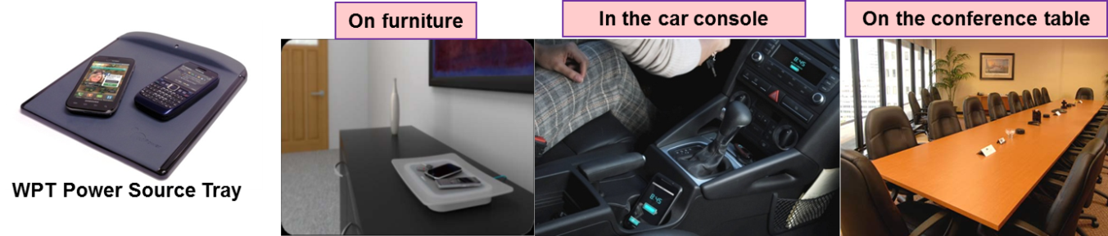
Figure A1.1-1 Flexible-positioning WPT use cases using Loosely Coupled WPT for portable and mobile devices on furniture, car-console, and conference table [16]

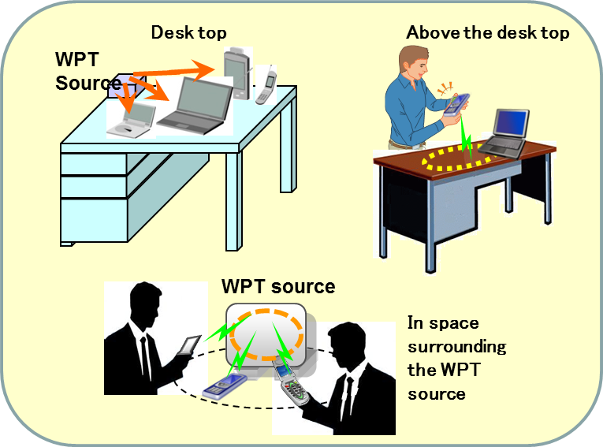
Figure A1.1-2 Flexible-positioning WPT use cases for simultaneous power transmission to multiple mobile devices and multiple types of devices at a distance

A1.2 Capacitive Coupling WPT for potable and mobile devices

The Capacitive Coupling system has already commercialized in Japan and EU in 2011. It’s used by tablet users for business application, for the visitors at the restaurant, and other places. Next target of the Capacitive Coupling system is notebook PC. Below demonstrates an application of the Capacitive Couplingwireless charging system for notebook PC. Transmission power level is about 30W, achieving total efficiency by 75-85%.
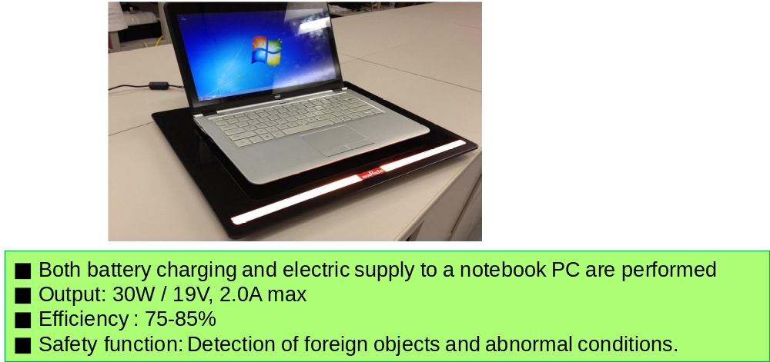

Figure A1.2-1Wireless charger for notebook PC

A1.3 WPT for EV

There is no doubt that EV and PHEV will be accepted, and will be used widely by consumers and businesses. However, charging an EV/PHEV fully by way of a power cable may take an hour or more at a home garage or at a charging stand of parking lot. A concept of WPT for EV and PHEV is to charge a car parking at a garage or a parking lot without a power-cable. It is expected that WPT facilitates acceptance of EV and PHEV.

Typical WPT use cases for EV and PHEV are as follows. The WPT system charges car battery wirelessly while the car is parked in a garage or in a parking lot. Required charging power may depend on the requirement of each user. In most cases for private users in their home garages, 3.3 kW or equivalent power will be acceptable. However, some users may want to charge their cars quickly; and vehicles like buses and trucks may need much bigger power for their business operation, so that20 kW or higher power ranges are also taken into consideration today.

Therefore, use cases may include a lot of varieties including those of individual car owners who have a home WPT garage and of business owners who manage car operation. Energy charged in the car battery will be used for driving, powering in-car devices, air-conditioning, and other on-board electronics.

A few typical use case examples are shown below. Most use cases assume that WPT is used in a short power-transmission distance or air-gap by a range of 10 - 20 cm between the power transmitter on the ground and the power receiver on the vehicle. In addition, there are other researches found in the world. For example, remote charging transmits power to the car via 2 - 3 m air-gap; dynamic power charging transmits power while the car is in motion.

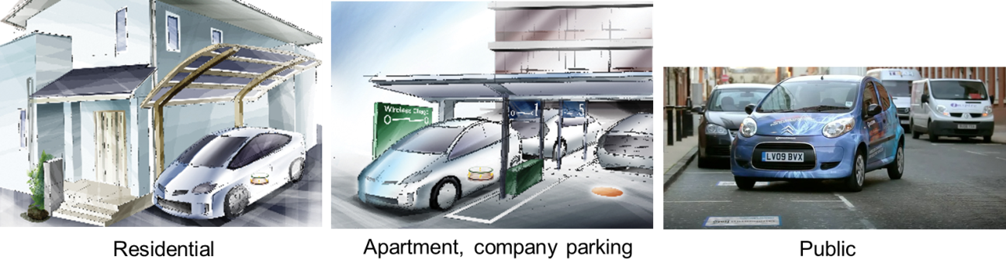
[[18]]

Figure A1.3-1 WPT application examples for EVs/PHEVs

A2. RF exposure assessment methodologies

The BWF WPT-WG released BWF “GUIDELINES FOR THE USE OF WIRELESS POWER TRANSMISSION TECHNOLOGIES Edition 2.0” [11] in April 2013. English version is available to download from the following BWF website.
http://bwf-yrp.net/english/update/2013/10/guidelines-for-the-use-of-wireless-power-transmission-technologies.html

In this document, the following aspects on RF exposure assessment methodologies are provided with detailed excerptions from the regulations and guidelines.

Section 8.3“Considerations for the radio-radiation protection guidelines” in [11] provides guidelines in detail in accordance with the usage scenes defined by the BWF WPT-WG and biological and technical aspects such as WPT frequency ranges to apply. Stimulating effect, heating effect, contact current, and induced current to / in human body tissue are described. In addition, recommended flowcharts for selecting an evaluation methodology and a measurement methodology are also provided since the traditional measurement methodologies may not meet the RF exposure assessment for WPT devices.

Annexes A to G in [11] excerpt domestic and international regulations and guidelines related to RF exposure and safety issues and also explain how to read and use them. In these annexes, Japanese regulations, ICNIRP Guidelines, and IEEE Guidelines are introduced. In addition, some papers recently published in the field of simulation-based SAR assessment are introduced as references.

