

APT REPORT ON

APPLICATIONS AND TECHNOLOGIES FOR INTEROPERABILITY OF MULTIPLE NTN AND TN OPERATING SYSTEMS

Edition: September 2026

The 37th Meeting of APT Wireless Group
7 – 11 September 2026
Dhaka, Bangladesh (Hybrid)

(Source: AWG-37/OUT-20)

No. APT/AWG/REP-165

APT REPORT ON
APPLICATIONS AND TECHNOLOGIES FOR interoperability of multiple NTN AND TN OPERATING SYSTEMS

Table of Contents

1. Introduction 4
2. Scope 6
3. Vocabulary of terms 6
4. Network Architecture Consisting of Multiple Network Operators/Operating Systems 7
4.1. Network architecture layouts for multiple NTN interconnection 8
4.2. Overview of 3GPP network architecture for shared satellite access 11
5. Enabling Technologies for a Network Consisting of Multiple Network Operated by Each Operator/Operating System 15
5.1. Overview of Enabling Technologies 15
5.2. Orchestrations technology for multiple operating systems 16
5.3. Network Sharing 21
5.4. Multi-RAT load-balancing associated with both a Satellite RAN and a Terrestrial RAN 21
5.5. Interworking between NTN and Terrestrial Networks 22
5.6. Mobility Management between NTN and TN 24
5.7. Regulatory and Spectrum Management Considerations for Multi-Operator NTN/TN Systems 24
5.8. Security and Trust Frameworks 25
5.9. Issues not Addressed in this Report 25
6. Use Cases and Potential Benefits 25
6.1. User-side Use Cases 26
6.2. User-side Benefits 27
6.3. Operator-side Use Cases 28
6.4. Operator-side Benefits 29
7. Global Standardization and Country-level Activities 29
7.1. Activities in standardization bodies 29
7.2. Activities in Japan 31
7.2.1 Development of NGSO constellations for multi-layered network and multi operators 31
7.2.2 Development of orchestrator architecture for integrated network control system architecture for the convergence of multiple TN and NTN domains 32
7.3. Activities in China 37
7.4. Activities in Indonesia 39
8. Conclusions 40
Appendix 1: Types and layouts of orchestrators 42

Introduction
In recent years, there have been rapid developments and deployments of Non-Terrestrial Networks (NTN) such as communication satellite constellations, especially the Non-Geostationary Satellite Orbit (NGSO) satellites and possibly Unmanned Aerial Vehicle (UAV) as well as High-Altitude Platform Stations (HAPS). NGSO satellites of low-earth orbits (LEO) provide low-latency, high data rate communications and are smaller, lighter, and lower in cost than Geostationary Satellite Orbit (GSO) satellites, while GSO satellites have a larger communication area coverage and more stable connectivity than NGSO satellites. In addition, technologies for interoperating or integrating Terrestrial Networks (TN) and NTN are being developed rapidly both by research and development communities and standards development organizations such as the International Telecommunication Union (ITU) and the 3rd Generation Partnership Project (3GPP).

By a forming multilayered network by integrating NGSO, GSO satellites, and TN systems, high quality, reliable communication services can be made available not only in cities and developed regions but also in remote, rural, underdeveloped regions. Additionally, dependable communication coverage can be extended to seas, mountains, deserts, air, and outer space. New applications in various fields such as environment monitoring, disaster relief, agriculture, and fisheries are being considered. For example, in the fishery industry, it may be possible to use real-time satellite earth observation data to find suitable locations and times for fishing by connecting multiple NTN systems. While in the disaster relief field, communication requiring end-to-end quality of service (QoS) such as data rate and latency can be realized by integrating TN and NTN domains seamlessly.

It is noted that the term domain has been used in this document to refer to a network segment controlled by a single network operating system. In this document, the term NTN or TN operating system is defined as “a system designed to manage and facilitate the operation of NTN or TN”. It refers to the integrated management and control system responsible for operating a network domain, including resource management, service management, orchestration, and network control functions.

To establish an NTN with NGSO satellite constellations that seamlessly cover the entire globe, a large number of satellites and ground stations are required to be deployed. However, achieving global coverage through a single operator or country is challenging due to the high capital investment required. This challenge highlights the necessity of interconnecting multiple NTN domains together with TN domains, each owned and managed by different operators, to ensure seamless global coverage. In this scenario, integrated control and management of radio resources is indispensable.

While significant progress has been achieved in the standardization and deployment of individual NTN systems, relatively limited attention has been given to the interoperability challenges arising when multiple NTN and TN domains operated by different entities need to cooperate. Such cooperation is expected to become increasingly important as future communication infrastructures evolve toward 6G and beyond, where service continuity, global coverage, resilience, and resource efficiency may depend on the dynamic coordination of heterogeneous NTN and TN domains.

Furthermore, multilayered NTN operating systems, formed by interconnecting satellites orbiting at different altitudes and operated by various operators, require interoperability to function effectively.

Additionally, 6G mobile networks are considered to support seamless mobility between terrestrial radio access networks (RANs) and NTN coverage, even though these networks are owned and managed by different operators. Recognizing this need, terrestrial mobile network operators and satellite-based NTN operators have already initiated collaborative projects to enable seamless roaming across their networks.

Since content and application servers are typically hosted in cloud infrastructures or data networks connected to TN, seamless TN-NTN integration is essential to ensure a full range of application services for end users connected via NTN. To deliver highly reliable and guaranteed quality service, close collaboration among operators is necessary to effectively integrate TN and NTN domains.

Moreover, similar to existing mobile virtual network operators (MVNOs), new or incumbent network service providers — whether TN or NTN operators or third-party entities — may enter the industry to offer end-to-end communication services. These service providers, like MVNOs, would lease the required computing and communication resources from both TN and NTN domains in the form of network slices, enabling them to deliver services to end users who can seamlessly switch between TN and NTN depending on mobility, location, and application requirements. To ensure efficient network operations, communication service providers need to monitor, orchestrate, and manage NTN and TN slices, optimizing their functionalities and resources to configure end-to-end communication paths and service function chains with guaranteed QoS.

Interoperation and integration of multiple NTN and TN operating systems –each with distinct characteristics such as coverage, bandwidth, latency, loss rate, cloud-based functionalities– require new architectures and technologies to establish seamless interconnections. To achieve end-to-end communication with guaranteed QoS, it is essential to develop interoperability technologies for managing multiple NTN operating systems, interoperability solutions for TN-NTN integration, and resource orchestration mechanisms for monitoring and controlling multiple TN and NTN domain resources.

Scope
This APT report aims to provide APT members with insights into the challenges of interoperating multiple NTN and TN domains, and the architectural, functional, and supporting technological advancements required to address them. It outlines potential use-case scenarios involving the integration of multiple NTN or TN domains operated by different network operating systems or operators. The report also highlights the types of information exchange necessary for the interoperation of multiple NTN and TN operating systems.

It is expected that this report would help in promoting collaboration in developing essential NTN and TN interoperability technologies throughout the Asia-Pacific region.

Vocabulary of terms
5GC : 5G Core
5GS : 5G System
AI : Artificial Intelligence
API : Application Program Interface
CAPEX: Capital Expenditure
CDMA : Code Division Multiple Access
CN : Core Network
CU : Central Unit
D2D : Direct-to-Device
DASH : Dynamic Adaptive Streaming over HTTP
DRM : Digital Rights Management
DU : Distributed Unit
FMSC : Fixed, Mobile, and Satellite Convergence
FSS : Fixed Satellite Service
GSO : Geostationary Satellite Orbit
GEO : Geostationary Earth Orbit
GMR : GEO-Mobile Radio
GSM : Global System for Mobile Communications
HAPS : High Altitude Platform Station
HLR : Home Location Register
HSS : Home Subscriber Server
IMS : IP Multimedia Subsystem
INCA : Integrated Network Control Architecture
ISL : Inter Satellite Link
ITU : International Telecommunication Union
ITU-R : ITU Radiocommunication Sector
ITU-T : ITU Telecommunication Standardization Sector
LEO : Low Earth Orbit
LDP : Label Distribution Protocol
LSP : Label Switched Path
MAP : Mobile Application Part
MCC : Mobile Country Code
MEO : Medium Earth Orbit
ML : Machine Learning
MOCN : Multi-Operator Core Network
MPLS : Multiprotocol Label Switching
MSC : Mobile Switching Center
MSS : Mobile Satellite Service
NGSO : Non-Geostationary Satellite Orbit
NNI : Network-Network Interface
NOP : Network Operator
NR : New Radio
NSI : Network Slice Instance
NSMF : Network Slice Management Function
NSSI : Network Slice Subnet Instance
NTN : Non-Terrestrial Networks
OPEX : Operational Expenditure
OSM : Open Source MANO (Management and Network Orchestration)
PLMN : Public Land Mobile Network
QoS : Quality of Service
RAN : Radio Access Network
RAT : Radio Access Technology
REST : Representational State Transfer
RTP : Real-time Transport Protocol
RU : Radio Unit
SDN : Software Defined Network
SDO : Standards Development Organization
SIP : Session initiation Protocol
SLA : Service Level Agreement
SMS : Short Message Service
SMSC : Short Message Service Center
SRI : Satellite Radio Interface
TN : Terrestrial Network
UAV : Unmanned Aerial Vehicle
UDM : Unified Data Management
UE : User Equipment
UNI : User-Network Interface
VLR : Visitor Location Register
VPN : Virtual Private Network

Network Architecture Consisting of Multiple Network Operators/Operating Systems
Non-terrestrial networks (NTN) consist of network components both on the ground segment (such as earth stations gateways and user terminals) and in space segment (such as satellites positioned at different altitudes). Satellites positioned in the geostationary earth orbit (GEO) are seen stationary from ground stations, while satellites stationed in non-geostationary satellite orbits (NGSO) such as medium-earth orbits (MEO) and low-earth orbits (LEO) change their positions continuously with respect to a location on the ground. Even though the ground-to-satellite radio or optical links in the case of GEO satellites are not required to change their endpoint associations, their link quality may change due to environmental conditions. Similarly, in the case of dynamically moving NGSO satellites and time-varying radio links, NTN topologies can be highly dynamic and require adaptation capabilities to maintain a stable network connectivity. This leads to management of increased complexity in NTN operations and controls, especially in terms of mobility, link switching, and radio resource coordination. The complexity can be managed by jointly considering the RAN aspects and core network aspects in an integrated manner.

This view is also reflected in the 3GPP studies. For instance, 3GPP TR 38.821 discusses how scenarios involving satellite-based gNBs, such as those supporting mobility across dynamic satellite links, require tight coordination between RAN-level mechanisms (e.g., beam management, timing alignment) and network-level controls (e.g., routing, session continuity). This point is further supported by TR 38.811, which addresses the RAN challenges arising from dynamically changing topologies, such as those related to mobility management, tracking area configuration, and protocol impacts across the network architecture. Furthermore, 3GPP TR 38.801 highlights the need for network slicing support within the RAN itself, reinforcing that such capabilities must be coordinated across both radio and core domains.

As suggested by these 3GPP studies, such an integrated approach could also be valuable in multi-operator scenarios, where coordination across different operating systems makes the separation of RAN and network aspects even more impractical.

Network architecture layouts for multiple NTN interconnection
For the interconnection of multiple NTN operating systems, the following inter-domain information exchange would be required.
- connectivity and topology information
- resource availability
- QoS status
- spectrum utilization
- SLA parameters
- security credentials
- service requests
- fault notifications

The possible architectural layouts are described below.

Case 1: Interoperability of multiple NGSO constellations operating systems
Multiple NGSO constellations operating systems are interconnected to expand the connectivity and coverage as shown in Figure 1.
FIGURE 1
Layout of network architecture consisting of
multiple NGSO constellation operating systems
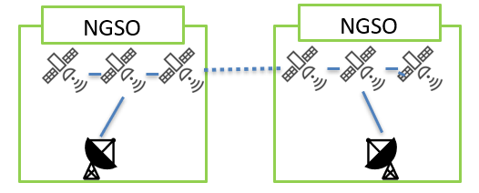
Case 2: Interoperability of a single GSO satellite operating system and multiple NGSO satellites operating systems.
NGSO and GSO operating systems are interconnected to expand the connectivity and coverage as shown in Figure 2.
FIGURE 2
Layout of network architecture consisting of
a single NGSO operating system and a single GSO operating system
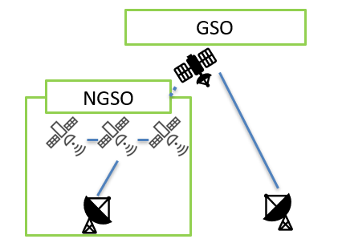
Case 3: Interoperability of multiple NGSO operating systems and multiple GSO operating systems
Multiple NGSO and GSO operating systems are interconnected to expand the connectivity and coverage as shown in Figure 3. It is possible to interconnect the multiple NTN operating systems through NGSO satellites, GSO satellites, or both.
FIGURE 3
Layout of multilayered network architecture consisting of
multiple NGSO operating systems and GSO operating systems
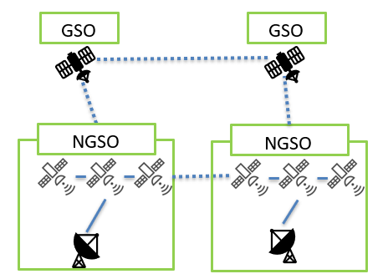
Case 4: Interoperability of multiple NGSO operating systems through a GSO operating system
Multiple NGSO operating systems are interconnected through a GSO operating system as shown in Figure 4. This case is a subset of case 3.
FIGURE 4
Layout of multilayered network architecture consisting of
multiple NGSO operating systems and a GSO operating system
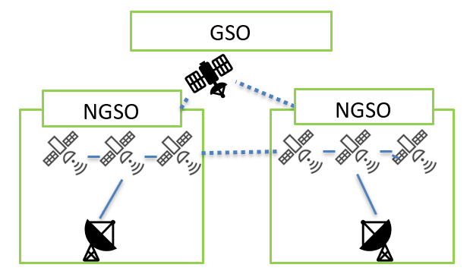

Overview of 3GPP network architecture for shared satellite access
3GPP has considered various possible scenarios for integrating satellite networks into the 5G architecture [TR 23.737]. These scenarios are outlined below.

4.2.1 Shared satellite access between multiple NTN operators/ operating systems
A satellite access network is shared between multiple core networks in a 5G Multi-Operator Core Network (MOCN) sharing architecture. In this case, the shared satellite Radio Access Network broadcasts system information for multiple NTN operators/ operating systems whose core networks are available. These NTN operators/ operating systems may also be with different Mobile Country Codes (MCCs).
FIGURE 8
Multi Operator Core Network sharing architecture with
satellite radio access network architecture (left) and coverage (right)
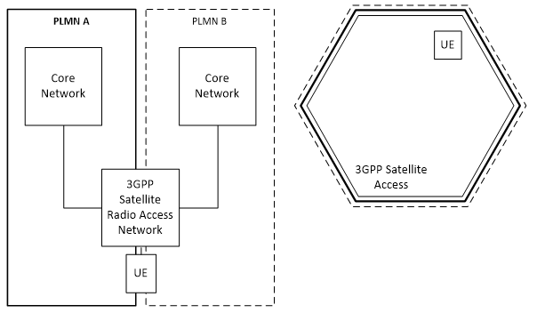

4.2.2 Shared access between multiple TN and NTN operators/operating systems

4.2.2.1 Shared access between multiple TN and NTN within one operator/operating system
One operator/ operating system may have both terrestrial 3GPP access and satellite 3GPP access. In this scenario, separate N2 instances are handling separate access type nodes. However, the coverage of the satellite access network may span over the coverage of the terrestrial access network.

FIGURE 9
Satellite and terrestrial 3GPP access networks within
one operator/operating system - architecture (left) and coverage (right)
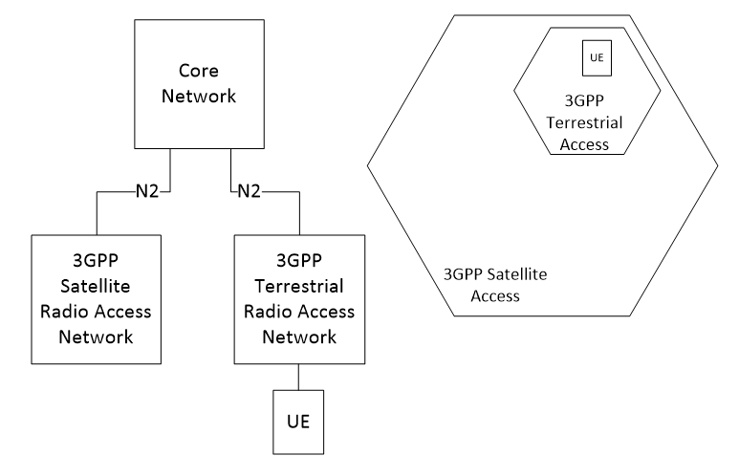

4.2.2.2 Shared access between multiple TN and NTN operators/operating systems
Figure 10 provides an illustration of the shared access network architecture for multiple TN and NTN operators/operating systems.
FIGURE 10
Shared access between multiple TN and NTN
operators/operating systems - architecture (left) and coverage (right)
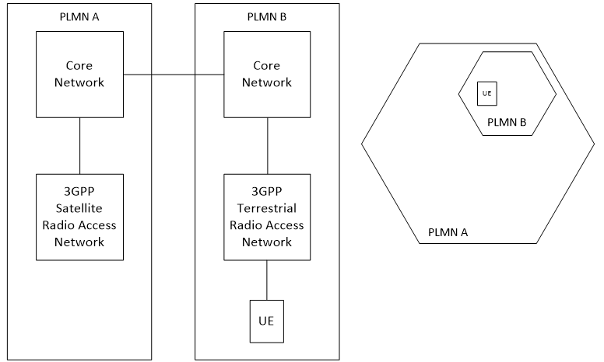

4.2.3 Architecture Models for Satellite Integration in 5G System (5GS)

4.2.3.1 5GS with transparent satellite enabled NR-RAN
In this implementation, the satellite is transparent, the NR signals are generated from gNBs from a satellite enabled NR-RAN that are located on ground. The satellite is equivalent to a Radio Frequency (RF) Remote Unit, and is full transparent to the New Radio protocols, including the physical layer (see below).
FIGURE 11
5GS with Satellite enabled NR-RAN
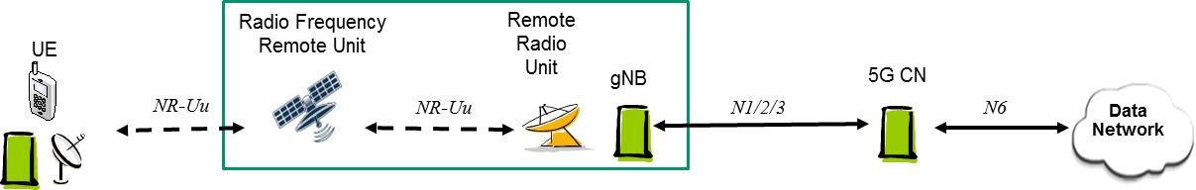

4.2.3.2 5GS with regenerative satellite enabled NR-RAN and distributed gNB
In this implementation, the satellite is regenerative. The satellite payload implements a gNB-DU as part of a satellite enabled NR-RAN. Some of the protocols of the NR are processed by satellites. A Satellite Radio Interface (SRI) transports the F1 protocol between the on-ground CU and the on-board DU (it can be the NR (see below)).
FIGURE 12
5GS with regenerative satellite enabled NR-RAN and distributed gNB
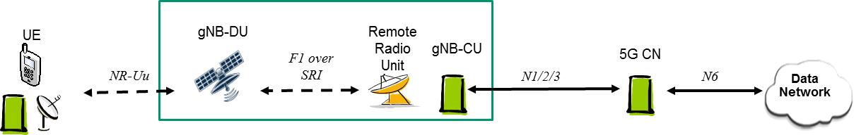

4.2.3.3 5GS with regenerative satellite enabled NR-RAN and on-board gNB
In this implementation, the satellite is regenerative. The satellite payload implements a full gNB supporting a satellite enabled NR-RAN. A Satellite Radio Interface (SRI) transports the N1/N2/N3 interfaces between the on-ground 5G CN and the on-board gNB-CU (see below).
FIGURE 13
5GS with regenerative satellite enabled NR-RAN and on-board gNB
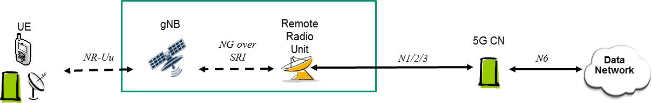

4.2.3.4 5GS with regenerative satellite enabled NR-RAN, with ISL for regional or global coverage
With regenerative implementation (either with distributed gNB or not), a 5GS can have a global coverage, providing a single 5G CN with global or regional (continental or sub-continental) coverage as well. This is valid for GEO or LEO (see below):
FIGURE 14
5GS with regenerative satellite enabled NR-RAN, with ISL for regional or global coverage
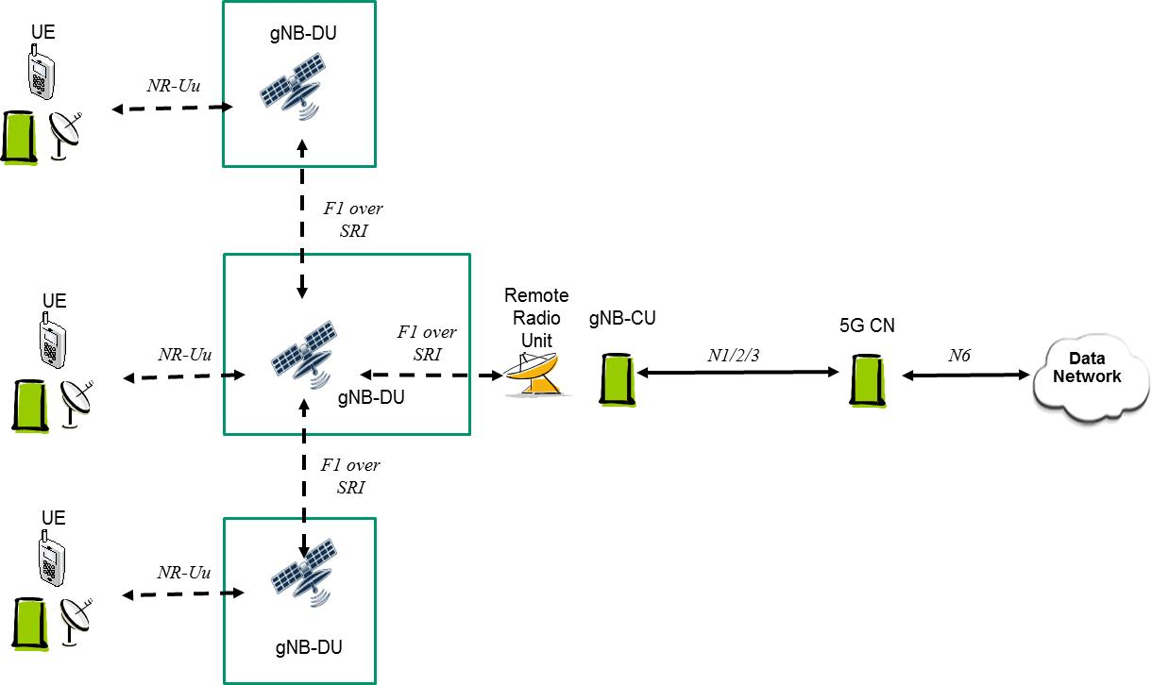

4.2.3.5 5GS with regenerative satellite enabled NR-RAN, with ISL & multiple 5G CN connectivity
Another configuration (see below) may consist in satellites each embarking a gNB supporting a satellite enabled NR-RAN, and 5G CN's accessing these gNBs, as described in the following figure, where specific (or not) satellite radio interfaces are used to handle control and user planes:

FIGURE 15
5GS with regenerative satellite enabled NR-RAN, with ISL & multiple 5G CN connectivity
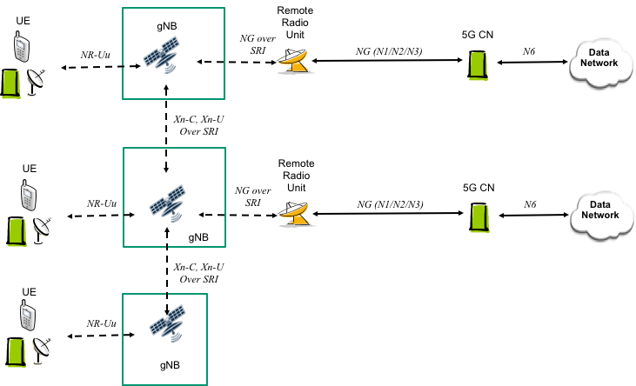

Enabling Technologies for a Network Consisting of Multiple Network Operated by Each Operator/Operating System

Overview of Enabling Technologies

The interoperability of multiple NTN and TN operating systems requires a combination of technologies to support coordination among operators, efficient resource utilization, service continuity, security, and regulatory compliance. The following subsections describe representative enabling technologies for interoperability among multiple NTN and TN operating systems, including:

• Orchestration technologies,
• Network sharing mechanisms,
• Multi-RAT load balancing,
• NTN-TN interworking technologies,
• Mobility management between NTN and TN,
• Regulatory and spectrum management approaches, and
• Security and trust frameworks.

Orchestrations technology for multiple operating systems

5.2.1 Introduction to orchestrator for integrated control of multiple TN and NTN networks
An orchestrator is a centralized control system that plays a crucial role in interoperability, service provisioning, monitoring, and resource control across different NTN and TN operating systems. This view is also reflected in 3GPP studies. For example, 3GPP TS 28.530 introduces the concept of end-to-end slice orchestration across multiple domains such as RAN, core, and slice subnet, as well as across networks of multiple operators. A hierarchical NSI/NSSI model enables cross-domain orchestration and management of communication resources including radio resources.
Figure 16 shows an example of the general layout of orchestrator for the integrated control of multiple TN and NTN operating systems. The orchestrator is connected to each TN and NTN operating system in the control plane. It obtains network control data about network conditions and performance metrics from the TN and NTN operating systems. The network condition can be evaluated by monitoring data of resource availability, allocation and utilization.
FIGURE 16
An example layout of orchestrator for integrated control of multiple TN and NTN operating systems
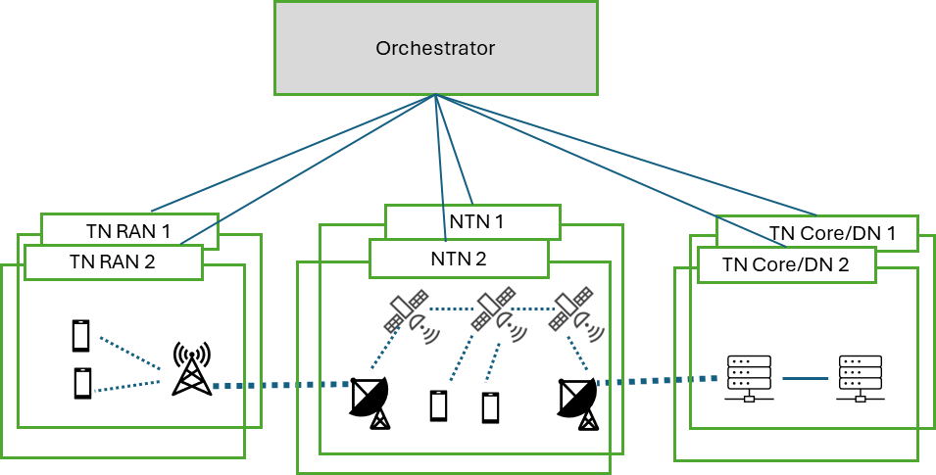
The performance metrics can include the data rate, latency, loss rate, etc. Resource management is challenging in NTN because its spectrum may overlap with the spectrum used in TN RAN. As the orchestrator can collect control data from all the TN and NTN operating system, it can possess the capability to assess the resource availability and utilization in each network and coordinate the resource controller of each of the TN and NTN operating system so that the interference caused to each other can be proactively minimized.

5.2.2.1 Roles of orchestrator
The basic roles of orchestrator are listed below:
- Interoperability: Managing seamless integration of different NTN or TN operating systems.
- Service provisioning and deployment: Ensuring dynamic and on-demand network service provisioning based on user requirements such as quality of service (QoS), virtual private networks (VPNs), and security policies.
- Monitoring: Continuously monitoring network performance and resource utilization, detecting bottlenecks or failures.
- Resource management and optimization: Optimizing traffic flows for better efficiency, allocating and adjusting resources, access and routing control.
- Computing and storage resource orchestration: Coordinating distributed computing and storage resources that may be deployed on future NTN platforms, including support for Earth observation data processing, AI inference workloads, and edge-computing services.

With the inclusion of NTN, more advanced coordination that considers mobility and three-dimensional space becomes necessary as described in Section 5.2.3.

Appendix 1 further elaborates the possible layouts of orchestrators with examples.

5.2.2 Levels of authority
The orchestrator performs orchestration of network operating systems to offer communication services satisfying users’ requirements or to maintain overall network quality while respecting the acceptable level of control and available level of information of each operating system or operator. Under this premise, there can be various levels of authority for the orchestrator; for example, the orchestrator only makes control suggestions, and the final decision is made by each network operating system, or each network operating system follows the orchestrator's instructions, or the orchestrator has more authority only in an emergency.
In addition, the scope of parameters controlled or monitored by the orchestrator can vary; for example, the orchestrator may only coordinate network interconnection points and service deployment times and may not care about the topology or route within each network operating system, or it may control or monitor the topology or routing or even resources of individual network operating systems.

This topic is also addressed in 3GPP. For example, 3GPP TS 28.531 Clause 6 defines management services for network slice and slice subnet provisioning in a way that supports different levels of authority between orchestrators and domain-specific management entities, such as those managing the RAN domain. For instance, the Network Slice Management Function (NSMF) may issue direct provisioning requests to Subnet Slice Management Functions (NSSMFs) using services like AllocateNssi or ModifyNssi. However, depending on the deployment, NSSMFs may retain autonomy and make local decisions, or expose only limited information and allow only indirect orchestration. This reflects a flexible orchestration model that accommodates varying levels of control and observability across domains or operators.

5.2.3 Orchestration in multiple operating systems including NTN
NTN has several distinctive challenges compared to TN, including dynamic topology and mobility patterns, varying communication link quality due to environmental conditions, limited energy resources, cross-operator interoperability, and diverse regulatory constraints.
As a result, the NTN orchestrator must perform a broader range of functions, including:
- Interoperability of link establishment procedure: Involves ensuring compatibility of RAN protocols and procedures for link setup, including signaling formats and timing, as well as satisfying link quality thresholds such as minimum signal strength.
- Mobility Management: Dynamic routing or determination of time-varying network-network interface (NNI), which refers to the interconnection point between separate operating systems. The following challenges may arise, for example:
When establishing a link, it is necessary to have prior knowledge of the counterpart or potential counterparts (e.g., their location and identifiers), and how this information is exchanged poses a challenge.
Orbit prediction capabilities and routing control based on those predictions are required.
There will be demands for higher orbit prediction accuracy and precise time synchronization.
Handover processes become more complex.
Due to variations in inter-/intra-topology and environmental conditions, communication quality may fluctuate, making SLA alignment difficult.
- Consistency of traffic policies: Covers comprehensive end-to-end traffic management, including bandwidth and total latency, for multi-hop wireless paths.
- Satellite Resource Allocation: Dynamic managing spectrum and satellite beam resources. NTN orchestrators have to consider wide areas to manage their spectrum and satellite beams.
- Energy Efficiency: Managing power consumption for sustainable NTN operations. Different from TN, NTN has significant power constraints.
- Legal frameworks and licensing: Subject to regulatory restrictions specific to each country.

5.2.4 NTN orchestrator routing technologies for multiple operating systems
The deployment of mega-constellations consisting of hundreds to thousands of Low Earth Orbit (LEO) satellites is accelerating. Leading initiatives such as Starlink, OneWeb, Kuiper, alongside national and private efforts, are driving this trend.

With the growth of LEO satellite constellations, as shown in Figure 17, some systems necessitate an evolution of routing technologies to ensure robust and fast inter-satellite and/or satellite-to-ground communications.

FIGURE 17
Satellite constellations consisting of many LEO satellites
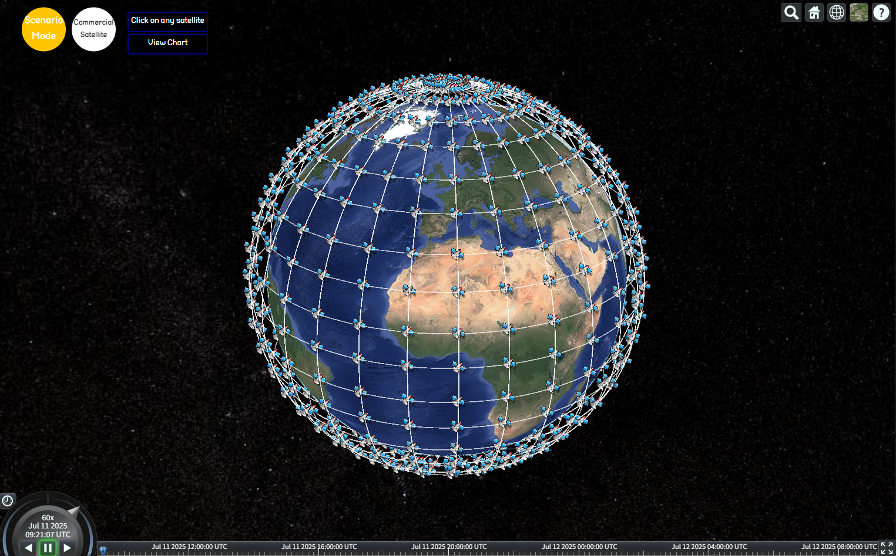

The following strategic requirements must be addressed for efficient routing in LEO satellite networks:
- Efficient traffic distribution and route configuration among a large number of satellite nodes
- Dynamic path selection based on delay and link quality
- Quality of Service (QoS) assurance
- Seamless integration with terrestrial gateways and backbone networks

5.2.4.1 IP Routing Technology for NTN
When applying conventional IP-based routing to LEO satellite networks, some satellites operate as IP routers forming a unified IP network through inter-satellite links and connections with terrestrial stations. Each satellite maintains routing tables and determines optimal paths based on link conditions, propagation delay, and distance.

Applicable IP routing protocols include link-state-based OSPF (Open Shortest Path First) and hybrid protocols such as EIGRP (Enhanced Interior Gateway Routing Protocol). These require pre-acquisition of link state information among satellites for effective routing.

However, LEO satellite networks have distinct characteristics compared to terrestrial networks. LEO satellites move at high velocity along orbital paths, causing network topology to change frequently in short intervals. Therefore, applying IP routing in such a dynamic environment introduces several limitations:
- Routing Speed Limitations: Frequent changes in connectivity necessitate continuous recalculation of routing paths, which traditional IP routing cannot accommodate in real time.
- Scalability Issues: The maintenance of routing tables becomes unmanageable at the scale of thousands of satellites.

5.2.4.2 Multiprotocol Label Switching (MPLS)-Based Routing Technology for NTN
IP-based routing offers strong stability and broad compatibility. However, it faces limitations when applied to the rapidly changing topology of LEO satellite networks. Therefore, a new approach such as MPLS-based routing is required to address these challenges.

MPLS determines packet forwarding paths based on fixed labels rather than IP addresses. This allows routers (satellites) to forward packets efficiently using label lookup rather than IP header analysis. Label Switched Paths (LSPs) can be pre-defined or dynamically calculated making MPLS suitable for rapidly changing topologies such as LEO satellite networks.

Key benefits of MPLS in LEO environments include:
- Fast Packet Forwarding: Label-based switching reduces processing overhead, enabling efficient packet forwarding even in resource-constrained satellite hardware.
- Traffic Engineering Capability: LSPs can be configured to reflect link congestion, delay, and priority requirements, allowing for optimized route selection.
- Integration with SDN Orchestrators: MPLS can be integrated with SDN to enable real-time visibility of the entire LEO topology and dynamically adjust Label Switched Paths (LSPs) accordingly.

5.2.4.3 Challenges and Future Work for NTN Routing
Several technical considerations must be addressed for effective MPLS deployment in LEO satellite networks:
- Advanced Label Distribution Protocols: Consistency in label mapping across MPLS routers requires enhanced LDP mechanisms.
- High Cost of LSP Reconfiguration: Frequent topology changes in LEO may lead to excessive overhead in recalculating and distributing LSPs.

5.2.5 Other technologies supporting orchestration
- Digital-twin technologies: Digital-twin technologies may further support orchestration by maintaining synchronized virtual representations of NTN and TN domains, enabling predictive resource management and proactive fault mitigation.

- NTN AI-Assisted Orchestration: Given the highly dynamic nature of NTN topologies and traffic patterns, artificial intelligence and machine learning techniques may assist orchestrators in predicting congestion, estimating link availability, forecasting satellite visibility windows, and optimizing resource allocation. AI-enabled orchestration can improve routing efficiency, handover preparation, spectrum utilization, and service continuity across multiple NTN and TN domains.

Network Sharing
A network sharing architecture shall allow multiple participating operators to share resources of a single shared network according to agreed allocation schemes. The shared network includes a radio access network. The shared resources include radio resources.
The shared network operator allocates shared resources to the participating operators based on their planned and current needs and according to service level agreements.
The 5G Multi-Operator Core Network (5G MOCN) network sharing architecture, in which only the RAN is shared in 5G System, is supported. The 5G System may also support Indirect Network Sharing deployment between hosting operator (i.e. shared network operator) and participating operator, in which the RAN is shared. The communication between the shared RAN and the core network of the participating operator is routed through the core network of the hosting operator that connects to the shared RAN.
FIGURE 18
A 5G Multi-Operator Core Network (5G MOCN) in which multiple CNs are
connected to the same NG-RAN
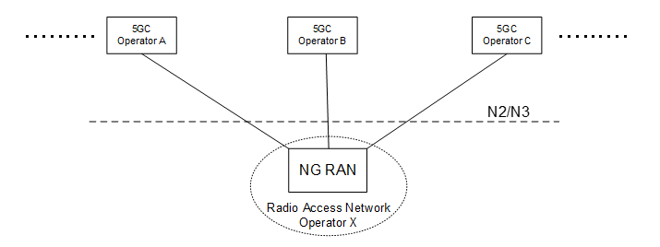

Multi-RAT load-balancing associated with both a Satellite RAN and a Terrestrial RAN
A network operator (NOP) wants to optimize radio resource of multi-RATs by supporting load-balancing between satellite RANs and terrestrial RANs. The Satellite RAN and Terrestrial RAN are simultaneously connected to the 5GC.
A NOP provides the following capabilities: radio resource management and traffic flow control in RAN, multi-RAT resource control in 5GC, and multi-RAT resource management in 3GPP Management.

FIGURE 19
Capabilities for Multi-RATs load-balancing for Satellite and terrestrial RANs
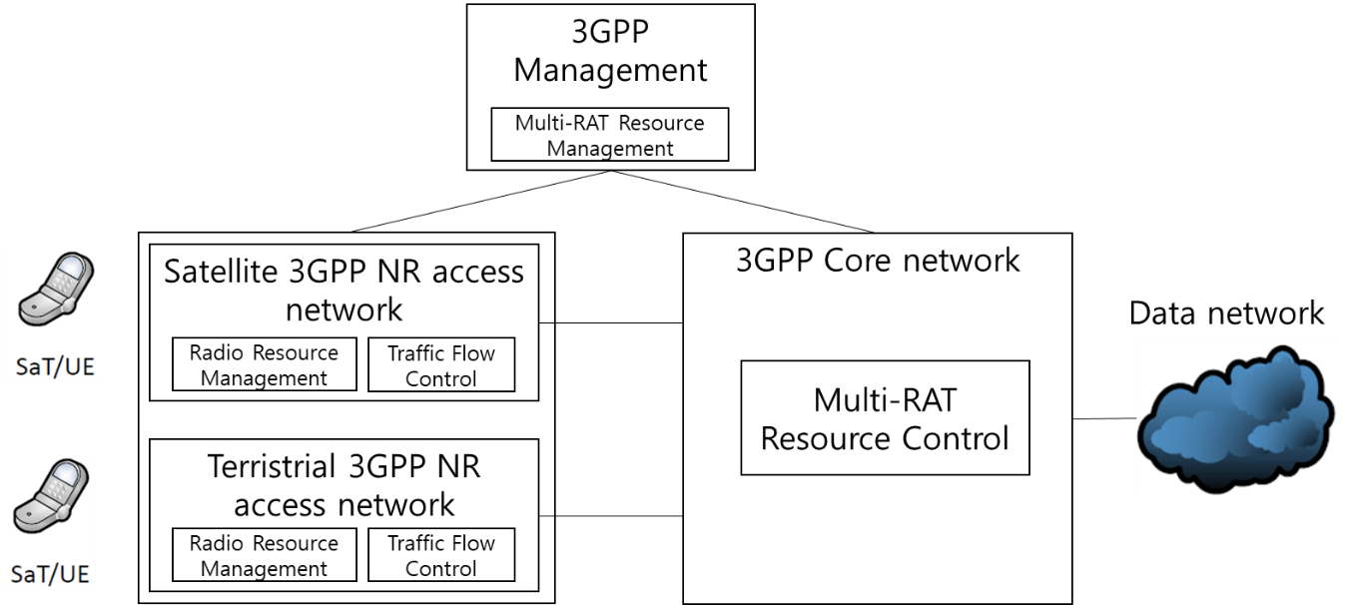

Both satellite and terrestrial 3GPP NR RANs have capabilities of its own radio resource management (e.g., dynamic selection of the appropriate radio bearers) and traffic flow control which dynamically decides, for each in progress connection, the traffic bit rates that have to be managed by each cell of the gNB. The 5GC has multi-RATs resource control capability which performs optimal load-balancing control of multi-RATs. 3GPP Management includes multi-RAT resource management capability which coordinates with multi-RAT resource control capability in 5GC for optimal multi-RAT load-balancing.

There are two possible solutions for multi-RAT load-balancing associated with both a Satellite RAN and a Terrestrial RAN:
- Switch traffic from currently active RAT to another RAT
- Split traffic into two RATs

The multi-RAT resource control module decides traffic switching or splitting load-balancing policy based on the reports received from satellite and terrestrial gNBs and performance measurement data in the core network.

Interworking between NTN and Terrestrial Networks
According to 3GPP TS 22.261, for 5G systems with satellite access:
- The 5G system shall support service continuity between 5G terrestrial access network and 5G satellite access networks owned by the same operator or owned by 2 different operators having an agreement.

FIGURE 20
Typical example of NTN-TN interworking
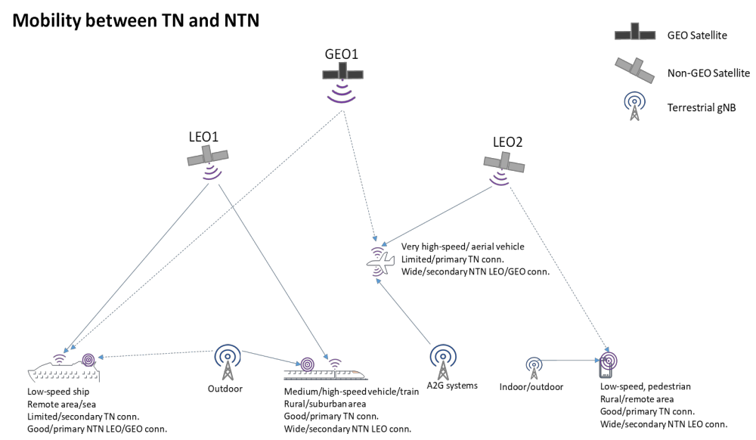

NTN and TN may use different frequency bands (e.g., FR1 vs FR2). The reference scenarios described in 3GPP TR 38.821 cover two types of NTN UEs: a) with omnidirectional antennas and b) with directive antennas. The table below outlines UE characteristics relevant to NTN-TN service continuity.

TABLE 1
NTN use cases mapped to TN-NTN service continuity use cases and
assumptions for frequency band and UE characteristics
NTN Use case | NTN-TN service continuity use case | Assumptions for UE characteristics
Stationary UE (eMBB) Pedestrian UE (eMBB)  Machine UE (mMTC) | Medium/high throughput – TN or NTN (LEO)  Low to medium throughput NTN (GEO) | The UE is assumed to have TN and NTN connectivity capabilities.  The UE has omni-directional antenna type applicable to both TN and NTN connectivity.  The NTN access may operate in frequency bands below or above 6 GHz (NTN bands including n248, n255, n256, etc, and extensions, as specified in TS 38.101‑5 and TS 38.104.)
Stationary/Vehicular relay UE (eMBB)  (Relay UE on vehicles or ships  Relay UE on high speed trains  Relay UE on board airplanes)  CPE | Medium/high throughput – TN or NTN (LEO)  Medium/high throughput NTN (GEO) | The relay UE is assumed to have TN and NTN connectivity capabilities and provides service to the TN only capable UEs outdoor or inside buildings, vehicle or train/airplane, respectively.  The vehicular relay UE can have different antenna types for TN and NTN connectivity.  The NTN access may operate in frequency bands below or above 6 GHz (NTN bands including n248, n255, n256, etc, and extensions, as specified in TS 38.101‑5 and TS 38.104)

Mobility Management between NTN and TN
UE supports mobility between NTN and Terrestrial Network (i.e. from NTN to Terrestrial Network (hand-in) and from Terrestrial Network to NTN (hand-out)), but it is not required to connect to both NTN and Terrestrial Network at the same time. It may also support mobility between radio access technologies based on different orbit (GSO, non-GSO at different altitude).
Furthermore, mobility management enhancements have been introduced to ensure service continuity covers inter-satellite, inter-gNB, inter-RAT.
Based on Recommendation ITU-R M.2177 on specifications for the satellite radio interfaces of IMT-2020, for the NTN to TN mobility, the Non-Terrestrial Network may broadcast NR and EUTRA TN cell coverage areas and cell information in the new System Information Block (SIB) 25. The coverage information consists in a list of geographical TN areas, with associated frequency information. UE can reduce its power consumption by skipping TN measurement based on the TN coverage information.
For the TN to NTN mobility, the TN cell can broadcast NTN neighbour satellites ephemeris via SIB 19. The UE can use ephemeris to connect to the NTN.

Regulatory and Spectrum Management Considerations for Multi-Operator NTN/TN Systems
The integration and interoperation of multiple NTN and TN operating systems across different operators and jurisdictions introduce a number of regulatory and spectrum management considerations. Addressing these aspects would support the effective deployment and operation of such systems in the Asia-Pacific region.

a. Cross-border coordination
Multi-operator NTN systems inherently involve cross-border service provision and global or regional coverage. Key considerations include:
- facilitating coordination between administrations in accordance with ITU Radio Regulations;
- establishing mechanisms for information exchange between relevant stakeholders;
- promoting regional cooperation to support seamless service continuity across borders.

b. Licensing considerations
The deployment of multi-operator NTN/TN systems may require flexible and scalable licensing approaches. These include:
- adopting different licensing regimes for space segment, gateway earth stations, and user terminals;
- implementing simplified or scalable licensing mechanisms to support large-scale deployment;
- facilitating market access for multiple operators while ensuring compliance with national regulations.

c. Interference management
The complexity of multi-layered and multi-operator networks may increase the risk of interference between systems. Relevant aspects include:
- establishing appropriate regulatory measures to prevent harmful interference;
- implementing monitoring and enforcement mechanisms;
- encouraging coordination and information exchange among operators.

d. Data governance and security
The interconnection of multiple NTN and TN domains involves the exchange of data across networks and jurisdictions.
- addressing data protection and privacy requirements;
- ensuring cybersecurity of interconnected systems;
considering lawful interception and national security requirements in accordance with applicable regulations.

Security and Trust Frameworks
Interoperability among multiple NTN and TN operating systems requires secure inter-domain trust relationships. Key considerations include:
- Federated identity management;
- Cross-domain authentication and authorization;
- Secure exchange of orchestration data;
- Protection of network slice resources;
- Supply-chain security;
- Quantum-resistant cryptography for long-life satellite systems.

Issues not Addressed in this Report
Potential areas for future study include:
• Inter-domain resource orchestration interfaces,
• NTN/TN network slicing,
• AI-assisted wireless resource management,
• Direct-to-device roaming,
• NTN-TN spectrum joint management, and
• Multi-orbit connectivity establishment and maintenance.

The above list which may be addressed in future reports, is indicated as examples and not as recommendations. In addition, items outside the scope of the Report, in particular on spectrum coexistence between NTN and TN, should not be considered.

Use Cases and Potential Benefits
The integration and interoperation of multiple NTN and TN operating systems enable various applications by leveraging the complementary characteristics of different network domains.
Such applications benefit from the combined capabilities of NTN systems, including wide-area coverage and flexibility, and TN systems, including high capacity and low latency in dense areas. Representative application areas include:
- Provision of connectivity in underserved and remote areas, where NTN systems complement terrestrial infrastructure to extend network coverage;
- Disaster recovery and emergency communications, where NTN systems provide resilient and rapidly deployable connectivity when terrestrial networks are unavailable or disrupted;
- Support for mobility scenarios, including maritime, aeronautical, and land transportation, where seamless connectivity can be maintained across different network domains;
- Internet of Things (IoT) and environmental monitoring, enabling connectivity for devices deployed in remote or hard-to-reach locations;
- Direct-to-device connectivity, supporting emerging use cases where user equipment can connect directly to NTN systems;
- Applications requiring reliable end-to-end performance, where coordination between NTN and TN systems can enhance service continuity and quality of service.
These applications illustrate the potential of multi-operator NTN and TN systems to support diverse communication needs across the Asia-Pacific region.
In this section, use cases and potential benefits enabled by the interoperation of multiple NTN operating systems are described. These operating systems may be managed by a single operator or by multiple operators, depending on deployment scenarios. The benefits and use cases can be categorized into user-side and operator-side groups as described below.

User-side Use Cases
The representative user-side use cases and their requirements are listed below:
- Accelerated Downlink for Earth Observation Data
By routing imaging data through multiple NTN systems to the nearest ground station, data delivery time can be minimized. This dynamic path selection overcomes visibility constraints faced due to a single operating system connectivity.
Requirements: This use case requires that the orbit and visibility information exchanged, and the features of bandwidth reservation, integrity verification, and priority control are available.
- Automatic Failover for Disaster Recovery
When terrestrial networks fail, satellite-based paths are automatically reconfigured to maintain emergency communications when the Earth's surface is hit by disasters.
Requirements: This use case requires that there would exist predefined backup paths, reserved capacity, fallback mechanisms, and priority-based traffic control.
- Optimized Video Streaming and Cloud Access
The availability of multiple NTN integrated systems for communications ensures low latency and high-data rate streaming without user intervention.
Requirements: This use case requires that the mechanisms of dynamic path switching based on delay and jitter, edge caching, and secure DRM continuity are available.
- Seamless NTN/TN Handover for Mobility
Connected vehicles, ships, and UAVs switch their communication links seamlessly between terrestrial and satellite networks, enabling continuous position tracking and control.
Requirements: This use case requires mechanisms for coordinated positioning and communication, session continuity during handover, and power optimization.

- Smart Agriculture and Fisheries
Multiple NTN integrated systems support the use-case of wide-area IoT data collection for crop monitoring and marine resource management, integrated with weather and environmental analytics.
Requirements: This use case requires low-power wide-area connectivity, data aggregation, and spectrum compliance.
- Aviation and Maritime Communications
Multiple NTN integrated systems support real-time weather updates, safety-critical messaging, and operational monitoring during flights and voyages.
Requirements: This use case requires continuous coverage, prioritized safety traffic, and interoperability across international boundaries.
- Space Exploration and Lunar Communications
Multiple NTN integrated systems can provide delay-based communication for lunar missions and deep-space exploration, integrated with terrestrial cloud for scientific data processing.
Requirements: This use case requires delay-tolerant protocols, visibility window management, and long-term resource allocation.

User-side Benefits
The integration of multiple NTN and TN domains provides end users with the benefits that are difficult to achieve through a single system. The benefits are listed below.
- Seamless Global Connectivity
NTN–TN integrated networks enable continuous connectivity without geographical limitations. Reliable communication can be maintained in areas where conventional networks are unavailable or unstable, such as oceans, mountainous regions, air routes, and even space.
- High Reliability and Quality of Service (QoS)
Leveraging redundant paths and multi-layer connectivity between LEO, GEO, and TN domains ensures user requirements for low-latency, high-throughput, and reliability. Multi-path routing enables uninterrupted communication not only during congestion but also in disasters.
- Enhanced Application Experience
TN-NTN integrated networks can support mission-critical, real-time services, which are not yet offered by conventional network operators. A few examples of these services are as follows:
  - Real-time sharing of large-scale Earth observation and environmental monitoring data.
  - Low-latency control for autonomous vehicles, drones, and vessels connected to heterogeneous networks.
  - Access to existing terrestrial as well as newly emerging non-terrestrial cloud and edge services for satellite users, ensuring equivalent digital experiences such as video streaming and cloud applications.
- Cost Efficiency and Convenience
It enables the dynamic selection of optimal paths based on performance and cost and allows users to access services through unified interfaces without being locked to a single operator.
- Security and Privacy
Common authentication and encryption frameworks for both TN and NTN domains will ensure confidentiality and integrity of user data across multiple operators. Zero-trust principles and slice isolation mitigate risks during inter-domain transitions.
- Resilience and Service Continuity
It will support failover mechanisms, dynamic path reconfiguration, and store-and-forward capabilities to maintain service continuity in case of failures across terminals, gateways, or satellites.

Operator-side Use Cases
The representative operator-side use cases and their requirements are listed below:
- LEO–GEO Interconnection for Transitional Service Deployment
GEO systems can complement incomplete LEO coverage, enabling early global service deployment.
Requirements: Interconnection mechanisms among multiple NTN operating systems, including the exchange of coverage information, service availability, and basic performance indicators, as well as coordination of routing and service continuity policies.
- Joint NTN/TN Network Slice Provisioning
Cross-domain resource coordination across NTN and TN operating systems supports industrial IoT, mobility, and media services with guaranteed QoS.
Requirements: Common service definitions and slice abstraction models across multiple operating systems, interfaces for exchanging resource availability and service requirements, and mechanisms for end-to-end QoS monitoring and lifecycle management.
- Extended International Roaming
Integrated NTN systems enable seamless roaming across multiple PLMNs and operating systems with appropriate access selection and location verification.
Requirements: Interoperable authentication, authorization, and accounting mechanisms, consistent subscriber profile management, and compliance with regulatory requirements across national boundaries.
- Commercial Spectrum Sharing and Interference Coordination
Integrated NTN systems facilitate the exchange of interference metrics and cooperative coordination mechanisms for adjacent-band or partial spectrum sharing.
Requirements: Exchange of spectrum usage information, interference indicators, protection criteria, and coordination mechanisms for dynamic spectrum allocation and beam management.
- Federated Edge and Cloud Integration
Collaborative edge computing and caching across multiple operating systems reduce latency for global applications.
Requirements: Interoperable cloud and edge management frameworks, workload placement mechanisms, data synchronization, and interfaces for sharing resource status and performance metrics.
- Emergency Restoration as a Service
NTN-based backhaul enables rapid service restoration during submarine cable outages or large-scale terrestrial failures.
Requirements: Pre-established coordination policies or agreements among participating operating systems, priority control mechanisms, reserved capacity, and rapid service activation capabilities.

Operator-side Benefits
- Efficient Global Coverage Expansion
Global connectivity can be achieved by interconnecting multiple operating systems, enabling phased service deployment even with partial LEO or GEO coverage.
- Resource Optimization and Cost Reduction
Traffic offloading across domains balances utilization and reduces CAPEX/OPEX through shared communication, computing, and storage resources.
- New Business Models
The operators can realize new business models based on the federation-based services and cross-domain network slicing enabling joint-provision of end-to-end QoS-guaranteed services globally.
- Operational Automation and Intelligence
The existence of standardized multi-domain interfaces facilitate automated route optimization, fault detection, and QoS adjustments across operators.
- Interference Mitigation and Spectrum Sharing
The coordinated beamforming, dynamic channel allocation, guard-band design, and protection ratio management reduce interference between NTN and TN systems.
- Security and Trust Frameworks
Cross-operator authentication, key management, audit logging, and slice isolation ensure secure interconnection. Compliance with international regulations is maintained for cross-border data flows.
- Resilience and Business Continuity
Multi-path routing, rapid failover, backup gateways, and caching mechanisms ensure service continuity during equipment failures or natural disasters.

Global Standardization and Country-level Activities

Activities in standardization bodies
The rapid progress in research, innovation, and standardization is accelerating the convergence of TN and NTN. Based on the challenges and enabling technologies discussed in the previous sections, the following potential standardization needs can be identified:

- Multi-operator orchestration APIs
- Cross-domain telemetry exchange
- Inter-orchestrator protocols
- NTN-TN slice federation
- Cross-domain security frameworks
- Inter-operator service assurance

Several key standardization bodies, including ITU and 3GPP, are actively working on developing standards to ensure interoperability and seamless user connectivity.
At the international regulatory and spectrum management level, the ITU‑R is conducting a broad range of technical and regulatory studies in preparation for the World Radiocommunication Conference 2027 (WRC‑27). Several agenda items directly address the evolution of satellite communications and their interaction with terrestrial mobile networks.

Key study areas include regulatory conditions for earth stations in motion operating in the Q/V bands, revised sharing conditions to enable small‑antenna fixed‑satellite service (FSS) uplinks in the Ku band, and the identification of new gateway link spectrum around 52 GHz for non‑geostationary orbit (NGSO) FSS systems.

In addition, under the WRC‑27 agenda items, new or expanded frequency allocations for FSS, broadcasting‑satellite service (BSS), and mobile‑satellite service (MSS), are being considered, such as additional allocations around 17 GHz, spectrum for low‑data‑rate NGSO MSS systems, and further MSS allocations to support future mobile satellite applications.

Report ITU-R M.2516, approved in November 2022, provides a broad view of future technical aspects of terrestrial IMT systems considering the time frame up to 2030 and beyond. This report also provides technologies for interconnection with non-terrestrial networks. The interconnection of terrestrial IMT and non-terrestrial communications aims to expand future terrestrial IMT technology to support seamless interconnectivity with non-terrestrial networks (NTN), including satellite communications, High altitude platform stations as IMT BSs (HIBS) and UASs as IMT BS platform, commonly referred to as drones and a type of aircraft without a human pilot on board.

ITU-R WP4B is currently working on the development of preliminary draft new report on development and technology trends for the satellite component of IMT towards 2030 and beyond. These technology trends in the preliminary draft new report address key challenges, such as reducing latency, improving energy efficiency, and ensuring seamless integration with terrestrial networks. The satellite and terrestrial network components can be interconnected to offer diverse communication access modes. The interconnected satellite network and terrestrial network may rely on a multi-operator core network/hybrid access network sharing model, enabling multiple core networks to share a hybrid access network based on terrestrial and satellite components.
In parallel with these ITU‑R activities, 3GPP is developing detailed technical specifications to integrate NTN into 5G systems.

Since Release 15, 3GPP has been exploring the issues of TN-NTN integration, describing deployment scenarios, service needs, propagation models, and satellite and UAV/HAPS system parameters. In Release 16, TR 23.737 introduced architectural insights into satellite access integration, while TR 28.808 discussed management and orchestration considerations. TR 23.737 analyzed core network and radio access challenges, suggesting procedural solutions, whereas TR 28.808 proposed a reference architecture for network and service management.

Starting from Release 17, 3GPP has planned to formulate normative specifications to integrate NTN into 5G, including support for new radio (NR) and narrowband IoT (NB-IoT). Upcoming releases are expected to enhance direct satellite connectivity for smartphones, refine public land mobile network (PLMN) selection through user equipment (UE) location verification (an enhancement of TR 24.821), and improve non-continuous coverage in sparse satellite constellations and satellite-based backhauling.

Together, the activities of ITU‑R and 3GPP demonstrate a coordinated evolution of global regulatory frameworks and detailed technical standards. This alignment is essential to ensure that future NTN deployments can be efficiently integrated with terrestrial mobile networks while maintaining effective spectrum sharing and robust interference protection across services.

Activities in Japan

Development of NGSO constellations for multi-layered network and multi operators
As introduced briefly in a report on multilayered network access [1], the project members in Japan continues to develop an experimental NGSO constellation system named LAIDEN (LAser Inter-satellite DEmonstration Network) with optical satellite links which realizes communication across multiple NTN operators including GSO satellite operators. In this system, the project members are developing an orchestrator that coordinate the routes that pass through multiple NTN operators. This mechanism is expected to maintain service availability even when the number of NGSO satellites is limited. The project also involves the development of optical inter-satellite and satellite-to-ground link technologies, as well as small- and medium-sized satellites.
FIGURE 21
Configuration of the Demonstration Experiment of LAIDEN

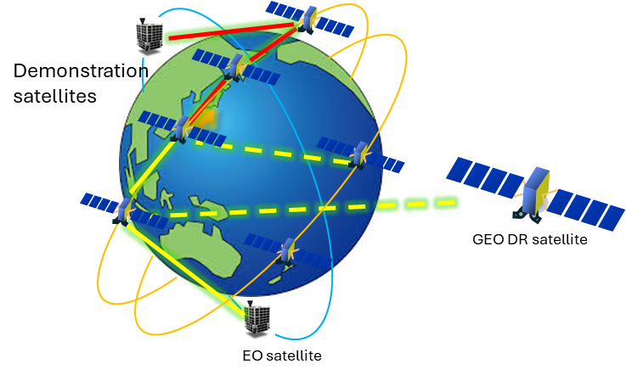

The system assumes a reservation-based service model. At the time of reservation, the orchestrator estimates feasible end-to-end paths across multiple NTN operators and coordinates with the involved operators to determine the NNI and UNI connection endpoints (i.e., the specific satellite interfaces to be interconnected) and timing in advance, thereby committing service availability. Because optical inter-satellite communications inherently require precise coordination of timing synchronization for link acquisition, the orchestrator additionally performs adjustment of connection timing between reservation and actual communication execution, taking into account non-negligible orbit prediction errors.

Envisioned use cases include the downloading of data from Earth observation satellites and the use of NTN as a backhaul route for critical communications in the event of submarine cable failures. Development items of the orchestrator include identifying the functions of the orchestrator, organizing the information that needs to be shared to establish links among operators such as satellite orbits and available wavelength, and extracting the requirements for individual operators such as network participation criteria. Based on these considerations, control messages and sequences between the orchestrator and each operator’s network control system are being defined and implemented. Demonstration experiments, including functional validation of the orchestrator, are scheduled to be conducted following the launch of several demonstration satellites planned for fiscal year 2027 or later.
After the completion of this project, the goal is to transition to operational services.

Development of orchestrator architecture for integrated network control system architecture for the convergence of multiple TN and NTN domains
In Japan, the research and development of an orchestrator system for the integrated control of resources of multiple NTN and TN operating systems has been progressing. The orchestrator system is equipped with functions to monitor the available and utilized resources such as spectrums of the NTN and TN networks and to dynamically control (i.e., adjust the amount of radio) resources so that the communication service requirements and reliable quality of service can be offered to users all the time.

Figures 22 (a) and (b) show the layouts of an orchestrator system controlling the multiple NTN and TN operating systems. Figure 21 (a) shows the layout of NTN system existing as backhaul links to extend TN RAN to distant or remote locations such as seas, islands, airspace and mountainous regions. Figure 21 (b) shows an alternate layout of the NTN system equipped with the capability of direct to devices that can provide connectivity to user devices. In this case, TN RAN and NTN coverages can be available either in a spatially overlapping manner within the same geographic areas or in a spatially disjoint manner across different areas.

Each NTN and TN domain is assumed to have its own local controller (CTRL), whose functions are orchestrated by the orchestrator. Key functions of the orchestrator are to collect control data from the individual NTN and TN domains, make decisions to control their resources in a coordinated manner, and disseminate the control decisions, in terms of control commands and parameters, to the individual controller of the multiple NTN and TN domains. The control data consists of parameters about the resources such as available resources, allocated resources and utilization, and performance metrics such as throughput, latency, and loss rate.

Although only one NTN operating system or domain has been shown in the figures, the orchestrator is capability of monitoring and controlling resources of multiple NTN segments. This capability covers scenarios of multiple NTN segments, including LEO and GEO satellite constellations, being rapidly deployed by different organizations. These NTN systems differ in orbital characteristics, coverage patterns, performance capabilities, and availability times. An NTN system that partially covers the globe deployed by a single organization alone may not be sufficient to always provide end-to-end quality services. As such heterogeneous NTN systems get deployed extensively, it becomes necessary to integrate NTN systems operated by different organizations so that end-to-end network services can be supported by interconnecting multiple NTN segments. In this scenario, network service operators are required to possess the orchestrator that has the capability to dynamically select the optimal NTN segment available at a given moment and geographical location, considering relevant commercial agreements. To achieve this, NTN segments are required to be interconnected and interoperable, enabling seamless transition, load balancing, and redundancy across diverse space-based infrastructures.

FIGURE 22
Layout of orchestrator controlling multiple NTN and TN operating systems
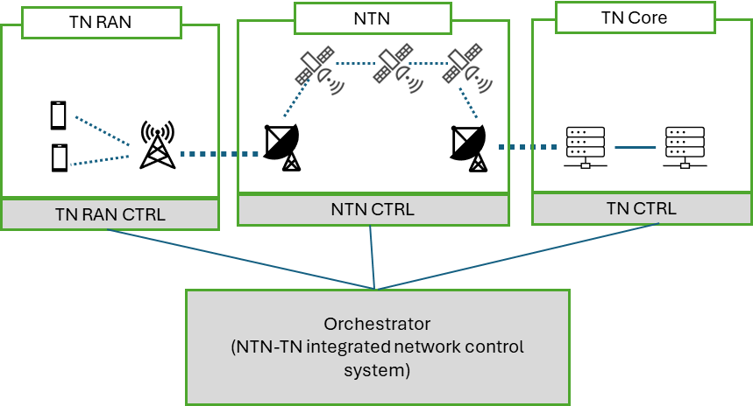
- NTN system providing backhaul link to extend TN RAN

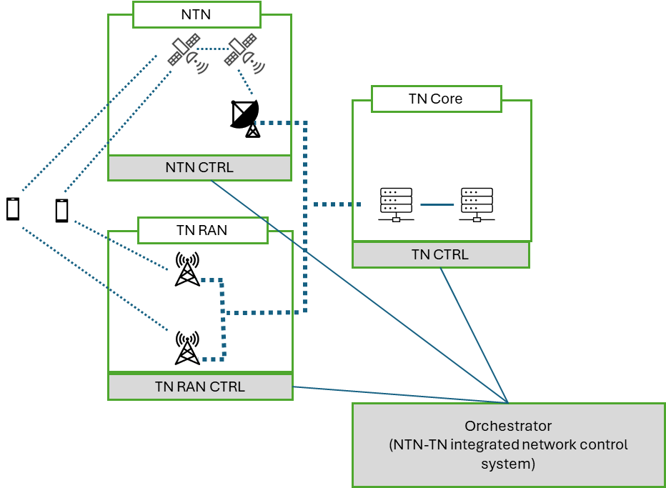
(b) Both NTN and TN RAN provide connectivity to user devices

Resource allocation, monitoring and control (e.g., interference management) in the layout of Figure 21 (b) is more challenging than that of Figure 21 (a) because in that layout both the TN and NTN radio access cells may need to be overlapped in the same location.

There are two types of radio resource allocation approaches that have been considered for the integration of NTN and TN operating systems: allocation from separate spectrum and allocation from the same spectrum.

For example, the spectrums of L band (1-2GHz) and S band (2-4 GHz) are used in mobile satellite services for mobile data and voice communications to small user terminals such as global satellite phones, machine-to-machine/IoT, asset tracking, as well as aeronautical and maritime safety communications [ITU-R REP M.2460]. The sub-6 GHz TN also gets spectrums allocated from these bands. Therefore, coordinated approaches to the NTN and TN spectrum allocation and dynamic control must be designed and implemented for reducing potential interference and maintaining desired communication quality. ITU-R Working Party 4B is developing new Recommendations and/or Reports on satellite-terrestrial integrated networks, including the development of the detailed specifications of the satellite radio interfaces of IMT-2020 and the work on the future development of satellite IMT-2030, part of the NTN components of IMT.

7.2.2.1 Orchestrator architecture
The integration of multiple NTN operating systems, as well as integration of multiple NTN and TN operating systems, requires the core network for interconnecting them through both in the control and data planes. Japan has developed the orchestrator architecture based on ITU-T Y.3207 for the coordinated control of radio resources and communication paths of both TN and NTN operating systems.

Figure 23 shows the functional components of the orchestrator’s architecture.

FIGURE 23
Orchestrator functional architecture for integrated control of NTN and TN resources
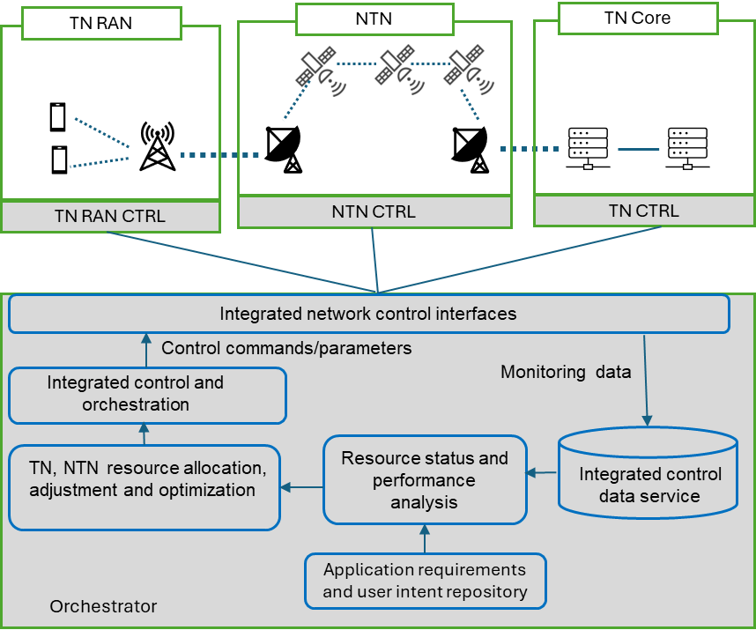

The following are key functional components:
- Integrated control data service function is responsible for collecting, storing and managing consistency of control data consisting of the measurement of radio resource capacity, their utilization, and service performance metrics (such as throughput and latency) obtained from the controllers of TN and NTN domains.
- Application requirements and user intent repository function interprets user and service provider expectations, translating abstract requirements (also called intents) into resource and system configuration parameters.
- Resource status and performance analysis function obtains the control data from the integrated control data service function, analyzes resource utilization and performance related control data to evaluate the status of resource availability, allocation, and utilization as well as performance metrics. It detects if the allocated resources are underutilized or overutilized (i.e., causing congestion and bottlenecks), and predicts future demands of resources.
- TN, NTN resource allocation, adjustment and optimization function makes decisions to adjust radio and computing resources TN and NTN domains based on the analytical results. Integrated control and orchestration function formulates control decisions, generating resource control parameters that are transmitted via the integrated network control interface to the controllers of NTN and TN domains.

This architecture assumes that both TN and NTN domains will be equipped with the capabilities of virtualization of both communication and computing resources soon. They can lease their resources and network slices to third party organizations providing application services such as automated driving, environment (sea, forest, hills, and deserts) monitoring, and smart farming to customers. The resources of the multiple domains can be orchestrated by software-defined network protocols.
7.2.2.2 Experimental System for Proof of Concept
As shown in Figure 24, an experimental system has been developed to validate the orchestrator’s functional capabilities in monitoring and controlling multi-domain resources while maintaining consistent QoS. Environment, and Control Operation Visualization Tools.
FIGURE 24
Experimental system layout.
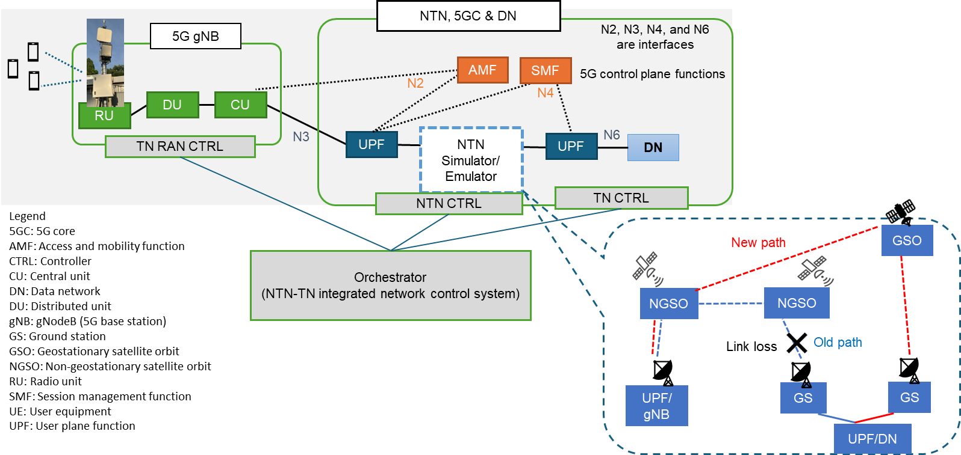

The orchestrator functions, interfaces, and control messages are implemented in Python, while communication with the TN and NTN controllers is implemented in RESTful APIs. Standard data formats such as YAML and JSON are used for exchanging control parameters.

The experimental system includes the 5G radio access network (5G gNB), 5G core (5GC) network functions, NTN simulators/emulators, and virtualized data network (DN). The local 5G RAN base stations (gNB) have been deployed. The 5GC network functions are based on open source free5GC software.
NTN components include a satellite network simulator in the control plane and an emulator for data plane path with the reconfigurable values of bandwidth, delay, jitter, and loss rate.

In this system, NTN is positioned between two sets of user plane functions (UPFs) of 5GC. 5GC network functions such as Access and Mobility Function (AMF) and Session Management Function (SMF) are configured to attached UE to the gNB whose functions are divided into three groups: central unit, distributed unit and radio unit. The Data Network (DN) is hosted on an OpenStack platform and managed by the Open-Source MANO (OSM) framework. A video application server, equipped with MPEG-DASH modules, delivers video streams of varying quality. A video client, installed on a laptop functioning as UE, retrieves and plays video content from the MPEG-DASH server. The video data gets transmitted through network path passing through the multiple domains of DN, 5GC, NTN, and 5G RAN.

As stated earlier, each network domain, including 5G RAN, has its own controller to monitor resource utilization and performance and control their resources. Performance metrics are visualized through tools that display control message flows between the orchestrator and individual TN and NTN domain controller, resource usage of individual network domains, and application’s QoS metrics such as throughput, latency, and jitter.

The orchestrator monitors the resource usage of both TN and NTN continuously through the control data obtained from the controller of each network domain. When the communication path gets congested due to a larger traffic demand, the orchestrator sends control commands to increase allocated resources (e.g. channel bandwidth). Similarly, if the orchestrator detects a communication path loss (e.g. due to mobility or failure of NTN nodes), the orchestrator sends NTN path reconfiguration commands to the NTN controller. Additional information about the experimental system can be obtained from a paper published at the ITU Kaleidoscope conference in 2024.

Activities in China

7.3.1 Deployment of Tiantong direct-to-device services with interconnection of satellite and terrestrial networks.
D2D services, including voice and SMS, were launched in China in 2023. These services are based on the interconnection between the Tiantong-1 mobile satellite system and the terrestrial mobile network, both operated by China Telecom. The Tiantong-1 system comprises three GEO satellites operating in the 2 GHz frequency band, providing coverage across China and neighboring regions in Southeast Asia.

Since its initial launch, the service has been exclusively available to China Telecom customers, with the capability to expand to other operators and Asian countries through interconnection with multiple TN and the Tiantong-1 satellite system, supporting a wider range of terminals from various vendors.

7.3.1.1 Network deployment architecture
As shown in Figure 25, the deployment architecture of direct-to-device services can be divided into two sides of networks, the Tiantong-1 satellite network on the left and the current terrestrial networks on the right.

FIGURE 25
Network deployment architecture for Tiantong-1 direct-to-device services
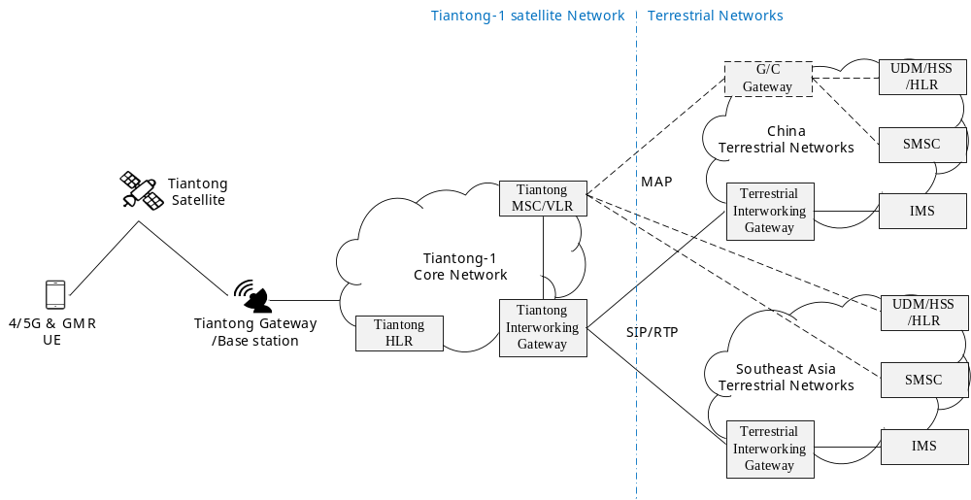
Tiantong Gateway and Base Stations as access network functions, the Tiantong-1 core network comprises three key network functions: Tiantong HLR for secondary authentication / authorization of roaming users, Tiantong MSC/VLR for roaming calls and sms, and Interworking Gateway for signaling and media interconnection.

The terrestrial network that owns the consumers mainly provides UDM/HSS/HLR for authentication/authorization and subscription storage, SMSC for sending and receiving SMS, IMS for voice calls, and interworking gateways that connect to the Tiantong Interworking Gateway.

The key solution for consumers accessing Tiantong-1 voice and SMS services is the interconnection between Tiantong-1 satellite network and terrestrial networks. This includes interworking of Tiantong interworking gateway and terrestrial interworking gateway with SIP/RTP protocol for voice call, and signaling control interworking of Tiantong MSC/ VLR and UDM/HSS/HLR and SMSC with MAP protocol for authentication/authorization and SMS. In the case of interconnection with CDMA terrestrial networks, the signaling links need to connect to G/C Gateway for translation and transformation of GSM MAP and CDMA MAP protocol.

7.3.1.2 Technical innovations
In summary, there are three technical innovations in the deployment architecture of Tiantong-1 direct-to-device services.
- Network architecture innovation. Addressing the networking issues of heterogeneous networks, such as roaming authentication using different protocols by introducing G/C Gateway, reducing latency by optimizing satellite link timer, considering overseas operations and regulatory requirements.
- Service experience innovation. Delivering voice and SMS services to terrestrial network subscribers without the need to change SIM cards and telephone numbers, providing a seamless interoperability experience.
- Satellite-specific service innovation. Supporting efficient use of scarce satellite resources, congestion control, differentiated user priority policies, flexible scheduling of satellite services.

Activities in Indonesia
Indonesia has initiated strategic steps in developing the integration of Terrestrial Networks (TN) and Non-Terrestrial Networks (NTN), focusing on both technical trials and business model exploration.

7.4.1 Spectrum Sharing Trial for TN-NTN Coexistence
Indonesia has conducted a technical trial to evaluate the coexistence of Terrestrial Networks (TN) and Non-Terrestrial Networks (NTN) operating on adjacent or overlapping frequency bands. The trial focuses on validating the feasibility of spectrum sharing between terrestrial and satellite systems, particularly within the 900 MHz band.

The trial includes analysis of potential interference and coordination mechanisms between TN and NTN systems. One key result from the trial indicates that occupying a 200 kHz guard-band within a 10 MHz bandwidth of TN for NTN is safe, without any harmful interference observed during satellite overpass scenarios. It is also noted that NTN systems are more sensitive to interference from TN systems, due to the nature of satellite signal propagation and the lower power margins typically used in satellite communications. This sensitivity underscores the importance of precise spectrum planning and interference mitigation in TN-NTN coexistence strategies.

7.4.2 Development of Business Model for Indonesia
Indonesia is currently studying several business model to ensure NTN D2D services suitable to end users. Currently, at least two schemes are being studied:

- Neutral Host Model: TN provide shared infrastructure using MSS spectrum, allowing equal access for all MNOs to deliver services over a common satellite platform.
FIGURE 26
Neutral Host Model
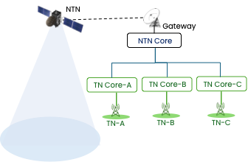
- Exclusive Host Model: Each TN collaborate exclusively with individual MNOs using IMT spectrum, where frequency licenses are held by each operator.
FIGURE 27
Exclusive Host Model
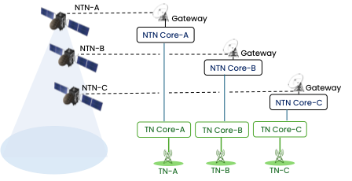

The scope of the studies includes regulatory studies, market analysis, stakeholder workshops, and international benchmarking. The parties involve in these studies among others are domestic satellite operators, mobile operators, and global benchmarking. The objective is to find the most appropriate licensing frameworks, technical standards, and cooperation mechanisms that support scalable, cost-efficient, and inclusive NTN service deployment in Indonesia.

Conclusions
This report provides an overview of the technical challenges, enabling technologies, network architectures, and application scenarios for integrating multiple Non-Terrestrial Networks (NTN) and Terrestrial Networks (TN) operated by different operators and systems. It highlights the importance of interoperability, orchestration, and resource coordination across heterogeneous domains to achieve seamless global connectivity and reliable service delivery.

The report also summarizes key enabling technologies—including multi-domain orchestration, network sharing, and multi-RAT coordination—as well as ongoing standardization and regional activities related to multi-operator NTN–TN integration. These developments demonstrate growing momentum toward practical deployment of integrated terrestrial and non-terrestrial infrastructures.

As communication requirements evolve toward 6G and beyond, multi-domain integration will play a critical role in supporting diverse use cases such as ubiquitous and resilient connectivity, satellites as backhaul, deploying space data centers, earth and space monitoring, autonomous driving, integrated sensing and communications, precision navigation and positioning, as well as emerging applications in aviation and space. The Asia-Pacific region, with its diverse geographical characteristics, can particularly benefit from NTN–TN convergence to ensure resilient, inclusive, and ubiquitous connectivity.

Continued collaboration among operators, industry stakeholders, standardization bodies, and research communities will be essential to address challenges related to interoperability, spectrum use, security, and resilience. By sharing knowledge and promoting harmonized approaches, APT Members can accelerate the development and deployment of integrated multi-layer NTN-TN integrated networks and further enhance regional and global connectivity.

This report is expected to serve as a useful reference for APT Members in understanding current developments and in promoting further study and cooperation toward the realization of interoperable NTN–TN networks consisting of multiple operating systems.

Appendix 1: Types and layouts of orchestrators
There can be several types of orchestrators, possibly existing in different layouts, as shown in the cases / figures below.

Case 1: Central network operating system acting as the orchestrator for seamless integration
FIGURE A1-1
The central network operating system may act as
an orchestrator and accommodate other network operating systems
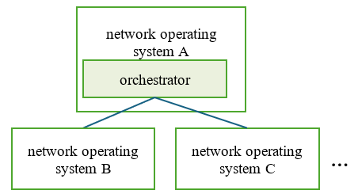

Case 2: Decoupled orchestration for network independence
FIGURE A1-2
The orchestrator can be an independent entity,
not tied to a specific network operating system
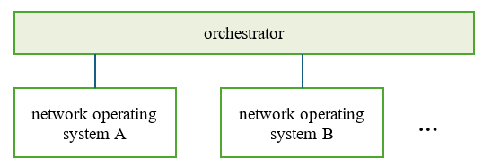

Case 3: Interconnected orchestrators for interoperation of various network operating systems
FIGURE A1-3
The multiple orchestrators controlling their respecting network
operating systems are connected to each other
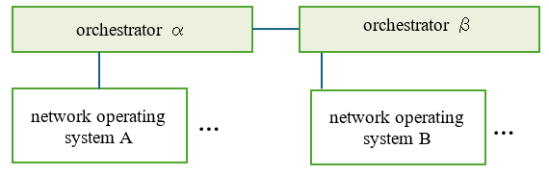
Case 4: Hierarchical orchestrators
FIGURE A1-4
The orchestrator can exist in a hierarchical layout
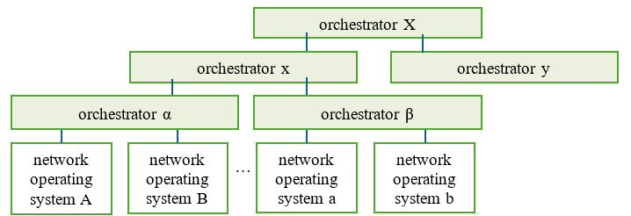

Case 5: Orchestrator controlling multiple network operating systems
FIGURE A1-5
Each network operating system may belong to one specific orchestrator
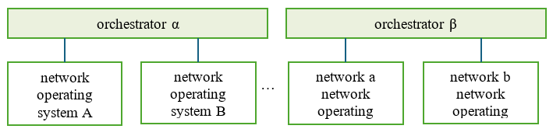

Case 6: Shared orchestrators
FIGURE A1-6
Each network operating system can belong to one or multiple orchestrators
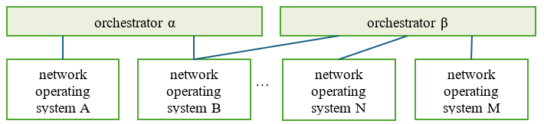
____________

This report assumes that UAVs will possess the functionality of radio stations (similar to satellites and HAPS) in near future
APT/AWG/REP-142, APT Report on multi connectivity for multilayered network access using terrestrial and non-terrestrial systems, September 2024
Recommendation ITU-T Y.3207 (2024), Fixed, mobile and satellite convergence – Integrated network control architecture framework for IMT-2020 networks and beyond.
https://www.intelsat.com/newsroom/softbank-corp-and-intelsat-launch-landmark-collaboration-to-create-ubiquitous-network/
3GPP TR 38.821 V16.2.0 “Solutions for NR to support Non-Terrestrial Networks (NTN)” (2023-04)
3GPP TR 38.811 V15.4.0 “Study on New Radio (NR) to support non-terrestrial networks” (2020-10)
3GPP TR 38.801 V14.0.0 “Study on new radio access technology: Radio access architecture and interfaces” (2017-04)
3GPP TR 23.737 V17.2.0 “Study on architecture aspects for using satellite access in 5G” (2021-03)
3GPP TS 28.530 V19.0.0 “Management and orchestration; Concepts, use cases and requirements” (2025-03)
3GPP TS 28.531 V19.1.0 “Management and orchestration; Provisioning” (2025-07)
See 3GPP TS 23.501 V19.2.1 “System architecture for the 5G System (5GS)” (2025-01)
This report assumes that UAVs will possess the functionality of radio stations (similar to satellites and HAPS) in near future
V.P. Kafle, M. Sekiguchi, H. Asaeda, and H. Harai, “Validation of Integrated Network Control Architecture for Fixed, Mobile and Satellite Convergence,” ITU Kaleidoscope Academic Conference – Innovation and digital transformation for a sustainable world, New Delhi, India, October 2024.

