

APT REPORT ON

THZ WAS CHARACTERISTICS TO SUPPORT VR APPLICATIONS OPERATING IN THE FREQUENCY RANGE 252-296 GHZ

Edition: September 2026

The 37th Meeting of APT Wireless Group
7 – 11 September 2026
Dhaka, Bangladesh (Hybrid)

(Source: AWG-37/OUT-13)

No. APT/AWG/REP-163

APT report on
thz WAS characteristics to support VR applications OPERATING IN THE frequency range 252-296 GHZ

Table of Contents

- Introduction
- Scope
- ITU-R and APT References
- Abbreviations and acronyms
- Regulatory information
- Usage scenario of THz WAS
  - Immersive communication system for VR applications operating in the THz frequency
  - 2-Dimensional THz WAS network on pairnet for immersive communication system
    - Pairnet
    - 2-D THz WAS network on pairnet
    - Proactive frequency assignment for 2-D THz WAS network on pairnet
  - Data rate requirements for VR applications
    - Streaming data rate requirement for VR applications
    - Data rate requirement based on data transfer time for VR applications
- Technical and operational characteristics of THz WAS
  - Overview of IEEE Std 802.15.3d™-2017 and IEEE Std 802.15.3™-2023
  - Technical and operational characteristics of THz transceivers
  - Spectrum mask and channel arrangement in the frequency range 252-296 GHz
- Antenna technologies for WAS
  - Waveguide-type antenna
  - Dielectric cuboid antenna (DCA)
  - Phased array antenna
    - Prototype transmitter and receiver
    - Beam steering performance
- Summary
- Bibliography

Annex 1: Example of frame sequence for 2-D THz network consisting of imaginary regular hexagonal lattices
Annex 2: Example of proactive frequency assignment for 2-D THz WAS network consisting of imaginary regular hexagonal lattices
- Introduction
AWG has developed APT Report on short range radiocommunication systems and application scenarios operating in the frequency range 275-1 000 GHz (APT/AWG/REP-66(Rev.1)) which contains 6 use cases such as KIOSK downloading, toll gate downloading, chip-to-chip communication in servers and switches of data center, Super high vision (4K/8K) video transmission, WLAN based on IEEE802.11 and cable replacement of data center.
Virtual Reality (VR) was not included as one of THz use cases in APT/AWG/REP-66(Rev.1), but it provides many immersive applications such as gaming, virtual tour of museum/world heritage, virtual exhibition of open house/model room, etc. Head Mounted Display (HMD) is a key device for VR applications. Wired HMD sometimes restricts users’ movement around the workstation. Wireless HMD offers more flexible experiences to users. Wireless HMD users can move around freely and interact with virtual objects in limited locations.
The data rates between HMD and the workstation are required in the range between hundreds of Gbps and tens of Tbps depending on resolution of 2D/3D videos which provide immersive VR experiences. IEEE Std 802.15.3™-2023 ⁽¹⁾ can support such high data rates wirelessly using a number of wide channel bandwidths under the point-to-point nature, i.e. device-to-device communication. IEEE Std 802.15.3™-2023 provides the channel arrangement which defines eight different channels such as 2.16 GHz, 4.32 GHz, 8.64 GHz, 12.96 GHz, 17.28 GHz, 25.92 GHz, 51.84 GHz and 69.12 GHz and those channels can be used to support high-speed data transmission over 100 Gbit/s between devices.
RLAN based on IEEE 802.11 standards could support wireless HMDs located in the limited area, but the standard, i.e. IEEE Std 802.11ay™-2021 can provide the maximum data rates of 20 Gbit/s using channel bonding/aggregation and MIMO technologies in the frequency range 57-71 GHz ⁽²⁾. Thus, the current RLAN standards could not support the high-speed data rates to wireless HMDs which are required for immersive VR experiences. In this Report, the technical and operational characteristics based on IEEE Std 802.15.3™-2023 are studied from the view of VR applications which require high-speed data rates to HMDs, and the possibility of 2-D THz WAS networks based on point-to-point communications links in the limited area where no wireless infrastructure is available is also studied introducing additional technical functional requirements such as antenna beam switching capabilities.
- Scope
This Report addresses the use case of THz VR applications, and their networks, technical and operational characteristics of THz Wireless Access System (WAS) operating in the frequency range 252-296 GHz.
- ITU-R and APT References
- APT/AWG/REP-66(Rev.1), Short range radiocommunication systems and application scenarios operating in the frequency range 275-1000 GHz.
- APT/AWG/REP-118(Rev.1), Point-to-point radiocommunication systems operating in the frequency range 252-296 GHZ.
- Report ITU-R M.2227, Use of multiple gigabit wireless systems in frequencies around 60 GHz
- Report ITU-R M.2417, Technical and operational characteristics of land mobile service applications in the frequency range 275-450 GHz.
- Report ITU-R M.2517, Coexistence between land-mobile and fixed service applications operating in the frequency range 252-296 GHz.
- Report ITU-R M.2541, Technical feasibility of IMT in bands above 100 GHz
- Abbreviations and acronyms
2D/3D 2 dimensional/3 dimensional
AR Augmented reality
AP Access point
DCA Dielectric cuboid antenna
DEV Device
FOV Field of view
HMD head mounted display
HPBW Half-power beamwidth
PAP Pairnet associated period
PCB Printed circuit board
PPD Pixel per degree
PRC Pairnet coordinator
PRDEV Pairnet device
PSP Pairnet setup period
RTT Round trip time
VR Virtual reality
WAS Wireless access system
WLAN Wireless local area network
WPAN Wireless personal area network
- Regulatory information
Mobile services are allocated in the frequency bands 252-265 GHz and 265-275 GHz. Land mobile service applications are identified in the frequency bands 275-296 GHz, 306-313 GHz, 318-333 GHz and 356-450 GHz in accordance with RR footnote No.5.564A, as shown below. The total bandwidth of 44 GHz could be utilized for mobile applications in the future.
248-3 000 GHz
Allocation to services
Region 1 | Region 2 | Region 3
252-265 FIXED
MOBILE
MOBILE-SATELLITE (Earth-to-space)
RADIO ASTRONOMY
RADIONAVIGATION
RADIONAVIGATION-SATELLITE
5.149 5.554
265-275 FIXED
FIXED-SATELLITE (Earth-to-space)
MOBILE
RADIO ASTRONOMY
5.149 5.563A
275-3 000 (Not allocated) 5.564A 5.565

5.564A For the operation of fixed and land mobile service applications in frequency bands in the range 275-450 GHz:
The frequency bands 275-296 GHz, 306-313 GHz, 318-333 GHz and 356-450 GHz are identified for use by administrations for the implementation of land mobile and fixed service applications, where no specific conditions are necessary to protect Earth exploration-satellite service (passive) applications.
The frequency bands 296-306 GHz, 313-318 GHz and 333-356 GHz may only be used by fixed and land mobile service applications when specific conditions to ensure the protection of Earth exploration-satellite service (passive) applications are determined in accordance with Resolution 731 (Rev.WRC-19).
In those portions of the frequency range 275-450 GHz where radio astronomy applications are used, specific conditions (e.g. minimum separation distances and/or avoidance angles) may be necessary to ensure protection of radio astronomy sites from land mobile and/or fixed service applications, on a case-by-case basis in accordance with Resolution 731 (Rev.WRC-19).
The use of the above-mentioned frequency bands by land mobile and fixed service applications does not preclude use by, and does not establish priority over, any other applications of radio services in the range of 275-450 GHz. (WRC-19)
- Usage scenario of THz WAS
6.1 Immersive communication system for VR applications operating in the THz frequency
VR spaces can be utilized for e.g. gaming, virtual tour of museum/world heritage, virtual exhibition of open house/model room, virtual instruction/education of fabrication process in industrial plant, virtual design and remote maintenance of automobile/vehicle/train/airplane, virtual production of movie, virtual stage rehearsal, remote diagnostics and surgery, etc. Figure 1 illustrates three examples of virtual instruction of fabrication process, virtual tour in museum and virtual tour of open house. VR space accelerates to create new businesses in industry, real estate, art world, etc., and improves productivity, production quality, work and time efficiencies. However, the real immersive VR space in stationary/low mobility environment is still beyond reality due to the lack of high-speed wireless links to head mounted displays (HMDs).

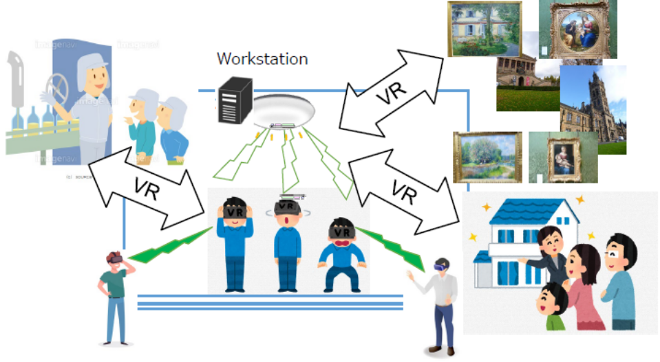
Figure 1
Illustration of virtual reality space for interactive immersive applications using THz WAS.
6.2 2-Dimensional THz WAS network on pairnet for immersive communication system
6.2.1 Pairnet
Pairnet is introduced to reduce protocol overhead and achieve low connection establishment latency. Pairnet consists of two devices (DEVs) as components ⁽¹⁾. Two components are called Pairnet coordinator (PRC) and Pairnet device (PRDEV). The distance between PRC and PRDEV varies from a few centimeters up to several hundred meters, depending on use cases. The superframe for pairnet is shown in Figure 2 and the typical time period of the superframe is 250 msec. Two devices are connected and high-volume data is exchanged during PSP (Pairnet setup period) and PAP (Pairnet associated period), respectively. Pairnet is already applied to the concept of “Touch and Get” which corresponds to ultra-short link setup time and ultra-fast contents downloading, as described in Report ITU-R M.2227.
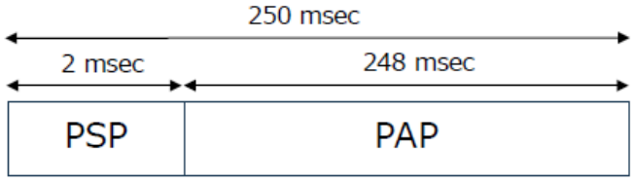
Figure 2
A superframe structure for pairnet ⁽¹⁾.
6.2.2 2-D THz WAS network on pairnet
IEEE Std 802.15.3™-2023 does not support the switched point-to-point connectivity using sector antennas as well as the new connection to a different destination device. Due to the lack of those functions, the use cases of the standard are limited to point-to-point applications such as intra-device communication, close proximity mobile system, wireless links for data centers and backhaul/fronthaul link which are included in Report ITU-R M.2417. In order to support immersive communication system, the switched sector antennas are introduced for pairnet. The switched antenna protocol will be discussed by IEEE 802.15 Working Group as necessary. Figure 3 shows one example of 6 switched pairnet and the relationship between the switched antenna coverages of PRC 0 and its neighboring PRDEVs located in the imaginary regular hexagonal lattice. Either PRC or PRDEV have six-directional beam antennas whose 3-dB beamwidth is 60 degrees, and each beam is switched to set up the link between PRC and PRDEV. The number of sector antennas is not limited to 6 but it will be determined considering processing time period to connect devices and THz RF device and antenna characteristics, if required. Imaginary regular hexagonal lattice will be replaced by the other type of lattice depending on the number of sector antenna.
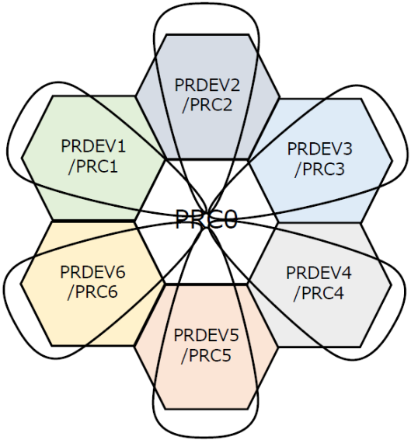
f₅
f₄
f₃
f₁
f₆
f₂
Figure 3
Relationship between switching antenna coverages and neighboring imaginary regular hexagonal lattices.
Figure 4 illustrates an example of zone mapping of PRCs and PRDEVs for 2-D THz WAS network on pairnet. PRC 0 corresponds to the workstation which stores VR content and transmits them to PRDEVs according to the request from PRDEVs. The workstation can be connected to the internet depending on VR applications. Color-highlighted devices can be either PRC or PRDEV in this scenario. During PSP, beacon frames are periodically sent to six 60-degree zones to initiate point-to-point connectivity to PRDEV located in the neighboring lattice. The area of one PRDEV is assumed to be limited in the imaginary regular hexagonal lattice whose side length is 1 m. The total area occupied by regular hexagonal lattices is about 200 m² where one workstation (PRC 0) and 76 devices (PRDEVs) are distributed.
Since 2-D THz WAS network consists of point-to-point connection between PRCs and PRDEVs, the total time period to connect all PRDEVs through PRCs with PRC 0 should be evaluated using 250 msec of the superframe time period, as shown in Figure 2. Figure A1 in Annex shows the frame sequence consisting of combinations of pairnet superframes for each PRCs and PRDEVs. If 250 msec of the superframe time period is acceptable for VR applications consisting of 77 devices in the limited area, all devices are connected to PRC0 within 3.75 sec. The data for PRDEVs is updated periodically but the latest update time for PRDEV for this example is 3.75 sec. This time period may be acceptable for 76 VR users. The updated time interval varies depending on the number of PRCs and PRDEVs, as well as the number of beams which corresponds to the imaginary shape of lattices.
The imaginary zone using regular hexagonal lattice could provide an efficient model for VR zone mapping, because the number of switching beams of THz transceivers is 6 which reduces the complexity of THz RF components as well as sector training sequences including routing protocol. Those parameters for pairnet may be specified by IEEE 802.15 in the future. Figure 9 also shows the second- and third-round data exchanges between PRCs and PRDEVs which are yellow- and coral-colored highlighted, respectively. The first-round data exchange is 3.75-sec period, but the total time period of the first and second-round times is 5.25 sec. This feasibility evaluation indicates that pairnet could provide wirelessly connected and limited space for VR applications in the condition that the sector antennas are equipped and the training protocol are installed in THz transceivers.
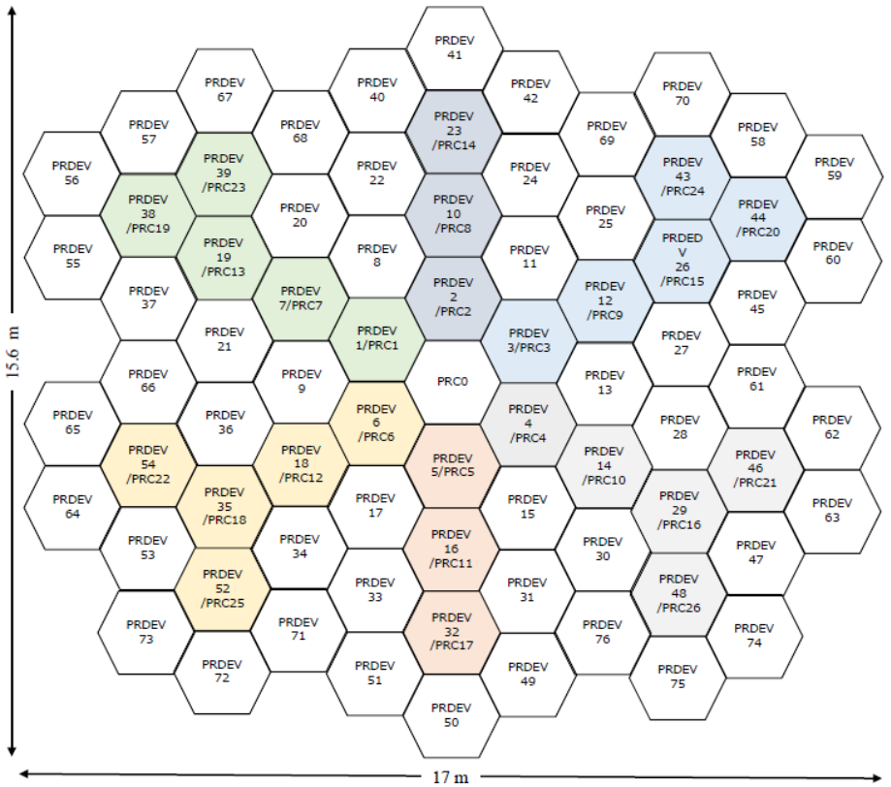
Figure 4
Zone mapping using imaginary regular hexagonal lattice for 2-D THz WAS network on pairnet.
6.2.3 Proactive frequency assignment for 2-D THz WAS network on pairnet
The frequencies of f₁, f₂, f₃, f₄, f₅, and f₆ are preassigned for each sector antenna of PRC 0 to simplify the sector training protocol, as shown in Figure 3. Since TDD is used for this system and the signal frequency f₁ from PRC 0 is received by PRDEV2, the preassigned frequencies for PRDEV2 for each sector antenna is determined according to the received frequency from PRC 0. Annex 2 describes the proactive frequency assignment for each PRCs and PRDEVs in THz WAS network. The preassigned frequencies in each PRCs and PRDEVs are shown in Figure A2. Although HMD may move around within the imaginary regular hexagon lattice, the direction of the signal frequency f₁ is maintained towards PRC 0 by selecting the sector antenna.
In the lattice group on Lines 1, 2 and 3, three frequency groups (f₃, f₆), (f₁, f₄) and (f₂, f₅) are periodically preassigned, respectively. There may be possible frequency interferences between HMDs on Lines 1, 2 and 3, if no obstacles are placed between HMDs in the different lattices. Furthermore, the superframe time period for data exchange between HMDs on each Line should be also considered because the frequency interference is not caused if the data exchange is performed in a different time period. The frequency interference issue will be discussed in the different deliverable because of the scope of this Report,

6.3 Data rate requirement for VR applications
6.3.1 Streaming data rate requirement for VR applications
Streaming data rate requirement for VR applications has been discussed and estimated by IEEE802.11, as shown in Table 1⁽³⁾⁽⁴⁾. PPD is the critical criterion to evaluate the clarity and sharpness of images in an VR headset and defined as the number of pixels within one degree of Viewer’s FOV. High PPD provides benefits to the viewers permitting smaller screens, sharpening videos and giving deep immersion. PPD changes in the range of 30-60 and the number of 60 of PPD approaches the limit of human eye reception. Wider FOV, which plays a pivotal role in defining the level of immersion, mirrors the natural human field of vision and offers more comfortable and natural viewing experience. Three levels of immersion are shown in Table 1 providing the corresponding raw, lightly compressed and compressed data rates. Latency for partial and deep/ultimate immersion is 10ms and 5ms, respectively. Reference (4) indicates that the raw and lightly compressed stream are preferable to meet the total latency less than 20ms.

Table 1
Requirement of VR ⁽³⁾⁽⁴⁾
 | Pixel Per Degree | Horizontal FOV | Vertical VFOV | Monocular Video Resolution | Frame Rate | Yuv444/ Yuv420 | Raw Data Rate (Gbps) | Lightly Compressed Data Rate (Gbps) | Compressed Data Rate (Gbps)
Partial immersion | 30 | 210 | 100 | 6300  ×  3000 | 60 | 36/18 | 2D; 40.83/20.42 | 2D; 4.08/2.04 | 2D; 0.40/0.20
 |  |  |  |  |  |  | 3D; 81.66/40.84 | 3D; 8.16/4.08 | 3D; 0.81/0.40
Deep Immersion | 45 | 360 | 100 | 16200  ×  4500 | 60 | 36/18 | 2D; 236.20/118.10 | 2D; 23.62/11.81 | 2D; 2.36/1.18
 |  |  |  |  |  |  | 3D; 472.40/236.20 | 3D; 47.24/23.62 | 3D; 4.72/2.36
Ultimate Immersion | 60 | 360 | 120 | 21600  ×  7200 | 144 | 36/18 | 2D; 806.40/403.11 | 2D; 80.64/40.31 | 2D; 8.06/4.03
 |  |  |  |  |  |  | 3D; 1612.44/806.22 | 3D; 161.24/80.62 | 3D; 16.12/8.06

6.3.2 Data rate requirement based on data transfer time for VR applications
The switched point-to-point communications cannot support streaming data to many devices simultaneously, but support transmitting/receiving high-volume contents to devices in a specified time period such as 250 msec, as indicated in section 6.2.1. Table 2 summarizes the relationship between the data volume and the data transfer time. The estimated data volumes per one minute of 3D 8K and 3D 4K are briefly shown in Table 2. The data transfer time is calculated using the data volume and the data rate. If the data transfer time of 250 msec standardized in IEEE 802 Std 802.15.3™-2023 is used to transmit a lightly compressed 3D 8K/4K video, the required data rate becomes 320/80 Gbps. If the data transfer time is expanded to 1 sec, the required data rate can be reduced to one quarter of 320/80 Gbps. The superframe for 2-D THz WAS network on pairnet is designed based on combinations of the data transfer time, the data volume and the achievable data rate to be described in section 7.1.
Table 2
Brief estimation of data transfer time
Video |  | 3D 8K video |  |  | 3D 4K Video
Estimated data volume  / minute (GB) |  | 800 (Raw) / 80 (Lightly compressed) |  |  | 20 (Raw) /2 (Lightly compressed)
Data rate (Gbps) |  | 4000 | 400 | 40 | 4000 | 400 | 40
Transfer time (sec) |  | 0.2/  0.02 | 2/  0.2 | 20/  2 | 0.05/  0.005 | 0.5/  0.05 | 5/  0.5
Required data rate (Gbps) | 250-msec transfer time | 3200/320 |  |  | 800/80
Required data rate (Gbps) | 1-sec  transfer time | 800/80 |  |  | 200/20
- Technical and operational characteristics of THz WAS
7.1 Overview of IEEE Std 802.15.3d™-2017 and IEEE Std 802.15.3™-2023
This standard defines an alternative physical layer (PHY) at the lower THz frequency range. Some of the key features and additions are as follows:
- Frequency range between 252 GHz and 325 GHz.
- Eight different channel bandwidths between 2.16 GHz and 69.12 GHz.
- Possible maximum data rates of up to 100 Gb/s.
- Use of a pairnet structure supporting wireless links for intra-device communication, close proximity communication, wireless data centers, and backhaul/fronthaul links.
- Two available PHY modes (single carrier and on-off keying) for system simplicity.
In 2023, this standard was amended updating the frequency range up to 450 GHz and adding two modulation schemes and published as IEEE Std 802.15.3™-2023⁽¹⁾ which incorporates 2.4 GHz, 60 GHz and 300 GHz radio equipment standards for WPAN. The channel arrangement is defined in the frequency range 252-450 GHz using channel bandwidths of 2.16 GHz, 4.32 GHz, 8.64 GHz, 12.96 GHz, 17.28 GHz, 25.92 GHz, 51.84 GHz and 69.12 GHz. Table 3 summarizes achievable data rates without pilot words (8bits) in the frame format, considering modulation and coding schemes provided in IEEE Std 802.15.3™-2023. It is noted that the data rates over 100 Gbps could be achieved by low-level modulation schemes such as QPSK and multi-level modulation schemes such as 64 QAM if the channel bandwidth is over 69.12 GHz and 25.92 GHz, respectively. However, the maximum bandwidth for WAS becomes 25.92 GHz because the total bandwidth is limited to 44 GHz, as discussed in section 7.3. Either channel bonding or aggregation techniques should be used for WAS to increase data rates, as already developed in IEEE 802.15.3 standard. Although MIMO whose operational frequency is 60-GHz band is provided in IEEE Std. 802.15.3™-2023, further studies on MIMO at THz band is required.
Table 3
Achievable maximum data rates in each channel bandwidth
Modulation Scheme | FEC rate | Bandwidth (GHz)
Modulation Scheme | FEC rate | 2.16 | 4.32 | 8.64 | 12.96 | 17.28 | 25.92 | 34.56 | 51.84 | 69.12
BPSK | 11/15 | 1.29 | 2.58 | 5.16 | 7.74 | 10.33 | 15.49 | 20.66 | 30.98 | 41.30
BPSK | 14/15 | 1.64 | 3.29 | 6.57 | 9.86 | 14.14 | 19.71 | 26.28 | 39.42 | 52.56
QPSK | 11/15 | 2.58 | 5.16 | 10.33 | 15.49 | 20.65 | 30.98 | 41.30 | 61.95 | 82.60
QPSK | 14/15 | 3.29 | 6.57 | 13.14 | 19.71 | 26.28 | 39.42 | 52.56 | 78.85 | 105.13
8-PSK | 11/15 | 3.87 | 7.74 | 15.49 | 23.23 | 30.98 | 46.47 | 61.96 | 92.93 | 123.91
8-PSK | 14/15 | 4.93 | 9.86 | 19.71 | 29.57 | 39.42 | 59.13 | 78.84 | 118.27 | 157.69
8-APSK | 11/15 | 3.87 | 7.74 | 15.49 | 23.23 | 30.98 | 46.47 | 61.96 | 92.93 | 123.91
8-APSK | 14/15 | 4.93 | 9.86 | 19.71 | 29.57 | 39.42 | 59.13 | 78.84 | 118.27 | 157.69
16-QAM | 11/15 | 5.16 | 10.33 | 20.65 | 30.98 | 41.30 | 61.95 | 82.60 | 123.90 | 165.21
16-QAM | 14/15 | 6.57 | 13.14 | 26.28 | 39.42 | 52.57 | 78.85 | 105.14 | 157.70 | 210.26
64-QAM | 11/15 | 7.74 | 15.49 | 30.98 | 46.46 | 61.95 | 92.93 | 123.90 | 185.86 | 247.81
64-QAM | 14/15 | 9.86 | 19.71 | 39.42 | 59.14 | 78.85 | 118.27 | 157.70 | 236.54 | 315.39
16-APSK | 11/15 | 5.16 | 10.33 | 20.65 | 30.98 | 41.30 | 61.95 | 82.60 | 123.90 | 165.21
16-APSK | 14/15 | 6.57 | 13.14 | 26.28 | 39.42 | 52.57 | 78.85 | 105.14 | 157.70 | 210.26
32-APSK | 11/15 | 6.45 | 12.97 | 25.81 | 38.73 | 51.63 | 77.44 | 103.25 | 154.88 | 206.51
32-APSK | 14/15 | 8.21 | 16.43 | 32.85 | 49.28 | 65.71 | 98.56 | 131.43 | 197.13 | 262.83

7.2 Technical and operational characteristics of THz transceivers
Table 4 summarizes an example of technical and operational characteristics of THz transceivers operating in the frequency range 252-296 GHz.
Table 4
Example of technical and operational characteristics of THz transceivers.
Parameters | Transceiver
Frequency range (GHz) | 252-296
Duplex method | TDD/FDD
Modulation method | BPSK/QPSK/16QAM/64QAM
Channel bandwidth (GHz) | 8.64/12.96/17.28/25.92
Maximum distance between devices(m) | 2
Spectrum mask | Compliant to IEEE802.15.3
Number of beams | 1
Antenna elevation angle (degree) | < ±60
Antenna azimuth angle (degree) | < ±60
Antenna type | Sector or Array antennas
Antenna pattern | Directional
Antenna polarization | Linear
Antenna gain (dBi) | > 15
e.i.r.p. (dBm) | > 0
RX noise figure (dB) | 10
Data rate (Gbit/s) | > 80
Indoor deployment (%) | 100

7.3 Spectrum mask and channel arrangement in the frequency range 252-296 GHz
The spectrum mask for THz WAS in the frequency range 252-296 GHz utilizes the spectrum defined in IEEE 802.15.3 standard. Figure 5 shows the generic transmit spectrum mask and their parameters depending on their channel bandwidths. IEEE 802.15.3 standard specifies the spectrum mask for 2.16-GHz, 4.32-GHz, 6.48-GHz, 8.64-GHz, 12.96-GHz, 17.28-GHz, 25.92-GHz, 51.84-GHz and 69.12-GHz channels, and Figure 5 (b) provides corresponding offset frequencies for each bandwidth.

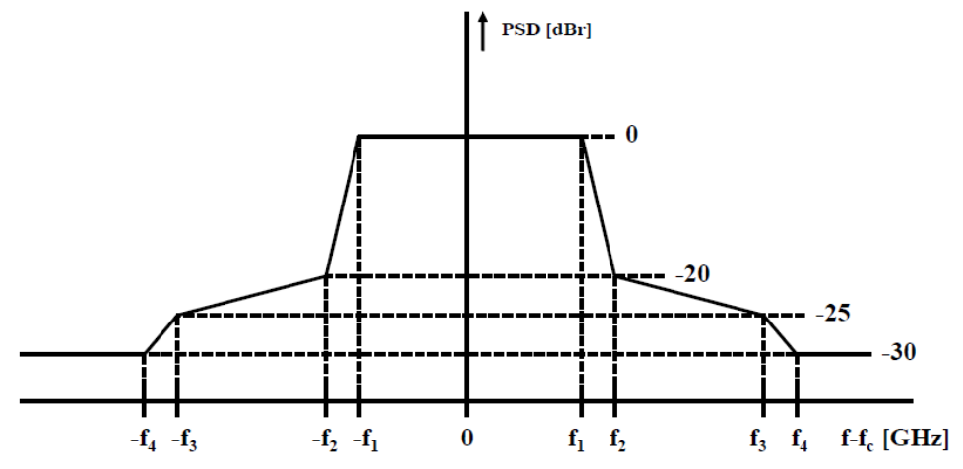
(a)Transmit spectral mask
Channel bandwidth (GHz) | f₁ (GHz) | f₂ (GHz) | f₃ (GHz) | f₄ (GHz)
2.16 | 0.94 | 1.10 | 1.60 | 2.20
4.32 | 2.02 | 2.18 | 2.68 | 3.28
8.64 | 4.18 | 4.34 | 4.84 | 5.44
12.96 | 6.34 | 6.50 | 7.00 | 7.60
17.28 | 8.50 | 8.66 | 9.16 | 9.76
25.92 | 12.82 | 12.98 | 13.48 | 14.08
34.56 | 17.14 | 17.30 | 17.80 | 18.40
51.840 | 25.78 | 25.94 | 26.44 | 27.04
69.120 | 34.42 | 34.58 | 35.08 | 35.68
(b) Spectrum mask parameters
Figure 5
Spectrum mask specified for THz WAS.

Although IEEE 802.15.3 standard specifies 9 channels in the frequency range 252-450 GHz, THz WAS utilizes the bandwidths of 2.16 GHz, 4.32 GHz, 8.64 GHz, 12.96 GHz, 17.28 GHz and 25.92 GHz in the frequency range 252-296 GHz, as shown in Figure 6. This channel arrangement is already included in Report ITU-R M.2417 and APT/AWG/REP-118(Rev.1).

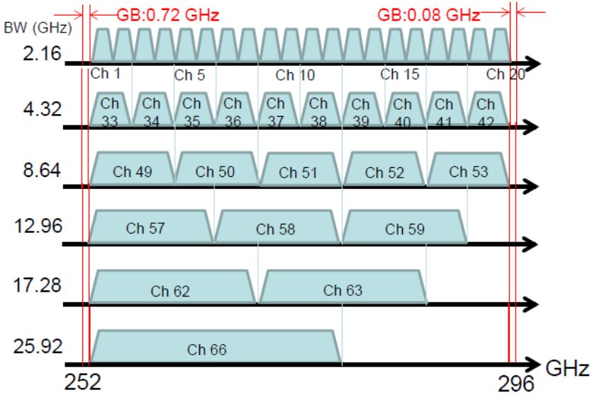
Figure 6
Possible channel arrangement for THz WAS in the frequency range 252-296 GHz.
- Antenna technologies for WAS
8.1 Waveguide-type antenna
A rectangle waveguide standard WR-3.4 (0.864 × 0.432 mm) whose operating frequency is the frequency range 220-330 GHz can provide the open-ended waveguide antenna whose half-power beamwidth (HPBW) is larger than 60-degree. However, HPBW can be decreased and adjusted by flaring the dimension using a small horn antenna. Regardless of the relatively large size of the metallic horn antenna, it features easy-mounting, flexible beam shaping and matured technologies.
8.2 Dielectric cuboid antenna (DCA)
Dielectric antenna is a highly efficient and miniaturized antenna because of no conduction losses and high permittivity, respectively. The DCA was proposed to replace a horn antenna with a dielectric material which can extremely reduce the size of an external component ⁽⁵⁾. Figure 7(a) shows an external view of DCA antenna with an aperture size of 1.2 × 1.2 ×1.3 mm³ and the length of approximately 1.3 mm. DCA antennas are made of polytetrafluoroethylene (PTFE) with a dielectric constant of 2.0 and a loss tangent of 11 × 10⁻⁴ at 300 GHz. The DCA features a protruded section of 0.8 × 0.4 × 1.0 mm³ to allow connection with a WR-3.4 rectangular waveguide, as shown in Figure 7 (b).
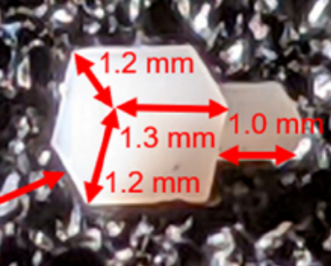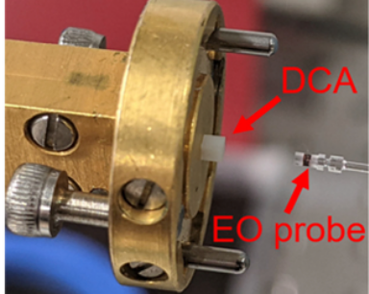
(a) (b)
Figure 7
Dielectric cuboid antenna whose antenna aperture size is 1.2 mm × 1.2 mm, and its length is approximately 1.3 mm.
8.3 Phased array antenna
8.3.1 Prototype transmitter and receiver
CMOS (Complementary metal-oxide-semiconductor) technology is expected to produce cost-effective transmitters and receivers due to its mass production and high integration of chip devices. Although CMOS technologies make fully integrated one-chip transceivers feasible at millimeter-wave and THz bands, the features of low breakdown voltage and lossy substrate in CMOS technologies affect the output power of CMOS transmitter. To improve the output power of CMOS transmitter, spatial power combining techniques using phased array antennas are introduced at THz bands ⁽⁶⁾.
Figure 8 shows the transmitter and receiver chips using 40-nm CMOS process ⁽⁷⁾⁽⁸⁾. Transmitter and receiver consist of upconverters, downconverters, multipliers, amplifiers, phase shifters and antenna pads. The LO frequency of the chips is 75 GHz, and the IF frequency is 50 ± 20 GHz. The chip sizes are 6.23 × 4.73 mm². Due to the size of each RF component, it is difficult to integrate radiation elements on chip with a half-wavelength spacing (λ₀). In the protype chips, 2 × 2 antenna pads are integrated with 1.08 λ₀ spacing. These chips are mounted on the printed circuit board (PCB) composed of multi-layer substrates and vertically connected to 3 × 3 array antennas through grounded coplanar waveguides (GCPW) -to-waveguide transition ⁽⁹⁾ to suppress grating lobes of radiation patterns.
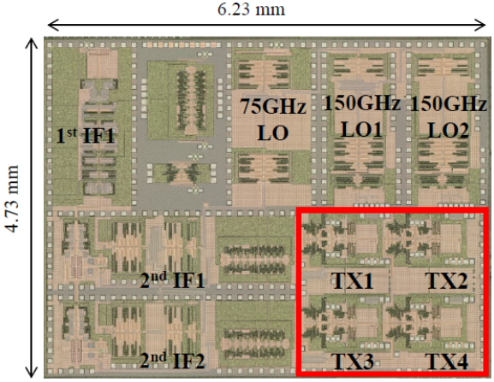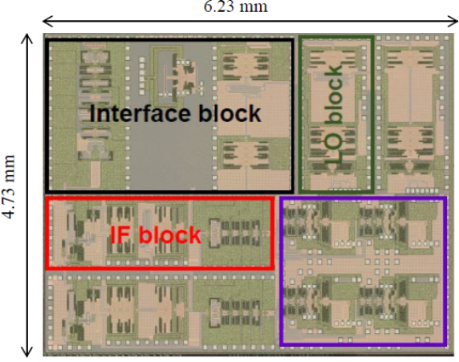
(a) Transmitter (b) Receiver
Figure 8
Transmitter and receiver chips fabricated using 40-nm CMOS process.
8.3.2 Beam steering performance
3 × 3 array antennas integrated on PCB are shown in Figure 9 ⁽¹⁰⁾ whose spacing is 0.54 λ₀. 2 × 2 antenna pads on chips which are mounted on the opposite side of PCB (red dotted lines) are directly connected to 2 × 2 aperture elements which are placed at the corner. The other interpolated aperture elements surrounded by the blue dotted lines are auxiliary ones which suppress grating lobes of the radiation patterns from 2 × 2 corner elements. The size of each aperture element is 0.7 × 0.432mm ⁽¹⁰⁾.
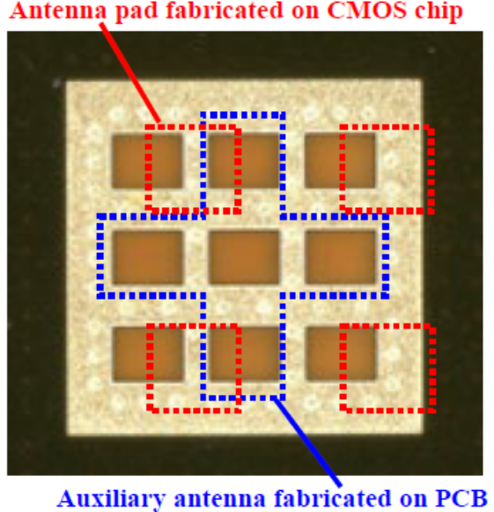
Figure 9
3 × 3 array aperture elements fabricated on PCB.
Figure 10 shows the measured radiation patterns from 3 × 3 array antennas at 275 GHz ⁽⁷⁾. The beam direction can be changed in the rage of ±30°. The output power of the 3 × 3 array aperture elements is evaluated using e.i.r.p. of the transmitter chip. Since the calculated gain of 3 × 3 array and the measure e.i.r.p. are about 14 dBi ⁽¹⁰⁾ and -8dBm at the center direction, respectively, the output power from 2 × 2 antenna pads on CMOS chip in Figure 8 (a) is estimated to be -22 dBm (6.3 μW). The e.i.r.p. is expected to be further improved by increasing the number of aperture elements on PCB and decreasing the conversion loss of upconverters in CMOS chips.

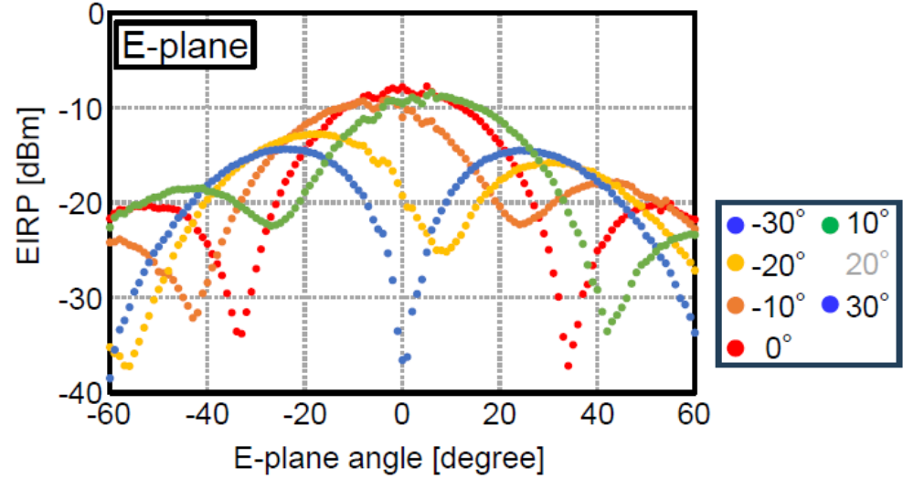
Figure 10
Measured radiation patterns at 275 GHz.
- Summary
2-D THz WAS network utilizes switched point-to-point links to exchange data between devices within a short time period in the limited area where no wireless infrastructure is available. This Report indicates the possibility that the fast link setup time and the high-volume contents downloading function supported by the current THz standard can be used to form 2-D THz WAS network for VR applications such as immersive communication systems, if the beam switching protocol is implemented for operation of the sector or phased array antennas in the future IEEE 802.15.3 standard.
- Bibliography
- IEEE Std 802.15.3™-2023, IEEE Standard for Wireless Multimedia Networks
- IEEE Std 802.11ay™-2021, Part 11: Wireless LAN Medium Access Control (MAC) and Physical Layer (PHY) Specifications, Amendment 2: Enhanced Throughput for Operations in License-exempt Bands above 45 GHz.
- IEEE 802.11-23/1977r1, Requirements Analysis for IMMW Use Cases.
- IEEE 802.11-18/0846-02, Next Generation PHY/MAC in Sub-7GHz
- K. Yamada, et al., “Short-range wireless transmission in the 300 GHz band using low-profile wavelength-scaled dielectric cuboid antennas,” Frontiers in Communications and Networks, Article 702968, Vol. 2, Jul. 2021.
- M. Fujishima, “Challenges and Innovations in CMOS-Based 300-GHz Transceivers for High-Speed Wireless Communication”, IEEE Open J. Solid-State Circuits Soc. Vol.5, pp.21-32, Dec. 2024.
- K. Takano, et al., “A 300-GHz-band 40-Gb/s 2D phased-array CMOS transmitter with near-half-wave antenna pitch”, IEEE Radio Frequency Integrated Circuits Symp. (RFIC), pp. 335-338, Jun. 2024.
- S. Tanaka, et al., “A 300-GHz-Band 36-Gb/s Scalable 2x2 2D Phased-Array CMOS Receiver”, IEEE Asian Solid-State Circuits Conference (A-SSCC), pp. 1-3, Nov. 2024.
- C. Chokchai, et al., “Broadband GCPW-to-waveguide transition in multi-layer dielectric substrates with modified V-shaped and double patch in 270 GHz band”, pp.537-547, IEEE Journal of Microwaves, Vol. 4, Issue 3, pp.537-547, Jul. 2024.
- A. Yamazaki, et al., “Grating-Lobe Suppressing Feed Technique for 2D Phased Array with Interpolating Excitation Elements in 300-GHz band”, IEEE International Workshop on Antenna Technology (iWAT), pp.56-58, Apr. 2024.

Annex 1
Example of frame sequence for 2-D THz network consisting of imaginary regular hexagonal lattices

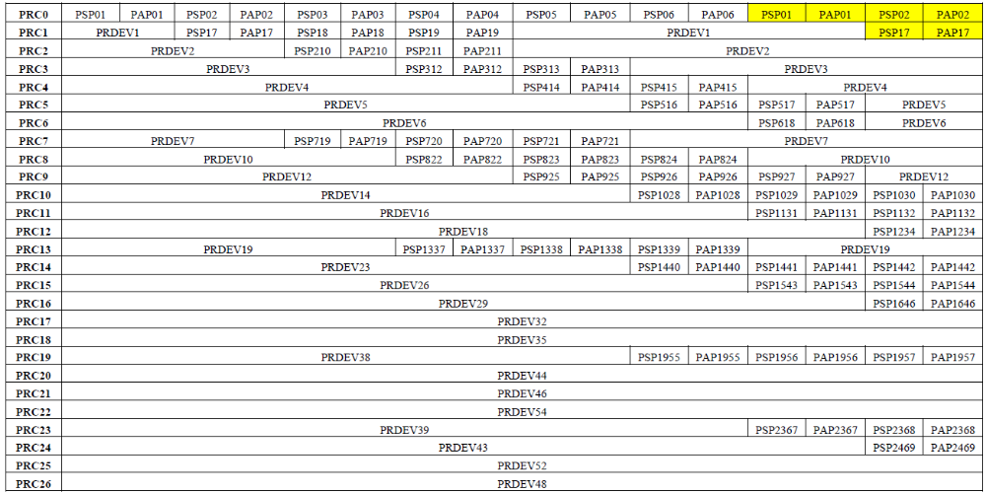
250 msec x 8 = 2 sec

Continued.
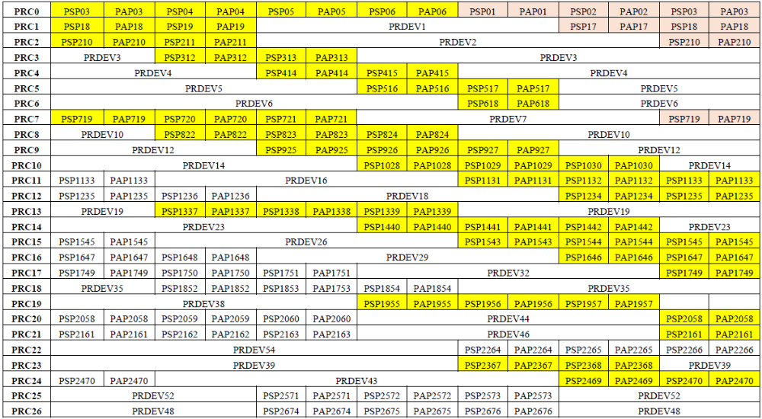
250 msec x 7 = 1.75 sec

Continued.
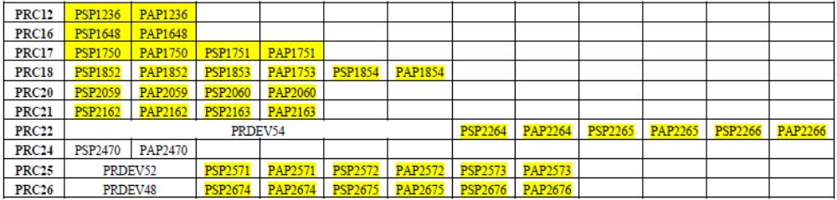
250 msec x 6 = 1.5 sec

Figure A1
Frame sequence for 2-D THz network. Yellow- and coral-colored highlighted superframes are the second- and third-round data exchanges.

Annex 2
Example of proactive frequency assignment for 2-D THz WAS network consisting of imaginary regular hexagonal lattices

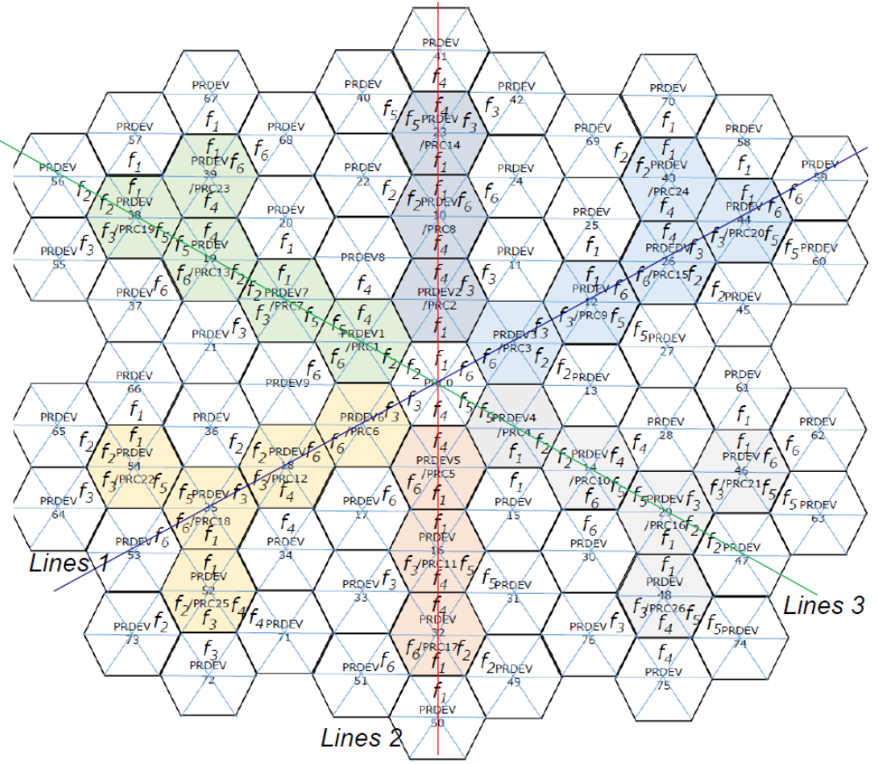
Figure A2
Six-channel frequency pre-assignment for 2-D THz WAS network based on imaginary regular hexagonal lattice

