

APT REPORT ON

MITIGATION TECHNIQUES FOR USE IN REDUCING THE POTENTIAL FOR INTERFERENCE BETWEEN FOD RADARS OPERATING IN THE FREQUENCY RANGE 92-100 GHZ

Edition: September 2026

The 37th Meeting of APT Wireless Group
7 – 11 September 2026
Dhaka, Bangladesh (Hybrid)

(Source: AWG-37/OUT-12)

No. APT/AWG/REP-162

APT Report on
mitigation techniques for use in reducing the potential for interference between FOD radars operating in the frequency range 92-100 GHz

Table of Contents

- Introduction
- Scope
- ITU-R and APT References
- Abbreviations and acronyms
- System characteristics of FOD radar
  - Technical and operational characteristics of FOD radar
  - Channel plan for FOD radar
- Interference scenarios
  - Deployment scenario and interference paths
  - Interference caused by reflection from airplanes
  - Interference caused by reflection from obstacles on the runway
- Mitigation techniques
  - Feeder line adjustment method
  - Frequency pre-assignment method
  - Phase synchronization method
- Summary

- Introduction
The presence of foreign object debris (FOD) on airport runways, taxiways, aprons and ramps poses a significant threat to the safety of air travel. FOD has the potential to damage aircraft during critical phases of flight, which can lead to catastrophic loss of life and airframe, and increased maintenance and operating costs. FOD radars (FRs) have been introduced to detect such FOD at airports. FRs, in particular, operating in the frequency range 92-100 GHz can provide high detection sensitivity, short detection response time, sufficient coverage of surveillance runway area and high location accuracy for safety airport operation. ITU-R has been studying the technical and operational characteristics for FRs in the frequency range 92-100 GHz and conducting sharing and compatibility studies between FRs and Earth exploration satellite service (EESS) (active) and EESS (passive) operating in these or adjacent bands.
FRs are densely equipped alongside runways due to large pathlosses in the millimeter-wave bands. For example, 48 FRs whose separation distance is 200 m are equipped alongside 4-km runway. There are many overlapped coverage areas between FRs, and when the airplane is moving in the overlapped coverage areas, some reflection from the airplane caused by direct emission from the neighboring radars may interfere with the FRs.
- Scope
This Report addresses mitigation techniques which reduce the potential for interference to FR caused by reflection of the signals from the neighboring radars by the airplane and the other obstacles.
- ITU-R and APT References
- Recommendation ITU-R M.2162
Technical and operational characteristics of radiolocation systems operating in the frequency range 92-100 GHz and radionavigation systems operating in the frequency range 95-100 GHz
- Report ITU-R M.2501
Technical and operational characteristics of the foreign object debris detection system operating in the frequency range 92-100 GHz
- Report ITU-R M.2562
Sharing and compatibility studies between foreign object debris detection system and other services in the frequency ranges 92-100 GHz
- APT/AWG/REC-12
APT Recommendation on Models for FWS Link Performance Degradation due to Wind
- APT/AWG/REP-81(Rev.1)
APT Report on FWS link performance under severe weather conditions
- Report ITU-R M.2422
Current and future usage of railway radiocommunication systems between train and trackside (RSTT)

- Report ITU-R M.2500
Coexistence between high-speed railway radiocommunication system between train and trackside operating in the frequency bands 92-94 GHz, 94.1-100 GHz and 102-109.5 GHz, and radio astronomy service and Earth exploration-satellite service (EESS) (active) and EESS (passive) services

- Abbreviations and acronyms

FOD Foreign object debris
FR FOD radar
FWHM Full width at half maximum
RCS Radar cross section

- System characteristics of FOD radar
  - Technical and operational characteristics of FOD radar
Recommendation ITU-R M.2162 provides technical and operational characteristics of FRs operating in the frequency range 92-100 GHz. Table 1 summarizes system parameters which are necessary for assessing mitigation techniques.

Table 1
Technical and operational characteristics of foreign object debris detection system
operating in the frequency range 92-100 GHz^{(1), (2)}

Parameters | Units | Values
Frequency range | GHz | 92-100
Channel plan |  | See Figure 1
Channel bandwidth | GHz | 0.58-7.98
Output power | mW | 50-200
Sweep frequency | kHz | 1.250
Antenna type | – | Cassegrain
Antenna gain | dBi | 44
Antenna pattern | – | Recommendation ITU-R F.699
Antenna height | m | 4-8
Full width at half maximum | degrees | Elevation: 1.0, Azimuth: 1.0
Antenna rotation speed | rpm | 15
Angular sampling interval | degree | 0.072
Cross-range sampling interval at 100 m and 200 m | cm | 13, 25
Detection distance | m | 200-500
Antenna elevation angle | degrees | −1.8
Radiated rotation angle | degrees | ±60
Radar cross section | dBsm | −20
Out-of-band emission | dBm/MHz | −50 (Channel Plans A, B, C)  −47 (Channel Plans D, E)
Adjacent channel leakage ratio | dBc | < −70
Receiver noise figure | dB | 10
Range resolution | cm | 1.88, 2.55, 7.98, 17.05, 25.86
Angular resolution | degree | 1
Azimuth resolution at 100 m and 200 m | m | 1.75, 3.49
Maximum number of FOD radars per 4-km runway | - | 48 (see Figure 2)
I/N protection criteria | dB | −6

  - Channel plan for FOD radar
Figure 1 shows the channel plan for FRs. The channel plans which exclude the use of the band 94-94.1 GHz are also included in Figure 1 because the frequency band 94-94.1 GHz is also allocated for EESS (active). The single channel operation of FRs may cause the frequency interference between the FR and its neighboring radar installed along the runway. The FR using multichannel may utilize dynamic channel selection techniques against interference.
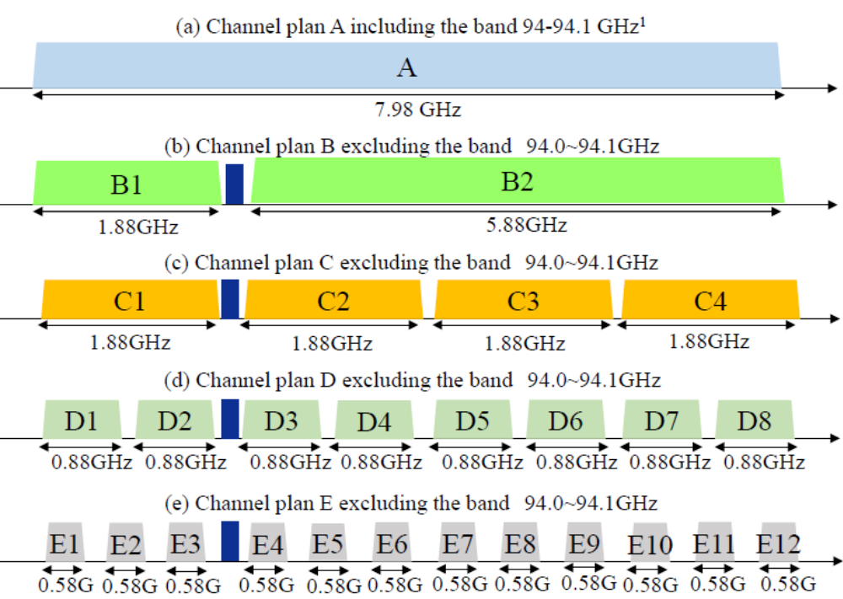
¹ This channel plan will be used if mitigation techniques are available to resolve the coexistence issues with EESS (active).
Figure 1
Channel plan for FOD radars operating in the frequency range 92-100 GHz^{(1), (2)}

- Interference scenarios
6.1 Deployment scenario and interference paths
Figure 2 shows the schematic illustration of implementation of FRs in 4-km runway. The separation distance of FRs is 200 m and the total number of FRs is 48 in this deployment scenario. There are many overlapped coverage areas between FRs, and some interference may be caused by the neighboring radars if airplanes are in the overlapped coverage areas. Two interference paths are considered in this Report. One is direct emission from neighboring FRs, which may be received when the main beams of two FRs face each other during rotation. The other is reflection of the signals from neighboring FRs by airplanes or by objects on the runway and taxiway, as described in Sections 6.2 and 6.3.
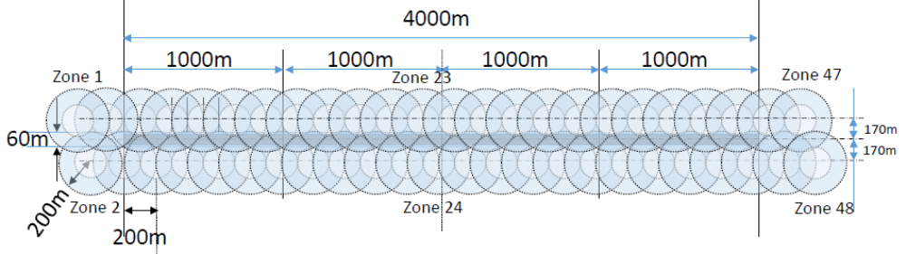
Figure 2
Deployment scenario of FOD radars in 4-km runway⁽³⁾

6.2 Interference caused by reflection from airplanes
Figure 3 illustrates the interference scenario where radar signals from the neighboring FRs (FR1, FR3, FR5 and FR6) which are reflected by the airplane interfere with FR2.
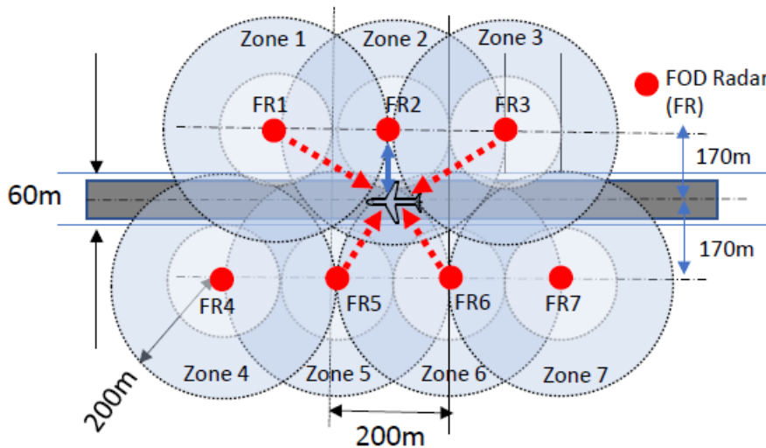

Figure 3
Possible interference scenario 1 caused by reflection from the airplane

Figure 4 illustrates the interference scenario in detail, where radar signals from the neighboring FR across the runway (FR2) are reflected by the airplane and interfere with FR1.
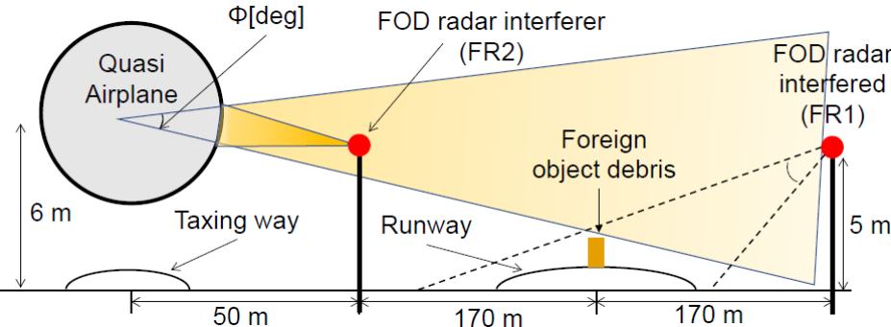
Figure 4
Possible interference scenario 2 caused by reflection from the airplane

6.3 Interference caused by reflection from obstacles on the runway
Figure 5 shows the photo of runway taxiway light, and it may cause the reflection of the radar signals. A number of LED lights are used in the taxiway and runway lighting systems. The specification of RCS for FRs is −20 dBsm, as shown in Table 1, and the typical RCS of LED lights which are recessed into the runway pavement could be estimated to be −20 dBsm. Therefore, almost all of lights along runway and taxiway are detectable by FRs. Interference level at FR2 by the reflected wave of the radar signal of FR1 caused by the recessed in-pavement centerline light is estimated to be −88 dBm using the bilateral radar equation and technical and operational characteristics provided in Table 1. Interference level to FR2 from FR1 is similar to the received signal level to FR2 which is reflected by the same in-pavement light. Considering a number of in-pavement lights are recessed in runway and taxiway at the airport, the multi-frequency channel operation of FRs, as introduced in Figure 1, should be considered to avoid frequency interferences.

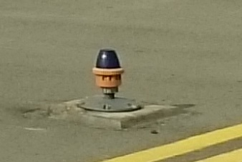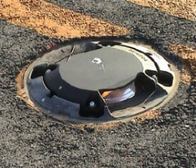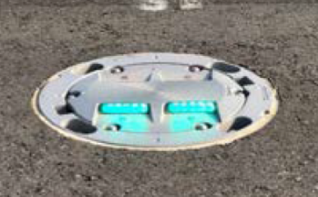
(a) Edge light (b) Centerline light (c) End light
Figure 5
Photo of runway taxiway lights

Figure 6 shows examples of calculated RCSs of metallic sphere and horizontal and vertical cylinders in free space. The estimation does not include complicated multipath effects caused by surface conditions of runway, but it should be noted that the value of RCS is basically decreased if the object shape viewed from FR is changed. RCSs of one-inch vertical and horizontal cylinders are about −20 dBsm and −12 dBsm. If the circular base of the horizontal cylinder is tilted by 45° toward FR, RCS decreases more than 40 dB due to large diffraction effect. RCS to be used for bilateral radar equations is an important parameter for estimation of interference levels caused by obstacles on runway and taxiway.

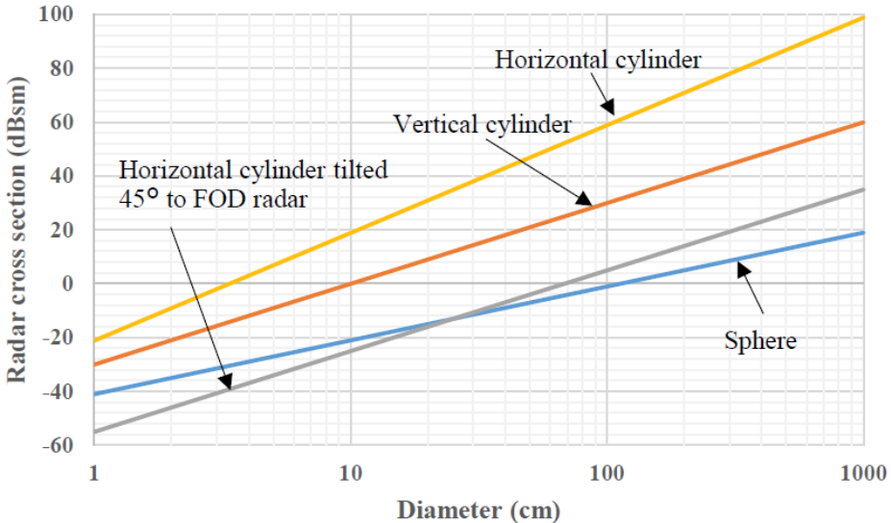
Figure 6
Examples of radar cross section of sphere and cylinders in free space
- Mitigation techniques
7.1 Feeder line adjustment method
In order to simplify the interference model, Figure 7 is used to experimentally evaluate interference signals from interferer (FR2). The distance between the interferer (FR2) and FR1 interfered with by FR2 is 43.8 m, and that between FR1 and airplane 200 m. The fiber length between FR1 and Central Office can be increased up to 1 000 m. If the radar signals from FR2 are reflected by the airplane, they may be received by FR1 as undesired signals and cause false images which give some wrong information regarding FODs location on runways. Since the feeder lines consist of fiber cables, the length of the feeder line can be adjusted to control the delay time of received undesired signals. Each FR is rotated synchronously once every four seconds by a control signal from Central Office. Central Office and each FR are connected by optical fibers 300 m in length. FR1 receives the reflected wave generated by the signals from FR1 and the reflected undesired signals from FR2. Owing to receiving two signals with different routes, the display shows real and false airplane images. Figure 8 (a) shows radar images when no additional fiber cable is added between FR1 and Central Office. An image of the airplane can be seen at Y=200 m, and a false image of the airplane can be seen at Y=180 m.
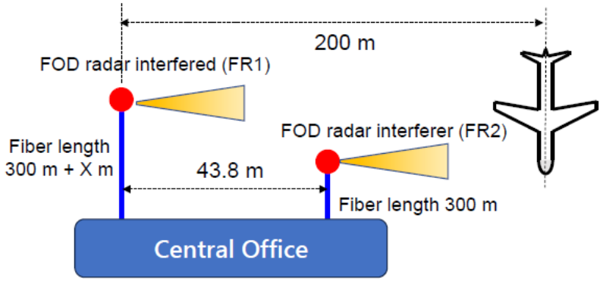
Figure 7
Simplified interference evaluation model

The false image caused by undesired reflection signals from FR2 could be suppressed by adding additional fiber cable between FR1 and Central Office which changes the beat frequencies (IF) generated by mixing FMCW transmitted signals from FR1 with FMCW received signals from FR2 using, for example, a low pass filter. Figure 8 (b) shows that the positions of the false images are shifted by adding a 400-m fiber cable between FR1 and Central Office. However, the length of a fiber cable of 400 m is not sufficient to suppress the false images. The length of the fiber cable required to remove the false image L_{f} is given as follows:
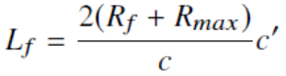
where R_{f}, R_{max}, c and c′ denote the location of the false images, the maximum detection distance, the speed of light, and the propagation velocity in the fiber cable, respectively.
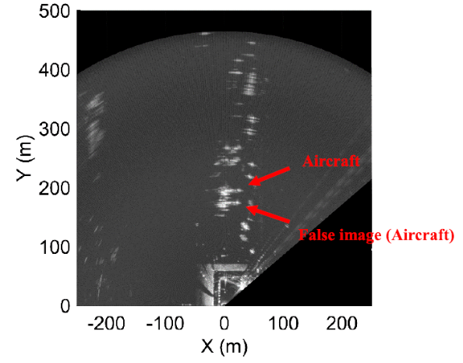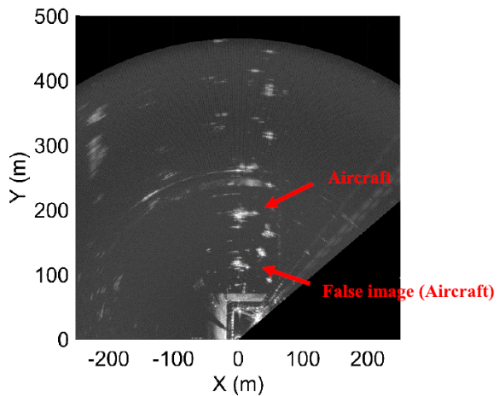
(a) No additional fiber cable (X=0) (b) Additional fiber cable length of 400 m
Figure 8
Measurement results of FR1 radar images

The length of the fiber cable to remove the false images at 180 m in Figure 8 (a) is calculated to be 870 m using the above equation. Figure 9 shows the experimental results of the radar images when a 1000-m fiber cable is added between FR1 and Central Office. The beat frequency is outside of the IF band of the receiver, and then the false image is successfully removed.
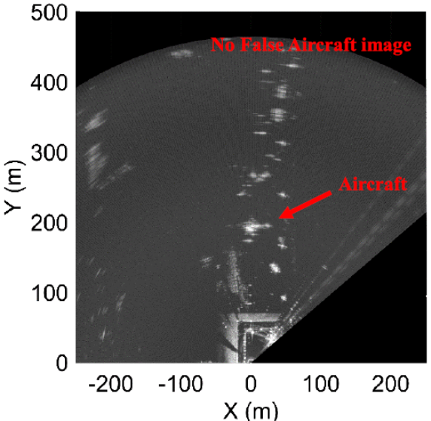
Figure 9
Measurement result of no false images (Fiber length 1 000 m)

7.2 Frequency pre-assignment method
Because Report ITU-R M.2562 indicates that in-band emission at the band 94-94.1 GHz from FRs may cause interferences to EESS (active), Channel plans B-E are recommended to use for FRs depending on the detection requirement of FODs. Although the single channel operation of FR can achieve the minimum range resolution, the frequency interference between an FR and its neighboring FRs could not be avoided, as illustrated in Figure 3. Figure 10 shows Channel plan C which has four frequency bands of 1.88 GHz in the frequency range 92-100 GHz and excludes the band 94-94.1 GHz. Figure 11 shows the relationship between the pre-assigned channels or frequency bands and the beam coverage of each FR on runway. The 120° fan-shaped beam coverage areas are formed along runway because the radiated rotation angles of FRs are specified within ±60°. This frequency pre-assignment can suppress the other channel reflection by any obstacles. The reflection of the same channel frequencies from other FRs may cause possible frequency interferences, e.g. FR1 to FR3, FR2 to FR4 and vice versa. However, a high-gain antenna of 44 dBi has FWHM of about 1° and can suppress undesired signal at the edge of the fan-shaped zone whose azimuth angle is ±60°.

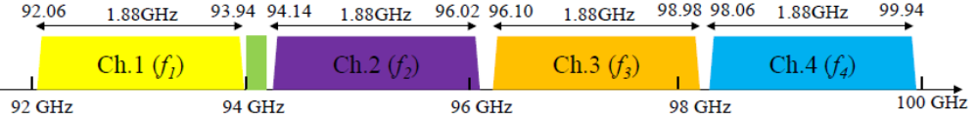
Figure 10
Channel plan C

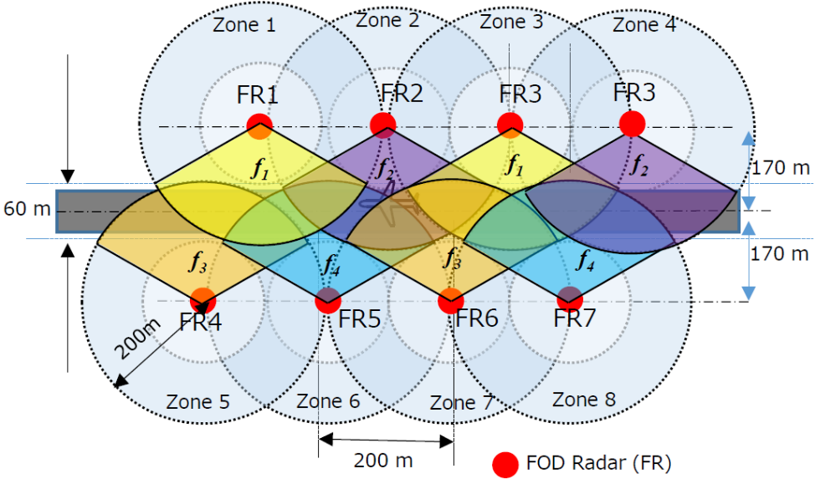
Figure 11
Relationship between frequency pre-assignment and each 120° fan-shaped zone

7.3 Phase synchronization method
The rotation timing of all FRs equipped in the same runway can be synchronized so that the mutual interference caused by direct signal transmission from adjacent FRs can be avoided. As illustrated in Figures 2 and 11, a number of FRs are equipped along runway and taxiway. Those FRs are connected to Central Office, and such a distributed radar network can precisely control the phase and frequency of each FR. Multi-channel radar operations can basically avoid frequency interferences if the frequencies are pre-assigned by the control station, but the phase synchronization method allows FRs to use the single-frequency operation such as Channel plan B whose bandwidth is 5.88 GHz. The other advantages, e.g. improvement of SNR and real-time correction of phase errors, are for further study.
Additionally, the severe weather conditions in Asia-Pacific countries may impact on the link performance of FRs according to APT deliverables ^{(4), (5)}. In particular, mechanical vibration of antennas induced by strong wind would produce amplitude and phase fluctuation of interference from neighboring FRs. Further studies on mitigation techniques under severe weather conditions will also be conducted in the future.

- Summary
Three mitigation techniques for the densely distributed FR networks to reduce the mutual interferences between radars are discussed based on technical and operational characteristics provided by ITU-R deliverables. ITU-R also published deliverables on high-speed railway radiocommunication system between train and trackside which utilizes the frequencies above 92 GHz ^{(6), (7)}. The coexistence study between FRs and RSTT should be conducted in the future.

https://www.mlit.go.jp/en/koku/koku_fr13_000010.html
The emission from FOD radar is automatically shut down in the zone outside of the fan-shaped beam coverage area whose azimuth angle is over ±60°.

