

APT REPORT ON

THE TECHNICAL CHARACTERISTICS RELEVANT TO THE IMPLEMENTATION OF IMT SYSTEMS IN THE FREQUENCY BAND 6 425 - 7 125 MHZ

Edition: September 2026

The 37th Meeting of APT Wireless Group
7 – 11 September 2026
Dhaka, Bangladesh (Hybrid)

(Source: AWG-37/OUT-07)

No. APT/AWG/REP-161

APT REPORT ON
THE TECHNICAL CHARACTERISTICS RELEVANT TO THE IMPLEMENTATION OF IMT SYSTEMS IN THE FREQUENCY BAND 6 425-7 125 MHZ

Table of contents
1. Background 3
2. Scope 3
3. Vocabulary of terms 3
4. Related documents 3
5. IMT identifications in the frequency band 6 425-7 125 MHz in ITU Radio Regulations 4
5.1 Relevant RR footnotes 4
5.2 Resolution 220 (WRC-23) 4
6. Frequency arrangements in Recommendation ITU-R M.1036-8 5
7. Technical specifications development by 3GPP 6
8. Utilization of the frequency band 6 425-7 125 MHz for IMT - 6G channel bandwidth 9
9. Information on trials of IMT systems conducted in the frequency band 6 425-7 125 MHz …………………………………………………………………………………………….10
10. National regulation on IMT systems in the frequency band 6 425-7 125 MHz 11
10.1 China 11
10.2 Viet Nam 12
10.3 Australia 12
11. Summary 12
ANNEX: Information on field trials of IMT systems in the frequency range 6 425-7 125 MHz 13

Background
Based on the decisions of the ITU World Radiocommunication Conference 2023 (WRC-23), the Radio Regulations (Edition of 2024) identify the frequency band 7 025-7 125 MHz in Region 3 and the band 6 425-7 125 MHz in three countries of Region 3 for use by administrations wishing to implement the terrestrial component of IMT, through footnotes Nos. 5.457E and 5.457D, respectively. In other Regions, the band 6 425-7 125 MHz is identified for IMT in Region 1 and in two countries of Region 2 through footnotes Nos. 5.457E and 5.457F, respectively.
Following WRC-23, some APT Members have been considering the implementation of IMT in the frequency band 6 425-7 125 MHz, or portions thereof. In this context, it would be useful to develop an APT Report addressing the technical characteristics relevant to the implementation of IMT systems in this frequency range.

Scope
This Report focuses on gathering information on the technical characteristics relevant to the implementation of IMT systems in the frequency band 6 425-7 125 MHz, in order to support APT countries that wish to implement IMT systems in this band, or portions thereof.
This Report does not consider sharing and compatibility matters between IMT systems and other services operating in this band or in adjacent frequency bands.

Vocabulary of terms
3GPP 3rd Generation Partnership Project
APT Asia-Pacific Telecommunity
BS Base Station
FR Frequency Range
IMT International Mobile Telecommunications
ITU International Telecommunication Union
RR Radio Regulations
SCS Sub-carrier spacing
TDD Time-Division Duplex
TS Technical Specification
UE User Equipment
WRC World Radiocommunication Conference

Related documents
ITU Radio Regulations (Editon of 2024)
Resolution 220 (WRC-23) Terrestrial component of International Mobile Telecommunications (IMT) within the frequency band 6 425-7 125 MHz
Recommendation ITU-R M.1036-8, “Frequency arrangements for implementation of the terrestrial component of International Mobile Telecommunications in the bands identified for IMT in the Radio Regulations”
3GPP Technical Specification (TS) 38.104, “NR; Base Station (BS) radio transmission and reception”
3GPP TS 38.141-2, “NR; Base Station (BS) conformance testing Part 2: Radiated conformance testing”
3GPP TS 38.101-1, “NR; User Equipment (UE) radio transmission and reception; Part 1: Range 1 Standalone”
3GPP Technical Report 38.908, “Protection of fixed satellite service (FSS) UL within 6425 to 7125 MHz”

IMT identifications in the frequency band 6 425-7 125 MHz in ITU Radio Regulations

5.1 Relevant RR footnotes
WRC-23 decided to make new IMT identification in the frequency band 6 425-7 125MHz as follows:
- in Region 1: the band 6 425 – 7 125 MHz was identified for use by administrations wishing to implement the terrestrial component of IMT via footnote No. 5.457E.
- in Region 3: the band 7 025 – 7 125 MHz was identified for use by administrations wishing to implement the terrestrial component of IMT via footnote No. 5.457E.
- in three countries Region 3 (Cambodia, Laos, and the Maldives): the band 6 425 – 7 025 MHz was identified for use by administrations wishing to implement the terrestrial component of IMT via footnote No. 5.457D.
- in two countries Region 2 (Brazil, Mexico): the band 6 425 – 7 125 MHz was identified for use by administrations wishing to implement the terrestrial component of IMT via footnote No. 5.457F.
In addition, WRC-23 included recognizing f) in Resolution 256 (WRC-23), which states that:
- “No. 5.457D identifies the frequency band 6 425-7 025 MHz for IMT for certain countries of Region 3, and that some other countries in Region 3 could propose adding their names to this footnote in accordance with Resolution 26 (Rev.WRC-23)”.

5.2 Resolution 220 (WRC-23)
When the frequency band 6 425-7 125MHz was identified for IMT at WRC-23, Resolution 220 (WRC-23) “Terrestrial component of International Mobile Telecommunications (IMT) within the frequency band 6 425-7 125 MHz” was adopted.
In order to ensure protection for the FSS (Earth-to-space), resolves 2 of this Resolution provides the mandatory requirements regarding the level of expected e.i.r.p. spectral density emitted by an IMT base station operating in the frequency band 6 425-7 125 MHz. Specifically, the expected e.i.r.p. spectral density emitted by an IMT base station, as a function of the vertical angle above the horizon, shall not exceed the following values (RR No. 21.5 does not apply):
Vertical angle range  θ_{L} ≤ θ < θ_{H}  (vertical angle θ above horizon) | Expected e.i.r.p.  (dBm/MHz)  (See NOTES 1, 2 and 3)
0° ≤ θ < 5° | 27
5° ≤ θ < 10° | 23
10°≤ θ < 15° | 19
15°≤ θ < 20° | 18
20°≤ θ <30° | 16
30°≤ θ < 60° | 15
60°≤ θ ≤ 90° | 15
NOTE 1: The expected e.i.r.p. is defined as the average value of the e.i.r.p., with the averaging being performed:
‒ over horizontal angles from −180° to +180°, with the IMT base station beamforming in a specific direction within its horizontal and vertical steering range,
‒ over different beamforming directions within the IMT base station horizontal and vertical steering range, and
‒ over the specified vertical angle range θ_{L} ≤ θ < θ_{H}.
NOTE 2: An IMT base station shall comply with the specified limits on expected e.i.r.p. spectral density for all mechanical tilts with which it can be deployed, taking into account considering m).
NOTE 3: See the Annex to this Resolution for additional details on how the expected e.i.r.p. can be calculated for this frequency band.
The details for the calculation of the expected e.i.r.p. are outlined in the Annex to Resolution 220 (WRC-23).

Frequency arrangements in Recommendation ITU-R M.1036-8
Following the decisions of WRC-23, ITU-R has published Recommendation ITU-R M.1036-8, “Frequency arrangements for the implementation of the terrestrial component of International Mobile Telecommunications in the bands identified for IMT in the Radio Regulations.” This Recommendation includes the recommended frequency arrangements for implementation of IMT in the 6 425-7 125 MHz frequency range, as shown in the table 1 and figure 1, noting the implementation aspects described in Section 1 of the Recommendation.
Table 1: Frequency arrangements in the 6 425-7 125 MHz frequency range
Frequency arrangements | Paired arrangements (FDD) |  |  |  | Un-paired arrangements  (TDD)  (MHz)
Frequency arrangements | Mobile station transmitter  (MHz) | Centre gap  (MHz) | Base station transmitter  (MHz) | Duplex separation  (MHz)
N1 | NOT APPLIED |  |  |  | 6 425-7 125
Notes to Table:
Note 1: Only TDD arrangements are recommended in this band.
Note 2: Frequency arrangement N1 could provide the possibility for administrations to implement IMT in the whole or parts of the bands identified in the RR (6 425-7 125 MHz, 6 425-7 025 MHz and 7 025-7 125 MHz).

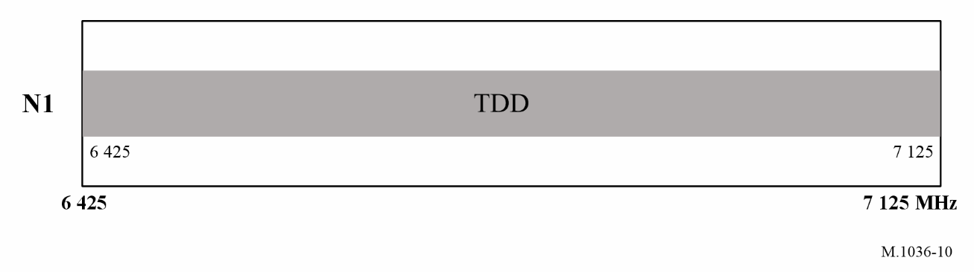
Figure 1: Frequency arrangement N1

Technical specifications development by 3GPP
In the 3GPP Release 19 technical specifications in December 2025, the 5G NR operating frequency band n104 has been specified for licensed use in the 6 425-7 125 MHz frequency range. These specifications define the relevant technical standards, including transmission and reception characteristics for base stations and user equipment, mainly in 3GPP TS 38.101-1 and 3GPP TS 38.104.
Table 2: Operating band for 6 425- 7 125 MHz
NR operating band | Uplink operating band (BS receive / UE transmit) | Downlink operating band (BS transmit / UE receive) | Duplex mode
n104 | 6 425- 7 125 MHz | 6 425- 7 125 MHz | TDD
3GPP TS 38.104 establishes the minimum RF characteristics and minimum performance requirements for NR base station (BS).
BS channel bandwidth requirements apply to the combination of BS channel bandwidths, SCS and operating bands shown in table Z. The transmission bandwidth configuration in table Z shall be supported for each of the BS channel bandwidths within the BS capability.
Table 3: BS channel bandwidths and SCS
NR Band | SCS (kHz) |  | BS channel bandwidth (MHz)
NR Band | SCS (kHz) | 3 | 5 | 7 | 10 | 15 | 20 | 25 | 30 | 35 | 40 | 45 | 50 | 60 | 70 | 80 | 90 | 100
n104 | 15 |  |  |  |  |  | 20 |  | 30 |  | 40 |  | 50
n104 | 30 |  |  |  |  |  | 20 |  | 30 |  | 40 |  | 50 | 60 | 70 | 80 | 90 | 100
n104 | 60 |  |  |  |  |  | 20 |  | 30 |  | 40 |  | 50 | 60 | 70 | 80 | 90 | 100
For band n104, the value of Maximum offset of the operating band unwanted emissions mask from the downlink operating band edge (Δf_{OBUE}) are defined in table X.
Table 4: Maximum offset of OBUE outside the downlink operating band for band n104
BS type | Operating band | Δf_{OBUE} (MHz)
BS type 1-H | n104 | 100
BS type 1-C | n104 | 40
For BS type 1-C operating in Band n104, the limits are specified in table 5:
Table 5: Wide Area BS type 1-C operating band unwanted emission limits for band n104 for Category B
Frequency offset of measurement filter -3dB point, Δf | Frequency offset of measurement filter centre frequency, f_offset | Basic limits | Measurement bandwidth
0 MHz ≤ Δf < 20 MHz | 0.05 MHz ≤ f_offset < 20.05 MHz | $$-7dBm-\frac{7}{20}\left(\frac{f_{offset}}{MHz}-0.05\right)$$ | 100 kHz
20 MHz ≤ Δf <  min(40 MHz, Δf_{max}) | 20.05 MHz ≤ f_offset <  min(40.05 MHz, f_offset_{max}) | -14 dBm | 100 kHz
40 MHz ≤ Δf ≤ Δf_{max} | 40.5 MHz ≤ f_offset < f_offset_{max} | -15 dBm (Note 3) | 1MHz
NOTE 1: For a BS supporting non-contiguous spectrum operation within any operating band the emission limits within sub-block gaps is calculated as a cumulative sum of contributions from adjacent sub-blocks on each side of the sub-block gap. Exception is Δf ≥ 40MHz from both adjacent sub-blocks on each side of the sub-block gap, where the emission limits within sub-block gaps shall be -15 dBm/1 MHz.
NOTE 2: For a multi-band connector with Inter RF Bandwidth gap < 2*Δf_{OBUE} the emission limits within the Inter RF Bandwidth gaps is calculated as a cumulative sum of contributions from adjacent sub-blocks or RF Bandwidth on each side of the Inter RF Bandwidth gap.
NOTE 3: The requirement is not applicable when Δf_{max} <40 MHz.
For BS type 1-H operating in Band n104, basic limits are specified in table 6:
Table 6: Wide Area BS type 1-H operating band unwanted emission limits for band n104 for Category B
Frequency offset of measurement filter -3dB point, Δf | Frequency offset of measurement filter centre frequency, f_offset | Basic limits | Measurement bandwidth
0 MHz ≤ Δf < 50 MHz | 0.05 MHz ≤ f_offset < 50.05 MHz | $$-7dBm-\frac{7}{50}\left(\frac{f_{offset}}{MHz}-0.05\right)$$ | 100 kHz
50 MHz ≤ Δf <  min(100 MHz, Δf_{max}) | 50.05 MHz ≤ f_offset <  min(100.05 MHz, f_offset_{max}) | -14 dBm | 100 kHz
100 MHz ≤ Δf ≤ Δf_{max} | 100.5 MHz ≤ f_offset < f_offset_{max} | -15 dBm (Note 3) | 1MHz
NOTE 1: For a BS supporting non-contiguous spectrum operation within any operating band the emission limits within sub-block gaps is calculated as a cumulative sum of contributions from adjacent sub-blocks on each side of the sub-block gap. Exception is Δf ≥ 100MHz from both adjacent sub-blocks on each side of the sub-block gap, where the emission limits within sub-block gaps shall be -15 dBm/1 MHz.
NOTE 2: For a multi-band connector with Inter RF Bandwidth gap < 2*Δf_{OBUE} the emission limits within the Inter RF Bandwidth gaps is calculated as a cumulative sum of contributions from adjacent sub-blocks or RF Bandwidth on each side of the Inter RF Bandwidth gap.
NOTE 3: The requirement is not applicable when Δf_{max} < 100 MHz.
For operating band n104, unwanted emission requirements of medium range BS type and local area BS type are also specified in 3GPP TS 38.104. 3GPP TS 38.101-1 also establishes the minimum RF requirements for NR User Equipment (UE) operating on frequency Range (FR) 1.
Band n104 is also supportive of intra-band carrier aggregation (CA) and inter-band CA with other 3GPP NR bands.
Table 7: Intra-band contiguous CA
NR CA Band | NR Band  (Table 5.2-1)
CA_n104 | n104

Table 8: Inter-band CA
NR CA Band | NR Band | Note
CA_n3-n104 | n3, n104 | n3 (FDD): UL 1710-1785 MHz, DL 1805-1880 MHz
CA_n8-n104 | n8, n104 | n8 (FDD): 880-915 MHz, DL 925-960 MHz
CA_n41-n104 | n41, n104 | n41 (TDD): UL/DL 2496-2690 MHz
CA_n78-n104 | n78, n104 | n78 (TDD): UL/DL 3300-3800 MHz
UE channel bandwidth requirements apply to the combination of channel bandwidths, sub-carrier spacing (SCS) and operating bands shown in Table 9. The transmission bandwidth configuration in Table 9 shall be supported for each of the specified channel bandwidths.
Table 9: UE channel bandwidth (MHz)
NR Band | SCS (kHz) | UE Channel bandwidth (MHz)
NR Band | SCS (kHz) | 3 | 5 | 7 | 10 | 15 | 20 | 25 | 30 | 35 | 40 | 45 | 50 | 60 | 70 | 80 | 90 | 100
n104 | 15 |  |  |  |  |  | 20 |  | 30 |  | 40 |  | 50
n104 | 30 |  |  |  |  |  | 20 |  | 30 |  | 40 |  | 50 | 60 | 70 | 80 | 90 | 100
n104 | 60 |  |  |  |  |  | 20 |  | 30 |  | 40 |  | 50 | 60 | 70 | 80 | 90 | 100
As shown in Table 10 below, UE maximum transmitter power is defined from 23 dBm to 29 dBm.
Table 10: UE power class
NR  band | Class 1 (dBm) | Tolerance (dB) | Class 1.5 (dBm) | Tolerance (dB) | Class 2 (dBm) | Tolerance (dB) | Class 3 (dBm) | Tolerance (dB)
n104 |  |  | 29 | +2/-3 | 26 | +2/-3 | 23 | +2/-3
Detailed technical characteristics of band n104 can be found in 3GPP TS 38.101 for UE and TS 38.104 for BS. NR repeater radio transmission and reception is specified in 3GPP TS 38.106. 3GPP technical report TR 38.908 describes to capture the background on the new BS EIRP mask requirement for NR band n104 for protection of Fixed Satellite Service (FSS) UL within 6 425 to 7 125MHz and how to conduct the conformance testing for the compliance of the new BS EIRP mask requirement.
As described above, all 3GPP technical specifications for the upper 6 GHz have been standardized and are ready for commercialization.
Additionally, in line with Resolution 220 (WRC‑23), the EIRP mask requirements for base stations operating in NR band n104, together with the associated test methods, are summarized in Technical Report (TR) 38.908. These EIRP mask requirements and test methods have also been incorporated into the relevant 3GPP specifications concerning base stations characteristics, as well as the corresponding test specifications.

Utilization of the frequency band 6 425-7 125 MHz for IMT - 6G channel bandwidth
The frequency band 6 425-7 125 MHz has a capability to support increasing customer demand and traffic growth as existing applications develop and new use cases are deployed at scale. It can be used for the future evolution of IMT systems, such as 5G-Advanced and 6G. This frequency band can provide the 200-400 MHz channel bandwidths that will be supported in the 6G era as shown in Figure 2. It can also accommodate multiple channels of over 200 MHz. Given the balance between available spectrum and number of IMT networks, a block of size of 200-400 MHz per mobile network operator is recommended.
Figure 2: Channel bandwidth expected for 6G
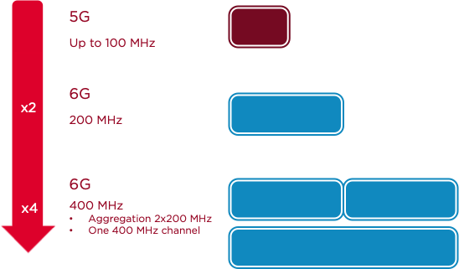
Source: GSMA
Cell capacity can be increased by using more spectrum and higher spectral efficiency systems with larger antenna arrays and new radio specifications. The current maximum component carrier (CC) bandwidth for 5G NR in the 3GPP specification is 100 MHz. However, as IMT network evolves, contiguous bandwidths (block sizes) of 200 MHz and 400 MHz in mid-band frequencies are expected to be the new norm, with 6G moving towards 400 MHz and beyond.
In line with this expected evolution, in March 2026, 3GPP agreed on the maximum channel bandwidth (CBW) of 400MHz in downlink (i.e., non-Carrier Aggregation single CC), and maximum CBW of 200MHz in uplink in the frequency range of 6 to 7 GHz.

Information on trials of IMT systems conducted in the frequency band 6 425-7 125 MHz
Trials related to IMT use in the frequency band 6 425-7 125 MHz have been carried out since 2022 to demonstrate the technical performance for deployment, reaching peak data speeds of 12 Gbps. These also show the ability of this band to improve city-wide capacity on existing network grids which may be used for 5G-Advanced or 6G.
Information on these including other trials in 2025 are listed below:
- Nokia: The potential of upper 6 GHz for 6G: Field insights and comparison with 3.6 GHz (https://www.nokia.com/asset/214700)
- SoftBank Corp. First Telecommunications Carrier in Japan to Launch Outdoor Trial of 7GHz Band for 6G (https://www.softbank.jp/en/corp/news/press/sbkk/2025/20250708_01/)
- Use of U6 GHz band for mobile - Performance evaluation and impact of shared use with RLANs (https://www.bt.com/content/dam/bt-plc/assets/documents/about-bt/tech-fellowship/use-of-u6-ghz-band-for-mobile.pdf)
- First pre-6G video stream in Austria: A1 and - Telekom Austria Group (https://newsroom.a1.group/news-first-pre-6g-video-stream-in-austria-a1-and-nokia-work-on-the-progress-of-mobile-technology?id=215803)
- Orange-Nokia Tests Confirm 6 GHz Band for Mobile Network - Orange Hello Future (https://hellofuture.orange.com/en/6-ghz-band-a-new-opportunity-for-future-mobile-networks-successfully-demonstrated-in-the-field/)
- Telefónica, Nokia and the UPV prove that the 6 GHz band for mobile communications through a pilot project (https://www.telefonica.com/en/communication-room/press-room/telefonica-nokia-and-the-upv-prove-that-the-6-ghz-band-for-mobile-communications-through-a-pilot-project/)
- The world first live 6GHz field deployment on du commercial spectrum allocated by TDRA (https://www.linkedin.com/posts/saleem-alblooshi-036763228_today-we-delivered-a-landmark-milestone-for-activity-7391442530132824064-69BD/)
- SoftBank Corp. Demonstrates Effectiveness of Centimeter-wave Spectrum in Urban Areas in Preparation for 6G (https://www.softbank.jp/en/corp/news/press/sbkk/2025/20251119_01/)
- 5G over 6 GHz: Faster than expected, and essential for the future according to Nokia and Orange (https://itdaily.com/blogs/network/orange-nokia-5g-6-ghz-demo/)
- CST Announces Success of First Regional Trial to Test 7 GHz Frequency Band for 6G (https://www.spa.gov.sa/N2436248)
- Germany: Deutsche Telekom demonstrates 12 Gbps on 5G using 6 GHz (https://www.telekom.com/en/media/media-information/archive/world-record-12-gigabits-per-second-in-mobile-communications-1048610)
- Thailand: 10 Gbps throughput achieved in 6 GHz trial by Chulalongkorn University (https://www.tct.or.th/event-th/23-association-event-th/1531-5g-a-imt-u6ghz-c-band)
- Malaysia: Maxis conducts 6 GHz field trial with Universiti Malaya (https://www.maxis.com.my/en/about-maxis/newsroom/2023/september/setting-the-right-path-to-meet-growing-data-consumption/)
- Australia: Telstra and Ericsson conducted a upper 6 GHz coverage trial (https://www.ericsson.com/en/blog/oceania/2025/powering-australias-digital-future-with-6ghz-for-mobile)
- Germany: Vodafone successfully completed the world’s first network test of 6 GHz spectrum using a commercially available chipset – the MediaTek M90 Modem – within a standard smartphone operating with 200 MHz bandwidth (https://www.vodafone.com/news/technology/vodafones-world-first-6ghz-spectrum-test-positions-europe-to-lead-in-advanced-5g-and-6g)
- UAE: e& UAE completed tests to utilize the 6-GHz for 5G services. The test has achieved data speeds of up to 10 Gbps by seamlessly aggregating the 6-GHz band with other FR1 TDD bands using commercial-grade customer premises equipment (CPE) (https://developingtelecoms.com/telecom-technology/wireless-networks/18302-e-uae-tests-6-ghz-and-600-mhz-bands-on-its-5g-network.html)

National regulation on IMT systems in the frequency band 6 425-7 125 MHz

10.1 China
In 2023, taking into account the international studies and the actual industry development, China decided to identify 6 425-7 125 MHz for IMT 5G/6G. A national footnote CHN45 was added to the National Table of Frequency Allocation (NTFA-2023) for IMT identification in 6 425-7 125 MHz. NTFA determined the status of 6GHz in the form of regulations in China, stabilized 5G/6G industry expectation and promote global/regional harmonization of the most valuable 5G/6G necessary mid-band spectrum.
Trial in 6 425-7 125 MHz band for IMT was conducted in China. In a trial in 2025, a 10Gbps downlink peak rate was reached by using 400MHz bandwidth, which proves the technical capability and the value of IMT in 6 425-7 125 MHz towards 5G-A and beyond.
In May 2026, to further advance the research and development, standardization, and industrialization of 6G technologies in China, the Ministry of Industry and Information Technology granted the IMT-2030 (6G) Promotion Group approval to use the 6 GHz frequency band for 6G testing. This authorization supports the group in conducting 6G technology trials in certain regions, focusing on research and development and testing and verification of key technologies and performance indicators for typical 6G scenarios as defined by the International Telecommunication Union.
(https://www.miit.gov.cn/xwfb/gxdt/sjdt/art/2026/art_e79e856fc58f4de0a21f79251fa61ef6.html).

10.2 Viet Nam
In 2025, Viet Nam decided to identify the 6 425 – 7 125 MHz band, or a portion thereof, for IMT. Consequently, a national footnote (VTN 16) was added to the National Table of Frequency Allocation to reflect this IMT identification.

10.3 Australia
In December 2024, after considering domestic and international factors for the future use of the 6 425-7 125 MHz band, Australia decided to:
- Reserve 6 585-7 100 MHz for IMT systems.
- Allocate the frequency segment 6 425-6 585 MHz for RLAN.
- Retain the frequency segment 7 100-7 125 MHz for TOB(Television Outside Broadcast).
The 6 585-7 100 MHz band is under the implementation stage of the ACMA Five-Year Spectrum Outlook 2026-31 with a consultation on the licensing approach planned for Q4 2026.
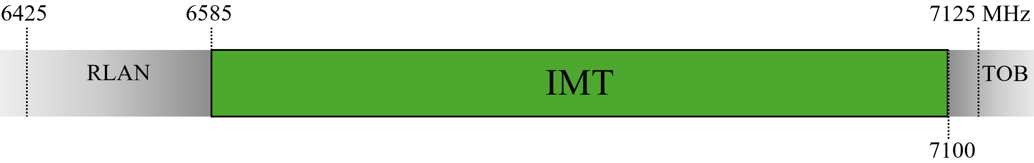

Summary
The 6 425-7 125 MHz frequency band was identified for IMT at WRC-23 in Region 1, which includes Europe, Africa and some parts of the Middle East. In addition, some countries in Region 2 have identified this frequency band for IMT. In Region 3, while the frequency band 7 025-7 125 MHz has been identified for IMT throughout the Region, the frequency band 6 425-7 025 MHz has been identified in three countries. Following WRC-23, interest has been growing among APT Members in the possible use of this frequency band, or portions thereof, for IMT.
Since WRC-23, progress has been made in establishing the technical basis for IMT implementation in this frequency band. ITU-R has included a frequency arrangement for this frequency band in Recommendation ITU-R M.1036-8, and 3GPP has developed technical specifications for 5G NR band n104, including radio transmission and reception characteristics for base stations and user equipment. 3GPP has also completed the specifications related to the base-station e.i.r.p. mask introduced by Resolution 220 (WRC-23), including their associated conformance testing specifications. In parallel, a number of trials have been conducted in various countries to demonstrate the capability of the frequency band 6 425-7 125 MHz to deploy IMT systems. In addition, some APT Members have already amended their national regulatory frameworks to enable IMT use in this frequency band.
This mid-band spectrum offers a good balance between mobility, coverage and data capacity, making it essential to promote growth and innovation of IMT technology. It is therefore the frequency band 6 425-7 125 MHz is expected to play an important role in supporting the evolution of IMT systems, especially when 6G is on the horizon.

ANNEX:

Information on field trials of IMT systems in the frequency range 6 425-7 125 MHz
The frequency band 6 425–7 125 MHz (U6GHz) was a key topic at WRC-23, where it was identified for IMT in several countries. Whilst, the adjacent band 7 125–8 400 MHz is studied for potential IMT identification at WRC-27 under Agenda Item 1.7.
These mid-band frequencies provide an optimal balance between mobility, coverage, and data capacity, making them critical in supporting the continued growth and innovation of IMT technologies—particularly as the industry advances towards 6G.
The IMT industry has been conducting research and development (R&D) to enable the use of these mid-band frequencies for IMT, following the outcomes of WRC-23. Major R&D campuses around the world played a central role in advancing the technology. Up until the beginning of 2026, the IMT industry has conducted field trials in at least 9 countries in collaboration with local operators, with more than 20 macro-cellular trials completed. Several of these activities have also been integrated into broader 6G research programmes.
This Annex provides further information and practical deployment considerations, particularly those that influence mobile network planning and grid design.
1. IMT coverage analysis in 3.6 GHz and U6GHz
The frequency band 3.4-3.8 GHz (3.6GHz) has been harmonized in Europe for the use of IMT and the mobile network grid for this 3.6GHz is quite mature. Mobile Network Operators (MNOs) plan their network carefully to ensure the right coverage and quality of service for their end users (customers/subscribers).
There has been some analysis and coverage simulations on the different frequency bands, which includes comparing the U6GHz frequency against the mature 3.6GHz band. One of such analysis by Nokia can be found in their whitepaper “Coverage evaluation of 7–15 GHz bands from existing sites” - https://www.nokia.com/asset/i/213702/.
2. Field trial: 3.6 GHz and U6GHz comparison
These mid-band frequencies offer good balance of mobility, coverage and data capacity, making it essential to promote growth and innovation of IMT technology especially when 6G is on the horizon.
Simulations and analyses have shown very promising results; that the U6GHz mobile network grid can use the existing 3.6GHz grid, hence, simplifying the deployment of U6GHz network. This was validated in real deployments in the field as extensive field trials by the IMT industry. Some of these trials are also incorporated into the individual 6G program for the continual innovation of mobile technology.
2.1 Telia-Nokia field trial in Espoo, Finland
Some extensive field trials were carried out in Espoo, Finland, in 2025 by Nokia and Telia (an MNO), which is documented in their whitepaper, “The potential of upper 6 GHz for 6G: Field insights and comparison with 3.6 GHz”, (https://www.nokia.com/asset/214700/).
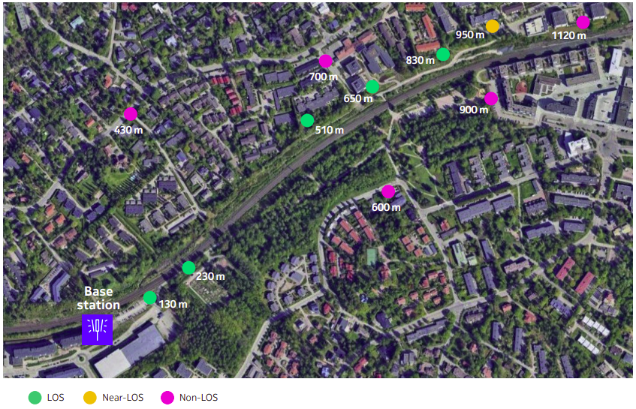
Figure A1: Telia-Nokia field trial site in Espoo, Finland
Figure A1 illustrates the location of the field trial in Espoo, Finland, along with the different propagation conditions. Figure A2 shows the location of the base station and where the two different radios were mounted.
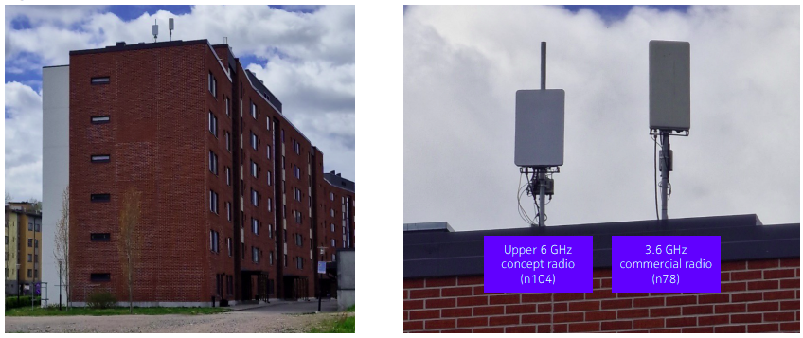
Figure A2: Rooftop site with upper 6 GHz and 3.6 GHz radios
2.1.1 Outdoor-to-Outdoor
The outdoor-to-outdoor (O2O) results are summarized in Figure A3 where it shows the downlink and uplink data throughput in line-of-sight (LoS) and non-line-of-sight (nLoS) environments.

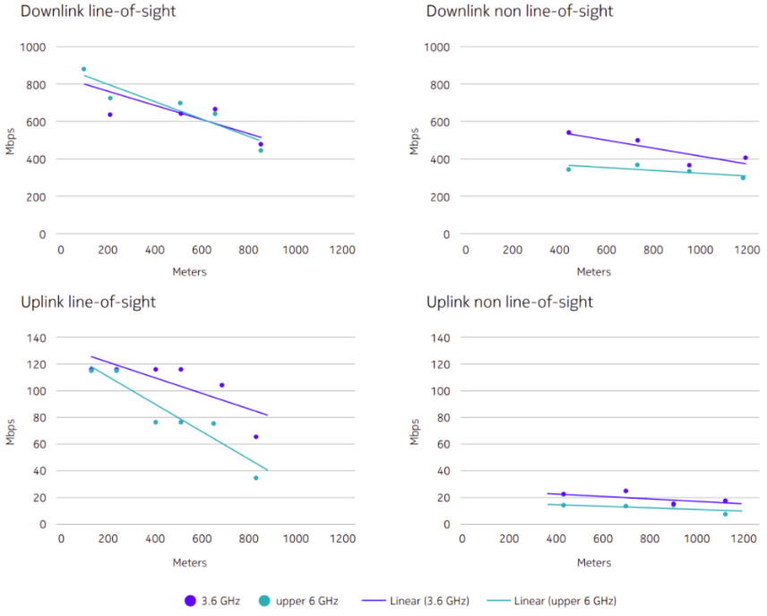
Figure A3: O2O Downlink/Uplink LoS and nLoS throughput results
2.1.2 Outdoor-to-Indoor
The field trial also includes outdoor-to-indoor tests and Figure A4 gives a sense of the location of the user-equipment (UE) in relation to the base station.
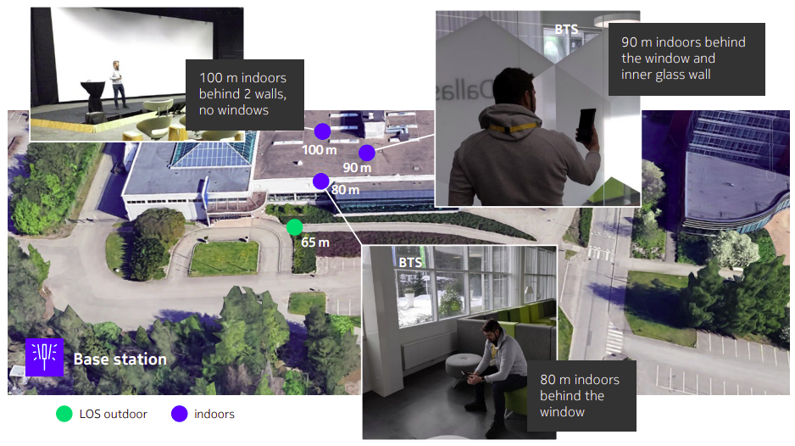
Figure A4: O2I measurement points and location
The outdoor-to-indoor (O2I) results are summarized in Figure A5 where it shows the downlink and uplink measurement data throughputs.
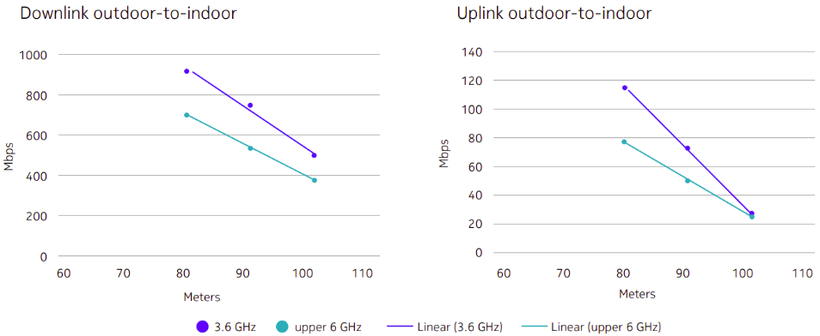
Figure A5: O2I Downlink/Uplink throughput results
2.1.3 Summary of the field trial and further information
The tests performed have confirmed the suitability of the U6GHz band for macro-cellular deployments. This also means that 6G can be deployed in the upper 6 GHz and 7 GHz radios with the current 3.6GHz 5G mobile network grid in urban and dense urban areas in nearly all cases. It has demonstrated the ability to provide coverage and additional capacity for mobile networks, effectively serving both outdoor and indoor users. Extrapolating the result to a bandwidth of 200 MHz significantly improves the throughput and performance in both O2O and O2I scenarios, for both uplink and downlink.
2.2 BT-Nokia field trial in Ipswich, United Kingdom
Nokia has also conducted similar 3.6GHz / U6GHz comparison field trial in the United Kingdom in May 2025 with the BT Group who is an MNO as well as fixed-line broadband provider.
2.2.1 Static Measurements
The location of the base station and the static measurement locations are shown in Figure A6. Both outdoor and indoor scenarios were considered to evaluate O2O and O2I scenarios.
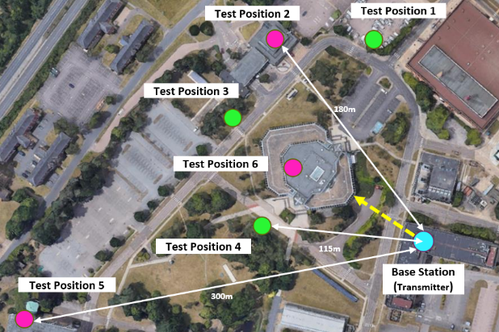
Figure A6: Field trial test positions (Ipswich, United Kingdom).
The trial records the received signal power and the average downlink throughput at each test position. The results are shown in Figure A7.
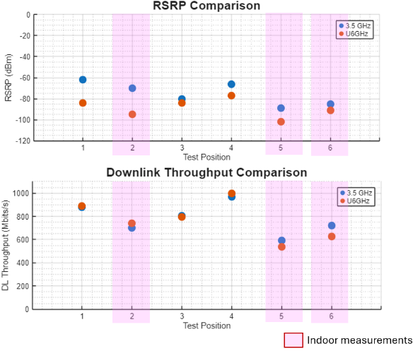
Figure A7: The static measurement of received signal power and downlink throughput.
2.2.2 Drive Test
In addition, a drive test was carried out, measuring the RSRP and the downlink throughput on the move. The results are shown in Figure A8.
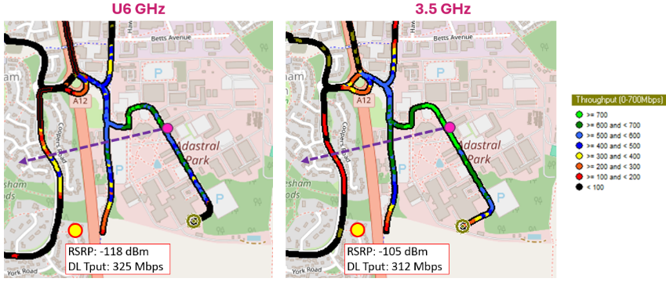
Figure A8: The drive test measurement result.
2.2.3 Summary of the field trial and further information
This second example of the field trial shows similar results to the Telia-Nokia trial where the performance of U6GHz radio is comparable to 3.6GHz radio, for both the static measurements and the drive test measurements.
Further information on this field trial is available at https://www.bt.com/bt-plc/assets/documents/about-bt/tech-fellowship/use-of-u6-ghz-band-for-mobile.pdf.
3. Ecosystem readiness of IMT in the upper 6 GHz
Field trials using real networks are usually the final few steps indicating ecosystem readiness. The result of these trials indicates that IMT in U6GHz can be deployed on the same 3.6GHz mobile network grid, while achieving similar performance. This is an important insight into the IMT network planning. Although further checks are required, these trials have certainly removed some doubts and critics of IMT indoor (and deep indoor) usability. It also shows that IMT in U6GHz can achieve comparable performance to those deployed in 3.6GHz band.
3.1 Commercial hardware
The field trials shown in Section 2 were carried out using Nokia’s platform, which is their Massive MIMO radio using the in-house chipset developed by Nokia Bell Labs. The platform isn't just a testbed; it is the blueprint for Nokia’s commercial 6G-ready hardware. By proving in field trials that it can deliver 3.6 GHz-like coverage on a 6/7 GHz frequency while staying within the weight and power limits of current towers, the IMT industry has cleared the technical path for mass-market commercial deployment.

https://www.nokia.com/bell-labs/research/6g-networks/6g-technologies/new-spectrum-technologies/
https://www.3gpp.org/ftp/tsg_ran/TSG_RAN/TSGR_111/Docs/RP-260798.zip
CEPT treats IMT as the primary technology that fulfils the requirement of an MFCN which stands for Mobile/Fixed Communications Networks.
This is the Reference Signal Received Power (RSRP)

