

APT REPORT ON

ANALYSIS OF MOBILE TRAFFIC TRENDS IN IMT NETWORKS

Edition: September 2026

The 37th Meeting of APT Wireless Group
7 – 11 September 2026
Dhaka, Bangladesh (Hybrid)

(Source: AWG-37/OUT-06)

No. APT/AWG/REP-160

APT REPORT ON
ANALYSIS OF MOBILE TRAFFIC TRENDS IN IMT NETWORKS

Table of contents
1. Introduction 3
2. Scope 3
3. Statistical data on mobile traffic collected from IMT networks in APT countries 3
3.1 Japan 3
3.2 China 5
3.3 Republic of Korea 6
3.4 Thailand (Kingdom of) 7
4. Analysis of current and future mobile traffic trends in IMT networks 8
4.1 Global Mobile Traffic Trends: Insights from the Ericsson Mobility Report 8
4.2 Bell Labs Consulting, Nokia 13
4.3 Nokia Mobile Broadband India Traffic (MBiT) Index 17
4.4 GSMA Vision 2040 study 20
5. Summary 24

Introduction
IMT systems play a fundamental role in shaping social and economic infrastructure and are closely tied to everyday life. Under these circumstances, the amount of mobile traffic in IMT networks continues to grow across many countries. While the significance of this trend is widely recognized, a comprehensive analysis of mobile traffic trends in IMT networks has not yet been conducted in previous AWG studies. This Report addresses this gap by providing a consolidated analysis of mobile traffic trends, and the factors influencing them.

Scope
This APT Report analyses the current status and future prospects of mobile traffic in IMT networks. This Report includes statistical data on mobile traffic collected from IMT networks in APT Members’ countries. In addition, several analyses of current and future mobile traffic trends conducted by relevant entities are included and compiled in this Report.

Statistical data on mobile traffic collected from IMT networks in APT countries
  - Japan
Since June 2010, the Ministry of Internal Affairs and Communications has publicly released data on mobile communication traffic over IMT networks in Japan. These data are compiled from reports submitted by mobile network operators every three months, with uplink and downlink measurements taken hourly throughout each reporting period.
Figure3.1-1 presents long-term trends in IMT traffic since June 2010. As of September 2025, IMT traffic in Japan has shown the following increases:
- Approximately 126.9-fold increase over about 15 years since the launch of LTE services (December 2010),
- Approximately 8.8-fold increase over the most recent 10 years,
- Approximately 2.6-fold increase over about 5 years since the launch of 5G services (March 2020).
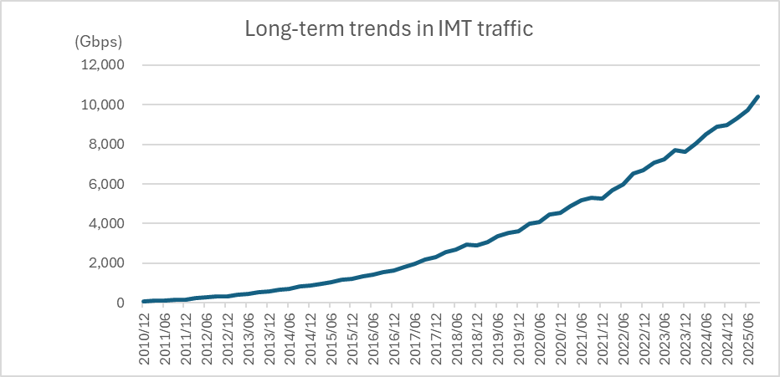
Figure3.1-1: Monthly averaged total IMT traffic (long term, 2010-2025)
Figures 3.1-2(a) and 3.1-2(b) show IMT traffic trends over the three-year period from September 2022 to September 2025. Figure 3.1-2(a) presents the average monthly traffic, while Figure 3.1-2(b) shows the corresponding average traffic per subscription. As of September 2025:
- Average monthly traffic increased by approximately 1.6 times over the past three years and by about 1.2 times over the past year,
- Average traffic per subscription increased by approximately 1.4 times over the past three years and by about 1.1 times over the past year.
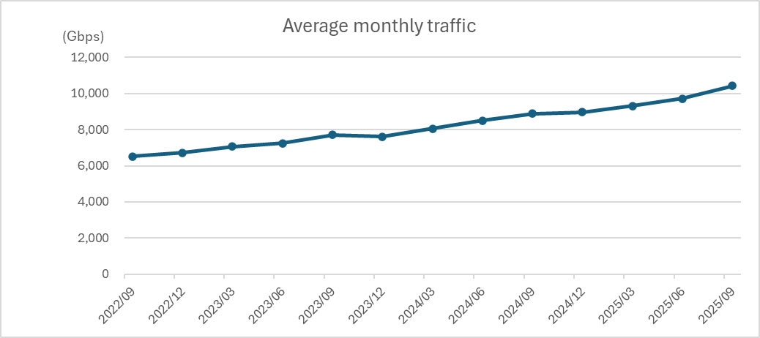
Figure 3.1-2(a): Monthly averaged total IMT traffic (past three years, 2022-2025)
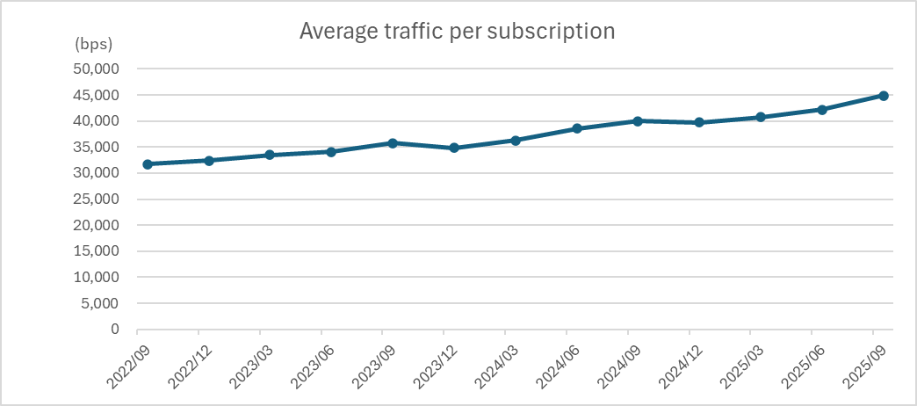
Figure 3.1-2(b): Monthly averaged total IMT traffic per subscription
(past three years, 2022-2025)
Figure 3.1-3 illustrates weekly variations in IMT traffic throughout the day, showing the following patterns:
- On weekdays, downlink traffic gradually increases from morning, peaks briefly around noon, and reaches its maximum between 21:00 and 22:00
- On weekends, downlink traffic increases from morning to noon and then remains steady for the rest of the day

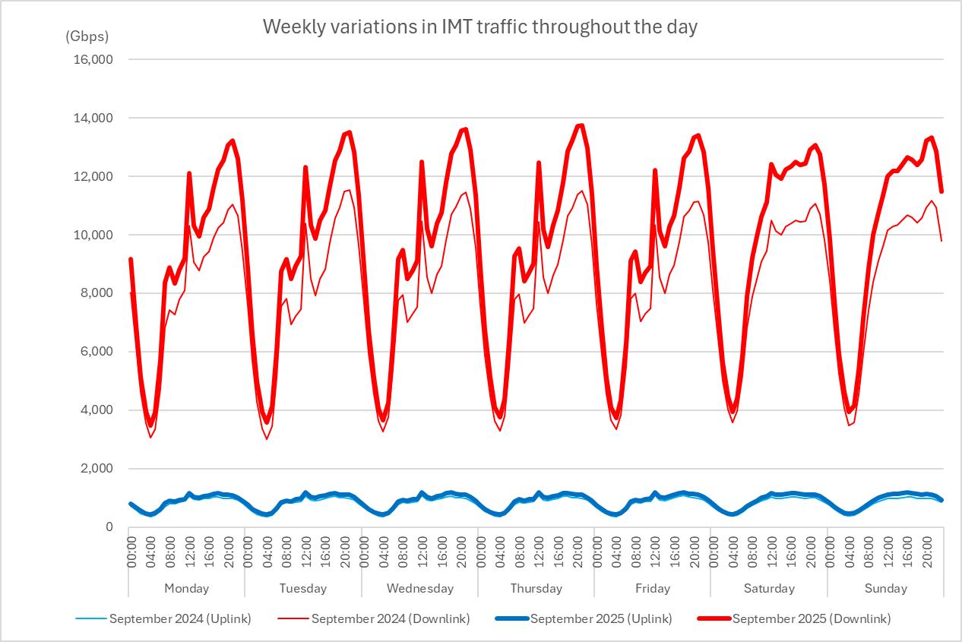
Figure 3.1-3: Weekly variations in IMT traffic throughout the day
  - China
Mobile Internet access traffic reached 395.8 billion GB in 2025, an increase of 17.3% over the previous year. The average monthly access traffic (DOU) reached 20.74 GB/household/month, an increase of 14.1% over the previous year. The DOU in December 2025 reached 23.04 GB/household/month, an increase of 3.34 GB/household/month over that of December 2024.
Figure 3.2-1 shows mobile internet access traffic and monthly average mobile internet traffic per household over the six-year period from the year 2020 to 2025.
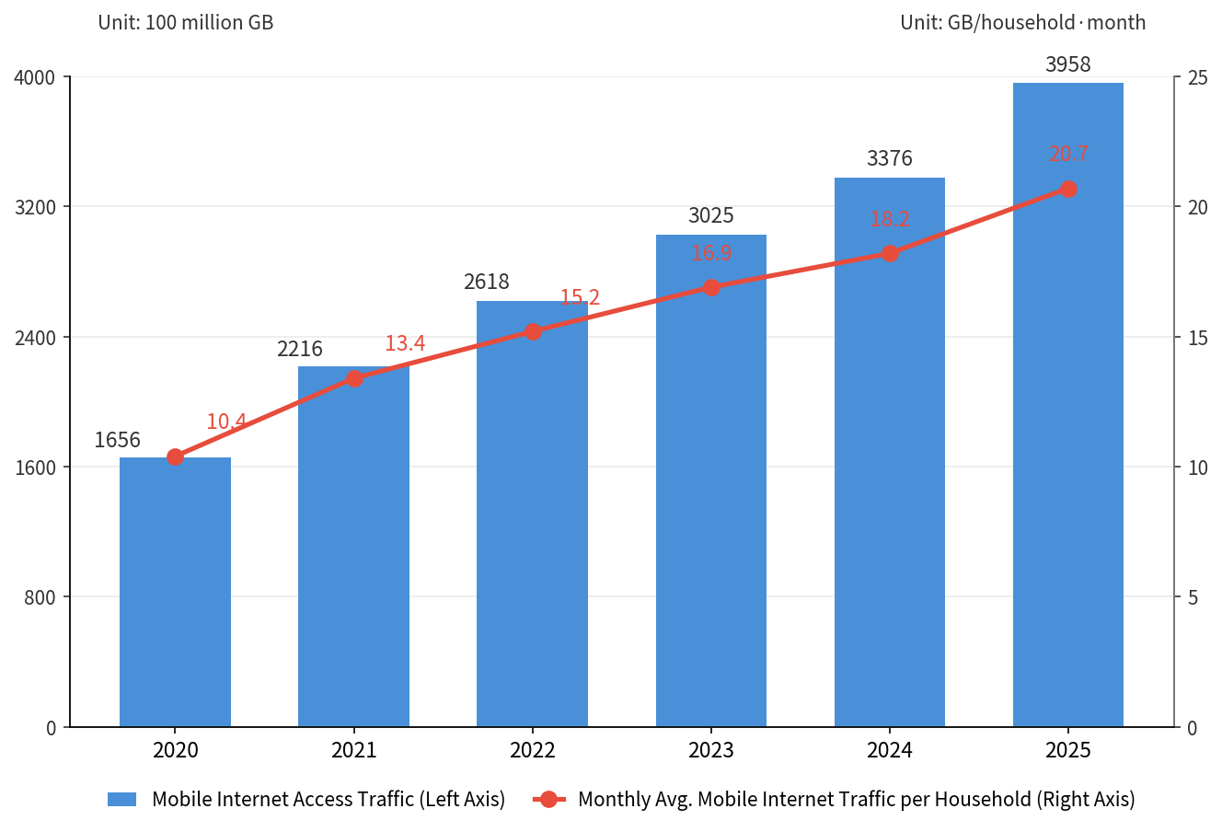
Figure 3.2-1: Mobile internet access traffic and monthly average mobile internet
traffic per household
By the end of 2025, the total number of mobile IoT terminal users in China has reached 2.888 billion, up by 8.8% year on year, and the user increasement was 232 million, accounting for 61.3% of the total number of mobile terminal connections. Mobile IoT terminals has been widely used in public services, the Internet of Vehicles, smart retail, and smart home, with the scale reaching 1.164 billion, 529 million, 365 million, and 323 million users respectively.
Figure 3.2-2 shows the total number of mobile IoT terminal users and the share of mobile IoT terminal users in total mobile terminal connections over the six-year period from the year 2020 to 2025.
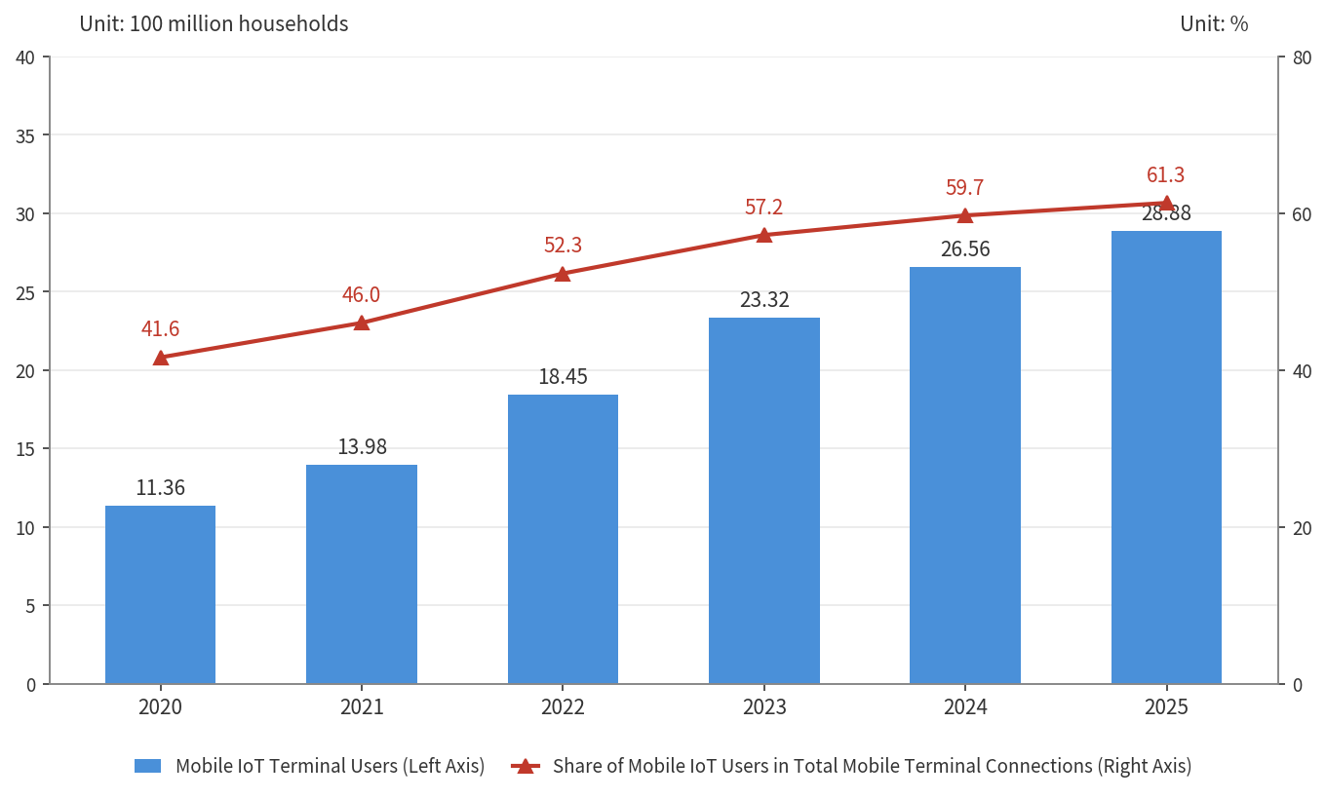
Figure 3.2-2: Total number of mobile IoT terminal users and the share of mobile IoT terminal users in total mobile terminal connections
  - Republic of Korea
The Ministry of Science and ICT of the Republic of Korea releases mobile traffic statistics every month. According to the latest statistics released in August 2026, as shown in Figure 3.3-1 below, total mobile traffic generated by 3G, 4G, and 5G networks reached approximately 1.53 EB as of June 2026, representing an approximately 2.18-fold increase compared to 0.702 EB recorded in December 2020. While traffic on 3G and 4G networks has continued to decline, 5G traffic has steadily increased, driving the continued growth in overall mobile data traffic.
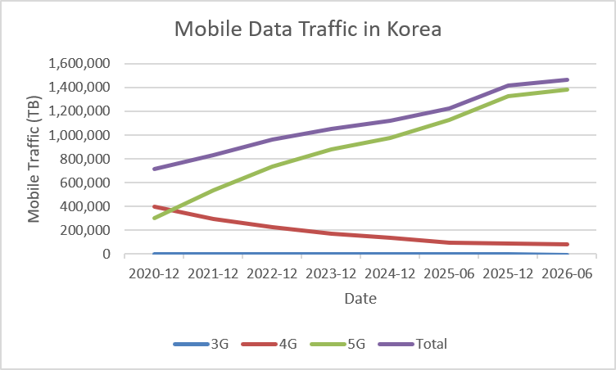
Figure 3.3-1: Mobile Data Traffic in Korea (December 2020 to June 2026)
  - Thailand (Kingdom of)
The Office of the National Broadcasting and Telecommunications Commission (NBTC) collects and compiles statistical data on mobile broadband traffic in Thailand based on submissions from Thailand’s mobile network operators.
Figure 3.4-1 summarizes mobile broadband internet traffic in Thailand from 2022 to 2025. It covers domestic mobile broadband traffic, downlink and uplink combined, measured at the point of user connection, carried over 3G and higher-generation mobile networks, and excludes wholesale and walled-garden traffic.
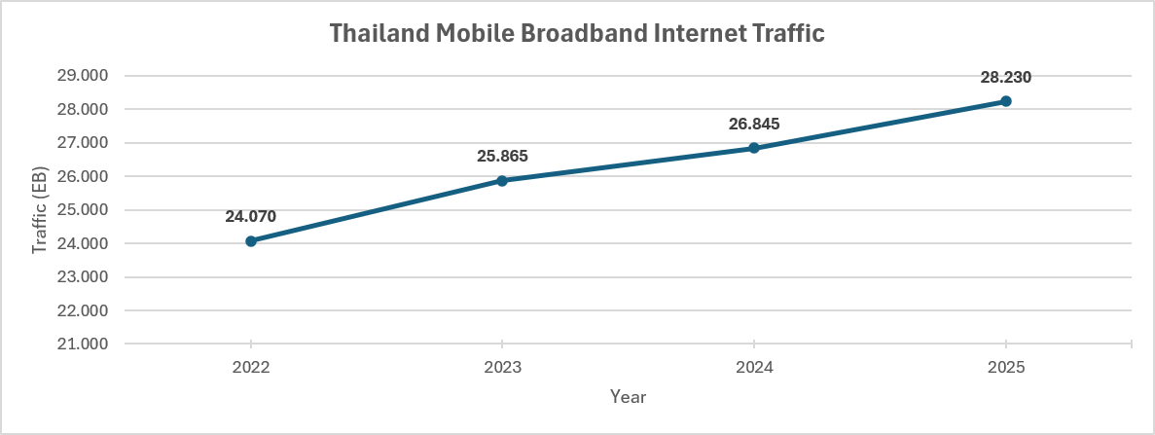
Figure 3.4-1: Mobile broadband internet traffic in Thailand, 2022 to 2025 (Exabytes)
Mobile broadband internet traffic in Thailand grew by approximately 17.3% between 2022 and 2025, from 24.07 to 28.23 Exabytes, a compound annual growth rate (CAGR) of about 5.5% per year. Year-on-year growth was strongest in 2023 (+7.5%), slowed in 2024 (+3.8%), and picked up again in 2025 (+5.2%).
Figure 3.4-2 summarizes average monthly mobile data usage per mobile broadband subscription. Due to the decrease in the total number of mobile subscribers, the actual mobile data usage per subscription rose more sharply over the same period compared to the total mobile broadband internet traffic in Thailand.
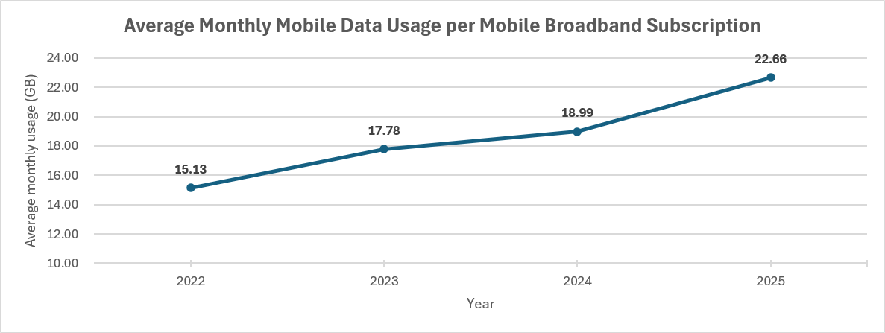
Figure 3.4-2: Average monthly mobile data usage per mobile broadband subscription, 2022–2025 (GB/month/subscription)
Average monthly mobile data usage per subscription rose from 15.13 GB in 2022 to 22.66 GB in 2025, an increase of about 49.8%, equivalent to a CAGR of approximately 14.4% per year. Growth accelerated in 2025 (+19.3%), following the more moderate growth in 2024 (+6.8%).

Analysis of current and future mobile traffic trends in IMT networks
  - Global Mobile Traffic Trends: Insights from the Ericsson Mobility Report
Global mobile networks are entering a new phase of traffic growth and transformation. While the rapid increase in mobile data traffic has been a defining characteristic of successive generations of mobile systems, the nature of future traffic growth is expected to change significantly. In addition to continued growth in conventional mobile broadband services, emerging artificial intelligence (AI)-enabled applications, generative and agentic AI, AI/AR smart glasses, autonomous systems and connected intelligent devices are expected to introduce new and increasingly uplink-intensive traffic patterns.
Ericsson Mobility Report (EMR) is a quarterly published industry report that provides insights into global mobile traffic, subscriptions, device usage, and network evolution. Based on measurements from commercial networks and extensive analysis, it tracks historical trends and offers forward-looking forecasts on mobile data growth, technology adoption such as 5G, and emerging use cases. The following figures from EMR of June 2026 illustrate the historical growth, current trends, and future projections of global mobile network data traffic, including total monthly traffic volumes, year-on-year growth rates, and average data consumption per active smartphone. More details can be found in the online full report, and customized data or graph can be generated by using an online tool, which is an interactive, web-based- tool designed to help users explore, visualize, and analyse mobile traffic and subscription data.
Figure 4.1-1 below shows the total global monthly network data traffic from Q1 2019 to Q1 2026, along with year-on-year percentage growth for mobile network data traffic. The year-on-year growth in Q1 2026 was mainly driven by continued strong growth in India and North America. Total monthly global mobile network data traffic reached 210 EB. The quarter-on-quarter mobile network data traffic growth between Q4 2025 and Q1 2026 was around 5 percent. Mobile data traffic growth is being driven by both rising smartphone subscriptions and increasing average data volume per subscription, fuelled primarily by increased video content consumption. At the end of 2025, video traffic accounted for around 75 percent of all mobile data traffic.
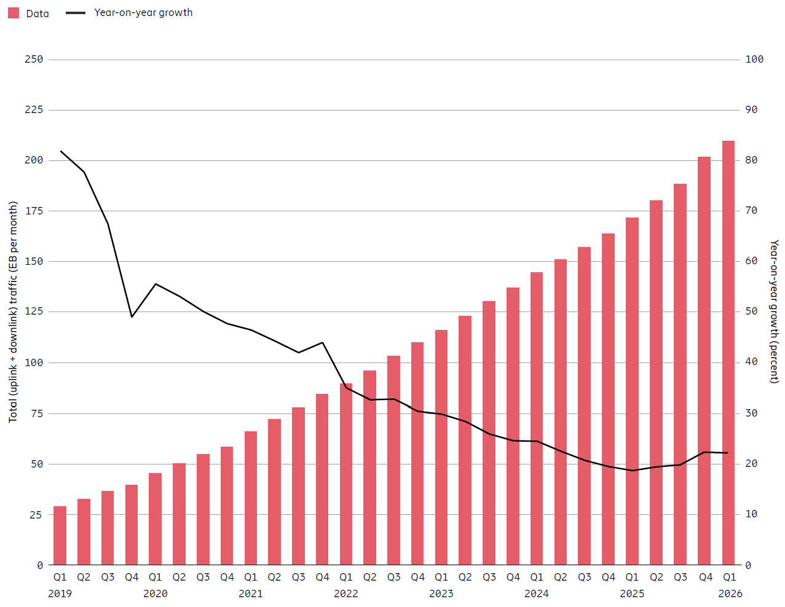
Figure4.1-1: Global mobile network data traffic and year-on-year growth
Note: Mobile network data traffic also includes traffic generated by Fixed Wireless Access services.
Figure 4.1-2 illustrates the expected future growth of global mobile network data traffic over the forecast period. Both global mobile data traffic and total mobile network data traffic, which includes FWA, grew slightly above expectations during 2025, ending the year at 146 EB per month and 203 EB per month respectively. Looking ahead, the projected growth rate for mobile data traffic during the forecast period remains consistent with the estimate from six months ago, with a growth factor of around 2.2 to reach 328 EB per month in 2031. Including FWA, total mobile network data traffic is anticipated to grow by a factor of around 2.5 during the period, slightly higher than the estimate six months ago, reaching 515 EB per month.
During 2025, the share of mobile data traffic carried over 5G increased from 34 percent to 48 percent and is projected to reach 85 percent in 2031. Total mobile network data traffic is expected to grow at 14 percent year-on-year in 2031, with a CAGR of 17 percent over the full forecast period. Mobile data traffic generated by 6G subscriptions is anticipated to represent a small share of the total in 2031.
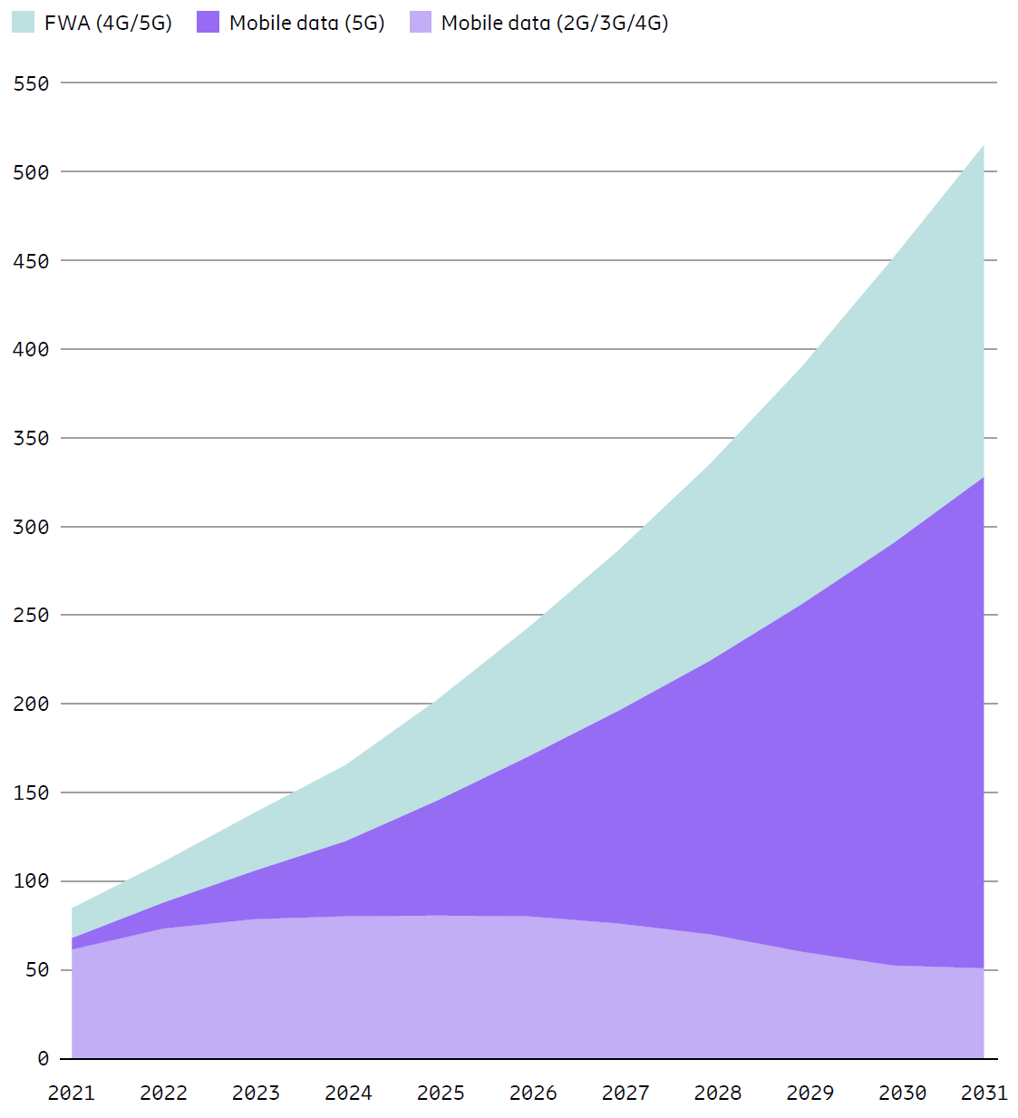
Figure 4.1-2: Global mobile network data traffic (EB per month)
Figure 4.1-3 illustrates the development and forecast of average monthly mobile data traffic per active smartphone, highlighting a clear and sustained increase over time. The growth in total network traffic is accompanied by a substantial increase in traffic consumption at the individual device level. Global average mobile data traffic per active smartphone reached approximately 22 GB per month in 2025 and is forecast to reach approximately 42 GB per month in 2031, representing a CAGR of approximately 12 percent.
Significant regional differences are expected to remain. For example, monthly traffic per active smartphone in India, Nepal and Bhutan is projected to increase from 37 GB in 2025 to 70 GB in 2031. Western Europe is projected to increase from 25 GB to 59 GB, while North America is expected to increase from 25 GB to 52 GB. These projections demonstrate that traffic growth is not limited to markets with currently low data consumption; substantial growth is also expected in already mature mobile broadband markets.

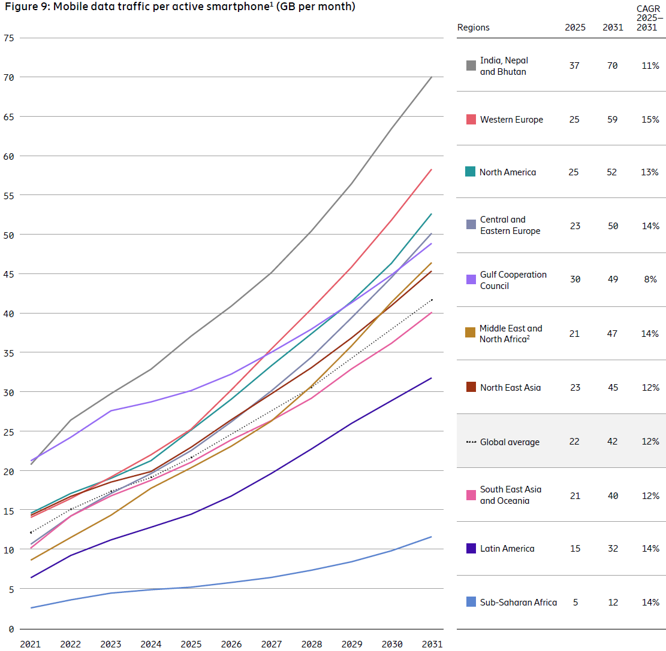
Figure 4.1-3: Mobile data traffic per active smartphone (GB per month)
Note: Traffic per active smartphone refers to all traffic generated by that device, regardless of number of subscriptions attached.
Historically, mobile networks have been primarily designed and dimensioned for downlink-dominated traffic patterns. Video streaming, web browsing and content consumption have resulted in substantially greater downlink than uplink traffic volumes. However, this historical asymmetry is beginning to change.
Measurements across 55 service providers globally show that 43 service providers experienced a higher uplink traffic growth rate than downlink growth in 2025, while 17 service providers experienced an uplink growth rate more than 1.5 times higher than the corresponding downlink growth rate. Although downlink traffic is expected to remain dominant in absolute terms, these observations indicate an important structural shift in mobile traffic patterns.
AI is expected to accelerate this shift. Unlike conventional content-consumption applications, many AI-driven services require devices to continuously capture and transmit information to cloud or edge-based AI systems. Camera images, video, audio, sensor information, location data and other contextual information may be transmitted in the uplink for real-time analysis and interaction.
For example, AI/AR smart glasses may require uplink throughput ranging from approximately 1 Mbps to 10 Mbps depending on the application. Where camera, audio and sensor information are streamed for cloud AI processing, the traffic ratio can become heavily uplink-dominated. Similarly, autonomous vehicles, drones, AI-assisted cameras and agentic AI systems can generate persistent uplink traffic through telemetry, video and environmental sensing.
This represents a fundamental difference from the traffic model that has historically shaped mobile network design. Future mobile devices may increasingly act not only as consumers of network content, but also as continuous producers of data describing their physical environment.
Scenario analysis in the Ericsson Mobility Report illustrates the potentially significant impact of AI adoption on uplink traffic growth, as shown in Figure 4.1-4. Depending on the penetration of AI-enabled devices and the intensity of AI application usage, uplink traffic in 2031 could increase to approximately two to five times the 2025 level.
In the medium AI adoption scenario, additional AI traffic results in uplink traffic approximately three times higher in 2031 than in 2025. This scenario assumes significant adoption of smartphone-based AI assistants, growing use of AI/AR smart glasses, initial adoption of AI-assisted cloud gaming and AI companions, together with AI-enabled industrial and connected devices.
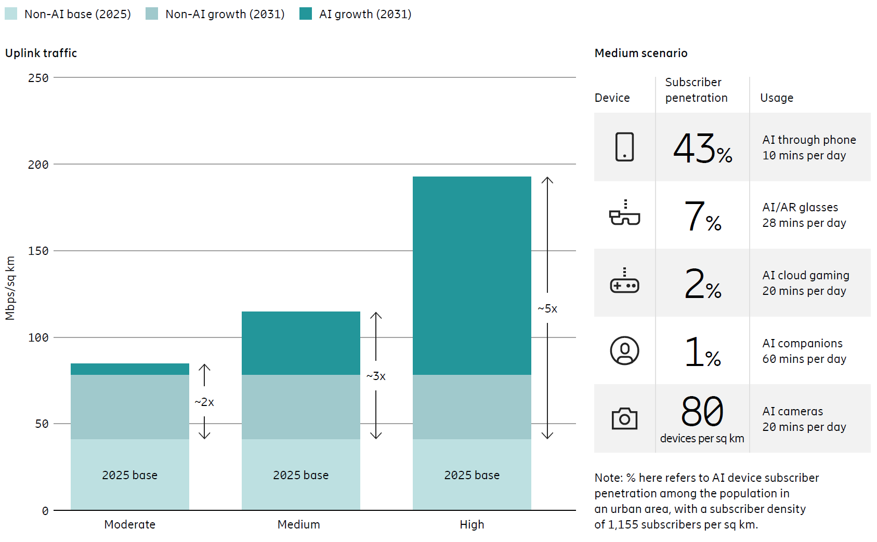
Figure 4.1-4: AI traffic impact on uplink growth
The analysis further highlights that AI-driven applications are inherently more uplink-intensive because they involve real-time interaction, video capture and continuous data generation. For the modelled applications, an average uplink throughput requirement of 1.5 Mbps is assumed, compared with a corresponding downlink requirement of 0.5 Mbps. This does not imply that overall mobile networks will become uplink-dominated; rather, it indicates that uplink capacity and coverage may increasingly become a limiting factor for new services even while total traffic remains downlink-dominated.
This distinction is important for international discussions on future mobile network evolution. A network designed primarily to accommodate aggregate downlink traffic growth may not necessarily be capable of supporting a large number of simultaneously active, uplink-intensive AI services. Capacity requirements must therefore increasingly consider the direction, persistence and simultaneity of traffic in addition to total traffic volume.
In summary, Mobile traffic will continue to grow rapidly through 2031, with global total mobile network traffic projected to increase from approximately 203 EB per month in 2025 to approximately 515 EB per month. At the same time, the future challenge is not only the magnitude of traffic growth, but also the changing nature of that traffic.
AI-enabled applications, intelligent devices and autonomous systems are expected to increase the importance of uplink connectivity by generating continuous streams of video, sensor and contextual information. Scenario analysis indicates that AI adoption could substantially accelerate uplink growth, with uplink traffic in 2031 potentially reaching two to five times the 2025 level depending on the pace of adoption.
Therefore, future mobile network evolution should address both continued overall traffic growth and the emerging shift toward more uplink-intensive traffic patterns. Technology development, spectrum planning and network dimensioning should increasingly consider uplink capacity, coverage and flexibility as key enablers of the AI-driven mobile ecosystem. Ensuring that future networks can efficiently support both downlink-intensive content delivery and uplink-intensive AI services will be essential for enabling the next generation of mobile connectivity.

4.2 Bell Labs Consulting, Nokia
Nokia, with its Bell Labs Consulting arm, produces annual forecasts of global network traffic to support planning and decision-making. This Global Network Traffic report covers several areas including mobile traffic data and its related elements. The latest report (2025) defines three scenarios – conservative, moderate and aggressive to give a range of possible outcomes. The following sub-sections are an extract from the report.

4.2.1 Mobile traffic growth
Total consumer mobile traffic is projected to reach 364–633 EB/month by 2034, growing at 12–18% CAGR, primarily driven by video and social media usage.
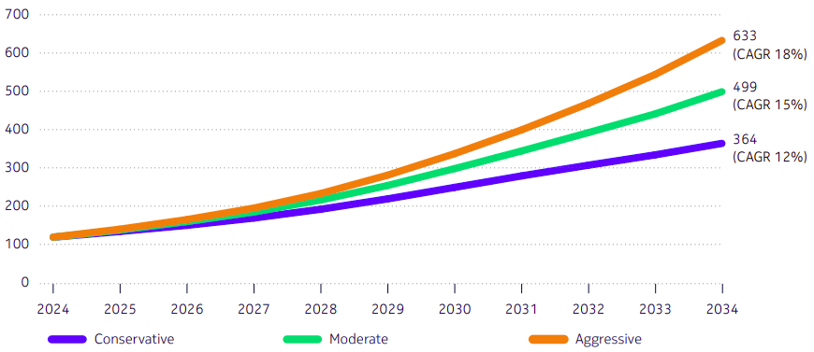
Figure 4.2.1-1: Consumer mobile traffic, EB/month.
Video traffic will remain the core growth engine, contributing nearly three-fourths of total mobile data, supported by AI-powered recommendations, GenAI-led content creation, and adoption of high resolution, large-screen and foldable devices. However, advancements in video codecs will help moderate traffic growth by improving compression efficiency even as video quality and viewing time rise. Social networking will maintain a steady share of around 9% throughout the period.
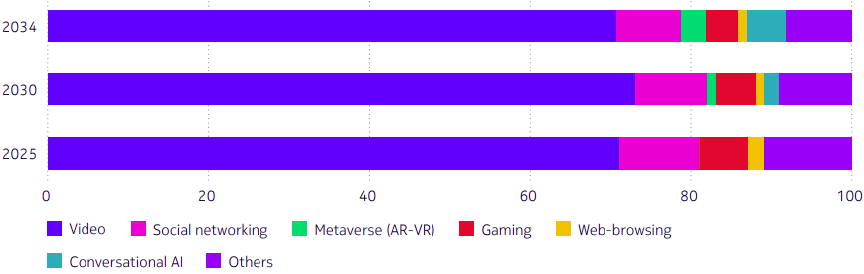
Figure 4.2.1-2: Application share of consumer mobile traffic for the moderate scenario.
In the later years, AI-driven content creation, cloud-based personal assistants, and AR/VR will emerge as new growth contributors, collectively adding around 8% of total traffic by 2034.
Meanwhile, 5G Advanced and early 6G deployments will ease bandwidth constraints and enable richer, high-quality streaming and immersive user experiences.

4.2.2 Mobile network evolution growth: 4G to 5G to 6G
The shape of mobile traffic over the next decade is determined less by how many people are connected and more by what networks they are connected to. 5G becomes the dominant access layer before the end of this decade, and 6G begins to appear in the early 2030s. As that transition plays out, more of the world’s mobile traffic rides on higher-throughput, lower-latency, more deterministic radio and transport infrastructure.
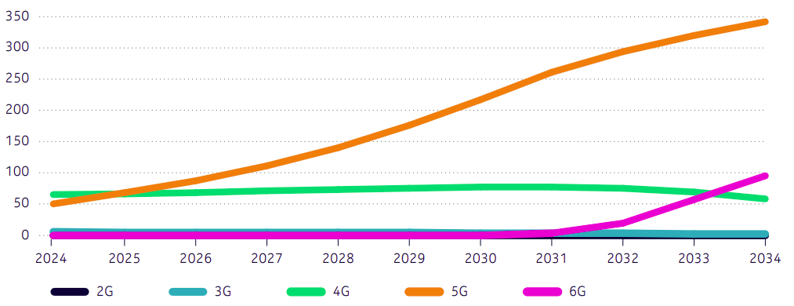
Figure 4.2.1-3: Mobile traffic in moderate scenario, EB/month.
That shift matters because the jump from 4G to 5G, and then from 5G toward 6G, does two things at once. First, it unlocks uses that were previously impractical on mobile, such as high-resolution live video, cloud gaming with real responsiveness, spatial or AR overlays in real time, and AI assistance that feels immediate rather than buffered. Second, it normalizes that behaviour. What begins as a premium experience for a subset of users becomes table stakes for everyone on upgraded radio layers. In other words, traffic density follows the network upgrade. Subscriber growth alone does not explain the curve; capability does.
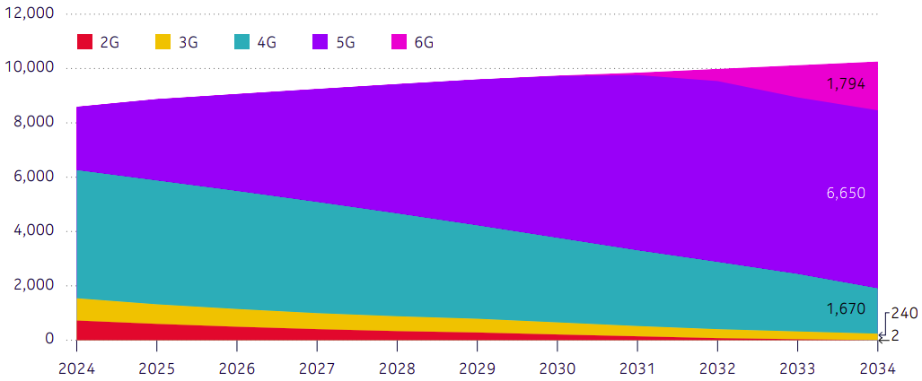
Figure 4.2.2-1: Normalized 5G+6G subscription increase (2024–2034).

4.2.3 Mobile traffic by region
In the near term, mature markets i.e. North America (NA), China and Western Europe (WE) are projected to experience slower traffic growth due to the saturation of mainstream applications and early-stage adoption of generative AI and extended reality (XR). However, in the mid-to-long term, these regions are expected to see sustained growth driven by the mass adoption of generative AI and accelerated XR adoption, alongside a shift to higher video resolutions.
Conversely, emerging markets will demonstrate steady growth. In the near term, this growth is fuelled by digital inclusion, 5G rollout, and increased service adoption, with a gradual shift from Standard-Definition (SD) to High-Definition (HD) video for premium users. The mid-to-long term will see continued expansion in traditional services, generative AI gaining mass traction, and HD becoming the norm, although XR traffic is expected to have limited impact.
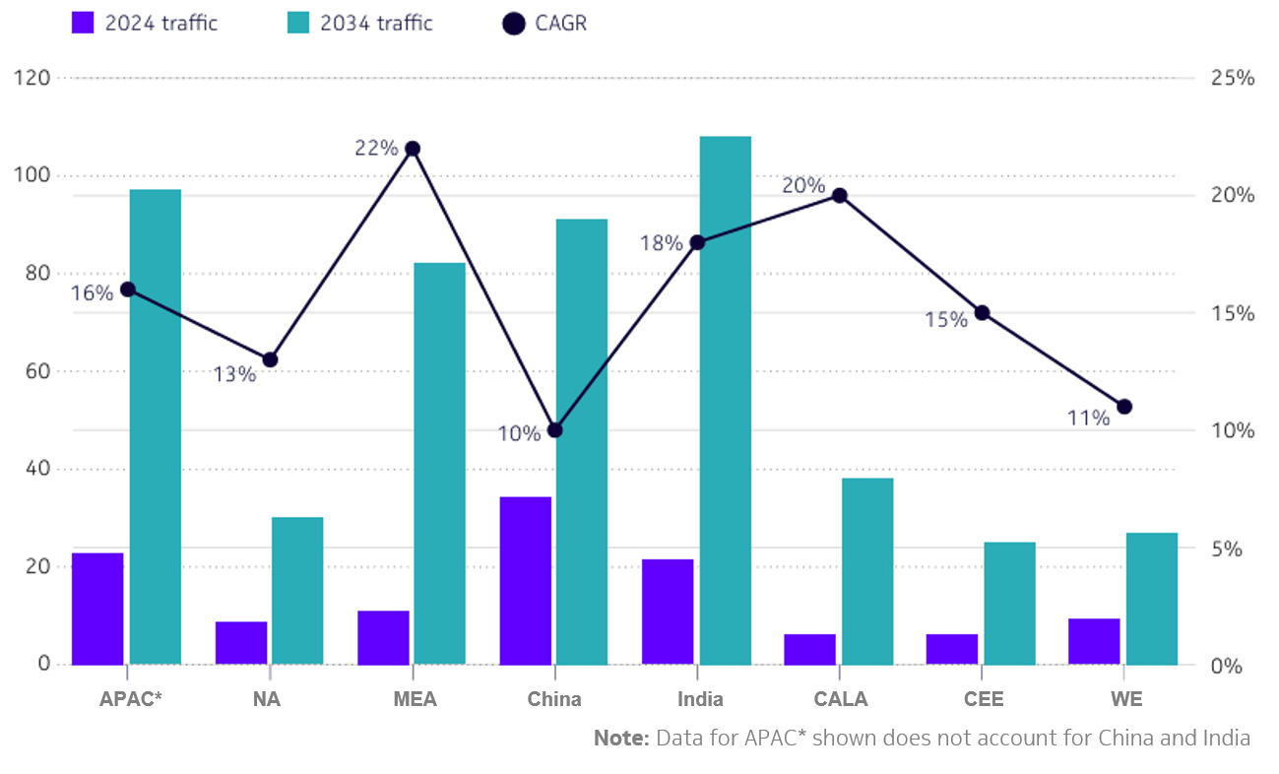
Figure 4.2.3-1: Mobile traffic for the moderate scenario, EB/month
Through 2034, APAC*, India, and MEA are expected to record strong compound annual growth rates (CAGRs) and drive global traffic growth. China will continue to contribute significantly in volume, despite a lower CAGR resulting from market maturity and high existing penetration.

4.2.4 Mobile traffic growth including FWA
Consumer cellular traffic, encompassing both mobile and fixed wireless access (FWA), is forecast to grow at a CAGR of 14% to 23% between 2024 and 2034, depending on the scenario (conservative, moderate or aggressive).
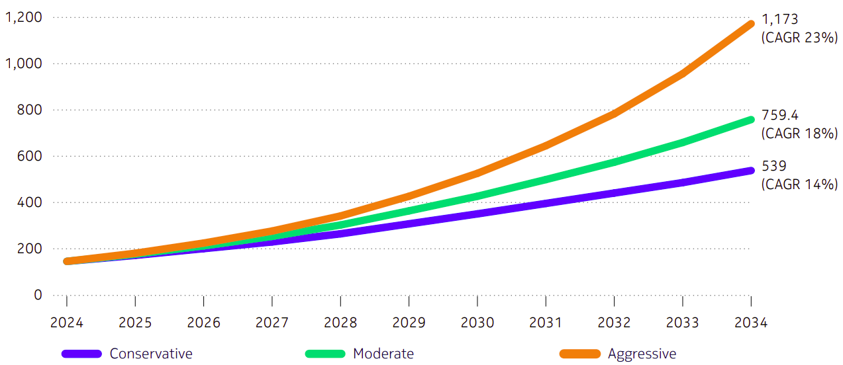
Figure 4.2.4-1: Mobile traffic including FWA, EB/month.
Under a moderate growth scenario, total consumer cellular traffic is expected to reach 759 EB/month by 2034, representing an 18% CAGR. FWA is a key driver of this expansion. By 2034, FWA is projected to contribute 261 EB/ month to the total cellular traffic under the moderate scenario, demonstrating its rapid growth and expanding share relative to traditional mobile traffic (499 EB/month). The steady expansion of FWA is expected to play a major role in driving the overall rise in consumer cellular data consumption.
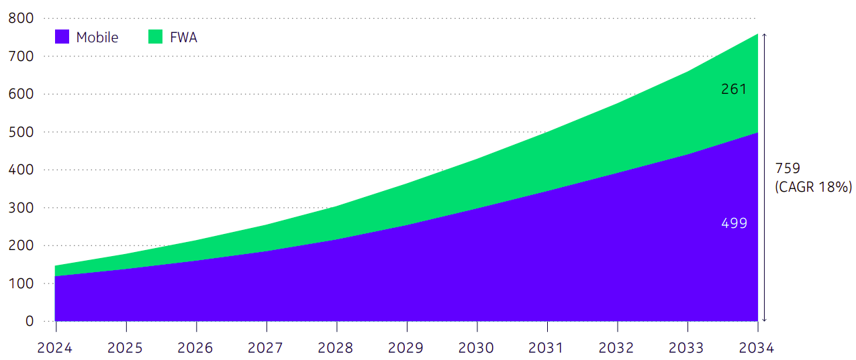
Figure 4.2.4-2: Mobile traffic including FWA for the moderate scenario, EB/month.

4.2.5 Further analysis and information
Nokia’s global network traffic report contains further information on the breakdown and the traffic over the whole wide-area network (WAN) and includes the modelling of the AI traffic used. The latest report (late 2025) can be found on https://www.nokia.com/asset/i/213660/.

4.3 Nokia Mobile Broadband India Traffic (MBiT) Index
Nokia MBiT Index is an annual report on mobile broadband performance in India. It provides valuable insights, data and analysis of mobile broadband and traffic growth and correlates these trends with the connectivity ecosystem including devices and traffic patterns.

4.3.1 MBiT Index 2026 (13th edition)
The 13th edition of the report assesses mobile broadband data traffic growth and trends across India. It also tracks data consumption per user and sheds light on the device ecosystem in India.
In the report, 5G consumption continues to show strong countrywide growth, with Metro circles leading in adoption. This is further fuelled by the growing uptake of FWA and the increasing availability of budget 5G phones.
The AI Supercycle is projected to have a profound impact on network traffic, primarily by driving substantial growth and altering traffic patterns. This report also explains the AI impact on traffic. The following sub-sections highlight some of the information contained in the 13th edition of the report.
4.3.2 Categorization of service areas (circles)
The data has been classified into 4 categories of service areas (circles), namely Metro, Category A, Category B, and Category C.
The Metro circles define the highest-density urban areas namely Delhi, Mumbai, Kolkata and Chennai. Category A defines large urban areas namely Andhra Pradesh and Telangana, Gujarat, Karnataka, Maharashtra (excluding Mumbai Metro) and Tamil Nadu (excluding Chennai Metro). Meanwhile Category B contains smaller urban areas which are Haryana, Kerala, Madhya Pradesh (including Chhattisgarh), Punjab, Rajasthan, Uttar Pradesh (East and West) and West Bengal (excluding Kolkata Metro). Category C circles are Assam, Bihar (including Jharkhand), Himachal Pradesh, Jammu & Kashmir, North East (Arunachal Pradesh, Manipur, Meghalaya, Mizoram, Nagaland, Tripura) and Odisha.
4.3.3 Mobile data traffic
The pan-India mobile traffic data is shown in Figure 4.3.3-1 with 5G (FWA & mobile) driving data growth as 4G traffic stabilizes. This coincides with over 10x growth in budget 5G phone shipments in 2025 (year-on-year).

Figure 4.3.3-1: Pan-India mobile data traffic (Exabyte, EB, per month)
The percentage data traffic growth of 5G from 2024 to 2025 is shown in Figure 4.3.3-2 and the data traffic of 5G contribution per month in 2025 is 12.9 Exabyte. 5G traffic crosses 50% in Metro circles, nearing halfway mark in other circles as 137 million 5G smartphones shipped in 2025. India’s 5G subscription base projected to reach ~1 billion by 2031.

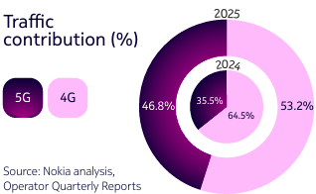
Figure 4.3.3-2: Illustration of data traffic analysis
The 5G data traffic contribution across the different categories as of December 2025 is shown in Figure 4.3.3-3.
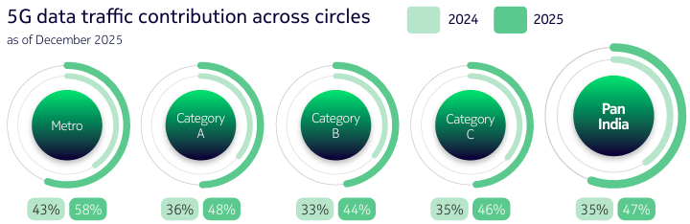
Figure 4.3.3-3: 5G data traffic contribution across the different categories
5G accounts for 58% of metro circles data traffic, up from 43% in 2024, and 5G adoption continues to accelerate with average traffic share reaching 47% across circles.
Figure 4.3.3-4 shows the growth in 5G + 4G data traffic per month across the circle categories from December 2024 to December 2025.
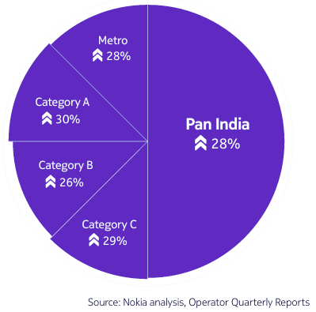
Figure 4.3.3-4: Growth in 5G+4G data traffic per month across circle categories
Our analysis has shown that the monthly data usage per user hits 31 GB in 2025, clocking 18% CAGR over five years and Figure 4.3.3-5 shows this year-on-year growth.

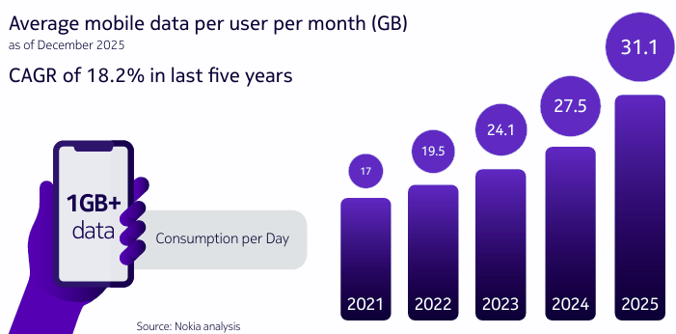
Figure 4.3.3-5: Year-on-year monthly data usage per user over five years
This average data traffic growth includes FWA as well as average mobile user consumption. There is a healthy 5G FWA subscribers year-on-year growth.

4.3.2 Further information
Further information of the Nokia MBiT Index can be found at:
https://www.nokia.com/about-us/company/worldwide-presence/india/mbit-index/
This webpage also contains the latest MBiT Index report with its key findings, and other information included with reference to previous reports.
  - GSMA Vision 2040 study
The GSMA’s Vision 2040 study provides a comprehensive assessment of mid-band spectrum needs for mobile evolution over the next decade. As part of the study, mobile traffic trends and a range of data traffic demand scenarios over the period to 2040 were assessed. The main findings are summarised below.
    - Continued traffic growth as mobile technology evolves towards 6G
Demand for mobile network capacity is expected to continue growing by 15–20% in the next five years (2025–2030), with more users migrating to 5G and utilising higher-speed networks. 6G is expected to be deployed from 2030, with large initial rollouts likely to occur in countries/ regions such as China, Japan, South Korea, the US, the GCC states, Europe, Vietnam and India. The number of 6G connections could reach more than 5 billion by 2040, representing approximately half of all mobile connections globally. The technology is expected to enable new and emerging use cases that could increase demand further in the 2030–2040 period, with much heavier uplink requirements.
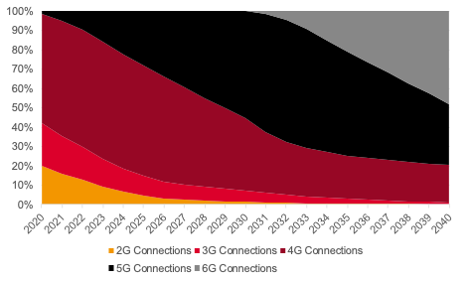
Figure 4.4.1-1: Proportion of mobile connections by technology, 2020–2040
Source: GSMA Intelligence
Note: A connection is a unique SIM card that has been registered on a mobile network. Connections differ from subscribers in that a unique subscriber can have multiple connections
Growth in mobile traffic in the next decade is expected to be driven by existing use cases, including video and gaming, as well as new and emerging use cases that will be enhanced by 6G, such as extended reality (XR) and network sensing. Global mobile traffic is forecast to increase from 140 EB/month in 2025 and reach 700–1,300 EB/month by 2040 (1 EB = 1 billion gigabytes), with traffic per connection reaching 60–95 GB/month. Annualised growth rates in global traffic could range between 10% and 15%, with AI driving higher uplink and latency requirements.
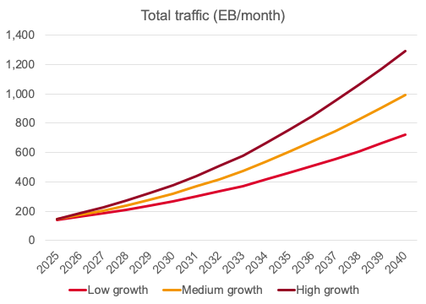
Figure 4.4.1-2: Global traffic growth by scenario, 2025–2040 (EB/month)
Source: GSMA Intelligence
Note: Includes mobile, FWA and IoT traffic.
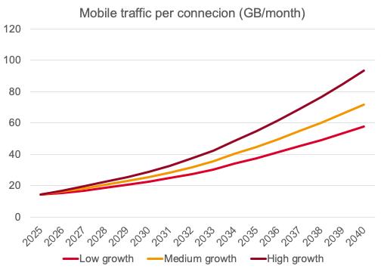
Figure 4.4.1-3: Global traffic growth by scenario, 2025–2040 (GB/connection/month)
Source: GSMA Intelligence
Note: Only includes mobile traffic (excludes FWA and IoT). Shows traffic per connection rather than by device. It is therefore closer to the data usage expected by a mobile user across all their devices (e.g. a smartphone, wearables, smart glasses)
Based on the lower demand growth scenario, global mobile traffic could increase by 10% per year during 2030–2040, reaching more than 700 EB/month by 2040 (almost 60 GB per mobile connection per month). With 6G deployments from 2030 onwards, the technology is expected to enable new and emerging use cases that could increase demand further in the 2030–2040 period, with much heavier uplink requirements. This includes XR, image- and video-driven generative AI (genAI) and potentially holographic communication. The highest demand growth scenario shows global mobile network traffic increasing by more than 20% per year after 2030, reaching almost 1,300 EB/month by 2040 (more than 90 GB per mobile connection per month).
In the Asia Pacific region, which includes advanced markets such as Australia, China, Japan and South Korea and fast-growing economies such as India, Indonesia and Vietnam, the total mobile data traffic is forecast to increase from 90 EB/month in 2025 and reach 420-720 EB/month by 2040, with data traffic per mobile connection ranging from 70-110 GB/month.
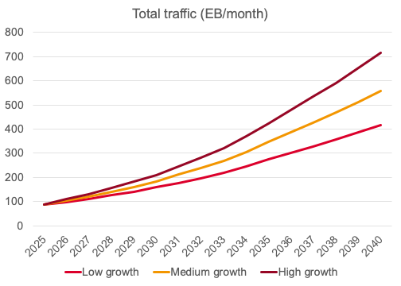
Figure 4.4.1-4: Asia Pacific traffic growth by scenario, 2025–2040 (EB/month)
Source: GSMA Intelligence
Note: Includes mobile, FWA and IoT traffic.
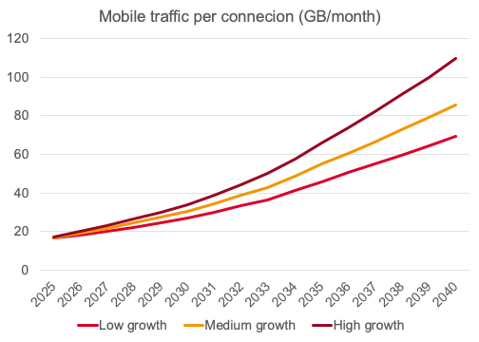
Figure 4.4.1-5: Asia Pacific traffic growth by scenario, 2025–2040 (GB/connection/month)
Source: GSMA Intelligence
Note: Only includes mobile traffic (excludes FWA and IoT). Shows traffic per connection rather than by device. It is therefore closer to the data usage expected by a mobile user across all their devices (e.g. a smartphone, wearables, smart glasses)
    - Impact of AI on mobile traffic growth
The adoption of AI will have a material impact on across telecommunications and ICT sectors. The Vision 2040 study identifies four main impacts that AI is expected to have on mobile traffic and the radio access network (RAN) as detailed below.
- AI could increase traffic by enabling new use cases. For example, generative AI (genAI) enables at-scale, hyper-personalised content creation and processing. While most genAI application usage is currently text-based, and so drives minimal increases in traffic, the increased use of genAI-driven video assistants and immersive interactions may increase downlink and especially uplink traffic.
- AI could also increase traffic by increasing the performance requirements of existing and emerging use cases, such as personalised video, running multi-modal queries and sensors to generate data for AI models. This has important implications because AI-driven traffic can be bursty and unpredictable, making it essential for networks to allocate resources efficiently.
- AI could impact the amount of time that people spend on their connected devices – either increasing it by offering more personalised, useful and engaging content or by reducing the amount of time that users need to spend online.
- AI could also reduce traffic by enabling more efficient traffic delivery, such as through content optimisation and video compression.
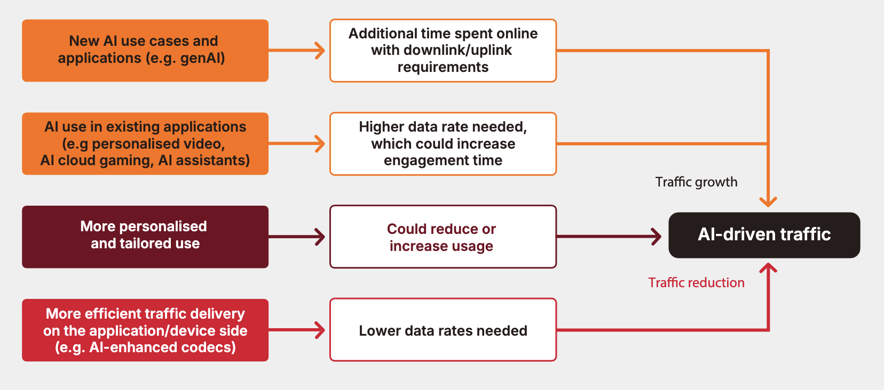
Figure 4.4.2-1: Impact of AI on mobile network traffic
Source: GSMA Intelligence
    - Mobile traffic in high demand areas
Mobile data traffic is not evenly distributed across countries. Understanding how mobile traffic demand is distributed geographically is fundamental to mobile operators and regulators in the assessment of spectrum needs which are ultimately determined by demand in the most congested locations during peak-usage periods. Operators must provision networks to handle capacity requirements in high-demand areas, making localised analysis essential for accurate spectrum planning.
Analysis of mobile traffic, population and geographic area for a sample of 10 countries shows that on average, 83% of mobile traffic is in urban areas that only account for around 5% of geographic area. On this basis, traffic per square kilometre in very dense urban areas (with population densities above 5,000 people per square kilometre) is 9 times greater than in other urban clusters and almost 700 times greater than in rural areas (in some countries, it is more than 1,000× greater than in rural areas).
In more mature mobile markets with high mobile broadband adoption, cellular mobile traffic distribution closely follows population distribution. However, in emerging markets, traffic is disproportionately higher in urban areas, due to the urban–rural digital divide. Figure 4.4.3-1 shows the distribution of traffic, population and area by geography for selected countries in Asia Pacific region.
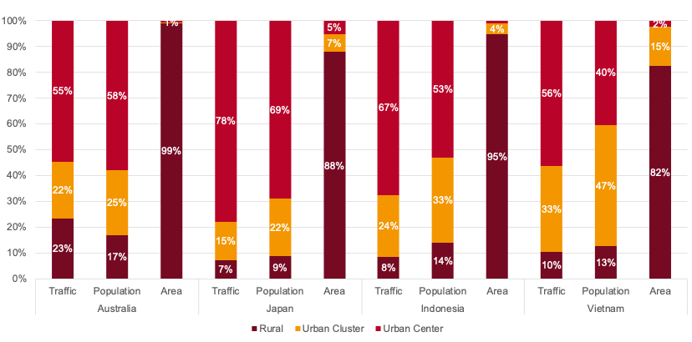
Figure 4.4.3-1: Distribution of mobile network traffic, population and area by geography
Source: GSMA Intelligence analysis, based on Cell AnalyticsTM data provided by Ookla
Note: Rural, urban clusters and urban centres are defined based on Global Human Settlement Layer (GHSL) classifications. Due to rounding, percentages may not sum to 100%.
Thus, dense urban locations are responsible for the majority of mobile traffic and even modest long-term annual traffic growth in these areas can quickly exceed available network capacity, necessitating additional spectrum resources.

Summary
This Report provides consolidated information on current and future mobile traffic trends in IMT networks, based on statistical data from APT Members and analyses conducted by mobile industry organizations and companies. The information collected indicates that mobile traffic has continued to increase over the past decade and that this growth is expected to continue in the coming years. At the same time, the nature of future traffic growth is expected to evolve, with emerging applications and services introducing new traffic patterns.
Statistical data from some APT Members show continued growth in mobile traffic. The available national data from these APT Members indicate that total mobile traffic has increased at annual rates ranging from approximately 5% to 15–20%. This growth is driven not only by an increase in the number of subscriptions, but also by higher data consumption per subscription. For example, traffic per subscription has increased at annual rates of approximately 10–20% in some of these countries. The data also indicates the rapid expansion of mobile IoT connections in some markets.
Analyses conducted by relevant mobile industry organizations and companies further indicate that mobile traffic is expected to continue growing, although the forecast periods and modelling approaches differ among the analyses. Video applications remain the largest contributor to mobile data traffic. The use of Fixed Wireless Access (FWA) in IMT networks is also becoming an important contributor to network traffic, particularly where it is used as an alternative or complement to fixed broadband services. At the same time, emerging mobile use cases, such as cloud-based applications, generative AI, agentic AI, AI-enabled applications, AI/AR smart glasses and immersive communication, such as AR/VR, are expected to become additional drivers of traffic growth. Autonomous systems and connected intelligent devices may also generate new and increasingly uplink-intensive traffic patterns through the continuous transmission of video, sensor and contextual information. Accordingly, future traffic growth may involve not only an increase in overall traffic volume, but also a growing importance of uplink traffic alongside continued growth in downlink traffic.
For example, one analysis projects that total global mobile network data traffic, including FWA, will increase from approximately 203 EB per month in 2025 to 515 EB per month in 2031. This analysis also indicates that uplink traffic in 2031 could reach approximately two to five times its 2025 level. A second analysis projects that total consumer cellular traffic, including FWA, will increase from approximately 150 EB per month in 2024 to approximately 759 EB per month in 2034 under the moderate-growth scenario. A third analysis projects that global traffic, including mobile, FWA and IoT traffic, will increase from approximately 140 EB per month in 2025 to approximately 700–1 300 EB per month in 2040. Although the exact growth rate differs depending on the assumptions and scope of each analysis, these forecasts suggest that IMT network traffic is expected to continue increasing at an annual growth rate exceeding 10%, and in some cases by approximately 20% per year.
The evolution of IMT network technologies is also a key factor shaping future traffic trends. The continued expansion of 5G networks and the evolution towards 5G-Advanced and 6G are expected to support higher-capacity, lower-latency and more reliable mobile applications. These network capabilities are expected to enable the new use cases described above, and may further increase traffic demand. In this context, future network evolution may need to consider not only overall traffic growth but also changing traffic characteristics, including increasing uplink requirements for emerging AI-driven and interactive applications.
It is important to continue monitoring and analysing mobile traffic trends in IMT networks. A clear understanding of these trends is beneficial for network planning, spectrum management, technology evolution, and policy development. Continued sharing of relevant statistical data and analytical findings would also help enhance a common understanding of mobile traffic growth, changing traffic patterns, and its implications for the future development of IMT networks and long-term spectrum planning.

The latest data, updated every three months, is available at the following link (Japanese only). https://www.soumu.go.jp/johotsusintokei/field/tsuushin06.html
https://www.miit.gov.cn/gxsj/tjfx/txy/art/2026/art_5c99d65350f7452f999e8efcb1ee2d6a.html
https://msit.go.kr/bbs/view.do?sCode=user&mId=99&mPid=74&pageIndex=&bbsSeqNo=79&nttSeqNo=3173724&searchOpt=ALL&searchTxt=
Ericsson Mobility Report
https://www.nokia.com/asset/i/213660/
EB is Exabyte equivalent to 1 billion Gigabytes
CAGR (Compound Annual Growth Rate): The average annual growth rate of an investment or metric over a specific period, smoothing out year-to-year fluctuations to show a steady rate of return.
Abbreviations used: APAC* (Asia-Pacific not accounting for China and India), NA (North America), MEA (Middle East and Africa), CALA (Caribbean and Latin America), CEE (Central and Eastern Europe), WE (Western Europe)
GSMA. Vision 2040: Future Spectrum Needs. July 2026 https://www.gsma.com/connectivity-for-good/spectrum/gsma_resources/vision-2040-future-spectrum-needs/

