

APT REPORT ON

ULTRA-WIDEBAND (UWB) AND ITS EVOLUTION

Edition: September 2026

The 37th Meeting of APT Wireless Group
7 – 11 September 2026
Dhaka, Bangladesh (Hybrid)

(Source: AWG-37/OUT-16)

No. APT/AWG/REP-01(Rev.4)

APT REPORT ON
ULTRA-WIDEBAND (UWB) and its evolution

TABLE OF CONTENTS

1 INTRODUCTION 3
1.1 Commercial UWB Products 3
1.2 Social and Economic Impact 3
2 UWB APPLICATIONS 5
2.1 UWB Tracking Systems 5
2.2 UWB Communications Systems 6
2.3 UWB Imaging Systems 6
3 Regulatory Activities by APT Members 7
4 CONCLUSION 8
5 REFERENCES 9
6 ANNEXES 12
Annex A: UWB REGULATORY DEVELOPMENTS 12
A.1 International Telecommunication Union (ITU) 12
A.2 Federal Communications Commission (FCC) 14
A.3 Electronic Communications Committee (ECC) 14
Annex B: Japan’s UWB Emission Mask 15
Annex C: Korea’s UWB Emission Mask 16
Annex D: China’s UWB Technical Requirements 17
Annex E: FCC’s UWB Emission Mask 18
Annex F: Europe’s UWB Emission Mask 19
Annex G: UWB Regulatory Framework in APT and other regions 27

1 INTRODUCTION

Traditional radio systems use dedicated frequency spectrum for sending and receiving radio signals in order to mitigate interference effects. Contrary to this approach, Ultra-Wideband (UWB) technology, as its name suggests, operates by spreading its radio signals across a very large frequency band (typical bandwidth > 500 MHz). UWB transmissions are very low in power, and will operate as an underlay, license-exempt service in frequency bands already allocated to other radiocommunication services(e.g. satellite services, fixed service, mobile service and radiolocation service), including those licensed exclusively to commercial entities for their use (e.g. cellular mobile operators and wireless broadband access operators).
Therefore, UWB transmission is designed to not cause interference to other radiocommunication services and not claiming any protection from those services, and it is characterized as a ‘Good Neighbour’ technology.

1.1 Commercial UWB Products

Commercial deployment of UWB began in industrial environments, where the technology was first used in high‑precision Real‑Time Locating Systems (RTLS) for asset location and tracking. Consumer adoption accelerated in 2019 when Jaguar Land Rover introduced the first vehicles with UWB‑based secure entry. Following the publication of the IEEE 802.15.4z standard in 2020—which strengthened industry confidence and provided a clearer interoperability path—additional OEMs such as BMW, Volkswagen, and Hyundai began adopting UWB.
Around this same period, Apple, Google, Samsung, and Xiaomi integrated UWB into smartphones, rapidly establishing a large installed base. Since then, UWB has expanded across mobility, consumer, and industrial markets, driven by its secure, accurate ranging and tracking capabilities. Adoption continues to grow, and analysts expect a significant increase in new UWB‑enabled applications as the ecosystem matures.

1.2 Social and Economic Impact

A comprehensive market analysis on UWB was done by ABI Research. Figure 1 shows that UWB-enabled devices shipped globally are poised to grow to over 0.5 billion devices in 2025 with accumulated shipments of >1.5 billion devices in the last 5 years . In fact, the UWB market is projected to grow by double digit percentages for the foreseeable future.

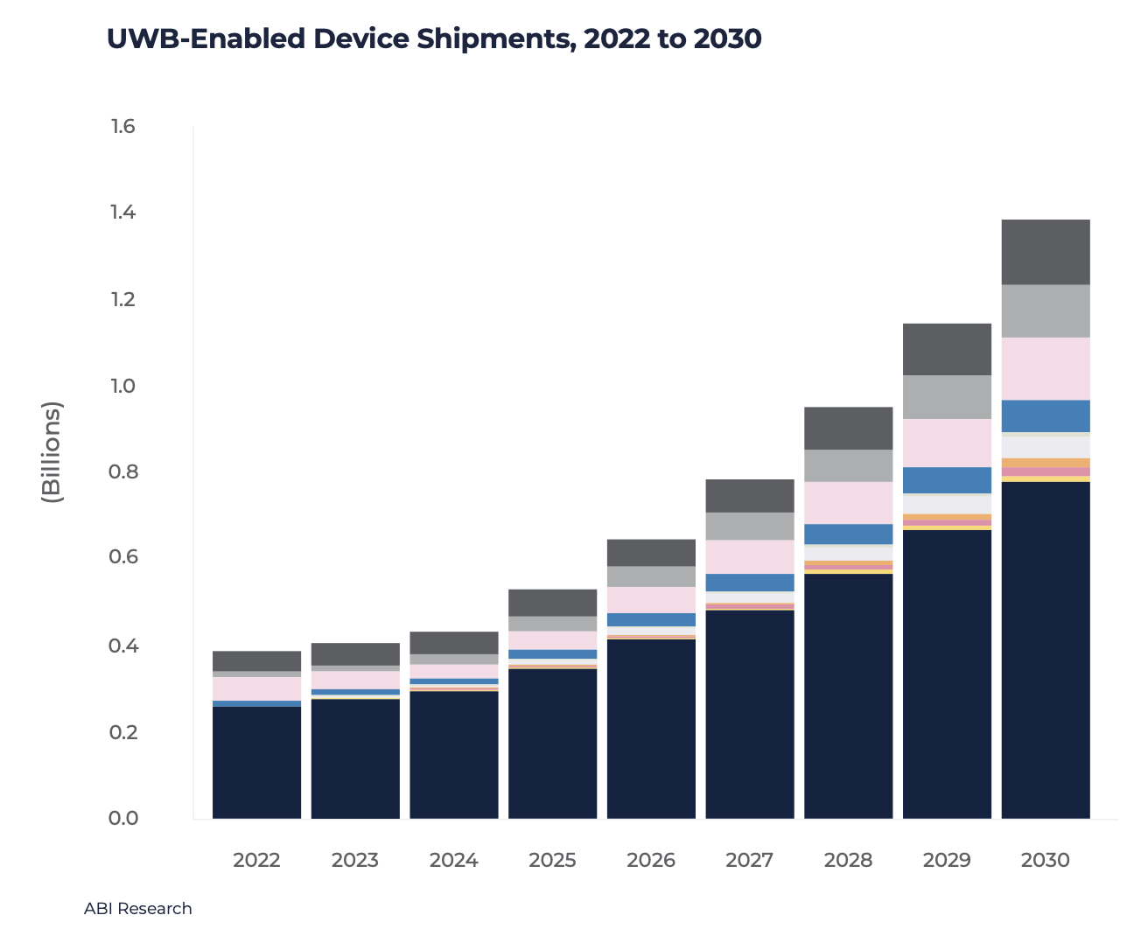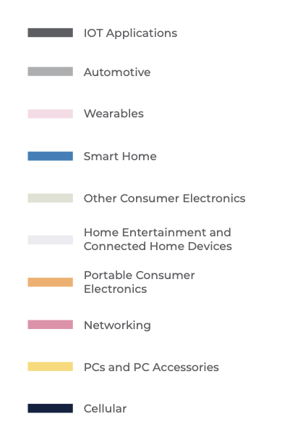
Figure 1 UWB-Enabled Device Shipments, 2020 to 2026
Source: ABI Research

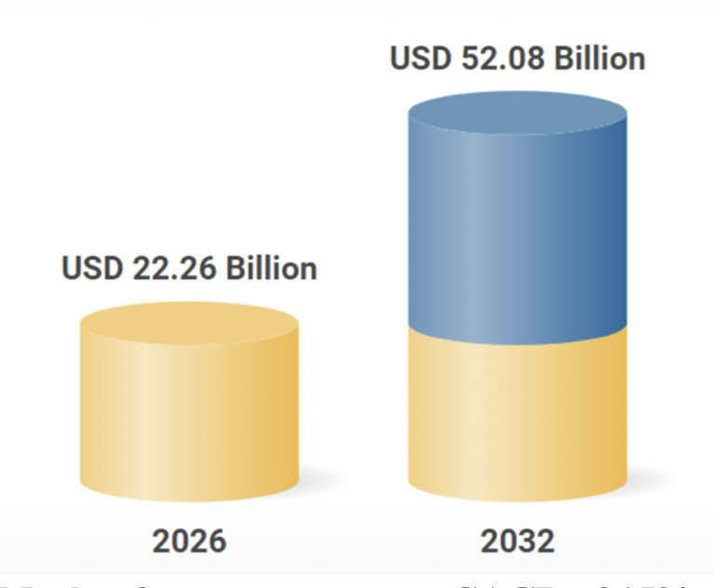
The other segments driving growth of UWB are Internet of Things (IoT) and Real-Time Location Systems (RTLS). There is a rising demand for UWB technology in RTLS applications. In a report published in April 2023, MarketsandMarkets estimated that the global indoor location market will grow from about $8.8 billion in 2022 to $24 billion by 2027, a CAGR of 22.4%.
Furthermore, as shown in Figure 2 to the right, a report from Research and Markets indicated that the global indoor location-based services market size was estimated at USD 22.26 billion in 2026, and is projected to grow at a CAGR of 15% to reach USD 52.08 billion in 2032.

Market forecast to grow at CAGR of 15%
Figure 2 The Global Indoor Location-Based Services Market
Source: Research and Markets

Beside the view on devices and applications using UWB, it is also important to look at the overall socio economic impact of UWB. In APAC alone, a total economic impact of 13.3 billion USD in 2030 has been predicted:
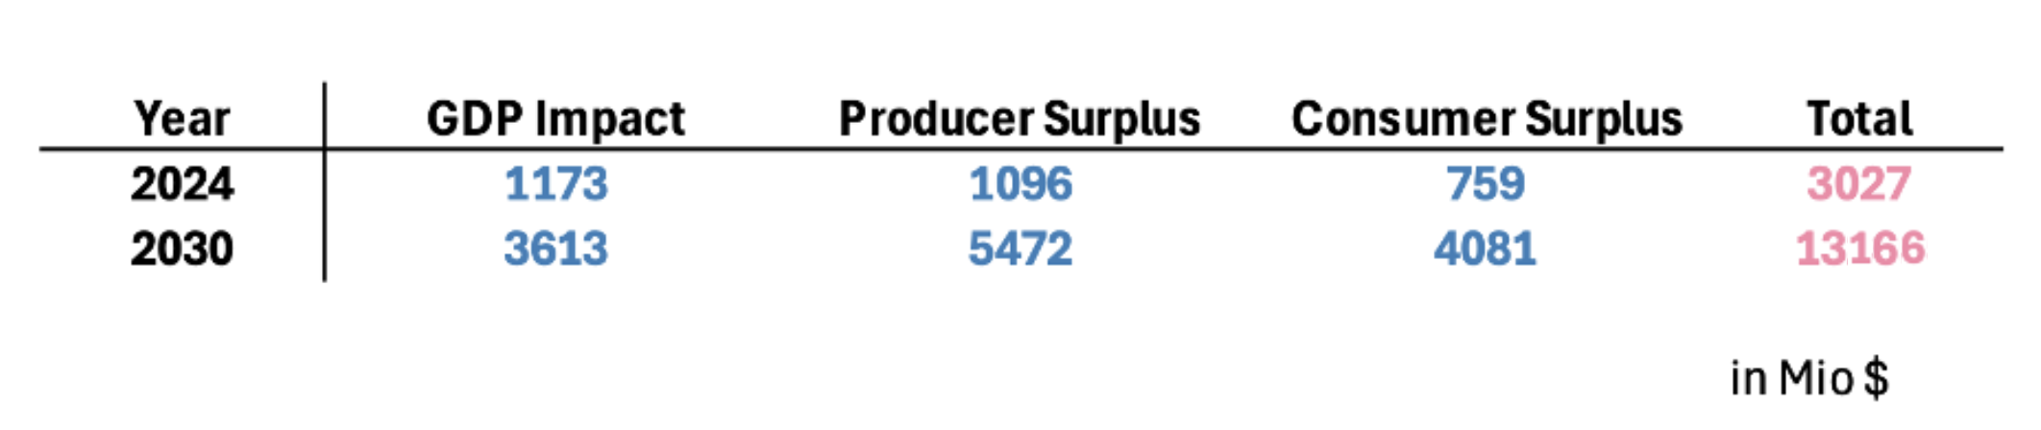
Together, the three dimensions (GDP impact, producer surplus and consumer surplus) provide a comprehensive view of the economic relevance of UWB.
The methodology, a detailed analysis across seven application areas (Smart Home, Mobility, Individual Consumer, Smart Retail, Industrial, Public Transportation, and Smart Building), ensured that realistic adoption scenarios have been considered.

2 UWB APPLICATIONS

In general, UWB devices can be broadly categorised based on different types of UWB applications, according to its potential to cause interference to the existing radiocommunications services. UWB applications can be categorised into tracking, communications systems and imaging. Accordingly, specific emission limits and operation guidelines can be designed to mitigate interference for each type of UWB application. Historically 24 GHz automotive radar was also classified as UWB, but these systems are not being deployed any longer. In many countries the regulations forbid the introduction of new devices. Automotive Radar is now deployed in the range 76 – 77 GHz and 77 – 81 GHz (79 GHZ bands) for the operation of automotive short-range radar.

2.1 UWB Tracking Systems

Utilizing the wide bandwidth (>500 MHz) characteristics, UWB technology has further evolved from the high data rate wireless communication system to an impulse radio technology which can support accurate distance measurement between devices or an infrastructure. This spatial context capability can be utilized by a variety of applications, including hands-free access control, location-based services, and device-to-device (peer-to-peer) services. In terms of commercialization initial solutions based on UWB locating were deployed for industrial indoor asset tracking. The industry organization representing such applications is Omlox. In recent years, UWB secure ranging based on IEEE 802.15.4z has been implemented and deployed in mobile handsets, automotive entry systems as well as IoT devices for asset tracking (e.g. UWB enabled tags), Car Access (CCC Digital Key) and door lock applications (CSA-Aliro). To further facilitate the adoption of UWB ranging technologies and its associated applications, leading industry members have joined together to create industry consortiums such as UWB Alliance for special interest applications, FiRa Consortium for Fine Ranging applications or Car Connectivity Consortium for Digital Car Key. Many new applications are emerging, specifically fuelled by the proliferation of UWB in smartphones and vehicles, among others indoor navigation, transportation sharing, V2X, transportation fare payment and parking garage access control, car-parking and car charging positioning, tap-free mobile payment, in-vehicle payment, point and trigger control, personal device access control, gesture control and presence based activation.

2.2 UWB Communications Systems

Consumer UWB devices within this category are classified as short-range UWB communications systems. While originally conceived as high-volume, high-data-rate devices analogous to RLAN systems as described in ITU-R Recommendation SM.1755, this vision has not materialised in practice. Contemporary deployments have instead gravitated toward low-latency audio applications — including headphone and speaker connectivity including personal area networks. The low radiated power and impulse radio (IR) modulation characteristics of these systems constrain their area of influence and, consequently, their interference footprint. This has direct implications for the device population and activity factor assumptions applied in Report ITU-R SM.2057, both of which warrant revision downwards.

2.3 UWB Imaging Systems

The use of UWB imaging systems in the frequency bands below 960 MHz and 3.1GHz – 10.6 GHz has now expanded from military to public security and protection purposes. UWB radar systems can be used to detect people buried underground or behind walls after disasters or accidents. It is also commonly used in the construction and maintenance industry to detect and locate reinforcement bars, electric wiring and pipes inside concrete/walls. Other types of UWB based sensors have also been developed and are currently being fielded that do not perform imaging but use low power UWB as a close distance radar in small settings, for e.g. automotive in-cabin sensing (child left behind, intrusion detection, driver monitoring and gesture control), indoor and outdoor presence and movement detection.
Ultra-Wideband (UWB) medical imaging is a non-invasive diagnostic and monitoring technique that uses low-energy radio pulses to capture detailed images of body structures. Operating on Impulse Radio UWB (IR-UWB) technology, it functions as an extremely low-power radar system, making it both safe and energy-efficient for continuous use. In sleep monitoring applications, UWB enables contactless tracking of movement, respiratory rate, sleep and wake states, and body positioning relative to the bed — all without requiring physical sensors or wearable devices. Beyond sleep analysis, the technology supports real-time vital sign monitoring, including respiratory rate and breathing pattern assessment, through clothing and without any direct patient contact.

2.4 Future evolution

The next generation of UWB features being specified by the IEEE 802.15.4ab standard, soon to be published, will benefit a wide range of UWB applications.

- Multi-millisecond (MMS) UWB ranging: this new ranging method improves the sensitivity and accuracy of ranging results by accumulating multiple UWB ranging sequence fragments to find attenuated signals previously lost in the noise. This method is further enhanced using narrowband assist (NBA) to provide synchronization and data transport, assisting the MMS UWB ranging to bring 15 to 25 dB link budget improvement over the previous standard’s capability. Applications benefiting from these enhancements include access control for vehicles and buildings, asset location and tracking, and indoor navigation.

- Additional data modulations support: new lower rate of 1.95 Mb/s for longer-range or more robust communication, higher rates of 64.4 Mb/s and 124.8 Mb/s to reduce air-time and energy use, and a new header allowing dynamic switching of data rates in response to changing channel conditions. Emerging applications include low-power / low-latency communications for gaming.

- Adding support for sensing: introduction of standardized sensing packets, of a pulse shape optimized for sensing, and advanced procedures supporting monostatic and multistatic sensing methods for efficient detection of small movements of multiple targets. Use cases benefiting from these enhancements include child presence detection in vehicles and other safety applications.

3 Regulatory Activities by APT Members

In Asia Pacific region, some APT member countries like Japan and Korea have implemented regulatory framework to permit unlicensed use of UWB devices in indoor environment, while others like Singapore and Hong Kong have established UWB trials within localised zones. In the case of Singapore, a UWB Friendly Zone (UFZ) was created in 2003 in the Science Park II for UWB developers to conduct realistic field experiments, and later defined a Technical Specification to allow the use of UWB. Hong Kong, on the other hand, allocates the 3.1-10.6 GHz band for UWB indoor trials and the 4.2-10.6 GHz band for outdoor trials around 2008 and defined the performance specifications in 2018.

In Japan, the preliminary mask for UWB was announced back in September 2005. Subsequent compatibility studies show that UWB devices operating in the 3400-4200 MHz band should incorporate interference mitigation techniques. However, devices were allowed to operate in the 4200-4800 MHz band without mitigation techniques until end of December 2010. Other technical conditions are imposed for UWB radio systems operating in the 3.4 to 10.25 GHz band. It had been limited to indoor use, however, in recent years, along with the diversification of wireless communication applications, high-precision positioning and object detection are expected to be installed in mobile devices and automobiles. As the needs for outdoor usage have increased, in 2018, the technical conditions for enabling outdoor use of frequencies from 7.587 GHz to 8.4 GHz were studied and the outdoor UWB radio system was institutionalized in 2019. Furthermore, in response to the need for band expansion for outdoor use and the need for radiolocation applications such as human sensors, the outdoor UWB radio system with including radiolocation from 7.25 GHz to 9.0 GHz was institutionalized with the condition that it’s operated without causing harmful interference to SRS earth stations, RAS stations, RLS stations and RNS stations in 2021 (see Annex B for Japan’s emission mask).

For Korea, the spectrum allocation for UWB starts in the frequency band from 4.2 to 10.2 GHz. The Ministry of Science and ICT (MSIT) of republic of Korea announced the revised UWB regulation in December 2022. Under the previous UWB regulation, only Channel 9 of UWB (7737.6 ~ 8236.8 MHz) was allowed for mobile device usage. To expedite the new UWB technology upon the requests from industries, the MSIT extended the UWB bands for mobile devices from 6 to 8.8 GHz.

For China, Ministry of Industry and Information Technology (MIIT) has published “Ultra-Wideband (UWB) Equipment Radio Management Provisional Regulations” in April, 2024, and the regulation came into effect on August 1, 2025. The Ultra-wideband (UWB) radio transmission equipment as mentioned in this regulation refers to radio transmission equipment with a transmit signal bandwidth (-10dB bandwidth) of not less than 500MHz, mainly used in short-distance high-speed wireless data communication, positioning, ranging, sensing and other application fields. The operating frequency band is from 7163 MHz to 8812 MHz. The use of UWB shall not cause harmful interference to other radio services, nor claim protection from other radio services. If any interference generated from UWB to other services, the UWB device should stop operation immediately, and could resume operation only when the harmful interference is mitigated. The UWB is prohibited to use in the distance of 1 km from the RAS stations. The UWB is prohibited to use on the aircraft(including unmanned aircraft).

Annex G contains the UWB regulatory framework in some of the APT members and other regions.

4 CONCLUSION

In view of the UWB product and regulatory developments, APT members are encouraged to be prepared for the pervasive use of UWB devices and formulate a regulatory framework to manage the risk of interference from UWB devices to the existing radiocommunication services while operating in a non-interference and non-protection basis. The ITU recommends that Administrations consider a regulatory framework with minimal administrative procedures, technical specifications and national regulations, which still provides the regulation and mitigation necessary to protect existing services. The USA, Europe, Korea , Japan and many others have already adopted a regulatory approach of allowing licence-exempt or class licence operation of UWB devices. Further evolutions to the regulatory framework have also been implemented, e.g. in Europe.

Whilst some countries have restricted the use of unlicensed UWB devices to indoor environment, it is possible that such restrictions are likely to be relaxed in future when mitigation techniques (e.g. minimum separation distance with affected services) are proven to be effective in reducing interference. In this regard, APT members may introduce operating restrictions based on individual regulatory requirements and use Annex G to assist in formulating a UWB regulatory framework. APT members might provide their findings to the AWG with regard the impact of UWB devices on existing services and vice versa. This information would provide APT members with additional information in choosing an appropriate regulatory framework for UWB devices

Going forward, it is suggested that the following can be considered by the APT members when developing their UWB regulatory framework:

- To allow deployment of UWB devices in parts of the bands below 10.6 GHz while ensuring protection of existing and planned stations of radiocommunication services and not claim protection from other radio services in band and in adjacent band.

- To adopt licence-exempt or class licensing approach for operating UWB devices;

- For UWB Imaging devices in the extended frequency range beyond 3.1 to 10.6GHz on a case-by-case basis with the necessary impact assessment;

- To set a maximum e.i.r.p. spectral‑density limit—ranging from –90 dBm/MHz down to –41.3 dBm/MHz—for licence‑exempt or class‑licensed UWB devices,. The specific limits would vary by band and application, and would incorporate any required notches, restrictions, or sharing mechanisms needed to protect existing and planned services in the operating and adjacent bands;

- To conduct studies to evaluate coexistence between UWB and other radio services, considering the expected massive use of UWB devices;

- To consider implementing other mitigation techniques to protect the existing and planned radiocommunication services allocated in relevant frequency bands (for indoor/outdoor systems).

5 REFERENCES

[1] FCC 02-48, “Revision of Part 15 of the Commission’s Rule Regarding Ultra-Wideband Transmission Systems”, First Report and Order, ET 98-153; adopted: February 14, 2002; released: April 22, 2002.

[2] FCC 04-285, “Revision of Part 15 of the Commission’s Rule Regarding Ultra-Wideband Transmission Systems”, Second Report and Order and Second Memorandum Opinion and Order, ET 98-153; adopted: December 15, 2004; released: December 16, 2004.

[3] ECC Report 64, “The Protection Requirements of Radio-Communications Systems Below 10.6 GHz from Generic UWB Applications” by Helsinki, February 2005.

[4] ECC/DEC/(06)04, “ECC Decision of 24 March 2006 amended 6 July 2007 at Constanta on the harmonised conditions for devices using Ultra-Wideband (UWB) technology in bands below 10.6 GHz”, released: March 2006 and amended 18 November 2022.

[5] ECC/DEC/(07)01, “Report from CEPT to the European Commission in response to the Fifth Mandate to CEPT on ultra-wideband technology”, released: March 2007 and amended 1 July 2022

[6] Commission Implementing Decision (EU) 2019/785 of 14 May 2019

[7] ECC Report 094, “The technical requirements for UWB LDC devices to ensure the protection of FWA systems”, by Nicosia, December 2006.

[8] Commission Decision 2007/131/EC on allowing the use of the radio spectrum for equipment using ultra-wideband technology in a harmonised manner in the Community, released: February, 2007.

[9] Recommendation ITU-R SM.1754,” Measurement techniques of ultra-wideband transmissions”.

[10] Recommendation ITU-R SM. 1755,” Characteristics of ultra-wideband technology”.

[11] Recommendation ITU-R SM. 1756,” Framework for the introduction of devices using ultra-wideband technology”.

[12] Recommendation ITU-R SM. 1757,” Impact of devices using ultra-wideband technology on systems operating within radiocommunication services”.

[13] AWF-3/14, “Technical Conditions on UWB Radio Systems in Japan”, by MIC, Japan.

[14] AWF-3/23(Rev.1), “Proposed Working Document Toward Preliminary Draft Recommendation APT [UWB] Spectrum Use For Ultra Wideband (UWB) Technology”, by Republic of Korea.

[15] AWF-4/INP-23, “Proposed Modification of Draft AWF Report on Ultra-Wideband (UWB)”, by Republic of Korea.

[16] AWG-25/INP-87(Rev.1), “Proposal of updating the Status of Viet Nam to APT Report on Ultra Wide Band (APT/AWG/REP-01Rev.1)’’ by Viet Nam (S.R.of).

[17] CEPT Report 084, “Ultra-Wideband technology review in view of a potential update of Commission Implementing Decision (EU) 2019/785”, by ECC, approved on 7 July 2023

[18] ECC Report 094 (‘Technical requirements for UWB LDC devices’, December 2006)

[19] ECC Report 120 (Technical requirements for UWB DAA (Detect and Avoid) devices, Jun 2008)

[20] ECC Report 167 (Practical implementation of UWB LT2 systems, May 2011)

[21] ECC Report 170 (Location Tracking Applications for Emergency Services (LAES), location tracking applications type 2 (LT2) and location tracking and sensor applications for automotive environments (LTA), Oct 2011)

[22] ECC Report 175 (UWB applications inside aircraft, Mar 2012)

[23] ECC Report 234 (Analyses of LDC UWB mitigation techniques, May 2015)

[24] ECC Report 251 (The impact of UWB applications on board aircraft, Mar 2016)

[25] ECC Report 278 (Location tracking and sensor applications (LTA) for vehicular access systems, April 2018)

[26] ECC Report 327 (Update of the UWB regulatory framework in the band 6.0 GHz to 8.5 GHz, Oct 2021)

[27] AWG-32/INP-38, “Proposed modification to APT Report on Ultra-Wide Band (UWB) ” by Indonesia (Republic of).

6 ANNEXES

Annex A: UWB REGULATORY DEVELOPMENTS

A.1 International Telecommunication Union (ITU)

As resolved at the ITU, UWB devices should not cause harmful interference to a radiocommunication service and shall not claim protection from interference to which they may be subjected. In other words, UWB devices are expected to operate on a non-interference and non-protection basis. The ITU, however, is unable to concur on a common emission mask (a set of maximum power limits for UWB to operate in the different frequency bands).

ITU has completed its work on the UWB framework which should be used as a guide by administrations when considering the introduction of devices using UWB technology. While the recommended framework aims to protect the existing radiocommunication services from interference, it is not intended to hinder the development of devices using UWB technology nor prevent innovative solutions offered by UWB while maintaining the regulatory framework. In this regard, the administrations will have to make their own analysis on mitigation factors and parameter sets that is most suitable for their respective situations.

A brief description of the Recommendations is as follows:

  - ITU-R SM.1754 [9] recommends measurement techniques for generating UWB signals with various modulation and randomisation schemes. This document includes both frequency domain and time domain measurement techniques of the PSD of UWB transmissions for all UWB signal types;

  - ITU-R SM.1755 [10] recommends the general characteristics of UWB technology;

  - ITU-R SM.1756 [11] recommends the framework and provides guidance to administrations considering the introduction of devices using UWB technology; and

  - ITU-R SM.1757 [12] recommends methodologies which assess the impact of UWB devices on systems operating in the spectrum band concerned. It includes a summary of both theoretical analyses and measurement studies carried out in the laboratory and in the field.

In developing a national framework for UWB, ITU-R SM.1756 put forward 2 possible implementations: 1) a generalised regulatory; and 2) an application-dependent regulatory. For the generalised regulatory implementation, the administrations may consider imposing usage restrictions, technical limits and controls (i.e. activity factors and UWB power spectral density), and mitigation techniques to address interference concerns. For application-dependent regulatory implementation, the approach is to restrict the use of certain UWB devices (i.e. imaging devices and automotive short-range radar) in certain premises and allow specific group of people to operate these devices.

The recommendation from ITU-R SM.1757 outlines a summary of studies in relation to the impact of devices using UWB on radiocommunication services. The emphasis is to evaluate the permissible UWB EIRP density in order to ensure proper protection of existing radiocommunication services operating within the frequency band. ITU-R TG 1/8 proposes three general categories of victim receivers, as listed in Table 1.

Category | Designation | Victim Service/Application | Dominant Interference Scenarios
A | Mobile and portable stations | - Mobile handset (GSM, DCS1800, IMT-2000, MSS, RNSS),  - Portable broadcasting receiver (ATSC-DTV, T-DAB, DVB-T, Analogue TV, Digital FM, ISDB-T, ISDB-T_{SB}),  - RLAN, Indoor FWA | Single-entry interference
B | Fixed outdoor stations | - FS station (P-P, P-M-P)  - Base station from the mobile service  - Radio astronomy station  - Earth station (FSS, MSS)  - Broadcasting fixed outdoor receiver  - Radar station | Aggregate interference from surrounding UWB  Single-entry interference
C | Satellite/aeronautical on-board receivers | - Satellite receiver (EESS, MSS, FSS)  - Aircraft stations | Aggregate interference from large scale area

Table 1: Categories of Victim Receivers

Table 1 shows the impact on the different categories of victim receivers from single device and the aggregate effects from multiple UWB devices in different pre-defined deployment scenarios. The objective of the study is to provide a guideline for administrations on the maximum EIRP density and separation distance that should be observed for each category of victim receivers.

A.2 Federal Communications Commission (FCC)

In view of the unclear impacts cause by UWB devices, the FCC adopted a cautious approach in devising its standards in the First Report & Order (R&O) on UWB technology. FCC believes that the combination of technical standards and operational restrictions will help to ensure that UWB devices can coexist and give adequate protection to other radiocommunication services.

Since 2004, there has been significant change in UWB use cases. UWB initially was expected to be used for wireless communication and in wall/ground penetrating devices. However, today UWB innovations are being driven by low-power, precision location and sensing applications, which demand different regulatory limitations.

Therefore, while the FCC rules have not changed, there have been a large number of FCC waiver requests, to enable the deployment of new UWB use cases and applications. Especially, in recent years, FCC has granted many waivers to facilitate such deployments.

A.3 Electronic Communications Committee (ECC)

In comparison with the FCC rules and technical specification, the ECC recommendations appear to be more stringent. Unlike the FCC which has 3 types of UWB devices, ECC considers 4 main types of UWB systems that operate below 10.6 GHz:
1) Generic UWB systems; 2) radio determination and radio location systems; 3) vehicular UWB systems and 4) UWB material sensing systems.

ECC regularly updates its Decision to address the evolving needs of the UWB industry based on sharing and compatibility studies documents in ECC Reports [18 - 26] in section 5.

ECC Decision (06)04 now contains regulatory conditions for
- Generic UWB applications (No fixed outdoor, no aviation and no vehicular use)
- UWB applications in road and rail vehicles (3 complementary sets of conditions)
- Specific applications involving fixed outdoor installations
- Specific applications involving enhanced indoor devices (allowing 10 dB extra transmit power)

In addition, ECC has a separate ECC Decision (07)01 [5] for UWB based material sensing applications based on:
- ECC Report 123 (The impact of Object Discrimination and Characterization (ODC) applications, Oct 2008)
- CEPT Report 045 (Report from CEPT to the European Commission in response to the Fifth Mandate to CEPT on ultra-wideband technology, June 2013)
- CEPT Report 069 (Report from CEPT to the European Commission in response to the Mandate on UWB, October 2018).

Both ECC Decisions are also integrated in a European Commission Decision on UWB [6] and are therefore harmonized across the entire European single market. This EC Decision is expected to be updated based on CEPT Report 084 [17] which was finalized in July 2023.

Annex B: Japan’s UWB Emission Mask

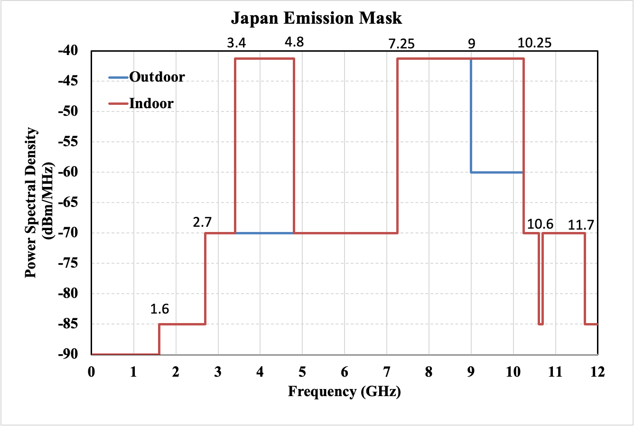

Note: For devices not equipped with any interference mitigation techniques, the average power shall be -70 dBm/MHz and the peak power shall be -64 dBm/MHz in the 3400 – 4800 MHz Band [13]. Devices for outdoor use have to be operated without causing harmful interference to SRS earth stations, RAS stations, RLS stations and RNS stations in the 7.25 – 9GHz band.

Annex C: Korea’s UWB Emission Mask

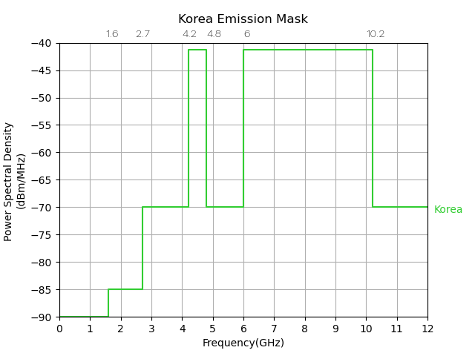

Annex D: China’s UWB Technical Requirements

Operation frequency range: 7163-8812MHz
Transmission signal bandwidth (-10dB bandwidth): minimum 500MHz
e.i.r.p. spectral density: maximum -41 dBm/MHz
Out of band emission limit:
Spectrum Range | Limit (e.i.r.p,)
5.925-7.125 GHz (7.125 GHz included) | -70 dBm/MHz
7.125-7.163 GHz | -51 dBm/MHz
8.812-9 GHz | -51 dBm/MHz
9-10.6 GHz (9 GHz included) | -65 dBm/MHz

Annex E: FCC’s UWB Emission Mask

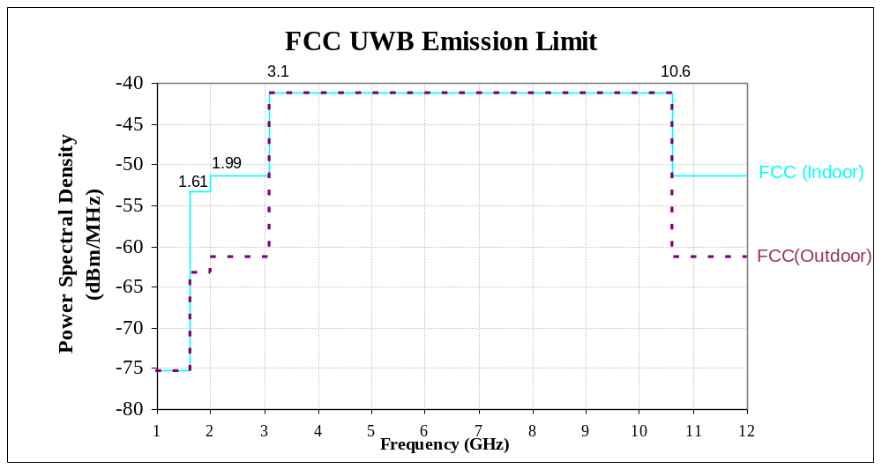

Source: FCC First Report &Order

Annex F: Europe’s UWB Emission Mask

ECC/DEC/(06)04: A1.1: GENERAL CASE

- ECC/DEC/(06)04: Generic UWB < 10GHz without mitigation or with mitigation (LDC and/or DAA)

Mitigations in ECC/DEC/(06)04
- Table 1, NOTE 1: LDC, details in Annex 2 of ECC/DEC/(06)04
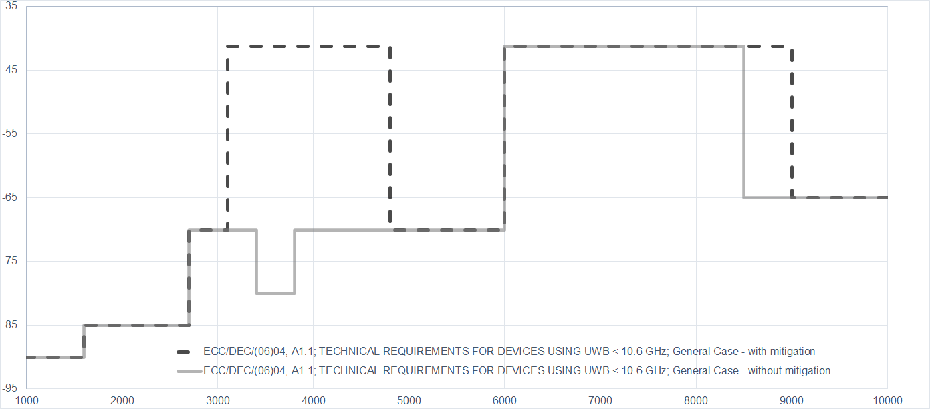
- Table 1, NOTE 2: DAA, details in Annex 3 of ECC/DEC/(06)04
Mean e.i.r.p spectral density [dBm/MHz]
Frequency [MHz]

ECC/DEC/(06)04: A1.2 VEHICULAR APPLICATION, INCLUDING UWB DEVICES INSTALLED IN ROAD AND RAIL VEHICLES

- ECC/DEC/(06)04: A1.2.1 General case for UWB devices installed in road and rail vehicles

Mitigations in ECC/DEC/(06)04
- Table 2, NOTE 1: LDC, details in Annex 2 of ECC/DEC/(06)04
- Table 2, NOTE 2: DAA, details in Annex 3 of ECC/DEC/(06)04
- Table 2, NOTE 3: TPC, details in Annex 4 of ECC/DEC/(06)04
- Exterior Limit, details in Annex 5 of ECC/DEC/(06)04
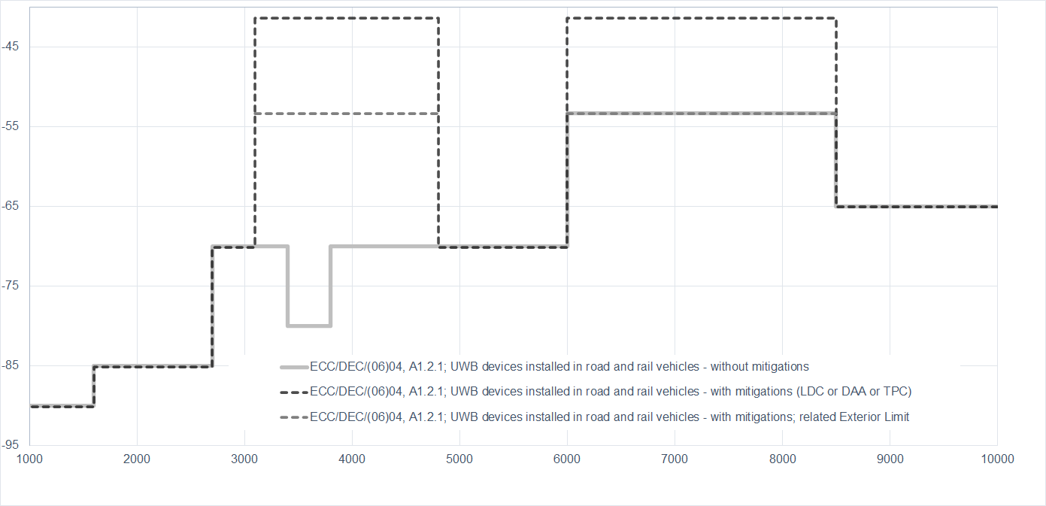
Mean e.i.r.p spectral density [dBm/MHz]
Frequency [MHz]

- ECC/DEC/(06)04: A1.2.2 Specific vehicular access systems using trigger-before-transmit

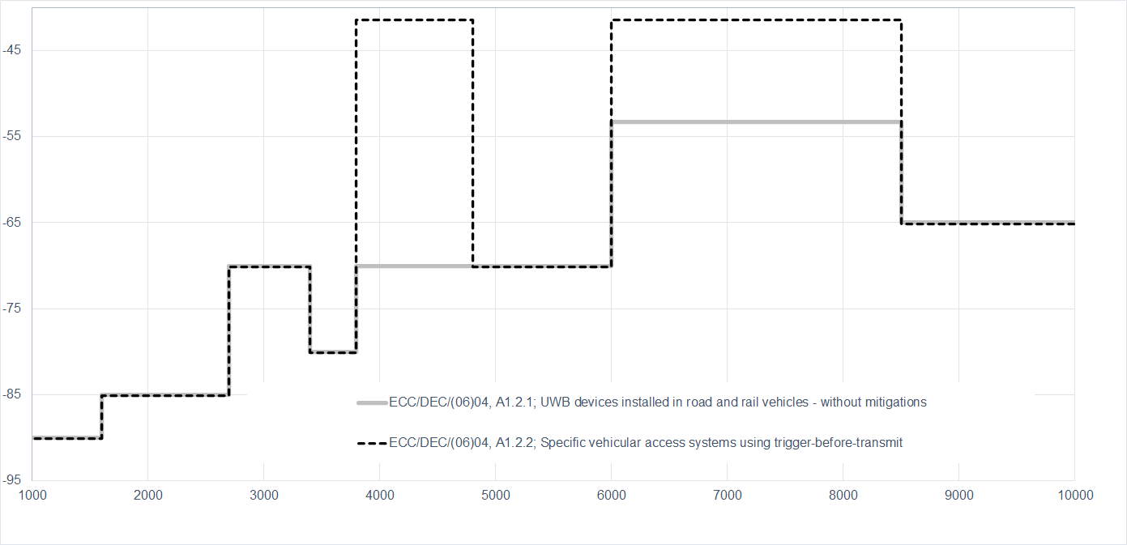
Mitigations and requirements in ECC/DEC/(06)04, Table 3
Mean e.i.r.p spectral density [dBm/MHz]
Frequency [MHz]

- ECC/DEC/(06)04: A1.2.3 Other vehicular applications, including applications involving infrastructure to vehicle and vehicle to vehicle communications in 6-8.5 GHz

Mitigations and requirements in ECC/DEC/(06)04, Table 4

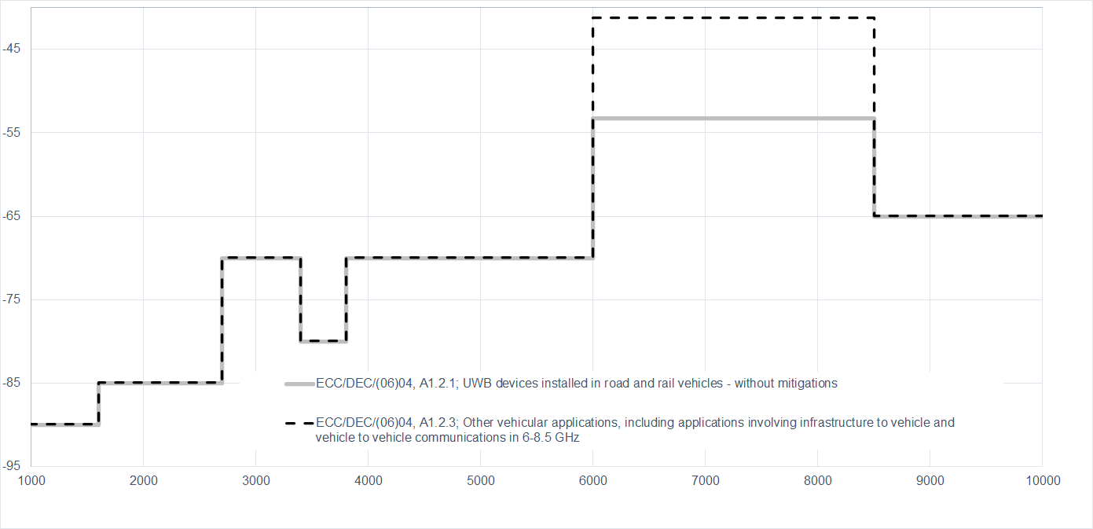
Mean e.i.r.p spectral density [dBm/MHz]
Frequency [MHz]

ECC/DEC/(06)04: A1.3: SPECIFIC RADIODETERMINATION, LOCATION TRACKING, TRACING AND DATA ACQUISITION APPLICATIONS IN 6-8.5 GHz

- ECC/DEC/(06)04: A1.3.1 Specific applications involving fixed outdoor installations

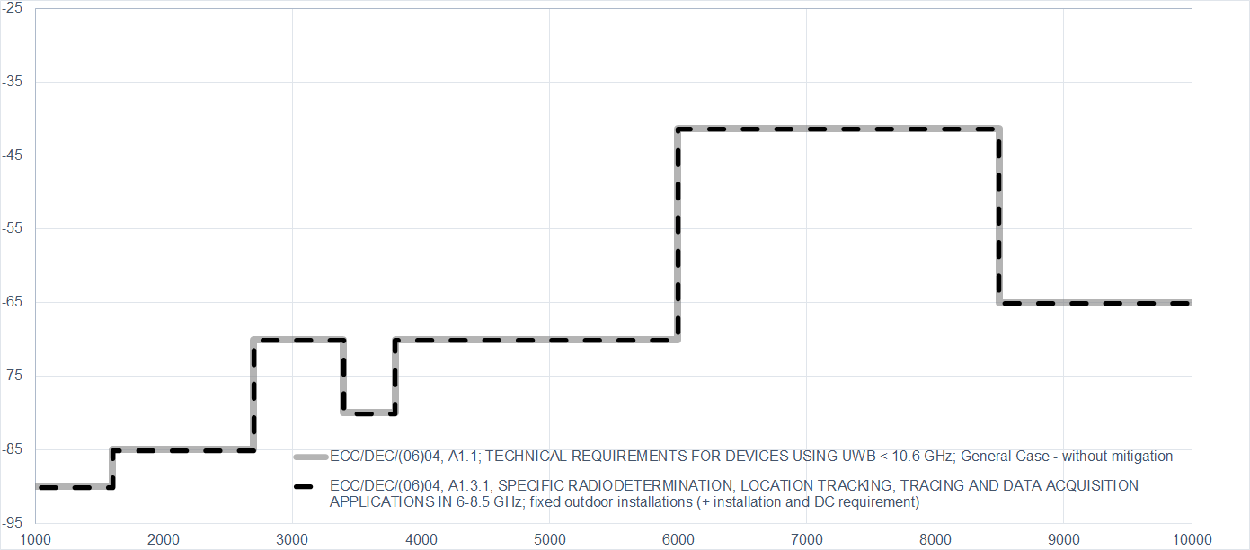
Mitigations and requirements in ECC/DEC/(06)04, Table 5
Mean e.i.r.p spectral density [dBm/MHz]
Frequency [MHz]

- ECC/DEC/(06)04: A1.3.2 Specific applications involving enhanced indoor devices
Mitigations and requirements in ECC/DEC/(06)04, Table 6

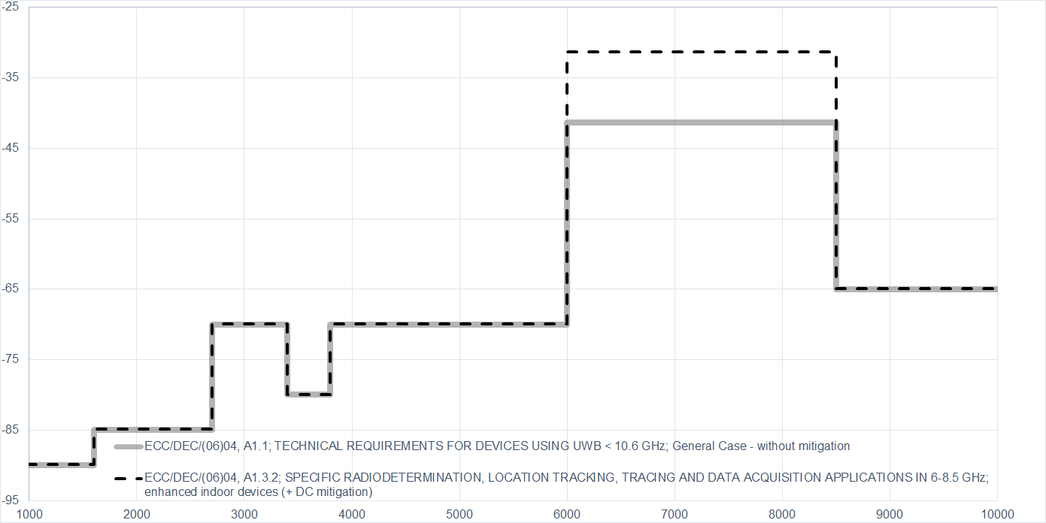
Mean e.i.r.p spectral density [dBm/MHz]
Frequency [MHz]

ECC/DEC/(07)01: Material Sensing Devices using Ultra-Wideband (UWB) technology (July 2022)

- ECC/DEC/(07)01: Table 1 : Limits for contact based UWB material sensing devices

Mitigations and requirements in ECC/DEC/(06)04, Table 1

There are several combinations of mitigations measures possible to operate under different power level e.i.r.p (-50 or -41.3 dBm/MHz) or to e.g. operate outdoor.
The emissions are outside the specified usage scenarios in the related harmonised standard
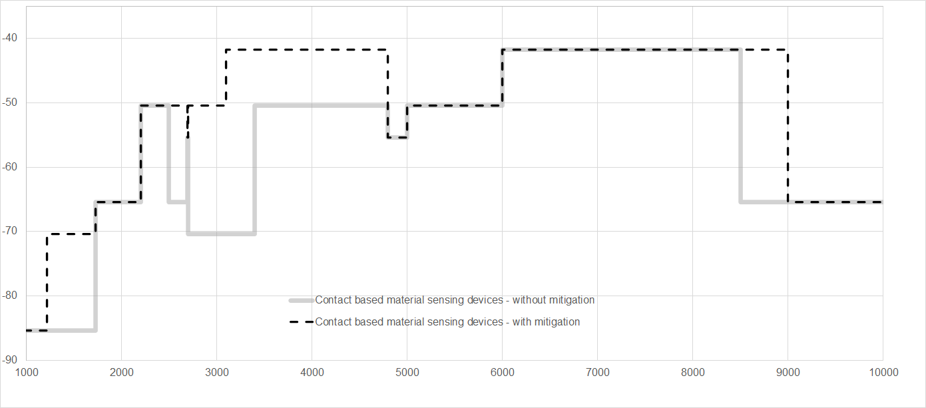
Frequency [MHz]
Mean e.i.r.p spectral density [dBm/MHz]

- ECC/DEC/(07)01: Table 2: Limits for non-contact based UWB material sensing devices

Mitigations and requirements in ECC/DEC/(06)04, Table 2

There are several combinations of mitigations measures possible to operate under different power level e.i.r.p (-50 or -41.3 dBm/MHz) or to e.g. operate outdoor.
The emissions are outside the specified usage scenarios in the related harmonised standard.

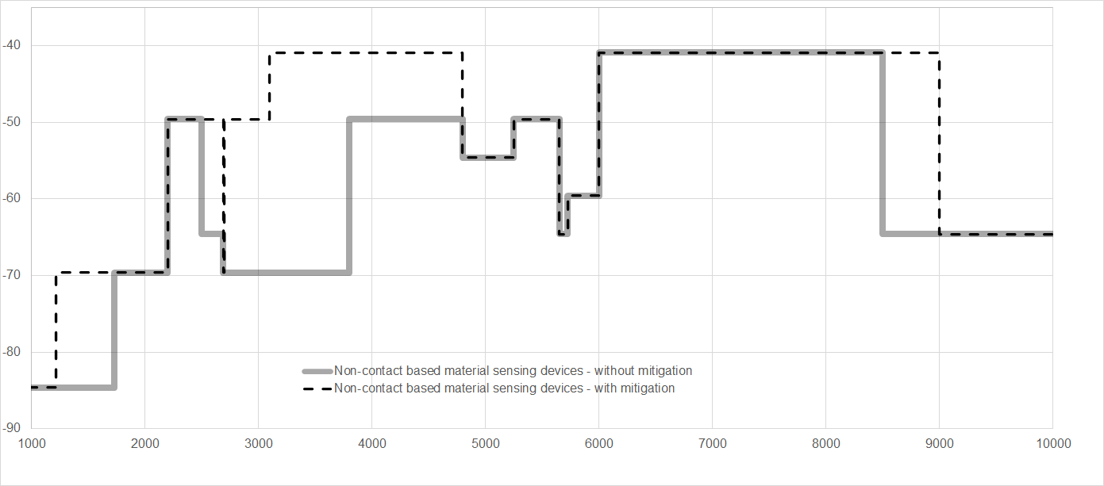
Mean e.i.r.p spectral density [dBm/MHz]
Frequency [MHz]

Annex G: UWB Regulatory Framework in APT and other regions

Frequency Identification for Systems using UWB technology
Country / Region | Frequency Band  (GHz) | Power Spectral Density Limit (e.i.r.p. dBm/MHz) | Regulations | Targeted Date for Spectrum Allocation | Remarks
Afghanistan | 6.4 – 10.7 | -41.3 | Licenses only for Indoor use | 2010 | For radio equipment with low density power to avoid interference to other services.
Australia | 3.1 – 4.8 | -70/-80¹/-41.3² | Radiocommunications (Low Interference Potential Devices) Class Licence 2015 | Decided | Ultra-wideband transmitters  Note 1: 3.4~3.8GHz  Note 2: with mitigate techniques for whole band  Refer to EN 302 065
Australia | 6 – 9 | -41.3/-65³ |  | Decided | Ultra-wideband transmitters  Note 3: Without mitigation techniques in 8.5~9GHz  Refer to EN 302 065
Australia | 6-8.5 | Various* |  | Decided | Ultra-wideband transmitters onboard aircraft  *Refer to EN 302 065-5
Australia | 4.2 – 4.8  6 – 6.8 | -62 |  | Decided | In-ground ultra-wideband transmitters  *Refer to EN 302 065 Part 2
Australia | 2.2-8.5 | Various* |  | Decided | Building material analysis transmitters using UWB  *Refer to EN302 435
Australia | 22 -26.5 | Various* |  | Decided | Short-range vehicle radar systems.  *Refer to EN302 288
Brunei  Darussalam | Various* | -41.3** | Telecommunications Notification 2018 | Decided | * Check Telecommunications Notification 2018 for frequency ranges.  **-41.3dBm/MHz at below ranges:  3.4 – 4.2 GHz with interference mitigation techniques  4.2 – 4.8 GHz,  6 – 9 GHz,  21.65 – 29.5GHz
Brunei  Darussalam | Various* | -3* |  | Decided | *77 – 81GHz
Cambodia
China (Mainland) | 7.163-8.812 | -41 | MIIT Wireless File 77 (2024) | 2025.8.1
China (Hong Kong) | 4.2 – 4.8  6 – 8.5 | -41.3 | HKCA 1080 | Decided | The equipment shall meet the technical requirements in accordance with the appropriate standards in below list:  ETSI EN 302 065-1/2/3/4 standards,  FCC Part 15 Subpart F.
China (Macao) | 4.2 – 4.8  6 -8.5 | -41.3 | CTT#198 | Decided
Fiji
India | <=1.6  1.6 – 10.6  >10.6 | -90  -41.3*  -85 | GSR 1046(E) | Decided | Generic ultra-wideband device usage  *-41.3 dBm/MHz at below ranges:  6 – 8.5GHz  3.1 – 3.4GHz (with LDC or DAA)  3.4 – 3.8GHz (with LDC or DAA)  3.8 – 4.8GHz (with LDC or DAA)  8.5 – 9GHz (with DAA)  Limit is lower for the rest frequency ranges.
India | <=1.6  1.6 – 10.6  >10.6 | -90  -41.3*  -85 | GSR 1046(E) | Decided | Location tracking system  *-41.3 dBm/MHz at below ranges:  6 – 8.5GHz  8.5 – 9GHz using DAA, otherwise -65dBm/MHz.  Limit is lower for the rest frequency ranges.
India | <=1.6  1.6 – 10.6  >10.6 | Various* | GSR 1046(E) | Decided | *Check GSR 1046(E) for Ultra-wideband device installed in Road and Rail Vehicle, Material sensing device using ultra-wideband technology and Building material analysis device.
Indonesia | 3.1 – 3.4 | -70 | 1. Regulation of Minister of Communications and Informatics of The Republic of Indonesia Number 2 of 2023 on The usage of radio frequency spectrum based on class licenses  2. Ministry of Communications and Digital Affairs Decree Number 260 Year 2024  UWB operates under a class license. | Allocated | - The radiocommunication equipment shall comply with other emissions requirements of EN 302 065  - The testing methods shall refer to EN 302 065 or EN 303 883
Indonesia | 3.4 – 3.8 | -80 |  | Allocated
Indonesia | 3.8 – 6.0 | -70 |  | Allocated
Indonesia | 6.0 – 8.5 | -41.3 |  | Allocated
Indonesia | 8.5 – 10.6 | -65 |  | Allocated
Japan | 3.4 – 4.8*  7.25 – 10.25 | -41.3 | The Ordinance for Regulating Radio Equipment | Allocated | For Land Mobile Radio Services, Data Communication only for Indoor use.  *DAA is required for 3.4 – 4.8GHz
Japan | 7.587-8.4 | -51.3/-41.3* | The Ordinance for Regulating Radio Equipment | Allocated | For Land Mobile Radio Services, Data Communication for Indoor and Outdoor use.  *-51.3dBm/MHz for 7.587-7.662GHz  -41.3 dBm/MHz for 7.662-8.4GHz
Japan | 7.25 – 9.0 | -41.3 | The Ordinance for Regulating Radio Equipment | Allocated | For Land Mobile Radio Services, Data Communication, Sensing, Radiolocation for Indoor and Outdoor use.  Required to be operated without causing harmful interference to SRS earth stations, RAS stations, RLS stations and RNS stations.
Japan | 24.25 – 29.0 | -41.3 | The Ordinance for Regulating Radio Equipment | Allocated | Automotive Short Range Radar systems
Republic of Korea | 4.2 – 4.8 | - 41.3 | Technical Standards of Wireless Equipment for Unlicensed Wireless Radio Stations (MSIT notice 2022-75) | Allocated | DAA or LDC shall be used
Republic of Korea | 6 – 10.2* | - 41.3 |  | Allocated | * 6-7.2 GHz UWB: LDC shall be used. Not allowed for fixed outdoor.  UWB range of 6.0 ~ 8.8 GHz is available for mobile device
Lao PDR
Malaysia | 3.1 – 3.4 | -70 | *by way of Class Assignment (CA) | Allocated | General UWB Communication Device  Frequency band 3.1 – 10.6 GHz:  Additional requirement for general UWB Communication device:  shall only be used in confined areas of buildings or localised on-site operations. Use of outdoor mounted antennae is not permissible.
Malaysia | 3.4 – 3.8 | -80 | *by way of Class Assignment (CA) | Allocated
Malaysia | 3.8 – 6.0 | -70 | *by way of Class Assignment (CA) | Allocated
Malaysia | 6.0 – 8.5 | -41.3 | *by way of Class Assignment (CA) | Allocated
Malaysia | 8.5 – 10.6 | -65 | *by way of Class Assignment (CA) | Allocated
Malaysia | 3.1 – 3.4 | -70 | *by way of Class Assignment (CA) | Allocated | UWB Device in Road and Rail Vehicles  Additional requirements for UWB device in road and rail vehicles  - for short range communications in road and rail vehicles, which include devices mounted inside or at the surface;  - does not apply to fixed road infrastructure installations;  - does not apply to fixed outdoor locations, for use in flying models, aircraft and other form of aviation; and  The maximum mean EIRP spectral density for the emission outside the vehicle at elevation angles higher than 0 degree. The reference plane for the 0 degree is the sensor mounting height.
Malaysia | 3.4 – 3.8 | -80 | *by way of Class Assignment (CA) | Allocated
Malaysia | 3.8 – 6.0 | -70 | *by way of Class Assignment (CA) | Allocated
Malaysia | 6.0 – 8.5 | -53.3 | *by way of Class Assignment (CA) | Allocated
Malaysia | 8.5 – 10.6 | -65 | *by way of Class Assignment (CA) | Allocated
Malaysia | 21.65 – 22 | -61.3 | *by way of Class Assignment (CA) | Allocated | Automotive Radar Device
Malaysia | 22 – 29.5 | -41.3 | *by way of Class Assignment (CA) | Allocated | Automotive Radar Device
Malaysia | 76 – 77 | 50 | *by way of Class Assignment (CA) | Allocated | Automotive Radar Device
Malaysia | 77 – 81 | -3 | *by way of Class Assignment (CA) | Allocated | Automotive Radar Device
Malaysia | 0.03 – 0.23 | -65 | *by way of Apparatus Assignment (AA) |  | For the use of ground probing radar device, in-wall probing radar device, and through-wall probing radar device
Malaysia | 0.23 – 0.96 | -60 | *by way of Apparatus Assignment (AA)
Malaysia | 2.17 – 3.4 | -51.3 | *by way of Apparatus Assignment (AA)
Malaysia | 3.4 – 5.0 | -41.3 | *by way of Apparatus Assignment (AA)
Malaysia | 5.0 – 6.0 | -51.3 | *by way of Apparatus Assignment (AA)
Malaysia | 6 – 10.6 | -65 | *by way of Apparatus Assignment (AA)
Malaysia | 2.17 – 10.6 | -41.3 | *by way of Apparatus Assignment (AA) |  | For the use of medical imaging device and surveillance device
Myanmar | 5.8 | Less than 100mW |  |  | Not be used in landing and not to interfer to the existing systems. The system will be approved by the Department by the official letter.
Nepal | 6 – 8.5 | -41.3 | Radio Frequency Policy of Telecommunication Services, 2080 |  | 6 – 8.5
New Zealand | 0.000009 - 1.6 | -90 | Radiocommunications Regulations (General User Radio Licence for Ultra Wide  Band Devices) Notice 2017 | Allocated | Note 1: 3.1 – 4.8 GHz, devices implementing low duty cycle mitigation techniques :  1. a maximum permitted mean power spectral density of -41.3 dBm/MHz e.i.r.p.; and  2. a maximum power of -30 dBW e.i.r.p.  Note 2: Road and rail vehicles:  1. For devices installed in road and rail vehicles, where transmit power control is implemented:  a. the maximum permitted mean power spectral density is -41.3 dBm/MHz e.i.r.p;  b. the maximum power is -30 dBW e.i.r.p.; and  c. the transmit power control must operate with a dynamic range of at least 12 dB below the maximum  mean e.i.r.p. spectral density.  2. For devices installed in road and rail vehicles, where transmit power control is not implemented:  a. the maximum permitted mean power spectral density is -53.3 dBm/MHz e.i.r.p.; and  b. the maximum power is -42 dBW e.i.r.p.  Note 3: Within the bands 4.2 – 4.8 GHz and 6.0 – 6.8 GHz, fixed outdoor transmitters installed in-ground are  permitted for operation below the horizontal plane with:  1. a maximum permitted mean power spectral density of -62 dBm/MHz e.i.r.p.; and  2. a maximum power of -52 dBW e.i.r.p.
New Zealand | 1.6 - 2.7 | -85 |  | Allocated
New Zealand | 2.7 - 3.4 | -70/-41.3¹ |  | Allocated
New Zealand | 3.4 - 3.8 | -80/-41.3¹ |  | Allocated
New Zealand | 3.8 - 4.2 | -70/-41.3¹ |  | Allocated
New Zealand | 4.2 - 4.8 | -70/-41.3^{1，2}/-53.3²/-62³ |  | Allocated
New Zealand | 4.8 - 6.0 | -70/-41.3¹ |  | Allocated
New Zealand | 6 - 8.5 | -41.3/-41.3²/-53.3²/-62³ |  | Allocated
New Zealand | 8.5 -10.6 | -65 |  | Allocated
New Zealand | 10.6 - 100 | -85 |  | Allocated
Pakistan | <=1.6  1.6 – 10.6  >10.6 | -90  -41.3*  -85 | Regulatory Framework for Short Range Devices (SRD) & Terrestrial Internet of Things (IoT) Services | Allocated | *-41.3 dBm/MHz at below ranges:  3.1 – 3.4 GHz (LDC or DAA)  3.4 – 3.8 GHz (LDC or DAA)  3.8 – 4.8 GHz (LDC or DAA)  8.5 – 9 GHz (LDC or DAA)  6 – 8.5 GHz.  Limit is lower for the rest frequency ranges.
Philippines | 6 – 8.5 | -41.3 | MC 06-08-2018 | Allocated
Singapore | 3.4 – 4.2  4.2 – 4.8  4.8 – 6  6.0 – 9.0 | -70, -41.3*  -41.3  -70  - 41.3 | IMDA TS UWB  Class licence.  For localised use only. Imaging devices shall be licensed on a case-by-case basis. | Allocated | Generic UWB devices.  *with mitigation technology
Singapore | 21.65 – 26.65  77 – 81 | - 41.3  - 3 |  | Allocated | Automotive Short Range Radar systems Automotive Short-Range Radar (SRR) systems that are vehicular radar systems intended for collision mitigation and traffic safety applications
Singapore | Various* | Various* |  | Allocated | Ground and Wall Probing Radar (GPR and WPR) systems used in survey and detection applications  *Check UWB Emission Mask and Table in IMDA TS UWB.
Sri Lanka | 1.6 – 10.6  > 10.6 | - 41.3*  -85 | Radio And Telecommunications Terminal Equipment(RTTE) Type Approval Rules 2020 | Allocated | *-41.3 dBm/MHz at below range: 6 – 8.5GHz.  Limit is lower for the rest frequency ranges.
Thailand | 1.6 – 2.0 | -41.3 | 1.NBTC Notification on Criteria for UWB 1.6-10.6 GHz  2.NBTC Notification on Technical Standard for UWB 1.6-10.6 GHz | Allocated | The technical requirements for the radiocommunication equipment shall comply with one or more of the following standards:  EN 302 065-1/2/3/4,  FCC Part 15 Subpart F Ultra-Wideband Operation
Thailand | 2.0 – 2.2 | -62.0 |  | Allocated
Thailand | 2.2 – 3.4 | -41.3 |  | Allocated
Thailand | 3.4 – 4.2 | -77.0 |  | Allocated
Thailand | 4.2 – 4.5 | -41.3 |  | Allocated
Thailand | 4.5 – 4.8 | -77.0 |  | Allocated
Thailand | 4.8 – 10.6 | -41.3 |  | Allocated
Vietnam | 4.2 – 4.8 GHz  7.2384 – 8.5  8.5 – 9  7.2384 – 9 | -70 , -41.3*  -41.3  -65  -41.3* | Circular No. 08/2021/TT-BTTTT  amended and supplemented by Circular No. 01/2025/TT-BKHCN | Allocated | Use the device in an indoor environment or an environment with equivalent radio shields; Not to be allowed to active the device in the aircraft.  *with mitigation technology
Europe | < 1.6  1.6 – 2.7  2.7 – 3.4  3.4 – 3.8  3.8 – 4.2  4.2 – 4.8  4.8 – 6  6.0 – 8.5  8.5 – 10.6  > 10.6 | -90  -85  -70  - 80  -70  -70  -70  -41.3  (Note 1, 2 and 3)  -65  -85 | Unlicensed.  Not to be used at fixed outdoor location.  ECC/DEC/(06)04 | Allocated | Note 1: In case of devices installed in road and rail vehicles, operation is subject to the implementation of Transmit Power Control (TPC) with a range of 12 dB with respect to the maximum permitted radiated power and an exterior limit of the maximum mean e.i.r.p. spectral density of -53.3 dBm/MHz.  Note 2: For vehicular access systems trigger-before-transmit operation and LDC ≤ 0.5% (in 1h) or TPC are required  Note 3: For specific applications that involve enhanced indoor devices, Maximum mean power spectral density (e.i.r.p.) is not greater than -31.3 dBm/MHz.  For details see ECC Dec (06)04.
USA | 3.1 – 10.6 | - 41.3 | Indoor Systems  FCC 47 CFR 15.517  Handheld Systems  FCC 47 CFR 15.519 | Allocated

Note: Information is compiled as of 9 Sep 2026 and is subject to changes.

1. IEEE 802.15.4AB:UNLOCKING UWB’STRUE POTENTIAL
Indoor Location Market
Indoor Location Based Services Market - Global Forecast 2026-2032
Katz, R., Callorda, F., and Valencia, R. (2025). An assessment of socio-economic value of Ultra-Wideband. New York: Telecom Advisory Services, March.
* omlox (www.omlox.com) is part of the Profibus International with more than 1.800 members globally
MSIT website: Public Notice 2022-75 (in Korean)
MIIT website: Attachment 2 (miit.gov.cn)

