

APT REPORT ON

ACCESSIBLE IOT APPLICATION AND SMART CITY SERVICES IN THE AP REGION

Edition: April 2026

The 38th APT Standardization Program Forum (ASTAP-38)
20-24 April 2026
Bangkok, Thailand

(Source: ASTAP-38/OUT-19)

No. APT/ASTAP/REPT-65
Table of Contents

1 Scope 4
2 References 4
3 Terms and Definitions 4
4 Abbreviations and Acronyms 4
5 Introduction to Accessible IoT Services 4
6 Use Cases on Accessible IoT applications and smart city services in the AP region 6
6.1 Accessible IoT services in a smart classroom for students with hearing disabilities 6
6.1.1 Source 6
6.1.2 Title 7
6.1.3 Time of submission 7
6.1.4 Summary 7
6.1.4.1 Introduction 7
6.1.4.2 Accessible Services 7
6.1.5 Discussion 8
6.1.6 Related Standards 8
6.2 Preventive Safety Service System of Korea 9
6.2.1 Source 9
6.2.2 Title 9
6.2.3 Time of submission 9
6.2.4 Summary 9
6.2.4.1 Introduction 9
6.2.4.2 Accessible Services 11
6.2.5 Discussions 12
6.2.6 Related Standards 13
6.2.7 References 13
6.3 IoT services for persons with disabilities – case of Yangju General Welfare Center for Persons with Disabilities 13
6.3.1 Source 13
6.3.2 Title 13
6.3.3 Time of submission 13
6.3.4 Introduction 13
6.3.5 Outcomes 14
6.3.6 Discussions 15
6.3.7 Related Standards 15
7 Standardisation of IoT Accessibility – Recommendation ITU-T Y.4204 15
8 Conclusion 17
Bibliography 19

1 Scope
This report focuses on addressing standardization activities of ITU-T on IoT accessibility and real-world examples of accessible IoT applications and smart city services for all people, including persons with disabilities, those with age-related disabilities and those with specific needs. The scope of this report is as follows:
- Introduction to standardization activities on IoT accessibility
- Use cases of accessible IoT applications and smart city services

2 References
- ITU-T Recommendation Y.4204: Accessibility Requirements for the Internet of Things applications and services

3 Terms and Definitions
Terms used in this report are as follows:
none

4 Abbreviations and Acronyms
Abbreviations used in this report are as follows:

COVID-19 Coronavirus disease 2019
IoT Internet of Things
ICT Information and Communications Technology

5 Introduction to Accessible IoT Applications and Smart City Services
In the past, Information and Communications Technology (ICT) accessibility has been focused on retrofitting to rectify the lack of access to ICTs for persons with disabilities and older persons, including those with specific needs. One approach to making ICT accessibility involved the use of specific technology or a service platform. Examples include IPTV (ITU-T Y.1901) and the World Wide Web (W3C WCAG 2.0), which incorporate accessibility features.
However, the Internet of Things (IoT) does not represent a particular service platform or a specific technology, as per the definition of IoT outlined in ITU-T Y.4000. Instead, it encompasses a broader concept that is loosely characterized as a global infrastructure. The accessibility requirements for the Internet of Things (IoT) bridge the gap between the general ICT accessibility requirements.

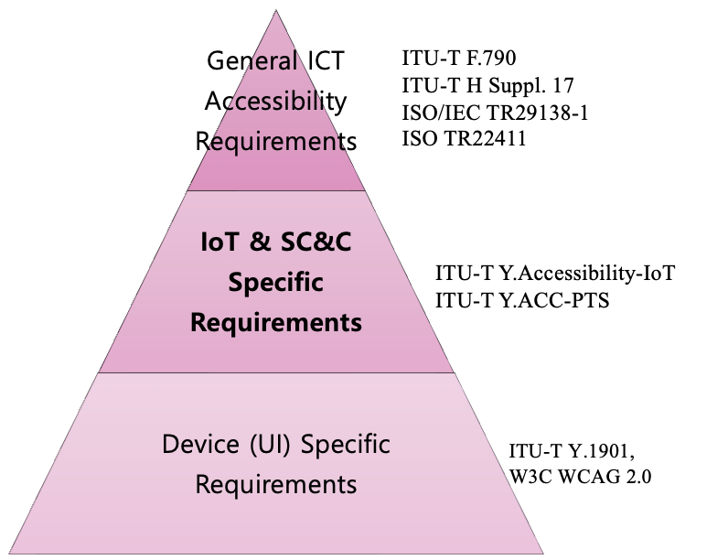
Figure 1. Relationships between accessibility standards

There are two issues that are particularly salient in the realm of IoT accessibility. Firstly, IoT accessibility is challenged by issues surrounding inter-connectivity. The various “things” that participate in the IoT ecosystem exchange data through an intricate IoT infrastructure, which encompasses multiple user interfaces and diverse data sources. It is imperative that accessibility features be preserved, regardless of the complexity inherent in the system.
Secondly, there are challenges related to the definition of "things.” Non-ICT devices, such as home appliances and kiosks, are integral participants in IoT services. Consequently, device-specific accessibility issues exist alongside those that are uniquely pertinent to the IoT environment.
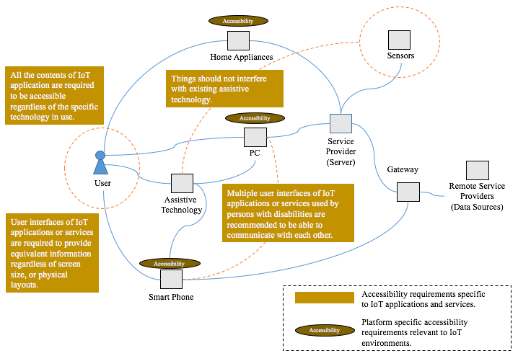
Figure 2. Accessibility requirements within the IoT service scenarios

Beyond these two core challenges, IoT accessibility also introduces new complexities related to distributed intelligence, dynamic service composition, and lifecycle management of accessibility features. Unlike traditional ICT systems, IoT services are often assembled dynamically from multiple devices, platforms, and third-party services. This means accessibility cannot be guaranteed solely at the level of individual components; it must be maintained end-to-end across sensing, data processing, service orchestration, and user interaction.
Furthermore, accessibility settings and user preferences must persist across heterogeneous environments. Users may interact with the same IoT service through smartphones, kiosks, smart speakers, or wearable devices, each with different capabilities and interface modalities. Without standardized mechanisms for transferring accessibility profiles and service states, users—especially persons with disabilities and older persons—may be forced to repeatedly reconfigure systems, creating significant usability barriers.
Another emerging issue is the increasing role of automation and artificial intelligence in IoT ecosystems. As AI-driven decision-making becomes embedded in smart homes, smart mobility, and smart city services, accessibility requirements must extend to algorithmic transparency, explainability, and bias mitigation. Intelligent adaptation should enhance inclusion, not introduce new forms of digital exclusion.
Privacy and trust also become critical in accessible IoT environments. Accessibility-related data—such as disability type, assistive technology usage, or health indicators—is highly sensitive. Future IoT architectures must therefore adopt privacy-by-design and security-by-design approaches, ensuring that personalization does not compromise user dignity or autonomy.
Finally, accessibility in IoT must evolve from reactive accommodation toward proactive universal design. This requires integrating accessibility considerations at the earliest stages of system architecture, device design, and service development. Rather than retrofitting solutions after deployment, accessibility must be treated as a fundamental quality attribute of IoT infrastructures.
Together, these considerations highlight the need for holistic, interoperable, and human-centric standardization approaches that move beyond platform-specific accessibility toward inclusive IoT ecosystems capable of supporting smart living and smart sustainable cities at scale.

6 Use Cases on Accessible IoT applications and smart city services in the AP region

To improve understanding of ITU-T Y.4204 and promote wider adoption of accessible IoT services, it is important to collect use cases from the Asia-Pacific region. Regional examples reflect diverse cultures, languages, demographics, and risk environments, helping validate the standard’s requirements in real-world contexts. Such use cases can demonstrate practical implementation, support capacity building, and accelerate inclusive, locally relevant deployment.
This section introduces use cases on accessible IoT applications and smart city services in the Asia-Pacific region.

  - Accessible IoT services in a smart classroom for students with hearing disabilities
    - Source
Republic of Korea
    - Title
Accessible IoT services in a smart classroom for students with hearing disabilities
    - Time of submission
ASTAP-34
    - Summary
      - Introduction
The number of hearing-impaired children entering general schools is increasing. Still, students with hearing disabilities suffering from "difficulty in understanding lectures" find it difficult to have equal educational opportunities as students without disabilities. Students with hearing disabilities in general schools receive lectures on residual hearing and vision (colloquial). However, it is challenging to receive lectures depending on the individual hearing level, classroom environment affected by noise or seat arrangement, teacher's pronunciation, and posture.
In the Republic of Korea, 77% of students with hearing disabilities go to general schools, showing the highest percentage among disability types. This is related to the Republic of Korea's educational policy showing a trend of inclusive education (113% increase from 2011), and in particular, the perception that hearing disabilities are partially improvable disability areas with hearing aids and cochlear implant surgery also affected. However, it is difficult to have complete hearing even with strengthening aids such as hearing aids, cochlear implants, and hearing training.
In particular, since the learning environment of the classroom is tailored to students without disabilities, a classroom environment such as the degree of noise and a reception environment that may be affected by the placement of seats such as near walls or windows are not quite welcoming for students with hearing disabilities. It is also greatly influenced by the teacher's teaching method and depending on the teacher's position, such as pronunciation, sound volume, blackboard writing, and walking around, it can be a factor that hinders the reception of information through hearing or vision (speech).
      - Accessible Services
In online classes activated due to COVID-19, the acquisition of information for those students with hearing disabilities is more significantly reduced in machine sound listening. Accordingly, a service that provides real-time text interpretation through artificial intelligence was developed and distributed to expand received information through class text interpretation services for students without disabilities. Using this, it is possible to expect improvement in the quality of school life and academic will through the improvement of reception lectures in classes.
The artificial intelligence real-time text interpretation service is equipped with the function of real-time text interpretation through artificial intelligence and contains various convenience functions that can be used for review during class while showing the teacher's lecture in real-time captions. The advantage of this service is that it is easier to use and more accurate than other artificial intelligence text interpretation services. It is also characterized by being able to watch Internet lectures from PCs through the AUX line. Table 1 depicts an overview of the service.

Table 1. The artificial intelligence real-time text interpretation service overview
Characteristics | Voice recognition solution tailored to the education field
Description | Speech conversion solution using speech recognition engine
Function | Voice lecture input through the transmitter(microphone) is stored on the tablet.  Then, text interpretation with real-time captions is provided to students.
Features | ∙ Terminology library for each subject  ∙ Storage function: Review based on translated content  ∙ Editing function: word search and memo function of translated contents
Deployments | Providing online caption service in 5 regions including Seoul Metropolitan Office of Education in 2020

    - Discussion
Using an alternative sense (from hearing to reading) to expand lecture reception for students with hearing disabilities, it was intended to confirm the 'change in lecture reception' by providing a text interpretation service that converts school lecture content from voice to text. This study was intended to verify the effectiveness of solution utilization in the actual educational field as the basic research stage of this model.
However, it is practically impossible to create an environment in which students can use the solution for sufficient time in the actual educational field due to environmental restrictions caused by the spread of COVID-19, so students' class reception and class understanding were investigated through simulated environments.
In this study, limited staff visited each participant’s household to simulate the actual class environment as similar as possible. The staff conducted simulated classes in each participant’s household by providing a 1:1 lecture on a topic that is familiar to the participant’s age and education level. After the lecture, participants were asked to answer a questionnaire. Then the collected responses were analyzed. To also reflect the increased utilization of online classes online class simulations were also conducted.
In the effectiveness test of the artificial intelligence real-time text interpretation service for a total of 24 elementary, middle, and high school students with hearing disabilities, the reception rate increased in both online and offline age groups, and significant changes were observed in the online group of high school students (10%). As a result of verifying the change in class understanding, the degree of understanding among all age groups, excluding elementary school offline, showed an increase in understanding, especially in online classes of middle and high school students. In the results of presenting a survey that asked students to score their own understanding of the contents of the class, all participants showed similar results in the evaluation of the understanding of the contents of the lecture.
As a result of using the solution, students' overall learning confidence increased, and it was observed that students' satisfaction with the solution utilization was also very high.
    - Related Standards
ITU-T Recommendation Y.4204: Accessibility Requirements for the Internet of Things applications and services

  - Preventive Safety Service System of Korea
    - Source
Republic of Korea
    - Title
Preventive Safety Service System of Korea
    - Time of submission
ASTAP-33 (initial use cases), ASTAP-35 (revision with discussions)
    - Summary
      - Introduction
The purpose of this project is to develop a personalized preventive safety service mobile app, K-Guard, that can protect the life safety of ordinary citizens, including persons vulnerable to safety, and to verify the effectiveness of the app. This project has been supported by the National Disaster Management Research Institute, Republic of Korea, since April 2019.

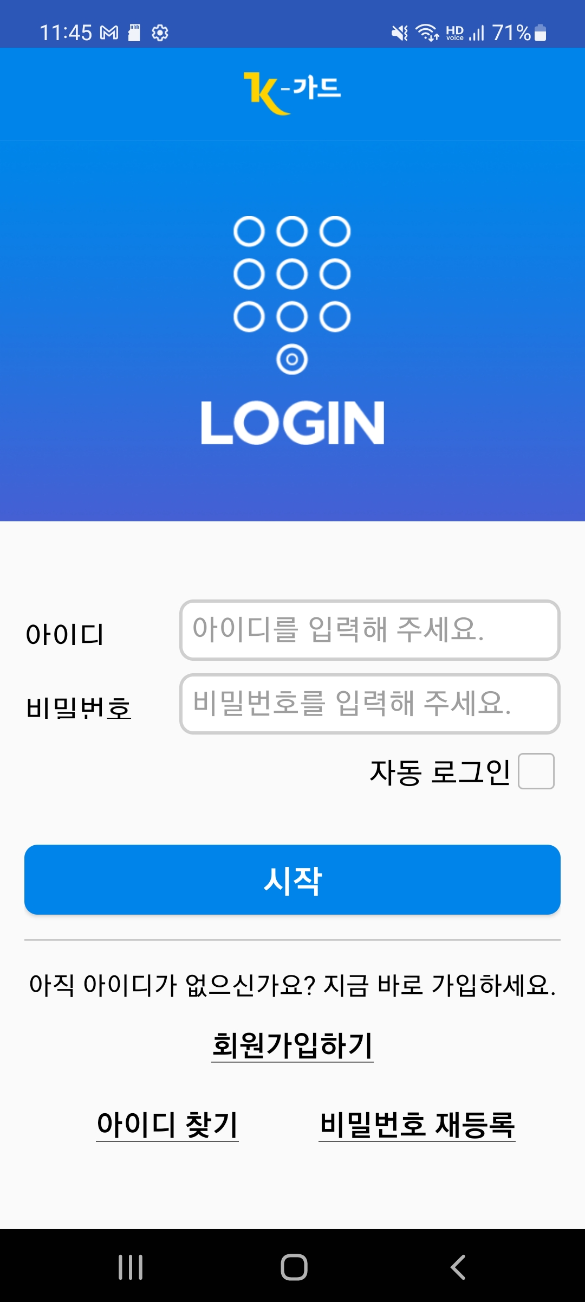 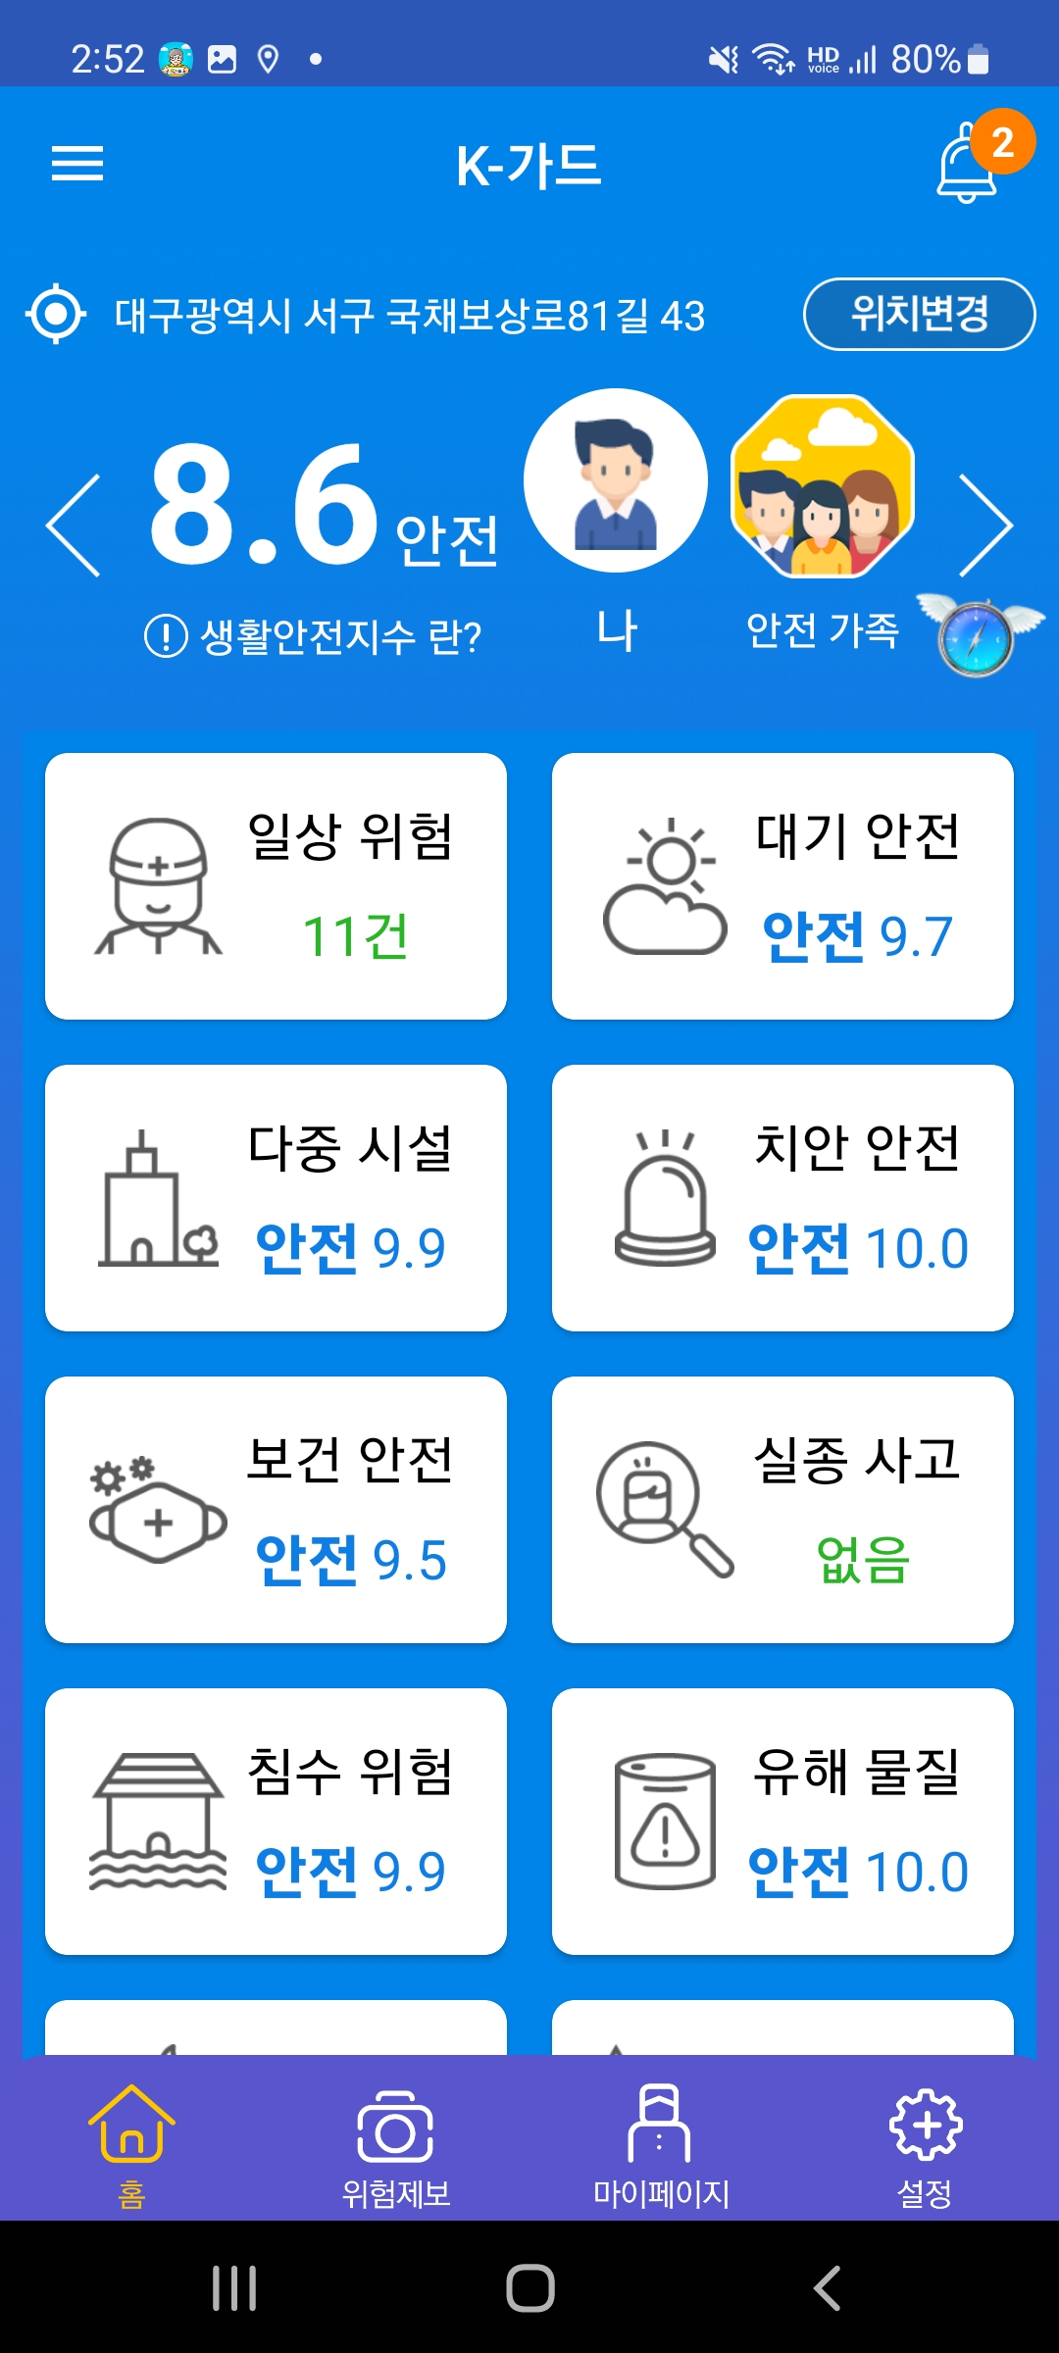
Figure 3. Screen image of the K-Guard App
The K-Guard app consists of a total of five sub-platforms, including collection, analysis, spatial, service, and common, and provides predictive and response information to users in response to various life safety risk information. The platform plays the role of a server as a core system of services that collects and analyzes risk information and creates customized content.
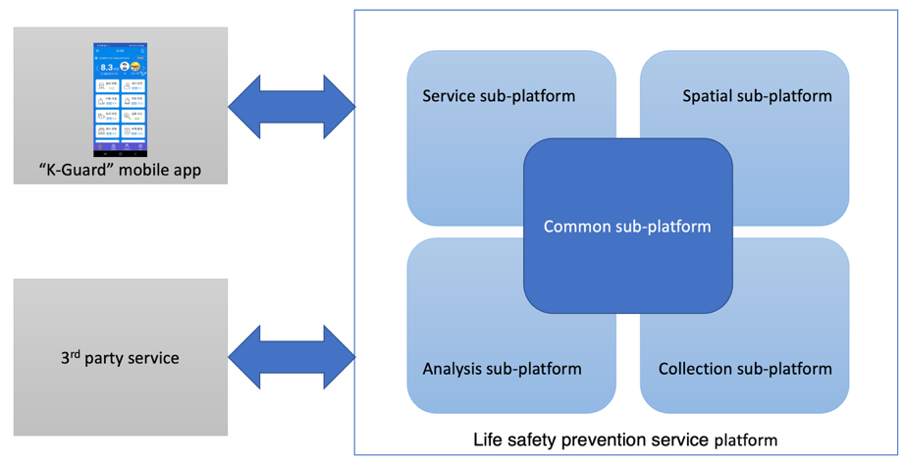
Figure 4. the K-Guard service system structure
The platform is standardized in a way that responds to various risks to life safety. In the demonstration, a total of 11 types of services were chosen for the demonstration of the platform. Eight of these services were selected based on the preference for living safety risks that citizens are most interested in through a survey of ordinary citizens. Three services were added with the hope of local governments in charge of the demonstration site. Table 2 summarizes the list of services.
Table 2. List of provided services on the K-Guard App (Source – Lee et al., 2022)
Name of service | Description | Reason for selection
Daily life risk | User report analysis service for various risks arising from daily life. | public survey
Hazardous substance leakage | A service that analyzes and informs the risk level of hazardous substances in case of leakage. | public survey
Public-use facility risk | A service that informs risk of public-use facilities such as public institutions, train stations, department stores, etc. | public survey
Crime risk | A service that analyzes and informs the security information around the user. | public survey
Health and disease | A service that analyzes and informs risks in the event of a pandemic. | public survey
Missing person | A service that notifies users around the location where a missing person occurs. | public survey
Flood hazard | A service that analyzes and informs the user of risks in the event of a flood. | public survey
Air quality safety | A service that analyzes air quality information around the user’s location and informs the user of the risk. | public survey
Slope collapse risk | A service that measures the risk of collapse through the slope sensor and informs the user. | The demand of the local government
Fire hazard | A service that measures the risk of fire and informs the user of the risk of fire through a fire detection sensor. | The demand of the local government
The safety of living alone | A service that checks the activity of a person living alone in the house and informs the registered user when there is no movement for more than a specific time. | The demand of the local government

      - Accessible Services
A model of the K-Guard service tailored to the persons vulnerable to safety was applied to an information service platform to prevent actual everyday life safety.
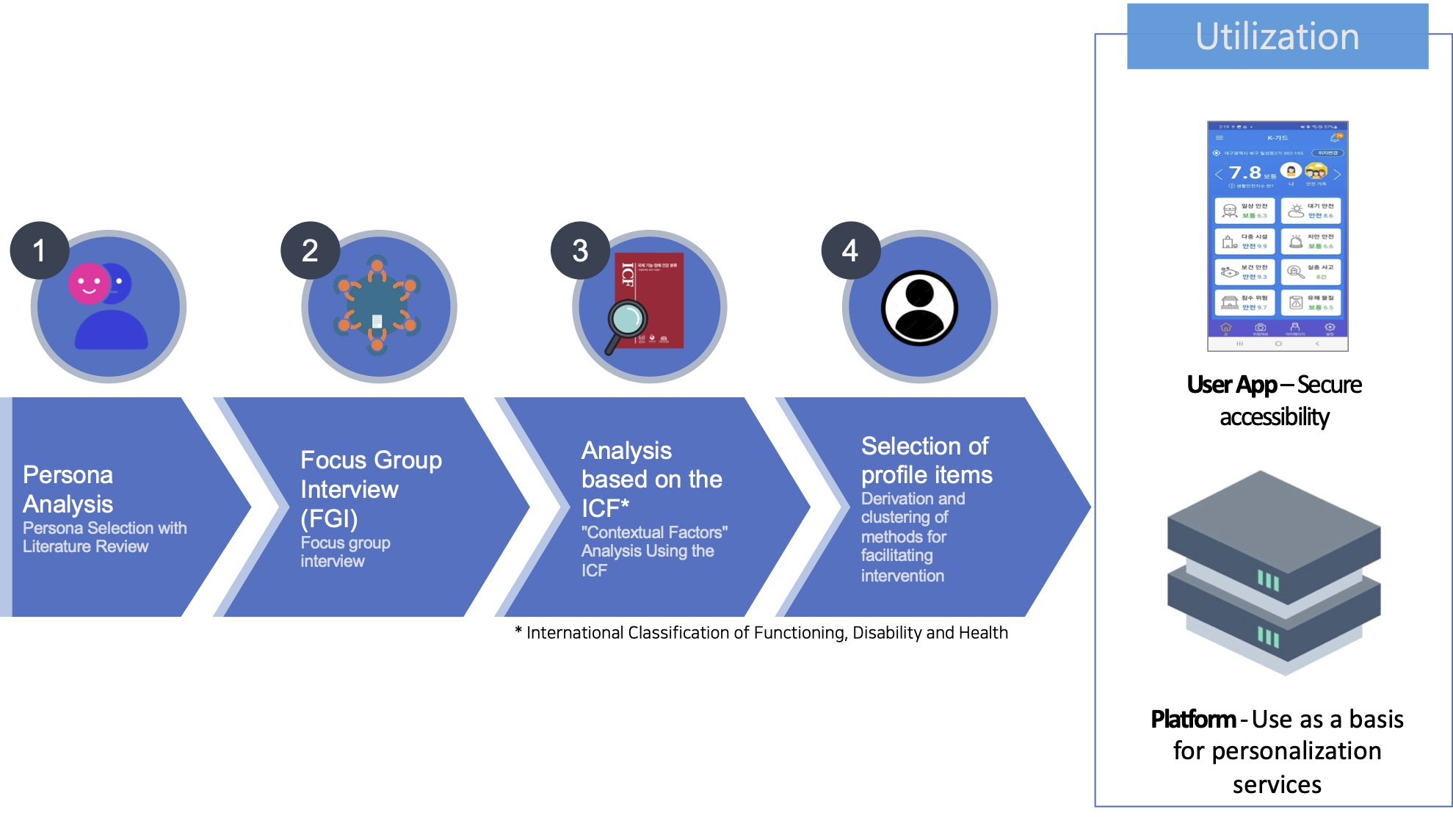
Figure 5. The process of deriving accessibility profiles for those vulnerable to safety
(Source – Lee et al., 2022)
The K-Guard app applied customized functions for the safety vulnerable as follows according to the intervention and facilitation factors derived through persona analysis, FGI, and ICF-based analysis. Figure 3 summarizes the process of deriving customized functions for the safety vulnerable.
First, when calculating the individual risk index, which is an indicator of comprehensive safety risk at the current user's location, 13 types of weight settings were applied and analyzed according to the user profile. For example, when there is a risk related to walking around, people with physical disabilities using wheelchairs are notified of the risk by setting a higher weight than those without disabilities.
Second, the K-guard app's compliance with mobile content accessibility standards was reviewed to ensure that persons with visual, hearing, and physical disabilities do not have any inconvenience in using the mobile app. In particular, the screen reader function of the mobile device was used to allow those with visual disabilities to convert textual content into voice information and provide notifications to persons with hearing disabilities with vibrations.
Third, through content analysis by experts with developmental disabilities, pictures and text content were improved so that persons with developmental disabilities, the elderly, and children could understand the various response information displayed.
Fourth, for the natives of Korean sign language, the corresponding information content was converted into sign language video content to be used at the user's discretion.
Fifth, for content that provides evacuation route information in multi-use facilities, etc., emergency exits and movement information accessible to wheelchair users were customized.
    - Discussions
A satisfaction survey and usability evaluation were conducted on 107 subjects after conducting a three-month demonstration service to 200 people in Seo-gu, Daegu-si, Republic of Korea. Participants voluntarily responded to the recruitment and received communication fee support worth 30,000 KRW (US $30 equivalent) per person in return for the three-month test.
As a result of the study, the most frequently used item among the app was the daily life risk notification, and 55.14% of the subjects used the app every day. As for the satisfaction level with the K-guard confirmed through Mobile Application Rating Scale (MARS), the usefulness of information was the highest with 4.15 points, followed by aesthetics with 4.13 points.
Table 3. Satisfaction of the K-guard: Results of MARS (Source – Lee et al. 2022)
Variables |  | Total  (n=107) | Persons without disability  (n=53) | Persons with disabilities  (n=30) | Elderly†  (n=24) | F | p
 |  | M ± SD | M ± SD | M ± SD | M ± SD | F | p
Engagement |  | 3.92 ± 1.00 | 4.08 ± 0.81 | 3.89 ± 1.04 | 3.62 ± 1.24 | 1.810 | 0.169
Functionality |  | 4.05 ± 0.85 | 4.20 ± 0.77 | 4.03 ± 0.90 | 3.75 ± 0.91 | 2.410 | 0.095
Aesthetics |  | 4.13 ± 0.84 | 4.22 ± 0.78 | 4.18 ± 0.81 | 3.88 ± 0.98 | 1.476 | 0.233
Information |  | 4.15 ± 0.83 | 4.19 ± 0.72 | 4.28 ± 0.85 | 3.90 ± 1.02 | 1.539 | 0.220
Additional items | Awareness | 4.28 ± 1.04 | 4.40 ± 0.86 | 4.27 ± 1.11 | 4.04 ± 1.27 | 0.972 | 0.382
Additional items | Knowledge | 4.20 ± 1.10 | 4.34 ± 0.90 | 4.17 ± 1.21 | 3.92 ± 1.35 | 1.236 | 0.295
Additional items | Attitude | 4.21 ± 0.97 | 4.28 ± 0.91 | 4.27 ± 0.94 | 3.96 ± 1.12 | 1.011 | 0.367
Additional items | Help seeking | 4.31 ± 0.98 | 4.43 ± 0.77 | 4.43 ± 0.90 | 3.87 ± 1.33 | 3.181 | 0.046*
Additional items | Behaviour change | 4.12 ± 1.10 | 4.25 ± 0.98 | 4.07 ± 1.11 | 3.92 ± 1.32 | 0.791 | 0.456
*p<.05, **p<.01, †60≤ and persons without disability, MARS: Mobile Application Rating Scale
In the usability evaluation conducted by dividing the subjects into groups of persons without disabilities, those with disabilities, and the elderly, positive responses were mainly low in the elderly group. There was no significant difference in the other groups. In the evaluation of the satisfaction and usability of the app, there were no items that showed significant differences compared to other subjects in the group with disabilities.
Positive responses were low, mainly in the elderly group. However, in previous studies, not all elderly people find it difficult to use smartphones. In this study, some elderly people responded that it was easy and convenient to use the app. In contrast, others responded that it was difficult to use it, showing that smartphone use varies depending on the situation of the elderly.
This study showed the possibility of developing an inclusive safety management system that can satisfy both persons with and without disabilities and also confirmed the various needs of those vulnerable to safety that may further embody this possibility.
    - Related Standards
Recommendation ITU-T Y.4204 (2019) Accessibility requirements for the Internet of things applications and services
Recommendation ITU-T Y.4219 (2022) Accessibility requirements for the user interface of smart applications supporting IoT
    - References
Lee, Y. J., Ji, S. Y., & Kim, S. H. (2020). A study on the accessibility requirements analysis model for the preventive safety and disaster service information system: Focusing on the communication ability. The Journal of Korean Society of Community Based Occupational Therapy, 10(3), pp. 1-13.
Lee, Y. J., Lee, C. Y., Ji, S. Y., & Kim, S. H. (2021). A study on the customized service system and accessibility profile for the vulnerable: Focused on the life safety prevention and response information system. The Journal of Korean Society of Community Based Occupational Therapy, 11(3), pp. 43-55.
Lee, Y. J., Lee, C. Y., Ji, S. Y., & Kim, S. H. (2022). A study on the development and usability evaluation of the k-guard app, an inclusive life safety prevention service using the accessibility profile for the vulnerable to safety. The Journal of Korean Society of Community Based Occupational Therapy, 12(3), pp. 37-.

  - IoT services for persons with disabilities – case of Yangju General Welfare Center for Persons with Disabilities
    - Source
Republic of Korea
    - Title
IoT services for persons with disabilities – case of Yangju General Welfare Center for Persons with disabilities
    - Time of submission
ASTAP-36
    - Introduction
The General Welfare Center for Persons with Disabilities in Yangju-si, Gyeonggi-do, Rep. of Korea, conducted a project to distribute IoT systems to families with adult persons with disabilities in northern Gyeonggi-do with the support of the Community Chest of Korea. In the project, from July 2022 to October 2023, a total of 22 families (12 families in Yangju-si, 3 families in Dongducheon-si, 4 families in Uijeongbu-si, and 3 families in Yeoncheon-gun) were selected through a public offering. Through individual counselling, the project was conducted to identify the environment in the home and the difficulties of living in the home to be resolved through the Internet of Things by distributing IoT devices and services to suit the needs of each family.
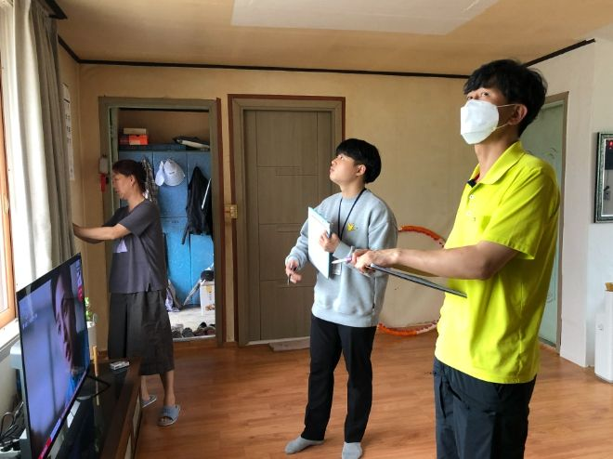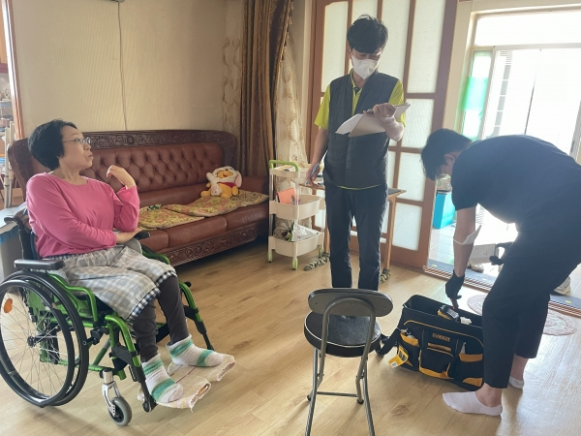
Figure 6. IoT devices installation setup

This project used IoT devices, including smart hubs, AI speakers, smart curtains, smart lighting switches, mini wireless switches, smart plugs, and smart door locks.
A smart hub is a device for connecting and controlling installed IoT devices. It also connects general home appliances that can be operated with AI speakers or smart switches.
The AI speaker used the voice recognition technology of the Google platform to control devices connected to the smart hub.
In this project, an IoT maintenance company were selected to support IoT device installation, maintenance, and user training. Experts visited each home in person to install the device to suit the home environment and periodically visited and inspected the problems to identify and improve them.
    - Outcomes
The services that participants responded with the most useful were smart curtains and smart light switches, which were highly useful because persons with disabilities who had difficulty moving around and having difficulty operating the switch alone could control it through AI speakers and remote switches.
In the second year, smart door locks were added, which allow users to open or lock the front door remotely, increasing convenience and security.


Figure 7. User interview

Participant 1 (with a physical disability) – "Because I use both hands to move the wheelchair, I realised that I was disabled when I turned on and off the light, but using IoT, my self-esteem increased."
Participant 2 (with physical disability) – "I've been injured when using the bathroom at night, but I'm so happy to be able to go safely now after participating in this project."
Participants in this project showed a slight increase in self-esteem from 2.5% to 2.6%, while depression results decreased from 2.92% to 2.45%, and stress from 2.65% to 2.47%, indicating significant results.
    - Discussions
This project was a pilot project to confirm the possibility that smart home devices can greatly help persons with disabilities live independently and improve their lives. However, for persons with disabilities to use the IoT environment well, simply purchasing and installing IoT equipment is ineffective, and various considerations must be made.
First, there is a limit to equipping all facilities in the home with IoT services, so introduction and maintenance costs should be considered. In particular, the purchase assistance project of IoT devices for persons with disabilities with economic difficulties should be supported in terms of social welfare.
Second, in order to select the service to be introduced, an expert evaluation and analysis are essential. It is important to closely examine which services can provide practical help through the analysis of social workers and experts in the community based on the needs of persons with disabilities collected through case management of persons with disabilities, and to consider details such as the installation location of remote switches.
Third, user training is required so that the facility can be used well, and the usability is checked through expert visit guidance and periodic device maintenance is required. In particular, it is important to establish a system for continuous maintenance because it is difficult for persons with disabilities to solve problems on their own if they fail or malfunction.
Fourth, in this project, only a few devices were used and dedicated assistive devices for persons with disabilities were not used, but in order to connect each device to each other and use it integrally on one platform, it is necessary to secure interoperability that guarantees the connection between devices, and to minimize barriers to entry by reducing the learning time and content of users by consistent interfaces.
    - Related Standards
ITU-T Recommendation Y.4204: Accessibility Requirements for the Internet of Things applications and services
- Standardisation of IoT Accessibility – Recommendation ITU-T Y.4204
Recommendation ITU-T Y.4204 outlines accessibility requirements tailored for Internet of Things (IoT) applications and services. It addresses the benefits of accessible IoT applications and services and specifies accessibility requirements for these applications and services catering to persons with disabilities, older adults with age-related disabilities, and others with specific needs to utilize IoT applications and services. Appendix I includes several use cases to illustrate the necessity of IoT accessibility. This Recommendation complements existing Recommendations that are specifically defined for certain platforms when such platforms are applied in the IoT context.
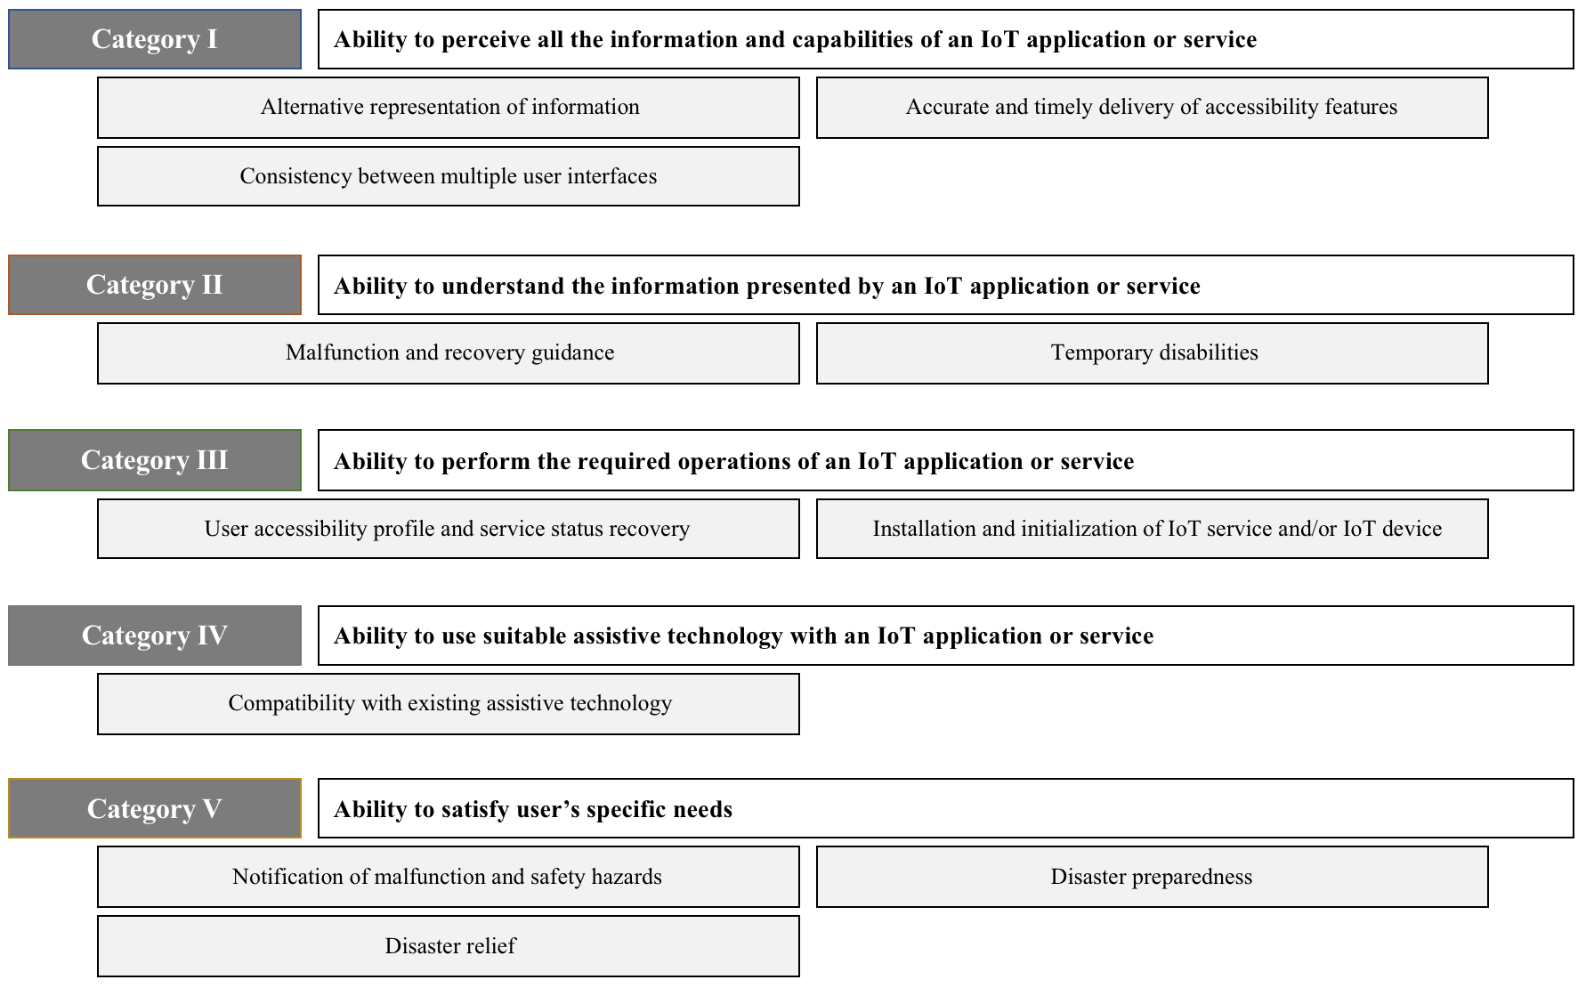
Figure 8. Five categories of IoT accessibility requirements
(source: ITU-T Recommendation Y.4204)
Unlike platform-specific accessibility standards, Y.4204 addresses accessibility at the IoT service level, acknowledging the heterogeneous and interoperable nature of IoT environments. It bridges the gap between general ICT accessibility requirements and device- or platform-specific features by applying universal design principles across IoT ecosystems.
As illustrated in Figure 8, at the core of Y.4204 are five categories of IoT accessibility requirements:
1. (Category I) Ability to perceive information and capabilities – IoT services must provide alternative representations of information (e.g., visual, audio, haptic, text) and ensure accessibility features are delivered accurately and consistently across multiple user interfaces.
2. (Category II) Ability to understand presented information – Systems must clearly notify users of errors or malfunctions, provide recovery guidance, and support users with temporary or situational disabilities through intuitive activation of accessibility features and culturally independent symbols.
3. (Category III) Ability to perform required operations – IoT applications must expose the status of connected “things,” support service and device reset, enable retrieval of user accessibility profiles, and provide accessible installation and initialisation processes for both services and devices.
4. (Category IV) Ability to use assistive technology – IoT services should be compatible with existing assistive technologies and must not interfere with devices such as hearing aids or medical equipment, while clearly communicating compatibility information.
5. (Category V) Ability to satisfy specific user needs – This includes immediate multimodal notification of safety hazards, automated escalation to emergency services when needed, and support for disaster preparedness and disaster relief, particularly for vulnerable populations.
The Recommendation also emphasizes user accessibility profiles, multimodal interaction, service status recovery, and continuity of accessibility settings across devices. Practical use cases—such as smart homes, transportation, healthcare, and disaster response—demonstrate how IoT can enable independent living, real-time assistance, and inclusive emergency management.
Overall, Y.4204 establishes accessibility as a fundamental requirement of IoT applications and services, not an optional enhancement. It provides a technical foundation for interoperable, human-centric, and inclusive IoT ecosystems, supporting the broader vision of “smart living for all.”
- Conclusion
When emerging technologies such as IoT are introduced, careful consideration is needed from the design stage of the system to ensure that the accessibility of persons with disabilities is respected. In the history of existing ICT technology, we must reflect on the messy and challenging improvement efforts that have occurred while enhancing access to these advanced technologies, often without adequate consideration for persons with disabilities. As mentioned earlier, IoT and smart city technologies can serve as practical tools to include persons with disabilities from the outset and create a new world for them when implemented thoughtfully. However, if sufficient access for disabled individuals is not secured, digital disparities will only worsen.
The development of IoT and smart city applications is ongoing and driven by the continuous introduction of new technologies. Examples include Digital Twin technology and Citiverse innovations utilising the Metaverse. To ensure accessibility for persons with disabilities in this evolving field, it is essential to establish guidelines that align with international standards to enhance their accessibility.
In the Asia-Pacific region, many countries are proactively adopting IoT and smart city technologies to close the ICT gap. However, when implementing technologies from developed nations, it becomes clear that ensuring accessibility for persons with disabilities cannot be achieved solely through their efforts. To adapt the accessibility measures established in alignment with the socio-cultural context of foreign countries to their own environments and needs, actions such as raising awareness about this issue, engaging in developing international standards, and creating various use cases are essential.
While ITU-T Y.4204 establishes foundational accessibility requirements for IoT applications and services, future standardization must evolve to address the increasing complexity of emerging technologies and Smart Sustainable Cities and Communities (SSC&C). Next-generation frameworks are expected to move from static accessibility requirements toward dynamic, AI-driven personalization, where services adapt in real time based on user context, preferences, and capabilities.
A key direction is the integration of user accessibility profiles across heterogeneous platforms, enabling seamless continuity of accessible experiences as citizens move between homes, public spaces, transportation systems, and digital services. This will require interoperable standards for accessibility metadata, identity management, and privacy-preserving data exchange.
Another priority area is the convergence of IoT with digital twins, edge AI, and multimodal interfaces. Future standards should define how accessibility functions are embedded within city-scale digital twins, allowing inclusive urban planning, real-time risk assessment, and personalized navigation services. Edge intelligence will also play a critical role by supporting low-latency accessibility adaptations directly at the device or local network level.
In SSC&C contexts, standardization must expand toward inclusive service orchestration, covering domains such as smart mobility, digital health, emergency response, and public participation. This includes harmonized requirements for accessible alerts, disaster preparedness, and cross-agency coordination, ensuring that vulnerable populations are systematically considered in urban resilience frameworks.
Trust, security, and ethics will become increasingly central. Future Recommendations are expected to incorporate privacy-by-design, explainable AI, and digital dignity principles, particularly when handling sensitive accessibility and health-related data.
Finally, global collaboration, especially within the Asia-Pacific, will be essential. Aligning IoT and SSC&C standards with international human rights frameworks and sustainable development goals will help ensure that technological innovation translates into equitable societal outcomes. Building on Y.4204, future work should emphasize human-centric, interoperable, and scalable architectures that enable truly inclusive smart cities—transforming accessibility from a technical requirement into a core pillar of digital transformation.

Bibliography

Lee, Y. J., Ji, S. Y., & Kim, S. H. (2020). A study on the accessibility requirements analysis model for the preventive safety and disaster service information system: Focusing on the communication ability. The Journal of Korean Society of Community Based Occupational Therapy, 10(3), pp. 1-13.
Lee, Y. J., Lee, C. Y., Ji, S. Y., & Kim, S. H. (2021). A study on the customized service system and accessibility profile for the vulnerable: Focused on the life safety prevention and response information system. The Journal of Korean Society of Community Based Occupational Therapy, 11(3), pp. 43-55.
Lee, Y. J., Lee, C. Y., Ji, S. Y., & Kim, S. H. (2022). A study on the development and usability evaluation of the k-guard app, an inclusive life safety prevention service using the accessibility profile for the vulnerable to safety. The Journal of Korean Society of Community Based Occupational Therapy, 12(3), pp. 37-.
Recommendation ITU-T Y.4204 (2019) Accessibility requirements for the Internet of things applications and services
Recommendation ITU-T Y.4219 (2022) Accessibility requirements for the user interface of smart applications supporting IoT
W3C (2008), Web Content Accessibility Guidelines (WCAG), W3C Recommendation 11 December 2008.
http://www.w3.org/TR/WCAG20/

