

APT REPORT ON

IMPLEMENTING PUBLIC SAFETY LTE (PS-LTE) MOBILE BROADBAND CAPABILITY IN ASIA PACIFIC REGION

Edition: April 2026

The 36th Meeting of APT Wireless Group
6 – 10 April 2026
Bandar Seri Begawan, Brunei Darussalam (Hybrid)

(Source: AWG-36/OUT-08)

No. APT/AWG/REP-93(Rev.2)

APT REPORT ON
Implementing Public Safety LTE (PS-LTE) Mobile Broadband capability in Asia Pacific Region

1. Abstract

Dedicated narrowband wireless public protection and disaster relief (PPDR) communications systems deployed to date were typically designed to meet the requirements of public safety agencies for secure and reliable (and generally encrypted) mission critical voice and low speed data/messaging services. These systems were intended to enhance and support day-to-day and operational incident response coordination within and amongst the various national/state PPDR agencies, to enable timely, reliable and secure cooperation as well as enhanced inter-agency and intra-agency (interoperable) communications.

Advanced IMT mobile broadband technology now offers the capability for enhanced multi-agency PPDR radiocommunications services based on broadband data packet-oriented applications. For example, broadband IMT technology is facilitating carriage of live stream video along with images and spatial data (maps and layers) for conveying information between personnel in the field and decision makers in operational command centres. As the converging technology advances and standards are being developed, mobile broadband systems may also facilitate emergency services’ operational voice and messaging traffic across a single infrastructure layer, allowing legacy narrowband systems such as TETRA, P-25 , DMR, etc. to eventually be retired from service. Further, commercial mobile broadband networks have the capability for meeting PPDR operational and/or supplementary communication requirements in a variety of ways, such as providing additional capacity or augmentation where dedicated PPDR networks are insufficient or not yet deployed, or by providing an integrated network approach involving dedicated PPDR spectrum and a commercial network with priority PPDR traffic handling functionality, as described in an Annex to this Report.

Annex 1 of this Report provides a broad overview of imminent broadband wireless developments, including information on the ‘freeze dates’ of the relevant 3GPP Specification Release versions, and the particular 3GPP technical specification ‘releases’ scheduled to deliver the various PPDR functional and technical requirements. This Annex also outlines the expected dates of availability to commercial operators, and indicative dates by which time commercial operators might be expected to deploy relevant functions and technology enhancements.

In 2003, WRC-2003 approved Resolution 646 in recognition of the importance of radio communications to the PPDR community and that PPDR users can benefit from the harmonization of radio spectrum for PPDR. Twelve years later the WRC-2015 approved the revision of Resolution 646 (Rev. WRC-2015) so that PPDR users can benefit from harmonized spectrum for PPDR broadband mobile.

In the APT progress has been made in studies on harmonizing spectrum for PPDR systems; on the technical requirements PPDR; and on implementing PPDR mobile broadband capability.
This report complements studies that has been conducted thus far by providing the current status of standardization on PPDR features by 3GPP and on network implementation Public Safety LTE (PS-LTE) by some countries in the world, as well as in APT countries.

2. Introduction
Narrowband ‘land mobile’ radiocommunications systems in current use by PPDR agencies are a mature, standards-based set of technologies capable of generally supporting interoperability and meeting PPDR operational requirements for mission critical push-to-talk voice communications. The emergence of broadband wireless access systems, including so-called ‘smart’ user devices along with new and innovative broadband applications, is seeing widespread adoption by the community, to the extent that broadband wireless technology offering ‘anytime/anywhere’ internet connectivity is now considered by most people to be an essential part of everyday life.

At the same time, the impact of natural disasters, the increased threat of terrorism, and growing populations, along with greater community expectations, are resulting in new demands by PPDR agencies for a similar broadband wireless capability that enables sending and receiving of rich multimedia informational content (including video, images, maps and location data).

The pace at which the availability of mobile broadband access and related applications is growing worldwide provides an opportunity for PPDR agencies to move beyond the limitations of the current mobile radio voice network paradigm - as exemplified by the FirstNet program in the United States and the Safe-Net in the Republic of Korea. More generally, the emergence of broadband wireless technologies provides an opportunity to redesign vital PPDR radiocommunications systems.

With the increasing deployment and availability of mobile broadband systems based on standardized IMT technologies, PPDR agencies and organisations have an opportunity to enhance their operational capabilities and efficiency, to improve their response to emergency events and community needs, and more effectively meet increasing public expectations.

The enhanced capabilities provided by mobile broadband systems will enable the primary PPDR operational benefits to be more effectively realized, including better decision making, improved speed and capacity of response and improving the safety of PPDR agency personnel and the general public. These operational benefits will flow through to the community through more efficient and targeted responses that could further minimize loss of life, extent and severity of injury, and damage to infrastructure and property within the community.

In general the implementation of a PS-LTE network will include the following aspects:

Applications (Apps)

A PS-LTE network will have to support PPDR applications and key mission-critical network services with the goal to provide the PPDR community the necessary communications tools it needs to operate efficiently and carry out mission critical tasks. It should be able to enable the creation of new applications while maintaining support for existing commercial applications.

Core Network
The evolved packet core (EPC) network has six primary functions: it switches data, processes and reformats information, stores and maintains data and keeps it secure. Applications and services and operational and business support systems are also in the core network. The core will interface with other networks and the Internet. The core is connected to radio access networks via the backhaul layer of the network.

Transport- Backhaul and Sidehaul

These are the links that carry user traffic, such as voice, data and video, and signaling from the radio base stations to the core network. It provides the connections between cell sites and the core wireless broadband network, the internet and other networks. To meet the quality of service needs of PPDR users the backhaul should be redundant wherever feasible to ensure that network traffic continues to flow during periods of extreme network demand and stress.

Radio Access Network (RAN)

The RAN portion of the network consists of the radio base station (also known as evolved NodeB (eNodeB)) infrastructure that connects to user devices. RAN includes cell towers and may include mobile hotspots embedded in vehicles that backhaul to the core network over satellite or other types of wireless infrastructure.
The coverage, capacity and performance for a PS-LTE network will depend on the national policy and priorities of the country in which the network is operating. Network reliability is a key PPDR requirement and most network outages are due to power failures and the loss of data links. PS-LTE sites will need redundant power backup that relies on a variety of sources. Power, backhaul, sites and coverage should be designed with the goal of avoiding single points of failure.

3. Review of IMT Technologies Capabilities for Meeting PS-LTE Requirements
Specific technical requirements for broadband PPDR systems are already defined in APT-AWG Report 38 (and also in Report ITU-R M.2377).
The operational requirements that are driving the need for a mobile broadband capability, as distinct from the narrowband voice and low speed data capability, are the data rich applications supporting multimedia communications including video, images, maps and large data files as the basis for conveying information between personnel in the field and decision makers in operational command centres. A key consideration however is whether the images currently being transmitted to and from PPDR agency personnel are of sufficient quality, definition and timeliness to effectively support operations.
A standards-based IMT approach to deploying a mobile broadband capability for PPDR operations will create a number of quantifiable benefits. These include:
- improved interoperability and increased opportunity for collaboration between relevant agencies, authorities, user organisations and citizens in everyday work, at major emergencies, and extraordinary events supported by multi-agency response at a local level, nationally, regionally and internationally; and
- a rich ecosystem of devices and applications that better meet operational needs and improve the cost/benefit situation.
In this section, the PPDR operational requirements that can be delivered by mobile broadband systems are reviewed in the context of IMT technology features and functions.
In Report ITU-R M.2377 and APT/AWG/REP-38 (Rev.1) PPDR generic requirements are specified in terms of both user needs and functional requirements. Commercial IMT network operators are rapidly deploying, operating and optimising their mobile broadband networks using the 3GPP LTE set of standards. As the LTE standards evolve through various releases, the ability to provide additional features and functionality in a commercial broadband network to support PPDR operational requirements is being continuously enhanced.
The following are some of the key considerations for the operational use of IMT technologies to support PPDR mobile broadband applications.
- The overarching needs of national PPDR agencies:
  - To communicate reliably, securely and effectively (recognized and is high on the political agendas in several APT countries).
  - To enable first and second responders and support staff to use voice (including group) communications, data and multimedia capable functionality in a ubiquitous manner.
  - The ability to share information in real time within and between agencies - it is essential that different responding agencies are able to communicate efficiently and to safely and efficiently work together to meet operational challenges.
  - To provide communication with the general public to mitigate the typical disaster environment if public networks are at risk of overload.
  - To provide all of these capabilities in a cost effective manner, including ‘up front’ deployment costs, annual operating costs, and end user device costs.
- Key aspects of current dedicated PPDR systems:
  - Designed primarily for mission critical push-to-talk (PTT) voice communications, including group communications with a very high Grade and Quality of Service (GoS/QoS) - connection latency is measured in milliseconds.
  - Have limited low speed data capacity, so consequently:
    - cannot easily be used to communicate real-time video between an incident site and the command centre;
    - cannot retrieve large data contents from a database - as a result, some responders may need to turn to alternative communication solutions such as private mobile phones; and
    - performance upgrades of current PPDR infrastructure and mobile devices are expected to fall considerably short of commercially available IMT mobile broadband capabilities.
  - Are a specialized and unique market with special technical and physical requirements, and therefore infrastructure and equipment can be more costly than that of commercial IMT systems.
- The expected technical evolution to mobile broadband technology includes:
  - Assessment of the convergence of technologies that provide single infrastructure layer opportunities
  - Supplementing the current national dedicated PPDR infrastructures by commercial IMT networks to enable mobile broadband system development.
  - Using off-the-shelf as well as purpose-designed mobile devices to enable PPDR mobile broadband capabilities to be fully capitalized.
  - To build and complement current PPDR applications with mobile broadband applications using packet-data services with very short response times.
- The unique operational requirements of PPDR are currently being considered by 3GPP for incorporation into commercial IMT standards. Of particular relevance, the January 2011 United States Government decision to adopt the 3GPP LTE technology to meet future public safety operational broadband needs is driving a renewed global interest in matching PPDR functional requirements; operational reliability and capacity/GoS objectives; and effective coverage needs to IMT networks that will be also using the same LTE technology.
- There has also been notable debate in several forums in regard to how commercial/public networks might also be employed for meeting the broadband wireless needs of PPDR agencies. Several reports/white papers have been developed as outlined in Report ITU-R M.2291
European agencies and administrations are similarly backing LTE for PPDR. The TETRA + Critical Communications Association (TCCA) represent the views of TETRA and other critical communication technology users and manufacturers. In mid-2012 the TCCA indicated:
“The TETRA and Critical Communications Association (TCCA) has an objective of driving the development of Mobile Broadband solutions for the users of Mission Critical and Business Critical mobile communications. Having reviewed existing technologies the TCCA believes that LTE holds the greatest prospect for delivering such solutions. As a result the TCCA intends to work with 3GPP to include the functionality necessary within the LTE standard to meet that objective.”
The TCCA also intends to work in cooperation with ETSI to create common interoperable solutions that are required by the Critical Communications user community. The TCCA believes strongly in the principles of common standards and harmonized solutions and on a global basis. We therefore encourage all of those involved in the standardisation and regulation arenas to support a single harmonized standard and to designate sufficient harmonized frequency allocations below 1 GHz for use in Public Protection & Disaster Relief (PPDR) and critical infrastructure industries such as the Utilities, Railways and others.”
In 2013 TCCA published a white paper titled “Mission Critical Mobile Broadband:
Practical standardisation & roadmap considerations”, which addresses:
- Technology considerations
- Standardisation process and timetable
- Impact of standards timetable on implementation options
- TCCA vision for Mission Critical networks evolution.
In the paper TCCA indicated that “There is much work to be done in terms of standardisation to make LTE a suitable solution to transport mission critical data applications. Adequate voice services over LTE are not expected until at least 2020.”
Even the critical data communications security and network integrity requirements sought by PPDR agencies can now be readily implemented by the end-to-end IP connectivity architectures of new IMT networks, through mechanisms such as IP-SEC and ‘tunnelling’ protocols, secure proxy-servers, and ‘meshed’ inter-nodal linkages. In fact the use of IMT technology by some military forces, which have a greater security requirement than PPDR agencies, is evidence of the security capability that IMT networks afford.
Accommodating such requirements on commercial networks would also need to be negotiated through contractual agreements based on service level requirements or government intervention.

4. Approaches for PPDR Mobile Broadband Network Deployment:

The LTE set of standards is being endorsed by a growing number of countries, at national level, regionally, and even in international forums as the preferred IMT technology to support commercial public and PPDR mobile broadband networks. There are several viable business models/deployment options for PPDR organisations to consider when planning their capability requirements.
- A dedicated PPDR capability provisioned either through:
- Dedicated infrastructure owned by the PPDR agency or controlling entity; or
- infrastructure owned by a commercial entity.
- A combination of a dedicated PPDR network with infrastructure owned by the PPDR agency or controlling entity providing coverage and capacity over a defined operational area with operational augmentation through a roaming agreement with a commercial network/s to extend services beyond that area based on negotiated contractual service level arrangements. This assumes standardized IMT networks deployed by all operators and well-considered roaming arrangements including priority access, and functional equivalency and transparency, along with appropriate GoS/QoS levels to meet PPDR requirements
- An integrated approach whereby dedicated PPDR spectrum resources, licensed to the PPDR agency, are integrated (alongside other spectrum resources) within a commercial network core and radio access network. This enables a dedicated spectrum partition to provide exclusive capacity for PPDR users, and which is further supplemented as/when needed by priority access and preferential data treatment to the commercial spectrum for additional capacity and load balancing to ensure the best user experience at all times. This is expected to be achieved in 3GPP Releases 12 and 13 of the LTE standards (e.g. QoS, admission and congestion control, inter-frequency load balancing, etc.).
- Negotiated roaming access to commercial IMT networks (without dedicated PPDR spectrum) on a prioritized basis, with the requisite assured service levels described above. This may be attractive as an interim (or ‘step up’) measure for PPDR agencies intending to move towards any of the above alternative arrangements in the longer term.
The user density differs significantly between dedicated PPDR networks and commercial IMT networks. In general, there are far fewer PPDR users distributed within a given service coverage area (footprint). This impacts the amount of investment that is required to achieve a given amount of geographic coverage. For example, in high population areas, commercial networks are typically designed to maximize capacity and offer ubiquitous coverage, whereas a dedicated PPDR network will be largely concerned with coverage (with a minimum capacity requirement across the service area). It follows that the cellular topology of dedicated PPDR IMT networks will in general (but not always) be less dense than their commercial counterparts.
Regardless of whether a dedicated, commercial or integrated approach is used to deploy the PPDR service, agencies require maximum confidence in regard to security and priority of access to effectively meet public safety requirements. As commercial IMT networks continue to evolve, and especially in the case of contemporary and emerging LTE and LTE-Advanced systems, they may be well placed to meet PPDR requirements, enable negotiated service level agreements and eventually resolve all significant areas of concern to PPDR agencies.
Dedicated PPDR networks today are dimensioned to achieve a voice and narrow band data QoS/GoS, level of reliability, and scale of coverage sufficient to meet demand profiles ranging from day-to-day business to larger scale emergency responses. Generally this dimensioning is only impacted by government capital and operational budgetary restraints. Evidence shows that to replicate PPDR dedicated networks for mobile broadband to accommodate the capacity and coverage required in disaster situations may require a significantly larger government capital and operational budget allocation than that which might be available.
In contrast, commercial IMT network investment is usually significantly larger than that of PPDR networks, by virtue of cost-recovery over their much larger user-base and the need to ensure systems keep pace with advances in technology and public expectations.

4.1 Dedicated PPDR Mobile Broadband Network

One approach to deploying wireless broadband PPDR services involves the entire infrastructure being owned and operated by the PPDR agency or controlling entity.
Traditionally, PPDR agencies have relied on their own private, purpose-built narrowband networks using dedicated spectrum to meet their operational requirements for voice and low speed data. This approach has enabled direct agency control of the network’s full capabilities and capacity for dynamic change of the performance of the network during times of disaster, to the extent possible with the relevant technology, if required.
For the model of a dedicated PPDR owned mobile broadband network, organisations would have their own infrastructure supported by spectrum drawn from frequency bands for which IMT band plans, technology and standards are available. This ownership model enables PPDR organisations to have control over the required priority levels of access, security, reliability, redundancy and robustness – but may also require adequate funding to build, maintain and operate the network, along with sufficient spectrum to operationally support capacity requirements for any and all emergencies and incidents that may conceivably arise.
The network may be owned and operated by the PPDR organisation. Or the management of the network could be subject to a commercial arrangement as currently applies for some narrowband network operations.
Historically, PPDR agencies have preferred dedicated networks, due to expressed concerns with the concept of total operational reliance on commercial IMT networks to meet their critical requirements - and with perceptions of the motivation or willingness of commercial network operators to meet the features, functions and performance requirements specified by the PPDR sector. These concerns generally focus on:
- assurances in regard to communications security and priority access over other users;
- the level of network ‘hardening’, compared to their traditional networks, including susceptibility to failure, intrusion and sabotage;
- commercial IMT network coverage may not be sufficiently robust in non-populated areas (while noting that investment constraints on PPDR networks might result in the same coverage shortcoming); and
- relying on commercial IMT operators for commitment to maintain mission-critical services (requirements as detailed in Report ITU-R M.2033), especially during ‘major’ incidents.
In future, the rapid advances in technology that drive more frequent refresh schedules, the budgetary considerations, escalating capital costs, availability of sufficient spectrum, and network operating expenses may well determine how future PPDR networks are built and funded in many countries around the world. There are also other benefits of global or regional harmonisation to be realized, including economies of scale to lower costs for individual agencies, availability of products from multiple vendors, as well as enabling inter-agency and cross-border interoperability.

4.2. Combination of Dedicated PPDR Mobile Broadband Network and Commercially Provisioned Network Services
Whilst there remains a preference among some sectors of the PPDR community for dedicated networks, services provided by commercial LTE networks are continuing to improve their ability to meet mission critical mobile broadband requirements. Commercial IMT network operators that are engaging with the PPDR community have the IMT standards and design expertise to work towards creating a mutually beneficial integration of PPDR and commercially provisioned mobile broadband systems to be successful.
An alternative approach to the dedicated PPDR option could be achieved through infrastructure owned by a commercial entity. The model of a dedicated PPDR capability provisioned through a commercial entity is similar to the option above but with performance and capacity requirements secured through negotiation around appropriate service delivery and captured in service level agreements with the owning entity.
Under this model, the PPDR mobile broadband capability is delivered through a dedicated network in designated operational priority areas augmented by commercially provisioned IMT network services in all other areas.
This assumes that PPDR organisations would deploy their own network infrastructure based on critical operational requirements with an agreed/common LTE standard using spectrum bands that enable commercial IMT provision to augment the operational capability beyond the dedicated coverage areas - as well as providing extra capacity to support operations inside the coverage area if and when required.
This deployment model provides some economic efficiencies with mobile broadband operational communications roaming on to commercial networks in coverage areas deemed not currently viable for PPDR organisations to deploy their own network. Other benefits may include potentially more rapid access to up to date IMT infrastructure and technologies through commercial relationships and improved interoperability through access to national carrier networks.
The augmentation is provided through a commercial roaming agreement and will provide the user with a standard roaming user experience, whereby:
- Data sessions will need to be re-established when roaming from the dedicated PPDR network to the commercial network and vice versa.
- Users will continue to roam on the commercial network for a period of time, even if a better customer experience is available via the dedicated network.
- Standard roaming agreements typically do not provide for access priority or preferential data treatment on the ‘roamed to’ networks due to the complexities in integrating the systems managing these capabilities between networks. This complexity grows substantially with multi-vendor deployments.

4.3 Integrated Network Approach
Under this model, an integrated approach is implemented where dedicated PPDR spectrum resources, licensed to the PPDR agency, are integrated with a commercial network core and radio access network.
This enables a dedicated spectrum partition to provide exclusive capacity for the sole use of PPDR agencies, but which is supplemented by priority access and preferential data treatment on the commercial spectrum for additional capacity and load balancing of users between available spectrum blocks, to ensure the best user experience at all times. This functionality is contained in LTE standards, which include these features (e.g. QoS, admission and congestion control, inter-frequency load balancing etc.). Annex 1 contains a summary of PPDR support functions available in various 3GPP releases.
An integrated approach also resolves some of the issues experienced with the augmentation option above that relies on roaming agreements. An integrated network provides:
- Seamless coverage mobility when moving from the dedicated spectrum to the commercial spectrum and vice versa.
- The ability to offer priority access and preferential data treatment on a commercial LTE network so that the PPDR user experience is consistent regardless of where they are in the LTE network.
- The ability to pro-actively and seamlessly load balance users between the dedicated LTE spectrum partition and the commercial LTE spectrum to ensure the best user experience is received at all times and the capacity available is sufficient at all times regardless of the spectrum allocation available to the PPDR agencies.
This option provides PPDR agencies with an option to meet their requirements in a cost efficient manner. It relieves the PPDR agencies of investing in coverage duplication and offers flexible capacity to meet infrequent emergency events or disaster situations, multiple network functional augmentation, and multiple core network deployments as well as operational support systems and ongoing operations and maintenance. It will also ensure the capability is updated and refreshed regularly (generally commercial network operators’ IMT technology update programs are ongoing and on a shorter time cycle than government upgrade programs) enabling PPDR agencies access to greater efficiencies for operational support.
See Annex 3 for a description of an example of this integrated arrangement recently trialled in Australia.
Some countries have adopted different approaches to achieving PPDR capability using IMT technologies and one such example from China is appended in Annex 4.

4.4 Commercial Network Approach
This model would be similar to that described in section 4.3, except with no dedicated PPDR spectrum partition. Access to data capacity would be provided using the commercial network’s existing spectrum holdings, with various service provisions (including prioritisation) provided through specific commercial agreements with a commercial network operator.
This option may not be preferred by some PPDR agencies. However, it may be attractive to administrations where consideration of spectrum provisions for PPDR is at an early stage, or as an interim measure to provide broadband data capacity to PPDR agencies with longer term plans to deploy one of the above options.

4.5 Collaborative Narrowband-Broadband Approach
Finally, a two-layer approach involving simultaneous operation of both narrowband and broadband systems may provide flexibility to enable countries with existing narrowband PPDR radio networks to adopt PPDR applications across private or public LTE networks. Countries that have deployed narrowband PPDR networks may decide to extend the life of their networks to provide mission critical Push-To-Talk services while leveraging public and/or private LTE networks for broadband services. This approach leverages the strength of both networks while the countries wait for the arrival of Mission Critical PPDR standards. The collaboration approach has the added advantage of redundancy.
It also provides an option for developing countries to deploy cost effective national PPDR radiocommunication networks first to meet fundamental one-to-one and one-to-many Push-to-talk communication needs of PPDR agencies. System migration plans to introduce broadband services should be part of the initial design and deploy when the operational need for broadband arises. Since mission critical PTT voice communications on LTE are under developmental phase, developing countries should consider proven narrowband technologies for PTT services.

5. Examples of Implementation of PS-LTE in AP countries

5.1 PS-LTE technical verification trial in Japan

In Japan, a technical verification trial was conducted by a group, of which members were interested in introduction of Public Safety LTE(PS-LTE), in 2016. The result and analysis of the trial are as follows:
(1) The PS-LTE area coverage using Large Cell system with 900 MHz band was verified and about 30km radius voice service could be secured for VoLTE as well as for PTT application. However, the area coverage for 512kbps data service shrank in comparison with voice service. How to provide higher data rate service taking into account of area coverage as well as system capacity might be an important further study item.

(2) The area coverage of VoLTE and PTT application was almost equivalent, and VoLTE (CODEC:AMR-WB, 12.65kbps) provided merit 5 voice quality while PTT application (CODEC:APCO P25 AMBE decoder, 7.2kbps) provided average merit 4 voice quality in the same area. Difference in CODEC greatly affects voice quality.
(3) The PS-LTE area coverage using Small Cell system was verified for highly urbanized area and semi-closed stadium using appropriate cell planning.
(4) The improvement of antenna gain of UE is effective to better area coverage.
(5) Direct Methanol Fuel Cell (DMFC) UPS is effective for small base station, as an emergency power supply with low emission and low noise capability.
(6) Some functions for PS-LTE standardized by 3GPP such as Group Communication System Enablers for LTE, Isolated E_UTRAN Operations and MBMS Enhancements were not verified at the trial, and remain for further study.
(7) For better area planning, 3GPP standardized LTE techniques such as Coordinated Multipoint, Inter-Cell Interference Coordination and Multi-user MIMO would be considered.”

5.2 PS-LTE implementation in China
In China, 12,000 narrowband base stations providing PPDR applications for police and fire department have been built to enable nationwide coverage. To meet the requirement proposed by large amount of voice and video dispatch services, IMT-based broadband PPDR system is necessary in the future. Therefore, China plans to adopt the modified LTE broadband system to support one-to-many voice call, one-to-many video call, push-to-talk and other PPDR applications. China has built several broadband PPDR trial networks in some urban area.
However, it might be uneconomical to abandon the existing narrowband PPDR network completely. Accordingly, China also plans to adopt PDT (Professional Digital Trunking) system along with modified LTE broadband system as an integrated solution. Narrowband trunking communication system, PDT, carries the mission critical voice service of PPDR tasks, while the modified LTE broadband system will carry other multimedia services.

5.3 PS-LTE implementation in Korea

Korea Safe-Net adopting PS-LTE technology offers multi-media communication services such as voice and video, and enables prompt and effective responses to disasters through rapid situation understanding and seamless communication among agencies, saving the people’s lives and property as well as reducing safety incidents. PS-LTE main project on implementation is now in progress. The pilot projects and verification about those results were successful.
See Annex 6 for the detailed status of PS-LTE implementation in Korea as a reference model.

6 Standardization activities for PS LTE

Annex 1 provides an update on 3GPP Standards (R13/14/15) and summarizes present status of international standardization of PS-LTE technologies by 3GPP and relevant implementation activities in some countries in the world including the Asia-Pacific Region. It also summarizes technical subjects that are important for implementation of PS-LTE networks.

7. Summary and Conclusions
PPDR agencies and organisations can significantly improve their operational capabilities, efficiency and response to community need and expectations by deploying mobile broadband systems based on standardized IMT technologies especially with the emergence of LTE and LTE-Advanced now offering enhanced operational benefits.
With the 3GPP LTE standard endorsed regionally, nationally and internationally as the preferred IMT technology to support commercial and PPDR mobile broadband networks, there are currently five main identified options for PPDR organisations to consider when planning their capability requirements for enhancing operational interoperability. These options include owning and managing dedicated network infrastructure, provisioning capability through use of contracted and integrated commercial network services with relevant service level agreements (SLAs) and the use of integrated narrowband and broadband networks/services.

Interoperability is enhanced if the spectrum bands used to deploy PPDR mobile broadband capability are harmonized nationally and regionally.

As the IMT technologies and the LTE standards continue to mature, there is an increasing opportunity for PPDR mobile broadband capabilities to be achieved through service driven contractual relationships with commercial IMT providers.

8. Annexes

Annex 1- International Standardization of PS-LTE technologies by 3GPP

This study summarizes present status of international standardization of PS-LTE technologies by 3GPP and relevant implementation activities in some countries in the world including the Asia-Pacific Region. It also summarizes technical subjects that are important for implementation of PS-LTE networks.

2. The attached presentation file is provided for the better understanding while the status of international standardization of PS-LTE technologies by 3GPP is drafted.

3. 3GPP Releases Freeze Dates
Release No. | Requirements freeze | Availability to operators | Earliest expected implementation
11 | September 2011 | March 2013 | **
12 | March 2013 | March 2015 | **
13 | September 2014 | March 2016 | **
14 | March 2016 | June 2017 | **
15 | June 2016 | June 2018 | **
16

** 3GPP does not project or report dates of expected implementation.

3GPP Releases with PPDR Support Functions
Release No. | PPDR support function
11 | IMS overload control – provide architectural requirements to support IMS overload control  Enhancements for multi-media priority service – “Gateway Control Priority”  Coexistence study for Public Safety high power user equipment in Region 2 (i.e. North America)  LTE for 700 MHz Digital Dividend (Asia Pacific Band – Band 28)  Consolidate 3GPP bands 5, 18 & 19 into a new single global band in the 814-849/859-894MHz band, i.e. 3GPP Band 26  LTE for 807-824/852-869MHz for Region 2 (non US) – i.e. 3GPP Band 27
12 | Proximity-based Services  Group Communication System Enablers for LTE  Prevention of mobile originating signalling and/or data traffic of UE in connected mode  Core network overload – user location reporting signalling improvements  End to end multimedia telephony services extensions – including improvement of end to end QOS handling  Interworking between a Public Land Mobile Network (PLMN) with WLAN to access the core network (EPC) and a Public Data Network (PDN)  Specify enhanced restoration procedures defining Evolved Packet System (EPS) behaviour and enable restoration of the service when possible in order to minimize the end-user service impact upon occurrence of a number of scenarios  GPRS Tunnelling Protocol for the Control Plane Overload Control Mechanisms  Proxy Call Session Control Function (P-CSCF) restoration enhancements  Signalling Improvements for Network Efficiency
13 | Enhancements to Proximity-based Services  Mission Critical Push To Talk over LTE  Isolated E-UTRAN Operation for Public Safety  MBMS Enhancements  User plane congestion management  LTE aggregation across 3GPP Bands 1,18 & 28  LTE Band 68
14 | Common functional Architecture to support mission critical services  Mission Critical Video over LTE  Mission Critical Data over LTE  Enhancements for Mission Critical Push To Talk
15 | Enhancement MC-PTT  Enhancement MC-Video  Enhancement MC-Data  MC Communication Interworking with Land Mobile Radio Systems-Interoperability between legacy and LTE systems:

The entries in the table which are red are features that were developed for general utility, not to fulfil public safety requirements specifically. At least some of the normative technical specification of the features listed in black specifically addresses public safety.
Those entries in the list provided by APT AWG in their incoming LS have been checked and preserved in the table, but this does not imply that the list of features of relevance to PPDR is complete. There was no attempt to create a complete list of features which could be relevant to PPDR.

Annex 2 -Example from Telstra Corporation Ltd

PPDR Mobile Broadband as an IMT application – Telstra Corporation Ltd
With Release 12 scheduled to be published after March 2015, the 3GPP specifications are well-advanced toward ensuring IMT (LTE) meets the functional requirements of PPDR mobile broadband systems in accordance with Report ITU-R M.2033. But, to further optimize the operational effectiveness of IMT networks in support of PPDR operations, the deployment and configuration aspects also need to be carefully planned. This Annex outlines an economically efficient means of delivering wide-area, fully functional and high-capacity mobile broadband services to meet the highly dynamic needs of PPDR agencies. Moreover, the strategy also offers a better ‘user experience’ by ensuring that PPDR users remain seamlessly connected throughout a broad coverage area.

PPDR mobile broadband deployment options
To exploit the capabilities of IMT mobile broadband technology, and the utility of assigned radio spectrum resources, PPDR agencies have three options in regard to their network infrastructure:
- Secure an exclusive PPDR spectrum allocation, and build/maintain a dedicated private PPDR mobile broadband network;
- Secure an exclusive PPDR spectrum allocation, and establish a commercial build-own-operate arrangement with another entity to deliver a dedicated PPDR mobile broadband network; or
- Integrate an exclusive PPDR spectrum resource within a broader IMT network, built and maintained by an established operator, to provide an integrated and seamless PPDR user experience. The radio, transmission and core network elements are shared, with options for dedicated authentication and user-management/access functionality under special MVNO arrangements.
These options have already been explored in some depth in some countries, and a summary of the outcomes of one such detailed analysis is summarized in the following sections.
Option 1 - Exclusive PPDR spectrum resources for a dedicated PPDR network
Given sufficient government financing, this option could be deployed with enough potential capacity and resiliency to accommodate day-to-day operations and most emergency response needs. PPDR agencies would not only have exclusive use of the spectrum and retain direct ownership and control of the network, but could directly manage service levels and determine user authentication and access rights. But a major disaster or terrorist event may still over-burden or extend beyond the reach of such a dedicated network, unless additional capacity or coverage relief measures were made available.
However, analysis indicates that a major disadvantage of this dedicated network option for administrations is the very high cost – including initial and periodic capital outlays, and ongoing regular lifecycle management, operations and maintenance costs. The inherent trade-offs between network scale (coverage), effective capacity and user functionality in a cost-constrained environment that has no counter-balancing revenue support, may mean that a smaller network is deployed than might otherwise have been intended.
Moreover, in economic terms, if the network scale is constrained by financing, then the real utility and economic value of the assigned spectrum will also be under-utilized – and the duplication of network investment by government/PPDR agencies and public network operators in major populated areas is economically inefficient, especially if there are alternative approaches available.
The analysis therefore clearly suggested that deploying a dedicated network is likely to be under-funded, fall short of coverage/capacity expectations, and economically wasteful.
PPDR spectrum occupancy
Unused spectrum
capacity

Figure 1 Dedicated network using exclusive spectrum

Option 2 - Exclusive PPDR spectrum resources with a commercial build-own-operate network arrangement
Similar to Option 1, under this option PPDR agencies retain exclusive use of the spectrum resources, but would no longer build, manage and maintain their own network. Instead, a commercial arrangement with another entity responsible for network build and operation/maintenance, including ownership of the network, would be established. While such a dedicated network would still need to be fully funded, the payments can be more conveniently spread out over time. PPDR agencies can also manage service level agreements and directly influence network scale and ongoing development (subject to available annual finance), and handle user authentication and access rights. Further, by avoiding the large up-front capital outlay, PPDR agencies may be able to financially support a somewhat larger coverage network, possibly with greater capacity, in comparison to Option 1.
The advantages of this approach are:
- potential for improved user experience by leveraging some aspects of an existing IMT network (e.g. radio sites and back-haul); and
- the deferral of the up-front capital costs associated with initial network build – and subsequent network expansions or upgrades – and spreading costs over some longer time period.
In addition, ongoing network lifecycle, management and maintenance costs may be lower than Option 1 if PPDR agencies can leverage the network operator’s existing economies-of-scale (for example, leveraging via an existing public network operator). Administration of such a network is also simplified, since the only support staff needed by PPDR agencies are those involved with managing the relationship with the network operator.
However, while this option may be attractive in the short-term, the actual long-term cost of such a dedicated and exclusive network will be significantly higher than Option 1 - because the interest (or ‘holding’) costs, that are associated with spreading the capital cost repayments over a longer time period, must inevitably be recovered. Such a cost premium might be considered the ‘cost of exclusiveness’ of the network.
Option 3 - Integrate PPDR spectrum resources within a broader IMT network
An alternative option, possibly more attractive to many administrations, relies on the ability of IMT networks to ‘partition’ designated spectrum blocks for exclusive use by certain user-groups, such as PPDR agencies – while also sharing the remainder the network coverage, capacity, switching/routing core, backhaul, and radio base-station infrastructure. Moreover, using priority settings available within the IMT technology, and in IP transport layers, a more affordable and effective strategy is available for delivering seamless emergency-grade mobile broadband services over a larger area. The key considerations of the strategy outlined in this Annex include:
- PPDR coverage must be broad – PPDR operational coverage must generally be nationwide (or at least state-wide) for operational effectiveness. While terrorist events or major crime scenes are mostly focused in populated (urban/suburban) areas, natural disasters such as cyclones/tornadoes, tsunamis/floods, volcanic eruptions, and forest fires can strike anywhere – often in regional/rural zones. Public networks may already provide national coverage – but, in any case, extending and ‘hardening’ an existing public network is inevitably easier/cheaper than building an entirely new network of similar scale.
- PPDR functionality must be transparently delivered everywhere – irrespective of geographic location, the full PPDR functionality should be readily/seamlessly available to authorized users. Reflecting the inherent urgency of emergency events and disasters, minimal access delays and latency is critical for ensuring effective response by PPDR agencies. This suggests need for an integrated network approach - a simple roaming ‘overflow’ scenario is unlikely to meet PPDR user needs for a fast and seamless experience.
- Mobile broadband networks are expensive to build and operate – the cost of building near-nationwide IMT networks ‘from scratch’ with high availability and capacity can be prohibitive – and the ongoing operations and maintenance costs (along with periodic technology upgrades) are a further significant cost burden. Examples of the cost of IMT network build and operation are widely available in the public domain: for example, Telstra’s nationwide 3G HSPA network in Australia, covering 99% of the population and about 27% of the continental landmass of Australia involved an investment of three-and-half-billion dollars (AUD), with an ongoing annual capital investment of hundreds-of-millions of dollars – and a similar level of costs for annual operations and maintenance.
- Sharing public network infrastructure will result in major cost-efficiencies – by avoiding the direct costs of core network, backhaul systems, site access/infrastructure, and Operational Support Systems (OSS), as well as leveraging the public network operator’s procurement scale. There are significant savings and a better user experience through more seamless functionality extending over a larger coverage footprint, for PPDR agencies under an integrated network scenario. While PPDR agencies may require dedicated (MVNO) servers to directly handle user authentication and access rights management, the overall cost of integrating with a public network will be considerably lower than deployment of a dedicated network.
Enhancing public network resiliency (hardening) is cheaper than building an equivalent new network – while some aspects of a public network may need to be further ‘hardened’, the costs associated with upgrading will always be lower in comparison to deployment of a new dedicated network. This includes items such as: enhanced site back-up power, backhaul link and node redundancy, additional physical and electronic intrusion protection, and other measures.
- Leveraging public network infrastructure means faster PPDR deployment – since the majority of network infrastructure is already in place, PPDR services can be put into active service (over a relatively large coverage area) much more quickly – even if further network ‘hardening’ work is still proceeding. This delivers the benefits of mobile broadband to PPDR agencies much sooner than is the case for a dedicated network build.
There are also other important issues that will attract national administrations to Option 3 outlined above, including:
- planning, building and operating an IMT broadband wireless network is not a core skill of PPDR agencies – but public network operators are already fully experienced;
- the risk of technology obsolescence and future upgrades to keep the network fit-for-purpose is borne by the public network operator; and
- retention and training of specialist technical staff, vehicles and equipment is no longer required of PPDR agencies, thus reducing agency operating costs.
PPDR spectrum resources
Public network spectrum resources
PPDR command centre(s)
Public network operations centre(s)
AAA & other network servers

Figure 2 Integrated IMT PPDR/public network sharing RAN, duplicated core, distributed OSS, and configured for partitioned PPDR spectrum and dual HSS/AAA

Delivering option 3 – the ‘LANES’ model
To deliver emergency-grade mobile broadband services using dedicated PPDR spectrum resources and seamless integration with a public IMT network, a three-stage deployment plan – called the LTE for Advanced integrated Network for Emergency Services (LANES) model – has been determined as the most appropriate approach:
- Stage 1 – deploy the PPDR spectrum as a ‘partitioned’ (dedicated) resource on existing public network base-station sites, with usage restricted to authorized PPDR users only. The concept is similar to reserving one or more dedicated ‘lanes’ on a public freeway, for exclusive use of emergency services vehicles (as opposed to building a separate road system exclusively for emergency services).
- Stage 2 – introduce ‘priority access’ and preferential service levels for authorized PPDR users, to facilitate priority access (‘overflow’) to the public network capacity in times of need (e.g. major event or disaster). This is akin to a mandate that public vehicles must yield to emergency vehicles on the freeway.
- Stage 3 – alongside Stages 1 and 2, progressively enhance the resiliency of the public IMT network in accordance with PPDR agency priorities, to ensure more robust mobile broadband services for users in the event of emergency events and disasters. This is similar to improving freeway lane structure for greater vehicle safety at higher speeds, accommodating specialized emergency vehicles, installing additional entries/exits, way-sides and removable centre barriers, and so forth.

Emergency Vehicles Only
Emergency Vehicles Only

Figure 3 the ‘LANES’ Concept for future integrated PPDR mobile broadband systems

Moreover, the concept of ‘partitioned’ spectrum is potentially achievable by two methods: distinct spectrum bands or distinct sub-bands – as illustrated below:

3GPP Band 28
3GPP Band 27
3GPP Band 1
807 MHz
824 MHz
PPDR
852 MHz
869 MHz
PPDR
703 MHz
748 MHz
758 MHz
803 MHz
Public LTE
Public LTE
1805 MHz
1880 MHz
Public LTE network
1710 MHz
1785 MHz
Public LTE network

Figure 3.1 Example cross-band partitioning

807 MHz
824 MHz
852 MHz
869 MHz
3GPP Band 27
PPDR
Public LTE network
PPDR
Public LTE network

Figure 3.2 Example sub-band partitioning
Such spectrum partitioning is intended to provide PPDR agencies with sufficient certainty in regard to network coverage and capacity, to support all day-to-day operational requirements and most emergency events and local disasters.
In the case of an integrated host network employing either cross-band or sub-band partitioning, the introduction of PPDR ‘priority access’ to the public IMT network spectrum enables additional resources to be seamlessly and immediately made available should PPDR traffic levels rise beyond the dedicated spectrum block threshold capacity. In the event of a major disaster, this effectively provides PPDR agencies with immediate and transparent access to considerably greater network capacity than would otherwise be available – while ensuring such economically valuable capacity is not lying idle and under-utilized at other times, as is the case for a dedicated PPDR network.
Network capability and resilience
To be fully effective, a host IMT network must provide PPDR users with the coverage reach, availability, and overall resilience commensurate with safety-of-life-and-property emergency operations. These three key attributes are inextricably associated with the architecture and configuration of the deployed network, and will involve:
- Sufficient radio base station sites deployed to not only meet coverage objectives, but also to ensure suitable ‘depth’ of coverage in all priority regions.
- Sufficient base-station site physical security and back-up power to maintain operations despite adverse natural events and human attack.
- Backhaul and core network systems configured for redundancy to mitigate any conceivable single-point-of-failure.
- Sufficient security measures and encryption to block unauthorized access or tampering with relevant network servers and routers.
- 24/7 network status/health monitoring and proactive capacity management to ensure that network issues are immediately addressed before they impact performance or user experience.
The key feature of such measures is that all of them can be equally and readily implemented in any network as and where required – irrespective of the platform being a dedicated or shared IMT network. It is noted, however, that a shared public IMT network platform will likely offer possible cost advantages due to the inherently larger procurement scale.
Device and terminal considerations
A rich eco-system of access devices and user terminals for public/commercial IMT (LTE) systems is already generally available and further developing, in the global market. This eco-system includes a wide range of hand-portable, vehicle-mounted, and OEM device modules.
The PPDR sector has traditionally relied on ruggedized versions of user terminals, along with some special application versions (for example, for helicopter/aircraft, motorcycle, and covert use). Such requirements will no doubt continue to be needed – although possibly not exclusively – so traditional PPDR device/terminal manufacturers will continue to play a central role in this specialized market segment. However, due to unique design requirements, and relatively small market size, special PPDR user terminals may involve somewhat higher development costs, and consequently a higher sales price. Thus, wider harmonisation of PPDR spectrum arrangements on a regional (or semi-global) basis will no doubt help to alleviate device/terminal costs – and harmonisation is noted as one of the key objectives of the existing Resolution 646 (Rev.WRC-15).
In addition, with the more widespread use of mobile broadband, ‘smart’ phones/devices and tablets will start to play a greater role in day-to-day PPDR operations – encouraging new functions, applications, and methods of working – enabling PPDR agencies to soon realize the benefits offered by economies of scale.
Conclusions
The analysis underlying this outline report shows that an integrated approach across spectrum and network infrastructure involving complementary use of public IMT (LTE) network resources and systems – even with dedicated PPDR spectrum – offers the most cost-effective and economically efficient method of delivering future mobile broadband services for PPDR agencies. It directly delivers the significant benefits of:
- earlier PPDR service availability/delivery;
- wide-area prioritized PPDR network access;
- larger seamless geographic coverage;
- dynamic additional capacity allocation for major events/disasters;
- seamless PPDR user experience across the entire coverage area;
- equivalent levels of resiliency;
- lower costs; and
- greater economies of scale.

In particular, the LANES strategy outlined in this report allows national resources to be efficiently used – and financial investment to instead be directed toward network ‘hardening’, rather than wasteful duplication of existing infrastructure. This strategy also ensures that valuable radio spectrum resources are genuinely and fully exploited to deliver maximum economic and social benefit to the national community. It enables a significantly larger PPDR mobile broadband network to be brought into operation, in a shorter time-frame, and with notably lower project and financial risk to administrations and PPDR agencies.
Leveraging the existing skills and experience of public IMT network operators, further reduces costs, risks and delays associated with bringing advanced LTE mobile broadband technology to assist in maintaining the effectiveness of today’s PPDR agencies.

Annex 3 -Example from China

China-Broadband PPDR IMT-Based Technology Solutions

Background
With the developing of database inquiry and visibility monitor services, PPDR agency assures the large scope of voice and video dispatch service as well as urgently need the wireless broadband system. So deploying the broadband IMT-based system for PPDR agency is necessary.
However, the existing narrowband PPDR network has been deployed in many countries, which can supply mission critical voice and short message services for PPDR agency. It might be uneconomical to abandon the existing narrowband PPDR network completely. Meanwhile, it will be a huge investment to build a new nationwide broadband PPDR network based on LTE technology. Therefore, the broadband and narrowband integrated network deployment solution which is a cost-efficient, operable and quickly applied deployment mode need to be studied.
For example, in China, 12,000 narrowband base stations have been built and well-covered the whole nationwide to provide the PPDR applications for police and fire department. Dedicated broadband PPDR network might require several times or even more of base stations than narrowband network, with the approximate spectrum and technology as IMT. In the short-term, it would be a tremendous load for Chinese administration and PPDR agency to afford the huge investment to achieve the full coverage of broadband PPDR network at once.
The advantages of broadband and narrowband integrated network deployment solution are as following:
- Make full use of existing backbone network and mature technology, protecting the original investment. The existing narrowband system can still meet the needs of PPDR requirements in voice and short message. Its equipment and operational mode are quite mature, which could be transplanted to the emerging broadband system. It can still be used rather than being replaced as a whole. If the integration with broadband system is achieved in the core network, the existing narrowband system resources can be reused to protect the original investment.
- Have more flexible and practical investment options. With the hot spots and the key parts of the city being deployed firstly, the administration’s budget might be well met by a step-to-step investment, avoiding the large one-off cost.
- Obtain by natural robust invulnerability ability. In the case of disaster recovery, the two radio access networks in parallel may back up each other and it may improve the invulnerability of one single system.

1. PPDR IMT-Based Technology Solutions
According to the above analysis, China plans to adopt the modified LTE broadband technology solution to support one-to-many voice call, one-to-many video call, push-to-talk and other PPDR applications.

China also plans to adopt PDT& modified LTE broadband narrowband integrated technology as the broadband PPDR technology solution. PDT is mainly used for carrying the mission critical voice and low speed data while other multimedia services are using modified LTE technology. The modified LTE technology is compatible with standard LTE and it will synchronize with the 3GPP LTE release, single call, group call of the voice and video, dynamic regroup number assigning and stun/kill should be realized as well.
The modified LTE system could meet the most of requirements of narrowband trunking system, however, there are still some important functions of dealing with mission critical PPDR task cannot be achieved, including voice or video DMO and dynamic priority adjustments. Therefore, it still needs narrowband trunking communication technology to carrying the mission critical voice of PPDR tasks, and the modified LTE technology will carry other multimedia services. China adopts the PDT& modified LTE broadband narrowband integrated communication technology to deal with the mission critical PPDR task, and which is characterized by a set of core network elements, supporting signalling and services process both of the PDT and the base stations. It not only realizes the unified command and services response at the same time of the PDT and LTE terminal, but also realizes the flexible proportion deployment of LTE and narrow trunking base station according to the actual situation of the area.
The unified trunking core network is adopted in the broadband and narrowband integrated network with unified service procedures, interfaces, numbering of user and multi-mode terminals, which supports the broadband and narrowband trunking services (voice, data, image, multimedia services etc.). The overall architecture is shown below as figure 1.

Figure 1 the Architecture of Broadband and Narrowband Integrated Network

The network architecture includes four layers: Terminal, base station, Switch control platform, Dispatching & network management platform.
Terminal layer includes various terminals, e.g. Multi-mode terminal, Single-mode terminal, CPE (Customer Premise Equipment), Vehicle-carried terminal, which support the functions of video and voice codec, channel coding, modulation-demodulation, service applications, and human-machine interface.
Base station layer includes broadband and narrowband base stations to process signalling and data of PPDR functions (radio resource management, scheduling, user access control, user authentication, etc.). It allows the access of terminals with different modes and connects to the same trunking core network.
Switch control platform includes the unified trunking core network elements to provide the PPDR service control (service registration, service establishment and management, data routing and transmission, management of subscriber profile, etc.) and PPDR service traffic transfer including voice, video, and data. It supports the access of various base stations (e.g. narrowband base station, broadband base station), and interface with other communication systems (e.g. public network, satellite).
Dispatch & network management platform includes dispatch console and network management server. The major functions include dispatching and command, user service record, network management, etc. which provide the interfaces for manual operations.

Operational procedure:

Some possible deployments are listed below,
- Deploy broadband only network with TD-LTE based Broadband Trunking technology. China has been building several broadband PPDR trial networks in some urban area at 1.4 GHz which contain more than 200 base stations.
- Deploy PDT & modified LTE broadband narrowband integrated network. The deployment progress can be divided into the following phases:
Phase 1: some broadband PPDR sites are built and cover the hot spots separately; these distributed sites only offer broadband data services;
Phase 2: the broadband PPDR sites are deployed contiguously and cover all hot spots and large cities, working together with narrowband PPDR sites to offer all kinds of voice, video and data services, which play an important role in PPDR communication. But some rural, mountain and undeveloped areas may only be covered by narrowband.
Phase 3: the broadband sites cover the whole area of the country to offer all kinds of services. However, considering the backup and disaster recovery invulnerability, the narrow communication sites would support the narrow voice and low rate service for a period of time.

Annex 4 – Example 1 from Japan

BROADBAND PPDR WIRELESS COMMUNICATION SYSTEM
USING VHF BAND IN JAPAN

1. Introduction
This attachment presents the current status of broadband PPDR wireless communication system using VHF band in Japan. Use cases, propagation characteristics, PHY and MAC layer design, computer simulations and field experiments of this system are introduced. Wireless communication experiments in long distance using the prototype shows that this system can provide long-range (6.6–9.3 km) broadband (2-3 Mbps) communication service.

2. Use Cases
Figure 1 shows some use cases of the broadband PPDR wireless communication system using VHF band. One of major applications is video image streaming (up to 10 Mbps in uplink) from disaster area (mobile station (MS)) to emergency headquarters (base station (BS)). Since BS is portable, this communication system can be deployed in various emergency cases.
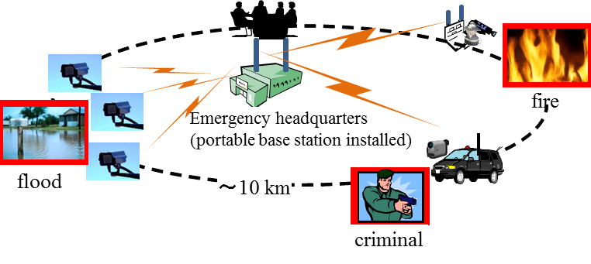
Figure 1 Use cases of broadband PPDR wireless communication system using VHF band

3. Propagation Characteristics of VHF band

3.1 Received Signal Power
We measured the downlink (BS-to-MS) signal power received at the measurement van running around the BS [1]. During this measurement, the BS was transmitting the OFDM signal with the output power of 20 W, the occupied bandwidth of 9.6 MHz. We drove the van down to 16 km away from the BS. In Figure 2, “BS” at the center of 3 concentric circles with radii of 5 km, 10 km, and 15 km shows the location of the base station and the colored roads show the route on which we drove the van and the color indicates the received signal power between -90 dBm (in blue) and -40 dBm (in red). It is observed in this figure that the received signal power within the distance of 10 km from the BS, except for the eastern area of the BS hidden by a mountain (193 m high), is above -80 dBm. Assuming sensitivity of -80 dBm, service coverage (radius) would be around 10 km from BS.

Figure 2 Received signal power
3.2 Delay Profile
Delay profiles of the multipath waves were measured at several points (P0-P16) in Figure 2 and three channel models for 200 MHz band broadband communication system were derived depending on communication distance d (km) as “Profile A, B and C” as shown in Table 1. If we want to support the coverage area with radius of around 10 km, over 20 micro seconds of multipath waves should be considered in the PHY and MAC design of this system.
Table 1: Channel Models for 200-MHz Band Broadband Wireless Communication System
 |  | Path 1 | Path 2 | Path 3 | Path 4 | Path 5 | Path 6
Profile A  d < 2.5 km | Delay time [us] | 0 | 0.7 | 1.2 | 3.2 | 5.5 | 6.8
Profile A  d < 2.5 km | Relative power [dB] | 0 | -34.9 | -25.9 | -22.7 | -34.8 | -34.6
Profile B  2.5 km <d < 5 km | Delay time [us] | 0 | 0.9 | 1.7 | 3.1 | 3.8 | 7.5
Profile B  2.5 km <d < 5 km | Relative power [dB] | 0 | -18.2 | -20.6 | -25.0 | -26.5 | -19.6
Profile C  d > 5km | Delay time [us] | 0 | 0.6 | 5.3 | 6.2 | 7.5 | 19.5
Profile C  d > 5km | Relative power [dB] | 0 | -12.1 | -25.2 | -22.2 | -18.5 | -21.8

4. Physical Layer and MAC Layer Design
IEEE Std.802.16™-2009 [2] had almost the same scope with this broadband PPDR system, since IEEE Std.802.16™-2009 supported broadband wireless communication between BS and multiple MSs in mobile environment. However, the operational spectrum band was microwave band not VHF band. This means that the IEEE Std.802.16™-2009 PHY specifications could be adopted but was not optimal for VHF band operation.
Hence we modified some PHY parameters of IEEE Std.802.16™-2009 for VHF band operation. Major modification was related to the pilot symbol insertion patterns for channel estimation. Figure 3 (a) shows the pilot patterns specified in IEEE Std.802.16™-2009 and Figure 3 (b) shows the modified pilot patterns for 200 MHz band operation. Regarding the downlink, modified pilot pattern has denser pilot symbols than the conventional one for more robust link. Regarding the uplink, the pilot symbol insertion interval in the time domain is longer than the conventional one. This is because the channel variation in the time domain is slower in VHF band compared to 2.5 GHz band. By using the modified pilot patterns, we can make the downlink more stable and we can enhance the uplink data rate without degrading the link quality for VHF band system. Actually, in the case of using modified pilot patterns and 9 to 38 of downlink to uplink time ratio, 9.4 Mbps (effective data rate) can be achieved in the uplink (with 64-QAM-CC3/4). This data rate is appropriate to transmit high quality video streaming.

(a) IEEE802.16-2009 (b) Newly designed for 200 MHz band
Figure 3 Pilot symbol insertion patterns

Regarding the MAC layer, there is no change from the original specifications of IEEE Std.802.16™-2009 because it already supports the MAC layer requirements.
Based on the PHY and MAC design above, Japanese standards body, ARIB (Association of Radio Industries and Businesses), developed the PHY and MAC standards for VHF band broadband wireless communication systems between portable base station (BS) and mobile stations (MSs) in 2011 [3]. This standard includes two PHY modes (Mode 1 and Mode 2). Mode 1 has two sub-modes. One sub-mode has the PHY of “Mobile WiMAX” based on 512 FFT size for 5-MHz channel bandwidth. The other sub-mode in Mode 1 is based on 1024 FFT size for 5-MHz channel bandwidth. Both sub-modes in Mode 1 are the subsets of IEEE Std.802.16™-2009 [2]. Mode 2 specifies new PHY with optimized pilot patterns for VHF band operation as shown in Fig.4 (b). Table 2 summarizes the classifications of the PHY and MAC specifications in the ARIB standard [3].
The newly designed PHY (Mode 2 in ARIB STD-T103) was added to IEEE Std.802.16 as “VHF mode” in IEEE Std.802.16n™-2013 [4]. As a result, all PHY specifications of ARIB STD-T103 have been included in IEEE802.16 standard.

Table 2: Classification of Specifications in ARIB STD-T103 [7]

5. Computer Simulation
Bit error ratio (BER) performance by computer simulation is presented in this subsection. Used simulation specifications are summarized in Table 3.
Table 3: Simulation Specifications
item | Specifications
Frequency | 200 MHz
Channel Models | - Profile A, (b) Profile C (shown in Table 1)
Mobility | 80 km/h
OFDM Symbol Structure  (pilot patterns) | ARIB STD-T103  (1) Mode 1 (FFT1024) uplink (Fig.3(a) right)  (2) Mode 2 uplink (Fig.3(b) right)  (3) Mode 1 (FFT1024) uplink (Fig.3(a) left)
Modulation and coding scheme | QPSK-CC1/2
Cyclic Prefix Mode | 1/8 (=22.9 [micro-sec]) of the effective symbol period
Channel estimation scheme | Interpolation between pilot symbols on the corners for uplink, Extrapolation for downlink in Mode1
Frequency domain equalization | Zero forcing
Maximum likelihood decoding of convolution coding | Soft-decision Viterbi algorithm

Figures 4 (a)-(b) show BER performance results for each channel model. Each figure includes three cases of OFDM symbol structure or pilot insertion patterns (1) uplink in Mode 1, (2) uplink in Mode 2 and (3) downlink in Mode 1.
All pilot patterns can meet the required BER performance (10⁻⁶) in reasonable C/N condition because guard interval in 1/8 cyclic prefix mode is 22.9 [s] which is longer than the maximum excess delay time of all channel models. For both channel models, uplink in Mode 1 (shown by “o”) gives the best BER performance. This is because pilot symbols in uplink of Mode1 are inserted in the most densely (pilot symbol occupancy ratio is 1/3) and therefore the highest channel estimation accuracy is available.
Uplink in Mode2 (shown by “x”), which is newly designed for 200 MHz band operation, gives almost the same BER performance as Mode 1 uplink although the pilot symbol occupancy ratio is much smaller (the pilot symbol occupancy ratio is 1/7) than uplink in Mode1. This is because the channel variation in the time domain is slow enough in 200 MHz RF band that channel estimation accuracy is almost the same as uplink in Mode 1. Mode 2 uplink can provide 1.3 times higher data rate compared to Mode 1 uplink without BER performance degradation.
BER performance in Mode 1 downlink (shown by “+”) is the worst among these three cases. Pilot symbol occupancy ratio (1/7) in Mode 1 downlink is the same as Mode 2 uplink, but the interpolation scheme for the channel estimation is not available because of the scattered pilot symbol insertion pattern as shown in Figure 3 (a) left. Channel estimation in Mode 1 downlink is not so accuracy as the uplink in Mode 2, therefore BER performance is worse than the Mode 2 uplink.
(a) Channel Model: Profile B, 80 km/h (b) Channel Model: Profile C, 80 km/h
Figure 4 BER performances by computer simulations
6. Experiments
This subsection describes the long-range wireless communication experiment by using the prototype compliant with “Mode 2” of the ARIB standard [3] or “VHF mode” of IEEE802.16n [2].

6.1 Experimental Setup
Figure 5 shows the overall situation of the measurement. This measurement was conducted in Numazu City, a medium-size city in Japan whose west side is located on the sea. Base station and its antennas are set up on the roof top of 45-meter City Hall building (57 m above sea level). The location of Numazu City Hall is indicated by yellow circle. Mobile station is setup at either of two points (“Point 1” or “Point 2”) shown by blue circles. This figure also includes cross-section between BS and “Point 1” and “Point 2”, respectively. “Point 1” is 6.6 km away from the BS. “Point 2” is 9.3 km away from the BS and radio path between BS and “Point 2” is almost maritime propagation. At BS, two Yagi-Uda antennas are setup so that maximum radiation of each antenna directs to “Point 1” and “Point 2”, respectively. At “Point 1” and “Point 2”, Yagi-Uda antennas with 5-elements are setup so that the maximum radiation directs to BS.
Figure 5 Experimental situations

Table 4 summarizes the major specifications of this experiment.
Table 4: Major Specification of Experiment
item | Specifications
PHY and MAC | ARIB Standard (ARIB STD-T103) Mode 2 (1024 FFT size)
Spectrum band | 187.5 -192.5 MHz (5 MHz channel bandwidth)
Maximum transmit power | 5 W : TX power from BS is 5 W,  TX power from MS is automatically controlled by BS.
Antenna | 5-element Yagi-Uda with maximum antenna gain 9 dBi

7 Experimental Results
7.1 Mobile Station at “Point1”
Figure 6 shows the spectrum (measured at BS) of the continuous OFDM signal from “Point 1” and measurement results. Frequency selective fading is observed in the path between BS and Point1. Achieved maximum uplink data rate was 3 Mbps (with QPSK-CC3/4).
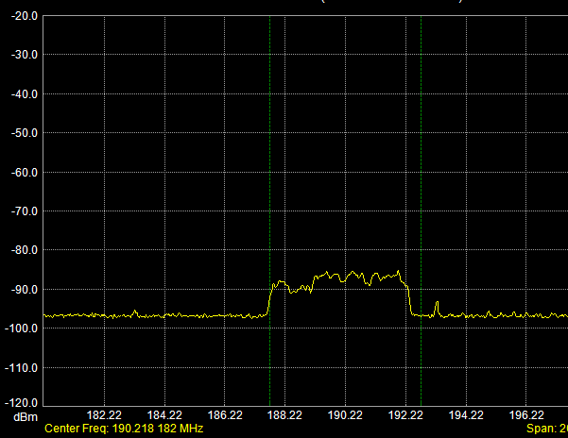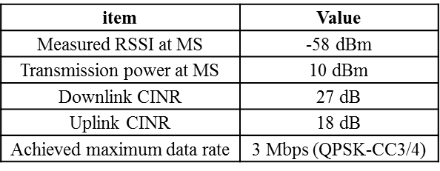
Figure 6 Spectrum of the signal from MS at “Point1” and measurement results
7.2 Mobile Station at “Point2”
Figure 7 shows the spectrum (measured at BS) of the continuous OFDM signal from “Point 2”. Since the radio path between BS and Point 2 is almost maritime propagation, frequency selective fading is not observed very much. Achieved maximum uplink data rate was 2 Mbps (with QPSK-CC1/2).
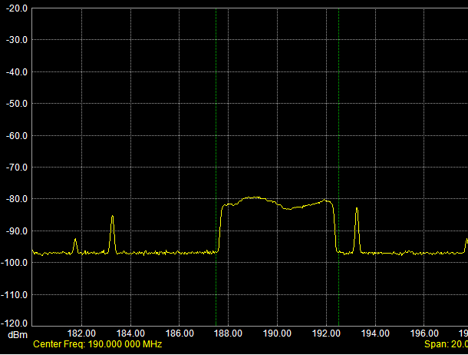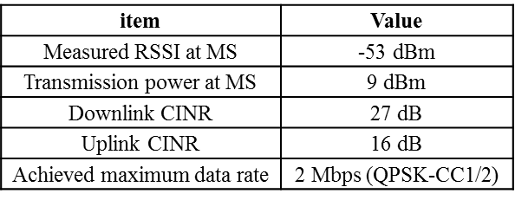
Figure 7 Spectrum of the signal from MS at “Point2” and measurement results

8. Conclusion
This annex presents the current status of the broadband PPDR wireless communication system using VHF band in Japan. Wireless communication experiments in long distance using the prototype showed that this system can provide long-range (6.6 – 9.3 km) broadband (2- 3 Mbps) communication system. The experiments in various environments are future works.

References
[1] Masayuki Oodo, Noriyuki Soma, Ryuhei Funada and Hiroshi Harada, “Channel Model for Broadband Wireless Communication in the VHF-band,” IEICE Technical Report RCS2010-28, pp.61-66, June 2010 (in Japanese)
[2] IEEE Std.802.16™-2009, “IEEE Standard for local and metropolitan area networks, Part16: Air Interface for Broadband Wireless Access Systems, May, 2009
[3] ARIB STD-T103 Ver1.0, “200 MHz-Band Broadband Wireless Communication Systems between Portable BS and MSs”, (URL: http://www.arib.or.jp/english/html/overview/doc/1-STD-T103v1_1.pdf), March, 2011
[4] IEEE Std.802.16n™-2013, “IEEE Standard for Air Interface for Broadband Wireless Access Systems— Amendment 2: Higher Reliability Networks” (Amendment to IEEE Std. 802.16™-2012), March, 2013

Annex 5 –Example 2 from Japan

RESULT AND ANALYSIS OF THE TECHNICAL VERIFICATION OF
LARGE CELL SYSTEM FOR PUBLIC SAFETY LTE SYSTEM IN JAPAN

1, Introduction

In Japan, Public Safety LTE (PS-LTE) System is considered as a candidate for a next generation Private Mobile Radio System, which is used for not only public safety but also private businesses purposes. This annex presents the results of technical verification trial conducted by the PS-LTE Technology Verification Consortium from October to December 2016, to verify the possibility of large cell configuration using LTE system in UHF band, which is a major issue to construct efficient and effective network for public safety. The trial included a comparison between PS-LTE system and Digital Multi Channel Access (D-MCA) System, which is a Private Mobile Radio System currently served in Japan using UHF band, and voice over LTE and PTT service, validation of link budgets and a comparison of a 4-branch receive vs. a 2-branch receive configuration for the large cell.
2. Configuration
The outline of the trial is as follows:
Trial period: Step 1 October to November 2016, Step 2 December 2016
Frequency: 895-900MHz (Up Link), 940-945MHz (Down Link) (3GPP Band 8)
Place: Step 1 Saitama BS (Large Cell in Saitama Prefecture),
Stadium BS (Small Cell in Saitama Prefecture)
Step 2 Ichigaya BS (Small Cell in Tokyo),
Shinjuku Office (In door in Tokyo)
Large Cell BS’s Specification:
3/6 Sector Antenna, 20W Output, 51m height
Physical Random Access Channel (PRACH) Preamble Format 1
UE’s Specification:
Android Smartphone, 0.2W output, Category 4, Roof top Antenna/Built-in antenna
MIL-STD-810G, IPX 5/8, IP6X

Outline of base station configurations and verified items of each trial step are described in Fig. 1 and 2, and external views of major facilities are described in Fig.3, 4, 5 and 6.

Step 1

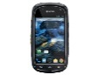
Large Cell Base Station (Saitama BS)
Saitama Radio Relay Station
Kitamoto City, Saitama Pref.
3/6 Sectors,2T4R Antenna
eNodeB and micro Core
Digital MCA Base Station

22km (50Mbps Ethernet)


Small Cell Base Station (Stadium BS)
Saitama Stadium 2002
Saitama City, Saitama Pref.
Directional, 2T2R Antenna
eNodeB

O&M (50Mbps Ethernet）

42km

Shinjuku Office, MRC Inc.

Items to be verified at Step 1

By Saitama BS and Stadium BS
(1) Wide area coverage (up and down), Comparison with D-MCA coverage, Propagation in stadium
(2) Data transmission speed, Error rate
(3) VoLTE quality, Connection rate
(4) Sector handover, Cell handover

Fig.1 Base Stations Configuration for PS-LTE Technical Verification (Step 1)

Step 2

Small Cell Base Station (Ichigaya BS)
Ichigaya
OMNI, 2T2R Antenna
eNodeB and DMFC
[Relocation from Stadium BS except for the antenna]

Shinjuku Office

(50Mbps Ethernet）
eNodeB and micro Core
[Relocation from Saitama BS]
Video distribution server

Items to be verified at Step 2

By Ichigaya BS and Shinjuku Office
(1) VoLTE quality
(2) Video collection and distribution (512kbps)
(3) Demonstration of Command station function
(4) M2M communication (Cat.1)

Fig.2 Base Stations Configuration for PS-LTE Technical Verification (Step 2)

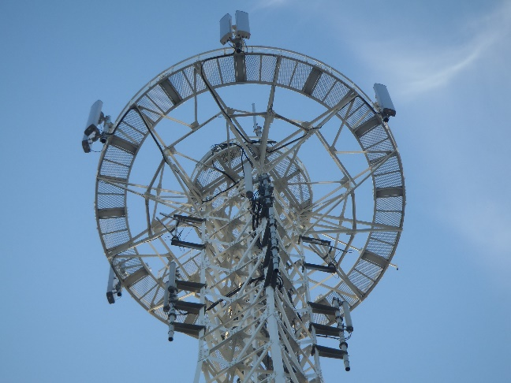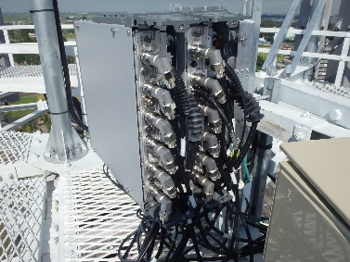
Fig.3 Saitama BS 3/6 Sectors of 2T4R Antennas and RF Module
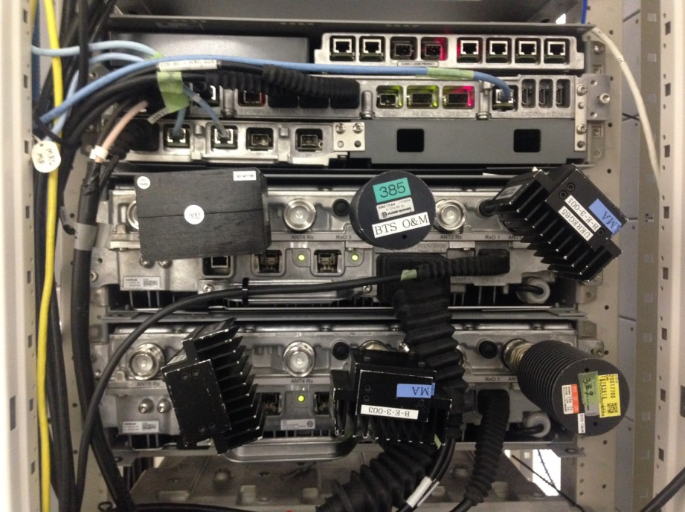
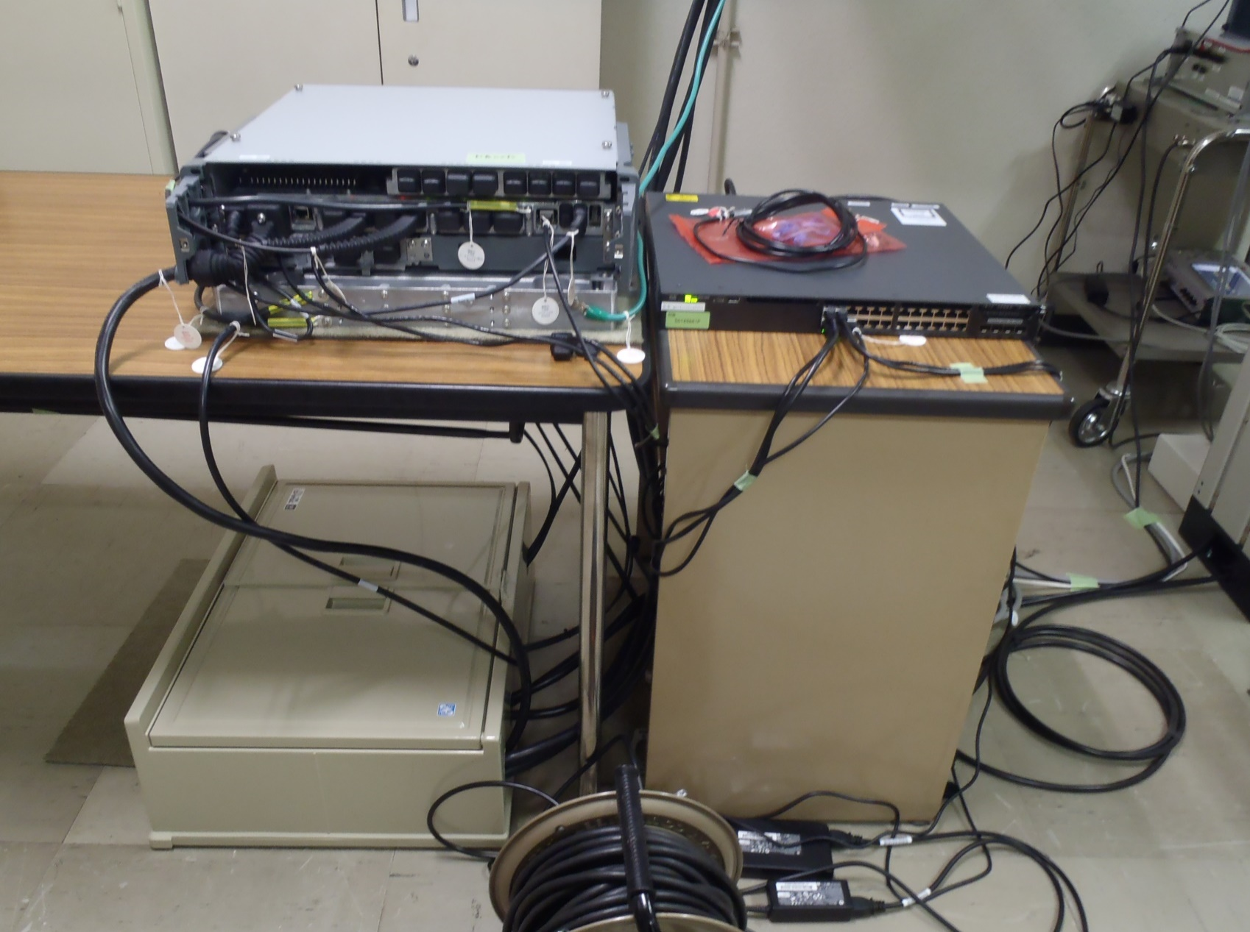
Interface
System Module
Micro Core
1

Fig.4 System Module and Micro Core

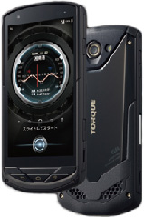
Fig.5 UE Fig.6 Roof Top Antenna
3. Saitama BS for macro-coverage (large cell)
3.1 Estimated Link Budget
Table 1 and 2 show the estimated Link Budgets of Saitama BS.
Table 1 Estimated Link Budget of Up Link (Frequency 897.5MHz)
Items |  |  | Value | Remarks
Transmission | a | Transmit Power [dBm] | 23.0 | 0.2W
Transmission | b | Transmit Antenna Gain [dBi] | 4.0
Transmission | c | Transmit Horizontal Directional Loss [dB] | 0.0
Transmission | d | Transmit Vertical Directional Loss [dB] | 0.0
Transmission | e | Feeder Loss [dB] | 1.5
Transmission | f | EIRP =a+b-c-d-e | 25.5
Reception | g | Required Reception Power(50kbps) | -117.6
Reception | g´ | Required Reception Power(512kbps) | -100.9
Reception | h | Reception Antenna Gain [dBi] | 19.5
Reception | i | Reception Horizontal Directional Loss [dB] | 0.0
Reception | j | Reception Vertical Directional Loss [dB] | 0.0
Reception | k | Reception Feeder Loss [dB] | 2.0
Reception | l | 2R→ 4R Effect | 7.0 | Note
Reception | m | Location Rate Margin | 3.0
Permissible Path Loss(50kbps) =f-g+h-i-j-k+l+m |  |  | 170.6
Permissible Path Loss(512kbps) =f-g´+h-i-j-k+l+m |  |  | 153.9
Coverage Radius(50kbps) [km] |  |  | 24.0 | Extended Hata Equation for UrbanArea  （BS Antenna Height 51m、  UE Antenna Height 1.5m）
Coverage Radius(512kbps) [km] |  |  | 8.05

Note: Christopher Redding “Extended Range Cell Testing” 2015 Public Safety Broadband
Stakeholder Meeting, PSCR
http://www.pscr.gov/projects/testing_evaluation/extended_cell/index.htm

Table 2 Estimated Link Budget of Down Link (Frequency 942.5MHz)
Items |  |  | Value | Remarks
Transmission | a | Transmit Power [dBm] | 43.0 | 20W
Transmission | b | Transmit Antenna Gain [dBi] | 19.5
Transmission | c | Transmit Horizontal Directional Loss[dB] | 0.0
Transmission | d | Transmit Vertical Directional Loss [dB] | 0.0
Transmission | e | Transmit Feeder Loss [dB] | 2.0
Transmission | f | EIRP =a+b-c-d-e | 60.5
Reception | g | Required Reception Power(50kbps) | -105.1
Reception | g´ | Required Reception Power(512kbps) | -88.4
Reception | h | Reception Antenna Gain [dBi] | 4.0
Reception | i | Reception Horizontal Directional Loss [dB] | 0.0
Reception | j | Reception Vertical Directional Loss [dB] | 0.0
Reception | k | Reception Feeder Loss [dB] | 1.5
Reception | l | Location Rate Margin | 3.0
Permissible Path Loss(50kbps) =f-g+h-i-j-k+l |  |  | 171.1
Permissible Path Loss(512kbps) =f-g´+h-i-j-k+l |  |  | 154.4
Coverage Radius(50kbps) [km] |  |  | 23.9 | Extended Hata Equation for  Urban Area  （BS Antenna Height 51m、  UE Antenna Height 1.5m）
Coverage Radius(512kbps) [km] |  |  | 8.00

3.2 Large Cell Area Comparison between D-MCA and PS-LTE
The PS-LTE area coverage using Large Cell system was almost equal to the present D-MCA Large Cell system, and about 30km radius voice service could be secured by Saitama BS for VoLTE as well as for PTT application.
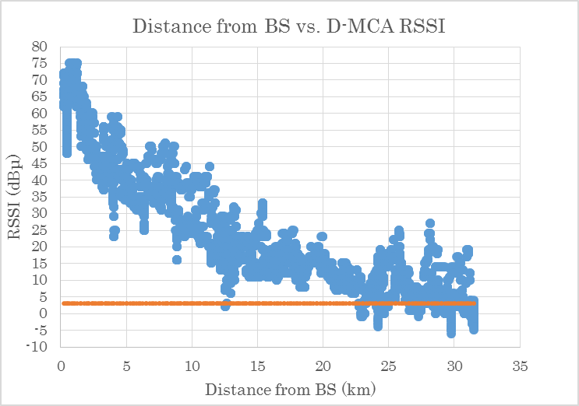
Note: D-MCA: Digital Multi Channel Access System
RSSI: Received Signal Strength Indication

Fig.7 Distance from BS vs. Digital MCA RSSI

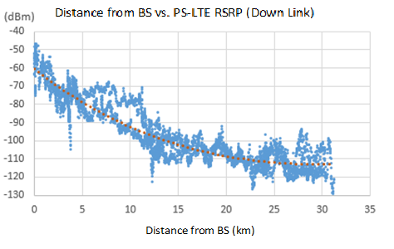
RSRP (Down Link)

Note: RSRP: Reference Signal Received Power

Fig.8 Distance from BS vs. PS-LTE RSRP (Down Link)
D-MCA RSSI

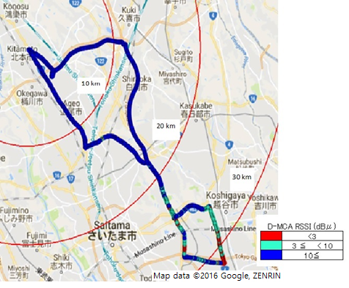
Fig.9 D- MCA RSSI
VoLTE Up Link Merit
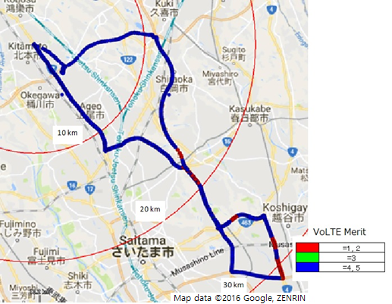
Fig.10 VoLTE Merit

3.3 Large Cell Throughput Comparison between 4R and 2R

The throughput improvement by 4R was not distinct but is effective to multi-path environment. It is assumed that the effectiveness of 4R is different from sub-urban area to urban area.
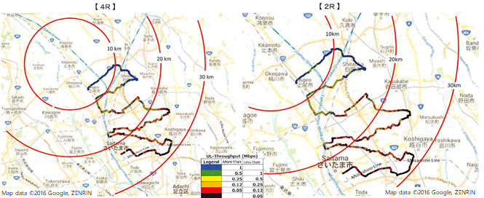
Fig.11 Large Cell Throughput Comparison between 4R and 2R

3.4 Large Cell Coverage Differences between VoLTE or 50kbps data and 512kbps data

The PS-LTE area coverage using Large Cell system was verified and about 30km radius voice service could be secured by Saitama BS for VoLTE as well as for PTT application. However, the area coverage for 512kbps data service shrank to about 18.5km in comparison with voice service.

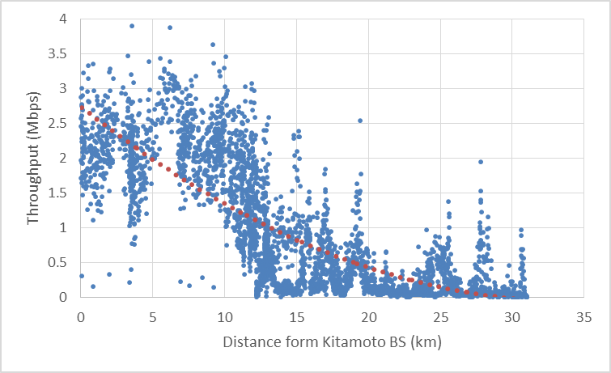
Fig.12 Up Link Throughput vs. Distance

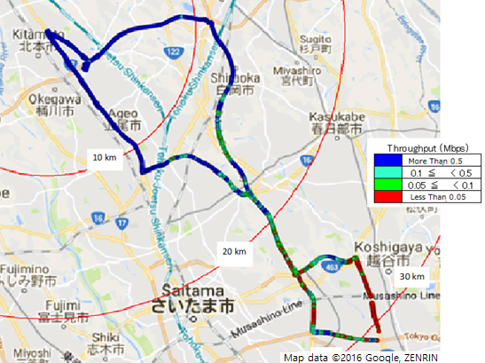
Fig.13 Up Link Throughput

3.5 Antenna height vs. Area coverage

The Antenna height improves area coverage. The following figure shows antenna height vs. estimated area coverages for 50kbps data and 512kbps data based on extended Hata equation.

Fig.14 Antenna height vs. Area coverage

3.6 Voice Quality

The comparison of voice quality between VoLTE(CODEC:AMR-WB, 12.65kbps) and PTT application(CODEC:APCO P25 AMBE decoder, 7.2kbps) was conducted. VoLTE provided merit 5 voice quality almost in the coverage area, while PTT application provided average merit 4 voice quality in the same coverage area. Difference in CODEC greatly affects voice quality.
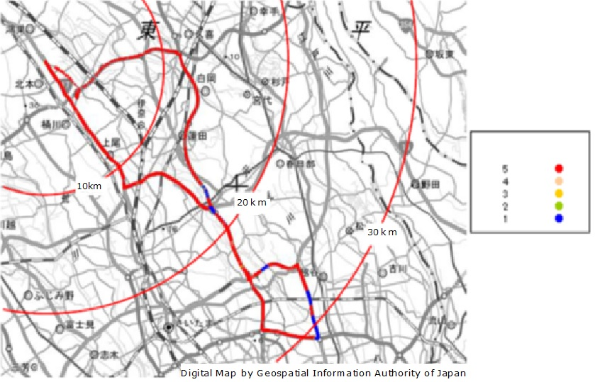
Fig.15 VoLTE(CODEC:AMR-WB, 12.65kbps) Voice Quality (Up Link)

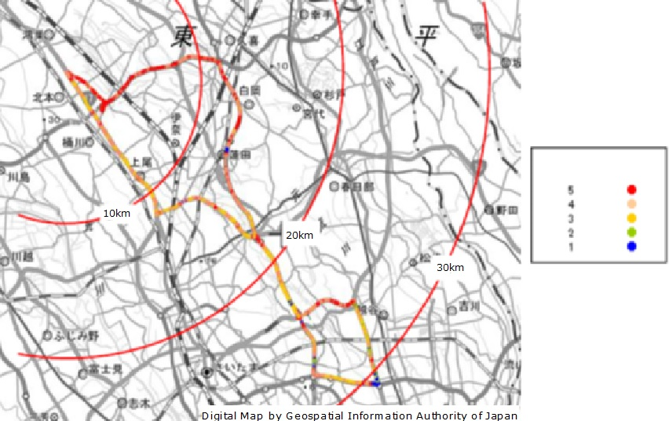
Merit
Merit
Fig.16 PTT application(CODEC: APCO P25 AMBE decoder, 7.2kbps) Voice Quality(Up Link)

4. Ichigaya BS for small cell

4.1 Estimated Link Budget (Vehicle mounted UE, 50kbps and 512kbps)

Table 3 Estimated Link Budget of Up Link (Frequency 897.5MHz)
Items |  |  | Value | Remarks
Transmission | a | Transmit Power [dBm] | 23.0 | 0.2W
Transmission | b | Transmit Antenna Gain [dBi] | 4.0
Transmission | c | Transmit Horizontal Directional Loss [dB] | 0.0
Transmission | d | Transmit Vertical Directional Loss [dB] | 0.0
Transmission | e | Transmit Feeder Loss [dB] | 1.5
Transmission | f | EIRP =a+b-c-d-e | 25.5
Reception | g | Required Reception Power(50kbps) | -117.6
Reception | g´ | Required Reception Power(512kbps) | -100.9
Reception | h | Reception Antenna Gain [dBi] | 8.0
Reception | i | Reception Horizontal Directional Loss [dB] | 0.0
Reception | j | Reception Vertical Directional Loss [dB] | 2.7 | Tilt 5 degree
Reception | k | Reception Feeder Loss [dB] | 2.0
Reception | l | 2R→ 4R Effect | 0.0
Reception | m | Location Rate Margin | 3.0
Permissible Path Loss(50kbps) =f-g+h-i-j-k+l+m |  |  | 149.4
Permissible Path Loss(512kbps) =f-g´+h-i-j-k+l+m |  |  | 132.7
Coverage Radius (50kbps)[km] |  |  | 4.88 | Hata Equation  （BS Antenna Height 35.1m,  UE Antenna Height 1.5m）
Coverage Radius (512kbps)[km] |  |  | 1.62

Table 4 Estimated Link Budget of Down Link (Frequency 942.5MHz)
Items |  |  | Value | Remarks
Transmission | a | Transmit Power [dBm] | 39.0 | 8W
Transmission | b | Transmit Antenna Gain [dBi] | 8.0
Transmission | c | Transmit Horizontal Directional Loss [dB] | 0.0
Transmission | d | Transmit Vertical Directional Loss [dB] | 2.8 | Tilt 5 degree
Transmission | e | Transmit Feeder Loss [dB] | 2.0
Transmission | f | EIRP =a+b-c-d-e | 42.2
Reception | g | Required Reception Power(50kbps) | -105.1
Reception | g´ | Required Reception Power(512kbps) | -88.4
Reception | h | Reception Antenna Gain [dBi] | 4.0
Reception | i | Reception Horizontal Directional Loss [dB] | 0.0
Reception | j | Reception Vertical Directional Loss [dB] | 0.0
Reception | k | Reception Feeder Loss [dB] | 1.5
Reception | l | Location Rate Margin | 3.0
Permissible Path Loss(50kbps)=f-g+h-i-j-k+l |  |  | 152.8
Permissible Path Loss(512kbps)=f-g´+h-i-j-k+l |  |  | 136.1
Coverage Radius(50kbps) [km] |  |  | 5.90 | Hata Equation  （BS Antenna Height 35.1m,  UE Antenna Height 1.5m）
Coverage Radius(512kbps) [km] |  |  | 1.95

4.2 Coverage

The small cell coverage in highly urbanized area is verified by Ichigaya BS. About 1km radius coverage is possible for voice or 50kbps data service and 512kbps data service.
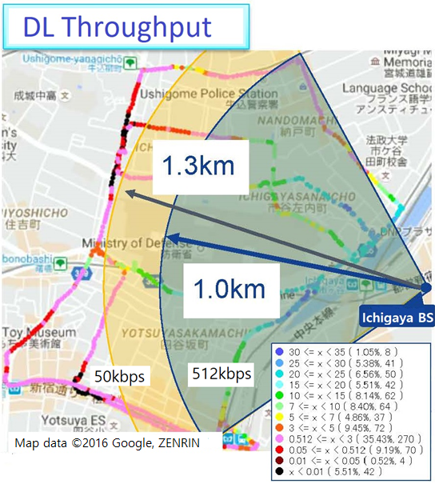
512kbps
Ichigaya BS

Fig.17 Down Link Throughput

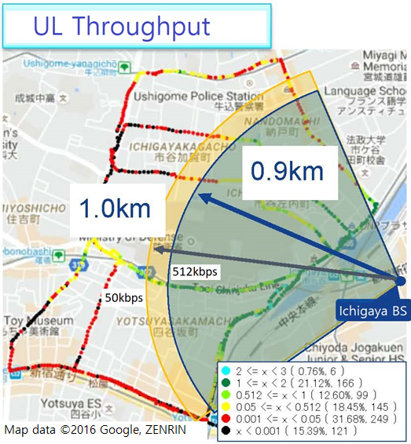
Fig.18 Up Link Throughput

4.3 Differences between Vehicle mounted Antenna vs. Built-in Antenna

The differences between Vehicle mounted Antenna and Built-in Antenna was verified. The average value was about 12 dB, then improvement of antenna gain of UE is effective to better area coverage.
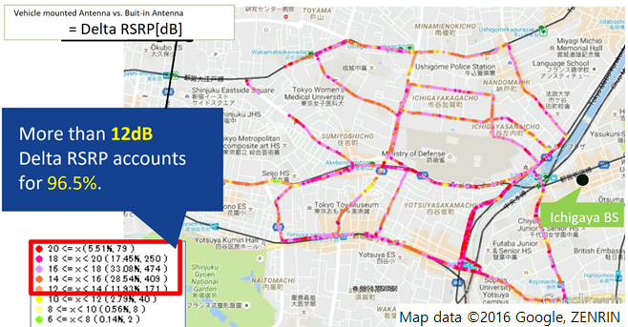
Fig.19 Differences between Vehicle mounted Antenna vs. Built-in Antenna

5. Stadium BS for small cell
5.1 Estimated Link Budget (Portable UE, 50kbps)

Table 5 Estimated Link Budget of Up Link (Frequency 897.5MHz)
Items |  |  | Value | Remarks
Transmission | a | Transmit Power [dBm] | 23.0 | 0.2W
Transmission | b | Transmit Antenna Gain [dBi] | 0.0
Transmission | c | Transmit Horizontal Directional Loss[dB] | 0.0
Transmission | d | Transmit Vertical Directional Loss [dB] | 0.0
Transmission | e | Transmit Feeder Loss [dB] | 3.0 | Human Body Loss
Transmission | f | EIRP =a+b-c-d-e | 20.0
Reception | g | Required Reception Power | -117.6
Reception | h | Reception Antenna Gain [dBi] | 13.0
Reception | i | Reception Horizontal Directional Loss [dB] | 0.0
Reception | j | Reception Vertical Directional Loss [dB] | 5.0 | Tilt10 degree
Reception | k | Reception Feeder Loss [dB] | 2.0
Reception | l | 2R→ 4R Effect | 0.0
Reception | m | Location Rate Margin | 3.0
Permissible Path Loss =f-g+h-i-j-k+l+m |  |  | 146.6
Permissible Path Loss outside Stadium |  |  | 121.6 | Stadium Path Loss：25dB
Coverage Radius [km] |  |  | 0.67 | Hata Equation（BS Antenna Height 24m、UE Antenna Height1.5m）

Table 6 Estimated Link Budget of Down Link (Frequency 942.5MHz)
Items |  |  | Value | Remarks
Transmission | a | Transmit Power [dBm] | 39.0 | 8W
Transmission | b | Transmit Antenna Gain [dBi] | 13.0
Transmission | c | Transmit Horizontal Directional Loss [dB] | 0.0
Transmission | d | Transmit Vertical Directional Loss [dB] | 5.0 | Tilt10 degree
Transmission | e | Transmit Feeder Loss [dB] | 2.0
Transmission | f | EIRP =a+b-c-d-e | 45.0
Reception | g | Required Reception Power | -105.1
Reception | h | Reception Antenna Gain [dBi] | 0.0
Reception | i | Reception Horizontal Directional Loss [dB] | 0.0
Reception | j | Reception Vertical Directional Loss [dB] | 0.0
Reception | k | Reception Feeder Loss [dB] | 3.0 | Human Body Loss
Reception | l | Location Rate Margin | 3.0
Permissible Path Loss =f-g+h-i-j-k+l |  |  | 150.1
Permissible Path Loss outside Stadium |  |  | 125.1 | Stadium Path Loss：25dB
Coverage Radius [km] |  |  | 0.81 | Hata Equation（BS Antenna Height 24m、UE Antenna Height1.5m）

5.2 Coverage

The Small Cell coverage for semi-closed area was verified, and the voice and data services using portable UE were secured except for shadowed backyard.
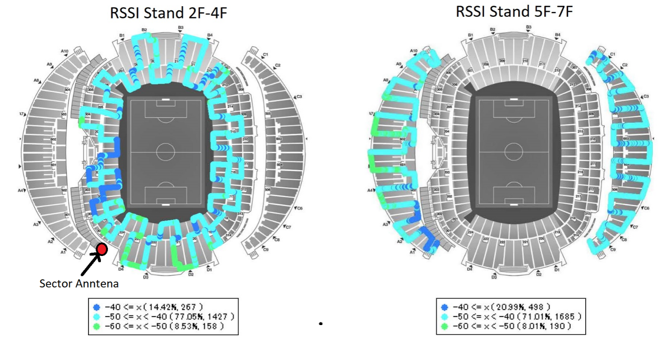
Fig.20 RSSI (Received Signal Strength Indicator)
6. Radio Resource Use Rate and Number of Acceptable Users
6.1 Resource Control for VoLTE Service

Up link consumes higher radio resource use rate when RSRP falls below -105dBm. Table 7 shows the result of the Laboratory Test to see the capacity of users in 5MHz band.

Table 7 Radio Resource Use Rate and Number of Acceptable Users for VoLTE Service
RSRP  [dBm] | Downlink |  |  | Uplink
RSRP  [dBm] | Lab. Test Result for 1UE |  | Number of Acceptable Users | Lab. Test Result for 1UE |  | Number of Acceptable Users
RSRP  [dBm] | Average DL PRB | TTI Use Rate | Number of Acceptable Users | Average UL PRB | TTI Use Rate | Number of Acceptable Users
-80 | 2.0 | 2.5% | 500 | 2 | 2.5% | 297
-90 | 2.0 | 2.5% | 500 | 2 | 2.5% | 297
-100 | 2.0 | 2.5% | 500 | 3 | 2.8% | 180
-110 | 2.1 | 2.7% | 438 | 1 | 59.9% | 25
-120 | 4.2 | 3.8% | 158 | 1 | 65.2% | 23

6.2 Resource Control for 512kbps

Since the packet size is larger than VoLTE, the number of users that can be simultaneously acceptable decreases. The number of maximum acceptable users is assumed 10 in uplink of 5MHz band even with strong electric fields of RSRP of -80dBm. The result of the Laboratory Test is shown in Table 8.

Table 8 Radio Resource Use Rate and Number of Acceptable Users for 512kbps
RSRP  [dBm] | Downlink |  |  | Uplink
RSRP  [dBm] | Lab. Test Result for 1UE |  | Number of Acceptable Users | Lab. Test Result for 1UE |  | Number of Acceptable Users
RSRP  [dBm] | Average DL PRB | TTI Use Rate | Number of Acceptable Users | Average UL PRB | TTI Use Rate | Number of Acceptable Users
-80 | 14.9 | 3.2% | 52 | 4.2 | 46.3% | 10
-90 | 17.0 | 4.7% | 31 | 5.6 | 35.9% | 9
-100 | 18.0 | 5.2% | 26 | 9.2 | 40.4% | 5
-110 | 20.1 | 10.4% | 11 |  |  | 0
-120 | 23.8 | 66.8% | 1 |  |  | 0

7. Operation Result of Direct Methanol Fuel Cell (DMFC) UPS

At the trial, Direct Methanol Fuel Cell (DMFC) UPS was used at Ichigaya BS. The advantages of DMFC are easiness to refuel, long operation time, low emission and low noise. The DMFC UPS’s specification is shown in Fig.21 and comparison between DMFC and other conventional power supply is shown in Table 9.

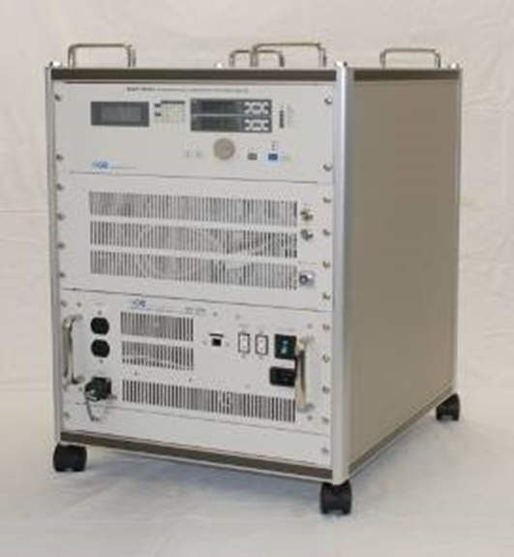
Dimensions 520×600×650mm
Dry Weight 70 kg
Output Power 500W(average) 1,000W(max)
Output Voltage AC100V
Fuel 54wt% Methanol solution
Fuel consumption rate 1L/hr
LIB Capacity 1,100Wh
Fig.21 DMFC-UPS with LIB (500W class) Specification

Table 9 Comparison DMFC vs. conventional power supply
 | DMFC | Battery | Engine
Capacity(W) | Several tens -hundreds | Several -hundreds | Over several hundreds
Size | A little large | Small | Small
Weight | A little heavy | Heavy | Light
Noise | Low | No noise | Quite large
Emission | Water and CO2  (with exhaust gas treatment） | No | Harmful
Operation time | Long | Short | Long
Charge | No | Necessary | No
Cost | High | Low | Low
Problems | Cost | Short operation time,  Necessary to charge | Difficulties in indoor use

Fig. 22 shows output power and Fig.23 shows fuel consumption of 4 day continuous operation of DMFC UPS at Ichigaya BS. The power consumption of Ichigaya BS was from 250W to 300W. During this operation, the commercial power supply was intentionally cut 4 times for total 30 hours. The consumption of methanol fuel was 17 litters, then 0.57 L/h. The effectiveness of DMFC UPS was verified.
DATE
Date:
7h Operation
without commercial power supply
8h Operation
without commercial power supply
Fig. 22 Output Power of DMFC for 4 day operation

DATE
17L Consumption: 0.57L/h

Fig. 23 Fuel Consumption of DMFC for 4 day operation
8. Conclusion

The trial verified important items for the implementation of PS-LTE system. Large cell system is configurable with 0.2W UE for clear voice and 50kbps data communications. Major verified items and considerations for implementation are as follows:

(1) The PS-LTE area coverage using Large Cell system was verified and about 30km radius voice service could be secured by Saitama BS for VoLTE as well as for PTT application. However, the area coverage for 512kbps data service shrank in comparison with voice service. How to provide higher data rate service taking into account of area coverage as well as system capacity might be an important further study item.
(2) The area coverage of VoLTE and PTT application was almost equivalent, and VoLTE (CODEC:AMR-WB, 12.65kbps) provided merit 5 voice quality while PTT application (CODEC:APCO P25 AMBE decoder, 7.2kbps) provided average merit 4 voice quality in the same area. Difference in CODEC greatly affects voice quality.
(3) The PS-LTE area coverage using Small Cell system was verified for highly urbanized area and semi-closed stadium using appropriate cell planning.
(4) The improvement of antenna gain of UE is effective to better area coverage.
(5) Direct Methanol Fuel Cell (DMFC) UPS is effective for small base station as an emergency power supply with low emission and low noise capability.
(6) Some functions for PS-LTE standardized by 3GPP such as Group Communication System Enablers for LTE, Isolated E_UTRAN Operations and MBMS Enhancements were not verified at the trial, and remains for further study.
(7) For better area planning, 3GPP standardized LTE techniques such as Coordinated Multipoint, Inter-Cell Interference Coordination and Multi-user MIMO would be considered.

Annex 6 - Example 1 from Korea (Republic of)

RECENT STATUS OF PS-LTE NETWORK IMPLEMENTATION IN KOREA

- Overview of PS-LTE Technology and Standardization

Public safety and communication network include network infrastructure technology for deployment and disaster safety ICT application service technology utilizing disaster network.

Table 1. PS-LTE technical classification
Items | Details
Network  infra technology | 37 Korea PS-LTE requirements, components, wireless terminals, wireless access equipment (RU, DU and repeater), EPC Equipment (SGW, PGW, MME, PCRF and HSS), IMS, MCPTT, eMBMS etc.
ICT application  servicetechnology | Multimedia/data service such as video, location-based service, status recognition service, remote measurement and diagnostic services, Computer Aided Dispatching etc.

PS-LTE equipment refers to the infrastructure equipment and transmission network equipment required to implement a disaster network supporting for the 37 requirements. Infrastructure equipment includes Network components, terminals, wireless access equipment (RU, DU and repeater). EPC equipment (SGW, PGW, MME, PCRF and HSS), IMS and MCPTT equipment are parts of infrastructure. Wired and wireless transmission network equipment may include front and backhaul transmission equipment, switch/router equipment, satellite transmission equipment, and etc. Software technologies are divided into two groups: disaster network service technologies, such as device to device operation, device relay function, group communication, Isolated base station Operation for Public Safety, MCPTT, call/message recording, NMS/EMS, BSS, OSS, authentication, security; and operation and management technologies required for disaster network such as operation, maintenance, network enhancement, network quality management, and training for operation technique.
The latest ICT convergence service technology will be more effective in disaster prevention and recovery through video streaming services, location-based services, cloud, big data technologies and augmented reality services based on platforms such as big data analytics and processing, disaster clouding and SDN/NFV.
The PS-LTE technology can be described as a combination of current LTE features and additional features specialized for disaster response. As shown in [Table 2], the 37 requirements of PS-LTE are compared with the current LTE capability and the additional features of PS-LTE. In other words, 22 features among the 37 requirements are also supported by the current LTE technologies. On the other hand, the remaining 15 features, such as terminal direct operation mode/terminal relay and standalone base station operation mode, are additionally required for PS-LTE network. The essential technologies required for PS-LTE-based disaster safety communication networks have been standardized in June 2017.

Table 2. Differences Between LTE and PS-LTE
Items | PS-LTE Requirements (37)
Items | LTE Features (22) | PS-LTE Features (15)
Survival/Reliability (7) | Mobility, Traffic congestion handling, Backup/restore (3) | Device to device operation, Device relay, Stand-alone base station operation mode, Redundancy/Transport medium operation, Call quality (4)
Disaster Responsibility (10) | Individual call, Device location check, Video call (3) | Group call, Area selection call, Dynamic regrouping, Pre-emption, Emergency call, Ambience listening, Multiple group receiving (7)
Interoperability (3) | Open/Standard compliance (1) | Fast call setup (Group Communication and MCPTT Functions), Network interconnection (Legacy conventional, TRS and public networks) (2)
Operations and Efficiency (12) | Situation propagation message, Secure subscriber capacity, Multi-party full-duplex call, Data communication, recording of voice and video calls, Calling party identification, Remote network management, Network management system, Report generation, Call capacity expansion, Frequency multiplexing (11) | Securing wide-area coverage/Broadband transmission technology (1)
Security (5) | Device enable/disable, Encryption, Authentication, Integrated Security Control (4) | Security Specification (1)

In terms of 3GPP standardization, the main technologies applied to the disaster safety communication network are as followings:
PS-LTE Main Project in South Korea is implemented based on 3GPP Rel. 13. In addition, the architecture and design of the system will be reflected to enable an upgrade to the 3GPP Rel.14 ~ 15 functionalities.
1) Group call service (MCPTT), group video service (MCVideo), and group data service (MCData) as an application service technology that users can experience
2) The baseline technologies for realizing applications including (e)ProSe, (e)D2D, GCSE, and eMBMS.
- (e)ProSe, (e)D2D: Baseline technology enabling direct communication between terminals within and outside the base station area;
- GCSE, eMBMS and MBMS_enh: Baseline technology to efficiently support group communication by saving radio and network resources
3) IOPS is a baseline technology that enables the base station to independently enable applications such as MCPTT if the base station is disconnected from the core network.

- Introduction

PS-LTE network implementation project of Korea was completed in March 2021 and since then nationwide network was empowered as a single nationwide network for 333 organizations of 8 sectors (including national rescue service, police, coast guard, military, local government, medical service, gas, electricity). PS-LTE network will interwork with LTE Railway(LTE-R) and LTE Maritime(LTE-M) in order to secure stable service quality regardless of service area and efficient sharing of spectrum resources in the area where the RF signals are overlapped from base stations using same 700 MHz frequencies but belonging to other networks.

The Ministry of the Interior and Safety(MOIS) is in charge of network buildings and operations in consideration of importance of PS-LTE network as a core communications infrastructure for public safety.

Figure 1. Concept of Korea Safe-Net
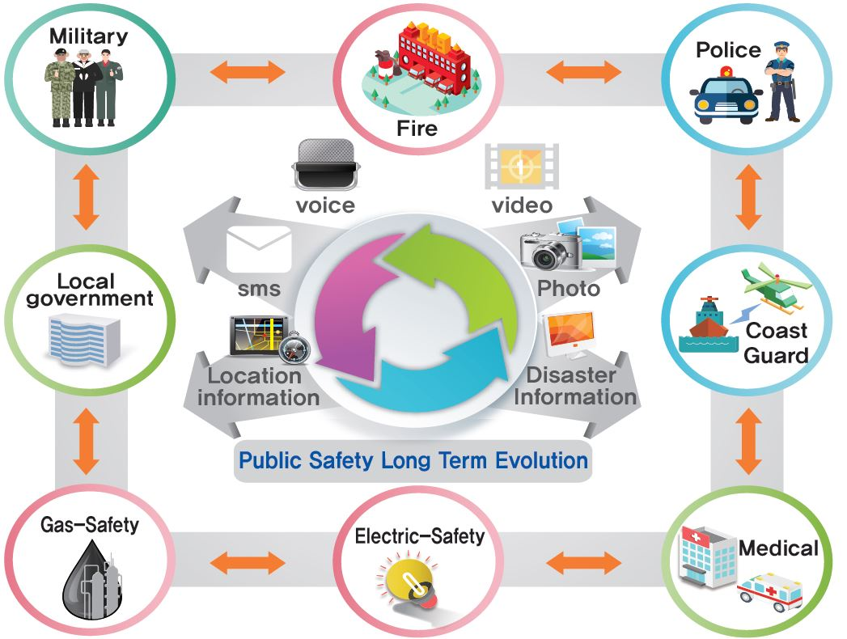
Source: Ministry of the Interior and Safety

- Allocation dedicated spectrum for Korea Safe-Net

Korea Safe-Net has been allocated in 718~728 MHz for uplink and 773-783 MHz for downlink.
For saving spectrum resources and minimizing investments, railway (LTE-R) and sea network (LTE-M) are also allowed to use the identical frequency spectrum. However, technology methods such as RAN Sharing, joint design, optimization and operational management of wireless networks are required to resolve potential interferences among the three networks using same frequencies. Before getting into the pilot stage, spectrum band and radio access technology were reviewed and relevant technical regulation were ruled. Spectrum usage fees to be imposed on stations using these frequency also has been adjusted reasonably.
For saving spectrum resources and minimizing investments, railway (LTE-R) and maritime network (LTE-M) are also allowed to use the identical frequency spectrum.

- Key functions of Korea Safe-Net

The key functions required for PS-LTE consist of 17 essential functions such as direct call, handling call congestion, group call and maintaining security and 20 additional functions such as standalone base station mode, securing quality of telephone call and ambience listening.

Table 3. Key function of PS-LTE
Voice, video group call | Basic communication function: MCPTT, eMBMS
Handle call congestion | Response capabilities for maintaining reliable system maintenance in case of call congestion
Location confirmation | Confirm the location of device via satellite or other location determination technologies
Security | Interested security control such as firewall, IDS etc. for preventing hacking
Ambience Listening | Remote listening function for device ambience
Source: Ministry of the Interior and Safety

- Network Implementation Plan

The basic design of PS-LTE was outlined from 2014 to 2015 based on the Informatization Strategic Plan (ISP), and the pilot PS-LTE was constructed in PyeongChang, Jeongseon, Gangneung, Gangwon province from 2015 to 2016. The results of the first pilot project were validated and the second pilot project to reinforce was carried out to support the PyeongChang Olympics from October 2017 to March 2018. The results from the pilot projects, after detailed analysis by experts from industry, academia and institutions, have been used to supplement the project plan for the roll-out of the Safe-Net network. The main project for network implementation is planned to be carried out in three stages from 2018 to 2020.Bidding for the main project was completed in December 2018, and implementation and operation provider for three regions were selected. A and B regions were awarded to KT and C regions to SK Telecom.
They gradually completed the network design, equipment supply, installation and testing from 2018 to 2020 and then had the responsibility of transport lease, and operation and maintenance of network from 2020 to 2025.

Figure 2. Project Milestones

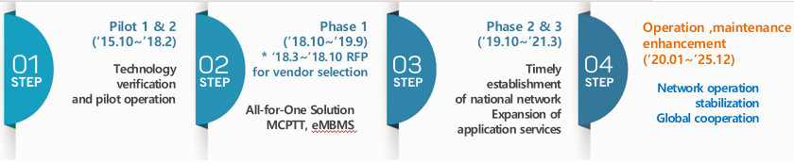

- Pilot Projects of PS-LTE Network

4.1 1st Pilot Project

From November 2015 to June 2016, pilot PS-LTE network was implemented and validated at PyeongChang area where 2018 Olympic Winter Games were held. The 1st pilot network consists of 1 network operation center, 220 base stations and 2,496 terminals. And the terminals were distributed to users of local government, national rescue service, police, coast guard, etc. During the 7 months of 1st pilot stage period, PS-LTE network requirements including interoperation with other existing network, performance of equipment, security were validated.

The PS-LTE network implementation in the 1st pilot stage was reviewed through validation council particularly in 4 aspects as below:

- Network implementation aspect: Feasibility of implementation of dedicated network with commercial mobile network in terms of economic efficiency
- Coverage goal aspect: Reasonable service coverage goal taking into consideration regional characteristics and population distribution etc.
- Shadow area minimizing aspect: Countermeasures to make service available in radio shadow area (e.g. sea, underground, tunnel), inter-working with LTE network for railway that is deploying coverage over 4,726 kilometers of railways nationwide and LTE network for maritime that plans to reach coverage up to 100km from the coast
- Implementation cost aspect: Cost reduction through adjusting equipment quantity, operational cost

Through the first pilot, coverage verification, implementation of voice and video PTT services, development of PS-LTE handsets and operation of various service scenarios have been recorded as technical achievements.

Figure 3. Pilot Network Configuration

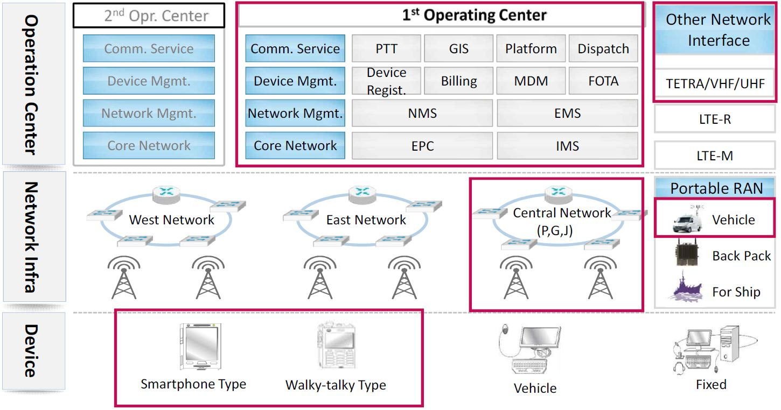
Note: Red boxes correspond to pilot project
Source: Ministry of the Interior and Safety

Figure 4. Actual example (1st Pilot Project)

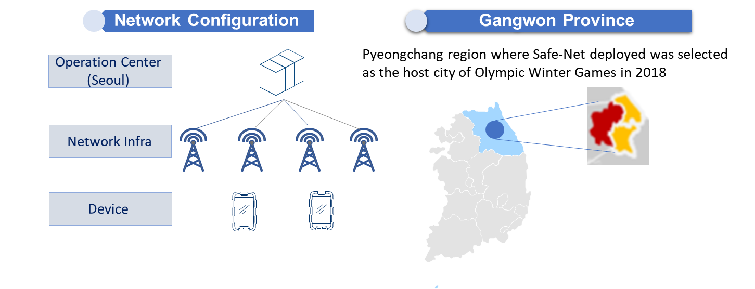

  - 2nd Pilot Project(Enhancement of Pilot)

The second pilot project was carried out after the reinforcement works for 6 months from Oct 2017 to Mar 2018. Main activities consisted of 1st Pilot Coverage Expansion, interworking with commercial network as means of coverage expansion in some shaded area, and Olympics & Paralympics Support.

The implementation strategy is as follows:
- Pilot Network Vulnerability Analysis
- Coverage expansion in core areas
- Full redundancy through multiplexing of main control equipment
- Provide the highest quality commercial LTE network
- Implement differentiated application services

During the 2nd Pilot, 55 units were added compared to the existing base stations, and the service quality of the stadium and core areas was improved by an average of 20 percent. And also new services such as MCPTT (Mission Critical Push-to-Talk) over LTE and GCSE (Group Communication System Enablers) were tested.

Figure 5. 2nd Pilot Project - additional installation & commercial LTE inter-networking

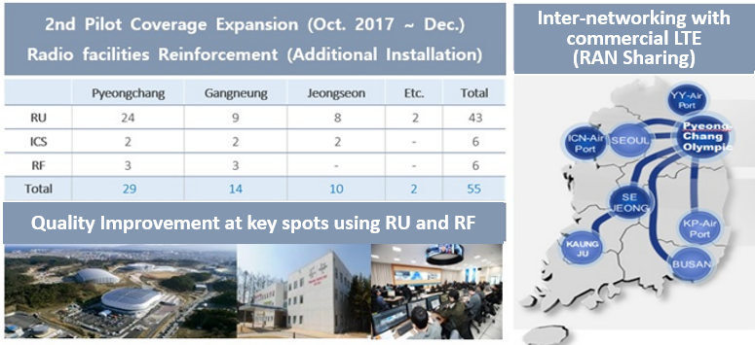
Source: Ministry of the Interior and Safety

Source: Ministry of the Interior and Safety

4.3 Pilot Project Summary

Korea Safe-Net has experienced the various technical achievements such as coverage verification, realization of voice and video PTT service, development of PS-LTE terminal, and operation of various service scenarios through the 1st & 2nd pilots.

The main technical achievements were as followings:

- Verification and derivation of a more cost-effective coverage solution called ALL-4-ONE with the design of PS-LTE network structures suitable for the terrain and environment of Korea
- Practical Implementation and Stabilization of multimedia-based diverse services and applications such as high-resolution images and videos, and UE location tracking, and remote control for GPS-based resources allocation.
- New services such as MCPTT (Mission Critical Push-to-Talk) over LTE and GCSE (Group Communication System Enablers) were tested as the trial
- Interoperability test among PS-LTE, 2 same frequeny LTE networks and commercial network.
- Verification RAN Sharing method of base stations sharing based on MOCN (Multi Operator Core Networks) to avoid interference among PS-LTE, LTE-R and LTE-M, which are using the same 700MHz frequency

Telcos and industries had the opportunity to stabilize the development of PS-LTE terminals by supplementing various improvements through field quality verification and feedback from the use agencies.

- Coverage expansion strategy

The national public safety network requires high security for its purpose of promoting public interests such as the maintenance of public order and military integrated defense operation at normal time. In emergency situations, both accessibility and high functionality for inter-organizational communication is crucial, even if communication facilities are destroyed and/or call traffic surges. These functions cannot be realized using any existing commercial communication networks, however it can plays a key role in securing the communication coverage at radio shadow areas such as basement and the inside of buildings, we plan to utilize a part of commercial communications in complementary way by taking the economic feasibility into account.

5.1 All – 4 – One coverage solutions

Coverage expansion strategy, ‘All – 4 – One’, focus on the purpose and economy of disaster safety network. It means all territories will be covered by a single network through 4 kinds of network’s integrated operation: fixed BS, commercial networks, mobile BS and other networks.
All-4-One is designed to be used in harmony with the eight coverage categories like this table.
As a result, fixed base stations are providing about 70% coverage and the remaining three solutions filling in about 30% coverage as a supplementary means.

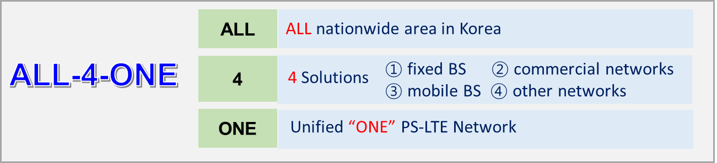

Table 4. Integrated operation with 4 kinds of networks
Index | National infrastructure | Road | Densely populated area | Mountain | Rural region | Indoor/  underground | Marine | Railroad
Fixed BS | ◎ | ◎ | ◎ | ○ | ○ | ○
Commercial networks |  | ○ |  | ○ | ◎ | ◎
Mobile BS |  |  |  | ◎ | ○ | ○ | ◎
Other networks |  |  |  | ○  (LTE-R) | ○  (LTE-R) | ○  (UHF, LTE-R) | ○  (LTE-M) | ◎  (LTE-R,)
◎: Main, ○: Sub
- Fixed Base Station: Macro RAN (DU, RU)
- Commercial Networks: LTE Network of Telecommunication Operator
- Mobile Base Station: Installed in vehicles or ships
- Other Networks: Interworking of LTE-Railway and LTE-Maritime, Using UHF

5.2 Interworking between PS-LTE and LTE-R or LTE-M network

In Korea, PS-LTE, LTE-R and LTE-M use the same frequency of 700M spectrum for separated network implementation on land, rail way and sea.
As shown at below cell boundary picture, co-channel interference occurs according to the RSRP(Reference Signals Received Power) value difference between networks in overlapping areas. In order to solve this interference efficiently
PS-LTE adopted RAN Sharing technology and then, jointly test and co-verify that seamless service is possible without call dropping or traffic degradation at the pilot project stage.
Korea Safe-Net adopts the RAN Sharing method of base stations sharing based on MOCN (Multi Operator Core Networks) to avoid interfering among PS-LTE, LTE-R and LTE-M, in the areas where the signals of 2 or 3 networks are overlapped, which is using the same 700MHz frequency. Also, it is in compliance with the requirements of 3GPP TS 23.251. Core network is individual to deploy and operate and it needs to assign the PLMN (Public Land Mobile Networks) number to identify the operator-specific network connection.

Figure 6. Co-channel interference among networks using same 700MHz
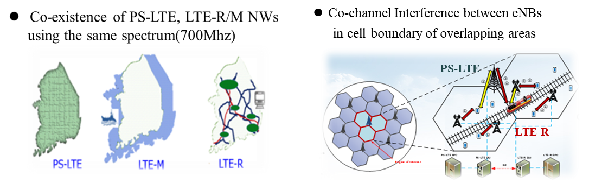

1) Overview of interworking
The interworking means the link to ensure seamless service through sharing of network systems and allocating radio resources in order to resolve interference with other public networks sharing the same frequency, as is the case in Korea. Even if they are moved to different network areas, each device must be provided with continuous service through other base stations that use 700 MHz spectrum, no matter where they are located.

2) Interworking procedures between terminals and other public networks
If a terminal is located in a base station area of another public network, it shall be ensured of access to the terminal through a series of access procedures upon request for access to the service. Terminal authentication function is required to prevent access from unauthorized terminals through interworking between other public networks.
In addition, efficient handovers should be provided from other public networks because there should be no interruption in service even if a terminal in service is moved to a base station in another public network.

Interworking should be met for three interwork scenario procedures, such as the internetwork reference model of [Figure 7].

- Attach procedure when the device is powered on in a different public network
- Handover procedure when the terminal is moved to another network with IDLE status
- Handover procedure when the terminal is moved to another public network in active status

In public network A and B, the network's internal interfaces are connected by a solid line to base station A (eNB A) and Core A (MME A, S-GW A), and the interfaces between terminal B and core B (MME B, S-GW-B) are connected by a dotted line. In addition, for securing IP transport between different public networks, interconnects between registered switches (IP SWs) with security guarantees access to dedicated lines (Ref. Dot lines in below [Figure 7.]).

Figure 7. Interworking model between PS-LTE and LTE-R/LTE-M(example)

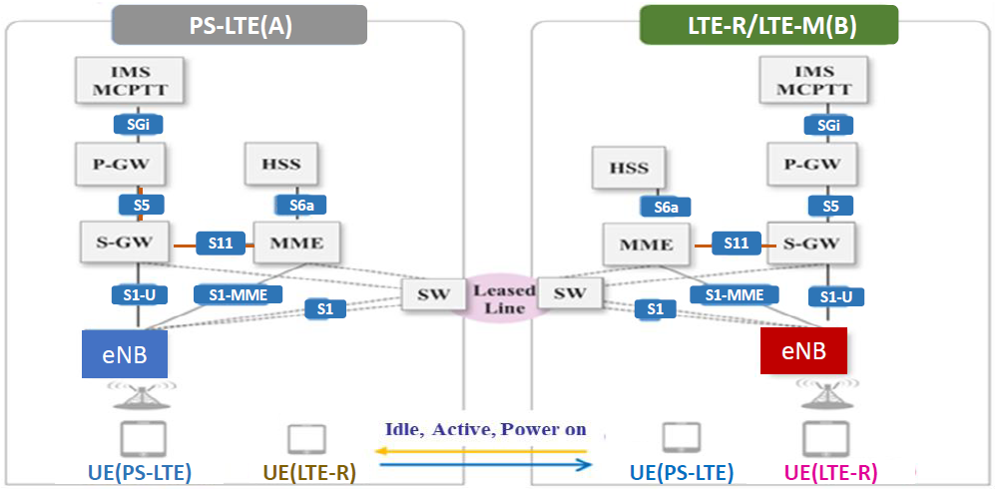

source: TTAK.KO-06.0471

3) Technical method for interconnection between public networks
The RAN sharing method of the 3GPP standard can be divided into Multi-Operator Core Network (MOCN) and Gate Way Core Network (GWCN), as shown in [Figure 8], depending on whether the MME connected to LTE eNB is separated or shared.

Figure 8. RAN Sharing technical method

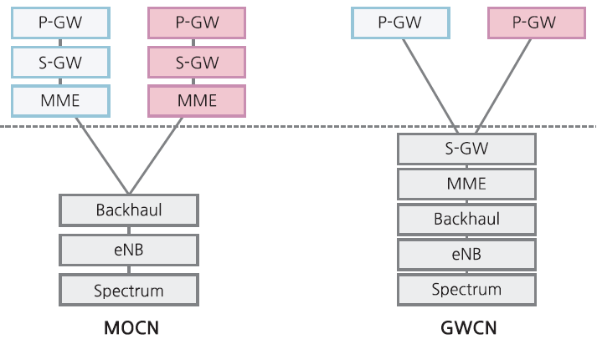
source: TTAK.KO-06.0471
MOCN is simple to link and has an advantage in terms of network operation, such as handling failures. If there are multiple users sharing the same access network (RAN) and a core network operated by each operator exists separately, it can be distinguished through the public network of ID which is a Public Land Mobile Network (PLMN). MOCN is a structure ([Figure 8]) in which each operator terminal (UE) is connected to a shared RAN, it is possible to check the corresponding PLMN ID to select the network.
PLMN consists of a Mobile Country Code (MCC) that denotes a country name and a Mobile Network Code (MNC) that denotes a public network classification. 450 is used as MCC for Korea, while MNCs use two digits of their own, which are different for different public networks.

Figure 9. Ran Sharing method(example)

Source: Ministry of the Interior and Safety

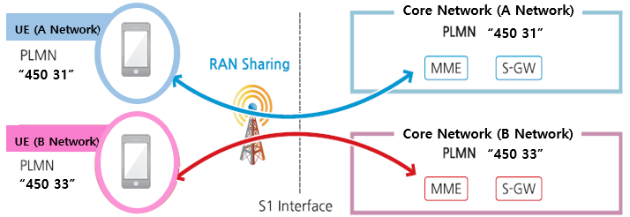
source: TTAK.KO-06.0471

4) Introduction to the TTA standard issued in December 2018
We developed and proposed Korea TTA standard regarding this interworking requirements & procedures

- Title
Requirements for Inter-Network and Sharing Radio Resources over Public Network using The Same 700 ㎒ Spectrum (19. DEC. 2018)
- Purpose
The standard is to standardize the common requirements for prevention of interference, sharing of radio resources and inter-working among public networks using the same 700 ㎒ frequency(Spectrum). Through this standardization, interworking operators can guarantee seamless services and can be used as the useful standard in network design, construction and operation process jointly.

- Common Requirements for Inter-working
- Network setting requirements
- Network interface requirements
- Network call processing requirements
- Requirements for radio resource allocation, hand over and cell design
- Common requirements for interworking
(QoS policy decisions and mutual agreements, dedicated line connection specifications, PLMN ID assignment and operation, secure security in interworking, IP address conflict prevention and joint management)

5.3 Interworking between PS-LTE and commercial network

PS-LTE is able to guarantee coverage in shadow areas and backup service in case of failure of PS-LTE network through RAN sharing with commercial LTE. This means improving the stability and viability of the PS-LTE network, as well as minimizing redundant investment and economic technology solutions.

PS-LTE has been interworked with commercial networks as an alternative to resolve shadow areas. MME (Mobility Management Entity) and SGW (Serving Gateway) were equipped in the 1st Operating Center during the second pilot, these additional deployments play important roles in network reliability and viability enrichment of PS-LTE.

There were several field surveys to verify interoperability between PS-LTE and commercial network, and the optimal value about terminal mobility was drawn through the tests.

Table5. Mobility management between PS-LTE, and commercial network

 | Terminal mobility policy
PS-LTE shadow area | PS-LTE device accesses to commercial network
Overlapping area | Priority access to PS-LTE using Idle Cell Reselection when PTT call is inactive, and stay in commercial network to avoid ping-pong while PTT is in use
Boundary | The handover is performed when the RSRP of other operator’s networks is greater than 3dB compared to the setting value (dBm) of RSRP
*RSRP: Reference Signal Received Power

Figure 10. Interworking between PS-LTE, LTE-M/LTE-R and Commercial LTE
(2nd Pilot Project example)

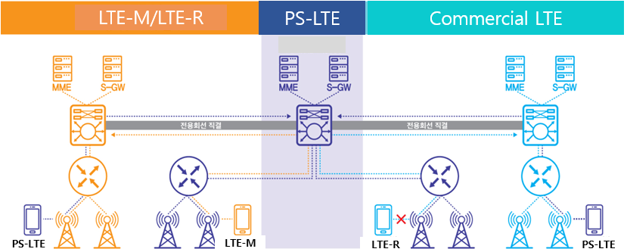
Source: Ministry of the Interior and Safety

- Main Project Implementation of PS-LTE Network

The objective of PS-LTE project is to reflect the results of the verification of the pilot project, fully consider the 3GPP standard-based technological advancement, efficient network interworking with the 3 networks and spread of the application services, and consequently establish a single nationwide network and secure a stable operation management system for 24 hours a day, 365 days a year.
Based on regional priorities, the project will be built in three stages by 2020 and will be operated and maintained by 2025. Its business size is about 1.5 trillion won (approximately 1.4 billion U.S. dollars) such as network construction cost, terminal equipment, dedicated line cost, operation and maintenance.

6.1 Period and scope of main project

  - Phase 1 (end of 2018 to SEP. 2019):
  - Target Region: Middle areas of 5 cities and provinces
  - Input Quantity: 1 main core and control system, 3,519 fixed base stations (RU), etc.
  - Main Goal: Improvement of the 1st operation center, construction of base stations in the target regions and 2nd the secondary operation center building, etc.

- Phase 2 (OCT. 2019 to SEP. 2020):
  - Target Region: Southern areas of 9 cities and provinces
  - Input Quantity: 1 main control system, 6,936 fixed base stations (RU), etc.
  - Main Goal: Establishment of the main control system for the secondary operation center, construction of base stations in the target regions, etc.

- Phase 3 (~ Mar. 2021)
  - Target Region: Metropolitan cities of Seoul, GyeongGi and Incheon
  - Input Quantity: 4,992 fixed base stations (RU), etc.
  - Main Goal: Completion of nationwide network including construction of base stations in the metropolitan regions, etc.

Figure 11. Implementation phase for main project

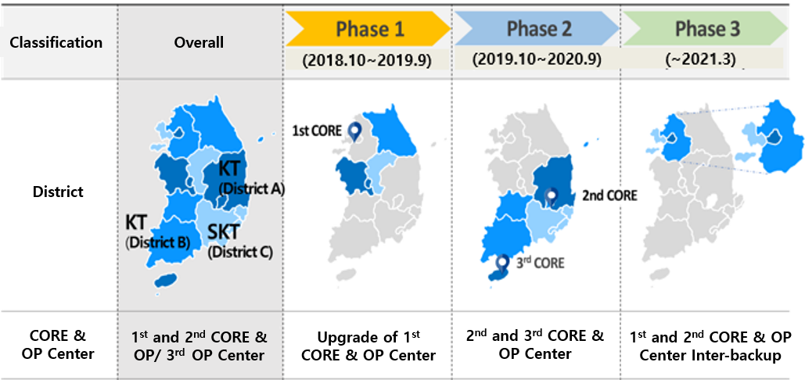
Source: Ministry of the Interior and Safety

6.2 PS-LTE Stability, Survivability Economic feasibility and Security in main Project

The most important aspects of this project are the enhanced stability, survivability, economic feasibility and security in the worst conditions, and economic feasibility is essential importance

First, for stability, PS-LTE considered 3 operation centers geographically separated into three regions in order to maintain continuous service in spite of natural or social disaster.
PS-LTE operation centers located at Seoul (1st), Daegu (2nd) and Jeju (3rd).
1st & 2nd Center can automatically switch over and 3rd center will be only activated at the worst case and each operation center will be also equipped with redundant EPC, IMS, eMBMS and MCPTT servers.
we implemented the equipment redundancy as well as geographical redundancy.

Figure 12. Redundancy using 3 geographical operation centers for Stability

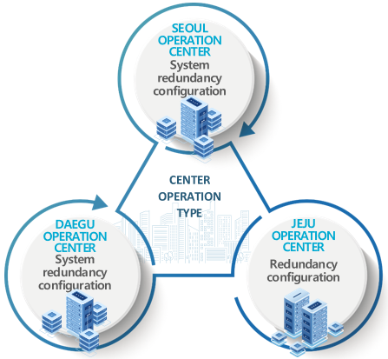

Source: Ministry of the Interior and Safety

Second, for survivability, PS-LTE has about five type of multiple back-up schemes to enhance survivability.
Using these backup solutions, such as RAN Sharing with commercial LTE, IOPS (Isolated eUTRAN Operation for Public Safety) mobile base station, device to device mode operation and umbrella cell base station for securing wide coverage range when a low-lying base station fails,
Korea PS-LTE can optimally respond to network conditions and operational changes

Figure 13. multiple back-up schemes for survivability

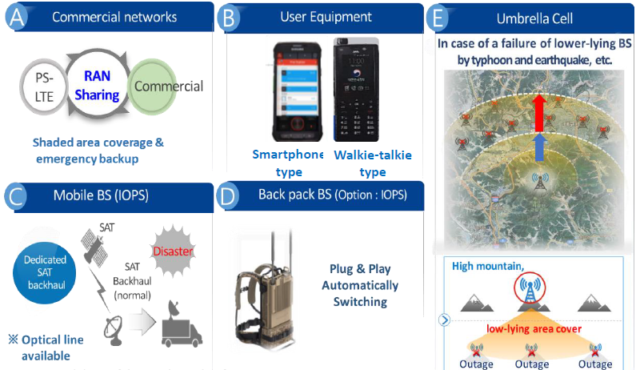
[Figure 14]. shows use case for various coverage solutions of access networks such as ①, ②, ③ and ④ depending on the geographical characteristics and operating conditions of the network.

Figure 14. Various coverage solutions of access networks (use cases)
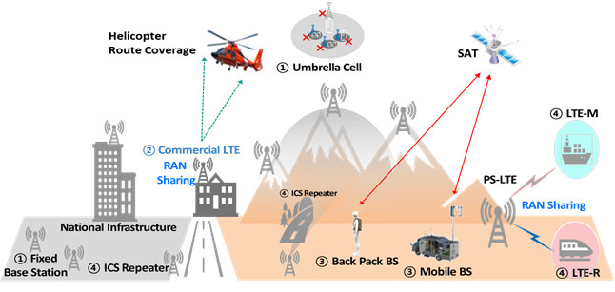
Source: Ministry of the Interior and Safety
① Fixed Base Station (national Infrastructure, high population Zone, Road)/Umbrella-Cell (emergency backup)
② Commercial networks (for shade areas, e.g., buildings, underground, islands, tunnels, Helicopter route coverage)
③ Mobile BS(Backhaul : optical cable is main and satellite link is optional when the optical cable is damaged.)
In Korea satellite network is a solution for the wireless backhaul of mobile BS instead of optical line. In the case where PS-LTE is not available such as shaded area of PS-LTE or collapse of PS-LTE eNB mobile BS can be a solution for it by providing satellite backhaul of PS-LTE. Taking into account this situation, SNG system communicating with the GSO FSS satellite(“Koreasat”) in Ku-band has been operated within the Korean territory.
/Back Pack BS (shaded area, traffic congestion, network failure)

④ ICS Repeater for shaded area, LTE-M (Maritime) in coast and sea and LTE-R(Railway) along railroad, respectively.

Third, in terms of economic feasibility, compared with the commercial network and PS-LTE, As shown in this [Figure 15], there is a difference in the increase trends of base station quantity.
commercial network has a characteristic that base station continuously increases in proportion to traffic capacity. On the other hand, PS-LTE has the advantage of reducing the number of base stations because it enables area-oriented network design rather than traffic. Also, PS-LTE has to accommodate a large number of subscribers without increase of base station quantity. For these reasons, eMBMS must be utilized for PS-LTE
Consequently, the number of base stations can be kept almost constant even after several years.

Figure 15. Cell design based on area rather than traffic

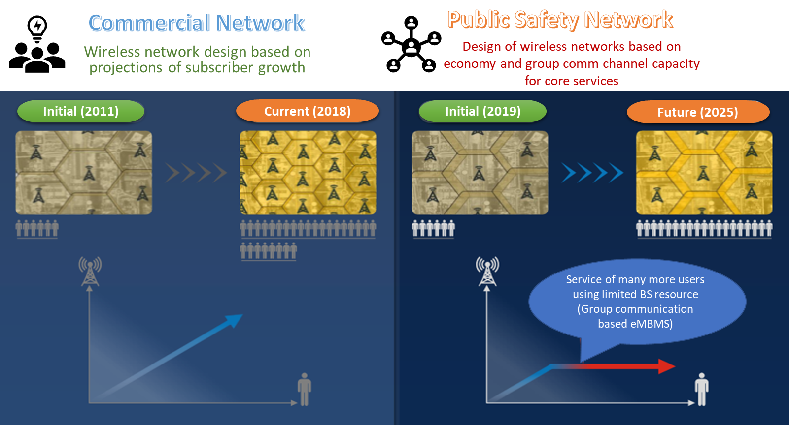
Source: Ministry of the Interior and Safety

In addition, the ALL-4-ONE solution for coverage extension described in Section 3.5 is most efficient design technique that can reduce the overall investment cost.

Fourth, for the security of the entire end-to-end layer, security design and security operation policies will be applied to the protected areas that meet the security level in accordance with the national security basic guidelines, identifying the security threat through the security environment level diagnosis of the operations center that was deployed in the previous pilot project.

PS-LTE network analyzes security threats by dividing security hierarchy of terminal, base station/transmission, operation center/main control, and network linkage, and implements countermeasure by hierarchy.

6.3. Operation and Maintenance (Jan. 2020 to the present)

Since Jan. 2020, operation of PS-LTE in certain areas had started and since March. 2021 the nationwide operation had begun for 8 disaster response agencies.

- About 20,000 BSs (DU, RU, ICS and deployable Base Station, etc.) are in operation. And about 210,000 UEs are provided. The number of UE is expected to increase as more disaster response agencies decide to use the PS-LTE.

- PS-LTE Standard Operation Procedure(SOP) to ensure interoperability of inter-agencies communication in disaster situations was made in 2021. According to the control tower's role and hierarchy, 5 SOP documents which describe the standards Common communication groups for inter-agency communication were released. SOPs for institutional communication group and temporary communication group for institution internal communication would be developed by each institution.

In Korea public safety and communication network (PS-LTE), three types of communication groups are defined and used for disaster management work or for integrated command at disaster sites. In particular, the common communication group is a function specialized for Korea's PS-LTE network
Three types of communication groups are as follows:
- Common communication group - all terminals can use in common to perform collaboration tasks between users at disaster sites and emergency situations.
- Institutional communication group - can use only terminals belonging to the user institution in order to carry out its own business.
- Temporary talk group (According to the special demand of the user organizations) – be created in a command device, etc., and is divided into temporary talk groups that can be used temporarily in the corresponding terminal.

Figure 16. SOPs for inter-agencies communication
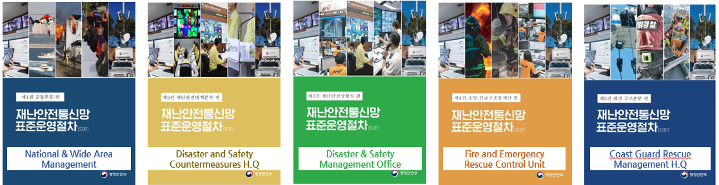
Source: Ministry of the Interior and Safety

- Basic & Application services of PS-LTE Network

Korea Safe-Net provides service related to 37 functional requirements such as basic voice call, group call, data communication, inter-terminal call, and location of terminal in case of normal or emergency of disaster safety communication network and provides geographical information through common platform.
Also, as an important achievement of the pilot project, we obtained valuable know-how of performance stabilization and optimizing the grouping and etc. also have developed the interoperability between different vendors of equipment.
In main project, MCPTT and eMBMS functions are implementing based on Rel. 13. with the architecture that can be upgraded to 3GPP 3GPP Rel.14 and 15.

Figure 17. MCPTT and eMBMS service (use cases)

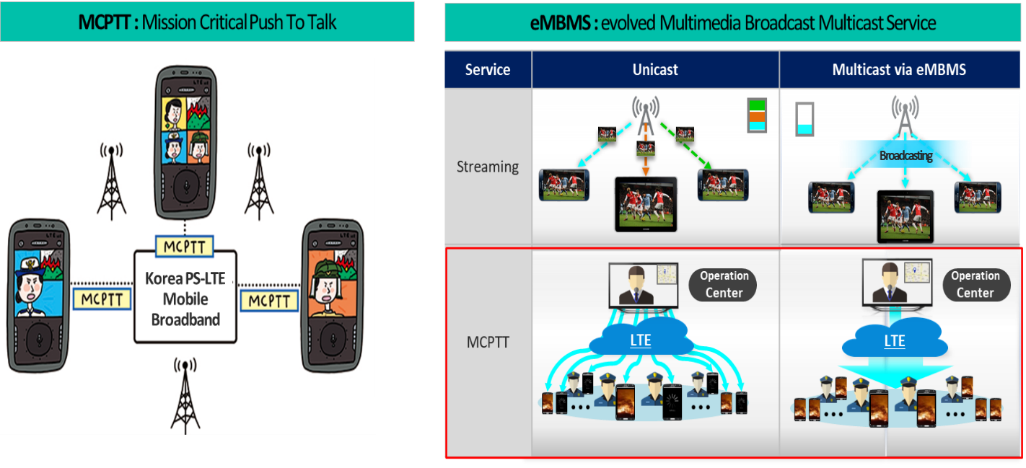
Source: Ministry of the Interior and Safety

7.1 Implementation of large-scale eMBMS expansion service

Effective use of multiple transmission technology (eMBMS) to resolve congestion due to increased usage was adapted. And a training based on eMBMS in preparation for large-scale rallies and events was made in Oct. 2022 to check the availability of large-scale device connections through eMBMS transition using MCPTT Voice call.

Figure 18. Large-scale eMBMS test

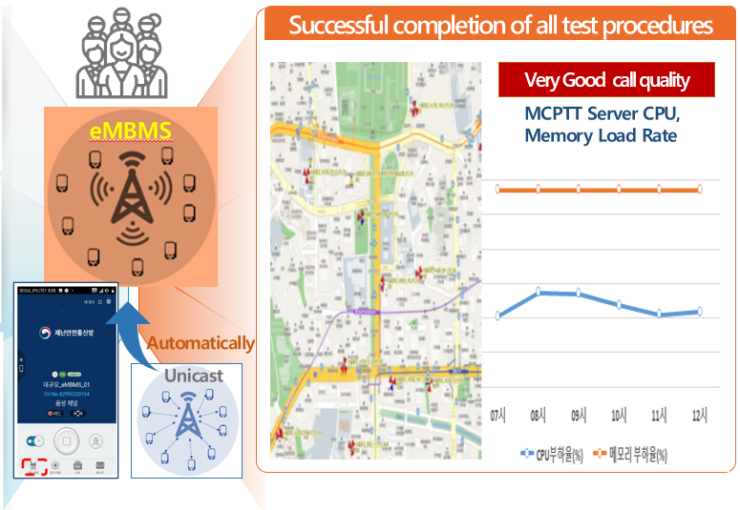
250 UEs x 40 groups/Area were proven in 10 Sites x 1,000 UEs/site.

7.2. Application Services

In parallel with PS-LTE network implementation,

various application services were developed and tested to improve the efficiency of disaster response.

- Services which are available now or under test for deployment
- Web portal is a site to work as a platform which provides disaster related policy and various statistic information. And from the portal, user can download various application S/W into their UE.
- Location Inquiry service provides various services based on the location information of UE which was obtained by GPS or registered Base station.
- Priority signal control for emergency vehicle with coordination of City control center.

Figure 19. Emergency Vehicle Preemption Control System using PS-LTE(example)

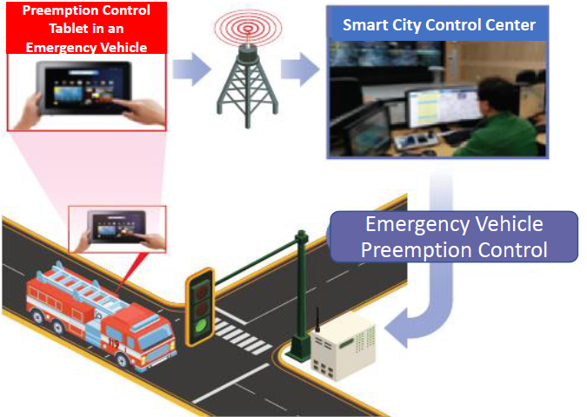
Source: Ministry of the Interior and Safety(Anyang-city)

- Services which are under development or planning
Many agencies want to import their current service in commercial network into PS-LTE.

- Emergency medical information transmission service to provide the rescue team in accident spot with information on hospital which has available doctor and emergency room.

Figure 20. Emergency medical information transmission service (example)

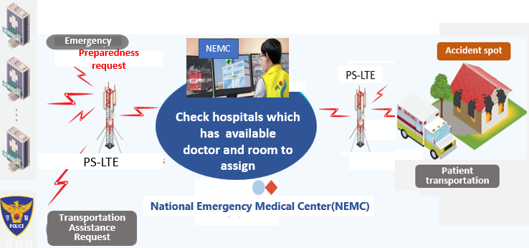
Source: Ministry of the Interior and Safety

- Accessing to a criminal record server by police on the spot to check whether the suspect is in the list of wanted persons.

Figure 21. Suspect person checking Service(example)

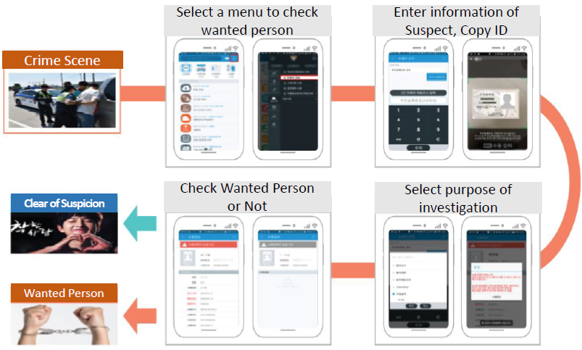
Source: Ministry of the Interior and Safety

- On-site video sharing platform which can share the video of accident area with risk respondent agencies to improve the efficiencies of rescue.

Figure 22. Integrated Video Sharing Platform to share on-site video(example)

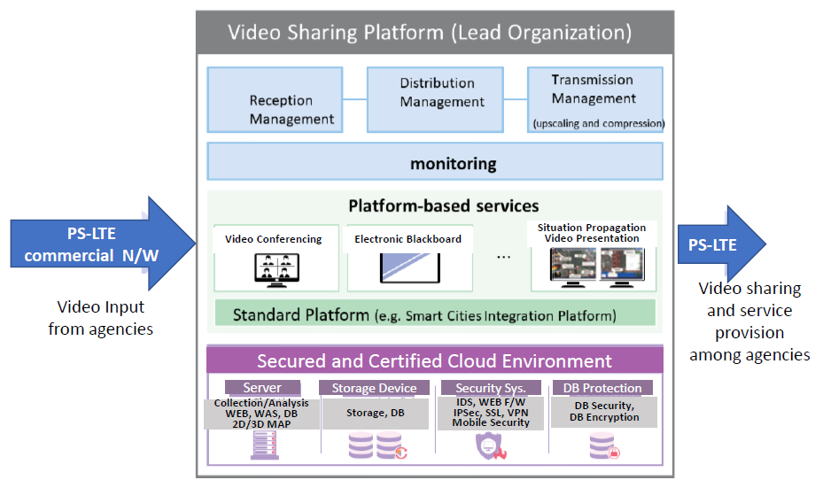
Source: Ministry of the Interior and Safety

- Dense crowd monitoring system monitors the stay of crowd in small areas by using information from mobile network system, CCTV and drone and provides alert to local government, police and firefighter to prepare any human disaster.

Figure 23. Monitoring dense population and providing alert(example)

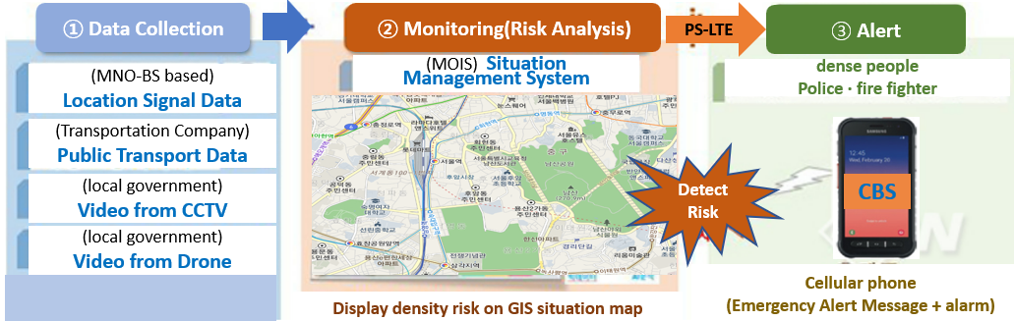
Source: Ministry of the Interior and Safety

For disaster prevention and disaster preparedness, many intelligent application services to monitor environment and dangerous facilities are under study and to be deployed in the near future.

8. Outline of PS-LTE Equipment Configuration and Features

The main features and functions of main equipment (main language, transport network, base station, terminal) of disaster safety network are as followings.
- Based on 3GPP Rel.13 standard, it is planned to upgrade to Rel.14 ~ 16 in the future.
- All devices are configured to accommodate IPv4 and IPv6, and IPv6 will be applied to the basic system configuration in consideration of future application services..
- Differentiated QoS scheduling and load balancing techniques are applied to solve the problems according to the scenarios in which call congestion may occur.
- Main core equipment uses virtualization technology.

Figure 24. PS-LTE Overall Architecture
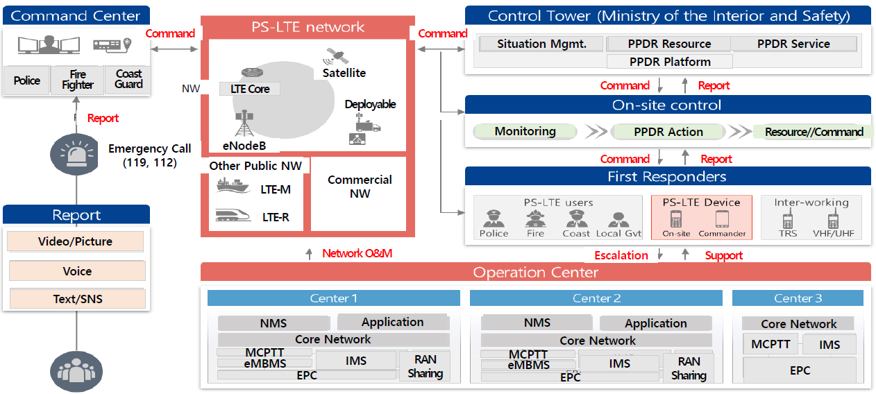
Source: Ministry of the Interior and Safety

(Core Equipment) This equipment (EPC, IMS, etc.) is used to provide call control, video / audio call, interworking function, call congestion response, eMBMS and MCPTT. In order to ensure survivability, the main functions are redundant and have mutual backup function so that the service is not disconnected in case of communication network failure. Equipment capacity can be secured by more than 400,000 users, and capacity expansion will be possible in the future.

Table 6. Core systems requirements
Classification |  | Main Function
Core equipment | E P C | Provides call control, terminal mobility management, and subscriber information management
Core equipment | I M S | core network infrastructure to provide video and voice call services
Core equipment | MCPTT | Provides fast connection speed and high reliability functions of MCPTT group call (PTT)
Core equipment | eMBMS (GCSE) | Multicasting-based batch transfer minimizes call congestion
Interworking  equipment | RAN Sharing | Open-link connection structure sharing base station of LTE network

(Transmission network system) backhaul (Core system ↔ DU: base station controller) and front hall (DU↔RU).
(Base Station System) Fixed base stations are installed in target coverage (national infrastructure, population density, major roads) preferentially, and commercial network interworking and mobile base stations are supplemented by RAN sharing. Coverage should be designed in consideration of demand for telecommunication service using the disaster network, maximization of coverage effect, and economy. From this point of view, Korea Safe-Net builds a network in a specialized way called All (anywhere in the country) - 4 (using four solutions) - One (building and operating a single communication service infrastructure). It also supports 3GPP Rel.13 standard function MCPTT QCI and eMBMS (GCSE) function.

Table 7. Base station requirements
Classification |  | Main Function
Fixed  base station | RU | wireless transmission and reception functions
Fixed  base station | DU | RU multi-aggregation and control
Fixed  base station | ICS  Repeater | For resolving small shadows, the RU transmit / receive signals are relayed,
Mobile base station | Portable  Type | Base station of backpack which is easily carried and installed by a person,
Mobile base station | Vehicle Type | Base station installed in a vehicle such as a truck or an SUV

(Terminal) There are various types of terminals (smart phone type, radio type, hybrid type) according to usage purpose, and there are vehicle type and fixed type terminals in the future. The hybrid type is a terminal capable of connecting PS-LTE and LMR that can be used in emergency situations when PS-LTE connection is not available. Air-to-Ground terminal which is equipped at a helicopter was released. The air-to-ground terminal equips control center console(international standard specification) for helicopter’s special structure and defines direct integration specification for intercom which is a part of communication for helicopter mission mounting equipment.

Table 8. Terminal Type
Classification | Main Function
Smart phone type | various applications can be installed and can be used universal terminal of Smartphone type
Walkie-talkie type | shape similar to a walkie-talkie terminal,  terminal in the form of a radio equipped with H/W keypad
Hybrid type | terminal integrating PS-LTE and LMR functions,
Vehicle / Fixed Terminal | terminal in the form of a movable smartphone or pad
Air-to-Ground | terminal located at helicopter to communicate with a terminal in ground

Figure 25. PS-LTE UEs
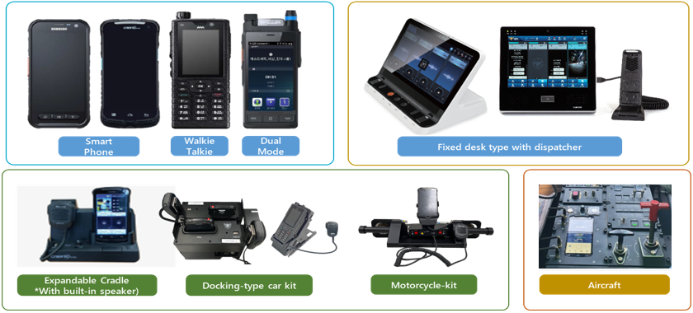
Source: Ministry of the Interior and Safety

The main common requirements of the terminal are as follows:
- VoLTE voice call, PSVT video call, MCPTT
- Unicast and multicast 'Group Calls' (GCSE / eMBMS)
- Support for call congestion
- Android OS (8.0) or higher OS
- 3GPP Rel13 or higher MCPTT
- WiFi (802.11 a / b / g / n/ac)
- PTT Hook H / W button and PTT emergency call H / W button
- Display of more than 4 inches and more than 720x1280
- Rearward 12 million / Camera more than 5 million pixels in front
- Support battery 3000mAh or more
- Ensures dustproof / waterproofing of IP 67 or more
- DMR digital narrow-band radio (12.5Khz TDMA) function (Hybrid type, Vehicle / Fixed)
- Embedded security
- Vaccines for detection of forgery/alteration and anti-virus were applied to all terminals. Vaccine management server provides vaccine pattern update and information regarding malicious code detection and device operation status.

(Dispatcher) Safe-Net dispatcher supports a wide range of MCPTT services such as private/group calls, emergency calls, text/multimedia messages of photos and videos, ambient listening/viewing, pre-emption functions, etc. The dispatcher can also provide additional extra services such as Geo fencing with GIS server, Recordings functions, Dispatcher management functions including device management system, and Call taking with legacy operating system.

Figure 26. Dispatcher and Screen Views

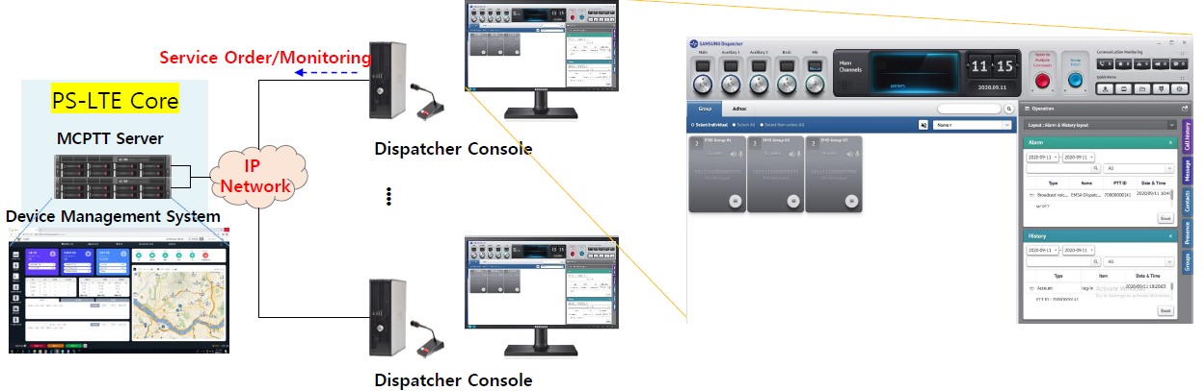
Source: Ministry of the Interior and Safety

9. Summary

As the PS-LTE-based disaster safety communication network was completed in Korea, it is a nationwide single wireless communication network capable of mutually coordinating the use of the users (fire, police, cost guard, military, municipalities, etc.). In addition, PS-LTE provides various multimedia services and "Mission Critical Push to Talk" (MCPTT) functions, which can help to predict pre-emptive disasters, to respond quickly to the risk, to prevent big disaster and to secure golden time.

To provide safety to people using PS-LTE, it is needed to make the operation of Safe-Net available anytime, anywhere and to increase the number of Safe-Net application services. For these, several technical strategies are formulated: 1) stable operation of the national safety core platform, 2) expansion and activation of disaster safety services, 3) enhancement of coverage and intelligence of infrastructure, and 4) cultivation of industry eco-system to grow together.
The Republic of Korea would like to find efficient ways to share technology and mutual cooperation with foreign countries preparing for the planning or design of the disaster safety communication network.

Annex 7 - Example 2 from Korea (Republic of)

Satellite backhauling Service with Interference Management
in PPDR System

1. Introduction

1.1 Background
In public safety communication environments, the shared use of the same frequency band among multiple wireless communication networks can lead to interference issues, even under normal operational conditions. This is particularly evident in overlapping areas where multiple networks coexist.
To address these challenges, technical and operational measures have been implemented, including:
- Deployment of base stations at distances exceeding 3 km apart to ensure sufficient separation (with at least 10 dB signal level difference),
- Application of Radio Access Network (RAN) Sharing technologies, and
- Nationwide coordination efforts to mitigate interference in the National Integrated Public Safety Network, with agreement finalized in November 2020.
In the event of large-scale disasters (e.g., wildfires, typhoons), public safety responders such as fire services, police, and medical teams are mobilized to the affected areas. In such scenarios, mobile base stations must be deployed to ensure mission-critical communications for response and recovery operations.
However, if these disaster areas overlap with existing communication system coverage, the deployment of additional mobile base stations without proper frequency coordination may result in severe interference between networks.
Furthermore, when mobile base stations are deployed arbitrarily—without awareness of the positions and radio environments of existing fixed base stations—network congestion and signal interference may significantly impair command and control communications.
To enable dynamic and interference-resilient PS-LTE operations, this contribution proposes the development and deployment of a Vehicle-mounted Satellite Communication System that supports active frequency interference avoidance and satellite backhaul integration.
- Key Technical Features:
- Interference avoidance for public safety mobile base stations through real-time signal analysis and direction finding
- Location identification and optimal re-deployment of mobile base stations using GIS-based data to avoid interference from same-frequency signals
- Satellite relay technology development to provide reliable backhaul links for mobile PS-LTE networks in disaster-affected or infrastructure-limited areas
1.2 System Model
The system considers two interference scenarios as follows.
- Interference Scenario 1: Frequency Band Sharing (Co-Channel Interference)
- PS-LTE network performance degradation due to the co-channel interference
- Interference Scenario 2: Jamming & Spoofing
- Jamming: the intentional disruption or interference in the co-channel
- Spoofing: the fake interference signals to confuse the receiver
Figure 1. Interference Scenario 1: Frequency Band Sharing
Figure 2. Interference Scenario 2: Jamming & Spoofing
To provide PS-LTE Backhaul service in disaster area and optimize communication environment the system model should support the key technologies. For the satellite backhaul there are some gateways which are connecting core network of PS-LTE and terminals located in MS, and for management the interference there are two equipment (direction finding and interference analysis).

Figure 3. System model of interference management techniques in the disaster

2. Direction Finding

2.1 Definition and Necessity of DF
Direction Finding (DF) technology refers to the method of estimating the direction of arrival (DoA) of a wireless signal, enabling the identification of the transmitter’s location. While traditionally applied in areas such as military communications, and aircraft tracking, it has recently emerged as a critical component in public safety communication systems, particularly in emergency response scenarios involving network disruptions.

Natural disasters or societal emergencies can cause severe damages on existing terrestrial communication infrastructures. In such situations, mobile base stations are deployed to rapidly restore communication links. However, even with these mobile units in place, the vast scale of the disaster area and the potential presence of multiple signal sources—such as other services or unauthorized transmissions—pose significant challenges. In order to avoid interference and ensure reliable communication, DF is essential for accurately identifying and distinguishing the directions of these signal sources.
For instance, if a signal transmitted from a rescue worker's device can be detected along a specific direction, the mobile base station can promptly form a directional beam toward that source, significantly enhancing communication efficiency. This becomes particularly critical in time-sensitive and resource-limited disaster environments, where the reliability and speed of communication can directly impact the effectiveness of rescue operations. Furthermore, this technology can contribute to real-time detection of congestion and interference within the network, enabling adaptive resource allocation and frequency management to maintain overall network performance.

2.2 Performance analysis of various DF technologies
In Korea, a performance analysis has been conducted on widely adopted DoA estimation algorithms, namely MUSIC (MUltiple SIgnal Classification) [1], Root-MUSIC [2], ESPRIT (Estimation of Signal Parameters via Rotational Invariance Techniques) [3], SOMP (Simultaneous Orthogonal Matching Pursuit) [4], and CI (Correlative Interferometry) [5], in the context of optimizing the communication environment to address frequency interference issues in the PS-LTE network. The characteristics, advantages, and limitations of each algorithm are summarized in the table below.
Algorithm | Characteristics | Pros | Cons
MUSIC | Based on eigenvalue decomposition of the signal covariance matrix to separate signal and noise subspaces | * High-resolution DoA estimation  * Robust under high SNR conditions | * High computational complexity  * Requires prior knowledge of the number of sources
Root-Music | Polynomial form of MUSIC; estimates DoA by finding the roots of a characteristic polynomial in the complex plane | * Very fine angular resolution  * No grid search required (fast) | * Requires uniform linear array (ULA)  * Complex root selection process
ESPRIT | Exploits shift-invariance property of the signal subspace using eigenvalue analysis | * Direct angle estimation without grid search  * Computationally more efficient than MUSIC | * Limited to specific array geometries  * Sensitive to multipath and array calibration errors
SOMP | Compressive sensing-based algorithm using joint sparsity across multiple measurements | * Accurate with fewer samples  * Applicable to high-dimensional sparse scenarios | * Sensitive to the sensing matrix design  * High computational burden due to sparse recovery
CI | Estimates DoA by correlating measured phase differences with a reference database of known directions | *Simple and intuitive to implement  * Proven effectiveness in practical systems | * Requires pre-built reference database  * Performance degradation with non-ideal or non-pilot signals
The simulation environment for evaluating the performance of DoA estimation techniques is described as follows.

Parameters | Value | Parameters | Value
Frequency | 700Mhz | Source of interferences | 2
Number of antennas | 4 | DoA of interference sources | 20°, -20°
Array antenna | ULA | Number of samples | 100

The root mean squared error (RMSE) between the estimated and actual DoA values as a function of varying SNR is analyzed. The RMSE is calculated, where $ϕ$ denotes the true angle and $\overline{ϕ}$ the estimated angle:
$$RMSE=\sqrt{E\left[{\left(ϕ-\overline{ϕ}\right)}^{2}\right]}$$
The below results are obtained for the single interference source scenario.
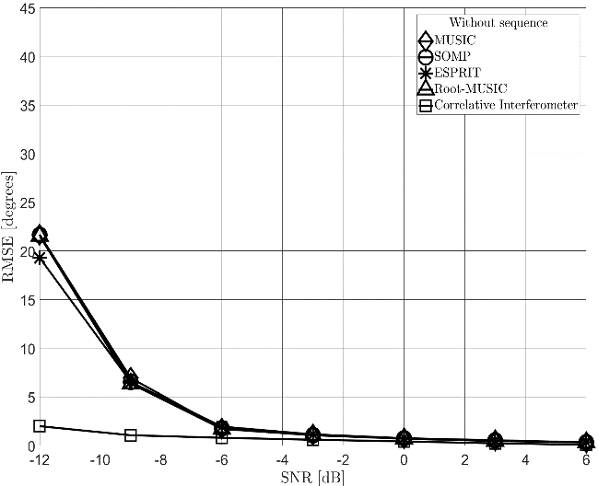
As the SNR increases, all algorithms show improved estimation accuracy. However, the CI method exhibits superior performance even under low SNR conditions. This is due to its reliance on phase differences rather than signal power. In the case of multiple interference sources, the results are as follows.
DoA of inteference source | Results
-20° | 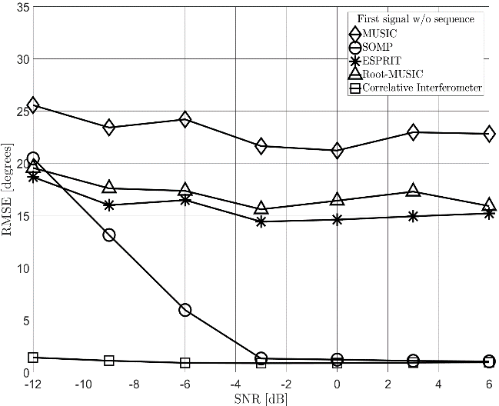
20° | 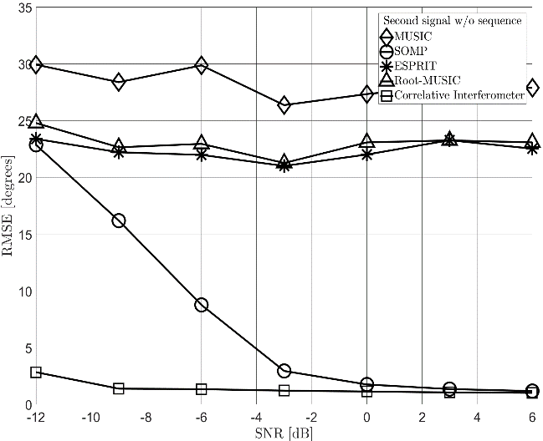
Even in the presence of multiple interferers, the CI algorithm consistently achieves outstanding RMSE performance, demonstrating its robustness against interference and power imbalance.
Since a sufficient signal quality cannot always be guaranteed in disaster scenarios, and based on the above theoretical findings, the CI algorithm was selected for implementation in the mobile base stations developed for Korea’s PS-LTE network.

2.3 Hardware implementation

2.3.1 Wideband Dual-Channel Receiver Module for DoA Estimation
Given that the frequency bands allocated for disaster communication are adjacent to those used for broadcasting and mobile communication, issues such as signal degradation may arise. To address these challenges, the system is designed with the following considerations:
- The system is designed to allow selection a bandpass filter or a band-rejection filter, depending on the operational environment.
- The system includes controllable front-end amplifiers and attenuators to dynamically adjust signal levels based on input signal strength.
- A synchronized local oscillator (LO) signal generator and distributor is implemented to ensure frequency and phase coherence across multiple receiver channels.
- A high-precision, phase-synchronized frequency generator synchronized with a GPS-disciplined oscillator (GPSDO) is designed to maintain alignment.
- The analog front-end is designed to uniformly receive wideband signals (40 MHz bandwidth), with filtering performance optimized to suppress spurious signals and maintain signal fidelity.
Parameters | Value
Frequency (MHz) | 710 ~ 806
Frequency resolution | Less than ±0.05 ppm
Bandwidth (MHz) | 48, 36, 24, 16, 12, 8, 4, 3.2, 1.6, 0.8, 0.64
Phase Noise (dB) | ≤-98 dBc/Hz (@100kHz)  ≤-124 dBc/Hz (@1MHz)
Input ATT range | 0 ~ 30 dB
Noise figure | ≤10dB
IP3 | 20dB≤
Operation temperature | -20℃ ~ 50℃

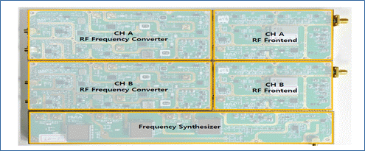
Figure 4. Wideband receiver module

2.3.2 Digital board with dual ADC for DoA estimation
In order to implement a DF system utilizing dual channels, two sets of 2-channel ADCs are integrated to perform signal processing. The system is designed according to the following specifications:
- IF signals are digitized through high-speed analog-to-digital converters (ADCs).
- The digitized RF samples from the ADCs performs essential functions for DF except DDC and antenna switch control.
- The preprocessed data from the FPGA is transferred to a processor where the direction estimation algorithms are executed.
- The entire system is designed to meet the required thermal specifications to ensure stable operation in both summer and winter outdoor environments.
Parameter | Specification
Processor | 64bits Quad Core A-72(1.8 GHz)
DRAM | DDR4 4GBytes with ECC
eMMC | 32GBytes eMMC
FPGA | Xilinx Kintex UltraSCALE+
ADC | Dual Channel 14Bits 210MHz  Sampling frequency 184.32 MHz
FPGA to Processor Interface | PCIE 3.0 x 4 lane
ethernet | 1Gbps
GPS | GPS DO OCXO
OS | Linux
Operation temperature | -20℃ ~ 50℃

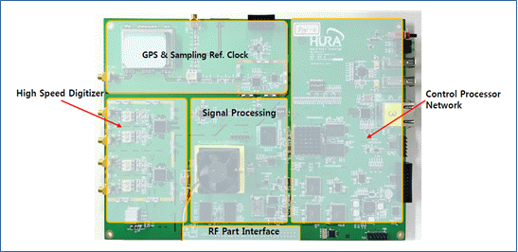
Figure 5. Dual ADC digital board

2.3.3 Array antenna design
In DF applications, circular array antennas that offer uniform estimation accuracy across all azimuth directions are often employed. However, in urban environments, such arrays have high sensitivity to receiver placement due to the impact of multipath propagation. Therefore, the antenna for 700MHz frequency band should be designed by taking the followings into account.
- Direction-finding antennas can take various forms depending on the underlying estimation algorithm, signal direction characteristics, and installation environment.
- For fixed direction-finding systems, circular array antennas with 5 to 9 elements are utilized. Antenna type and element spacing are determined according to the target frequency band and system requirements.
- Mobile direction-finding systems require more compact configurations due to vehicular space constraints and increased vulnerability to multipath interference.
- Accurately estimating the direction of PS-LTE base station signals from a moving vehicle remains a significant technical challenge, and the choice of antenna structure is critical to overall system performance. Key challenges in this context include:
  - The presence of multiple base stations operating on the same frequency band
  - Coherent incident signals resulting from multipath propagation
  - The need to distinguish between environments with and without direct line-of-sight (LOS) signals
Parameter | Specification
Frequency | 710 ~ 806 or higher
Antenna channel | Array antenna with 2 or more channels
Installation location | Mounted on vehicle roof
Operation temperature | -20℃ ~ 50℃

3. Interference Avoidance Technology based on Optimal Positioning of Base Station using GIS Integration

3.1 Overview
This section introduces an interference avoidance technology for public safety networks (PS-LTE) based on GIS-integrated radio interference analysis models. The objective is to determine the optimal deployment location of mobile base stations during disasters, in order to avoid frequency interference and ensure efficient operation of disaster response communications.
Operational Concept for Optimal Mobile Base Station Deployment
- During a disaster event, this function determines the optimal location for mobile base station deployment in the affected area.
- The system identifies existing base stations near the disaster area and analyzes their coverage areas.
- Based on the coverage analysis results, candidate zones for mobile base station placement are identified.
- The system evaluates interference levels at each candidate location, taking into account the impact on nearby base stations.
- The optimal position is selected where interference is minimal while still offering wide-area coverage.
This approach allows mobile base stations to provide reliable services while minimizing interference with existing infrastructure. The concept of operations focuses on coverage-based zone designation using GIS, which reduces the analysis and decision-making time during disaster response.
3.2 Propagation Interference Analysis Models
To minimize interference among PS-LTE base stations and ensure optimal mobile base station deployment, radio path loss models incorporating terrain data are applied. The following ITU-R recommended models are referenced:
ITU Model | Name
ITU-R P.452 | Prediction procedure for the evaluation of interference between stations on the surface of the Earth at frequencies above about 100 MHz
ITU-R P.525 | Calculation of free-space attenuation
ITU-R P.526 | Propagation by diffraction
ITU-R P.1546 | Method for point-to-area predictions for terrestrial services in the frequency range 30 MHz to 4 000 MHz
ITU-R P.1812 | A path-specific propagation prediction method for point-to-area terrestrial services in the frequency range 30 MHz to 6 GHz

- ITU-R P.452 Model [6]
The ITU-R P.452 model provides a procedure for predicting interference between terrestrial radio stations in the frequency range above 0.1 GHz. It considers various propagation mechanisms such as:
- Line-of-sight (LoS): Direct path between transmitter and receiver without obstructions.
- Diffraction: Path affected by obstacles blocking LoS.
- Troposcatter: Weak signal paths over long distances (100–150 km); may deliver strong interference under certain conditions.
- Surface Ducting: A short-term propagation effect significant over water and flat coastal areas, enabling strong signal reception at long distances.
- Layered Reflection: Multipath reflections/refracted signals from elevated atmospheric layers, enabling long-distance transmission.
- Rain Scattering: Generally results in weak interference, not typically causing severe problems.
The model performs terrain profile analysis between two radio stations to compute overall path loss based on the applicable propagation mechanisms.
- ITU-R P.525 Model [7]
This model defines the method for calculating Free-Space Path Loss (FSPL), representing the ideal loss incurred by a signal traveling through free space without any obstacles.
- ITU-R P.526 Model [8]
The ITU-R P.526 model estimates signal loss due to diffraction caused by obstacles (e.g., terrain or buildings) between the transmitter and receiver.
- The model distinguishes between smooth earth diffraction and knife-edge diffraction:
  - Smooth earth diffraction is applied for over-the-horizon and LoS paths with sub-path obstructions.
  - Knife-edge diffraction accounts for one, two, or more obstacles.
- For a single obstacle, the diffraction loss is calculated as a function of a dimensionless parameter ν\nuν.
- For two obstacles, diffraction losses are evaluated separately and compared.
- For three or more obstacles, the Delta-Bullington method is applied to estimate the aggregate loss.

- ITU-R P.1546 Model [9]
This model predicts point-to-area field strength for terrestrial services between 30–4000 MHz, based on empirical curves derived from measurements. It incorporates:
- Distance,
- Antenna height,
- Frequency,
- Time availability, and applies correction factors for terrain clearance and clutter effects near transmitter and receiver sites.
- ITU-R P.1812 Model [10]
The ITU-R P.1812 model is an enhanced version of P.1546, supporting more accurate path-specific propagation predictions over 30 MHz to 6 GHz. It utilizes:
- Digital terrain elevation data (DTED),
- Clutter data and predicts median path loss using time and location variability parameters over a given terrain profile.
3.3 Development of Radio Interference Analysis Function Utilizing Terrain Information
The radio interference analysis function utilizing terrain information applies the specification data of the target base station, analysis configuration parameters, and surrounding terrain data to the radio interference analysis model. This enables analysis of electric field strength, coverage, and potential interference affecting adjacent base stations.
- Base Station Management
Accurate coverage analysis of the public safety network (PS-LTE) base station requires that actual operational parameters such as base station location, antenna height, operating frequency, transmission power, and antenna gain be reflected in the analysis. The base station management function models the relevant information of the target base station and manages it in a dedicated database.
- Path Profile Management
Path profile analysis evaluates terrain cross-sections between transmitter and receiver locations to determine line-of-sight (LoS) availability. This process identifies obstacles and provides essential data for calculating propagation loss between communication endpoints.
- Base Station Coverage Analysis
To determine the necessity of deploying additional mobile base stations at disaster sites, the coverage of existing base stations must be analyzed. The coverage analysis function applies the specifications of PS-LTE base stations and surrounding terrain information to the propagation model, visualizing the service area on an electronic map to assist operators in determining whether additional mobile base stations are required. The results may vary depending on the selected model and the geographic environment of the area.
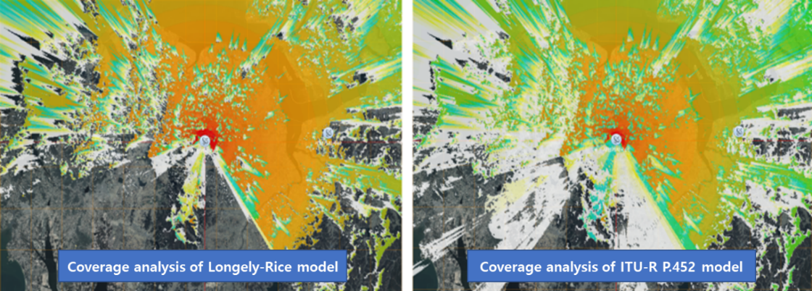
Figure 6. PS-LTE Base Station Coverage Analysis Result
- Base Station Interference Analysis
Interference between base stations occurs when adjacent stations operate on the same frequency band. If a terminal is located in an area where multiple base station signals overlap, it may receive unintended signals from neighboring stations, resulting in interference. This function analyzes overlapping coverage or designated areas and determines the existence and scope of interference based on each base station’s signal strength.
- Definition and Criteria for Interference:
  - Interference is considered to occur when the signal strength from a mobile base station received by a terminal within the PS-LTE base station’s coverage area exceeds the specified interference threshold (co-channel protection criteria).
  - Interference is also determined when the signal level difference between the PS-LTE base station and the mobile base station exceeds the protection criteria.
  - Evaluation is based on PS-LTE reception standards and terminal operations within the PS-LTE service area.
- Development of Optimal Base Station Placement Function Using Interference Analysis Results
The optimal placement function for mobile base stations uses the following stepwise approach: disaster area setting → identification of nearby base stations → interference analysis → setting deployment zones for mobile base stations → analysis for optimal placement → visualization of results.
- Identify and analyze the coverage of nearby base stations surrounding the defined disaster area.
- Set candidate zones for mobile base station deployment based on coverage analysis.
- Visualize base station coverage and analysis results using GIS-based mapping.
Core Functions:
- Management of PS-LTE and commercial base station information.
- Parameter management for base stations (frequency, power, antenna gain, etc.).
- Setting of disaster zones and target regions for deployment.
- Coverage analysis for existing and candidate base stations.
- Definition of optimal mobile base station positions based on interference and coverage analysis.
- Visualization using electronic maps.
- Electronic Map Functionality
GIS-based scenario creation and simulation tools are implemented using a proprietary electronic map system. Key features include:
- Support for multiple layers: national topographic maps, 3D maps, satellite images.
- Display of base station icons on maps.
- Real-time display of cursor coordinates and elevation.
- Multiple coordinate systems supported (WGS-84, UTM, MGRS).
- Basic controls for pan, zoom, and map navigation.
- Drawing tools for indicating disaster zones and movement paths of mobile base stations.
- Distance, bearing angle, and total path calculation by multi-point selection.
- Display of path profile and propagation results integrated with terrain maps.
- Applied GIS resolution: DTED Level 2 (30 m spatial resolution, horizontal: WGS-84, vertical: MSL).
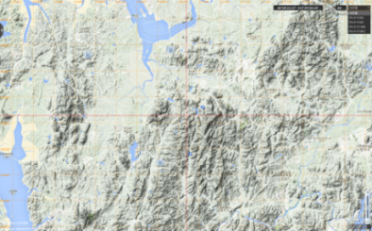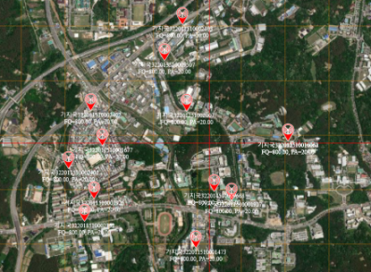
Figure 7. Map Layers View – 3D Map, Satellite Map, National Topographic Map, Base Station Display
- Base Station Management Function
This function manages both PS-LTE and mobile communication base stations. It supports the registration, querying, modification, and deletion of base station entries and their operational specifications.
- Management of PS-LTE and commercial base station metadata.
- Use of registered technical parameters for consistent analysis.
- Information fields include:
  - Station ID, name, and address.
  - Geographic coordinates (latitude/longitude).
  - Parameters: frequency, signal level, antenna gain, cable attenuation, additional losses.
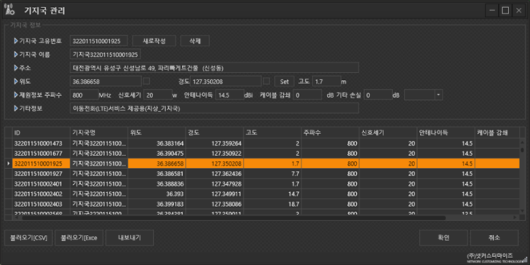
Figure 8. Base Station Management Interface
- Optimal Mobile Base Station Placement Analysis
This function identifies optimal positions for mobile base stations by evaluating service coverage in the disaster zone and minimizing interference with nearby stations. Placement is recommended in areas with relatively low signal levels from adjacent stations.
- Analyzes potential service coverage and interference levels for each candidate location.
- Displays serviceable areas and quantitative coverage data on the map.
- Coverage ratio per position is listed for optimal site selection.
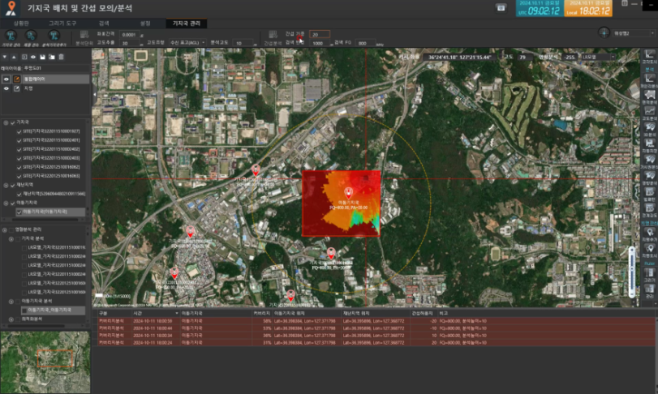
Figure 9. Service Area Analysis with Interference Consideration
- Interference Mitigation Methods Using Mobile Base Station Parameter Adjustment
When interference occurs during mobile base station deployment at disaster sites, it can be mitigated through adjustments in parameters or position.
- Transmission Power Adjustment:
  - Perform coverage analysis while varying transmission power.
  - Adjust power to ensure sufficient service coverage without exceeding interference thresholds.
  - If power adjustment is insufficient, conduct relocation analysis.
- Location Adjustment:
  - Relocate to candidate zones identified through optimal placement analysis.
  - Evaluate coverage and interference at each location.
  - Select a final location where adequate coverage is provided and interference remains below threshold levels.

4. Satellite Backhaul Technology
For the implementation of a satellite backhaul system in public safety networks, both a satellite hub station (referred to as the "hub") and satellite terminals (referred to as the "terminals") are required. This section describes the key enabling technologies for both the hub and terminal components.

4.1 Design of a Hub Station Supporting Multi-Topology Networks
This section defines the key components (modules) of a hub station designed to support multiple satellite network topologies (STAR, MESH, and SCPC). The major functions of each module are described as follows:
- Dynamic Resource Management Module (DRM)
  - Performs dynamic resource management for MF-TDMA access to support multi-user access based on DVB-RCS2 standards [11], including the generation of Forward Link Signaling (FLS).
  - Determines link ACM (Adaptive Coding and Modulation) and allocates radio resources for multi-beam STAR network and MESH network.
  - Receives timing information from the Clock Distribution Management (CDM) module to generate FLS signaling.
  - Generate link and synchronization status information by receiving link state report of each terminals from Return Link Demodulation module.
  - Manage handover and monitoring.
- Clock Distribution Management Module (CDM)
  - Generates and distributes timing references used in the whole system.
  - Produce system reference clocks for use in the RLD_TP and Forward Link Modulation (FLM) modules based on GPS information
- Forward Link Modulation Module (FLM)
  - Performs modulation and channel coding for DVB-S2/S2X [12] forward link transmission.
  - Supports NCR (Network Clock Reference) synchronization in DVB-S2/S2X ACM environments by generating and distributing NCR signals.
  - Exchanges timing information with the CDM and DRM modules for synchronization.
  - Composed of multiple FLM modules for multi-beam operation (e.g., East Sea beam, West Sea beam, South Korea beam).
- Return Link Demodulation Module (RLD)
  - Demodulates and decodes the DVB-RCS2 compliant return link signals received in transparent mode.
- Receive Data Processor Module (RDP)
  - Processes Return Link Encapsulation (RLE) data in accordance with the DVB-RCS2 standard.
- Network Management Server Module (NMS)
  - Manages system access and administrative control of the ground station.
  - Monitors and controls the status of both hub and terminal subsystems.
  - Manages satellite network resource allocation and traffic management.
  - Maintains the network topology, terminal registration, and configuration.
  - Tracks user operation history and performs statistical processing.
  - Oversees hub and terminal equipment.
  - Monitors beam-level operational status and manages multi-beam configurations.
Module | Features
DRM | Management of return link resources in accordance with the DVB-RCS2 standard
CDM | System clock management
FLM | Transmission of DVB-S2/S2X forward link signals  - Symbol rate: up to 80 Msps  - Modulation/coding: up to 16APSK, full LDPC support
RLD | Reception of DVB-RCS2 return link signals’  - Symbol rate: 0.128 to 4.096 Msps  - Modulation/coding: QPSK to 16QAM, full Turbo code support
RDP | Processing of DVB-RCS2 return link MAC and encapsulated data
NMS | Control and monitoring of hub and terminal systems, network resource management
- FWD : PER=${10}^{-7}$(DVB-S2X)
- RTN : PER=${10}^{-5}$(DVB-RCS2)
- Availability : 99.7%

4.2 Development of the Satellite Backhaul Hub Station
The satellite backhaul hub station is composed of multiple functional modules:
- The Clock Distribution Management (CDM), Forward Link Modulation (FLM), and Return Link Demodulation (RLD) modules were designed and manufactured in compliance with the cPCI 6U standard.
- These three modules (CDM, FLM, and RLD) are integrated into a 4U sub-rack to ensure compact and modular assembly.
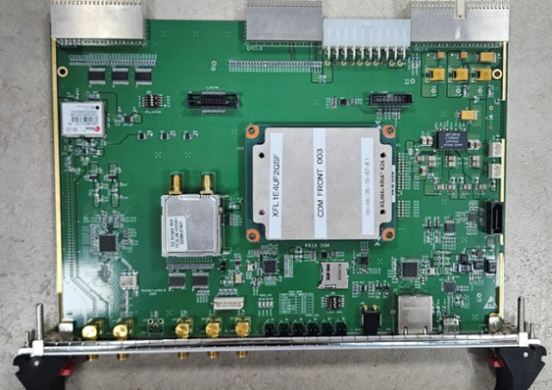 | 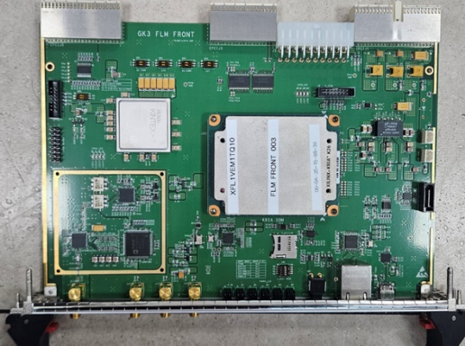
CDM | FLM
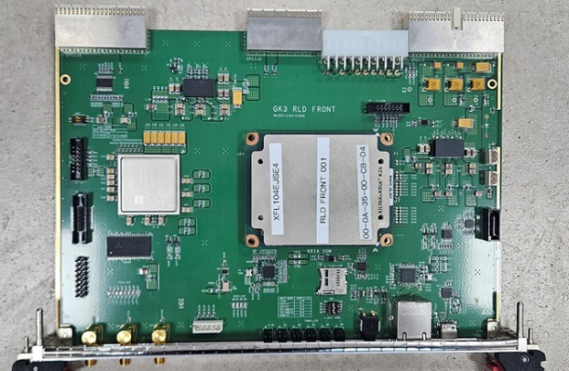 | 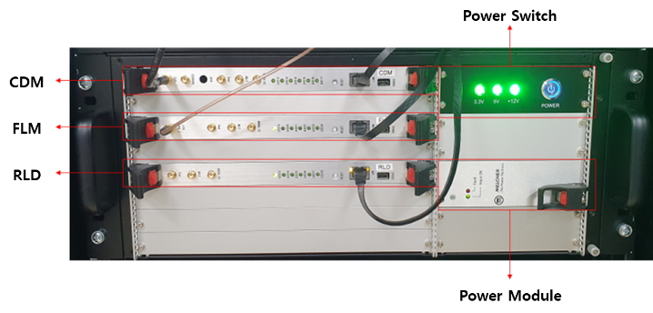
RLD | subrack for CDM, FLM, RLD
Figure 10. Implementation of CDM, FLM, RLD
The satellite backhaul hub, which provides satellite backhaul connectivity for public safety networks, is integrated into a standard 19-inch rack for deployment efficiency and system scalability. The 19-inch standard rack includes the following components:
- A 4U sub-rack containing the CDM, FLM, and RLD modules
- The Dynamic Resource Management (DRM) and Receive Data Processing (RDP) modules
- A network switch, KVM switch, and KVM console
- Together, these components constitute the complete integrated hub station for satellite backhaul operation.
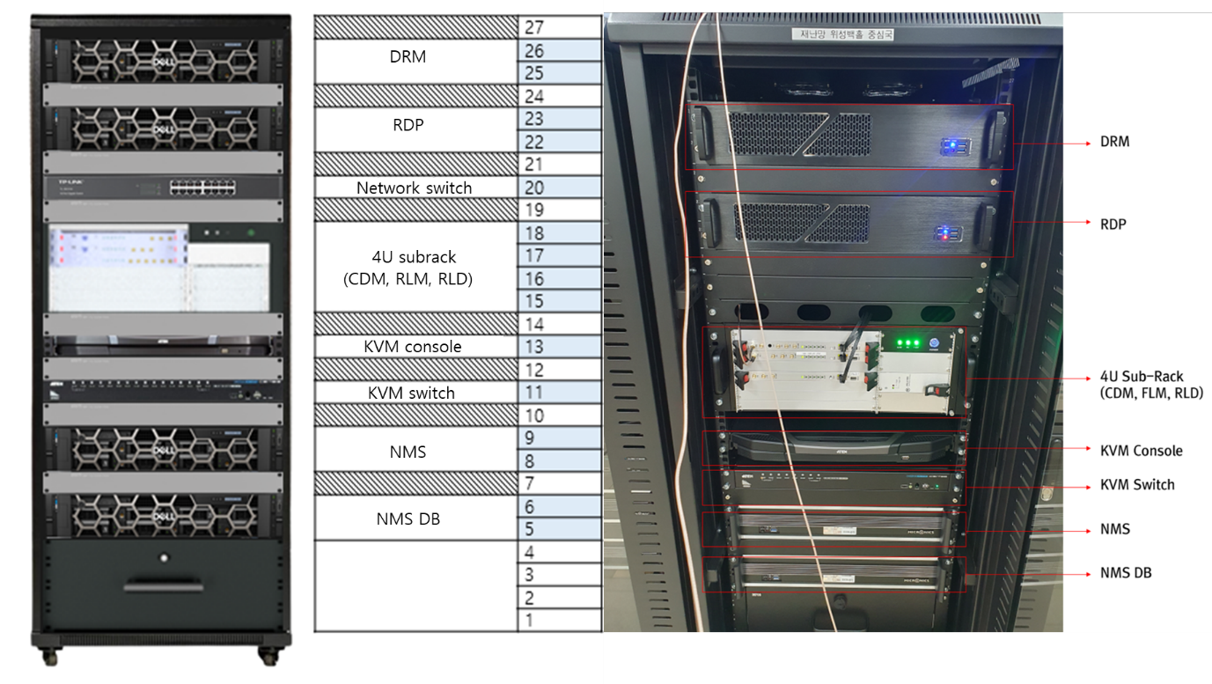
Figure 11. Satellite backhaul Hub rack

4.3 Design of a Terminal Supporting Multi-Topology Networks
This section defines the architectural components of the terminal designed to support multiple topologies, including STAR, MESH, and SCPC. Each component and its primary functions are described as follows:
Module | Features
Antenna module | Providing RF signal conversion for satellite transmission and reception  Supporting satellite tracking functionality (for mobile terminals)
STAR/MESH supporting module | TDMA terminal modem functionality  Receives DVB-S2 signals  Transmits and receives DVB-RCS2 signals  Maintains and acquires network synchronization
SCPC supporting module | SCPC terminal modem functionality  Transmits and receives DVB-S2 signals
- FWD : PER=${10}^{-7}$(DVB-S2X)
- RTN : PER=${10}^{-5}$(DVB-RCS2)
- Availability : 99.7%

4.4 Development of the Satellite Backhaul Terminals
The terminal is designed as a compact satellite backhaul unit, integrated into a dedicated enclosure for operational efficiency and portability.
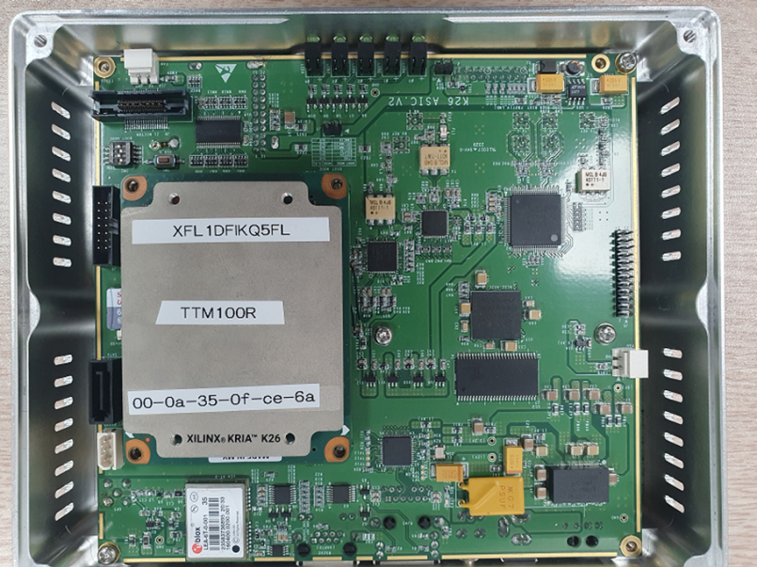
Figure 12. Implementation of terminal

5. Conclusion
To provide PS-LTE Backhaul service in disaster area and optimize communication environment the system model should support the key technologies.
- Direction finding of interference sources
- Optimal location selection to avoid interference
- Satellite backhauling for mobile base stations
Chapter 1 introduces the interference scenario and defines the system model. Chapter 2 introduces direction finding technology, Chapter 3 introduces Optimal localization technology, and Chapter 4 introduces satellite backhauling technology.
As NTN communication services are expanding globally, we would like to introduce a technical component as a way to minimize the interference impact of the PPDR system by considering not only interference between terrestrial networks but also interference caused by NTN.

6. References

[1] Schmidt, Ralph. "Multiple emitter location and signal parameter estimation." IEEE transactions on antennas and propagation 34.3 (1986): 276-280.
[2] Rao, Bhaskar D., and KV Sl Hari. "Performance analysis of root-MUSIC." IEEE Transactions on Acoustics, Speech, and Signal Processing 37.12 (2002): 1939-1949.
[3] Roy, Richard, and Thomas Kailath. "ESPRIT-estimation of signal parameters via rotational invariance techniques." IEEE Transactions on acoustics, speech, and signal processing 37.7 (2002): 984-995.
[4] Malioutov, Dmitry, Müjdat Cetin, and Alan S. Willsky. "A sparse signal reconstruction perspective for source localization with sensor arrays." IEEE transactions on signal processing 53.8 (2005): 3010-3022.
[5] Wei, He-Wen, and Yun-Gang Shi. "Performance analysis and comparison of correlative interferometers for direction finding." IEEE 10th International conference on signal processing proceedings. IEEE, 2010.
[6] ITU-R P.452, “Prediction procedure for the evaluation of interference between stations on the surface of the Earth at frequencies above about 100 MHz”, ITU, 2023
[7] ITU-R P.525, “Calculation of free-space attenuation”, ITU, 2024
[8] ITU-R P.526, “Propagation by diffraction”, ITU, 2019
[9] ITU-R P.1546, “Method for point-to-area predictions for terrestrial services in the frequency range 30 MHz to 4 000 MHz”, ITU, 2019
[10] ITU-R P.1812, “A path-specific propagation prediction method for point-to-area terrestrial services in the frequency range 30 MHz to 6 GHz “, 2023
[11] ETSI, EN. "302 307-2 V1.3.1 (2021-07). Second Generation Framing Structure, Channel Coding and Modulation Systems for Broadcasting, Interactive Services, News Gathering and Other Broadband Satellite Applications; Part 2: DVB-S2 Extensions (DVB-S2X)."
[12] ETSI, EN. "301 545-2 V1.2.1 (2014-04). Digital Video Broadcasting (DVB); Second Generation DVB Interactive Satellite System (DVB-RCS2); Part2: Lower Layers for Satellite standard. "

Radiocommunications interoperability can be defined as the ability of users to communicate, by radio, with whom they need to, when they need to, when authorized.
Group session establishment, dispatch group configuration and group calls
For example, see the ongoing 3GPP studies on D2D functionality for public safety over LTE, as described in http://www.3gpp.org/ftp/Information/WI_Sheet/SP-110638.zip.
http://www.tandcca.com/Library/Documents/LTEBoardstatement.pdf
http://lteworld.org/whitepaper/mission-critical-mobile-broadband-practical-standardisation-roadmap-considerations
Refer to Annex 3 for 3GPP Release 12 freeze date.
For example, providing considerably larger base-station electrical power back-up systems, more robust site engineering, and a much larger network of base-stations generally arranged to provide overlapping coverage.
See European Commission / Simon Forge report on Use of commercial mobile networks and equipment for "mission-critical" high-speed broadband communications in the sectors of PPDR, Transport and Utilities http://www.era.europa.eu/Document-Register/Documents/FinalReportEN.pdf
Refer to Annex 1 for 3GPP Releases with PPDR support functions.
This annex also contains information on use of IMT technology for Railway Radiocommunications, which could be addressed separately.
Mobile Virtual Network Operator – equivalent to a private network operating as a closed user group (in this case with exclusive spectrum resource), within a wider commercial network that provides shared core network but with options for separate user authentication and access rights management.
Moreover, the base station sites, towers, site-shelters, backhaul links and core-network accommodation were already mostly available courtesy of preceding (2G) network investment.
PDT (Professional Digital Trunking) is Chinese police narrowband digital trunking technology which has been spent 5 years researching by Chinese PPDR agency.

