

APT REPORT ON

WIRELESS POWER TRANSMISSION FOR MOVING MACHINES

Edition: April 2026

The 36th Meeting of APT Wireless Group
6 – 10 April 2026
Bandar Seri Begawan, Brunei Darussalam (Hybrid)

(Source: AWG-36/OUT-14)

No. APT/AWG/REP-157

APT report on

wireless power transmission for moving machines

Contents

1. Introduction 3
2. Terminologies and Definitions 4
2.1. Definitions 4
2.2. Abbreviations and Acronyms 5
3. Technologies Overview on WPT for Moving Machines 5
3.1. Outlines 5
3.2. Technology Introduction 6
3.3. Technology Trends and Levels 8
3.4. WPT Operation Scenario 10
3.5. WPT Use Case for Moving Machines 11
3.6. Safety Technology for Wireless Power Systems 12
3.7. Electromagnetic Impact on System Components 16
4. Market Status and Products of WPT for Moving Machines 17
4.1. Product Cases of WPT for Moving Machines 17
4.2. Market Status 22
5. Relevant Standards and Regulations on WPT for Moving Machines 23
5.1. Standardization Status 23
5.2. Regulation Status 24
6. Summary 25

Introduction

Wireless Power Transmission (WPT) technology is used to transfer power wirelessly from power sources to devices that use or consume power. Significant innovations in WPT can free users from electric power cords or changing batteries if electric power is supplied wirelessly. There are two major categories in WPT technologies, non-beam WPT and beam WPT. Non-beam WPT technology transfers power to devices using magnetically, capacitively or inductively coupled means in the near field, while beam WPT transfers power wirelessly using radio waves over longer distances (several meters or more, and the potential to cover wider areas). Non-beam WPT technology is being developed to be used to charge electric vehicles, portable devices (laptops, smartphones, etc.) and moving machines such as delivery robots, service robots, small electric mobility, and other applications both in industrial and non-industrial purposes. The utilization of non-beam WPT for moving machines contributes to acceleration and further optimization in the automation and labor saving.
The APT survey report on WPT for moving machines (APT/AWG/REP-134) shows that the APT countries have much interest in developing, implementing, institutionalizing, and standardizing WPT for moving machines. From this background, the purposes of this new APT Report are,

- To survey technical trends and applications of non-beam WPT technologies for moving machines in order to enhance their commercialization to APT countries,
- To share the information regarding market status and product cases of non-beam WPT for moving machines in order to enhance further commercialization in the APT countries,
- To share the information regarding international standardization and national rule-making among APT countries in order to harmonize the frequency ranges for non-beam WPT for moving machines and contribute to international rule-making

Moving machines within the scope of this APT report are
- A mechanically, electrically, or electronically operated device for performing a task which provides various services in human life
- Possible applications can include, but are not limited to, housework, life support, light transport, cleaning, entertainment, and etc.
- Moving machines can include, but are not limited to, Automated Guided Vehicle (AGV), Autonomous Mobile Robot (AMR), service robot, small electric mobility (e-bike, wheel chair, etc.), drone, etc.

And moving machines within the scope of this report does not include
- Portable devices which are objects that must be moved by a person (Smart devices, Wearable devices, Tablets, Laptop, Camera, etc.)
- Electric Vehicles (EVs) that use electric motors for transport (EVs include road and rail vehicles, water vessels, electric aircraft, etc.)

This report provides technical and market information on wireless power transmission technologies for moving machines. The information presented in this report does not necessarily represent the regulatory positions of APT member administrations.

Terminologies and Definitions

Definitions
1) | Automated Guided Vehicle (AGV) | An AGV system, or automated guided vehicle system, otherwise known as an automatic guided vehicle, autonomous guided vehicle or even automatic guided cart, is a system which follows a predestined path around a facility.
2) | Wireless power transmission/transfer (WPT) | WPT is the transmission of power from a power source to an electrical load wirelessly using the electromagnetic field
3) | Static WPT | Static WPT, also known as stationary WPT is a WPT technology which enables the load/receiver side machines to be charged while they are stopped over or facing the power transmitting coil.
4) | Dynamic WPT | Dynamic WPT is a WPT technology which enables the load/receiver side machines to be charged while they are moving over or facing the power transmitting coil.
5) | Magnetic field coupling | Magnetic field coupling, also known as inductive coupling, is a type of wireless power transmission (WPT) that generates an alternating current (AC) magnetic field. This magnetic field induces an electric current within a receiver coil in the compatible device when it is placed on the charging base. The induced current is then converted into direct current (DC) to charge the device's battery.
6) | Electric field coupling | Electric field coupling, or capacitive coupling, transmits energy using electric fields. A transmitting base generates the field, which is received by the device. Adjusting field strength and frequency enables efficient and stable power transfer.
7) | Non-beam WPT | Non-beam WPT is technology which transfers power to devices using magnetically, capacitively, or inductively coupled means in the near field.
8) | Beam WPT | Beam WPT is technology which transfers power wirelessly using radio waves over longer distances (several meters or more, and the potential to cover wider areas).
9) | Autonomous Mobile Robot (AMR) | An AMR is a mobile robotic system capable of understanding and navigating its environment without external infrastructure or predefined routes. AMRs use sensors, artificial intelligence, and  mapping technologies to dynamically plan paths and avoid obstacles in real time.

Abbreviations and Acronyms

AC | Alternate Current
DC | Direct Current
EMF | Electro Magnetic Field
EMI | Electro Magnetic Interference

Technologies Overview on WPT for Moving Machines

Outlines
Recently, issues such as real-time charging, life waterproofing, charging safety, and productivity improvement have occurred in mobile robot charging systems such as cleaning, guidance, and factory automation. To solve this problem, the need for wireless charging technology is increasing.
It is expected that a full-fledged wireless charging market will be formed for moving machines within a few years, and it is already entering the stage of commercialization in various fields as well as robots and is attempting to expand the base of its industrial ecosystem through wireless power transmission.[1,2]
Wireless power transfer technology provides the convenience and freedom of power supply to enables commercialization of innovative convergence services based on unmanned and automation.

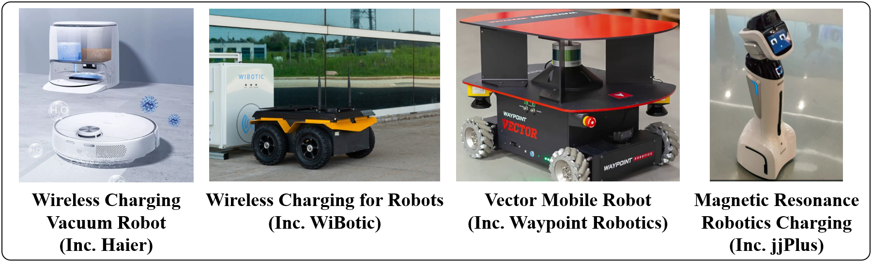

Fig. 1. Examples of WPT for various types of moving machines
[Source: Public information from company websites (Haier(https://ko.haierobots.com), WiBotic(https://www.wibotic.com), Waypoint Robotics(https://locusrobotics.com), jjPlus(www.jjplus.com))]
Autonomous moving machines powered by batteries have been widely used to transport goods within production sites, moving items efficiently from point A to point B. As a type of moving machine, autonomous moving machines are increasingly applied in logistics and warehouse environments. With the rapid global growth of the e-commerce industry, improving the efficiency of logistics and parcel delivery has become a major challenge. In this context, autonomous moving machines used for logistics are also referred to as logistics robots or warehouse robots.



Fig. 2. Smart cart applied to Alibaba warehouse
[Source: Quicktron website, https://www.quicktron.com/]

Technology Introduction

Research Optimization of Coil Design
In order to design a wireless power transmission pad suitable for limited space for AGV among autonomous moving machines, research is being conducted to analyze parameters such as coil diameter, number of turns, and ferrite placement. This method evaluates the correlation between these parameters through finite element analysis simulation and verifies heat generation and efficiency by producing 3kW level hardware.

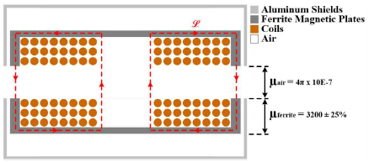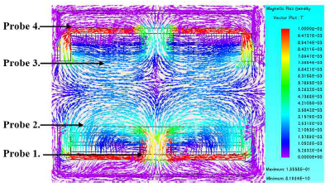

Fig. 3. Magnetic flux paths with side ferrite (Left), FEM simulation result (Right)

Side ferrite design can be considered to compensate for the reduced k(Coupling coefficient) in multilayer coil designs. As k increases due to the placement of ferrite, $L_{P}$(Coil inductance of transmitter) and $L_{S}$(Coil inductance of receiver) decrease. However, as ferrite is placed in the window area where the existing coil is located, the number of turns decreases, creating a trade-off, so the optimal ferrite design must be selected. [3, 4, 5]

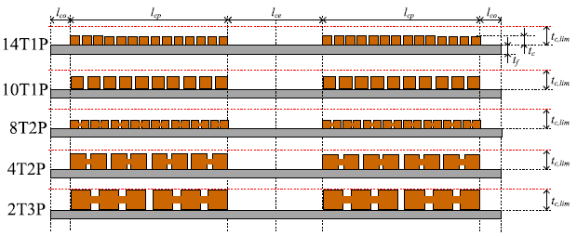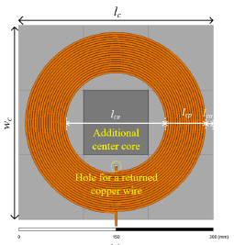

Fig. 4. Coil design rule in the different winding turn (Left), Simulation model of the 2-D thin planar coil (Right)

Depending on what performance the system is designed to achieve, the technologies applied and required may vary. In order to secure performance in terms of size, two-dimensional thin coils are being studied as shown in the figure 4, and through optimal turn number and inductance design, high coil efficiency can be achieved and heat management can also be optimized. [6]
For high-power charging, research on various capacities, DDQ-type TX/RX-coil structures, and efficient charging between heterogeneous coil structures is being actively conducted.
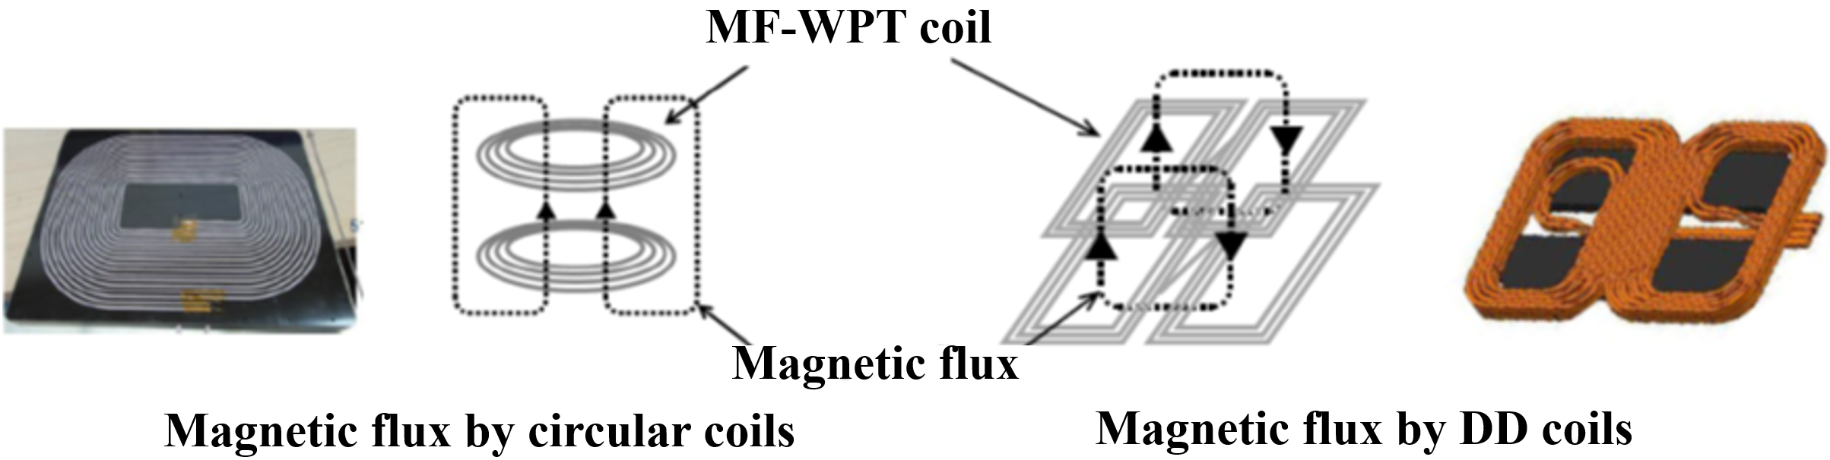
Fig. 5. Examples of magnetic flux according to circular coil and DD coil structures

Circuit Topology
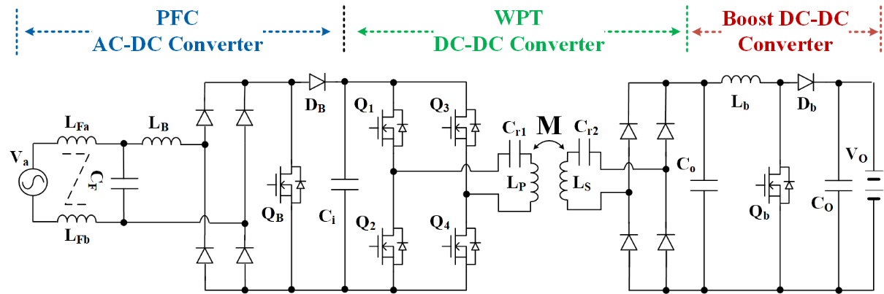
The wireless power transmission main circuit includes a PFC (Power Factor Correction) AC-DC converter for input power factor improvement, a DC-DC converter for wireless power transmission, a step-up converter for secondary safety power supply, and a 3-stage power converter. However, since efficiency characteristics and performance cannot be satisfied, a single stage wireless power transmission charging system is currently being researched and developed (Jeonju University Industry-University Cooperation Foundation)
Fig. 6. Wireless power transmission circuit
In a wireless power transmission system suitable for industrial high-power (3kW or more) AGVs, a new method was proposed to expand the range of Zero Voltage Switching (ZVS) by resonating a matching capacitor ($C_{TX}$) and an additional inductor ($L_{RES}$), unlike the existing method. In the WPT system, it is difficult to maintain ZVS depending on load variation and there is a high possibility of increased switching loss, but through this method, a power transmission system that is resistant to load changes is implemented using LC resonance. [7, 8]
Compared to existing capacitor or inductor adjustment methods, the load range has been expanded, power transmission efficiency has been improved, and research is ongoing to flexibly respond to such load changes.
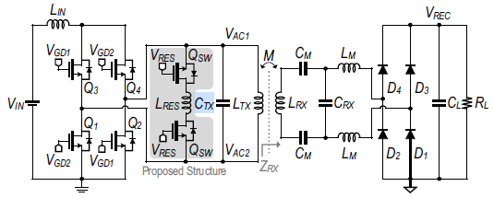
Fig. 7. Circuit diagrams of with the current-fed parallel resonant converter
Existing electromagnetic wave impact (EMF/EMI) reduction technologies are developed focusing on low-power wireless power transmission systems such as IT mobile products. Recently, as a way of EMF reduction technology for high-power wireless power transmission transmitting and receiving antenna design is being developed.
Japan's TAIYO KOGYO CO., LTD. developed a transmitting/receiving PCB coil pad for EV for wireless power transmission based on high-current PCB manufacturing technology (400um, 2-layer substrate).

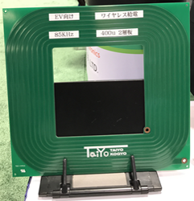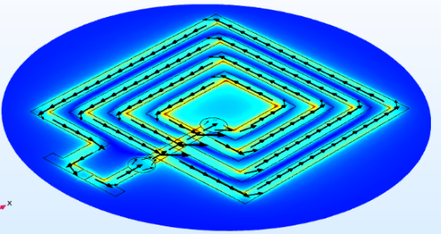

Fig. 8. High Current PCB Coupler
For moving machines, not only a static charging method when stopping, but also a semi-dynamic charging method that is charged when moving is being developed.

Technology Trends and Levels
Until recently, AGVs were the primary option for internal transportation, but AMRs are increasingly being adopted due to their advantage of intelligent navigation. While both are used for transport purposes, they differ in how they operate.
AGVs follow fixed paths using simple programming and infrastructure such as wires or magnetic stripes. They can detect obstacles but cannot navigate around them, requiring them to stop until the obstruction is cleared. As a result, their routes must be predefined, and their deployment often involves costly and extensive installations.
In contrast, AMRs use advanced software, cameras, sensors, and laser scanners to build maps and navigate intelligently. They are capable of detecting obstacles and dynamically choosing optimal alternative paths, allowing them to move autonomously without relying on fixed tracks.
According to the APT survey report, several APT countries have already deployed wireless power transfer (WPT) technologies to charge moving machines. This section outlines the current trends and maturity levels of WPT technologies for such applications.

Table 1. WPT Technology Trends and Situation

Application | WPT System | Frequency | Transmission power | Development/ Commercialized phase
AGV, AMR  (Fig. 9) | Magnetic field coupling  (static/dynamic) | 85kHz | 7kW | Product (static WPT) and Prototype
AGV, AMR  (Fig. 9) | Electric field coupling  (static/dynamic) | 6.7MHz | 4kW | Prototype
Drone  (Fig. 10) | Magnetic field coupling  (static) | 85kHz | 5kW | Prototype
Bicycle, Kickboard  (Fig. 11) | Magnetic field coupling  (static) | 85kHz | 300W | Prototype
Electric wheelchair | Magnetic field coupling  (static) | 85kHz | 300W | Prototype
Delivery/Security/ Cleaning robot etc. | Magnetic field coupling  (static/dynamic) | 85kHz | 5kW | Prototype

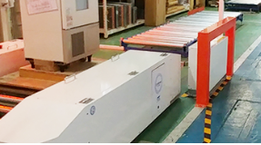

Fig. 9. WPT System for AGV
[Source: by courtesy of DAIHEN Corporation]
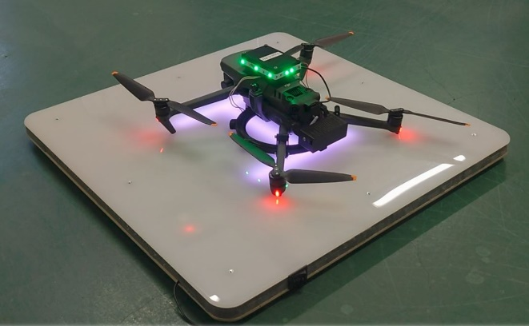
Fig. 10. WPT System for Drone
[Source: by courtesy of B&PLUS Corporation]

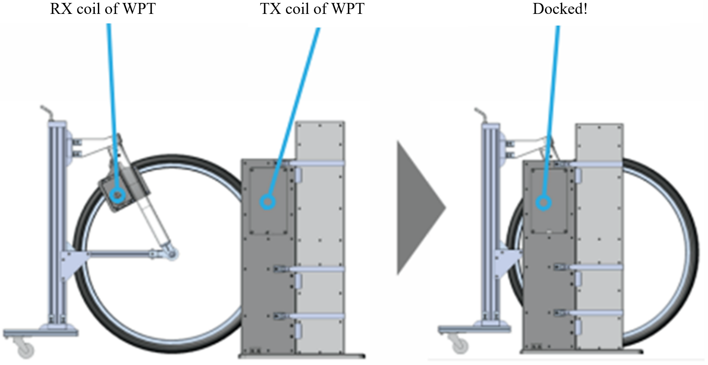

Fig. 11. WPT System for Bicycle
[Source: by courtesy of OMRON Corporation]

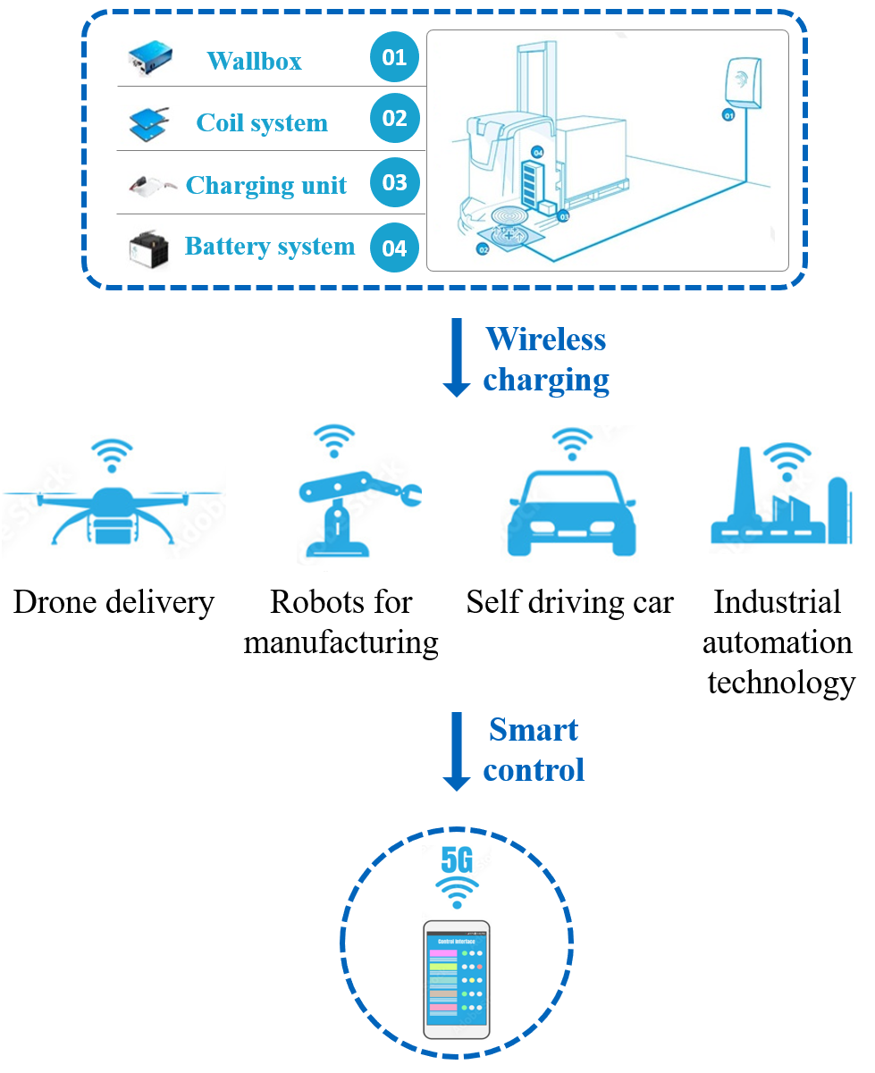

Fig. 12. WPT Technology Trends and Situation

WPT Operation Scenario

This section presents an example scenario where there are M transmitters and N receivers when moving machines are charged with WPT.
This scenario describes the operational sequence in an M-transmitter and N-receiver wireless power transfer system, including priority-based transmitter assignment, task data saving, movement of receivers toward designated transmitters, and condition checks for battery status, malfunction, and foreign object detection prior to establishing contact and initiating charging.[7]

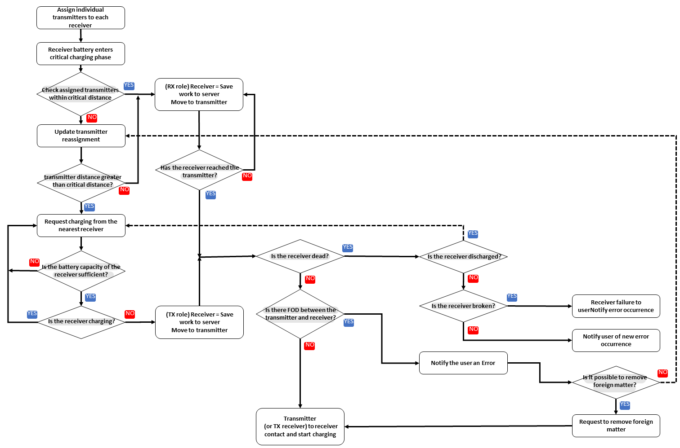

Fig. 13. Example of WPT Operation Scenario (M_TX:N_RX)

WPT Use Case for Moving Machines
The functional requirements between wireless charging transmitters and receivers required to wirelessly charge moving machines are defined in the form of use cases. As an example, Fig. 14 shows a wireless charging use case between a drone and a mobile charging station. The mobile charging station also includes moving machines capable of transmitting power. When the battery is low, the drone requests a charging transaction to the mobile charging station, and the mobile charging station starts a charging transaction if charging is possible by considering the current charging occupancy and the safety of the charging system, and stops the charging transaction if there is an abnormality in the system. The drone and the mobile charging station select a location to start charging by considering the battery remaining amount and moving speed, and transfer power after adjusting the docking and alignment. If an error is detected after the charging transaction starts, they communicate to provide error information to other devices.
The functional requirements between wireless charging transmitters and receivers for moving machines can be defined through practical use cases. One representative example is shown in Fig. 14, which illustrates a wireless charging interaction between a drone and a mobile charging station. In this scenario, the mobile charging station—also considered a type of moving machine with power transmission capability—supports autonomous wireless charging.
When the drone's battery level drops below a certain threshold, it sends a charging request to the mobile charging station. The station then evaluates whether charging is feasible based on current charging availability and system safety conditions. If acceptable, it initiates the charging transaction; if any abnormality is detected, the process is terminated.
Both the drone and the charging station coordinate to select an optimal charging location by considering factors such as remaining battery level and relative speed. Once docking and alignment are complete, power transfer begins. If an error occurs during charging, both systems engage in communication to share diagnostic information with other relevant devices or systems in the network.
While most wireless power transfer (WPT) systems are designed with a fixed transmitter and a mobile receiver (e.g., AGVs or AMRs equipped with a receiver coil), recent developments have introduced mobile WPT systems, where the charging unit (transmitter) itself is capable of movement.
This approach enables greater flexibility in operational environments, allowing the charger to autonomously navigate to the location of the moving machine, rather than requiring the machine to approach a fixed charging pad. Such systems are especially suitable for scenarios with large coverage areas, unpredictable schedules, or robots with limited autonomy.

Key Characteristics of WPT for moving machines:

- Autonomous movement of the charging unit -> EVAR
- Sensor fusion-based navigation (e.g., LiDAR, cameras, QR markers) -> WiBotic
- Applicable for flexible or unstructured environments -> Aldebaran Robotics
- Enables “robot-to-robot” charging scenarios -> TDK

Representative cases, as listed in Table 4, include EVAR (KOREA), WiBotic (USA), Aldebaran Robotics (FRANCE), and TDK (Rotating Parts).
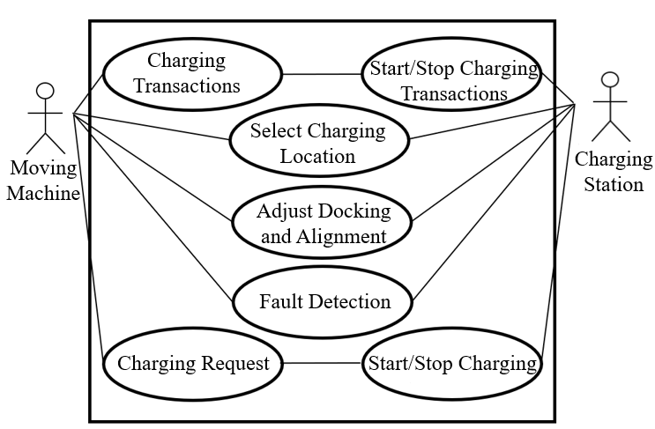

Fig. 14. Functional Interaction Sequence for Wireless Charging Between Moving Machine and Charging Station

Safety Technology for Wireless Power Systems

Definition of Foreign Object (FO) in Wireless Charging Technology
Usually, a foreign object refers to an object other than the power receiver that is the target of charging, but in the field of wireless charging, a foreign object refers to an object that causes problems with the wireless charging function, such as reduced efficiency, changes in magnetic fields, overheating, and fire. Therefore, the foreign object referred to in this technical report is defined as an object that causes problems with the wireless charging function.

The Need for Foreign Object Detection (FOD) Technology
Foreign objects cause wireless charging performance degradation by affecting the magnetic field strength due to reduced charging efficiency and changes in inductance. In particular, metal object among foreign object can affect the magnetic field of the wireless charging system, causing changes in inductance, reduced charging efficiency, and fire due to heat generation, so it is important to detect foreign object in the wireless charging system. In the wireless charging system, if a foreign object exists during wireless power transmission as in Fig. 15, an eddy current is generated in the foreign object in the opposite direction to the direction of the magnetic field, and voltage is applied. This affects the wireless charging system.

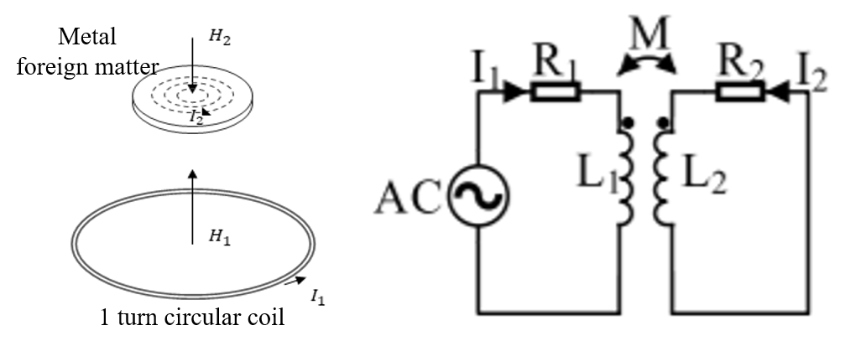
Fig. 15. Overview of the magnetic field effect of foreign object and equivalent circuit

The relationship between the impedance of the power transmission line and the impedance of a foreign object can be expressed as in Equation 1. At this time, the resistance and inductance components in the impedance are affected by the mutual inductance M. Equation 2 describes the parameters of Equation 3 in detail.

Equation 1. $\dot{Z}=\dot{R_{1}}+ {\dot{j}}_{ω}+{\dot{L}}_{1}$
Equation 2. $\dot{R_{1}}= R_{1}+\frac{ω^{2}M^{2}}{R_{2}^{2}+ω^{2}L^{2}}R_{2}$
$\dot{L_{1}}= L_{1}+\frac{ω^{2}M^{2}}{R_{2}^{2}+ω^{2}L^{2}}L_{2}$
Equation 3. M= ɸI2=SbB·dSI2

The mutual induction coefficient M between the power transmission line and the foreign object can be expressed as in Equation 3.
In the equation above, $I_{2}$ is the induced current due to the magnetic field, $ɸ$ is the magnetic flux applied to the foreign object, $B$ is the magnetic flux density, and $S$ is the cross-sectional area of ​​the foreign object. The eddy current generated in the foreign object causes an increase in the resistance component of the impedance and a decrease in the inductance. This means that the foreign object can cause burns and fire due to the high temperature of the foreign Object in the wireless charging system. Detection of foreign object in the wireless charging system is an essential and important function.

FOD Application in Wireless Charging
The FOD technology standard is divided into two types: one is a method to detect foreign object by detecting the amount of power loss during wireless charging, and the other is a method to detect foreign object by measuring the Q value before charging starts. These two FOD technology standards were developed together with test and evaluation methods and can utilize a reference power transmission coil and a reference power reception antenna. [8]

Determination by Power Loss Detection
In this method, the Tx calculates power loss by utilizing the transmitted power and the received power reported by the Rx. To achieve this, the Rx measures the actual received power $P_{Rx}$from the Tx and sends this value back to the Tx.
The received power $P_{Rx}$ consists of not only the output power of the Rx but also the internal power loss $P_{Rx_loss}$ caused by components such as the rectifier circuit and the secondary coil. However, since the Rx cannot directly measure the exact value of $P_{Rx_loss}$, it estimates this value. As a result, the power value reported by the Rx to the Tx is not the precise $P_{Rx}$, but an estimated value that includes an error ${∆P}_{error}$.
When a foreign object is present, the power loss increases due to additional energy dissipation, which in turn increases the estimation error ${∆P}_{error}$while decreasing the received power $P_{Rx}$. This leads to a reduction in the accuracy of the estimated received power $P_{received}$, meaning the error in $P_{received}$becomes larger.

Equation 4. $P_{received}= P_{Rx}+{∆P}_{error}$

To evaluate the accuracy of $P_{received}$, the Tx compares the transmitted power $P_{Tx}$ with $P_{received}$, as defined by WPC. In the absence of a foreign object, $P_{Tx}$ and $P_{received}$ are assumed to be equal. Thus, the accuracy of $P_{received}$ can be assessed by calculating power loss, enabling foreign object detection. As the received power increases, power loss caused by foreign objects also increases, resulting in a greater difference between $P_{Tx}$ and $P_{received}$.
To reflect this, the accuracy of $P_{received}$is evaluated based on the maximum receivable power of the Rx, categorized into three ranges: ≤5 W, ≤10 W, and ≤15 W. In the initial WPC standard, only the FOD method based on power loss detection, as described in this section, was applied. This had a limitation in that foreign objects could not be detected before charging started.

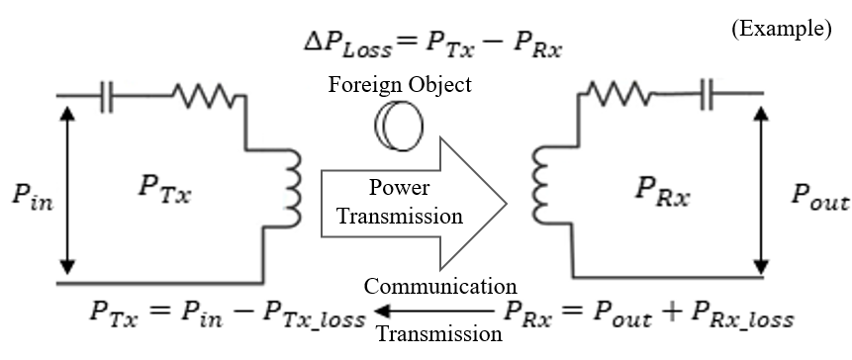

Fig. 16. Overview of power loss due to foreign object during charging

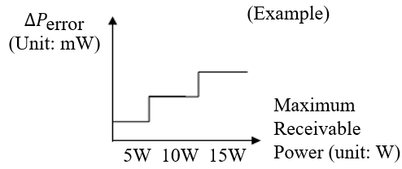

Fig. 17. FOD detection method through power loss

Measuring the change in Q (Quality Factor)
FOD detection by power loss detection has a disadvantage in that it cannot detect foreign object before charging starts. A FOD detection method that can compensate for this disadvantage is the Quality Factor change measurement method, which can detect foreign object that have penetrated before charging starts by comparing the Q value of Rx measured on the Tx charging pad and the Q value of Rx received from Rx. This FOD technology is based on the principle that the Q value decreases when a foreign object enters the wireless charging system.

The following two methods can be used to measure the Q value of Rx.

- Ratio between the rail voltage of the Tx and the induced voltage of the resonant capacitor
As shown in Fig. 18, this is a method of measuring the ratio of the DC rail voltage applied to the Tx operating at the resonant frequency before power transmission and the voltage induced in the resonant capacitor of the LC Tank. Since it must be driven until self-resonance occurs, it usually takes time on the order of microsecond.

- Measuring the attenuation of impulse waveforms

It is measured by calculating the attenuation rate of the envelope for the waveform of the resonance signal by momentarily applying a small impulse to the Tx system ($\frac{U_{0}e-ω}{2Qt}$) and it takes tens to hundreds of microseconds. $U_{0}$ means the initial voltage of the waveform of the resonance signal when calculating the envelope, usually the peak (maximum) voltage.

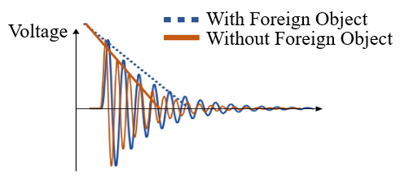

Fig. 18. Impulse waveform

The performance of FOD technology can be evaluated by utilizing the change in Q value of Rx measured on the Tx charging pad. As shown in Fig. 19, if a change of a certain ratio or more in the Q value measured on the Tx charging pad is detected compared to the Q value information transmitted from Rx to Tx, it is determined to be a foreign substance.
The FOD recognition error through the measurement of Q value change is affected by the design form of the power transmission coil. The method of measuring the Q value change decreases the amount of Q value decrease depending on the location of the foreign object on the Tx surface. This means that the FOD recognition rate can decrease depending on the location of the foreign object on the Tx surface, and the method of measuring the Q value change can be improved.
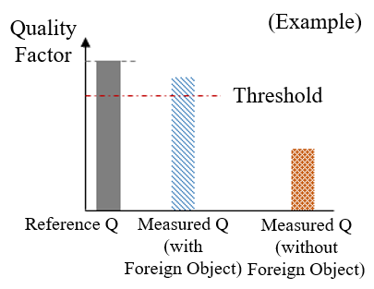
Fig. 19. Method for detecting foreign object through quality factor variation

Electromagnetic Impact on System Components
In WPT systems for autonomous machines, energy is transmitted via an electromagnetic field. As a result, components within the machine, especially precision sensors and control circuits, may be exposed to magnetic interference. To ensure system reliability and performance, shielding methods must be implemented, or magnetic-sensitive components must be physically distanced from the charging section.
Table 2 summarizes the typical components found in autonomous moving machines and assesses their susceptibility to magnetic fields. For example, IMUs, magnetometers, and certain communication modules exhibit high sensitivity and may experience malfunction or reduced accuracy in strong electromagnetic environments. Accordingly, electromagnetic compatibility (EMC) design is a key consideration in integrating WPT into such systems.

Table 2. Magnetic field influence on autonomous moving machines system components

Type |  |  | Magnetic field influence
  Application
  Example Use Cases
Sensor | Hall Sensor | Obtaining path information of ground magnet | High
Sensor | Infrared | Acquiring infrared image data | Low
Sensor | Camera | Acquiring image data | Low
Sensor | Ultrasonic | Recognizing obstacles in front | Low
Sensor | LiDAR | Measuring long-distance distances and recognizing objects | Low
Sensor | IMU | Estimating robot position | High
Actuator | DC Motor | Drive motor for movement | Medium
Actuator | Step Motor | Drive motor for movement | Low
Actuator | Robot Arm | Performing special functions | Low
Board | Embedded Board | Lower control devices such as motors and sensors | High
Board | PC | Upper control devices | High

Wireless charging systems for autonomous moving machines are being applied in various configurations depending on the mechanical design and component layout of the machine. In current industrial applications, both bottom and side charging methods have been implemented, with charging pads positioned to suit the physical structure of the AGV or AMR.
Commercial WPT systems for AGVs have already been installed in factories, typically using magnetic field coupling at a frequency of 85 kHz. These systems deliver up to 7 kW of power and achieve efficient charging performance under practical alignment and air gap conditions, as illustrated in Fig. 20.

Market Status and Products of WPT for Moving Machines

Product Cases of WPT for Moving Machines
The applications for wireless charging technology are listed in Table 2, and most of them are based on unmanned vehicles and autonomous robots. AGV is a representative example.[9]

Table 3. Use Cases of Autonomous moving machines Across Industries

Type
  Application
  Example Use Cases
 | Factory | Factory patrol and anomaly detection
  Security
 | Power Plant
  Power plant perimeter patrol and anomaly detection
Agriculture & Livestock
  Farming & Livestock
  Crop and livestock monitoring, automated feeding, and watering
 | AGV
  Logistics & Transportation
  Factory logistics transport along designated paths
 | AMR
  Obstacle-avoidance autonomous mobile robots
 | Forklift
  Automated forklift for transporting loaded goods
 | Guidance
  Service
  Shopping mall patrol and indoor navigation
 | Sales & Payment
  Automated sales and payment processing
  Food Delivery
  Indoor restaurant food delivery, short-distance outdoor delivery
 | Toys
  Household
  Electric toy for home use
 | Cleaning | Automated floor cleaning robot for home use

Wireless charging technologies are increasingly being applied to autonomous moving machines ranging from household robots to logistics and transportation vehicles. These applications typically require power supply in the range of 50 W to over 1 kW, depending on the machine size and usage scenario.[10]
Various commercial products have already adopted wireless charging systems, particularly in AGVs and AMRs used in industrial environments. These systems commonly use magnetic field coupling methods, optimized for mid-range power transfer, to enable contactless and autonomous charging.
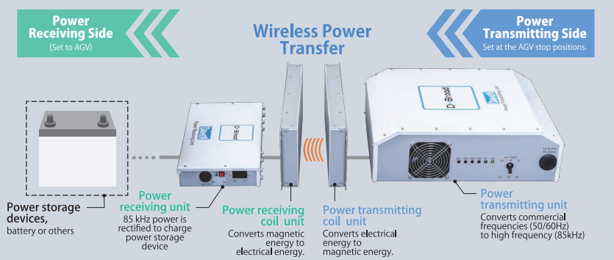

Fig. 20. Example of wireless power transfer system for AGV using magnetic field coupling
(85kHz band, 2kW)
[Source: DAIHEN Corporation website, https://www.daihen.co.jp/en/][11]

Moving machine applications are mainly based on unmanned vehicles and autonomous robots, and in order to wirelessly charge these applications, an air gap of 20 to 50 mm or more is required from the Tx charging pad to the Rx charging section. When 85 kHz frequency is used for wireless charging and 1 kW of power is supplied, the charging efficiency is approximately 80 to 86% at a misalignment position of 10 to 20 cm in the vertical direction and approximately 71 to 79% at a misalignment position of 1 to 11 cm in the horizontal direction. In order to apply wireless charging technology with a charging efficiency of 85% or more to a robot system, an air gap condition of 10 cm or less and an aligned charging position are required.

Table 4. Examples of wireless charging systems for autonomous moving machines
[Sources: Public information from company websites is provided in the note below.]
Company | Product | Characteristic
EVAR  (KOREA) | 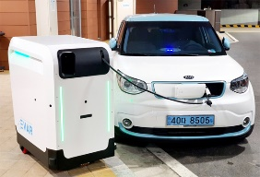 | • An AGV-type electric vehicle charging robot that can autonomously drive indoors/outdoors using ultrasonic and lidar, and autonomously moves to a wireless charging area with a wide charging range using a route regression function
DAIHEN  (JAPAN) | 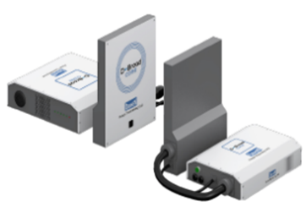  D-Broad(Core) | • 50/60Hz –> 85kHz (AC) conversion, supplied by coil  • The distance between coils is about 40mm, and the charging efficiency is 80% (side layer charge)  • Tx coil size = 290mm x 396mm x 31mm  • Rx coil size = 290mm x 396mm x 31mm  • In case of attaching a capacitor at 24V output, the output voltage range is 24V 10% and the maximum output current is 67.2A
TDK  (JAPAN) |  | • AGV (1kW), using magnetic resonance method  • coil size  - Tx = 211mm x 315mm x 80mm  - Rx = 197mm x 160mm x 40mm  • The transmission distance between the Tx coil and the Rx coil is 20-40mm with a tolerance of 30mm
TDK  (JAPAN) | 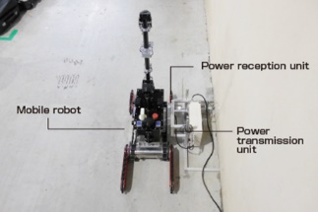 | • Optimal system for mobile robots  • Power transmission distance is 10-30mm, achieving 10mm idle distance and 88% system efficiency  • Inspection and monitoring of facilities;
TDK  (Rotating Parts) | 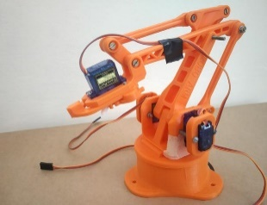 | • 24VDC , 2A(50W)  • By transmitting the rotating part with wireless power, there is no limit to the rotation angle, and there is no contact deterioration or wear.  • The magnetic flux generated by the coil is not exposed due to the ferrite sheet.
Delta Electronics(USA) | 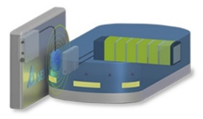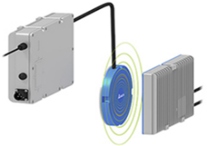 | • Input Voltage Range: 100V_ac ~ 265V_ac  • 5A continuous Interlock (to keep it from moving when charging)  • The maximum air gap is 25mm and CANbus communication is performed.  • Charging Pad Size (700mm x 520mm x 55mm)
B & PLUS  (JAPAN) | 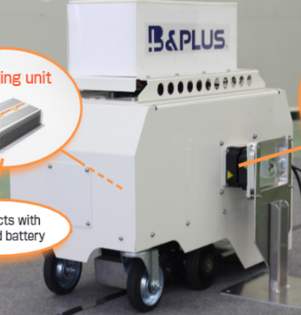 | • Use of electromagnetic coupling method (non-contact)  • Battery discharge: 30A  • Power Supply Unit  - 85kHz AC to DC conversion, battery charging  • Charging capacity: 600W/Air gap: 0mm ~ 20mm  • Charging distance  - Error in x direction: 10mm, error in y direction: 15mm
INDEVA | 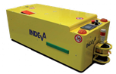 | • Charging station is fixed on the floor.  • Battery: ~24V , 40/70A/h
Beewatec | 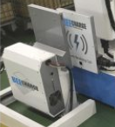 | • Using magnetic resonance method  • Air gap : 20mm ~ 40mm  • Same specifications and parameters as DAIHEN's D-Broad (Core) and D-Broad (Slim)
WiBotic  (USA) | 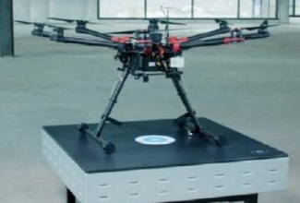 | • Drones and power pads that can be wirelessly charged are charged through the antenna and small receiver of the drone.  • Operates in a structure that recognizes and docks after attaching a marker to the charging terminal  • Applicable to moving machines such as drones, AGVs, marine robots in many ways
Leynew | 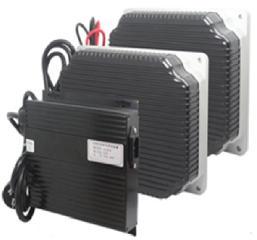 | • Wireless power system for 1kW industrial equipment  • Air gap: 15mm 10mm  • Power Efficiency: 85% or higher  • coil size  - Tx: 240mm x 210mm x 65mm  - Rx: 240mm x 210mm x 65mm  • Output Voltage: 12V ~ 30V (adjustable)  • Output Current: 10A ~ 35A (adjustable)
Maxtronics  (FRANCE) |  | • Autonomous docking charging system using humanoid robot Nao's chair-shaped docking station  • The robot recognizes the QR code attached to the chair, determines the docking position, and then proceeds to charge while sitting down.
Living.AI  (China) |  | • Humanoid robot equipped with wireless charging docking capability  • Autonomous return to charging station when battery level is low
Letianpai  (China) |  | • Service robot supporting autonomous docking and wireless charging  • Autonomous charging at a designated docking station
Misty Robotics  (USA) | 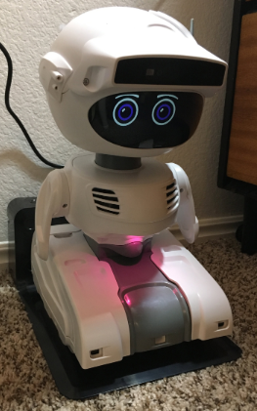 | • Autonomous mobile robot supporting wireless charging docking
※ Note : Source of Table 4: EVAR (www.evar.co.kr), Delta Electronics (www.deltaww.com), INDEVA (www.indevagroup.com), Beewatec (www.beewatec.com), WiBotic (www.wibotic.com), Leynew (https://leynew.en.alibaba.com), Maxtronics (https://maxtronics.com), Living.AI (https://living.ai), Letianpai (https://store.letianpai.com), Misty Robotics (www.mistyrobotics.com)

Market Status
The countries that lead the world's major markets are the United States, Canada, and Mexico in North America, the United Kingdom, Germany, and France in Europe, and Australia, China, India, and Japan in Asia.

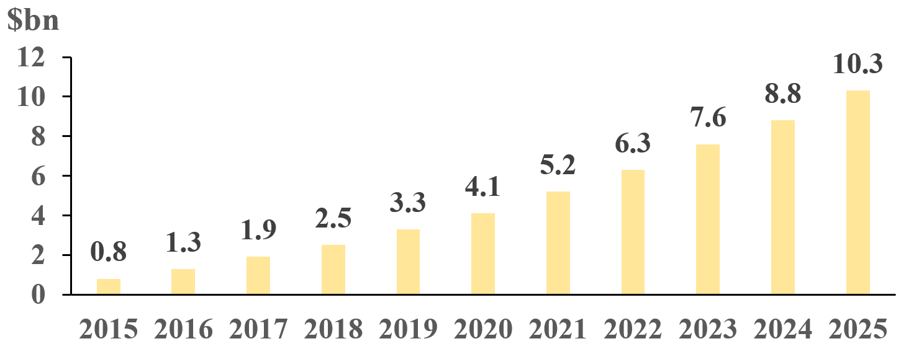

Fig. 21. Global AGV market size
[Source: Styleintelligence February-2018_v1.3][12]
The types, functions, and suppliers of smart carts (robots) for logistics warehouses are shown in the figure below.

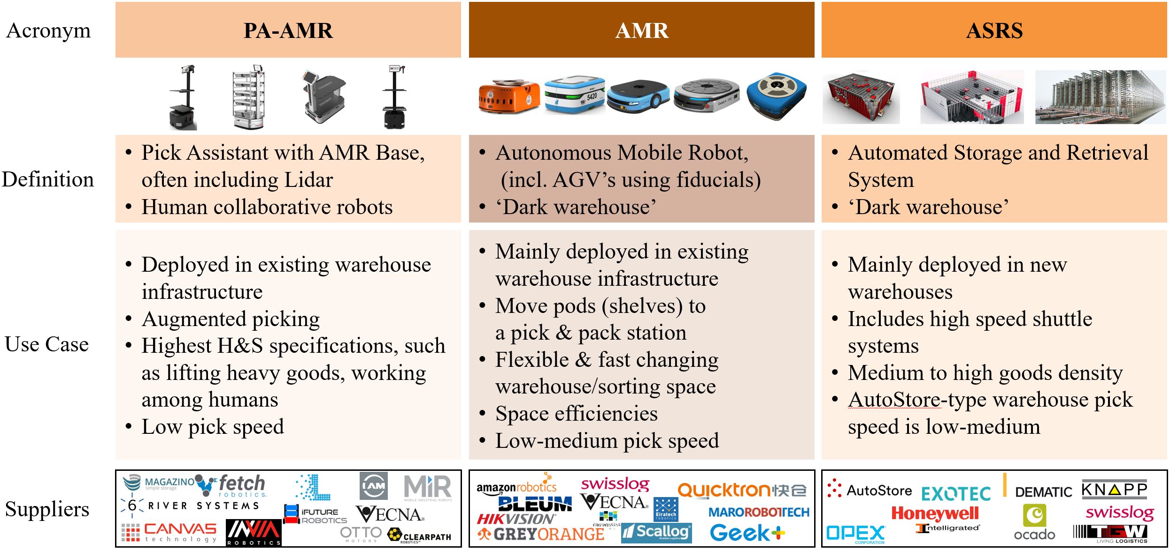

Fig. 22. Classification of warehouse robots (PA-AMR, AMR, ASRS)
[Source: Styleintelligence February-2018_v1.3 (company logos belong to their respective owners)] [12]

The application of smart carts in warehouses is being led by global distribution and logistics companies such as Amazon, Alibaba, Walmart, and FedEx.

Fig. 23. Goods-to-Person Robotics Supplier Landscape
[Source: Styleintelligence February-2018_v1.3 (company logos belong to their respective owners)] [12]

Relevant Standards and Regulations on WPT for Moving Machines

Standardization Status

KOREA
Korea Rep. of PG1002 has developed technical standards for IoT applications in the energy and power sector, such as smart streetlights and smart elevators, and is also promoting the standardization of specialized networking technologies and LwM2M-based application technologies. Also, in 2020, the standardization of wireless charging up to 11kW of WPT3 was completed. In the future, Korea plans to focus on the development of heavy duty standards over 22kW. Autonomous vehicles including robots and AGVs require standard development at a frequency of 85kHz.

United State
In the United States, the AirFuel Alliance is a leading private organization working on RF wireless charging standards across short- to long-range applications. Meanwhile, WPC, mainly active in the U.S. and Europe, focuses on standardizing wireless charging for small devices, kitchen appliances, and light electric mobility.

Europe and United States
The standardization of wireless charging technology for electric vehicles is being led by the U.S. and Europe. The U.S. SAE has established J2954 for light-duty EV wireless charging up to 11kW and J2954/2 for heavy-duty EV wireless charging up to 500kW. In Europe, the IEC DPAS 61980-4 (HD-SWPT) specifications for EV wireless charging up to 500kW.

Regulation Status

KOREA
In the Republic of Korea, any broadcasting and communication equipment, as well as devices that generate or are affected by electromagnetic interference, must undergo a conformity assessment in accordance with Article 58 of the Radio Waves Act. While regulations for wired electric vehicle (EV) chargers are well established, regulatory frameworks for wireless chargers are still in development.
The 85 kHz band has been officially allocated for WPT in EVs, as stipulated in the Ministry of Science and ICT Notification No. 2022-74 (December 2022). To support this, the National Radio Research Agency (RRA) updated the standards for measuring electromagnetic field intensity from WPT equipment (Notification No. 2023-11, June 2023), aiming to clarify safety requirements for such systems.
Additionally, the Ministry of Trade, Industry and Energy (MOTIE) issued an administrative notice (Notification No. 2023-564, July 2023) for WPT installation requirements in the Korea Electrical Code (KEC). A comprehensive policy framework, the Future Automotive Parts Industry Act (enacted in July 2024), has also been introduced to govern emerging automotive technologies—including WPT—across the full value chain.
Furthermore, a new national standard (KS) for evaluating magnetic field exposure from WPT systems was established to enhance safety and compliance in the application of wireless charging for EVs and potentially for autonomous moving machines.
The Radio Research Agency (RRA) newly established wireless power transmission devices of 1 kW or less, used in commercial, light industrial, and industrial environments, that do not require a license for radio application facilities. This includes serving and delivery robots, among others. (Mar. 27, 2025, Notification on Conformity Assessment of Broadcasting and Communication Equipment)

China
In January 2022, mobile and portable WPT devices were restricted to a transmission power of less than 50W. China has designated wireless charging for electric vehicles as a key initiative under the Energy Technology Revolution Innovation Action Plan (2016-2030). Since 2019, the National Energy Administration has been installing EV wireless charging stations in public areas across various provinces. Additionally, China plans to introduce a separate national standard (GB) for EV wireless charging using the 85 kHz band.

As of now, no public regulatory framework specific to wireless power transfer (WPT) for autonomous moving machines has been announced in China. However, China has actively pursued industrial deployment of WPT for electric vehicles and logistics robots, and relevant spectrum allocation is being studied under national industrial guidelines and research projects.

JAPAN
Non-beam WPT equipment may be used for wireless charging of moving machines. If it utilizes electric current at a frequency of 10 kHz or higher, it is categorized as ‘Equipment Utilizing High Frequency Current’ and it requires individual installation permission pursuant to the provisions of Article 100 of the Radio Act. However, equipment which obtained ‘Type Specification’ stipulated in Article 46 Paragraph 2 of the Ministerial Ordinance for Enforcement of the Radio Act is exempted from the individual installation permission pursuant to Article 45 of the same Ordinance. As to electric field coupling WPT using 6.7MHz band, “WPT for transport robots” has been institutionalized as one of the categories of Type Specification under the Ministerial Ordinance for Enforcement of the Radio Act in Japan. The main conditions of “WPT for transport robots” are shown below.

- Frequency band: 6.765 MHz – 6.795 MHz
- Maximum transmission power: 4kW
- Use case: limited to industrial use (only in the environment where only the operators can access.

Responding to the growing needs of WPT use in Japan, regulatory framework for non-beam WPT, in particular WPT for moving machines, have been discussed in a committee under the Ministry of Internal Affairs and Communications (MIC). It was concluded that institutionalization of Type Specification for WPT requires either domestic adoption of CISPR or track record of products in use with individual installation permission. Once the requirement is fulfilled, the institutionalization process will be handled in six months at shortest. Following this conclusion, the Japanese industries have begun discussion with MIC on the needs of development of new type specification for magnetic field coupling WPT using 85 kHz band for robots and small electric mobility.

Europe
In Europe, technical standards for WPT in electric vehicles have been established under ETSI EN 303 417, which allows the use of the 85 kHz frequency band (79–90 kHz) since September 2017. These standards focus on interoperability, electromagnetic compatibility (EMC), and human exposure limits. While no WPT-specific regulation currently exists for autonomous mobile machines such as AGVs and AMRs, the EV-related framework serves as a reference point for broader applications.

United States
In the U.S., the Federal Communications Commission (FCC) governs the use of radio frequencies for wireless power transmission under Part 18.305. The 85 kHz band is authorized for unlicensed industrial applications, including wireless EV charging. Additionally, regulatory development is ongoing to address electromagnetic compatibility (EMC) and human exposure assessment for high-power WPT systems. While no specific regulation has been published for mobile robots or autonomous machines, EV-related test procedures are being extended to related domains.

Summary

This report provides a structured and comprehensive overview of WPT technologies for moving machines, covering technology trends, application cases, and the current status of standards and regulations. The focus is on non-beam WPT, with real-world demonstrations and commercialization examples highlighted across autonomous robots, AGVs, AMRs, drones, and small electric mobility devices. Technical discussions include coil design, circuit topology, safety measures such as FOD, and methods for mitigating EMI.
From a market perspective, analysis confirms that WPT is already in practical use across industrial, logistics, service, and household sectors. The dominant approach is magnetic field coupling in the 85 kHz band, enabling efficient power transfer of several kilowatts. Commercial products have been optimized to accommodate variations in structure, alignment, and air gaps, while emerging concepts such as mobile transmitters and robot-to-robot charging are also being explored.
The growing demand for wireless charging reflects the need to overcome challenges such as real-time charging, waterproofing, safety assurance, and productivity improvement. Major WPT approaches for moving machines include magnetic field coupling and electric field coupling, with commercialization steadily progressing through prototypes and market-ready products across multiple applications.
Although WPT standardization for EVs and small electronic devices has already been established in regions including Korea, the United States, and Europe, standards specifically addressing moving machines remain under development. Regulations, however, are advancing. For example, EV WPT using magnetic field coupling at 85 kHz has already been regulated, and Japan recently introduced rules for WPT using electric field coupling at 6.765–6.795 MHz, targeting factory robots such as AGVs.
This report examines and summarizes the technologies, market status and relevant standards and regulations regarding WPT for moving machines such as AGV/AMR, service robots, small electric mobility (e-bike, wheelchair, etc.), drone, etc. It is expected that this report will serve to facilitate deployment, maximize user benefits, and promote the harmonization of international standards and regulations by sharing technical, market, and policy insights among APT member countries.
Reference
- K. Detka and K. Górecki, “Wireless Power Transfer—A Review,” Energies, vol. 15, no. 7236, 2022.
- N. Iqteit, K. Yahya, and S. Ahmad Khan, ‘Wireless Power Charging in Electrical Vehicles’, Wireless Power Transfer – Recent Development, Applications and New Perspectives. IntechOpen, Aug. 18, 2021.
- Colmiais, I.; Dinis, H.; Mendes, P.M. Long-Range Wireless Power Transfer for Moving Wireless IoT Devices. Electronics 2550.13, 2024
- J. C. Olivares-Galvan, E. Campero-Littlewood, S. Maximov, S. Magdaleno-Adame and W. Xu, "Wireless Power Transfer: Literature survey," in Proc. IEEE Int. Autumn Meeting on Power Electronics and Computing (ROPEC), Morelia, Mexico, 2013, pp. 1–7., Morelia, Mexico, pp. 1-7, 2013
- ChangSu Shin, Study on Wireless Charging Pad Design for Automated Guided Vehicle, The Korean Institute of Power Electronics Spring Conference, pp.187-189, 2020
- E. S. Lee, “2-D Thin Coil Designs of IPT for Wireless Charging of Automated Guided Vehicles,” IEEE J. Emerg. Sel. Topics Power Electron., vol. 10, no. 2, pp. 2629–2644, Apr. 2022.
- IEC TR 63668 ED1, “Autonomous WPT on moving devices which support multimedia and service
- Jang, W.-H., Robotics Technology Report, TTA, TTAR-06.0284, 2023
- APT, APT Survey Report on Wireless Power Transmission for Moving Machines, Report APT/AWG/REP-134, 2023
- Kye-Seok Yoon, Extended ZVS Range via LC Resonance in Current-Fed Parallel Resonant Converter for AGV Wireless Power Transfer, IEEE TRANSACTIONS ON CIRCUITS AND SYSTEMS—II: EXPRESS BRIEFS, vol. 72, no. 2, pp424-428, FEBRUARY 2025
- DAIHEN Corporation, “Wireless power transfer systems,” Available: https://www.daihen.co.jp/
- Styleintelligence February-2018_v1.3, “Good to Person (G2P) Robotics, Available: https://www.stiq.ltd/

