APT REPORT ON

EMERGING SATELLITE TECHNOLOGIES AND LEO SYSTEMS
IN ASIA-PACIFIC

Edition: September 2025

The 35th Meeting of APT Wireless Group
8 – 12 September 2025
Bangkok, Th



APT REPORT ON

USAGE OF COOPERATIVE VEHICLE-INFRASTRUCTURE ITS

Edition: April 2026

The 36th Meeting of APT Wireless Group
6 – 10 April 2026
Bandar Seri Begawan, Brunei Darussalam (Hybrid)

(Source: AWG-36/OUT-13(Rev.1))

No. APT/AWG/REP-156

APT REPORT ON
USAGE OF COOPERATIVE VEHICLE-INFRASTRUCTURE ITS

Table of Contents

1 Introduction 3
2 Scope 3
3 Background 3
4 Related documents 4
5 List of acronyms and abbreviations 4
6 Outline of this report 5
7 Overview of Cooperative Vehicle-Infrastructure ITS 6
7.1 Road user 7
7.2 Infrastructure 7
7.3 Cloud network 8
8 Use cases in APT countries 9
8.1 Accident prevention support 9
8.2 Emergency vehicle driving support 11
8.3 Public Transportation Priority Systems 12
8.4 Automated driving support 13
8.5 Support of collecting data for road management information on highway 15
8.6 Support of collecting data for road management information on urban and suburban road 18
8.7 Victim support on large-scale disaster 20
8.8 Watching support / Crime prevention support 23
9 Conclusion 24
References 25
Annex 1 Summary of responses to questionnaire 26
Annex 2 Cases in Japan 34
A2.1. Communication system and applicable frequency 34
A2.2. Example of deployment and experiment 35
Annex 3 Cases in India 48
A3.1 Use-cases discussed in the context of India in the Technical Report 48
A3.2 R&D Use-cases and Trials for V2X in India 48

Introduction
Major services of the Cooperative Vehicle-Infrastructure Intelligent Transport Systems (ITS) are traffic safety and automated driving support. Recently, Cooperative Vehicle-Infrastructure ITS have been investigated for other services in order to address several social challenges, for example, Support of collecting data for road management information, victim support on large-scale disasters, and watching support.

Scope
This report is to provide use cases with survey results on the currently used radio technologies and deployment status of Cooperative Vehicle-Infrastructure ITS for addressing several social challenges in APT member countries. Cooperative Vehicle-Infrastructure ITS have a feature to utilize roadside infrastructure installed on the road, including traffic signals and LED display boards, and equipped with peripherals such as roadside sensors and communication devices, and the roadside infrastructure communicates with road users such as vehicle, motorcycles, bicycles, emergency vehicles, and pedestrians cooperatively. This report identifies use cases of Cooperative Vehicle-Infrastructure ITS with some demonstration experiment results, which have been considered in APT countries.

Background
Asia-Pacific Telecommunity (APT) published APT Report on “The usage of ITS in APT Countries” [Revision 2 (APT/AWG/REP-18)] in 2018. Usages relevant to vehicle-to-infrastructure communication are also indicated in the Report ITU-R M.2228-1 (07/2015) ” Advanced intelligent transport systems radiocommunications” and Report ITU-R M.2445 (11/2018) “Intelligent Transport Systems (ITS) usage”. The Report ITU-R M.2228-1 shows “Advanced ITS concept” which describes vehicular networking functionality.
This report focuses on V2I category which is yellow highlighted in FIGURE 3.1 which is updated from “Advanced ITS concept”.

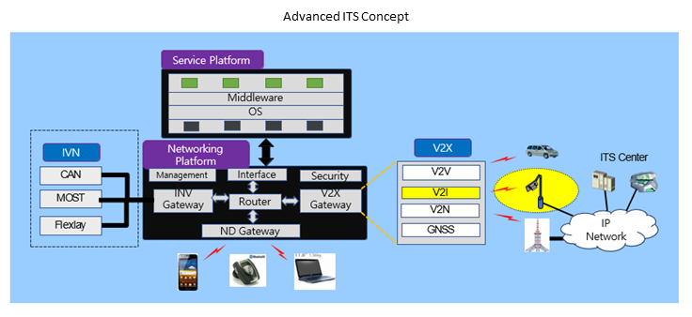
FIGURE 3.1 Advanced ITS concept (referred to ITU-R M.2228-1)
There have been various movements and discussions about vehicle-to-infrastructure communication associated with radiocommunication methods and its applications. This report summarizes the use cases of Cooperative Vehicle-Infrastructure ITS with empirical case studies. This report could be the reference for deployment of roadside infrastructure to solve social issues in APT countries.

Related documents
ITU-R Recommendations:
ITU-R M.1453 Intelligent transport systems - Dedicated short range communications at 5.8 GHz
ITU-R M.1890 Operational radiocommunication objectives and requirements for advanced Intelligent Transport Systems
ITU-R M.2084 Radio interface standards of vehicle-to-vehicle and vehicle-to-infrastructure two-way communications for Intelligent Transport System applications
ITU-R M.2121 Harmonization of frequency bands for Intelligent Transport Systems in the mobile service
ITU-R Report:
ITU-R M.2228 Advanced intelligent transport systems (ITS) radiocommunications
ITU-R M.2444 Examples of arrangements for Intelligent Transport Systems deployments under the mobile service”
ITU-R M.2445 Intelligent transport systems (ITS) usage
ITU-R M.2520 The use of the terrestrial component of International Mobile Telecommunications for the Cellular-Vehicle-to-Everything
ITU-R M.2534 Connected Automated Vehicles
ITU-R Handbook:
Land Mobile (including Wireless Access) - Volume 4: Intelligent Transport Systems. Year 2021
APT Reports:
APT/AWG/REP-61 APT Report on "The Usage of Road Sensor Network in APT Member Countries
APT/AWG/REP-18 (Rev.2) APT Report on "Usage of Intelligent Transportation Systems in APT Countries
APT/AWG/REP-121 APT Report on cellular based V2X for ITS applications in APT countries

List of acronyms and abbreviations
ADAS Advanced Driver-Assistance Systems
APT Asia-Pacific Telecommunity
ARIB Association of Radio Industries and Businesses (Japan)
AWG APT Wireless Group
B2I Bicycle-to-Infrastructure
C-ITS Cooperative ITS communication
GNSS Global Navigation Satellite System
IEEE Institute of Electrical and Electronics Engineers
ISO International Organization for Standardization
ITS Intelligent Transport Systems
ITU International Telecommunication Union
I2I Infrastructure-to-Infrastructure
I2N Infrastructure-to-Network
LPWA Low Power Wide Area
OBU On-Board Unit
PTPS Public Traffic Priority System
TCC Traffic Control Center
V2I Vehicle-to-Infrastructure
V2P Vehicle-to-Pedestrians
V2V Vehicle-to-Vehicle
V2X Vehicle-to-Everything (Infrastructure/Vehicle/Pedestrians and others)
VMS Variable Message Sign
WLAN Wireless Local Area Network

Outline of this report
Outline of this report is described as follows:
Explanation of overview for Cooperative Vehicle-Infrastructure ITS,
- Configuration and flow of the systems,
- Definition and function of items which make up the systems, such as road users, infrastructure and cloud networks.

8 use cases of Cooperative Vehicle-Infrastructure ITS, which have been selected as potential solutions to serious social challenges faced by APT countries.
The structured information for each use case is described as follows:
- Issues addressed by the use case
- Service description and service procedure of the use case
- Communication information list
- Communication systems and applicable frequencies

Highlighted 8 use cases are as follows:
- Accident prevention support for head-on collisions at intersections with poor visibility
- Emergency vehicles driving support to shorten the arrival time
- Public transportation priority system to ensure on-time operation of buses
- Automated driving support to provide blind spot area information from automated driving on-board sensors for safe and comfortable driving
- Support of collecting data for road management information on highway to collect vehicle driving data and utilize for traffic information management
- Support of collecting data for road management information on urban and suburban road to collect traffic flow data of road users for road design
- Victim support on large-scale disaster for guiding disaster victims to evacuation sites in the event of a large-scale disaster and for detecting damaged areas on roads
- Watching support / Crime prevention support for notifying parents of the whereabouts of children and elderly people

Overview of Cooperative Vehicle-Infrastructure ITS
Cooperative Vehicle-Infrastructure ITS contributes to solving various social issues through cooperation between road users and roadside infrastructure. Typical configuration of Cooperative Vehicle-Infrastructure ITS is shown in FIGURE 7.1. The roadside infrastructure for Cooperative Vehicle-Infrastructure ITS may be referred to as “ITS Smart Pole”. It is a social infrastructure that can correspond to multiple use cases as shown in Chapter 8.
The systems have the potential to revolutionize transportation by making it safer, more efficient, and more sustainable. Furthermore, support for a global marketplace ensures that ITS technologies can be deployed and used worldwide, increasing their reach and impact. This is important for the growth and development of the ITS industry, as well as for the realization of the full potential of ITS to improve transportation safety, efficiency, and sustainability on a global scale.
ITS Smart Pole detects road users such as bicycles and pedestrians, using installed roadside sensors, and analyses their behaviors. This data is then transmitted via a V2X radio unit, which is installed in the roadside infrastructure, to a road user equipped with a V2X radio device traveling on a road in a different direction. The road user, who received the data, is aware of another road user's approach from the other direction. On the other hand, the road user equipped with V2X radio device transmits the position, speed, and other travel data of itself to the V2X radio unit on roadside infrastructure, and the roadside infrastructure notifies the road user from the other direction that another road user is approaching on an LED display board or through a speaker.
The detected or received data from road users could be uploaded to the cloud networks by the control unit installed in the roadside infrastructure to manage and analyze the data.
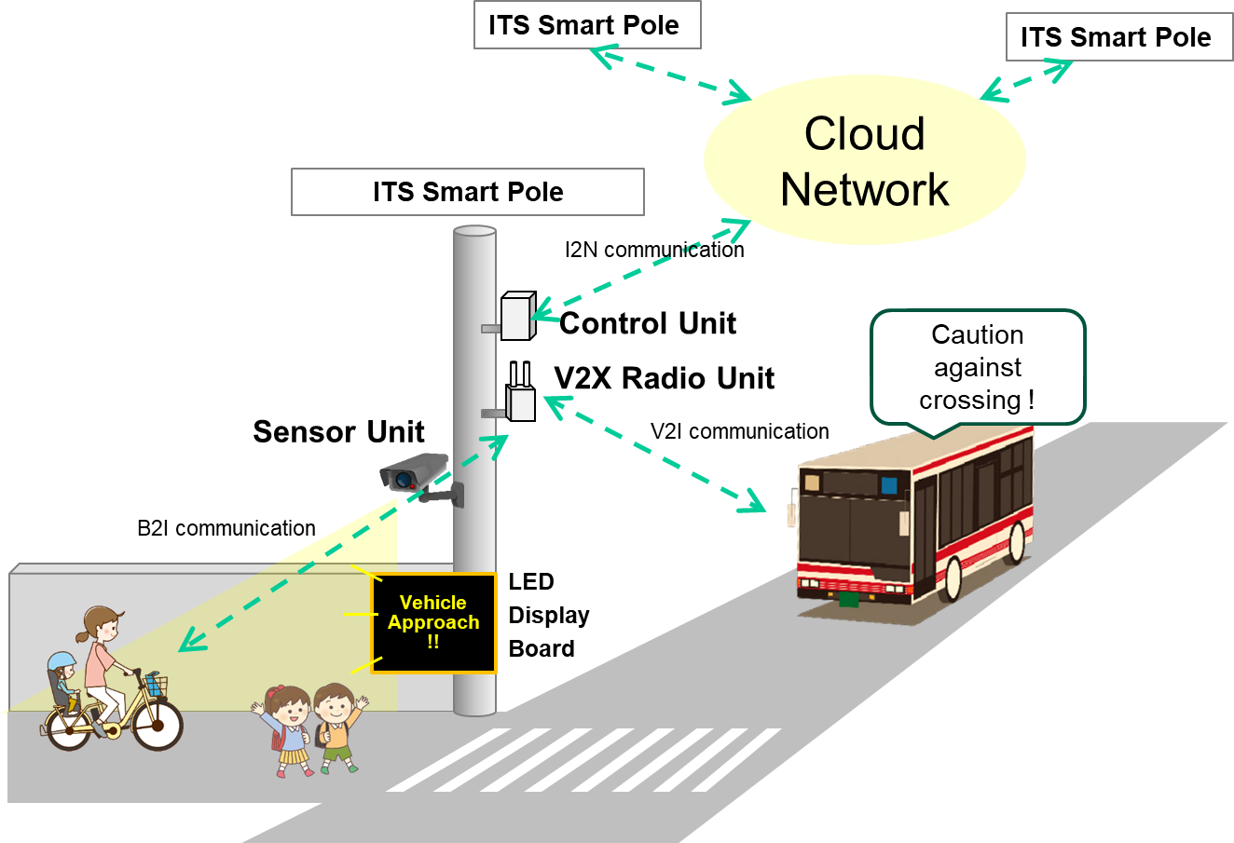
FIGURE 7.1 Configuration of Cooperative Vehicle-Infrastructure ITS
B2I communication indicates direct communication between bicycle and infrastructure, equipped with radio devices in both parties.

  - Road user
The definition of road users is as follows:
- Four-wheeled vehicles include large vehicles such as trucks and buses, passenger vehicles and emergency vehicles such as ambulances and fire trucks
- Two-wheeled vehicles such as bicycles and motorcycles,
- Personal mobility vehicles such as segways and kickboards
- Pedestrians
Some road users are equipped with V2X radio devices that can communicate with roadside infrastructure, while others are not.

  - Infrastructure
The infrastructure of Cooperative Vehicle-Infrastructure ITS is installed at roadside locations such as signalized intersections, unsignalized intersections, and basic road segments. Specific locations include co-located traffic signals, utility poles, streetlights, building walls, pedestrian decks, and ground power facilities. The roadside infrastructure has abilities of functions and mechanisms as follows. The basic block diagram is shown in FIGURE 7.2.
- Sensors unit that can monitor road conditions and road users. The types of sensors are listed in TABLE 7.1 and are selected and utilized according to the use cases.
- Control unit to analyze and understand the behavior of detected objects in real time
- V2X radio unit that can communicate with road users who are equipped with V2X radio devices.
- General purpose radio unit that can communicate with road users who are equipped with general purpose radio devices such as Wireless-LAN
- Wireless beacon receiver that can monitor road users with Bluetooth or other wireless beacon transmitters.
- LED display board and speaker for notifying road users who are NOT equipped with V2X or general purpose radio devices.
- GNSS correction data generation unit for time synchronization.
- External I/F to connect to cloud network, and other infrastructure

TABLE 7.1 Sensors and cameras utilized Cooperative Vehicle-Infrastructure ITS
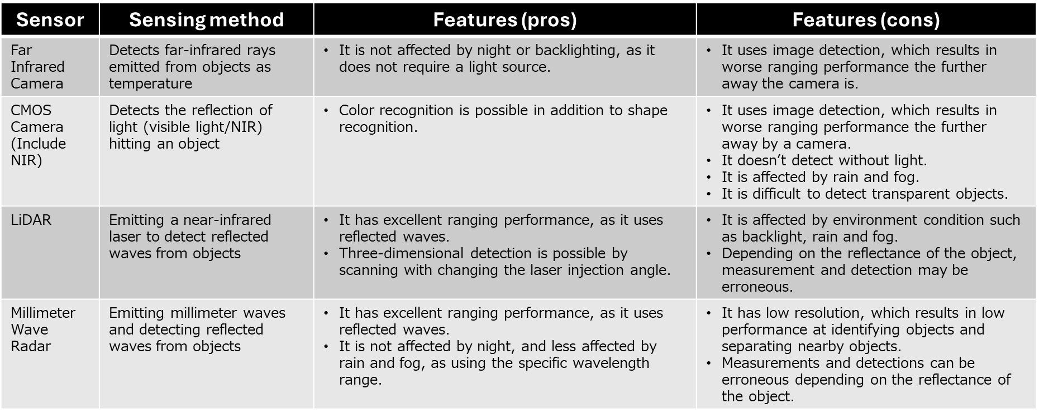
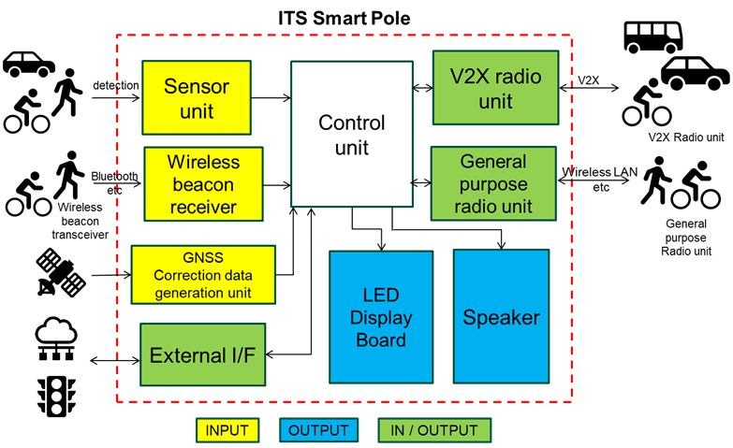
FIGURE 7.2 Basic block diagram of ITS Smart Pole
  - Cloud network
Data of road users detected by roadside sensors on ITS Smart Pole or received via V2X radio unit may be uploaded to the cloud network. In this case, the data could be managed, integrated, processed, or analyzed by cloud computing. Finally, the data could be utilized as mobility data platforms in cloud networks to the various services described as shown in FIGURE 7.3.
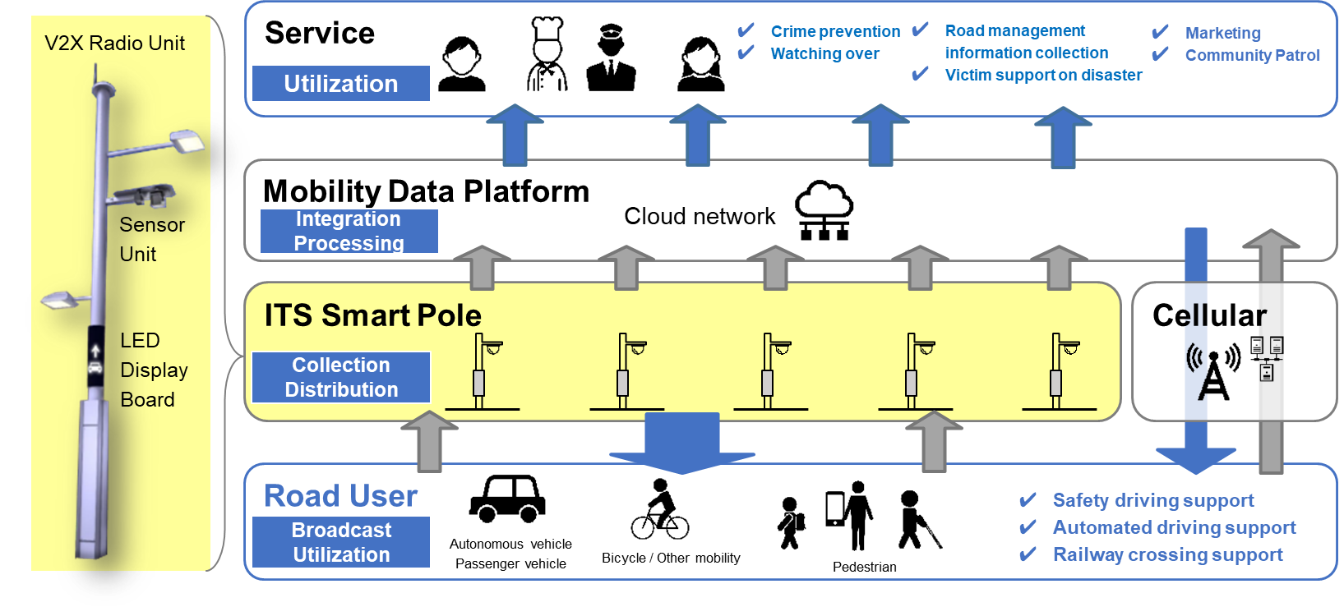
FIGURE 7.3 Layer configuration of ITS Smart Pole and the services

Use cases in APT countries
In recent years, traffic accidents, traffic congestion, and environmental degradations have become serious problems in APT countries due to population growth and increased car ownership. In addition, there are traffic issues caused by natural disasters. Cooperative Vehicle-Infrastructure ITS are an effective means of solving these problems and issues, and following chapters introduce the use cases.
The deployment and experiment cases in APT countries are described in Annexes.

  - Accident prevention support
Traffic accidents are one of the critical social issues in APT counties. Although the number of fatal and serious injury accidents have been on a declining trend in some APT countries (According to statistics from the National Police Agency in Japan, they were reduced by 40 % in 2022 compared to 2013) due to improvements of automotive ADAS technology in recent years, there are still many challenges to be solved. One of the major causes in traffic accidents is collision accidents at unsignalized intersections. In addition, there is a high percentage of bicycle-related accidents with vehicles. This chapter describes an effective solution for collision accidents between vehicles and other road users, such as bicycles and pedestrians, at unsignalized intersection utilizing Cooperative Vehicle-Infrastructure ITS.

    - Service description
The service will notify road users (vehicles, motorcycles, bicycles, pedestrians and other road users) from priority routes about the presence of bicycles and pedestrians from non-priority routes at unsignalized intersections. A service image is shown in FIGURE 8.1.
This warning assists drivers to slow down or stop before an intersection to prevent accidents.
Roadside infrastructure (referred to as ITS Smart Pole) is installed at intersections and on roads in the service area. The ITS Smart Poles are equipped with roadside sensors and radio beacons to detect moving objects on the non-priority routes. Additionally, V2X radio units and LED display boards are installed to notify everyone involved. Roadside sensors or beacons will detect moving vehicles on the non-priority routes and notify moving vehicles on the priority routes through V2I communication or visual means.
The data is shown in TABLE 8.1, which is transmitted via V2X systems.

    - Service procedure
- Roadside sensors or wireless beacons detect road users (bicycles/pedestrians) on a non-priority route.
- V2X radio unit and LED display board provide information on road users in the non-priority route to road users (vehicles, motorcycles, bicycles, pedestrians) in the priority route.
- Moving road users on the priority route stop or slow down before entering the intersection based on the above notification information.
- Even if road users in the non-priority route rush out of the priority route, road users will not cause a traffic accident.
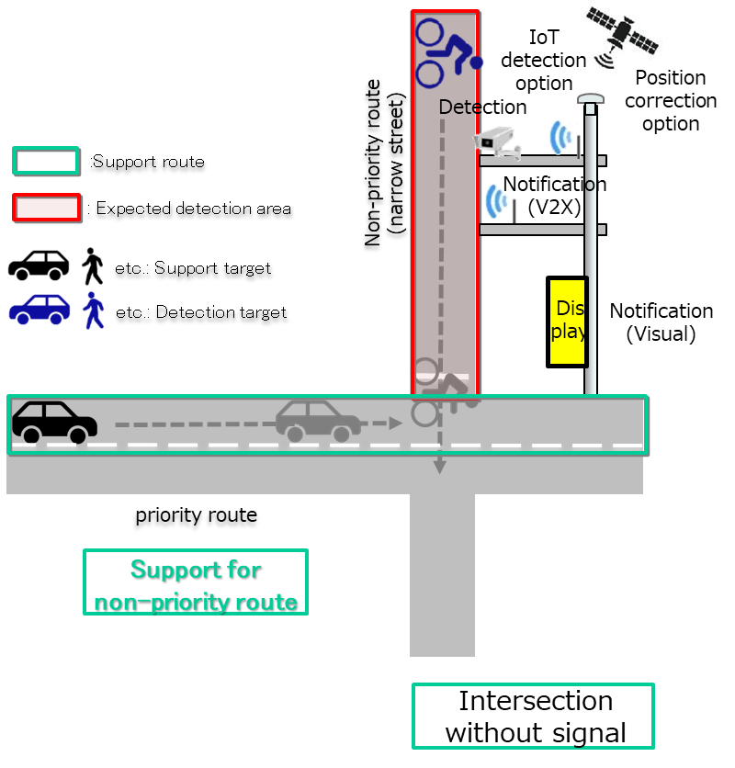
FIGURE 8.1 Service image of accident prevention support

TABLE 8.1 V2X Communication message
Item | Remark
Individual identification ID | ID by which an individual can be identified
Time-stamp | Time in hours, minutes and seconds of UTC
Object position data | Latitude, longitude, elevation and others
Object status data | Object speed, object heading and others
Object classification | Vehicle, motorcycle, bicycle, pedestrian and others

    - Communication systems and applicable frequencies
Communication systems and applicable frequencies will be adopted in each APT country depending on the country's status.
The specific communication systems and applicable frequencies are referred to each Annex by the APT countries.

  - Emergency vehicle driving support
In urban areas, emergency vehicles such as ambulances and fire trucks often get caught in traffic congestion, resulting in delays in reaching their destinations, such as hospitals. Furthermore, there are frequent incidents of traffic accidents involving emergency vehicles during their emergency runs, posing serious social issues. To address these issues, Cooperative Vehicle-Infrastructure ITS are being considered to assist the safe and smooth movement of emergency vehicles as they approach target intersections and travel along roads.

    - Service description
This service notifies surrounding vehicles via LED display boards installed near intersections and along the roads, allowing them to recognize that an emergency vehicle is approaching. This enables surrounding vehicles to understand the position and intention of the emergency vehicle and take appropriate actions, thus supporting the safe and efficient movement of the emergency vehicle. A service image is shown in FIGURE 8.2.
In this service, roadside infrastructure equipped with V2X radio units and LED display boards, such as the ITS Smart Pole or VMS (Variable Message Sign) and others, are installed near intersections and along the roadside in the service area. Emergency vehicles are equipped with V2X OBUs. Subsequently, the V2X OBU in the emergency vehicle transmits data such as its status of emergency operation and position data. This data is received by the roadside infrastructure, which then displays an "Emergency Vehicle Approaching" message or icon on the LED display board, alerting surrounding vehicles and prompting them to take caution.
The data is shown in TABLE 8.2, which is transmitted via V2X systems.

    - Service procedure
- Emergency vehicles are equipped with V2X OBUs.
- During emergency response, the V2X OBU in the emergency vehicle transmits data such as its status of emergency operation and position data.
- The data transmitted by the V2X OBU is received by roadside infrastructure equipped with V2X radio units and LED display boards.
- As the emergency vehicle approaches, the LED display board on the roadside infrastructure shows an "Emergency Vehicle Approaching" message or icon.
- Once the emergency vehicle has passed, the display on LED display board ceases.

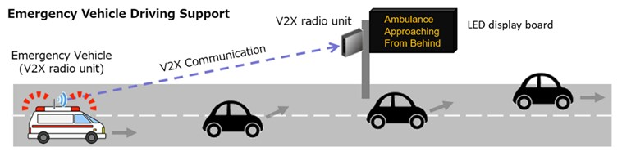
FIGURE 8.2 Service image of emergency vehicle driving support

TABLE 8.2 V2X Communication message
Item | Remark
Individual identification ID | ID by which an individual can be identified
Time-stamp | Time in hours, minutes and seconds of UTC
Vehicle position data | Latitude, longitude, elevation and others
Vehicle status data | Vehicle speed, vehicle heading and others
Vehicle classification | Size, role, extended data for emergency vehicle

    - Communication systems and applicable frequencies
Communication systems and applicable frequencies will be adopted in each APT country depending on the country's status.
The specific communication systems and applicable frequencies are referred to each Annex by the APT countries.

  - Public Transportation Priority Systems
Traffic congestion is also one of the major issues to be addressed in APT countries, and the time and economic losses caused by congestion are significant (e.g., estimated economic losses from congestion in Japan are around 12 trillion yen). It is known that congestion can be alleviated by using public transportation such as buses instead of using private vehicles and it is expected the number of public transportation users shall be increased, however many users are dissatisfied with "delays". Then PTPS (Public Transportation Priority System) has been introduced to address this issue.
PTPS is a system that supports the priority passage of public vehicles such as buses through the deployment of dedicated and priority lanes, signal control to minimize stop time, and warnings for illegal vehicles using the dedicated lanes. One use case of PTPS, known as advanced PTPS, is described in the following chapter.

    - Advanced PTPS for route buses ^{[2]}
      - Service description
This system selects support vehicles based on bus delay status, controls the timing of traffic signals, and reduces the time it takes to cross intersections, thereby enabling the smooth operation of public transportation such as route buses. A service image is shown in FIGURE 8.3.
At the target signalized intersection, roadside infrastructure equipped with V2X radio units is installed, and PTPS OBUs are installed on the route buses. The PTPS OBU calculates bus’s position, speed, direction, and delay time, and generates state information. The generated information is transmitted to the TCC (Traffic Control Center) via the roadside infrastructure. The TCC aggregates information from multiple buses and selects the buses that should be given priority. It then adjusts the timing of the traffic signals at the intersections where the priority buses pass to shorten the time required for intersection crossing. This operation serves as an example of an advanced PTPS.
The data is shown in TABLE 8.3, which is transmitted via V2X systems.

      - Service procedure
- The PTPS OBU calculates the bus’s position, speed, direction, and delay time, and creates state information about the vehicle.
- This information is transmitted to the TCC via the roadside infrastructure.
- The TCC aggregates information from multiple buses.
- The TCC selects the buses that should be given priority based on the aggregated information.
- The TCC adjusts the timing of the traffic signals at the intersections where the priority buses pass to shorten the time required for intersection crossing.
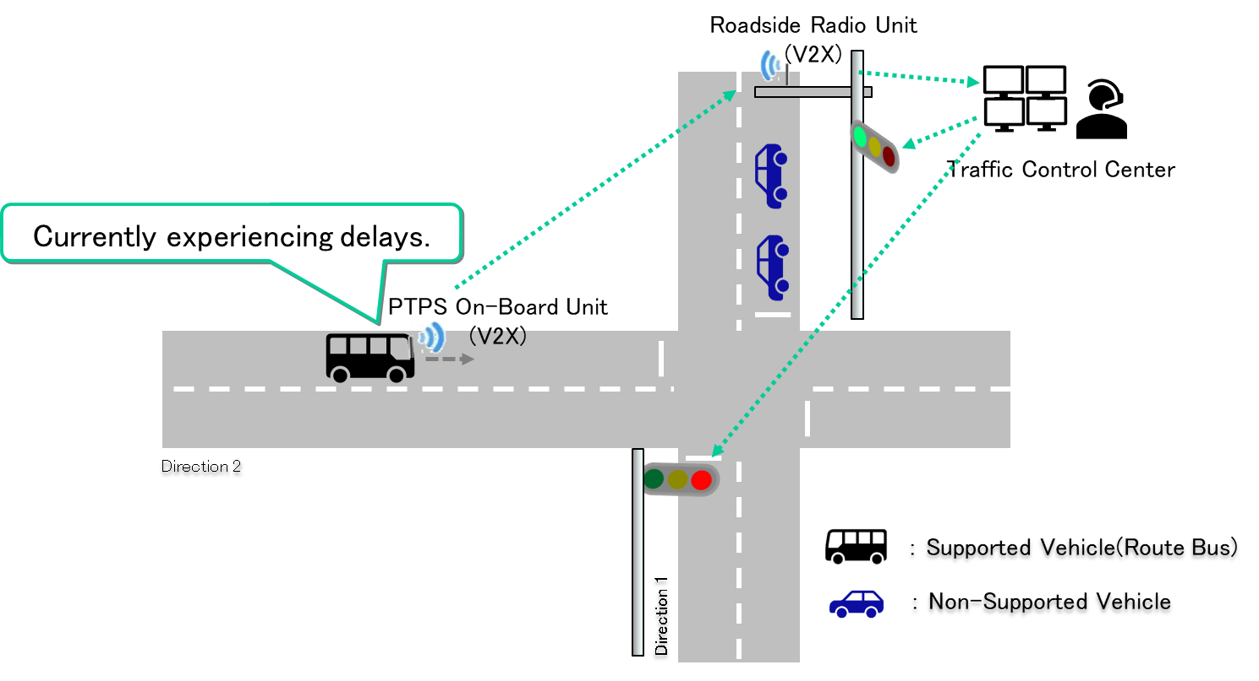
FIGURE 8.3 Service image of advanced PTPS for route buses

TABLE 8.3 V2X Communication message
Item | Remark
Time-stamp | Time in hours, minutes and seconds of UTC
Vehicle position data | Latitude, longitude, elevation and others
Vehicle status data | Vehicle speed, vehicle heading and others
PTPS Request | Data related to priority request, including bus operator number, route number, operation status, and priority request (Yes/No)

      - Communication systems and applicable frequencies
Communication systems and applicable frequencies will be adopted in each APT country depending on the country's status.
The specific communication systems and applicable frequencies are referred to each Annex by the APT countries.

  - Automated driving support
Automated driving technology is one of the solutions to future social issues. For example, this technology could solve the shortage of commercial drivers, an aging population and also traffic accidents. It has some technical challenges to achieve higher levels of automated driving technology through the deployment of the technology of automated driving vehicles alone. Therefore, it is considered that Cooperative Vehicle-Infrastructure ITS systems will be necessary to realize higher levels of automated driving.

    - Service description
This service contributes to expanding the operational design domain and enabling smoother driving for automated driving vehicles. This is achieved by detecting objects in blind spots for automated driving on-board sensors using roadside sensors and notifying these objects through V2I communication. A service image is shown in FIGURE 8.4.
The roadside infrastructure (ITS Smart Pole) is installed at intersections and along roads within the service area. Roadside sensors detect targets on the road that are blind spots for automated driving on-board sensors. Data is sent to automated driving vehicles via V2I communication using the V2X radio unit.
The automated driving system determines the next action and operates the vehicle based on the data received from the ITS Smart Pole and the data from the automated driving on-board sensors. This enables automated driving vehicles to drive safely and comfortably even at intersections and roads with many blind spots.
The role of ITS Smart Pole is shown in FIGURE 8.5.
The data is shown in TABLE 8.4, which is transmitted via V2X systems.

    - Service procedure
- Automated driving vehicles approach intersections and roads with many blind spots.
- The roadside sensor of the ITS Smart Pole detects targets in the blind spot of automated driving vehicle.
- The ITS Smart Pole sends detected target data to the automated driving vehicle by V2I communication.
- The automated driving system determines the next action based on the data received from the ITS Smart Pole and the data from the automated driving on-board sensors and operates the vehicle.

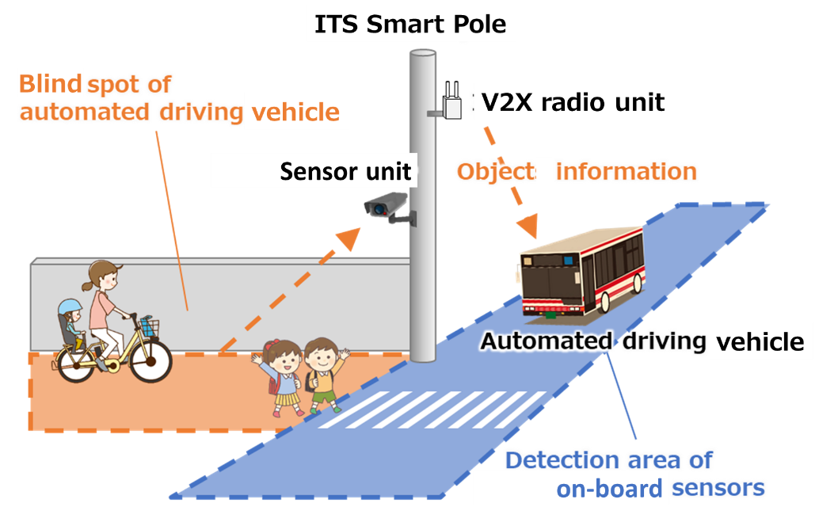
FIGURE 8.4 Service image of automated driving support

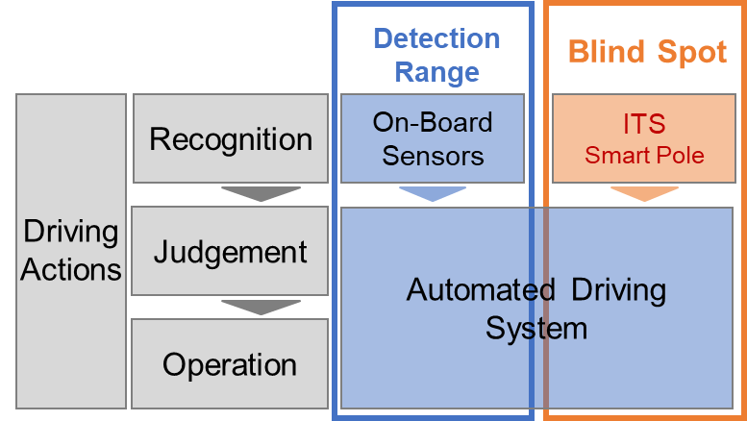
FIGURE 8.5 The role of ITS Smart Pole in the service

TABLE 8.4 V2X communication message
Item | Remark
Individual identification ID | ID by which an individual can be identified
Time-stamp | Time in hours, minutes and seconds of UTC
Object position data | Latitude, longitude, elevation and others
Object status data | Object speed, object heading and others
Objects size | Length, width and others
Detection area | Detection area of the roadside sensor

    - Communication systems and applicable frequencies
Communication systems and applicable frequencies will be adopted in each APT country depending on the country's status.
The specific communication systems and applicable frequencies are referred to each Annex by the APT countries.

  - Support of collecting data for road management information on highway
In general, traffic volume and vehicle speed are monitored by vehicle detectors to determine road traffic conditions. However, the detected data is momentary, and it is not possible to acquire data pertaining to vehicle behavior continuously in time and space. Therefore, it often takes time to detect the occurrence of sudden traffic events such as traffic accidents, traffic congestion, and fallen objects. In addition, it is a challenge to plan countermeasures by capturing detailed traffic conditions and the occurrence/resolution of traffic congestion.

    - Road traffic condition data collection support
      - Service description
Roadside infrastructure (ITS Smart Pole) collects data about vehicles traveling within its communication range. This data is aggregated and analyzed to determine the propagation status of traffic congestion and its changes. The results of this analysis are then used to plan traffic congestion countermeasures and determine their effectiveness. A service image is shown in FIGURE 8.6.
The ITS Smart Pole can continuously receive data transmitted by vehicles equipped with V2X OBUs while they are within its communication range. The transmitted data includes positional data such as latitude and longitude. Based on such data, organizations responsible for road management operations analyze and monitor traffic congestion factors.
By using V2I communication, traffic information such as the propagation status of traffic congestion and its changes can be captured at a high resolution. Furthermore, such traffic information can be used for planning traffic congestion countermeasures and determining their effectiveness.
The data is shown in TABLE 8.5, which is transmitted via V2X systems.

      - Service procedure
- Vehicles equipped with V2X OBUs continuously transmit data such as latitude and longitude.
- ITS Smart Poles installed on the roadside continuously receive data from vehicles equipped with V2X OBUs that are traveling within its communication range.
- The received data is transmitted to cloud and central equipment.
- The collected data is recorded and aggregated.
- The aggregated data is analyzed to determine the propagation status of traffic congestion and changes in traffic congestion.
- The information is used to plan traffic congestion countermeasures and determine their effectiveness.

      - Scenes of use (examples)
- Verification of the effects of lane change restrictions
- Verification of the effects of longitudinal gradients, and other factors
- Confirming the impact on traffic congestion and the effectiveness of measures and using the results to formulate additional countermeasures.
- Data from traffic simulators, and others, will be used to evaluate the effectiveness of traffic congestion countermeasures.
- Utilized for studying the locations of vehicle detectors (including millimeter wave, LiDAR, and others), CCTV (Closed-Circuit Television), and other data-gathering equipment.

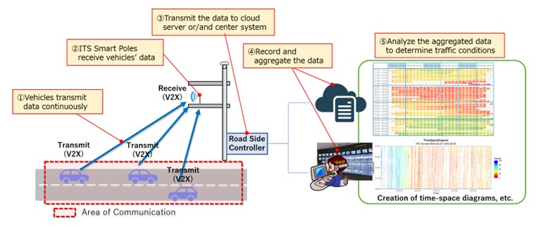
FIGURE 8.6 Service image of road traffic condition data collection support

TABLE 8.5 V2X communication message
Item | Remark
Individual identification ID | ID by which an individual can be identified
Time-stamp | Time in hours, minutes and seconds of UTC
Vehicle position data | Latitude, longitude, elevation and others
Vehicle status data | Vehicle speed, vehicle heading and others
Vehicle classification | Size, role

      - Communication systems and applicable frequencies
Communication systems and applicable frequencies will be adopted in each APT country depending on the country's status.
The specific communication systems and applicable frequencies are referred to each Annex by the APT countries.

    - Support for detection of obstacles on the road
      - Service description
The ITS Smart Pole can continuously receive data transmitted by vehicles equipped with V2X OBUs traveling within its communication range. Based on such data, organizations responsible for road management operations can detect accidents, falling objects, and other unexpected events on the road, and take necessary actions according to circumstances of the event. The actions include supporting the prompt dispatch of road patrol vehicles. A service image is shown in FIGURE 8.7.
By using the V2I communication, it is possible to detect sudden events that have a significant impact on travel speeds at an early stage and promptly implement appropriate actions. As a result, V2I communication enables us to improve the level of road management.
The data is shown in TABLE 8.6, which is transmitted via V2X systems.

      - Service procedure
- Vehicles equipped with V2X OBUs continuously transmit data such as latitude and longitude.
- ITS Smart Poles installed on the roadside continuously receive data from vehicles equipped with V2X OBUs that are traveling within its communication range.
- The received data is transmitted to cloud and central equipment.
- The collected data is recorded and aggregated.
- The aggregated data is analyzed to detect any phenomena that may cause sudden events.
- Necessary actions are taken promptly, such as supporting the prompt dispatch of road patrol vehicles.

      - Scenes of use (examples):
- Early detection of potential sudden events on the road
- Providing alert data to vehicles on the road (especially following vehicles)
- Prevention of falling objects and secondary accidents

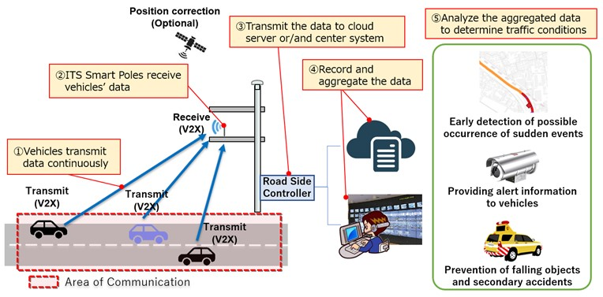
FIGURE 8.7 Service image of support for detection of obstacles on the road

TABLE 8.6 V2X communication message
Item | Remark
Individual identification ID | ID by which an individual can be identified
Time-stamp | Time in hours, minutes and seconds of UTC
Vehicle position data | Latitude, longitude, elevation and others
Vehicle status data | Vehicle speed, vehicle heading and others
Vehicle classification | Size, role

      - Communication systems and applicable frequencies
Communication systems and applicable frequencies will be adopted in each APT country depending on the country's status.
The specific communication systems and applicable frequencies are referred to each Annex by the APT countries.

  - Support of collecting data for road management information on urban and suburban road
Road design is a key factor in achieving traffic safety and reducing traffic congestion in APT countries. This chapter introduces one of the use cases of Cooperative Vehicle-Infrastructure ITS, which involves collecting and analyzing traffic flow and trace data to support road design and management.

    - Service description
The service provides probe data collected by observing the routes and speeds of road users, including vehicles, motorcycles, bicycles and pedestrians, passing through major intersections and roads over a long period of time. A service image is shown in FIGURE 8.8.
In this service, roadside infrastructure (ITS Smart Pole) collects data such as road users’ routes, speeds, longitudinal acceleration, and types using roadside sensors and V2X radio unit. The data is stored in the database on a cloud network for a long period of time. Users can extract and view data for their desired time period. For example, Users can view the routes and speeds of bicycles during periods when roadside construction is underway. This makes it possible to evaluate whether roads are unsafe not only under normal conditions but also during events such as construction work. The service is expected to support the development of bicycle and motorcycle paths and also to consider detour routes and the placement of safety guides in emergency situations.
The data is shown in TABLE 8.7, which is transmitted via V2X systems.

    - Service procedure
- The roadside sensor of the ITS Smart Pole detects road users on the road and measures their position, speed, acceleration/deceleration, attributes, and others
- Road users equipped with V2X radio units notify the ITS Smart Pole of their own position, speed, longitudinal acceleration, type, and others via wireless communication.
- The ITS Smart Pole sends the collected data as probe data to cloud servers via wired or wireless wide area network.
- The cloud server stores the received probe data in storage.
- Observers can view probe data for the required period from a cloud server using an application installed on a PC or other terminal.

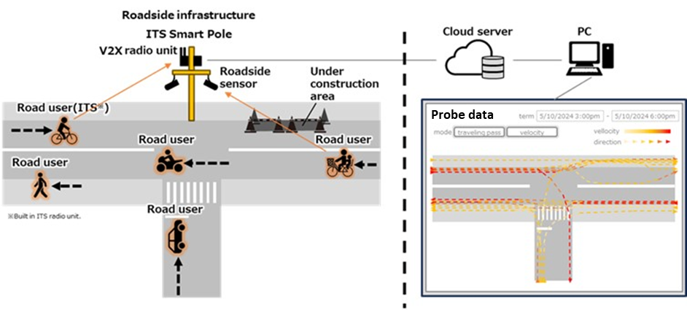
FIGURE 8.8 Service image of Support of collecting data for road management information on urban and suburban road

TABLE 8.7 V2X communication message
Item | Remark
Individual identification ID | ID by which an individual can be identified
Time-stamp | Time in hours, minutes and seconds of UTC
Position data | Latitude, longitude, elevation and others (Including road users, sensor objects)
Status data | Speed, heading and others (Including road users, sensor objects)
Classification | Vehicle, motorcycle, bicycle, pedestrian and others

    - Communication systems and applicable frequencies
Communication systems and applicable frequencies will be adopted in each APT country depending on the country's status.
The specific communication systems and applicable frequencies are referred to each Annex by the APT countries.

  - Victim support on large-scale disaster
In recent years, the number of disasters, such as large-scale earthquakes in APT countries, has been increasing worldwide. Although warning signs are observed and evacuation advisories issued before disaster strikes, there remains a challenge in which people sometimes are unable to evacuate due to the limited time available for information collecting before disaster strikes and delays in information collection. This chapter proposes use cases for addressing these issues using Cooperative Vehicle-Infrastructure ITS.

    - Evacuation guidance support
      - Service description
The service notifies individuals who have difficulty accessing disaster information about evacuation routes in their area when evacuation advisories are issued by the national or local government. Notifications are provided for routes designated by the local government, such as the main evacuation route. A service image is shown in FIGURE 8.9.
Roadside infrastructure (ITS Smart Pole) equipped with LED display boards is installed in the service area. Based on the decision results made by the local government, the ITS Smart Poles are instructed to display the information of evacuation shelter guidance via the network. This enables people who have difficulty accessing disaster information to evacuate correctly.
The information which is transmitted via communication systems is shown in TABLE 8.8.

      - Service procedure
- Information and decisions made by the local government are used to instruct the ITS Smart Pole to display evacuation shelter guidance information via the network.
- The ITS Smart Pole, upon receiving instructions, displays evacuation routes, and other relevant information on LED display boards.
- People in the area who see the information on the LED display boards are able to identify the correct evacuation route and take appropriate actions.
- People who have difficulty accessing disaster information are able to avoid disasters and crises.

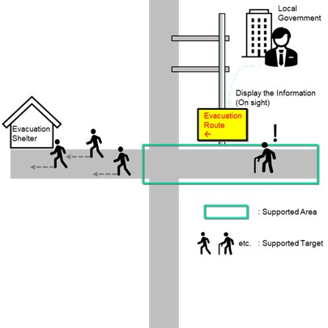
FIGURE 8.9 Service image of evacuation guidance support
TABLE 8.8 Communication message
Item | Remark
Information on evacuation shelter guidance | Information indicating the route to evacuation shelters sent by the local government

      - Communication systems and applicable frequencies
Communication systems and applicable frequencies will be adopted in each APT country depending on the country's status.
The specific communication systems and applicable frequencies are referred to each Annex by the APT countries.
    - Road damage confirming support
      - Service description
The service notifies authorized local government officials of the road passability information* from onset of the disaster until the disaster emergency system is lifted at intersections or individual roads within areas designated by the local government. (*The road passability information is the result of data on vehicle type, location, speed, and others transmitted from V2X OBUs of normal vehicles, emergency vehicles and vehicles exempt from regulations, are aggregated and processed as appropriate.) A service image is shown in FIGURE 8.10.
A roadside infrastructure (ITS Smart Pole) is installed in the service area. The ITS Smart Pole receives and collects traffic data from multiple vehicles equipped with V2X OBUs and periodically generates traffic performance information based on the accumulated data. The service is provided by displaying traffic data and traffic performance information on a digital map on the server of the disaster response headquarters or the cloud based on the traffic performance information distributed from the ITS Smart Pole and confirming it with local government officials.
The data which is transmitted via communication systems is shown in TABLE 8.9.

      - Service procedure
- Traffic data*1 is transmitted from vehicles equipped with V2X OBUs: normal vehicles, emergency traffic vehicles, vehicles exempt from regulations.
- The ITS Smart Pole receives and collects the traffic data from multiple vehicles equipped with V2X OBUs.
*Optional: It may also acquire camera images.
- The ITS Smart Pole periodically accumulates traffic data and generates traffic performance information*2.
*Optional: It can extract video, photography, and other data for a certain period of time before and after the passing time of a vehicle equipped with a V2X OBU.
- The information generated and extracted in Step 3 is transmitted from the ITS Smart Pole to servers or clouds systems at disaster response headquarters, via LPWA, cellular network, and other communication methods.
- The traffic data and traffic performance information are displayed on a digital map hosted on servers or cloud systems at the disaster response headquarters.
*1 Raw data includes position, speed, and vehicle type for each vehicle.
*2 Traffic performance information refers to data aggregated at fixed intervals within specific road segments e.g. links or may be further categorized by vehicle type.

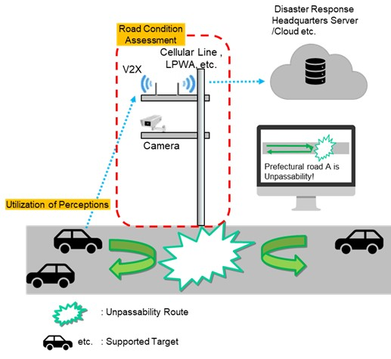
FIGURE 8.10 Service image of road damage confirming support

TABLE 8.9 Communication message
Item | Remark
Individual identification ID | ID by which an individual can be identified
Time-stamp | Time in hours, minutes and seconds of UTC
Vehicle position data | Latitude, longitude, elevation and others
Vehicle status data | Vehicle speed, vehicle heading and others
Vehicle classification | Size, role and others
Traffic performance information | Information generated based on traffic data

      - Communication systems and applicable frequencies
Communication systems and applicable frequencies will be adopted in each APT country depending on the country's status.
The specific communication systems and applicable frequencies are referred to each Annex by the APT countries.

  - Watching support / Crime prevention support
In recent years, crimes and accidents have become increasingly diverse, including child abductions and traffic accidents involving elderly individuals with dementia. Guardians responsible for care of children or elderly individuals have a strong need to collect information about individuals to prevent crimes and accidents. Therefore, this chapter describes a use case in which Cooperative Vehicle-Infrastructure ITS supports guardians in gathering information.

    - Watching support
      - Service description
The service notifies guardians of the location of children, elderly individuals, and other persons under their care at intersections and along roads, enabling them to keep track of the location of the watched persons. A service image is shown in FIGURE 8.11.
Roadside infrastructure (ITS Smart Pole) is installed at intersections and along roads within the service area. The individuals being watched wear a special transmitter or shoes with a transmitter.
Signals from the transmitter are received by the ITS Smart Pole, and the location information is distributed to service providers and local governments that are authorized to handle personal information securely.
The service is provided by delivering this information to the guardians who are subscribed to the service.
The data which is transmitted via communication systems is shown in TABLE 8.10.

      - Service procedure
- The person being watched wears a special transmitter or shoes equipped with the transmitter or rides a bicycle with the transmitter.
- The ITS Smart Pole receives personal identification information from the device when the person being watched passes by.
- The ITS Smart Pole uploads the location data of each individual to the cloud.
- The cloud stores the location information.
- Guardians can track the location of the person being watched either through notifications from the cloud, or by checking information whenever needed.

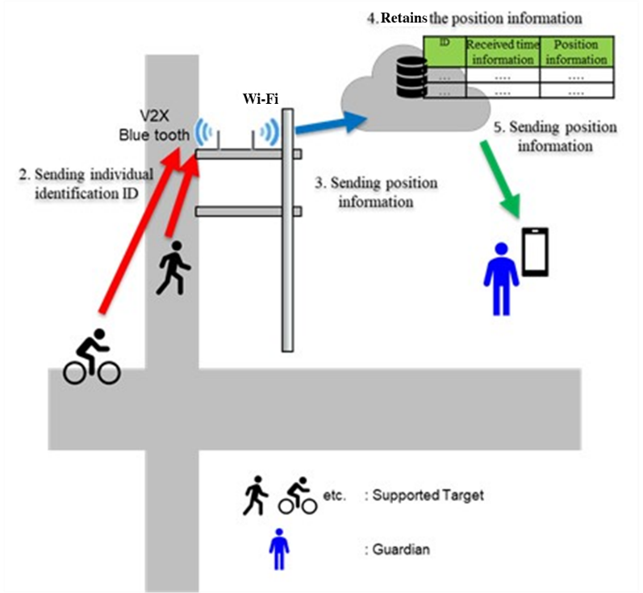
FIGURE 8.11 Service image of watching support

TABLE 8.10 Communication message
Item | Remark
Individual identification ID | ID by which an individual can be identified (pedestrian, bicycle)
Time-stamp | Time in hours, minutes and seconds of UTC
Position data | Latitude, longitude, elevation and others (pedestrian, bicycle)
Status data | Speed, heading and others (pedestrian, bicycle)
      - Communication systems and applicable frequencies
Communication systems and applicable frequencies will be adopted in each APT country depending on the country's status.
The specific communication systems and applicable frequencies are referred to each Annex by the APT countries.

Conclusion
This report provides an overview of Cooperative Vehicle-Infrastructure ITS and their potential to address critical social and transportation challenges within APT countries. This report defines the scope of these systems, highlights their configuration, and presents eight key use cases, It is important to note that these use cases are not mutually independent but can share infrastructure as shown in Figure 9.1 below.
Furthermore, this Report underscores the importance of interoperability and harmonized standards for the successful, widespread adoption of ITS technologies within administration.
In summary, this report serves as a valuable reference for APT countries to further study and considers the deployment of Cooperative Vehicle-Infrastructure ITS. The continued collaborative effort will be essential to advance this important work and realize the full potential of these technologies to create safer, more efficient, and more sustainable transportation networks across the Asia-Pacific region.
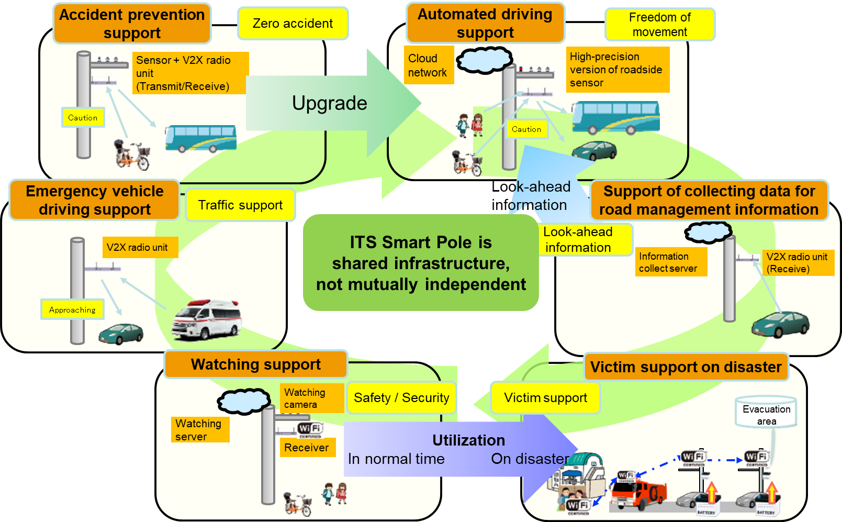
FIGURE 9.1 Multiple use cases covered by Cooperative Vehicle-Infrastructure ITS

References

- Y Haibara et al. “Demonstration to support safe driving of public buses by sensors installed on utility poles in Himeji City, Hyogo Prefecture” published paper in 19th ITS Symposium 2021

- Cross-ministerial Strategic Innovation Promotion Program (SIP) 2nd Phase, Automated Driving for Universal Services (SIP-adus, NEDO management number: JPNP18012), implemented by the Cabinet Office and served by the New Energy and Industrial Technology Development Organization (NEDO) as a secretariat.

- J Arai et al. “Availability of road traffic management information using ITS Connect” published paper in 19th ITS Symposium 2021

- T Sato et al.” Traffic Monitoring by utilizing the probe data of ITS Connect (760MHz DSRC)” published paper in 68th Infrastructure Planning Conference

- Y.Okubo et al. “Validation of Traveling Lane Prediction on Expressways Utilizing ITS Connect Data” published paper in 68th Infrastructure Planning Conference

- ITS Connect System Inter-Vehicle Communication Message Specification TD-001 Version 1.1
SAE-J3016 APR2021“Taxonomy and Definitions for Terms Related to Driving Automation Systems for On-Road Motor Vehicles

Annex 1 Summary of responses to questionnaire

Summary of responses to questionnaire
This section summarizes the responses from Thailand, Japan, Bangladesh, Korea, China, Viet Nam to the Questionnaire.

Question 1: Installation of V2X systems (including V2N system).
1.1. Has your country considered the installation, conducted the demonstration tests, or implemented the actual operations of a V2X system to resolve the use cases as described in ANNEX-1 (on the questionnaire)?
<Answer>
Yes
No
If ”No”, Are there any plans for future implementation?
<Answer>
Yes
No

1.2. If “Yes” in 1.1 either question, please provide the applicable information including the communication methods (standards) and frequency ranges.

Question 2: Effectiveness of Cooperative Vehicle-Infrastructure ITS, which is described in ANNEX-1 (on the questionnaire).
2.1. Are the V2I systems effective for your country to resolve traffic and social issues as indicated in the use cases in ANNEX-1 (on the questionnaire)?
<Answer>
Effective
Neither
Not effective

2.2. Is it effective that one system can cover multiple use cases?
<Answer>
Effective
Neither
Not effective

TABLE 1 Summary of responses to questionnaire Question 1 and Question 2

Country | Current implementation  Q.1.1 | Future implementation  Q.1.1 | Implemented (or will be implemented) application  Q1.2 | Effectiveness of V2I systems  Q2.1 | Effectiveness of multiple coverage  Q2.2
Thailand (Kingdom of) | No | Yes | - | Neither (Under study) | Neither (Under study)
Japan | Yes | - | ITS Connect (ARIB STD-T109), 755 -765 MHz is used in some actual operations and demonstration tests.  5.9 GHz band is considered to use V2X communication. | Effective | Effective
Bangladesh (People's Republic of) | No | No | - | Effective | Effective
Korea (Republic of) | Yes | - | LTE based V2X (3GPP 36 series Rel.14 and beyond) in January 2024  Frequency Range: 5.855~5.875 GHz (20 MHz) | Effective | Effective
China (People's Republic of) | Yes | - | LTE based V2X (3GPP 36-series Rel.14 and beyond) | Effective | Effective
Viet Nam (Socialist Republic of) | Yes | - | ITS Connect (ARIB STD-T109), 598-608 MHz is under study, considering proposal for use in demonstration tests. | Neither (Under study, not yet demonstration tests) | Neither (Under study, not yet demonstration tests)
India (Republic of) | Yes | - | Frequency Ranges:  • 865-868 MHz¹  • 5.9 GHz: 5.875-5.925 GHz²  • 24 GHz: 24.05-24.25 GHz³  • 70 GHz: 76-77 GHz⁴  ¹ Used for FASTag application as per GSR 853 (E) dated 10 Dec 2021  2 as per provisions in NFAP  3 as per GSR 1047(E) dated 18. Oct 2018 and GSR 271 (E) dated 24 May 2024  4 as per GSR 699 (E) dated 16 Sep 2015 | Effective  For the purpose of tolling, India has wide-scale implementation of tolling systems (FastTag⁵) with significant impact on traffic and society benefits of efficient cash-less toll collection.  5 as per G.S.R 690(E) dated 20 May 2021 regarding FASTag on all M N category vehicles | -  India is considering ITS/V2X solutions for multiple use-cases and there is no conclusion yet.
Question 3: The regulations relevant with Cooperative Vehicle-Infrastructure ITS, which is described in ANNEX-1 (on the questionnaire).
3.1 Are there any regulations that would need to be considered when installing the systems or roadside infrastructure (as described in ANNEX-1 (on the questionnaire)) on a road?
<Answer>
Yes,
The related administrations= _______________________
The related regulations= _______________________
No
Unknown

3.2 Are there any regulations that would need to be considered when transmitting traffic signal information or traffic information?
<Answer>
Yes,
The related administrations= _______________________
The related regulations= _______________________
No
Unknown

TABLE 2 Summary of responses to questionnaire Question 3

Country | The related administrations  Regulations for installing RSU  Q3.1 | The related regulations  Regulations for installing RSU  Q3.1 | The related administrations  Regulations for transmitting signal info. and traffic info.  Q3.2 | The related regulations  Regulations for transmitting signal info. and traffic info.  Q3.2
Thailand (Kingdom of) | Department of Transport, Office of the National Broadcasting and Telecommunications Commission (NBTC) | Road Traffic Act, Radiocommunication Act | Department of Transport | Road Traffic Act
Japan | Ministry of Internal Affairs and Communications,  National Police Agency,  Ministry of Land, Infrastructure, Transport and Tourism | Radio Regulation,  Road Traffic Regulation,  Road Regulation | National Police Agency | Road Traffic Regulation
Bangladesh (People's Republic of) | /Road Transport and Highways Division,  Bangladesh Road Transport Authority (BRTA),  /Ministry of Home Affairs,  /Ministry of Posts, Telecommunications and Information Technology,  /Bangladesh Telecommunication Regulatory Commission (BTRC),  /Ministry of Local Government,  /Rural Development and Co-operatives. | Radio Regulation,  National Frequency Allocation Table (NFAT),  Road Transport Act, 2018. | Bangladesh Road Transport Authority (BRTA) | Road Transport Act, 2018
Korea (Republic of) | Ministry of Science and ICT, Korean National Police Agency, Ministry of Land, Infrastructure and Transport | Radio Waves Act, Road Traffic Act | Korean National Police Agency | Road Traffic Act
China (People's Republic of) | Ministry of Industry and Information Technology, Ministry of Public Security, Ministry of Natural Resources, Ministry of Housing and Urban-Rural Development, Ministry of Transport | Radio Regulation, Road Traffic Safety Law, Highway Law | Ministry of Industry and Information Technology, Ministry of Public Security, Ministry of Natural Resources, Ministry of Housing and Urban-Rural Development, Ministry of Transport | Radio Regulation, Road Traffic Regulation, Road Regulation
Viet Nam (Socialist Republic of) | Ministry of Science and Technology, Ministry of Construction, Ministry of Public Security, Ministry of Industry and Trade | Radio Frequencies Regulation, Road Traffic Regulation | Unknown | Unknown
India (Republic of) | India  Ministry of Roadways, Transport & Highways, NHAI, State and Urban Development, and other applicable departments | Provisions in National Frequency Allocation Plan (NFAP), Regulations of Ministry of Roadways, Transport & Highways, NHAI, State and Urban Development, and other applicable departments | India  Ministry of Roadways, Transport & Highways, NHAI, State and Urban Development, and other applicable departments | Provisions in National Frequency Allocation Plan (NFAP), Regulations of Ministry of Roadways, Transport & Highways, NHAI, State and Urban Development, and other applicable departments

Question 4: Social issues relevant to the use cases
Have the traffic or social issues, which are to be resolved in the eight proposed use cases under discussion in the report AWG-32/TMP-48 (as described in ANNEX-1 (on the questionnaire)), been raised in your government (ministries) policy?

UC-1 (a. Accident prevention support)
UC-2 (b. Emergency vehicle driving support)
UC-3 (c. Public Transportation Priority Systems)
UC-4 (d. Automated driving support)
UC-5 (e. Road management information collection support for highway)
UC-6 (f. Road management information collection support for urban and suburban road)
UC-7 (g. Victim support on large-scale disaster)
UC-8 (h. Watching support / Crime prevention support)
<Answer>
Yes
No
Others Ex) under consideration_______________________

TABLE 3 Summary of responses to questionnaire Question 4

Country | UC-1 | UC-2 | UC-3 | UC-4 | UC-5 | UC-6 | UC-7 | UC-8
Thailand (Kingdom of) | Others | Others | Others | Others | Others | Others | Others | Others
Japan | Yes | Yes | Yes | Yes | Yes | Yes | Yes | Yes
Bangladesh (People's Republic of) | Others | Others | Others | Others | Others | Others | Others | Others
Korea (Republic of) | Yes | Yes | Yes | Yes | Yes | Yes | Others | Yes
China (People's Republic of) | Yes | Yes | Yes | Yes | Yes | Yes | Yes | (Blank)  Protection for vulnerable road users
Viet Nam (Socialist Republic of) | Yes | Yes | Yes | Yes | Yes | Yes | Yes | Yes
India (Republic of) | Others: Under consideration | Others: Under consideration | Others: Under consideration | Others: Under consideration | Others: Under consideration | Others: Under consideration | Others: Under consideration | Others: Vehicle Location Tracking Device using V2N and Emergency Button in all Public Service Vehicles (e.g., taxi or cab)

Annex 2 Cases in Japan

DEPLOYMENT AND EXPERIMENT CASES IN JAPAN

Communication system and applicable frequency
This captor shows the communication systems and applicable frequencies used in the use cases as described in main body of the report. Furthermore, communication target is described each table of usage of the communication system.

- Infrastructure to everything communication systems
The systems as below are adopted to Infrastructure to everything communication in Japan.

TABLE A2.1.1 Communication system
Communication system | Applicable frequency (bandwidth)
ITS Connect (ARIB STD-T109) | 760 MHz (10 MHz)

The system is applicable to the following use cases.

TABLE A2.1.2 Usage of the communication system
Use case | Communication target
Accident prevention support | ITS Smart Pole - Vehicle
Emergency vehicle driving support | Vehicle - ITS Smart Pole/  VMS (Variable Message Sign)
Public Transportation Priority Systems | Bus - Roadside infrastructure
Automated driving support | Automated driving car -  ITS Smart Pole
Support of collecting data for road management information on highway | Vehicles - ITS Smart Poles
Support of collecting data for road management information on urban and  suburban road | Road users - ITS Smart Poles
Victim support on large-scale disaster  Evacuation guidance support | Local government system -  ITS Smart Pole
Victim support on large-scale disaster  Road damage confirming support | Vehicle - ITS Smart Pole
Watching support / Crime prevention support | Person who is watched -  ITS Smart Pole

- Other communication systems
In each use case, the following systems can also be used outside of Infrastructure to everything communication.

TABLE A2.1.3 Communication system
Communication system | Applicable frequency (bandwidth)
Cellular Network | -
LPWA | 900 MHz band
Bluetooth | 2.4 GHz
Wi-Fi | 2.4 GHz, 5 GHz
Fiber optic internet | -

The system is applicable to the following use cases.

TABLE A2.1.4 Usage of the communication system
Use case | Communication target | Communication system
Public Transportation Priority Systems | Roadside infrastructure  -TCC | Cellular Network
Public Transportation Priority Systems | Roadside infrastructure  -TCC | Fiber optic internet
Victim support on large-scale disaster  Evacuation guidance support | ITS Smart Pole - network | Cellular Network
Victim support on large-scale disaster  Road damage confirming support | ITS Smart Pole - network | Cellular Network
 | ITS Smart Pole - network | LPWA
 | ITS Smart Pole - network | Fiber optic internet
Watching support / Crime prevention support | ITS Smart Pole- network | Bluetooth
Watching support / Crime prevention support | ITS Smart Pole- network | Wi-Fi

Example of deployment and experiment
The outline of deployment examples and demonstration experiments is summarized as follows.
“Status” indicates the status of social deployment for each use case.
      - “Accident prevention support” for head-on collisions at intersections with poor visibility
Status: Started deployment

      - “Emergency vehicles driving support” to shorten the arrival time
Status: Under experiment

      - “Automated driving support” to provide blind spot area information from automated driving on-board sensors for safe and comfortable driving
Status: Under experiment

      - “Support of collecting data for road management information on highway” to collect vehicle driving data and utilize for traffic information management
Status: Under experiment

The usage of Cooperative Vehicle-Infrastructure Intelligent Transport Systems (ITS) has been considered as part of Japan’s initiative to deploy automated driving services in 50 locations by 2025 and 100 locations by 2027. The system is designed with flexibility to support a wide range of use cases and is expected to be used not only for automated driving services but also for other use cases, thereby accelerating its deployment.

- Accident prevention support
Experiments for deployment have been conducted to verify the use case of accident prevention support using Cooperative Vehicle-Infrastructure ITS in several cities, as showing in TABLE A2.2.1. One of example Himeji city in Japan is shown in this section.

TABLE A2.2.1 Experiment locations
Location
Himeji city, Hyogo
Sanda city, Hyogo
Otsu city, Shiga
Shiojiri city, Nagano
Toyota city, Aichi

    - Background / Objective
The objective of the experiment was to verify the effectiveness of V2X radio units installed on utility poles (roadside infrastructure) at unsignalized intersections with poor visibility in preventing accidents by detecting pedestrians running out of blind spots and notifying bus drivers of potential danger. FIGURE A2.2.1 is a demonstration experiment illustration.

    - Method
Roadside sensors (such as radar, camera) installed on utility poles detect pedestrians, and the V2X radio unit transmits dynamic data (such as position, speed, direction) of pedestrians to the V2X on-board unit (OBU) on the bus via ITS Connect communication.
The location of the bus is accurately corrected using a GNSS receiver, and when the OBU determines that there is a risk of an accident based on the dynamic data of both the pedestrians detected by roadside sensors and the bus itself, a hazard alert is sent to the bone-conduction earphones worn by the bus driver.
Demonstration experiment (V2I) system configuration is shown in FIGURE A2.2.2, and one of the utility poles which has ITS radio unit and sensors is shown in FIGURE A2.2.3.

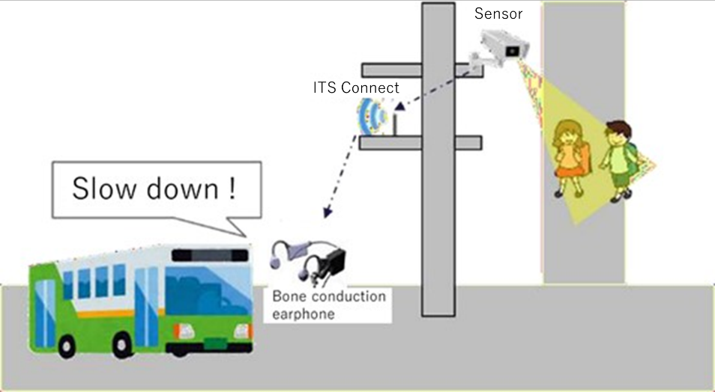
FIGURE A2.2.1 Demonstration experiment (V2I) illustration

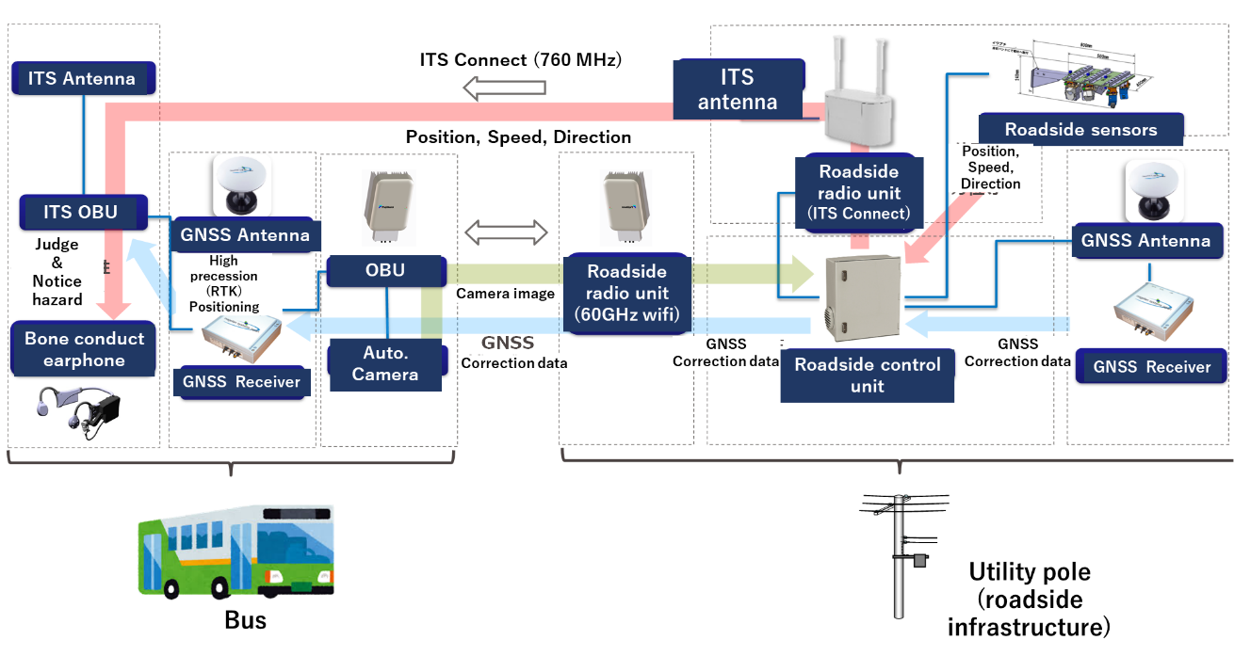
FIGURE A2.2.2 Demonstration experiment (V2I) system configuration

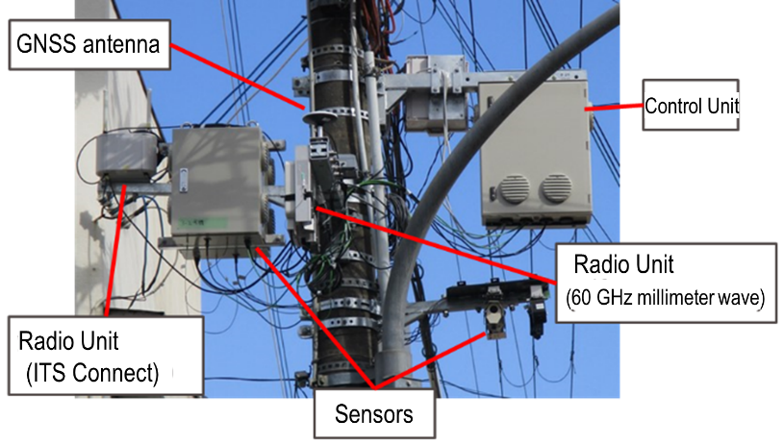
FIGURE A2.2.3 V2I related devices on utility pole (roadside infrastructure)

    - Result
The analysis results of changes in bus driving behavior are shown in FIGURE A2.2.4..
Without decelerating triggered by the notification, the bus and pedestrians entered the intersection with a 2-second time difference. However, when the hazard notification was replayed and the bus performed braking, the time difference increased to 9.4 seconds.

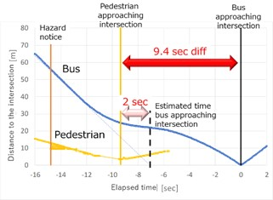
FIGURE A2.2.4 Distance between buses/pedestrians and the intersection, vs time

After receiving the hazard notification, the bus driver initiated braking to slow down, Upon visually recognizing that a pedestrian had entered the intersection, the driver applied braking again, decelerated further, and then resumed acceleration, as shown in FIGURE A2.2.5. Although this experiment was conducted at an intersection with poor visibility, the bus driver was able to begin decelerating 3.5 seconds before the pedestrian entered the intersection.

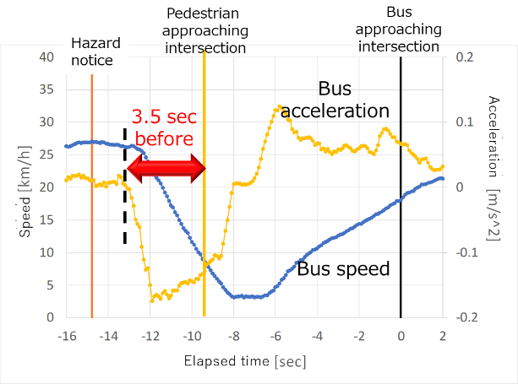
FIGURE A2.2.5 Bus speed and acceleration, vs time

The experiment was conducted with three bus drivers, all of whom consistently confirmed that listening to the hazard notifications increased the time gap between the bus and pedestrians/bicyclists, and the time they entered the intersection. The result is shown in TABLE A2.2.2.

TABLE A2.2.2 Average of intersection entry time
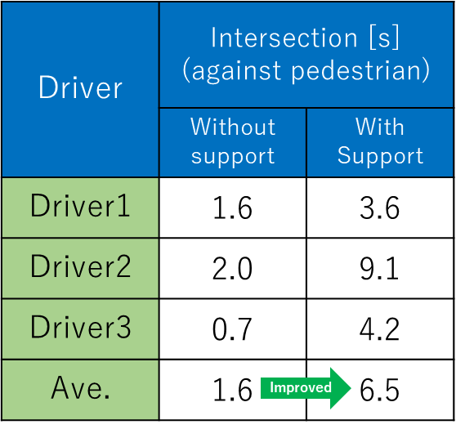

    - Summary
When the driver was notified of the hazard at the appropriate time, all drivers (5 out of 5 instances) took the safe action of braking. The results obtained from this demonstration indicate that the system is effective in preventing accidents at unsignalized intersections with poor visibility. Furthermore, the system is also expected to be a measure for preventing accidents involving sudden road user intrusions in the context of automated driving vehicles operating on public roads in the future.

- Emergency vehicle driving support
    - Overview
A field demonstration was conducted by installing electric poles equipped with roadside sensors and V2X radio units at an intersection. These devices enabled the recognition of the vehicle types and emergency vehicles approaching from the priority route. When vehicles or pedestrians entered the intersection, pictogram and arrows were displayed on LED display boards to alert drivers and draw attention to the potential hazard. The field demonstration image is shown in FIGURE A2.2.6.

    - Detail
The field demonstration was conducted by installing an ITS Smart Pole at an unsignalized intersection (specifically, a five-way intersection) where there was a risk of head-on collisions. The ITS Smart Pole was equipped with roadside sensors and a V2X radio unit to detect approaching vehicles and then displays relevant information on LED display boards to alert and warn both drivers and pedestrians at the intersection. ITS Connect is utilized in the system to receive data from emergency vehicles, and in response, it displays an "Emergency Vehicle Approaching" message or pictogram on the LED display boards as shown in FIGURE A2.2.7.

    - Operation sequence (when a passenger vehicle or similar enters):
      - Roadside sensors detect objects on the priority route, including vehicles, bicycles, pedestrians, and other road users.
      - The control unit processes the detected data.
      - LED display boards notify vehicles on the non-priority route about the approaching road users.
      - The system encourages safe driving behavior for vehicles on the non-priority route.

    - Operation sequence (when an emergency vehicle enters):
- Detect the approach of emergency vehicles equipped with V2X OBUs.
- Process the detected data in the control unit.
- Notify vehicles on the non-priority route of the approaching emergency vehicle via LED display boards.
- Prompt vehicles on the non-priority route to yield the right of way to the emergency vehicle.
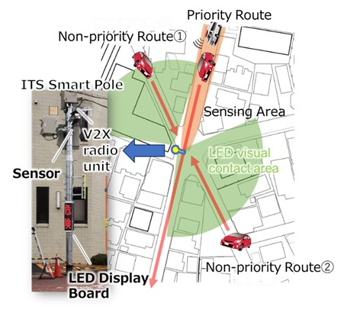
FIGURE A2.2.6 Field Demonstration Image

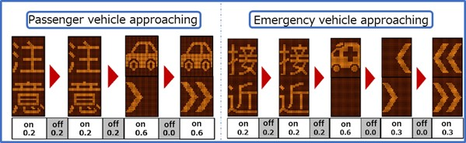
FIGURE A2.2.7 LED Display Image
※注意 -> “ Warning” “接近” → “Approaching”

- Automated driving support
Experiments for deployment have been conducted to verify the conditions and effectiveness of automated driving support using Cooperative Vehicle-Infrastructure ITS in several cities, as shown in TABLE A2.2.3. One example, Shiojiri city in Japan is shown in this section.

TABLE A2.2.3 Experiment locations
Location
Toyota city, Aichi
Kashiwa city, Chiba
Shiojiri city, Nagano
Sanda city, Hyogo
Numazu city, Shizuoka
Sakai town, Ibaragi
Kamishihoro town, Hokkaido
.
    - Background / Objective
The objective of this experiment is to clarify the validity of an available time in order to construct a system that provides safe and smooth right-turn support by notifying an automated driving vehicle of the available time on a non-visible route. An additional objective is to evaluate the accuracy of the estimated intersection arrival time of the target object, which is calculated by the Electronic Control Unit (ECU) of the automated driving vehicle using data such as the position and speed of the object detected by the roadside sensors at the intersection (refer to as transportation object data).

    - Method
FIGURE A2.2.8 shows the target non-visible intersection and the installed ITS Smart Pole. In the scenario where an automated driving vehicle enters from a non-priority route and turns right onto a priority route, the roadside sensors on the ITS Smart Pole detect a wide range of vehicles, bicycles, pedestrians, and other objects moving or existing along the priority route. This transportation object data is then delivered to the automated driving vehicle via V2I communication.

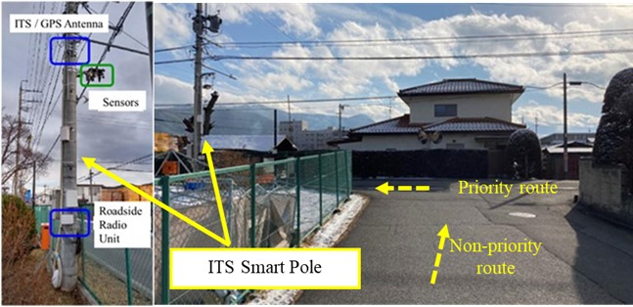
FIGURE A2.2.8 The target non-visible intersection and the installed ITS Smart Pole
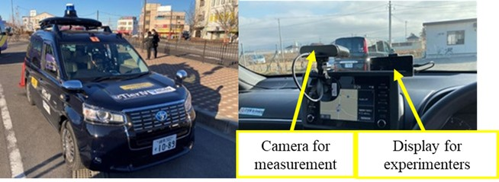
FIGURE A2.2.9 The automated driving vehicle, the display for experimenters and the camera for measurement

The ECU calculates the estimated intersection arrival time of the target object using transportation object data received via the on-board radio unit and notifies the display panel attached for the experimenter's confirmation in three stages according to the notification definitions in TABLE A2.2.4: "Vacant Notification", "Informative" and "Alert".
The shortest intersection arrival time is considered, with “shortest” referring to the need to notify the nearest object data approaching the intersection when multiple arrival times exist, such as when there are multiple objects are present on the priority route or when objects enter the intersection simultaneously from both directions. The study of the optimal vacant notification time focuses on the parameter “X” related to "Vacant Notification." This is important to ensure that the automated driving vehicle on the non-priority route does not perform emergency braking or cause near-miss incidents with vehicles traveling on the priority route during the right-turn maneuver. In this experiment, the optimal value of ”X” was examined by reproducing the aforementioned scenario using an experimental vehicle, while observing the behavior of the vehicles on the priority route and the evaluating driver's senses.

TABLE A2.2.4 Notification Definition of Right Turn Assistance Information
Notification Levels | Notification Definitions
Vacant Notification | The shortest intersection arrival time must be over “X” seconds.
Informative | The shortest intersection arrival time must be between 4.5 seconds and “X” seconds.
Alert | The shortest intersection arrival time must be less than 4.5 seconds.

In evaluating the estimated intersection arrival time of the target object, the error was calculated as the time difference between the estimated intersection arrival time calculated by the ECU and the actual intersection arrival time, which was measured using a camera.

    - Result
The time “X” as the vacant notification was defined as the sum of the time for the completion of the right turn by the automated driving vehicle and the distance of the vehicle following behind the automated driving vehicle after the completion of the right turn. This safety margin was designed to prevent emergency braking, near-miss incidents, and other unsafe situations. For the former right turn completion time, the duration was measured from the start of the right turn to the completion of the right turn after the automated driving vehicle temporarily stops at the stop line on the non-priority route and enters the priority route. The result showed that it took about 6 to 7 seconds. Therefore, by varying X to 8, 9, and 10 seconds, it was considered that the automated driving vehicle could safely perform a right turn from the non-priority route onto the priority route, while another experimental vehicle traveled on the priority route at the legal speed of 50 km/h.
Based on the evaluation conducted by the driver of the experimental vehicle considering factors such as driving behavior, near-miss incidents, and others safety-related effects during the right-turn operating, 10 seconds was determined to be the optimal value for the vacant notification time.
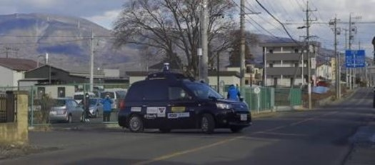
FIGURE A2.2.10 Right-turning scene of the automated driving vehicle

TABLE A2.2.5 shows that the error between the estimated intersection arrival time and the actual intersection arrival time was within 200 milliseconds in the two trials. As an additional experiment, right-turn operations were performed in automated driving mode after receiving right-turn assistance information that included a 200 millisecond error, in order to verify the system’s effectiveness. The results confirmed that the automated driving vehicle was able to make a right turn safely with the right-turn assistance information, and that the error was within the acceptable range for system operation.

TABLE A2.2.5 The Accuracy Results of Estimated Intersection Arrival Time
Item | Trial: #1 | Trial: #2
Estimated Intersection  Arrival Time | 9.5 s | 9.5 s
Actual Intersection  Arrival Time | 9.3 s | 9.6 s
Error | -200 ms | +100 ms

    - Summary
In the study of the optimal vacant notification time, 10 seconds was considered the most suitable value based on the evaluation from experimental driving. This duration was accounted for the time required to complete a right turn by the automated driving vehicle, plus a safety margin to avoid conflicts with following vehicles after the turn.
In evaluating the estimated intersection arrival time which was calculated using the transportation object data of objects detected by the roadside sensors at the intersection, it was confirmed that the error between the actual arrival time and the estimated arrival time calculated by the ECU was within 200 milliseconds. This error was found to be within the acceptable range of the system.
Finally, the effectiveness of the right-turn assistance information provided by the system was thus clarified.
- Support of collecting data for road management information on highway
Experiments for deployment have been conducted to verify the use case of support of collecting data for road management information on highway using Cooperative Vehicle-Infrastructure ITS in several locations as shown TABLE A2.2.6. One example, Tokyo in Japan is shown in this section.

TABLE A2.2.6 Experiment locations
Location
Metropolitan expressway
Tomei expressway
Shin-tomei expressway

    - Background / Objective
The objective of this project was to understand the communication range and explore the potential of utilizing it as a new data collection infrastructure by compiling and organizing the data actually collected via V2I communications in ITS Connect.

    - Method
An experimental vehicle equipped with a V2X OBU is prepared to receive OBU transmission messages from general vehicles equipped with V2X OBUs on urban/suburban roads and highways.
TABLE A2.2.7 shows an example of an OBU transmission message. By analyzing the reception logs, the potential communication range is calculated, and the methods for data utilization are further examined.

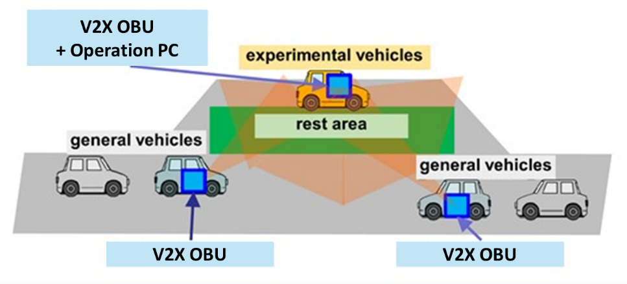
A vehicle equipped with an OBU is deployed in the experiment, assuming a roadside unit.
FIGURE A2.2.11 Diagram of experimental method diagram

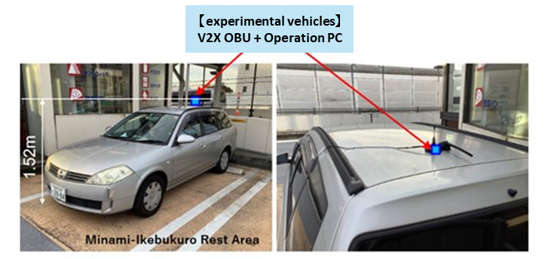
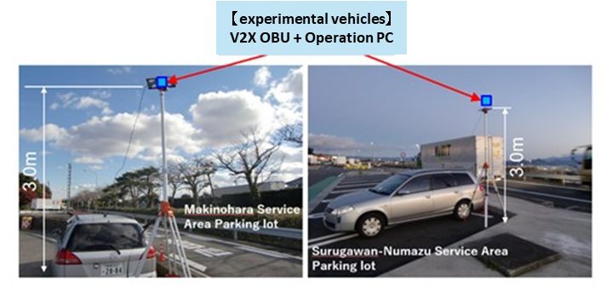
FIGURE A2.2.12 Picture of vehicle with V2X unit
V2X Antenna for OBU is used for roadside units and the characteristics are not optimized

TABLE A2.2.7 Example of OBU transmission message^{[6]}
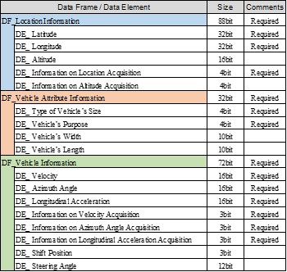

    - Result
FIGURE A2.2.13 shows the results of communication range verification. It illustrates the range of OBU transmitted messages reached by the experimental vehicle, indicating that communication is possible within a radius of over 1,000 meters.

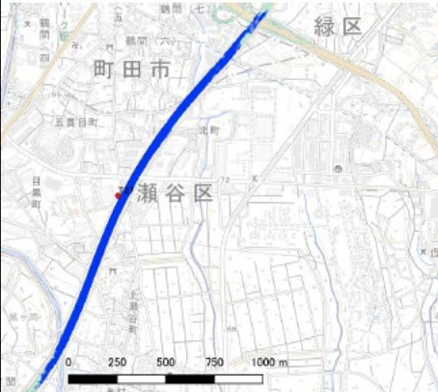
Communication range
Seya-ku,
Yokohama
Midori-ku,
Yokohama

Machida, Tokyo
FIGURE A2.2.13 Result of communication range verification (example)

FIGURE A2.2.14 shows an example of data utilization. It illustrates a plot of position versus speed data extracted from an OBU transmission message of a vehicle traveling on an expressway. Subfigure (a) displays the transmitted data from a vehicle traveling on the main line, and subfigure (b) displays the result of data transmitted from a vehicle entering a parking area.
The figure indicates that the decrease in speed is more pronounced the vehicle parked in the parking area (right) compared to the vehicle traveling on the main line (left). Since such changes in vehicle speed can be continuously collected, it is possible to collect and understand speed variations caused by traffic accidents and fallen objects in real time.

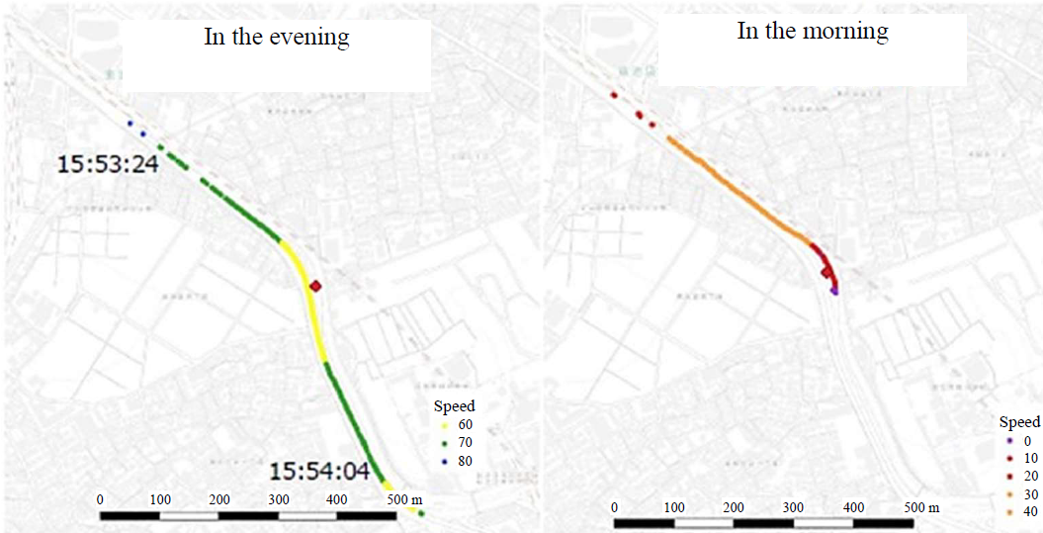
[km/h]
[km/h]
- Cars traveling on the main line (b) Cars entering a parking area
FIGURE A2.2.14 Visualization results of velocity change

    - Summary
Based on the data obtained through this experiment and the aggregated results, it was confirmed that ITS Connect can be used to collect high-resolution data from individual vehicles over a communication range of 1,000 meters or more. However, this was under condition where the wireless environment, including the antenna setup, was not optimized. If the wireless environment is favorable, communication range of 2,000 meters or more can be achieved. For reference, the data shown in FIGURE A2.2.15 has also been obtained. Furthermore, the visualization of the speed changes demonstrated the potential for utilizing the collected data effectively.

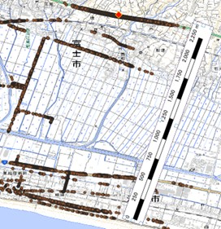
Communication range
Fuji, Shizuoka
FIGURE A2.2.15 Result of communication range (example)

Annex 3 Cases in India

India has published a Technical Report (TEC 31218:2023) on “Technologies and Standards for Intelligent Transportation Systems”. The report discussed many use-cases considered in India and information about those use-cases are provided below. Further, initial trials and experiments conducted in India relevant to use-cases in Section 8 of this report are also provided below.

A3.1 Use-cases discussed in the context of India in the Technical Report
- Transactional Applications:
  - Tolling Related Applications
  - Restricted access at a certain time-period or permanently.
  - Data Collection / Monitoring
  - Speed Limit Violation
- Emergency/VIP Vehicles:
  - Traffic Light Related Applications like Traffic Light Information, Request for preemption (helpful in setting up green corridors)
- Safety broadcast information:
  - Traffic congestion alerts etc.
  - Public service information.
  - Bad Road / Roadworks warning.
  - Disaster Zone communication.
- Enabler of Services:
  - V2X as a sensor to work in combination with other sensors at Edge/Cloud where applications can run based on sensor fusion.

A3.2 R&D Use-cases and Trials for V2X in India

A.3.2.1 Trial 1: Green Corridor for Emergency Vehicles using V2X Infrastructure
A trial was conducted to integrate the VMSs (Variable Message Sign) along with existing and new signaling systems using V2X infrastructure to enable a ‘green corridor’ for emergency vehicles such as ambulance. This allowed the changing of red signal cycle to green and extending green signal cycle to provide priority passage for such emergency vehicles.

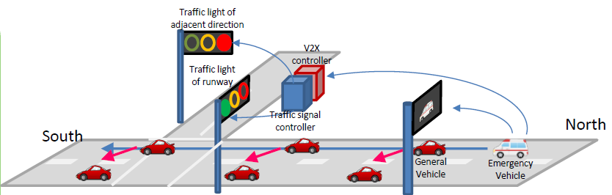

A.3.2.2 Trial 2: Research Demonstration of V2X (Vehicle-to-Everything) Communication

Some of the use case scenarios showcased were:

- Ambulance Alerting System: Car drivers are alerted about an approaching emergency vehicle and its path through V2X communication. It helps the driver to safely plan maneuvers and make way for an emergency vehicle. The alert system will also share minute details like the distance between the vehicles on a real-time basis.
- Wrong-way Driver Alerting system: Car drivers get a pre-alert about the existence of a wrong way-driver approaching using V2X communication.
- Pedestrian Alerting System: This alert assists car drivers about a pedestrian nearby, using V2X communication, who could be coming in the way of the car. This will help the drivers to take precautionary measures to avoid a potential collision.
- Motorcycle Alerting System: Car drivers learn through V2X communication about a fast-moving 2-wheeler approaching from a blind spot and likely to collide. Real-time information is shared with the driver about the distance and direction of the approach.
- Road Condition Alerting System: A driver receives an alert of bad road conditions and cautions the driver to tread carefully ahead in the journey.
- Car as a computer: Enables all interested car users to share the idle computing capacity of the microprocessor in the car when it is not being used for driving.

Automated driving levels are defined by several authorities in the world. In this report, the levels are referred to SAE J3016 APR2021^{[7]} which provides a taxonomy with detailed definitions for six levels of driving automation, ranging from no driving automation (Level 0) to full driving automation (Level 5).
https://www.arib.or.jp/english/html/overview/doc/5-STD-T109v1_3-E1.pdf
Technical Report TEC 31218:2023: “Technologies and Standards for Intelligent Transport System”, https://tec.gov.in/public/pdf/M2M/TR_Technologies%20and%20Standards%20for%20Intelligent%20Transport%20System.pdf

