

APT REPORT ON

WAS/RLAN TECHNOLOGY DEVELOPMENT AND
IMPLEMENTATION ASPECTS

Edition: April 2026

The 36th Meeting of APT Wireless Group
6 – 10 April 2026
Bandar Seri Begawan, Brunei Darussalam (Hybrid)

(Source: AWG-36/OUT-15)

No. APT/AWG/REP-144(Rev.2)

APT REPORT ON
WAS/RLAN TECHNOLOGY DEVELOPMENT AND
IMPLEMENTATION ASPECTS

Table of Contents
Table of Contents Page
1. Scope 4
2. Introduction 4
3. Abbreviations and acronyms 5
4. Technologies used for WAS/RLAN 6
5 Use cases for WAS/RLAN 9
6 Spectrum considerations and Implementation aspects for WAS/RLAN networks 12
7. References 17
8. Annexures 18
Annex 1: Technology features in IEEE 802.11 for WAS/RLAN 19
Annex 2: Technical features in SparkLink 28
Annex 3: Channel and Spectrum usage of 3GPP technologies 30
Annex 4: Questionnaire Responses 32
Annex 5: Regulatory Information from outside APT Region 63
Annex 6: Study by Ericsson: Considerations on WAS/RLAN Spectral Efficiency 66
Annex 7: Study by Comtel: RLAN Throughput measurement in 2.4 GHz, 5 GHz and lower 6 GHz bands 69
Annex 8: Study by GSMA on Distribution of Wi-Fi 76

1. Scope
This Report provides an overview of technology developments and implementation aspects of license-exempt Wireless Access Systems, and Radio Local Area Networks (WAS/RLAN). It reviews the technology evolution and spectrum considerations in relevant frequency bands as below.
- 5.0 GHz band –Portions of 5150-5925 MHz (5 150-5 250 MHz, 5 250-5 350 MHz and 5 470-5 850 MHz)
- Lower 6GHz Band –5925-6425 MHz (or portions thereof)
- Upper 6 GHz Band –6425-7125 MHz (or portions thereof)
- 60GHz band- from 57-71GHz (or portions thereof)
RLAN technologies covered in this report are mainly based on the Recommendation ITU-R M.1450 “Characteristics of broadband radio local area networks,” which contains characteristics of RLAN standards.

2. Introduction
Multiple technologies operate in the Radio Local Area Networks (RLAN) domain. These technologies, following various standards, play a significant role in broadening wireless connectivity options for users by expanding access and optimizing resource utilization through the use of unlicensed or locally licensed spectrum. This offers an opportunity to support innovation, competition, and inclusivity within the wireless landscape, which can lead to enhanced accessibility and efficiency in wireless communications.

In today's hyper-connected world, unlicensed WAS/RLAN has become an indispensable part of our daily lives, enabling seamless communication, collaboration, and access to information. WAS/RLAN networks provide ubiquitous connectivity, allowing users to access the internet and communicate wirelessly across a wide range of devices, including smartphones, laptops, tablets, IoT devices, and more. WAS/RLAN enables users to connect to the internet and local networks without the constraints of physical cables, enhancing mobility and flexibility in various environments, such as homes, offices, public spaces, and outdoor areas. WAS/RLAN networks can easily be scaled to accommodate growing numbers of users and devices, making them a cost-effective solution for both individuals and organizations. WAS/RLAN has evolved into critical infrastructure for modern society, supporting essential services such as education, healthcare, business operations, and emergency communications. WAS/RLAN plays a pivotal role in enabling connectivity, fostering innovation, and driving economic growth worldwide. Global harmonization of spectrum allocations and economies of scale are essential factors that contribute to the successful deployment and widespread adoption of unlicensed WAS technology, ensuring its continued evolution and relevance in the digital age.

Economies of scale enable manufacturers to achieve lower production costs per unit by scaling up production volumes, resulting in more affordable unlicensed WAS devices and equipment for consumers and businesses. Lower costs and increased availability of unlicensed WAS technology due to economies of scale encourage widespread adoption and deployment of unlicensed WAS networks, benefiting both end-users and service providers. Economies of scale incentivize continued innovation and advancement in unlicensed WAS technology, driving the development of more efficient, reliable, and secure wireless networking solutions.

The extension of 3GPP technologies into unlicensed spectrum bands stems from years of collaborative efforts across diverse industries and technical domains. These efforts have led to the development of New Radio Unlicensed (NR-U) as a suitable option for RLAN. Through extensive engagement in standards and regulatory discussions, experts from cellular technologies based on 3GPP standards and Wi-Fi technology based on IEEE standards have contributed to this achievement. NR-U's operation within the unlicensed spectrum offers expanded access, particularly in areas where traditional Wi-Fi coverage may be lacking. Moreover, the potential for enhanced coverage and throughput in unlicensed spectrum is further bolstered by carrier aggregation, which integrates carriers from licensed and unlicensed spectrums to optimize channel utilization and reliability.

3. Abbreviations and acronyms

Acronyms | Definition
AFC | Automated Frequency Coordination
AP | Access Point
BEL | Building Entry Loss
BSS | Basic Service Set
DFS | Dynamic Frequency Selection
DUT | Device Under Test
EIRP | Equivalent Isotropically Radiated Power
FS | Fixed Service
FSS | Fixed Satellite Service
LPI | Low Power Indoor
MLO | Multi-Link Operation
PL | Path Loss
RAS | Radio Astronomy Services
RX | Receiver
SP | Standard Power
TX | Transmitter
ULS | Universal Licensing System
VLP | Very Low Power
Wi-Fi | Wireless Fidelity
FSS | Fixed Satellite Service
IMT | International Mobile Telecommunications
WRC | World Radiocommunication Conference
LTE | Long Term Evolution
RLAN | Radio Local Area Network, also known as WLAN or Wi-Fi
WAS | Wireless Access System
NR | 5G New Radio
IEEE | Institute of Electrical and Electronics Engineers
3GPP | The 3rd Generation Partnership Project
NR-U | 5G NR in unlicensed spectrum
SON | NR Self-Organizing Networks
TSN | Time-sensitive Networking
IIoT | Industrial Internet of Things
eURLLC | enhanced Ultra-reliable Low-latency Communications

4. Technologies used for WAS/RLAN
4.1 Wi-Fi Technology for WAS/RLAN networks
Since Wi-Fi was first released to consumers in 1997, Wi-Fi standards have been continually evolving – typically resulting in higher throughput, more capacity and increased coverage. In recent years, the Wi-Fi standards body, IEEE 802.11, developed several generations of Wi-Fi standards, commercially known as Wi-Fi 6/6E (802.11ax), and Wi-Fi 7 (802.11be). From Wi-Fi 6E, the frequency range has been extended to 6 GHz (5925-7125 MHz) to address the increasing traffic demand and device density.

Wi-Fi 6E/7 can support multi-gigabit speeds, larger numbers of channels, and millisecond levels of latency.

Wi-Fi 7, also known as Extremely High Throughput (EHT), increases peak data rates to over 40 Gb/s by using 320 MHz channels and 4K QAM modulation. In addition, Wi-Fi 7 also further reduces the network latency and improves link robustness in the presence of interference via features such as Multi-Link Operation (MLO).

Work for the next generation, 802.11bn (Wi-Fi 8), is already on the agenda of the IEEE 802.11 working group. IEEE 802.11bn focus on Ultra High Reliability (UHR) communication in RLAN networks. UHR is a newly established Study Group within the IEEE 802.11 working group that will investigate PHY and MAC technologies to improve reliability of WLAN connectivity, reduce latencies, increase manageability, increase throughput including at different SNR levels and reduce device level power consumption.

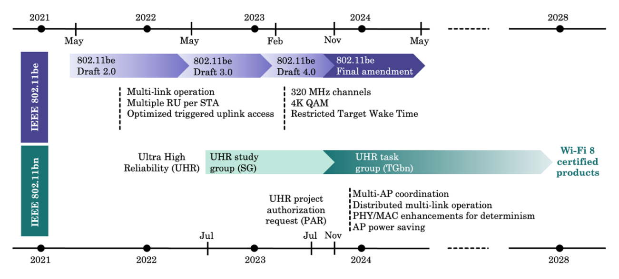
Current standardization, and commercialization timelines for IEEE 802.11be (top) and IEEE 802.11bn (bottom).

More stringent requirements are emerging to meet the demands of new applications (e.g. augmented and virtual reality, proximity ranging and sensing) both in terms of throughput, latency bounds and accuracy. The very large bandwidth available in the unlicensed bands between 42 GHz and 71 GHz, is a great opportunity to help meet these requirements even in the densest environments.

IEEE 802.11 working group also starts the standardization work for the next generation millimeter wave Wi-Fi, P802.11bq (Integrated Millimeter Wave). P802.11bq will define standardized modifications to both the IEEE Std 802.11 physical layer (PHY) and the IEEE Std 802.11 Medium Access Control (MAC) that allows Wireless Local Area Network (WLAN) non-standalone operation in unlicensed bands between 42 GHz and 71 GHz. This amendment leverages or reuses existing PHY and MAC specifications, e.g. SU transmission PPDU format and MAC frames, and defines bandwidth modes operating in non-overlapping channels.

Wi-Fi technology uses license-exempt spectrum and must allow adjacent uncoordinated networks to coexist whilst providing high service quality to users.

4.2 SparkLink – Towards Next Generation Short Range Connectivity for Future Intelligent connected world
The trend towards wirelessness is gradually extending from traditional communications and electronics to various emerging areas. Long cables are dropped and unnecessary renovations are reduced. There is no physical disruption to existing devices, houses or the complex operation of deploying cables. Instead, all possible connected devices, terminals, everything, using high-speed, low-latency, stable and reliable wireless transmission.
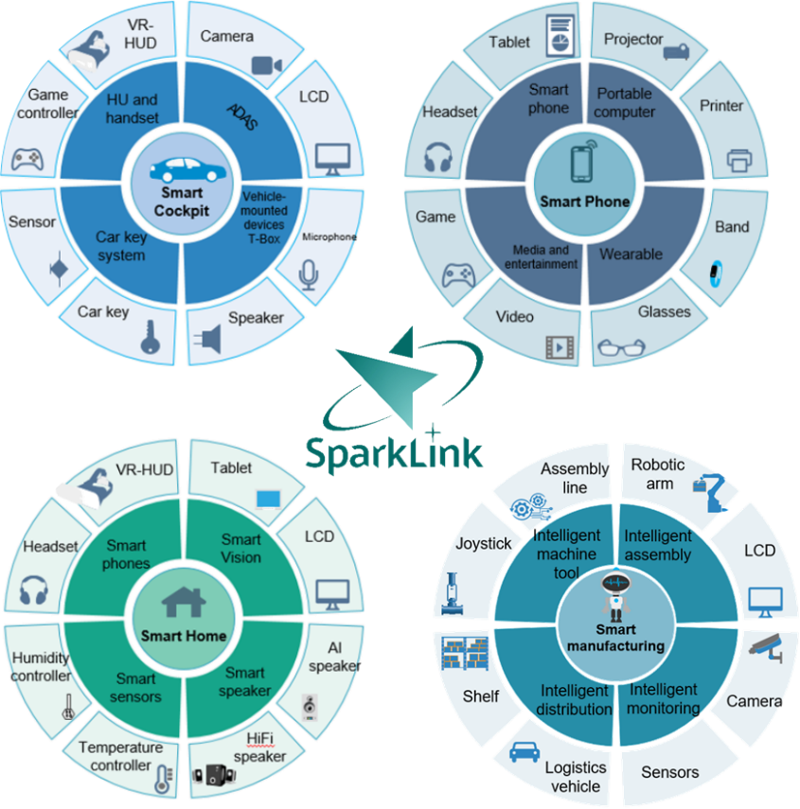
Figure 9 Application scenarios of SparkLink
In the smart cockpit of the future, there will be more and more wirelessly-enabled connections to drive screens, microphones and cameras to work. The various types of furniture in the home will use high-precision wireless control to do their job. Curtains will automatically open when the floor sweeper walks across the floor to prevent being rolled into the machine. The colour of the ambient light will change according to the position of you and your phone, creating a better home experience. Machinery and equipment in factories are free to be controlled precisely by wireless signals, working in tandem with sensors to be efficient and stable. These are all great ideas for the future, but they also pose serious challenges to existing wireless technologies.
The SparkLink technology is dedicated to this, offering a new wireless connectivity experience. This technology is capable of providing ultra-low latency, ultra-high speed, ultra-reliable and ultra-precisely synchronized wireless transmission to provide better short-range wireless connectivity for smart cockpits, smart homes, smart terminals and smart manufacturing, especially in case of dense deployed scenarios. The detailed introduction of SparkLink technology refers to Annex A2.
This technology is developed by International SparkLink Alliance, which is an initiative of communications manufacturers, vehicle manufacturers, module manufacturers, chip manufacturers and application providers. The International SparkLink Alliance has released the SparkLink1.0 series standards and is working on the 2.0 series. As of July 2024, more than 1,000 entities have joined the SparkLink Alliance.

4.3 3GPP Advancements in 5G New Radio Unlicensed (NR-U)

The groundwork for deploying 5G New Radio (NR) in unlicensed spectrum, referred to as NR-U, began with 3GPP Release 16. Following Release 16, more recent Releases 17 and 18 have further refined NR-U functionalities. They have integrated features such as NR-U downlink/uplink channel occupancy reporting to support data collection for NR Self-Organizing Networks (SON) features [13]. Additionally, new deployment options for SON are introduced, including non-public (private) networks, expanding deployment possibilities within the 5G landscape.
Furthermore, 3GPP Release 17 ensures that NR-U defined procedures for operation in unlicensed spectrum will also apply to the unlicensed 60 GHz band. Specifically, NR-U operation in the 52.6 GHz to 71 GHz range can occur either in stand-alone mode or aggregated via carrier aggregation (CA) or dual connectivity (DC) with an anchor carrier, utilizing the existing NR downlink/uplink waveforms to accommodate new licensed and unlicensed frequency bands within this spectrum. However, operating within these bands does impact various aspects of the NR radio, including signal phase noise characteristics, transmitter linearity, power efficiency, and receiver noise figure, among others. Nevertheless, 3GPP has validated that implementing new advanced phase noise cancellation algorithms will sufficiently strengthen the physical layer, including the existing phase tracking reference signal and a sub-carrier spacing of 120 kHz, to support this extended frequency range. Moreover, an increased sub-carrier spacing of up to 960 kHz has been specified, enabling 3GPP to leverage even wider carriers of up to 2 GHz, consequently expanding the range of achievable data rates [14].

5. Use cases for WAS/RLAN

Multi-gigabit WAS/RLAN venue capacity

Wide spectrum allows for a large number of wide band channels. This can help to avoid the excessive collisions and contention for airtime that has become normal in venue such as arena.

Industrial and campus network

Because of their inherent features like flexibility, scalability, low latency, deterministic throughput, and ease of installation, Wi-Fi 6E and Wi-Fi 7 would be connectivity enablers of Industry 4.0. They will be utilized for direct control of machines and other industrial appliances. Managing and monitoring of the rapidly reconfigurable, connected factories will become a reality.

The Health Care sector will also realize significant advancements from Wi-Fi 6E and Wi-Fi 7. With the introduction of the wide channel, guest traffic and enterprise traffic can be carried on different radios and on different channels. Thus, high priority clinical network traffic is not impeded by competing general use traffic – such as guest Internet access. High capacity and low latency Wi-Fi 6E/7 will act as enablers of Advanced Medical tools, devices and smart medical wearables. Monitoring and managing hospitals using these digital technologies, will become more accurate, faster and more reliable.

Public Transport system, high density client devices environment

The transport sector will certainly experience massive improvements in connectivity after the deployment of WAS/RLAN in the wide channel. This is evidenced by the recent WAS/RLAN network upgrade in Seoul. The average WAS/RLAN speed on Seoul subway trains was 71 Mbps, which is significantly lower than the download speeds in Seoul’s subway stations, where commuters can expect a blistering 367 Mbps download speed. In 2022, the mobile carriers in the Republic of Korea installed Wi-Fi 6E routers on board the subway trains, together with mmWave base stations along the tracks for Wi-Fi 6E backhaul and ten mmWave customer premises equipment (CPE) on the trains themselves. According to the Ministry of Science and ICT, with the introduction of Wi-Fi 6E, subway commuters will have a more reliable internet connection, with speeds 10 times faster than the previous WAS/RLAN.

Low-latency WAS/RLAN calling, video conference and Augmented Reality /Virtual Reality (AR/VR)

Low latency is key to seamless experiences in real-time applications like videoconferencing and gaming. The wideband channels band will enable time-sensitive services like high definition audio and video conferencing. It will also support technologies like Virtual Reality, Cloud Gaming and Interactive Applications.

Today, AR and VR are changing both businesses functions and personal entertainment. From education and ecommerce to healthcare and construction, AR/VR can help to reduce training and operational costs and improve the productivity of workers and students.

AR/VR applications require high throughput and sub 10ms levels of latency. A delay in transmission/reception can cause problems for many, including desynchronization between connected devices that can disrupt the expected behaviour. These performance requirement will only be achieved with multiple wideband WAS/RLAN channels.

Rural/Remote Communities’ connectivity

WAS/RLAN is one way to provide connectivity to rural and remote communities. The high data rates, ease and lower cost of deployment, and lower operational and maintenance costs are critical factors in driving the deployment of WAS/RLAN license-exempt technologies to rural and remote communities, particularly for less developed countries (LCDs) and small Island States in the Pacific region

Rural and remote communities are embracing technology solutions that help them become "smart communities." These solutions use WAS/RLAN systems to meet connectivity needs in community-based health clinics, schools, agricultural cooperatives, and local social and economic activities.

A high-capacity data link can be established to a central point with a fiber point of presence, a satellite link or a microwave point-to-point to provide backhaul connectivity. If necessary, this data link could then be reticulated throughout the township via WAS/RLAN. This method of broadband access is beneficial for remote towns/villages and low-income communities, given the lowering cost of satellite access, making this approach more practical where there is an acute need for broadband access but not a large enough market to justify licensed spectrum or wired solutions.

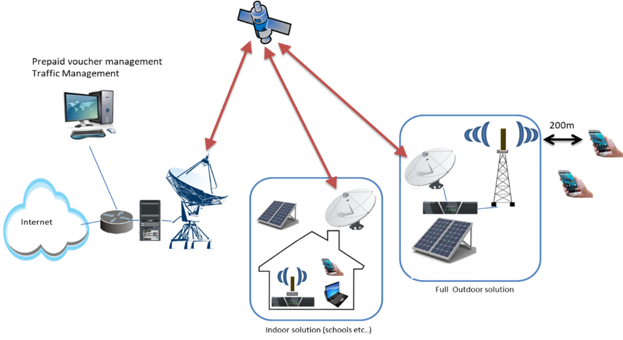

Industrial and campus network
Additionally, numerous industrial applications rely heavily on time-sensitive networking (TSN) due to its guaranteed low latency. 5G provides a standardized framework to integrate existing TSN networks. Additionally, several other 5G features beneficial for Industrial Internet of Things (IIoT), such as synchronized sharing, multiple transmission and reception points (multi-TRP) with coordinated multi-point transmissions (CoMP), and enhanced ultra-reliable low-latency communications (eURLLC), can be implemented alongside NR-U.

Use of FTTR and WAS/RLAN
The fixed network feeding the Wi-Fi access points is actually the bottleneck of Wi-Fi performance. Fiber is delivered to the floor of a building, and then connected to each apartment via DSL or Ethernet or dropped fiber inside the home. End use will further use access point to expand Wi-Fi coverage in the home. Nevertheless, in very densely-populated cities, subscribers often ran into channel contention issues, reducing the throughput of their Wi-Fi connections.
To solve these issues, operators realized that the only way they could guarantee consistent throughput throughout the home was to extend fiber to each room. Fibre to the Room (FTTR) is a new technology that brings high-speed Wi-Fi directly to each room, through fibre optic cables wired to the room. By extending fiber inside homes and into individual rooms through a unique combination of a centralized ONT (Optical Network Terminal) and subtended ONT access points, advanced speed of Wi-Fi connections in each room of a home can be ensured. FTTR could solve some of the pesky channel interference issues seen with Wi-Fi in densely-populated environment.
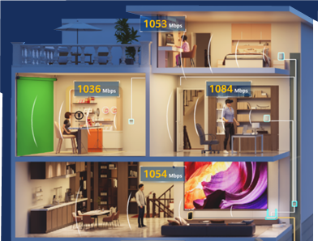
Figure x: Combination of FTTR and Wi-Fi
It’s reported that the combination of FTTR plus Wi-Fi 6 improves overall speeds by up to 80% over previous-generation Wi-Fi 5 access points. With FTTR + Wi-Fi 6 combination, data rate can reach beyond 1000 Mbps, and full signal coverage in the entire house can be provided.

6 Spectrum considerations and Implementation aspects for WAS/RLAN networks
6.1 Spectrum and Regulatory Aspects of WAS/RLAN networks
Presently, several unlicensed frequency bands have been allocated for WAS/RLAN.
The frequency range for the use of RLAN may vary depending on each administration’s decision and should strictly comply with the national regulation decisions. In the international context, administrations wishing to implement RLAN are subject to compliance with the provisions of the Radio Regulations. Some administrations have considered WAS/RLAN operation on an unlicensed or license-exempt and a non-interference, non-protected basis as outlined in their national regulation and without engaging with other administrations in this regard.
According to RR FN. 5.150, 2.4GHz is designated for industrial, scientific and medical (ISM) applications. Radiocommunication services operating within these bands must accept harmful interference which may be caused by these applications. ISM equipment operating in these bands is subject to the provisions of No. 15.13.
On 5GHz, Resolution 229(WRC-19) defines the “Use of the frequency bands 5 150-5 250 MHz, 5 250-5 350 MHz and 5 470-5 725 MHz by the mobile service for the implementation of wireless access systems including radio local area networks”. Multiple conditions were defined for the use of RLAN in 5GHz band in order to protect the other radio communication services in the band, see more details in section 7.1.1.
Some administrations allocated entire 6 GHz from 5925 – 7125 MHz, as unlicensed 3rd frequency band for WAS/RLAN. So, a contiguous 1200-megahertz block of spectrum is now available in some countries for the development of new and innovative high-speed, short range WAS/RLAN devices.

6.2 Use of channels in the 5 GHz band

WAS/RLAN use of license-exempt spectrum in the 5 GHz band. Some of the available channels either have Dynamic Frequency Selection (DFS) requirements to protect military and meteorological radars in these frequencies, or are limited to indoor use only.

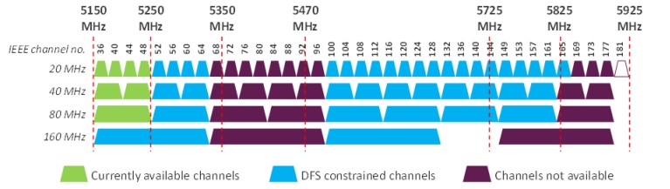
Figure 2 WAS/RLAN channels in the 5 GHz band
At the World Radiocommunications Conference 2019 (WRC-19), the Radio Regulations were amended to allow limited outdoor WAS/RLAN use in the 5.15 – 5.25 GHz band: up to 1W with controlled use and by implementing antenna elevation masks that limit EIRP in the direction of satellite space stations.

Resolution-229 (WRC-19) provides guidance for administrators who want to deploy higher-power outdoor WAS/RLAN services in 5.15 – 5.25 GHz. This Resolve gives administrations flexibility to permit WAS/RLAN stations, for indoor or controlled outdoor use, to operate up to a maximum EIRP of 30 dBm, while also mitigating the interference risk to Fixed Satellite Service (FSS) Earth-to-space communications with an EIPR mask at certain elevation angles.

More detail information of use of 5GHz band for WAS/RLAN in APT countries can be found in annex A4.

For 5725 - 5850 MHz, some regulators have decided to relax the DFS requirements from indoor use of WAS/RLAN in the frequency.

6.3 Use of WAS/RLAN in 6 GHz band (or portions thereof)
6.3.1 Equipment Classes for 6 GHz License-Exempt Operation
Wi-Fi 6E defines three separate operating classes for Wi-Fi 6E access points: Low Power Indoor (LPI), Standard Power (SP), and Very Low Power (VLP) to assist in coexistence with licensed incumbent services. Client device technical characteristics are a function of the type of access point they are connected to.
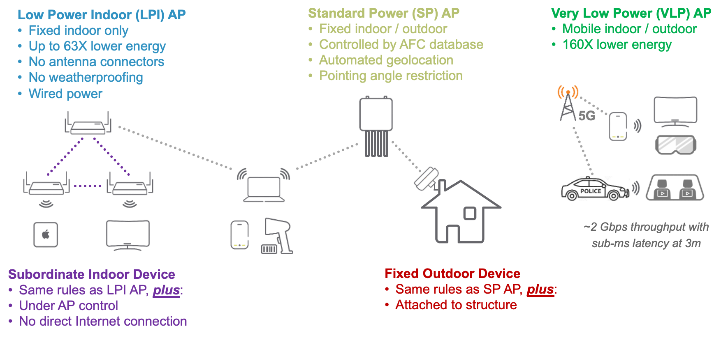
Figure 6 Device Classes in 6 GHz
Low Power Indoor Class

The most popularly used device class for Wi-Fi 6E is LPI. These will be the familiar home or enterprise APs and clients. By definition, these devices are indoors and are shielded by buildings to some extent so the power that leaks outside will be attenuated, which allows safe operation across the band at a power level only slightly lower than 5 GHz indoor Wi-Fi APs.
Depending on the regulatory requirement, LPI equipment can operate at a maximum EIRP of 23 dBm, 24 dBm or 30 dBm and is often defined in terms of a Power Spectral Density (PSD) of dBm/MHz. To ensure that these indoor-only units are not used outdoors, or with external high-gain antennas (which has the potential to cause interference), regulators typically provide a list of physical requirements for certifying an LPI AP:

- No battery-powered operation
- Not weatherized
- Labeled for indoor use only

To further improve spectral efficiency and performance, direct communication between client devices (Client to Client) communications are also authorized by some regulators and under consideration by others.

Standard Power Class

The EIRP of a Standard Power AP is up to 36 dBm. Because of the increased risk of interference with incumbent services from a higher EIRP, there are certain regulatory requirements for SP APs to operate. First, depending on the incumbent service types, SP APs are only allowed to operate in the certain frequency ranges within the overall 6 GHz band. Secondly, operation of SP requires an Automatic Frequency Coordination (AFC) service to calculate the channel availability and allowed EIRP at a specific location.

The AFC query-response protocol has been defined by the Wi-Fi Alliance and consists of an inquiry message from the AP and a response from the AFC server. An important information element in the inquiry is the AP’s geolocation. There is no single method to accurately determine the AP’s location; it is assumed that GPS or some other robust and reliable method is used. The AFC uses the AP’s latitude, longitude, antenna height (above ground level) and some other information in the registration and inquiry messages, to calculate and provide to the AP a response containing the set of channels or frequency ranges and the maximum permissible power levels at which it may transmit without creating interference to nearby incumbent services.

According to the reply of the APT member countries (see annex A4), the databases in most of those countries are not open to public. For the AFC implementation, the database may not need to be open to public

Very Low Power Class

VLP devices can operate both indoor and outdoor. This allows use cases like mobile APs, mounted in vehicles or hotspots on smartphones. In most countries and regions, the maximum EIRP for a VLP AP is 14 dBm, with a PSD limit of 1dBm/MHz.

Client Devices

Client devices are expected to be limited in geography by APs. If there is no AP signal, devices cannot connect and will not transmit. Therefore, it is assumed that the AP is transmitting in an authorized manner, and the client can adjust its transmit power and channel with reference to the AP.

6.3.2 Technical conditions for authorizing WAS/RLAN in the 6 GHz frequency band

When making 6 GHz frequency band available for WAS/RLAN under a general authorization / licence exemption / unlicensed regimes technical conditions need to be applied for coexistence with existing radio systems, particularly fixed links. There are different options that have been applied by regulators and regions these options are contained below.
Many administrations allowed entire 6 GHz band from 5925 -7125 MHz band for the use of unlicensed Wi-Fi, with two types of operation.

- Authorizing unlicensed standard-power access points, through use of an AFC system. The AFC is designed to protect devices with fixed locations.
- Opening the entire 6 GHz band for unlicensed indoor low power access points. By authorizing use of the entire 6 GHz band for indoor use, so 59 channels of 20 MHz or 29 channels of 40 MHz or 14 channels of 80 MHz or 7 channels of 160 MHz channels or 3 channels of 320 MHz are possible to expand capacity and performance capabilities.

6.3.3 Regulatory information for use of 6 GHz band

Some APT countries allowed the use of RLAN in 6 GHz band (or portions thereof), detail information can be found in annex A4.

6.4 Sharing with incumbent services in the 6 GHz band
The 5925 – 7125 MHz frequency range is primarily allocated to Fixed Service (FS), Fixed Satellite Service (FSS) and Mobile Service (MS). The 6650 – 6675 MHz frequency range is also used by the Radio Astronomy Service (RAS). Although there is no primary allocation, ITU Radio Regulation requires administration to protect RAS at 6650-6675.2 MHz in its footnote 5.149.

6.4.1 Usage of the 5925 – 7125 MHz spectrum
As per the Radio Regulation, 2020, 6 GHz has been allocated for the following services
S.  No. | Frequency Band | Allocated on Primary basis | Region
1 | 5925 – 6700 MHz | FIXED,  FIXED SATELLITE (Earth to space),  MOBILE | Globally
2 | 6700 – 7075 MHz | FIXED,  FIXED SATELLITE (Earth to space),  MOBILE | Globally
3. | 7075 – 7125 MHz | FIXED,  MOBILE | Globally

As per the results of WRC-23, the frequency bands 6425-7125 MHz in Region 1 and 7025-7125 MHz in Region 3 are identified for IMT, and the frequency band 6425-7025 or 6425-7125 MHz in some countries is identified for IMT on the basis of country footnotes applied to all regions.
In addition, texts on the implementation of WAS/RLANs are added in the Radio Regulations: “The frequency bands are also used for the implementation of wireless access systems (WAS), including radio local area networks (RLANs).”
6.5 New spectrum in 60 GHz band (or portions thereof)
More stringent requirements are emerging to meet the demands of new applications (e.g. augmented and virtual reality, proximity ranging and sensing) both in terms of throughput, latency bounds and accuracy. The very large bandwidth available in the unlicensed bands between 42 GHz and 71 GHz, is a great opportunity to help meet these requirements even in the densest environments.

IEEE 802.11 working group defined 802.11ad and 802.11ay for Wi-Fi(WiGig) use in the 60GHz. Some countries allowed the portions of 57-71GHz for WiGig. IEEE 802.11 working group also starts the standardization work for the next generation millimeter wave Wi-Fi, P802.11bq (Integrated Millimeter Wave). P802.11bq will define standardized modifications to both the IEEE Std 802.11 physical layer (PHY) and the IEEE Std 802.11 Medium Access Control (MAC) that allows Wireless Local Area Network (WLAN) non-standalone operation in unlicensed bands between 42 GHz and 71 GHz. This amendment leverages or reuses existing PHY and MAC specifications, e.g. SU transmission PPDU format and MAC frames, and defines bandwidth modes operating in non-overlapping channels.

7. References
- Aruba Whitepaper - Technical Guide to Wi-Fi 6E and the 6 GHz band.
https://www.hpe.com/psnow/doc/a00114649enw?jumpid=in_lit-psnow-red
- IEEE Standard for Information technology--Telecommunications and information exchange between systems Local and metropolitan area networks--Specific requirements Part 11: Wireless LAN Medium Access Control (MAC) and Physical Layer (PHY) Specifications," IEEE Std 802.11-2020
https://ieeexplore.ieee.org/document/9363693
- IEEE Standard for Information technology--Telecommunications and information exchange between systems Local and metropolitan area networks--Specific requirements Part 11: Wireless LAN Medium Access Control (MAC) and Physical Layer (PHY) Specifications," IEEE Std 802.11ax-2021
https://ieeexplore.ieee.org/document/9442429

- FCC-20-51A1, In the Matter of Unlicensed Use of the 6 GHz Band Expanding Flexible Use in Mid-Band Spectrum Between 3.7 and 24 GHz, REPORT AND ORDER AND FURTHER NOTICE OF PROPOSED RULEMAKING, Adopted: April 23, 2020 Released: April 24, 2020. https://docs.fcc.gov/public/attachments/FCC-20-51A1.pdf
- Frequency Sharing for Radio Local Area Networks in the 6 GHz Band, January 2018, Version 3, RKF Engineering Solutions https://broadbandindiaforum.in/wp-content/uploads/2021/11/Frequency-Sharing-for-RLANs-in-the-6GHz-band-in-India_Accessible.pdf
- ECC Report 302, Sharing and compatibility studies related to Wireless Access Systems including Radio Local Area Networks (WAS/RLAN) in the frequency band 5925 - 6425 MHz. https://docdb.cept.org/document/10170
- Recommendation ITU-R RA.769-2: "Protection criteria used for radio astronomical measurements" https://www.itu.int/dms_pubrec/itu-r/rec/ra/R-REC-RA.769-2-200305-I!!PDF-E.pdf
- M. Mehrnoush, C. Hu and C. Aldana, "AR/VR Spectrum Requirement for Wi-Fi 6E and Beyond," in IEEE Access, vol. 10, pp. 133016-133026, 2022, doi: 10.1109/ACCESS.2022.3231229. https://benthamscience.com/article/133051
- Cisco Whitepaper - IEEE 802.11ax: The Sixth Generation of Wi-Fi White Paper. https://www.cisco.com/c/en/us/products/collateral/wireless/white-paper-c11-740788.html
- Intel Corporation – Next generation Wi-Fi - Wi-Fi 7 and beyond https://www.intel.com/content/dam/www/public/us/en/documents/pdf/wi-fi-7-and-beyond.pdf
- Giordano, L. G., Geraci, G., Carrascosa, M., & Bellalta, B. (2023). What Will Wi-Fi 8 Be? A Primer on IEEE 802.11 bn Ultra High Reliability. arXiv preprint arXiv:2303.10442. https://arxiv.org/abs/2303.10442
- Recommendation ITU-R M.1450: “Characteristics of broadband radio local area networks” https://www.itu.int/dms_pubrec/itu-r/rec/m/R-REC-M.1450-4-201004-S!!PDF-E.pdf
- 3GPP, TS 38.300, “NR and NG-RAN Overall Description; Stage 2 (Release 18),” 2023. https://www.3gpp.org/technologies/5g-system-overview
- 3GPP, TR 38.808, “Study on supporting NR from 52.6 GHz to 71 GHz (Release 17),” 2021. https://www.sciencedirect.com/science/article/abs/pii/S1389128624002020
- Cisco Meraki, Best Practice Design: High Density Wi-Fi Deployments (link).
- Aruba Networks, Very High-Density 802.11ac Networks: Planning Guide (link).
- Plum, Report - Wi-Fi® Spectrum Requirements, March 2024 (link).

8. Annexures

Annexure 1

Annex 1: Technology features in IEEE 802.11 for WAS/RLAN
A1.1 IEEE 802.11ax (Wi-Fi 6/6E)

IEEE 802.11ax, officially marketed by the Wi-Fi Alliance as Wi-Fi 6 (2.4 GHz and 5 GHz) and Wi-Fi 6E (6 GHz), is an IEEE standard for wireless local-area networks (WLANs) and the successor of 802.11ac. It is also known as High Efficiency Wi-Fi, for the overall improvements to Wi-Fi 6 clients in dense environments. The technology is designed to operate in license-exempt bands between 1 and 7.125 GHz, including the 2.4 and 5 GHz bands already in common use as well as the 6 GHz band. The allowed frequency range for Wi-Fi should strictly comply with the national regulation decisions.

There are a number of features in IEEE 802.11ax with the main design goal to enhance throughput-per-area in high-density scenarios, such as corporate offices, shopping malls and dense residential apartments.

  - Downlink and uplink OFDMA

OFDMA is one of the more complex features in 802.11ax. It allows a single transmission (for downlink OFDMA, the access point transmits) to be split by frequency within a channel, such
that different frames addressed to different client devices use groups of subcarriers. Uplink OFDMA is equivalent to downlink OFDMA, but in this case multiple client devices transmit simultaneously, on different groups of subcarriers within the same channel.

In 802.11ac, Wi-Fi channel was broken down into a collection of smaller OFDM sub-channels and at any given point in time, a single user is allocated all those sub-carriers in each PPDU. However, this allocation method does not provide the best spectrum efficiency as each data traffic may not necessarily require the full bandwidth to transmit. In 802.11ax OFDMA (802.11ax) is introduced to enhance the efficiency, individual groups of subcarriers are individually allocated to clients as resource units on a per-PPDU basis.

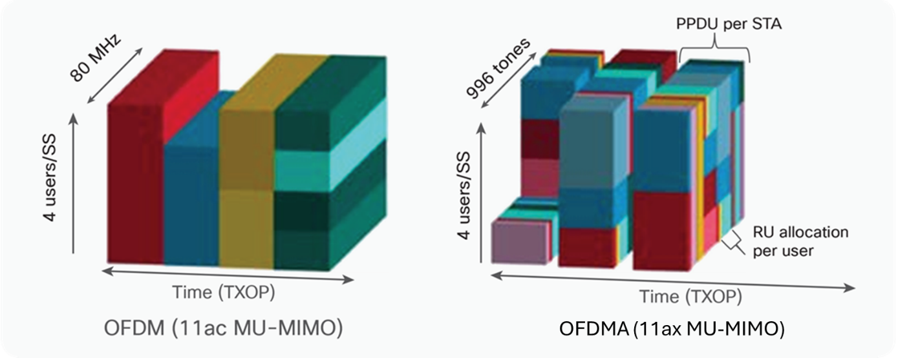
Figure 9 OFDM vs OFDMA
  - Downlink and uplink multi-user MIMO

The downlink version extends an existing 802.11ac feature where an access point determines that multipath conditions allow it to send, in a single time-interval, frames to different client devices. 802.11ax increases the size of downlink MU-MIMO groups, allowing more efficient operation. Uplink multi-user MIMO is a new addition to 802.11ax, but it is deferred to wave 2: like uplink OFDMA, the access point must coordinate the simultaneous transmissions of multiple clients.
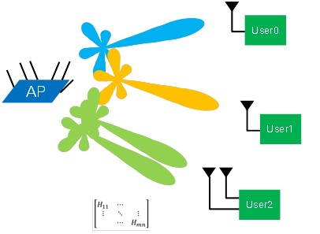
Figure 10 AP using MU-MIMO beamforming to serve multiple users located in spatially diverse positions
  - Transmit beamforming

This is another existing feature where an access point uses a number of transmit antennas to land a local maximum signal on a receiver’s antennas. It improves data-rates and extends range.

  - Higher order modulation

802.11a/g introduced 64-QAM, and 802.11ac 256-QAM: in 802.11ax, the highest-order modulation is extended to 1024-QAM. This increases peak data-rates under good conditions
(high SNR). OFDM symbols, subcarrier spacing and FFT size are all changed to allow efficient operation of small OFDMA subchannels: these changes allow an increase in the length of guard interval without loss of symbol efficiency.

Table 3 802.11ax selected rates (Mbps, short GI)
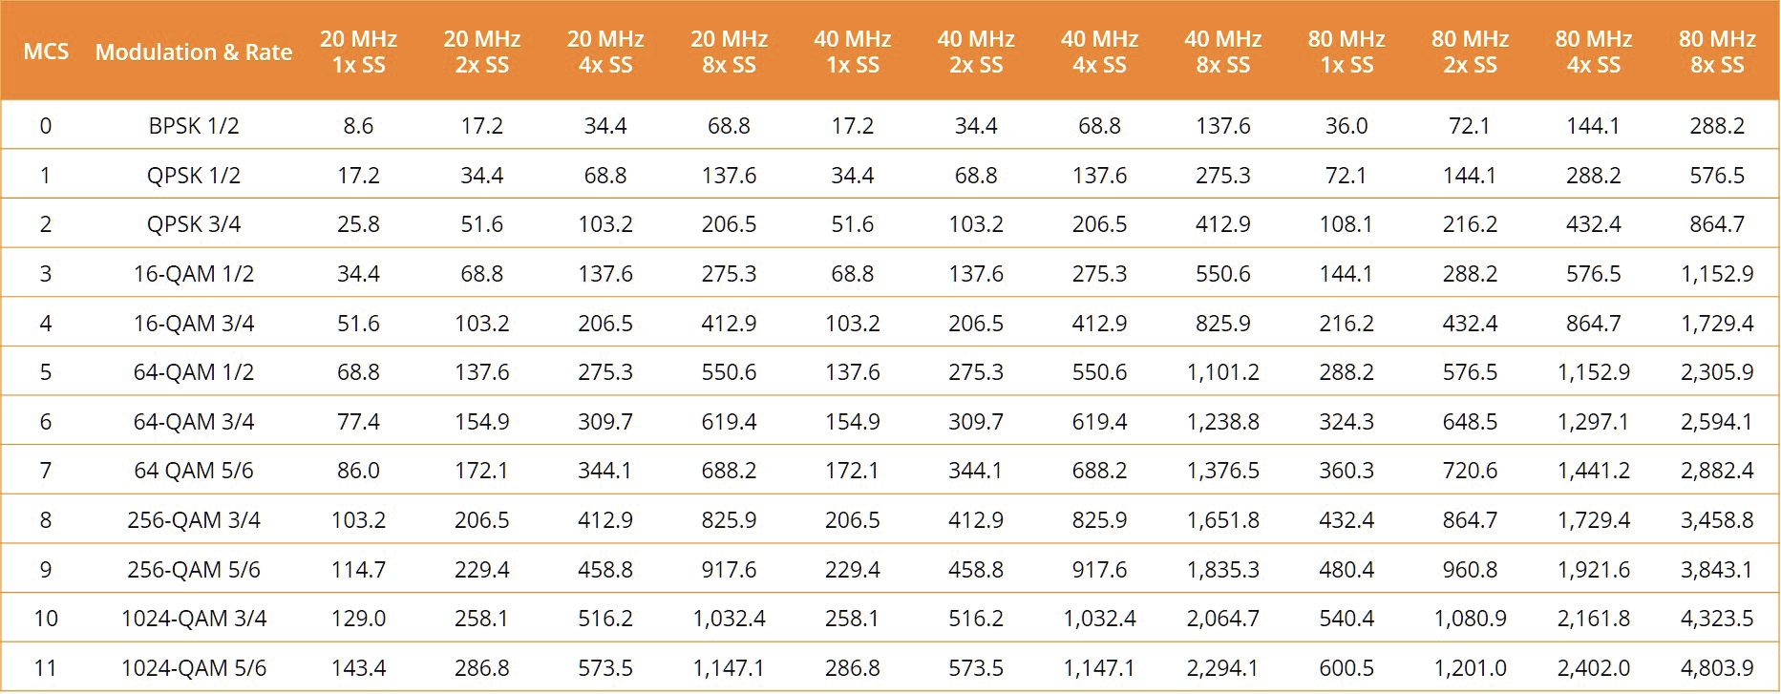

  - Outdoor operation

A number of features improve outdoor performance. The most important is a new packet format where the most sensitive field is now repeated for robustness. Other features that contribute to better outdoor operation include longer guard intervals and modes that introduce redundancy to allow for error recovery.

  - Reduced power consumption

Existing power-save modes are supplemented with new mechanisms allowing longer sleep intervals and scheduled wake times. An 802.11ax AP can negotiate with the participating STAs the use of the Target Wake Time (TWT) function to define a specific time or set of times for individual stations to access the medium. The STAs and the AP exchange information that includes an expected activity duration. This way the AP controls the level of contention and overlap among STAs needing access to the medium. 802.11ax STAs may use TWT to reduce energy consumption, entering a sleep state until their TWT arrives. Furthermore, an AP can additionally devise schedules and deliver TWT values to STAs without individual TWT agreements between them.
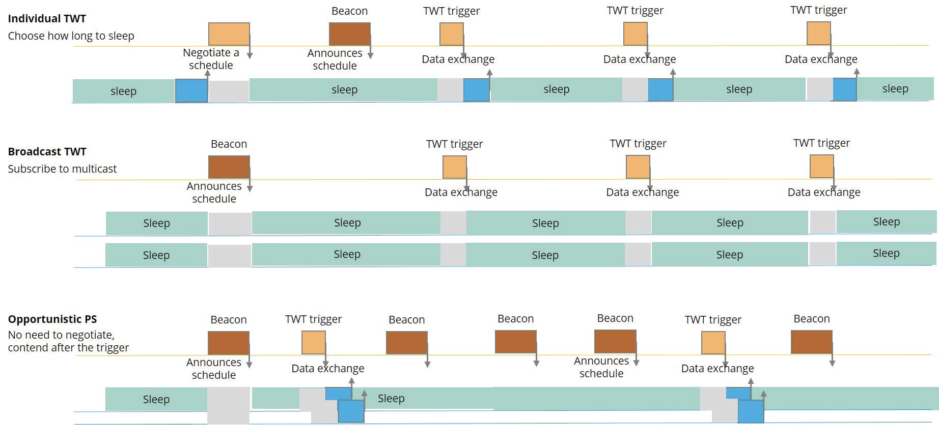
Figure 11 TWT power-save options in 802.11ax
Also, for IoT devices, a 20MHz-channel-only mode is introduced, allowing for simpler, less powerful chips that support only that mode.

  - Spatial re-use with color codes

To improve the system level performance and the efficient use of spectrum resources in dense deployment scenarios, the 802.11ax standard implements a spatial reuse technique. STAs can identify signals from overlapping Basic Service Sets (BSS) and make decisions on medium contention and interference management based on this information.

When an STA that is actively listening to the medium detects an 802.11ax frame, it checks the BSS color bit or MAC address in the MAC header. If the BSS color in the detected PPDU is the same color as the one that its associated AP has already announced, then the STA considers that frame as an intra-BSS frame.

However, if the detected frame has a different BSS color than its own, then the STA considers that frame as an inter-BSS frame from an overlapping BSS. The STA then treats the medium as BUSY only during the time it takes the STA to validate that the frame is from an inter-BSS, but not longer than the time indicated as the length of the frame’s payload.

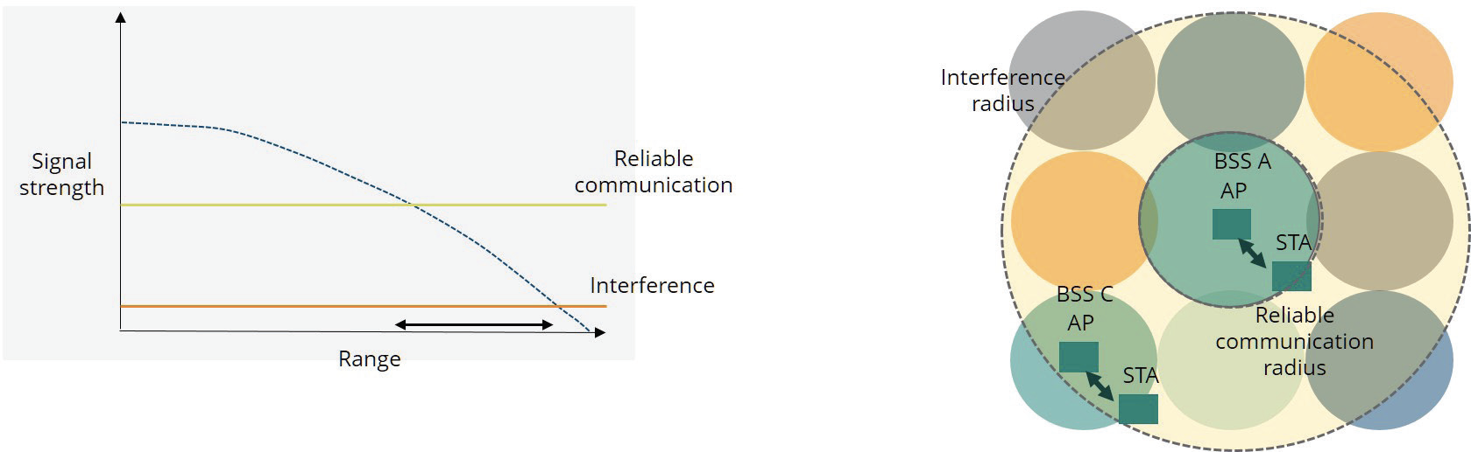
Figure 12 BSS coloring: co-channel interference
BSS coloring works by distinguishing between “same BSS” and “distant BSS” transmissions and applying different CSMA/CA power thresholds. This allows simultaneous transmissions in the different cells, as, in addition to two power thresholds, each client device keeps two network allocation vectors (NAV’s) which tell it how long the medium will be occupied.
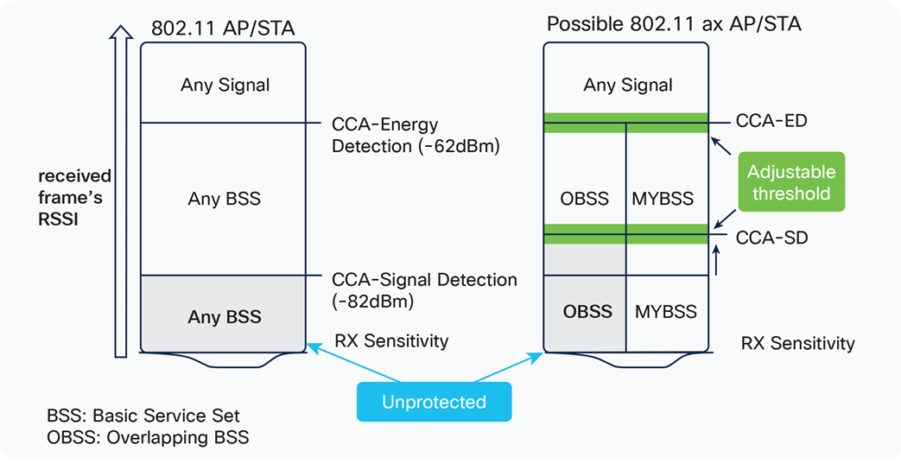
Figure 13 OBSS and BSS Color operation

A1.2 IEEE 802.11be (Wi-Fi 7)

IEEE 802.11be-2024, dubbed Extremely High Throughput (EHT), is a wireless networking standard in the IEEE 802.11 set of protocols which is designated Wi-Fi 7 by the Wi-Fi Alliance. It is built upon 802.11ax, focusing on WLAN indoor and outdoor operation with stationary and pedestrian speeds in the 2.4, 5, and 6 GHz frequency bands.

  - 320 MHz Channels & 4K QAM

Wi-Fi 7 enables significantly faster speeds by packing more data into each transmission. 320 MHz channels are twice the size of previous Wi-Fi generations. 4K QAM (Quadrature Amplitude Modulation) enables each signal to more densely embed greater amounts of data compared to the 1K QAM with Wi-Fi 6/6E.
The benefit for a typical Wi-Fi 7 laptop is a potential maximum data rate of almost 5.8 Gbps. This is 2.4X faster than the 2.4 Gbps possible with Wi-Fi 6/6E and could easily enable high quality 8K video streaming or reduce a massive 15 GB file download to roughly 25 seconds vs. the one minute it would take with the best legacy Wi-Fi technology.

  - Multi-Link Operation (MLO) & Deterministic Latency

While legacy Wi-Fi provides access to multiple wireless bands, devices typically choose only one band to make transmissions—switching to another if conditions change. With MLO (Multi-Link Operation), Wi-Fi 7 devices can simultaneously connect on multiple bands. This enables faster speeds through aggregation. Or multiple bands can be used concurrently to share redundant/unique data for improved reliability with ultra-low and precise latencies.

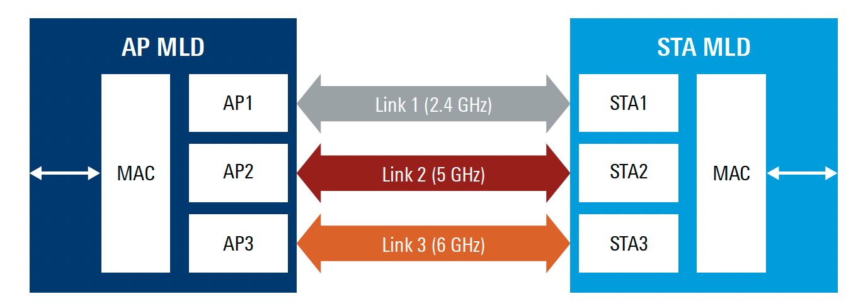
Figure 14 Restricted target wake time principle
  - Multi Resource Units (RU) and Puncturing

Multi-RU Puncturing improves the usage of transmission channels by increasing throughput and reducing latency when multiple users are present. It enables the use of multiple resource units, while puncturing is available to avoid interference with incumbent services, the congestion caused by interference and to maintain high transmission speeds.

Puncturing can take 80 MHz and 160 MHz Wi-Fi channels and slice or bond them in increments of 20 MHz. To help avoid the congestion caused by interference, and it can maintain transmission speeds in multi-user scenarios without dropping the signal.
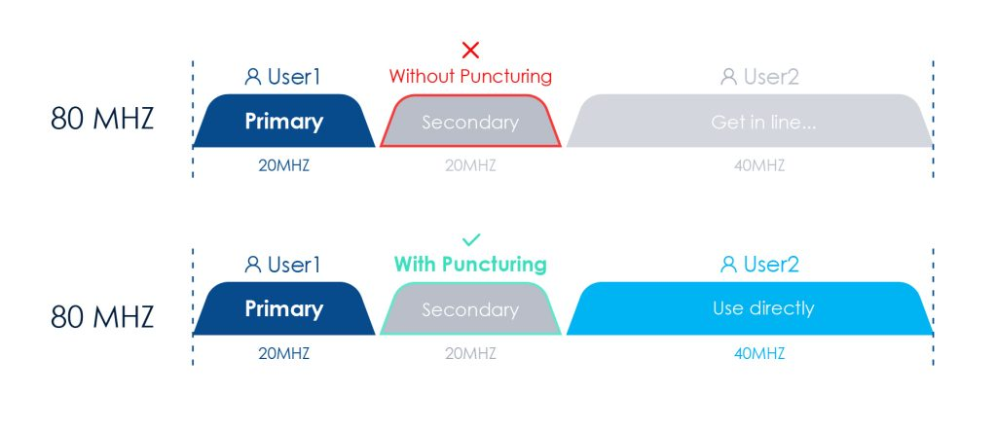
Figure 15 Puncturing improves spectrum efficiency

A1.3 Channel and Spectrum usage of Wi-Fi technology

Initially Wi-Fi networks operates in the unlicensed 2.4 GHz and later unlicensed 5 GHz bands was also open for Wi-Fi. The 2.4-GHz band works the best for indoor Wi-Fi use, as easily penetrates through walls and furniture, and signals generally travel farther at the same power level as they do in the 5-GHz band.

In the 2.4 GHz band, roughly 80 MHz frequency band is available for the Wi-Fi use. The channels are 20 or 22 MHz wide, so normally three nonoverlapping channels are existing. The situation is slightly different in Europe, where 13 channels are allowed, but still just three nonoverlapping channels.

Signals in the 5-GHz band have a shorter range in the home, mostly because of the walls and furniture, but the band extends from 5.125 to 5.925 GHz (800 MHz), so 24 non-overlapping channel of 20MHz-wide each or 12 channels of 40 MHz wide or 6 channels of 80 MHz or 2 channels of 160 MHz wide channels can work.

In the Wi-Fi world, when two conversations collide, all the devices go quiet and then try to talk again a little while later. The amount of time they wait is determined by an exponentially increasing time delay, known as a backoff. With more collisions, the backoff increases, and the Wi-Fi becomes slower and less reliable. Today, congestion has increased so much in many regions making 2.4 GHz band unusable for transferring data at high rates.

Wi-Fi congestion may go even worse, as the mobile-phone carriers are planning to use the technology called as LTE-Unlicensed (LTE-U) or Licensed Assisted Access (LAA). It uses 4G LTE radios and routers to send and receive data via the same 5 GHz frequencies as used by unlicensed Wi-Fi.

A1.4 Channel and Spectrum usage of Wi-Fi technology in 6 GHz

The basic operation of Wi-Fi involves a wireless access point (AP) or router that acts as a central hub for wireless devices to connect to the network. The AP is connected to the wired LAN and serves as a bridge between the wired and wireless networks.

Wi-Fi uses licence-exempt 2.4 GHz, 5 GHz and 6GHz bands. The 6 GHz band encompasses 1200 MHz of spectrum from 5925 – 7125 MHz, compared to 83.8 MHz in the 2.4 GHz band and 570 MHz in sections of 5 GHz. Some countries and regions have enacted rules to protect DSRC/CV2X services.

This allows for 59x20 MHz wide channels; 29x40 MHz; 14x80 MHz, or 7x160 MHz. The number of wide channels is especially significant, as gaps in allocated spectrum in the 5 GHz band limit 80 MHz channels to 7 and 160 MHz channels to 3, and wide channels are necessary for the highest data rates possible with the latest generations of Wi-Fi technology.

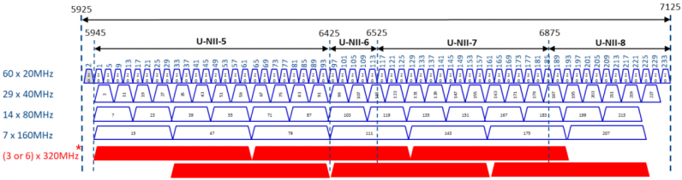
Figure 3 6GHz Wi-Fi Channels plan

The 6 GHz band is uniquely suited to address the demand for additional Wi-Fi spectrum for the following principal reasons:

- a) The 6GHz band will be able to support wide channel bandwidth for dense Wi-Fi networks.

A shared license-exempt band requires multiple radio channels in order to distribute load and reduce co-channel interference (CCI). It is well known that 2.4 GHz with only 3 non-overlapping channels is heavily congested around the world. This is depicted on the left of Figure 4. It is commonly understood by the industry and academia that self-coordinated Wi-Fi requires no fewer than about seven to nine non-overlapping radio channels in a typical corporate or campus deployment to absorb current demand levels, as shown in the middle diagram of Figure 4. For large public venue environments with extreme loading levels such as stadia, arenas, university lecture halls, and airports research and years of experience have proven that 20 or more discrete channels are required for Wi-Fi to operate successfully and carry the tremendous levels of traffic at such venues. Every major enterprise Wi-Fi equipment manufacturer has historically published detailed design guidelines for such large venues calling for 20 MHz channels to be used, because only this narrowest channel width yielded a sufficient number of non-overlapping channels in the 5 GHz band.

The principle behind this phenomenon is that having fewer channels increases the probability of collisions between co-channel radio cells, even at low loading levels. An obvious
reason for this is depicted in Figure 4, where nodes in a Wi-Fi network with small inter-cell distances can “hear” many more co-channel radios. But a more subtle effect is the resulting rise in the noise floor from “hidden” Wi-Fi cells. This increasing the collision probability and reduces the available signal-to-noise level, which in turn reduces the data rate, thereby making each transmission take longer (increased latency). By contrast, having more channels both reduces the absolute number of “hearable” co-channel cells, and helps keep the noise floor nearer the thermal limit, which maximizes data rates and therefore transmits data more quickly – requiring less airtime. This attribute of Wi-Fi enables well-designed networks with a sufficient number of channels to absorb extremely high demand surges.

The 5 GHz band is only able to provide 5x80MHz or 3x160MHz channels, which are not sufficient to deploy a useful Wi-Fi network. Network operators are forced to use narrower channels such as 40 MHz or even 20 MHz, which limit the peak data throughput under 600 Mbps for a typical device in even optimal RF conditions. Given that multi-gigabit broadband connections are being more and more widely adopted, narrow band Wi-Fi networks become the bottleneck of overall network performance and user experience.

The 1200 MHz of spectrum in the 6 GHz band yields an equivalent number of 80 MHz channels as there are 40 MHz channels in the 5 GHz band. With 1200 MHz of spectrum in the 6 GHz band, 80 MHz channels will become the default in the large majority of enterprise deployments. It even allows 7x160 MHz or 3x320MHz channels that can enable novel use cases like Augmented/Virtual Reality which require low latency and extremely high throughput.
Figure 4 Inter-Cell distance increases with available channel count
    - b) The 6 GHz band does not need to support any legacy Wi-Fi technology.

    - Wi-Fi technology is backward compatible with previous generations. Legacy devices like Wi-Fi 4 and 5 can work together with devices supporting the latest Wi-Fi 6 standard. However, this backward compatibility can decrease the network performance, as the technology features provided by the latest Wi-Fi standard cannot be realised with legacy devices in the same network. The 6 GHz band would, for the first time, eliminate outdated and inefficient radio access technologies, permitting the far more spectrally efficient Wi-Fi 6E (and above) to operate without the burden of legacy radio interoperability. This will improve the user experience and spectral efficiency, which can only serve to further the adoption of Wi-Fi technologies.

Annex 2

Annex 2: Technical features in SparkLink

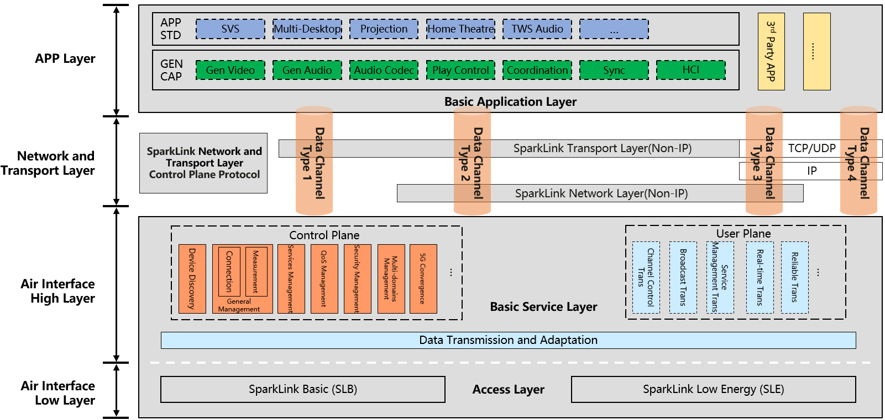
Figure 2 SparkLink Wireless Communication System
The SparkLink wireless communication system consists of the basic application layer, basic service layer, and access layer. The access layer provides two transmission modes. One is SparkLink-Basic (SLB), which focuses on high throughput, low latency and high concurrency. While the other one is SparkLink Low Energy (SLE), which focuses on high speed transmission based on low energy.
Above the access layer which supports different operation modes, there is a unified protocol stack. The basic service layer provides a modular service by control plane and user plane protocols for supporting an upper-layer service by defining different functional units, to meet the connection and interaction requirements of the E2E service processing (from service triggering to service termination).
The basic application layer, consisting of application profile and generic capability standards, enables various applications, such as surround view system, multi-desktop, wireless projection, home theatre, TWS audio and so on. Between the basic service layer and the basic application layer, the SparkLink network and transport layer supports TCP/UDP, IP protocols and the SparkLink Non-IP protocol.
SparkLink can provide multiple access services of data transfer, which the data of a traffic flow is carried over multiple logical channels at the access layer. It includes duplicate transmission, split transmission, transmission switching from SLB to SLE, and transmission switching from SLE to SLB.
Table 1 the SparkLink Technical features
Items | SparkLink Basic / SLB | SparkLink Low Energy / SLE
Scenarios | High throughput, low latency, high reliability and precision  synchronization | Low power consumption, low latency, high reliability
Peak Throughput | > 14Gbps for multi-carriers | 12Mbps
Latency | 20µs (One-way) | 125µs (One-way)
Reliability | > 99.999% | > 99.999%
Sync-Precision | Sub-microsecond level | Microsecond level
Multi-user supporting | Support 4096 user address space  Support unicast and reliable multicast | Support 2^24 user address space  Support unicast and reliable multicast
Anti-interference | Min working SINR -5dB  Polar Codec and quick HARQ  FISA and multi-points high-precision Sync | Min working SINR：-3dB  Polar Codec  Quick adaptive Frequency-hopping
Security | High (bi-directions certification, algorithm negotiation) | High (bi-directions certification, algorithm negotiation)
The SparkLink-Basic (SLB) provides 20MHz to 320MHz wideband transmission capability, using OFDMA and site-to-site synchronized mechanisms and other advanced technologies. The low latency (20µs) is achieved by specific designed frame structure. Huge user address space with reliable multicast. Using Polar Codec, quick HARQ, FISA (Fast Interference Sensing and Avoidance) and multi-points high-precision Sync to realize stable operation at low min SINR (-5dB). Bi-directions certification and algorithm negotiation guarantee the high security. The typical operation frequency bands of SLB are 2.4GHz,5.1GHz and 5.8GHz.
The other one is SparkLink Low Energy (SLE), which provides up to 12Mbps transmission date rates with up to 4MHz bandwidth support. Supporting 125µs one-way latency. The same as SLB, SLE has very large user address space with reliable multicast. Using Polar Codec and quick adaptive frequency-hopping to realize stable operation at low min SINR (-3dB). Bi-directions certification and algorithm negotiation are also supported by SLE to achieve high security. The typical operation frequency band of SLE is 2.4GHz.
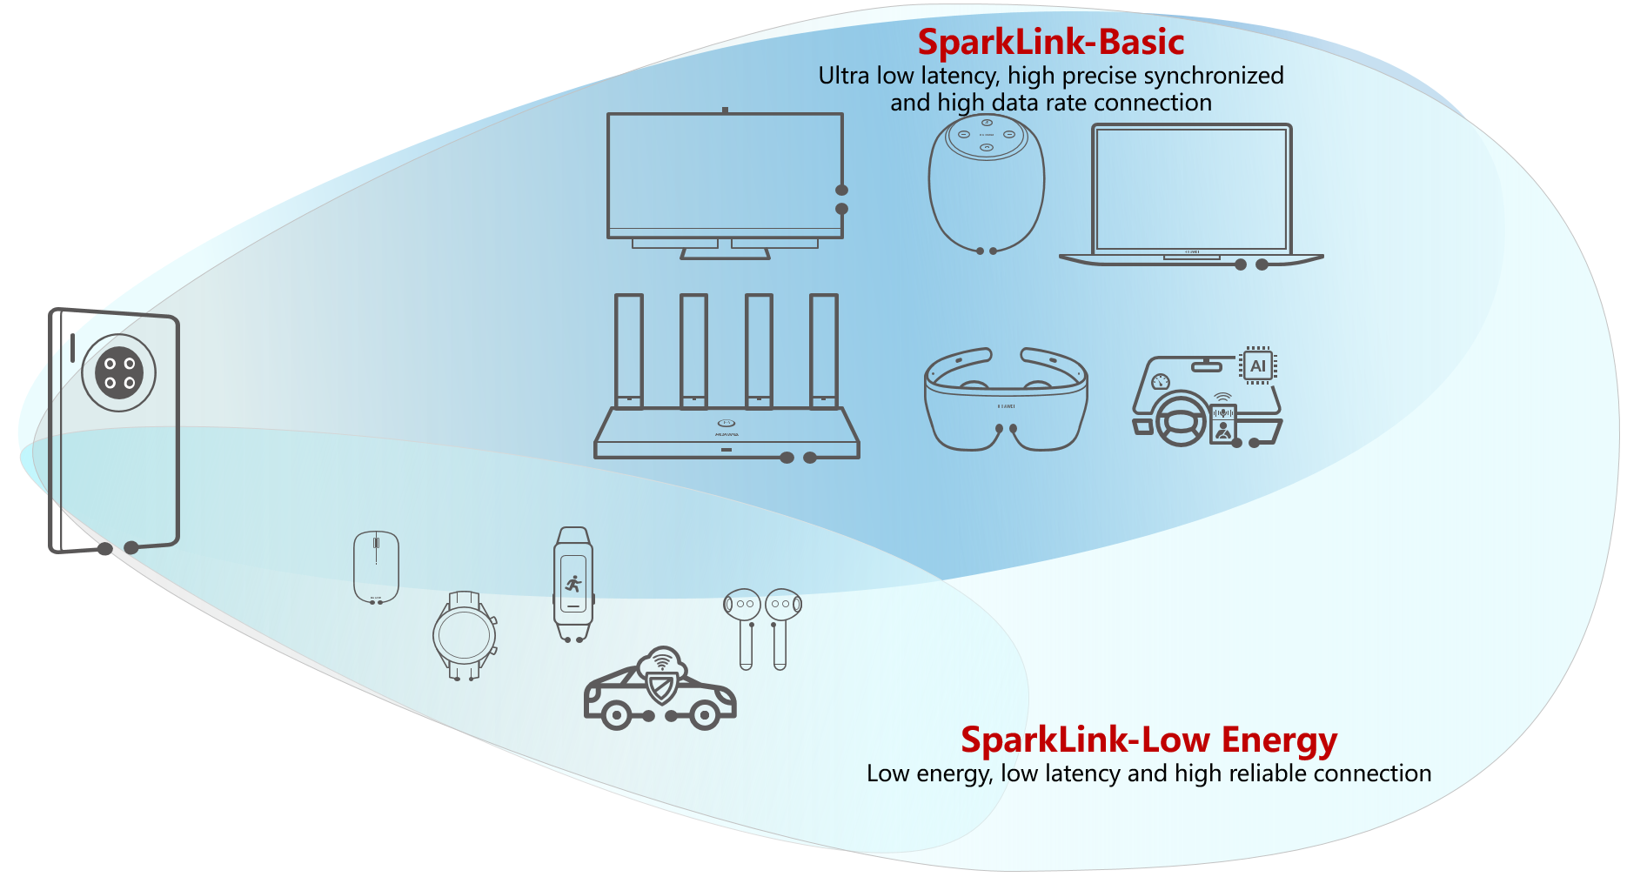
Figure 3 SparkLink Technology Family
With such capabilities, it is expected that SparkLink can contribute to build the future intelligent connected world.
Annex 3

Annex 3: Channel and Spectrum usage of 3GPP technologies
Wireless Access Systems (WAS) are defined as end-user radio connections to public or private core networks. Technologies in use today for implementing wireless access include cellular, cordless telecommunication, and wireless local area network systems.
WAS typically uses cellular radio frequencies and protocols such as GSM, CDMA or LTE to provide wireless connectivity to devices, and it is often used in mobile phones, tablets, and other mobile devices.

Wireless Access Systems (WAS) are defined as end-user radio connections to public or private core networks. Technologies in use today for implementing wireless access include cellular, cordless telecommunication, and wireless local area network systems.

The basic operation of WAS involves a network of base stations, or cell sites, that are strategically located to provide coverage over a particular area. Each cell site is equipped with one or more antennas that transmit and receive wireless signals to and from mobile devices within the coverage area.

When a mobile device wants to connect to the cellular network, it searches for an available cell site and sends a signal requesting access. The cell site authenticates the device and assigns it a unique identifier, such as a mobile phone number or subscriber identity module (SIM) card. Once the device is connected, it can communicate with other devices on the network and access the Internet or other network services. The wireless signals are encoded and modulated using various techniques to ensure reliable and secure communication.

The WAS network can be secured using various encryption and authentication protocols, such as Advanced Encryption Standard (AES) and Transport Layer Security (TLS). These protocols provide protection against unauthorized access and ensure the confidentiality and integrity of the data transmitted over the network.

WAS uses different wireless protocols and frequencies, depending on the technology used by the cellular network operator. For example, in case of GSM (Global System for Mobile Communications) standard, it uses a combination of time division multiple access (TDMA) and frequency division multiple access (FDMA) to divide the wireless spectrum into channels that can be shared by multiple users.

Overall, WAS provides a convenient and reliable way for mobile devices to connect and communicate over a wireless network, and it is widely used in cellular networks around the world.

Channel assignment in WAS (Wireless Access System) is the process of assigning frequencies or channels to different base stations, or cell sites, in a cellular network to avoid interference and ensure efficient use of the available wireless spectrum. The goal of channel assignment is to minimize the number of channels used while ensuring that each cell site has sufficient channels to serve its users. This is because the wireless spectrum is a limited resource, and it must be shared among all the cell sites in the network.

There are different channel assignment strategies that can be used in WAS, depending on the technology used by the cellular network operator. One common approach is the fixed channel allocation (FCA) strategy, where a fixed set of channels is assigned to each cell site, and the channels are reused across the network.
Another approach is the dynamic channel allocation (DCA) strategy, where channels are dynamically allocated to cell sites based on the traffic load and channel availability. This approach can help to optimize the use of the available spectrum and improve network efficiency.

In WAS, channel assignment can also be influenced by other factors such as the physical environment, the distance between cell sites, and the number of users in a particular area. In urban areas with high user density, for example, smaller cell sites may be used to provide better coverage and capacity, and more channels may be assigned to these sites to accommodate the higher traffic.

Overall, channel assignment is a critical aspect of WAS network design and optimization, and it requires careful planning and management to ensure optimal network performance and user experience.

3GPP has specified the following channel plans and associated channel bandwidths as per 3GPP TS 38.101 (Tables 5.2-1 and 5.3.5-1).
NR operating band | Uplink (UL) operating band  BS receive / UE transmit  F_{UL_low} – F_{UL_high} | Downlink (DL) operating band  BS transmit / UE receive  F_{DL_low} – F_{DL_high} | Duplex Mode | Channel Bandwidths (MHz)
n46 | 5150 MHz – 5925 MHz | 5150 MHz – 5925 MHz | TDD¹³ | 10,20,40,60,80,100
n96¹⁴ | 5925 MHz – 7125 MHz | 5925 MHz – 7125 MHz | TDD¹³ | 20, 40, 60, 80, 100*
n102¹⁴ | 5925 MHz – 6425 MHz | 5925 MHz – 6425 MHz | TDD¹³ | 20, 40, 60, 80, 100*
NOTE 13: This band is restricted to operation with shared spectrum channel access as defined in 37.213.
NOTE 14: This band is applicable only in countries/regions designating this band for shared-spectrum access use subject to country-specific conditions.
NOTE * Optional channel BW for Rel 18

Annex 4

Annex 4: Questionnaire Responses
A4-1 Questionnaire
Question 1: What is/are current frequency ranges for license-exempt (in some countries also known as general use license, class license) WAS/RLAN technology to use in your country?

Answer:
 | Frequency range | Maximum EIRP | Maximum PSD | Use condition (s) | Applicable Technical Standard (s)
Bhutan
Nepal | 865 – 868 MHz |  |  | Non-Exclusive and Non-protective shared basis  Cannot be used for Backhaul/Backbone Network | Machine to Machine(M2M)/Internet of Things
Nepal | 2.4 – 2.4835 GHz | 4W (36 dBm) |  | No exclusive right, shall be used in non-protection and shared basis.  Cannot be used for Backhaul/Backbone Network
Nepal | 5.150 – 5.350 GHz | 4W (36 dBm) |  | Non-Exclusive and Non-protective shared basis  Cannot be used for Backhaul/Backbone Network
Nepal | 5.470 – 5.65 GHz | 4W (36 dBm) |  | Non-Exclusive and Non-protective shared basis  Cannot be used for Backhaul/Backbone Network
Nepal | 5.725 – 5.825 GHz | 4W (36 dBm) |  | No exclusive right, shall be used in non-protection and shared basis.  Cannot be used for Backhaul/Backbone Network
Nepal | 6 – 8.5 GHz | 0 dBm in 50 MHz | -41.3 dBm / MHz | Non-Exclusive and Non-protective shared basis without interfering telecommunication services  Cannot be used for Backhaul/Backbone Network
Thailand | 2400-2500 MHz | 100 mW |  | Indoor/outdoor | EN 300 328  FCC Part 15.247
Thailand | 5150-5350 MHz | 200 mW |  | Indoor  DFS and TPC are required in 5250-5350 MHz | EN 301 893  FCC Part 15.407
Thailand | 5470-5725 MHz | 1W |  | Indoor/outdoor  DFS and TPC are required in 5470-5725 MHz | EN 301 893  FCC Part 15.407
Thailand | 5725-5850 MHz | 1W |  | Indoor/outdoor | EN 302 502  FCC Part 15.247  FCC Part 15.407
Thailand | 5925-6425 MHz | 25 mW | 1.25 mW/MHz | Indoor/outdoor | FCC Part 15.407  ETSI EN 303 687
Thailand | 5925-6425 MHz | 25 mW | 12.5 mW/MHz | Indoor/outdoor  Channel bandwidth must be less than 20 MHz  Duty Cycle must comply with ETSI EN 303 687 | FCC Part 15.407  ETSI EN 303 687
Thailand | 5925-6425 MHz | 250 mW | 12.5 mW/MHz | Indoor | FCC Part 15.407  ETSI EN 303 687
Japan | 2400-2483.5 MHz | - | FHSS (within 2427-2470.75 MHz band): 3mW/MHz  SS: 10mW/MHz  OFDM (26MHz): 10mW/MHz  OFDM (40MHz):  5mW/MHz  Others: 10mW | Indoor/outdoor | Article 49-20, Paragraph 1 of the Radio Equipment Regulations
Japan | 2471-2497 MHz | - | 10mW/MHz | Indoor/outdoor | Article 49-20, Paragraph 2 of the Radio Equipment Regulations
Japan | 5 150-5 250 MHz | - | Indoor/outdoor:  20 MHz: 10 mW/MHz  40 MHz: 5 mW/MHz  80 MHz: 2.5 mW/MHz  160 MHz: 1.25 mW/MHz  (combined with 5250-5350 MHz)  Indoor/outdoor:  With EIRP mask for elevation above the horizon:  20 MHz: 50 mW/MHz  40 MHz: 25 mW/MHz  80 MHz: 12.5 mW/MHz  Inside automobiles:  (on-board access points)  20MHz: 2 mW/MHz  40MHz: 1 mW/MHz  80MHz: 0.5 mW/MHz  20 MHz: 10 mW/MHz  40 MHz: 5 mW/MHz  80 MHz: 2.5 mW/MHz  160 MHz: 1.25 mW/MHz | Indoor/outdoor or inside automobiles  Registration is required for access points for outdoor use or with a maximum EIRP greater than 200mW | Article 49-20, Paragraph 3 of the Radio Equipment Regulations
Japan | 5 250-5 350 MHz | - | 20 MHz: 10 mW/MHz  40 MHz: 5 mW/MHz  80 MHz: 2.5 mW/MHz  160 MHz: 1.25 mW/MHz  (combined with 5150-5250 MHz) | DFS required,  indoor only,  TPC or reduced transmission power by 3 dB | Article 49-20, Paragraph 3 of the Radio Equipment Regulations
Japan | 5 470-5 730  MHz | - | 20 MHz: 50 mW/MHz  40 MHz: 25 mW/MHz  80 MHz: 12.5 mW/MHz  160 MHz: 6.25 mW/MHz | DFS required,  not allowed in the sky,  TPC or reduced transmission power by 3 dB | Article 49-20, Paragraph 3 of the Radio Equipment Regulations
Japan | 5 925-6 425 MHz | 25 mW (VLP),  200 mW (LPI) | VLP:  20 MHz: 1.25 mW/MHz  40 MHz: 0.625 mW/MHz  80 MHz: 0.3125 mW/MHz  160 MHz: 0.15625 mW/MHz  320 MHz: 0.078125 mW/MHz  LPI:  20 MHz: 10 mW/MHz  40 MHz: 5 mW/MHz  80 MHz: 2.5 mW/MHz  160 MHz: 1.25 mW/MHz  320 MHz: 0.625 mW/MHz | Indoor only for LPI | Article 49-20, Paragraph 4 of the Radio Equipment Regulations
Malaysia | 2400 MHz to 2500 MHz | 500 mW | - | - | i. Class Assignment for Short-range  Radiocommunication Device  ii. Technical Code for the Specification for Short Range Devices – Specifications  Note: The use of frequency band(s) for devices that have been listed in the Class Assignment are subject to the requirements and conditions as specified in the Class Assignment. The latest Class Assignment document can be found in this URL:  http://www.mcmc.gov.my/en/spectrum/assignment-of-spectrum/class-assignment.
Malaysia | 5150 MHz to 5250 MHz | 200 mW | - | Outdoor use only
Malaysia | 5150 MHz to 5250 MHz | 1 W |  | Indoor use only
Malaysia | 5250 MHz to 5350 MHz | 1 W | 10 mW/MHz | •Indoor use only  •The devices shall use Dynamic Frequency Selection (DFS) and Transmitter Power Control (TPC)
Malaysia | 5470 MHz to 5650 MHz | 1 W | 10 mW/MHz | The devices shall use Dynamic Frequency Selection (DFS) and Transmitter Power Control (TPC)
Malaysia | 5725 MHz to 5875 MHz | 1 W | - | -
Malaysia | 5925 MHz to 6425 MHz | 25 mW | 1.25 mW/MHz  (10 mW/MHz for narrowband usages) | Indoor and outdoor use
Malaysia |  | 200 mW | 10 mW/MHz | Indoor use only
Australia | 2400–2483.5 MHz | 500 mW |  | A radiocommunications transmitter either:  (a) must comply with the requirements in EN 300 328; or  (b) must not be operated if its operation uses fewer than 15 hopping frequencies.
Australia | 2400–2483.5 MHz | 4 W |  | A radiocommunications transmitter must not be operated if its operation uses fewer than 75 hopping frequencies.
Australia | 5150–5250 MHz | 1W (averaged over the entire transmission burst) |  | A radiocommunications transmitter must not be operated if its maximum EIRP exceeds 125 mW (21 dBm) in any direction above 30 degrees of elevation.
Australia | 5150–5250 MHz | 200 mW (averaged over the entire transmission burst) | 10mW/MHz  or  40µW/4kHz for narrowband use | (1) A radiocommunications transmitter must only be operated indoors.  (2) The power spectral density of a radiocommunications transmitter must not be greater than:  (a) 10 mW EIRP per 1 MHz, if the transmitter has a bandwidth of 1 MHz or greater; or  (b) 40 µW per 4 kHz, if the transmitter has a bandwidth less than 1 MHz.
Australia | 5250–5350 MHz | 200 mW (averaged over the entire transmission burst) | 10mW/MHz  or  40µW/4kHz for narrowband use | (1) A radiocommunications transmitter must only be operated indoors.  (2) The power spectral density of a radiocommunications transmitter must not be greater than:  (a) 10 mW EIRP per 1 MHz, if the transmitter has a bandwidth equal to or greater than 1 MHz; or  (b) 40 µW per 4 kHz, if the transmitter has a bandwidth less than 1 MHz.  (3) A radiocommunications transmitter must use:  (a) Dynamic Frequency Selection; and  (b) if the transmitter is operated with a maximum EIRP greater than 100 mW – Transmit Power Control.
Australia | (a) 5470–5600  (b) 5650–5725 | 1 W (averaged over the entire transmission burst) | 50mW/MHz | (1) The maximum radiated mean power density of a radiocommunications transmitter must not exceed 50 mW EIRP per 1 MHz.  (2) A radiocommunications transmitter must use:  (a) Dynamic Frequency Selection; and  (b) if the transmitter is operated with a maximum EIRP greater than 500 mW – Transmit Power Control.
Australia | 5925-6585 MHz | 250 mW | 12.5mW/MHz | (1) The radiocommunications transmitter must only be operated indoors.  (2) The power spectral density of a radiocommunications transmitter must not be greater than 12.5 mW EIRP per 1 MHz.  (3) A radiocommunications transmitter must use contention-based protocols for multiple access.  Example: Carrier Sense Multiple Access (CSMA) and Multiple Access Collision Avoidance (MACA) are examples of contention-based protocols.  (4) The radio emissions from a radiocommunications transmitter below 5925 MHz must not be greater than -27 dBm/MHz EIRP.
Australia | 5925-6585 MHz | 25 mW | 1.25mW/MHz | (1) The power spectral density of a radiocommunications transmitter must not be greater than 1.25 mW EIRP per 1 MHz.  (2) A radiocommunications transmitter must use contention-based protocols for multiple access.  Example: Carrier Sense Multiple Access (CSMA) and Multiple Access Collision Avoidance (MACA) are examples of contention-based protocols.  (3) The radio emissions from a radiocommunications transmitter below 5925 MHz must not be greater than -37 dBm per 1 MHz EIRP.
Indonesia | 2400 - 2483.5 MHz | Indoor: 27 dBm  Outdoor: 36 dBm | - | Indoor  (maximum bandwidth  40 MHz)  Outdoor (maximum bandwidth  20 MHz)  (access/backhaul) | Ministry of Communications and Digital Affairs Decree Number 12 Year 2025
Indonesia | 5150 - 5250 MHz | 23 dBm | - | Indoor  (maximum bandwidth  80 MHz)  (access) | Ministry of Communications and Digital Affairs Decree Number 12 Year 2025
Indonesia | 5250 - 5350 MHz | 23 dBm | - | Indoor  (maximum bandwidth  80 MHz)  (access) | Ministry of Communications and Digital Affairs Decree Number 12 Year 2025
Indonesia | 5150 - 5350 MHz | 23 dBm | - | Indoor  (maximum bandwidth  160 MHz)  (access) | Ministry of Communications and Digital Affairs Decree Number 12 Year 2025
Indonesia | 5725 - 5825 MHz | Indoor: 23 dBm  Outdoor: 36 dBm | - | Indoor (maximum bandwidth  80 MHz)  Outdoor  (maximum bandwidth  20 MHz)  (access/backhaul) | Ministry of Communications and Digital Affairs Decree Number 12 Year 2025
Indonesia | 5925 – 6425 MHz | Low Power Indoor (LPI): 23 dBm  Very Low Power (VLP): 14 dBm | LPI:  20 MHz: 10 dBm/MHz  40 MHz: 7 dBm/MHz  80 MHz: 4 dBm/MHz  160 MHz: 1 dBm/MHz  320 MHz: -2 dBm/MHz  VLP:  20 MHz: 1 dBm/MHz  40 MHz: -2 dBm/MHz  80 MHz: -5 dBm/MHz  160 MHz: -8 dBm/MHz  320 MHz: -11 dBm/MHz | Indoor only for LPI  (Maximum bandwidth 320 MHz)  (access) | Ministry of Communications and Digital Affairs Decree Number 12 Year 2025
Indonesia | 57 - 64 GHz | 40 dBm | 23 dBm/MHz (EIRP) | Indoor  (maximum bandwidth  2.16 GHz)  (access) | Ministry of Communications and Digital Affairs Decree Number 12 Year 2025
India | 2400-2483.5 MHz | 36 dBm |  | Non-interference, non-protection and shared (non-exclusive) basis.
India | 5.150-5.250 GHz | 36 dBm  21 dBm  53 dBm  30 dBm | 17 dBm/MHz  11 dBm/MHz | Access point:  ≤ 6 dBi antenna gain & 30 dBm conducted power.  Above 30°elevation (outdoor)  Fixed point to point access point:  ≤ 23 dBi antenna gain & 30 dBm conducted power.  Client/portable mobile device:  ≤ 6 dBi antenna gain & 250 mW conducted power
India | 5.250-5.350 GHz  5.470-5.725 GHz | 30 dBm | 11 dBm/MHz | Access point:  ≤ 6 dBi antenna gain & 250 mW conducted power or 11dBm + 10 log B, whichever is less, where ‘B’ is the emission bandwidth in MHz.
India | 5.725-5.875 GHz | 36 dBm  53 dBm | 30 dBm/500 kHz | Access point:  ≤ 6 dBi antenna gain & 30 dBm conducted power.  Fixed point to point access point:  ≤ 23 dBi antenna gain & 30 dBm conducted power.
India | 5.925-6.425 GHz | 30 dBm  14 dBm | 11 dBm/MHz  1 dBm/MHz | Low Power Indoor  Very Low Power Outdoor
Vietnam | 2400 ÷ 2483,5 MHz | ≤ 200 mW EIRP (for equipment using FHSS modulation) |  | Common use condition (for all RLAN bands): Organizations and individuals deploy and use WLAN/RLAN equipment that need to comply with laws and regulations on telecommunications, information security and data protection. | QCVN 54:2020/BTTTT
Vietnam |  | ≤ 10 mW/1 MHz EIRP (for equipment using non-FHSS modulation)
Vietnam | 5150 ÷ 5250 MHz | ≤ 200 mW EIRP |  | Using in an indoor environment (Indoor use) or an environment with electromagnetic wave shielding (ie: in car) | QCVN 65:2013/BTTTT
Vietnam | 5250 ÷ 5350 MHz | ≤ 200 mW EIRP (for equipment being adjustable power) |  | The device must be capable of dynamic frequency selection (DFS) | QCVN 65:2013/BTTTT
Vietnam |  | ≤ 100 mW EIRP (for equipment being non-adjustable power) |  | The device must be capable of dynamic frequency selection (DFS)
Vietnam | 5470 ÷ 5725 MHz | ≤ 1 W EIRP (for equipment being adjustable power) |  | The device must be capable of dynamic frequency selection (DFS) | QCVN 65:2013/BTTTT
Vietnam |  | ≤ 500 mW EIRP (for equipment being non-adjustable power) |  | The device must be capable of dynamic frequency selection (DFS)
Vietnam | 5725 ÷ 5850 MHz | ≤ 1 W EIRP |  |  | QCVN 65:2013/BTTTT
Vietnam | 57 ÷ 66 GHz | ≤ 10 W EIRP |  | - Require to use the integrated antenna  - Do not install in a fixed outdoor location | QCVN 88:2015/BTTTT
China | 2 400-2 483.5 | 20 dBm (e.i.r.p. for integrated antenna gain < 10 dBi)  27 dBm (e.i.r.p. for antenna gain >= 10 dBi) | 10 dBm/MHz (e.i.r.p. for Integrated antenna gain < 10 dBi)  17 dBm/MHz (e.i.r.p. for Integrated antenna gain >= 10 dBi)  Frequency hopping <= 20dBm/100kHz | Interference Avoidance mechanism is mandatory  Additional out of band emission limit applies in order to protect the service in the adjacent band and in specific bands. * | National regulation rules applied
China | 5 150-5 350 | 23 dBm (e.i.r.p.) | 10 dBm/MHz (e.i.r.p.) | Indoor use only (use within vehicle is prohibited).  5 250-5 350 MHz, TPC and DFS are mandatory.  Interference Avoidance mechanism is mandatory  Additional out of band emission limit applies in order to protect the service in the adjacent band and in specific bands* | National regulation rules applied
China | 5 725-5 850 | 33 dBm (e.i.r.p.) | 19 dBm/MHz (e.i.r.p) | Interference Avoidance mechanism is mandatory  Additional out of band emission limit applies in order to protect the service in the adjacent band and in specific bands* | National regulation rules applied
Korea | 5 150 – 5 350 MHz | 30 dBm | 10 dBm | PSD should be reduced depending on the occupied bandwidth.  Especially, PSD should be reduced to lower than 3.97 dBm/MHz for any channel which includes all or some of 5 230 - 5 250 MHz (and see domestic regulation for detail).  TPC and DFS requirements should be complied in 5 250 - 5 350 MHz band.
Korea | 5 470 – 5 850 MHz | 30 dBm | 10 dBm/MHz | PSD should be reduced depending on the occupied bandwidth.  TPC and DFS requirements should be complied in 5 470 - 5 725 MHz band.
Korea | 5 925 ~ 6 425 MHz | 30 dBm | 5 dBm/MHz | LPI¹⁾  (Indoor only)  (LBT is required)  - - allowed only the devices installed and operated by being connected to the power supply within a building or the devices that communicate with these devices  - not allowed in moving objects, such as vehicles, aircraft, railways, ship, drones, etc.  - applicable for only indoor usage. | Unlicensed Wireless Equipment Regulation Article No.7
Korea | 6 425 ~ 7 125 MHz | 27 dBm | 2 dBm/MHz |  | Unlicensed Wireless Equipment Regulation Article No.7
Korea | 5 925 ~ 6 425 MHz | 14 dBm | 1 dBm/MHz | VLP²⁾  (Indoor/Outdoor)  (LBT is required)  2) - not allowed in a drone  - devices built in vehicle are allowed in 6 085-6 425 MHz band only  - applicable for both indoor and outdoor usage
Korea | 5 925 ~ 6 425 MHz | 30 dBm | 5 dBm/MHz | Subway³⁾  (Inside subway train only)  (LBT is required)  3) - allowed only the devices installed and operated by being connected to the power supply within a subway train or the devices that communicate with these devices
Sri Lanka |  | Please refer the Annexure A Table 6 of Radio and Telecommunications Terminal Equipment (RTTE) Type Approval Rules given in the following link (Page no 28A):  https://trc.gov.lk/images/SM/RTTE_GAZETTE-English.pdf
Brunei | 2.4000 – 2.4835  GHz | <= 200 mW  (e.i.r.p.) |  | Operating under this provision shall be allowed to transmit between 100 mW and 200mW (e.i.r.p), and approved on exceptional basis | FCC Part 15 §  15.247 or  EN300 328  FCC Part 15 §  15.209;  or EN 300 328
Brunei | 5.150 – 5.350  GHz | <= 1000 mW  (e.i.r.p.) |  | WLAN operating in 5.250 – 5.350  GHz under this provision shall employ Dynamic Frequency Selection (DFS) mechanism and implement Transmit Power Control (TPC). Non-localised operations shall be approved on an exceptional basis | FCC Part 15 §  15.407  (b) or EN 301  893  FCC Part 15 §  15.407 or EN  301  893
Brunei | 5.470 – 5.725  GHz | <= 1000 mW  (e.i.r.p.) |  | WLAN operating under his provision shall employ Dynamic Frequency Selection (DFS) mechanism and implement Transmit Power Control (TPC). Non-localised operations shall be approved on an exceptional basis
Brunei | 5.725 – 5.850  GHz | <= 4000 mW  (e.i.r.p.) |  | Operating under this provision shall be allowed to transmit between 100 mW and 200mW (e.i.r.p), and approved on exceptional basis | FCC Part 15 §  15.209  FCC Part 15 §  15.247 or
Brunei | 5.725 – 5.850  GHz | <= 100 mW  (e.i.r.p.)
Pakistan | 2.4 – 2.5 GHz | 30 dBm
Pakistan | 5.15 – 5.25 GHz | 200 mW |  | Indoors
Pakistan | 5.25 – 5.35 GHz | 200 mW |  | Indoors / DFS / TPC
Pakistan | 5.47 – 5.725 GHz | 200 mW |  | Indoors / DFS / TPC  Indoor / outdoor  (Depending upon channel)
Pakistan | 5.725 – 5.875 GHz | 1W for indoor and outdoor use with up to maximum antenna gain of 23 dBi (max EIRP = 30 dBm + 23 dBi) |  | Indoor / outdoor
Pakistan | 57 – 66 GHz | + 40 dBm |  | Indoor / outdoor
Palau | 2.4 – 2.4835 GHz | 1 Watt |  | FCC,CE,MIC & ACMA Certifications Standard (s) | FCC,CE,MIC & ACMA Certifications Standard (s)
 | 5.15 – 5.85 GH | 1 Watt |  | FCC,CE,MIC & ACMA Certifications Standard (s) | FCC,CE,MIC & ACMA Certifications Standard (s)
Nepal | 2.4 – 2.4835 GHz | 4W (36 dBm)
New Zealand | 2400 - 2483,5 MHz | See: General User Radio Licence for Short Range Devices https://www.rsm.govt.nz/about/publications/gazette-notices/general-user-radio-licence-gurl-notices/ |  |  | See: Radiocommunications (Radio Standards) Notice  https://www.rsm.govt.nz/about/publications/gazette-notices/product-compliance-gazette-notices/
New Zealand | 5150 – 5350 MHz
New Zealand | 5470 – 5875 MHz
New Zealand | 5925 – 6425 MHz
Philippines | 2.4 – 2.4835 GHz | 100 mW |  | *Indoor equipment & devices with EIRP not exceeding 250 mW  *Outdoor equipment & devices with EIRP exceeding 250mW | NTC Memorandum Circular No. (M.C.) 03-05-2007 / Memorandum Circular No. (M.C.) 09-09-2003
Philippines | 5150-5350 MHz | 200 mW
Philippines | 5470-5850 MHz | 250 mW
Philippines | 17.1-17.3 GHz | 100 mW
Please provide detailed information such as indoor/outdoor, DFS requirement in the “use condition” field.
Question 2: Is there any WAS/RLAN devices certification and labelling rules in your country and if so, what are these rules?

Answer:

Bhutan | Type Approval Rules and Regulations.  However, we do not require WLAN with low power devices to be Type Approved.
Nepal | Yes. WAS/RLAN devices shall be type approved by Nepal Telecommunications Authority. Only type approved equipment are allowed to be imported in Nepal. However, Type Approval Certificate is not an import license.  There is WAS/RLAN devices certification and labelling rules. NTA determines and/or approves the standard and quality standard for plant and equipment relating to telecommunications services based on Spectrum Policy. For detail refer Type approval working procedure for customer premises radio Telecommunications Equipment-2016 (TAP-04).
Thailand | A Supplier’s Declaration of Conformity (SDoC) rule applies.
Japan | Yes, there are technical standards certification and labelling rules for WAS/RLAN equipment as follows:  - Ordinance on Technical Standards Conformity Certification of Specified Radio Equipment (Ordinance of the Ministry of Posts and Telecommunications No. 37 of 1981);  - Notice to define technical requirements for radio equipment of radio stations for low-power data communication systems (MIC Notice No. 48 of 2007, No.291 of 2022).
Malaysia | All communication devices (including WAS/RLAN devices) which are required to be certified shall be certified pursuant to Regulation 14 of the Communications and Multimedia (Technical Standards) Regulations 2000. Certified communication devices shall bear MCMC label to indicate that they comply with the standards and legal requirements enforced by MCMC. For details, please refer to: http://www.mcmc.gov.my/en/communications-equipment/certification-of-communications-equipment.
Australia | Yes, Australian labeling rules apply to most radiocommunications transmitters. All short range devices in Australia must be labelled to certify that they conform to applicable standard – the Radiocommunications (Short Range Devices) Standard 2014, which references AS/NZS 4268 (which, in turn, makes reference to other international standard for various device types).
Indonesia | All WAS/RLAN devices must be certified and labeled in accordance with the Regulation of the Minister of Communications and Informatics No. 3 of 2024. The testing parameters for certification shall refer to Ministry of Communications and Digital Affairs Decree Number 12 Year 2025.
India | Yes, Equipment Type Approval. The procedure along with application for obtaining Equipment Type Approval is included in the relevant notification.  https://dot.gov.in/spectrummanagement/license-exemption-5-ghz-gsr-1048e-dated-22102018
Vietnam | There are some rules to certificate and label for WAS/RLAN device:  -Firstly, EMC measurement is performed in a shielded room. Measurement results will be issued.  -Secondly, If the measurement results meet the technical standards the device will get a declaration of conformity, a certification and a label (being specified in the circular No. 02/2022/TT-BTTTT).
China | Devices certification is required. See details at:  https://ythzxfw.miit.gov.cn/lawGuide?data=e108714ad0804b5d8e9f2c8c09049875
Korea | Public Notice on Conformity Assessment of Broadcasting and Communication Equipment, etc. Please see the relevant website https://www.rra.go.kr/en/cas/intro.do  - In the Public Notice, Chapter 2 (Certification) includes Application for conformity certification (Article 5), Examination of conformity certification (Article 6), and Issuance of certificate of conformity (Article 7).  - In the Public Notice above, Article 23 stipulates labelling rules.  - Most RF (radio frequency) devices must be approved through the certification of conformity. For devices that may affect the radio environment, broadcast communications network, or the like, as well as devices whose normal operation is subject to possible interference from radio waves, the certificate of conformity can be applied for from the National Radio Research Agency (RRA) with the appropriate documentation.
Sri Lanka | Radio And Telecommunications Terminal Equipment (RTTE) Type Approval Rules 2020. Please refer the following link for more details. https://www.trc.gov.lk/content/files/licensing/RTTE_GAZETTE-English.pdf
Brunei | Yes, Equipment has to be Type Approved and undergo Equipment Registration for compliance  and labelling. http://online.aiti.gov.bn/
Pakistan | Yes, as part of type approval technical regulations 2021 which are in vogue within Pakistan, all type approved devices are required to affix a label stating device is “PTA Type Approved”. PTA allows both e-labelling and traditional labelling option for ease of manufacturers.
Palau | FCC,CE,MIC & ACMA Certifications Standard (s)
New Zealand | See compliance information for suppliers https://www.rsm.govt.nz/business-individuals/supplier-compliance/steps/step1-meet-standards/
Philippines | Yes. NTC M.C. Nos 03-05-2007 and 09-09-2003

Question 3: What’s the current utilization of existing WAS/RLAN spectrum bands by the WAS/RLAN in your country? Do you have any measures of the utilization of existing WAS/RLAN spectrum bands
Answer:
Bhutan | ISM Band
Nepal | 2.4GHz and 5.8GHz bands (unlicensed bands) are widely used for Wireless LAN.
Thailand | WAS/RLAN equipment is license exempted and can be used freely nationwide
Japan | The utilization of the bands is not measured.
Malaysia | Such information is not available.
Australia | Australia does not keep records of utilization of spectrum bands authorized for use by class licences, but utilization can be characterized as extensive. The ACMA does not directly measure utilization of these bands.
Indonesia | The current WAS/RLAN spectrum bands are utilized for access and backhauling as transport network.  In the future, registration method for measuring the utilization of RLAN that used for outdoor (access/backhaul) will be developed.
India | The utilization is for indoor and outdoor.
Vietnam | The designed bands for WAS/RLAN are widely utilized, with various type of application such as public/private Wi-Fi access, Wi-Fi direct, Bluetooth, Ip camera, remote control.  In case of licence-exempted band, so far there is no report on the utilization of existing WAS/RLAN spectrum bands.
China
Korea | The annual data for conformity assessment number of 2.4/5/6 GHz WAS/RLAN  - On average over 12 K devices, unlicensed devices such as WAS/RLAN in 2.4 ㎓, 5 ㎓and 6㎓ band, are newly certified every year in Korea. And over 68 M devices were sold.  Note : Multifunction devices such as smart phones, tablets, and lap-top PCs were excluded.  Note: Multifunction devices such as smartphones, tablets, and laptop PCs were excluded.  The number of devices sold each year accounts for the sales of devices certified in the last 3 years prior to the sales, meaning 2020 sales indicate the sale of devices certified between 2017 and 2019.  - Below is an example of measurement data for the utilization of WAS/RLAN channel in Seoul.  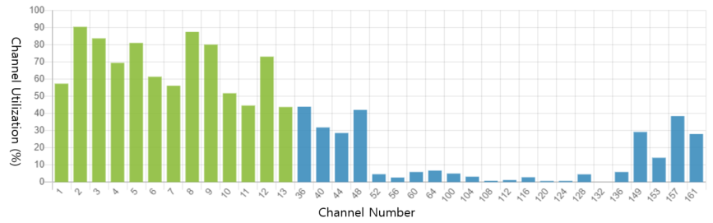  Note: This is an example of Gangnam Subway Station between 11 AM and 12 PM on April 22, 2023. The channel utilization of 1, 5, 9, and 13 was over 90% for 3 hours a day on average.  The channel utilization of 36, 44, and 149 was over 50% for 7 hours a day on average.
  Frequency  Band | The number of certified devices
  Frequency  Band | 2020 | 2021 | 2022 | Average
  2.4 ㎓ band | 10,800 | 11,411 | 11,733 | 11,314
  5 ㎓ band | 1,371 | 1,351 | 1,487 | 1,403
  6 ㎓ band | 1 | 99 | 396 | 165
  Total | 12,172 | 12,861 | 13,616 | 12,882
  Frequency  Band | The number of WAS/RLAN devices sold
  Frequency  Band | 2020 | 2021 | 2022 | Average
  2.4 ㎓ band | 69,821,832 | 58,102,434 | 48,570,108 | 58,831,491
  5 ㎓ band | 16,600,906 | 7,972,220 | 4,747,660 | 9,773,595
  Total | 86,422,738 | 66,074,654 | 53,317,768 | 68,605,086
Sri Lanka | No
Brunei | The band are widely used for public on low power device and wireless LAN.
Pakistan | The frequency band 2.4 GHz & 5.7 GHz are heavily utilized for RLAN services in Pakistan from past many years. Recently, the frequency bands 5.150 – 5.725 GHz and 57- 66 GHz bands have also been approved for RLAN.
New Zealand | No, operation is under a General User Radio Licence, which is issued for all of New Zealand and no data is recorded on use.
Philippines | The use and operation of WAS/RLAN in the Philippines shall be on an unprotected and non-interference basis i.e., operators cannot claim protection against interference and are not permitted to cause harmful interference to other radio services to which the bands are also allocated.

Question 4: What are the current fixed broadband technologies used in your country (e.g., Cable, Fiber, unlicensed or cellular based FWA, etc.), and what is the adoption rates for fixed broadband services (e.g., xDSL/ FTTx/FWA/satellite) in your country?
Answer:
Bhutan | Fixed Broadband Internet, Fixed Wireless Internet
Nepal | Current fixed broadband technologies used are as follows  • Cable  • Optical Fiber  • Unlicensed FWA  • Cellular based FWA  Adoption rates for fixed broadband services are:  Population penetration for fixed broadband has increased from 35.48% to 43.23% during a period of 1 year (October 2022-October 2023.
  S. No | Services | Market Proportion based on active subscribers
  1 | Fixed Broadband (Wired) | 43.68
  2 | Fixed Broadband (Wireless) | 0.201
  3 | Mobile Broadband | 56.12
Thailand | xDSL, Cable Modem, FTTx and FWA are available
Japan | The adoption rate for fixed broadband technologies (as of March 31, 2022):  - Fiber: 99.72%  The number of subscribers (as of September 30, 2023):  <Fixed broadband> total 46.48 million  FTTH: 39.97 million  CATV: 6.23 million  DSL: 0.28 million
Malaysia | The current fixed broadband technologies used in Malaysia includes fibre, copper and other technologies such as satellite, FWA and Gigawire. As of Q4 2022, the fixed broadband subscriptions in Malaysia stands at 4.22 million, with 47.6% penetration rate per 100 premises. The penetration rates of the fixed broadband services by technology are as follows:  * Includes Ethernet and Gigawire
  Technology | Penetration Rate per 100 premises (%)
  FTTx | 46.5
  xDSL | 0.8
  FWA | 0.2
  Satellite | 0.1
  Others* | 0.1
Australia | In Australia, 95% of broadband connections are delivered by the government-owned National Broadband Network (NBN Co.) Statistics collected by the competition regulator (ACCC) show that current fixed technologies include Fibre optic cable (Fibre optic includes fibre-to-the-curb (FTTC), fibre-to-the-basement (FTTB), fibre-to-the-node (FTTN) and fibre-to-the-premises (FTTP)), hybrid-fibre coaxial cable (HFC) and Fixed Wireless.  Adoption rates of nbn services in June 2022 were:  > FTTN: 35.5%  > HFC: 23.3%  > FTTP: 20.4%  > FTTC: 12.8%  > FTTB: 3.2%  > FWA: 4.6%.  Fixed wireless is also offered by commercial mobile network operators. Nbn has 400k fixed wireless customers, TPG and Optus reported a further 377,000 fixed wireless customers at December 31, 2022 (source: December quarter 2022 report | ACCC).
Indonesia | Fixed broadband technologies used in Indonesia mostly based on fiber optic and satellite.  Adoption rate for fixed broadband services (FTTx):  Year 2021 : 17.23 % households  Year 2022 : 22.91 % households  Total household : 68,700,700 (data 2019)
India
Vietnam | - CaTV (Internet over cable TV), xDSL, FTTH and cellular based FWA are the current fixed broadband technologies.  - By the end of 2022, FTTx connection has been deployed to 100% of communes/wards/ townships, 91% of villages, 100% of schools, 72.4% of household (20 million houses).
China | Fixed networks(fiber) have gradually upgrade from 100 Mbit/s to 1000 Mbit/s. By the end of 2022, 15.23 million 10G PON ports with gigabit service capabilities have been built, nearly double the level of 2021. 110 cities across China have reached the gigabit city standard.  By the end of 2022, China had 590 million fixed broadband access users, with a population penetration rate of 41.8 units per 100 people.  https://www.miit.gov.cn/jgsj/yxj/xxfb/art/2023/art_69798e71872c407ab677fd1c73885337.html
Korea | Fiber and FTTx are used as one of major technologies for fixed broadband.
Sri Lanka
  Fixed broadband technology | Adoption rate
  xDSL | 61%
  FWA | 37%
  FTTX | 2%
Brunei | As of June 2023, FTTH enrolment with 92% coverage area.
Pakistan | Cable, Fiber/FTTx, HFC, through Point-to-Point link on 5.725 – 5.875 GHz band with Max. EIRP 30 dBm
Palau | Cable fiber, cellular based FWA and DSL
New Zealand | We have Fibre, DSL, HFC, Fixed Wireless Access, and Satellite as the fixed broadband technologies used in New Zealand.
Philippines | Cable, Fiber, Satellite broadband and FWA.  Adoption rates for fixed broadband services have been increasing steadily, driven by factors such as growing internet penetration, increasing demand for high-speed connectivity, and government initiatives to improve broadband infrastructure and accessibility across the country. However, there may still be challenges in terms of coverage gaps, particularly in rural and remote areas, which requirement further investment and deployment of broadband infrastructure.

Question 5: What is the average fixed broadband connection speed per connection (both residential premises and business/ enterprise premises) (e.g., xDSL/ FTTx /FWA/satellite) in your country?
Answer:
Bhutan | The normal average leased line internet connections leased by general households is 2 to 4Mbps
Nepal | Not available
Thailand | The average fixed broadband connection DL/UL speed is 252.97/216.63 Mbps (Ookla Speedtest Global Index, as of June 2025).
Japan | The average speed is not measured.
Malaysia
  Indicator | Download Speed  (As of January 2023) | Source
  Mean fixed-broadband speed | 138.84 Mbps | Ookla speedtest global index
  Median fixed-broadband speed | 92.69 Mbps | Ookla speedtest global index
Australia | In Australia, 95% of broadband connections are delivered by the government-owned National Broadband Network (NBN Co.). There is also a significant enterprise market, but data on enterprise speeds and performance are not collected. Data is also not separately available for business premises.  The following applies only to residential customers. nbn products are sold by speed, so consumers get whatever speed they select ranging from 12Mbps to 1Gbps. The following shows the average available speed and then the most popular product (i.e.: what speed plan the majority of customers are paying for).  Statistics collected by the competition regulator show:  > The average speeds available for FTTP are 276 Mbps.  > 46% of FTTP connections are on 50 Mbps  > Average speed available for FTTC, FTTB, FTTN and HFC is 46.75 Mbps  > 62% of these connections are on 50 Mbps  > Average speed available on fixed wireless is 37.3 Mbps  > 60% of connections are on 60 Mbps.  Source: December quarter 2022 report | ACCC
Indonesia | The average fixed broadband connection (FTTx) for downlink is 25.45 Mbps and the average uplink speed is 12.95 Mbps (Ookla, December 2022).
India
Vietnam | In recent survey, it showed that average fixed broadband connection speed per connection in Viet Nam, depending on operators, are in the range from 50 Mbps to 100 Mbps.
China | 554 million fixed broadband users reached the access rate of 100 Mbit/s, accounting for 93.9% of broadband users. 91.75 million fixed broadband users reached the access rate of 1000 Mbit/s, accounting for 15.6%. The total bandwidth of fixed broadband users reaches 1993.3 million Gbit/s. The average subscribed bandwidth per household has reached 367.6 Mbit/s.  https://www.miit.gov.cn/jgsj/yxj/xxfb/art/2023/art_69798e71872c407ab677fd1c73885337.html
Korea | 10 Gbps is the average speed for fixed broadband connection using FTTx.
Sri Lanka | Average xDSL Throughput – DL 30 UL 2 Mbps  Average FWA Throughput – DL 22 UL 4 Mbps  Average FTTX Throughput –DL 95 UL 47 Mbps
Brunei | As of June, average speed 50 mbps (one operator only)
Pakistan | 8 – 10 Mbps
Palau | 5 Mbps – 20 Mbps residence  For business - Palau's Fastest DSL provider, PNCC offers high-speed broadband DSL and Fiber Optic solutions for your fast paced business. PNCC understands the technology budget challenges, so we have developed "Commercial DSL Contracts" that should meet your needs. Please inquire about Commercial DSL Contracts
New Zealand | Information on downlink and uplink connection speeds are available on:  https://public.tableau.com/app/profile/commerce.commission/viz/MeasuringBroadbandNewZealandDashboard/Overview
Philippines | The average connection speed per connection is 25.5 Mbps

Question 6: Which WAS/RLAN technologies are used in your country, for example Wi-Fi, LTE-U, NR-U? And what are the use cases for these technologies?
Answer:
Bhutan | Wi-Fi
Nepal | Wi-Fi is the only WAS/RLAN technology currently in use in Nepal. NTA has successfully completed the wireless broadband project in karnali province using universal service obligation fund, also called RTDF in Nepal. Besides this NTA has developed and completed several wireless project covering various religious destinations, Everest Basecamp trekking route , Round Annapurna circuit among others.
Thailand | Wi-Fi technology is used in 2.4 GHz, 5 GHz and lower 6 GHz frequency bands.  LTE-U technology is used in 5 GHz frequency band.
Japan | The technical standards have been established for WAS/RLAN technologies, and the use of any technology and its utilization for any use case are permitted as long as the above standards are followed.
Malaysia | As to date, Wi-Fi is the widely used technology for WAS/RLAN. Some of the use cases of WAS/RLAN include Internet Access, Mobile Device, Home Networking, Smart Home Device, Business Networking, Internet of Things (IOT) and Education.
Australia | As the vast majority of WAS/RLAN use in Australia is authorised under class licensing, and Australian regulations are also generally technology-neutral, so users are free to deploy any technology that meets applicable technical conditions. We therefore have no specific record of which technologies are deployed, or their use cases.
Indonesia | WAS/RLAN  a. WiFi/RLAN : used for access and backhaul.  b. 5 GHz band (5150 – 5350 MHz and 5725 – 5825 MHz) opened for class-licensed IMT-based technology such as LAA
India | License exemption is technologies neutral.  WAS/RLAN technologies use cases in India are predominantly for Home Broadband, Enterprise Broadband and Public Wi-Fi hotspots
Vietnam | Up to now, WAS/RLAN technologies are used in Vietnam that has been just Wi-Fi. The use cases for this technology are public/private Wi-Fi access, Wi-Fi direct, Bluetooth, Ip camera, remote control.
Korea | WiFi 6E is used for WAS/RLAN technologies and use cases are attached as Annex 3-1.
Sri Lanka | Wi-Fi, Zigbee  Wi-Fi- Private LAN, Zigbee- smart meters
Brunei | WAS/RLAN commonly used as home broadband and low powered device in our  country.
Pakistan | Wi-Fi to the extent of indoor.
Palau | U-NII and IEEE 802.11
New Zealand | The permitted technologies need to be in accordance with the General User Radio Licence for Short Range Devices https://www.rsm.govt.nz/about/publications/gazette-notices/general-user-radio-licence-gurl-notices/ and compliance requirements for suppliers. This is found in https://www.rsm.govt.nz/business-individuals/supplier-compliance/steps/step1-meet-standards/, including the Radio Regulations (Radio Standards) Notice.
Philippines | Wi-Fi is extensively used for providing wireless internet connectivity in various settings such as homes, offices, cafes, restaurants, airports, and public spaces. It is also used for machine-to-machine communication, IoT devices, and smart home applications.

Question 7: What is your country’s spectrum plan on the 6 GHz band for WAS/RLAN use?
Answer:
Bhutan | We have not yet planned the 6GHz band for WAS/RLAN since it is explicitly used by the satellite services at the moment. In future, with the coming of WiFi-6, we may look into refarming for WAS/RLAN.
Nepal | As the 6 GHz band is currently used for FS/FSS services, there is no immediate action plans related to the use of 6 GHz band for WAS/RLAN. At the moment, Nepal is monitoring the international developments in this topic.
Thailand | The equipment using the band 5.925-6.425 GHz is license exempted and can be used freely nationwide. (RLAN).  The use of the band 6.425-7.125 GHz is planned to be considered before WRC-27.
Japan | The national regulation was revised to allow WLAN operations in the 5925-6425 MHz frequency band in September 2022. The 6425-7125 MHz frequency band is under consideration for future assignments.
Malaysia | Malaysia has made available the 5925 MHz to 6425 MHz frequency band for WAS/RLAN under the Class Assignment for Short-range Radiocommunication Device. Malaysia is currently monitoring the international development and studies of the 6 GHz band in view of any future considerations of the 6425 MHz to 7125 MHz frequency band.
Australia | The ACMA has authorised 2 classes of device in the 5925–6585 MHz 6 GHz band. These two classes of device are often referred to as low power indoor (LPI) and very low power (VLP). The proposed power limits and restrictions specific to these classes are:  • For LPI devices:  maximum power 24 dBm EIRP  maximum power density 11 dBm/MHz EIRP  must operate indoors.  contention-based protocols for multiple access, such as Carrier Sense Multiple Access (CSMA) or Multiple Access Collision Avoidance (MACA), must be implemented.  the radio emissions from a radiocommunications transmitter below 5925 MHz must not be greater than -27 dBm/MHz EIRP.  • For VLP devices:  maximum power 14 dBm EIRP  maximum power density 1 dBm/MHz EIRP  may operate in any location.  contention-based protocols for multiple access, such as Carrier Sense Multiple Access (CSMA) or Multiple Access Collision Avoidance (MACA), must be implemented.  the radio emissions from a radiocommunications transmitter below 5925 MHz must not be greater than -37 dBm per 1 MHz EIRP.
Indonesia | At present, Indonesia has authorized the utilization of the lower 6 GHz frequency band (5925-6425 MHz) for Low Power Indoor (LPI) and Very Low Power (VLP) applications, classified under class license.
India | India has authorized the frequency range 5925 MHz to 6425 MHz for WAS/RLAN.
Vietnam | Currently, there is no spectrum plan or regulation for the use of WAS/RLAN in the 6 GHz band. We are considering to allocate spectrum for RLAN and/or IMT in 6 GHz band, taking into account international trend and country need for the development of nation broadband infrastructure.
China | China will identify the band 6425-7125 MHz or portions thereof, for IMT in the new version of the Regulations on the Radio Frequency Allocation of China. Currently there’s no plan to use 6GHz band for WAS/RLAN in China.
Korea | Since 2022, the frequency band 5 925-7 125 MHz has been opened for WAS including WiFi 6E with license-exempt usage, and WiFi 6E will be evolved to WiFi 7 after 2024.
Sri Lanka | 5.925GHz to 6.425 GHz
Brunei | 5925 to 6425 MHz (500 MHz)
Pakistan | In Pakistan co-existence studies are going on for adoption of 6 GHz band for Wi-Fi-6E with respect to satellite uplink operations.
Palau | no current plan
New Zealand | The 5925 - 6425 MHz frequency range has been made available in New Zealand to WAS/RLAN and information was provided in the General User Radio Licence for Short Range Devices https://www.rsm.govt.nz/about/publications/gazette-notices/general-user-radio-licence-gurl-notices/.  The 6425 -7125 MHz frequency range is still to be considered, taking into account international and regional developments, including Wi-Fi, Mobile (IMT) and any possible shared use of spectrum. Further information on this is outlined in the New Zealand Spectrum Outlook https://www.rsm.govt.nz/about/publications/spectrum-outlook-and-annual-reports/new-zealand-spectrum-outlook-2023-management/
Philippines | The Philippines is considering the band 5925 – 6425 MHz for Wi-Fi 6E.

Question 8: What are the incumbent services and their frequency ranges in the 6 GHz band?
Answer:
 | Frequency Range | Incumbent services | Conditions
Bhutan | 6GHz | Satellite Services (VSAT) and Television Satellite
Nepal | 5925 MHz - 6425 MHz | Fixed Point to Point Microwave Link | NA
Nepal | 6425 MHz - 6700 MHz | Fixed Satellite Services | NA
Nepal | 6425 MHz - 7125 MHz | Fixed Point to Point Microwave Link | subject to the co-ordination with FSS Allocation
Thailand | 5.925-6.425 GHz | Fixed-satellite service (Uplink)
Thailand | 6.425-7.125 GHz | Fixed-satellite service (Uplink) and Fixed service
Japan | 5 925-6 425 MHz | FIXED  FIXED SATELLITE (Earth-to-space)
Japan |  | MOBILE | Low-Power Data Transmission System shall be used
Japan | 6 425-6 570 MHz | FIXED  FIXED SATELLITE (Earth-to-space)  MOBILE
Japan | 6 570-6 870 MHz | FIXED  FIXED SATELLITE (Earth-to-space)
Japan | 6 870-7 075 MHz | FIXED  FIXED SATELLITE (Earth-to-space)  MOBILE
Japan | 7 075-7 125 MHz | FIXED  MOBILE
Malaysia | 5925 MHz to 7075 MHz | Fixed Satellite Service  Earth Station (VSAT/Hub station) | - Use by way of Apparatus Assignment (licensed apparatus) and Class Assignment* (Non-licensed apparatus).  For FSS use under the Class Assignment, the requirements and conditions are specified in Class Assignment for Fixed-Satellite Service Earth Station.
Malaysia | 5925 MHz to 7125 MHz | Fixed Service  - Microwave Link  - Outside Broadcast Microwave Link | - Use by way of Apparatus Assignment (licensed apparatus).  - Fixed service operates on non-interference basis (NIB) to the earth stations of Fixed Satellite Service.  Other requirements/conditions are specified in the relevant documents which can be found at this URL:  https://www.mcmc.gov.my/en/spectrum/standard-radio-system-plan-resources:
Malaysia | 5925 MHz to 6425 MHz | Short-range Radiocommunication Device (including WAS/RLAN) | - Use by way of Class Assignment (Non-licensed apparatus)  - The relevant requirements and conditions are specified in the Class Assignment for Short-range Radiocommunication Device (SRD) (please refer to the answers provided in Question 1 above).
Australia | 5925 – 6425 MHz | Fixed Earth  Point to Point links  Radiodetermination
Australia | 6425–7125 MHz | Fixed Earth  Earth Receive  Point to Point links  Radiodetermination
Indonesia | 6 425 – 7 110 MHz | Fixed Wireless Point to Point (Microwave Link) | utilized service
Indonesia | 5 925 – 6 725 MHz | Fixed Satellite Service | utilized service
Indonesia | 6 725 – 7 025 MHz | Fixed Satellite Service | planned band
India | 5925-6425 MHz | Fixed Service (Point to Point links), FSS (E-to-s)
India | 6 425-6725 MHz | FSS (E-to-s)
India | 6725-7025 MHz | FSS (E-to-s), Fixed Service (Point to Point links)
India | 7025-7 125 MHz | Fixed Service (Point to Point links)
Vietnam | 5925-6425 MHz | FIXED  FIXED-SATELLITE (Earth-to-space)  MOBILE | RR. No. 5.457A 5.457B  5.149 5.440 5.458
 | 6425-6700 MHz | FIXED  FIXED-SATELLITE (Earth-to-space)  MOBILE | RR. No. 5.457A 5.457B  5.149 5.440 5.458
 | 6700-7075 MHz | FIXED  FIXED-SATELLITE (Earth-to-space) (space-to-Earth)  MOBILE | RR. No. 5.441  5.458 5.458A 5.458B  VTN16  VTN16 The following frequency bands are preferred for the use of systems in the Fixed-satellite service:  3400-3560 MHz (space-to-Earth direction)  6425-6725 MHz (Earth to Space)  10700-11700 MHz (space-to-Earth direction)  12750-13250 MHz (Earth to Space)  13750-14000 MHz (Earth to Space)  14250-14500 MHz (Earth to Space)  Earth stations operating in the bands 3400-3560 MHz and 10700-11700 MHz must employ the receiver filters to reject out-of-band signals in accordance with the regulations specified by the Ministry of Information and Communications.  Systems in other services operating in this band shall not cause harmful interference to and shall not be protected from harmful interference cause by systems in the Fixed-satellite service.
 | 7075-7110 MHz | FIXED  MOBILE | RR. No. 5.458
China | 5925-6700 MHz | FIXED  FIXED-SATELLITE (Earth-to-space) 5.457A  MOBILE CHN38
  5.149 5.440 5.458 CHN12
  CHN18 CHN23
China | 6700-7075 MHz | FIXED  FIXED-SATELLITE (Earth-to-space) (space-to-earth) 5.441  MOBILE
  5.458 5.458A 5.458B
  CHN23
China | 7075-7145 MHz | FIXED  MOBILE
  5.458 CHN23
Korea | 6 425 ~ 6 605 MHz  6 765 ~ 6 945 MHz | Broadcasting (Fixed)
 | 6 605 ~ 6 765 MHz  6 945 ~ 7 125 MHz | Broadcasting (Mobile)
 | 5 925 ~ 6 425 MHz  6 430 ~ 7 110 MHz | M/W (Fixed)
 | 6 876 ~ 7 051.86 MHz | Satellite (Feeder link)
Sri Lanka | 5.925 – 6.700 GHz | FIXED  FIXED-SATELLITE (Earth-to space)  MOBILE  Satellite - Fixed Earth Station Fixed Service – Network  Maritime - Maritime Mobile
 | 6.700 – 7.075 GHz | FIXED  FIXED-SATELLITE (Earth-to space) (space-to-Earth)  MOBILE  Fixed Service - Network
 | 7.075 – 7.145 GHz | FIXED MOBILE  Fixed Service - Network
Brunei | 5925-6425 MHz | Fixed
Brunei | 6425-7125 MHz | - Fixed-Satellite Service (Uplink)  - Fixed Service
Pakistan | 5925 – 7425 MHz | - Fixed
Pakistan | 5925 – 6425 MHz | - FSS (uplink)
Palau | 6415.84 – 6417.64 MHz |  | In progress
Palau | 6280.397 – 6281.547 MHz |  | In progress
New Zealand | Please refer to the New Zealand Table of Radio Spectrum Usage in New Zealand in PIB 21 https://www.rsm.govt.nz/about/publications/pibs/pib-21/.
Philippines | 5925 – 6425 MHz | Point-to-Point Radio Communications System
Philippines | 6425 – 7125 MHz | Point-to-Point Radio Communications System

Question 9: Does your administration have a frequency assignment/license database system for the 6 GHz band? If there is such a database, is it open to public for 3rd coordination system to interact with? Please provide some details
Answer:
Bhutan | N/A
Nepal | The assignment database is maintained for Fixed Satellite Service and Fixed Services (Microwave) separately. But such database is not publicly available.
Thailand | There is a frequency assignment/license database system, but it is not open to public.
Japan | Yes, we have a database system for all domestic radio stations, which is available on the MIC website.
Malaysia | The frequency bands assigned under the Apparatus Assignment are registered in MCMC’s Spectrum Management System. Some information of frequency assignments (such as transmit/receive frequencies, assignment holders, location, etc.) are available in MCMC’s website, which can be found at  https://www.mcmc.gov.my/en/legal/registers/cma-registers.  There is no frequency database system for short-range radiocommunication devices (including WAS/RLAN) under the Class Assignment.
Australia | Yes, publicly available and searchable database, the Register of Radiocommunications Licenses at https://web.acma.gov.au/rrl/register_search.main_page ,however note that devices authorized by Class Licence do not appear on the register.
Indonesia | Yes, there is license database for 6 GHz band existing usage.  It is not open to public for 3rd coordination system to interact with.
India | There is a robust licensing and frequency assignment system in place. Yes, India does have frequency assignment/license database system for the frequency bands including 6 GHz band. Wireless Planning and Coordination Wing (WPC) is nodal agency to do any coordination.
Vietnam | Yes, the administration has. However, in current regulations, it is not open to public for 3rd coordination system to interact with.
China | Yes, there’s database system. However, there’s no plan to public the database for any 3rd system as it might bring risk.
Korea | The Republic of Korea has a frequency assignment/license database system for all radio stations including 6 GHz band and a plan to develop for 6 GHz frequency coordination system in near future.
Sri Lanka | No
Brunei | There is a frequency assignment/license database system, but it is not open to public.
Pakistan | In Pakistan we maintain a database of all authorized/ licensed users including operations in 6 GHz band. Currently, it is not open to public for 3rd party coordination system to interact with.
Palau | In Progress
New Zealand | New Zealand’s Frequency assignment/licence database is the Register of Radio Frequencies (RRF) which contain the records held by Radio Spectrum Management (RSM). The RRF can be accessed by visiting https://rrf.rsm.govt.nz/ui?state=1
Philippines | Yes, It is not open to public.
A4-2: Korea’s detailed response to Question 6
Question 6: Which WAS/RLAN technologies are used in your country, for example Wi-Fi, LTE-U, NR-U? And what are the use cases for these technologies?

Technology | Frequency | Use case | Remarks
Wi-Fi 6(E) | 5/6 GHz | <Business Solution>  1) Wi-Fi 6E and AI robot-based smart solution for businesses*:  Building a high-capacity, low-latency, and multi-connection environment with Wi-Fi 6E in small business, and executing automatic order taking, easy payment, serving, and checkout scenarios with AI serving robots.  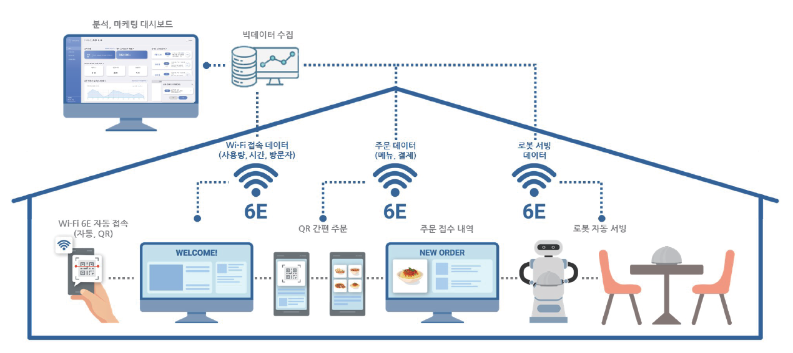  2)Customer service through CR code in business stores, based on Wi-Fi 6E*:  Implementation of a Wi-Fi 6E service in small business stores that provides contactless services such as displaying menus, ordering, and payment to users who connect through a QR code. A big data collection platform is also implemented for marketing information targeting small businesses.  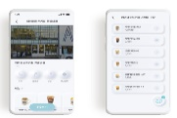    3) Logistics warehouse service using Wi-Fi 6E-based AMR (Auto Mobile Robot)*:  Demonstration of a smart logistics integrated management system by integrating a Wi-Fi 6E-based mesh configuration and an AMR (Auto Mobile Robot) based logistics management platform at an air logistics center.  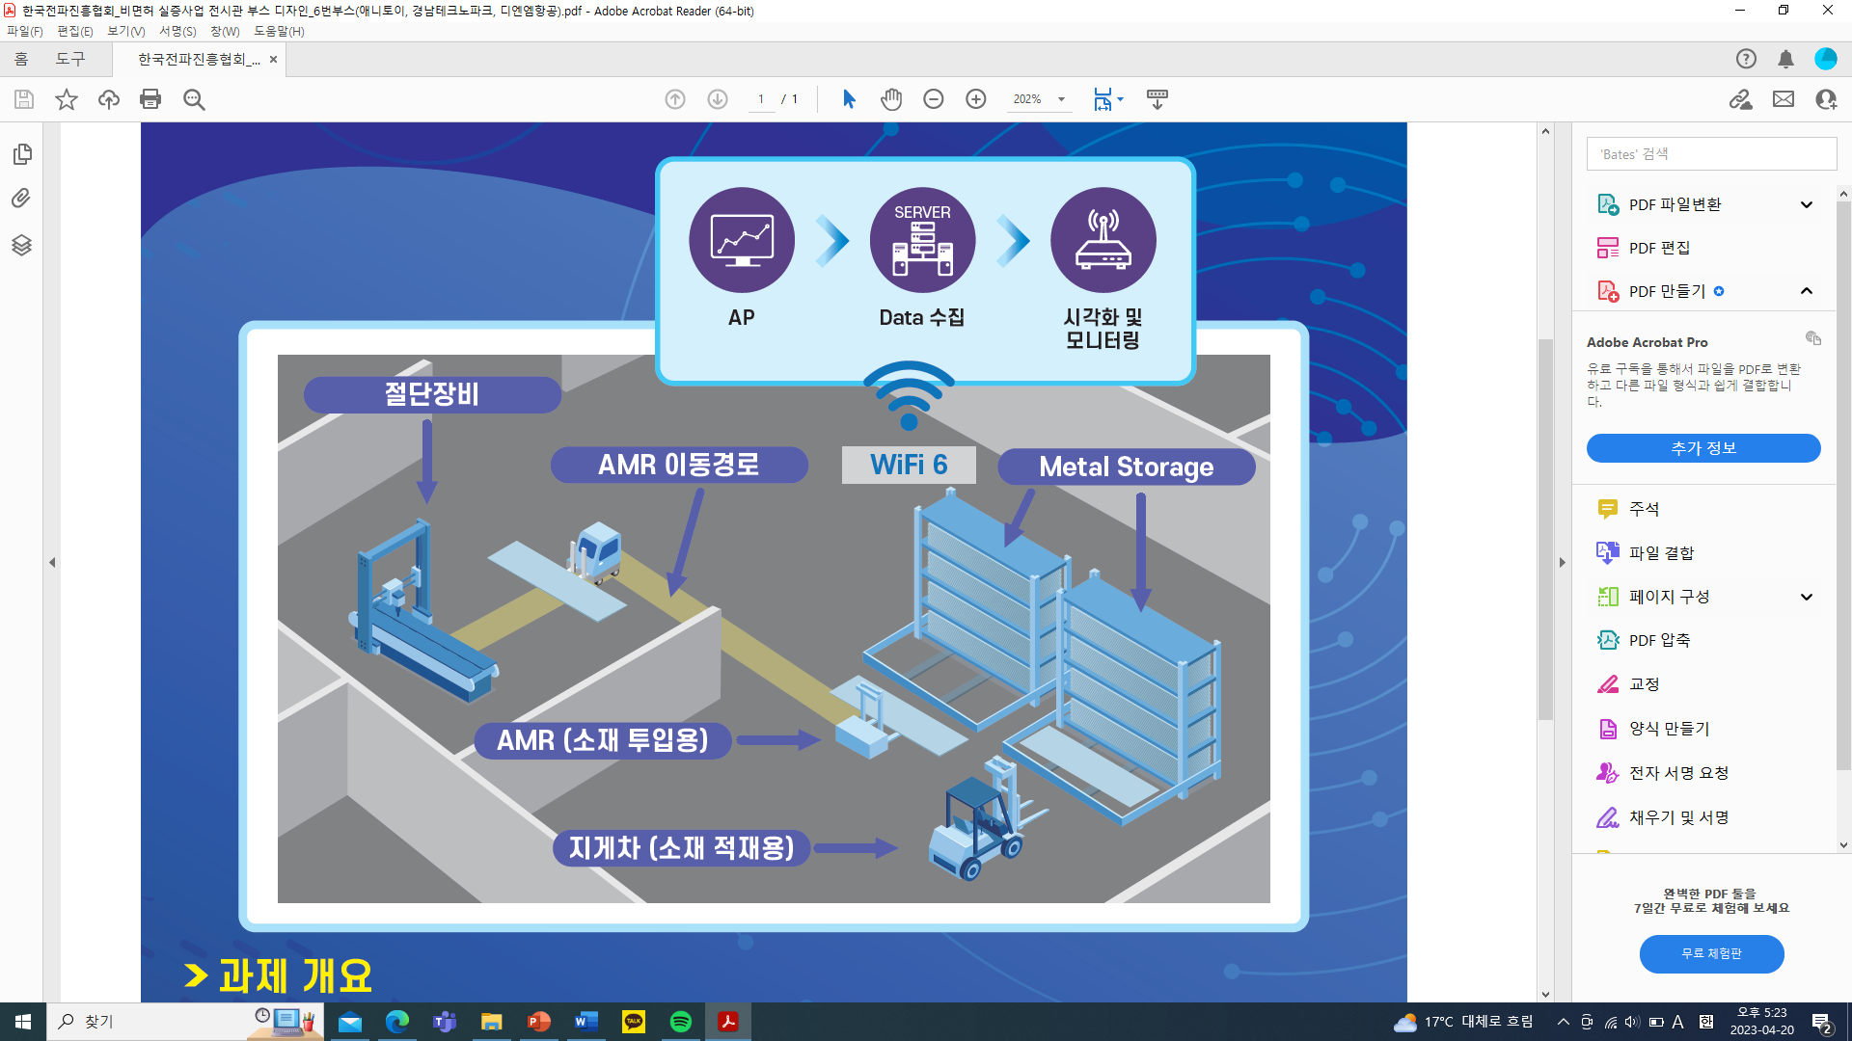  <Education and Learning>    1) Providing education and training services to the classroom using next-generation Wi-Fi 6E-based immersive contents*:  Real-time two-way online education program is created using VR contents based on Wi-Fi 6E, and a high-quality educational environment is established.    2) Realistic tour guide service using Wi-Fi 6E in exhibition and experience spaces *:  By using Wi-Fi 6E, real-time transmission of large 3D/VR immersive contents is served to two exhibition halls of the National Science Museum. Meta-verse experience services based on kiosks and Holo-lens 2 are provided. 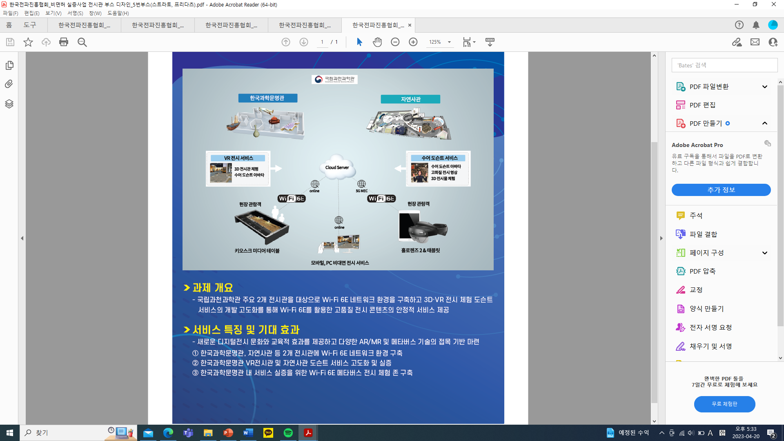  <Navigation>  1) Wi-Fi 6E-based high-precision AR Navigation*: Providing location-based AR navigation services to users who are connected to Wi-Fi 6E at a distance by combining visual positioning system (VPS) data with AR content.  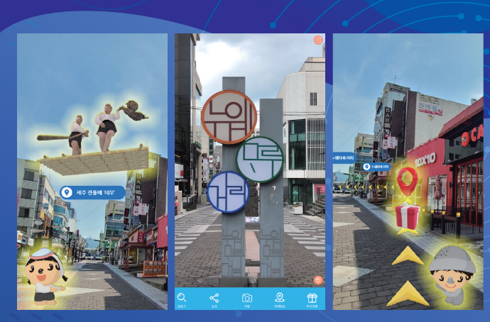  <Streaming Service>  1) Seamless data roaming service with 6GHz Wi-Fi technologies*:  At the outdoor gates of Airport, it is possible to connect to a 6 GHz Wi-Fi network using a smartphone while moving around. By utilizing roaming and mesh networking capabilities, it is possible to maintain Wi-Fi service and enable video calls and streaming of 4K-quality video content..  . 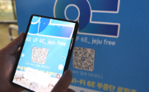  2) Non-face-to-face sports relay service using AI and Wi-Fi*:  Utilization of AI and Wi-Fi 6 GHz for contactless sports broadcasting services.  Simultaneous live broadcasting of sports games through AI cameras, transmitting two types of video in FHD and panorama to provide the game footage to both the stadium audience and viewers.    3) 8K level interactive service using 6GHz band*:  Real-time streaming service of VR contents featuring world natural heritage sites for visitors of a VR theme park in a botanical garden, accessed through an Android-compatible 8K VR player app.  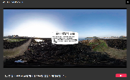  4) Watching local broadcast channels provided through terrestrial ATSC 3.0 on-vehicle using Wi-Fi 6E. *:  Demonstration of free UHD broadcast service through mobile devices by receiving multi-channel UHD terrestrial broadcasting on a moving bus, converting and transmitting it through Wi-Fi 6E. 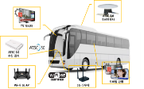  <Performance test>  1) Performance comparison experience and visualization between existing Wi-Fi and Wi-Fi 6E*.  Verification and visualization of performance comparison, such as actual measured speed, between LTE, 5G, Wi-Fi 5/6/6E.  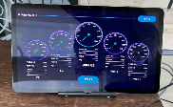  - Wi-Fi 6E outdoor MESH network*.  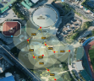  Validation of stable internet service by constructing a mesh network using 9 or more Wi-Fi 6E access points as multi-nodes in public places, and verifying and comparing network performance based on signal strength. | *The technology and service demonstration items are developed by small and medium-sized venture entrepreneurs with the support of the Korean government and the Korea Radio Promotion Association
LTE-U | 5GHz | 1) Public Wi-Fi offloading for data traffic from public Wi-Fi networks to LTE-U networks  2) Mobile video for providing high-quality mobile streaming video and live video  3) Internet of Things (IoT) for providing wireless connectivity to IoT devices  4) Emergency services for providing wireless connectivity to emergency services for police, fire, and medical services
NR-U | 5/6GHz | Not yet

Annex 5

Annex 5: Regulatory Information from outside APT Region
This section includes regulatory and information about a few administrations outside the APT region.
A5.1 Regulatory Information for the 5 GHz band

Table 1 Regulatory requirement for RLAN operating in 5.15 – 5.35 GHz
Country | Regulatory requirement
US | 1W maximum conducted power and maximum antenna gain 6 dBi, maximum power spectral density 17dBm/MHz;  Maximum EIRP at any elevation angle above 30 degrees as measured from the horizon must not exceed 125 mW (21 dBm);  Allows point to point system with 23dBi antenna gain
Canada | 1W maximum conducted power and maximum antenna gain 6 dBi, maximum power spectral density 17dBm/MHz;  Maximum EIRP at any elevation angle above 30 degrees as measured from the horizon must not exceed 125 mW (21 dBm);  Allows point to point system with 23dBi antenna gain

A5.2 Regulatory information in for the 6 GHz band

Brazil

In Brazil, the whole 6 GHz band (5925 – 7125 MHz) available for license-exempt RLAN use, which includes two device classes: LPI (30 dBm) and VLP (17 dBm) devices. Brazil Anatel is currently working on enabling SP mode under supervision of AFC System.

Canada

Canada allows license-exempt RLAN use across the entire 6 GHz, with 3 different power levels available across different portions of that range:
- 14 dBm “very low power”
- 30 dBm “low power” for indoor use only
- 36 dBm for standard power devices under AFC control.

The AFC is to be compatible – as much as possible – with the US version, to help deal with cross-border coordination.

“Listen-before-talk” protocols are to be implemented on all low and very-low power devices. SP APs under the control of an AFC system will be permitted to operate on a license-exempt basis in the 5925 – 6875 MHz frequency range. For the protection of FSS satellite-based receivers from Standard Power devices operating outdoors, the SP APs’ maximum EIRP must be under 125 mW at elevation angles above 30 degrees above the horizon – consistent with Canada’s experience in other bands.

United States

The Federal Communications Commission (FCC) made the entire 6 GHz band (5925 – 7125 MHz) for Wi-Fi 6E and other unlicensed uses in the US in April 2020.
The FCC authorizes indoor low-power operations over the full 1200 MHz and Standard Power devices in 850 MHz of the 6 GHz band (the other ranges being excluded due to the presence of mobile incumbent services). The FCC requires the SP APs to use an AFC to prevent interference to incumbent services.
For Standard Power outdoor use, the maximum EIRP at any elevation angle above 30 degrees as measured from the horizon must not exceed 21 dBm.

Table 2 Maximum EIRP for 6 GHz unlicensed devices in the US
Devices Class | Operating bands | Maximum EIRP | Maximum EIRP Power Spectral Density
Standard-Power AP (AFC controlled) | U-NII-5 (5925 - 6425 MHz)  U-NII-7 (6525 - 6875 MHz) | 36 dBm | 23 dBm/MHz
Client Connected to Standard-Power AP | U-NII-5 (5925 - 6425 MHz)  U-NII-7 (6525 - 6875 MHz) | 30 dBm | 17 dBm/MHz
Low-Power (indoor only) | U-NII-5 (5925 - 6425 MHz) U-NII-6 (6425 - 6525 MHz) U-NII-7 (6525 - 6875 MHz) U-NII-8 (6875 - 7125 MHz) | 30 dBm | 5 dBm/MHz
Client Connected to Low-Power AP |  | 24 dBm | -1 dBm/MHz

Europe

In 2020, Europe made a decision on License Exempt LPI and VLP operation in the 5925 – 6425 MHz range and currently studying the 6425 – 7125 MHz range. The devices operating within that frequency range are allowed to operate at two different power limits: 23 dBm (10 dBm/MHz), if only used indoors or 14 dBm (1 dBm/MHz) in all locations. EU also harmonized the band for Client to Client operation under LPI mode.

ATU

In July of 2021, African Telecommunications Union (ATU) recommended License Exempt LPI and VLP operation in the 5925 – 6425 MHz range. The devices operating within that frequency range are allowed to operate at two different power limits: 23 dBm (10 dBm/MHz), if only used indoors or 14 dBm (1 dBm/MHz) in all locations.

Colombia

In Nov 2022, Colombia ANE announced allocation of the entire 6GHz band (5925 –7125MHz) for License Exempt LPI operation at maximum power level of 30 and 24 dBm (5 and -1 dBm/MHz) for Access Point and Client devices respectively.

Argentina

In May 2023, Argentina Enacom announced allocation of the entire 6GHz band (5925 –7125MHz) for License Exempt operation. Regulatory details are not announced yet.

Saudi Arabia
In March of 2021, Saudi Arabia allocated the entire 6GHz band (5925-7125MHz) for License Exempt LPI operation at maximum power level of 30 and 24 dBm (10 dBm/MHz) for Access Point and Client devices respectively. Work on SP and VLP modes are ongoing.

Annex 6

Annex 6: Study by Ericsson: Considerations on WAS/RLAN Spectral Efficiency
The analysis in this section shows that gigabit Wi-Fi connectivity can already be widely achieved using the 5 GHz and lower 6 GHz bands by optimizing Wi-Fi AP configurations, e.g., channel widths, and can be further enhanced by adopting the latest Wi-Fi standards, e.g., Multi-Link Operation (MLO) feature. For more demanding applications, consistent gigabit connectivity can be ensured by deploying additional AP(s) as needed. In fact, the main challenge for Wi-Fi is the interference between Wi-Fi networks. By addressing this interference with advanced features, capacity within the existing spectrum can be further improved.
A6.1 Impact of Wi-Fi channel bandwidth on spectral efficiency
To achieve higher Wi-Fi data rates, the trend has been to increase Wi-Fi channel bandwidths, such as 40 MHz channels in IEEE 802.11n (Wi-Fi 4), 80 MHz and 160 MHz channels in IEEE 802.11ac (Wi-Fi 5) and IEEE 802.11ax (Wi-Fi 6/6E), and now 320 MHz channels in the IEEE 802.11be (Wi-Fi 7) standard. However, using narrower channels can be a more efficient approach in many instances.. For example, industry planning guidelines [15], [16] suggest using a channel width of 20 MHz in environments with a high density of access points (APs) to minimize the number of APs operating on the same channel. Note that these guidelines are based on Wi-Fi 5 technology.
Another source that supports the above recommendation is the Plum report [17]. This report analyses how spectrum availability influences Wi-Fi's ability to deliver gigabit connectivity in high-density residential environments. The study in the report includes simulations of a high-density Wi-Fi deployment in a typical apartment building, where each apartment has gigabit fiber connectivity. The simulation scenario follows the deployment pattern defined by the IEEE P802.11 Wireless LANs project.
While it is not the primary focus of the Plum report, it is noted that the report’s results indicate that Wi-Fi spectral efficiency and capacity can be improved using only spectrum resources in the 5 GHz and lower 6 GHz bands along with current Wi-Fi technology, if they are used efficiently. In fact, the report also indicates that in all cases considered, wider Wi-Fi channels (160 MHz) decrease Wi-Fi spectral efficiency, while narrower channels (80 MHz) can enhance efficiency due to better frequency reuse, allowing more channels to be shared.
Further, Plum report section 3.1 notes that "Should the upper 6 GHz band be made available, this would give 99% coverage (using nineteen 80 megahertz channels) or 86% coverage (nine 160 megahertz channels). If the upper 5 GHz channels are also available, 100% coverage can be achieved in the 160 MHz case, and just short of this in the 80 MHz case."

The finding above is based on a comparison of the results shown in Figures 3.5 and 3.6 of the Plum report. The following table summarizes the spectral efficiency per Wi-Fi AP for different channel bandwidths and the available numbers of channels as presented in the Plum report:
- Spectral efficiency values are determined by dividing the throughput at various percentiles shown in Figures 3.5 and 3.6 of the Plum report by the bandwidth of each individual channel.
- The same color code as used in Figures 3.5 and 3.6 of the Plum report is applied here, considering only the potential future scenarios in the APT region: green (eleven 80 MHz channels or five 160 MHz channels) and pink (nineteen 80 MHz channels or nine 160 MHz channels).
- For each color, the percentages in parenthesis correspond to the reduction in spectral efficiency when using 160MHz channels instead of 80 MHz channels.
Table A6-1 Comparison of spectral efficiencies of wider and narrower Wi-Fi channels from data presented in the Plum report
Probability  of exceedance | Spectral efficiency (SE) for individual links, i.e., per AP (bit/s/Hz)
 | 80MHz  (11-channels) | 160MHz  (5-channels) | 80MHz  (19-channels) | 160MHz  (9-channels)
90% | 9.0 | 1.8  (-80%) | 13.5 | 3.5  (-74%)
50% | 15.0 | 9.0  (-40%) | 15.0 | 12.0  (-20%)

Table A6-1 shows that with the spectrum availability in the 5 GHz and lower 6 GHz bands (green column), increasing the channel bandwidth from 80 MHz to 160 MHz results in a substantial decrease in spectral efficiency and capacity. Moreover, even with the addition of 4x160 MHz channels (expanding from 5x to 9x 160 MHz channels if the upper 6 GHz band is included), the Plum report shows that spectral efficiency only improves from 1.8 to 3.5 bit/s/Hz in 90% of locations (compared to 9.0 bit/s/Hz with 11x80 MHz channels) and from 9.0 to 12.0 bit/s/Hz in 50% of locations (compared to 15.0 bit/s/Hz with 11x80 MHz channels).

Figure A6-1 shows the complementary cumulative distribution function (CCDF) curves for spectral efficiency, comparing eleven (11) 80 MHz channels with five (5) 160 MHz channels (i.e., the spectrum availability of the 5 GHz and lower 6 GHz bands).

Figure A6-1 Comparison of the spectral efficiency of individual links for the case of eleven (11) 80 MHz channels and five (5) 160 MHz channels, from data presented in the Plum report

Based on Figure Y, Wi-Fi spectral efficiency and capacity can be improved significantly by decreasing the channel bandwidth while using only the 5 GHz and lower 6 GHz bands. For instance, when using 80 MHz channels instead of 160 MHz channels, the spectral efficiency per apartment:

- increases from 1.8 to 9.0 bit/s/Hz, i.e., +400% increase, in 90% of locations.
- increases from 9.0 to 15.0 bit/s/Hz, i.e., +67% increase, in 50% of locations.

Moreover, using only the 5 GHz and lower 6 GHz bands with 80 MHz channels, a Wi-Fi AP can deliver a capacity of over 1 Gbit/s (13.50 × 80 = 1.08 Gbit/s) in 60-70% of locations within an apartment, while 720 Mbit/s (9 × 80) is achievable in 90% of locations. In other words, 1 Gbit/s capacity can be provided to 60-70% of the area within an apartment. For a device outside this area, adjusting the AP placement within the apartment or deploying additional APs can ensure that 1 Gbit/s connectivity is available for that device.

Annex 7

Annex 7: Study by Comtel: RLAN Throughput measurement in 2.4 GHz, 5 GHz and lower 6 GHz bands
This annex provides on a measurement results of Wi-Fi performance undertaken across 42 rooms in a hotel, using the available spectrum from 2.4GHz, 5GHz, and L6 GHz bands in February-March 2024.
A7.1 Test set up
The test environment for assessing the performance of the latest Wi-Fi technology was carefully designed within an end-to-end controlled, standalone setting utilizing 42 hotel rooms located in three overlapping floors. This controlled yet complex setup provided a robust platform for rigorously evaluating the performance of latest Wi-Fi technology.
The overall test layout and test network architecture are illustrated in Figure 1 and Figure 2. A video is also available which shows the actual test site along with the set up (www.comtelitalia.it/indoor_connectivity_test_en/).
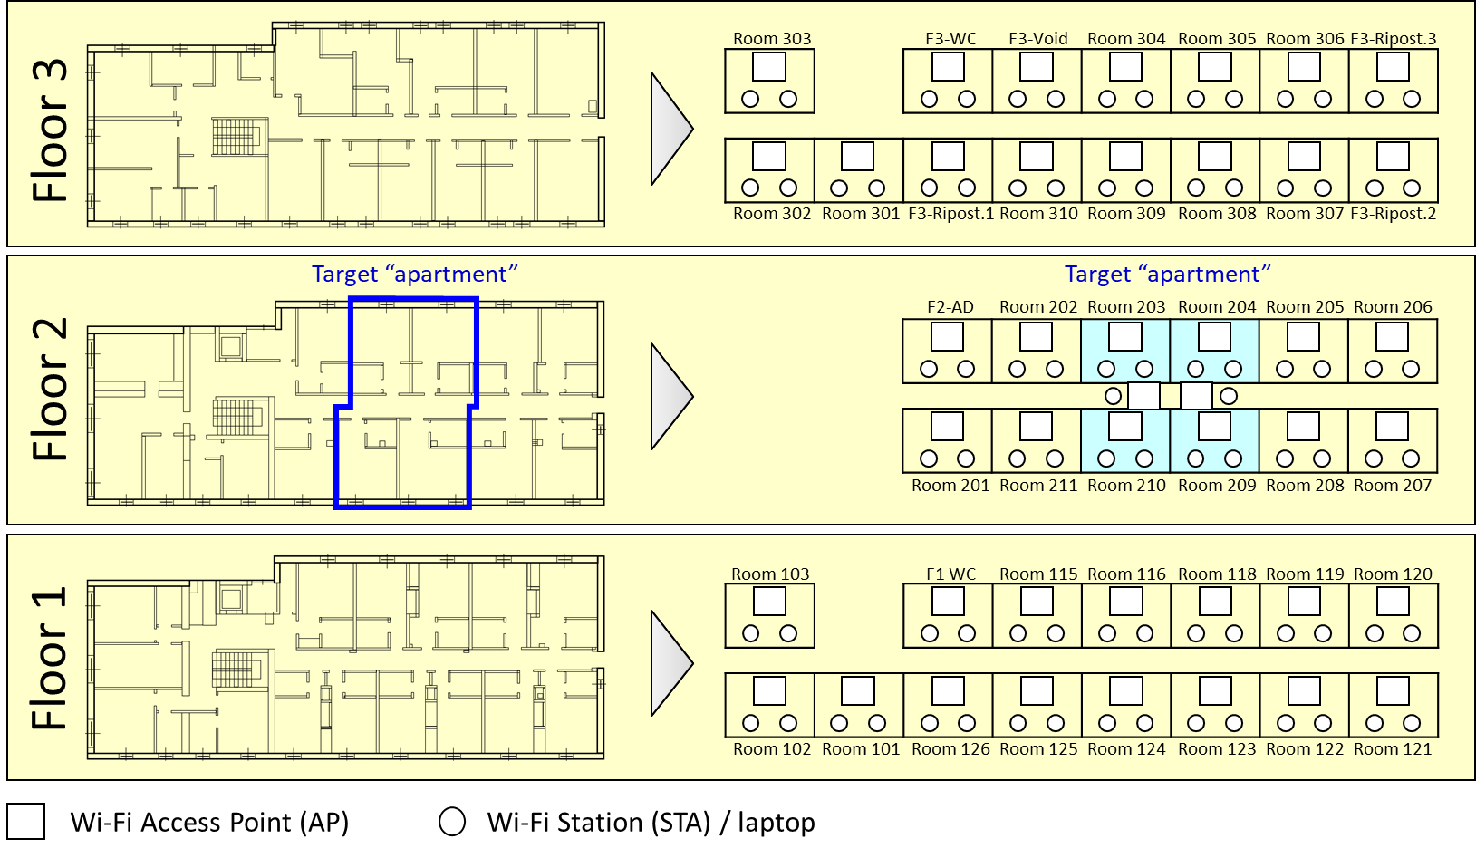
- Test layout (15 + 12 +15 rooms across three floors), 44 APs, 86 STAs/laptops
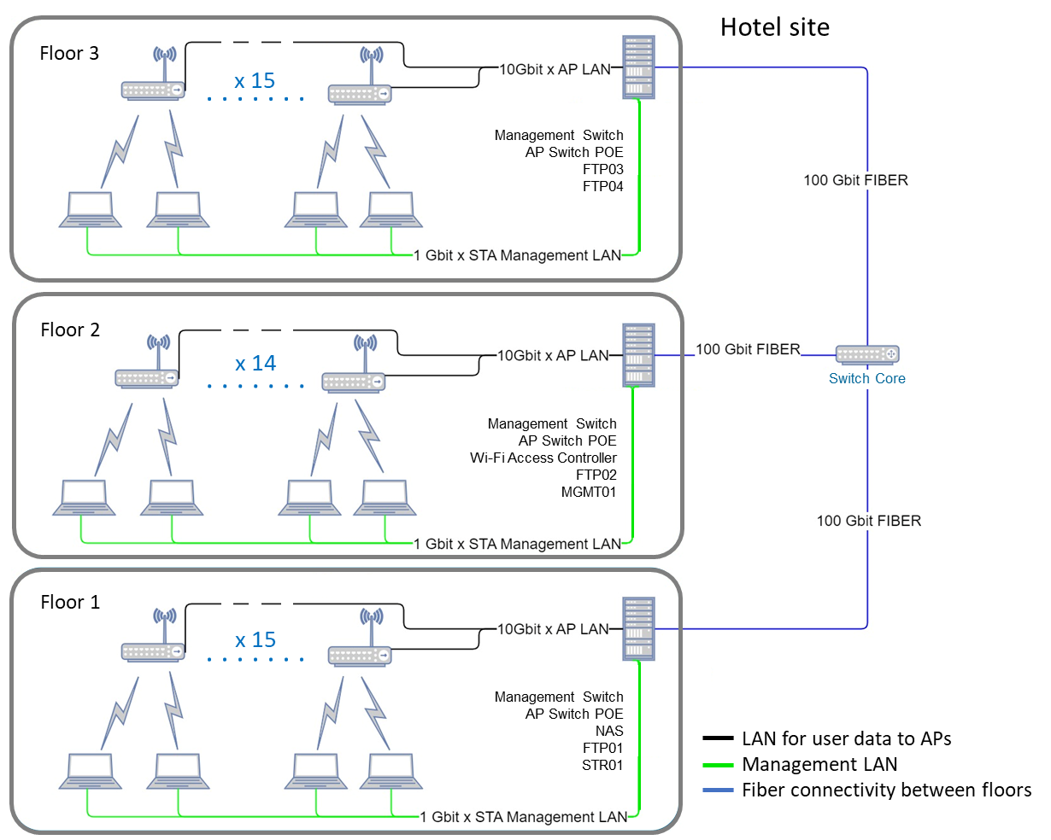
- Network architecture.
Each of the 42 rooms was equipped with one Wi-Fi AP and two STAs/laptops, leading to a total of 42 APs and 84 STAs/laptops. Measurements were performed on Wi-Fi APs and STAs/laptops located in four rooms in the middle of the second (middle) floor. These four rooms are referred to as the “target apartment”.
The test topology aimed at two main scenarios: a dense urban apartment, and an isolated house/dwelling.
Isolated house/dwelling
The target apartment is a good representation of a one-story house dwelling, where the four rooms in the target apartment are tested in isolation (i.e. are not subjected to the interference from APs in other rooms).
This scenario was designed to assess the performance of Wi-Fi technology in an environment relatively free from external Wi-Fi interference. The objective was to determine the optimal performance characteristics of the Wi-Fi network in conditions that are ideal, where interfering Wi-Fi signals are minimal, such as that in an isolated house/dwelling. This setup helps us understand the best-case scenario for Wi-Fi technology in terms of signal strength, throughput, and reliability also providing an indication of the type of performance that can be achieved by Wi-Fi in other settings such as schools.
Dense urban apartment
The target apartment provides a good representation of a typical apartment in a dense urban environment when the Wi-Fi APs in the rooms surrounding the target apartment are switched on.
This setup aimed at replicating a more challenging urban living environment where the presence of multiple overlapping Wi-Fi networks creates a high-interference backdrop. This scenario tests the Wi-Fi network’s ability to maintain connectivity, speed, and data integrity in the face of significant external disturbances, mirroring the typical conditions many users experience in dense residential areas.
Figure 3 shows the tested 20 MHz, 80 MHz and 160 MHz channels across the 2.4 GHz, 5 GHz and L6 GHz bands, respectively; and Figure 4 shows the frequency re-use patterns deployed in the tests.
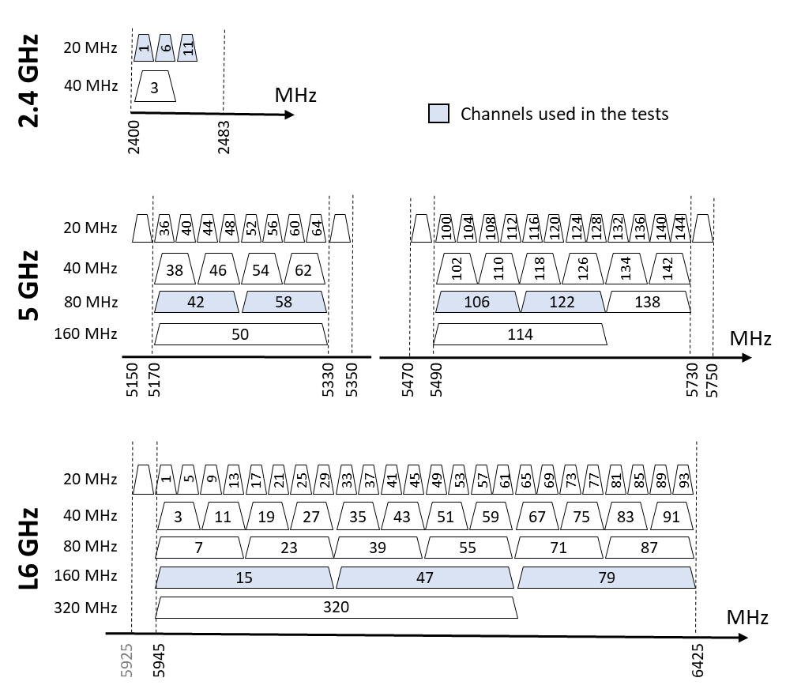
- Channel arrangements in the three tested bands
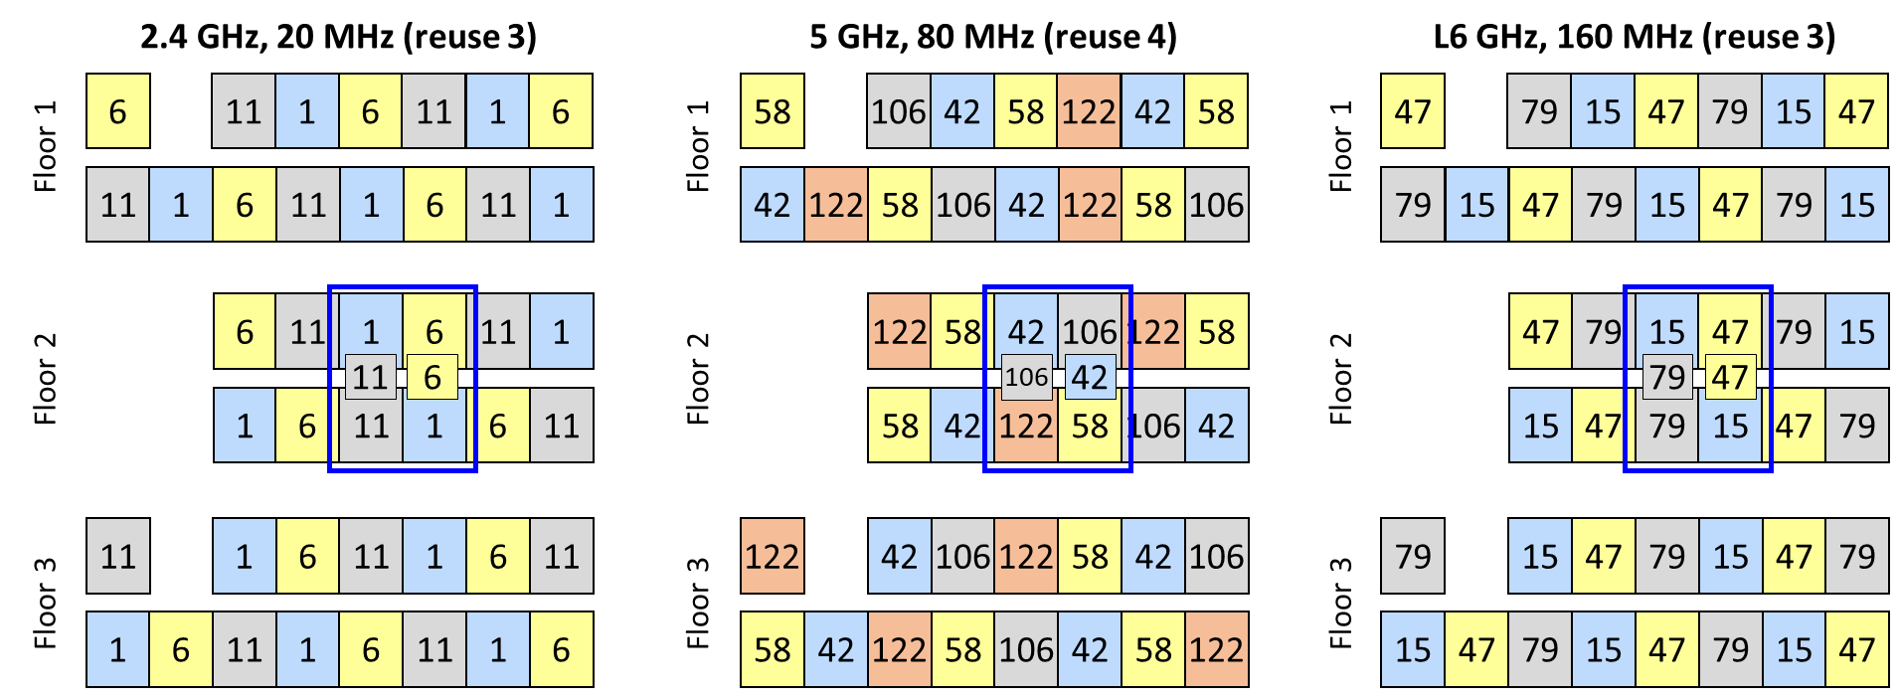
- Frequency planning for the three tested bands
A7.2 Test results
More than 60 test sessions were undertaken, with measurements performed separately for the 2.4 GHz, 5 GHz, and L6 GHz bands. Test sessions were undertaken for different numbers of interfering Wi-Fi APs (from zero APs up to 40 APs), for a growing number of APs in the target apartment (from 1 AP to 4 APs), and for different traffic models towards the STAs/laptops in the target apartment. Measurements were made for the different scenarios offering a reference for different dense urban residential environments.
The analysis focuses on evaluating how the increase in the numbers of APs and connected STAs, within the controlled environment of the target apartment, impacts key network performance indicators such as throughput.
Isolated house/dwelling
Figure 5 below shows the variation of total throughout in the target apartment across the different scenarios. It shows that the total throughput delivered to the target apartment exceeded 1 Gbit/s for all scenarios.
With reference to Scenario 1.1, 1.5 Gbit/s was delivered with 1 AP connected to 2 STAs in the same room. In case of Scenario 1.5, 6.3 Gbit/s was reached with 4 APs deployed in the four rooms in the target apartment. The throughput decreased when moving from Scenario 1.1 to Scenario 1.2, indicating the coverage challenges associated with Wi-Fi propagation between rooms. With the fixed number of 8 STAs served in the test Scenarios 1.2 to 1.5, we distinctly observe enhancements in the target apartment’s total throughput as APs are added within the target apartment.
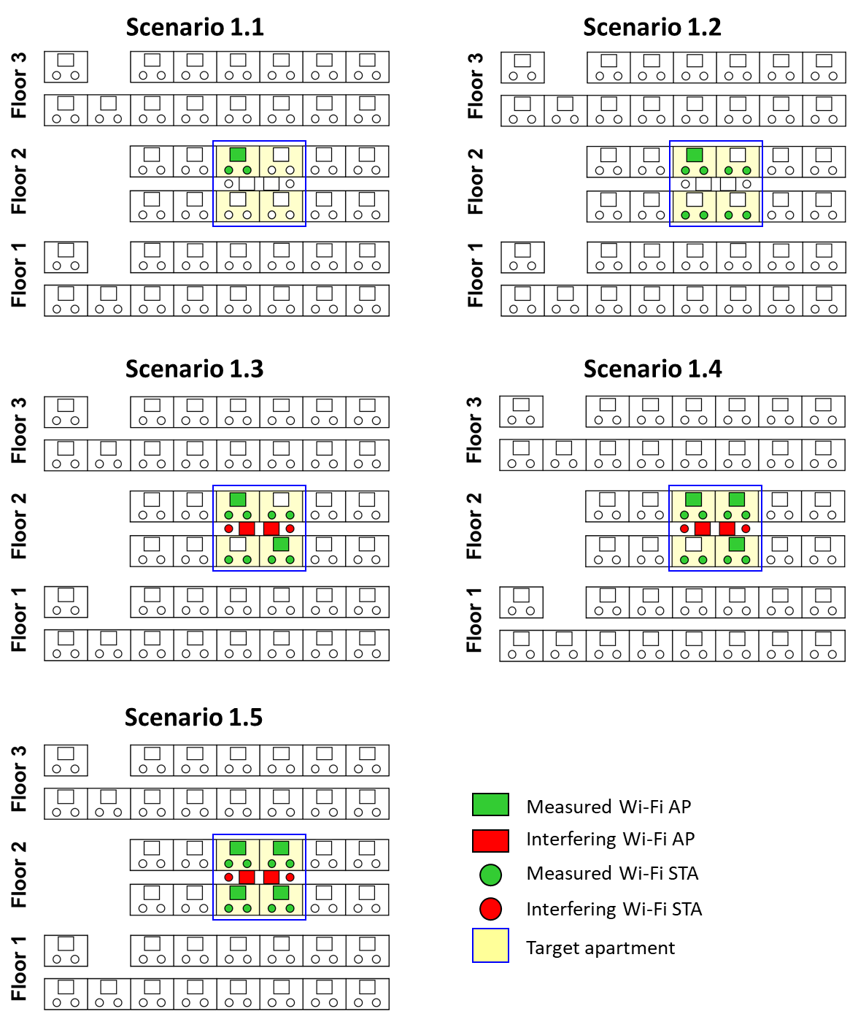
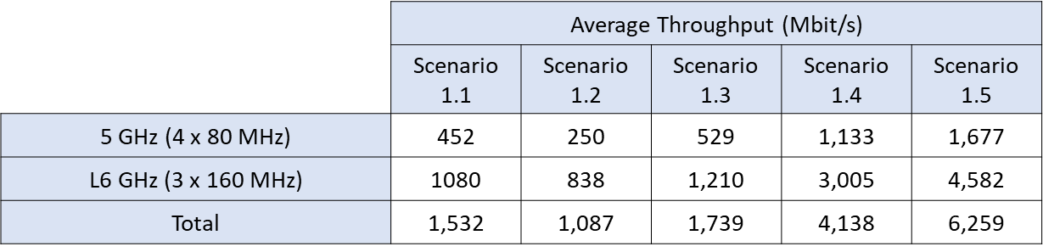
- Increase in measured total throughput in the target apartment as a result of AP densification across the 5 and L6 GHz bands – isolated house/dwelling.
Dense urban apartment: interference from immediately adjacent apartments
The scenarios shown in Figure 6 aim at replicating a dense urban apartment subject to interference from a growing number of other apartments within the same building block. The analysis concentrates on assessing how escalating interference levels, while maintaining a constant number of APs and connected STAs in the target apartment, affect throughput and packet loss. This evaluation provides insights into how Wi-Fi networks perform under progressively challenging conditions of external interference in environments where device density in the target apartment remains constant.
The test result in Figure 6 shows that the total throughput delivered to the target apartment readily exceeded 1 Gbit/s for all scenarios. A gradual decline in throughput for the APs in the target apartment is observed as interference from APs in adjacent apartments increases. Nevertheless, the total throughput delivered to the target apartment always remained above 3 Gbit/s.
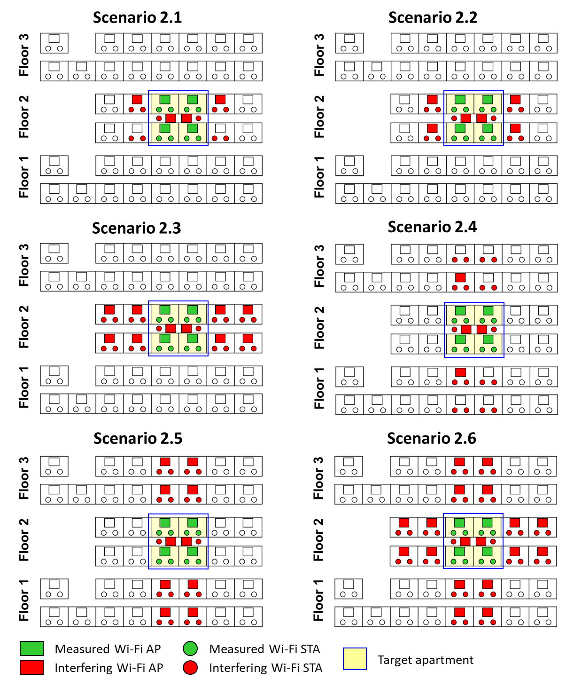
 | Average Throughput (Mbit/s)
 | Scenario 2.1 | Scenario 2.2 | Scenario 2.3 | Scenario 2.4 | Scenario 2.5 | Scenario 2.6
5 GHz | 1,424 | 1,467 | 1,402 | 1,437 | 1,347 | 1,291
L6 GHz | 3,740 | 3,596 | 3,532 | 2,112 | 1,973 | 2,169
Total | 5,164 | 5,063 | 4,934 | 3,549 | 3,320 | 3,460
- Measured total throughput in the target apartment across the 5 and L6 GHz - dense urban apartment.
Dense urban apartment: interference from all apartments
The test investigates the impact of increasing the number of APs within the target apartment, set against a backdrop of fixed and maximum external interference from outside the rooms in the target apartment.
The results in Figure 7 clearly demonstrate a consistent increase in throughput as the number of APs within the apartment increased from two to four. With one AP per room in the final scenario, the network achieved optimal distribution of traffic load, minimizing bottlenecks and maximizing data flow efficiency. With 4 APs (Scenario 3.3), we measured a total throughput of around 4.6 Gbit/s. For similar arrangements as above but with only 2 and 3 APs in the target apartment (Scenarios 3.1 and 3.2), measurements indicated total throughputs of around 1.7 Gbit/s and 2.4 Gbit/s, respectively.
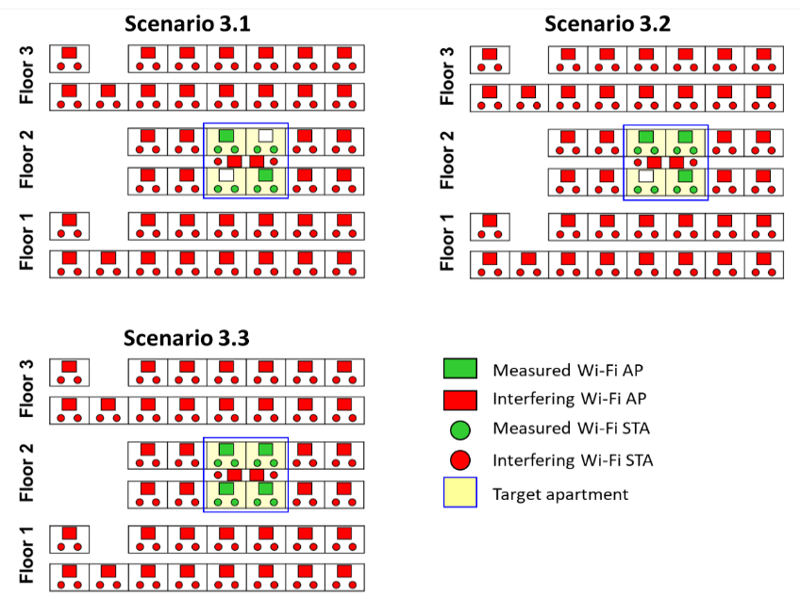
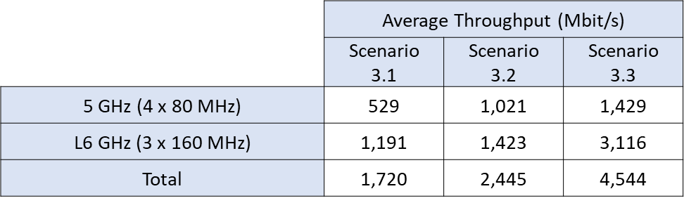
- Increase in measured total throughput in the target as a result of AP densification
across the 5 and L6 GHz bands – dense urban apartment.
A7.3 Observations of the study
The measurements show that the use of currently available spectrum in the 2.4 GHz, 5 GHz, and lower 6 GHz bands allows Wi-Fi to readily deliver throughputs of 1 Gbit/s or more within indoor premises – including in the highly interfered environments of dense urban apartments. The results of measurements also indicate that the performance of Wi-Fi today is coverage-limited rather than capacity-limited. Tests also indicate that this limitation can be mitigated through densification of Wi-Fi APs within premises, where with APs installed in multiple rooms, Wi-Fi can deliver throughputs of several Gbit/s using existing bands. A good fixed network behind the Wi-Fi APs is also important to ensure the Wi-Fi performance to prevent the fixed network becomes the bottleneck. For the purposes of this test, the hotel was equipped with a 100 Gbit/s wired local area network (LAN), with 10 Gbit/s Ethernet connectivity to each AP. More efforts are needed to extend high capacity fibre availability for residential users and businesses.

Annex 8

Annex 8: Study by GSMA on Distribution of Wi-Fi
In this study, Figure 1 shows, a large proportion of Wi-Fi scans taken from Q1 2024 across 10 cities are on Wi-Fi 4, which provide a theoretical maximum speed up to 450 Mbps.
Wi-Fi 6 already support gigabit network speeds with throughputs up to 2.4 Gbps for a single device or up to 9.6 Gbps in total.
Figure 1: Distribution of Wi-Fi scans based on technology
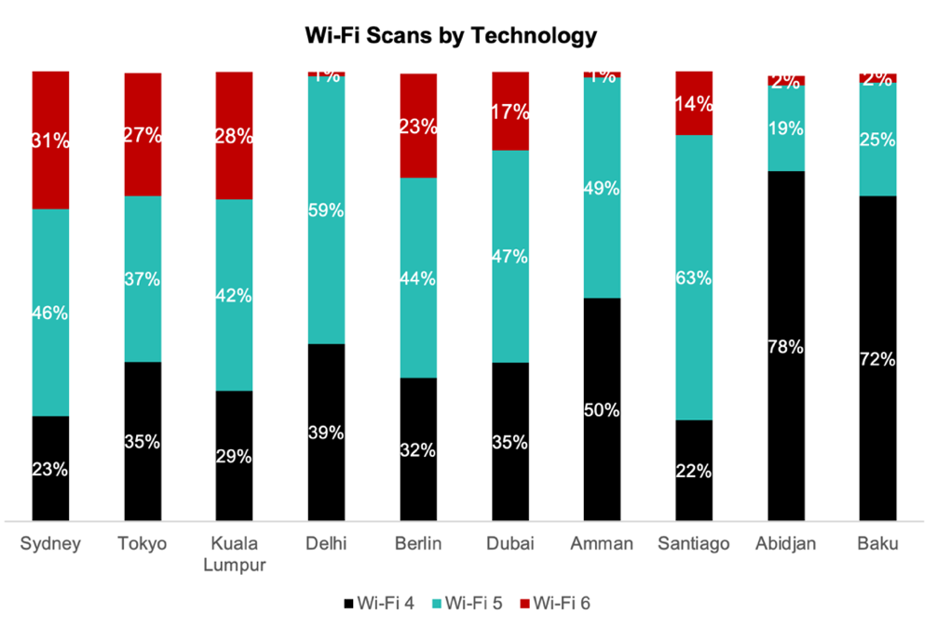
Source: GSMA Intelligence analysis, based on Speedtest Intelligence data provided by Ookla
Secondly, some countries have opened up the lower 6 GHz for RLAN, providing 3 additional channels of 160 MHz which are not yet being used as shown in Figure 2. These almost double the amount of unlicensed spectrum available and can provide enough capacity for meeting expected demand even in homes with a large number of intensive users.

Figure 2: Distribution of Wi-Fi scans based on bands
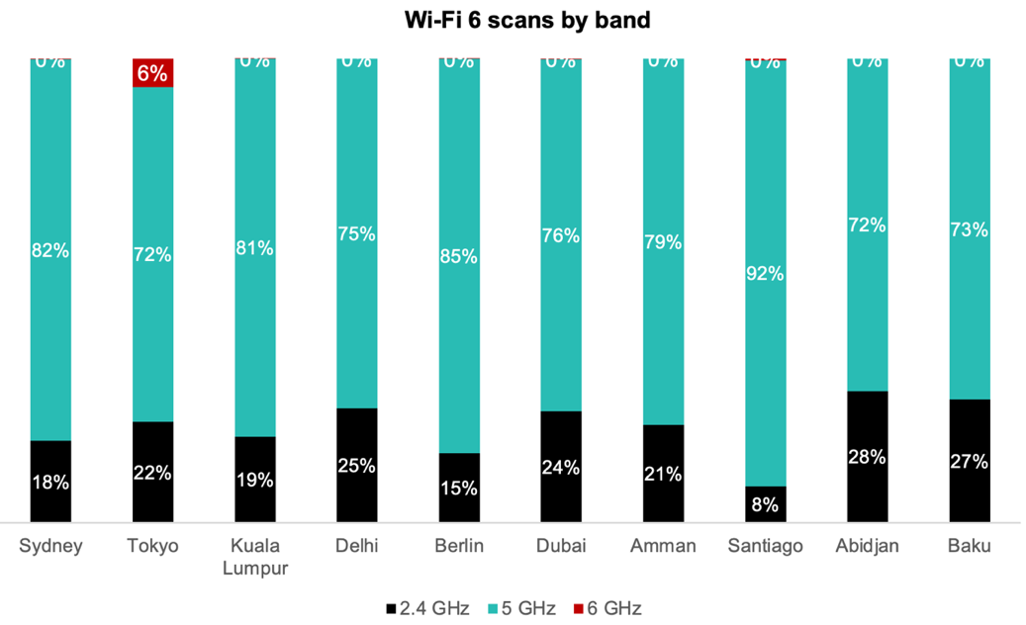
Source: GSMA Intelligence analysis, based on Speedtest Intelligence data provided by Ookla

The frequency range for the use of RLAN may vary depending on each administration’s decision and should strictly comply with the national regulation decisions.
https://sparklink.org.cn/en/
https://www.itu.int/dms_pub/itu-r/oth/0C/0A/R0C0A00000F0076PDFE.pdf
For instance, in 2020 Ofcom UK removed the DFS requirement for indoor WAS/RLAN operations up to 200 mW EIRP in the 5.8 GHz band. https://www.ofcom.org.uk/__data/assets/pdf_file/0036/198927/6ghz-statement.pdf
https://www.wi-fi.org/file/afc-specification-and-test-plans
“Very High Density 802.11ac Networks”, Aruba Networks, 2015, https://higherlogicdownload.s3.amazonaws.com/HPE/MigratedAssets/Aruba_Very_High_Density_802.11ac_Networks_VRD.zip
https://dot.gov.in/spectrummanagement/delicensing-24-24835-ghz-band-gsr-45-e-5150-5350-ghz-gsr-46-e-and-5725-5875-ghz
https://dot.gov.in/spectrummanagement/license-exemption-5-ghz-gsr-1048e-dated-22102018
Federal Register, Unlicensed Use of the 6 GHz Band
https://docdb.cept.org/download/50365191-a99d/ECC%20Decision%20(20)01.pdf
Wifi 6: Sergio Massa launched a program to improve Internet connectivity throughout the country - Infobae
Wifi 6: Sergio Massa launched a program to improve Internet connectivity throughout the country - Infobae
https://www.comtelitalia.it/indoor_connectivity_test_en/
GSMAi (2022). The socioeconomic benefits of the 6 GHz band. https://data.gsmaintelligence.com/research/research/research-2022/the-socioeconomic-benefits-of-the-6-ghz-band-considering-licensed-and-unlicensed-options

