

APT REPORT ON

TRENDS AND SPECTRUM DEVELOPMENTS FOR IMT USAGE IN
2025 ~ 2030 IN ASIA-PACIFIC REGION

Edition: April 2026

The 36th Meeting of APT Wireless Group
6 – 10 April 2026
Bandar Seri Begawan, Brunei Darussalam (Hybrid)

(Source: AWG-36/OUT-06)

No. APT/AWG/REP-136(Rev.2)

APT REPORT ON
TRENDS AND SPECTRUM DEVELOPMENTS FOR IMT USAGE IN 2025 ~ 2030 IN ASIA-PACIFIC REGION

Table of Contents

1. Introduction 3
1.1 WRC-23 outcomes for IMT identification 3
2. Questionnaire and Responses from APT Members 6
2.1 Questionnaire 6
2.2 Responses received from APT Members 6
2.3 Details of responses 6
2.3.1 Status of 5G deployment 6
2.3.2 Status of IMT spectrum assignment and challenges 8
2.3.3 Spectrum planning and roadmap 10
2.3.4 IMT technology evolution in 2025-2030 timeframe 11
2.3.5 Mobile connectivity targets 12
2.3.6 Current and forecast data usage 15
2.3.7 Role of FWA 17
2.3.8 Forecast availability of network resources 18
2.3.9 IMT-2020 industrial use cases 19
2.3.10 Traffic demand 21
2.3.11 Technology switch-off and refarming plans 21
3 Industry Research Reports and Information 25
3.1 Socio-economic impact in APAC of mid-band spectrum 25
3.2 Mid-band spectrum needs in some densely populated areas 27
3.3 5G traffic growth towards 2030 31
3.4 IMT developments in some bands 33
3.4.1 IMT trials in upper 6 GHz (6.425-7.125 GHz) 33
3.4.1.1. Chulalongkorn University (February 2023) 34
3.4.1.2. Du, e& (August 2023) 34
3.4.1.3. Deutsche Telekom (August 2023) 35
3.4.1.4. Maxis, Universiti Malaya (September 2023) 35
3.4.1.5. Vodafone (October 2023) 35
3.4.1.6. Ericsson, MediaTek (November 2023) 35

- Introduction
IMT technologies, such as 5G, enable a wide range of new applications and services that transform all industries and economies, but the sustainable success and effectiveness depend on timely and affordable availability of spectrum.
The focus of this report is on future spectrum of terrestrial component of IMT in the period 2025-2030. To get the most out of 5G, spectrum is needed across low-, mid- and high-bands to deliver widespread coverage and support all use cases.
Low-band spectrum (below 1 GHz) supports wide area coverage and promotes digital equality by giving greater access to mobile broadband services in all areas is important for covering less-populated areas. High-band spectrum (above 24.25 GHz) will be used for the highest capacity, lowest latency applications.
The mid-band spectrum which lies in the 1-7 GHz range, is crucial for IMT penetration and 5G deployment in the Asia-Pacific region, balancing coverage and capacity. It enables high-speed connectivity in urban and rural areas, supporting economic growth, smart cities, and digital inclusion. Efficient allocation of mid-band frequencies enhances network performance, ensuring seamless connectivity for industries, businesses, and consumers in the region. Mid-band spectrum is also, necessary for the increases in bandwidth and capacity that 5G applications will require for city-wide coverage. New mobile broadband use cases such as enhanced mobile broadband (eMBB), fixed wireless access (FWA), IoT and Industry 4.0 depend on mid-band spectrum. These use cases will greatly enhance the impact of mobile services on society and economies.
Mid-band spectrum resources include both lower mid-bands (e.g. 1500 MHz, 1800 MHz, 2100 MHz, 2300 MHz and 2600 MHz) and upper mid-bands (e.g. 3.3–3.8 GHz, 4.8–4.99 GHz and 6.425-7.125 GHz).

1.1 WRC-23 outcomes for IMT identification
WRC-23 decided to make new identification to IMT or update existing IMT footnotes at regional/country level in a few frequency bands (or portions thereof), see the detail summary in bands and in Table 1 below.
- 3.3-3.4 GHz: 3.3-3.4 GHz is identified for IMT in 8 Region 3 countries, 49 Region 1 countries and in Region 2.
- 3.6-3.8 GHz:
- 3.6-3.8 GHz is identified for IMT in a large number countries of Region 1;
- 3.6-3.7 GHz is identified for IMT in Region 2; 3.7-3.8 GHz is identified for IMT in 15 countries / territories in Region 2.
- 4.8-4.99 GHz: 4.8-4.99 GHz is identified for IMT in 47 countries from different regions.
- 6.425-7.125 GHz:
- 6425-7125 MHz is identified for IMT in Region 1.
- 7025-7125 MHz is identified for IMT in Region 3. The 6425-7025 MHz band is also identified for IMT in three Region 3 countries.
- 6425-7125 MHz is identified for IMT in two Region 2 countries.
- 10-10.5 GHz: 10-10.5 GHz is identified for IMT in 12 countries in R2.
Table 1. The creation/update of IMT footnotes at WRC-23
Band (GHz) | Footnotes identifying the band for IMT
Band (GHz) | Region 1 | Region 2 | Region 3
3 300-3 400 MHz | 5.429B | 5.429D | 5.429F
3 600-3 800 MHz | 5.433B, 5.434B | 5.434, 5.435B | /
4 800 – 4990 MHz | 5.441B
6 425-7 125MHz | 5.457E | 5.457F | 5.457E, 5.457D
10-10.5 GHz | / | 5.480A | /

With WRC-23 decision, the 3.3-3.4 GHz, 4.8-4.99 GHz and 6.425-7.025 GHz frequency bands are identified for IMT in some Region 3 countries. The frequency band 7.025-7.125 GHz is identified for IMT in Region 3. 3GPP has developed the technical specifications for the three bands under band n77&n78, n79, and n104 separately. Some Region 3 countries may consider to make the bands ready for IMT at their national level according to their needs.
Since there is a lead time between the allocation of frequency bands by WRCs and the deployment of systems for IMT bands, WRC-23 further agreed on WRC-27 AI 1.7 to study 4 400-4 800 MHz, 7 125-8 400 MHz and 14.8-15.35 GHz for IMT identification.
Table 2 shows the total amount of spectrum identified for IMT in Region 3 after WRC-23. Figure 1 shows the evolution of IMT spectrum identifications since WARC-92/WRC-97.
Table 2: IMT Spectrum identified as of WRC-23 in Region 3
Frequency Range | Spectrum identified for IMT
Below 1 GHz | 510 MHz
1-7 GHz | 1 976 MHz
Above 24.25 GHz | 17.25 GHz
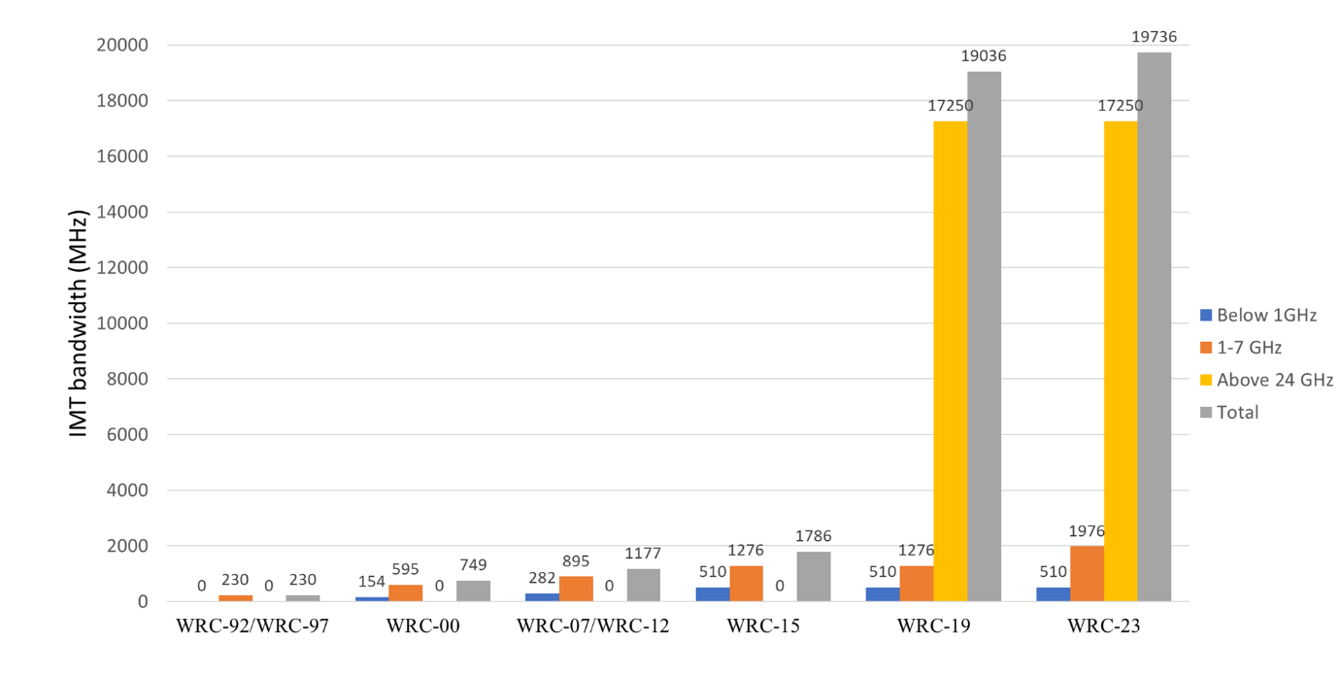
Figure 1: Total amount of spectrum identified for IMT (Region 3)
The original data used for Figure 1 originates from ITU and aims to present a general overview of the history of IMT identifications at WRCs.
It should be noted that the identifications in the bands above 24.25 GHz were made only by WRC-19 with the amount of spectrum for Region 3 equal to 17 250 MHz. The remaining amount of identified IMT spectrum lies in the bands between 450 MHz and 7 125 MHz.
Figure 1 may not fully represent the IMT harmonization level. Some of the countries in Region 3 have yet to identify some of the frequencies presented in Figure 1. For example, the bands 2 500 – 2 690 MHz (190 MHz) and 6 425 – 7 025 MHz (600 MHz) are both included in the statistics. However, the first band is identified in all countries of Region 3, while the second band is identified in some countries of Region 3 (see Table 1).

- Questionnaire and Responses from APT Members
  - Questionnaire
The questionnaire on future spectrum planning for advanced IMT coverage and capacity improvements in 2025 ~ 2030 in Asia Pacific region is available at AWG-30/OUT-27.

  - Responses received from APT Members

No. | Source | Input document
1 | Bhutan (Kingdom of) | AWG-31/INP-12
2 | Nepal (Federal Democratic Republic of) | AWG-31/INP-17
3 | Thailand (Kingdom of) | AWG-31/INP-23
4 | Palau (Republic of) | AWG-31/INP-44, AWG-32/INP-24
5 | Viet Nam (Socialist Republic of) | AWG-31/INP-83, AWG-36/INP-77
6 | China (People’s Republic of) | AWG-31/INP-89, AWG-35/INP-24, AWG-36/INP-65
7 | Korea (Republic of) | AWG-31/INP-102
8 | Sri Lanka (Democratic Socialist Republic of) | AWG-32/INP-10Rev1
9 | Brunei Darussalam | AWG-32/INP-15
10 | Pakistan | AWG-32/INP-19
11 | Nepal (Federal Democratic Republic of) | AWG-32/INP-30
12 | Indonesia (Republic of) | AWG-32/INP-35, AWG-36/INP-38
13 | Philippines (Republic of) | AWG-33/INP-104
14 | Japan | AWG-35/INP-45

  - Details of responses
    - Status of 5G deployment
Q1: Has your country deployed 5G services? Please provide the details on 5G services deployment in your country (e.g. in which stage).

Answers
Bhutan | Yes. 5G services are currently deployed in selected areas especially in the cities. It is currently Non-Standalone 5G.
Nepal | Yes, 5G network has been deployed in Nepal. But the services are in trial phase, such services have not been deployed commercially.
Thailand | 5G has been deployed in low band, mid band, and high band spectrum. Low band and mid band are in commercialized stage, but high band is in testing stage and not yet commercialized
Palau | No.
Viet Nam | Viet Nam has officially granted commercial 5G licenses to MNOs since 2024 through frequency band auctions (2 600MHz, 3 700MHz, and 700MHz). Viettel, Vinaphone, and Mobifone are three MNOs that won the auction.  These MNOs have deployed approximately 35,000 base stations, providing coverage to 90% of population across the country.  - Coverage and deployment areas: Initial deployment focuses on major cities, industrial zones, airports, seaports, and key economic areas, with gradual expansion to other regions.  - Technology and architecture: Operators are deploying both Non-Standalone (NSA) and Standalone (SA) 5G architectures, with ongoing development of Open RAN solutions and locally developed equipment.  - Future plans: The government and operators aim to expand 5G coverage to around 99% of the population by the end of 2030, with plans to deploy tens of thousands of additional base stations.  According to statistical data from the i-Speed speed measurement system of the Viet Nam Internet Center (VNNIC, Ministry of Science and Technology), 5G mobile broadband speeds in Viet Nam increased significantly, exceeding 50% compared to December 2025. In January 2026, the nationwide average 5G download speed reached 594.81 Mbps, representing a 52% increase, while the average upload speed reached 123.71 Mbps, 29.5% higher than in December 2025. Previously, in August 2025, the average fixed broadband speed in Viet Nam reached 261.8 Mbps, placing Viet Nam among the top 10 globally in fixed broadband speed.
China | Yes, 5G is widely deployed in China.  The number of 5G subscribers reached 1.118 billion, accounting for 61.8% of mobile subscribers.  https://www.miit.gov.cn/jgsj/yxj/xxfb/art/2025/art_d7c6f18eb71845b79c37c200baae215f.html
Korea | 5G commercialization services in the frequency bands 3 400-3 700 MHz and 26.5-28.9 GHz have been provided by three major telecommunication carriers since 2019. In addition, Local 5G services called “e-Um 5G” in the frequency bands 4 720-4 820 MHz and 28.9-29.5 GHz have been provided by more than 50 entities since 2021. The E-Um 5G provides customized services tailored to each industrial sector and coverage within a specific geographical area, such as a manufacturing center or a campus premise.
Sri Lanka | No, it has been planned to deploy in Q2 2024. Already started the 5G trials in 3.5 GHz and 27 GHz bands from year 2021.
Brunei | - 5G non-standalone services has been commercially deployed since June 2023.  - Utilized 700MHz, 1800MHz and 3.5 GHz
Pakistan | 5G Test/Trials are being conducted by the telecom operators in Pakistan in various frequency bands. Commercial launch shall be allowed in the light of policy of the Federal Government.
Nepal | Nepal has not deployed 5G services but spectrum in 2600MHz band has been allocated to an operator for 5G trial purpose.
Indonesia | Yes, Indonesia started commercial 5G deployment in 2021. 5G services in Indonesia use several frequency bands, including 1800 MHz (FDD), 2100 MHz (FDD), 2300 MHz (TDD), with 5G NSA configuration using DSS in FDD and static for TDD, and 1400 MHz (TDD) for FWA with 5G SA configuration.  Most 5G services are currently used for enhanced mobile broadband (eMBB), while some deployments also support industrial use cases.  As of 2025, 5G network coverage in Indonesia reaches approximately 22.06% of the population, indicating that deployment is still at an early stage and is continuing to expand gradually.  Further development of 5G services is expected as network infrastructure continues to expand and additional spectrum resources become available.
Philippines | Yes. The deployment of 5G services in the Philippines is ongoing, the exact stage of deployment may vary by location and service provider. However, there is a concerted effort by telecommunications companies and regulatory authorities to advance 5G technology and expand its coverage to benefit consumers and businesses across the country.
Japan | In April 2019, the frequency bands 3.6-4.1 GHz (five blocks of 100 MHz each), 4.5-4.6 GHz (one block of 100 MHz), 27.0-28.2 GHz (three blocks of 400 MHz each), and 29.1-29.5 GHz (one block of 400 MHz) were allocated to four mobile network operators for 5G.  In March 2020, 5G commercial services were launched in Japan. Subsequently, regulatory arrangements were made to promote the deployment of 5G, making it possible to introduce 5G in frequency bands previously used for LTE.  In December 2024, a 100 MHz block in the 4.9-5.0 GHz frequency band was allocated to a mobile network operator for 5G.  As of the end of March 2024, the population coverage rate of 5G in Japan has reached 98.1%.

    - Status of IMT spectrum assignment and challenges
Q2: Among frequency bands that are identified for IMT in ITU Radio Regulations, what are the reasons, challenges, and/or limitations for not having assigned some of them, if any, in your country?

Answers
Bhutan | We have assigned the frequency in mid 3.5GHz only. The telecom operators have not demanded in other bands at the moment. Other bands are also not deployed due to technological and geographical limitations.
Nepal | • The frequency band 470 MHz – 698 MHz has been allocated for Digital Terrestrial Television Broadcasting and television distribution networks. Therefore, this band is not allocated for IMT services.  • Similarly, 1427 MHZ – 1518 MHz, 4800 MHz – 4990 MHz and all bands in mmWave are not assigned for IMT.  • Among the bands already allocated for IMT services, the demand for 700 MHz band and C-band is gradually emerging, but these bands are unassigned as of now.  • Plans are made for prompt release of spectrum in all allocated bands. But, a portion of the spectrum in C-band is being used by broadcasting service (Satellite), and refarming plans are being prepared.
Thailand | Challenge is in the 3500 MHz frequency band, in order to be able to co-exist with TVRO systems.
Palau | Palau is not a member of ITU and the reasons, challenges is limited information for IMT in ITU Regulations.  In progress.
Viet Nam | Following WRC-23, a total of 29 countries, as well as Vietnam’s National Frequency Allocation Table, identified several bands including 610–694 MHz, 1427–1518 MHz, and 24.25–27.5 GHz for IMT. However, these bands have not yet been assigned for IMT use in Vietnam. The 610–694 MHz band is still utilized for Digital Terrestrial Television (DTT) broadcasting, creating challenges for refarming. Therefore, Vietnam has established a transition roadmap requiring all television services operating in the 600 MHz band to migrate to sub-600 MHz channels by the end of 2028. For the 1427–1518 MHz band, the device ecosystem is not widely developed compared to commonly used 5G bands such as n78 or n41. Limited device support reduces operators’ incentives to deploy networks, resulting in low deployment demand. Regarding the mmWave band (24.25–27.5GHz), several studies have highlighted that mmWave deployment requires extremely dense base-station infrastructure due to limited coverage and high propagation loss, resulting in significantly higher capital expenditure. Combined with its limited practical utilization outside hotspot scenarios, mobile operators generally show limited commercial interest in large-scale IMT deployment in mmWave bands.
China | -
Korea | IMT identification with these provisions in the RR gives flexibility for Members to use the identified IMT frequency bands in accordance with their own national spectrum policies. Therefore, it is encouraged that ITU (collectively representing Members) should continue exploring new identification of IMT spectrum in order not only to keep providing a way of efficient use of spectrum but also to assist Members to use/select those identified frequency bands for IMT according to their own national spectrum policies.
Sri Lanka | Existing services / Economic situations /Use cases
Brunei | No issues at the moment, current assigned bands are adequate to cater the current market and technology.
Pakistan | Almost all of the IMT bands identified for IMT services in Radio Regulations for Region-3 are being considered for IMT services in Pakistan.
Nepal | - The frequency band 470 MHz - 698 MHz has been allocated for Digital Terrestrial Television Broadcasting and television distribution networks. Therefore, this band is not allocated for IMT services.  - Similarly, 1427 MHZ - 1518 MHz, 4800 MHz – 4990 MHz and all bands in mmWave are not assigned for IMT.  - Among the bands already allocated for IMT services, the demand for 700 MHz band and C-band is gradually emerging, but these bands are unassigned as of now.  - Plans are made for prompt release of spectrum in all allocated bands. But, a portion of the spectrum in C-band is being used by broadcasting service (Satellite), and refarming plans are being prepared.
Indonesia | Some frequency bands identified for IMT in the ITU Radio Regulations have not yet been assigned for such use in Indonesia, such as the 3.5 GHz band, as it is currently used for Fixed Satellite Service (FSS). The frequency bands 700 MHz and 2.6 GHz planned to be auctioned in 2026.
Philippines | The reasons, challenges, and limitations for not assigning certain frequency bands for IMT in the Philippines can vary depending on a combination of technical, regulatory, economic, and policy factors.
Japan | Some of the frequency bands identified for IMT have not be used for IMT systems due to existing other spectrum usages. We note that IMT identification in the ITU Radio Regulations are intended for administrations wishing to implement IMT in their countries taking into their national spectrum situations.

    - Spectrum planning and roadmap
Q3: In your spectrum planning roadmap, which frequency bands are being considered or will be considered to be used for IMT in the coming years?

Answers
Bhutan | Mostly mmWave for 5G services.
Nepal | The frequency bands 700 MHz, 2100 MHz, 2300 MHz, 2600 MHz and C-band are being considered to be used for IMT in coming years.
Thailand | The 1500 MHz, 3500 MHz, and 28 GHz frequency bands are being considered.
Palau | Planning stage  In progress
Viet Nam | In the near future, Viet Nam is considering several frequency bands for IMT, including 610–694 MHz, 3 400–3560 MHz, 3 560–4 000 MHz, and 6 425–7 125 MHz.  The identification of these additional bands is driven by the increasing demand for spectrum to support the development of advanced mobile technologies, particularly 5G and beyond. This demand is closely aligned with the objectives set out in Resolution No. 57-NQ/TW, which emphasizes the development of modern digital infrastructure with ultra-high capacity, wide coverage, and readines.
China | China has already identified the bands 6 425-7 125 MHz, 24.75-27.5 GHz, 37-43.5 GHz, and 66-71 GHz for IMT in the new version of the Regulations on the Radio Frequency Allocation of the People's Republic of China effective from July 1, 2023. Specifically, the whole or portions of the 6 425-7 125 MHz band is identified for IMT systems. The frequency band 24.75-27.5 GHz is identified for IMT systems. The portions of the 37-43.5 GHz band is identified for IMT systems. IMT systems will not be put into actual deployment until the relevant compatibility and coexistence conditions and coordination procedures are determined. According to footnote 5.559AA, the frequency band 66-71 GHz is identified for use by administrations wishing to implement the terrestrial component of IMT.
Korea | The frequency band 3 700-4 000 MHz will be provided according to the national spectrum plan in the coming year.
Sri Lanka | - 3.2 -3.4 GHz  - 3.6 -3.8 GHz  - 26/28 GHz
Brunei | Currently there is no demand and as per normal practice, this all depends on  current network provider needs and demands.
Pakistan | Frequency bands including 700 MHz, 900 MHz, 850 MHz, 1427 – 1518 MHz, 1800 MHz, 2300 MHz, 2600 MHz, 3300 – 3600 MHz, 24 GHz and 39 GHz are being used/ considered for IMT use in Pakistan.
Nepal | - 2600MHz  - 700MHz  - 26GHz  - 2300MHz  - 3500/3700MHz  - 7025-7125MHz (WRC-23)
Indonesia | Indonesia has considered and prioritized the frequency band 700 MHz, 2.6 GHz, 3.5 GHz, and 26 GHz for IMT, while other IMT frequency bands are still under study.
Philippines | 24.25-27.5 GHz / 37-43.5 GHz / 66-71 GHz
Japan | The 26 GHz band (25.25-27 GHz) and the 40 GHz band (37.0-43.5 GHz) are under consideration. Regarding these two frequency bands, a survey to identify the needs for using the frequency bands 25.25-27 GHz and 40.5-43.5 GHz for 5G was conducted from May to June 2025. As of August 2025, based on the results of the survey, discussions are ongoing on how to conduct a conditional spectrum auction, with the aim of allocating portions of the 26 GHz band.

    - IMT technology evolution in 2025-2030 timeframe
Q4: In the 2025-2030 time frame, what is the expected dominant IMT technology (4G or 5G) in your country/territory? What are the expected market shares by technology in 2025 and 2030?

Answers
Bhutan | Have not projected it till 2025-2030. However, with more awareness and with the demand of higher throughput capacities, 5G services is expected to be the most dominant in 2030.
Nepal | In 2025, it is expected that 4G will be the dominant technology with 90% market share compared to 10% of 5G. But by 2030, 5G is expected to overtake 4G and have market share of 60% and 4G will have a market share of 40%.
Thailand | -
Palau | do not know
Viet Nam | By Q4 2025, 4G subscribers reached about 67 million, 5G subscribers were about 32 million. Therefore, 4G is still the dominant technology now in Viet Nam.  It is predicted that 5G will account for over 50% of mobile subscribers by 2029.
China | The dominant IMT technology in China for the 2025-2030 time frame is expected to be 5G or further evolved technologies.  Based on official data from the Ministry of Industry and Information Technology (MIIT) website, as of the end of 2025, the number of 5G base stations in China reached 4.838 million, and the total number of mobile phone users reached 1.827 billion. Mobile phone users are rapidly migrating to 5G, with the number of 5G mobile phone users reaching 1.204 billion, accounting for 65.9% of all mobile phone users. The focus is now shifting towards the maturity and deep application of 5G, including the commercial use of 5G-Advanced, and its integration with Artificial Intelligence (AI) and the digital economy.  Source:  https://www.miit.gov.cn/gxsj/tjfx/txy/art/2026/art_da754fe24a9347dc89bef9bf9c28528e.html
Korea | The mobile traffic data over 5G (IMT-2020) network per day is now around 3.5 times more than the traffic data over LTE network in February 2023 according to the MSIT statistical data . In the 2025-2030 time frame, 5G market shares would be continuously increased. In addition, the Republic of Korea has an intermediate plan for pre-IMT-2030 demonstration around 2026.
Sri Lanka | 4G
Brunei | Current dominant for IMT technology is cellular network. Expected market  shares to be more focus towards enhanced mobile technology i.e., FWA
Pakistan | The expected dominant IMT Technology in 2025-2030 in Pakistan shall be 4G LTE as per the prevailing market situation, along with proliferation of 5G services in major cities. Input on expected market shared by different technologies may also be requested from PTA.
Nepal | - 4G  - Expected market shares by technology needs to be studied.
Indonesia | Indonesia implements neutral technology policy based on IMT standard which give the MNO flexibility to choose technologies to be deployed.
Japan | As of the end of March 2025, the number of mobile phone subscriptions stands at 223.79 million. There are 112.72 million 4G subscriptions, accounting for 49.1% of all mobile phone subscriptions. The number of 5G subscriptions is 112.07 million. While the number of 4G subscriptions decreased by 6.1% compared to the same period of the previous year, the number of 5G subscriptions increased by 21.3%.  No estimations have been made regarding the expected market shares by technology in 2030.  Source:  https://www.soumu.go.jp/menu_news/s-news/01kiban04_02000259.html (in Japanese)

    - Mobile connectivity targets
Q5: Has your country/territory defined specific mobile connectivity targets to be met in the 2025-2030 time frame? Have targets been defined within a national broadband plan? Such targets include (but not limited to):
- Speed/data-rate, throughput, latency
- Connectivity along transport routes (e.g. highways, high speed railways)
- Coverage (percentage of population and/or geographic area)
- Connectivity ratio (number of end users, or end user ratio)
- Number of base stations
- Affordability of devices
- Defined milestones to meet the above targets (within 2025-2030 time frame), if any
What is the current status in respect of meeting these targets?

Answers
Bhutan | Yes, we intend to cover the nation with 100% mobile coverage within 2025-2030.
Nepal | No such targets are defined for 2025-2030 timeframe. But similar targets relating to throughput, coverage, number of base stations etc. were defined as rollout obligation for 2020-2025 timeframe while providing additional spectrum for 4G expansion
Thailand | Network coverage rollout is defined as a target  Network rollouts are currently in line with the planned target
Palau | In progress.  Speed/data-rate, throughput, latency  Coverage (percentage of population and/or geographic area)  Number of base stations  Affordability of devices
Viet Nam | According to the draft of Digital Infrastructure Strategy to 2025 with a vision to 2030 of Vietnam, digital infrastructure shall be developed with high quality, broadband and security to meet the development needs of the e-government, digital economy and digital society; ensure that all people can approach and use advanced services on digital infrastructure with high quality and reasonable rates, some of the key indicators as follows:  By 2025:  - Broadband telecommunications infrastructure (mobile, fixed) covers 100% of villages nationwide.  - 100% of the population is covered by high-speed, broadband mobile with an average speed of 70 Mbps .  - 95% of households have a fixed broadband connection.  - 100% of households in urban areas have access to an Internet connection with a minimum speed of 200 Mbps and can reach speeds of 1 Gbps; 95% of households in rural areas have access to speeds up to 100 Mbps.  - 100% of the adult population has a smartphone.  By 2030:  - 5G network covers 100% of the population.  - 100% of households have GBps fiber-optic broadband.  - 100% of enterprises have IoT application with low-speed connectivity to deploy advanced services of the Industrial Internet of Things.
China | In November 2024, China's twelve government departments jointly issued the “Upgraded Plan for the 'Sail' Action on Large-Scale 5G Applications”, defining targets and implementation pathways for nationwide 5G integration by 2027.  By the end of 2027, China aims to establish a development landscape characterized by "universally accessible capabilities, widely adopted applications, and inclusively delivered value," achieving full-scale 5G commercialization with the following targets:  - 5G Scale Empowerment Achieves Remarkable Outcomes  Personal 5G user penetration exceeds 85%, 5G network traffic accounts for over 75% of total access, and new 5G-driven consumption experiences continuously diversify. Pioneering 5G applications will be deployed in key sectors including factories, hospitals, and scenic areas, driving industry-wide digital transformation. 5G IoT terminal connections exceed 100 million, with 5G adoption reaching 45% in large and medium-sized industrial enterprises.  - 5G Industrial Supply Continuously Enriched  Participation in 5G-Advanced international standardization deepens while domestic industry standards accelerate refinement, yielding over 150 integrated application standards. The 5G convergence industrial system matures through deeper integration with digital technologies, upgrading supply capabilities in core areas: chips/modules, industrial terminals, virtual private networks, and shared capability platforms. This fosters development of 1,000+ innovative industry-specific terminal modules.  - 5G Network Capabilities Significantly Enhanced  Network coverage expands in both breadth and depth, achieving 38 5G base stations per 10,000 people and >85% network residency ratio with full IPv6 support. On-demand evolution to 5G-Advanced achieves large-scale ultra-broadband coverage in all prefecture-level and higher cities. Deployment of 70,000 industrial virtual private networks drives construction of 5,000 edge computing nodes, establishing a converged "connectivity-sensing-computing-intelligence" digital infrastructure.  - 5G Application Ecosystem Accelerates Prosperity  Model cities for scaled 5G development will emerge alongside 200 specialized solution providers and 50 distinctive innovation hubs. Over 5 benchmark security solutions for critical fields will establish safety frameworks aligned with 5G advancement. A collaborative ecosystem thrives where enterprises of all sizes grow synergistically, complemented by increasingly robust global open partnerships.
Korea | TBD
Sri Lanka | Sri Lanka is in the process of preparing a National Digital Economy Strategy. One of the objectives of this strategy is to achieve Universal Broadband Access at an affordable cost targeting;  • Minimum 100 Mbps for all Institutions  • Minimum 20 Mbps for every citizen in the country by the end of 2030.  5 years period from the Assignment.
Brunei | Currently there are no specific target for the period of 2025-2030.
Pakistan | Federal Government is revising Telecom Policy 2015, which shall be replaced by National Broadband Policy. The National Broadband Policy may include all these connectivity targets. Similarly, PTA may be in a better position to provide answer to this question as rollout obligations are part of the licenses issued by PTA.
Nepal | No there are not any specific mobile connectivity targets to be met. But previously NTA had set some rollout obligations to the operators while assigning spectrum through auction. Some of the rollout obligations includes  - The operator shall ensure that it shall provide national 4G coverage (in all 7 provinces and 77 districts) by the end of 2020  - 4G coverage in urban area shall be 95% (by population) by end of2022.  - 4G coverage in rural areas of municipalities and rural municipalities shall be 90% (by population) by end of 2022.  - 4G coverage in Tourist Areas/Specified National parks/Highway shall be 95% by end of 2022.  - All installed 4G sites shall be of LTE advance standard.  - User experience (Download Speed) shall be of minimum of 20Mbps in urban and 10Mbps in rural areas.  As per the reports, most of the obligations set by NTA has been met by the operators except minimum download speed of 20Mbps in urban and 10Mbps in rural areas.
Indonesia | According to National Medium-Term Development Plan for 2025-2029,
  No | Digital Infrastructure Indicator | Target 2029
  1 | Mobile broadband coverage per population | 98 %
  2 | Download speed of mobile broadband | 100 Mbps
Japan | In June 2025, with a view toward 2030, the Ministry of Internal Affairs and Communications (MIC) has formulated and published the “Digital Infrastructure Development Plan for 2030” to clarify its policy on the development of essential digital infrastructure and specific promotion measures, thereby facilitating the integrated and efficient advancement of Japan’s digital infrastructure. For example, this plan sets forth the following 5G development targets:  5G population coverage rate  - End of FY2030 (March 2031): 99% nationwide and in each prefecture  (Status as of the end of FY2023 (March 2024): 98.1% nationwide)  Number of 5G Base Stations  - End of FY2025 (March 2026): 300 000  - End of FY2030 (March 2031): 600 000 (including 300 000 through infrastructure sharing)  (Status as of the end of FY2023 (March 2024): 260 000)  Note: The above numerical targets are to be achieved through the combined efforts of the four mobile network operators. These figures may be subject to change due to future frequency reallocations and other factors.  Source: https://www.soumu.go.jp/main_sosiki/joho_tsusin/eng/pressrelease/2025/6/11_2.html (in English),  https://www.soumu.go.jp/menu_news/s-news/01kiban07_02000077.html (in Japanese)

    - Current and forecast data usage
Q6: What is the current and forecast data usage by 2030 for various types of human and non-human usage (Gbyte / month) using IMT technology in your country/territory?

Answers
Bhutan | No such forecast has been made.
Nepal | There are two major IMT operators in Nepal, and their combined traffic is approximately 80,000,000 Gigabyte/ month. The forecast data usage by 2030 (Year to Year, YoY) for various types of human and non-human usage using IMT technology in Nepal is as below:
  Description | 2023 | 2024 | 2025 | 2026 | 2027 | 2028 | 2029 | 2030
  YoY Data Traffic Growth, % | 45% | 16% | 35% | 20% | 25% | 20% | 22% | 25%
  YoY Machine Type Data Traffic Growth, % | 0.05% | 1% | 2% | 4% | 7% | 9% | 15% | 20%
Thailand | -
Palau | In progress.
Viet Nam | No public report in this regard.
China | Mobile Internet access traffic reached 261.8 billion GB in 2022, an increase of 18.1% over the previous year. The average monthly access traffic (DOU) reached 15.2 GB/household/month, an increase of 1.84 GB/household/month over the previous year. The access traffic of IoT terminals increased by 64.4%. Digital consumption carried by data traffic has penetrated into all fields of production and life services, and has continuously innovated consumption content and forms.  Mobile IoT is entering into an important development period. By the end of 2022, the total number of terminal connections in China’s mobile networks has reached 3.528 billion, among which 1.845 billion are cellular IoT end users, representing the number of “thing” (non-human) connections. Since the end of August 2022, the number of “things” connections has surpassed the number of “human” connections, and the proportion of “things” connections has risen to 52.3%. The foundation of Internet of Everything (IoE) has been continuously consolidated. Cellular IoT terminals are used in public services with 496 million terminals, Internet of Vehicles with 375 million terminals, smart retail with 250 million terminals, and smart home with 192 million terminals.  https://www.miit.gov.cn/gxsj/tjfx/txy/art/2023/art_77b586a554e64763ab2c2888dcf0b9e3.html  In the first half of 2025, cumulative mobile internet traffic reached 186.7 billion GB, representing a 16.4% year-on-year increase. By the end of June, the number of mobile internet users stood at 1.592 billion, with a net addition of 21.41 million subscribers since the beginning of the year. In June alone, the average mobile data traffic per user (DOU) reached 20.75 GB/user/month, up 14.4% year-on-year and 1.05 GB/user/month higher than at the end of 2024.  In the first half of 2025, outgoing mobile call duration reached 1 trillion minutes, while fixed-line outgoing call duration totaled 35.1 billion minutes. Nationwide mobile messaging traffic grew by 22.3% year-on-year, with messaging revenue increasing by 2.2%.  In the first half of 2025, mobile internet access traffic in China's Eastern, Central, Western, and Northeastern regions reached 78.04 billion GB, 44.18 billion GB, 53.43 billion GB, and 11.03 billion GB respectively, with year-on-year growth rates of 15.7%, 16.7%, 15.4%, and 25.8%.
Korea | TBD
Sri Lanka | -
Brunei | As of Q3 of 2023, the current usage for fixed network are 41,370 TB derived from usage of various application by users in the country. Forecast data usage by 2030 are currently not available.
Pakistan | Mobile data usage in Pakistan for the last five years is provided in the following graph:  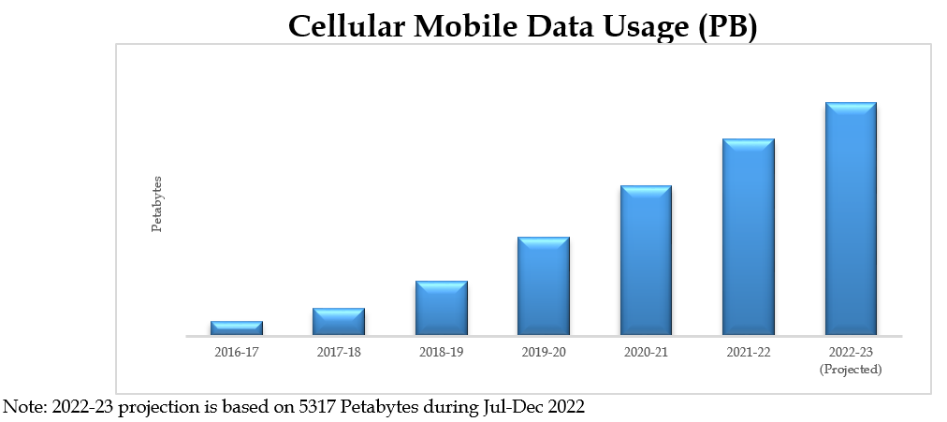  Projections for 2030 is under estimation and will be provided later on.
Nepal | There are two major IMT operators in Nepal, and their combined traffic is approximately 80,000,000 Gigabyte/ month. The forecast data usage by 2030 (Year to Year, YoY) for various types of human and non-human usage using IMT technology in Nepal is as below:
  Description | 2023 | 2024 | 2025 | 2026 | 2027 | 2028 | 2029 | 2030
  YoY Data Traffic Growth, % | 45% | 16% | 35% | 20% | 25% | 20% | 22% | 25%
  YoY Machine Type Data Traffic Growth, % | 0.05% | 1% | 2% | 4% | 7% | 9% | 15% | 20%
Indonesia | N/A
Japan | Since June 2010, data on mobile communication traffic volume (excluding voice) has been analysed every three months based on reports from mobile network operators. According to the most recent figures for December 2024, the average monthly traffic volume was 8 973.2 Gbps, and the total monthly traffic was 3 004 220.5 TB (equivalent to approximately 3 004.2 PB), representing an increase of about 1.2 times compared to the previous year.  No data usage forecasts for 2030 are available.  Source: https://www.soumu.go.jp/johotsusintokei/field/data/gt010602.pdf (in Japanese)

    - Role of FWA
Q7: What role do you expect will be played by FWA, regardless of technology, to help meeting the connectivity targets for fixed users (including residential households and enterprise users)?

Answers
Bhutan | FWA will decongest the mobile networks and will help in ensuring the QoS of Mobile services.
Nepal | The fixed wireless access (FWA) has not been successful as expected. The service providers are starting to provide FWA services using IMT 4G technology and will be provided with 5G too. The success of such initiative will depend on many factors including identifying the appropriate market, offered throughput, price and quality.
Thailand | FWA will be an inexpensive connectivity alternative for rural areas.
Palau | -
Viet Nam | Regarding to the fixed broadband infrastructure, by the end of 2022 in Viet Nam, FTTx connection has been deployed to 100% of communes/wards/ townships, 91% of villages, 100% of schools, 72.4% of household (20 million houses). In this circumstance, FWA could play a supplementary role to fill in the un-connected or hard-to-deploy areas.
China | -
Korea | TBD
Sri Lanka | It is expected involve FWA technologies for extending connectivity to rural areas.
Brunei | To cater for area where FTTH are unable to penetrate, in other words as a  backhaul to FTTH network.
Pakistan | FWA can play a vital role in Pakistan to help meeting the connectivity targets for fixed users in view of the very low fixed wired connectivity options/ penetration.
Nepal | The fixed wireless access (FWA) is expected to fulfil the connectivity target in coming year.
Indonesia | FWA is expected as complementary service to Fiber to the “x” (FTTx) to facilitate faster market penetration. It will expand the penetration especially in urban and rural areas, for both residential households and enterprise users.
Japan | Mobile network operators are offering FWA services, which provide internet connectivity without the use of fibre optic cables. By simply installing a dedicated device known as CPE (Customer Premises Equipment), end users can easily access high-speed internet without the need for fibre optic cable installation.

    - Forecast availability of network resources
Q8: What is the forecast availability of new base station site resources and the degree of increased densification (e.g., distance between sites) between 2025-2030 in your country/territory? Is there any plan to reuse the current site resources for future IMT deployment?

Answers
Bhutan | No such forecast has been made. However, the existing resources will be used in densification for IMT deployment and also riding the new services over current base station infrastructures.
Nepal | Currently, there are more than 8500 physical base stations throughout the Country. Site densification of the service providers are currently based on the need basis. Each operator builds hundreds of towers every year to expand the network footprint as well as to enhance the customer experience. Regarding future IMT deployment, the current site resources will be reused whenever possible. In addition, infrastructure sharing is also planned for optimal reuse of the resources. But no specific plans and forecast have been made for 2025-2030.
Thailand | Information is not available
Palau | In progress.
Viet Nam | Most of mobile operators plan to reuse the current 4G site resource for 5G deployment.  To adapt the increase of mobile data traffic, together with secure new spectrums and employ advance technology, operators also consider densifying their base station sites
China | The site resource is a limited resource. The general target is to reuse the current site resources as much as possible for future IMT deployment
Korea | TBD
Sri Lanka | Current sites will be reused for IMT deployment; further densification will be required.
Brunei | Current station has been reused and being put together as Single Radio Access  Network (SRAN) compromise of 3G, 4G and 5G.
Pakistan | The rollout of 5G technology shall require installation of much more base stations as compared to existing 3G/4G technologies between the during of 2025 – 30 in Pakistan. The current site resources shall be utilized for future IMT deployment as per the current prevailing practice of using 2G base stations for deployment of 3G & 4G systems.
Nepal | Currently, there are more than 8500 physical base stations throughout the Country. Site densification of the service providers are currently based on the need basis. Each operator builds hundreds of towers every year to expand the network footprint as well as to enhance the customer experience. Regarding future IMT deployment, the current site resources will be reused whenever possible. In addition, infrastructure sharing is also planned for optimal reuse of the resources. But no specific plans and forecast have been made for 2025-2030.
Indonesia | N/A
Japan | No forecasts have been made regarding this question.

    - IMT-2020 industrial use cases
Q9: What IMT-2020 sectoral/industrial use cases are you expecting to unfold in your country/territory? Please select all that apply.
Agriculture
Drones
Education
Energy
Manufacturing
Media
Medical
Mining
Smart Cities
Transportation
Others, please specify

Answers
 | Bhutan | Nepal | Thailand | Palau | Viet Nam | China | Korea
Agriculture |  | X | X | X | X | X | X
Drones | X | X |  |  |  | X | X
Education | X | X |  | X | X | X | X
Energy | X | X |  | X |  | X | X
Manufacturing | X |  | X |  |  | X | X
Media |  | X |  | X | X | X | X
Medical | X | X | X | X | X | X | X
Mining |  |  |  |  |  | X | X
Smart Cities |  | X | X | X | X | X | X
Transportation |  | X | X | X | X | X | X
Others, please specify |  |  |  |  |  | Public service

Further information from China: In 2022, achievements in integrated applications in the fields of intelligent manufacturing, intelligent medical care, intelligent education and digital government affairs continue to emerge. More than 4000 “5G + Industrial Internet” projects have been invested and built across the country, creating a number of 5G fully connected factories. Telecom operators use 5G slicing technology to provide more than 14,000 5G virtual private networks, helping industries accelerate digital transformation.
https://www.miit.gov.cn/zwgk/zcjd/art/2023/art_9f5022af3cdf48789484117d9da03c58.html

 | Sri Lanka | Brunei | Pakistan | Nepal | Indonesia | Philippines | Japan
Agriculture | X | X | X | X | X |  | X
Drones | X |  | X |  |  |  | X
Education | X | X | X | X | X | X | X
Energy | X | X | X | X |  | X | X
Manufacturing | X |  | X |  | X | X | X
Media | X |  | X | X |  | X | X
Medical | X | X | X | X | X | X | X
Mining | X |  | X |  | X
Smart Cities | X | X | X |  | X | X | X
Transportation | X | X | X | X | X | X | X
Others, please specify

    - Traffic demand
Q10: Have there been any report indicating significantly increased high mobile (4G and 5G) traffic demand and/or network congestion in your country?

Answers
Bhutan | Yes especially during the Covid 19-lockdown period
Nepal | Yes, Mobile traffic (4G) has been growing and service providers are reporting congestions in different spectrum bands. The service providers are doing continuous upgrade to avoid the congestion
Thailand | -
Palau | Yes, 4G
Viet Nam | No public report in this regard.
China | -
Korea | TBD
Sri Lanka | Yes
Brunei | There is a significant increase in traffic since the introduction of 5G network in June 2023 based on our internal report.
Pakistan | Trend in mobile data usage is provided in the above graph. PTA also publishes mobile data usage stats on its website at the following link:  https://www.pta.gov.pk/en/telecom-indicators/13  Further, PTA also publishes its annual reports with analysis of its telecom sector development, the same may also be referred for reporting on increased data demand and usage e.g. Chapter 2 (Telecom and ICT development) of PTA Annual Report 2022, available at following link:  https://www.pta.gov.pk/en/data-&-research/publications/annual-reports
Nepal | Not reported yet
Indonesia | Yes, there has been some reports indicating an increase in traffic demand for mobile broadband.
Japan | No reports are available.

    - Technology switch-off and refarming plans
Q11: Has any timeline been set for the switch-off of any particular technology (e.g., 2G or 3G)? By taking the experience from past re-farming of spectrum, what are the plans to re-farm existing spectrum for IMT in your country/territory before 2030? Is there a roadmap or any plan to build one? Where possible, please state frequency band, total bandwidth available and anticipated timeline for re-farming.

Answers
Bhutan | No timeline has been set for switch-off. There are plans to re-farm spectrum but no specifications and timeline has been set. The switch-off will depend on the operators.
Nepal | In Nepal, majority of the voice traffic is still using 2G/3G technology. The voice traffic is not increasing, it is steady. The operators are also providing VoLTE services which is expected to offload CS traffic gradually to be more focused on data lead network. Based on the market dynamics of handset, user behaviour and push on usage of VoLTE, CS network will be gradually downsized. However, explicit timeline for the complete switch-off of 2G or 3G has not been set. It is anticipated that 3G network will be phased out before 2G. As the spectrum assigned to the operators are mainly technology neutral, the operators are free to refarm spectrum to spectrally efficient technology for better customer experience. The Authority provides required assistance and coordination for such refarming.
Thailand | -
Palau | Planning stage
Viet Nam | Viet Nam has established a national roadmap for the phase-out of legacy mobile technologies. 2G services are scheduled to be switched off nationwide by 15 September 2026, followed by the switch-off of 3G networks by September 2028, in order to refarm spectrum and accelerate the transition to 4G and 5G services.  To support the 2G switch-off, Viet Nam implemented several policy measures, including restricting the import and distribution of 2G-only devices, promoting migration of users to 4G smartphones through public awareness campaigns and device support programs, and encouraging mobile operators to expand nationwide 4G coverage. These measures helped accelerate the transition from legacy networks and enabled the successful switch-off.  Financial and technical support: Subsidizing smartphone prices and providing affordable 4G feature phones to make them more accessible to users.  Extensive communication: Widespread announcements via SMS and news to help users prepare and avoid the "shock" of losing connectivity. End-user Standards (Equipment):  Import/Manufacturing Prohibition: From July 2021, the Ministry of Science and Technology (MIC before) issued a technical standard (QCVN 117:2023/BTTTT) mandating that mobile phones must support VoLTE and operate on all or at least one of the 4G frequency bands specified in the standard.  Network Blocking: From December 2023, network operators began blocking mobile devices that only support 2G/3G (only use 2G/3G networks) that do not meet standards, regulations, or are not included in the national database.  By 2026, the entire 2G infrastructure will be shut down, paving the way for 5G and higher technologies, optimizing frequencies.  Spectrum re-farming for IMT:  Viet Nam plans to progressively refarm existing mobile frequency bands from legacy technologies to more advanced IMT systems, particularly 4G and 5G, before 2030. The primary bands targeted for this transition include the 900 MHz, 1800 MHz and 2100 MHz bands.
  Frequency band | Total bandwidth | Current/planned use | Anticipated timeline
  900 MHz | 2×35 MHz | 2G, 3G, 4G, 5G / 4G & above | 16/9/2026&16/9/2028
  1800 MHz | 2×75 MHz | 2G, 4G, 5G / 4G & above | 16/9/2026
  2100 MHz | 2×60 MHz | 3G, 4G, 5G / 4G & above | 16/9/2028
China | At the national level, there is no unified re-farming roadmap, and the telecom operators are allowed and encouraged to re-farm existing spectrum for new generation of IMT when there are permissions from the administration.
Korea | 2G service was shut down by operators around 2021 taking into account the license duration and the spectrum re-farming plan. 3G service is also approaching shut down in the aspect of 3G mobile traffic data, but the exact timeline is hard to predict considering existing users.
Sri Lanka | The discontinuation of 3G services is taking place at a slow pace.
Brunei | No current plan to switch off / re- farming of any particular active/existing bands in the country.
Pakistan | Cellular mobile operators are voluntarily switching off 3G technology in consultation with PTA and switching to 4G technology. Similarly, Federal Government has set the deadline of 2024 for switching of WLL based services. 700 MHz band is also being approved by the Government for refarming. Refarming of 2600 MHz band is also under consideration.
Nepal | CDMA shut down has been completed in 2023. Currently, majority of the voice traffic is still using 2G/3G technology. The voice traffic is not increasing, it is steady. The operators are also providing VoLTE services which is expected to offload CS traffic gradually to be more focused on data lead network. Based on the market dynamics of handset, user behaviour and push on usage of VoLTE, CS network will be gradually downsized. However, explicit timeline for the complete switch-off of 2G or 3G has not been set. It is anticipated that 3G network will be phased out before 2G. As the spectrum assigned to the operators are mainly technology neutral, the operators are free to refarm spectrum to spectrally efficient technology for better customer experience. The Authority provides required assistance and coordination for such refarming.
Indonesia | No timeline has been made for 2G shutdown, meanwhile 3G has been switched-off since 2023. In regards to the re-farming of IMT spectrum, Indonesia has implemented neutral technology policy in all IMT frequency bands.
Philippines | There is no timeline has been set for the switch-off of technology like 2G or 3G but there are discussions and considerations for this.
Japan | Operation of 2G has already been terminated in Japan.  Of the three mobile network operators that provided 3G services, two have already ceased 3G operations. The remaining operator also plans to end 3G service by the end of March 2026.

- Industry Research Reports and Information
  - Socio-economic impact in APAC of mid-band spectrum
The study report assesses mid-band spectrum on a global basis with analysis at the Asia Pacific level. The socio-economic impact study examined the contribution of 5G spectrum to gross domestic product (GDP) by 2030, providing insight into the role 5G will play in helping deliver global economic growth. At a global level, mid-bands are expected to account for 63% of the overall socio-economic value generated by 5G. In the APAC region, mid-band 5G spectrum is expected to drive an increase of around $285 billion in APAC GDP in 2030.
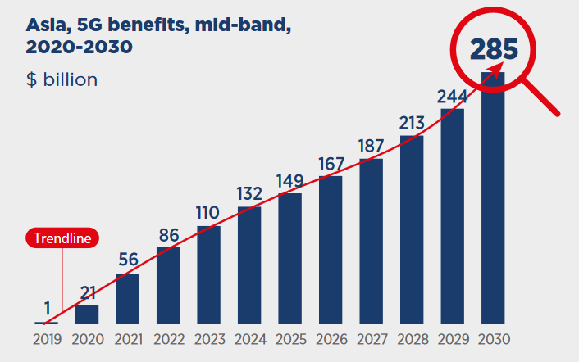
Figure 2. Annual impact of 5G on GDP in APAC, by band, 2020-2030
In Asia Pacific, the East Asia and Pacific regions are expected to drive most of the benefits associated with 5G mid-band spectrum, with the biggest economies (China, Japan and South Korea) delivering most of the regional benefits, supported by extensive 5G network deployment.
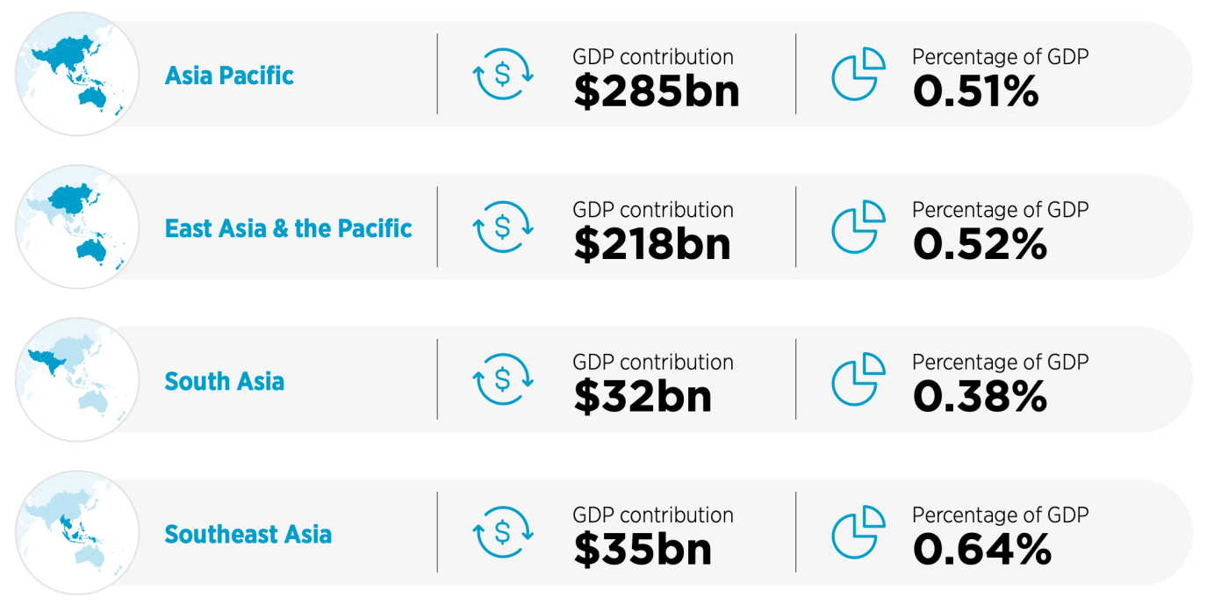
Figure 3. Asia Pacific: GDP contribution generated by mid-band 5G, 2030
At the country level, the largest economies of each Asia Pacific sub-region are expected to drive most of the region’s overall contribution to GDP from mid-band 5G. In terms of overall Asia Pacific contribution, China, Japan and South Korea are the major contributors, due to the high level of 5G penetration that will be reached by 2030 in these countries.
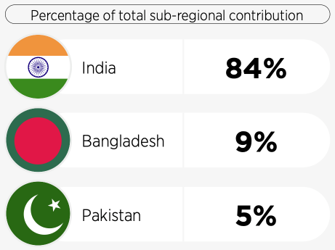
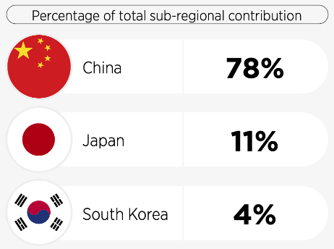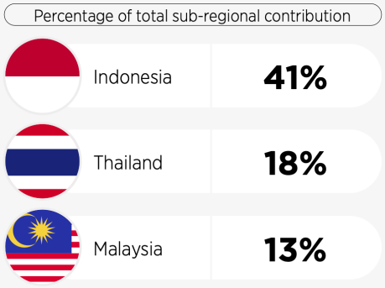
Figure 4. Share of sub-regional GDP contribution generated by mid-band 5G, 2030
For the period 2020–2030, eMBB and FWA use cases (and their associated applications) are expected to drive most of the 5G benefits. This is particularly the case for mid-band spectrum as indicated below.
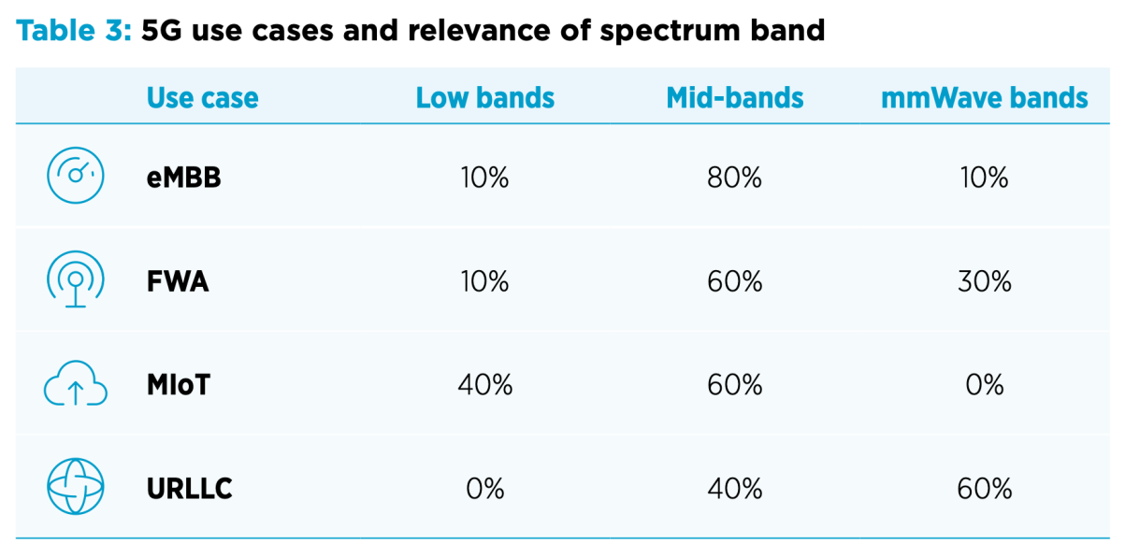
Figure 5. 5G use cases and spectrum band relevance
However, for FWA, pilot projects on the use of mmWave bands to deploy FWA in suburban and rural areas suggest mmWave may play a greater role in the future.

  - Mid-band spectrum needs in some densely populated areas
Delivering reliable high-speed mobile broadband services is a particular challenge in densely populated areas such as major cities. The large number of people in relatively small areas can easily over-burden the capacity of mobile networks. As a result, mobile networks’ spectrum requirements are typically higher in these urban settings. The mid-band spectrum is essential for IMT to meet the connectivity demands of densely populated cities. It offers the ideal balance of coverage and capacity, enabling high-speed 5G networks in congested urban environments. With growing data consumption, efficient mid-band spectrum allocation ensures seamless connectivity, lower latency, and enhanced digital services for millions of users.
This GSMA report analysed how much spectrum is expected to be needed to meet key ITU targets for IMT- 2020 (5G) in 36 cities around the world in the 2025-2030 timeframe. At this time, 5G take-up is expected to be significantly higher than today. The analysis calculates how much spectrum is needed to reliably deliver 100 Mbps download speeds and 50 Mbps upload speeds to end users.
The report’s analysis found that the amount of spectrum needed depended on a number of factors. These included:
- Population density (excluding temporary population);
- Predicted amount of available spectrum by 2025;
- Geographical separation of base stations (inter- site distance);
- 5G technology used in every band, with MIMO upgrades and both outdoors small and macro cells;
- Percentage of high-band, indoor small cells and Wi-Fi offload; and
- Cellular network activity factor.
This study takes into account the effect of Wi-Fi offload, but not other alternative technologies such as satellite, that can also can also support use cases requirements, in particular for Fixed Wireless Access and IoT. Therefore, spectrum requirements presented in this study would be adjusted accordingly.
It is to be underlined that this study focuses on densely populated urban areas, and conclusions should not be extrapolated to the whole territory of the concerned countries. For sub-urban and rural areas, current spectrum identification for IMT may be sufficient on the long-term. For dense urban areas, other bands such as mmWave are also relevant (see below figure) and would cover some traffic requirement instead of increasing mid-band spectrum needs. This study takes into account the effect of mmWave offload.
Figure 6: Mix of spectrum for 5G
The study also highlights that alternative solution such as network densification can be considered to cover traffic requirements, even if the increase in network cost is to be anticipated.
By the end of 2021, mid-band spectrum – primarily in the 3.5 GHz range, but also in the 2.3 GHz, 2.6 GHz and 4.8 GHz bands – had been the most commonly used around the globe to launch 5G networks. By 2030, and without potential factors of improvement listed above, an average of 2 GHz of additional spectrum is expected to be needed in some densely populated areas to deliver 5G services at a performance consistent with the ITU’s IMT-2020 (5G) requirements.
Figure 7 below shows expected spectrum requirement in cities within scope of the report.
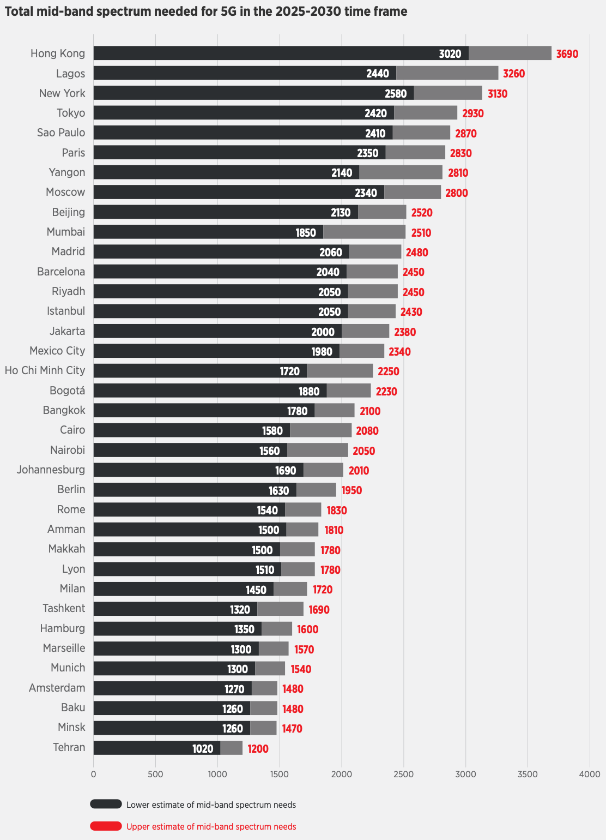
Figure 7. Total mid-band spectrum needed for 5G in the 2025-2030 timeframe
As of end-2023, live 5G commercial networks are available in 20 Asia Pacific markets, with at least 7 more planning to launch services in 2024, based on GSMA Intelligence.
By 2030, the number of 5G connections in APAC is forecast to exceed 3.1 billion, up from some 1 billion as of end-2023. 5G technology is expected to make up 61% of total connections in the APAC region by 2030 as shown in Figure 8.
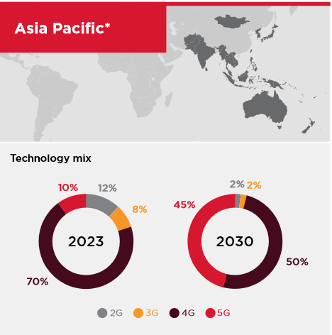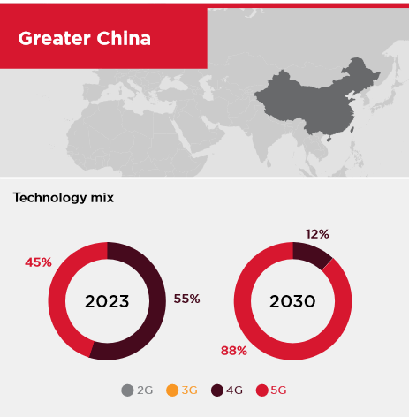
Figure 8. Adoption Rate of IMT Technology in APAC region by percentage of connections
In addition, LS Telecom in 2019 have indicated that countries in Asia Pacific region in average have only licensed 44% of the available harmonized IMT spectrum for low and mid band IMT spectrum. It meant that there are still average of 56% of the harmonized IMT spectrum for low and mid band in Asia Pacific region that have not yet licensed which could be used for 5G deployment. However, it is noted that administrations may not be able to use the entire portion of globally identified IMT spectrum for mobile services, and so must ensure they have sufficient spectrum in appropriate ranges to meet their needs. It is noted that this report is released in 2019. If latest data is available, the conclusion may be adjusted.
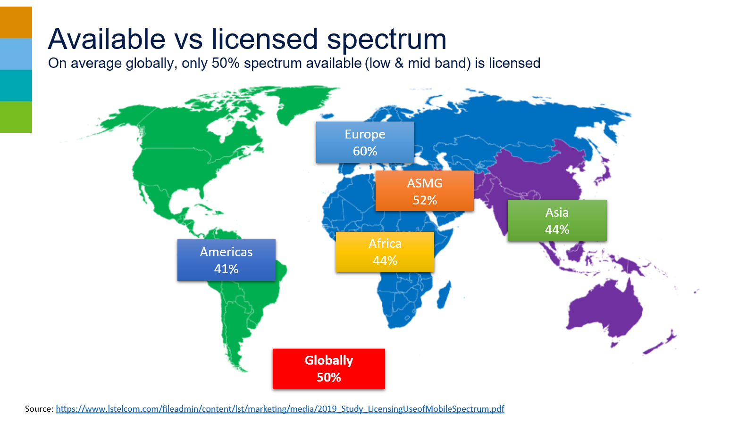
Figure 9. Available IMT Spectrum for low and mid band spectrum worldwide in 2019
5G delivers broadband FWA with fibre-like speeds, but at a fraction of the deployment cost. This can have a profound impact in areas with limited access to high-speed fibre. Mid-band spectrum is well-equipped to provide 5G FWA in population clusters such as towns and smaller urban areas, especially where other options are expensive or unavailable.
  - 5G traffic growth towards 2030
According to Ericsson, global mobile data traffic is expected to reach 130 EB per month at the end of 2023. This is projected to grow by a factor of around 3 and to reach 403 EB per month in 2029. When fixed wireless access (FWA) is included, total mobile network traffic is anticipated to reach around 160 EB per month at the end of 2023, rising to an expected 563 EB per month by the end of 2029 as shown in Figure 10.

Of total mobile data traffic, 5G’s share is estimated to be 25 percent at the end of 2023, an increase from 15 percent at the end of 2022. This share is forecast to grow to 76 percent in 2029.
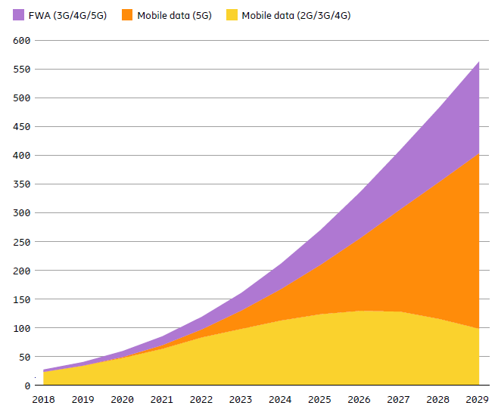
Figure 10: Global mobile network data traffic (EB per month)
Global average monthly mobile data usage per smartphone is expected to reach 56 GB in 2029, rising from 21 GB at the end of 2023. Mobile data traffic per smartphone is even higher among countries in the Asia Pacific region as shown in Figure 11. The growth in mobile data traffic per smartphone can be attributed to three main drivers: improved device capabilities; an increase in data-intensive content; and growth in data consumption, due to continued improvements in the performance of deployed networks.

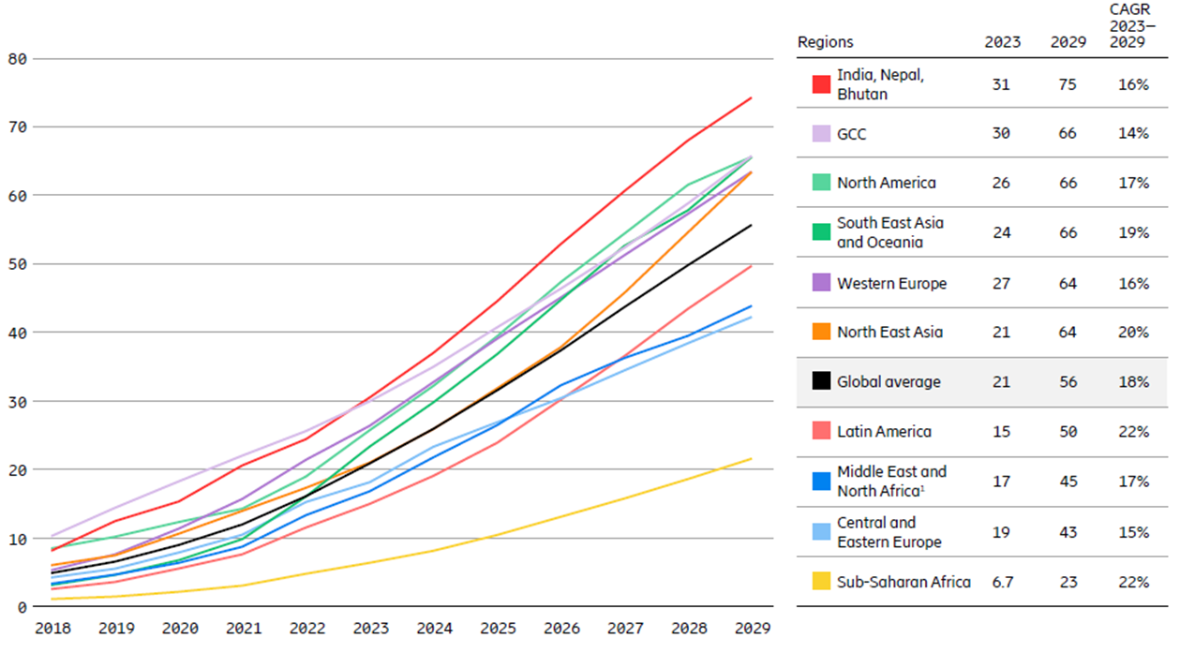
Figure 11: Mobile data traffic per smartphone (GB per month)
FWA connections are forecast to increase rapidly across the rest of this decade from 130 million in 2023 to 330 million by 2029. Of the total projected connections, close to 85 percent are expected to be over 5G. The Asia Pacific region is expected to account for over 45 percent of global FWA connections as shown in Figure 11.

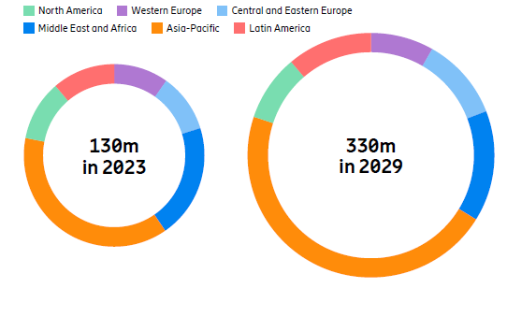
Figure 12: Regional split in FWA connections 2023-2029
Similar projections from Nokia confirm the growth trends in mobile and FWA traffic as summarised in Figure 13. 5G connectivity and technology will be a crucial enabler of enterprise services, business office applications and industry 4.0 uses such as metaverse, IoT and digital twins. As a result, enterprise traffic is another category which is projected to expand significantly over this decade.

Traffic category | Projected traffic for 2030 | Growth
Consumer mobile | 415 to 644 EB/mo. | 4.3x to 6.6x
Consumer FWA | 172 to 423 EB/mo. | 5.9x to 14.6x
Enterprise | 270 to 1647 EB/mo. | 5x to 25x
Figure 13: Network traffic by category

  - IMT developments in some bands
    - IMT trials in upper 6 GHz (6.425-7.125 GHz)
In the “6 GHz IMT Ecosystem Report” it is indicated that there are no difficulties to supply IMT equipment in the upper 6 GHz band (6.425-7.125 GHz) from the ecosystem perspective. Several recent field trials involving the upper 6 GHz band confirm this and the results provide further evidence on the ability of the upper 6 GHz band to provide an effective coverage and capacity layer for IMT. Further details on these trials are provided below.

      - Chulalongkorn University (February 2023)
Chulalongkorn University, Thailand, conducted a field test of upper 6 GHz to study the data transmission quality for 5G Outdoor to Outdoor (O2O) and Outdoor to Indoor (O2I) deployment scenarios using the upper 6 GHz band. Using a channel bandwidth of 80 MHz, the test achieved average throughputs of 1100 Mbps (O2O) and 550 Mbps (O2I). This trial demonstrates that upper 6 GHz is able to offer good macro base station coverage performance, making it a suitable band for nation-wide IMT deployment.

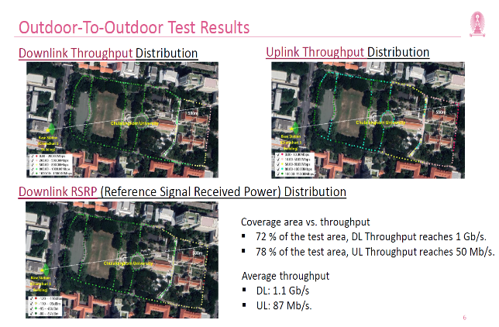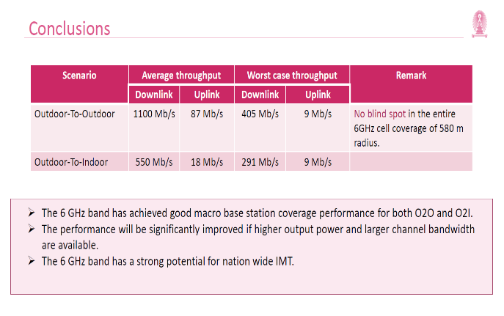
Figure 14: Overview of test results
      - Du, e& (August 2023)
UAE operators du and e& completed a successful 5G-Advanced trial project involving the upper 6 GHz band. Using 400 MHz bandwidth, the trial achieved a throughput of 10 Gbps. The TDRA which confirmed the results, noted that the increase in data speed will support many future projects at the UAE level, especially those that require highly sophisticated technologies (e.g. nanotech) and high internet speeds, such as remote diagnostics in healthcare, or autonomous (self-driving) vehicle projects in transportation, as well as help in the management of some industrial installations.

      - Deutsche Telekom (August 2023)
German operator Deutsche Telekom completed a trial which achieved a data rate of ~12 Gbps. To achieve this speed, two 5G data streams – from upper 6 GHz and 3.7 GHz spectrum – were combined. The results highlight the capacity expansion benefits of 5G deployment using carrier aggregation of 3.5 GHz and upper 6 GHz mid-band spectrum and the ability of such a deployment to achieve reasonable indoor coverage.

      - Maxis, Universiti Malaya (September 2023)
This upper 6 GHz trial conducted by Malaysian operator Maxis and Universiti Malaya achieved a peak throughout of 1.28 Gbps with 80 MHz bandwidth using a prototype Active Antenna Unit and a prototype mobile device. The test results showed good indoor penetration and the ability to achieve speeds of over 300 Mbps at locations more than 400m away from the mobile site, as well as potential for improvements in mobile signal propagation with more advanced antenna technology.

      - Vodafone (October 2023)
Vodafone announced a successful test of the upper 6 GHz band in Spain which achieved download speeds of up to 5 Gbps and on average 2 Gbps across various indoor locations. It was noted that 75% of all mobile traffic originates from users at home, in the office, or in enclosed public places such as cafes, bars, shops, and gyms, and the ability of upper 6 GHz to serve indoor users will ensure consumers and businesses receive even faster access and more reliable 5G services over the next 5-10 years.

      - Ericsson, MediaTek (November 2023)
Ericsson and MediaTek successfully carried out an interoperability test involving 5G NR data calls over upper 6 GHz band. This was performed with a MediaTek prototype test device and an Ericsson base station. The test was the first 5G NR data call on the 3GPP-defined n104 band (6.425-7.125 GHz) and highlights the efforts by telecom vendors, service providers, and device/chipset makers to build a global ecosystem for IMT in the upper 6 GHz band.

GSA 5G Device Ecosystem Member Report February 2025
ITU-R Report on Future technology trends of terrestrial IMT systems towards 2030 and beyond.
Wireless access application in which the location of the end-user termination and the network access point to be connected to the end-user are fixed. https://www.itu.int/dms_pubrec/itu-r/rec/f/R-REC-F.1399-0-199905-S!!PDF-E.pdf
https://www.gsma.com/spectrum/wp-content/uploads/2022/02/mid-band-5G-spectrum-benefits.pdf
Source: GSMA
Source: GSMA
https://www.gsma.com/spectrum/wp-content/uploads/2022/07/5G-Mid-Band-Spectrum-Needs.pdf
An assumption surrounding what percentage of human and machine connections require the 100 Mbps download and 50 Mbps upload connection at any one time during the busiest hours.
GSMA Intelligence. 5G in Context, Q4 2023. https://data.gsmaintelligence.com/research/research/research-2024/5g-in-context-q4-2023
Notes: *Asia Pacific excluding Greater China. Source: GSMA Mobile Economy Report 2024. https://www.gsma.com/solutions-and-impact/connectivity-for-good/mobile-economy/wp-content/uploads/2024/02/260224-The-Mobile-Economy-2024.pdf
Source: LS Telcom
Ericsson. Mobility Report, November 2023. https://www.ericsson.com/4ae12c/assets/local/reports-papers/mobility-report/documents/2023/ericsson-mobility-report-november-2023.pdf
Source: Ericsson Mobility Report
Source: Ericsson Mobility Report
Source: Ericsson Mobility Report
Nokia Global Network Traffic 2030 report. https://onestore.nokia.com/asset/213660
Source: Nokia Global Network Traffic 2030 report
GSMA. The 6 GHz IMT Ecosystem. https://www.gsma.com/spectrum/wp-content/uploads/2022/08/6-GHz-IMT-Ecosystem.pdf
More information at https://www.chula.ac.th/en/news/118185/
Source: Chulalongkorn University
More information at https://www.eand.com/en/news/29-aug-etisalat-by-eand-5G-advanced-network-speed-trials.html and https://www.du.ae/about/media-centre/newsdetail/du-breaks-new-ground-in-5g-advanced-trial
More information at https://www.chula.ac.th/en/news/118185/https://tdra.gov.ae/en/media/press-release/2023/tdra-announces-successful-completion-of-phase-ii-of-advanced-5g-trials
More information at https://www.telekom.com/en/media/media-information/archive/world-record-12-gigabits-per-second-in-mobile-communications-1048610 and https://api.cept.org/documents/ecc-pt1/81398/ecc-pt1-24-032_%C2%ADdt_6-ghz-trial
More information at https://www.maxis.com.my/en/about-maxis/newsroom/2023/september/setting-the-right-path-to-meet-growing-data-consumption/
More information at https://www.vodafone.com/news/technology/vodafone-tests-reveal-6ghz-spectrum-to-avoid-5g-capacity-crunch
More information at https://www.ericsson.com/en/news/2023/11/ericsson-and-mediatek-demo-on-6-ghz-licensed-5g-band

