

APT REPORT ON

RELEVANT INFORMATION FOR CONSIDERATIONS ON THE POSSIBLE IMPLEMENTATION OF IMT IN THE FREQUENCY BAND 1 427-1 518 MHZ

Edition: April 2026

The 36th Meeting of APT Wireless Group
6 – 10 April 2026
Bandar Seri Begawan, Brunei Darussalam (Hybrid)

(Source: AWG-36/OUT-03)

No. APT/AWG/REP-113(Rev.1)

APT report on
relevant Information for considerations ON THE POSSIBLE Implementation OF IMT in THE frequency band 1 427–1 518 MHz
- Introduction

At ITU World Radiocommunication Conference 2015 (WRC-15), it was agreed to identify the frequency bands 1 427–1 452 MHz and 1 492–1 518 MHz for IMT (International Mobile Telecommunications) in all three Regions and to identify the frequency band 1 452–1 492 MHz for IMT in Region 2, Region 3 and 54 countries in Region1 in accordance with Resolution 223 (Rev.WRC-15).

This Resolution invites ITU-R to develop harmonized frequency arrangements to facilitate IMT deployment in the frequency band 1 427–1 518 MHz, taking into account the results of sharing and compatibility studies. In this context, ITU-R has started the work on the development of frequency arrangements for the implementation of the terrestrial component of IMT systems in the frequency band 1 427–1 518 MHz. At the Radiocommunications Assembly (RA-19) in October 2019, Recommendation ITU-R M.1036 revision 6 was approved as “Frequency arrangements for the implementation of the terrestrial component of International Mobile Telecommunications in the bands identified for IMT in the Radio Regulations”. Section 4 of this revision provides three options (G1, G2 and G3) for frequency arrangements for the band 1 427–1 518 MHz.

Resolution 223 (Rev.WRC-15) was revised by the ITU World Radiocommunication Conference in 2019 (WRC-19). Resolution 223 (Rev.WRC-19) invites ITU-R to conduct compatibility studies to provide technical measures to ensure coexistence between MSS (Mobile Satellite Service) in the frequency band 1 518–1 525 MHz and IMT in the frequency band 1 492–1 518 MHz, including guidance on the implementation of frequency arrangements for IMT deployment in the frequency band 1 427–1 518 MHz, taking into account the results of these studies. The Resolution further invites ITU-R to include the results of the studies in one or more ITU-R Recommendations and Reports, as appropriate.
- Scope

This Report provides relevant information for administrations considering the possible implementation of IMT in the frequency band 1 427–1 518 MHz taking into account current and planned usage in the adjacent bands.
- Vocabulary of terms

EESS Earth exploration-satellite service
FDD Frequency division duplexjohn.lewis@bluewin.ch
IMT International Mobile Telecommunications
MSS Mobile Satellite Service
RR Radio Regulations
SDL Supplementary Downlink
TDD Time division duplex
WRC World Radiocommunication Conference
3GPP 3rd Generation Partnership Project
- Regulatory considerations

The following WRC Resolutions in the ITU Radio Regulations (RR) and ITU-R Recommendation are relevant for developing APT frequency arrangements to implement the terrestrial component of IMT systems in the frequency band 1 427–1 518 MHz. The existing regulatory conditions in Resolution 750 (Rev.WRC-19) need to be considered to develop frequency arrangements. Furthermore, additional considerations may be required in accordance with Resolution 223 (Rev.WRC-19), Resolution 761 (Rev.WRC-19) and Recommendation ITU-R M.1036.

4.1 Resolution 750 (Rev.WRC-19)

To protect the Earth exploration-satellite service (EESS) (passive) in the frequency band 1 400–1 427 MHz, Resolution 750 (Rev.WRC-19) stipulates those unwanted emissions of IMT stations brought into use in the 1 427–1 452 MHz shall not exceed the corresponding limits in Table 1 below, subject to the specified conditions:

Table 1
EESS (passive) band | Active  service band | Active service | Limits of unwanted emission power from  active service stations in a specified bandwidth  within the EESS (passive) band¹
1 400-  1 427 MHz | 1 427-  1 452 MHz | Mobile | −72 dBW in the 27 MHz of the EESS (passive) band for IMT base stations  −62 dBW in the 27 MHz of the EESS (passive) band for IMT mobile stations^{2, 3}
¹ The unwanted emission power level is understood here as the level measured at the antenna port.
² This limit does not apply to mobile stations in the IMT systems for which the notification information has been received by the Radiocommunication Bureau by 28 November 2015. For those systems, the recommended value applies −60 dBW/27 MHz.
³ The unwanted emission power level is to be understood here as the level measured with the mobile station transmitting at an average output power of 15 dBm.

4.2 Resolution 223 (Rev.WRC-19)

This Resolution invites ITU-R
- to conduct compatibility studies in order to provide technical measures to ensure coexistence between MSS in the frequency band 1 518–1 525 MHz and IMT in the frequency band 1 492–1 518 MHz, including guidance on the implementation of frequency arrangements for IMT deployment in the frequency band 1 427-1 518 MHz, taking into account the results of these studies
- to include the results of these studies in one or more ITU-R Recommendations and Reports, as appropriate.

The results of studies mentioned above areavailable in Report ITU-R M.2529 and Recommendation ITU-R M.2159.

4.3 Resolution 761 (Rev.WRC-19)

This Resolution provides technical and regulatory measures to facilitate coexistence between IMT and BSS (sound) in the frequency band 1 452–1 492 MHz in Regions 1 and 3.

4.4. Recommendation ITU-R M.1036-8

This Recommendation contains three options for frequency arrangements for the implementation of the terrestrial component of IMT in the bands identified for IMT in the RR. There are frequency division duplex (FDD), time division duplex (TDD) and supplemental downlink (SDL) options. Each option is qualified with the following notes:
- With respect to IMT in the frequency band 1 492-1 518 MHz and the MSS in the frequency band 1 518-1 525 MHz, Recommendation ITU-R M.2159 provides technical and regulatory measures to facilitate adjacent band compatibility. Based on the results of the studies, administrations may consider a number of possible measures, including additional frequency separation below 1 518 MHz, e.g. up to 6 MHz, at the upper part of G1, G2 or G3.
- Moreover, when implementing these frequency arrangements, administrations are also encouraged to take into account Annex 3 to Recommendation ITU-R M.2159 in order to address IMT-MSS coexistence in certain areas, such as seaports and airports.
- Considerations on results of co-existence studies with respect to the Mobile Satellite Service

Annex 4 contains information for MSS usage in the frequency band 1 518–1 559 MHz in some APT countries, based on a questionnaire issued in the year 2017. According to the responses to Question 3 in Annex 4, some APT countries have awarded the licenses for application of the MSS in the frequency band above 1 525 MHz, and MSS terminals operate on many ships and aircraft in the region. Land mobile terminals (handheld and transportable) are also in operation. Some of the terminals mentioned above are already capable of operating in the band 1 518–1 525 MHz. In addition, the frequency band 1 518–1 525 MHz is being used or planned to be used for MSS by some APT countries. The use of the 1 518–1 525 MHz band by MSS in the APT Region includes GSO and NGSO systems.

The Report ITU-R M.2529 contains eight compatibility studies to evaluate potential interference and provide technical measures for coexistence between MSS in the frequency band 1 518–1 525 MHz and IMT in the frequency band 1 492–1 518 MHz. Some studies in this ITU-R Report also address the potential interference due to blocking of MESs operating in the frequency band 1 525–1 559 MHz, including ship earth stations used in the GMDSS in the frequency band 1 530–1 544 MHz (see RR No. 5.353A) and aircraft earth stations under MSS allocation in the band 1 525–1 559 MHz, noting that priority is given to the AMS(R)S in coordination in the band 1 545–1 555 MHz (see RR No. 5.357A).

Summaries of all studies in the Report ITU-R M.2529 can be found in Section 5. The probabilities of interference from IMT base stations/mobile stations into MES are assessed considering different I/N protection criteria, receiver blocking levels and frequency separations between IMT and MSS.

The Recommendation ITU-R M.2159 provides technical measures to provide adjacent band compatibility between satellite systems in the mobile-satellite service operating in the band 1 518–1 525 MHz and IMT-systems operating in the band 1 492–1 518 MHz in line with the Resolution 223 (Rev.WRC-19).

These technical considerations concerning co-existence with the MSS are for consideration by administrations in determining the preferred frequency arrangements for IMT and the compatibility measures to limit the impact to MSS operations in their countries including existing MESs that are operating on land, on ships and on aircraft.
- IMT Technology Options

6.1 Frequency Division Duplex

6.1.1 General considerations
IMT systems using the following FDD arrangement for a paired frequency band have been already deployed in a certain country in the Asia-Pacific region.
- 1 427.9–1 462.9 MHz: FDD uplink
- 1 475.9–1 510.9 MHz: FDD downlink
- Centre gap: 13 MHz
- Duplex separation: 48 MHz

The relevant industry specifications for this arrangement are available as 3GPP Bands 11 and 21. Based on these specifications, commercial equipment (for both base stations and mobile stations) has been implemented for that country. This existing market in the country contributes economies of scale for the FDD equipment.

An FDD arrangement using a paired frequency band gives flexibility to administrations when assigning the frequency band to mobile operators, i.e., assignment of the frequency band is possible to any types of operators, either new or existing. This is because the standalone operation of an IMT network is possible by using downlink and uplink spectrum in the band.

An FDD frequency arrangement using a paired frequency band in this band is also suitable for providing wide coverage due to its good propagation characteristics than higher frequency bands for capacity (e.g., 2.6 GHz and 3.5 GHz bands).

Furthermore, implementing “5G” systems is expected to use much higher frequency bands (e.g., above 24 GHz) for capacity. It would be helpful to adopt paired FDD arrangements in the band below 3 GHz (including in the 1 427–1 518 MHz) for coverage purposes, while adopting unpaired arrangements in the higher frequency bands would be reasonable for capacity purposes.

6.1.2 ITU Radiocommunication Sector
Recommendation ITU-R M.1036-8 includes the following FDD arrangement.

Arrangement “G2”
- 1 427–1 470 MHz: FDD uplink (43 MHz bandwidth)
- 1 475–1 518 MHz: FDD downlink (43 MHz bandwidth)
- Centre gap: 5 MHz
- Duplex separation: 48 MHz

This Recommendation also indicates that:
- With respect to IMT in the frequency band 1 492-1 518 MHz and the MSS in the frequency band 1 518-1 525 MHz, Recommendation ITU-R M.2159 provides technical and regulatory measures to facilitate adjacent band compatibility. Based on the results of the studies, administrations may consider a number of possible measures, including additional frequency separation below 1 518 MHz, e.g. up to 6 MHz, at the upper part of G1, G2 or G3.
- Moreover, when implementing these frequency arrangements, administrations are also encouraged to take into account Annex 3 to Recommendation ITU-R M.2159 in order to address IMT-MSS coexistence in certain areas, such as seaports and airports.

6.1.3 3rd Generation Partnership Project
The following FDD arrangements using a paired frequency band, namely Bands 11 and 21, have been specified for the 3GPP LTE technologies:
Band 11:
- 1 427.9–1 447.9 MHz: FDD uplink
- 1 475.9–1 495.9 MHz: FDD downlink
Band 21:
- 1 447.9–1 462.9 MHz: FDD uplink
- 1 495.9–1 510.9 MHz: FDD downlink

The following FDD arrangement using a paired frequency band, namely Band 74 for the 3GPP LTE technologies, has also been specified:
Band 74:
- 1 427–1 470 MHz: FDD uplink
- 1 475–1 518 MHz: FDD downlink

In Band 74, the size of pass bandwidth is maximized to 43 MHz per link with support of 1.4, 3, 5, 10, 15 and 20 MHz channel bandwidths. For example, within the 43 MHz bandwidth, 5 MHz×8 blocks could be used for mobile broadband applications, while the remaining 3 MHz could be used for IoT applications using narrower channel bandwidth (< 5 MHz).

Furthermore, 3GPP has developed corresponding 5G (NR) specifications for the Band 74 arrangement, named Band n74.

6.1.4 Other consideration
An FDD arrangement includes transmitting IMT base stations and transmitting IMT mobile stations. It is usual to place the uplink in the lower part of the band and downlink in the upper part of the band. This means that the IMT mobile station is subject to compatibility requirements concerning the EESS (passive) in the band 1 400–1 427 MHz. The IMT base station is subject to compatibility concerning the MSS in the band 1 518–1 525 MHz.

While the above arrangement “G2” by ITU-R provides no guard band concerning MSS above 1 518 MHz, Recommendation ITU-R M.1036 notes that administrations may consider an additional frequency separation below 1 518 MHz (e.g., a total separation of 0 MHz to 6 MHz) at the upper part of arrangement G2 as one of several possible measures to facilitate adjacent band compatibility between IMT and MSS. This could be accomplished by not assigning the uppermost IMT blocks in this frequency arrangement.
Another possible measures to facilitate the adjacent band compatibility is to use pico-cell or indoor-cell deployment for IMT networks.

6.2 Time Division Duplex

6.2.1 General considerations
A TDD arrangement provides inherent and unique flexibility to administrations to implement part(s) of the frequency 1 427–1 518 MHz band and facilitates progressive allocation (there is no need to free symmetrical portions to allow the use of the band).

Like FDD, a TDD arrangement gives flexibility to administrations when assigning the frequency band to mobile operators, i.e., assignment of the frequency band is possible to any types of operators, either new or existing. This is because the standalone operation of an IMT network is possible by using downlink and uplink spectrum in the band.

TDD arrangement allows further flexibility and spectrum efficiency thanks to possible adaptation to asymmetrical traffic between downlink/uplink.

A TDD frequency arrangement in this band is also suitable for providing wide coverage due to its good propagation characteristics compared to higher frequency bands for capacity (e.g., 2.6 GHz and 3.5 GHz bands).

Considering these features and the fact that 5G technology offers the flexibility of using a TDD frequency arrangement also for downlink only to adapt to traffic, TDD arrangements for this band offers both consistent capacity and coverage for countries that need 5G standalone deployment in 1 427–1 518 MHz band as well as for those who need downlink only capacity. This leads to possible harmonisation between the two ecosystems.

However, it should be noted that inter-network synchronization (i.e., using the same downlink/uplink ratio and synchronization of transmission timing) is required when more than one TDD network are deployed in the same geographical area and the adjacent frequency block without a guard band. The studies on inter-network synchronization are documented in the APT Report on “Network Synchronization Technologies in Radio Access Networks for IMT TDD Systems” (APT/AWG/REP-60).

6.2.2 ITU Radiocommunication Sector
Recommendation ITU-R M.1036-8 includes the following TDD arrangement.

Arrangement “G3”
- 1 427–1 517 MHz: TDD uplink and downlink (up to 18 blocks of 5 MHz)

This Recommendation also indicates that:
- With respect to IMT in the frequency band 1 492-1 518 MHz and the MSS in the frequency band 1 518-1 525 MHz, Recommendation ITU-R M.2159 provides technical and regulatory measures to facilitate adjacent band compatibility. Based on the results of the studies, administrations may consider a number of possible measures, including additional frequency separation below 1 518 MHz, e.g. up to 6 MHz, at the upper part of G1, G2 or G3.
- Moreover, when implementing these frequency arrangements, administrations are also encouraged to take into account Annex 3 to Recommendation ITU-R M.2159 in order to address IMT-MSS coexistence in certain areas, such as seaports and airports.

6.2.3 3rd Generation Partnership Project
The following TDD arrangements, namely Band 45, Band 50 and n50 and Band 51 and n51, have been specified by 3GPP:
Band 45:
- 1 447–1 467 MHz: TDD
Band 50 and n50:
- 1 432–1 517 MHz: TDD
Band 51 and n51:
- 1 427–1 432 MHz: TDD
where Bands n50 and n51 have been specified for 5G NR deployment.
3GPP has defined some inter-band Carrier Aggregation (CA) and E-UTRA (Evolved Universal Terrestrial Radio Access) - NR Dual Connectivity (EN-DC) (EN-DC) configurations for Bands n50 and n51 to operate as specified in Table 2 below

Table 2: Inter-band CA and EN DC bands for Bands n50 and n51
Inter-band CA bands (n50) | - CA_n28-n50  - CA_n41-n50  - CA_n50-n78
EN-DC bands (n50) | - DC_1_n50  - DC_3_n50  - DC_20_n50  - DC_28_n50
EN-DC bands (n51) | - DC_1_n51  - DC_3_n51  - DC_7_n51  - DC_20_n51  - DC_28_n51  - DC_42_n51

6.2.4 Other consideration

A TDD arrangement could include transmitting IMT base stations and transmitting mobile stations operating on frequencies close to the EESS (passive) band 1 400–1 427 MHz and close to the MSS band 1 518–1 525 MHz. This means that the IMT mobile station and IMT base station are subject to compatibility requirements regarding the EESS (passive) in the band 1 400–1 427 MHz and the MSS in the band 1 518–1 525 MHz. Because of the mobile nature of the IMT user equipment, its use presents different compatibility challenges to the IMT base station concerning interference to the MSS terminals in the bands above 1 518 MHz.

The 3GPP Release 15 New Radio (NR) enables TDD system to operate as downlink only, where TDD NR system can support SDL as a configuration scenario (10:0 configuration) with all resources to operate as downlink, considering the flexibility of the 5G NR frame structure and the capability of the scheduler to decide on the type of each resource block as downlink or uplink.

While the above arrangement “G3” by ITU-R provides a 1 MHz guard band with respect to MSS above 1 518 MHz, Recommendation ITU-R M.1036 notes that administrations may consider an additional frequency separation below 1 518 MHz (e.g., a total separation of 0 MHz to 6 MHz) at the upper part of arrangement G3 as one of several possible measures to facilitate adjacent band compatibility between IMT and MSS. This could be accomplished by not assigning the uppermost IMT blocks in this frequency arrangement.
Other possible measures to facilitate the adjacent band compatibility is to use pico-cell or indoor-cell deployment for IMT networks.

Another possible measure to facilitate adjacent band compatibility may be to restrict usage of IMT mobile stations within a specific range of MSS terminals, especially at airports and seaports.

6.3 Supplemental Downlink frequency band

6.3.1 General considerations
The CEPT countries have adopted Supplemental Downlink (SDL) technology in a number of ECC Decisions, CEPT Report, and ECC Reports on channel arrangement, additional protection, and least restrictive technical conditions (Block Edge Masks). CITEL has also approved a recommendation on SDL for this band.
- 1 427–1 517 MHz: SDL

An SDL frequency band does not require a centre gap, which can utilize more spectrum compared to an FDD arrangement using a paired frequency arrangement.
- The introduction of LTE-Broadcast (LTE-B) services allows use of low-power/low-tower distribution of audio-visual content over both local areas (stadiums, race tracks, sporting fields) and wide areas (towns, cities, or even nationwide); and
- Provision of additional IMT downlink capacity aimed at supplementing the capability of other FDD bands already in use by IMT systems – and more efficiently responding to the asymmetric traffic scenarios now being experienced in some FDD bands, which will result in more efficient usage of the corresponding FDD uplink block(s).

However, an SDL frequency band requires another frequency arrangement containing an uplink frequency band to be operated in an IMT network. This requirement provides restrictions on frequency assignments by administrations, where the assignments are restricted to those operators who have been already assigned IMT uplink spectrum in other frequency band(s).

6.3.2 ITU Radiocommunication Sector
Recommendation ITU-R M.1036-8 includes the following SDL arrangement.

Arrangement “G1”
- 1 427–1 517 MHz: SDL

This Recommendation also indicates that:
- With respect to IMT in the frequency band 1 492-1 518 MHz and the MSS in the frequency band 1 518-1 525 MHz, Recommendation ITU-R M.2159 provides technical and regulatory measures to facilitate adjacent band compatibility. Based on the results of the studies, administrations may consider a number of possible measures, including additional frequency separation below 1 518 MHz, e.g. up to 6 MHz, at the upper part of G1, G2 or G3.
- Moreover, when implementing these frequency arrangements, administrations are also encouraged to take into account Annex 3 to Recommendation ITU-R M.2159 in order to address IMT-MSS coexistence in certain areas, such as seaports and airports.

6.3.3 3rd Generation Partnership Project
The following SDL arrangements, namely Band 32, Bands 75 & n75 and Bands 76 and n76, have been specified by 3GPP:
Band 32:
- 1 452–1 496 MHz: SDL
Band 75 and n75:
- 1 432–1 517 MHz: SDL
Band 76 and n76:
- 1 427–1 432 MHz: SDL
where bands n75 and n76 have been specified for 5G NR deployment.

In regard to inter-band Carrier Aggregation (CA) bands for Band 32, Band 75 and Band 76, 3GPP has defined some configurations to operate as specified in Table 3 below:

Table 3 Inter-band CA bands for Band 32, Band 75 and Band 76
Inter-band CA bands (Band 32) | - CA B1-B32  - CA B3-B32  - CA B7-B32  - CA B20-B32
Inter-band CA bands (Band 32) | - CA B1-B20-B32  - CA B3-B7-B32  - CA B3-B20-B32  - CA B7-B20-B32
Inter-band CA bands (Band 32) | - CA B3-B7-B20-B32  - CA B3-B8-B32  - CA B1-B7-B20-B32
Inter-band CA bands (Band 75) | - CA B20-B75
Inter-band CA bands (Band 76) | - CA B20-B76
Note: | - B1: 1 920–1 980/2 110–2 170 MHz  - B3: 1 710–1 785/1 805–1 880 MHz  - B7: 2 500–2 570/2 620–2 690 MHz  - B20: 832–862/791–821 MHz  - B32: 1 452–1 496 MHz (SDL)  - B75: 1 432–1 517 MHz (SDL)  - B76: 1 427–1 432 MHz (SDL)

3GPP has defined some inter-band Carrier Aggregation (CA) and E-UTRA (Evolved Universal Terrestrial Radio Access) - NR Dual Connectivity (EN-DC) (EN-DC) configurations to operate as specified in Table 4 below

Table 4 Inter-band CA and EN DC bands for Bands n75 and n76
Inter-band CA bands (n75) | - CA_n8-n75  - CA_n20-n75  - CA_n28-n75  - CA_n75-n78
Inter-band CA bands (n76) | - CA_n76-n78
EN-DC bands (n75) | - DC_1_n75-n78  - DC_3_n75-n78  - DC_20_n8-n75  - DC_20_n28-n75  - DC_20_n75-n78
EN-DC bands (n76) | - DC_20_n76-n78

6.3.4 Other consideration
An SDL arrangement could include transmitting IMT base stations operating on frequencies close to the EESS (passive) band 1 400–1 427 MHz and the MSS band 1 518–1 525 MHz). This means that the IMT base station is subject to compatibility requirements with respect to the EESS (passive) in the band 1 400–1 427 MHz and compatibility with respect to the MSS in the band 1 518–1 525 MHz.

While the above arrangement “G1” by ITU-R provides a 1 MHz guard band with respect to MSS above 1 518 MHz, the preliminary draft Recommendation ITU-R M.1036 notes that administrations may consider an additional frequency separation below 1 518 MHz (e.g., a total separation of 0 MHz to 6 MHz) at the upper part of arrangement G1 as one of several possible measures to facilitate adjacent band compatibility between IMT and MSS. This could be accomplished by not assigning the uppermost IMT blocks in this frequency arrangement.

Other possible measures to facilitate the adjacent band compatibility is to use pico-cell or indoor-cell deployment for IMT networks.
- Considerations on the potential implementation of IMT in the frequency band
1 427–1 518 MHz in some countries in Asia-Pacific Region

Received responses to the “Questionnaire on the potential implementation of IMT in the frequency band 1 427–1 518 MHz in Asia-Pacific Region” from some APT Members are summarized in Annex 4.
- Additional information on the use of IMT in the frequency band 1 427–1 518 MHz

During the development of this Report, some additional information on the use of IMT in the frequency band 1 427-1 518 MHz was provided. This information was included in Annex 5 to this Report.
- Summary

This Report provides the relevant information for considerations of possible implementation of IMT in the frequency band 1 427–1 518 MHz by the APT Members. This information is detailed in Sections 4 to 8 and Annexes in this Report.

It should be noted that ITU-R studies are being conducted to provide possible technical measures to facilitate adjacent band compatibility between IMT in the frequency band 1 492–1 518 MHz and the MSS in the frequency band 1 518–1 525 MHz. APT Members are also encouraged to consider the results of these studies when implementing frequency arrangements for IMT in their countries.

ANNEX 1
Summary of 3GPP specification development for an FDD band plan in the frequency band 1 427–1 518 MHz
- General information
As shown in Figure 1, 3GPP has developed a new FDD operating band (Band 74) for those countries who wish to deploy FDD-LTE networks in the frequency band 1 427–1 518 MHz (2 × 43 MHz, uplink: 1 427–1 470 MHz, downlink: 1 475–1 518 MHz). The size of pass bandwidth is maximized to 43 MHz per link with support of 1.4, 3, 5, 10, 15 and 20 MHz channel bandwidths. Within the 43 MHz bandwidth, 5 MHz × 8 blocks could be used for mobile broadband applications, while the remaining 3 MHz could be used for IoT applications using narrower channel bandwidth (< 5 MHz). Furthermore, 3GPP has completed the development of corresponding 5G (NR) specifications for the Band 74 arrangement, named Band n74.

Figure 1
FDD band plan (Band 74) in the 1 427–1 518 MHz developed by 3GPP

It should be noted that this new FDD operating band (Band 74) is an extension of the existing FDD operating bands in Japan, i.e., Bands 11 (2 × 10 MHz, uplink: 1 427.9–1 447.9 MHz, downlink: 1 475.9–1 495.9 MHz), and 21 (2 × 15 MHz, uplink: 1 447.9–1 462.9 MHz, downlink: 1 495.9–1 510.9 MHz) and is compatible with them.

- Duplexer configuration
3GPP agreed to specify relevant requirements for Band 74 (2 × 43 MHz) based on dual duplexer configuration using a lower duplexer of 2 × 33MHz and an upper duplexer of 2 × 30MHz, as shown in Figure 2.

Figure 2
Agreed duplexer configuration to specify relevant requirements for the FDD band plan

- Required transmission restriction for user equipment (mobile station)
3GPP finished the study to evaluate possible methods and conditions for the existing Bands 11 and 21 UEs to comply with the mandatory EESS (passive) protection requirement in Resolution 750 (Rev.WRC-19).

The study concluded that there might be no restriction when UEs transmit the upper 10 MHz of Band 11 (1 437.9–1 447.9 MHz) and 15 MHz of Band 21 (1 447.9–1 462.9 MHz), and the following mitigation techniques in the uplink would be needed when UEs transmit in the lower 10 MHz of Band 11 (i.e., 1 427.9–1 437.9 MHz):
- For the cases of transmit bandwidth ≤ 1.44 MHz, no uplink transmission resource restriction or power back-off is required,
- For the cases of transmitting bandwidth > 1.44 MHz, some power back-off and/or uplink transmission resource restrictions are required.

In addition, the study observed that the enhanced MTC (eMTC) technology (transmit bandwidth ≤ 1.08 MHz) or the in-band Narrow Band-IoT (NB-IoT) technology (transmit bandwidth ≤ 180 kHz) by 3GPP could also be accommodated without restriction due to the results above.

Based on these conclusions of the study and further work in the work item, necessary specifications to protect the EESS (passive) from mobile station transmission have been already included in the 3GPP Band 74 specifications.

Annex 2
3GPP specification for TDD band Plans in L-Band (1 427–1 518 MHz)

3GPP has specified the following 2 operating bands for TDD in L-band⁽¹⁾:
- Band 50: 1 432–1 517 MHz
- Band 51: 1 427–1 432 MHz (e.g., for Home and Local Area)

The specification of BS emissions in downlink was completely complying with the downlink of SDL arrangement (considering the 2 operating bands of Band 75 and Band 76) in order to facilitate the harmonization of TDD and SDL in particular for the current 5G NR. The 5G NR technology, as per 3GPP Release 15, offers flexibility and possible harmonization of TDD and SDL arrangements, where the TDD system can be configured with all resources operating as DL only as one deployment scenario.

Also, it was not possible to define a single band covering the whole range 1 427–1 517 MHz since a BS standard RF-filter is not able to allow transmission in the first 5 MHz of the band (1 427–1 432 MHz), with the objective to meet EESS protection below 1 427 MHz and MSS protection above 1 520 MHz. Accordingly, an additional 5 MHz band covering 1 427–1 432 MHz is considered to maximize spectrum efficiency with low power transmission requirements to ensure EESS protection.

3GPP finished its own study to evaluate possible methods and conditions to ensure EESS and MSS protection from the user equipment (mobile station) transmission with specific restriction including power back-off. For the EESS protection, UE should comply with the mandatory EESS protection requirement in Resolution 750 (Rev.WRC-19) for the adjacent blocks. Several compatibility studies have been submitted to ITU-R between TDD IMT (particularly for IMT UE transmission) and various MSS systems operating in the adjacent L-band. The ITU-R studies are not yet completed and hence the 3GPP standards do not take account of the ITU-R compatibility measures.

Reference
- 3GPP TR 36.753-f00, “TDD is operating band in the L-band for LTE".

Annex 3
3GPP SDL bands in L-Band

3GPP has specified the following 2 operating bands for SDL in L-band ⁽¹⁾:

- Band 75: 1 432–1 517 MHz
- Band 76: 1 427–1 432 MHz (for Home BS and Local Area BS only)
The definition of a single band covering the whole range 1 427–1517 MHz was not possible since a BS standard metallic 10th order RF-filter, to meet both –42 dBm/27 MHz unwanted emission limit in 1 400–1 427 MHz to protect EESS and –30dBm/MHz EIRP unwanted emissions level above 1520 MHz, is not able to allow transmission in the first 5 MHz of the band (1 427–1 432 MHz). It has not been chosen the option to adopt a 12th order RF-filter, which allows shrinking the guard band but at the expense of higher complexity and increased penalty in in-band loss (according to filter simulation results, a 12th order RF-filter with a Qu = 3000 allows to start the pass band at 1 430 MHz but in-band loss rms results in in-band loss of 0.5 dB in 1 435–1 512 MHz, 1.5 dB below 1 435 MHz, 1.1 dB above 1 512 MHz).

In order to maximize spectrum utilization, the definition of an additional 5 MHz band covering 1 427–1 432 MHz has been considered. Due to the necessity to meet the unwanted emission requirements to protect EESS, implementations in that band are limited to low power BSs. (An example of the 1 427–1 432 MHz band implementation for Home BS with a 5th order RF-filter shows a loss of 3 dB at 1 427 MHz and an in-band loss rms of 2.2 dB).

Reference
- R4-1708932, 3GPP TR 36.934 V0.3.0, “LTE Extended 1.5 GHz SDL band (1 427–1 518 MHz)”

Annex 4

Summary of responses to “Questionnaire on the potential implementation of IMT in the frequency band 1 427–1 518 MHz in Asia-Pacific Region.”

To facilitate studies on possible frequency arrangement(s) for terrestrial IMT in the frequency 1 427–1 518 MHz for the Asia-Pacific region, AWG-21 (2017) developed the questionnaire on the potential implementation of IMT in the frequency band 1 427–1 518 MHz in the Asia-Pacific Region. The questionnaire also seeks information on the usage of frequency bands above 1 518MHz, which would impact the development of the frequency arrangement(s).

A summary of the received responses to each question in the questionnaire is provided below.

Question 1: Has your country already implemented IMT in the frequency band 1 427–1 518 MHz or part(s) of the band?
Answer:

Country names | Answers
Thailand | Yes
Papua New Guinea | No
Bangladesh | No
Australia | No
Japan | Yes
Indonesia | Yes, for Fixed Wireless Access (FWA).
Philippines | No
Lao PDR | No
Iran | No
Malaysia | No
Singapore | No
Korea (Republic of) | No
China | No. There is no IMT implementations in the frequency band 1 427–1 518 MHz in China.
Viet Nam | Not yet.

If the answer to Question 1 is “Yes”, then please answer the following Question 1a.

Question 1a: In which frequency band(s) has your country already implemented IMT in the frequency range 1 427–1 518 MHz and what type of frequency arrangement(s) has your country implemented? (e.g., FDD using a paired band, FDD using a downlink only band, TDD, etc.)
Answer:

Country names | Answers
Thailand | SDL (Downlink: 1452-1472 MHz)
Papua New Guinea | N/A
Bangladesh
Australia | n/a
Japan | FDD using a paired band (Uplink: 1 427.9–1 462.9 MHz, Downlink: 1 475.9–1 510.9 MHz).
Indonesia | TDD: 1 432 – 1 512 MHz
Philippines | N/A
Lao PDR
Iran | –
Malaysia | Not applicable
Singapore
Korea (Republic of)
China
Viet Nam | NA

Question 2: Does your country currently consider future implementation of IMT in the frequency band 1 427–1 518 MHz or part(s) of the band?
Answer:

Country names | Answers
Thailand | -
Papua New Guinea | NO. However, PNG administration supports a regional approach and remains open to future consideration subject to outcomes of relevant AWG studies and finalization of technical conditions and harmonization measures for implementation of IMT in the frequency band.
Bangladesh | The Band 1 427–1 518 MHz is not under current consideration but will be consider in the future.
Australia | The band is currently in the preliminary re-planning stage of investigations for potential future use for IMT.
Japan | N/A
Indonesia | Currently, Indonesia already implemented IMT in the frequency range 1 432 – 1 512 MHz for Fixed Wireless Access (FWA).
Philippines | No
Lao PDR | Yes
Iran | Yes
Malaysia | Yes
Singapore | Singapore supports the future implementation of IMT in the frequency band 1 427–1 518 MHz or part(s) of the band pending results from the studies on frequency arrangement and adjacent channel coexistence. In the interim, IMDA has also made available the band 1 452–1 492 MHz for technical and market trials.
Korea (Republic of) | Yes
China | No. Currently, China is not considering to implement IMT systems in the frequency band 1 427–1 518 MHz.
Viet Nam | Yes. Viet Nam government has identified frequency band 1 427–1 518 MHz for IMT in the National Frequency Allocation Table.

If the answer to Question 2 is “Yes”, then please answer the following Questions 2a to 2d.

Question 2a: In which frequency band(s) does your country currently consider future implementation of IMT in the frequency range 1 427–1 518 MHz?
Answer:

Country names | Answers
Thailand | -
Papua New Guinea | N/A
Bangladesh
Australia | No decisions have been made in regard to frequency bands.
Japan
Indonesia | -
Philippines | N/A
Lao PDR | Yes
Iran | In the whole band (1 427–1 518 MHz)
Malaysia | 1 452–1 492 MHz
Singapore | Singapore supports full band IMT deployment (i.e. 1 427–1 518 MHz) to maximise spectrum utilisation. However, any final implementations will have to take into consideration cross-border interference issues and the results of compatibility studies for adjacent band coexistence issues (i.e. potential interference to MSS operations in adjacent band 1 518–1 559 MHz).
Korea (Republic of) | 1 452–1 492 MHz
China
Viet Nam | Full range of 1 427–1 518 MHz

Question 2b: In which time frame does your country currently consider future implementation of IMT in the frequency range 1 427–1 518 MHz?
Answer:

Country names | Answers
Thailand | -
Papua New Guinea | N/A
Bangladesh
Australia | No decisions have been made in regard to time frames.
Japan
Indonesia | -
Philippines | No plan yet
Lao PDR | N/A
Iran | In the next 2 years
Malaysia | To be determined
Singapore | Taking into account the global timeframe for equipment availability and time required to ensure cross-border coordination, Singapore expects the future implementation of L-band to take place around 2020, subject to the migration of the existing users within the band.
Korea (Republic of) | Before 2021
China
Viet Nam | Under consideration

Question 2c: What type of frequency arrangement(s) is under your consideration? (e.g., FDD using a paired band, FDD using a downlink only band, TDD, etc.)
Answer:

Country names | Answers
Thailand | -
Papua New Guinea | N/A
Bangladesh
Australia | No decisions have been made in regard to frequency arrangements.
Japan
Indonesia | -
Philippines | N/A
Lao PDR | FDD and SDL are under consideration.
Iran | Flexible Probably
Malaysia | To be determined. Final consideration for frequency arrangement will depend on future development.
Singapore | Singapore has received support from the industry for FDD, TDD and SDL frequency arrangements in its recent public consultation. Given that each channelling arrangement has its advantages and disadvantages, Singapore will continue to assess and monitor the developments in order to adopt a frequency arrangement that is most suitable for Singapore.
Korea (Republic of) | FDD using a downlink only band
China
Viet Nam | We are considering both FDD and SDL options. Considering the relevant regulatory and technical issues, we may prefer FDD option because it is similar to our other band plans (such as 900 MHz, 1800 MHz, 2100 MHz band plans). Also, FDD arrangement will allow mobile operators more flexibility in the implementation of IMT systems and Administrations flexibility when assigning the frequency band to mobile operators.

Question 2d: What kind of technologies/applications is envisaged in your future implementation of IMT in the frequency band 1 427–1 518 MHz or part(s) of the band? (e.g., 4G/5G, mobile broadband, IoT, etc.)
Answer:

Country names | Answers
Thailand | -
Papua New Guinea | N/A
Bangladesh
Australia | While no decisions have been made, if arrangements were put in place, they would be technology flexible and would not specify any particular implementation or application.
Japan
Indonesia | -
Philippines | N/A
Lao PDR | 4G/5G
Iran | Flexible to technology and probably to applications
Malaysia | To be determined
Singapore | Singapore will adopt technologies/applications that are compliant or compatible to the IMT requirements, and study the global technology and market trends in the deployment to determine if further specification is required.
Korea (Republic of) | 4G/5G
China
Viet Nam

Question 3: In which frequency band does your country award the licenses for application of the mobile-satellite service in the frequency range 1 518–1 559 MHz?
Answer:

Country names | Answers
Thailand | Not at the moment
Papua New Guinea | Standard L-band MSS frequencies: 1 525–1 559 MHz (space-to-Earth) and 1 626.5–1 660.5 MHz (Earth-to-space). These frequency bands are authorized for MSS operation in PNG. PNG further notes that these are similar in most APT member countries and are used by land, aeronautical and maritime MSS terminals throughout the Asia Pacific region
Bangladesh | It is reserved but not yet awarded.
Australia | 1 525–1 559 MHz
Japan | 1 525–1 559 MHz (for MSS downlink)
Indonesia | 1 525–1 559 MHz
Philippines | The frequency band 1 530–1 599 MHz (Space-to- Earth) is allocated to Global Mobile Personal Communications by Satellite (GMPCS). Memorandum Circular No. 11-08-98.
Lao PDR | None
Iran | In the frequency range 1 525–1 559 MHz
Malaysia | No
Singapore | 1 525–1 559 MHz
Korea (Republic of) | No
China | Previously, China allocates the frequency range 1 525–1 559 MHz to mobile-satellite service as the primary service, and the mobile-satellite service is treated as the secondary service in the frequency range 1 518–1 525 MHz due to compatible issues between MSS and meteorological aids service in 1 668–1 675 MHz (uplink band corresponds to 1 518–1 525 MHz).  China is updating the national frequency allocations, the mobile-satellite service is considered to be upgraded as the primary service in the frequency range 1 518–1 525 MHz.
Viet Nam | Frequency range from 1 525-1 559 MHz.

Question 4: Does your country have any plan to extend usage of the frequency band for application of the mobile-satellite service in the frequency range 1 518–1 559 MHz?
Answer:

Country names | Answers
Thailand | Not at the moment.
Papua New Guinea | YES. Also the services associated with developments in MSS need to be protected from adjacent IMT services at the 1 518 MHz band edge. Compatibility studies must be considered if administrations intend to support introduction of MSS services in the extended L-band.
Bangladesh | No.
Australia | No. However, several proposals have been presented by the MSS industry sector to the Australian regulator. These proposals are likely to be considered along with consideration for using the band below the 1 518 MHz frequency boundary for IMT. At this stage, no decisions have been made.
Japan | N/A
Indonesia | No
Philippines | None so far
Lao PDR | No
Iran | No
Malaysia | To be determined
Singapore | No plan at the moment
Korea (Republic of) | No
China | Yes, China has plans to extend usage the frequency band for mobile-satellite service. Currently, some satellite operators of China have submitted filings for the upper 34 MHz frequency of 1 518–1 559 MHz, but the coordination issues with other MSS system applications haven’t resolved so far.
Viet Nam | Not yet

If the answer to Question 4 is “Yes”, then please answer the following Question 4a.

Question 4a: In which frequency band(s) does your country currently consider to extend usage of application of the mobile-satellite service?
Answer:

Country names | Answers
Thailand | –
Papua New Guinea | Developments in Mobile Satellite Services (MSS) in the future are poised to bring benefits through added capacity and capabilities, which will become available for safety and security applications and which will also support important commercial activities such as those associated with fishing, aviation, tourism, and new opportunities in the “Internet of Things (IoT)”. PNG recognizes these benefits of MSS applications and therefore would like to take advantage of future MSS developments by extending the use of MSS to the full extended L-band frequencies: 1 518–1 525 MHz and 1 668–1 675 MHz.
Bangladesh
Australia | n/a
Japan
Indonesia
Philippines | N/A
Lao PDR | –
Iran | –
Malaysia | Not applicable
Singapore
Korea (Republic of)
China | Currently, China is considering to extend usage of application of mobile-satellite service in 1 518–1 559MHz.
Viet Nam | NA

Question 5: Does your country have any incumbent applications in the frequency band
1 427–1 518 MHz which may have a cross-border interference issue with adjacent countries?
Answer:

Country names | Answers
Thailand | No
Papua New Guinea | None at this stage, however PNG takes note of the need to protect BSS (sound) operating in 1 452–1 492 MHz from IMT hence will request that administration take note of current technical and regulatory studies pursuant to Resolution 761 (WRC-15) and consider coordination to avoid cross-border interference.
Bangladesh | No
Australia | Yes, BSS need to consider coordination with FS in Australia.
Japan | No
Indonesia | No
Philippines | The frequency band 1 427–1 530 MHz is allocated to terrestrial fixed point –to- point and point –to- multipoint.
Lao PDR | None
Iran | No
Malaysia | Yes
Singapore | No
Korea (Republic of) | Mobile applications
China | Yes.  In the frequency range 1 467–1 492 MHz, China has deployed digital audio broadcast applications, but the adjacent countries may implement IMT applications, which could cause a cross-border interference issue. In China, many satellite networks are submitted to BR in the frequency band 1 467–1 492 MHz, and some of these satellite networks are operational and notified. Besides, some other additional or succeeding BSS (Sound) satellite systems are also planned to be deployed in the GSO.  In the frequency range 1 518–1 525 MHz, China has launched a MSS satellite and some high-power satellites are planned to be deployed including GSO and non-GSO, there may also have a cross-border interference issue from IMT application in adjacent band from the neighboring countries.
Viet Nam | There are about 80 fixed links licensed in the frequency band 1 427–1 518 MHz. However, we have not had any cross border interference issue with respect to this band.

Annex 5

Additional information on the use of IMT in the frequency band 1 427-1 518 MHz

During the development of this Report, the following information was provided. This information was retained in this Annex for reference purpose only.

- Information on IMT usage in Japan
The presentation material embedded below provides the information on the use of L-band for IMT in Japan.

(Embedded material is also reproduced in the Attachment of Annex 5)

- Information provided by GSA
In January 2022, the GSA has updated its 2020 report on the band 1 427–1 518 MHz. The following are key insights of that report.
- Spectrum in the 1 400–1 500 MHz range (1 427–1 518 MHz, including Bands 11, 21, 32, 45, 50, 51, 74, 75, 76 and n50, 51, n74, n75, n76, n91, n92, n93 & n94) is of interest for mobile services, and although the market is at an early stage, an increasing number of countries are considering this spectrum, or parts thereof, for IMT:
- 1 427–1 452 MHz: Identified for IMT globally
- 1 452–1 492 MHz: Identified for IMT globally except CEPT countries
- 1 492–1 518 MHz: Identified for IMT globally
- The CEPT has decided on the use of 1 427–1 518 MHz for Mobile/Fixed Communications Networks.
- The ASMG has decided on the use of 1 427–1 518 MHz for IMT.

This GSA report¹ also contains the state of mobile operator licensing around the world at 1 400–1 500 MHz.

The device ecosystem is growing:

- There were 382 commercial devices supporting the frequency bands 1 427.9-1 462.9 MHz and 1 475.9-1 510.9 MHz for FDD (Bands 11 and/or 21) in 2020, and the number of devices supporting Bands 11 and/or 21 has grown to 431 devices by March 2022.
- There were 237 commercial devices supporting the band 1 452–1 496 MHz for SDL (Band 32) in 2020, and the number of devices supporting Band 32 has grown to 319 devices by March 2022.

- Information on IMT usage in Thailand

In June 2025, Thailand has successfully implemented the L-band for IMT services. In this implementation, four blocks of 5 MHz have been assigned to one mobile network operator. The details are shown in the table below.

Frequency Block (MHz) | Operator | IMT Technology | Channel bandwidth (MHz) | Licence duration (Years)
SDL: Downlink
1452-1472 MHz | TRUE | 5G/4G | 20 | 15

- Information on IMT usage in Indonesia
In 2025, the Ministry of Communications and Digital Affairs of Indonesia issued a Ministerial Regulation No. 13 of 2025 on the use of the 1.4 GHz frequency band for Fixed Wireless Access (FWA) based on International Mobile Telecommunications (IMT). Following a spectrum auction held in 2025, this band was assigned to two operators to support the deployment of FWA across multiple service regions.
The details of the spectrum assignment are shown in the table below.
Frequency Block (MHz) | Operator | Service Region | IMT Technology | Channel Bandwidth (MHz) | Licence Duration (Years)
TDD
1 432 – 1 512 | PT Telemedia Komunikasi Pratama | Region I  (Islands of Java, Maluku, and Papua) | 5G (n50) | 80 | 10
1 432 – 1 512 | PT Eka Mas Republik | Region II  (Islands of Sumatera, Bali, and Nusa Tenggara) | 5G (n50) | 80 | 10
1 432 – 1 512 | PT Eka Mas Republik | Region III  (Islands of Kalimantan and Sulawesi) | 5G (n50) | 80 | 10

Attachment of Annex 5:

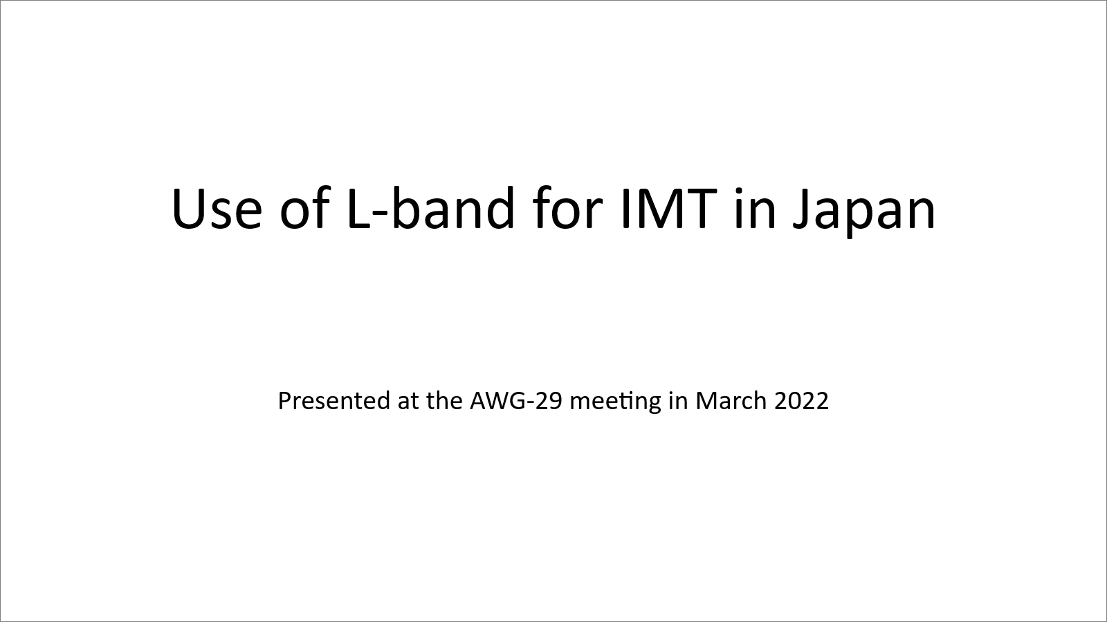

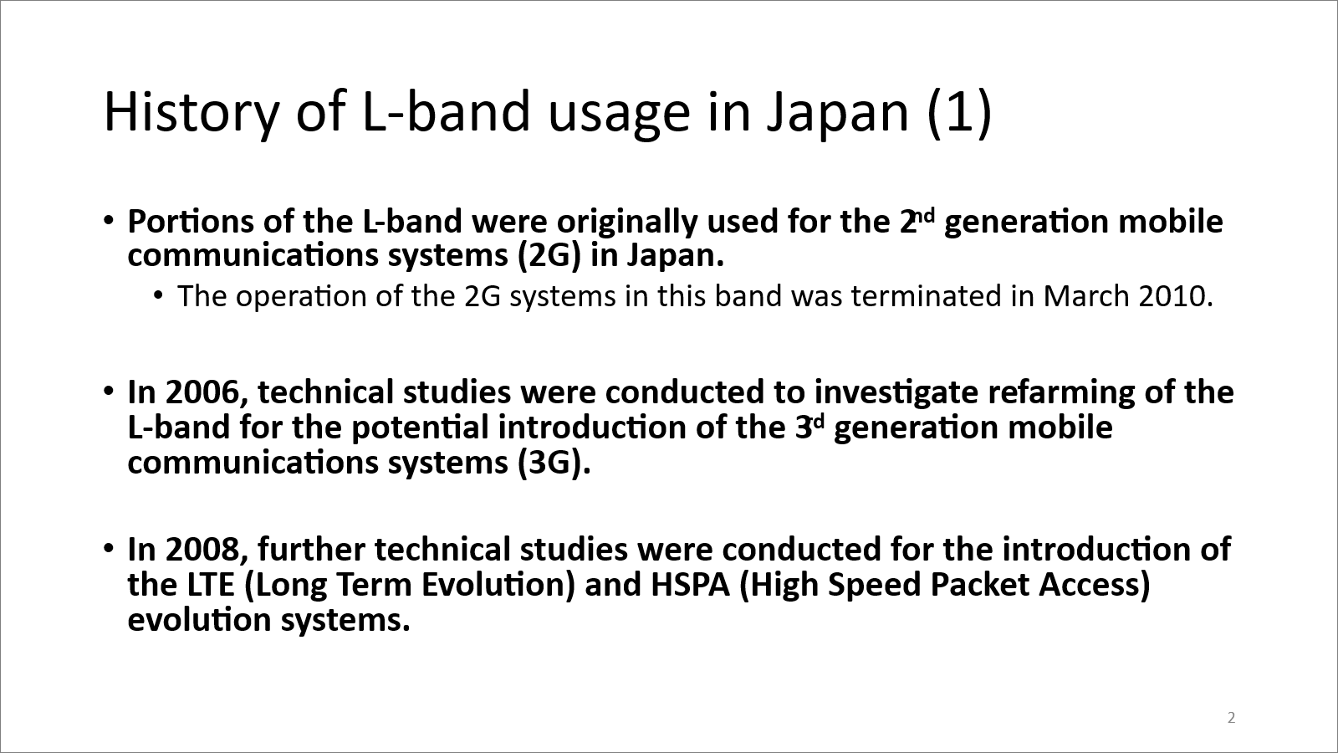

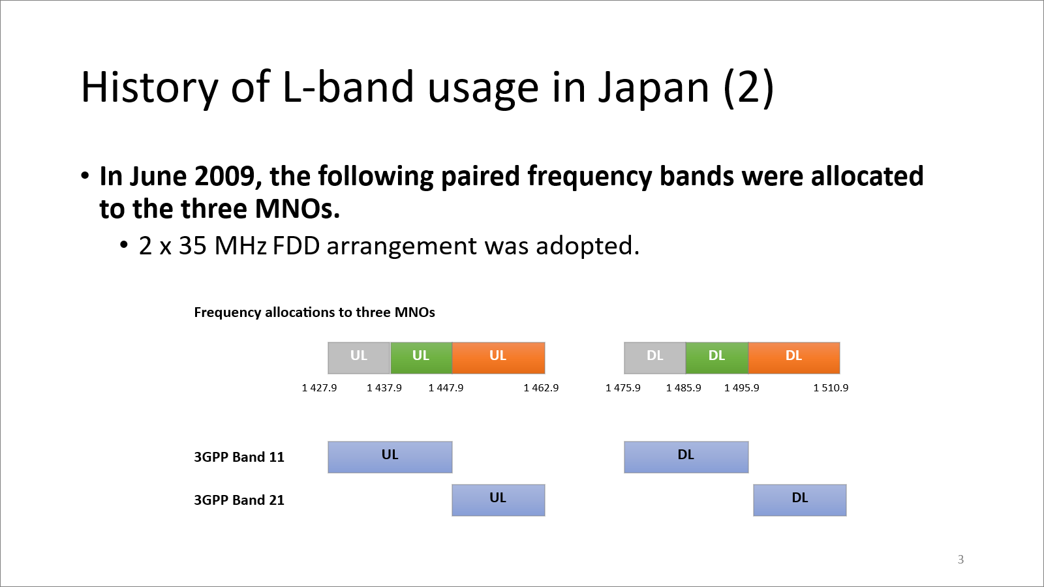

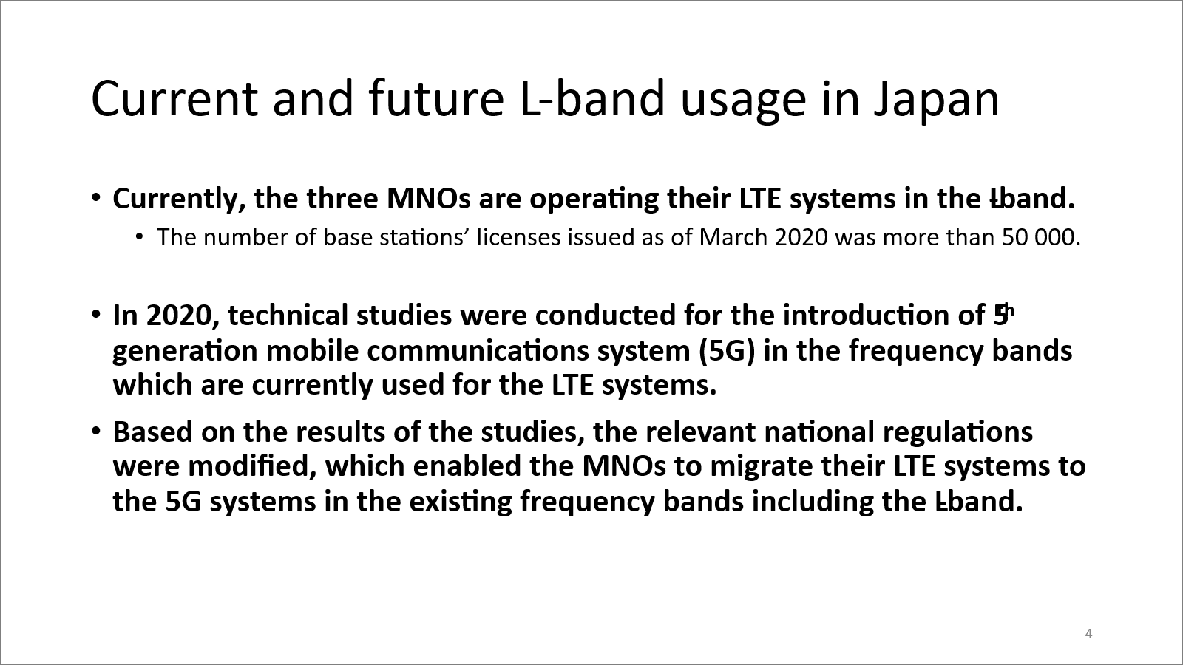

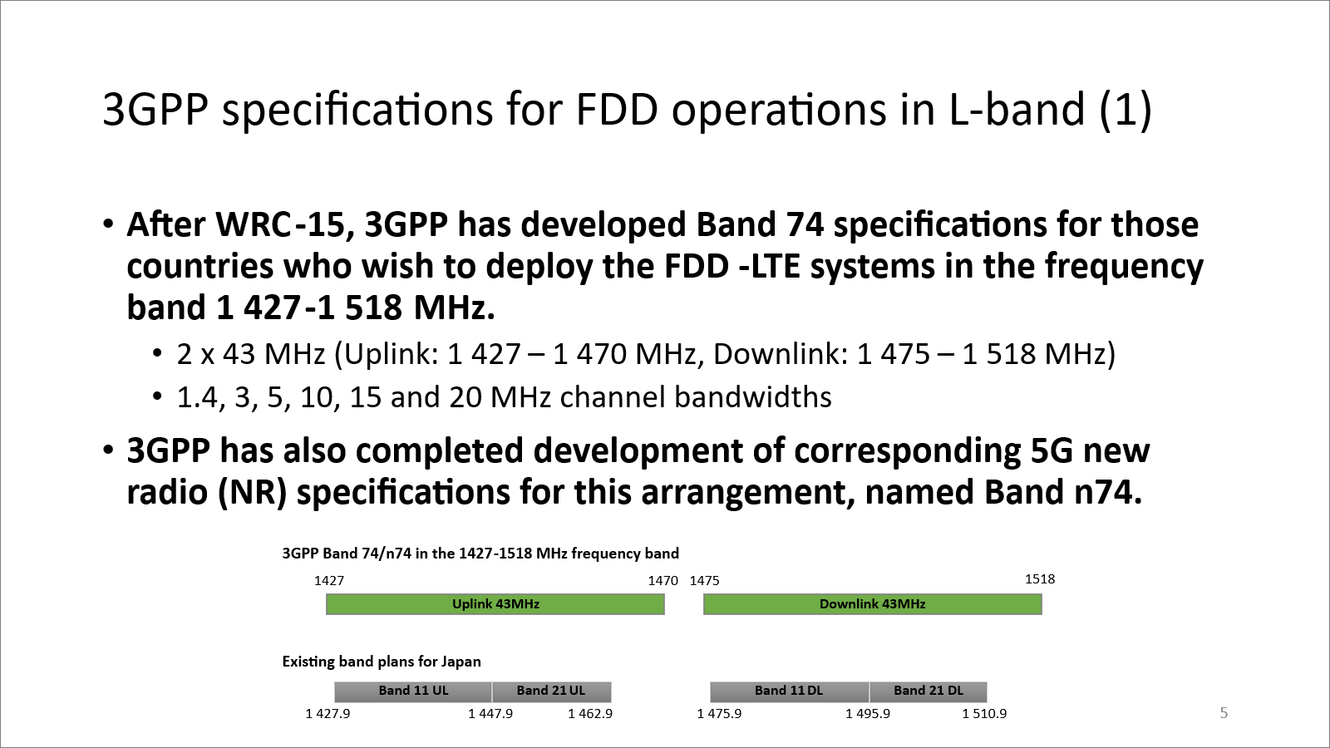

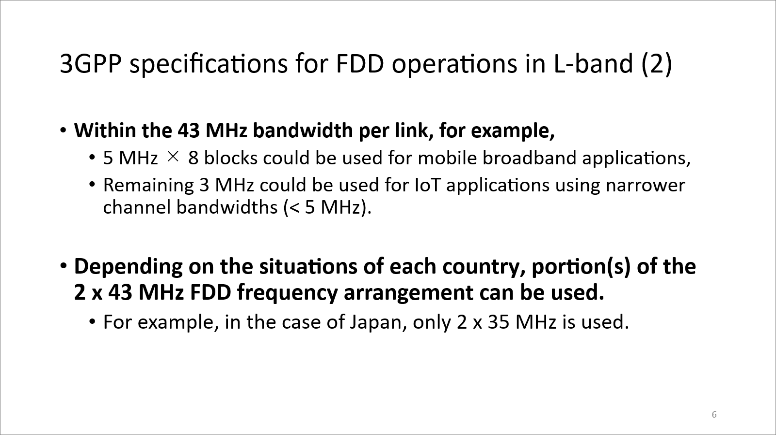

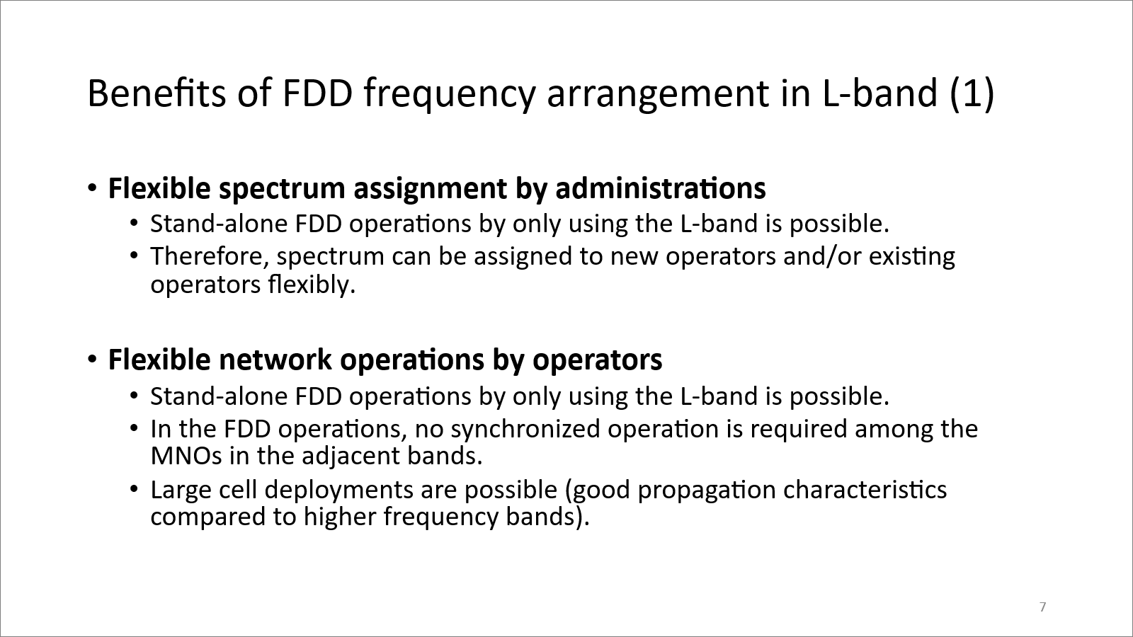

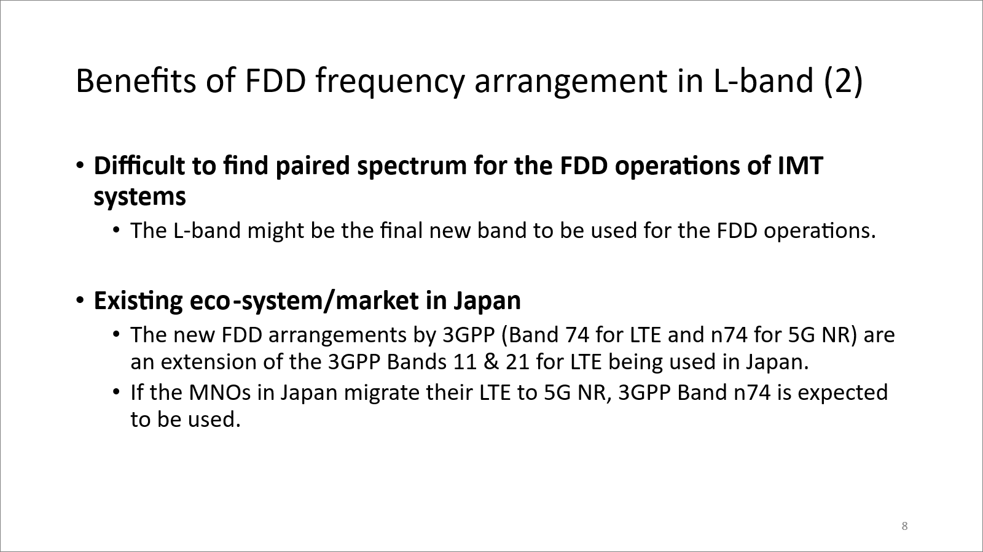

___________

“National Spectrum Positions: Spectrum from 1 400–1 500 MHz (January 2022)” https://gsacom.com/paper/1400mhz-1500mhz-january-2020-national-spectrum-positions/ “”
“ECC Decision (17)06: The harmonised use of the frequency bands 1 427-1 452 MHz and 1 492-1 518 MHz for Mobile/Fixed Communications Networks Supplemental Downlink (MFCN SDL)” https://docdb.cept.org/download/4f052b0b-2c6c/ECCDEC1706.pdf and “ECC Decision (13)03: The harmonised use of the frequency band 1452-1492 MHz for Mobile/Fixed Communications Networks Supplemental Downlink (MFCN SDL)” https://docdb.cept.org/download/1508
“ASMG PREPARATION FOR WRC-23” Document APG23-2/INF-25
GSA GAMBoD database https://gsacom.com/gambod-lte-5g-devices/

