

APT REPORT ON

MITIGATION MEASURES TO IMPROVE SHARING AND COMPATIBILITY BETWEEN 4G-LTE AND 5G-NR SYSTEMS AND OTHER SYSTEMS OPERATING IN PORTIONS OF 3300 – 4200 MHZ

Edition: April 2026

The 36th Meeting of APT Wireless Group
6 – 10 April 2026
Bandar Seri Begawan, Brunei Darussalam (Hybrid)

(Source: AWG-36/OUT-02)

No. APT/AWG/REP-112(Rev.1)

APT REPORT ON

MITIGATION MEASURES TO IMPROVE SHARING AND COMPATIBILITY BETWEEN 4G-LTE AND 5G-NR SYSTEMS AND OTHER SYSTEMS OPERATING IN PORTIONS OF 3300 – 4200 MHZ

Table of contents
1. Executive summary 3
2. Background 4
3. Scope 5
4. Vocabulary of Terms 5
5. References 5
6. Introduction 6
7. Compatibility and interference considerations between 4G-LTE/5G-NR and FSS earth stations in APT countries 6
8. Potential interference mitigation techniques to improve sharing and compatibility between 4G-LTE/5G-NR and FSS earth stations 9
9. Sharing and Compatibility Studies between 4G-LTE/5G-NR and FSS earth stations in some APT countries 13
10. Summary and Conclusions 23
Annex 1: FSS Deployment in the 3400 to 4200 MHz band 26
Annex 2: FSS Interference Criteria 26
Annex 3: A summary from the ITU-R of co-existence studies 26
Annex 4: Examples of actions taken by China to enable coexistence of IMT and C-Band FSS 27
Annex 5: Recent studies provided to APT between IMT around 3.5 GHz into FSS 30
Annex 6: Coexistence trial undertaken by Indonesia between IMT-2020 (5G-NR) and the Fixed Satellite Service (FSS) in the 3400 – 4200 MHz band 31
Annex 7: Study on co-existence between IMT-2020 and the Fixed Satellite Service in the 3400 – 4200 MHz band in Viet Nam 37
Annex 8: Examples of Fixed Satellite Service earth station RF band pass filter performance 43

Executive summary
This Report presents studies on the mitigation of interference to Fixed-Satellite Service (FSS) earth stations operating in the C-band, arising from the introduction of new terrestrial systems. It consolidates regional experience, technical evaluations, and regulatory practices to provide administrations and industry stakeholders with practical approaches to ensure the continued protection of satellite Earth stations.
Drawing on the guidance in Report ITU-R S.2546, the Report emphasizes:
- The importance of identifying and cataloguing FSS earth stations in national databases, preferably through a licensing / registration system coordinated by administrations, to ensure protection measures can be applied.
- Technical mitigation techniques, including the use of filters, guard bands, geographic separation, and site shielding to reduce interference risks.
- Administrative and regulatory actions, such as licensing frameworks, notification procedures, and coordination mechanisms between terrestrial and satellite operators.
- The need for collaborative planning among regulators, operators, and industry stakeholders to balance efficient spectrum use with the continued use of satellite Earth stations.
The Report concludes that a combination of technical and regulatory approaches is necessary to protect C-band FSS while enabling the deployment of terrestrial services. Clear visibility of existing FSS usage, achieved through systematic licensing / registration and database management, is essential to effective mitigation and long-term spectrum coexistence.

Background
This report investigates mitigation measures between services and systems operating in the same and adjacent bands within the 3300 – 4200 MHz frequency range. Different national administrations have allocated portions of this band for different services, this includes Fixed Satellite Services, Fixed Services, Radiolocation services and Mobile Services. This report focuses on to improving sharing and compatibility between 4G LTE/5G NR and Fixed Satellite Service Earth station receivers in the 3400 – 4200 MHz band.
Provisions of Article 5 of the ITU Radio Regulations relevant to the frequency range covered by this document are complex with differing primary and secondary regional allocations for MOBILE worldwide primary allocations to the FIXED SATELLITE service, augmented by multiple overlapping provisions contained in footnotes. In addition to the Table of Frequency Allocations the footnotes relevant to Region 3 are: 5.149 5.429 5.429E 5.429F, 5.432, 5.432B, 5.433, 5.282 5.432A, 5.433A, and 5.435.
IMT and FSS may meet at different parts of the range, 3.3 GHz, 3.4 GHz, 3.6 GHz, 3.7 GHz or 3.8 GHz, depending on regional and national identifications as well as national regulations. However, the nature of the sharing issue does not change if we consider only the boundary frequency in C band of two services. APT members should consider the studies of CEPT on sharing and compatibility between IMT and FSS which 3.8 GHz is the boundary point and apply to the cases of different boundary frequency.
The exact frequency bands used by 4G LTE/5G systems will vary between countries, depending on regional and national identifications as well as national regulations. However, the nature of the sharing issue and potential mitigation measures are not changed for different frequencies of the upper edge of the 4G LTE/5G band
A summary from a portion of the ITU-R of co-existence studies between IMT around 3.5 GHz into FSS and utilizing ITU-R recognized system parameters for IMT and FSS, are reproduced in Annex 3. Some of the studies indicate coexistence conditions such as separation distance between IMT and FSS operating in an adjacent band.
Examples of actions of some APT Members have taken to enable coexistence of IMT and C-Band FSS are provided in Annex 4.
Recent studies provided to APT between IMT around 3.5 GHz into FSS and utilizing ITU-R recognized system parameters for IMT and FSS can be found in Annex 5. These studies indicate coexistence conditions such as separation distance between IMT and FSS operating in an adjacent band. These studies also propose the use of additional receiver filtering to achieve practicable sharing via separation distance.
A field experiment to study the coexistence between IMT and FSS in the 3.5 GHz band has been conducted by an APT member. The results of the field experiment show that the adjacent band coexistence between 5G operated in the 3400-3600 MHz band and FSS operated in the 3700-4200 MHz band could be implemented using additional band pass filter which need to be installed at the receiving FSS earth stations terminal with specifications of larger than 60 dB suppression for the band below 3600 MHz. In addition, a 100 MHz guard band (i.e. 3600 – 3700 MHz between 5G and FSS is required for the adjacent band coexistence. The detail of the field experiment could be seen in Annex 6.
Some APT administrations are considering introducing IMT in the 3.5 GHz band. As has been demonstrated in the ITU-R studies, interference can also occur from IMT systems to FSS earth stations which receive in the adjacent frequency band to the IMT systems unless carefully managed.
The detailed descriptions on how to manage adjacent band interference issues from IMT to FSS are detailed in section 7 below. Report ITU-R S.2546 also provides detailed explanation on the different interference scenarios, the potential impact into FSS earth station receivers and presents mitigation techniques implementable on both the FSS and IMT side to facilitate coexistence between the two services.

Scope
There is potential interference between those systems, both co-frequency band and adjacent band interferences. This document covers the co-frequency sharing issues between IMT and FSS and the adjacent band coexistence interference analysis between the IMT systems and C-Band Downlink FSS systems.

Vocabulary of Terms

FSS Fixed Satellite Services
IMT International Mobile Telecommunications
IM Intermodulation
LOS Line-of-Sight
OOBE Out of band emissions

References
- APT/AWG/REP-37(Rev.1)Edition: March 2014 “The current usage and future plan of the band 3400 – 3600 MHz”, as provided in the responses to the Questionnaire at the 13th APT Wireless Group Meeting, are contained in the Attachment to APT Report on Frequency Usage of The Band 3400-3600 MHz.
- APT/AWG/REP-15(Rev.7) "Information of Mobile Operator's Frequencies, Technologies and License Durations in Asia Pacific Countries"
- APT/AWG/REP-83 “Survey the usage and the usage and future plan of the band 3300-3400 MHz in the Asia Pacific region”
- Report ITU-R S.2368 “Sharing studies between International Mobile Telecommunication-Advanced systems and geostationary satellite networks in the fixed-satellite service in the 3 400-4 200 MHz and 4 500-4 800 MHz frequency bands in the WRC study cycle leading to WRC-15”.
- Report ITU-R S.2546 “Mitigation measures between FSS and IMT in the frequency band 3 400-3 600 MHz”

Introduction
Administrations have options in what applications and systems they choose to authorise within the 3300 - 4200 MHz band. The spectrum usage varies among APT administrations and the most likely use cases include:
- Allocating or could be allocation spectrum in portions of the 3300 - 4200 MHz band to be used for 4G-LTE/5G NR as indicated in Table 1 below.
- Radiolocation Services (e.g. Radar) in the 3100 – 3400 MHz band.
- Fixed links within the 3400 - 4200 MHz band or portions thereof.
- Fixed Satellite Service Earth station receive licenses (Downlink) within the 3400 – 4200 MHz band (or portions thereof). Depending on the administration these could be on the following basis:
  - Specific licenses per locations on a case by case basis .
  - Television receive-only (TVRO) authorizations in some countries.
There is potential coexistence interference between those systems, both intra-band and inter-band interferences. This paper covers the inter-band coexistence interference analysis between the 4G-LTE/5G NR and C-Band Fixed Satellite Service Earth stations (Downlink) systems.
Table 1: 4G-LTE / 5G-NR Spectrum Allocations in APT region around 3.5 GHz Band
Country/Region | Spectrum Range
Australia | 3.4 to 4.0 GHz
China | 3.3 to 3.6 GHz
Hong Kong SAR, China | 3.4 to 3.6 GHz
India | 3.4 to 3.67 GHz
Japan | 3.4 to 4.1 GHz
Korea (Republic of) | 3.4 to 3.7 GHz
New Zealand | 3.3 – 3.8 GHz
Thailand | 3.3 - 3.7 GHz
Vietnam | 3.6 – 3.980 GHz

In addition to IMT systems, the spectrum utilization within the 3.5 GHz band includes the Radiolocation Service (i.e., 3100 – 3400 MHz) and C-Band Downlink FSS Systems (i.e. 3400 – 4200 MHz). The spectrum usage varies among APT Members.
APT/AWG-REP-15 (Rev.10), and SATRC SAPVIII-REP-05 provides more information on the current status of IMT assignments and future planning for IMT in the 3300 – 4200 MHz range for Asia Pacific countries.

Compatibility and interference considerations between 4G-LTE/5G-NR and FSS earth stations in APT countries

7.1 Co-frequency compatibility and interference considerations
In the frequency band around 3.5GHz, in addition to IMT systems, the spectrum utilization within the 3.5 GHz band includes the Radiolocation Service (i.e. 3100 – 3400 MHz) and C-Band Downlink FSS Systems (i.e. 3400 – 4200 MHz). The spectrum usage varies among APT Members and example spectrum utilization plans are shown in Figure 2 below:
Figure 1: Example 1-Spectrum Utilization Plans for the 3.1 – 4.2 GHz range

Figure 2: Example 2- Spectrum Utilization Plans for the 3.1 – 4.2 GHz range
Existing ITU-R studies related to co-frequency sharing between FSS earth stations and IMT systems have been carried out in the prior to WRC-15. The study results are contained in Report ITU-R S.2368; “Sharing studies between International Mobile Telecommunication-Advanced systems and geostationary satellite networks in the fixed-satellite service in the 3 400-4 200 MHz and 4 500-4 800 MHz frequency bands in the WRC study cycle leading to WRC-15”. This Report gives examples of the separation distances required between IMT base stations and FSS earth stations. Separation distances are at least 10s of km and typically exceed 100km. The Report concludes that the sharing between IMT-Advanced and FSS is feasible only when FSS earth stations are at known, specific locations, and deployment of IMT-Advanced is limited to the areas outside of the minimum required separation distances for each azimuth to protect these specific FSS earth stations.
FSS and IMT systems co-frequency sharing in the same geographical area is difficult.

With regard to interference from FSS to 4G-LTE/5G-NR, RR No. 5.432A and RR No. 5.433A applies which stations of the mobile service in the frequency band 3400 – 3500 MHz and in the frequency band 3500 – 3600 MHz shall not claim more protection from space stations than that provided in the Table 21-4 of the Radio Regulations.
Some APT administrations have established exclusion or coordination areas around earth stations. Where an exclusion area is established, IMT base stations may not be located inside the defined area. Where a coordination area is established, IMT stations may be located inside the defined area subject to a detailed interference assessment. For this case in particular, some of the interference mitigation measures identified in this report could be applied to help reduce the level of received interference and to allow IMT stations inside a coordination area to be authorized.

7.2 Adjacent frequency compatibility and interference considerations

Spectrum from 3400 to 4200 MHz (C-band) parts thereof is used for TV receive-only (TVRO) application in the fixed satellite service (FSS). Some APT administrations have decided to assign or have a plan to assign 4G LTE/5G-NR in spectrum adjacent in part of this band which leads to a need to consider possible interference from IMT stations to FSS earth stations in the adjacent band.

Adjacent frequency interference from 4G-LTE/5G-NR to FSS C-Band Earth station receivers needs to be considered.

Some resulting adjacent band interference considerations are below:

- C-band filter on low noise block down converters (LNB) of FSS receivers (including TVROs) may not have enough rejection to cater for 4G-LTE/5G-NR IMT systems in the adjacent band as these filters were designed and/or manufactured at a time before the existence of the 4G-LTE/5G-NR IMT systems
- It is likely that the low cost LNB used in FSS receivers (particularly TVRO receivers) would get overloaded by the IMT systems emissions, even though the IMT systems operate according to international standards, due to same reason as indicated above
Results of a study done by ANATEL, Brazil, on the coexistence of LTE-A systems in Band 42 with FSS C-band earth station receivers (Downlink) are given below:
- With no C-band filter in TVRO systems, coexistence is only possible in the urban small cells case or for some configurations of urban/suburban macro cells
- With adequate C-band filter, coexistence is possible in every scenario
- Some guard band (gap) between the beginning of FSS frequency band and the end of LTE-A frequency band might help in getting cost effective C-band filers in TVRO systems

FSS earth stations are very sensitive to interference from 4G-LTE/5G-NR systems. While the separation distances related to adjacent band compatibility issues are significantly smaller than those for co-frequency operations, it may not be feasible to ensure physical separation, in particular if FSS earth stations are deployed in large numbers or without the knowledge of their locations. Hence, careful consideration should be given to adjacent band compatibility issues, where interference to satellite receive earth stations could happen in the following ways:
- LNA/LNB overdrive from the wanted 4G-LTE/5G-NR emission in the adjacent band:
- High power 4G-LTE/5G-NR emissions saturate the LNA/LNB of the FSS earth station, even if the 4G-LTE/5G-NR signal is adjacent to the satellite signal;
- LNA/LNB non-linearity behaviour when operate point close to P-1dB, such as NF deterioration, increased harmonics level, Phase distortion and intermodulation (IM)
- Out-of-band-emissions (“OOBE”) of the 4G-LTE/5G-NR signal could cause in-band interference to FSS receivers.
- LNA/LNB Intermodulation (IM):

LNA/LNB intermodulation could be explained as follows:
- A non-linear device, such as an amplifier, can self-generate intermodulation products and there are input levels that would cause the LNA/LNB to exhibit non-linear behavior

Improving the filter receiver characteristics of FSS earth stations will effectively reduce the impact from high power IMT-advanced signals that caused LNB overdrive and this is one of the interrelated mitigation techniques that altogether contribute to an acceptable interfering level at the input of the LNB. To further mitigate the possibility of interference between IMT and services operating in the adjacent band, a number of mitigation techniques are available that take advantage of additional system characteristics or local features such as. guard band, exclusion zone, coordination zone, block-edge mask, antenna tilt, lower antenna height, antenna location, optimization of antenna directivity loss, sector disabling, antenna dynamic null steering, transmit power control, forward error-correction and interleaving, and improved filter characteristics. The interference mechanisms, combined with the characteristics of the sharing scenario (e.g. relative antenna alignment between the interfering and interfered-with systems, propagation scenario and characteristics of the terrain, protection criteria, among others) contribute to the definition of the minimum separation distance required to guarantee coexistence of the services in bands adjacent to each other.The criteria for FSS interference taken from Recommendations ITU-R S.1432 and SF.1006 are presented in Annex 2 and a summary of numerous ITU-R studies on sharing between IMT systems and geostationary satellite networks with various characteristics which have been carried out are attached in Annex 3.

Potential interference mitigation techniques to improve sharing and compatibility between 4G-LTE/5G-NR and FSS earth stations

Some FSS earth stations operate with a frequency response in the 3400-4200 MHz band and may be at known specific locations or be within large areas ubiquitous manner. For administrations that only allow the former mitigations may be straight forward. For administrations that allow the latter mitigations may be more complex and on a larger scale.

With the introduction of 4G LTE/5G-NR in this band, these high powered 4G LTE/5G-NR wanted emissions could drive the FSS LNA/LNB out of its intended operating point, causing non-linearities, intermodulation and overload. The 4G LTE/5G-NR systems signal power at the input of an FSS earth station LNB can easily saturate the LNB and interferer with the satellite signal. One solution to mitigate the 4G LTE/5G-NR systems interference is to insert a RF waveguide filter between the feedhorn of the antenna and the input of the LNB. This will reduce to a great extent the 5G signal in the adjacent band from saturating the LNB.

Narrowing the frequency response of FSS earth stations could be an effective mitigation technique for those earth stations that do not need to receive the same frequencies used by IMT systems, to lower the magnitude of the interfering IMT signal received. This can be achieved in two ways:
- Adding a filtering function before the LNB.
- Adding a filtering function inside the LNB.
FSS users may choose from the 2 ways mentioned above according to the receiver characteristics requirements. (In China, the LNA/LNB should work in its dynamic range when the input power in 3300-3600MHz is -20dBm. Adding filter before the LNB is easy to meet this requirement. In Indonesia, based on field experiment, Band Pass Filter with minimum rejection filter of 60 dB below 3.6 GHz is installed before LNB to protect FSS operating in 3700 – 4200 MHz band, the detail described in Annex 6.)
- In scenarios with strong interference, both ways may be applied concurrently.
- Considering the margin of FSS link budgets will be reduced by these mitigation techniques, sensitive FSS links may require replacement of the FSS earth stations antenna with a larger diameter reflector.
As filter requirements are derived on parameters which are related to the characteristics of sharing scenario (e.g. magnitude and width of the sections in IMT emission profile, protection criteria and FSS service requirements among others), it is necessary to ensure that the I/N protection criteria is met. It may be necessary to simultaneously implement this mitigation technique with other mitigation techniques mentioned in Table 2 to protect FSS earth stations.

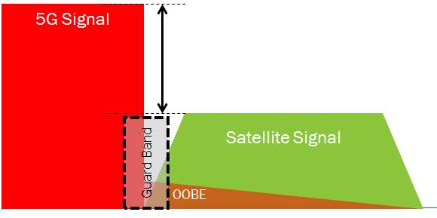
Figure 1: Representation of Adjacent Band Interference from IMT to FSS

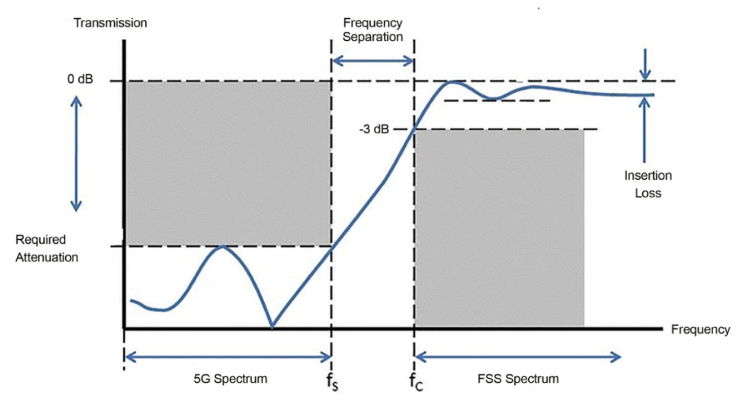

Figure 2. Filter and frequency separation

As shown in Figure 2 above, the filter could be operated properly if there is frequency separation between the edge of the IMT/5G transmission and the FSS transmission to provide the waveguide filter the necessary bandwidth to reject the 5G interference at the earth station.
Table 2 shown below summarises the potential interference mitigation techniques which may be applied to the interference issues. Some of the mitigation techniques applied to mobile systems are implemented in order to reduce the self interference in their own mobile network, which will contribute to reduce the inter band interference to radars systems/FSS. Some of these techniques are applicable only when the location of victim system (Radiolocation services/FSS) is known.
When implementing these mitigation techniques, the main objective would be to meet the I/N protection criteria which indicates coexistence between systems is possible and it may be necessary to simultaneously implement the appropriate mitigation techniques to achieve this.
Table 2: Potential Interference Mitigation Techniques
Mitigation techniques | Comments | Implementable by FSS or IMT
Improving FSS earth station receiver performance | - FSS earth station receiver performance can be improved with appropriate filtering, see Annex 8 for appropriate filters.  - Insertion of filters before or within the LNB reduces adjacent-band IMT emissions. Trade-offs include insertion loss, noise temperature increase, and group delay distortions. Different filter classes (Butterworth, Chebyshev, etc.) balance passband flatness vs. transition sharpness.  - FSS earth stations receiver performance can be improved with more robust design (e.g. particularly of the LNA / LNB) | FSS
Adaptive Signal Processing / Interference Cancellation | - Digital algorithms use secondary antennas to capture interfering signals and cancel them from the main received signal. Effective in some scenarios, but limited if interference arrives from the main beam direction or at low elevation angles. | FSS
Frequency separation | - Band in which is not used by FSS or 4G LTE/5G-NR to minimise interference to FSS earth stations in the adjacent band  - The frequency separation will alleviate the requirement on the transition region of the receiving FSS earth station filter. | FSS&IMT
Exclusion zone | - Radial separation distance from location of FSS earth station within which no IMT station shall be allowed in order to adequately protect FSS earth stations, particularly TT&C stations | FSS&IMT
Restriction zones | - Unlike exclusion zones, IMT operation is permitted but under stricter technical limits (e.g. reduced e.i.r.p., antenna downtilt, additional filtering). Provides flexibility while still protecting sensitive FSS stations. | FSS&IMT
Coordination zone | - Area within which coordination between FSS earth station, including TT&C stations, and 4G LTE/5G-NR is necessary to ensure co-existence.  - The perimeter of the coordination zone is outside the exclusion zone, but coordination zone does not include the exclusion zone. | FSS&IMT
Block-edge mask | - Compliance with emission limits will ensure protection of FSS earth stations in the adjacent band
Antenna tilt | - Vertical down tilting of base station antenna reduces interference to radar systems and FSS  - Interference reduction may be as high as 10 to 15 dB depending on the vertical antenna pattern
Lower antenna height | - Lower antenna heights at the base stations improve sharing, especially when surrounded by obstacles such as tall buildings  - It may not be possible to lower the macro cell below a certain height, otherwise cell coverage maybe degraded
Antenna location, shielding, optimization of antenna directivity loss | - Considering the geographic conditions, IMT-Advanced base station antennas may be located in areas where natural or man made shielding minimizes interference from/to the radar and FSS antennas  - In some cases, the building/terrain attenuation can be expected to be between 0 and 20 dB in the band, and required separation distance between IMT-Advanced and radar and FSS systems may be reduced  - This method is not effective if line of sight condition is configured between IMT-Advanced system and operating position of mobile radars or FSS, and if radar and FSS antenna directivity loss is insufficient. Therefore, this method should be applied together with other mitigation methods
Sector Disabling | - The aim of this technique is to reduce, in the direction of the victim system, the transmitting output power of base stations that are located at a distance smaller than the separation distance, noting that such an area would be covered through the use of other frequency bands by IMT-Advanced systems
Antenna dynamic null steering | - A null is steered toward the radar and FSS antenna direction to reduce the interference by adopting dynamic beam forming antenna such as dynamic adaptive array antenna  - The level of interference mitigation is a function of the number of antenna elements and the propagation effects
Transmit power control | - Interference to radars and FSS could be reduced by setting the transmission power of IMT-Advanced stations to the minimum required level especially when radar signal is detected
Forward error-correction and interleaving | - Forward error correction coding and bit interleaving is effective in reducing the susceptibility of the IMT-Advanced receiver to interference from the radar
Improved Filter Characteristics | - The out-of-band (OOB) and spurious emission characteristics of IMT base-station transmitters are based on the most stringent mask specified in the 3GPP technical specification series 36 (TS 36). Moreover, it is expected that commercial IMT products shall typically offer significantly better performance than 3GPP requirements  - Additional transmitter filtering on IMT base stations can limit leakage into FSS bands. | IMT

Similar mitigation techniques are presented in Report ITU-R S.2546 that are applicable to the FSS earth stations (section 5), the IMT network (section 6) or to both IMT and FSS (section 7).

Technical Conditions suitable for IMT in the frequency band 3 300-3 400 MHz

The technical condition in this portion is the form of a Block-Edge-Mask (BEM) applicable to IMT base stations with different power levels for protection of FSS in adjacent band 3 400 -3 700 MHz: Power limit may need to be implemented for outdoor deployment. For indoor deployment, this power limit can be relaxed on a case-by-case basis.

For situation where IMT and FSS earth stations that co-exist in a band or in adjacent band, are within territories of different administrations, cross-border coordination should be carried out on a case-by-case basis. Since the frequency band 3 400-3 700 MHz was allocated to the FSS (space-to-Earth) on a primary basis as in the Radio Regulations, FSS shall be protected from IMT interference, achieving by guard band or applying BEM.

Sharing and Compatibility Studies between 4G-LTE/5G-NR and FSS earth stations in some APT countries

Actions that China and Hong Kong have taken to enable coexistence of IMT and C-Band FSS

These are some practical actions taken by China and Hong Kong to mitigate the coexistence problem between IMT and FSS in C-Band.

In order to promote the coordination between IMT and FSS, China issued the Interference Coordination Guide between 5G stations and FSS earth station in the 3.0-5.0 GHz. Several potential interference mitigation techniques were also listed:

- Change co-channel FSS receive frequency to other frequency bands;
- Improve the receive technique characteristics of LNA/LNB, such as adding additional filter;
- Installing shielding net around the earth station;
- Avoid setting up 5G base stations in the main lobe of earth station antenna;
- Adjust the maximum radiation direction;
- Reduce the 5G maximum output power;
- Building separation.
It meets an agreement between MNOs and FSS earth station users to add an additional filter between the LNA/LNB and feed to protect the adjacent channel FSS earth station from harmful interference.

Annex 4 details the actions taken by these administrations.

Study A - Adjacent band compatibility at the 3400 MHz boundary (5G NR operating in 3300 – 3400 MHz)
These are case studies for the specific case of one satellite and assumptions were made on FSS characteristics based on that one satellite such as the earth elevation angle of 48 degrees. Other earth stations operate at lower elevation angles than this. Further, the studies only considered long term protection criteria. Short-term protection has yet to be studied.
This study focused on potential interference from:
- Unwanted emissions generated by 5G NR operating in 3300-3400 MHz to the leftmost FSS transponders operating in adjacent frequency (3400-3436 MHz)
- Unwanted emissions generated by 5G NR operating in 3300-3390 MHz to the leftmost FSS transponders operating in adjacent frequency (3400-3436 MHz)
- Unwanted emissions generated by 5G NR operating in 3300-3390 MHz to the leftmost FSS transponders operating in adjacent frequency (3406-3442 MHz)
With the following assumptions:
- The possibility of the UE interfering with FSS may be safely disregarded as the EIRP UE is much lower than BS EIRP and located at low height from the ground
  - The separation distance required to protect FSS from NR BS will be much larger than the protection distance from NR UE
- In-band blocking to LNB/LNA of FSS earth station can be safely disregarded as the FSS LNB reception is limited within the 3400-4200 MHz range
And the following guard band scenarios:
A:
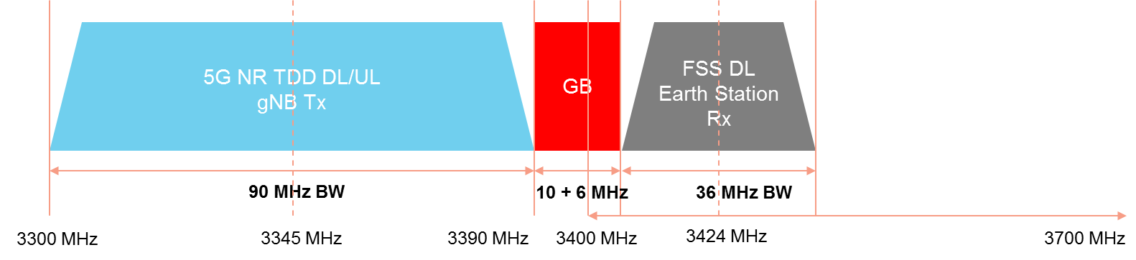
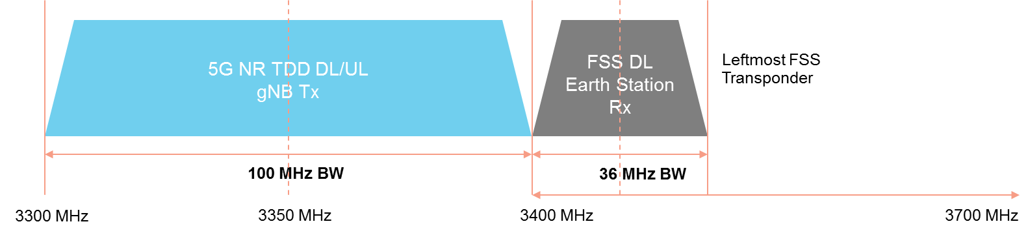
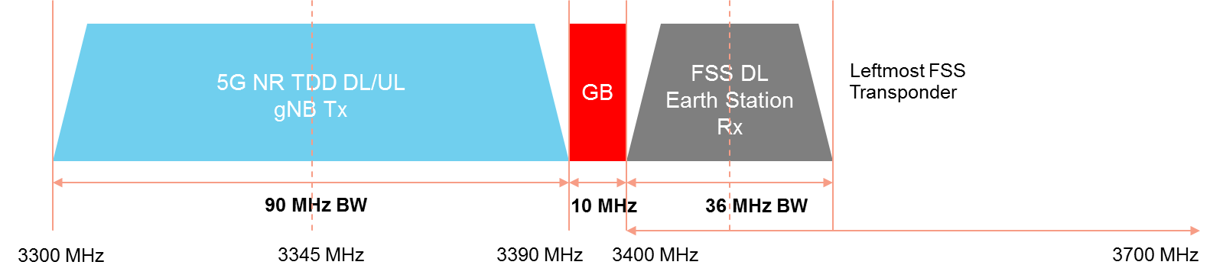
B:
C:

Studies were undertaken relative to 5G NR macro cells, micro cell and indoor/pico cells and FSS receivers, the results of the studies were:
For Macro cells:
- Additional Tx filter is required to suppress OOBE emission of NR macro cell in order to co-exist with FSS
- With FSS error protection criteria of 6% degradation (-12.2 dB I/N):
  - the protection distance is at least 8.34 km with 16 MHz GB (3390MHz – 3406MHz)
  - to achieve < 1km protection distance with 16 MHz GB, at least 19 dB isolation is needed from the Tx filter to suppress the out-of-band emission from NR Macro Base Station Transmitter
  - to achieve < 1km protection distance with 10 MHz GB, at least 28 dB isolation is needed from the Tx filter to suppress the out-of-band emission from NR Macro Base Station Transmitter
- With FSS error protection criteria of 1% degradation (-20 dB I/N):
  - the protection distance is at least 20.5 km with 16 MHz GB (3390MHz – 3406MHz)
  - to achieve < 1km protection distance with 16 MHz GB, at least 28 dB isolation is needed from the Tx filter to suppress the out-of-band emission from NR Base Station Transmitter
  - to achieve < 1km protection distance with 10 MHz GB, at least 35 dB isolation is needed from the Tx filter to suppress the out-of-band emission from NR Base Station Transmitter
- Site shielding around FSS earth station can reduce the filter requirement for NR macro Base Station transmitter
  - Recommendation ITU-R SF.1486 document illustrated up to 33 dB isolation may be obtained by providing physical or natural shielding at the VSAT stations. However, such implementation could be challenging and this may not be achievable at all earth station sites.
For Micro cells (Output Power < 31 dBm, EIRP < 43 dBm):
- With 10 MHz GB, NR micro cell is able co-exist with FSS with protection distance < 1 km
- With FSS error protection criteria of 6% degradation (-12.2 dB I/N):
  - the protection distance is at least 0.6 km with 10 MHz GB between NR and FSS
  - to co-exist with 0 MHz GB and < 1km protection criteria, at least 3 dB isolation is needed from the Tx filter to suppress the out-of-band emission from NR Micro Base Station Transmitter
- With FSS error protection criteria of 1% degradation:
  - the protection distance is at least 1.45 km with 10 MHz GB between NR and FSS
  - to achieve < 1km protection distance with 10 MHz GB, at least 4 dB isolation is needed from the Tx filter at is required to suppress the out-of-band emission from NR Micro Base Station Transmitter
For indoor/pico cells:
- NR indoor / Pico cell is able to co-exist with FSS with protection distance as low as 0.1 km with 10 MHz GB
- Coexistence with 0 MHz GB between NR indoor cell and FSS is also possible with 0.13 km protection distance (with 6% criteria) or 0.3 km (with 1% criteria)
  - This allows the allocation of the full 100MHz (3300-3400MHz) for 5G
Interference Mitigation:
The study shows the following interference mitigation measures are required to ensure co-existence of IMT (5G) and FSS on either side of the 3400 MHz boundary:
Additional Isolation from IMT Transmitter Filter:
- In order for NR macro cell to co-exist with FSS, additional filter at TX is required to suppress OOBE emission
- Lower power transmission at edge-PRB of NR is also possible to reduce filter requirement
- Following is the sensitivity analysis to see how the protection distance reduced with additional Tx filter at NR macro cell
*6% degradation of FSS protection criteria

FSS Site Shielding
- Site shielding around FSS earth station can reduce the filter requirement for NR macro Base Station transmitter
- Recommendation ITU-R SF.1486 document illustrated up to 33 dB isolation may be obtained by providing physical or natural shielding at the VSAT stations
- However, there would be a cost for implementation and this may not be achievable at all earth station sites.

Study B - Adjacent band sharing and compatibility at the 3600 MHz boundary (FSS operating in 3 400 – 3 600 MHz)
These are case studies for the specific case of one satellite and assumptions were made on FSS characteristics based on that one satellite such as the earth elevation angle of 48 degrees. Other earth stations operate at lower elevation angles than this. Further, the studies only considered long term protection criteria. Short-term protection has yet to be studied.
Studies were undertaken relative to 5G NR macro cells, micro cell and indoor/pico cells and FSS receivers. The 5G NR operating bandwidth is assumed to be 100 MHz, and defined Guard Bands (GB) of:
- 100 MHz GB: FSS operating at 3400 to 3600 MHz and NR operating at 3700 to 3800 MHz
- 41 MHz GB: FSS operating at 3400 to 3600 MHz and NR operating at 3641 to 3741 MHz (Note: 41 MHz GB scenario is developed as 40 MHz offset from frequency edge is still considered as out of band emission domain, not spurious emission)
- 20 MHz GB: FSS operating at 3400 to 3600 MHz and NR operating at 3620 to 3720 MHz
The potential interference scenarios studied were:
- Unwanted emissions generated by 5G NR described in 3 different guard-band scenarios the FSS transponders operating in adjacent frequency (3400 to 3600 MHz)
- Incoming BS NR signals at much higher power levels can severely affect the operating point of the FSS LNA/LNB operating at 3400 to 4200 MHz causing a non-linear behavior and saturation
The possibility of the UE interfering with FSS may be safely disregarded as the EIRP UE is much lower than BS EIRP and located at low height from the ground. The separation distance required to protect FSS from NR BS will be much larger than the protection distance from NR UE
The analytical model is used in this study to calculate the minimum pathloss between an NR BS and FSS earth station based on FSS protection criteria specified in Recommendation ITU-R S.1432 and Report ITU-R M.2109 and 3GPP NR BS Out of Band Emission (OOBE) and spurious emission mask specified in 3GPP TS 38.104
The minimum protection distance is calculated based on free space pathloss model of Recommendation ITU-R P.452-16, radio horizon propagation limit, and few assumptions such as on FSS earth station elevation angle and NR BS antenna isolation
The results of the studies showed:
For Macro Cell (EIRP = 74 dBm):
The minimum protection distance for Macro BS to avoid FSS LNB saturation is 1.02 to 3.21 km for LNA gain of 50 to 60 dB, regardless the guard-band size since the typical FSS LNA is operating at whole 3400-4200 MHz frequency range.
An additional front-end Rx filter at FSS is required to reduce the received signal in-band power from NR BS.
5 to 15 dB additional front-end RF filter (for LNA gain 50 to 60 dB) can reduce the minimum protection distance between Macro NR BS and FSS to 600m.
With Guard band > 40 MHz, unwanted emission of Macro NR BS is able to conform with FSS error protection criteria with 100 m protection distance.
If lower guard band (20 MHz) is allocated, higher protection distance between FSS and NR macro BS is required ~7.89 km.
To achieve < 1km protection distance with 20 MHz GB, at least 18 dB isolation is needed from the Tx filter to suppress the out-of-band emission from NR Macro Base Station Transmitter.
Site shielding around FSS earth station can reduce the filter requirement for NR macro Base Station transmitter.
For Micro Cell (EIRP = 43 dBm)
With Guard Band > 41 MHz scenario, NR BS micro cell is able to co-exist with FSS with protection distance < 100 meter without additional Tx Filter at NR BS and without additional front-end RF filter required at Rx earth station
With 20 MHz GB, the protection distance for NR micro cell is 600 m without additional Tx filter and without additional front-end RF filter at Rx LNA earth station
For Indoor / Pico Cell (EIRP = 29 dBm)
With Guard Band > 41 MHz scenario, NR BS indoor cell is able to co-exist with FSS with protection distance < 100 meter without additional Tx Filter at NR BS and without additional front-end RF filter required at Rx earth station
For 20 MHz Guard Band scenario, the protection distance for indoor cell is 60 m without additional Tx filter and without additional front-end RF filter at Rx LNA earth station
Interference Mitigation
Interference from the 5G NR cell into FSS receivers may be achieved with additional Front-End Rx Filter Isolation
- In order for NR macro cell to co-exist with FSS, 1.02 to 3.21 km protection distance for LNA gain 50 to 60 dB is required regardless of the Guard Band size, as FSS is operating at 3400 to 4200 MHz frequency range
- Additional 5 to 15 dB front-end RF filter is required, depending on the LNA gain, to lower the protection distance to 600 meter at FSS earth station Rx (LNA) for single carrier 100 MHz scenario
- Lower power transmission at edge-PRB of NR is also possible to reduce filter requirement
- Following is the sensitivity analysis to see how the protection distance reduced with additional front-end filter at FSS for 50 to 60 dB LNA gain and single / multi carrier NR scenario

Study C - Adjacent band sharing and compatibility at the 3600 MHz boundary (5G NR operating in 3400 – 3600 MHz)
These are case studies for the specific case of one satellite and assumptions were made on FSS characteristics based on that one satellite such as the earth elevation angle of 48 degrees. Other earth stations operate at lower elevation angles than this. Further, the studies only considered long term protection criteria. Short-term protection has yet to be studied.

The study focused on the co-existence and interference analysis in the 3600 -3700 MHz boundary between the 5G NR which operated on 3400 –3600 MHz and FSS DL at 3700 –4200 MHz (each transponder operates with 36 MHz bandwidth).

The exact spectrum arrangements in a country may deviate slightly from the arrangements used in the study, however such slight deviations would not have a material impact on the results of the study e.g. guard band requirements.

Possible interference caused by 5G-NR that affects FSS DL earth station are:
- Unwanted emissions (OOBE and spurious emission) generated by NR operating in an adjacent frequency band may create interference to FSS
- Incoming BS NR signals at much higher power levels can severely affect the operating point of the LNA/LNB and drive it out of its dynamic range to where it exhibits a non-linear behavior

Few scenarios developed for different NR Base Station classes: Wide Area (Macro Cell), Mid Range (Micro Cell), and Pico (Indoor Cell), where the NR operating bandwidth is assumed to be 100 MHz, with 41 –100 MHz guard band (same result for both guard band as the it is greater than 40 MHz which is the frequency offset limit for unwanted emission as stated on 3GPP TS 38.104):
- Scenario with the maximum allowable interference on the FSS follow the ITU criteria (-12 dB), which is -115.24 dBm
- Scenario with the maximum allowable interference on the FSS follow the specific Country X criteria (-6 dB), which is -109.04 dBm
- Scenario with the FSS DL LNA input threshold follow Country X criteria, which is -59 dBm

Unwanted emissions generated by 5G NR described in 2 different maximum allowable interference scenarios on the FSS transponders operating in adjacent frequency (3700-4200 MHz).

Incoming BS NR signals at much higher power levels can severely affect the operating point of the FSS LNA/LNB operating at 3400-4200 MHz causing a non-linear behavior and saturation

The possibility of the UE interfering with FSS may be safely disregarded as the EIRP UE is much lower than BS EIRP and located at low height from the ground

The separation distance required to protect FSS from NR BS will be much larger than the protection distance from NR UE

The analytical model is used in this study to calculate the minimum pathloss between and NR BS and FSS earth station based onFSS protection criteria specified in Recommendation ITU-R S.1432 & Report ITU-R M.2109 and 3GPP NR BS Out of Band Emission (OOBE) and spurious emission mask specified in 3GPP TS 38.104.

The minimum protection distance is calculated based on free space pathloss model of Recommendation ITU-R P 452-16, radio horizon propagation limit, and few assumptions such as on FSS earth station elevation angle and NR BS antenna isolation

The results of the studies show:

Macro Cell (EIRP = 74 dBm)

Minimum protection distance for Macro BS to avoid FSS LNB saturation is 2.86 km for LNA input is -59 dB, regardless the guard-band size since the typical FSS LNA is operating at whole 3400-4200 MHz frequency range.

Additional front-end Rx filter at FSS is required to reduce the received signal in-band power from NR BS.

12 dB additional front-end RF filter (for LNA input is -59 dB) can reduce the minimum protection distance between Macro NR BS and FSS to 720 m.

With Guard band 41 -100 MHz, unwanted emission of Macro NR BS is able to conform with FSS error protection criteria with 100 m protection distance.

Site shielding around FSS earth station can reduce the filter requirement for NR macro Base Station transmitter.

Micro Cell (EIRP = 43 dBm)

With Guard Band 41 –100 MHz MHz scenario, NR BS micro cell is able co-exist with FSS with protection distance < 100 meter without additional Tx Filter at NR BS and without additional front-end RF filter required at Rx earth station.

Indoor / Pico Cell (EIRP = 29 dBm)

With Guard Band 41 –100 MHz scenario, NR BS indoor cell is able to coexist with FSS with protection distance < 100 meter without additional Tx Filter at NR BS and without additional front-end RF filter required at Rx earth station.

Interference Mitigation:

In order for 1 Carrier NR macro cell to co-exist with FSS with -59 dB LNA input limit, 2.86 kmprotection distance is needed regardless the Guard Band size, as FSS is operating at 3400-4200 MHz frequency range.

Additional 12 dB front-end RF filteris required to lower the protection distance to 720 meter at FSS earth station Rx (LNA) for single carrier 100 MHz scenario.

Lower power transmission at edge-PRB of NR is also possible to reduce filter requirement.

Additional 5G NR carrier will increase the additional filter needed at FSS earth station Rx (100 MHz Bandwidth per Carrier).

Following is the sensitivity analysis to see how the protection distance reduced with additional front-end filter at FSS for single / multi carrier NR scenario.

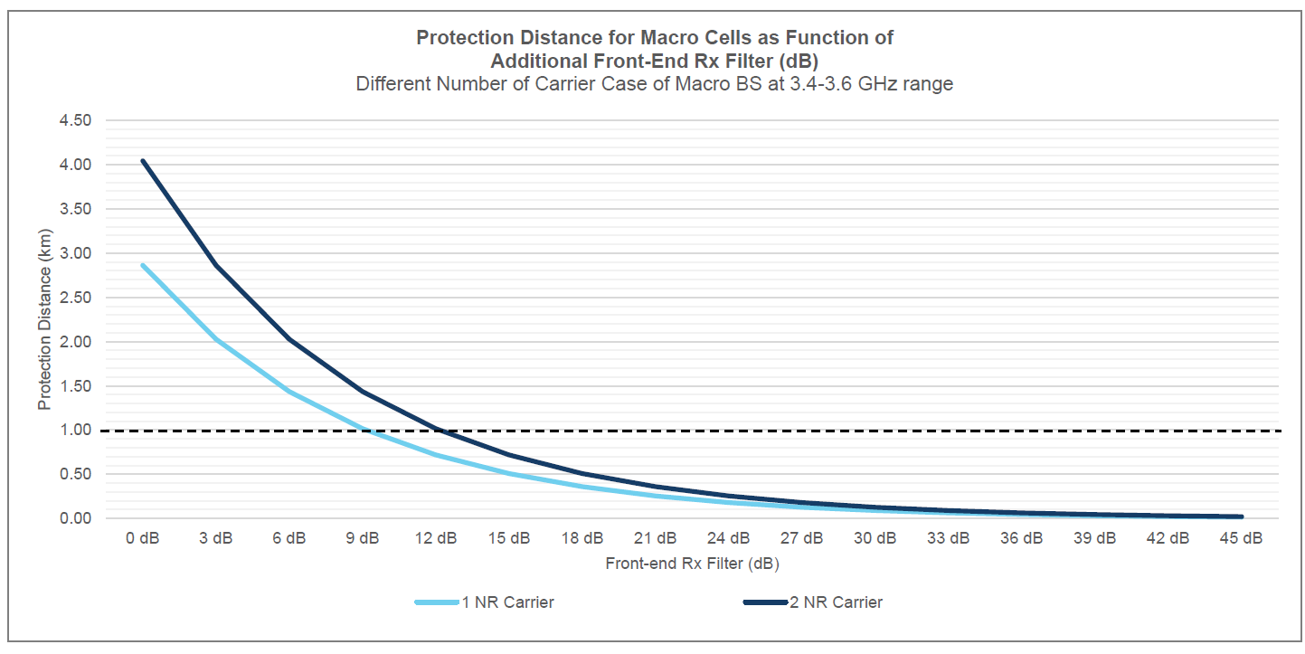

Study D - Adjacent band sharing and compatibility between 5G NR base stations and FSS TT&C

These are case studies for the specific case of one satellite and assumptions were made on FSS characteristics based on that one satellite such as the earth elevation angle of 48 degrees. Other earth stations operate at lower elevation angles than this. Further, the studies only considered long term protection criteria. Short-term protection has yet to be studied.

Use of 350 kHz by TTC (satellite controlling) e.g. at 3694.5 MHz and 3695.5 MHz, may create co-channel interference with NR system operating in the band 3600-4200 MHz.

This study focuses on the co-existence and co-channel interference analysis of NR BS to FFS TTC.

Due to the very low power level of the incoming FSS signals, in-band signal generated by NR operating in co-channel frequency band will create interference to FSS.

Three scenarios were studied for different NR Base Station classes: Macro Cell, Micro Cell), and Pico cell.
The analytical model is used in this study to calculate the minimum pathloss between and NR BS and FSS earth station based on FSS protection criteria specified in Recommendation ITU-R S.1432 and 3GPP NR BS specified in 3GPP TS 38.104.

The minimum protection distance is calculated based on free space pathloss model of Recommendation ITU-R P.452-16, radio horizon propagation limit, and few assumptions such as on FSS earth station elevation angle and NR BS antenna isolation

The results of the studies show:
3600 MHz
4200 MHz
IMT (NR)
FSS TTC (350 kHz)
at 3694.5 and 3695.5 MHz

The minimum isolation between macro NR and FSS TTC for co-channel scenario is 145 dB, which required more than 20 km isolation distance, or 23 km assuming 30m NR antenna height.

The isolation distance of micro cell and pico-cell is significantly lower (1.73 km to 0.19 km)

Interference Mitigation:
Lower power transmission at co-channel (interfering) PRB of Macro NR is possible to reduce protection distance.

Site shielding around FSS TTC earth station to reduce protection distance requirement, Recommendation ITU-R SF.1486 document illustrated isolation may be obtained by providing physical or natural shielding at the VSAT stations.

Coexistence trial undertaken by Indonesia between IMT-2020 (5G-NR) and the Fixed Satellite Service (FSS) in the 3400 – 4200 MHz band

In this experiment of coexistence trial between IMT-2020 (5G-NR) and Fixed Satellite Service (FSS) for the extended C-band, the 5G-NR used 3500-3600 MHz band, while FSS used 3700-3702 MHz band for DVB-S2 and point-to-point (PTP) services which performed by using Satellite News Gathering (SNG) station, where a 100 MHz guard band (3600-3700 MHz) addition and Band Pass Filter (BPF) is used as the mitigation techniques to reduce the interference impact to the FSS Earth Station. The configuration of the experiment is shown in the following figure:

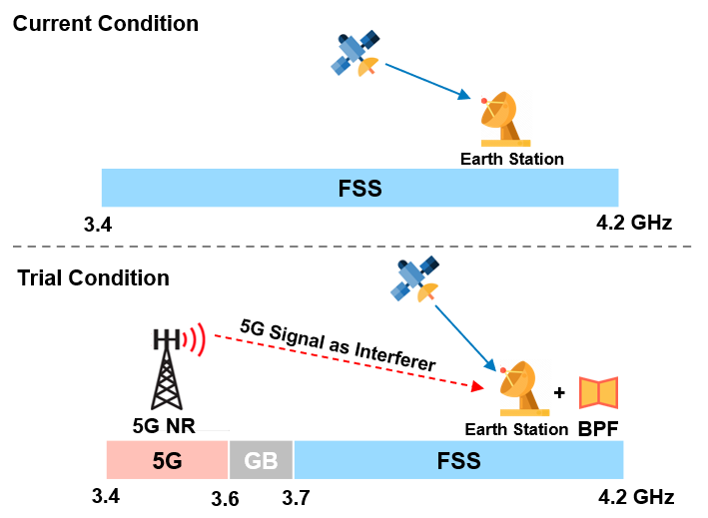
The scope of experiment focusing on 5G-NR static and mobility performance test, and field trial for 3.4-4.2 GHz adjacent channel frequency sharing. Many variables are tested during the coexistence field trial for two scenarios, where FSS earth station lower than 5G-NR transmitter in LOS condition and earth station lower than 5G-NR transmitter in NLOS condition. The experiment conducted with various distance between 5G and FSS earth station, varying 5G power transmit configuration, and UE near-far location relatively to the FSS earth station.

Based on the field experiment, Band Pass Filter with minimum rejection of 60 dB below 3.6 GHz with maximum insertion loss 0.4 dB need to be installed before LNB to protect FSS operations in the 3700 – 4200 MHz band, from IMT in 3500 – 3600 MHz, in addition to a 100 MHz guard band. The detail of the field experiment being described in Annex 6. Indonesia welcomes any suggestions or improvements to this trial results in order to have an optimum implementation policy in Indonesia for IMT in Extended C-band while maintaining the protection required to the FSS operating in Standard C-Band as appropriate. trial.

Study on co-existence between IMT-2020 and the Fixed Satellite Service in the 3400 – 4200 MHz band in Viet Nam

This case study indicates that the solution of installing fillers (LNA/LNB) to Earth stations (except TT&C Stations) has limited the blocking interference from 5G-NR systems but has not yet solved the interference caused by 5G-NR systems in the presence of activated UEs in the near the earth station. The solutions for TT&C stations will be further studied to determine the exclusion zone area and coordination zone.

Summary and Conclusions

A summary of APT administrations studies and field test experiment to study the adjacent band coexistence between IMT and FSS could be seen in the Table below.

Administration | IMT bands |  | FSS bands |  | Guardband  (MHz) |  | BPF suppression (dB) | Mitigation measures |  | Reference
China | 3.4-3.6 | 3.7-4.2 |  | 100 |  | ≥55dB  Insert loss: ≤ 0.5dB |  |  | a) Change co-channel FSS receive frequency to other frequency bands;  b) Improve the receive technique characteristics of LNA/LNB, such as adding additional filter;  c) Installing shielding net around the earth station;  d) Avoid setting up 5G base stations in the main lobe of earth station antenna;  e) Adjust the maximum radiation direction;  f)Reduce the 5G maximum output power;  g) Building separation. | Annex 4
Indonesia | 3.5-3.6 |  | 3.7-4.2 |  | 100 |  | 60 dB with maximum insertion loss 0.4 dB. | - an additional BPF with suppression of larger than 60 dB below 3600 MHz at a typical earth station  - guard band of 100 MHz (3600–3700 MHz). |  | Annex 6

The 3100 – 4200 MHz band can be subdivided in various ways to accommodate the services allocated to it. Administrations are able to subdivide the spectrum to suit their national requirements. This report provides some example frequency arrangements especially in relation to the Mobile and Fixed Satellite Services and shows that with appropriate mitigation measures these frequency arrangements may be realised in a practical sense. Administrations may find this information useful in determining the most efficient frequency arrangements.

Prior to allowing terrestrial 4G LTE/5G-NR to operate in the 3.5 GHz band, C-band FSS receiving earth stations and fixed links were used. The locations of C-band FSS receiving earth stations may be known (at specific locations) or unknown (in a wide area) depending on what national administrations have permitted. As highlighted by Report ITU-R S.2546, knowledge of the locations of the FSS earth stations using the C-band frequency is important in order to implement the correct mitigation techniques, both on the FSS and mobile side, to ensure coexistence. Specific mitigation techniques may be required depending on the interference scenarios. These will be based on various factors, including the extent to which C-band earth stations are deployed in a country or region, whether the earth station locations are known or not known, and the operational parameters of the 4G LTE/5G-NR and its planned deployment. Mitigation techniques mentioned in section 7 reduce interference risks and improve sharing and compatibility. The following figure from Report ITU-R S.2546 provides a summary of the mitigation techniques applicable depending on the interference scenario:
Figure 1
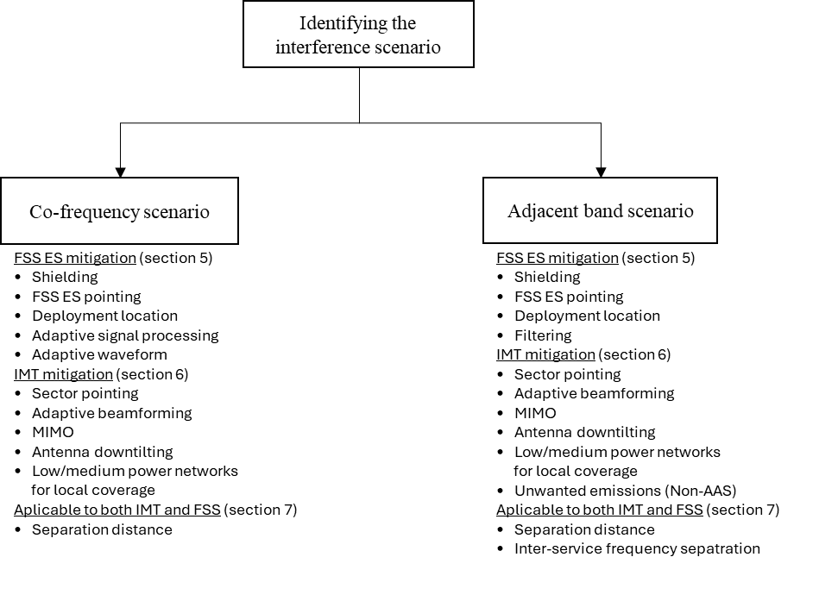

Therefore, each regulator may need to carefully analyse the use of C-band spectrum in their own country and consider mitigation techniques to protect C-band FSS earth stations from interference. Regulators from each administration may find the following consideration useful:

- Stakeholder involvement: Active engagement of industry, operators, and users through public consultations is valuable in defining allocations, technical conditions, and mitigation measures.
- Earth station registration: Knowledge of existing and planned FSS earth station locations and characteristics (coordinates, antenna patterns, frequency ranges, etc.) is essential, and a licensing / registration process provides regulators with the necessary data.
- Mobile technical specifications: Understanding IMT technical specifications (e.g., spectrum emission masks) can be used to determine the amount of power expected from IMT base stations and can be used to estimate potential impact to neighboring receiving earth stations.
- Filter design: RF filters are a key mitigation tool applicable to FSS Earth Stations and IMT base stations.
- Frequency separation: Guard bands and optimal frequency offsets, informed by filter characteristics and emission limits, facilitate adjacent-band coexistence.
- Databases and coordination: Maintaining earth station licensing databases and applying distance-based coordination/exclusion measures are particularly important for mission-critical FSS earth stations (e.g. TT&C or strategic facilities).

Annex 1: FSS Deployment in the 3400 to 4200 MHz band

Satellite services in the 3400 to 4200 MHz band include the following:
- Very Small Aperture Terminal (VSAT) Networks
- Internet Services
- Point to Point Links
- Satellite News Gathering
- TV and data broadcasting to satellite master antenna television (SMATV)
- Direct-to-Home (DTH) receivers, FSS earth stations dedicated to signal reception such as television receive-only (TVRO) terminals including those in areas outside the coverage area of terrestrial television stations
- Feeder links for the mobile satellite service
- Also used for tracking, telemetry and command (TT&C) purposes by FSS Satellites

Annex 2: FSS Interference Criteria

Long Term Interference Criterion
- In-band sharing studies
  - I/N = -12.2 dB corresponding to the total interference from other systems having co-primary status, for 100% of the worst month
  - I/N = -10 dB corresponding to the aggregate interference from co-primary allocation for 20% of any month
- Adjacent band sharing
  - I/N = -20 dB corresponding to the aggregate interference from all other sources of interference, for 100 % of the time.

Short Term Interference Criterion
- I/N = -1.3 dB which may be exceeded by up to 0.001667% time (single entry)

The interference potential into an FSS earth station should be evaluated taking into account both long-term and short-term interference criteria.

Annex 3: A summary from the ITU-R of co-existence studies

Annex 3 provides a summary from the ITU-R of co-existence studies between IMT into FSS in the 3 400-4 200 and 4 500-4 800 MHz frequency bands and utilizing ITU-R recognized system parameters for IMT and FSS. Some of the studies indicate coexistence conditions such as separation distance between IMT and FSS stations operating in an adjacent band.

Numerous studies with different characteristics, shown below, have been carried out on sharing between IMT systems and geostationary satellite networks in FSS:

Table A3-1: Different Studies on FSS Interference
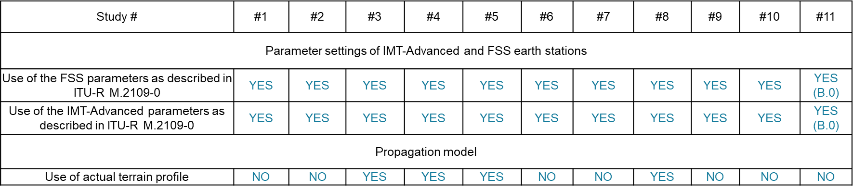
NOTE B.0 – Partial use of parameters, derived from actual networks installed in Brazil.
Table A3-2: Required separation distance to protect FSS from adjacent band emissions
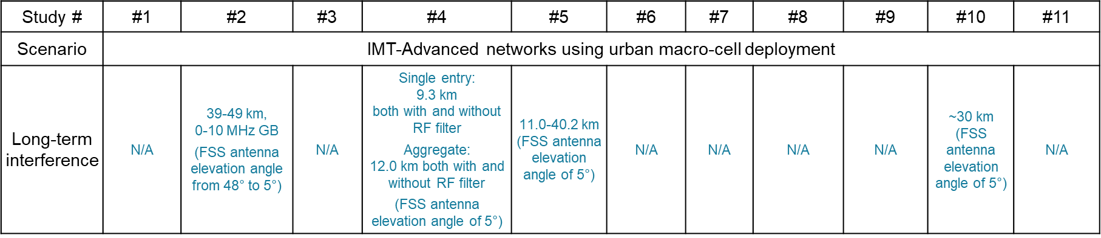
Table A3-3: Required separation distance to protect FSS associated with LNA/LNB overdrive
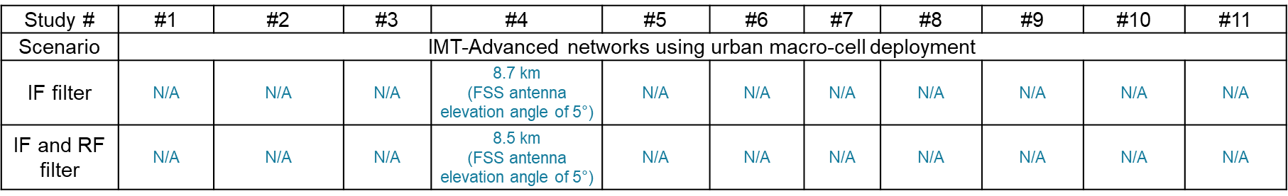

Annex 4: Examples of actions taken by China to enable coexistence of IMT and C-Band FSS
Chinese Regulation
In Dec. 2018, China issued the Interference Coordination Regulation between 5G stations and other radiocommunication stations in the 3.0-5.0 GHz which took effects from Jan. 1st 2019
To promote the development of 5G, MIIT issued the frequency plan for the IMT-2020 in November 2017:
– 3 300-3 600 MHz are planned for IMT-2020, where 3 300-3 400 MHz is only indoor in principle.
– No more new licenses for space service frequency in 3 400-3 700 MHz and space TT&C frequency in 3 400-3 600 MHz
– No more new licenses for FS frequency in 3 400-4 200 MHz.

Figure 1: Frequency allocation in 3 300-4 200 MHz band
- Interference coordination areas between 5G stations and satellite earth stations from theoretical analysis are as below
  - 3.4-3.6 GHz 5G outdoor systems v.s. 3.4- 3.6 GHz satellite earth stations, coordinated separation distance 42.5km
  - 3.4-3.6 GHz 5G indoor systems v.s. 3.4- 3.6 GHz satellite earth stations, coordinated separation distance 1km
  - 3.4-3.6 GHz 5G outdoor systems v.s. 3.6-3.7 GHz satellite earth stations, coordinated separation distance 4km
  - 3.4-3.6 GHz 5G indoor systems v.s. 3.6- 3.7 GHz satellite earth stations, coordinated separation distance 50m
  - 3.4-3.6 GHz 5G outdoor systems v.s. 3.7-4.2 GHz satellite earth stations conforming with certain technique requirements (adopting filtering and anti-saturation measures), coordinated separation distance 100m
  - 3.4-3.6 GHz 5G outdoor systems v.s. 3.7-4.2 GHz satellite earth stations not conforming with certain technique requirements, coordinated separation distance 2km
- While the exact interference areas should be set based on the real geographical territory and the testing
- Interference coordination between 5G stations and fixed service stations and between 5G stations and radio astronomy stations are also specified in this Regulation.
- Since Jan. 1st 2019, no new licenses for satellite space stations and earth stations in the frequency range of 3400-3700MHz are allowed, except for the space stations and corresponding TT&C stations that have been approved to develop or in development, or TT&C stations in existing TT&C areas without imposing additional protection requirement to 5G systems.
- Since Jan. 1st 2019, the newly installed satellite earth stations (including TT&C stations) in the 3700-4200MHz frequency band, the technical specifications of their low noise amplifier (LNA) or low-noise block down converter (LNB) shall conform with certain technique requirements.
- the LNA/LNB in 3700-4200MHz band should work in its dynamic range when the input power in 3300-3600MHz is -20dBm.
- In Jul. 2019, MIIT issued the Interference Coordination Guide between 5G stations and FSS earth station in the 3.0-5.0 GHz to promote the coordination and speed up 5G network deployment. Several potential interference mitigation techniques were also listed:
- Change co-channel FSS receive frequency to other frequency bands;
- Improve the receive technique characteristics of LNA/LNB, such as adding additional filter;
- Installing shielding net around the earth station;
- Avoid setting up 5G base stations in the main lobe of earth station antenna;
- Adjust the maximum radiation direction;
- Reduce the 5G maximum output power;
- Building separation.

- In Dec.2019, MIIT released the draft limits of unwanted emission power form 5G base station in 3400-3600MHz band:
- Limits of unwanted emission power from 5G base station in 3400-3600MHz band is -26dBm/MHz in 3650-3700MHz band.
- Limits of unwanted emission power from 5G station in 3400-3600MHz band is -47dBm/MHz in 3700-4200MHz band
Chinese Interference Mitigation Experience
It meets an agreement between MNOs and FSS earth station users to add an additional filter between the LNA/LNB and feed to protect the adjacent channel FSS earth station from harmful interference. Depending on the antenna mode, 1 or 2 filters shall be needed.

Figure A 4.1 Interference mitigation method
To assure the FSS earth station can still work normally after adding the filter, the filter index is confirmed after many discussion and validation.
- Input frequency: 3.4-4.2GHz
- Output frequency: 3.7-4.2GHz
- Insert loss: ≤ 0.5dB in 3.7-4.2GHz (tested in 23°C);
- VSWR≤1.4dB
- 5G signal suppression
  - ≥55dB in 3.4-3.5GHz
  - ≥55dB in 3.5-3.6GHz
  - ≥70dB in 4.8-4.9GHz (to prevent the 5G interference in 4.8-4.9GHz)
More than 400 earth stations have been reformed in 2019 to protect FSS service as well as to ensure 5G deployment.
OFCA Hong Kong SAR, China Consultancy Report

Existing SMATV systems could be upgraded by retrofitting a band-pass filter (“Upgraded System”) in order to ensure their co-existence with the future mobile base stations of the public mobile services.
The size of 100 MHz guard band is optimal in order to warrant sufficient signal suppression of the relatively strong mobile signals by the band-pass filter to ensure normal operation of the Upgraded System. In particular, leveraging on the 100 MHz guard band, the recommended band-pass filter that operates in the 3.7 – 4.2 GHz range shall suppress unwanted mobile signals at frequencies below 3.6 GHz by at least 55 dB.

While SMATV systems shall operate in the reduced frequency range of 3.7 – 4.2 GHz, under the recommended configuration of the Upgraded System, the low-noise block downconverter of existing SMATV systems that receive in the 3.4 – 4.2 GHz range might continue to be used until end of equipment life. New or replacement LNB should operate in the 3.7 – 4.2 GHz band.

Indoor and outdoor small cells of the public mobile service as well as macro mobile base stations installed at a height lower than an antenna dish of an Upgraded System in the vicinity can co-exist with that Upgraded System without any need for mitigating measures.

When the antennas of a macro base station of the public mobile service and that of an Upgraded System are installed at the same building rooftop, there should not be interference to the latter in practice owing to the wide angular separations and different pointing direction of the respective antennas.

When the antennas of a macro base station of the public mobile service are higher than that of an Upgraded System in close proximity with their antennas directly facing each other, interference to the latter may occur. Under such a circumstance, the antenna of the macro base station concerned should be relocated by a horizontal distance of some 65 m in the east or west directions. In practice, moving the macro base station to an adjacent building in the respective directions will generally satisfy the requirement.

Annex 5: Recent studies provided to APT between IMT around 3.5 GHz into FSS

- Study A - Adjacent band compatibility at the 3400 MHz boundary (5G NR operating in 3300 – 3400 MHz)

- Study B - Adjacent band sharing and compatibility at the 3600 MHz boundary (FSS operating in 3400 – 3600 MHz)
- Study C - Adjacent band sharing and compatibility at the 3600 MHz boundary (5G NR operating in 3400 – 3600 MHz)

Study D - Adjacent band sharing and compatibility between 5G NR base stations and FSS TT&C

Annex 6: Coexistence trial undertaken by Indonesia between IMT-2020 (5G-NR) and the Fixed Satellite Service (FSS) in the 3400 – 4200 MHz band

- Introduction

Indonesia has conducted a successful experiment of coexistence trial between IMT-2020 (5G-NR) and Fixed Satellite Service (FSS) for the extended C-band in Bandung, Indonesia in October - November 2020. The experiment was performed at 11.00 PM – 04.00 AM (GMT+7) considering the lowest traffic data for FSS under clear sky condition.

In this experiment, the 5G-NR used 3500-3600 MHz band, while FSS used 3700-3702 MHz band for DVB-S2 and point-to-point (PTP) services which performed by using Satellite News Gathering (SNG) station, where Band Pass Filter (BPF) is used as a mitigation technique to reduce the interference impact to the FSS Earth Station. Before making the real-field experiment, 4 types of BPF filters were verified, while only one type of BPF filter is used during the coexistence experiment.

This experiment is expected to provide experimental contributions to the coexistence operation between IMT-2020 (5G-NR) and FSS in 3400–4200 MHz band, especially in Asia Pacific Region.

- Scope of Experiment

Ministry of Communications and Informatics (MCI) in collaboration with Telkom Group (PT. Telekomunikasi Selular (Telkomsel), PT. Telekomunikasi Satelit Indonesia (Telkomsat), and Telkom University) have conducted coexistence trial between
IMT-2020 (5G-NR) and FSS in 3400–4200 MHz band which was held in Bandung, on October - November 2020 with the scope of experiment focusing on:

  - 5G-NR Static and Mobility Performance Test
Trial on 5G-NR static test was conducted at the optimum location to test the 5G-NR peak throughput. To test the 5G-NR power transmit configuration impacts, 5G-NR static test is also conducted at the cell edge for user throughput experience. Furthermore, the mobility test is also conducted to test for signal quality distribution.

Table A6-1. Parameters to evaluate the 5G-NR static and mobility performances
Test Item | Objective | Distance | 5G Power Configuration
5G-NR Static Test for Peak Throughput | Single user peak throughput | UE is located at 50 m away from Base Station | 53 dBm  (200 Watt)
5G-NR Static Test at the cell edge | Impact on power configuration to user throughput experience at the cell edge | UE is located at 840 m away from Base Station | - 47 dBm  (50 Watt)  - 50 dBm  (100 Watt)  - 53 dBm  (200 Watt)
5G-NR Mobility Test | Impact power configuration to signal quality distribution | Mobility | - 50 dBm  (100 Watt)  - 53 dBm  (200 Watt)
Table A6-1 shows parameters of 5G-NR with several power configurations from 50 to 200 Watt to evaluate the impact of interference from 5G-NR to the FSS.
  - Field trial for 3.4-4.2 GHz Adjacent Channel Frequency Sharing
Fig. 1 Configuration of coexistence experiment between 5G-NR and FSS
at 3.4-4.2 GHz including the use of BPF filter.
Coexistence field trial of 5G-NR in 3400 –3600 MHz and FSS in 3700-4200 MHz was performed through adjacent channel frequency sharing without interfering FSS. Mitigation technique during trial implemented by having an additional BPF installed at the FSS Earth Station with Guard Band of 100 MHz (3600-3700 MHz), and Separation Distance as described in Table A6-2.
Table A6-2. Allocated frequencies for 5G-NR and FSS
Item | Frequency | Note
5G-NR | 3500–3600 MHz | Fixed at height of 20 m located at (107.629389, -6.97585). The BS is equipped with MIMO 64x64. The power is shown in Table 1 with antenna gain of 25 dBi, tilt 3 degree, azimuth 230 degree. Maximum Code Rate DL/UL 256QAM/64QAM, Polarization -45 to +45.
FSS (Geostationary satellite orbit/GSO) | 3700-3702 MHz | SNG For DVB-S2 services and for PTP (sequentially). Telkom 3S satellite at 118E. FEC DVB-S2 8-PSK ¾ and Point-to-Point (PTP) 16-APSK, polarization 55.8, maximum input of LNB  -53 dBm, maximum antenna gain 36.6 dBi, and antenna diameter 2 m. Antenna noise temperature (K): 52 (10 deg El), 45 (20 deg El). Cross Pol: -30 dB (On Axis), -26 dB (in 1 dB BW). Azimuth and Elevation:  location 1: 56.456; 75.33, location 2: 56.462; 75.327, location 3: 56.461; 75.328, location 4: 56.452; 75.33, location 5: 56.456: 75.33.
Guard Band (GB) | 3600-3700 MHz | 100 MHz considering the recent coexistence study in Hongkong and China.
BPF Suppression | 3700-4200 MHz | Minimum rejection (below 3.6 GHz) is 60 dB with maximum insertion loss 0.4 dB.
Many variables are tested during the coexistence field trial for two scenarios, where FSS earth station lower than 5G-NR transmitter in LOS condition and earth station lower than 5G transmitter in NLOS condition. The experiment conducted with various distance between 5G and FSS earth station, varying 5G power transmit configuration, and UE near-far location relatively to the FSS earth station. The tests are conducted for two different services which are SNG DVB-S2 and VSAT PTP (Point-To-Point).

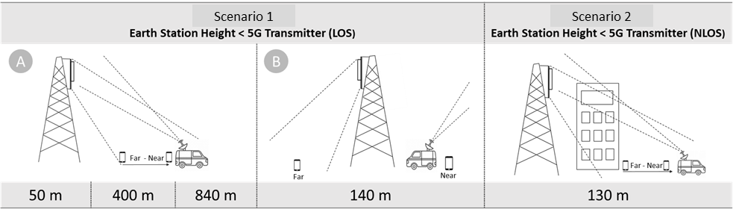

Fig. 2. Scenarios used during the real-field trial.

The different locations of earth station for various distances (see Fig. 2) for Scenario 1A, Scenario 1B, and Scenario 2 are defined as in Point 1, Point 2,
Point 3, Point 4, and Point 5 (see Table 2) are shown in Fig. 3.

Table 2. Distance and channel conditions considered during the experiment.

Scenario | Point | Distance | Location (Long/Lat)
Scenario 1A | Point 1 - LOS | 50 m | (107.6289138, -6.976264)
Scenario 1A | Point 2 - LOS | 400 m | (107.6258139, -6.9768417)
Scenario 1A | Point 3 - LOS | 840 m | (107.6263731, -6.9767862)
Scenario 2 | Point 4 – NLOS | 130 m | NLOS:  (107.6289459, -6.9774088)  UE Far:  (107.6295722, -6.9757246)
Scenario 1B | Point 5 - Backlobe | 140 m | (107.6289138, -6.976264)

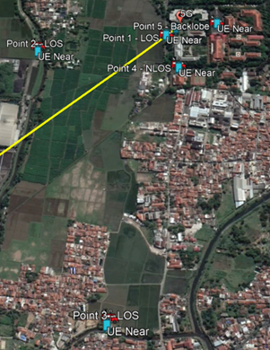
Fig. 3 Map showing the Points 1, 2, 3, 4, and 5 for all testing scenarios in Telkom University in Bandung and surrounding area.

  - Band Pass Filter (BPF) verification Lab Test

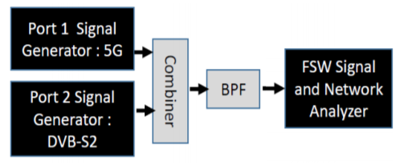
Fig. 4. Structure of BPF testing for coexistence mitigation.

Simulation to verify band pass filter rejection is also conducted in the lab environment using Signal Generator and Signal Analyzer. Four different types of band pass filter were tested.

- Results of Experiment

The results are concluded as follows:

  - 5G-NR Static and Mobility Performance Result
The results show that some degradations of 5G-NR performance appear due to power transmit configurations as shown in Table 1, since the power limitation is used to evaluate the interference impact to the FSS.

Table 3. 5G performance test result.

Test Item | Result
5G Static Test for Peak Throughput | 5G Single User Peak Throughput can be achieved by using 100 MHz TDD for 1-transmit 4-receive (1T4R) UE with throughput up to 1.6 Gbps for DL and 73 Mbps for UL.
5G Static Test at the cell edge | Results of static test on cell edge with reduced power compared to 5G maximum power of 53 dBm (200 Watt) EIRP as the baseline are:  - Power 50 dBm (100 Watt)  Throughput degradation  DL 17% (from 567.5 Mbps to 473 Mbps),  UL 11% (from 39.1 Mbps to 34.85 Mbps)  - Power 47 dBm (50 Watt)  Throughput degradation:  DL 23% (from 567.5 Mbps to 437.5 Mbps),  UL 44% (from 39.1 Mbps to 21.9 Mbps)
5G Mobility Test | 5G with transmit power 50 dBm (100 Watt) has worse signal strength distribution compared to 5G maximum Power of 53 dBm (200 Watt) resulting:  - 15.5% difference of RSRP levels above -95 dBm  - Cell Radius shrinks 12.5 % from 825 m to 728 m for sidelobe direction.

  - 3.5 GHz Adjacent Channel Frequency Sharing Field Trial Result

With BPF as a mitigation method with suppression of more than 60 dB, the results of trials on all scenarios (including the worst scenario) show that impact of 5G in 3400–3600 MHz to satellite service in Standard C-band (3700–4200 MHz) are acceptable as indicated that the FSS services can still run smoothly without any service interruption as indicated in Fig. 5.
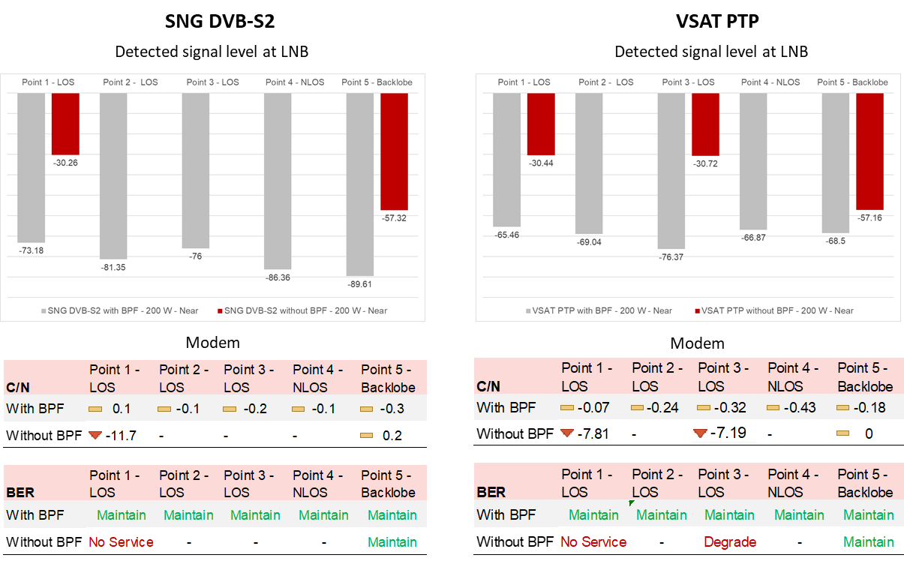
Fig. 5. Recorded parameter of measurement on FSS received signals.

Based on the field trial, in Line-of-Sight (LOS) condition for the case of 5G Base Station (BS) located higher than Earth Station (ES), we found that the coexistence in adjacent channel between IMT-2020 (5G) in 3.5 GHz (3400–3600 MHz) and FSS in Standard C-band (3700–4200 MHz) can be implemented using BPF with suppression of larger than 60 dB at ES Guard Band of 100 MHz for 5G maximum power of 53 dBm (200 Watt).

Without BPF, coexistence is not feasible if earth station of FSS and 5G are in Head-to-Head Scenario, even with 840 m separation distance, and longer separation need to be tested in the future for feasible coexistence without BPF mitigation. Based on result, the only feasible scenario for coexistence without BPF is the scenario when earth station of FSS and 5G are in Backlobe side. Please note that all distances obtained in this experiment are from the real-field test.

UE Near-Far scenario to earth station with BPF does not give any significant impacts. Therefore, UE near-far to/from the ES can be ignored.

  - Band Pass Filter (BPF) verification Lab Test Result

4 types of BPF have been verified in Lab test, where we found that the recommended BPF are only two types of BPF. Those BPF can fulfill the suppression requirement of larger than 60 dB to stop the 5G signals in frequency range 3400-3600 MHz.

Table 4. Results of BPF rejection and insertion loss verification.
BPF Type | Verification Result |  | Compliance
BPF Type | 5G Signal Rejection | Insertion Loss | Compliance
Type-1 | 65 dB | 0.4 dB | Comply
Type-2 | 34 dB | 2.5 dB | Not Comply
Type-3 | 48 dB | 1.8 dB | Not Comply
Type-4 | 68 dB | 1.9 dB | Comply
The BPF used for mitigation in this coexistence field trial is BPF Type-1 and installed at the SNG.
- Conclusion

A real-field experiment for coexistence between 5G and FSS in 3.5 GHz band has been conducted in Indonesia with results on 5G Static and Mobility Performance Test, Field trial of 3.5 GHz Adjacent Channel Frequency Sharing, and Band Pass Filter (BPF) verification Lab Test.

Based on field trial, in Line-of-Sight (LOS) condition for the case of 5G Base Station (BS) with maximum power configuration of 53 dBm (200 Watt) located higher than Earth Station (ES) where 5G was in main lobe coverage and FSS was in sidelobe coverage (ES elevation angle 75 degree), we found that the coexistence in adjacent channel frequency usage between IMT-2020 (5G-NR) operated in 3.5 GHz band (3400–3600 MHz) and FSS operated in Standard C-band (3700–4200 MHz) can be implemented using:
(a) an additional BPF with suppression of larger than 60 dB below 3600 MHz at a typical earth station; and
(b) guard band of 100 MHz (3600–3700 MHz).

It should be noted that the above conclusion only applies to the particular test and the transportability of these conclusions to other environments in other jurisdictions cannot be assumed to follow the guidance in a) and b).

Annex 7: Study on co-existence between IMT-2020 and the Fixed Satellite Service in the 3400 – 4200 MHz band in Viet Nam
- Introduction
The C-band has been widely using or considering to develop IMT-2020 (5G) systems in several countries in the APT region. This band is large enough to allocate to at least 2 operators a continuous and wide bandwidth of 100 MHz per operator, which allows enabling a 5G network with diverse applications. Among the sub-6 GHz bands, this band is one of the best candidates for 5G. So that, Viet Nam is considering to re-allocate part of the C-band for developing 5G.
However, in Viet Nam, the Vinasat satellite is using the band 3400-3700 MHz (space to Earth), while some popular satellites are using the band 3700-4200 MHz to provide the FSS service in the territory of Vietnam. After a long time of development, FSS earth stations are used everywhere such as urban, rural, rigs, islands... Several of them play an important role to provide telecommunication services or broadcasting to remote areas. So that, it is necessary to remain the systems.
According to that, the Ministry of Information and Communications (MIC) has proposed the harmonization C-band plan and mechanism to use both 5G systems and FSS systems.
- Frequency harmonization to IMT and FSS in C-band
- Band plan:
MIC has had a public hearing on the new plan of the C-band. The proposed frequency arrangement is as below:
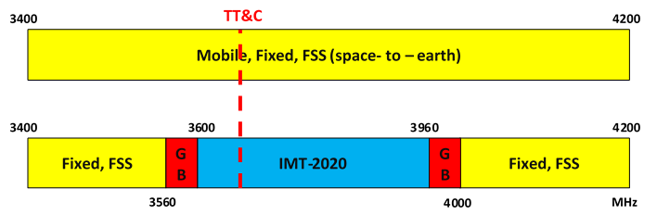
- Technical requirement:
MIC, satellite service providers and mobile operators have been coordinating to study compatibility and sharing between IMT-2020 and FSS in the band 3400-4200 MHz. MIC is considering requirements:
- The users of the Vinasat-1 satellite using in the band 3560-3700 MHz, except TT&C, should change to use the band 3400-3560 MHz. The users of other satellites using the band 3560-4000 MHz should change to use the band 4000-4200 MHz.
- IMT spurious emissions received in the victim FSS in the operating band of earth stations and TT&C must meet the limit of I/N = -12.2 dB (Recommendation ITU-R S.1432)
- IMT systems are not allowed to deploy in restriction zone around the TT&C location in order to against the overdrive.
- IMT systems using the band 3600-3800 MHz are requested to coordinate to Vinasat TT&C in order to protect against in-band or adjacent band interference in the 47 km coordination zone before they are deployed.

- Additional requirements
- For FSS earth station users such as TVRO, Vsat:
Because most of the earth stations use the wideband LNBs covering the IMT band, they need to be installed a bandpass filter (BPF) for protecting these LNBs against overdrive. A typical BPF characteristic is recommended as below:

Pass band (MHz) | 3400 - 3560 and/or 4000-4200
Stopband (MHz) | 3600-3690
Insertion loss (dB) | 0.8 - 1.8
Side-band compression (dB)  @20 MHz; @40 MHz | 45; 60
Return loss (dB) | 15

- For TT&C:
The theoretical restriction zone is calculated based on the free path loss model. For example:

BS TRP (w)  1 NR | Antenna gain (dBi) | Separated distance from TT&C location (km)
100 | 24 | 3,22
200 | 24 | 4,54

Note: It should be added more information about specification and direction of antennas of BS and Earth Stations
- For IMT systems:
The limit of IMT emissions received in the victim FSS antenna in 3600-3960 MHz is proposed to the level of -60 dBm (Report ITU-R M.2109).
In order to avoid harmful interference from unwanted emission of 5G-NR base stations to earth station receivers, the 5G-NR base station unwanted emission limit needs to meet conditions as below:
- OBUE and general spurious emission limits compliance to 3GPP (Cat. B)
- The spurious emission limit in the band 3.4-3.56 GHz and 4.0-4.2 GHz is -52 dBm/MHz.
This unwanted emission requirement is in the National technical regulation on 5G Base Station (QCVN 128:2021/BTTTT). This regulation will take effect from July 2022.

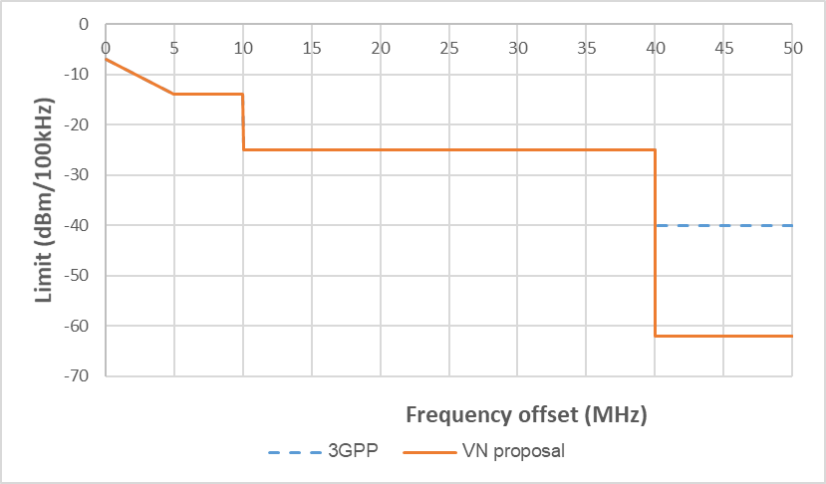

- Experiment results
3.1. The impact of a 5G-NR base station (BS) on the FSS earth station (ES) without a BPF
The study was conducted in 2019-2020. MIC has measured the quality of existing user LNBs. One 5G-NR BS (3GPP standard) has been used to investigate the impact of the 5G-NR BS on existing ESs operating in the Vinasat-1 network such as Vsat, TVRO.
The study results indicate that there is a significant interference from the 5G-NR BS to the ES receiver, even at the distance up to 550 m.
The results have been presented as below:
- The operating band of existing user LNB in the market:
Most existing user LNB has a wide bandpass. The below figure shows an example of the LNB, which can operate in the band of 2.899-4.465 GHz (~1566 MHz)

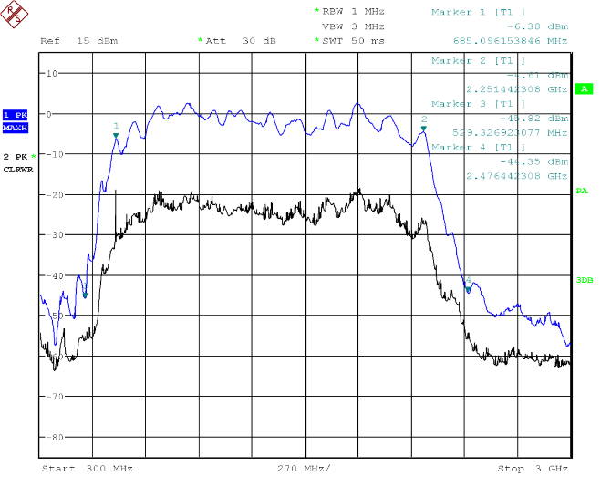

- Test the impact of a 5G-NR base station (BS) on an earth station (ES)
- Scenario:
The 5G-NR BS and the ES have been located in facing buildings with the same height [insert text on height of antenna required]. There are no obstructions between them. The 5G-NR BS TRP has been increasing step by step until the connection of the ES is interrupt.
The result shows that the 5G-NR BS can cause the serious interference to the ES even at low levels of the transmitting power.
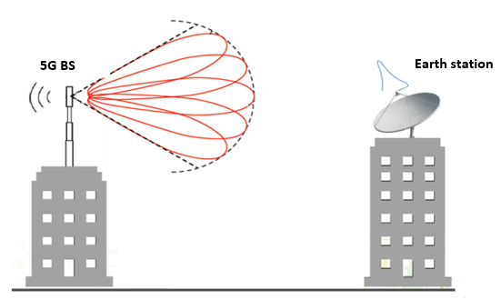

5G-NR BS operating band | 3600 - 3700 MHz and 3700 - 3800 MHz
5G-NR BS TRP | Up to 200 W
5G-NR BS standard | 3GPP
FSS ES receiving frequency | 3590 MHz

Note: It should be added more information about specification and direction of antennas of BS and Earth Stations
- When the separation distance is 550 m

5G-NR BS frequency  (GHz) | Guard band  (MHz) | Separation distance (m) | BS TRP cause interrupt the connection of the ES (w)
3.61-3.71 | 20 | 550 | 1.5
3.625-3.725 | 35 | 550 | 2.2
3.645 – 3.745 | 55 | 550 | 5.0
3.7-3.8 | 110 | 550 | 200

- When the separation distance is 125 m

5G-NR BS frequency  (GHz) | Guard band  (MHz) | Separation distance (m) | BS TRP cause interrupt the connection of the ES (w)
3.61-3.71 | 20 | 125 | 0.6
3.63-3.73 | 40 | 125 | 2.0
3.7-3.8 | 110 | 125 | 6

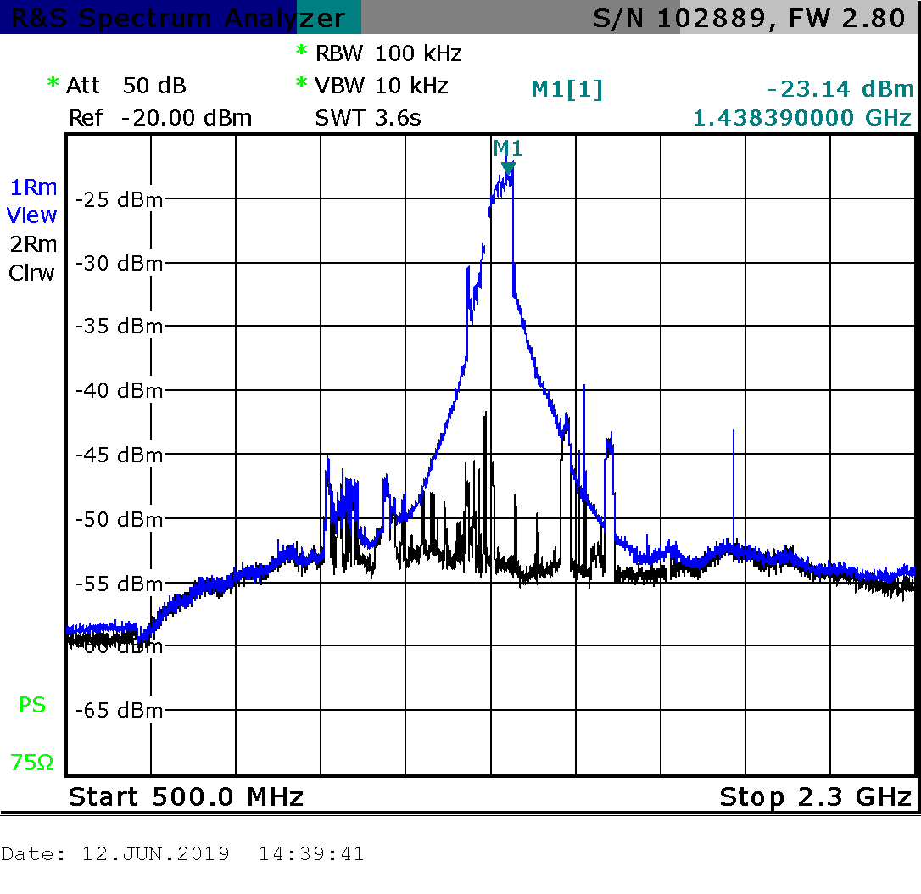
The desired signal (black) and 5G-NR signal (blue) received in the ES receiver
3.2. The impact of a 5G-NR on an earth station (ES) with a BPF
The study has been conducted since early 2021 when an operator is testing 5G-NR (3GPP standard) in the 3600-3700 MHz band. The separation distance between the ES location and the 5G-NR BS location is far enough to ignore the impact of the BS on the ES when none of 5G-NR UEs was activated near the ES.
The study results indicate the impact of 5G-NR when activating UEs near the location of the ES after the BPF has installed in front of the LNB:
- The ES receiver has not been overloaded when the BPF is installed in front of its LNB.
- However, 5G-NR unwanted emissions can cause remarkable interference when the activated 5G-UEs move to the ES location in 20 m.
The results have been presented as bellow:
- Test the BPF:
This study used a BPF in the Viet Nam market, which had a stopband above 3600 MHz with a compression of approximate 60 dB.
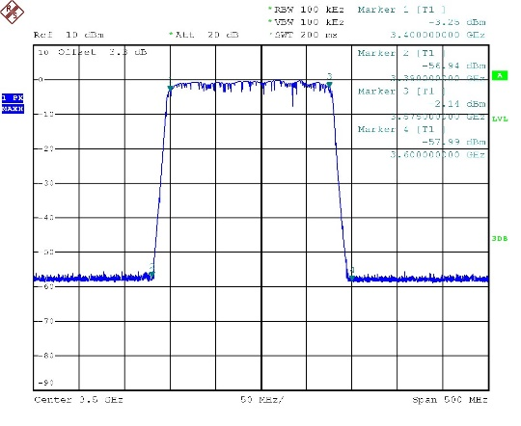 | 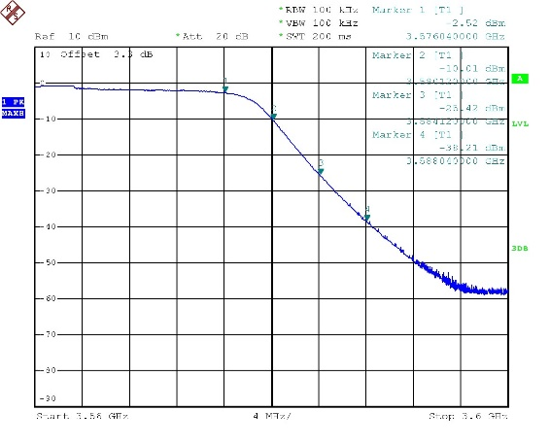
Passband and stopband | Side-band (3575-3600 MHz) compression

- The impact of a 5G-NR on an earth station (ES)
- Scenario:
The locations of the 5G-BS and the ES has been fixed. 5G-UEs have been activated in the speed test mode and moved around the ES. The test has been taken in the case of with/without the BPF.
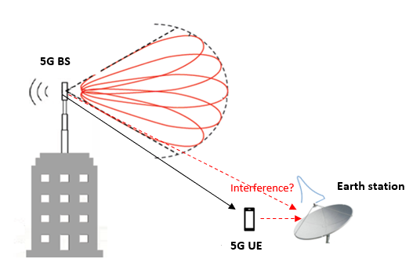
5G-NR carrier | 3600-3700 MHz
FSS ES receiving frequency | 3544.25 MHz

Note: It should be added more information about specification and direction of antennas of BS and Earth Stations

- Without BPF
When two UEs are activated, the LNB has been overloaded and the impact of the unwanted emissions from UEs or BS has not been seen clearly.
- With BPF
Because the 5G carrier falls into the BPF stopband, it has been greatly attended. In this case, the total received power in the ES receiver is only -32.78 dBm, so that the LNB has not been overloaded.
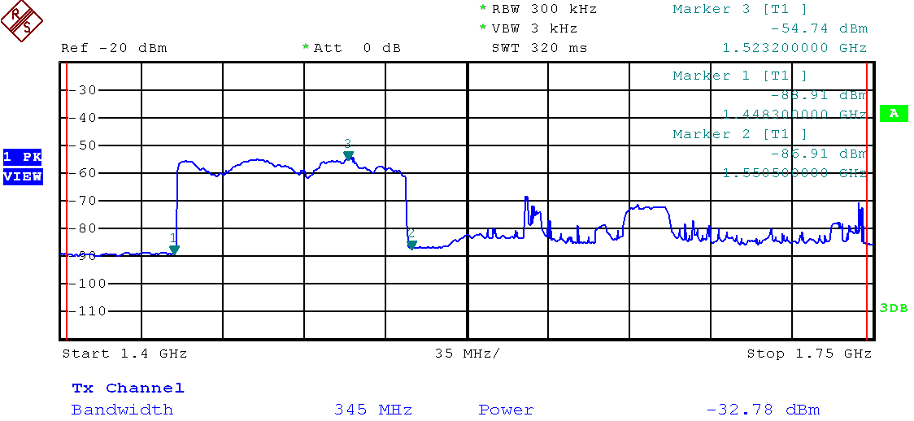
However, it can see clearly the presence of the 5G-NR unwanted emissions in the band 3400-3560 MHz, which cause the in-band interference to the ES. It has been still recognized when the separation between UEs and the ES is up to 20 m.
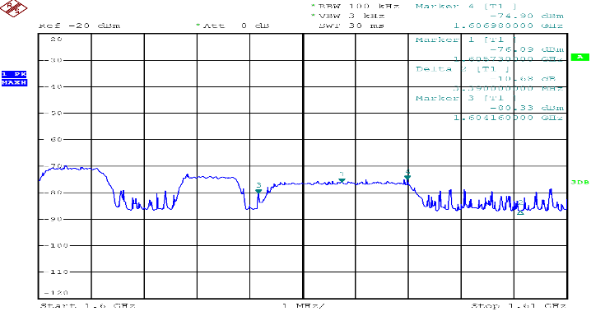

The 5G-NR unwanted emissions (Marker 1, 4) in the operating band of the ES receiver when activating UEs near the ES location.

- Next studies
The interference effect of unwanted emission from 5G-NR needs to be further studied in order to more accurately investigate the impact from the 5G-BS and 5G-UE on the ES receiver, especially in the case of using multiple 5G-UEs.

Annex 8: Examples of Fixed Satellite Service earth station RF band pass filter performance

The FSS earth station receiver performance is an important factor for the compatibility between 4G/LTE /5G-NR and C-band FSS earth stations. A Band Pass Filter is an effective way of improving sharing and compatibility between 4G-LTE/5G-NR and C-band fixed satellite service earth station receivers in an adjacent band. There are a range of filters available on the market designed for different frequency separations (e.g. 20, 25, 40 and 100 MHz). This annex gives the characteristics of 5 of those Band Pass Filters that can be used to mitigate sharing and compatibly issues. The Band Pass Filters specifications may be used as an input by countries to define their sharing rules.

Example of BPF specification (Designed for 100MHz frequency separation and already used in field trials)
- Input frequency: 3.4-4.2GHz
- Output frequency: 3.7-4.2GHz
- Insert loss: ≤ 0.5dB in 3.7-4.2GHz (tested in 23°C);
- VSWR≤1.4dB
- 5G signal suppression
  - ≥55dB in 3.4-3.5GHz
  - ≥55dB in 3.5-3.6GHz
  - ≥70dB in 4.8-4.9GHz (to prevent the 5G interference in 4.8-4.9GHz)

Example of BPF specification (Designed for 40MHz frequency separation and already used in field trials)

Pass band (MHz) | 3400 - 3560 and/or 4000-4200
Stopband (MHz) | 3600-3690
Insertion loss (dB) | 0.8 - 1.8
Side-band compression (dB)  @20 MHz; @40 MHz | 45; 60
Return loss (dB) | 15

Table A7-1: Vendor A BFP specification (Designed for 20MHz frequency separation)
Pass band frequency range | 3.9-4.2 GHz
Max Insertion loss | 1.4 dB
Rejection
3.88GHz | 60dB
4.23GHz | 25dB
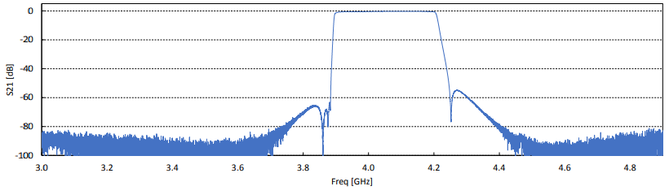
Vendor B BPF specification (Designed for 20MHz frequency separation)

Vendor C BPF specification
Design for 25 MHz frequency separation
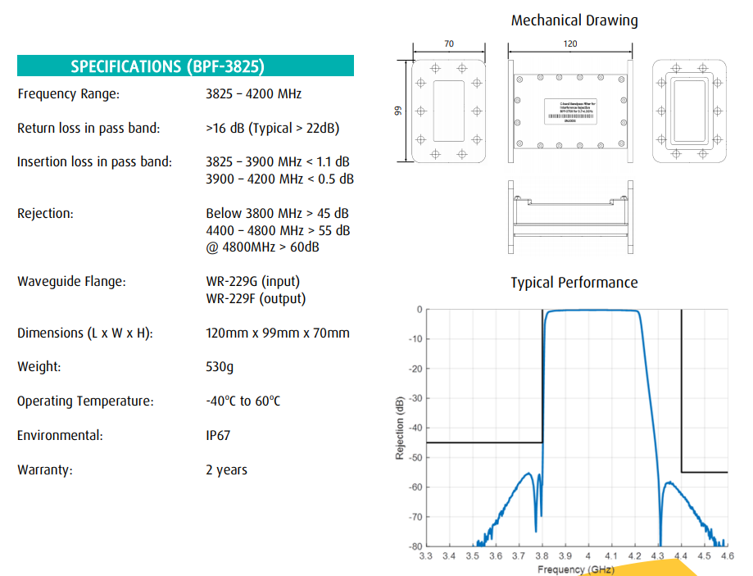
____________

In the ITU Radio Regulations (RR), the frequency bands 3 300-3 400 MHz, 3 400-3 500 MHz and 3 500-3 600 MHz are identified for IMT in some countries in Region 3. In addition to these frequency bands, some countries in Region 3 have deployed or are considering to deploy 4G-LTE and 5G-NR systems in the frequency band above 3 600 MHz, which is allocated to the mobile service on a primary basis in Region 3. The applicability of mitigation measures studied in this document would differ from country-to-country in Region 3.
IMT system refers to IMT-Advanced and IMT-2020 which cover the approved 4G-LTE and 5G-NR systems
Source – Report ITU-R M.2109 “Sharing studies between IMT-Advanced systems and geostationary satellite networks in the fixed-satellite service in the 3 400-4 200 and 4 500-4 800 MHz frequency bands”
Annex 2 of Recommendation ITU-R S.1432
See Chinese Regulation at http://www.srrc.org.cn/article22361.aspx
http://www.srrc.org.cn/article23502.aspx/
See Consultancy Report of Hong Kong OFCA at https://www.ofca.gov.hk/filemanager/ofca/common/reports/consultancy/cr_201803_28_en.pdf

