

APT REPORT ON

STUDIES WITHIN THE ARCHITECTURE AND PERFORMANCE OF INTEGRATED MSS SYSTEMS AND HYBRID SATELLITE/TERRESTRIAL SYSTEMS BELOW 3 GHZ

Edition: April 2017

The 21st Meeting of APT Wireless Group
3 – 7 April 2017
Bangkok, Thailand

(Source: AWG-21/OUT-12)

No. APT/AWG/REP-57(Rev.1)
APT Report ON Studies within the Architecture and Performance of Integrated MSS Systems and Hybrid Satellite/Terrestrial Systems below 3 GHz

Purpose

This purpose of this Report is to address technical issues associated with the integrated MSS systems and hybrid satellite/terrestrial systems in the Asia-Pacific Region where natural disasters such as earthquake and tsunami occur quite often, the effective communication infrastructure that is required for providing broadband services in wide areas, bridging the digital divide and introduction of other applications.

This Report also assesses the performance of integrated MSS system and hybrid satellite/terrestrial system based on scenarios considered.

Scope

The scope of this Report is limited to the technical study which is within the scope of the current Terms of Reference of TG-MSA (see Document AWG-14/TMP-14 (Rev.1)). This technical study should not be related to any sharing and/or regulatory issues.

Definitions

For the purposes of this Report, the following definitions apply:

Integrated mobile-satellite service (MSS) system: System employing a satellite component and a complementary ground component (CGC) which is complementary to the satellite component and operates as, and is, an integral part of the MSS system. In such systems, CGC is controlled by the satellite resource and network management system. Further, CGC uses the same portions of MSS frequency bands as the associated operational mobile-satellite system.

Hybrid satellite/terrestrial system: System employing satellite and terrestrial components where the satellite and terrestrial components are directly connected, but operate independently of each other. In such systems, the satellite and terrestrial components have separate network management systems and do not operate in the same frequency band.

Dual mode: Terminal operates in both satellite system and terrestrial system.

Abbreviations

For the purposes of this Report, the following abbreviations apply:

BLER Block Error Rate
BTS Base Terrestrial Station
CGC Complementary Ground Component
DBF Digital Beamformer
GBBF Ground based beam forming
HSS Home Subscriber Server
MCS Modulation and Coding Scheme
MME Mobility Management Entity
MSS Mobile-Satellite Service
MSS-ATC MSS-Ancillary Terrestrial Component
MSS-CGC MSS-Complementary Ground Component
NICT National Institute of Information and Communications Technology
P-GW Packet Data Network (PDN) Gateway
PCRF Policy & Charging Rules Function
PPDR Public Protection and Disaster Relief
QoS Qualify of Service
S-GW Serving Gateway
SAT Satellite Components
SGIPS Satellite/Ground Interworking Policy Server
SINR Signal to Interference plus Noise Ratio
SMS Satellite Mobile Station
STICS Satellite/Terrestrial Integrated mobile Communication System
TMS Terrestrial Mobile Station

Background

Integrated mobile-satellite service (MSS) systems and hybrid satellite/terrestrial systems are innovative space/terrestrial infrastructures with a high degree of spectrum utilization efficiency and have the ability to provide a variety of benefits that serve the public interest, including multimedia broadband services to handheld or portable terminals and public protection and disaster relief (PPDR) solutions, as well as MSS operators from economic viability and economies of scale perspectives.

MSS systems can provide ubiquitous connectivity through their wide-area coverage characteristics and offer instant and reliable communication systems within their coverage area. Their strength and utility in providing blanket coverage to terrestrial communications networks in areas where population densities cannot support introduction of large-scale commercial land-based infrastructure has made MSS systems an indispensable part of communication networks.

Terrestrial-based networks on the other hand, have their strength and traditional role in providing high capacity communication networks in suburban and urban areas, including inside buildings, that no conventional MSS system has the ability to penetrate due to excessive blockage and shadowing of the satellite link in such areas.

Figure 1 shows the three cases of MSS systems.

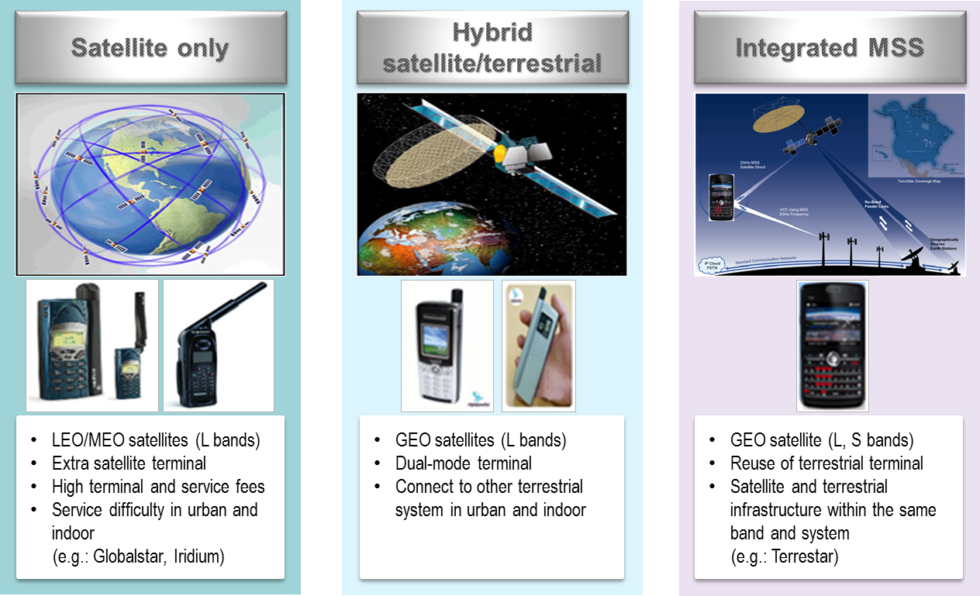
Figure 1 Three cases of MSS systems

The main difference between integrated and hybrid systems is whether both the satellite and ground components use a common network and spectrum. The ground component of an integrated system is a complementary part of the satellite system, and thus it uses the same frequency band allocated to the satellite system and also it is operated by the same network. Some examples of these systems are the MSS-ATC (MSS-Ancillary Terrestrial Component) in the United States and Canada, and MSS-CGC (MSS-Complementary Ground Component) in Europe and are implemented in the 1-3 GHz bands. On the other hand, a hybrid system may combine a satellite system with the terrestrial system with different frequency bands networks, and even air interfaces. User handsets of a hybrid system can use a terrestrial system in terrestrial coverage areas as well be capable of a satellite system in satellite coverage areas. In other words, satellite systems play a complementary role of terrestrial systems. For example, in commercial hybrid systems, some operator provides a hybrid service composed of GSM as a terrestrial system and GMR-1 as a satellite system used by one unified terminal.

To summarize, the integrated relates to a very specific network scenario and service, while the hybrid systems encompass many other network scenarios combining satellite and terrestrial components.

Advantages of integrated MSS system and hybrid satellite/terrestrial system

Amongst the main drivers or added value associated to the resulting combined network compared to a standalone satellite component among are:

- Extended service area. Able to provide service to maritime, rural and low density populated areas.
- Wider range of service provisioning with lower costs for customers and operators.
- Rapid and independent infrastructure deployment. Backhaul solution for fixed or mobile services, military communications and disaster recovery benefits from this capability.
- Improved Quality of Service (QoS) delivered to operators and correspondingly, to end-users. Satellite networks are able to further complement terrestrial based internet access technology to deliver high speed broadband service, especially in low density populated area.
- Increased service availability and flexibility. Providing service for critical communication links, enabling path diversity and allows various fade mitigation methods.

Integrated MSS system

Overview

An integrated MSS system represents the evolution of traditional MSS networks into an integrated, single network that uses both space and ground transmission paths to serve end user handsets. The ground component (CGC) is complementary to the satellite component and operates as an integral part of the MSS system. With proper network planning and common network control of the satellite and ground components of the system, the operators of such systems can use their assigned MSS spectrum in an intensive and efficient manner, provide indoor and outdoor coverage in urban, suburban, rural and remote areas, and provide service directly to small handsets.

Figure 2 shows the concept of an integrated MSS system.

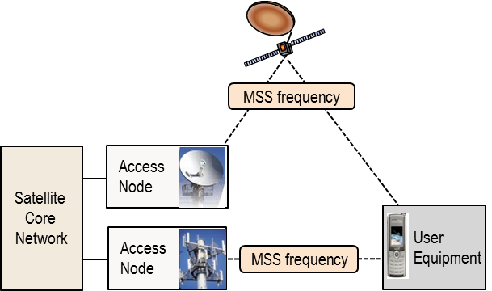
Figure 2 Concept of an integrated MSS system

Applications and example systems

Satellite component in the integrated MSS system will be able to provide the following services with similar quality and capacity to those of CGC:

- Messaging (SMS, MSS, email, etc)  - Voice telephony (including VoIP)  - High quality video telephony  - Push-to-talk  - File transfer/download  - Consultation | - Remote collaboration  - Mobile commerce  - Mobile broadcasting/multicasting  - Machine-to-Machine communication  - Remote sensor  - Remote bio-monitoring  - Personal environment service  - ITS-enabled services  - Emergency calling  - Public alert  - Location based service

Possible system architecture and features

Figure 3 shows the general system architecture for the integrated MSS system. The system consists of satellite components (SAT) and complementary ground components, operating in the MSS bands in a way that CGC can reuse satellite frequencies which are used for adjacent satellite beams. Satellite management system should make efficient resource allocations (frequency, subcarrier, power, etc) for CGCs for optimized system deployment by maximizing overall system throughput under satisfying service requirements of both components. SAT/CGC gateway can decide which component is appropriate for packet transmission considering the situations of satellite and CGC network.

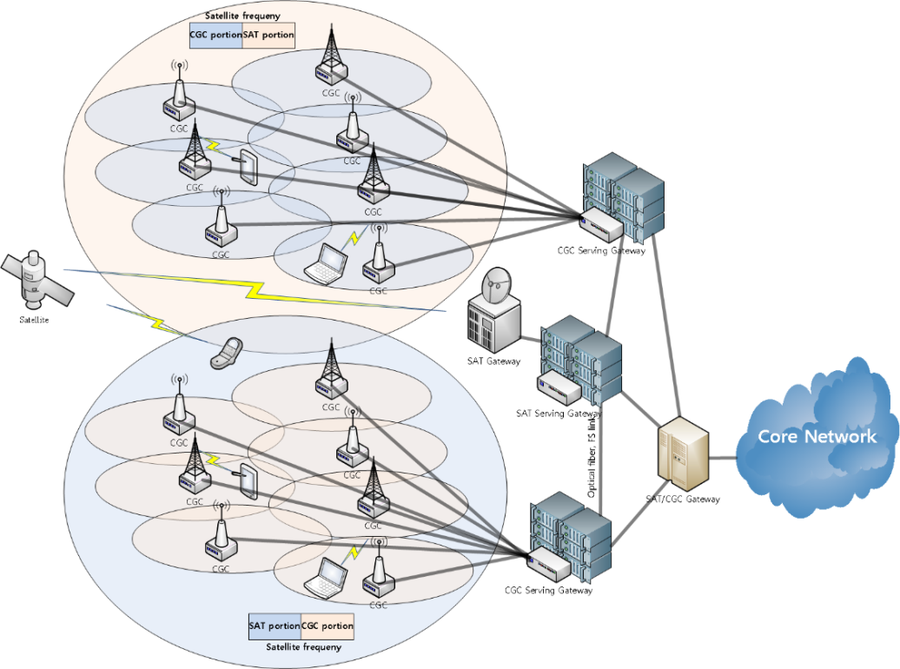
Figure 3 Overall system architecture

The functions of the gateways shown in Figure 3 are as follows:
- Satellite Gateway: It serves as an interface between the satellite and the ground networks and also serves as transit points between satellites.
- Satellite serving gateway: It is the point of interconnection between the satellite radio-side and the SAT/CGC gateway. This gateway serves the satellite UE by routing the incoming and outgoing IP packets.
- CGC serving gateway: It is the point of interconnection between the CGC radio-side and the SAT/CGC gateway. This gateway serves the CGC UE by routing the incoming and outgoing IP packets.
- SAT/CGC gateway: It is the point of interconnection between the serving gateways and the core network. This gateway serves the satellite and CGC serving gateways routing the incoming and outgoing IP packets.

The LTE based network architecture can be adapted into the satellite component. That is, the satellite network consists of eNodeB for satellite radio interface, S-GW (Serving Gateway), MME (Mobility Management Entity), HSS (Home Subscriber Server), PCRF (Policy & Charging Rules Function) and P-GW (Packet Data Network (PDN) Gateway). Furthermore, SAT-OFDM and BMSat radio interface technologies, which are included in Recommendation ITU-R M.2047 regarding the detailed specification for the satellite radio interface of IMT-Advanced, could be considered for this LTE based satellite network.

Figure 4 represents one example of overall network architecture based on 3GPP LTE protocol to implement the overall system architecture as in Figure 3.

Figure 4 Network architecture for LTE based integrated MSS system

The satellite eNodeB, which has similar functionality with eNodeB of CGCs, is identified in the satellite network in order to adopt terrestrial LTE radio interface to satellite specific environment while HSS and PCRF are shared for both satellite and CGC networks. Although most of entities for the integrated MSS system architecture come from those for the terrestrial 3GPP LTE network architecture, some entities should be additionally defined for common managements for the resources of the satellite and CGCs. For this, Satellite/Ground Interworking Policy Server (SGIPS) is defined for interworking between the satellite and CGC as well as controlling resources of the satellite and CGC components for optimized system performance. SGIPS makes cooperation as well as information exchange between the satellite and CGCs available. In addition, SGI, which is an interface between SGIPS and MME, is defined to provide information for resource managements of the satellite and CGCs.

Recommendation ITU-R M.1182-1 provides five levels of different architecture for the integration of mobile-satellite service (MSS) systems with terrestrial public switched telephone network (PSTN) or cellular network. Annex 1 of the Recommendation addresses the concepts of such an architecture, and Annex 2 describes an example of a closely integrated broadband terrestrial and satellite mobile communication system.

Potential constraints on system performance and proposed enhancements

Frequency reuse

Complementary ground components are different from independent ground components used by MS operators as they are technically and operationally an integral part of the satellite system and are controlled by the common resource and network management mechanism of such system operating in the same frequencies as the associated satellite components and being delivered to an integrated user equipment. The frequency reuse between satellite and CGCs will require careful management to reduce the likelihood of co-channel interferences that may cause performance degradation of the MSS system. This matter is dealt with as an intra-system interference to be overcome.

Considering these, for the efficient deployment of integrated MSS system, it is believed that the following could be considered for performance analysis of the integrated MSS system and hybrid satellite/terrestrial systems.

- Large antenna and multi-beam technology
- Possible reuse of terrestrial terminal with small form factor
- Increased system capacity from a number of multi-beams
- Terrestar (18m antenna reflector), Ligado (22m antenna reflector) [add E21 antenna which is 18m]

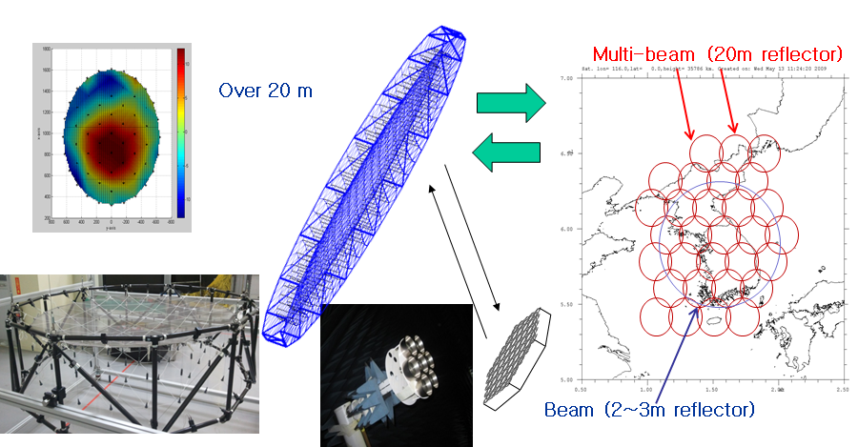
Figure 5 Multi-beam technology with large antenna

- Radio interface technologies
- Maximum commonality between satellite and terrestrial radio interfaces for the implementation of common cost-effective user terminal
- Implementation of low cost terminals with small form factor: possibly reuse of existing terrestrial terminals

Table 1 Radio interfaces
Satellite radio interfaces | Terrestrial radio interfaces
GMR-1 | GSM
EGAL | CDMA-2000
SAT-CDMA | WCDMA
SAT-OFDM | LTE

- Definition of service scenarios for an integrated MSS system for
- Coverage extension of mobile broadband services
- Deployment cost reduction for mobile broadband services

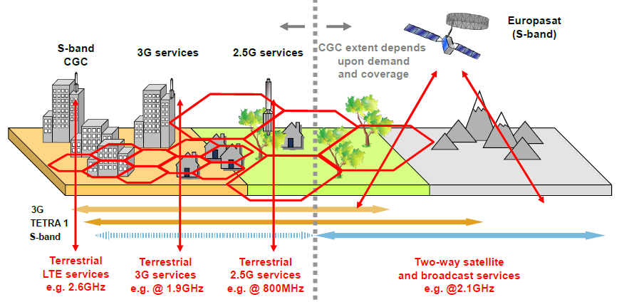
Figure 6 Possible service scenarios example for an integrated MSS system (from Inmarsat [1])

- Intelligent system architecture design for an integrated MSS system
- Efficient satellite frequency reuse in CGCs
- Tolerable interference between satellite and CGCs
- Interference coordinated deployment between satellite and CGCs

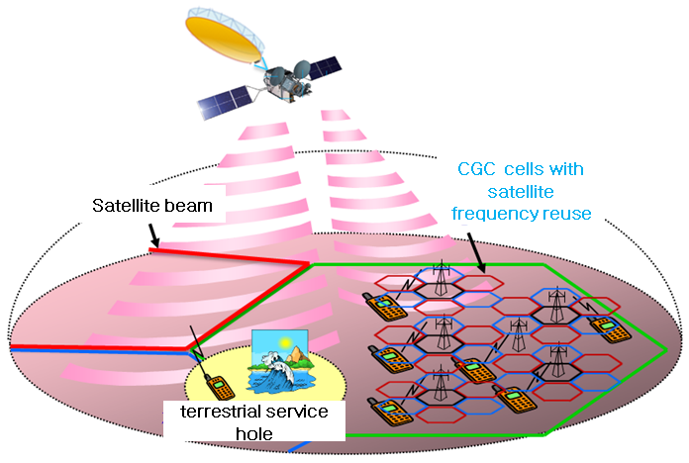
Figure 7 General system architecture for an integrated MSS system

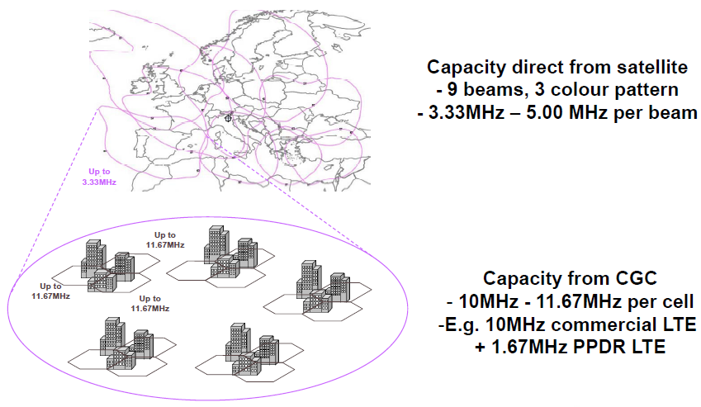
Figure 8 Frequency reuse concept example (from Inmarsat)

- Intelligent resource allocations and interference management techniques
- Controlled by the resource and network management mechanism
- Performance enhancement and increased system capacity from reduced interference between satellite and CGCs

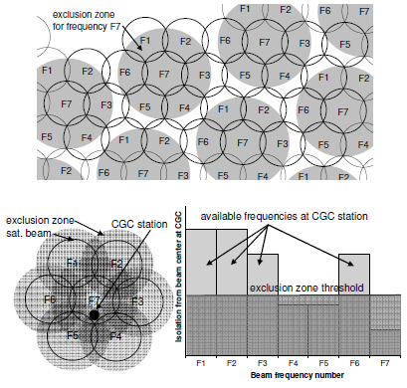
Figure 9 Exclusive zone concept [2]

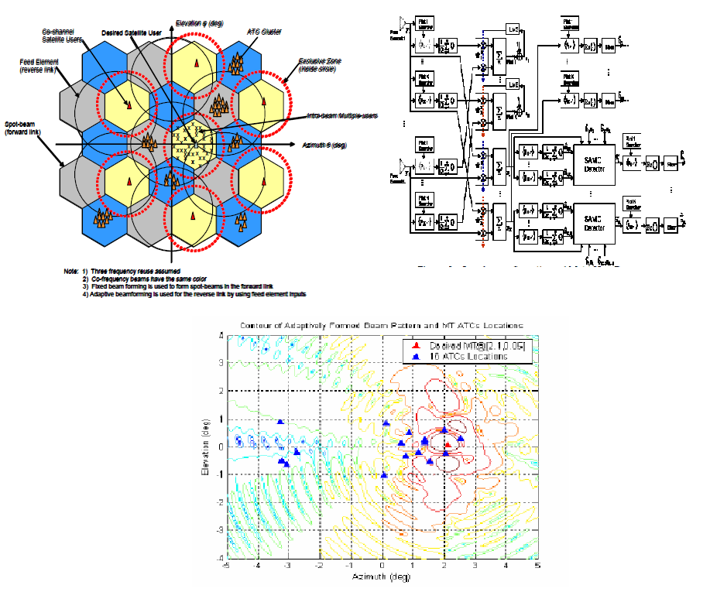
Figure 10 Adaptive beam forming with multi-user detection and interference reduction [3]

- Ground based beam forming (GBBF) techniques
- Delivers unprecedented flexibility to provide broadband services through stable and configurable beams
- Independent of satellite radio interface technologies
- Possible signal processing improvement for interference mitigation on ground
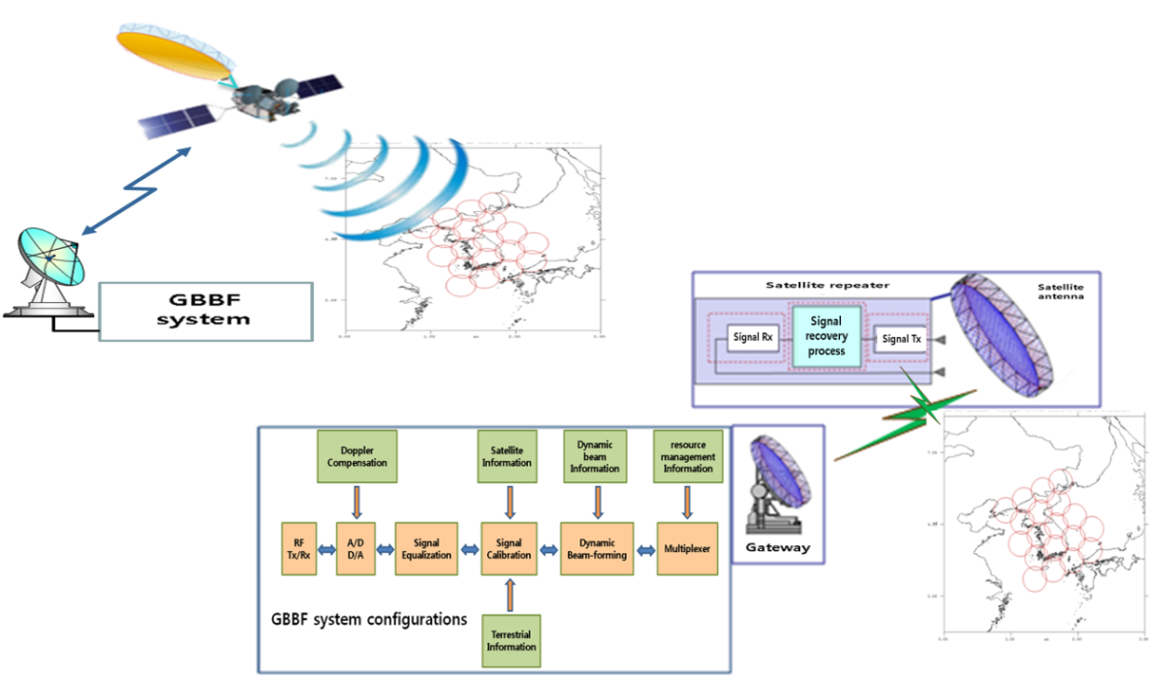
Figure 11 GBBF system concepts

- Interworking scenarios between satellite and terrestrial components
- Beam/cell reselection (e.g. between satellite and 4G/3G/WiFi)
- Terrestrial mode in normal situation and satellite mode in niche market of terrestrial
- on/off operation considering battery life of terminal

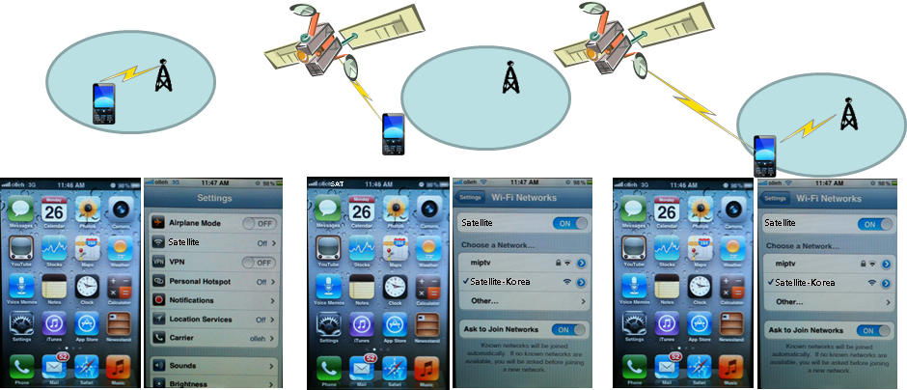
Figure 12 Example of interworking between satellite and CGCs

- Possible implementation of integrated terminal
- Terrestar Blackberry-type terminal: (similar cost of existing terrestrial terminals)
- Addition of satellite RF module into existing terrestrial terminal with moderate cost increase and no extra antenna
- Implementation of terrestrial and satellite single chipset
- With extra antenna, more broadband service could be supported )
- Satellite systems may maintain devices which are not integrated, for instance, portable devices with higher power and directional antennas, coexisting with LTE devices for the CGC. Users may carry both devices in their vehicles or have both at their residences for use depending on the coverage environment.

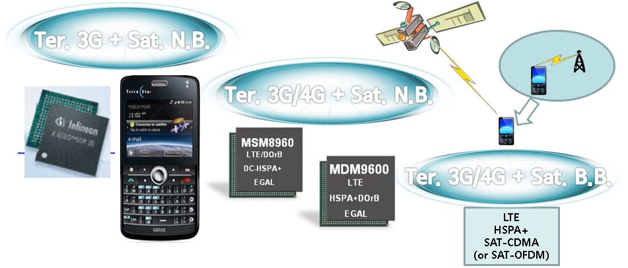
Figure 13 Single-chip based integrated user terminal

References

[1] Paul Febvre, “Personal Satellite Access Terminals: Observations with a 40-year Perspective,” PSATS2011 Keynote 1.
[2] Vincent Deslandes, et al., “Analysis of Interference Issues in Integrated Satellite and Terrestrial Mobile Systems”, ASMS2010 conference.
[3] Dunmin Zheng, et al. “Adaptive beam-forming with interference suppression and multi-user detection in satellite systems with terrestrial reuse of frequencies.

System performance evaluation

Parameters for Satellite Component

For performance evaluation, configuration parameters of the satellite component are assumed as shown in Table 2 and SAT-OFDM radio interface, which is included in Recommendation ITU-R M.2047..

Table 2 System parameters for the satellite component
Beam Tier | 3
Number of beams | 37
Frequency, fc (GHz) | 2.0
Channel Model | Rx Power=Tx Power + Antenna Gain –Path Loss – Shadowing
Satellite Antenna Pattern | Recommendation ITU-R S. 672-4  (Max. Gain = 50 dBi)
3dB Beam Width (degrees) | 0.3
Num. frequency Reuse | 6
Frequency bandwidth (MHz) | 5
Num. UE/Beam | 25 (1RB/1UE, 1RB=180kHz)  *RB: Resource Block
UE Tx power (mW) | 250
UE Antenna gain (dBi) | 0
Sat. Tx power per Beam (W) | 200
Path Loss (dB) | 92.4 + 20logfc(GHz) + 20logR(km) (R: distance)
Shadowing | Open Environment for satellite link ,  Urban Environment for ground link

In order to implement the frequency reuse colors of 6, the satellite beam plan of Figure 14 is assumed, considering the minimization of inter-beam interference. For the notation of A(B) in the Figure, “A” and “B” represent the satellite beam number and the satellite carrier number (one of 6 satellite carriers), respectively.

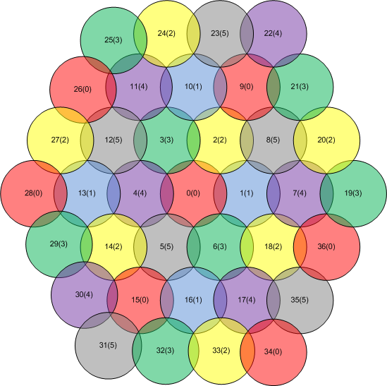
Figure 14 Satellite beam plan

Parameters for Complementary Ground Component

For performance evaluation, configuration parameters of the CGC are assumed as seen in Table 3 and LTE radio interface, which is included in Recommendation ITU-R M.2012 regarding the detailed specifications for the terrestrial radio interface of IMT-Advanced, is considered for LTE based CGC network.
Table 3 System parameters for the CGC
Cell radius (km) | 1
Frequency reuse | 1 (3 sector)
CGC Tx power (W) | 20
Antenna pattern | 3GPP TR 36.942
CGC antenna gain (dBi) | 15
Frequency (GHz) | 2.0
UE Tx power (dBm) | -30 ~ 24
UE Antenna gain (dBi) | 0
Path Loss (dB) | Urban: 128.1+37.6logR (km)
Outdoor wall penetration loss (dB) | 10
Uplink power control | 3GPP TR 36.942 applies

The CGC can reuse satellite frequencies which are used by adjacent satellite beams and any frequencies that are not used by the satellite beam in the area where the CGC is deployed

Exclusion Zone Concept

To reduce intra-components interferences, the exclusion zone concept is also considered for performance evaluation as shown in Figure 15. The exclusion zone will restrict the ability of the CGC to reuse resources of a satellite beam associated with neighboring satellite beam. Therefore, CGCs associated with a satellite beam “A” should not reuse the uplink resources of a satellite beam “B” within the area where exclusion zone is established, as well as where the satellite beam “B” covers. This restriction also applies to any adjacent satellite beam.

Figure 15 Exclusion zone concept

Link Performance and Impact on SINR

Signal to Interference plus Noise Ratio (SINR) degradation occurs in the satellite uplink from many CGC uplink signals. Therefore, the uplink performance of the satellite component in the integrated MSS system is addressed in this Report.

Figure 16 shows the uplink performance of SAT-OFDM radio interface according to various MCS (Modulation and Coding Scheme) modes.

Figure 16 Uplink performance of the satellite component

From Figure 16, the required SINRs for each MCS mode for BLER (Block Error Rate) of 10⁻² are listed in Table 4.

Table 4 Required SINR for MCS in SAT-OFDM
MCS mode | Data rate | Required SINR for BLER of 10⁻²
0 | 16 kbps | -4.3dB
1 | 24 kbps | -3.3dB
2 | 32 kbps | -2.5dB
3 | 40 kbps | -1.5dB
4 | 56 kbps | -0.8dB
5 | 72 kbps | 0.1dB
6 | 88 kbps | 1.0dB
7 | 102 kbps | 2.0dB
8 | 120 kbps | 2.8dB

Figures 17, 18, and 19 shows the SINR degradation of satellite uplink according to the number of CGC user terminals or base stations (depending on which is assigned to the same frequency range as the satellite uplink) in case of no exclusive zone and application of exclusive zone of -6 and -12 dB, respectively. N_{CGC} represents the number of UEs or base stations in a CGC that contribute noise to the satellite uplink.

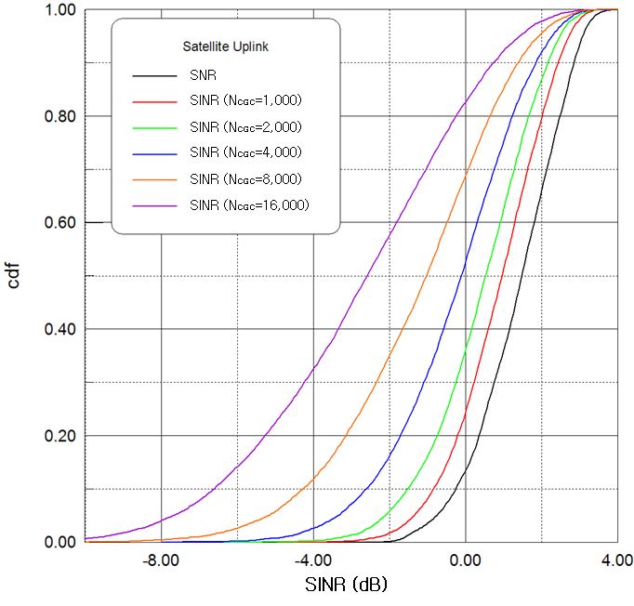
Figure 17 SINR degradation of the satellite component (no exclusive zone)

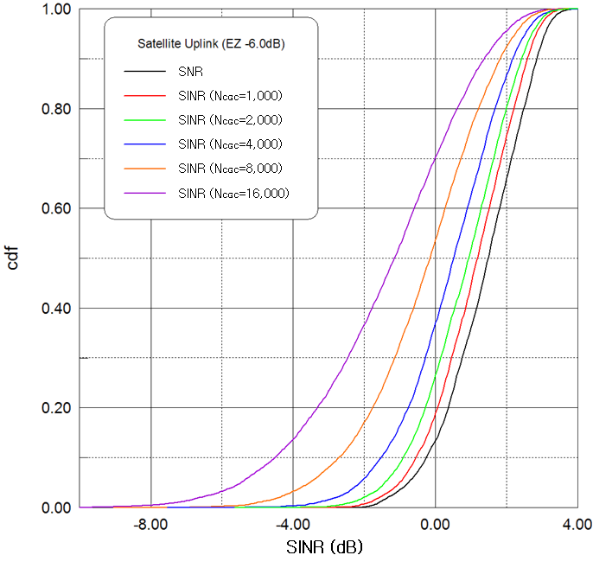
Figure 18 SINR degradation of the satellite component (exclusive zone of -6 dB)

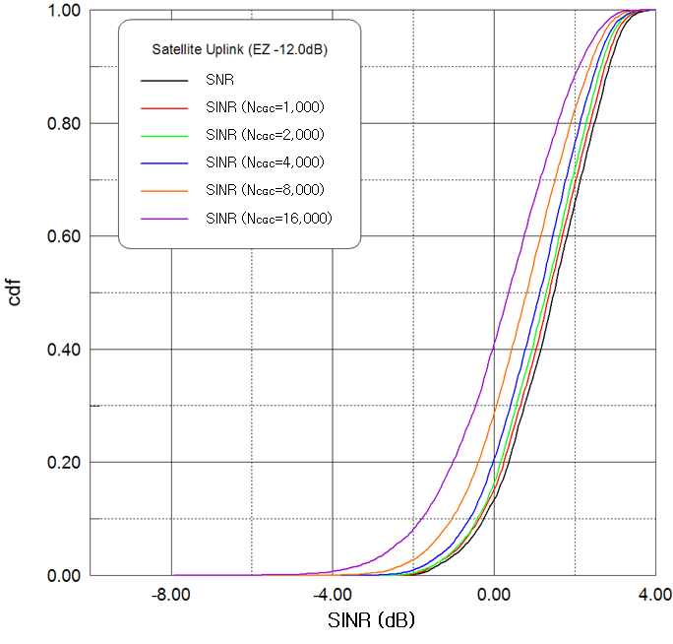
Figure 19 SINR degradation of the satellite component (exclusive zone of -12 dB)

As shown in the figures above, as the number of uplink interferers increases, SINR degradation of satellite component gets worse. However, with application of exclusive zone for CGC, SINR degradation of satellite component can be improved.

Satellite Resource Availability in CGCs

In the event the CGC uplink is in the same frequency range as the satellite uplink, the allowable average UE transmit power could be determined according to the supported MCS mode in the uplink of SAT-OFDM. For example, when the UE of the satellite component needs services with BLER of 10⁻² corresponding to only MCS mode 0, the satellite uplink requires SINR of more than -4.3 dB, assuming the availability of 99%. Therefore, aggregated total transmit power per RB from CGC UEs, which is calculated by the UE transmit power per RB, should be limited to 42.9 dBm. It means that one thousand UEs with average transmit power per RB, 12.9 dBm are allowable and, in the case, when one thousand UEs are deployed in the integrated MSS system, satellite resource availability would be maximized with satisfying the service requirement of satellite component.

Tables 5 to 9 show LTE RB availability in CGCs of the integrated MSS systems, assuming that the UE of the satellite component needs services with BLER of 10⁻² corresponding to MCS mode 0. They represent various cases including no satellite frequency reuse in CGCs, the CGC UE transmit power per RB of 0 dBm and no exclusive zone, the CGC UE transmit power per RB of 6 dBm and no exclusive zone, the CGC UE transmit power per RB of 0 dBm and the exclusive zone of -9 dB, and the CGC UE transmit power per RB of 6 dBm and the exclusive zone of -9 dB, respectively.

Table 5 LTE RB availability in CGCs (no satellite frequency reuse)
Satellite bandwidth per beam | CGC bandwidth per cell | Satellite RB | CGC RB | Satellite RB availability | CGC RB availability
5MHz | 0MHz | 25 | 0 | 25 | 0
3MHz | 12MHz | 15 | 60 | 15 | 60
1.4MHz | 21.4MHz | 6 | 106 | 6 | 106

Table 6 LTE RB availability in CGCs (CGC Tx power/RB: 0dBm, no exclusion zone)
Satellite bandwidth per beam | CGC bandwidth per cell | Satellite RB | CGC RB | Satellite RB availability | CGC RB availability
5MHz | 25MHz | 25 | 125 | 25 | 15.9
3MHz | 26MHz | 15 | 130 | 15 | 68.9
1.4MHz | 28MHz | 6 | 140 | 6 | 110.3

Table 7 LTE RB availability in CGCs (CGC Tx power/RB: 6dBm, no exclusion zone)
Satellite bandwidth per beam | CGC bandwidth per cell | Satellite RB | CGC RB | Satellite RB availability | CGC RB availability
5MHz | 25MHz | 25 | 125 | 25 | 4.0
3MHz | 26MHz | 15 | 130 | 15 | 62.2
1.4MHz | 28MHz | 6 | 140 | 6 | 107.1

Table 8 LTE RB availability in CGCs (CGC Tx power/RB: 0dBm, exclusion zone: -9dB)
Satellite bandwidth per beam | CGC bandwidth per cell | Satellite RB | CGC RB | Satellite RB availability | CGC RB availability
5MHz | 25MHz | 25 | 125 | 25 | 63.6
3MHz | 26MHz | 15 | 130 | 15 | 95.6
1.4MHz | 28MHz | 6 | 140 | 6 | 123.3

Table 9 LTE RB availability in CGCs (CGC Tx power/RB: 6dBm, exclusion zone: -9dB)
Satellite bandwidth per beam | CGC bandwidth per cell | Satellite RB | CGC RB | Satellite RB availability | CGC RB availability
5MHz | 25MHz | 25 | 125 | 25 | 16.0
3MHz | 26MHz | 15 | 130 | 15 | 69.0
1.4MHz | 28MHz | 6 | 140 | 6 | 110.3

From the above evaluation results, it is noted that the satellite frequency reuse in the CGCs of the integrated MSS system increases satellite spectrum utilization as well as the CGC deployment in indoor and urban environments have benefits to increase the number of allowable CGCs as there may be additional clutter in the direction of the satellite, compared to that of CGCs in rural and suburban environment. In addition, for system performance enhancement, intelligent resource management schemes such as the exclusive zone concept need to be applied together.

System Level Simulation Results

Simulation parameters

Effect of the interference from the CGC network on throughput performance in the satellite components can be accessed via system-level simulation. In the system-level simulation for performance assessment in the satellite components, the following parameters in Table 10 are assumed.
Table 10 System-level simulation parameters
General Parameter
Distance between beam centers (km) | 180
The number of satellite UEs per beam | 25
Satellite UEs distribution | Random
Downlink carrier frequency (GHz) | 2.1
Uplink carrier frequency (GHz) | 2.0
Bandwidth per beam (MHz) | 5
Frequency reuse factor | 6
Modulation and coding scheme(MCS) modes | From MCS 0 to MCS16
Target BLER of MCS mode | 10⁻²
Back-off for AMC mode decision (dB) | 2
The number of Stop and Wait HARQ processes | 500
Maximum number of HARQ retransmission | 3
ARQ transmission window size | 1500 PDUs
Maximum number of ARQ retransmission | 2
Channel environment | Open
Scheduling method | Proportional Fairness
Power control | Full power allocation
Traffic model | Full buffer
Link-to-system mapping | Effective Exponential SINR Mapping
Satellite Parameter
Antenna height (km) | 36,000
Number of transmit antenna | 1
Number of receive antenna | 1
Antenna radiation pattern | ITU-R S.672-4
Antenna gain (dBi) | 50
Power for communication payload (kW) | 3.8 (0.2 per beam)
Loss of nonlinearity (dB) | 3
Other loss (dB) | 1.5
System noise temperature (K) | 450
User Equipment Parameter
Antenna height (m) | 1.5
The number of transmit antenna | 1
The number of receive antenna | 1
Antenna radiation pattern | Omnidirectional
Antenna gain (dBi) | 0
Satellite UE transmit power (W) | 0.25, 2
Other loss (dB) | 3
System noise temperature (K) | 290

Performance in open environments

- Uplink performance

Figure 20 shows average uplink spectral efficiency for the satellite UE with maximum transmit power of 250 mW in the satellite component according to the interference level from the CGC UE.
As shown in the figure, because the satellite UE does not secure enough link margin, performance degradation is very sensitive to the interference from the CGC UEs. For example, when I/N value is assumed to -10 dB and 0 dB, performance degradation of 9.7 % and 54.4 % are shown in the satellite uplink, respectively.

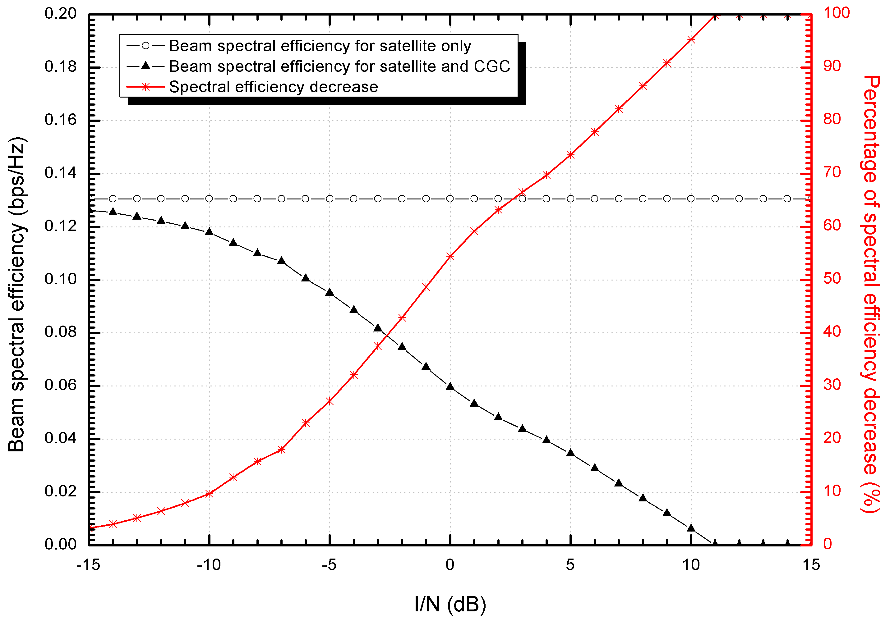
Figure 20 Uplink performance for the satellite component (250mW UE) in open environments

On the other hands, Figure 21 shows average uplink spectral efficiency for the satellite UE with maximum transmit power of 2 W in the satellite component. As shown in the figure, because the satellite UE secures some link margin, performance degradation is less sensitive to the interference form the CGC UEs than that in case of 250 mW UE.

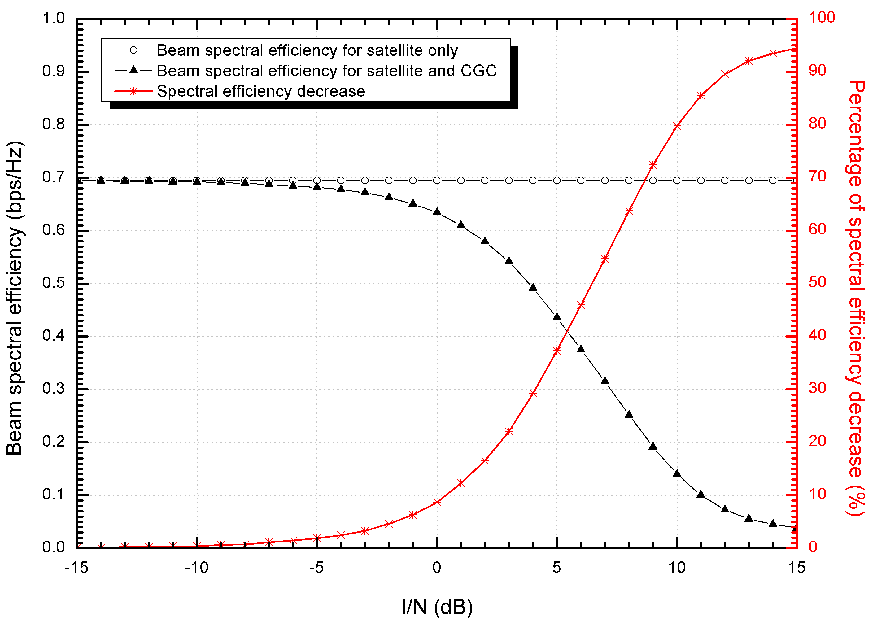
Figure 21 Uplink performance for the satellite component (2W UE) in open environments

It is noted in the Figure 21 that when I/N value is assumed to -10 dB and 0 dB, performance degradation of 0.35 % and 8.59 % are shown in the satellite uplink, respectively.

- Downlink performance

Figure 22 shows average downlink spectral efficiency in the satellite component according to the interference level from the CGCs. In the simulation, the transmit power per beam is assumed to be 200W.

Because the satellite downlink secures some link margin compared to the satellite uplink case, performance degradation of the satellite downlink is less sensitive than that of the satellite uplink, in general. As shown in the figure, when I/N value is assumed to -10 dB and 0 dB, performance degradation of 1.15 % and 15.01 % are shown in the satellite downlink, respectively. It is also shown in that Figure that the performance degradation above is a little bit more severe than that of 2 W satellite UE in the uplink, because 16QAM modulation is applied in the downlink while QPSK modulation in the uplink.

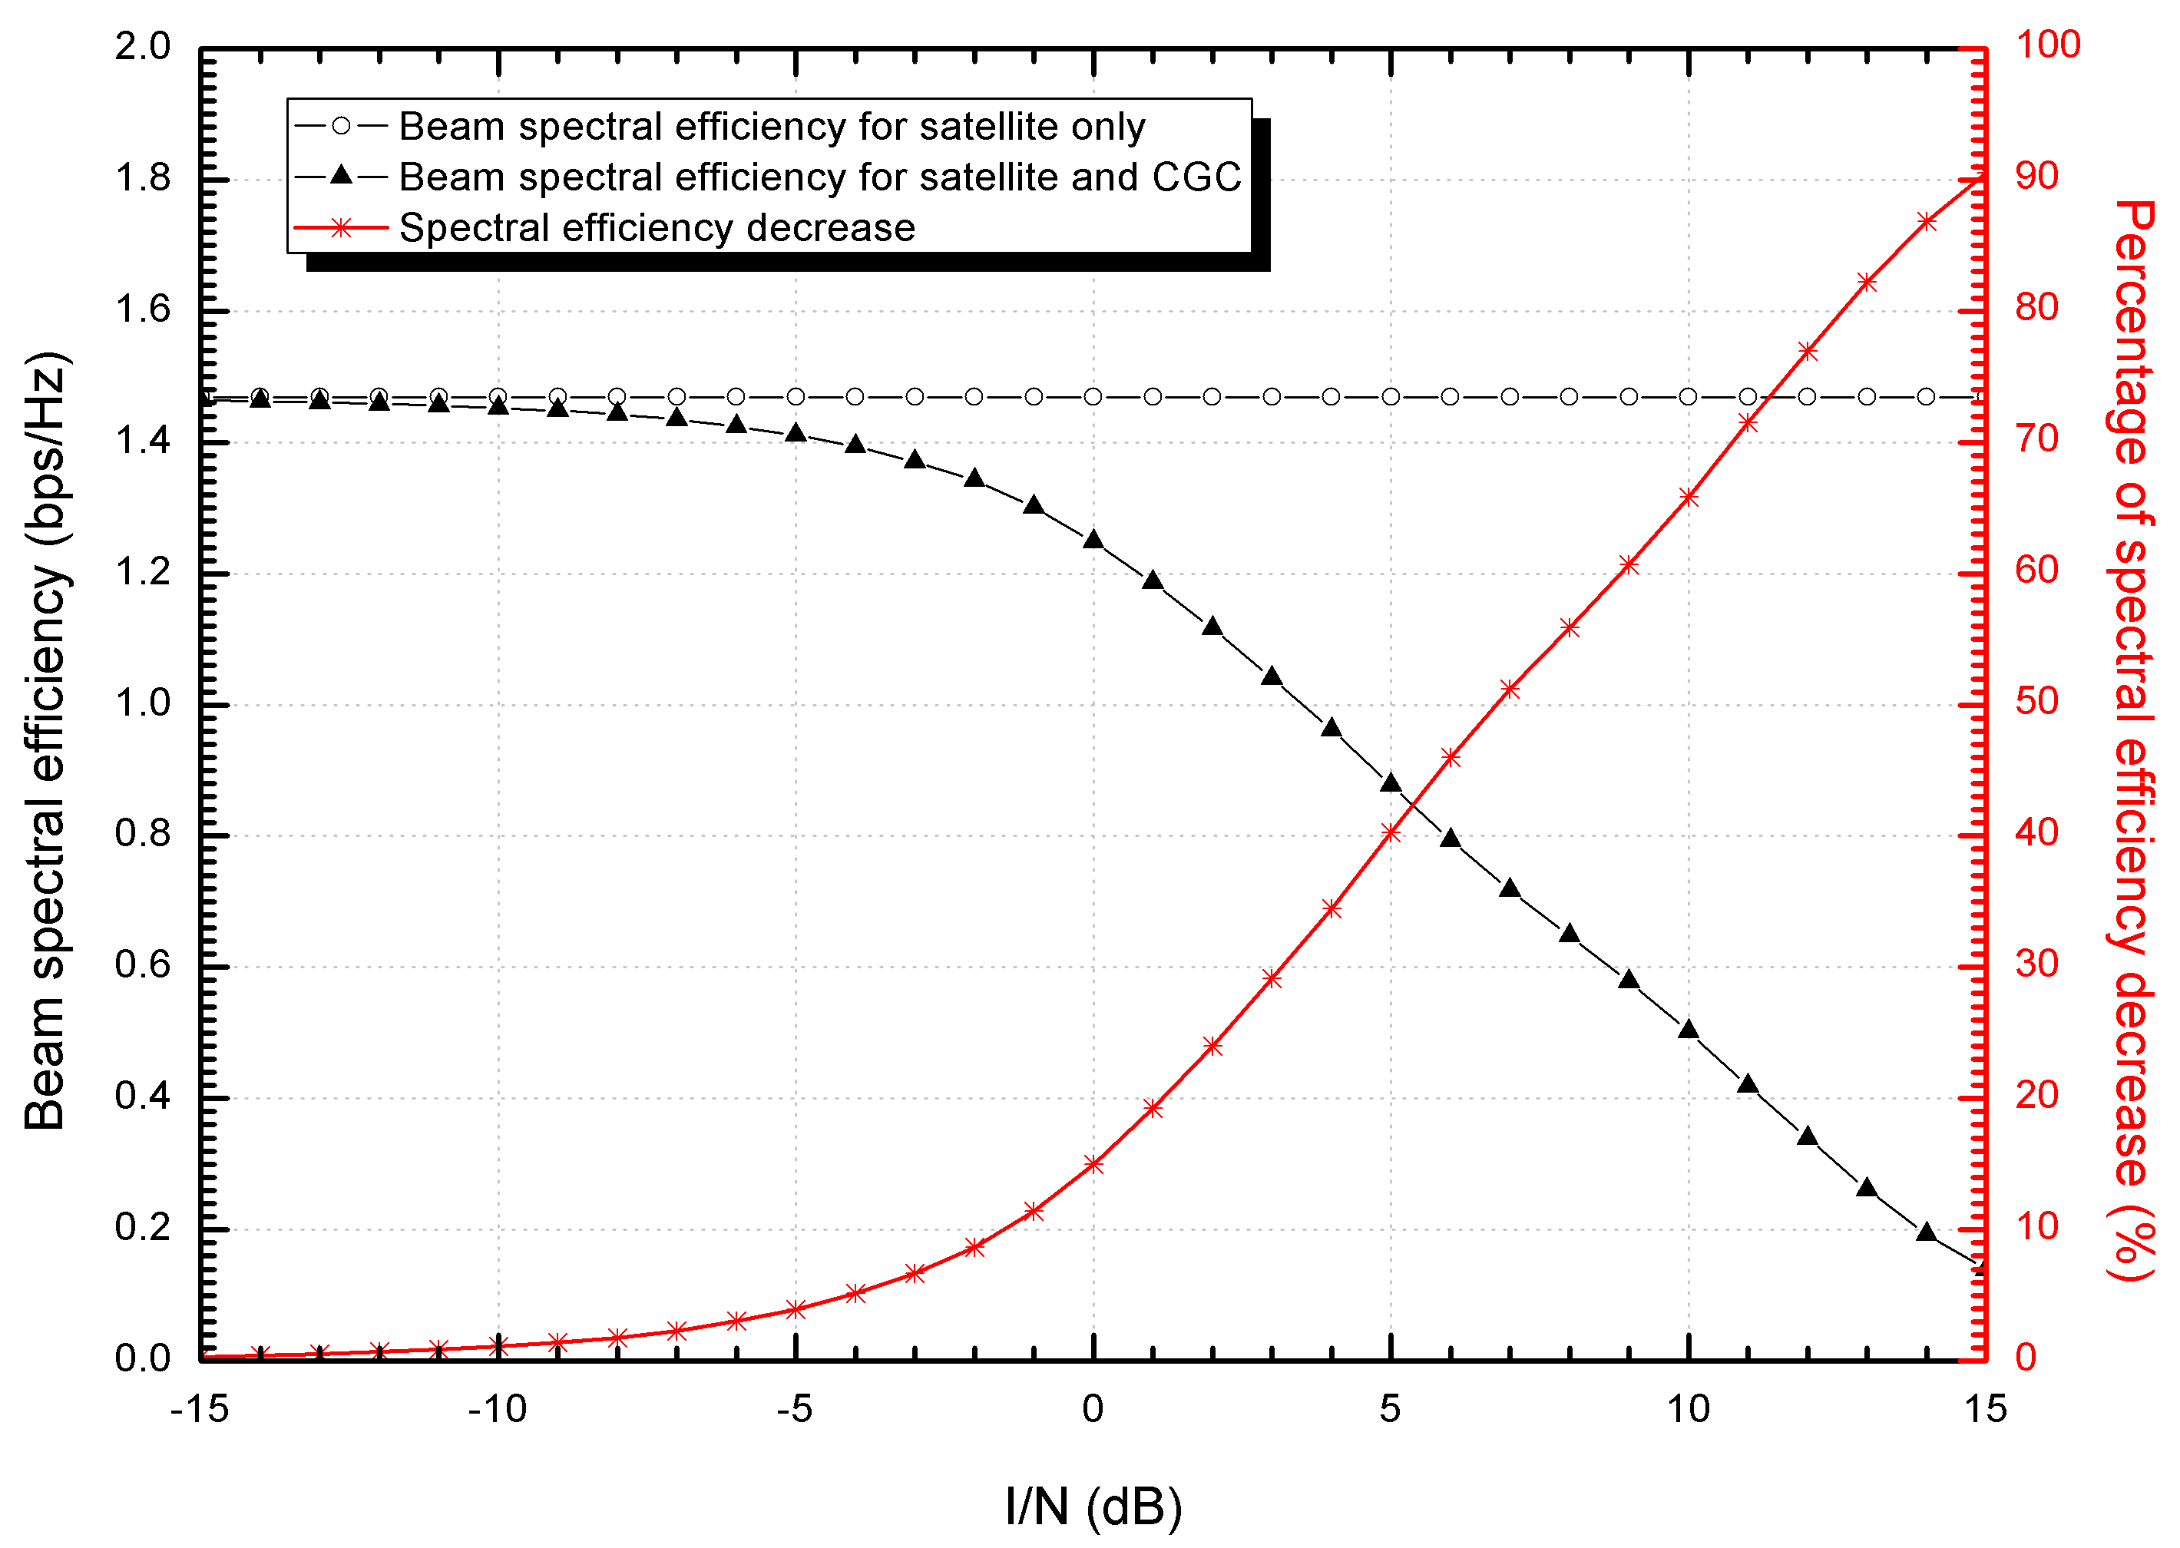
Figure 22 Downlink performance for the satellite component in open environments

Summary

From the above simulation results, it is noted that the satellite frequency reuse in the CGCs of the integrated MSS system induces a certain amount of system performance degradation in the satellite component, depending on up/down link design requirements such as supportable UE types, modulation and coding scheme, etc. For example, assuming that the performance degradation of less than 10 % would be permitted in system level simulation, the satellite UE with the power of 2W could endure interference from CGCs ten times as large as the satellite UE with the power of 250 mW. Therefore, for the operation of the satellite component under tolerable interference level, the CGC deployment should be carefully controlled within service scenarios and system architecture of the satellite component.

Current Studies

Satellite/Terrestrial Integrated Mobile Communication System (STICS) by the National Institute of Information and Communications Technology (NICT) of Japan

There is an increasing need for providing mobile phone services in the terrestrial cellular service dead zones and providing telecommunications infrastructure to support relief missions in the event of a natural disaster. Using a satellite link enables quick deployment of a mobile network in rural areas or disaster zones where urgent communication recovery is required. The National Institute of Information and Communications Technology (NICT) has studied a new satellite mobile communication system, namely, Satellite/Terrestrial Integrated mobile Communication System (STICS) to overcome the above problems and provide modern satellite applications, under the Commissioned Business program of Japan’s Ministry of Internal Affairs and Communications. STICS is a kind of integrated Mobile Satellite Service (MSS) system, in which terrestrial mobile and satellite communication systems coexist and they are seamlessly integrated in the same frequency band.

It is noted that other MSS systems are to some extent compatible with 3G and 4G. STICS is one of several possible use cases. The following subsections introduce the concept of STICS and feasibility study to verify the system.

Concept of STICS

In this section, concept of STICS [1] is introduced. Figure 23 illustrates a conceptual sketch of STICS. The system realizes “dual” communication of both terrestrial and satellite systems. A common terminal is used for both communications. The handheld terminal is equipped with micro/internal antenna for voice/low-data communication, and a portable terminal is equipped with small antenna for data communications.

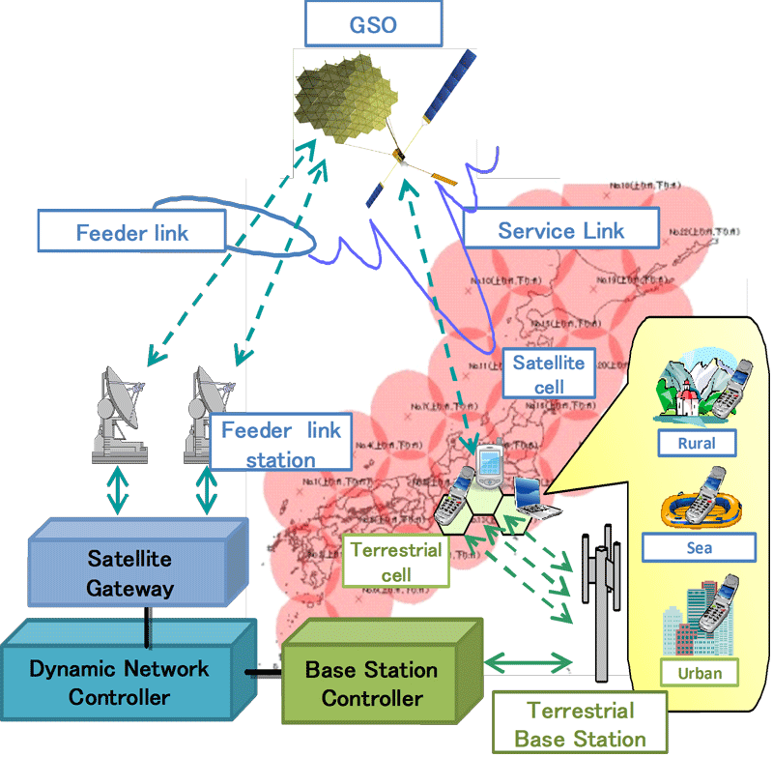
Figure 23 Conceptual sketch of STICS

The feeder-link stations and the base station are equipped with a satellite gateway and base station controller, respectively. They are managed by using a common dynamic network controller. It is connected to the core network.

The system is assumed to utilize the S-band frequency. To share these bands between satellite and terrestrial system to realize high spectral efficiency, two frequency allocation methods, called “normal mode” and “reverse mode” are considered. Figure 24 illustrates two modes.

(a) Normal mode (b) Reverse mode
Figure 24 Frequency allocation scheme

Frequency sharing between satellite and terrestrial system is realized by the mechanism described as follows.
- Allocated band is divided into several sub-bands.
- Sub-bands are assigned to multiple satellite cells with multi-color scheme.
- Particular sub-band is assigned to terrestrial cells outside the satellite cell using the sub-band.

In reality, co-channel interference between satellite component and terrestrial component of STICS exists since satellite antenna has sensitivity outside the satellite cell. There are four interference paths between satellite and terrestrial system as shown in Figure 25.

(a) Normal mode (b) Reverse mode
Figure 25 Interference path

To realize the system, high EIRP and G/T communication satellite using a multibeam antenna with the 30m-class-diameter reflector is required. The satellite antenna gain and G/T is more than 47 dBi and more than 21 dB/K, respectively. Spot beam size is around 200 km. As a result, around hundred satellite beams are required to realize Japanese islands and the Exclusive Economic Zone (EEZ) as satellite system service area.

System requirement

Several key factors are addressed to realize the system described in previous subsection.

- Frequency sharing between satellite component and terrestrial component of the integrated system

Frequency sharing system needs to be designed considering the existence of co-channel interference. Especially, interference caused from terrestrial component to satellite component is important issue because aggregate interference from large number of terminals/base stations is received at the satellite. Allowable number of satellite and terrestrial links under co-channel interference is key factor in evaluation of system feasibility.

- Cooperative control of satellite and terrestrial system

Cooperative control of satellite and terrestrial system is required to establish satellite or terrestrial link to dual-mode terminal in seamless manner. To maintain communications link under temporally changing satellite and terrestrial traffic, the traffic state needs to be monitored and resource allocation needs to be dynamically changed.

- Multibeam and low-sidelobe satellite antenna

To cover the required service area by using 30m class-diameter large satellite antenna, around hundred multibeam system is required. Sidelobe levels of the satellite antenna needs to be maintained at a low level to suppress beam-to-beam interference level in multibeam system, and to suppress interference level to/from other systems. To satisfy these requirements, analog beamforming is not practical because weight of the beamforming circuit is too heavy. Onboard digital beamforming is advantageous in realizing these requirements because of its scalability and flexibility.

- Reconstruction of satellite resource allocation

Satellite and terrestrial traffic is asymmetrically distributed in wide area and changing temporally. Especially in emergency situation such as a disaster, high volumes of traffic are expected. Therefore satellite resources (e.g. frequency, power) need to be flexibly allocated to each satellite beam depending on the traffic state. Onboard digital channelizing is a candidate technology to satisfy this requirement because of its flexibility.

Feasibility studies

Frequency sharing system needs to be designed considering the existence of co-channel interference. Interference caused from terrestrial component to satellite is important issue because aggregate interference from large number of terminals/base stations is received at the satellite. Measuring transmit power of existing W-CDMA system is useful in estimating the interference power from terrestrial component to satellite in STICS system. Therefore NICT carried out the measurement campaigns of W-CDMA cellular phone system transmit power by using test van, aircraft, and handcart. This section describes the overview and some results on these measurement campaigns.

Test measurement of cellular phone transmit power using test van

- Background

Measurement of transmit power of the terrestrial cellular phone terminal is useful in estimation of the realistic value of the interference power from terrestrial terminal to satellite in STICS, if conventional IMT system is considered as the terrestrial system. In a W-CDMA system the transmit power of the cellular phone changes with the transmit power control (TPC). Therefore, the interference power from terrestrial terminal to satellite would change depending on location of the terrestrial terminal. NICT has conducted the measurement of W-CDMA cellular phone transmit power by using test van [2]. This section describes the overview and some results on the measurement.

- Measurement system

Figure 26 shows block diagram of the measurement system. The output power of a typical cellular phone is measured by the power meter. (cellular phones of 3rd generation mobile communication (3G) of three mobile phone carriers in Japan are available for the measurement).Measurement frequency is in the 2GHz band. A dummy human head to simulate the electrical characteristics of the real human head, called Phantom, is located near the external antenna to mimic realistic usage condition of cellular phone. Position of the test van is recorded by using navigation software and GPS. Field image of experiment is recorded in D-VCR. Figure 27 shows the test van. Using this system, the output power of the W-CDMA terminal was measured at several locations from dense urban to rural area around Kanto district in Japan including Tokyo. Table 11 lists the measurement locations.

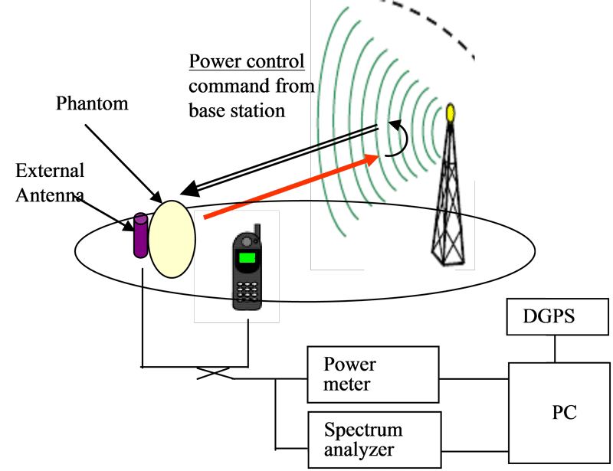
Figure 26 Block diagram of measurement system
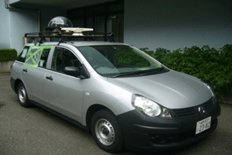
Figure 27 Test van

Table 11 Measurement Locations
 | Location | City
A | Dense urban | Shibuya
B | Urban | Koganei
C | Suburban | Yoshimi
D | Suburban | Ohtsuki
E | Rural | Yamanashi
F | Urban | Kawagoe
G | Urban | Oume

- Measurement result

Figure 28 shows the average output power vs. population density. Low output power is observed in Dense urban and Urban area which is lower than -5 dBm. Maximum power is observed in rural area which is +7 dBm. These measured powers are quite lower than the maximum capability of W-CDMA cellular phone is +24 dBm. The average output power decreases as population density increases. This trend is observed in data for both carrier “X” and “Y”.

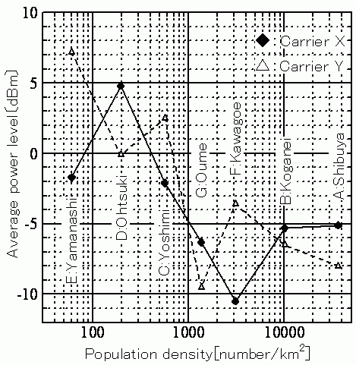
Figure 28 Output power vs. population density

- Summary

Measurements using the test van in several locations in Kanto district in Japan (from dense urban to rural areas) indicated that the average transmit power of cellular phone is quite lower than the maximum capability of W-CDMA cellular phone system, and that the average transmit power is inversely proportional to the population density. These results are useful in estimation of the interference level from terrestrial terminal to satellite in STICS.

Test measurement of interference power from cellular phones and base stations using airplane

- Background

The interference from terrestrial base stations or mobile terminals to the satellite component is one of the important parameters for realization of a new satellite mobile communication system, named Satellite-Terrestrial Integrated Mobile Communication Systems (STICS). Although there are some studies about the characteristics of transmitted power of mobile terminals and its statistical data are released, there are no studies that evaluate the amount of radiation of cellular base stations and mobile terminals toward the satellite. NICT has conducted several experiments to measure the radiation powers of the existing mobile base stations and mobile terminals toward satellites [3]. An experiment to measure the radiation power of the existing mobile terminals and base stations using an airplane was conducted as part of the interference evaluation toward satellites. This section gives the overview of the experiment using an airplane and some of the results.

- Interference evaluation experiment

The interference from the terrestrial mobile terminals could be a dominant interference in the normal system because the number of terrestrial mobile terminals is large and the accumulated transmitted power may cause interference to satellite component. As for the reverse system, the downlink of base stations could be a dominant interference to the satellite. An experiment was conducted to measure the radiation power of the existing mobile base stations and mobile terminals toward satellites using an airplane as shown in Figure 29.

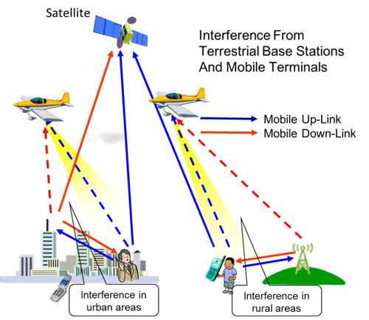

Figure 29 Schematic of experiment using aircraft

- Platform and measurement system

As shown in Figure 30, an airplane ‘Cessna208B’ was used as a platform for the measurement equipment in the experiment. The measurement system was loaded in the airplane’s cabin and a receiving horn antenna was also mounted in the cabin sticking out of the floor hatch of the cabin tilting at a 45 degrees angle from a horizontal direction as shown in Figure 30 in consideration for the satellite elevation angle in Japan. The receiver can receive the radio signals in the 1.9-2.2 GHz bands by selecting the receiver’s channel and measure the received power from the existing mobile base stations and mobile terminals.

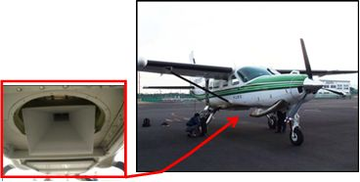
Figure 30 Airplane (Cessna208B) and measuring horn antenna used for the measurement of the interference

Table 12 and Figure 31 show the reception frequencies of the measurement equipment in the experiment and the measurement system diagram, respectively. The antenna system also equipped a GPS system and a gyro-sensor to obtain the position and attitude of the receiving antenna to measure the position of the system.

Table 12 Reception Frequencies
 | Reception frequencies [MHz]
Up-Link | 1942.5, 1947.5, 1952.5, 1957.5
Up-Link | 1962.5, 1967.5, 1972.5, 1977.5
Down Link | 2132.5, 2137.5, 2142.5, 2147.5
Down Link | 2152.5, 2157.5, 2162.5, 2167.5

Amp
Spectrum
Analyzer
DIP
Horn Antenna
From Control PC
BPF for Uplink
BPF for Downlink
Figure 31 Measurement system diagram

- Measurement and results

The experiment was conducted in several areas as shown in Figure 32 which includes rural and urban areas with varying density of base stations and mobile terminals in Japan. There are more than ten IMT base stations per 1 km² in urban areas and one or two base stations per 1 km² in rural areas. The measurement locations are as follows:

- Rural and urban areas around Tokyo and off the coast of Choshi.
- Long distance area over 500 km between the Kanto region and the Kii peninsula.
- Thinly-populated areas with population density of 100 or less per square kilometer.

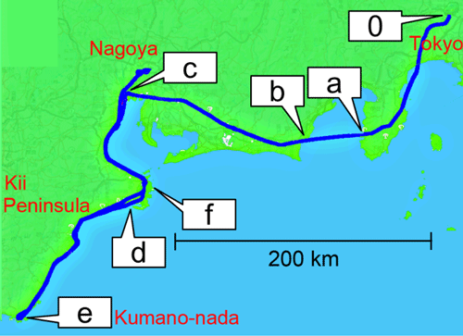
Figure 32 An example of flight between the Kanto region and the Kii peninsula (0: Tokyo, c: Nagoya, e: Kumano-nada)

- Wide area measurement

The measurement data for a wide area over 500 km were obtained in order to evaluate the radiation distribution of the interference from the entire Japanese islands. As shown in Figure 32, the measurement was started at Kanto region area (0: Tokyo area) and ended at the Kii peninsula (c-d-e-f: Nagoya area). The entire area of the measurement includes city, ocean, thinly-populated areas, and seacoasts. Therefore, the improvement of the accuracy of the analyzing the interference is expected by obtaining several types of measurement data.

A measured example of received power between the Kanto region and Nagoya region is shown in Figure 33. It is observed that the downlink channel is larger than in the uplink channel to 25~30 dB and that several peaks during the urban area around “c”. It is considered that the peaks of the received power are due to passing over base stations.

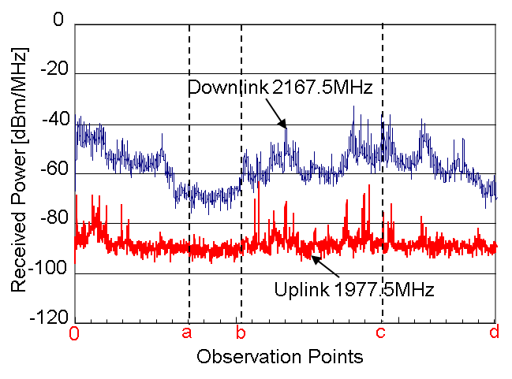
Figure 33 A measured example of received power between the Kanto region and Nagoya region

- Thinly-populated area measurement

Another measurement of the radiation power along the coastline of the Kii peninsula was made. The area along the coastline of the Kii peninsula (c-d-e) includes thinly-populated areas with population density of 100 or less per square kilometer. The measurement was started at Nagoya (c) and ended at Kumano-nada (e) located at the south end of the Kii peninsula.

A measured example of received power along the coastline (c-d-e-f) is shown in Figure 34 where the area between “d” and “f” includes thinly-populated zones. It is observed that the received power of the down link in the area is 20 dB lower than the other areas.

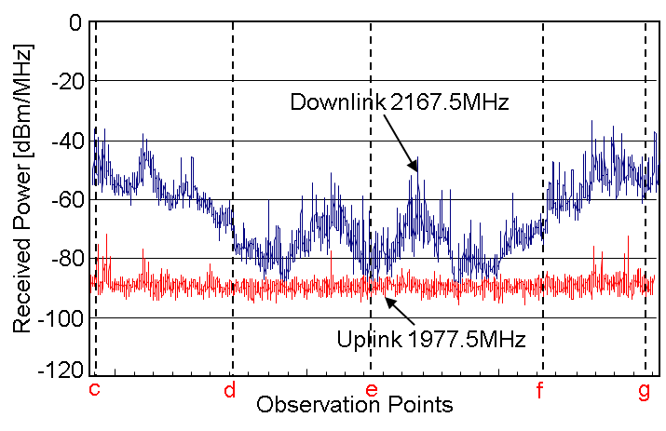
Figure 34 A measured example of received power between Nagoya and Kumano-nada

- Relationship between measured power and interference to satellite

The final goal of the experiment is to evaluate the interference level toward satellite using the observed results. The total interference level toward satellite has to be evaluated from the observed level obtained by airplane. Therefore, it is important to show the relationship between the received power and the size of effective footprint of the receiving antenna as depicted in Figure 35.

Satellite
About 200 km
Altitude: 5786km
Altitude: 500m～1000m

Figure 35 Relationship between measured power and interference to satellite

- Evaluation model

As depicted in Figure 36, the one-dimensional simulation model is introduced to evaluate the relation between the size of the footprint and the received power of the horn antenna used in the experiment. In the simulation model, transmitters are placed at equal spaces in a line to simulate distributed mobile terminals or base stations. The total length of the distributed transmitters is defined by L. The value of L is generally large because a number of transmitters are assumed to exist on the ground. The value β is calculated by considering the length of L and the geometric position of the receiving antenna in Figure 36.

Then a parameter α in Figure 36 is introduced to determine the range of the footprint of antenna and to give the number of transmitter within the footprint. The value of ‘l’ is also calculated in a similar way of the calculation of the parameter L. The total power of incoming signals from the ground, which means the received power of the antenna, can be calculated by taking into account of the conditions such as the number of the transmitters within L, the antenna beam pattern of the receiving antenna, and the radio propagation. Therefore, the power ratio r(α) of the received power caused by the transmitters within the range of ‘l’ to the total received power can be calculated as,

PR (α) = | Total received power from the area ‘l’
PR (α) = | Total received power from the area ‘L’
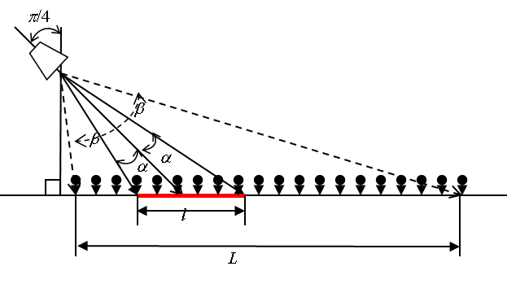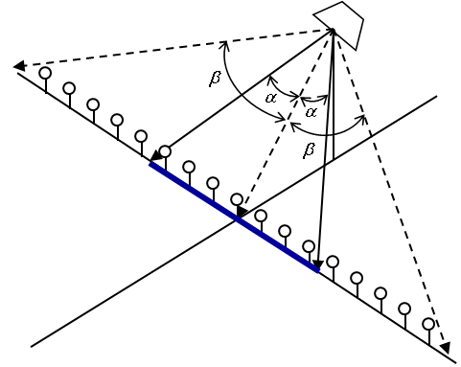
Figure 36 One-dimensional simulation model E-plane (left) and H-plane (right) of antenna and transmitters on the ground

Figure 37 shows the simulation result of the power ratios of H- and E-planes with respect to α where the transmitters on the ground are assumed to send signals with equal power and omni-directional antenna. The actual antenna gain patterns of the horn antenna used in the experiments was used to conduct the simulations. The simulation result shows that the power ratio from 0 to 0.8 of both E- and H-planes of the receiving antenna increases in almost direct proportion to α. This means the accurate estimated values of α are expected if the value of the power ratio up to 0.8 is chosen. The simulation result shows that 80 percent of the received power at the horn antenna results from the transmitters within the area defined by the angle of α = 16.6 degrees (H-plane) or α = 16.2 degrees (E-plane) when the center frequency is set at 2110 MHz.

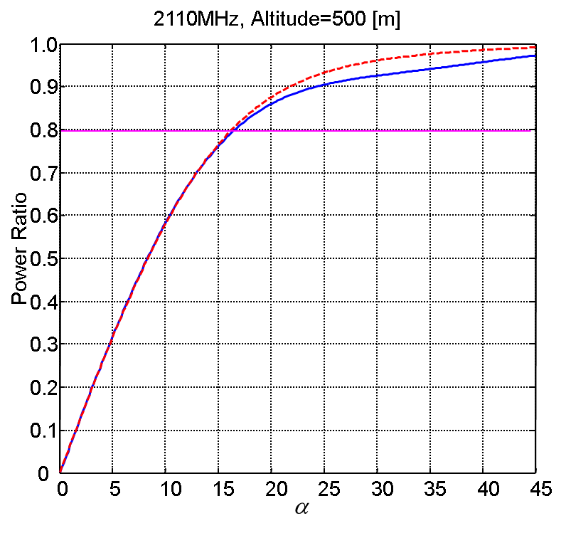
Figure 37 Simulation result of the power ratios of H- and E-plane

- Summary

Some results of evaluating the interference from IMT uplink and downlink channels using a horn antenna equipped with an airplane are discussed through the experiment and simulations. In the experiments, it is observed that the receiving powers vary depending on the areas and that the received power in the downlink channel is larger than in the uplink channel to 25~30 dB. This result shows that the introducing ‘the normal frequency-division duplexing system’ in STICS may reduce the interference to the satellite. It is also observed that the received power of the down link in thinly-populated areas with population density of 100 or less per square kilometer is 20 dB lower than the other areas in Japan. Finally, the relationship between the measured power and the footprint of the receiving antenna is given by introducing the system model of distributed transmitters on the ground.

Test measurement of interference power from cellular phone in indoor/outdoor situation using handcart

- Background

In STICS, the same frequency band is shared between satellite component and terrestrial component to realize high spectral efficiency. One possible interference path is terrestrial component uplink interfering to satellite uplink (interference sources are cellular phones using terrestrial link, and interfered station is satellite). The important point in estimating the interference level caused by cellular phone using terrestrial link is that the interference level varies depending on the usage condition of the cellular phones. One reason is that the propagation loss in ground-to-satellite interference path differs depending on the location of the cellular phone user (outdoor LOS/NLOS, indoor toward satellite). Another reason is that if conventional IMT-2000 system is considered as a terrestrial service, interference level also varies by the change of transmit signal power of cell phone caused by transmit power control (TPC). Past studies on ground-to-satellite propagation only focus on the propagation loss in ground-to-satellite channel.

To collect fundamental data for the estimation of the interference level to satellite caused by cellular phones using terrestrial link in STICS, NICT has carried out the fundamental outdoor/indoor experiment [4]. In the experiment, a mobile station (MS) equipped with a IMT-2000 cellular phone (as a cellular phone using terrestrial service in STICS) is located at the outdoor/indoor environments and a pseudo satellite (PS, as a STICS satellite) is located on top of a tower which mimics STICS interference situation. This section gives an overview of the experiment and some results.

- Outdoor/Indoor propagation experiment

Figure 38 illustrates frequency reuse between satellite component and terrestrial component and interference path for satellite uplink in normal mode. The entire 30 MHz frequency bandwidth of 2 GHz MSS band is divided into several sub-bands.

The STICS satellite illuminates hundreds of spot beams to cover Japanese islands and Exclusive Economic Zone (EEZ) area (though one satellite beam is illustrated in the figure for simplicity). Sub-band frequencies are assigned to these beams using a typical frequency reuse. Frequency sharing between satellite and terrestrial link is realized by assigning sub-band f1 to the terrestrial link outside the satellite cell for which sub-band f1 is assigned.

Figure 38 Schematic diagram illustrating frequency reuse between satellite component and terrestrial component and interference path to satellite in normal mode
Spatial guard-band enhances the isolation level to reduce the received interference power at the satellite caused by cellular phone using terrestrial link. The subject in this work is that the interference to satellite caused by the cellular phone using terrestrial link is not uniform, and varies depending on the propagation state of the cellular phone (outdoor/indoor, LOS/NLOS toward base station/satellite). Therefore, fundamental data on the interference level to the satellite with various locations of cellular phone is required to estimate the amount of the interference level to satellite.

- Measurement system

The experiment was carried out on December 2010 in the site of NICT headquarter in Koganei, Tokyo Japan. The site consists of concrete office buildings with average height of 12m (maximum 21m).

Figure 39 illustrates the schematic of the experimental system. The MS equipped with IMT-2000 cellular phone is located at outdoor/indoor measurement position. A transmit signal from the cellular phone is divided by a power divider into two signals, one of which is radiated from an external antenna and the other is measured at a power meter. The MS also equips a CW transmitter with maximum transmit power of 1 W at 2.3 GHz. The PS is located on top of the 50-m height tower with horizontal distance toward the MS of 50 m-150 m. 2.3 GHz CW transmitted from a CW transmitter antenna is received by a horn antenna with half-power beam width of 30°, amplified by a low noise amplifier, and measured by a spectrum analyzer. The horn antenna is pointed at the direction of maximum received power for each several sections on the route of the MS (maximum length = 30m = ten sections). The transmit power of cellular phone at the MS and the received power of CW at the PS are measured simultaneously. Table 13 lists the measurement conditions.

Table 13 Measurement Conditions

Figure 39 Schematic of experimental system
- Measurement result

Figure 40 shows the histogram of cellular phone EIRP. It is observed that the EIRP in indoor is higher than that in outdoor. The differences of average and median values are 11 dB and 7 dB, respectively. On the other hand, as shown in Figure 41 the received power of CW at the PS in indoor is lower than that in outdoor. The differences of average and median values are 17 dB and 20 dB, respectively. In comparing these results between outdoor and indoor measurements, it is important to note that the amount of increase in attenuation at MS-PS channel in indoor is larger than the amount of transmit power raise in indoor.

Figure 40 Histogram of cellular phone EIRP
Figure 41 Histogram of received power of CW at the PS. Transmit power of CW, which is changed depending on position of the MS, is normalized at 1W. Received power at the PS is defined as power of incident wave at the horn antenna

From these measured quantities, one can estimate the received power of cellular phone transmit wave at the PS Pps_phone by using the following simple equation

,

where P_{ms_phone} is the transmit power of the cellular phone at the MS, P_{ps_cw} is the received power of CW at the PS, and P_{ms_cw} is the transmit power of CW at the MS.

The histogram of the estimated received power of cellular phone transmit wave at the PS is plotted in Figure 42. It is observed that the estimated received power of indoor cellular phone transmit wave is lower than that of outdoor cellular phone transmit wave. The differences of average and median values are 8 dB and 10 dB, respectively. Table 14 summarizes the results.

Figure 42 Histogram of estimated received power of cellular phone transmit wave at the PS
Table 14 Summarized Results
*Sections with unsuccessful measurements are not used in analysis.
- Summary

A propagation experiment has been carried out in outdoor/indoor environment in office building site to estimate the interference level to satellite caused by cellular phone using terrestrial link in STICS. Statistical analysis was performed by using measured data collected from over six-hundred positions in outdoor/indoor locations. It indicates that the amount of increase in the attenuation of indoor MS to PS propagation channel compared with that of outdoor MS to PS propagation channel is larger than the amount of raise in the transmit power of indoor cellular phone compared with that of outdoor cellular phone. This fact leads to the result that the estimated received power of transmit wave from indoor cellular phone at the PS is lower than that from outdoor cellular phone (the estimated received power is calculated by using measured cellular phone transmit powers and received powers of CW at the PS). These results are useful in the estimation of the interference level to satellite caused by cellular phone using terrestrial link in STICS.

System capacity evaluation

- Background

In STICS, mobile terminal has seamless connection to both terrestrial and satellite components. These terrestrial and satellite components shares same frequency band under the co-channel interference. In this study, system capacity of terrestrial and satellite components under co-channel interference is evaluated to verify frequency sharing between terrestrial and satellite components [5]. Capacity is evaluated when interference path between satellite and terrestrial components is between satellite and terrestrial base stations. Two scenarios are evaluated; normal period and disaster period. We have developed a tool to calculate the capacity of terrestrial and satellite links in STICS. Considering different interference mechanism, minimum separation distance between satellite terminal and base station existing near satellite cell edge is evaluated as a worst-case evaluation to evaluate interference path between satellite terminal and base station.

- Frequency sharing scheme and interference mechanism

Frequency sharing between satellite and terrestrial links is realized by the allocation of different sub-band to satellite and terrestrial link. However, in reality, co-channel interference between satellite and terrestrial links exists since satellite antenna has sensitivity outside the satellite cell. Figure 43 illustrates the interference path in STICS.

There are four interference paths between satellite and terrestrial links. Combination of interfered and interfering links is shown in Table 15. Each interfered link has two interfering links (satellite and terrestrial links). It is important to note that the interference mechanism varies whether the interference path is satellite-terrestrial terminals (satellite propagation channel, i.e. the terrestrial uplink from the terrestrial user terminal to the satellite antenna) or satellite terminals-base stations (terrestrial propagation channel, i.e. the satellite uplink from satellite user terminal to BS). When propagation channel is satellite-terrestrial terminals, aggregate power from huge number of terrestrial terminals in the whole service area interferes into the satellite receive path since propagation distance from every terrestrial terminal to satellite is similar (except for indoor users, or users in urban canyons shielding the satellite path).

On the other hand, when propagation channel is satellite terminals-base stations, interference level drastically changes depending on propagation distance. Since every satellite beam is large (around 200km diameter), interference from satellite terminals located at the center of satellite cell can be ignored (assuming there is no nearby CGC system). The interference should be considered when satellite terminals location is near satellite cell edge.

Moreover, “spatial guard-band” is able to be applied as a measure of interference mitigation in STICS. The concept of spatial guard band is to define the area around particular satellite cell in which terrestrial user terminal is prohibited to utilize the sub-band assigned for the satellite cell. The advantage of this spatial guard-band is to mitigate the interference level between satellite and terrestrial link. However, increase of this guard-band decreases the communication area for terrestrial link. Therefore, it is expected to evaluate both the effect and the limit.

Table 15 Combination of interfered and interfering links

Figure 43 Interference path between satellite and terrestrial links

- Evaluation methodology

System capacity of the STICS based on required C/N0 is calculated in the normal mode by the developed interference calculation simulator [6] and channel capacity calculation subroutine as shown in Figure 44. Detailed interference model is constructed and measured data on transmit power is used as input data for the model.

Figure 44 System capacity evaluation methodology

Link parameters for satellite and terrestrial links are listed in Tables 16 and 17, respectively. The frequency bands 1 980-2 010 MHz and 2 170-2 200 MHz are applied as the evaluation frequency band. The information rate of 9.6 kbps is a typical rate of the system since voice communication is the main assumed service of the STICS system. In terrestrial link, service area is divided into many grids (grid size=around 10km) to put number of terminals and transmit power of each terminal for each grid. Number and transmit power of base station is put by using radio station license information in Japan in 2010. Number of terminals is calculated from daytime population for each grid and assumed call rate (1%). Transmit power of terminal for population class which is estimated based on statistical analysis of measured data of W-CDMA cellular phone transmit power obtained by measurement campaign in Japan [7] is applied as the transmit power of terminal. The average transmit power is below 1mW, which is quite lower than cellular phone maximum transmit power of around 200mW.

Table 16 Condition of terrestrial link.

Table 17 Condition of satellite link.

Satellite beam allocation is shown in Figure 45. Eighty-three satellite beams is assumed to cover Japanese island and Exclusive Economic Zone (EEZ). Sub-band of 4.3 MHz is assigned to each satellite beam (seven beam=one cluster=30MHz). Transmit power of each satellite link is 200mW. Maximum number of satellite link of 10,000 links is derived from assumed total transmit power of satellite of 2kW. In the normal period, terminals are assumed to be uniformly distributed. In the disaster period, maximum number of satellite channel, which is able to be assigned to one satellite beam, is assumed to be used. This is realized by changing frequency band allocation to each satellite beam by using channelizing function of satellite transponder which is assumed to be applied in STICS.

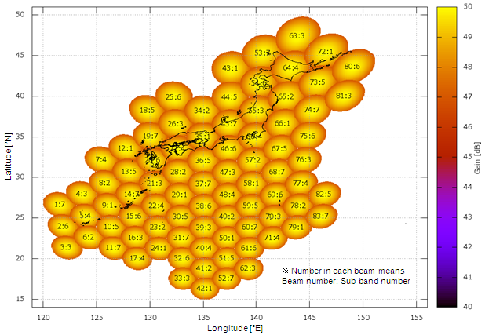
Figure 45 Satellite beam allocation.

Capacity evaluation is performed for three cases; interfering link is only terrestrial link (interference from satellite link is ignored), only satellite link (interference from terrestrial link is ignored), both satellite and terrestrial links. Calculation procedure is described as follows. By using developed interference calculation simulator, received signal power and interference signal power are calculated for each interfered link. Then, obtained values are used to calculate the capacity by using the program by the following procedure.

(a) Average interference level for each link is calculated based on the equation
(1),
where M is number of interfering links in which frequency band is overlapped to interfered link, Im is the interference level for m-th interfering link, and B is ratio of frequency band overlap between m-th interfering link and interfered link.

(b) Link coefficient a, which is maximum number of interfering links under the condition that particular interfered link satisfies required C/N0, is calculated based on the equation
(2)
The effect of spatial guard-band is also evaluated by setting spatial guard-band at 0dB, 5dB, 10dB.

- Evaluation for normal period

- Evaluation under interference between satellite and terrestrial terminals

Desired signal: satellite uplink

Satellite uplink suffers the interference from terrestrial terminal uplinks using same sub-band outside the satellite cell, and the interference from satellite terminal uplinks using same sub-band in other satellite cells. The result of capacity calculation is shown in Figure 46. The number of satellite link is 10,000, which means that the satellite link is established independent on the value of spatial guard-band. When spatial guard-band is 0 dB, the number of terrestrial terminals is 14 million, when the satellite uplink only suffers the interference from the terrestrial terminals and the interference from satellite link in other satellite cells to the satellite uplink is ignored and the number of terrestrial terminals is 13 million when the satellite uplink suffers the interference from both terrestrial terminals and satellite link in other satellite cells, respectively. Maximum number of terminals is observed when spatial guard-band is 10 dB. On the other hand, communication area for terrestrial terminal is 100%, 88%, and 31% when spatial guard-band is 0 dB, 5 dB, and 10 dB, respectively. This indicates that the communication area for a terrestrial terminal decreases when spatial guard-band increases.

Figure 46 Capacity of interfering links when interfered link is satellite uplink.

Desired signal: terrestrial downlink

Terrestrial downlink suffers the interference from satellite downlinks (interference between satellite and terrestrial links), and the interference from terrestrial downlinks in other terrestrial cells (interference between terrestrial links). In this study, fixed value (interference margin of 6 dB) is applied as the interference between terrestrial links. Then, Capacity of satellite downlink is evaluated. The number of satellite link is 10,000, which means that the satellite link is established independent on the value of spatial guard-band.

- Evaluation under interference between satellite terminals and terrestrial base stations

Desired signal: Satellite downlink

Satellite downlink suffers the interference from terrestrial downlink using same sub-band outside the satellite cell. Base station is interfering station. Satellite terminal is interfered station. In this study, minimum separation distance is evaluated considering the worst-case interference situation in which satellite terminals are located at the cell edge of the satellite cell. Three cases are evaluated; single interfering base station, multiple interfering base stations, and multiple interfering base stations with interference from other satellite beams using same channel. In multiple base station case, nine base stations are located near satellite cell edge with separation distance between base stations of 5 km. Minimum separation distance between base station and satellite terminals under the condition that satellite link satisfies the required C/N0. Spatial guard-band corresponding to the separation distance is also calculated.

As shown in Table 18, the evaluation results for three cases are calculated; case (a) is single interfering base station, case (b) is multiple interfering base station, and case (c) is multiple interfering base station with other interfering satellite links (average co-channel interference level from eighty-three satellite beams is applied). To calculate spatial guard-band corresponding to the separation distance, satellite antenna pattern is projected to the ground surface. Then, difference between the satellite antenna gain at a particular separation distance from satellite cell edge and the gain at the satellite cell edge is defined as spatial guard-band. Results are calculated for terrestrial propagation models for Urban, Suburban, and Open area based on the extended Hata model. The result indicates that separation distance and corresponding spatial guard-band increases when interference increases (case (b) and (c)). Among these cases, maximum separation distance to share the same frequency band between satellite downlink and terrestrial downlink is 30.2 km (corresponding spatial guard-band is 1.3 dB).

Table 18 Separation distance between satellite terminal and base station and spatial guard-band when interfered link is satellite downlink.

Desired signal: Terrestrial uplink

Terrestrial uplink suffers the interference from satellite uplink in the satellite cell using same frequency. In this study, minimum separation distance is evaluated considering the worst-case interference situation in which satellite terminals are located at the cell edge of the satellite cell. Three cases are evaluated; single interfering satellite terminal, multiple interfering satellite terminals, and multiple interfering satellite terminals with interference from terrestrial links using same frequency. In multiple interfering satellite terminal case, all channels which are able to be assigned to one satellite beam are assigned to satellite terminals (223 channels=30 MHz). Fixed value is applied as the interference from terrestrial link (interference margin of 6 dB, which means that the noise floor of terrestrial base station’s receiver increases by 6 dB by co-channel interference from terrestrial link).

Table 5 lists the evaluation result (terrestrial propagation models for Urban, Suburban and Open area are based on the extended Hata model). The result indicates that separation distance and corresponding spatial guard-band increases when interference increases (case (b) and (c)). Among these cases, maximum separation distance to share the same frequency band between terrestrial uplink and satellite uplink is 30.9 km (corresponding spatial guard-band is 1.4 dB).

Table 19 Distance between satellite terminal and base station and spatial guard-band when interfered link is terrestrial uplink

- Evaluation for disaster period

Considering disaster period, capacity is evaluated under the example scenario such that satellite resource (frequency band) is concentrated to the particular satellite beam. Satellite beam allocation in disaster scenario is illustrated in Figure 47. Beam No.55 covers the disaster area in this scenario. All the frequency bands for other six satellite beams in the same cluster are allocated to this satellite beam. Satellite link capacity is seven times higher than that in normal period.

As shown in Figure 48, evaluation results showed the trend similar to the results in the normal period. 10,000 satellite links are established under the co-channel interference. Terrestrial link capacity is more than ten million terminals. Maximum number of terrestrial terminals is observed when spatial guard-band is 10 dB. Similar trend is also observed for communication area for terrestrial terminal against spatial guard-band. It is 84%, 65%, and 31% when spatial guard-band is 0 dB, 5 dB, and 10 dB, respectively. This indicates that the communication area for terrestrial terminal decreases when spatial guard-band increases.

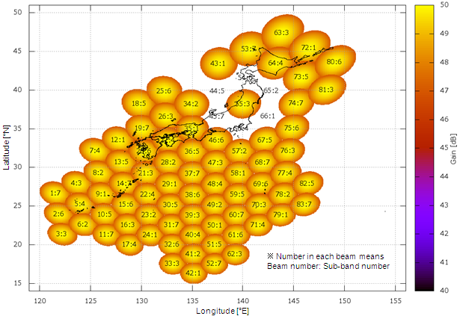Figure 47 Satellite beam allocation in disaster scenario

Figure 48 49 Capacity of interfering links when interfered link is satellite uplink in disaster scenario

- Summary
In this study, capacity of terrestrial and satellite links in STICS under co-channel interference is evaluated to verify frequency sharing between terrestrial and satellite links. Obtained results are summarized as follows.

(a) Evaluation under the interference between satellite and terrestrial terminal
- Evaluation for the normal period: maximum satellite links (10,000 links in this study) and more than ten million terrestrial links are able to be assigned.
- One example evaluation for the disaster period: capacity is similar to that for the normal period.
- Increase of spatial guard-band improves capacity for terrestrial link and causes decrease of communication area for terrestrial link.
(b) Evaluation under the interference between satellite terminal and terrestrial base station
- Interfered link is established by taking separation distance between satellite terminal and terrestrial base station.

From these observations, it is concluded that frequency sharing between satellite and terrestrial links in STICS is feasible.

Studies on cooperative control technology between satellite and terrestrial components

- Background

In STICS, cooperative control of satellite and terrestrial system is required to establish satellite or terrestrial component to dual-mode terminal in seamless manner. To maintain communications link under temporally changing satellite and terrestrial traffic, the traffic state needs to be monitored and resource allocation state needs to be dynamically changed.

To evaluate feasibility of the cooperative control of satellite and terrestrial component, network architecture and dynamic control algorithm has been studied to flexibly assign frequency band depending on temporal change of satellite and terrestrial traffic [8]. Moreover, hardware simulator is developed to verify this dynamic control algorithm [9].

- Network architecture

Proposed network architecture is based on 3GPP (3rd Generation Partnership Project) architecture which is shown in Figure 50 [8]. Satellite and terrestrial systems are connected to each other via administrator server which has a capability of dynamic network control. Terrestrial system is controlled under 3GPP system and the satellite system is considered as Non-3GPP system. In administrator server, usage ratio, variation ratio and abnormal detection of the terrestrial and satellite network is monitored and used for an integration control. Then, it generates three commands as follows:

- Dynamic resource allocation. The role of this command is to modify or change bandwidth of satellite or terrestrial frequency.
- Traffic regulation. This command is applied to make traffic regulation in heavy traffic concentration.
- Handover (H/O) between satellite and terrestrial network. This is the command to make handover between satellite and terrestrial network.

Figure 50 Network architecture of STICS.

- Simulation result with hardware simulator

A hardware simulator has been developed to verify this dynamic network control algorithm as shown in Figure 51. It consists of terminal, satellite, satellite gateway, terrestrial mobile base station/control station, and dynamic network controller to simulate communication process such as call connection, handover, etc. By using the hardware simulator, actual communication signal between terminals with dynamic switching of satellite/terrestrial link is verified based on satellite resource control, priority call control and call restriction depending on temporal change of traffic.

Figure 51 Schematic diagram of hardware simulator for network system

The test by using the hardware simulator was carried out which is a large-scale simulation mimicking disaster scene by using actual traffic data in the Tohoku-Pacific Ocean Earthquake in Japan. High traffic and base station damage at disaster area are simulated with simulation area and terminal location as shown in Figure 52. Example simulation result shows that it is difficult to satisfy all traffic demand in large-scale disaster. However, it is also observed from the simulation result as shown in Figure 53 that priority calls in the disaster area are able to be connected when 25MHz of whole 30MHz bandwidth is assigned to the satellite beam in the disaster area.

Figure 52 Simulation area and terminal location

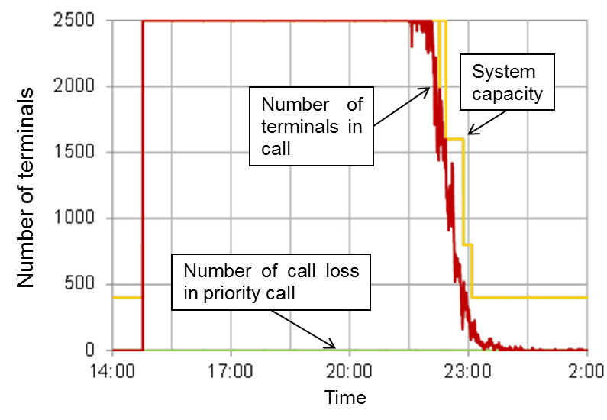
Figure 53 Example of simulation result (Number of call loss in priority call at satellite station etc.)

- Summary

From these observations, it is concluded that priority-based access control enables priority call connection to satellite link, and the cooperative control technology including dynamic control algorithm is effective for STICS.

Studies on technologies onboard satellite for STICS

- Background

In STICS, to cover the required service area by using 30m-class-diameter large satellite antenna, around hundred multi-beam system is required. Sidelobe level of the satellite antenna needs to be maintained in low level to suppress beam-to-beam interference level in multibeam system, and to suppress interference level to/from other systems. To satisfy these requirements, analog beamforming is not practical. Onboard digital beamforming is advantageous in realizing these requirements because of its scalability and flexibility. Satellite and terrestrial traffic is asymmetrically distributed in wide area and changing temporally. Especially in emergency situation such as disaster, large traffic happens in disaster area. Therefore satellite resource (e.g. frequency, power) needs to be flexibly allocated to each satellite beam depending on the traffic state. Onboard digital channelizing is a candidate technology to satisfy this requirement because of its flexibility.
Regarding these requirements for satellite onboard communications system, studies on the satellite onboard technologies such as the multi beamforming, low sidelobe, and reconstruction of resource allocation have been conducted.

Figure 54 illustrates the schematic diagram of satellite onboard communications system. It consists of user-link section in S-band with 30-m-class large reflector antenna, digital section, and feeder-link section. Digital section has digital beamformer and digital channelizer (DBF/channelizer) for transmit and receive section to meet the aforementioned requirements. To verify feasibility of functions needed for onboard satellite, prototype user-link section (S-band radiating elements, diplexers, LNAs, SSPAs, D/Cs and U/Cs) and digital section (DBF/channelizer dedicated for sixteen elements and sixteen beams) has been developed and tested [10, 11]. Figure 55 shows the outlook of the small-scale models.

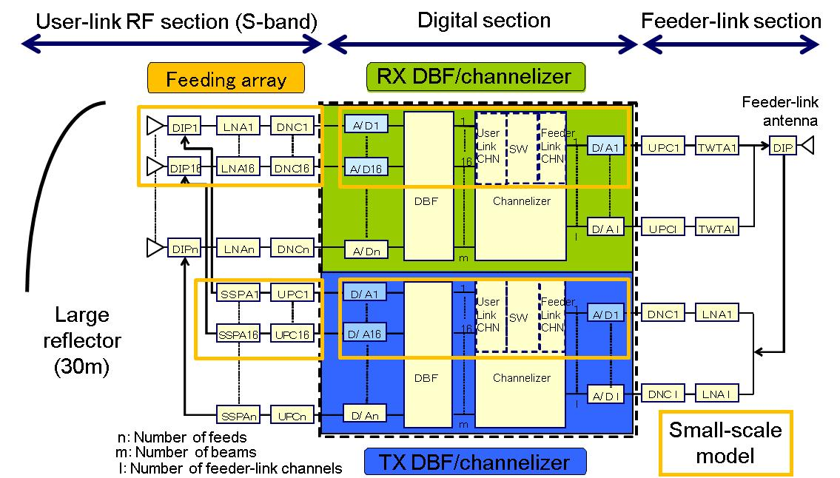
Figure 54 Schematic diagram of satellite onboard communications system

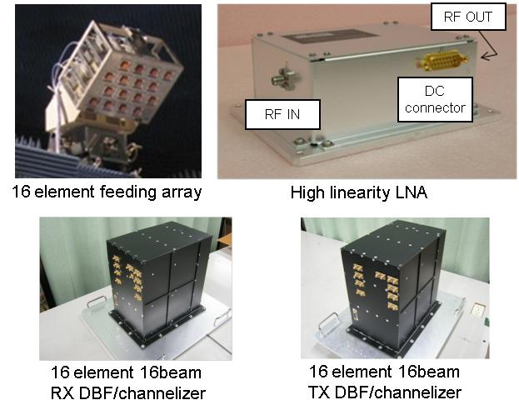
Figure 55 Outlook of small-scale models

- Study on onboard technologies for multi beamforming and low sidelobe

A prototype DBF/channelizer with sixteen-elements and sixteen-beams has been developed as part of hundred-elements and hundred-beams DBF/channelizer. As shown in Figure 56, DBF, sixteen element feeding array, and 3.3m deployable mesh reflector was applied to multi beam measurement in anechoic chamber. Measurement of hundred beams is realized by multiple repetitive measurements of sixteen-beam DBF. Hundred beams with multi color frequency allocation (number of frequencies = seven) is allocated in service area. Part of measured radiation patterns are shown in Figure 57. The result indicates that hundred beams are formed to expected directions and that the measured radiation patterns agreed with the calculated patterns. From these observations, effectiveness of multi beamforming technology is confirmed.

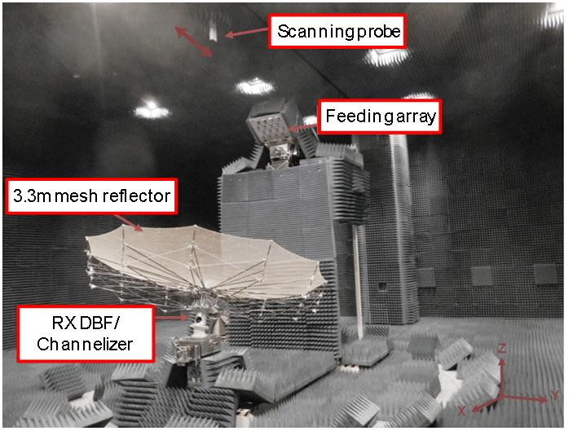
Figure 56 Outlook of for multibeam measurement system

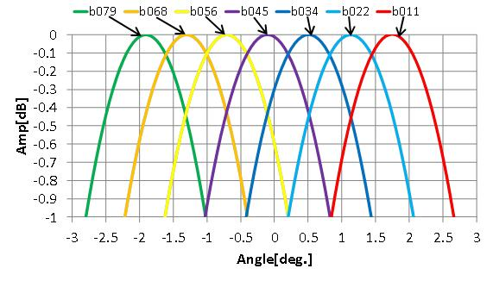
Figure 57 Part of measured radiation patterns of hundred multibeams (seven beams)

To verify low sidelobe in STICS satellite antenna, the antenna sidelobe suppression test based on DBF weight control has been conducted. Sixteen element DBF and feeding array is dedicated to the measurement. Figure 58 illustrates the verification process. At first, radiation pattern of sixteen element feeding array with sixteen element DBF is measured by using near-field measurement system (as shown in Figure 59).

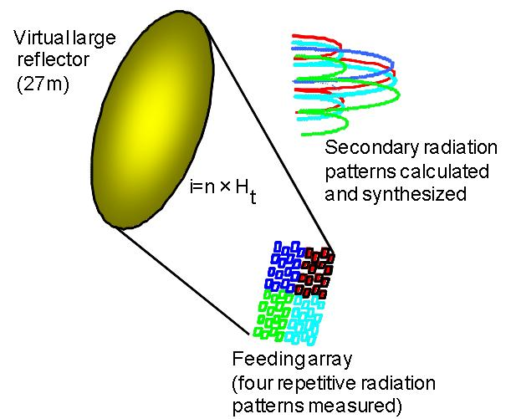
Figure 58 Verification process of low sidelobe technology

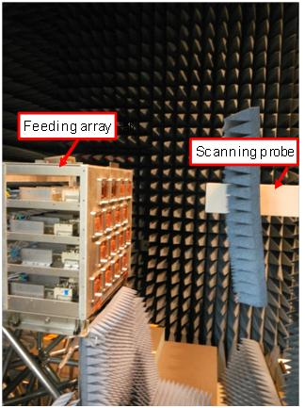
Figure 59 Near-field measurement of feeding array

Then, electromagnetic field on virtual large reflector (27m diameter) illuminated by the feeding array is calculated from measured near-field of the feeding array. Finally, Secondary radiation pattern is calculated by the electromagnetic field on the virtual large reflector. Four repetitive measurements of sixteen element DBF and feeding array is conducted to obtain secondary radiation pattern of the reflector with 64 element feeding array. Exciting coefficient of DBF for low sidelobe antenna is calculated and set to the DBF before the measurement. The evaluation result as shown in Figure 60 indicates that low sidelobe with 20 dB from peak gain of main beam was obtained.

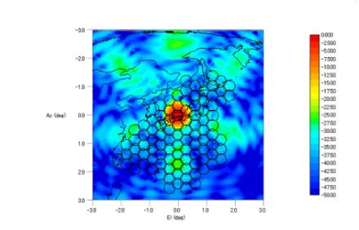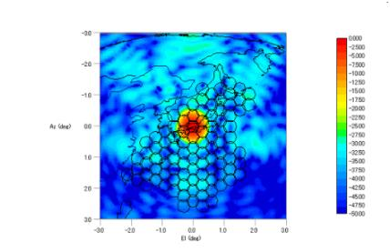

(a) Conventional pattern (b) Low-sidelobe pattern
Figure 60 Example results of low-sidelobe test

Furthermore, several tests were carried out to study the distortion of radiation pattern of large mesh reflector antenna caused by heat distortion of reflector and compensation of its radiation pattern. One of the tests was antenna sidelobe suppression test in anechoic chamber using DBF/channelizer, feeding array and 3.3m deployable reflector. In this test, reflector surface shape was intentionally distorted and was measured. Sidelobe level was successfully suppressed based on DBF weight control. Throughout this test, we confirmed that distorted radiation pattern is able to be compensated with DBF technology, and that in future deployment of this technology, onboard measurement methodology for reflector surface shape is required.

- Study on onboard technology for reconstruction of resource allocation

Channelizer realizes efficient spectrum usage by re-arrangement of feeder link channel. It also has resource re-allocation function by which frequency band allocation for each satellite beam is dynamically changed.

Required feeder link bandwidth for channelizer in STICS is 120 MHz. However, we developed digital channelizer with feeder link bandwidth of 200 MHz to meet future requirement for future broadband satellite transponder. With this channelizer, the feeder-link bandwidth is reduced from 400 MHz to 200 MHz (400 MHz is feeder-link bandwidth without using channelizer).

Performance test for DBF/channelizer was carried out by the coupling test of transmitting and receiving DBF/channelizer. The test successfully verified basic functions and performances such as resource re-allocation, dynamic range, spectrum efficiency, and transmission performance. A measured example of resource allocation test is shown in Figure 61.

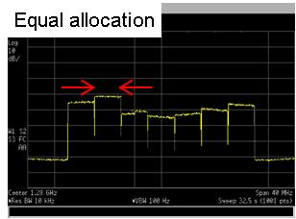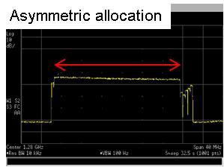
(a) Equal bandwidth allocation (b) Wide bandwidth allocated to
a satellite beam in disaster
Figure 61 Measured example of resource allocation test

- Summary

Throughout the R&D, we proposed the satellite onboard communications system technology for STICS, and developed small-scale prototype of DBF/channelizer and feeding array. Onboard technologies for multi beamforming, low sidelobe, and reconstruction of resource allocation were verified by the feasibility tests.

References

[1] T. Minowa, M. Tanaka, N. Hamamoto, Y. Fujino, N. Nishinaga, R. Miura and K. Suzuki, “Satellite/Terrestrial Integrated Mobile Communication System for Nation's Security and Safety,” Trans IEICE on Communication (Japanese edition), Vol.J91-B, No.12, pp.1629–1640. (Dec., 2008).
[2] Y. Fujino, A. Miura, N. Hamamoto, H. Tsuji, and R. Suzuki, “Research of Satellite/Terrestrial Integrated Mobile Communication System for Secured and Safe Society,” Proc. 2010 Asia-Pacifc Radio Science Conference (AP-RASC 2010), Toyama, Japan, Sep. 2010.
[3] H. Tsuji, Y. Fujino, N. Hamamoto, and R. Suzuki, “Interference Measurement Experiment of Mobile Base Station Downlinks Using an Aircraft in Satellite-Terrestrial Integrated Mobile Communication systems,” Proc. 2009 International Symposium on Antennas and Propagation (ISAP 2009), Bangkok, Thailand, Oct. 2009.
[4] A. Miura, H. Watanabe, N. Hamamoto, H. Tsuji, Y. Fujino, and R. Suzuki, "Outdoor/indoor propagation experiment for estimation of interference to satellite caused by cellular phone in satellite/terrestrial dual-mode frequency-shared cellular phone system," Proc. 2011 IEEE International Symposium on Antennas and Propagation (APSURSI), pp.2793-2796, July 2011.
[5] A. Miura, H. Tsuji, K. Endo, Y. Fujino, and M. Toyoshima, “On capacity evaluation in satellite-terrestrial integrated mobile communication system,” Proceedings of 64th International Astronautical Congress, IAC-13-B2.6.6, Beijing, China, Sep. 2013.
[6] A. Miura, H. Watanabe, N. Hamamoto, Y. Fujino, and R. Suzuki, “On interference level in satellite uplink for satellite terrestrial integrated mobile communication system,” 28th AIAA International Communications Satellite Systems Conference, AIAA-2010-8850, Anaheim, CA, USA, Aug./Sep. 2010.
[7] Y. Fujino, A. Miura, N. Hamamoto, H. Tsuji, and R. Suzuki, “Research of Satellite/Terrestrial Integrated Mobile Communication System for Secured and Safe Society,” Proc. 2010 Asia-Pacifc Radio Science Conference (AP-RASC 2010), Toyama, Japan, Sep. 2010.
[8] Y. Fujino, H. Tsuji, K. Endo, K. Okada, and H. Wakana, “Modeling and simulation of dynamic traffic control between satellite and terrestrial in case of national disasters by using Satellite Terrestrial Integrated mobile Communication System,” Proceedings of 30th AIAA ICSSC, Ottawa, Canada, Sep. 2012.
[9] A. Miura, Y. Fujino, T. Orikasa, H. Tsuji, K. Okada, M. Akioka, and M. Toyoshima, “R&D status of satellite/terrestrial integrated mobile communication system,” Proceedings of 31th AIAA ICSSC, Florence, Italy, Oct. 2013.
[10] A. Miura, M. Akioka, T. Orikasa, H. Tsuji, Y. Fujino, T. Matsuzaki, N. Kobayashi, T. Kumagai, and Y. Koishi, “A study of on-board processor for terrestrial and satellite integrated communication system,” 2013 Joint conference of 19th Ka and broadband commnucations, navigation and earth observation conference and 31st AIAA ICSSC, Florence, Italy, Oct. 2013.
[11] T. Orikasa, H. Tsuji, Y. Fujino and A. Miura, “A study of large reflector antenna mounted on communication satellite for satellite/terrestrial mobile communication system,” 2013 Joint conference of 19th Ka and broadband commnucations, navigation and earth observation conference and 31st AIAA ICSSC, Florence, Italy, Oct. 2013.

Hybrid satellite/terrestrial system

Overview

Hybrid networks composed by satellite backhauling and terrestrial radio access network comes into place, specifically to provide broadband connectivity to low densely populated areas, i.e. suburban and rural areas. An advantage of combining these two technologies is that of efficiently extending network coverage and of avoiding deploying of expensive backbone infrastructures needed to enable connectivity in non-urban areas.

In addition, hybrid networks are also expected to offer a complementary communication means by satellite networks when terrestrial networks are not available due to, e.g. a disaster, while offering high quality services by terrestrial networks for ordinal conditions. For example, Japan had experienced a service outage for long period in a wide area because terrestrial networks were severely damaged at the Great East Japan Earthquake on March 11, 2011. Consequently, a large number of users were affected and imposed to wait for their recovery. Taking such use cases into account, satellite networks will play an important role to provide robust and efficient means of communication.

Figure 62 shows the concept of a hybrid satellite/terrestrial system.

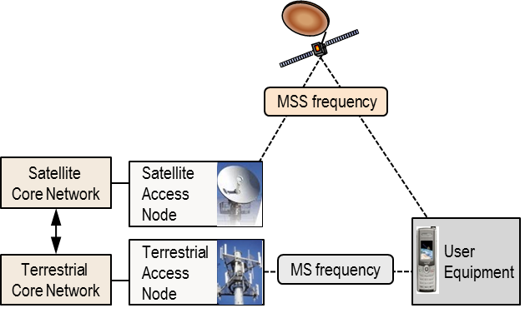
Figure 62 Concept of hybrid satellite/terrestrial system

Requirements from users’ point of view

It is not reasonable to assume that users always carry a separate terminal for satellite systems in addition to a terrestrial system handset preparing an unexpected disaster. Therefore, it is essential that the ordinal terrestrial handsets (e.g. Smartphone) can also be capable of satellite systems so that users can always keep them without increasing the terminal size. Namely, satellite communications needs to be available even for the low-end user terminals with the same transmission power, antenna gain etc. as the terrestrial systems.

Applications

Considering the support of hybrid systems by the ordinal handsets, all of the applications available in the current and/or future terrestrial systems should be supported. However, the link throughput of the satellite system is limited since it works particularly under the power limited circumstances for satellite communications. Given these technical constraints, the feasible applications will be the follows:

- Message service (SMS, MMS etc)
- Voice call (including VoIP)
- Internet browsing (Limited use)
- Social Network Service (Limited use)
- Mobile broadcasting / multicasting
- Emergency calling

Key technologies for hybrid systems

- Large deployable antenna for satellites

It is necessary to obtain additional gain by large antenna equipped on the satellite in order to establish a satellite link because it is not so easy to obtain it by the implementation of user handsets as mentioned earlier in Section 8.2. Some operators in the United States are the example commercial satellites that have equipped large deployable antennas (18-22m antenna reflector).

- Beam shape adjustment

It is observed that a surface of large deployable reflector would be deformed due to thermal changes in space. Thus, there is a risk of unexpected interference that a beam covering a certain service area shifts to another service area due to reflector surface distortion. In order to solve this issue, the establishment of beam adjustment associated with reflector surface distortion is one of the most important technologies at satellite installation using a large reflector.

- Multi-beam technology and flexible frequency reuse

When the terrestrial system has been unexpectedly halted by e.g. a disaster, it is anticipated that the amount of voice calls using satellite system would rapidly increase in the devastated region. To deal with such traffic, satellite systems are required to be capable of a precise control of coverage areas by multi-beam technology and flexible resource allocation of frequency based on the traffic demand in the areas. Furthermore, it is expected to improve the frequency reuse efficiency by multi-beam technology which allows dense beam assignment. Since the precise beam shape control is required, combination with beam correction technology described above is important.

- Air interface corresponding to narrow band

As another technology to compensate low output power of user handsets, it is considered to increase power density by the narrowband uplink transmission. GMR (GEO-Mobile Radio Interface *ETSI TS 101 376[GMR-1], TS 101 377[GMR-2]) and xHRPD (Extended Cell High Rate Packet Data *TIA-1185) can be considered as a standardized air interface.

Possible system architecture and features

Figure 63 shows possible system architecture of a hybrid system. The system consists of a terrestrial network (e.g. LTE in the figure) and a complementary satellite network (e.g. xHRPD in the figure). The satellite network is interconnected to terrestrial network after terminating the air interface at satellite base station subsystem (SBSS). Terminated satellite air interface is converted to standard interface for LTE core network at HRPD serving gateway (HSGW). In this configuration, satellite network does not have authentication systems (AAA) and gateway systems to connect to PDN. Those functions are provided by interconnected terrestrial core network.

Figure 63 Network architecture for LTE and xHRPD based hybrid MSS system

Hybrid systems don't require mutual control between a terrestrial network and a satellite network because it works to switch these networks. Since an additional satellite system can be installed without an extensive modification in existing terrestrial systems and significantly service impact on existing terrestrial users, hybrid systems have an advantage in terms of system introducing at an early stage.

Technical issues

As described in Section 8.4, a technical challenge is how to obtain the necessary gain in the user terminal – satellite link, which cannot be obtained by the user terminal due to the limitation of the terminal size. One solution is provided as an example, i.e. compensates the gain by large antenna on the satellite. However, according to the experiment of ETS-VIII (Engineering Test Satellite VIII) in Japan equipped with a large reflector, a distortion of the reflector surface occurs by thermal variation, by solar eclipse etc. As a result, it was observed that the pointing direction of the beam shifted about 0.15 degrees to the east direction [1].

This observed phenomenon cannot be ignored in for the satellite systems using a large antenna. Considering the possible distortion on reflector surface, beams should allocate with large margin to avoid interference between beams. Consequently, it is concerned that this issue reduces frequency reuse efficiency because satellite system is not possible to allocate sufficient capacity. The solution of this issue is efficient not only for hybrid systems but also for other satellite systems.

To cope with this issue, R&D regarding dynamic control technology to maintain the beam shape started in Japan since 2014. Figure 64 shows the overall image of the R&D.

Figure 64 Overall image of the R&D (dynamic control technology)

Due to the limited bandwidth resource of the L band and S band which are assumed to be utilized for service link, technologies for effective practical utilization of the limited frequency resource are necessary. Multi-beamforming technology with multi-color frequency allocation is one of the representative example. Additionally, for instance, for specified affected area (specified beam) during the disaster, where needs for MSS has increased, flexible channelizing function in order to be able to re-allocate the satellite resources (power and frequency) appropriately is necessary. As an approach to realize these mentioned hereinabove, here comes the Multi-beamforming technology with multi-color frequency allocation using DBF/channelizer. With the next generation satellite mobile communication system in combination of digital transponder loaded with this technology and the large deployable antennas mentioned above, it is promising to realize the improvement of spectral efficiency, and flexible resources re-allocation, while ensuring the convenience at the same time.

On the other hand, large deployable antennas, due to a distortion of the reflector surface occurs by extremely thermal variation, such as solar eclipse etc. have an issue on the shift of antenna radiation pattern on the territory, or the distortion of the beam shape. The phenomenon of beam shift or distortion may cause a drop of receiving level of user terminal or interference from the neighboring beam, and result in performance degradation of communication. Besides, for geographically limited location, such as affected area, and out islands, the influence on capacity due to change of coverage is also considerable. Such kind of influence on spectral efficiency cannot be negligible, therefore, adjustment technology for beam shift or distortion is required. Figure 65 shows the image of location of shifted beam in the situation both with (right) and without (left) adjustment. Moreover, technology which sequentially adjust and minimize the beam shift or distortion, in a high frequency, before the beam shift or distortion getting large, to minimize the influence on communication service and coverage area.

Figure 65 Image of location of shifted beam in the situation both with (right) and without (left) adjustment

Adjustment of beam performs according to the period of solar eclipse or the change of the sun through a series of process, including the measurement of antenna reflector, calculation of the compensation amount based on the measurement results, reflection of the calculation results to the equipment. In this R&D, the description mentioned above is referred to as dynamic control, with the control flow as (1) Vision metrology for antenna reflector, (2) Transfer of the shape data of antenna reflector surface, (3) Creation of excitation distribution compensation parameters (Excitation coefficient of DBF) based on the shape data, (4) Data transfer of the excitation coefficient of DBF, (5) Adjustment of beam based on the reflected excitation coefficient of DBF, (6) Transmission of the adjusted beam.

Figure 66 shows the flow of dynamic control.

Figure 66 Flow of dynamic control

Hereunder shows the dynamic control flow under an assumption that calculation load for calculating excitation coefficient of DBF from the antenna shape is so large that high processing capability computer is necessary. Firstly, the achieved shape data is forwarded to ground section, and the optimized excitation coefficient of DBF is calculated by the ground section. The calculated excitation coefficient of DBF is transmitted from the ground section to satellite, and reflected to the DBF loaded on the satellite to optimize the beam shape.

The following sub-sections present the results of the studies.

Application of vision metrology to large reflector of mobile communication satellite and beam compensation by optimization of phased array parameters

In this section, the feasibility of beam pattern compensation and dynamic control based on the optimization of phased array parameter with the reflector shape measured with vision metrology in orbit is described according to the reference article [2].

Deformation of reflector surface shape can cause the change of beam pattern and deterioration of antenna property. In the orbital experiment of Engineering Testing Satellite – VIII ( Kiku-8 ), shift of beam footprint about 0.2 degree is found. This change is considered due to the thermal deformation of reflector structure or surface shape [1] although there are no in-situ data or information on reflector shape in orbit after launch. The surface of deployable antenna is flexible structure consisting of surface cable and mesh surface.

Digital beam forming antenna with phased array feed can control the antenna beam performance and quality by setting appropriate excitation amplitude and excitation phase. If we can measure the surface shape of reflector precisely in orbit, updating phased array parameter optimized to current reflector shape in proper interval will lead to the continuously stable antenna pattern compensating the distortion by deformation by structural and thermal factor. This continuous optimization scheme is the basic concepts proposed here.

In the research and development effort by Softbank and NICT, application of the vision metrology to measurement of reflector surface in orbit is proposed and its feasibility is studied. Vision metrology technique is based on the theory and methodology of photogrammetry and used for industrial measurement in fine precision for various applications and manufacturing. In vision metrology, very high precision measurement requires many numbers of images with various perspectives and distances taken with cameras which lens distortion is well calibrated. However, measurement on satellite bus has strong limitation for design of photogrammetric network because the area on satellite bus available for settling cameras is very small comparing to the large aperture of reflector. Finding the feasible photogrammetric network including the specification and arrangement of camera and references are important and challenging issue.

The photogrammetric network with four 4Mega pixel cameras with three meters separation in square arrangement is proposed for the measurement for twenty meters aperture reflector at the thirteen meters distance from the measurement camera on the satellite bus. Feasibility of the photogrammetric network is studied by photogrammetric bundle adjustment simulation and experimental photogrammetric measurement with bundle adjustment calculation with 3.5 meters aperture deployable reflector. Figure 67 is the schematic drawing of the configuration example of the simulation and experiment measurement. In these simulation and experiment , the 3.5 aperture reflector is regarded as the 1/6 scale model of twenty meters reflector and four camera with 0.5 meters separation which corresponds also 1/6 scale of three meters separation on actual satellite bus. The experiment and simulation configuration is the 1/6 scale geometry of twenty meters reflector with focal length thirteen meters. Assumed four cameras arrangement is square with three meters by three meters separation. This camera arrangement is compatible with the limited size of ordinary GEO communication satellite bus. Figure 68 is the example of simulation for the 1/6 scale configuration. The expected measurement error from the bundle adjustment simulation was around 1 millimeters for 3.5 meters reflector for experiment. The simulation results shows that the shape of reflector with twenty meters diameter can be measured about 6 millimeters or within ten millimeters precision which is enough to compensate the antenna pattern deteriorated by thermal deformation. [3]

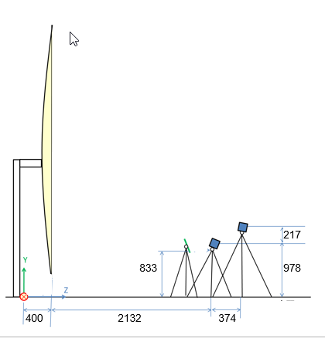
Figure 67 Schematic drawing of the configuration example of the simulation and experiment measurement.

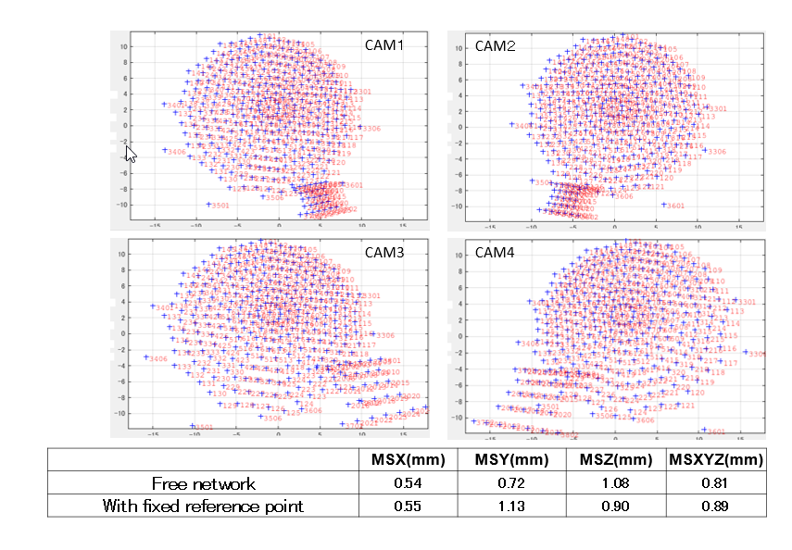
Figure 68 The example of results of simulation for the 1/6 scale configuration

Further measurement experiment of photogrammetric bundle adjustment with scaled model of deployable mesh reflector is done (Figure 69). The preliminary results shows that the change of shape can be measured within one millimeter error for 3.5 meters reflector. This results shows that the shape of reflector with twenty meters diameter can be measured about 6 millimeters or within ten millimeters precision because the 3.5 millimeter reflector can be regarded as the 1/6 scale model of twenty meters reflector.

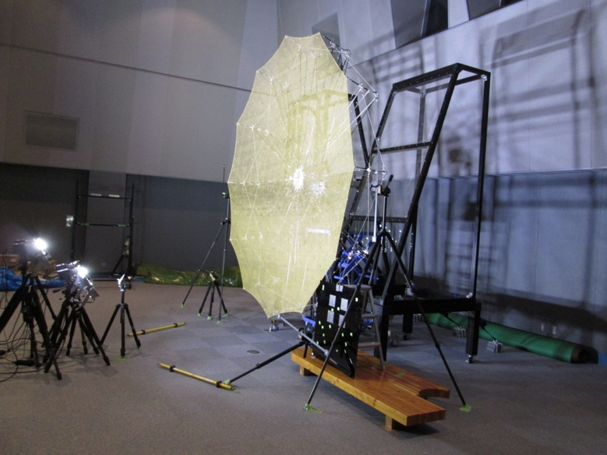
Figure 69 measurement experiment of photogrammetric bundle adjustment with scaled model of deployable mesh reflector

Electromagnetic compensation of antenna pattern distortion caused by deformation of reflector is proposed in previous studies [4][5]. In this study, antenna pattern distortion and feasibility of compensation by using optimized phased array parameter with measured reflector shape in orbit is studied with simulation including antenna pattern calculation. Optimized phased array parameter is determined to make the gain in provided direction maximized with maximum ratio combining algorithm.

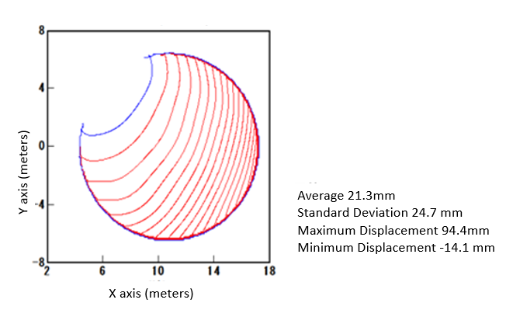

Figure 70 The contour presentation of antenna deformation pattern provided for the simulation.

Table 20:Primary parameters of reflector for simulation
Reflector Type | Offset Parabola
Frequency | 2GHz
Effective Aperture | 13 meters
F/D | 0.8
Offset Angle | 51.2 degree
Number of elements | 37
Phased array parameter | Miximuz peak gain with maximum ration combine

Principal parameters and specification of the assumed antenna are shown in table 20. A feed section for simulation is thirty seven elements phased array. Figure 70 is the contour presentation of antenna deformation pattern provided for the simulation. The assumed deformation corresponding beam wondering observed in ETS-XIII experiment, which is regarded as due to change of thermal condition, is overlapped onto ideal parabola reflector. The displacement from the designed (ideal) parabola surface averaged over the whole reflector surface is about twenty millimeters and maximum displacement at the far side edge of reflector is about ninety millimeters.

For this antenna and overlapped distortion, gain contour for beam deteriorated due to reflector surface deformation and beam with compensated by optimized phased array parameters for the deformed surface are calculated for boresight, eastern and western area of Japan. Figure 71 is the calculated antenna patterns for boresight beam for the central part of Japan Islands. Figure 72 and Figure 73 is the beam for eastern extreme (Hokkaido) and western extremes (Okinawa) of Japan Islands, respectively. The contour levels are set as -3 dB, -10 dB, and -20 dB of the peak gain at beam center. Optimized excitation amplitude and phase for phased array are calculated with maximum ratio combine with constraints of maximum peak gain at assigned position and antenna pattern is calculated with the calculation scheme based on physical optics method. Black line is for designed parabola reflector surface and nominal phased array parameters which is optimized to the originally designed reflector surface. Red line is for deformed reflector with nominal parameters, green line, for deformed reflector with optimized parameters for deformed reflector surface. Beam pattern change of boresight case with red contour in Figure 71 shows beam wandering of three hundred kilometers in northwest direction and change of side lobe pattern. Green contour is the beam pattern with deformed reflector and phased array parameter optimized to the deformed reflector.

The feasibility of beam pattern compensation by using accurately measured reflector shape is confirmed. In our proposed scheme, vision metrology base on photogrammetry will be used to obtain the reflector surface shape data. In our simulation, the phased array parameters optimized to the deformed surface is calculated and the distortion of antenna pattern due to reflector deformation was successfully recovered. Therefore, continuous iteration of reflector surface measurement and phased array parameter optimization, dynamic beam control for DBF, provides continuous antenna pattern maintenance for stable satellite communication service even in rapid thermal condition change during eclipse.
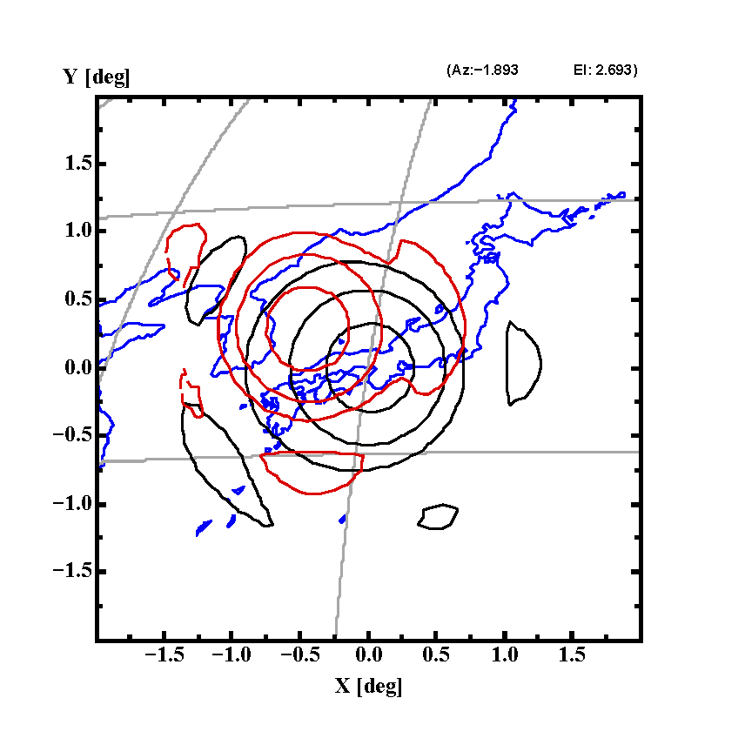
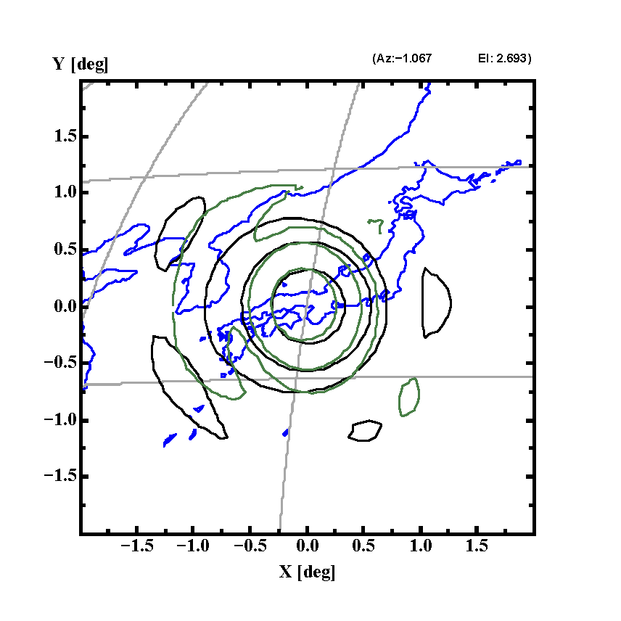

Figure 71: Compensation of beam distortion (Boresight)

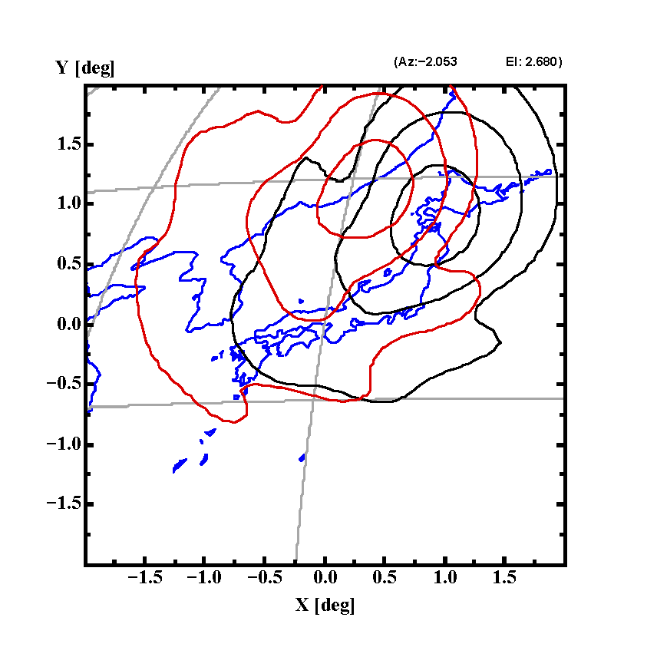
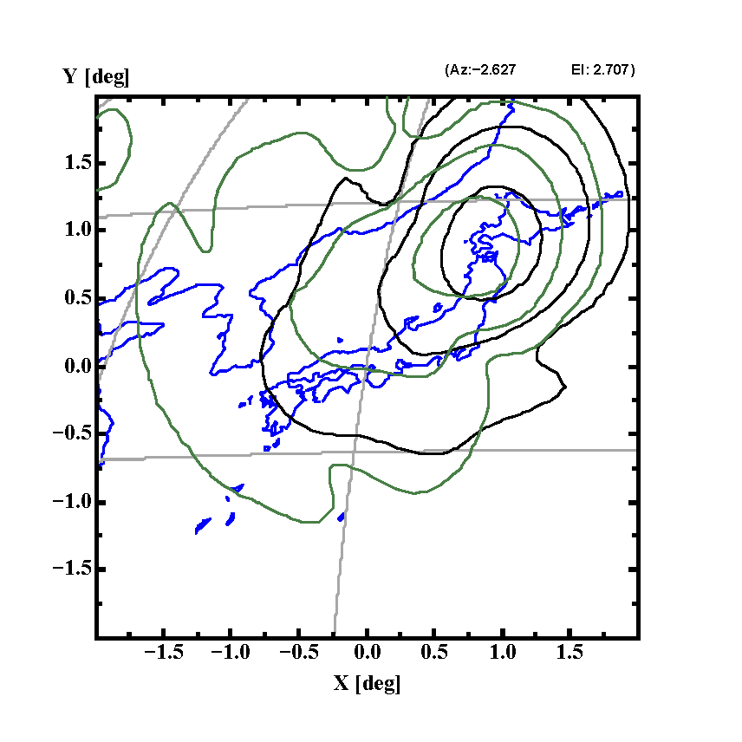

Figure 72: Compensation of beam distortion (North east extreme case (Hokkaido))

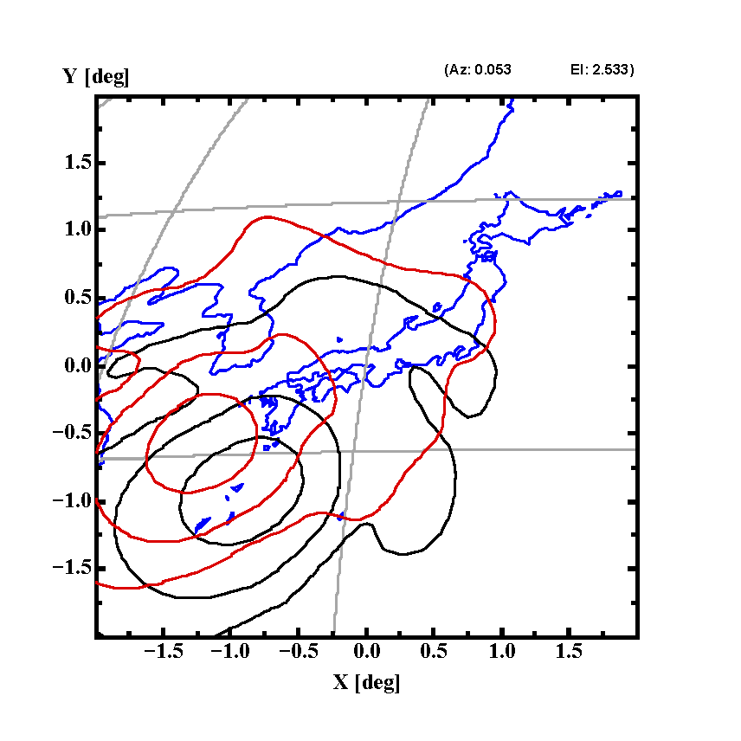
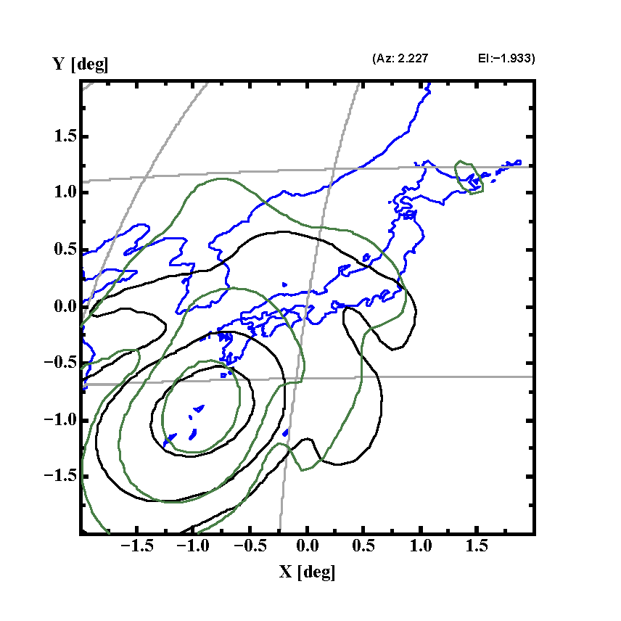

Figure 73: Compensation of beam distortion (South west extreme case (Okinawa))

Algorism Design for Dynamic Control and Verification through Simulation

- Dynamically Controllable DBF/channelizer

- Development Plan for The Dynamically Controllable DBF/channelizer

Large deployable antennas, due to a distortion of the reflector surface occurs by extremely thermal variation an issue on the shift of antenna radiation pattern on the territory, or the distortion of the beam shape. In order to adjust the temporal change of beam shape, and constantly maintain the beam with a stabilized shape, on the satellite loading DBF/channelizer, the development of beamforming technology using precisely adjusted excitation control based on the antenna shape data is necessary.

With regard of the excitation control technology, antenna feed due to highly functional phase array feeding by the so-called digital beamformer, as well as the frequency reusable multi beam system, as a previous stage, with highly functional DBF/channelizer constituted by digital channelizer are assumed. Besides, signal processing of the beamforming and channelizing by the DBF/channelizer, is considered to be integrated by large-scale FPGA (Field Programmable Gate Array). The DBF, for the feeding section due to phase array feeding, constructed by multiple feed elements, to control the phase and amplitude (excitation distribution), which is able to realize the expected beam allocation and the beam shape and characteristic of each beam is under consideration.

As the assumed multi-beam system, DBF/channelizer corresponding multi-beam of 35 beam using feed elements of 36 elements is under consideration.

The purpose of this research is on the dynamic control of excitation distribution and the development of footprint measurement technology, therefore, the development only focus on the transmission section.

Figure 74 shows the block diagram of the function confirmation model for the DBF/channelizer.

Figure 74 Block diagram of the function confirmation model for the DBF/channelizer

The function confirmation model, is constructed by Analog-to-Digital (AD) spectral separating section, DBF section, Digital-to-Analog spectral multiplexing section, and the control section. After the DBF calculation by the DBF section, feed elements multiplexed separately in the spectral multiplexing section. In the case that different user signals are transmitted at the same frequency, different excitation distribution coefficients are calculated, and transmitted, and realize the frequency reuse by changing the beam allocation. It is assumed that the bandwidth for IF (Intermediate Frequency) signal is 30MHz, which is occupied by 20 channels with bandwidth of 1.5MHz for each unit channel.

Figure 75 shows the frequency utilization image of service link.
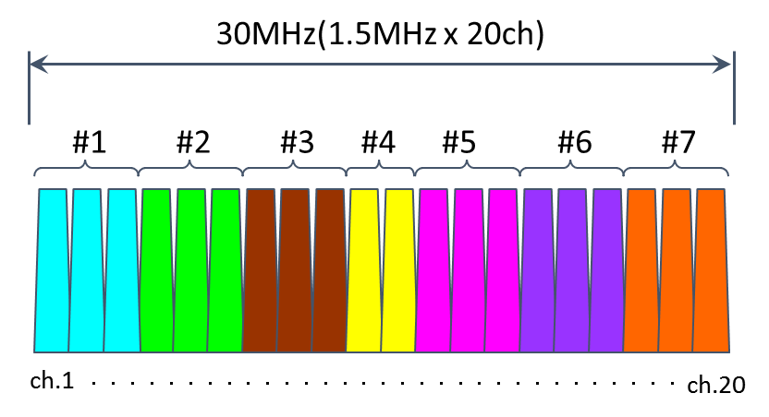
Figure 75 Frequency utilization image of service link

As the basic constitution, 20 channels of 30MHz are allocated to 7 beams from #1 to #7, and the 7 beams constitute 1 cluster. With a 5 clusters constitution in total, the total beam number is 35.
In practical, the bandwidth processed by function confirmation model is 150MHz, constituted with 100 channels.

Figure 76 shows the appearance of the DBF/channelizer.

Figure 76 Outlook of the DBF/channelizer

AD converted user signal, is complex-multiplied by excitation coefficient of DBF using the DBF calculation circuits. Namely, through DBF calculation, amplitude phase control of user signal is performed.

The beam adjustment, is performed with a change of excitation coefficient of DBF. The change of excitation coefficient of DBF, is performed when contents of memory for excitation coefficient of DBF are rewritten.

The reflection of excitation coefficient of DBF, due to the constitution of beam by complex elements, is necessary to be performed simultaneously. In consideration of the simultaneous performance, regarding the memory for excitation coefficient of DBF, which is assigned to the beam in service, the excitation coefficient of DBF to realize beam adjustment, is saved in another memory, and constructed to be able to change the memory in use by switches.

Figure 77 shows the construction for the change of excitation coefficient of DBF.

Figure 77 Block diagram of the change of excitation coefficient of DBF

Although, the beam adjustment is able to be realized by switching between at least 2 memories for excitation coefficient of DBF, the construction with 4 memories is designed. Such construction is used for responding the matter of concerns in advance.

With the beam adjustment, in the case that the amplitude and phase of the excitation coefficient of DBF changes dramatically, it is concerned that disorder of beam may occur.

Due to the disorder of beam, phenomenon such as abnormal radiation of sidelobe is expected. It is also under consideration of using method such as complementation of excitation coefficient of DBF in steps, in a short time (microsecond order), therefore, the 4 memories design is used as an example here.

By setting the individual element control switching pattern to the switching pattern memory, and the performance of the individual element control switch, it is able to select the excitation coefficient of DBF from any of the memories.

Table 21 shows an example of the switching pattern.

Table 20 Example of the switching pattern
Pattern | Element1 | Element 2 | Element 3 | ・・・ | Element 35 | Element 36
SW PTN 1 | A | A | A | ・・・ | A | A
SW PTN 2 | B | B | B | ・・・ | B | B
SW PTN 3 | C | C | C | ・・・ | C | C
SW PTN 4 | D | D | D | ・・・ | D | D

By selecting excitation coefficient of DBF from the corresponding memory saving the switching patter, it is able to accomplish flexibly adjustment, such as adjusting all the beam simultaneously, adjusting the targeted cluster, or adjusting the targeted beam.

- Development Plan on Effect Measurement of Dynamic Control Technology

In addition to the DBF/channelizer, prototype of beamforming simulator for evaluating the formed beam shape is built. It is utilized not only as the test tool to validate the operation, performance, and function of the of DBF/channelizer, but also, as a necessary part in a comprehensive evaluation of the dynamic control technology, to get the simulated output of the assumed beam, whereas the IF output signal with the same number as that of the elements output from the transponder is utilized as the input, and the upconverter, amplifier, the antenna feeding section, and reflector are simulated by software.

Figure 78 shows the connection between the DBF/channelizer and the beamforming simulator, and an output image.

Figure 78 Relationship between the DBF/channelizer and the beamforming simulator

As it is able to control beams accurately by using the dynamic control technology, improvement of spectral efficiency by frequency reuse through multi-beam is expected.

With the practical beam control by using the dynamical control technology, to objectively reveal the effectiveness, simulations are also conducted to find out the level of spectral efficiency that can be expected.

For the simulations, it is able to calculate the individual user characteristics (receiving power, channel number, CINR), and the average characteristics (CINR distribution, spectral efficiency), under the situation that multiple beams and users are allocated in a specified area.

Figure 79 shows an outline of the simulator.

Figure 79 Outline of the simulator

- Effect Measurement of the Dynamic Control Technology

Figures 80 and 81 show the contour diagrams before and after the dynamic control with the beamforming simulator described above, separately. Kansai region beam is shown as an example. Figure 80 shows the status before dynamic control, including a contour diagram (beam2) of the ideal reflector surface as reference, and a contour diagram (beam1) of the reflector surface which has introduced thermal variation based on simulation. Figure 81 shows the status after dynamic control, including the same contour diagram (beam1) of the reference ideal reflector surface and a contour diagram (beam2) of the reflector surface with thermal variation simulated. It has been confirmed that by dynamic control, the main lobe displaced to the east direction shifted roughly back to the position before the variation. Also, it has been confirmed that the shape of the main lobe did not significantly distort and the side lobe did not increase during the application of dynamic control according to the observation through transient response.

Furthermore, although the minimum satellite antenna gain in the assumed service area was reduced by about 4.0 dB due to the distortion of the reflector surface by thermal variation, with dynamic control the minimum gain was returned to a less drop of about 0.6 dB. It has been confirmed that both the peak gain position and the beam gravity center position shifted to 115 km east due to the distortion of the reflector surface by thermal variation, and was adjusted back to about 19 km east by the dynamic control.

As a result, it has been confirmed that the dynamic control should actually function effectively against the characteristic degradation of the beam due to the distortion of the reflector surface by thermal variation.

Figure 80 contour diagram (beam2) of the ideal reflector surface and a contour diagram (beam1) of the reflector surface with thermal variation before dynamic control
Figure 81 contour diagram (beam1) of the ideal reflector surface and the contour diagram (beam2) of the reflector surface thermal variation after the dynamic control

Footprint measurement system for satellite with onboard large reflector antenna

- Background

In communications satellite employing large deployable antenna, temporal change of beam shape caused by the deformation of antenna geometry has been reported [1]. This phenomenon will cause the degradation of the quality of service such as the change of the coverage area. Several functions are expected to stabilize the beam shape of the satellite-mounted large antenna. The observation of antenna geometry on orbit, which is realized by three-dimensional image acquisition devices (e.g. multiple digital cameras) mounted on satellite, will be effective to observe the shape of the reflector. The correction of beam shape deformation, which is realized by the array feeder with digital beamforming technology, will maintain the beam shape to the optimum one, based on the deformed reflector shape. The on-ground measurement of the temporal change of the beam shape is needed to confirm the beam shape correction process. To tackle this problem, a new R&D project has been started since 2014 under the Commissioned Business program of Japan’s Ministry of Internal Affairs and Communications. In the framework of the R&D project, National Institute of Information and Communications Technology (NICT) conducts the R&D of fundamental technology for the measurement system of the satellite antenna beam shape on ground (namely “footprint measurement system”).

- Concept of footprint measurement system, its R&D target and development plan [6]

Figure 82 illustrates the overall image of the footprint measurement system. This system consists of multiple measurement stations distributed to the wide area and the control server. Transmitted wave illuminated from the satellite mounted large antenna is measured simultaneously by these stations, where data is collected to the control server via the terrestrial network in order to analyze and display the footprint.

Figure 82 Overall image of the footprint measurement system.

Figure 83 shows the target, problem and research item on the fundamental technology of the footprint measurement system. Target measurement accuracy of the system is to achieve the measurement error within around one tenth of the half-power beam width of the satellite antenna beam in real time measurement (measurement interval is under study). In order to achieve the target measurement accuracy, it is required to clarify the measurement accuracy of the data collected from the measurement system. Since there are number of measurement stations in this system, accurate signal calibration and timing synchronization are expected to maintain the measurement accuracy. It is also required to clarify the optimum allocation of the stations to properly observe the beam shape. Geographical limitation for the location of the stations (e.g. ordinary located in land area) will affect the accuracy of the obtained footprint. Considering the cost of developing stations, it is expected to find minimum number of stations to obtain the footprint with permissible measurement accuracy. To solve these problems, we design and develop a small scale prototype of the footprint measurement system to confirm the fundamental performances and functions. At the same time, the simulation study on the relationship between the allocation of the stations and the measurement accuracy is conducted. The prototype will be improved in terms of enhancement of the number of stations and functions. Field measurement test with actual satellite signal will be planned to verify the functions and performances of the system.

Figure 83 Target, problem and research item on the fundamental technology of the footprint measurement system
- Prototype system [6]

The component-level prototype system consisting of five fixed measurement stations and the control server has been developed as the schematic diagram shown in the Figure 84. Measurement stations have the function of signal power measurement by the portable spectrum analyzer, and the function of antenna-pointing toward target satellite by the antenna rotator. The control server has the function of setting parameters of the measurement event, receiving satellite signal power data from the stations via the public network, calculation and display of the footprint from the data. These functions were confirmed by the initial test. Additionally, prototype of the portable measurement stations had been developed as the complement of the fixed-type measurement stations.

Figure 84 Schematic diagram of the footprint measurement system.

Fixed measurement stations are the terminal equipment for measurement located at multiple sites on ground. The objective of these stations is to measure the signal frequency and intensity illuminated from the satellite antenna and to record the measured data temporally. It consists of the antenna, antenna rotator, portable spectrum analyzer, client unit etc. The antenna is 60cm-diameter reflector antenna with 20 dBi of antenna gain at around 2.5 GHz to amplify the signal intensity to obtain sufficient Signal to Noise Ratio at the spectrum analyzer. The antenna rotator is equipped to the station in order to point the satellite of interest. The antenna is pointed to the satellite direction at the location of the station (latitude and longitude) by setting Two Line Element (TLE), which is the information on the satellite position on orbit. The client unit is the core unit of the stations, which controls the antenna rotator and spectrum analyzer to collect the data, conducts the initial processing for the measured data sent from the spectrum analyzer, and records the processed data temporally. The prototype measurement station is developed as the outlook shown in the Figure 85 (the picture shows the antenna, antenna rotator, and the portable spectrum analyzer).

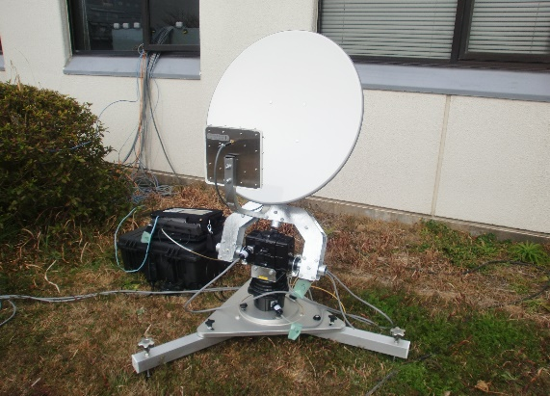
Figure 85 Outlook of the prototype measurement station.

Portable measurement stations are developed as complement of the fixed measurement stations. The portable measurement station aims to measure local change of the footprint. At first, approximate beam shape is measured by the footprint measurement system. If local deformation of the footprint is estimated as the result of the approximate beam shape measurement, portable measurement stations are deployed to the local site and conduct the measurement to be able to observe more accurate beam shape. The key requirements of the portable measurement station are: small size and lightweight (portability), future interface to the network of fixed-type measurement system. We designed and developed two types of the prototype portable measurement stations.

The control server is the important functional unit in the whole measurement system since it takes charge of setting measurement condition at each measurement event, collection of measured data from each measurement station in real time manner, calculation of the footprint from collected data, display the footprint image, and record measured and footprint data. The control server consists of the communication unit, processing unit, display unit, and recorder unit. The communication unit transmit/receive information between communication units in the client unit of the measurement station.

Process of the footprint measurement between the control server and the measurement station is described as follows.

- Setting the information on measurement event
Operator creates the files for setting measurement conditions and measurement schedule at the control server.

- Collection of measured data file
Once each measurement station starts the measurement and creates the measured data file, the control server get the data file in real-time manner, record it to the recorder unit and conduct primary data processing.

- Creation of footprint image
The processing unit of the control server creates the footprint image by the calculation of numerical interpolation from signal intensity data of measurement stations.

In order to evaluate the performance of the prototype, component level integration tests were conducted. The initial performance test was carried out in February 2015 in NICT Kashima space technology center (Kashima, Ibaraki, Japan). This test using five fixed measurement stations and the control server indicated that the control server collected the measured data file at the interval of four seconds as scheduled and that the whole system works as expected. And then, the receiving test of the actual satellite (Engineering Test Satellite VIII: ETS-VIII) signal was carried out in March 2015 in NICT Headquarter (Koganei, Tokyo, Japan). This test was conducted to experimentally receive the satellite signal transmitted for the other experiment. The information regarding ETS-VIII was given from Japan Aerospace Exploration Agency (JAXA). This satellite signal receiving test indicated that all the five measurement stations successfully receive the ETS-VIII S-band continuous wave and the measured data is collected at the control server as scheduled. From these results, fundamental performance of the prototype system is verified.

- Field measurement test [7,8]

The field measurement tests were carried out by using the developed prototype system and the actual satellite signal in order to verify the effectiveness of the footprint measurement system. The measurement setup is illustrated in Figure 86. ETS-VIII large deployable antenna with the electrical aperture size of 13m was dedicated to the measurement. The antenna beam called “Kanto beam” at the downlink frequency of 2.5025 GHz was illuminated to the East part of Japan. The measurement stations were distributed in the east part of Japan. Measured received signal data are collected to the control server located at NICT Kashima space technology center (Kashima, Ibaraki, Japan) to analyze the data and create the footprint. Figure 87 shows the location of the measurement stations in the experiment, which was located within almost the peak -7dB area of the main beam of the ETS-VIII antenna. The experiments were carried out in September 2015, December 2015 and September 2016.

Figure 86 Measurement setup of field measurement test.
Figure 87 Location of the measurement stations.

- Comparison with scanned attitude pattern
Before the measurement, the received signal level of all the measurement stations were calibrated. The calibration was performed by receiving ETS-VIII signal at all the stations located in the same place, calculating the difference of signal level between the stations, and correcting the difference. Figure 88 shows the North-South cut pattern of the satellite antenna obtained in 2009 by scanning satellite attitude and relative measured signal level of five fixed measurement stations in the field measurement test. The result indicates that although the relative signal level measured in September 2015 deviated from the attitude scanned pattern, the signal level measured in September 2016 showed good agreement with the attitude scanned pattern, since the calibration accuracy was improved by applying 24-hours of consecutive measured data and moving average.

Figure 88 Measured cut pattern compared with attitude scanned pattern.

- Creation of footprint image
In order to evaluate the footprint measurement performance, a simulated footprint was at first created as a reference. Commercial three-dimensional surface mapping software (Golden Software “Surfer”) was applied to create the footprint. Kriging was applied as the representative interpolation algorithm. Input data is the signal level at each station calculated from the attitude scanned pattern. As shown in the Figure 89, the main beam shape of the ETS-VIII antenna beam was observed in the simulated footprint. From this observation, this footprint was applied as the reference. It is noted that the simulated footprint is slightly elongated toward East-West direction. This is assumed to be caused by that the area that the measurement stations were located is smaller than the expected area to create the footprint of the main beam by the surface mapping software. The field footprint measurement test was carried out in 24-hours to observe the daily change of the beam shape. Two examples of footprint images created by using measured signal level data are shown in Figure 90. As shown in the examples of the footprint, it was confirmed that the main beam shape of the measured footprints almost agreed with that of the simulated footprint. It is noted that the beam shape of the footprint slightly deviated depending on the measured time, which is assumed to be caused by measurement error.

Figure 89 Simulated footprint image.

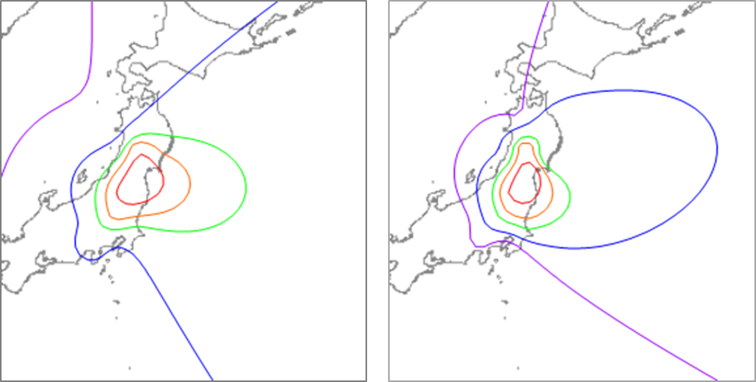
(a) (b)
Figure 90 Examples of footprint images created by using measured signal level data (contour scale are the same as Figure 89). (a) 22:00 16th September, 2016, (b) 2:00 17th September 2016.

- Conclusions

In this section, we described the needs of monitoring the beam shape of satellite mounted large reflector antenna, proposed the “footprint measurement system” which is on-ground real-time beam-shape measurement system, introduced the development of the prototype system and showed the result of the field measurement test which verified the effectiveness of the system.
Further study on the surface mapping methodology and the measurement error will be carried out in the future.

References

[1] M. Satoh, T. Orikasa, and Y. Fujino, “Evaluation of electrical performance for large-scale deployable reflector antenna equipped with engineering test satellite viii on orbit,” Trans. IEICE on Communication, Vol. J94-B, No. 3, pp. 344–352, Mar. 2011 [in Japanese].
[2] M. Akioka, A. Miura,T. Orikasa, H. Tsuji, M. Toyoshima, M. Satoh, and Y. Fujino, “Dynamic beam pattern control based on shape of large deployable reflector measured with vision metrology in orbit,” 34th AIAA International Communications Satellite Conference, Ohio, United States, Oct.2017.
[3] M. Akioka, A. Miura, T. Orikasa, H. Tsuji, M. Toyoshima, M. Satoh, S. Yamamoto, and Y. Fujino, “Dynamic beam control based on vision metrology of large deployable antenna for mobile satellite communication,” International Aeronautical Congress 2015.
[4] A. W. Rudge, D. E. N. Davies, “Electronically controllable primary feed for profile-error compensation of large parabolic reflectors,” Proceedings of IEEE, Vol. 117, 351-358, 1970.
[5] R. J. Acosta, A. A. Zaman, J. D. Terry, “System overview on electromagnetic compensation for reflector antenna surface distortion,” 1993 IEEE AP-S International Symposium, 1993.
[6] T. Orikasa, H. Tsuji, M. Akioka, M. Sato, A. Miura, and M. Toyoshima, “On r&d of footprint measurement system for satellite with onboard large antenna,” 33rd AIAA ICSSC, 2015-4344, Gold Coast, Australia, Sept. 2015.
[7] M. Sato, A. Miura, T. Orikasa, M. Akioka, H. Tsuji, and M. Toyoshima, “Result of field experiment of footprint measurement system for satellite with onboard large antenna,” IEICE Technical Report, vol. 116, no. 144, SAT2016-11, pp. 1-6, July 2016 [In Japanese].
[8] M. Sato, A. Miura, T. Orikasa, M. Akioka, Y. Fujino, and M. Toyoshima, “Field experiment of footprint for satellite with onboard large deployable antenna,” IEICE General Conference, B-3-2, Mar. 2017 [In Japanese].
.

Conclusion

This Report provides the architecture and performance of integrated MSS systems and hybrid satellite/terrestrial systems below the 3 GHz band.

In the context of the drive to deliver broadband services throughout global coverage, the MSS system will promote the rapid deployment and delivery of such services to rural areas, geographically isolated areas and countries where wire-line networks are still in need of significant upgrading before wire-line broadband is achievable. In those rural areas where broadband is already or is soon to be available, the deployment of MSS broadband services will provide an alternative service, thereby promoting choice.

In addition, the implementation of CGCs in a MSS system could allow for the development of a range of new market and broadband services. The CGCs could operate at the same frequencies as the associated satellites and be used to improve the availability of MSS, for example in areas where the communication with space stations cannot be guaranteed. The CGCs would provide more efficient spectrum usage and improved coverage according to the deployment of the CGCs would further attract larger consumer markets resulting in increased economies of scale.

In conclusion, integrated MSS systems and hybrid satellite/terrestrial systems with suitable latest technologies will be expected as effective rural area solutions and also reasonable PPDR solutions in the Asia-Pacific Region where natural disasters such as earthquake and tsunami sometimes occur.

____________

As referred to in Europe.

