

APT GUIDLEINE ON

TECHNICAL CONDITIONS FOR THE USE OF MOBILE COMMUNICATION SERVICES ONBOARD AIRCRAFT

Edition: September 2018

The 24th Meeting of the APT Wireless Group
17 – 21 September 2018
Bangkok, Thailand

(Source: AWG-24/OUT-23)

No. APT/AWG/OP-02(Rev.3)

APT GUIDELINES ON TECHNICAL CONDITIONS FOR THE USE OF MOBILE COMMUNICATION SERVICES ONBOARD AIRCRAFT

Introduction:
With the vast adoption of smartphone, nowadays, people want to remain connected anytime and anywhere to check their social medias on a regular basis or to simply surf on the internet. This includes such use of smartphone within an aircraft while flying.
Since 2010, airlines started to provide mobile communication services onboard aircraft (“MCA”) to their passengers in order to differentiate to their competitors. To provide such MCA service, the In-Flight Communication (“IFC”) providers seek and sign roaming agreements with the passenger’s home operators. Passengers will then be able to use the inflight mobile service as they do abroad on the ground and they will be billed by their own mobile operator.
As per nature, an aircraft flight internationally and will cross several country’s airspace, it would therefore be beneficial for the IFC providers to have a harmonized use of the MCA system.

Scope
This report provides the technical conditions under which such mobile communication system onboard aircraft (MCA) could operate without creating any harmful interference to the ground mobile networks.

Vocabulary of terms
IFC: In-Flight Communication
MCA Mobile communication onboard aircraft
NCU Network Control Unit
CEPT European Conference of Postal and Telecommunications Administrations
MCL Minimum Coupling Loss
SINR: Signal over interference + noise ratio

Description of the MCA system
Service availability:
The MCA service will be available once the aircraft reach an altitude greater than 3,000 meter above ground level.
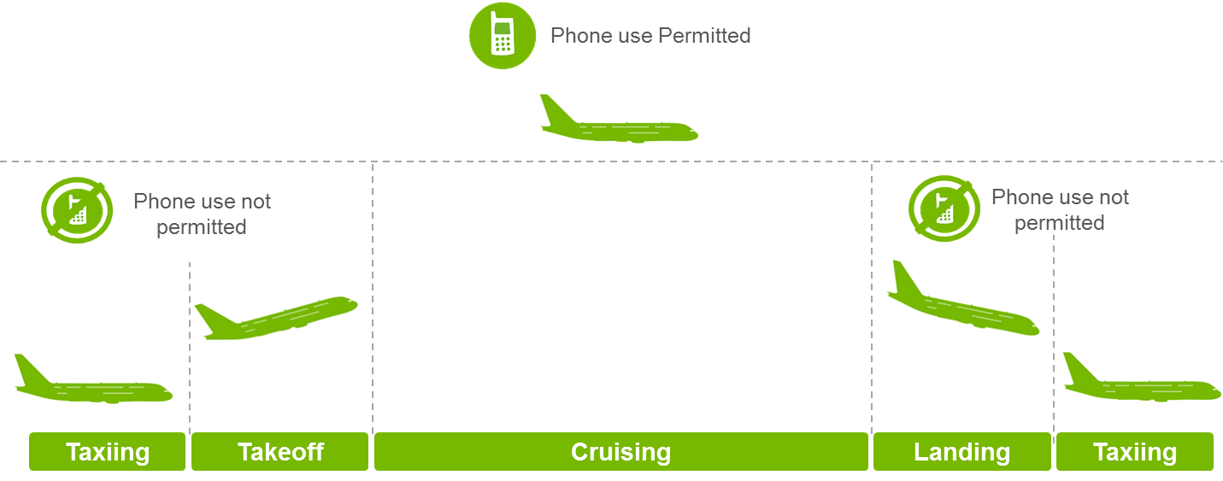
Figure 1: service availability
The MCA system could operate in the 1800 MHz band (1710-1775 MHz – Uplink / 1805-1880 MHz – downlink) and in the 2100 MHz band (1920-1980 MHz/ 2110-2170 MHz). The reason of this choice is mainly technical, e.g. the minimum transmit power of the GSM terminal operating in 1800 MHz is lower than in the 900 MHz band, the path loss is higher for the 1800 MHz and 2100 MHz bands compared to the lowest frequency bands. In addition, the CEPT has adopted an ECC Decision (06)07 which allows connectivity in the bands 1800 MHz for GSM and LTE and in the 2100 MHz band for UMTS. It would therefore be beneficial for MCA operators to have a harmonized technical requirement across the globe.

- Pico-BS (Base Station)
The pico-BS acts as a mini mobile network base station. It provides and manages the radio interface to mobile phones in the aircraft and handles communications to the mobile phones onboard. The pico-BS transmits at power levels reduced to just a few milliwatts, and also controls the transmission power of those authorised passengers’ handsets to a given minimum power level. Coincidentally it ensures that transmission levels are sufficiently low as not to cause harmful interference to ground cellular networks. An aircraft could be equipped with several BS, depending on its size.

- The Network control unit
The network control unit (“NCU”) ensures that the onboard mobile phones can only connect to the onboard base station. In order to do so, the NCU will increase the noise floor by injecting sufficient RF noise into the cabin to screen the ground cellular network and therefore to prevent the mobile phones onboard being able to synchronise with terrestrial cellular networks. Without synchronization the onboard mobile phones will not attempt to connect to those terrestrial networks. At present, such NCU is only needed to screen the ground UMTS network. However, future investigations could show that even without an NCU onboard mobile phone cannot connect to the ground UMTS network.

Guidelines
This section defines the guidelines on technical conditions for the use of mobile communications services onboard aircraft (“MCA”) and provides the maximum permitted power possible for the MCA system.

Note this section presented here are provided as supporting information for national regulatory administrations when considering the technical conditions of the MCA service.

The technical guidelines defined in steps 3 have been created from the following steps:

- Step One: identification of control bands, connectivity bands
Identification of the bands required to control and the potential connectivity bands that could operate an onboard service. It is highlighted that connectivity can only occur if the cellular system has a pre-defined roaming infrastructure, this reduces the possibility of offering connectivity service to only MAP based (e.g. GSM or UMTS) and IS 41 based (e.g.cdma2000) cellular networks.

- Step Two: Derivation of power limits
This section proposes the criteria for harmful interference to receivers on the ground and the associated power limit to conform to this criterion.

- Step Three: The Guidelines on Technical Conditions for the Use of MCA system
Guidelines on Technical Conditions for the Use of Mobile Communication services Onboard Aircraft.

The following provides the technical guidelines for national telecommunication Regulatory administrations to use when considering the technical conditions for the use of MCA system.

Step One: UMTS bands used in Asia Pacific Region and in-flight connectivity bands

- Cellular frequency bands used for UMTS in the Asia Pacific region
Based on APT Report on "Information of Mobile Operator's Frequencies, Technologies and License Durations in Asia Pacific Countries" APT/AWG/REP-15, the following frequency bands allocated to UMTS have been identified in the Asia Pacific region.

Table 1: UMTS frequency bands
Frequency band (DL) | Band
869 – 894 | A
925 - 960 | B
2110 -2170 | E

MCA operations without a specific device known as “Network Control Unit” (NCU) are sufficient to guarantee a reasonable protection against resulting interference and signaling issues to and from terrestrial GSM and / or LTE wireless telecommunication systems. However, for frequency bands where UMTS is in operation, User Equipment on board should be prevented from attempting to access networks on the ground. This could be ensured:
- By the inclusion of a Network Control Unit (NCU), which raises the noise floor inside the cabin in mobile receive bands, and/or;
- Through aircraft fuselage shielding to further attenuate the signal entering and leaving the cabin.

It is highlighted that a mobile phone will only transmit if it can identify a mobile network and if it could attach to it. Therefore, if a country/region has not deployed a particular UMTS frequency band (i.e. 900 MHz) then the onboard cellular system will not need to control that band.

Consideration may also be required for non-cellular wireless technologies when deployed in the same frequency band. In particular where there is a mix of both cellular wireless and non-cellular wireless terrestrial deployed systems in the same band.

- Inflight mobile bands and technologies
The following table provides the cellular technologies and the associated frequency bands that could be used for the provision of the MCA services:

Table 2: inflight connectivity bands
Technology | Frequency band (UL/DL) | Band
LTE1800 / GSM1800 | 1710 – 1785/ 1805 -1880 | C
LTE1900 / GSM1900 | 1850-1910/ 1930-1990 | D
UMTS (WCDMA) | 1920 – 1980/ 2110 -2170 | E

Step two: Derivation of Power limits of the system
The following provides the criteria for harmful interference to terrestrial receivers in order to define the limiting power conditions of an onboard cellular system.

- The criteria for harmful interference
In order not to cause harmful interference to terrestrial networks, the Mobile Phone onboard aircraft system shall not cause more than a 1 dB rise in the effective noise floor of the receiving “victim” terminal receiver on the ground.

The effective noise floor of the receiver is based on the absolute lowest level that a receiver could possibly work; i.e. the physical limit for thermal noise (kBT) plus the additional losses in the circuitry of the device (the so called noise figure).

This figure is based on input from the international standards group 3GPP (Third Generation Project Partnership, see http://www.3gpp.org)) which defines 3rd Generation mobile systems and comprises of operators and suppliers in the mobile industry. Further this criteria was used as the basis for the technical annex of the European ECC Decision (06)07. 3GPP provided the following clarification:

- 3GPP proposes the noise figure for a terminal is 7 dB thus providing an effective noise floor of the terminal equal to kBT + noise figure (= 7 dB).

- 3GPP proposes the noise figure for the network radio base station is 4 dB thus providing an effective noise floor of the base station equal to kBT + noise figure (= 4 dB).

- 3GPP endorsed the criteria of 1 dB increase in the effective noise floor for the definition of harmful interference for the onboard mobile system. A 1 dB increase in the effective noise floor of the receiver equates to the
interfering signal (I) = Effective Noise floor (N) – 6 dB.

- Power limits as a function of frequency and height above ground
International developments for the MCA service define a minimum height above the ground to which the service can be activated. The minimum limit has been set at 3,000 m (10,000 feet) which coincides with the distinction between the definition of critical and non-critical phases of flight in the aeronautical industry.

In order to have a cellular technology neutral approach, a power level parameter given as dBm/Hz is used. However, the permitted power emanating outside an aircraft will be dependent on both the solution proposed and the properties of the aircraft itself. Therefore, in order to provide an aircraft agnostic solution, power levels must be defined as power emitted outside the aircraft. Consequently, in order to provide a technology neutral solution, the power maximum limits are defined as a function of both frequency and height above the ground in order to satisfy the criteria stated in 3.1 above.

Given the different characteristics between the base station receiver and the mobile station receiver, two sets of limits are required. The following table provides the maximum power level an aircraft can transmit in the downlink direction i.e. into the receiver of the mobile phone on the ground and assuming a minimum height the service can be activated as 3,000 meters above the ground.

Table 3: Maximum EIRP from the onboard system
Height above ground  (m) | Maximum E.i.r.p. permitted outside the aircraft in dBm/Hz
Height above ground  (m) | Band A:  800 MHz | Band B:  900 MHz | Band C:  1800 MHz | Band D:  1900 MHz | Band E:  2 GHz
3000 | -72.5 | -72.0 | -66.0 | -65.5 | -65.0
4000 | -70.0 | -69.5 | -63.5 | -63.0 | -62.5
5000 | -68.0 | -67.5 | -61.5 | -61.0 | -60.5
6000 | -66.5 | -66.0 | -60.0 | -59.5 | -59.0
7000 | -65.1 | -64.5 | -60.0 | -58.0 | -58.0
8000 | -64.0 | -63.5 | -57.5 | -57.0 | -56.5
9000 | -63.0 | -62.5 | -56.5 | -56.0 | -55.5
10000 | -62.0 | -61.5 | -55.5 | -55.0 | -54.5

It should be noted that the power limits defined in the table above are dependant on the elevation angle at the victim terminal on the ground. The values contained in the table are for the case where the victim terminal is directly below the aircraft given that a mobile phone antenna is assumed to be omni-directional.

With respect to the MCA services, the following table provides the maximum power level defined outside the aircraft that a mobile phone onboard an aircraft can transmit in the uplink direction i.e. into the receiver of the base station on the ground and assuming a minimum height the service can be activated as 3,000 meters above the ground.

Table 4: Maximum EIRP from a mobile terminal
Height above ground  (m) | Maximum e.i.r.p permitted, defined outside the aircraft, resulting from a mobile terminal in dBm/Hz
Height above ground  (m) | Band:  1800 MHz | Band:  1900 MHz | Band:  2 GHz
3000 | -56.5 | -56.0 | -55.5
4000 | -54.0 | -53.5 | -53.0
5000 | -52.0 | -51.5 | -51.0
6000 | -50.5 | -50.0 | -49.5
7000 | -49.0 | -48.5 | -48.0
8000 | -48.0 | -47.5 | -47.0
9000 | -47.0 | -46.5 | -46.0
10000 | -46.0 | -45.5 | -45.0

For base stations on the ground the worst case scenario is the combination of the antenna vertical pattern and the free space path loss. By using the vertical pattern derived from the ITU-R Recommendation F.1336-4, it follows that this occurs at an angle of 57 degrees from the horizontal for bands below 1800 MHz and at an angle of 37 degrees for bands above 1800 MHz. It should be noted that the limits define in the table above are dependent on the elevation angle at the victim base station on the ground. The values contained in the table correspond to conformance to the harmful interference criteria at an angle of elevation of 37 degrees.

Step 3 - Technical condition for MCA systems

Table 5: Technical conditions for MCA systems
Nr. | Parameter | Description | Comments | Status
1 | Frequency band | Band A; 869 – 894  Band B; 925 – 960  Band C; 1805-1880  Band D; 1930 -1990  Band E;2110 -2170 | The bands A, B, and E will have to be controlled within the aircraft cabin depending on which country/region the service is operated in as defined in Table 6.  Only bands C, D and E can be used for onboard cellular system on the condition that the system controls onboard terminals to transmit within the power limits defined in Table 7. | C
2 | Radio service | Mobile Service |  | M
3 | Application | On-board cellular passenger  communication system | GSM standard | C
3 | Application | On-board cellular passenger  communication system | LTE standard | C
3 | Application | On-board cellular passenger  communication system | UMTS Standard | C
4 | Channelling / modulation | GSM standard | 200 kHz | C
4 | Channelling / modulation | LTE standard | 4.5 MHz | C
4 | Channelling / modulation | UMTS standard | 3.84 MHz | C
5 | Transmit power limit | Maximum permitted e.i.r.p. limits of on-board cellular system are defined outside the aircraft.  Authorisation of the use of the system will depend on the fact that the installed system conforms to the limits outside the aircraft defined in Reference Table 2 and Table 3 in order to ensure no harmful interference with terrestrial mobile networks. | The absolute minimum height above ground for any transmission from the system in operation shall be 3000 meters. However, this minimum height requirement could be set higher, in particular in order to comply with the aircraft base station and onboard mobile phone emission conditions as set out in Reference tables 2 and 3, | M
6 | Channel occupation rules | GSM standard | 200 kHz | C
6 | Channel occupation rules | LTE standard | 5 MHz | C
6 | Channel occupation rules | UMTS standard | 5 MHz | C
7 | Duplex direction / separation | GSM standard | 95 MHz | C
7 | Duplex direction / separation | LTE standard | 95 MHz | C
7 | Duplex direction / separation | UMTS standard | 190 MHz | C
8 | Additional Requirements to BS | The aircraft base station shall control the transmit power of all mobile terminals allowed to transmit on the aircraft.  The maximum controlled nominal power value for mobiles phones shall be no greater than -53 dBm/ Hz at all stages of communication, including initial access. | For GSM mobiles this is equivalent to a maximum permitted nominal power limit of 0 dBm/ 200KHz | M
C = Conditional requirement depending on country/region overflown and connectivity solution used
M= Mandatory requirement

Table 6: Maximum permitted e.i.r.p. by aircraft due to onboard transmitters in downlink bands
(base station and NCU transmit) direction
Height above ground  (m) | Maximum E.i.r.p. permitted outside the aircraft in dBm/Hz
Height above ground  (m) | Band A :  800 MHz | Band B:  900 MHz | Band C:  1800 MHz | Band D:  1900 MHz | Band E:  2 GHz
3000 | -72.5 | -72.0 | -66.0 | -65.5 | -65.0
4000 | -70.0 | -69.5 | -63.5 | -63.0 | -62.5
5000 | -68.0 | -67.5 | -61.5 | -61.0 | -60.5
6000 | -66.5 | -66.0 | -60.0 | -59.5 | -59.0
7000 | -65.1 | -64.5 | -60.0 | -58.0 | -58.0
8000 | -64.0 | -63.5 | -57.5 | -57.0 | -56.5
9000 | -63.0 | -62.5 | -56.5 | -56.0 | -55.5
10000 | -62.0 | -61.5 | -55.5 | -55.0 | -54.5
It should be noted that the limits, defined in Table 6, are dependent on the elevation angle of the victim terminal on the ground. The values contained in the table are applicable to the scenario where the victim terminal is directly below the aircraft.

Table 7: Maximum permitted e.i.r.p. by aircraft due to onboard transmitters in uplink bands
(mobile phone transmit) direction
Height above ground  (m) | Maximum e.i.r.p permitted, defined outside the aircraft, resulting from a mobile terminal in dBm/Hz
Height above ground  (m) | Band:  1800 MHz | Band:  1900 MHz | Band:  2 GHz
3000 | -56.5 | -56.0 | -55.5
4000 | -54.0 | -53.5 | -53.0
5000 | -52.0 | -51.5 | -51.0
6000 | -50.5 | -50.0 | -49.5
7000 | -49.0 | -48.5 | -48.0
8000 | -48.0 | -47.5 | -47.0
9000 | -47.0 | -46.5 | -46.0
10000 | -46.0 | -45.5 | -45.0
It should be noted that the limits, defined in Table 7, are dependent on the elevation angle of the victim base station receiver on the ground. The values contained in the table correspond to worse case conformance criteria parameters to ensure no harmful interference criteria (calculated at an angle of elevation of 37°).

Attachment 1

ANALYZATION ON TECHNICAL CONDITIONS FOR THE USE OF MOBILE COMMUNICATION SERVICES ONBOARD AIRCRAFT

- Introduction
A mobile communication service onboard aircraft (“MCA”) allows airline passengers to use their mobile phones during flights in the same way as on the ground. The mobile phone will connect to an onboard base station which could operate either in GSM1800 or in LTE1800 or in UMTS2100 band. All the traffic generated onboard the aircraft will be routed to the ground mobile infrastructure via a satellite backhaul or via a direct air-to-ground link.

The following picture shows an example of the general MCA architecture:

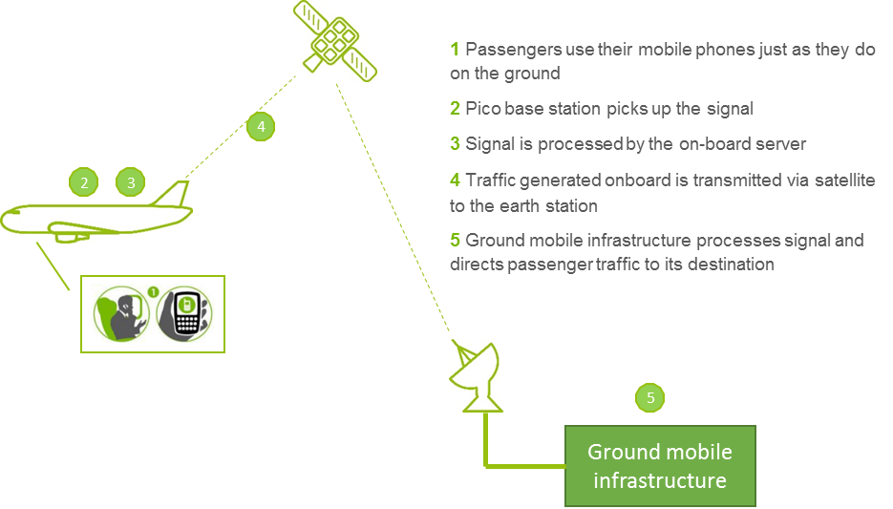
Figure 1: example of a general MCA architecture

Note the ground mobile infrastructure managed by an MCA operator is only located in one country and it is not replicated in all overflown countries or in the country of the registration of the aircraft.

It is requested to control the onboard mobile phone. Such control is done by an equipment called the network control unit (“NCU”). The NCU is designed to ensure that signals transmitted by ground-based base stations are not detectable by the mobile phone within the aircraft cabin and so that it can only register to the onboard base station.
The mobile networks considered in this analysis are based on GSM, UMTS and LTE technologies and the service provided is public.

- Connectivity analysis
The connectivity analysis addresses the ability of a mobile phone onboard an aircraft to connect to a ground based base station (Minimum Coupling Loss analysis), and assesses the impact of visibility of multiple ground based base stations on the airborne user terminal receiver to assess whether this is likely to be sufficient in practice to prevent a usable connection with a ground based base station being made (SINR analysis).

  - MCL analysis
A minimum coupling loss analysis is made to:
- Identify the conditions in which the mobile phone on aircraft (ac-UE) will have visibility of the ground-based networks (scenario 1).
- Assess in which conditions the ac-UE will have the ability to connect to ground-based networks (scenario 2).

For an assumed airborne platform altitude, calculations have been performed by taking into account the worst case elevation angle for the on-ground receive calculating the received power at the airborne user terminal input by taking account of the ground based base station transmit antenna gain towards the airborne user terminal receiver and the path loss
Figure 2:Scenario for received power variation at the airborne user terminal receiver

Scenario 1-Downlink
The received power (dBm) at the user equipment onboard aircraft is:
$P_{{rec}_{ ac-MS}}= {e.i.r.p.}_{g-BTS}-L_{Aircraft}-L_{Prop}-{BL}_{ac-MS}+G_{ac-MS}$
where:
${e.i.r.p.}_{g-BTS }$: e.i.r.p. of the signal radiated by the g-BTS, in the direction of the aircraft (dBm);
$L_{Aircraft }$: Attenuation due to the aircraft (dB);
$L_{Prop}$: Propagation loss between g-BTS and aircraft (free space path loss model) (dB);
${BL}_{ac-MS}$: Body loss of ac-MS (dB);
$G_{ac-MS}$: Antenna gain of the ac-MS (dBi).

With resulting margin for the uplink:
${M_{ac-MS}= S}_{ac-MS}- P_{{rec}_{ ac-MS}}$
where:
$S_{ac-MS}$: Receiver sensitivity of the user equipment onboard aircraft (dB).

Note if the margin is positive, it means that the signal received by the airborne User Equipment is below its sensitivity.

Scenario 2-Uplink
The received power (dBm) at the ground terrestrial base station is:
$$P_{{rec}_{ g-BTS}}= {e.i.r.p.}_{ac-MS}-L_{Aircraft}-L_{Prop}-{BL}_{ac-MS}+G_{g-BTS}$$
where:
${e.i.r.p.}_{ac-MS }$: e.i.r.p. of the signal radiated by the ac-MS (dBm);
$L_{Aircraft }$: Attenuation due to the aircraft (dB);
$L_{Prop}$: Propagation loss between g-BTS and aircraft (free space path loss model) (dB);
${BL}_{ac-MS}$: Body loss of ac-MS (dB);
$G_{g-BTS}$: Antenna gain of the ground base station (dBi).

With resulting margin for the uplink
$${M_{gBTS}= S}_{g-BTS}- P_{{rec}_{ g-BTS}}$$
where:
$S_{g-BTS}$: Receiver sensitivity of the ground base station (dB).

Note if the margin is positive, it means that the signal received by the ground base station is below its sensitivity. As a consequence, no further analysis is requested.
  - SINR analysis
In the event that the margin of the MCL scenario 2 is negative, then a SINR analysis is performed. This analysis examines the impact of interference aggregation from other base stations that are also visible to the airborne user terminal that is communicating with a terrestrial base station.
The ITU-R M.2292 provides the macro cell geometry which is depicted in Figure 3 and in which "A" is the cell radius and "B", the inter-site distance.

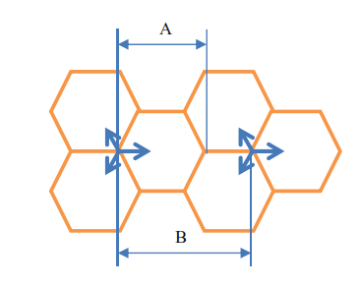
Figure 3: macro cell geometry

For each position of the aircraft, the strongest signal is selected and associated to the "wanted ground Base Station" while the other ground Base Stations are considered as interferers.
Figure 4: analysis geometry

For this calculation, a model was developed using OCTAVE, an open source software similar to MALTLAB.
The SINR threshhold used in the studies is as follow:
- 9 dB for the GSM (3GPP TS 45.050);
- - 6 dB for LTE (ETSI TR 136 942), and;
- -20 dB for UMTS (3GPP TS25.133).

- Input parameters used for modelling
  - Antenna Model
ITU-R Recommendation F.1336-4 is used to model all base station antennas with the following assumptions:
- Improved peak sidelobe pattern was used for MCL calculations;
- Improved average sidelobe pattern was used for all S/(N+I) calculations;
- Parameters K_{a}, K_{p}, K_{h} are set to 0.7 and the parameters K_{v} is set to 0.3;
- 65 degrees sector antenna with 3 dB beamwidth.
  - GSM Parameters
The parameters listed in

Table 8 are applicable to GSM technology operating in the 900 MHz and 1800 MHz bands and have been used in the calculations:

Table 8 : Parameters for GSM900 and GSM1800
Parameters | GSM900 |  | GSM1800
Parameters | BS | MS | BS | MS
Antenna input power (dBm/channel) | 43 | 33 | 43 | 30
Receiver bandwidth (MHz) | 0.2 | 0.2 | 0.2 | 0.2
Antenna gain (dBi) | 15 | 0 | 18 | 0
Antenna height (m) | 30 | Aircraft height above ground | 30 | Aircraft height above ground
Electrical antenna downtilt (degrees) | 3 | N/A | 3 | N/A
Feeder Loss (dB) | 0 | N/A | 0 | N/A
Noise figure (dB) | 4 | 7 | 4 | 7
Receiver noise floor (dBm/channel) | -117 | -114 | -117 | -114
Body loss (dB) | 0 | 4 | 0 | 4
Reference receiver sensitivity (dBm/channel) | -104 | -102 | -104 | -102
Co-channel interference criterion | S/(N+I)=9 dB
Aircraft attenuation (dB) | 5
Cell radius (km) | 5 (1800 MHz) / 8 (900 MHz)
Reuse sites (RS) (km) | 7
Inter-site distance | 1.5 * √RS *cell radius
  - UMTS Parameters
The parameters listed in Table 9 are applicable to UMTS technology for the 900 MHz and 2100 MHz bands and have been used in the calculations:
Table 9: Parameters for UMTS900 and UMTS2100
Parameters | UMTS900 |  | UMTS2100
Parameters | BS | MS | BS | MS
Antenna input power (dBm/channel) | 33 | 24 | 33 | 24
Receiver bandwidth (MHz) | 3.84 | 3.84 | 3.84 | 3.84
Antenna gain (dBi) | 15 | -3 | 18 | -3
Antenna height (m) | 30 | Aircraft height above ground | 30 | Aircraft height above ground
Electrical antenna downtilt (degrees) | 3 | N/A | 3 | N/A
Feeder Loss (dB) | 0 | N/A | 0 | N/
Noise figure (dB) | 5 | 9 | 5 | 9
Receiver noise floor (dBm/channel) | -103 | -99 | -103 | -99
Body loss (dB) | 0 | 4 | 0 | 4
Reference receiver sensitivity (dBm/channel) | -121 | -114 | -121 | -117
Co-channel interference criterion | S/(N+I)=-20dB (CPICH)
Aircraft attenuation | 5dB
Cell radius | 4(2100 MHz) / 8 km (900 MHz)
Inter-site distance | 1.5 x cell radius
  - LTE Parameters
The parameters listed in Table 10 are applicable to LTE technology and have been used in the calculations:
Table 10: Parameters for LTE 450/700/800/900/1800/2100/2300/2600/3500/3700
Parameters | LTE450/700/800/900 |  | LTE1800/2100/2300/  2600/3500/3700
Parameters | BS | MS | BS | MS
Antenna input power (dBm/channel) | 46 | 23 | 46 | 23
Receiver bandwidth (MHz) | 9 | 9 | 9 | 9
Antenna gain (dBi) | 15 | -3 | 18 | -3
Antenna height (m) | 30 | Aircraft height above ground | 30 | Aircraft height above ground
Electrical Antenna downtilt (degrees) | 3 | N/A | 3 | N/A
Feeder loss dB) | 0 | N/A | 0 | N/A
Noise figure (dB) | 5 | 9 | 5 | 9
Receiver noise floor (dBm/channel) | -99.4  (LTE 700/800) | -95.4  (LTE 700/800) | -99.4 | -95.4
Receiver noise floor (dBm/channel) | -102.4  (LTE 450/900) | -98.4  (LTE 450/900) | -99.4 | -95.4
Body loss (dB) | 0 | 4 | 0 | 4
Reference receiver sensitivity (dBm/channel) | -101.5 | -90.5  (LTE 450) | -101.5 | -94  (LTE 1800)
Reference receiver sensitivity (dBm/channel) | -101.5 | -95.5  (LTE 700) | -101.5 | -97  (LTE 2100)
Reference receiver sensitivity (dBm/channel) | -101.5 | -94  (LTE 800) | -101.5 | -97  (TDD-LTE 2300/2600)
Reference receiver sensitivity (dBm/channel) | -101.5 | -97  (LTE 900) | -101.5 | -95  (FDD-LTE 2600)
-96
(LTE 3500/3700)
Co-channel interference criterion | S/(N+I)= -6dB (pilot)
Aircraft attenuation (dB) | 5
Cell radius (km) | 4 (f>2GHz) / 5 (1GHz<f<2GHz) / 8 (f<1GHz)
Inter-site distance (km) | 1.5 x cell radius

- MCL Results
The worst case elevation angle for the bands below 1 GHz was assumed to be 57 degrees and for the bands above 1 GHz the worst case elevation angle was assumed to be 37 degrees.

  - Scenario 1
    - GSM Downlink

Table 11: MCL results for GSM900
GSM900: frequency used 942.5 MHz
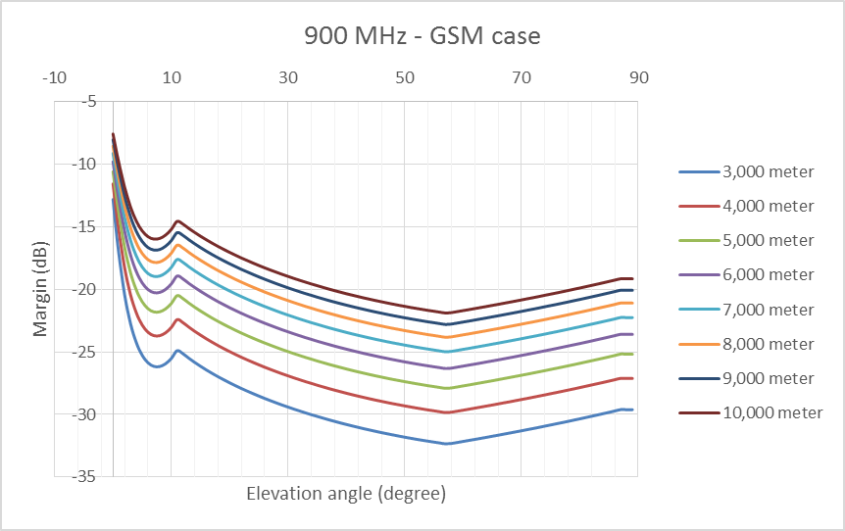
Aircraft height above ground  (m) | Worst case elevation angle  (deg) | Distance  ac-MS/ground BS (km) | Path loss  (dB) | Received power by ac-MS  (dBm/channel) | Margin  (dB)
3000 | 57 | 3.58 | 103.0 | -69.7 | -32.3
5000 | 57 | 5.96 | 107.4 | -74.1 | -27.9
10000 | 57 | 11.92 | 113.4 | -80.1 | -21.9

Table 12: MCL results for GSM1800
GSM1800: frequency used 1842.5 MHz
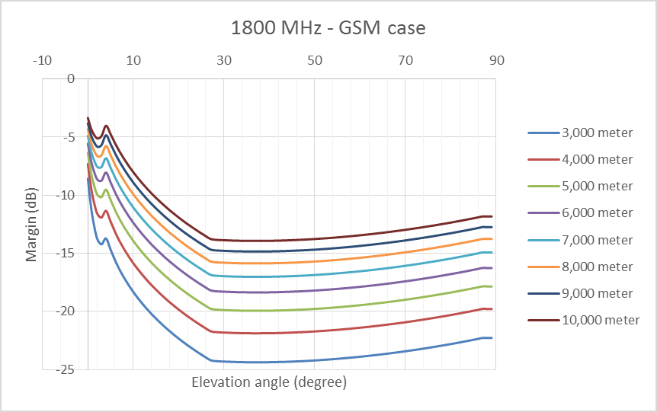
Aircraft height above ground  (m) | Worst case elevation angle  (deg) | Distance  ac-MS/ground BS (km) | Path loss  (dB) | Received power by ac-MS  (dBm/channel) | Margin  (dB)
3000 | 37 | 4.96 | 111.6 | -77.6 | -24.4
5000 | 37 | 8.3 | 116.1 | -82.0 | -20.0
10000 | 37 | 16.59 | 122.1 | -88.1 | -13.9
    - UMTS Downlink
Table 13: MCL results for UMTS900
UMTS900: frequency used 942.5 MHz
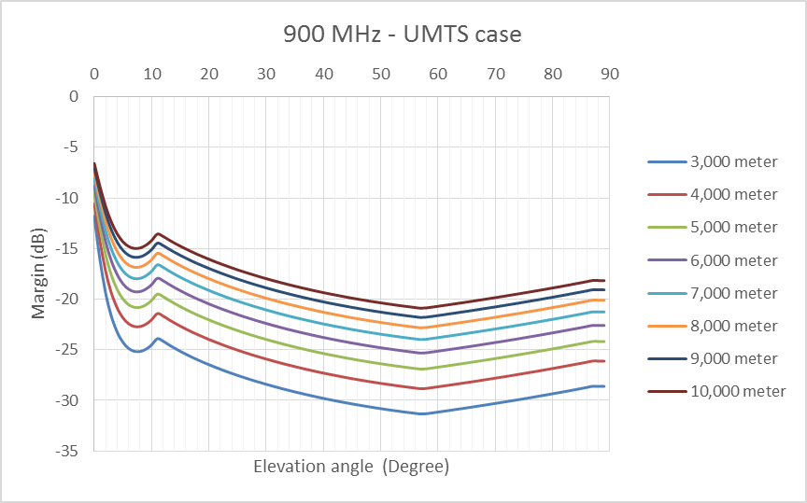
Aircraft height above ground  (m) | Worst case elevation angle  (deg) | Distance  ac-MS/ground BS (km) | Path loss  (dB) | Received power by ac-MS  (dBm/channel) | Margin  (dB)
3000 | 57 | 3.58 | 103.0 | -82.7 | -31.3
5000 | 57 | 5.96 | 107.4 | -87.1 | -26.9
10000 | 57 | 11.92 | 113.4 | -93.1 | -20.9

Table 14: MCL results for UMTS 2100
UMTS2100: frequency used 2140 MHz
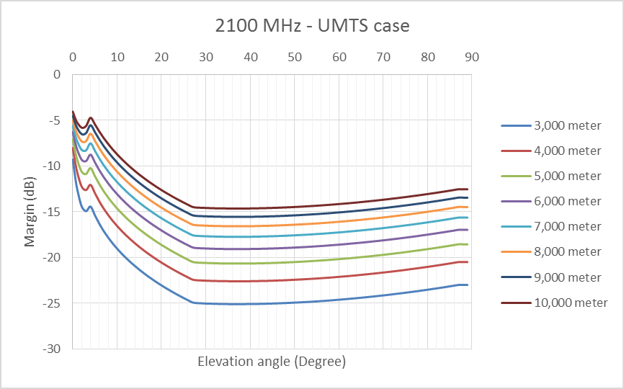
Aircraft height above ground  (m) | Worst case elevation angle  (deg) | Distance  ac-MS/ground BS (km) | Path loss  (dB) | Received power by ac-MS  (dBm/channel) | Margin  (dB)
3000 | 37 | 4.96 | 112.9 | -91.9 | -25.1
5000 | 37 | 8.30 | 117.4 | -96.3 | -20.7
10000 | 37 | 16.59 | 123.4 | -102.4 | -14.6
    - LTE Downlink

Table 15: MCL results for LTE450
LTE450: frequency used: 465 MHz
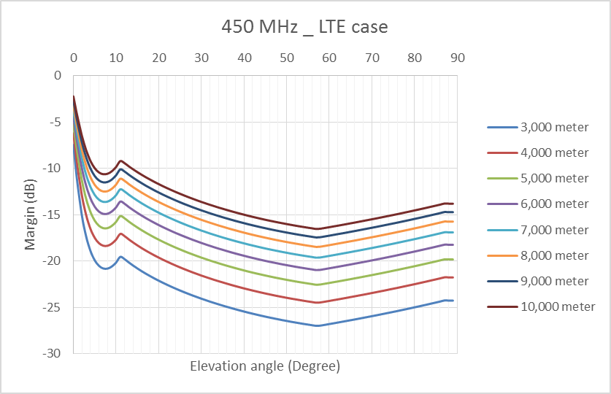
Aircraft height above ground  (m) | Worst case elevation angle  (deg) | Distance  ac-MS/ground BS (km) | Path loss  (dB) | Received power by ac-MS  (dBm/channel) | Margin  (dB)
3000 | 57 | 3.58 | 96.8 | -63.5 | -27.0
5000 | 57 | 5.96 | 101.3 | -68.0 | -22.5
10000 | 57 | 11.92 | 107.3 | -74.0 | -16.5
Table 16: MCL results for LTE900
LTE900: frequency used 942.5 MHz
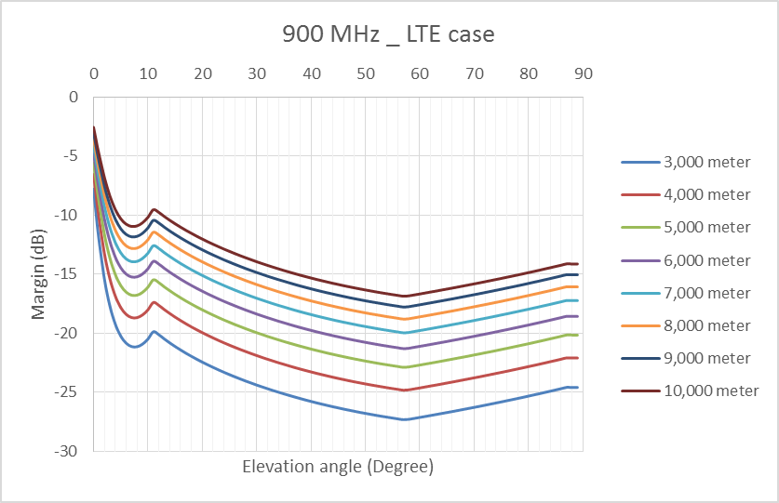
Aircraft height above ground  (m) | Worst case elevation angle  (deg) | Distance  ac-MS/ground BS (km) | Path loss  (dB) | Received power by ac-MS  (dBm/channel) | Margin  (dB)
3000 | 57 | 3.58 | 103.0 | -69.7 | -27.3
5000 | 57 | 5.96 | 107.4 | -74.1 | -22.9
10000 | 57 | 11.92 | 113.4 | -80.1 | -16.9
Note the MCL results for LTE700 and LTE800 are pretty similar to the results for LTE900

Table 17: MCL results for LTE1800
LTE1800: frequency used 1842.5 MHz
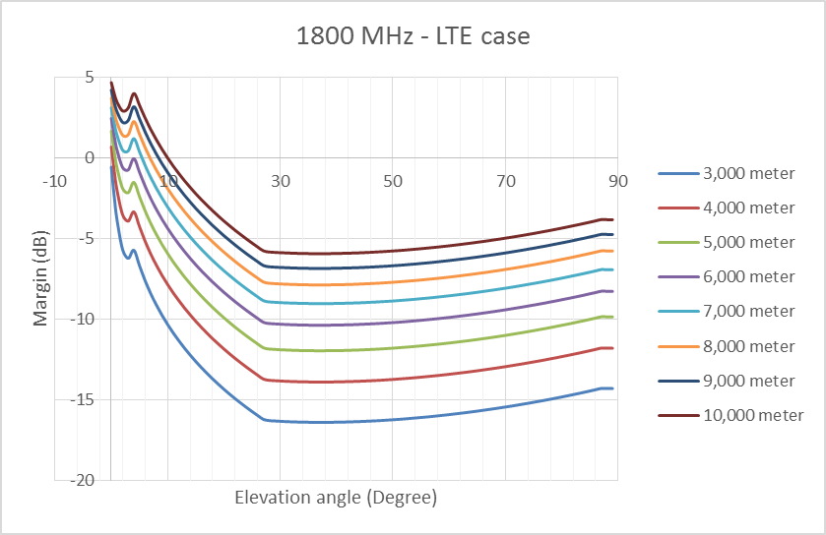
Aircraft height above ground  (m) | Worst case elevation angle  (deg) | Distance  ac-MS/ground BS (km) | Path loss  (dB) | Received power by ac-MS  (dBm/channel) | Margin  (dB)
3000 | 37 | 4.96 | 111.6 | -77.6 | -16.4
5000 | 37 | 8.3 | 116.1 | -82.0 | -12.0
10000 | 37 | 16.59 | 122.1 | -88.1 | -5.9
Table 18: MCL results for LTE2100
LTE2100: frequency used 2140 MHz
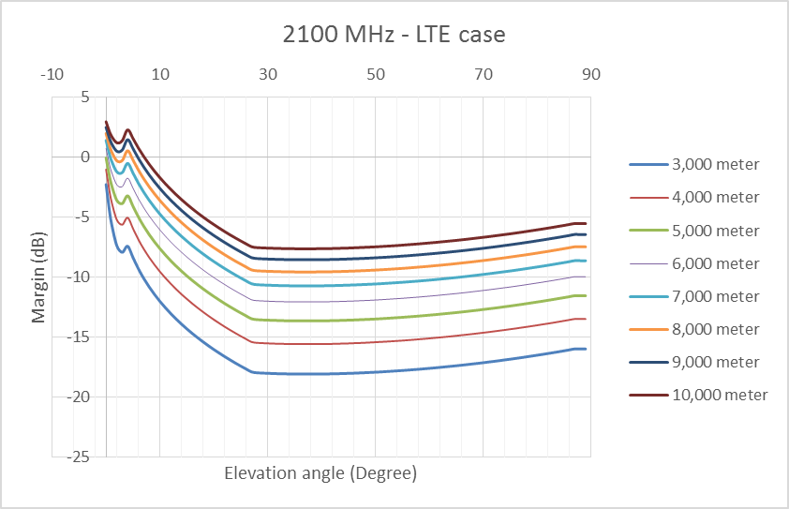
Aircraft height above ground  (m) | Worst case elevation angle  (deg) | Distance  ac-MS/ground BS (km) | Path loss  (dB) | Received power by ac-MS  (dBm/channel) | Margin  (dB)
3000 | 37 | 4.96 | 112.9 | -78.9 | -18.1
5000 | 37 | 8.3 | 117.4 | -83.3 | -13.7
10000 | 37 | 16.59 | 123.4 | -89.4 | -7.6
Table 19: MCL results for LTE2300
LTE2300: frequency used 2350 MHz
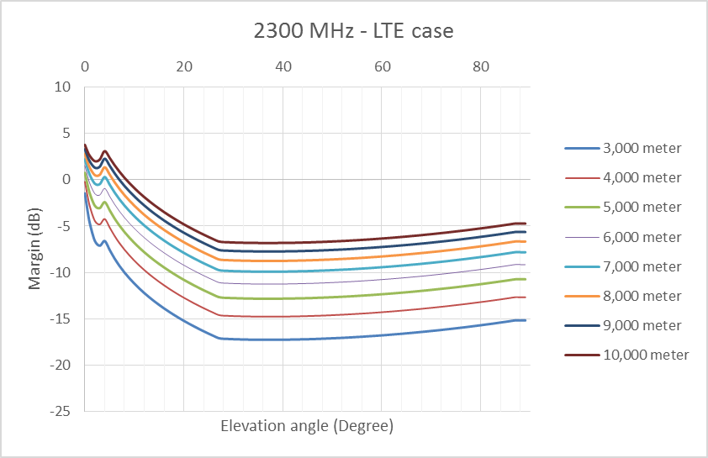
Aircraft height above ground  (m) | Worst case elevation angle  (deg) | Distance  ac-MS/ground BS (km) | Path loss  (dB) | Received power by ac-MS  (dBm/channel) | Margin  (dB)
3000 | 37 | 4.96 | 113.7 | -79.7 | -17.3
5000 | 37 | 8.3 | 118.2 | -84.2 | -12.8
10000 | 37 | 16.59 | 124.2 | -90.2 | -6.8

Table 20: MCL results for LTE2600 FDD
LTE2600-FDD: frequency used 2655 MHz
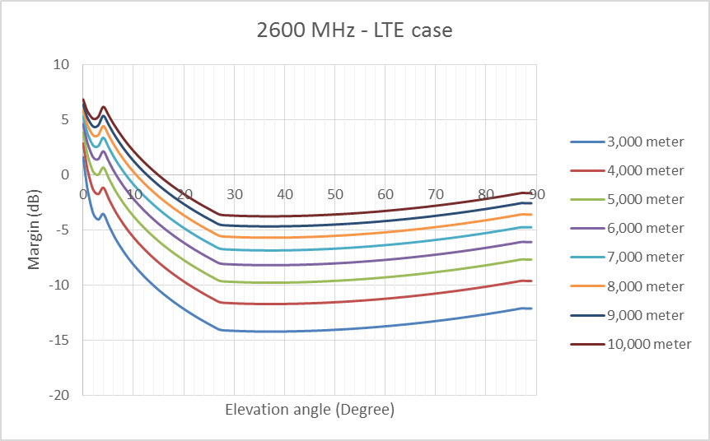
Aircraft height above ground  (m) | Worst case elevation angle  (deg) | Distance  ac-MS/ground BS (km) | Path loss  (dB) | Received power by ac-MS  (dBm/channel) | Margin  (dB)
3000 | 37 | 4.96 | 114.8 | -80.8 | -14.2
5000 | 37 | 8.3 | 119.3 | -85.2 | -9.8
10000 | 37 | 16.59 | 125.3 | -91.2 | -3.8
Table 21: MCL results for LTE3500
LTE3500: frequency used 3500 MHz
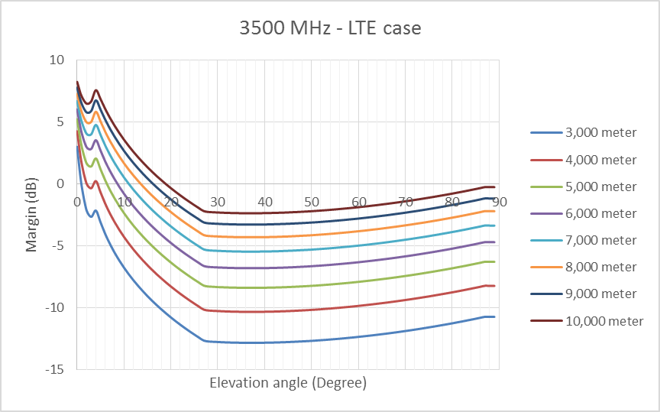
Aircraft height above ground  (m) | Worst case elevation angle  (deg) | Distance  ac-MS/ground BS (km) | Path loss  (dB) | Received power by ac-MS  (dBm/channel) | Margin  (dB)
3000 | 37 | 4.96 | 117.2 | -83.2 | -12.8
5000 | 37 | 8.3 | 121.7 | -87.6 | -8.4
10000 | 37 | 16.59 | 127.7 | -93.6 | -2.4

  - Scenario 2
    - GSM Uplink
Table 22: MCL results for GSM900
GSM900: frequency used 897.5 MHz
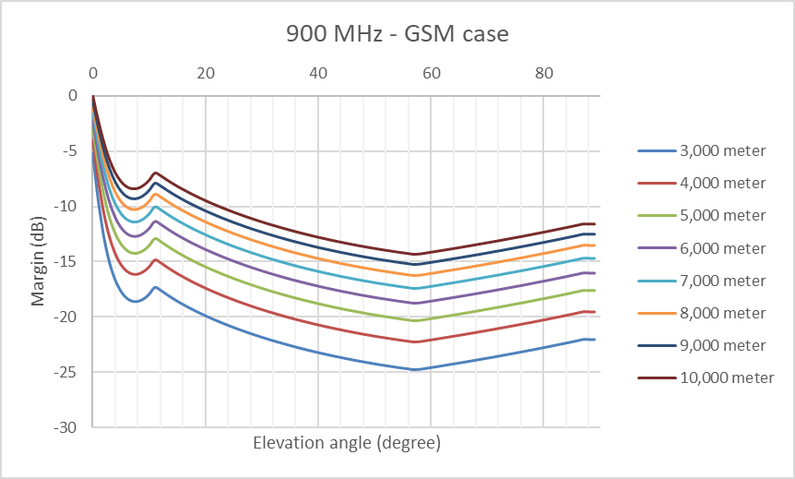
Aircraft height above ground  (m) | Worst case elevation angle  (deg) | Distance  ac-MS/ground BS (km) | Path loss  (dB) | Received power by ground BS  (dBm/channel) | Margin  (dB)
3000 | 57 | 3.58 | 102.5 | -79.2 | -24.8
5000 | 57 | 5.96 | 107.0 | -83.7 | -20.3
10000 | 57 | 11.92 | 113.0 | -89.7 | -14.3
Table 23: MCL results for GSM1800
GSM1800: frequency used 1747.5 MHz
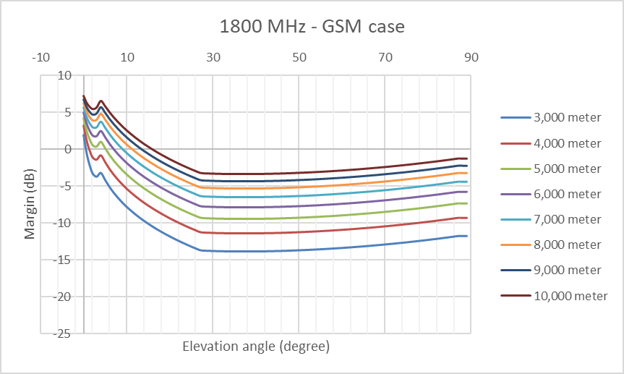
Aircraft height above ground  (m) | Worst case elevation angle  (deg) | Distance  ac-MS/ground BS (km) | Path loss  (dB) | Received power by ground BS  (dBm/channel) | Margin  (dB)
3000 | 37 | 4.96 | 111.2 | -87.1 | -13.9
5000 | 37 | 8.3 | 115.6 | -91.6 | -9.4
10000 | 37 | 16.59 | 121.6 | -97.6 | -3.4

    - UMTS Uplink
Table 24: MCL results for UMTS900
UMTS900: frequency used 897.5 MHz
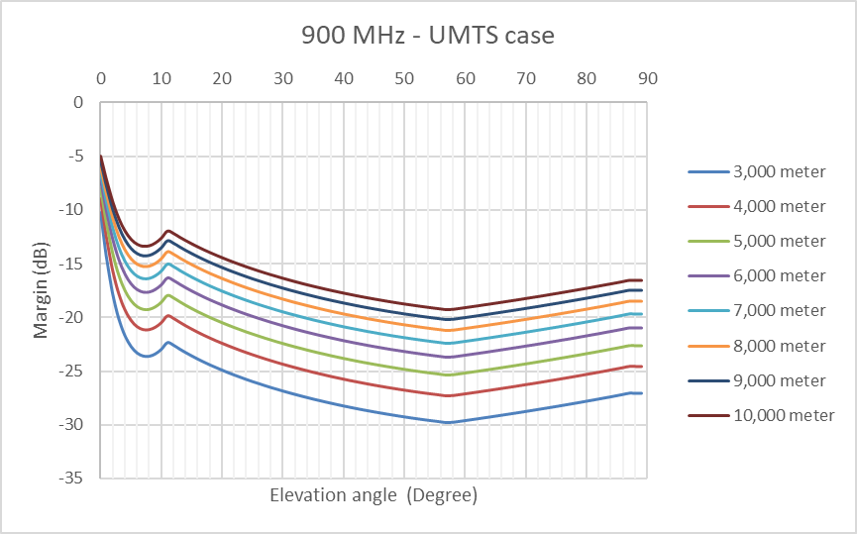
Aircraft height above ground  (m) | Worst case elevation angle  (deg) | Distance  ac-MS/ground BS (km) | Path loss  (dB) | Received power by ground BS  (dBm/channel) | Margin  (dB)
3000 | 57 | 3.58 | 102.5 | -91.2 | -29.8
5000 | 57 | 5.96 | 107.0 | -95.7 | -25.3
10000 | 57 | 11.92 | 113.0 | -101.7 | -19.3
Table 25: MCL results for UMTS2100 (scenario 2)
UMTS2100: frequency used 1950 MHz
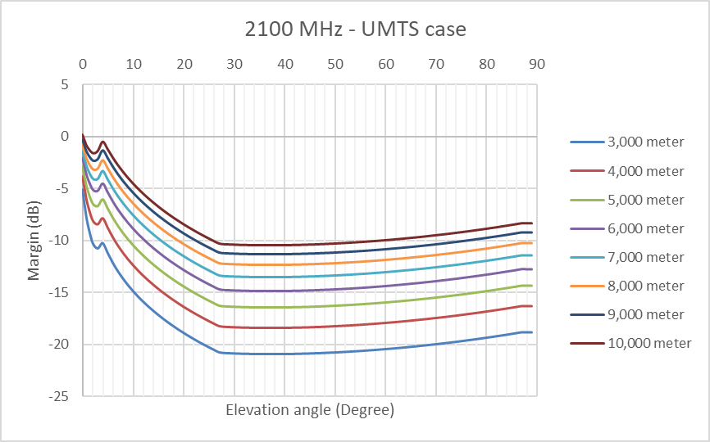
Aircraft height above ground  (m) | Worst case elevation angle  (deg) | Distance  ac-MS/ground BS (km) | Path loss  (dB) | Received power by ground BS  (dBm/channel) | Margin  (dB)
3000 | 37 | 4.96 | 112.1 | -100.1 | -20.9
5000 | 37 | 8.3 | 116.6 | -104.5 | -16.5
10000 | 37 | 16.59 | 122.6 | -110.6 | -10.4

    - LTE Uplink
Table 26: MCL results for LTE450 (scenario 2)
LTE450: frequency used 455 MHz
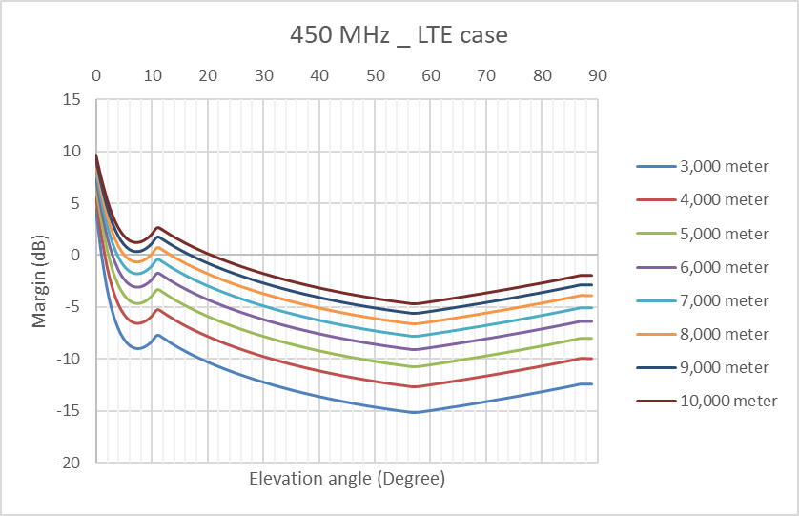
Aircraft height above ground  (m) | Worst case elevation angle  (deg) | Distance  ac-MS/ground BS (km) | Path loss  (dB) | Received power by ground BS  (dBm/channel) | Margin  (dB)
3000 | 57 | 3.58 | 96.6 | -86.3 | -15.2
5000 | 57 | 5.96 | 101.1 | -90.8 | -10.7
10000 | 57 | 11.92 | 107.1 | -96.8 | -4.7

Table 27: MCL results for LTE900
LTE900: frequency used 897.5 MHz
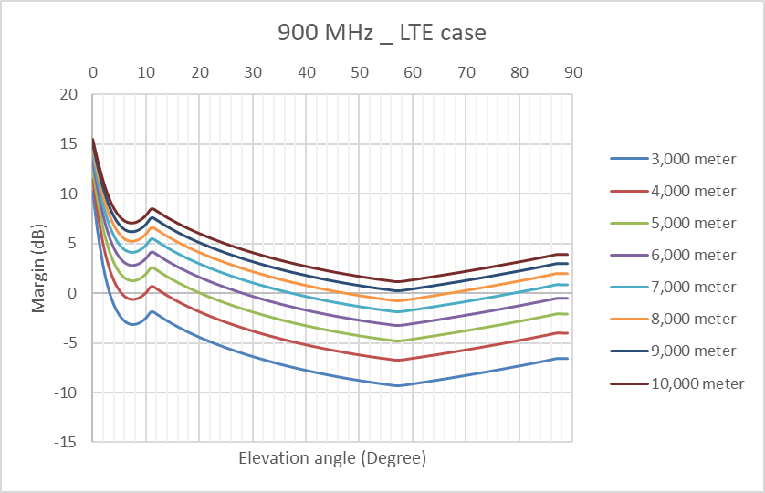
Aircraft height above ground  (m) | Worst case elevation angle  (deg) | Distance  ac-MS/ground BS (km) | Path loss  (dB) | Received power by ground BS  (dBm/channel) | Margin  (dB)
3000 | 57 | 3.58 | 102.5 | -92.2 | -9.3
5000 | 57 | 5.96 | 107.0 | -96.7 | -4.8
10000 | 57 | 11.92 | 113.0 | -102.7 | 1.2
Note the MCL results for LTE700 and LTE800 are close to the results for LTE900

Table 28: MCL results for LTE1800
LTE1800: frequency used 1747.5 MHz
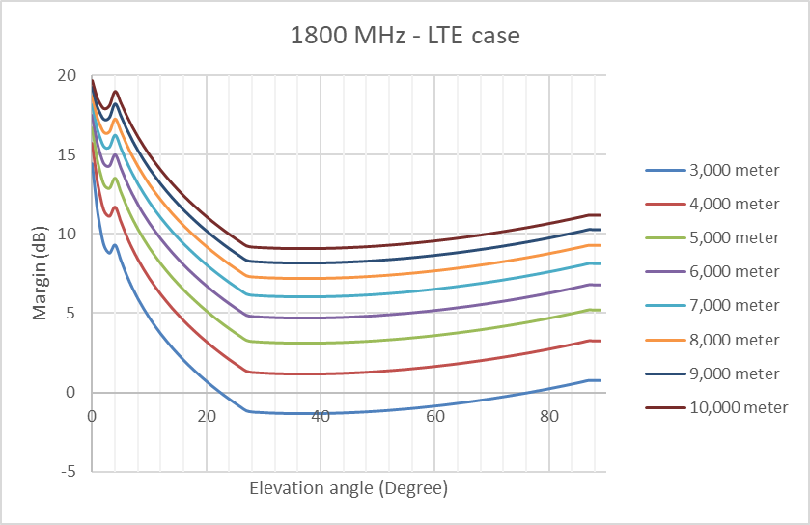
Aircraft height above ground  (m) | Worst case elevation angle  (deg) | Distance  ac-MS/ground BS (km) | Path loss  (dB) | Received power by ground BS  (dBm/channel) | Margin  (dB)
3000 | 37 | 4.96 | 111.2 | -100.1 | -1.4
5000 | 37 | 8.3 | 115.6 | -104.6 | 3.1
10000 | 37 | 16.59 | 121.6 | -110.6 | 9.1

Table 29: MCL results for LTE2100
LTE2100: frequency used 1950 MHz
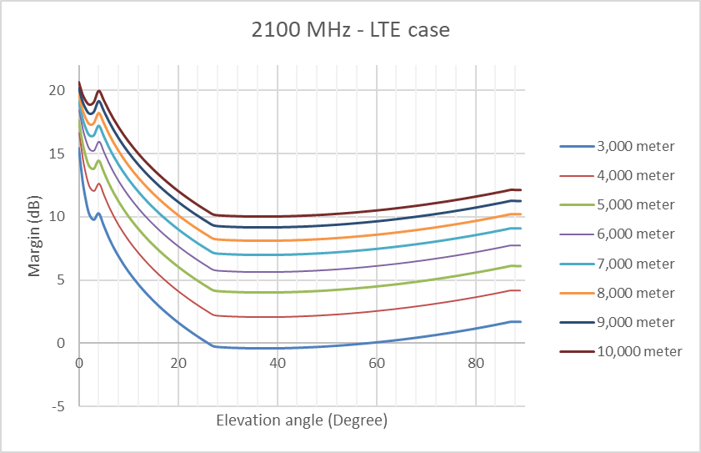
Aircraft height above ground  (m) | Worst case elevation angle  (deg) | Distance  ac-MS/ground BS (km) | Path loss  (dB) | Received power by ground BS  (dBm/channel) | Margin  (dB)
3000 | 37 | 4.96 | 112.1 | -101.1 | -0.4
5000 | 37 | 8.3 | 116.6 | -105.5 | 4.0
10000 | 37 | 16.59 | 122.6 | -111.6 | 10.1
Table 30: MCL results for LTE2300
LTE2300: frequency used 2350 MHz
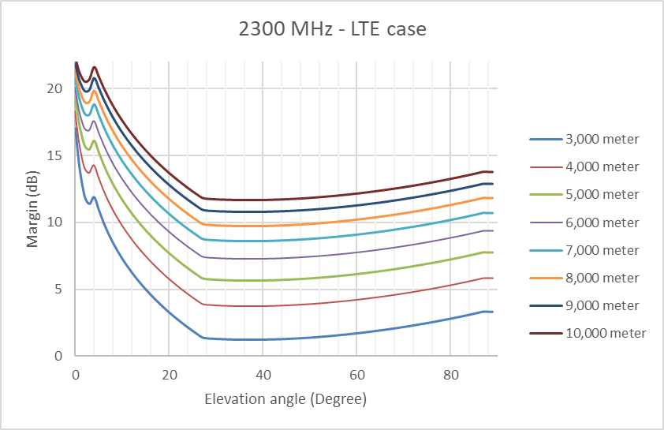
Aircraft height above ground  (m) | Worst case elevation angle (deg) | Distance  ac-MS/ground BS (km) | Path loss  (dB) | Received power by ground BS  (dBm/channel) | Margin  (dB)
3000 | 37 | 4.96 | 113.7 | -102.7 | 1.2
5000 | 37 | 8.3 | 118.2 | -107.2 | 5.7
10000 | 37 | 16.59 | 124.2 | -113.2 | 11.7

Table 31: MCL results for LTE2600 FDD
LTE2600-FDD: frequency used 2535 MHz
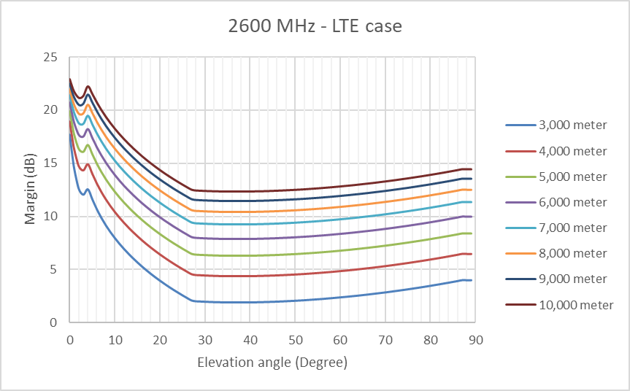
Aircraft height above ground  (m) | Worst case elevation angle  (deg) | Distance  ac-MS/ground BS (km) | Path loss  (dB) | Received power by ground BS  (dBm/channel) | Margin  (dB)
3000 | 37 | 4.96 | 114.4 | -103.3 | 1.8
5000 | 37 | 8.3 | 118.9 | -107.8 | 6.3
10000 | 37 | 16.59 | 124.9 | -113.8 | 12.3
Table 32: MCL results for LTE3500
LTE3500: frequency used 3500 MHz
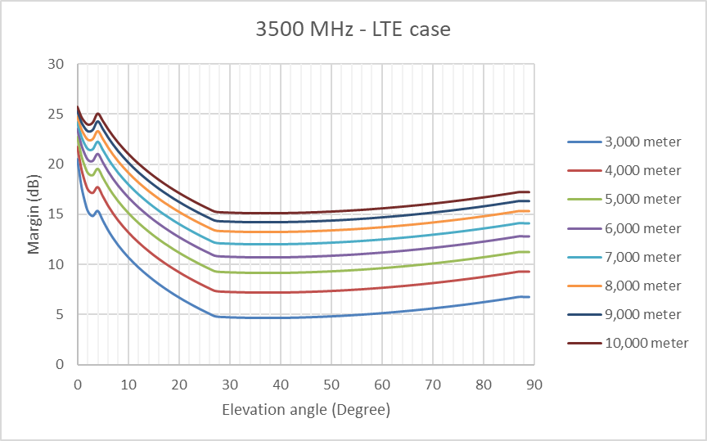
Aircraft height above ground  (m) | Worst case elevation angle  (deg) | Distance  ac-MS/ground BS (km) | Path loss  (dB) | Received power by ground BS  (dBm/channel) | Margin  (dB)
3000 | 37 | 4.96 | 117.2 | -106.1 | 4.6
5000 | 37 | 8.3 | 121.7 | -110.6 | 9.1
10000 | 37 | 16.59 | 127.7 | -116.6 | 15.1
  - MCL Summary
The Scenario 1 (downlink: g-BS transmit, ac-MS receive) analysis shows that whatever the cellular technologies and the operating frequency bands, the ground base station is always visible by the airborne mobile phone.
The Scenario 2 (uplink: g-BS receive, ac-MS transmit) analysis shows that the ground base station could not receive the signal from an airborne mobile phone based on LTE and whose operation frequency is above 2100 MHz. For 1800 MHz and 2100 MHz, the Airborne User equipment will not be visible by the ground base station above 4000 metres.

- SINR Results
  - UMTS results
SINR for downlink in UMTS900, 2-tier

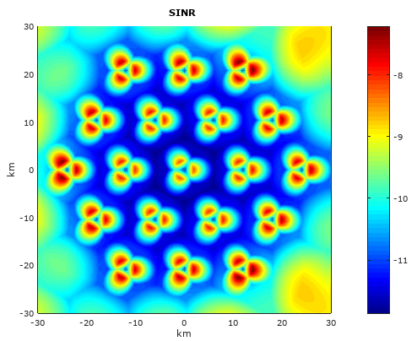 | Altitude of aircraft: 3,000 m  Maximum SINR in the center area : -8.2 dB
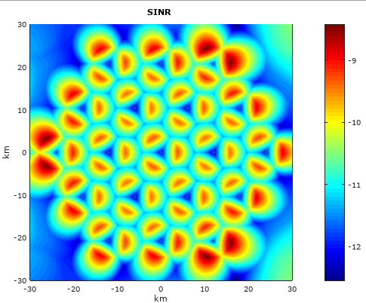 | Altitude of aircraft: 6,000 m  Maximum SINR in the center area: -9.3 dB
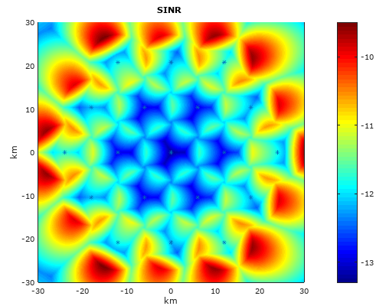 | Altitude of aircraft: 10,000 m  Maximum SINR in the center area: -11.6 dB

SINR for downlink in UMTS2100, 2-tier

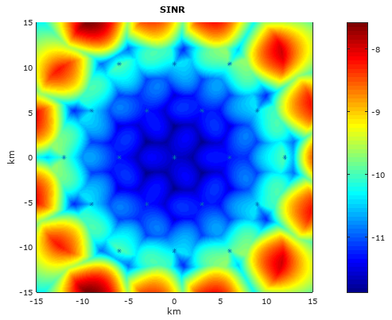 | Altitude of aircraft: 3,000 m  Maximum SINR in the center area: -11.2 dB
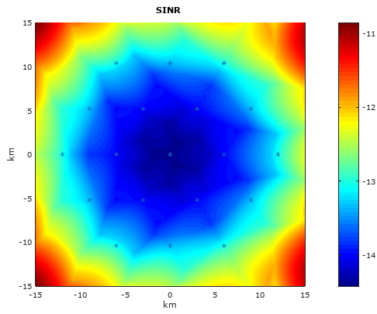 | Altitude of aircraft: 6,000 m  Maximum SINR in the center area: -14.1 dB
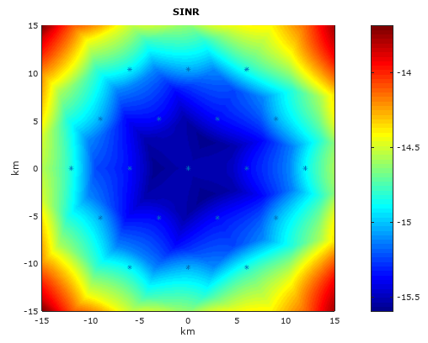 | Altitude of aircraft: 10,000 m  Maximum SINR in the center area: -15.4 dB

  - LTE results
SINR for downlink in LTE450, 2-tier
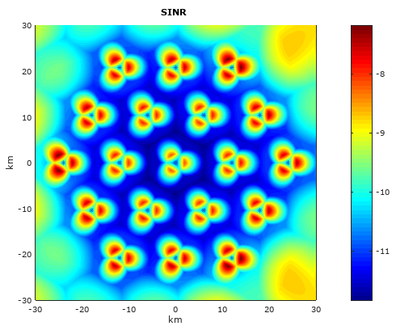 | Altitude of aircraft: 3,000 m  Maximum SINR in the center area: -8.3 dB
The results for LTE700 and LTE800 are similar to the result for LTE900

SINR for downlink in LTE900, 2-tier
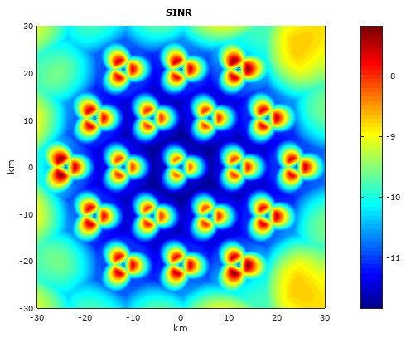 | Altitude of aircraft: 3,000 m  Maximum SINR in the center area: -8.3 dB
The results for LTE700 and LTE800 are similar to the result for LTE900

SINR for downlink in LTE1800, 2-tier
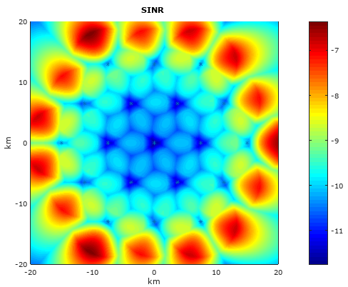 | Altitude of aircraft: 3,000 m  Maximum SINR in the center area: -9.9 dB

  - GSM results
SINR for downlink in GSM900, 2-tier
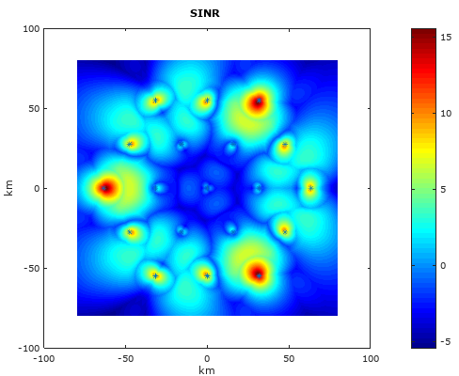 | Altitude of aircraft: 3,000 m  Maximum SINR in the center area: 0 dB

SINR for downlink in GSM1800, 2-tier
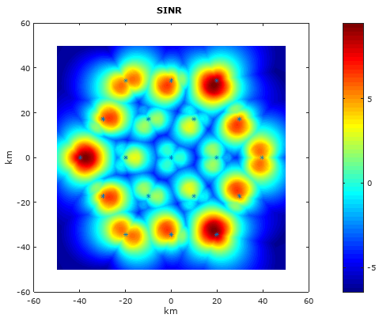 | Altitude of aircraft: 3,000 m  Maximum SINR in the center area: 0.2 dB

  - SINR results
The SINR analysis concludes that no successful registration of onboard mobile phone to a ground base station is possible in any of the GSM and LTE frequencies considered, while registration remains possible in any UMTS frequencies considered.

- Conclusion
The interference analysis has considered GSM, UMTS and LTE technologies. From the analysis, it can be concluded that an NCU is not required to screen the ground GSM and LTE networks.
For UMTS systems, the analysis concludes that an NCU is necessary to prevent connection of onboard mobile phone to mobile communications networks on the ground.
____________

https://www.gnu.org/software/octave/
RS = 7 is number of tri-sector sites (21 frequencies total, 3 sectors per site)
Value quotes typical operator power levels for the UMTS pilot channel = max Input power (43 dBm) -10 dB = 33dBm. In order to be able to register to the ground network, the MS should be able to decode the pilot channel.
Assume frequency re-use factor of 1 for LTE and UMTS.
NOTE: In some bands the bandwidth is limited to 5 MHz, however, there is a corresponding reduction in transmitted power and improvement receiver sensitivity.

