**APT REPORT ON**

**TECHNICAL AND OPERATIONAL ANALYSIS FOR USING HIGH ALTITUDE PLATFORM STATION AS IMT BASE STATIONS (HIBS) IN THE FREQUENCY BANDS BELOW 2.7 GHZ IDENTIFIED FOR IMT**

**Edition: September 2025**

**The 35th Meeting of APT Wireless Group**

**8 – 12 September 2025**

**Bangkok, Thailand (Hybrid)**

***(Source: AWG-35/OUT-09)***

**No. APT/AWG/REP-92(Rev.1)**

**APT REPORT ON**

**Technical and operational Analysis for USING high altitude platform station as imt base stations (HIBS) in the frequency bands below 2.7 GHz identified for IMT**

**1 Introduction**

In light of growing demand for broadband, there is a need for a solution to provide broadband access to underserved areas with minimal ground-level infrastructure and maintenance. At WRC-15, Resolution 160 was adopted to study how to facilitate access to global broadband applications delivered by high altitude platform station in the fixed service and WRC-19 Agenda Item 1.14 on high altitude platform station using frequency bands above 6 GHz for broadband delivery, achieved with frequency identifications in 6 GHz, 21/26 GHz, 28 GHz, 31 GHz, 38 GHz, and 47 GHz frequency bands.

At the same time, to utilize its capability to provide service to a large footprint (wider than 30,000 km2) at low latency (1/30 of LEO and 1/1800 of GEO[1]), high altitude platform station may also be used as IMT base stations, namely high altitude platform station as IMT base stations (hereafter “HIBS”), in the frequency bands below 2.7 GHz for providing mobile connectivity to underserved areas. Especially in providing connectivity for IoT, which is expected to become widespread in 2020 and beyond, mobile network operators (MNOs) are expected to meet the requirement for wider area coverage using their spectrum and at a reasonable cost. Indeed, satellite systems could also achieve wider area coverage, but it is difficult to have low latency similar to ground-based IMT network against high altitude platform station systems.

To allow flexible use of frequency bands for HIBS by MNOs (especially those who do not have the 2 GHz band), WRC-23 Agenda Item 1.4, which is to consider possible additional identification for use of HIBS within existing bands in the frequency ranges below 2.7 GHz identified for IMT, was established at WRC-19 based on the proposals from APT and other regional groups. At WRC-23, some frequency bands were identified for HIBS by RR Nos, **5.312B,** **5.314A**, **5.388A** and **5.409A** with the regulatory conditions in the relevant Resolutions **213 (WRC-23)**, **218 (WRC-23)** and **221 (Rev.WRC-23)** indicated the platforms operating between 18 km and 25 km.

In order to assist administrations who are planning implementation of HIBS in each country, this report provides possible benefits and analysis of technical, operational and regulatory aspects for using HIBS.

**2 Possible usage scenarios and benefits of HIBS**

This chapter describes the current situation and the future prospects for the “underserved areas”, or areas which are difficult to cover by ground-based IMT base stations, along with the assumed effects of using HIBS in those areas for different usage scenarios. Among NTN solutions, HIBS offer not only wide-area coverage but also key features such as low latency, high capacity, and high penetration. These features contribute to the realization of various usage scenarios.

**2.1 Underserved areas**

Population coverage has traditionally been used as a metric for IMT service areas and “underserved areas” can be described as areas where it is difficult to provide mobile connectivity to the residents. Economic challenges (e.g. very small population covered, lack of backhaul connectivity and power supply, etc.) and opposition from land owners and local communities to the construction of base stations/cell towers are some of the reasons why those areas cannot be covered by ground-based IMT base stations. Areas where IMT base stations, power supply and backhaul connectivity have been damaged by natural disasters can also become temporary “underserved areas.”

Meanwhile, mobile connectivity is becoming widespread, connecting not only people but also objects (IoT: Internet of things, IoE: Internet of Everything). Sensor networks which combine different types of sensors and IoT technology based on IMT systems (eMTC: enhanced Machine-Type Communication, NB-IoT: Narrowband IoT) are expected to be used widely including in unpopulated areas. By providing mobile connectivity that can be accessed by existing IMT user terminals in areas where ground-based IMT base stations could not cover (e.g. in midair (for drones) and coastal areas), we can also expect new industries to emerge. From this standpoint, these areas which are not targeted for population coverage by current ground-based IMT base stations can also be included as future “underserved areas.”

**2.2 Possible usage scenario and benefit**

**2.2.1 Coverage enhancement for rural areas**

Mobile coverage enhancement not only leads to increased competitiveness and revenue for MNOs but past studies show that it also contributes to the country’s economic growth. GSMA’s report “Benefits of network competition and complementary policies to promote mobile broadband coverage[2]” describes the close correlation between broadband penetration and GDP growth.

In the UK, the government imposed 90% of geographic coverage obligation on the 4 MNOs for voice service by the end of 2017 to support the country’s economic growth and all MNOs met this requirement[3]. However, according to Ofcom’s latest report[4], challenges remain especially in rural areas where securing power for base stations and backhaul connectivity can be difficult and the actual geographic coverage of voice service is reported to be lower than 90%.

By using HIBS in addition to ground-based IMT base stations, MNOs can cover these areas in economically efficient way and contribute to the country’s economic growth.

(For example, 1 HIBS can cover 100 km in radius which is equivalent to the area covered by 942 macro cell base stations (3 base stations can cover 100 km2).)

Furthermore, especially in rural areas, MNOs can reduce their costs by replacing costly ground-based IMT base stations which serve only a small number of users with HIBS.

**2.2.2 Safety and security**

By ensuring ubiquity through coverage enhancement including deserted areas, MNOs will be able to provide mobile connectivity to users regardless of time, place or circumstances. Thus, users will be able to connect emergency call wherever they are, whether in case of troubles such as a sudden car breakdown or when they are lost.

In addition, in a situation where ground-based IMT base stations have been damaged by natural disasters and cannot be restored quickly due to lack of access to the affected areas, communication networks can be restored quickly by covering those areas with HIBS.

In this way, HIBS can contribute to national safety and security. Satellites also have wide area coverage and are robust against natural disasters but the important point here is that in addition to these features, HIBS can connect with user terminals that users carry all the time. Capability to provide connection to ordinary mobile phones is an essential requirement for safety and security and therefore HIBS is certainly well-suited for such usage.

For example, Japanese mobile network operator is conducting experiments using UAV with sufficient flight speed to rapidly establish coverage at disaster sites. The use of this platforms to provide a rapidly deployable backup for mobile networks during natural disasters is highly anticipated. **[5]**

Furthermore, the technologies and insights gained from this effort can also be applied to the operation of HIBS, demonstrating its potential as an effective means of providing these situations.

* + 1. **Internet of Things**

Introduction of ICT in maintenance and management of public infrastructures such as roads (pavements), bridges and dams are becoming widespread. One of the applications is the deployment of sensor network using IMT-based IoT technology and HIBS, infrastructures in both urban areas and rural/deserted areas can be managed on the same sensor network. This idea can be applied not only to artificial structures but also to natural objects which are difficult for people to get close to or to constantly monitor. For example, such sensor network may be used for volcanic activity monitoring network for eruption forecasting purpose.

Another usage scenario is sensor network for large-scale agriculture and livestock farming. In addition to automation and streamlining of process based on big data collection and analysis, such use can lead to the development of a new industry in this area.

In this way, HIBS will be able to support efficient management and maintenance of domestic artificial structures and natural objects and to contribute to the development of the farming industry by expanding the reach of IoT services.

* + 1. **Drones and mobile connectivity around the coast**

Drones for industrial use are expected to be used for wide range of fields including logistics. Some drones that have been introduced use ground-based IMT base stations for communication. However, since the deployment of ground-based IMT base stations are basically not optimized to communicate with objects up in the air, interferences caused by the uplink signals from drones to IMT base stations other than those that they are communicating with and coverage holes are ongoing challenges of these systems. By using HIBS to provide drone connectivity, these problems can be avoided and can support increasing the usage of drones that use IMT-based communication.

Another use case would be to provide mobile connectivity to passengers and crew on fishing boats, passenger boats and transport vessels in the coastal area. Enabling access to the analytical results of the data on coastal waters on a real-time basis can support to increase fishing efficiency and enabling access to ordinary mobile phones on board ships and vessels can lead to the creation of new industries.

* + 1. **IMT Network Service**

HIBS deployment can follow at least 3 options as follows:

a. HIBS as element of a new MNO(s).

b. HIBS as eNodeB(s) or gNB(s) of existing MNO(s).

c. HIBS as repeater of ground-based eNodeB(s) or gNB(s) of existing MNO(s).

* + 1. **Event service**

HIBS can also be deployed above a venue, for example stadium, holiday scenic spots or exhibition place, to provide a high capacity which caused by the sudden increase of people traffic. The rapid deployment of HIBS can augment the terrestrial infrastructure of network to satisfy the unusual network capacity requirement during short periods of time.

**3 Architecture of HIBS**

**3.1 Carrier of HIBS**

In the stratosphere at an altitude of 18 to 25 km where HIBS operate, there is little convection and keeping flying objects in place is relatively easy. Thus, airship-type HIBS carriers have originally been considered and fixed-wing solar-powered planes are also being considered recently. There is some convection in the stratosphere and HIBS carriers will need to control their positions while in operation. HIBS carriers will repeat the cycle of using solar power to use their propulsion systems and to charge secondary batteries simultaneously during daytime and using the power of the secondary batteries to control their positions during night-time. Therefore, power generation and battery charging capability are very important for the long-term stable operation of HIBS. When HIBS were studied in the past, this essential capability for the continuous operation, and not telecommunication technology, was one of the factors that prevented the introduction of commercial systems. Currently various industries such as the power generation industry and the automotive industry are promoting the development of solar power generation technology and secondary battery technology. These technological advancements are expected to enable a stable continuous flight for several months making it possible for operating HIBS.

**3.2 System architecture**

Figure 1 shows a system level diagram for HIBS (Heavier Than Air platform is just an illustration). Mobile service bands below 2.7GHz will be used for the service link between HIBS and user equipment (UE). Fixed service bands already identified for high altitude platform station will be used for the feeder link between HIBS and gateway (GW) station. In addition, inter-HIBS links and satellite links may also be considered for feeder link of HIBS as shown in Figure 1.

A HIBS has an area of about 7800km2(Radius = 50km). However, large area such as desert and ocean need to expand the communication coverage by aggregate HIBS. The Inter-HIBS links which connect between each HIBS and the satellite links which connect between HIBS and satellite are required to perform as backhaul links which may solve the arduous or impossible tasks to establish the stations in underserved areas. Inter-HIBS links and the links from HIBS to gateway (GW) are regarded as feeder links of HIBS.

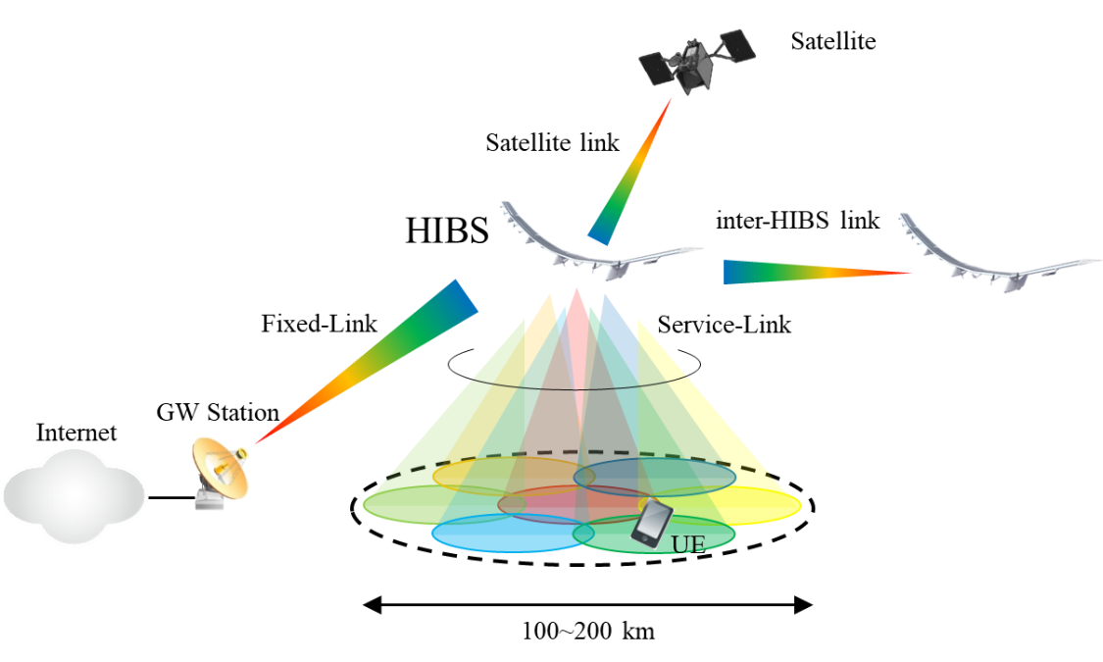

**Figure 1 HIBS systems level diagram**

Service link coverage of one HIBS is assumed to be around 100 km in radius at maximum and under single-beam operation, ordinary mobile phones cannot be connected at the cell edge due to low antenna gain to cover wide area with a single beam. Therefore, multi-beam operation, which allows to use high-gain antenna such as sector or phased-array antenna, will be the basic principle of HIBS operation.

Two types of HIBS are assumed: repeater (frequency converter) type and base station type as shown in Figure 2.



**Figure 2 Types of HIBS**

The equipment configuration of Repeater-type HIBS is simple, so it has advantages from the viewpoint of light weight, low power consumption, and failure tolerance. On top of that, any type of base stations (Enhanced NodeB (eNB) or next Generation NodeB (gNB)) for terrestrial mobile communications services can be used as it is without complying with severe stratosphere environment.

Base Station-type HIBS will use a fixed wireless access system for its backhaul communications, so its spectrum usage efficiency outperforms that of simple Repeater-type. In addition, the communications distance between its base station and UE is shorter compared to Repeater-type because the base station is placed on high altitude platform station different from the ground via repeater in the case of Repeater-type, which means the maximum coverage area can be wider from the viewpoint of communications distance limitation (e.g. 100 km in the case of IMT-Advanced systems)

**3.3 System characteristics**

The following tables show the deployment and system related characteristics of HIBS with exemplary parameters utilized for the sharing and compatibility studies, which were used in the technical studies for WRC-23 Agenda Item 1.4.

Characteristics for feeder links will be the same as those used in the ITU-R studies[6].

**3.3.1 Exemplary parameters related to specification**

Table 1 and Table 2 describe specification related parameters for HIBS and the User Equipment (UE) associated to HIBS, respectively.

**Table 1 Specification related parameters of HIBS**

|  |  | HIBS (BS) | | |
| --- | --- | --- | --- | --- |
| No. | Parameter | Band 1  (For the frequency bands in the range of 694-960 MHz, see Annex 2) | Band 2  (1 710-1 980 MHz 2 010-2 025 MHz 2 110-2 170 MHz) | Band 3  (2 500-2 690 MHz) |
| 1 | Duplex method and transmission direction | FDD/TDD (See section 6.2.1) | | |
| 2 | Channel bandwidth (MHz) | 20 MHz | | |
| 3 | Signal bandwidth (MHz) | >90% of channel bandwidth | | |
| 4 | Transmitter characteristics |  | | |
| 4.1 | Power dynamic range (dB) | 0 dB conducted BS output power | | |
| 4.2 | Spectrum mask | See Table 1-a | | |
| 4.3 | ACLR | 45 dB | | |
| 4.4 | Spurious emissions | ‒13 dBm/‒30 dBm(1) | | |
| 5 | Receiver characteristics |  | | |
| 5.1 | Noise figure | 5 dB | | |
| 5.2 | Sensitivity | ‒95.6 dBm | | |
| 5.3 | Blocking response | ‒43 dBm | | |
| 5.4 | ACS | 37.6 dB | | |
| 5.5 | SINR operating range | The SINR mapping function is given below. | | |
| Note to the Table:  (1) The measurement bandwidth is 100 kHz for frequencies between 30 MHz and 1 GHz, and 1 MHz for frequencies above 1 GHz, as indicated in Recommendation ITU-R SM.329, § 4.1. The choice between the two spurious emissions values of ‒13 dBm/‒30 dBm should take into consideration specific national requirements and the studies with other services and applications, as the results of such studies may indicate which value is more appropriate to achieve compatibility. | | | | |

**Table 1-a Spectrum mask**

| Frequency offset from “edge of transmission” Δf | Emission limit | Measurement bandwidth |
| --- | --- | --- |
| 0 MHz  Δf < 5 MHz |  | 100 kHz |
| 5 MHz  Δ*f* < 10 MHz | ‒14 dBm | 100 kHz |
| 10 MHz  Δf | Spurious domain limits | – |
| Notes to the Table:  (1) For AAS BS, the Over-The-Air (OTA) emission requirements measured as Total Radiated Power (TRP) are defined as the basic limits described in the Table plus 9 dB.  (2) Δf is equal to f_offset minus half of the measurement bandwidth. | | |

**Table 2 Specification related parameters of UE served by HIBS**

|  |  | UE served by HIBS | | |
| --- | --- | --- | --- | --- |
| No. | Parameter | Band 1 | Band 2 | Band 3 |
| 1 | Duplex method and transmission direction | FDD/TDD (See section 6.2.1) | | |
| 2 | Channel bandwidth (MHz) | 20 MHz | | |
| 3 | Signal bandwidth (MHz) | >90% of channel bandwidth | | |
| 4 | Transmitter characteristics |  | | |
| 4.1 | Power dynamic range (dB) | 63 dB | | |
| 4.2 | Spectrum mask | See Table 2-a | | |
| 4.3 | ACLR | 30 dB | | |
| 4.4 | Spurious emissions | -36 dBm/100 kHz (30 MHz ≤ f < 1000 MHz)  -30 dBm/MHz (1 GHz ≤ f < 12.75 GHz) | | |
| 5 | Receiver characteristics |  | | |
| 5.1 | Noise figure | 9 dB | | |
| 5.2 | Sensitivity | -91 dBm | -91 dBm | -92 dBm |
| 5.3 | Blocking response | -44 dBm | | |
| 5.4 | ACS | 27 dB | | |
| 5.5 | SINR operating range | The SINR mapping function is given below. | | |

**Table 2-a Spectrum mask – UE served by HIBS**

|  |  |  |
| --- | --- | --- |
| Frequency offset from “edge of transmission” Δf | Emission limit | Measurement bandwidth |
| 0  Δf < 1 MHz | –13 dBm | 0.2 MHz |
| 1 MHz  Δf < 5 MHz | –10 dBm | 1 MHz |
| 5 MHz  Δf < 15 MHz | –13 dBm | 1 MHz |
| 15 MHz  Δf < 25 MHz | –25 dBm | 1 MHz |
| Δf > 25 MHz | Spurious domain limits | - |

SINR operating range and mapping function

The following equations approximate the throughput over a channel with a given SINR, when using link adaptation:

$$Throughput \left(SINR\right), bps/Hz =\left\{\begin{aligned}0 for SINR< SINR_{MIN} \\ α∙S\left(SINR\right) for SINR_{MIN}≤SINR<SINR_{MAX} \\ α∙S\left(SINR_{MAX}\right) for SINR ≥ SINR_{MAX} \end{aligned}\right.$$

where:

*S(SINR)* Shannon bound, *S(SINR)* =log2(1+*SINR*) (in bps/Hz)

*α* attenuation factor, representing implementation losses

*SINRMIN* minimum SINR of the code set, dB

*SINRMAX* maximum SINR of the code set, dB.

The parameters α, *SINRMIN* and *SINRMAX* can be chosen to represent different modem implementations and link conditions. The parameters proposed in Table 3 represent a baseline case, which assumes:

– 1:1 antenna configuration.

– AWGN channel model.

– Link Adaptation (see Table 3 for details of the highest and lowest rate codes).

– No HARQ.

**Table 3 Parameters describing baseline link level performance for HIBS**

|  |  |  |  |
| --- | --- | --- | --- |
| Parameter | DL | UL | Notes |
| Α | 0.6 | 0.4 | Represents implementation losses |
| *SINRMIN*, dB | –10 | –10 | Based on QPSK, 1/8 rate (DL) & 1/5 rate (UL) |
| *SINRMAX*, dB | 30 | 22 | Based on 256QAM 0.93(DL) & 64QAM 0.93 (UL) |

**3.3.2 Deployment related parameters**

**3.3.2.1 Network topology**

Figure 3 illustrates a cluster structure of HIBS network in wider-area deployment scenario, which depends on targeted area to be covered and the clutter of this area. Each area covered by single HIBS is shown as a hexagon and defined “HIBS area”. “HIBS area Radius” is defined as (A) and distance between HIBS referred to as “inter-HIBS distance” is defined as (B).

**Figure 3 HIBS area structure**

Based on the above assumption, inter-HIBS distance (B) can be calculated by HIBS area radius (A) as “B = A $\sqrt{3}$”.

A HIBS area can be divided into multiple cells with multi-beam configurations. Figure 4 illustrates examples of multiple cells deployment (3 and 7) produced by a single HIBS. In the cases of 7 cells, the cell deployed at the centre of a HIBS area is defined as “1st layer cell”, the cells on the outer side of 1st layer cell are defined as “2nd layer cell” as shown in Figure 4. Generally, the cells in the same layer are arranged at equal horizontal angle interval. For example, in 7 cells deployment as shown in Figure 4-(b), the 6 cells in 2nd layer are arranged every 60 degrees in the horizontal direction.

**Figure 4 Examples of HIBS multiple cells deployment**

**3.3.2.2 Platform antenna characteristics**

As shown in Figure 5, the angle of the main beam below the horizontal plane is defined as “platform antenna tilt”.

**Figure 5 Platform Antenna tilt**

Figure 6 illustrates an example of HIBS antenna design for a 7 cells deployment with multi-beam configurations by the combination of several antenna panels.

**Figure 6 Example of HIBS antenna design (for 7 cells deployment)**

The characteristics of these HIBS antennas (platform antenna tilt, maximum antenna gain and antenna pattern) may be different among cell layers when HIBS area consists of multiple cell layers (e.g., 7 cells deployment).

**3.3.2.3 Deployment related parameters of HIBS**

Table 4 describes deployment related parameters for HIBS and the UE associated to HIBS, designed for vast areas less affected by clutter loss (LOS environment).

**Table 4 Deployment related parameters of HIBS**

| No. | Parameter | Band 1  (For the frequency bands in the range of 694-960 MHz, see Annex 2) | Band 2  (1 710-1 980 MHz 2 010-2 025 MHz 2 110-2 170 MHz) | Band 3  (2 500-2 690 MHz) |
| --- | --- | --- | --- | --- |
| **1** | **Network topology and characteristics** | | | |
| 1.1 | BS density or ISD | 1 BS/HIBS area | | |
| 1.2 | HIBS area radius | 100 km | 100 km | 90 km |
| 1.3 | HIBS Network Configuration  (Duplex Mode)(1) | FDD/TDD(1a) | FDD/TDD(1b) | FDD/TDD(1c) |
| **2** | **Base station characteristics/Cell Structure** | | | |
| 2.1 | HIBS Platform Altitude | 18-25 km(4) | | |
| 2.2 | Number of cells/HIBS | 7 | | |
| 2.3 | Frequency reuse | 1 | | |
| 2.5 | HIBS Platform Antenna pattern | Recommendation ITU-R M.2101(2)(3) | | |
|  | Element gain | 8 dBi | | |
|  | Horizontal/vertical 3 dB beamwidth of single element | 65º for both H/V | | |
|  | Horizontal/vertical front-to-back ratio | 30 dB for both H/V | | |
|  | Antenna polarization | Linear/±45 degrees | | |
|  | Antenna array configuration (Row × Column) | 2 x 2 elements (1st layer cell),  4 x 2 elements per cell (2nd layer cell) | | |
|  | Horizontal/Vertical radiating element spacing | 0.5 of wavelength for both H/V | | |
|  | Ohmic losses | 2 dB | | |
| 2.6 | HIBS Platform Antenna tilt | 90º (1st layer cell), 33º (2nd layer cell) | 90º (1st layer cell), 23º (2nd layer cell) | 90º (1st layer cell), 23º (2nd layer cell) |
| 2.7 | HIBS Conducted power per antenna element | 37 dBm (1st layer cell),  34 dBm (2nd layer cell) | | |
| 2.8 | HIBS Platform e.i.r.p./cell | 55 dBm (1st layer cell),  58 dBm (2nd layer cell) | | |
| 2.9 | HIBS Platform e.i.r.p. Spectral Density/cell | 42 dBm/MHz (1st layer cell), 45 dBm/MHz (2nd layer cell) | | |
| **3** | **UE characteristics** | | | |
| 3.1 | UE density for equipment that are transmitting simultaneously | 3 UEs per cell(3) | | |
| 3.2 | UE height | 1.5 m(3) | | |
| 3.3 | Body loss | 4 dB(3) | | |
| 3.4 | Typical antenna gain for UE | -3 dBi(3) | | |
| 3.5 | Transmit power control model | Refer to Recommendation ITU-R M.2101(3) | | |
| 3.6 | Maximum UE transmitter output power | 23 dBm(3) | | |
| Notes to the Table:  (1) When performing sharing and compatibility studies with IMT terrestrial networks, the frequency arrangements as shown in section 6.2.1 should be taken into account when evaluating cross-border interference scenarios from HIBS operating on one Duplex mode into the neighbouring country’s terrestrial IMT networks operating on another Duplex mode.  (a) The 694/698-728 MHz and 830-835 MHz ranges in all Regions and the 805.3-806.9 MHz range in Regions 1 and 2 is to be used for only uplink.  (b) The 1 710-1 785 MHz range in Regions 1 and 2 and the 1 710-1 815 MHz range in Region 3 is to be used for only uplink and the 2 110-2 160/2 170 MHz range in all Regions is to be used for only downlink.  (c) The 2 500-2 510 MHz range in Regions 1 and 2 and the 2 500-2 535 MHz range in Region 3 is to be used for only uplink, and that the 2 655-2 690 MHz range is not to be used in Region 3.  (2) Considering the relevant normalization factor, if needed.  (3) The values are representative of HIBS extracted from the deployment related parameters of the ground component of IMT.  (4) See Resolutions **213 (WRC-23)**, **221 (Rev.WRC-23)** and **218 (WRC-23)**. | | | | |

**3.3.2.4 Protection criterion for HIBS**

HIBS protection criterion (irrespective of the number of cells and independent of the number of interferers) is the same as that for the ground component of IMT base station.

**3.4 Link budget example**

Link budget example where a UE is located at 100 km distant from high altitude platform station based on the system characteristics in Section 3.3 is shown in Table 5. It shows that the link budget is sufficient for ordinary mobile phones to be used in communication systems based on high altitude platform station even at the distance of 100 km.

**Table 5 Link budget example in 2 GHz frequency band**

|  |  |  |  |
| --- | --- | --- | --- |
|  |  | DL (HIBS🡪UE) | UL (UE🡪HIBS) |
| Tx power | dBm | 43 | 23 |
| Tx antenna gain | dBi | 17 | -3 |
| Propagation loss | dB | 138.5 | 138.5 |
| Rx antenna gain | dBi | -3 | 17 |
| Body loss | dB | 4 | 4 |
| Received power | dBm | -88.5 | -108.5 |
| Channel bandwidth | MHz | 18 | 0.18 |
| Total noise power  (including NF) | dBm | -96.5 | -116.5 |
| Received SNR | dB | 11 | 11 |

**4 Current status and future plan of the frequency bands in APT countries**

At its 23rd meeting in April 2018, AWG developed the questionnaire on current status and future plan related to HAPS in APT countries and 11 administrations responded.

**4.1 Current status and future plan of the frequency bands specifically identified to HIBS**

Table 6 shows a summary of current status and future plan of the frequency bands in RR No.5.388A.

**Table 6 current status and future plan of the frequency bands in RR No.5.388A**

|  |  |  |  |  |  |  |  |
| --- | --- | --- | --- | --- | --- | --- | --- |
| **RR** | **Frequency Ranges** | **Have HAPS trials** | | | **Have future plan for HAPS** | | |
| **Yes** | **No** | **Not sure** | **Yes** | **No** | **Not sure** |
| 5.388A | 1 885-1 980 MHz |  | AUS  BGD  BRM  CHN  INS  IRN  J  KOR  NZL  THA  VTN |  |  | AUS  KOR  VTN  INS | BGD  BRM  CHN  IRN  J  NZL  THA |
| 5.388A | 2 010-2 025 MHz |  | AUS  BGD  BRM  CHN  INS  IRN  J  KOR  NZL  THA  VTN |  |  | AUS  KOR  VTN | BGD  BRM  CHN  INS  IRN  J  NZL  THA |
| 5.388A | 2 110-2 170 MHz |  | AUS  BGD  BRM  CHN  INS  IRN  J  KOR  NZL  THA  VTN |  |  | AUS  KOR  VTN | BGD  BRM  CHN  INS  IRN  J  NZL  THA |

**4.2 Current status and future plan of the frequency bands identified to IMT**

Table 7 to 19 shows a summary of current status and future plan of the frequency bands identified to IMT.

**Table 7 current status and future plan of the frequency band 450-470 MHz (RR No.5.286AA)**

|  |  |  |  |  |  |
| --- | --- | --- | --- | --- | --- |
| **IMT or Services currently using and future planned** | | **Interest in introduction of HAPS IMT** | | | **Concerned services or systems in terms of sharing and compatibility with HAPS IMT base stations** |
| **Yes** | **No** | **Not sure** |
| IMT | BGD  BRM  INS  THA  VTN | BMR | AUS  KOR  NZL  VTN | BGD  CHN  INS  IRN  J  THA | * **(AUS)** Land Mobile system Fixed Point to Point Point to Multi-Point (heavy use in high and medium density areas) * **(BRM)** Data rate will be the issue * **(CHN)** Fixed Mobile (Other than IMT) Wireless Train Dispatching System Meteorological-satellite (space-to-Earth) |
| FIXED | AUS  CHN  INS  J  NZL  THA |
| MOBILE (other than IMT) | AUS  CHN  INS  IRN  J  KOR  NZL  THA |
| * Civil WLL Applications (BGD) * Wireless Train Dispatching System (CHN) * Meteorological-satellite (space-to-Earth) (CHN) * Special government service (INS) | |

**Table 8 current status and future plan of the frequency band 470-698 MHz (RR No.5.296A)**

|  |  |  |  |  |  |
| --- | --- | --- | --- | --- | --- |
| **IMT or Services currently using and future planned** | | **Interest in introduction of HAPS IMT** | | | **Concerned services or systems in terms of sharing and compatibility with HAPS IMT base stations** |
| **Yes** | **No** | **Not sure** |
| IMT | INS | BRM | AUS  KOR  VTN | BGD  CHN  INS  IRN  J  NZL  THA | * **(AUS)** Land Mobile system Fixed Point to Point Point to Multi-Point (heavy use in high and medium density areas)  TV Broadcasting (heavy use) * **(BRM)** Payload will be the issue * **(CHN)** Fixed Mobile(Other than IMT) Broadcasting Space research service Radionavigation Radiolocation Radio astronomy service * **(NZL)** TBD |
| FIXED | AUS  CHN  INS  NZL  THA |
| MOBILE (other than IMT) | AUS  CHN  INS  J  NZL  THA |
| BROADCASTING | AUS  BGD  BRM  CHN  INS  IRN  J  KOR  NZL  THA  VTN |
| RADIONAVIGATION | INS |
| * Wireless Microphones (AUS) * PMR (BGD) * Civil WLL Applications (BGD) * Governmental Mobile Systems Radio Service (BGD) * Space research service (CHN) * Radionavigation (CHN) * Radiolocation (CHN) * Radio astronomy service (CHN) * Others (KOR) | |

**Table 9 current status and future plan of the frequency band 610-698 MHz (RR No.5.296A)**

|  |  |  |  |  |  |
| --- | --- | --- | --- | --- | --- |
| **IMT or Services currently using and future planned** | | **Interest in introduction of HAPS IMT** | | | **Concerned services or systems in terms of sharing and compatibility with HAPS IMT base stations** |
| **Yes** | **No** | **Not sure** |
| IMT | INS  NZL | BRM | AUS  KOR  VTN | BGD  CHN  INS  IRN  J  NZL  THA | * **(AUS)** TV Broadcasting (heavy use) * **(BRM)** Payload will be the issue * **(CHN)** Broadcasting Radio astronomy service * **(NZL)** TBD |
| FIXED | INS  THA |
| MOBILE (other than IMT) | INS  J |
| BROADCASTING | AUS  BGD  BRM  CHN  INS  IRN  J  KOR  NZL  THA  VTN |
| * Wireless Microphones (AUS) * Radio astronomy service (CHN) * Digital TV (INS) * Others (KOR) | |

**Table 10 current status and future plan of the frequency band 698-790MHz (RR No.5.313A)**

|  |  |  |  |  |  |
| --- | --- | --- | --- | --- | --- |
| **IMT or Services currently using and future planned** | | **Interest in introduction of HAPS IMT** | | | **Concerned services or systems in terms of sharing and compatibility with HAPS IMT base stations** |
| **Yes** | **No** | **Not sure** |
| IMT | AUS  BGD  BRM  IRN (future planned)  J  KOR  NZL  THA  VTN | J | AUS  KOR  VTN | BGD  BRM  CHN  INS  IRN  NZL  THA | * **(AUS)** IMT (heavy use) Fixed Point-to-Multipoint Land Mobile * **(CHN)** Broadcasting * **(NZL)** TBD |
| FIXED | AUS  INS |
| MOBILE (other than IMT) | AUS  INS  J  KOR  THA |
| BROADCASTING | CHN  INS  IRN  J  THA |
| * Others (KOR) | |

**Table 11 current status and future plan of the frequency band 790-960 MHz (RR No.5.317A)**

|  |  |  |  |  |  |
| --- | --- | --- | --- | --- | --- |
| **IMT or Services currently using and future planned** | | **Interest in introduction of HAPS IMT** | | | **Concerned services or systems in terms of sharing and compatibility with HAPS IMT base stations** |
| **Yes** | **No** | **Not sure** |
| IMT | AUS  BGD  BRM  CHN  INS  IRN  J  KOR  NZL  THA  VTN | J | AUS  KOR  VTN | BGD  BRM  CHN  INS  IRN  NZL  THA | * **(AUS)** IMT (heavy use) Fixed Point-to-Multipoint Fixed Point-to-Point Land Mobile * **(CHN)** IMT, 825-835/870-880MHz, 889-915/934-960MHz Fixed Mobile(Other than IMT) Broadcasting,  Aviation navigation service * **(NZL)** TBD |
| FIXED | AUS  CHN  INS  NZL  THA |
| MOBILE (other than IMT) | AUS  CHN  INS  J  KOR  NZL  THA |
| BROADCASTING | CHN  INS |
| * Trunk Civil mobile applications (BGD) * Civil fixed and mobile service (BGD) * Governmental mobile applications (police systems) (BGD) * Governmental Cellular mobile applications (BGD) * Cellular mobile applications, Civil fixed and mobile systems (BGD) * GSM 900 systems (BGD) * RFID (BGD) * Governmental fixed and mobile applications (BGD) * EGSM systems (BGD) * Aviation navigation service (CHN) | |

**Table 12 current status and future plan of the frequency band 1 427-1 452 MHz (RR No.5.341C)**

|  |  |  |  |  |  |
| --- | --- | --- | --- | --- | --- |
| **IMT or Services currently using and future planned** | | **Interest in introduction of HAPS IMT** | | | **Concerned services or systems in terms of sharing and compatibility with HAPS IMT base stations** |
| **Yes** | **No** | **Not sure** |
| IMT | BRM  IRN (future planned)  J  NZL  THA  VTN | J | AUS  KOR  VTN | BGD  BRM  CHN  INS  IRN  NZL  THA | * **(AUS)** Fixed Point-to-Multipoint Fixed Point-to-Point Fixed receivers Aeronautical * **(CHN)** Fixed Mobile (Other than IMT) * **(NZL)** TBD |
| SPACE OPERATION (Earth-to-space) | AUS |
| FIXED | AUS  CHN  INS  NZL  THA |
| MOBILE (other than IMT) | CHN  INS  NZL |
| * Aeronautical (AUS) * Broadcasting fixed links (BGD) * Others (KOR) | |

**Table 13 current status and future plan of the frequency band 1 452- 1492 MHz (RR No.5.346A)**

|  |  |  |  |  |  |
| --- | --- | --- | --- | --- | --- |
| **IMT or Services currently using and future planned** | | **Interest in introduction of HAPS IMT** | | | **Concerned services or systems in terms of sharing and compatibility with HAPS IMT base stations** |
| **Yes** | **No** | **Not sure** |
| IMT | BRM  IRN (future planned)  J  NZL  THA  VTN | J | AUS  CHN  KOR  VTN | BGD  BRM  INS  IRN  NZL  THA | * **(AUS)** Fixed Point-to-Multipoint Fixed Point-to-Point * **(CHN)** Fixed Mobile (Other than IMT) Broadcasting Broadcasting satellite * **(NZL)** TBD |
| FIXED | AUS  CHN  INS  NZL  THA |
| MOBILE (other than IMT) | CHN  INS  NZL |
| BROADCASTING | CHN  INS |
| BROADCASTING-SATELLITE | CHN |
| * Reserved for digital audio broadcasting   Channel=0.25-0.50-1-2-3.5 (BGD)   * Fixed and mobile civil applications in support of broadcasting and governmental fixed and mobile applications until band is used for broadcasting (BGD) * Others (KOR) | |

**Table 14 current status and future plan of the frequency band 1 492-1 518 MHz (RR No.5.341C)**

|  |  |  |  |  |  |
| --- | --- | --- | --- | --- | --- |
| **IMT or Services currently using and future planned** | | **Interest in introduction of HAPS IMT** | | | **Concerned services or systems in terms of sharing and compatibility with HAPS IMT base stations** |
| **Yes** | **No** | **Not sure** |
| IMT | BRM  IRN (future planned)  J  NZL  THA  VTN | J | AUS  KOR  VTN | BGD  BRM  CHN  INS  IRN  NZL  THA | * **(AUS)** Fixed Point-to-Multipoint Fixed Point-to-Point * **(CHN)** Fixed Mobile (Other than IMT) * **(NZL)** TBD |
| FIXED | AUS  BGD  CHN  INS  NZL  THA |
| MOBILE (other than IMT) | BGD  CHN  INS  NZL |
| * Others (KOR) | |

**Table 15 current status and future plan of the frequency band 1 710-1 885 MHz (RR No.5.384A)**

|  |  |  |  |  |  |
| --- | --- | --- | --- | --- | --- |
| **IMT or Services currently using and future planned** | | **Interest in introduction of HAPS IMT** | | | **Concerned services or systems in terms of sharing and compatibility with HAPS IMT base stations** |
| **Yes** | **No** | **Not sure** |
| IMT | AUS  BGD (TDD)  BRM  CHN  INS  IRN  J  KOR  NZL  THA  VTN | J | AUS  KOR  VTN | BGD  BRM  CHN  INS  IRN  NZL  THA | * **(AUS)** IMT (heavy use) Fixed Point-to-Multipoint Fixed Point-to-Point Aeronautical Mobile * **(CHN)** IMT,1710-1785/1805-1880MHz,1880-1885MHz * **(NZL)** TBD |
| FIXED | AUS  INS  NZL  THA |
| MOBILE (other than IMT) | INS |
| * Aeronautical (AUS) * Earth Station Transmit (AUS) * GSM-1800 (BGD) * Governmental Systems (BGD) * Others (KOR) * IMT TDD (INS) | |

**Table 16 current status and future plan of the frequency band 1 885-2 025 MHz (RR No.5.388)**

|  |  |  |  |  |  |
| --- | --- | --- | --- | --- | --- |
| **IMT or Services currently using and future planned** | | **Interest in introduction of HAPS IMT** | | | **Concerned services or systems in terms of sharing and compatibility with HAPS IMT base stations** |
| **Yes** | **No** | **Not sure** |
| IMT | AUS  BGD (TDD, FDD, Satellite)  BRM  CHN  INS  IRN  J  KOR  NZL  THA  VTN | J | AUS  CHN  KOR  VTN | BGD  BRM  INS  IRN  NZL  THA | * **(AUS)** IMT (heavy use) Fixed Point-to-Multipoint Fixed Point-to-Point Television Outside (TOB/ENG) Broadcasting * **(CHN)** IMT,1885-1980MHz, 2010-2025MHz Mobile-satellite (Earth to Space) * **(NZL)** TBD |
| FIXED | AUS  INS  THA |
| MOBILE (other than IMT) | AUS  INS  J |
| MOBILE-SATELLITE (Earth-to-space) | CHN  INS  J  NZL |
| * Civil WLL CDMA Applications (BGD) * IMT TDD (INS) * SRD (1 900-1 906) (THA) | |

**Table 17 current status and future plan of the frequency band 2 110-2 200 MHz (RR No.5.388)**

|  |  |  |  |  |  |
| --- | --- | --- | --- | --- | --- |
| **IMT or Services currently using and future planned** | | **Interest in introduction of HAPS IMT** | | | **Concerned services or systems in terms of sharing and compatibility with HAPS IMT base stations** |
| **Yes** | **No** | **Not sure** |
| IMT | AUS  BGD (FDD, Satellite)  BRM  CHN  INS  IRN  J  KOR  NZL  THA  VTN | J | AUS  CHN  KOR  VTN | BGD  BRM  INS  IRN  NZL  THA | * **(AUS)** IMT Fixed Point-to-Multipoint Fixed Point-to-Point Television Outside Broadcasting (TOB/ENG) Satellite Earth Stations * **(CHN)** IMT,2110-2170MHz Space research service (deep space) Mobile-satellite (Space to Earth) * **(J)** MSS (s-E), 2190-2195MHz. Widely covered including Maritime * **(NZL)** TBD |
| FIXED | AUS  INS  THA |
| MOBILE (other than IMT) | AUS  INS |
| SPACE RESEARCH (deep space) | AUS  CHN |
| MOBILE-SATELLITE (space-to-Earth) | CHN  INS  J  NZL |
| * Unidirectional Fixed Links (BGD) * MSS IMT (INS) | |

**Table 18 current status and future plan of the frequency band 2 300-2400 MHz (RR No.5.384A)**

|  |  |  |  |  |  |
| --- | --- | --- | --- | --- | --- |
| **IMT or Services currently using and future planned** | | **Interest in introduction of HAPS IMT** | | | **Concerned services or systems in terms of sharing and compatibility with HAPS IMT base stations** |
| **Yes** | **No** | **Not sure** |
| IMT | AUS  BGD (TDD)  CHN  INS  J  KOR  NZL  THA  VTN | BRM  J | AUS  CHN  KOR  VTN | BGD  BRM  INS  IRN  NZL  THA | * **(AUS)** IMT (TDD) (heavy use) * **(CHN)** IMT, 2300-2400MHz Fixed Radiolocation * **(NZL)** TBD |
| FIXED | CHN  INS  IRN |
| MOBILE (other than IMT) | INS  J  THA |
| RADIOLOCATION | CHN  INS |
| * BWA (Broadband Wireless Access) (INS) | |

**Table 19 current status and future plan of the frequency band 2 500-2690 MHz (RR No.5.384A)**

|  |  |  |  |  |  |
| --- | --- | --- | --- | --- | --- |
| **IMT or Services currently using and future planned** | | **Interest in introduction of HAPS IMT** | | | **Concerned services or systems in terms of sharing and compatibility with HAPS IMT base stations** |
| **Yes** | **No** | **Not sure** |
| IMT | AUS  BGD (FDD, TDD)  CHN  INS  IRN  J  KOR  NZL  THA  VTN | BRM  J | AUS  KOR  VTN | BGD  BRM  CHN  INS  IRN  NZL  THA | * **(AUS)** IMT (heavy use) Fixed Point-to-Multipoint * **(CHN)** IMT, 2500-2690MHz Fixed-satellite (space to earth) Mobile-satellite (space to earth) Broadcasting satellite Fixed-satellite (earth to space) Mobile-satellite (earth to space) * **(J)** MSS(s-E), 2500-2535MHz. Widely covered including Maritime MSS(E-s), 2655-2690MHz. Aggregative interferences from HAPS IMT base stations need to be evaluated * **(NZL)** TBD |
| FIXED | AUS  INS  J  THA |
| MOBILE (other than IMT) | BRM  CHN  INS |
| FIXED-SATELLITE (space-to-Earth) | CHN  INS |
| MOBILE-SATELLITE (space-to-Earth) | CHN  INS  J |
| BROADCASTING-SATELLITE | CHN  INS |
| FIXED-SATELLITE(Earth-to-space) | CHN  INS |
| MOBILE-SATELLITE(Earth-to-space) | CHN  INS  J |
| * BWA (Broadband Wireless Access) (INS) * *Broadcasting （*THA*）* | |

**5 Sharing with ground-based IMT systems in the same country**

Conditions for sharing between HIBS and ground-based IMT base stations and other services in neighboring countries are already stipulated in Resolutions **213 (WRC-23)**, **218 (WRC-23)** and **221 (Rev.WRC-23)** and mitigation measures for the compliance with such conditions (e.g., PFD limits) are described in Section 6. This section focuses on the sharing and coexistence scenarios where both ground-based IMT base stations and HIBS are deployed in the same country.

**5.1 Sharing with ground-based IMT systems of the same operator**

As shown in Figure 7, considering the difference in coverage areas between HIBS and ground-based IMT base stations, interference can be avoided through frequency, geographic, time or space-domain separation. The four domain separation scenarios are described in more detail below.

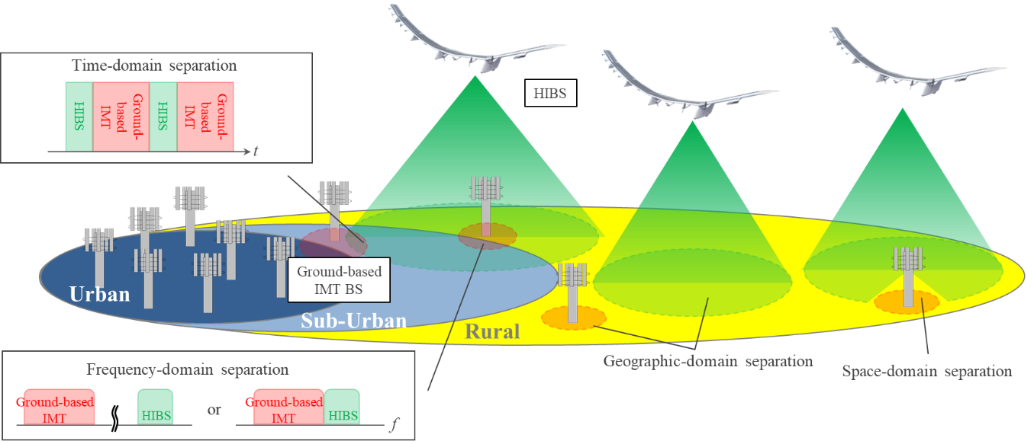

**Figure 7 Interference avoidance scenarios between ground-based IMT BS and HIBS**

* **Frequency-domain separation：**  
  MNOs may not be using all of their own spectrum in their service area, especially in rural areas. In such case, HIBS and ground-based IMT base stations can coexist by using different frequency bands (e.g. 1.7 GHz for HIBS, 900 MHz and 2.1 GHz for ground-base stations). Even when MNOs are using all of their own frequency bands in certain area, HIBS and ground-based IMT base stations may also coexist by separating in a frequency band (e.g. 5 MHz bandwidth for HIBS, 10 MHz bandwidth for ground-based IMT base stations in a frequency band).
* **Geographic-domain separation:**  
  As described in Section 2.2, one of the usage scenarios of HIBS would be to cover areas that are currently not covered by ground-based IMT base stations. Therefore, it would be feasible to use the same frequency (co-channel) when implementing appropriate separation distance between HIBS and ground-based IMT base stations based on the results of the sharing studies.
* **Time-domain separation：**In a case where neither frequency nor geographic-domain separation can be implemented, time-domain separation can be implemented by aligning the time-slots between ground-based IMT base stations and HIBS. Slots will be divided between ground-based IMT base stations and HIBS in advance to avoid the co-channel interference.
* **Space-domain separation:**

In situations where neither frequency-domain nor geographic-domain separation is feasible, space-domain separation can also be implemented by leveraging advanced antenna technologies with beam control capabilities.

Nullforming, a technique realized through beamforming, enables the suppression of radiowave emissions in specific directions. This significantly reduces interference from HIBS to ground-based IMT base stations operating in the same frequency band and geographic area. When this technique is applied to HIBS equipped with Active Antenna Systems (AAS)—such as cylindrical antennas—it becomes possible to mitigate co-channel interference without compromising the service quality of HIBS[7]. It allows for more flexible and efficient spectrum utilization in integrated deployments of HIBS and ground-based IMT base stations.

* **Sharing with HetNet technologies：**Another approach to share the same frequency between HIBS and ground-based IMT systems is to use HetNet (Heterogeneous Networks) technologies, which have already been used to share the same frequency between macro and small cells in ground-based IMT systems. In HetNet, the co-channel interference between them can be avoided by allocating different radio resources in the time or frequency domain. On top of that, the radio resource allocation for each HIBS and ground-based IMT systems can be dynamically changed depending on the amount of each traffic in order to efficiently utilize frequency.

**5.2 Coexistence with ground-based IMT systems of different operators in adjacent channels**

3GPP has conducted coexistence study in the 2 GHz frequency band, as documented in [TR 38.863](https://portal.3gpp.org/desktopmodules/Specifications/SpecificationDetails.aspx?specificationId=3926) (See Scenarios 7 and 8 in Section 6), focusing on cases where different MNOs deploy HIBS and ground-based IMT networks in adjacent channels within the same area. These simulations analyzed the potential interference between the two systems under such adjacent-channel conditions.

As a result, it was concluded that an ACLR of 45 dB and an ACS of 46 dB for HIBS are sufficient to coexist with ground-based IMT systems in adjacent channels within the same area. These values are consistent with the ACLR and ACS for ground-based IMT base stations.

Reflecting these findings, the 3GPP specifications [TS 38.104](https://portal.3gpp.org/desktopmodules/Specifications/SpecificationDetails.aspx?specificationId=3202) for NR and [TS 36.104](https://portal.3gpp.org/desktopmodules/Specifications/SpecificationDetails.aspx?specificationId=2412) for E-UTRA define these ACLR and ACS as RF requirements for HIBS. This alignment ensures that HIBS can coexist with ground-based IMT networks in adjacent channels, provided it meets the same emission and receiver performance levels as those required for ground-based IMT base stations.

**6 Relevant information for consideration of HIBS implementation**

To facilitate possible HIBS implementation for APT members, this section provides relevant information such as regulatory conditions based on the results of WRC-23 Agenda Item 1.4 and also spectrum usage of HIBS including frequency arrangements and 3GPP band plans.

**6.1 Regulatory conditions for HIBS**

The regulatory conditions for use of HIBS including protection conditions for existing services/systems (e.g. PFD limits: Power flux density limits) are stipulated in the following WRC Resolutions.

* Resolution **213 (WRC-23)**: Use of high-altitude platform stations as International Mobile Telecommunications base stations in the frequency band 694-960 MHz, or portions thereof
* Resolution **221 (Rev.WRC-23)**: Use of high-altitude platform stations as International Mobile Telecommunications base stations in the frequency bands 1 710-1 980 MHz, 2 010-2 025 MHz and 2 110-2 170 MHz
* Resolution **218 (WRC-23)**: Use of high-altitude platform stations as International Mobile Telecommunications base stations in the frequency band 2 500-2 690 MHz, or portions thereof

**6.1.1 Approaches for the compliance with PFD limits**

Resolutions **213 (WRC-23)**, **221 (Rev.WRC-23)** and **218 (WRC-23)** stipulate several PFD limits for the protection of existing services. There is a difference of examination for compliance with them under notification process in ITU-R between co-channel PFD limits and the adjacent-channel PFD limits as follows:

* **Co-channel PFD limits**: Radiocommunication Bureau (BR) calculate a PFD level produced by HIBS based on the characteristics in notification information (i.e. Table 2 of Appendix 4 to RR) submitted by HIBS operating administration.
* **Adjacent-channel PFD limits**: HIBS operating administration in each country submit commitments for the compliance with PFD limits by notification information (See Items 1.14.b, 1.14.c, 1.14.ca, 1.14.cb and 1.14.cc in Table 2 of Appendix 4 to the RR).

This section focuses on the approach for the compliance with the co-channel PFD limits which will be examined with calculations by BR, dealing with the PFD limits for the protection of ground-based IMT in 1.7-2.1 GHz bands as an example.

**6.1.1.1 Agreement of the exceedance of PFD limits of HIBS**

The provision is *resolves* 1.1 in Resolution **221 (Rev.WRC-23)**, which stipulates the PFD limits for the protection of ground-based IMT in 2 GHz frequency band, indicated that the co-channel PFD limits can be exceeded if “*explicit agreement of the affected administration is provided.*” This text is included in the co-channel PFD limits for not only ground-based IMT but also other existing services in Resolutions **213 (WRC-23)**, **221 (Rev.WRC-23)** and **218 (WRC-23)**. It is expected that HIBS operating administrations may reach agreement with neighboring countries through bilateral coordination such as the following cases:

* Stations of existing services protected by the PFD limits are not operated in the neighboring countries, or only operated in the areas where not affected by interference from HIBS (e.g. areas far from country borders).
* Other regional or bilateral agreements on technical criteria for the protection of existing services already existed and these can be applied to coexistence between HIBS and existing services.
* Specific terrain (e.g. mountain and hill) and surface obstacles (e.g. forest and building) in actual deployment environments of HIBS and interfered services would contribute on mitigating interference from HIBS.
* More relaxed PFD level is appropriate for the protection of existing services considering the actual characteristics of existing services in neighboring countries.

With respect to the PFD limits for the protection of IMT, as *resolves* 1.1 in Resolution **221 (Rev.WRC-23)**, different values are stipulated for base stations and mobile stations (User terminal). In principle, both values are applied to HIBS. However, if neighboring countries agree that only mobile stations are required for the protection through bilateral coordination (i.e. Only receiving mobile stations/transmitting base stations are operated in subject frequency bands in such countries), only the PFD limit for the protection of mobile stations would be applied to HIBS as a footnote, “*The pfd levels to protect IMT base stations will apply unless the affected administration informs the Radiocommunication Bureau that only terminal stations need to be protected.*” (See footnotes of *resolves* 4.1 in Resolution **213 (WRC-23)**, *resolves* 1.1 in Resolution **221 (Rev.WRC-23)** and *resolves* 1.1 in Resolution **218 (WRC-23)**).

**6.1.1.2 Equation for calculation of HIBS PFD level**

The PFD level (dB(W/(m2·MHz))) produced by HIBS is calculated by the following equation:

$$PFD=10\log\left(\sum_{n=1}^{N}{\frac{{EIRP}_{HIBS}\left(n\right)}{{ADL}_{HIBS}\left(n\right)}}\right)-PL-10 log⁡({λ^{2}}/{4π})$$

where:

${EIRP}_{HIBS}\left(n\right)$: HIBS maximum e.i.r.p (W/MHz) in cell n

$N$: number of cells

${ADL}_{HIBS}\left(n\right)$: angular discrimination of HIBS in cell n

$PL$: path loss (dB) between HIBS and an interfered station

With respect to propagation prediction models for calculation of path loss, ITU-R WPs 3J, 3K and 3M (Document [5D/960](https://www.itu.int/md/R19-WP5D-C-0960/en)) guided that [Recommendation ITU-R P.528](https://www.itu.int/rec/R-REC-P.528/en) would be used if the below both cases are applicable:

* Non-directional antenna is used for ground stations (interfered stations), and
* Terrain or surface obstacles are not presented in deployment environment.

In any other cases, based on this guidance, [Recommendation ITU-R P.619](https://www.itu.int/rec/R-REC-P.619/en) would be used as the baseline propagation model and the following propagation effects can be considered in the calculation of path loss as base line:

* Free space loss (see section 2.1 in Recommendation ITU-R P.619)
* Depolarization loss (typically 3 dB) (see section 2.2 in Recommendation ITU-R P.619)
* Diffraction loss due to the spherical earth (see section 2.6 in Recommendation ITU-R P.619)

**6.1.1.3 Mitigation measures**

The following measures would contribute on mitigating interference level from HIBS to comply with the PFD limits:

* Geographical separation
* Power reduction
* Antenna pointing adjustment
* Cell size optimization
* Antenna side-lobe suppression

It should be noted that large separation distances may limit the area where HIBS can be deployed, and significant power reduction may degrade quality of HIBS services.

Antenna pointing adjustment to avoid HIBS main beam directing to country borders or interfered stations would be performed to satisfy the PFD limits without imposing heavy operational constraints for HIBS (e.g. large separation distance and power reduction).

Regarding transmitting beam suppressions, which is one of antenna pointing adjustment measures. Figure 8 shows the concept of technique is to suppress some parts of multiple HIBS beams which direct to country borders or interfered stations. This technique is realized by footprints fixation with beamforming technology and mechanical adjustment of antenna direction.

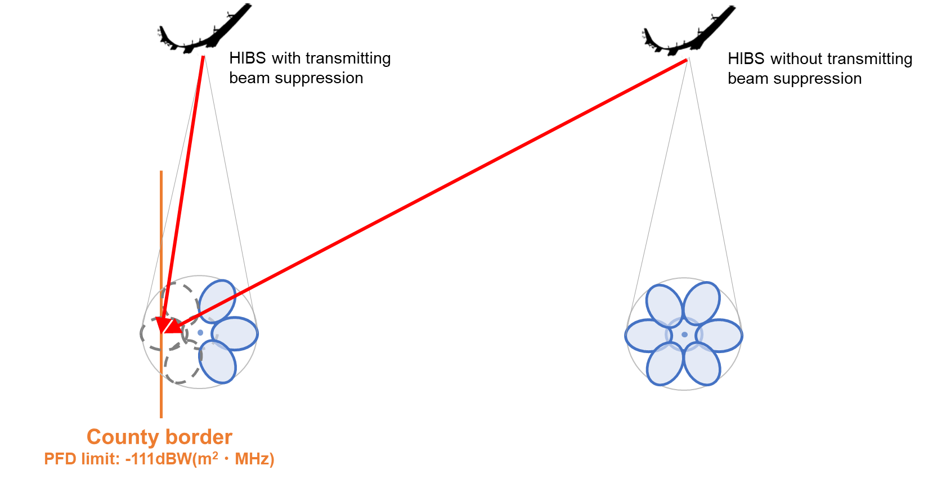

**Figure 8 Transmitting beam suppressions**

An analysis calculated the horizontal separation distance from the HIBS nadir to meet the PFD limit (-111 dB(W/(m2·MHz))) for protecting IMT mobile stations in the 1.7-2.1 GHz bands in *resolves* 1.1 of Resolution **221 (Rev.WRC-23)** when 4 beams of the total 7 beams were suppressed as shown in Figure 8. The assumption of the analysis is as the below table.

**Table 20 Assumption of the transmitting beam suppressions analysis**

|  |  |
| --- | --- |
| **Item** | **Assumption** |
| Parameters of HIBS | See section 3.3 |
| Propagation model | Recommendation ITU-R P.619 (20% of time percentage) (See section 6.1.2) |
| Equation of HIBS PFD level | See section 6.1.2 |

As depicted in Figure 9, the analysis demonstrated that the separation distance was 199 km when all 7 beams were operational, whereas the separation distance was not necessary when 4 beams were suppressed (only 3 beams were operated).

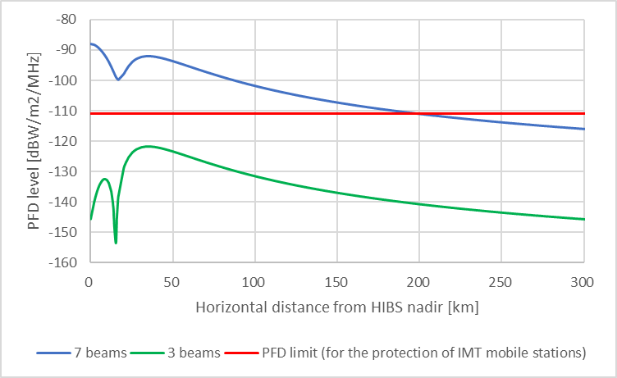

**Figure 9 Calculation results of PFD level produced by HIBS with different number of transmitting beams**

In addition to the above, cell size optimization with phased array antennas and antenna side-lobe suppression would also contribute toward mitigating interference from HIBS without large separation distances and power reduction.

Furthermore, if there are specific terrain (e.g. mountains and hills) and surface obstacles (e.g. forests and buildings) in actual deployment environments of HIBS and interfered services, these would also mitigate interference from HIBS. These effects can be considered when calculating the PFD levels produced by HIBS for bilateral coordination, as shown in Figure 10.

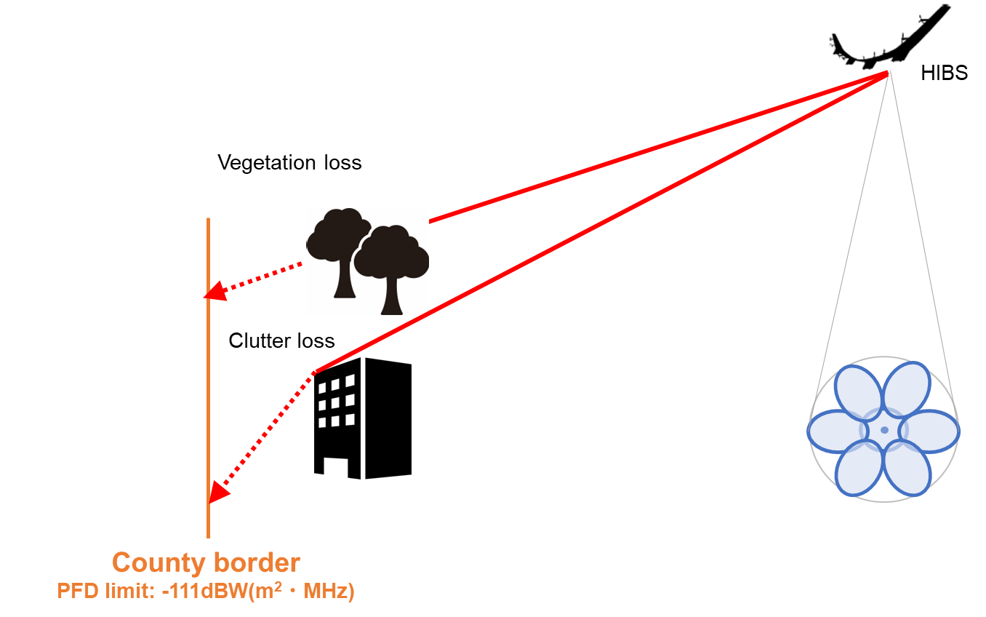

**Figure 10 Propagation effects in specific environment**

An analysis calculated the horizontal separation distance from the HIBS nadir to meet the PFD limit for protecting IMT mobile stations in the 1.7-2.1 GHz bands considering clutter and vegetation loss. The assumption of the analysis is as the below table.

**Table 21 Assumption of the analysis considering the propagation loss**

|  |  |
| --- | --- |
| **Item** | **Assumption** |
| Parameters of HIBS | See section 3.3 |
| Propagation model | Recommendation ITU-R P.619 (20% of time percentage) (See section 6.1.2)  Vegetation loss: Section 2.2.2 of [Recommendation ITU-R P.833](https://www.itu.int/rec/R-REC-P.833/en)-10 (A: 1.87, E: 0.01, G: -0.12, see Table 3)  Clutter loss: Annex 6 to Document [3K/178](https://www.itu.int/md/R19-WP3K-C-0178/en) (Clutter height (hs): 25m) |
| Equation of HIBS PFD level | See section 6.1.2 |

As depicted in Figure 11, the analysis demonstrated that the horizontal separation distance from HIBS nadir can be reduced by 90-130 km considering clutter and vegetation losses.

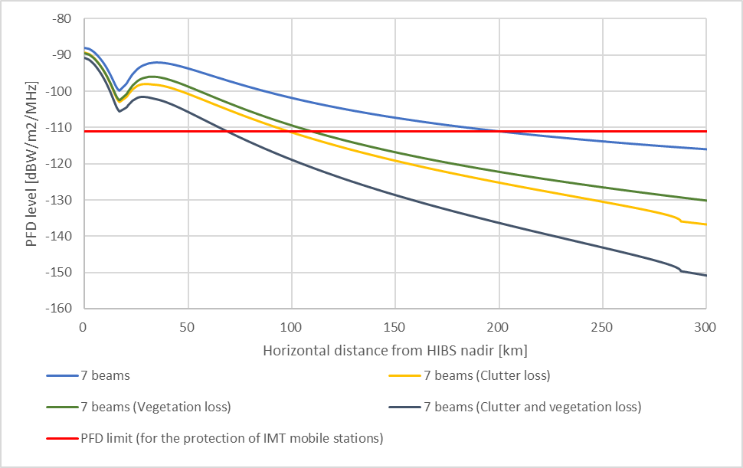

**Figure 11 Calculation results of PFD level produced by HIBS considering the propagation loss**

These measures, either individually or in combination, can be applied to meet the PFD limits depending on actual deployment environments, rather than simply ensuring large separation distances and/or reducing HIBS transmitting power.

**6.2 Spectrum usage**

**6.2.1** **Frequency arrangements**

It could be possible for HIBS to employ the same frequency arrangements (see Recommendation ITU-R M.1036) as used by ground based IMT networks. Detailed information was summarized in Annex 2, which outlines the frequency arrangements for HIBS in the frequency ranges 694-960 MHz, 1 710-1 885 MHz, 1 885-1 980 MHz, 2 010-2 025 MHz, 2 110-2 170 MHz and 2 500-2 690 MHz. These arrangements, which are extracted from Recommendation ITU-R M.1036, were considered in ITU-R studies under WRC-23 agenda item 1.4 and are in accordance with transmitting/receiving frequency bands restrictions in RR Nos, **5.312B,** **5.314A**, **5.388A** and **5.409A.**

**6.2.2 3GPP Band plans**

Table 23 outlines NR and E-UTRA operating bands which can be enabled for HIBS operation in 3GPP specifications TS 38.104 for NR and TS 36.104 for E-UTRA:

**Table 23 HIBS band plan supported by 3GPP specifications[8]**

|  |  |  |  |  |
| --- | --- | --- | --- | --- |
| **NR operating band** | **E-UTRA operating band** | **Frequency range** | | **Duplex mode** |
| **Uplink (UL)**  **operating band**  **BS receive / UE transmit** | **Downlink (DL) operating band**  **BS transmit / UE receive** |
| n1 | 1 | 1920 MHz – 1980 MHz | 2110 MHz – 2170 MHz | FDD |
| n2 | 2 | 1850 MHz – 1910 MHz | 1930 MHz – 1990 MHz | FDD |
| n3 | 3 | 1710 MHz – 1785 MHz | 1805 MHz – 1880 MHz | FDD |
| n5 | 5 | 824 MHz – 849 MHz | 869 MHz – 894 MHz | FDD |
| n7 | 7 | 2500 MHz – 2570 MHz | 2620 MHz – 2690 MHz | FDD |
| n8 | 8 | 880 MHz – 915 MHz | 925 MHz – 960 MHz | FDD |
| n20 | 20 | 832 MHz – 862 MHz | 791 MHz – 821 MHz | FDD |
| n25 | 25 | 1850 MHz – 1915 MHz | 1930 MHz – 1995 MHz | FDD |
| n26 | 26 | 814 MHz – 849 MHz | 859 MHz – 894 MHz | FDD |
| n28 | 28 | 703 MHz – 748 MHz | 758 MHz – 803 MHz | FDD |
| n34 | 34 | 2010 MHz – 2025 MHz | 2010 MHz – 2025 MHz | TDD |
| n38 | 38 | 2570 MHz – 2620 MHz | 2570 MHz – 2620 MHz | TDD |
| n39 | 39 | 1880 MHz – 1920 MHz | 1880 MHz – 1920 MHz | TDD |
| n41 | 41 | 2496 MHz – 2690 MHz | 2496 MHz – 2690 MHz | TDD |
| n67 | 67 | N/A | 738 MHz – 758 MHz | SDL |
| n85 | 85 | 698 MHz – 716 MHz | 728 MHz – 746 MHz | FDD |
| n90 | - | 2496 MHz – 2690 MHz | 2496 MHz – 2690 MHz | TDD |

ANNEX 1

**REsponse to the questionnaire ON current status and future plan related to HAPS in APT countries**

**1 Introduction**

High altitude platform station (HAPS) is a station located on an object at an altitude of 20 to 50 km and at a specified, nominal, fixed point relative to the Earth. Considering that a large number of people remain unconnected, there is a need for greater connectivity and telecommunication services in underserved communities and in rural and remote areas. This challenge has focused attention on many tools in the connectivity toolkit. HAPS is also a possible mean to deal with the challenge by providing mobile services in remote areas, including mountainous, coastal and sandy desert areas.

An identification for HAPS as IMT base stations has been added in Radio Regulation. According to Resolution 221 (Rev.WRC-07), in Regions 1 and 3, the bands 1 885-1 980 MHz, 2 010-2 025 MHz and 2 110-2 170 MHz and, in Region 2, the bands 1 885-1 980 MHz and 2 110-2 160 MHz may be used by HAPS as base stations to provide International Mobile Telecommunications (IMT).

At the last meeting of APT Conference Preparatory Group (APG19-3), a proposal contributed from Japan (APG19-3/INP-54) was considered as an initial idea for inclusion in the agenda of future WRC meeting. The proposal is to consider identification to use HAPS as base stations to provide IMT in the frequency bands below 2.7 GHz that have been already identified to IMT, and whether changes are needed to the set of existing bands identified for use by HAPS IMT base stations. APG19-3 invited AWG to develop further technical information and inform APG the results of its studies in a timely manner for consideration.

**2 Objective of the Questionnaire**

To facilitate the study of the existing and future operation of HAPS in the frequency band below 2.7 GHz in the Asia Pacific region and to support discussion of a possible future WRC-23 Agenda Item in APG19, and collect the information of service-link in mobile service and feeder-link in fixed service, AWG-23 developed this questionnaire to collect the information on the current status and future plan of implementation and deployment relating to HAPS in APT countries.

**3 Summary of the respondents**

Eleven administrations responded to the questionnaire. The detailed responses could be found in the following input contributions:

|  |  |
| --- | --- |
| Country | Document |
| Australia | [AWG-24-INP-07](https://www.apt.int/sites/default/files/2018/09/AWG-24-INP-07_AUS2_-_HAPS__Australian_response_to_Questionnaire.docx) |
| Iran | [AWG-24-INP-13](https://www.apt.int/sites/default/files/2018/09/AWG-24-INP-13_IRANresponsetoQuestionnaire_on_HAPS.docx) |
| Thailand | [AWG-24-INP-20 (Rev.1)](https://www.apt.int/sites/default/files/2018/09/AWG-24-INP-20Rev.1_Thailand-HAPS_Questionnaire.docx) |
| Myanmar | [AWG-24-INP-25](https://www.apt.int/sites/default/files/2018/09/AWG-24-INP-25_Myanmar_HAPS_Response.docx) |
| New Zealand | [AWG-24-INP-26](https://www.apt.int/sites/default/files/2018/09/AWG-24-INP-26_NZL_HAPS__response.docx) |
| Indonesia | [AWG-24-INP-39](https://www.apt.int/sites/default/files/2018/09/AWG-INP-39_INS_Response_to_Questionnaire_HAPS_IICF.docx) |
| China | [AWG-24-INP-65 (Rev.1)](https://www.apt.int/sites/default/files/2018/09/AWG-24-INP-65_Rev.1_China_HAPS.docx) |
| Japan | [AWG-24-INP-84](https://www.apt.int/sites/default/files/2018/09/AWG-24-INP-84_Japan19_0.docx)/AWG-25-INP-30 |
| Korea | [AWG-24-INP-87](https://www.apt.int/sites/default/files/2018/09/AWG-24-INP-87_KOR_Response_to_HAPS_Questionniare.docx) |
| Viet Nam | [AWG-24-INP-98 (Rev.1)](https://www.apt.int/sites/default/files/2018/09/AWG-24-INP-98_rev1_VTN_Questionnaire_on_HAPS.docx) |
| Bangladesh | [AWG-24-INP-117](https://www.apt.int/sites/default/files/2018/09/AWG-24-INP-117_Bangladesh2.docx) |

ANNEX 2

**detailed Information on spectrum usage for consideration of HIBS implementation**

To facilitate possible HIBS implementation for APT members, this annex shows detailed information on spectrum usage of HIBS including frequency arrangements.

**Frequency arrangements**

Table A2.1 outlines the frequency arrangements for HIBS in the frequency ranges 694-960 MHz, 1 710-1 885 MHz, 1 885-1 980 MHz, 2 010-2 025 MHz, 2 110-2 170 MHz and 2 500-2 690 MHz which are extracted from Recommendation ITU-R M.1036. These arrangements were considered in ITU-R studies under WRC-23 agenda item 1.4 and are in accordance with transmitting/receiving frequency bands restrictions in RR Nos, **5.312B,** **5.314A**, **5.388A** and **5.409A.**

**Table A2.1 HIBS frequency arrangements below 2.7 GHz**

**(a) 694-960 MHz**

| **Frequency band** | | **Duplex mode** |
| --- | --- | --- |
| **Mobile station transmitter  (MHz)** | **Base station transmitter  (MHz)** |
| 824-849 | 869-894 | FDD |
| 880-915 | 925-960 | FDD |
| 832-862 | 791-821 | FDD |
| 698-716 | 728-746 | FDD |
| 776-793 | 746-763 | FDD |
| 703-748 | 758-803 | FDD |
| 703-733 | 758-788 | FDD |
| 698-703 | 753-758 | FDD |
| 733-736 | 788-791 | FDD |
| External | 738-758 | FDD |
| 703-733 External | 758-788 738-758 | FDD |
| 814-849 | 859-894 | FDD |
| Note: In Region 3, the frequency band 698-960 MHz, or portions thereof, in Australia, Maldives, Micronesia, Papua New Guinea, Tonga and Vanuatu, and the frequency bands 703-733 MHz, 758-788 MHz, 890-915 MHz and 935-960 MHz, or portions thereof, in China, India, Indonesia, Japan, Korea (Rep. of), Malaysia, the Philippines and Thailand are identified for HIBS in RR No **5.314A**. Such use of HIBS in the frequency bands 698-728 MHz and 830-835 MHz is limited to reception by HIBS. | | |

**(b) 1 710-1 885 MHz, 1 885-1 980 MHz, 2 010-2 025 MHz and 2 110-2 170 MHz**

|  |  |  |
| --- | --- | --- |
| **Frequency band** | | **Duplex mode** |
| **Mobile station transmitter (MHz)** | **Base station transmitter  (MHz)** |
| 1 880-1 920 | | TDD |
| 1 920-1 980 | 2 110-2 170 | FDD |
| 2 010-2 025 | | TDD |
| 1 710-1 785 | 1 805-1 880 | FDD |
| 1 850-1 900 | 1 930-1 980 | FDD |
| 1 710-1 770 | 2 110-2 170 | FDD |
| Note: In Region 3, the frequency bands 1 710-1 980 MHz, 2 010-2 025 MHz and 2 110-2 170 MHz are identified for HIBS in RR No **5.388A**. Such use of HIBS in the frequency bands 1 710-1 815 MHz is limited to reception by HIBS, and in the frequency band 2 110-2 170 MHz is limited to transmission from HIBS. | | |

**(c) 2 500-2 690 MHz**

|  |  |  |
| --- | --- | --- |
| **Frequency band** | | **Duplex mode** |
| **Mobile station transmitter  (MHz)** | **Base station transmitter  (MHz)** |
| 2 500-2 570 | 2 620-2 690 | FDD |
| 2 570-2 620 | | TDD |
| 2 500-2 570  External | 2 620-2 690  2 570-2 620 | FDD |
| 2 500-2 690 | | Flexible FDD/TDD |
| Note: In Region 3, the frequency band 2 500-2 655 MHz is identified for HIBS in RR No **5.409A**. Such use of HIBS in the frequency bands 2 500-2 535 MHz is limited to reception by HIBS. | | |

Adoption of appropriate frequency arrangements for HIBS operating administration in each country would contribute on compliance with regulations in RR and bring the benefits of harmonized utilization of the spectrum for HIBS and protection of existing services and systems including ground-based IMT in neighboring countries.

1. Comparing the altitude with HIBS (18-25 km), LEO (600 km) and GEO (36,000 km).
2. https://www.gsma.com/publicpolicy/wp-content/uploads/2015/02/Benefits-of-network-competition-and-complementary-policies-to-promote-mobile-broadband-coverage-Report.pdf
3. https://www.ofcom.org.uk/spectrum/information/cellular-coverage
4. https://www.ofcom.org.uk/__data/assets/pdf_file/0017/113543/Connected-Nations-update-Spring-2018.pdf
5. https://www.softbank.jp/corp/news/press/sbkk/2023/20231106_02/
6. Report ITU-R F. 2439-0(11/2018) (https://www.itu.int/dms_pub/itu-r/opb/rep/R-REP-F.2439-2018-MSW-E.docx)
7. K. Tashiro, K. Hoshino and A. Nagate, "Nullforming-Based Precoder for Spectrum Sharing Between HAPS and Terrestrial Mobile Networks," in IEEE Access, vol. 10, pp. 55675-55693, 2022  
   https://ieeexplore.ieee.org/document/9779715/references#references
8. For the use of the band plans for HIBS, it should be in accordance with RR.