**APT REPORT ON**

**DUAL-POLARIZED SOLID-STATE RAINFALL RADAR OPERATING IN THE FREQUENCY BAND 9-10 GHZ (X-BAND) NECESSARY FOR USE IN OPTIMAL DAM AND RIVER MANAGEMENT SYSTEMS**

**Edition: September 2025**

**The 35th Meeting of APT Wireless Group**

**8 – 12 September 2025**

**Bangkok, Thailand (Hybrid)**

***(Source: AWG-35/OUT-13)***

**No. APT/AWG/REP-152**

**APT Report on**

**dual-polarized solid-state rainfall radar operating in the frequency band 9-10 GHz (X-band) necessary for use in optimal dam and river management systems**

**Table of Contents**

1. Introduction
2. Scope
3. References
4. Abbreviations, acronyms and technical terms for radar technology
5. Overview of X-band dual-polarized solid-state rainfall radar
6. Main specifications of the X-band dual-polarized solid-state rainfall radar
7. Features of the X-band dual-polarized solid-state rainfall radar
8. Outline of the optimal dam and river management system
9. Overview of flood risk management application
10. Case study
11. Conclusion

# Introduction

To mitigate the risk of flood disasters, it is essential to measure rainfall accurately and promptly using a rainfall radar distinct from weather radars, which primarily measure atmospheric conditions at various altitudes. Although its observation area is small, the X-band radar has a high spatial resolution and can be observed in a short time. Therefore, it can be used as a real-time rainfall information sensor to quantify the amount of rainfall with spatial continuity in the observation area.

However, rainfall data utilized in dam and river management, telemetry systems that wirelessly collect data from ground-installed rain gauges have been commonly employed traditionally. In conventional telemetry observations, since data observed at points are used as representative values of rainfall over a wide area for dam inflow calculations, errors occur in the actual rainfall volume in rainfall environments such as squalls, which are characteristic of Southeast Asia. In addition, regarding the maintenance and management of the ground-based telemetry system, the maintenance and management costs are enormous, including access to the site.

A next-generation dam management system utilizing X-band radar that solves this problem, is introduced. Rainfall observation by radar measures the amount of rainfall with spatial continuity, and changes and differences in rainfall intensity within the observation area can be observed as numerical values, so it is possible to calculate the amount of rainfall that is closer to the actual volume. Based on the example of the next-generation dam management system introduced at the Pasak Jolasid Dam in Thailand, a dam and river management system consisting of a compact X-band dual-polarized solid-state rainfall radar designed for the purpose of lowering installation costs and simplifying maintenance, and a dam water level and flood risk management application, is introduced.

# Scope

This report provides technical specifications and features of X-band dual-polarized solid-state rainfall radar in the frequency range 9-10 GHz for use in optimal dam and river management systems.

# References

Recommendation ITU-R SM.1541-7 Unwanted emissions in the out-of-band domain

# Abbreviations, acronyms and technical terms for radar technology

RADAR Radio Detection and Ranging

TRX Transceiver

LFM pulse Linear frequency modulated pulse

CFRP Carbon Fiber Reinforced Plastics

DSP Digital Signal Processor

BIST Built-In Self-Test

GIS Geographic Information System

SOP Standard Operating Procedure

CSV Comma Separated Values

GSMaP Global Satellite Mapping of Precipitation

JAXA Japan Aerospace Exploration Agency

Z Radar Reflectivity

V Doppler Velocity

W Spectrum Width

ZDR Differential Reflectivity

φdp Differential Phase

KDP Specific Differential Phase

ρHV Correlation Coefficient

# Overview of X-band dual-polarized solid-state rainfall radar

The compact X-band dual-polarized solid-state rainfall radar maintains the performance of a conventional X-band dual-polarized solid-state radars while achieving smaller size and lower power consumption. The overview and system configuration of the compact X-band dual-polarized solid-state rainfall radar are presented in Figs. 5-1 and 5-2, respectively.

1.8m excl. protruding object

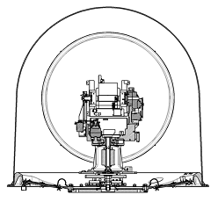



1.8m

Radar Control Terminal

Fig. 5-1 Overview of compact X-band dual-polarized solid-state rainfall radar

Fig. 5-2 System diagram of compact X-band dual-polarized solid-state rainfall radar

X-band radar has a shorter observation range than the radars using the other frequency bands commonly employed for weather observation purposes. However, due to its shorter wavelength, it offers the advantage of being able to detect smaller precipitation particles. To manage the river basin upstream of the dam, we selected the high-resolution X-band (9-10 GHz) because the observation range is 80 km, which is sufficient to cover the basin.

The antenna was installed on top of a steel tower in the conventional X-band radar system, and the main equipment of the system, including the transmitter, receiver, antenna controller, digital signal processor, radar control terminal, etc. were installed indoors, such as in a shelter.

The compact X-band dual-polarized solid-state rainfall radar has an all-in-one structure with an integrated sensor that incorporates the main equipment inside the radome.

The transceiver (TRX), digital signal processor (DSP), and antenna controller are positioned above the drive unit, with the number of parts significantly reduced by employing a structure that eliminates rotary joints.

Power supply, monitoring, control and data distribution to each unit are carried out via slip rings. Radar monitoring and control uses Ethernet networks, and the radar control terminal, which is a monitoring and control terminal, is configured with a general-purpose computer.

# Main specifications of the X-band dual-polarized solid-state rainfall radar

The comparison table of the main specifications of the conventional X-band rainfall radar and the compact X-band rainfall radar is shown in Table 6-1. The radome diameter is approximately half that of the conventional X-band rainfall radar, 1.8 m, and has been significantly reduced in size. As a result, the weight has been reduced to less than 350 kg compared to the conventional X-band rainfall radar approximately 2,500 kg, successfully reducing the weight by more than 80 %. The comparison of the sizes of the conventional X-band rainfall radar and the compact X-band rainfall radar is shown in Fig. 6-1. In addition, the transmission power has been reduced from 200 W to 125 W, but the wide pulse width has been increased from 32 μs to 50 μs, achieving the same observation processing range (80 km).

Table. 6-1 Comparison of main specifications between conventional X-band rainfall radar and compact X-band rainfall radar

|  |  |  |
| --- | --- | --- |
| Items | Conventional  X-band rainfall radar | Compact  X-band rainfall radar |
| Radome  Diameter | 3.6 m (Hight 4.5m) | 1.8 m |
| Reflector Diameter | 2.2 m | 1.2 m |
| Beam Width | 1.2°  (Half Power) | 2.0°  (Half Power) |
| Polarization | Linear Horizontal &Vertical Dual Polarization  XPD 30 dB or more | |
| Antenna Gain | 43 dBi or more | 38 dBi or more |
| Azimuth Scanning Speed | 0.1 - 6.0rpm | |
| Elevation Angle Span | - 2°- 182° | |
| Survival Wind Speed | 60m/s or less | |
| Operating Frequency | 9,350~9,450 MHz or 9,700 - 9,800 MHz | |
| Pulse Width | Short: 1 μs  Long: 32 μs | Short: 1 μs  Long: 50 μs |
| Pulse Repetition Frequency | 1,500 Hz or less | 2,000 Hz or less |
| Peak Power | 200 W (H-Pol)  200 W (V-Pol) | 125 W (H-Pol)  125 W (V-Pol) |
| Range Resolution | 150 m | 25 m – 250 m (12.5 m span) |
| Observation Range | 80 km | |
| Total Weight | 2,500 kg | 350 kg or less |
| Operating Temperature | -20 °C – 50 °C | 0 °C – 50 °C |
| Power Consumption | 2,000 VA or less | 450 VA or less |
| Input Power | 200 VAC, single phase,  2 W, 50 / 60 Hz | 100-230 VAC, single phase, 2 W, 50 / 60 Hz |



1.8m

1.8m

80% Lightweight

3.6m

4.5m

図形 が含まれている画像

AI によって生成されたコンテンツは間違っている可能性があります。

Fig. 6-1 Comparison of the sizes of the conventional X-band rainfall radar and the compact X-band rainfall radar

Increasing the pulse width has the following disadvantages:

- Decreased resolution in radial direction

- Expansion of nearby unobservable areas

Although the conventional X-band radar also experienced reduced resolution in the radial direction due to the use of wide pulses, this issue is mitigated by transmitting linear frequency modulated (LFM) pulses and employing a pulse compression technique. The compact X-band rainfall radar mitigates the disadvantage of reduced radial resolution by increasing the pulse compression ratio compared to the conventional model.



**TX Pulse**

**Expansion Process**

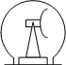

**Antenna**

**LFM Pulses**

**LFM Pulses**



**Reflected Wave**



**Reflected Wave**

**Signal Process**

**Compressed Signal**

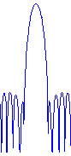

Fig. 6-2 Flow of Pulse Compression Process

The disadvantage of expanding the nearby blind area can also be mitigated by extending the observation range of the narrow pulse for nearby observation beyond that of the conventional X-band radar, as illustrated in Fig. 6-3. The composite distance of the observation data with the wide pulse and narrow pulse does not change. The wide pulse and the narrow pulse are transmitted alternately (*1 in Fig. 6-3), and the range from 0 to 15 km that cannot be observed when the wide pulse is transmitted (*2 in Fig. 6-3) is filled with the received data from the narrow pulse (*3 in Fig. 6-3), creating continuous observation data from 0 to 80 km.



Fig. 6-3 Composite of Wide Pulse and Narrow Pulse

The narrow pulse for nearby observation uses a different frequency to avoid interference with the wide pulse, but the occupied bandwidth is kept below 4 MHz. Furthermore, power consumption has been reduced to 450 VA compared to 2,000 VA of the conventional product, achieving a power saving of more than 75%.

# Features of the X-band dual-polarized solid-state rainfall radar

# Weight reduction and price reduction of the antenna part

By using CFRP as the material for the reflector, the weight reduction and the price reduction have been achieved compared to conventional aluminum parabolic antennas. The electrical performance of the CFRP antenna maintains the same performance as that of the aluminum antenna. By reducing the weight of the parabolic antenna, a reduction in driving power has been achieved, as well as reducing the load on the motor and bearings, improving durability. Also, considering negative elevation angles, it can be driven from -2° to +182°, making it possible to observe a wide range of vertical cross-sections.

# Reducing the lifecycle cost of the TRX unit and suppressing unwanted emissions

It is equipped with a TRX unit for each of H and V pol. In order to achieve observation performance and durability, a high-power RF solid-state amplifier is used. Unlike magnetrons and klystrons, there is no need for periodic replacement, and the low power consumption significantly reduces overall life cycle costs. The transmitter supports narrow bandwidth for effective use of radio waves and suppression of unwanted emissions. The receiver has achieved downsizing while maintaining the same performance as the conventional models. In addition, by placing the TRX unit close to the parabolic antenna, the feed line can be made as short as possible, resulting in both suppression of power loss and weight reduction.

# Narrowing the bandwidth

As shown in Fig. 7.2-1, the compact X-band rainfall radar achieves an overall bandwidth of less than 4 MHz by arranging the frequencies of the narrow pulse (P0N) and the LFM pulse swept of 2 MHz (Q0N) at 2.5 MHz intervals. To achieve this, the occupied bandwidth of each of the narrow pulse and the LFM pulse must be within 2.5 MHz, and the gradient of the rising and falling waveforms of the transmission wave is adjusted by the amplifier to limit the bandwidth.

Fig. 7.2-2 illustrates a conceptual profile of signal amplification at the rising and falling edges of the transmitted pulse. Fig. 7.2-3 shows the corresponding transmitted waveform based on this profile. In both figures, the vertical axis qualitatively indicates signal level: amplification in Fig. 7.2-2 and output power in Fig. 7.2-3. The horizontal axis represents time and is not drawn to scale.

As shown in Fig. 7.2-4, the power level of frequencies far from the center can be suppressed by taking a gentle slope. Narrowing the bandwidth makes it easier to combine multiple X-band rainfall radars to build an observation network, and it also makes it easier to allocate frequencies to avoid interference with other radars and satellite broadcasts that use the same band. In particular, narrowing the bandwidth is very effective when observing rainfall using the X-band rainfall radar, since multiple X-band rainfall radars are often combined to compensate for blind zones caused by topographical conditions.



Fig. 7.2-1 Occupied Bandwidth by Narrow Pulse (P0N) and LFM Pulse (Q0N)

3dB

Output Power (relative)

Gain (relative)

1μs

Time (relative)

Time (relative)

Fig. 7.2-2 Rising and Falling Gradient Characteristics of Amplifier Fig. 7.2-3 Generated Transmission Waveform

Level (dB)

Frequency (MHz)

Fig. 7.2-4 Occupied Bandwidth by Amplification Slope

# Unwanted emissions

Out-of-band domain of the unwanted emissions, the conditions of Recommendation ITU-R SM.1541-7 Annex 8 must be met, and the value must be 60 dB lower than the leading power of the fundamental frequency in the unwanted emissions. As shown in Fig. 7.2-5 and 7.2-6, both the narrow pulses and the LFM pulse ITU-R SM.1541-7 Annex 8.

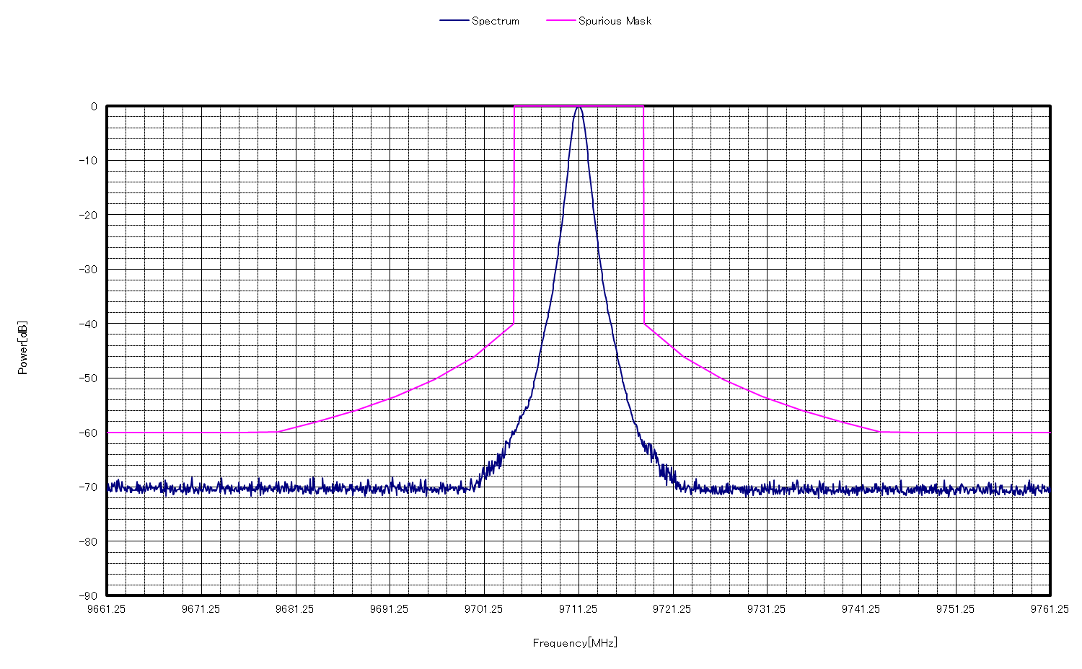

0

-10

-20

-30

-40

-50

-60

-70

-80

-90

Power (dB)

Frequency (MHz)

9661.25 9671.25 9681.25 9691.25 9701.25 9711.25 9721.25 9731.25 9741.25 9751.25 9761.25

Spectrum Limit of Unwanted Emissions

Fig. 7.2-5 Unwanted Emissions of Narrow Pulse (P0N)

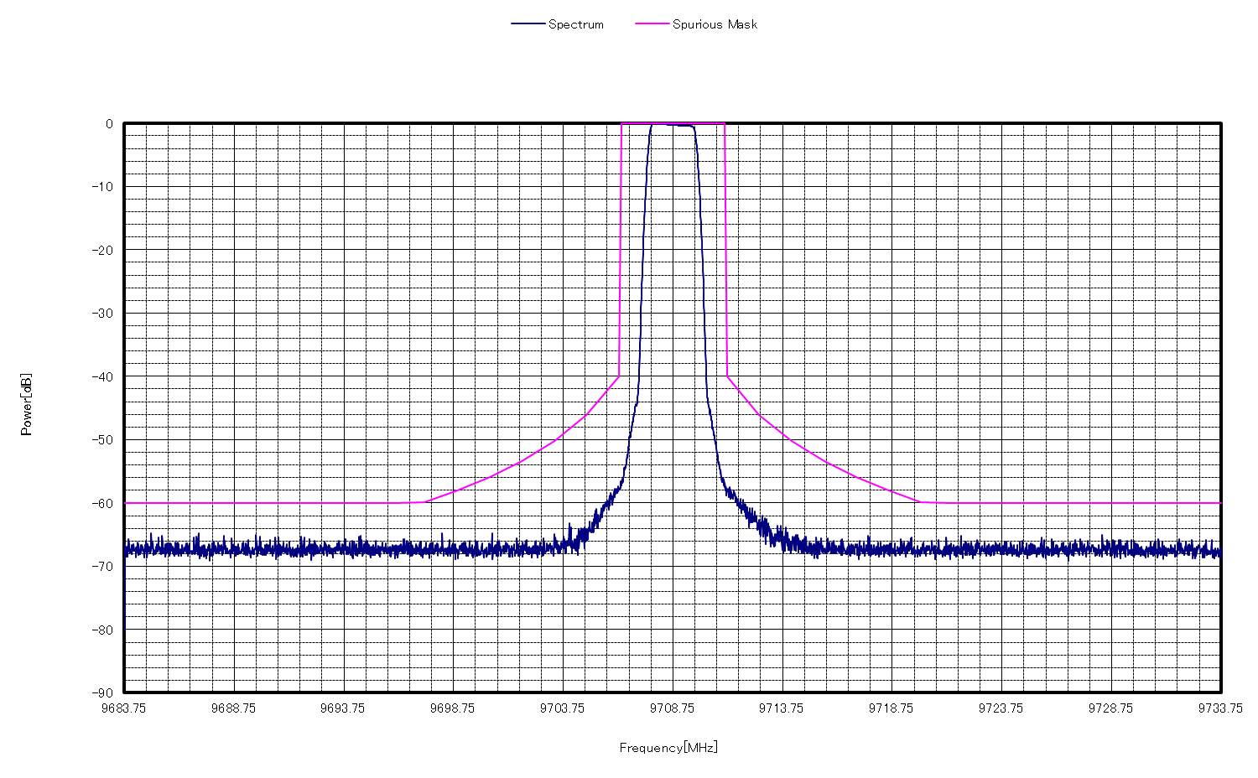

Power (dB)

0

-10

-20

-30

-40

-50

-60

-70

-80

-90

Frequency (MHz)

9683.75 9688.75 9693.75 9698.75 9703.75 9708.75 9713.75 9718.75 9723.75 9728.75 9733.75

Spectrum Limit of Unwanted Emissions

Fig. 7.2-6 Unwanted Emissions of LFM Pulse (Q0N)

# Downsizing of unit and speeding up of processing of DSP

A dedicated DSP unit is used instead of a general-purpose computer for signal processing. The dedicated DSP unit has achieved downsizing of the unit and high-speed processing. In addition to radar reflectivity (Z), Doppler velocity (V), and spectrum width (W), the outputs of the basic data types in dual-polarized radar, i.e., differential reflectivity (ZDR), differential phase (φdp), specific differential phase (KDP), and correlation coefficient (ρHV), are supported as standard.

Examples of observation data are shown in Fig. 7.3-1. The reflectivity (Z) represents the reflection intensity from hydrometeor, and the Doppler velocity (V) represents the hydrometeor mean velocity of the vector component moving toward or away from the radar. In addition, the correlation coefficient (ρHV) indicates the diversity of precipitation particles, and the specific differential phase (KDP) is less affected by attenuation due to rain on the way, so precipitation intensity can be estimated with high accuracy. The quality of observation data is equivalent to that of the conventional products. The rainfall value calculated based on the specific differential phase (KDP) obtained from dual polarization is not affected by power attenuation due to rainfall along the way, because the rainfall value is calculated from the amount of phase change. This contributes to the dam and river management purposes as it provides highly accurate observational information on actual rainfall intensity.

Radar Reflectivity (Z)

Doppler Velocity (V)

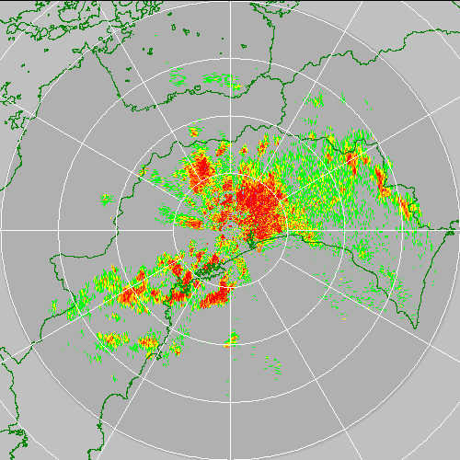

Correlation Coefficient (ρHV)

Specific Differential Phase (KDP)

Fig. 7.3-1 Example Image of Observation

# Portability, maintainability and extensibility

The compact X-band rainfall radar supports power input from 100 to 230 VAC. It can be operated with a single power cable and an Ethernet network cable connected to the radar control terminal. Therefore, the number of cables required for installation has been significantly reduced compared to the conventional X-band rainfall radar. Power consumption is approximately 75% lower than the conventional X-band rainfall radar, the total weight of the equipment is less than 350 kg, and the structure is designed to resist earthquakes, so it can be used not only at fixed stations but also on vehicles and operated as a portable device. Since a general-purpose computer is used for radar monitoring and observation control, observation can be performed with the minimum configuration of the rainfall radar itself and a general-purpose computer required for system operation. As for maintainability, it has a Built-In Self-Test (BIST) function for the antenna and TRX unit, enabling remote maintenance without using measuring equipment.

# Comparison with surface rainfall

The observational data obtained by the X-band dual-polarized solid-state rainfall radar were compared with that obtained by ground rain gauges, and the optimal values of the calculation parameters for the radar rainfall values were determined so that the radar rainfall values matched the ground rainfall values. Fig. 7.5-1 shows a comparison of the correlation results in the rainfall intensity between the X-band rainfall radar and the ground rain gauge before and after parameter optimization.

Parameters

B = 130, β = 1.8

A = 129, b = 0.85

Z >= 25

ρHV >= 0.8

0.3 <= KDP <= 10.0

Parameters

B = 200, β = 1.6

A = 129, b = 0.85

Z >= 38

ρHV >= 0.98

0.3 <= KDP <= 10.0

Initial Parameters Optimal Parameters

B, β, a and b are variables used to quantify radar rainfall.

Fig. 7.5-1 Correlation Comparison of Rainfall Intensity between X-band Rainfall Radar and Ground Rain Gauge

Fig. 7.5-2 shows a comparison of the total accumulated rainfall between the X-band rainfall radar and the ground rain gauge before and after parameter optimization at the one ground rain gauge location.

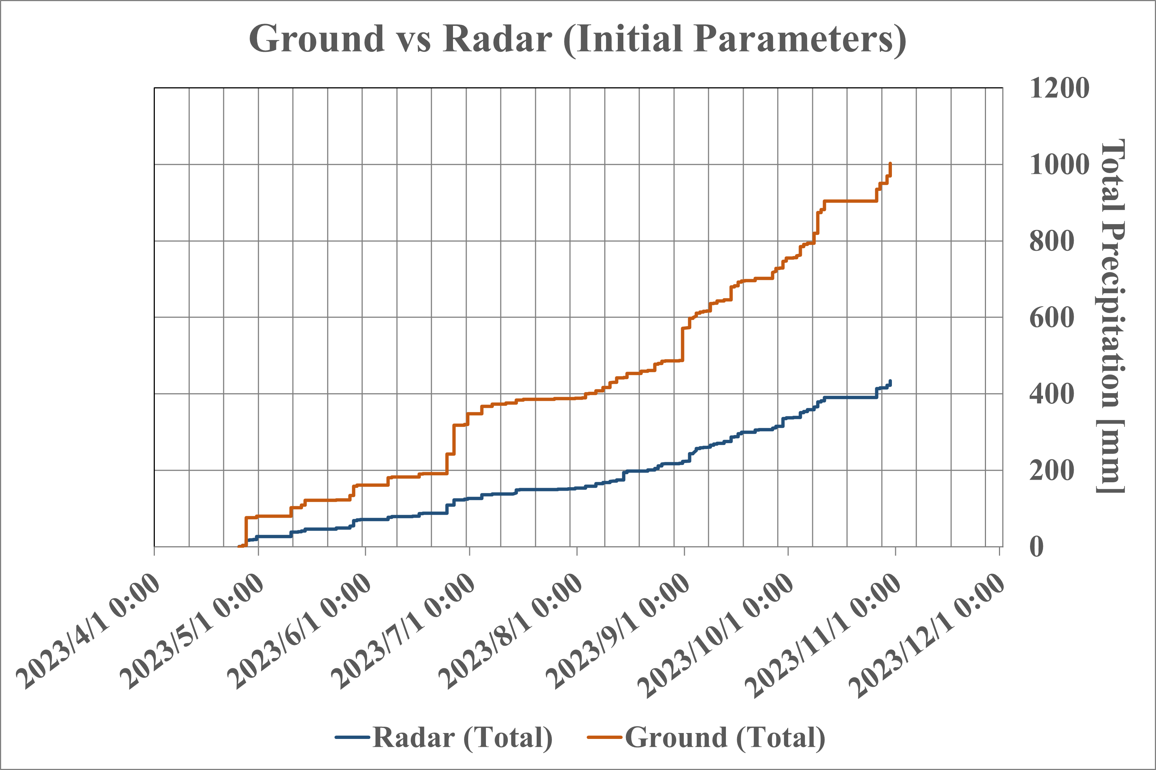

Initial Parameters Optimal Parameters

Fig. 7.5-2 Comparison of Total Accumulated Rainfall between X-band Rainfall Radar and Ground Rain Gauge

at the one ground rain gauge location

When using radar rainfall data for dam and river management, such as dam inflow calculations, the accuracy of the accumulated rainfall value is important. As shown in Fig. 7.5-2, by optimizing the parameters, it is possible to obtain a high correlation between radar rainfall values and ground rainfall values. Whereas a ground rain gauge provides point data at its installation location, X-band rainfall radar can provide highly accurate rainfall values that are highly correlated with a ground rain gauge over a wide observation range, making it extremely useful for dam and river management.

# Outline of the optimal dam and river management system

Dam management and the management of rivers in a basin for disaster prevention purposes are management activities designed to minimize damage from floods and other natural disasters. The main aspects of water management other than structure maintenance are listed below.

# River basin rainfall monitoring

Generally, observation data from telemeters installed on the ground is used, but for monitoring localized heavy rain that occurs in short-term events, it is desirable to have as high-density and real-time observations as possible. The system can calculate past rainfall, such as 10-minute rainfall and cumulative rainfall for each 150 m x 150 m mesh within the 80 km radius of the X-band dual-polarized solid-state rainfall radar observation range. By selecting a mesh on the map on applications using GIS (Geographic Information System), the rainfall calculation results within that mesh can be displayed in a graph and a form format every minute or every 10 minutes.

This makes it possible to select any area within the radar observation range and calculate the amount of inflow into a dam, the average river basin rainfall, etc. In addition, the results of warning judgment according to each region's Standard Operating Procedure (SOP) are displayed on the corresponding mesh, supporting highly accurate disaster prevention activities.

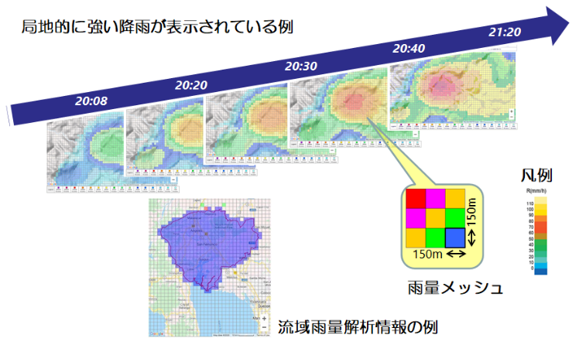

Example of local heavy rainfall.

Mesh of Rainfall

Legend

Example of basin rainfall analysis information.

Fig. 8.1-1 Display screen example for the calculation results

of 60-minute rainfall and basin rainfall

# Prediction of inflow into the dam and control of discharge

The capacity and arrival time of water reaching the dam are predicted and calculated based on rainfall data in the upstream area. If an inflow exceeding the flood control capacity is calculated and the calculated water level is predicted to exceed the dam's upper water level, the dam discharge amount should be increased gradually, and the flood control capacity is increased before the inflow water reaches the dam. It is necessary to discharge an amount equivalent to the above inflow amount in advance.

# Flood forecasting and warnings

A flood forecasting in the downstream area is simulated by adding the amount of rainfall in the downstream area to the dam discharge, and warnings are issued to residents in the area at risk of flooding according to predetermined procedures and methods.

# Overview of flood risk management application

The flood risk management applications are used for optimal operation of dam and river management. The flood risk management applications consist of a dam inflow prediction system and a dam operation support system. In addition, the observation data necessary to ensure the accuracy of flood risk management applications is automatically input in real-time from data observed by the X-band dual-polarized solid-state rainfall radar.

# Dam inflow prediction system

The amount of water flowing into the dam is predicted and calculated using a hydrological model by adding the amount of rainfall observed by the X-band dual-polarized solid-state rainfall radar for each mesh to the upstream river flow calculated from the river water level upstream of the radar observation range, taking into account the land topography and geological conditions and the amount of evaporation. The constants of the runoff model are determined through a trial study that reproduces past floods.

# Dam operation support system

The dam discharge control algorithm takes into account the predicted and calculated inflow, the current water level of the reservoir, and the amount of rain that falls directly on the dam and calculates the optimal discharge timing to protect the dam facility itself (not exceeding the dam's maximum water level) and to avoid flooding downstream. In addition, data for downstream flood risk calculations are updated in real-time based on discharge volume settings.

# Data required to operate flood risk management applications

The operational accuracy of flood risk management applications depends on the accuracy and real-time nature of input observation data. The 150 m mesh data observed every 5 minutes with the X-band dual-polarized solid-state rainfall radar is saved as a CSV-formatted file and provided to flood risk management applications. In the flood risk management applications, CSV-formatted files from the X-band dual-polarized solid-state rainfall radar are aggregated into hourly data, which is the time resolution of the hydrological model. Furthermore, it is converted to mesh data of 15 seconds longitude and latitude (approximately 500 m) for use in the hydrological model. In addition, areas outside the observation range of the X-band dual-polarized solid-state rainfall radar are complemented with rainfall data from the Global Satellite Mapping of Precipitation (GSMaP) provided by the Japan Aerospace Exploration Agency (JAXA).

# Case study

The case study of the Pasak Jolasid Dam in Thailand (the target system of the Ministry of Internal Affairs and Communications' Proof of Concept experiment), which is operated by combining the X-band dual-polarized solid-state rainfall radar and flood risk management applications, and the effects of optimal dam and river management is explained.

# Observation range of X-band radar

This time, the X-band dual-polarized solid-state rainfall radar was installed at the observation station S-42, about 20 km north of Pasak Jolasid Dam. The observation range of the X-band is 80 km, but taking into account the effects of heavy rainfall unique to Thailand, the effective observation range was set to 60 km. The Pasak River basin, Pasak Jolasid Dam and the radar coverage area are shown in Fig. 10.1-1. Since the Pasak River basin is long from north to south, the X-band dual-polarized solid-state rainfall radar installed this time is located on the south side near the Pasak Jolasid Dam. In the future, it is desirable to use two radars for management in order to take the inflow from the upstream into account.

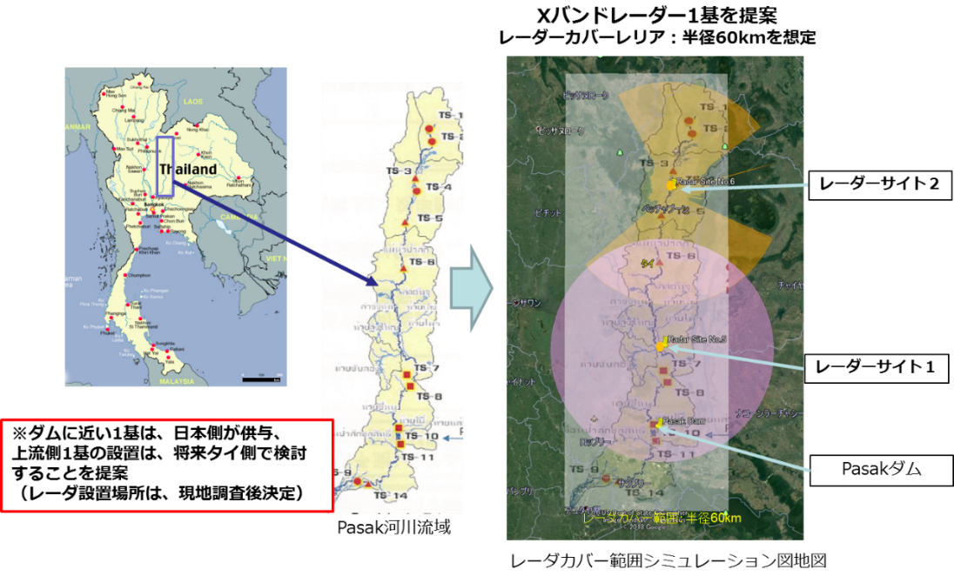

Rada Site #2

Considering addition in the future.

Rada Site #1

Operating in this project.

Pasak Jolasid Dam

River Basin of Pasak River

Simulation Map of Radar Coverage

Radar Coverage: Assuming Radius 60km

Fig. 10.1-1 Coverage of X band Radar

# Configuration of Pasak Jolasid Dam Management System

The configuration of the X-band dual-polarized solid-state rainfall radar and flood risk applications is shown in Fig. 10.2-1.

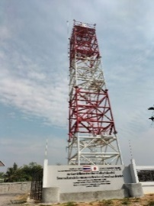

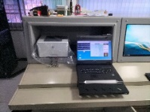

**Rainfall Radar**

**& Control Terminal**

Operating PC for Optimal Dam and River management systems

at Dam Operating Room

Radar Tower

Fig. 10.2-1 System configuration of Pasak Jolasid Dam management system

Radar Control Terminal

at Radar Site

# Setting parameters for the flood risk management applications

Real-time monitoring is conducted by acquiring the storage water level of Pasak Jolasid Dam, river water level at the existing observation station upstream of the dam, and surface rainfall. Future river flow is predicted by runoff calculation from the observed values of the X-band dual-polarized solid-state rainfall radar. Parameters corresponding to the geological conditions of the basin, evaporation, and river channel shape were changed as constants for the hydrological model with the X-band dual-polarized solid-state rainfall radar, and trial calculations were performed to determine the optimal values. An example of searching for parameters of a hydrological model is shown in Fig. 10.3-1.

Fig. 10.3-1 Parameter Search for hydrological Models

The optimal dam and river management system is used by dam managers to make decisions about dam operations (e.g., releasing water) based on the prediction information obtained from the inflow prediction system, especially during floods. The Pasak Jolasid Dam is responsible for downstream flood damage protection by securing water for agriculture and storing flood water. It is necessary to consider not only water storage capacity management focused on reducing flood risk, but also water storage capacity management that does not cause drought risk.

# Conclusion

This compact X-band radar contributes to the modernization of a real-time dam management system for dam water level and flood risk management applications. The compact X-band dual-polarized solid-state rainfall radar improves high-accuracy rainfall observations and effective use of frequencies. In addition, by combining the compact X-band radar with downstream area flood forecasting applications, it can be used for river flood forecasting and warnings.

Consequently, systems that integrate water management and flood disaster prevention applications with the compact X-band radar are anticipated to be predominantly introduced in Southeast Asia, where the risk of disasters related to water is prevalent, with the objective of contributing to regional disaster prevention and mitigation.

__________