**APT REPORT ON**

**TECHNICAL AND REGULATORY ASPECTS OF RAN AND SPECTRUM SHARING IN IMT NETWORKS AMONG MOBILE NETWORK OPERATORS IN THE ASIA PACIFIC REGION**

**Edition: September 2025**

**The 35th Meeting of APT Wireless Group**

**8 – 12 September 2025**

**Bangkok, Thailand (Hybrid)**

***(Source: AWG-35/OUT-06)***

**No. APT/AWG/REP-150**

**APT REPORT ON**

**TECHNICAL AND REGULATORY ASPECTS OF RAN AND SPECTRUM SHARING IN IMT networks AMONG MOBILE NETWORK OPERATORS IN the ASIA PACIFIC REGION**

# Introduction

Infrastructure sharing in telecommunications refers to the use of infrastructure or resources by more than one operator through an arrangement. In the context of International Mobile Telecommunications (IMT) networks, sharing decisions range from sites, towers to active network components such as Radio Access Network (RAN) and spectrum. According to the literature, there are several approaches to infrastructure sharing, but it is generally considered a practical and promising solution for reducing capital expenditure for deployment of mobile networks. The main advantages of infrastructure sharing are the cost benefits. However, it is also driven by the need to migrate to new technologies and to expand mobile broadband coverage.

According to the results of a global survey conducted by the ITU about infrastructure sharing, most countries have found that infrastructure sharing has a positive impact on the price of services for end-users.

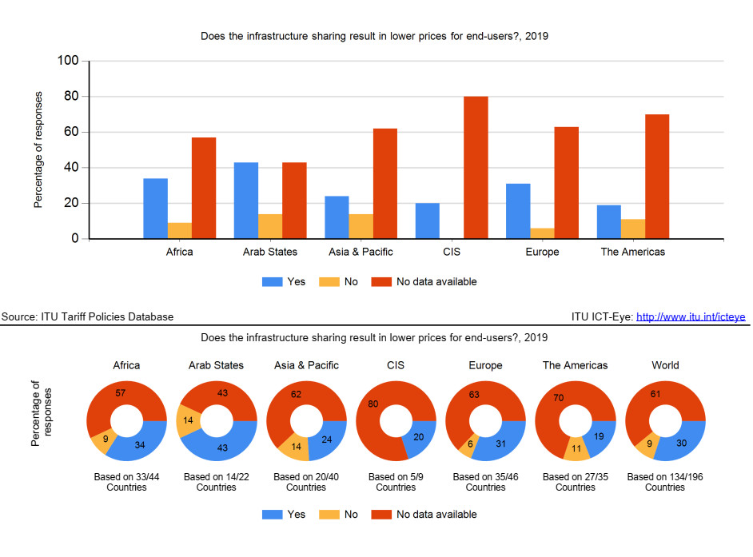

Infrastructure sharing models are generally divided into two broad categories: active and passive sharing. Passive infrastructure sharing means sharing of physical sites, cable trays, ductings, manholes and handholes, dark fibers, buildings, shelters, towers/masts, power supplies and battery backups, etc. Active infrastructure sharing involves sharing active electronic network elements such as base stations, other equipment for mobile networks, access node switches and management systems for fiber networks.

Spectrum sharing is another important aspect to ensure efficient utilization of the available spectrum. The basic objective of spectrum sharing is to enhance spectral efficiency by combining/pooling the spectrum holdings of multiple licensees.

The non-linear gain in spectral efficiency with the quantum of spectrum could allow for greater network capacity and improved service quality.

Infrastructure sharing, however, may also lead to reduced competition, and therefore appropriate country-specific policies need to be devised based on national interest. Depending on the market, policies and regulations should encourage and facilitate the highest possible level of infrastructure sharing. Governments and regulators should be proactive in establishing enabling frameworks for infrastructure sharing to boost the growth of the telecommunications sector.

# Scope

The purpose of this report is to provide technical and regulatory consideration of RAN and spectrum sharing in IMT networks among Mobile Network Operators (MNOs) in the Asia Pacific region.

# Global trend of RAN and spectrum sharing

Network and spectrum sharing arrangements are generally voluntary in nature and increasingly common. Several well-known mobile industry trends have driven a steady rise in the development of network sharing agreements among MNOs over the past 20 years. These include the growing importance and adoption of mobile broadband coverage, the increasing costs of network deployment, and the focus on sustainability and creation of green and energy-efficient networks.

Global trend of network sharing: announced deals by type of sharing (cumulative).   
Source: Coleago, GSMA Intelligence

# Techniques for RAN and spectrum sharing among MNOs in IMT networks

This section focuses on sharing techniques mainly relating to active infrastructure sharing.

Active infrastructure sharing is sharing of electronic infrastructure of the network including RAN (consists of antennas/transceivers, base stations, backhaul networks and controllers) and core network (servers and core network functionalities). This form of sharing is more complex as it requires close cooperation between MNOs and can be further classified as outlined in the following sections.

## MORAN and MOCN

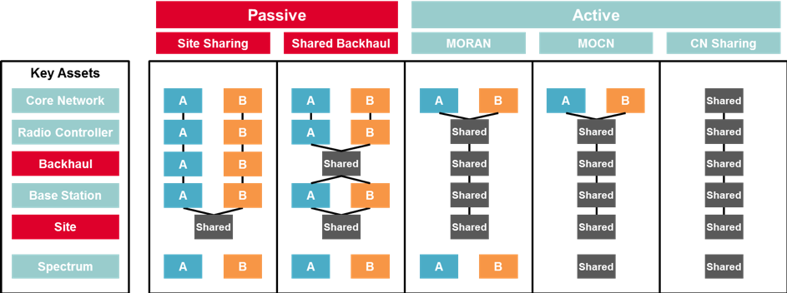

Network Resource Sharing Models (Source: GSMA)

- **MORAN** (Multi-Operator Radio Access Network), where RANs(tower, antenna etc.) are shared but each MNOs uses its dedicated spectrum is used by each MNO. With MORAN everything in the RAN (antenna, tower, site, power) except the spectrum is shared between two or more MNOs. The base station equipment is configured to broadcast multiple Public Land Mobile Network (PLMN) IDs on their respective carriers. MNOs maintain independent control over their spectrum and services, allowing for a high degree of service differentiation. The solution simplifies RAN infrastructure sharing and is well-suited for scenarios where MNOs want to maintain operational independence.

- **MOCN** (Multi-Operator Core Network), where two or more core networks share a single RAN and a common spectrum block. Multiple PLMN IDs are broadcasted on shared carriers, and a user's device selects its home network. With MOCN, two or more core networks share the same RAN, including the spectrum. MOCN is a resource efficient solution as it could give an opportunity for MNOs to pool their respective spectrum allocations, which could result in improved trunking efficiency. For UMTS, MOCN has been supported since 3GPP Release-6. For LTE since Release-8 and support for GERAN was added as part of Release-11.

As in the case of site sharing, MORAN and MOCN can be implemented per sites and enables strategic differentiation. However, operation of network equipment needs to be shared (or at least issues must be shared with participants) and therefore increases the complexity of sharing relative to site sharing. The cost-saving potential is greater than site sharing. Core network enables greater cost-saving potential but is complicated to operate and to maintain strategic differentiation.

**Difference between MORAN and MOCN**

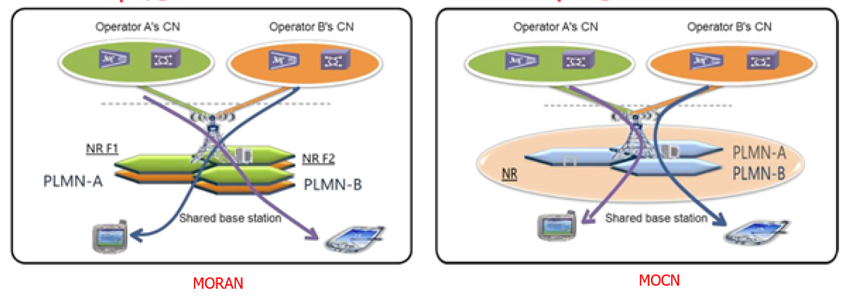Comparison Between MORAN and MOCN (Source: GSMA)

**In MORAN**, multiple independent carriers are configured and the Public Land Mobile Network (PLMN) IDs of operators are broadcasted on those carriers. Baseband Units (BBUs) are shared and connected to Remote Radio Units (RRUs) and Active Antenna Units (AAUs) provided by the same vendor of BBUs. Each carrier is **independently** configured and managed. The RAN infrastructure provides logically and physically separated cell resources and core network connectivity on a per-MNO basis. The MORAN solution features **simple** RAN infrastructure sharing and operation & maintenance (O&M), and is applicable to scenarios where MNOs need to maintain service and deployment **independence** in shared networks.

**In MOCN**, one or more carriers are configured for frequency sharing. MNOs **share** their cells – physically and logically; in each cell, multiple PLMNs are broadcasted. **Sharing** radio resources among participating MNOs is performed according to service level agreements.

Parameterization of cell-level features needs to be negotiated among all MNOs. UEs accessing shared cells select one of the broadcasted PLMNs and communicate this selection to the base station, which connects UEs to their selected core network. MOCN is used when the MNO A has a spectrum license, and another MNO does **not** have a spectrum license but would like to use the spectrum of MNO A.

**In summary, MORAN allows for a more independent network, while MOCN represents a unified way of network implementation and sharing.**

## National/domestic Roaming

Roaming is a method of infrastructure sharing. National/domestic roaming refers to roaming agreements in the national/domestic context. For example, national roaming, a subscriber from MNO A may roam into MNO B’s network when entering into non-overlapping coverage provided by MNO B and vice versa. This type of sharing enables cost saving comparable to or greater than core network sharing. However, national roaming comes with complexity (e.g., when to choose home network over visited network has given signal strength) and there can be regulatory issues where regulators may be concerned with reduced competition.

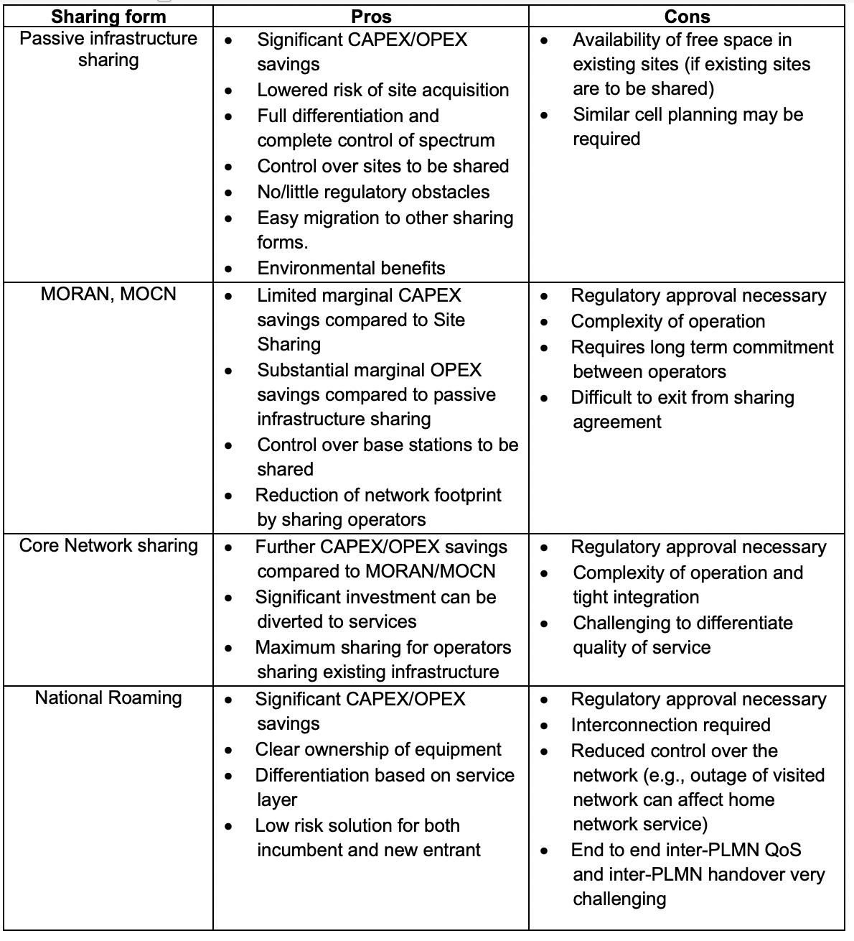

Comparison of infrastructure sharing forms (technology)(Source: GSMA)

## MVNO - Mobile Virtual Network Operators

Mobile Virtual Network Operator (MVNO) business is a growing trend today and a very lucrative opportunity in mobile telecommunications. MVNO provides wireless communication services without the full infrastructure or license to use radio frequencies. It provides wireless communications with agreements already in place with MNOs. These MVNOs obtain bulk access to mobile communications networks for their consumers at set retail and wholesale prices.

**MVNO business models**

MNOs are realizing the significance of MVNO partners to reach out to niche audiences with unique needs using suitable low cost business models & pricing strategies. As a result, MVNOs are fast emerging across segments such as telecom, roaming, retail, media, business, discount, lifestyle, and M2M.

The different business models in the MVNO market are based on how the value chain is restructured. Therefore, four main business models that emerge are: Branded Reseller, Light-MVNO (with HSS/HLR,BOSS), Full-MVNO (with more like, STP, DRA, GTP-Router, PGW/GGSN, PCRF, SMSC/USSD GW) and MVNE (with more like MME, SGW, SGSN, MSC, GMSC).

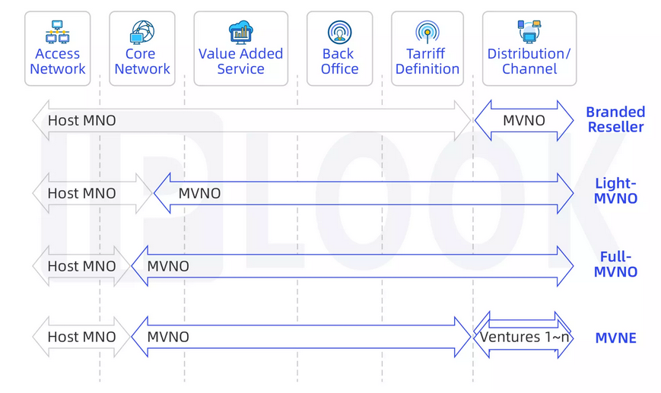

MVNO business models (Source: IPLOOK)

***Branded reseller***

Branded reseller is the lightest MVNO business model, where the venture just provides its brand and, sometimes, its distribution channels. While the MNO provides the rest of the business, from access network to the definition of the mobile service offer. This is the model that requires the lowest investment for a new venture, therefore the fastest to implement. However, most of the business levers remain with the network provider (MNO or MVNE). Therefore, the new venture has a very limited control of the business levers and value proposition of the service.

***Light-MVNO***

Light-MVNO is an intermediate model between a branded reseller and a full-MVNO. This model allows new ventures to take control of the marketing and sales areas and, in some cases, increase the level of control over the core network, back-office processes and valued-added services definition and operations.

***Full-MVNO***

Full-MVNO is the most complete model for a new venture, where MNO just provides the access network infrastructure and part of the core network, while the new venture provides the rest of the elements of the value chain. This MVNO business model is typically adopted by telecom players that could gain synergies from their current business operation.

***Network enablers***

Network enablers, typically known as Mobile Virtual Network Enablers (MVNE), this is a third-party provider focused on the provision of infrastructure that facilitate the launch of MVNO operations. An MVNE can be positioned between a host MNO and an MVNO venture to provide services ranging from value added services and back office processes to offer definition. MVNEs reduce the entry barriers of MVNO ventures, given that an MVNE aggregates the demand of small players to negotiate better terms and conditions with host MNO. They pass on some of these benefits to their MVNO partners. Moreover, the all-in-a-box approach to launch an MVNO through a MVNE has accelerated, even more, the explosion of the MVNO market.

## Spectrum leasing

Spectrum leasing is another form of sharing. In a spectrum leasing model, licensed bands that have already been assigned to an MNO on an exclusive basis can be rented to another MNO. Spectrum leasing typically involves a partial transfer of a licensee’s rights to spectrum to another MNO for a limited period and/or for a portion of the spectrum included in the licence. Spectrum leasing (as well as other secondary market transactions) is often subject to regulatory approval. In general, stakeholders taking part in such transactions can be MNOs or other companies that have a spectrum licence on one side, and a party such as another MNO or other entity requiring access to spectrum on the other side.

# Regulations for RAN and spectrum sharing in IMT networks among MNOs

Effective regulatory frameworks are essential for facilitating RAN and spectrum sharing to establish a healthy, competitive, and innovative telecommunications market. When MNOs engage in RAN or spectrum sharing in IMT networks, regulatory frameworks should balance competition, fair market practices, and technical efficiency. Below are some key considerations:

## Ensuring a balance between healthy competition and sharing benefits

Spectrum caps limit the amount of spectrum any single MNO can hold. They are typically applied during spectrum awards to prevent market dominance and ensure equitable access to spectrum resources. However, their application to post-award RAN or spectrum sharing should be approached cautiously. Regulators may reassess caps on a case-by-case basis, taking into account the specific nature of sharing arrangements.

Furthermore, it is imperative that regulators should provide some flexibility for spectrum sharing among MNOs in scenarios where such arrangements provide clear benefits, such as extending rural coverage, improving network capacity or enhancing network efficiency, without undermining effective market competition.

To safeguard market health, regulators should continuously monitor the competitive impacts of RAN and spectrum sharing, and be prepared to intervene with appropriate remedial measures to address competition issues when they arise.

## Technical conditions

The technical requirements for out-of-block emission limits and TDD synchronization are related to reducing interference between MNOs. These technical conditions are crucial for mitigating interference between MNOs working in adjacent spectrum blocks. Therefore, these technical conditions are widely used when licensing spectrum to MNOs.

When MNOs implement RAN/spectrum sharing, national regulators could consider introducing necessary technical conditions for out-of-block emission limits and/or TDD synchronization to prevent interference to other MNOs operating in the adjacent spectrum block.

**5.2.1. Out-of-block emission limits**

Out-of-block emission limits define the maximum permissible interference from the emission of signals outside the designated frequency band. By enforcing these limits, the risk of interference between different MNOs sharing the same or adjacent frequency bands can be minimized. In RAN/Spectrum Sharing, such limitations are often specified when an MNO shares a radio access network (RAN) or spectrum with another MNO. Out-of-block emission limits ensure that the signals emitted by one network do not interfere with other networks, thereby maintaining service quality for all parties involved.

グラフ, 棒グラフ

AI 生成コンテンツは誤りを含む可能性があります。

Illustration of a general out-of-block limits

|  |  |
| --- | --- |
| **Out-of-block emission** **elements** | **Definition** |
| In-block | Block for which the BEM(Block Edge Mask) is derived. |
| Baseline | Spectrum used for IMT, except for the MNO block in question and corresponding transitional regions. |
| Transitional region | The transitional region applies 0 to 10 MHz below and above the block assigned to the MNO. |

**5.2.2. TDD synchronization**

Proper TDD synchronization between MNOs using the same or adjacent spectrum to deploy IMT networks in TDD mode is essential to avoid collision of transmissions, prevent interference and spectrum waste. Synchronized operation will require neighboring MNOs to coordinate to select a compatible frame structure, and a common phase clock reference (e.g. UTC) with a requirement on the accuracy/performance, and a common understanding about the start of the frame with regards to the common phase clock reference.

The synchronized operation of TDD networks could avoid the cross-link interference between networks and provide excellent performance in an economic and efficient way.

## Consideration on network and spectrum sharing

Network and spectrum sharing is only possible if regulations do not prohibit it, commercial measures incentivize it, and it is technically practical (i.e. different MNOs can operate their IMT networks effectively without interference). Regulators can enable sharing by giving incumbent MNOs the right to share their spectrum voluntarily through commercial agreements or by awarding rights to use spectrum in areas and/or at times when the incumbent is not using it.[1]

The right regulatory framework could support leasing and help overcome potential concerns around the implications for competition. This can be achieved by providing clarity with respect to several components, including considerations for the granting of permission to lease spectrum and the roles and responsibilities of the lessor and lessee when it comes to network coverage and rollout, and fees, as well as licence obligations relating to technological neutrality, quality of service and consumer protection.[2]

According to one study, some of the key regulatory considerations for spectrum sharing are as follows:[3]

* Exclusive licensing has been central to the success of mobile services and should continue. Any spectrum sharing mechanisms should be considered as a complementary possibility.
* Licensing authorities should allow voluntary spectrum sharing, leasing and trading amongst MNOs and facilitate such mechanisms through clearly defined spectrum rights, long licence terms, and limited administrative costs.
* Sharing will only be useful for MNOs if the proposed band is harmonised for mobile use and is available and usable in sufficient quantities in areas and at times where needed.
* MNOs favour a simple sharing framework that is investment-friendly and supports reliable, high quality mobile services.
* Competition issues should be assessed considering the specific circumstances of sharing, leasing and trading agreements. Certain safe harbours can be established where the spectrum represents a small share of the market capacity or where a market share is below a certain threshold.

# Case studies in APT Countries

## Vietnam

* Policy and Regulations in the Telecommunications Law:

*-* The sharing of telecommunications infrastructure is carried out through contracts on the basis of ensuring the legitimate rights and interests of the parties involved.

*-* In case the parties cannot agree on the price to share telecommunications infrastructure, negotiations shall be carried out in accordance with the law on prices. In case the parties cannot agree on other contents about sharing telecommunications infrastructure, the competent state agency shall decide.

- Roaming and MVNO: Ensure provision of services with fair, reasonable and non-discriminatory prices and related conditions; Transparent information about prices, technical standards and regulations, the quality of networks and services.

* Under the Telecommunications Law:

Active infrastructure sharing must ensure: Comply with the provisions of the Telecommunications Law; Comply with the Competition Law, the Radio Frequency Law and other relevant laws.

* Under the Radio Frequency Law:

Active infrastructure sharing according to the MORAN model is feasible and does not violate the provisions of the Law on Radio Frequency, while according to the MOCN model, appropriate policies are being studied.

There are 5 MNOs in Vietnam. Basically, they all have different domestic and international roaming agreements. For example: Viettel - Vietnam's largest network operator currently has data roaming agreements with more than 500 network operators in 213 countries/territories around the world. Viettel's international roaming service is very diverse, with many support utilities such as callback messages when roaming internationally (Roaming call back), unlimited data roaming rates.

Up to now, MIC-Vietnam has licensed for 5 MVNOs: Indochina Telecom, Mobicast, ASIM, Digilife and FPT Retail. In particular, Indochina Telecom and Mobicast use VinaPhone's infrastructure, while ASIM, Digilife and FPT Retail networks use MobiFone's infrastructure. Only Viettel does not cooperate with any MVNO, even though Viettel is said to have the strongest infrastructure today.

## China

The Ministry of Industry and Information Technology(MIIT) of the People’s Republic of China has published “Notice on Supervision of Radio Frequency Sharing in 5G Systems” in 2021, which proposed two methods of spectrum sharing among IMT operators: (1) spectrum sharing on base station side, (2) spectrum sharing on user terminal side[4].

* spectrum sharing on the base station side, the 5G base stations of one telecommunication operator A change the transmission or reception frequency range specified in its radio station licenses, providing 5G services to its own user terminals and the user terminals of other operators (B or C) using the 5G frequency licensed to other operators. By this sharing method, the telecommunication operators sharing the frequency shall apply for a new radio frequency sharing license.
* spectrum sharing on user terminal side, the user terminals of one telecommunication operator A change the transmission or reception frequency range, connect to 5G base stations owned by other telecommunication operators (B or C), and access 5G service from other operators. By this sharing method, the base stations of other operators (B or C) maintain the transmission or reception frequency range specified in its radio station licenses.

The IMT operators planning to carry out spectrum sharing on the base station side shall apply to MIIT for the change of radio frequency use licenses, and submit the agreement on spectrum sharing on the base station side and other necessary materials, including but not limited to the following:

1. Specific frequency range involved in spectrum sharing on base station side;
2. The frequency use rights and obligations of the base station spectrum sharing operators;
3. Spectrum sharing region;
4. Spectrum sharing period;
5. The IMT operators applying for the 5G base station radio station license in the spectrum sharing region shall bear the main responsibility for interference coordination between the 5G base station and other legitimate radio stations, as well as the main responsibility for international coordination and declaration of radio frequencies of relevant 5G base stations in border areas;
6. Apportionment ratio of frequency usage fees for all operators involved;
7. Conditions for termination of spectrum sharing, ownership of shared frequency use right after termination of spectrum sharing and related aftermath matters;
8. Other contents stipulated by laws and administrative regulations.

The IMT operators that plans to carry out spectrum sharing on the user terminal side shall jointly submit materials to MIIT to clarify the specific frequency range, sharing region, sharing period, sharing termination conditions and other matters involved in spectrum sharing on user terminals. There is no need to apply for licenses when setting and using user terminals. The radio station licenses handling, frequency usage fee payment, radio frequency utilization rate, etc when operators carry out spectrum sharing on the user terminal side shall be implemented in accordance with the current regulations of exclusive frequency licensing.

Furthermore, China is also promoting the shared construction and utilization of telecommunications infrastructure. In 2023, multiple departments in China jointly issued the Implementation Opinions on Further Deepening the Co-construction and Sharing of Telecommunications Infrastructure to Promote the High-Quality Development of "Dual-Gigabit"[5] Networks, which stipulated that

* Promoting Coordinated and Intensive Construction of "Dual-Gigabit" Networks: Strictly implement the co-construction and sharing procedures for facilities such as utility poles, ducts, equipment rooms, optical cables, and base station access transmission lines. Support the co-construction and sharing of 5G access networks and advance the implementation of 5G national roaming.
* Deepening Joint Access to "Dual-Gigabit" Networks: Establish a registry of residential areas, residential buildings, and commercial buildings currently lacking broadband network access or served by only one basic telecommunications operator. Promote joint access to broadband networks, significantly enhancing gigabit optical network coverage.
* Strengthening Maintenance and Streamlining of Rural Communication Poles and Cables: Establish and improve a co-construction, sharing, and co-maintenance mechanism for rural telecommunications infrastructure. Encourage basic telecommunications operators to promote the co-construction and sharing of rural poles and cables through models such as laying separate cables/pipes in the same trench, sharing poles for separate cables, sharing cable cores within the same cable, fiber core swapping, and leasing fiber cores.
* Encouraging Cross-Industry Open Sharing: Promote the open sharing of facility resources—including towers, ducts, utility tunnels, tunnels, optical cables, and equipment rooms—for "dual-gigabit" network construction through reasonable and fair market-based approaches. Fully leverage the enabling role of communication networks across all industries.

In 2021 and 2023, case collection activities for the construction and sharing of telecommunications infrastructure were respectively organized. After the review and access, a total of 92 typical cases were announced[6][7]. These cases can provide valuable experience and practices for basic telecommunications operators to carry out co-construction and sharing. This will further promote the intensive construction and integrated sharing of telecommunications infrastructure, and help continuously enhance the level of co-construction and sharing.

At the World Telecommunication and Information Society Day conference on May 17, 2023, China Telecom, China Mobile, China Unicom, and China Broadcasting Network jointly announced the official launch of the world’s first 5G inter-network roaming commercial trial in Xinjiang, China. 5G inter-network roaming refers to the user terminal could use 5G services by accessing to other operators’ 5G networks and continue using 5G services, when the respective operators have no 5G network coverage[8].

At the Mobile World Congress in March 2025, China Telecom and China Unicom teamed up with GSMA and partners to release the Shared Network Smart Co-Governance White Paper, further systematically summarizing the key technologies and successful practices of network smart governance under the co construction and sharing mode. China Telecom and China Unicom have been steadily building and launching their shared 4G/5G networks across China in accordance with the cooperative framework agreement on network co-construction and sharing that was signed in 2019. Regarding 5G networks, the two operators have made tangible breakthroughs in terms of product, technology, Operations & Maintenance (O&M), and management innovations in collaboration with other partners. In terms of 4G networks, the two operators have been engaged in reconstructing their installed 4G networks from 2022 to 2024, in order to make them shareable with the aim of improving quality and efficiency at reduced costs. Aiming to minimize the total cost of ownership (TCO), the two operators designed plans for removing and then redeploying their 4G networks with careful consideration of elements such as coverage, load, complaints, antenna resources, equipment capabilities, and local conditions. By October 2024, the two operators had deployed 1.37 million shared 5G base stations and reconstructed over 2 million shared 4G base stations. This joint effort of building, optimizing, and operating networks has paid off with network quality and user experience having steadily improved, while investments and costs have been greatly reduced[9].

China is guiding IMT operators to enhance coordination and cooperation, fully boost market dynamism, integrate prime resources, carry out 5G network sharing and inter-network roaming, accelerate efforts to form a network pattern with multiple networks coexisting in hotspots and one network ensuring basic needs in remote areas, and create 5G networks with intensive resource and efficient operation[10].

## Republic of Korea

The Ministry of Science and ICT(MSIT) announced a “Rural 5G Network Sharing Plan” in April 2021 with three mobile network operators in Korea, SK Telecom, KT and LG Uplus. To implement the rural 5G network sharing plan, the three operators signed an agreement to enable 5G users to access the 5G network in rural and remote areas regardless of which operator they subscribe to, with the aim of providing nationwide 5G service.

Following the launch of the world's first commercial 5G network service, discussions began on building a joint network to rapidly expand the nationwide 5G network and bridge the 5G divide between urban and rural areas. As 5G network is known to take longer to deploy nationally compared to LTE, the MSIT and three operators agreed on a RAN sharing policy to accelerate the delivery of 5G coverage rapidly, not just in some metropolitan regions but in rural areas.

This is the worldwide first case of a 5G RAN Sharing agreement involving all operators in a nation to accommodate all MNO and MVNO subscribers and global roamers without differentiating customer experience. It is designed to provide all subscribers with the same quality as their independent network when on a shared network.

Under the plan, the three operators jointly built and shared 5G systems in 1342 rural areas across the Republic of Korea, and in April 2024, the construction of a nationwide 5G network was completed, covering all rural areas in addition to urban areas where the three MNOs had already independently built 5G networks. MSIT and three MNOs will continuously improve the network stability, quality, etc. in rural 5G network sharing areas.

After discussing which technology method to implement, the Multi-Operator Core Network (MOCN) radio access network sharing architecture is selected for this 5G network sharing plan, where only the RAN is shared in the 5G network. MOCN enables two or more operators with distinct core networks to use shared RAN and spectrum. Figure below describes the MOCN implementation for the 5G network sharing system in Korea.

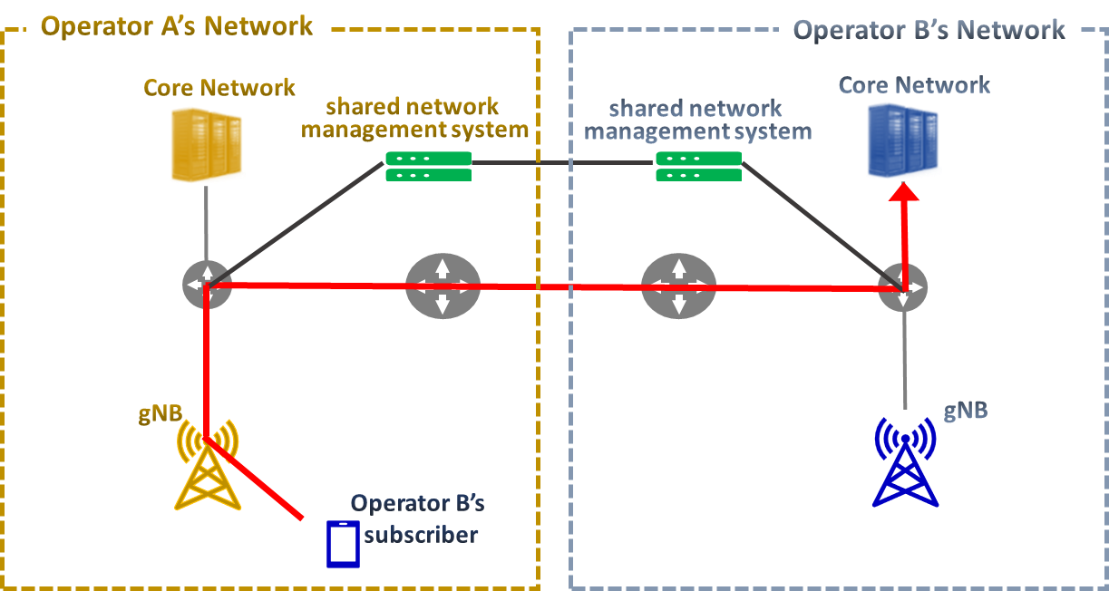

MOCN for Korea 5G Network Sharing System

The all information on each operator’s radio access networks, including coverage, parameters, etc. is shared by “shared network management system”. It is newly developed for shared network to integrate quality management through which three operators monitor and immediately address service performance, load, defects, errors etc. on the shared network. For interoperability between each operator’s own access network and the others’ core networks, the operators designated edge communication bases when connecting the backbone networks to ensure stability and reduce latency. The bases are configured to process traffic within the region and ensure stability by ensuring route redundancy between base data centers when interoperating between networks.

## Republic of Indonesia

Ministry of Communication and Digital Affairs of Indonesia has issued a regulatory framework that supports collaborative use of spectrum resources. Under Ministerial Regulation No. 7 of 2021, operators are permitted to implement spectrum pooling, where multiple license holders combine their assigned spectrum bands for shared use. This framework enables more efficient spectrum utilization and provides a strong foundation for network consolidation strategies. Supported by this policy, the merger of Indonesia’s MNOs XL Axiata (XL) and Smartfren (SF) into a single telecommunication operator represents a major milestone for Indonesia’s digital connectivity. The combined entity (XLSMART) will hold a wide range of spectrum resources and manage a large customer base across the nation.

A key challenge is to determine the most effective technical pathway to consolidate two separate networks into one unified infrastructure, ensuring both operational synergies and customer experience. Three primary options are available: MOCN (Multi-Operator Core Network), MORAN (Multi-Operator RAN), and National Roaming (NR). Each approach has unique strengths and trade-offs, depending on network conditions and merger objectives.

Technical Approaches for Network Consolidation :

グラフィカル ユーザー インターフェイス

AI 生成コンテンツは誤りを含む可能性があります。

|  |  |  |  |
| --- | --- | --- | --- |
| **Aspect** | **National Roaming (NR)** | **MORAN** | **MOCN** |
| **Description** | One operator’s customers roam on the other’s network | Shared physical sites only | Shared RAN + spectrum pooling |
| **When Suitable** | If **one operator is dominant** in RAN & coverage | If operators only want cost savings in overlapping clusters | If both operators have **similar RAN size & coverage** |
| **Pros** | - Immediate nationwide coverage | - Easy to implement | - Spectrum pooling |
| - Seamless customer experience | - Cost savings in infra | - High synergy & savings |
| - Quick transitional solution | - Transitional in clusters | - Better QoS |
|  |  | - Aligned with “one network” |
| **Cons** | - No infra/spectrum synergy | - No spectrum pooling | - High technical complexity |
| - QoS depends on dominant network | - Limited synergy | - Dual cores in transition |
|  | - Higher long-term cost |  |
| **Customer Impact** | Seamless coverage but uneven QoS possible | Neutral, minor QoS gains | Stronger bandwidth, stable QoS |
| **Timeline** | Immediate | Short–Medium | Medium |
| **Strategic Role in XLSMART** | **Chosen as short-term bridge** for coverage & service continuity | Not preferred for long-term | **Chosen as primary strategy for RAN integration** |

After evaluation, XLSMART has decided to adopt a hybrid approach:

1. National Roaming (NR) will be used as an early-stage quick-win to provide seamless service continuity for customers while physical integration work is ongoing.
2. MOCN will be the primary technical approach for long-term RAN consolidation, allowing spectrum pooling, site rationalization, and eventual single-RAN operation.
3. Once the RAN integration is completed, the consolidation will move forward to the Transport layer and finally to the Core network, resulting in one unified end-to-end network.

Roadmap to one consolidation network:

1. Phase 1 – National Roaming (NR) : Immediate nationwide coverage continuity
2. Phase 2 – MOCN Deployment : Spectrum pooling and RAN site rationalization
3. Phase 3 – Transport Integration : Unified fiber/microwave/IP backbone
4. Phase 4 – Core Integration : Migration to single unified core network

By choosing MOCN and NR as its strategic pillars, XLSMART ensures both short-term service continuity and long-term efficiency. NR provides an immediate solution during the transition, while MOCN delivers the structural foundation for a fully unified RAN, enabling transport and core consolidation afterward. This strategy guarantees cost efficiency, regulatory alignment, and superior customer experience, ultimately creating one integrated network for Indonesia’s digital future.

# Summary

Infrastructure sharing in IMT networks has become an important mechanism that allows multiple MNOs to share infrastructure and resources. It offers several benefits, such as cost reduction, more efficient expansion of mobile broadband coverage, and contributions to sustainability and green networks.

Various types of network infrastructure, such as sites, towers, RAN, and spectrum, can be considered for sharing. Sharing models are generally classified into active and passive categories: passive sharing targets physical sites, buildings, and power facilities, while active sharing involves electronic network elements such as RAN and core network equipment. Spectrum sharing can also be implemented, which may improve the efficiency of spectrum utilization. For RAN/spectrum sharing, there are different technologies, such as MORAN and MOCN, each with its own advantages and disadvantages. Additionally, national/domestic roaming, MVNOs, and spectrum leasing are other forms of sharing.

It is important to note that, since infrastructure sharing could have some implications on market competition, it is crucial to establish appropriate policies tailored to the circumstances of each country. Governments and regulators should proactively establish supportive frameworks to promote infrastructure sharing.

This Report also includes several case studies provided by APT Members regarding infrastructure sharing in their respective countries. Additionally, the Annex to this Report provides information on the policy and regulatory aspects of infrastructure sharing considered outside the Asia-Pacific region.

In order for the Asia-Pacific countries to maximize the benefits of RAN and spectrum sharing in IMT networks, it may be useful to include further information, new case studies, and supporting materials regarding the deployment and adoption of RAN and spectrum sharing, when they become available.

# Annex:

## Policy and Regulatory aspects of Infrastructure sharing (Outside the Asia-Pacific region)

1. BEREC (**Body of European Regulators for Electronic Communications)** Report on infrastructure sharing

- Current regulations and legal framework for infrastructure sharing in different countries, including information-sharing requirements, NRA powers, infrastructure sharing obligations and any guidelines in place to support operators.

- Current sharing arrangements: Active sharing with joint deployment, National roaming (without joint deployment), Passive sharing, Special agreements, Further agreements; Assessments and/or decisions on infrastructure sharing.

- Benefits and challenges from infrastructure sharing arrangements: Benefits of sharing, Challenges and downsides associated with sharing, General experiences with sharing agreements (including of Negative experiences, Neutral experiences and Positive experiences, Barriers to increase infrastructure sharing

- Future evolution of sharing arrangements and the role of 5G in shaping requirements/regulatory framework: Most countries expect that infrastructure sharing will become more important in the future.

Most NRAs, however, believe that continued market monitoring will be required before NRAs can take informed decisions in the context of deployment of 5G. The development of best practices – and their relevance to 5G – will also rely on past experiences of NRAs in addressing potential challenges related to infrastructure sharing agreements.

Some NRAs state that local authorities and/or legislation should support 5G (Bulgaria, Norway). Some countries think that the regulatory framework is appropriate and sharing agreements have to be mainly commercially based (Finland, Netherland, Sweden, Switzerland, Turkey, UK) and competition law provides a sufficient framework to assess which sharing is desirable (and allowed) and which not (Netherland). Some countries think that infrastructure sharing might be related to licence exempt spectrum bands (Denmark, Ireland).

Some countries explicitly mention that competition has to be maintained (Czech Republic, Denmark, Serbia). Individual countries see a risk that MNOs through exclusivity agreements with infrastructure owners could impede the rollout of other MNOs (France) or want to impose the sharing of passive sites. An individual country states that service competition may suffice (Belgium).

To sum up, countries expect that 5G will be especially related to more small cells and higher backhaul capacity. It is believed that there will be an increase or at least an increased need in sharing (passive, active, backhaul, active indoor spectrum and others). Some countries state that operators concluding exclusivity agreements with infrastructure owners could impede other operators’ rollout. It should therefore be ensured that sharing does not lower competition.

1. Shared Access Licence - Guidance document (OFCOM):

- The Shared Access licence is part of a new framework for enabling shared use of spectrum and is currently available in four different bands: the 1800 MHz shared spectrum; the 2300 MHz shared spectrum; 3.8-4.2 GHz; the lower 26 GHz band.

- There are two kinds of licence: low power and medium power Shared Access licence (including technical conditions).

- Licence fees and non-technical licence conditions (Licence duration and revocation; Trading the licence to someone else; Keeping records and providing information to Ofcom; Accessing, modifying and shutting down your equipment if something goes wrong; Changing frequency if we ask you to do so).

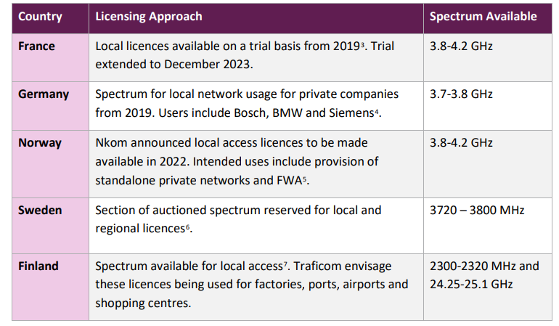

Examples of Shared Access spectrum developments in Europe (Source: Ofcom)

## Mandated sharing and risks of SWNs

Single wholesale networks (SWNs) or wholesale open access networks (WOAN) are much less common. Like network sharing arrangements, SWNs are also based on rationale of reducing both network capex requirements and end-user service costs. Unlike voluntary sharing agreements, SWNs are mandated – they are not voluntary and lack the flexibility for operators to determine the best arrangement for sharing. Instead of relying on competing mobile networks and voluntary network and spectrum sharing arrangements to deliver mobile broadband services in their country, such proposals specify at least partial network ownership and financing by the government.

While there are variations in the SWN proposals discussed and implemented by different governments, in most cases, operators are also limited to provide mobile broadband in one technology (4G or 5G) solely via the SWN. There have been examples of such arrangements in Mexico and Rwanda, and most recently in Malaysia[11].

SWNs have not proved successful to date and the plans have largely been abandoned for competition-based approaches. Two important reasons are the lack of take-up of their services and the fact that coverage improvements have been slower compared to competitive rollouts. SWNs lead to highly controlled and monopolistic networks, tend to encourage high consumer prices, which has resulted in low adoption. Other shortcomings illustrated by real-world use cases include SWN licensees that have been unable to recoup investments. The results of nearly all SWN initiatives have been idle spectrum, lower levels of innovation, limited socioeconomic benefits, and restricted quality of service.

*Source: GSMA*

1. GSMA. Spectrum Sharing. June 2021. <https://www.gsma.com/connectivity-for-good/spectrum/wp-content/uploads/2021/06/Spectrum-Sharing-Positions.pdf>
2. GSMA. Spectrum leasing in the 5G era. January 2022. <https://www.gsma.com/connectivity-for-good/spectrum/wp-content/uploads/2022/01/Spectrum-Leasing-5G-Era.pdf>
3. GSMA. Best Practice in Mobile Spectrum Licensing. February 2022. <https://www.gsma.com/connectivity-for-good/spectrum/wp-content/uploads/2022/02/Mobile-Spectrum-Licensing-Best-Practice.pdf>
4. <https://www.miit.gov.cn/zwgk/zcwj/wjfb/tz/art/2021/art_771cac9bf8ac4f4d97ee87cc5bd2362e.html>
5. <https://www.gov.cn/lianbo/bumen/202305/content_6876197.html>
6. <https://www.miit.gov.cn/jgsj/txs/gzdt/art/2022/art_45a7b18dfb6d41e0bc3254a9686620d3.html>
7. <https://www.miit.gov.cn/jgsj/txs/wjfb/art/2024/art_30e11debd2ab4eed88a00dfe8bdaa8a2.html>
8. <https://www.miit.gov.cn/xwdt/gxdt/sjdt/art/2023/art_9d2f16ff8d6242f49706ef73ba8692cb.html>
9. <https://www.gsma.com/get-involved/gsma-foundry/gsma_resources/shared-network-smart-co-governance-white-paper/>
10. <https://www.miit.gov.cn/jgsj/txs/wjfb/art/2020/art_72744a8f6ad146b6b6336c0e25c029c6.html>
11. GSMA. Policy Trends in Policy Trends in the Aftermath of Single Wholesale Networks. January 2024 <https://www.gsma.com/connectivity-for-good/spectrum/gsma_resources/swn-single-wholesale-networks/>