

APT REPORT ON

IMPACT STUDY FOR RADIO FREQUENCY BEAM
WIRELESS POWER TRANSMISSION (WPT)

Edition: April 2025

The 34th Meeting of APT Wireless Group
31 March – 4 April 2025
Kathmandu, Nepal

(Source: AWG-34/OUT-13)

No. APT/AWG/REP-148

APT REPORT ON

IMPACT STUDY FOR RADIO FREQUENCY BEAM

WIRELESS POWER TRANSMISSION (WPT)

Contents

1. Introduction

2. Terminologies and definitions

2.1 Definitions

2.2 Abbreviations and acronyms

3. Spectrum studies for radio frequency beam WPT

4. Study results on the impact to the incumbent radio services
4.1 920 MHz band
4.2 2.4 GHz band
4.3 5.7 GHz band
4.4 24 GHz band
4.5 61 GHz band

5. Summary

References

1. Introduction

Radio frequency beam WPT is intended to charge IoT devices and various types of electronic devices such as sensor networks where devices are spaced over several meters apart and each device is far from a power source, making cable-powering is not practical. Unlike non-beam WPT for mobile / portable devices and electric vehicles, the radio wave from radio-frequency beam WPT propagates over the air in certain range at a distance, substantially much longer than non-beam WPT, to satisfy service requirements. Then, the interference from the WPT emission must be assessed by an appropriate methodology which should be specified as technical requirements by administrators to protect existing radio services already having allocations in the same frequency band and in adjacent or neighboring bands. These studies should take account of the current and planned frequencies used by existing services. Studies on the impact of WPT to radiocommunication services have been performed for many years at ITU-R and other related organizations [1] [2]. The APT Wireless Group has been performing studies on spectrum issues, technologies, and regulatory status of radio frequency beam WPT [3].

This APT Report shares impact assessment results of radio beam frequency WPT undertaken in APT member countries on the radiocommunication services operating in the same or adjacent frequencies in order to provide necessary protection. The Report also intends to provide guidance to the administrations wishing to allow implementation of radio frequency beam WPT in the proposed frequency ranges in order to minimize the potential impact of radio frequency beam WPT to radiocommunication services. For that purpose, the following survey and study results in the APT member countries are shared and discussed:
- Frequency ranges for radio frequency beam WPT technologies,
- Existing radio services that might be impacted by radio frequency beam WPT when operating in the proposed frequency ranges,
- Impact assessment results,
- Regulatory category and device licensing of radio frequency beam WPT,
- Possible harmonized frequency ranges.

The study directly refers to APT/AWG/REP‑122 “APT Survey Report on radio frequency beam WPT” [4] in Section 3 to share the current status of radio frequency beam WPT in the APT member countries. Then, the study introduces the discussion on frequency ranges and regulatory issues that should be considered by administrations planning a radio frequency beam WPT service launch. In Section 4, case studies on the interference assessment of proposed radio beam frequency WPT are presented. In the studies, results were derived under each national regulatory condition and from test methodologies proposed from the proponent. A short summary is provided at the end of each study. Expected WPT applications and operational environment requirement are also mentioned. As radio regulation for WPT in each country differs and diverges with national circumstance, the study includes radio regulatory aspects such as ISM / non-ISM categorizations and usage permissions with license / license exempt conditions. ITU-R’s study status and related information are also provided for reference.

The Report will be revised as the technology evolves and regulatory status in APT member countries changes in the future.

2. Terminologies and definitions

2.1 Definitions

Terminology | Definition
Radio frequency beam WPT | WPT operating via electromagnetic waves, where the primary equipment transmits a directional beam and the secondary equipment has to be placed within this beam, within a maximum specified separation distance from the primary equipment, for receiving power wirelessly
WPT (wireless power transmission) | Transfer of electrical energy from a power source to a power recipient (i.e., load) via electric and/or magnetic fields or electromagnetic waves for the purpose of powering or charging the electrical recipient wirelessly
WPT system | System realizing a WPT function and consisting of one primary equipment unit and one or more corresponding secondary equipment units

2.2 Abbreviations and acronyms

Abbreviation / acronym | Definition
AM | Amplitude Modulation
CCA | Clear Channel Assessment
CW | Continuous Wave
DSRC | Dedicated Short Range Communication
EMF | Electromagnetic Field
FPU | Field Pickup Unit
GEO MSS | Geostationary Orbit Mobile Satellite Service
IEC | International Electrotechnical Commission
IoT | Internet of Things
ISM | Industrial, Scientific and Medical
ITU | International Telecommunication Union
ITU-R | ITU Radiocommunication Sector
LAN | Local Area Network
LPWA | Low Power Wide Area
LTE | Long Term Evolution
MCA | Multi-channel Access Radio System
RF-ID | Radio Frequency - Identification
SG | Study Group
SRD | Short Range Devices or Short-range Radiocommunication Devices
STL | Studio to Transmitter Link
TSL | Transmitter to Studio Link
TTL | Transmitter to Transmitter Link
WG | Working Group
WP 1A | Working Party 1A
WPC | Wireless Power Consortium
WPT | Wireless Power Transfer/Transmission

3. Spectrum studies for radio frequency beam WPT

3.1 APT

APT/AWG/REP‑122 “APT Survey Report on radio frequency beam WPT” [4] describes frequency ranges regulated and/or planned for radio frequency beam WPT. A summary is shown in TABLE 3.1. While eight administrations responded to the questionnaire, some administrations provided intention to utilize radio frequency beam WPT with frequency ranges under planning or in the new rulemaking process. The other responses showed less intention or no demand as of September 2022 when the Survey was issued and circulated.

Responses from a few countries in the Survey Report showed that frequency ranges regulated or planned for radio frequency beam WPT are located in 920 MHz band, 2.4 GHz band, 5.7 GHz band, 24 GHz band, and 61 GHz band. Exact band edges frequencies differ as it depends on the different national frequency assignments and regulatory conditions.

In wide range of variety of application envisaged, it covers wireless charging of mobile/portable devices, computer peripheral devices, drones / robots, factory automation devices, and various types of sensor network devices. The field of the application of the technology will be expanding over to new innovations.

One country that provided study results on the impact of radio frequency beam WPT, enforced new rules for radio beam frequency WPT in 2022. The new rules were derived from their own studies under their national regulation categorizing radio frequency beam WPT as a kind of “licensed radio station” and the result of compatibility assessment with incumbents. As seeing increasing demand, further studies for seeking possibility to revise the rules are in progress.

A few other countries responded with commercialization status or planning status using the bands shown above based on ISM license exempt or SRD device category. Incumbent services that may potentially be subject to interference from radio frequency beam WPT were also identified for further study.

Device category of WPT in national regulation may greatly affect the policy making of the country for decisions on frequency ranges, spectrum sharing with incumbents, device certification, and those harmonization in regional or global rules. We see varieties in the licensing category for radio beam frequency WPT devices such as ISM equipment, SRD devices, or radio station devices. Licensed or license-exempt is one issue to consider. Some countries mentioned that such regulation category is developing to define possibly in the future.

Study results on the impact of WPT taken in this Report may mitigate burden in the new rulemaking process. So far, impact study results as case studies under a national regulation have been presented from one country. As the number of case studies increases this Report will be of great help in discussing assessment methodologies and regulatory measures to mitigate harmful interference and protect incumbent services.

Considering provision of the guidance to the APT administrations wishing to allow implementation of radio frequency beam WPT technologies in the proposed frequency ranges in order to minimize potential impact of beam WPT on radiocommunication services, a development of an APT Recommendation on suitable WPT frequency ranges should be discussed when this APT Report is fully discussed and approved in the AWG.

TABLE 3.1
Regulation status for radio frequency beam WPT (as of September 2022) [4]

 | Country/ Region | - Demand  - Applications  - Commercialization status  - Current regulations  - New regulations  - Regulatory category  - Impact study status | Frequency ranges in consideration, planned, or regulated for radio frequency beam WPT | Incumbent radiocommunication services protected from radio frequency beam WPT
1 | Iran  (Islamic Republic of) | - No  - None  - None  - No  - No  - This regulation is developing and not define which category of license will be used yet.  - No | This regulation is developing and not define which category of license will be used yet. | - Wireless LAN  Frequency range: 5725-5850 MHz, 24-24.250 GHz, 57-64 GHz and 57-64 GHz in SRDs  (2) Mobile communication systems  Frequency range: According to APT/AWG/REP-15
2 | Myanmar  (Republic of the Union of) | - Yes  - Mobile devices, such as smart phones  - Already, on the market  - Yes  - Yes  - ISM, SRD, Unlicensed  - Not yet started, but some plans. | 920 MHz band  2.4 GHz band  5.7 GHz band  - GHz band | - Wireless LAN  Frequency ranges: 2.4 GHz, 5.7 GHz and 24 GHz  - RF-ID  Frequency range: 919-924 MHz
3 | Japan | - Yes  - Sensor devices, small display devices,  - Commercialization starts in 2022.  - Yes.  - Yes, new regulations enforced in May 2022  - Licensed radio equipment  - Yes, some results available. MIC of Japan released a Report in July 2020, also Report ITU-R SM.2505-0 in July 2022 describes them. | 920 MHz band,  Frequency range: 917-920 MHz  2.4 GHz band,  Frequency range: 2.410-2.486 GHz  5.7 GHz band,  Frequency range: 5.738-5.766 GHz | - 920 MHz band beam WPT  - Mobile communication systems  Frequency range: LTE-A (3GPP Band 8) 900 - 915 MHz (uplink), 945 - 960 MHz (downlink)  - RF-ID  Frequency range: 916.7 - 923.5 MHz, 915.9 - 929.7 MHz  - Radio astronomy  Frequency range: 1 400 - 1 427 MHz  - Digital MCA Service  Frequency range: 930 - 940 MHz (uplink), 940 - 945 MHz (downlink)  - Advanced MCA Service  Frequency range: 895 - 900 MHz (uplink), 850 - 860 MHz (downlink)  - 2.4 GHz band beam WPT  (2-1) Wireless LAN  Frequency range: 2 400 - 2 497 MHz  (2-2) Mobile communication systems  Frequency range: Geostationary Mobile Satellite System 2 500 - 2 535 MHz, Non-Geostationary Mobile Satellite System 2 483.55 - 2 500 MHz  (2-3) Radio astronomy  Frequency range: 2 695 MHz  (2-4) Amateur radio  Frequency range: 2 400 - 2 450 MHz  (2-5) Premises radio  Frequency range: 2 400 - 2 483.5 MHz  (2-6) Field Pickup (FPU) for broadcasting  Frequency range: 2 330 - 2 370 MHz  (2-7) Unmanned mobile image transmission system (Wireless system for drones and other unmanned vehicles)  Frequency range: 2 483.5 - 2 494 MHz  (3) 5.7 GHz band beam WPT  (3-1) Wireless LAN  Frequency range: 5 470 - 5 730 MHz  (3-2) Radio astronomy  Frequency range: 4 990 - 5 000 MHz, 10 600 - 10 700 MHz  (3-3) Amateur radio  Frequency range: 5 650 - 5 850MHz  (3-4) DSRC  Frequency range: 5 770 - 5 850 MHz  (3-5) Weather radar  Frequency range: 5 250 - 5 372.5 MHz  (3-6) Studio to Transmitter Link (STL) & Transmitter to Transmitter Link (TTL) for broadcasting  Frequency range: 5 850 - 5 925 MHz  (3-7) Field Pickup (FPU) & Transmitter to Studio Link (TSL) systems for broadcasting  Frequency range: 5 850 - 5 925 MHz  (3-8) Unmanned mobile image transmission system (Wireless system for drones and other unmanned vehicles)  Frequency range: 5 650 - 5 755 MHz
4 | Indonesia | - No  - None  - No plan  - No  - Yes  - SRD  - No | Not yet specified | - Wireless LAN  Frequency range: 2 400 – 2 483,5 MHz, 5 150 – 5 250 MHz, 5 250 – 5 350 MHz, 5 725 – 5 825 MHz,  - Mobile communication systems  Frequency range: 880-915 MHz, 925- 960 MHz  - RF-ID  Frequency range: 920 – 923 MHz  - DSRC  Frequency range: 5 725 – 5 825 MHz  - LPWA 920-923 MHz  - Other services that should be protected will have to wait for the result of future impact studies
5 | China  (People’s Republic of) | - No  - None  - None  - No  - No  - None  - No | None | None
6 | Cambodia (Kingdom of) | - Yes  - Mobile devices, such as smart phones  - Computer peripheral devices, such as wireless mouses and wireless headphones  - Already, on the market  - Yes  - ISM equipment, Un-licensed radio equipment  - No | 920 MHz band  Frequency range:  920-923 MHz  2.4 GHz band  Frequency range:  2 400-2 500 MHz  5.7 GHz band  Frequency range:  5 725-5 875 MHz  24 GHz band  Frequency range:  24-24.25 GHz  61 GHz band  Frequency range:  61-61.5 GHz | - Wireless LAN  Frequency range: 2 400-2 483.5 MHz, 5 150-5 350 MHz, 5 470-5 725 MHz, 5 725-5 850 MHz  - Mobile communication systems  Frequency range: Band 850 MHz (UL: 824-849 MHz, DL: 869-894 MHz),  Band 900 MHz (UL: 880-915 MHz, DL: 925-960 MHz),  Band 1800 MHz (UL:1 710-1 785 MHz, DL: 1 805-1 880 MHz),  Band 2100 MHz (UL: 1 920-1 980 MHz, 2 110-2 170 MHz),  Band 40 (TDD, 2 300-2 400 MHz),  Band 7 (UL: 2 500-2 570 MHz, DL: 2 620-2 690 MHz),  Band 38 (TDD, 2 570-2 620 MHz)  - RF-ID  Frequency range: 923-925 MHz, 866-869 MHz  - Broadcasting service  Frequency range: AM: 526.5-1 606.5 kHz  VHF Band II: 87.5-108 MHz  VHF Band III: 174-230 MHz  UHF band IV: 470-622 MHz  UHF Band V: 622-862 MHz  - Weather radar  Frequency range: 2 860-2 900 MHz
7 | Thailand  (Kingdom of) | - No  - None  - None  - No  - No  - None  - No | None | None
8 | Korea  (Republic of) | - Yes.  - Sensor devices, mobile devices such as smart phones, computer peripheral devices, such as wireless mouses and wireless headphones, moving machines, such as drones  - Probably to commercialize in the future  - No  - Yes  - None  - No | None | - Wireless LAN  Frequency range: 2 400-2 483.5 MHz, 5 150-5 825 MHz  - Mobile communication systems  Frequency range: 949.3-959.3 MHz, 2 500-2 550 MHz  - RF-ID  Frequency range: 917 -923.5 MHz  - Radio astronomy  Frequency range: 5.65-5.85 GHz  - DSRC  Frequency range: 5.895-5.905 GHz

3.2 ITU-R SG1 WP 1A

Studies for radio frequency beam WPT have been undertaken in ITU-R SG1 WP 1A. Applications of radio frequency beam WPT systems were already summarized in Report ITU-R SM.2392-1[5]. Studies on the impact from radio frequency beam WPT to other radiocommunication services were also discussed in WP 1A. The results of these impact studies were summarized and published as Report ITU-R SM.2505 [1] in 2022.

A revision work of Report ITU-R SM.2505-0 is in progress. The new revision would incorporate more than seven study cases that discuss the impact of radio frequency beam WPT to incumbents in variety of regions and countries in frequency rages of 915-921 MHz (three study cases are presented), 917-920 MHz, 2410-2486 MHz, 5738-5766 MHz, 2483.5-2500 MHz, 61-61.5 GHz, and possible additional frequency range(s). These study results include proposed assessment methodologies for use cases assumed in Region1, Region 2, and Region 3.

At the same time, a new Recommendation ITU-R SM.2151 [6] was approved and published in September 2022. In this ITU-R Recommendation, four frequency ranges, 920 MHz band, 2.4 GHz band, 5.7 GHz band and 61 GHz band, are recommended as guidance on frequency ranges for the operation of WPT via radio frequency beam, including wireless charging for mobile/portable devices and wireless powered & charging for sensor network devices. Other frequency ranges for radio frequency beam WPT, such as 24 GHz band, are also discussed in WP 1A towards the revisions of Report ITU-R SM.2505 and Recommendation ITU-R SM.2151.

When commercializing radio frequency beam WPT, it is critical to assess the impact to the incumbent radio services. In ITU-R WP1A, study results on the impact from radio frequency beam WPT to the incumbent radio services have already been published as Report ITU-R SM.2505.

4. Study results on the impact to the incumbent radio services

This section discusses case studies on the impact of radio beam WPT to the incumbent radio services. Proposed applications in envisaged use cases, technical specifications of the proposed WPT, incumbent radio services subject to interference evaluation in the same, adjacent, or neighboring bands are introduced. Finally, assessment of spectrum sharing of the proposed WPT with incumbent radiocommunication services using current protection criteria in operation is provided in each case.

As of March 2025, Japan provided study results. The future revisions of the Report will add new study results and updates of the current study results.

4.1 920 MHz band

One case study taken in Japan [2] is shown below. Report ITU-R SM.2505-0 [1] contains three other cases using the 920 MHz band.

4.1.1 920 MHz band - case study 1

4.1.1.1 Use case scenario

The following Table shows use case scenarios of radio frequency beam WPT for the 920 MHz band case 1 using 917-920 MHz.
TABLE 4.1.1-1
Use case scenarios, applications, and conditions for radio frequency beam WPT using the 920 MHz band [2] [3]
Use case scenarios, applications, and conditions | Descriptions
Usage environment | Factory (Indoor), nursing home, etc.
Application | Wireless charging of mobile/portable devices, Wireless powered and charging of sensor networks including:  - Factory Automation  - Building Management  - Medical Devices  - Wearable devices  - Logistics  - Automotive devices  - Retail (e.g. Electronic shelf label)
Number of receiving devices per one WPT transmitter | 5 to 10 devices  (Simultaneous reception)
Power range | Several μW to hundreds of μW
Power transfer distance | Less than 5 m
Coexistence with other wireless systems | WPT shall take appropriate interference mitigation measures to meet the protection criteria.
Power transfer while human bodies exist | WPT may transmit power if human body exposure to radio waves does not exceed the limits of the national radio exposure guidelines.

4.1.1.2 Specification
Specifications and system parameters used for the study are shown in Table 4.1.1-2 and in Figure 4.1.1-1.
TABLE 4.1.1-2
Specifications of radio frequency beam WPT using the 920 MHz band for the study [2] [3]
Transmitter antenna output power | 1 W (30 dBm)
Frequency channels | 918.0, 919.2 MHz  (2 channels)
e.i.r.p. | 36 dBm Max.
Tolerance of occupied bandwidth | 200 kHz
Transmitter antenna radiation gain | 6.0 dBi
Location and height of transmitter antenna | Located indoor area
 | 2.5 m above floor
Transmitter antenna directive pattern | Wide-angle directional antenna.  See FIGURE 4.1.1-1
Usage environment | Indoor
WPT controlled environment
and/or WPT general environment (See NOTE 1)
Modulation | Not specified
Building entry loss | 10.0 dB
NOTE 1: ‘WPT controlled environment’ and ‘WPT general environment’ define environmental conditions for WPT operation in Japanese regulation.
‘WPT controlled environment’ is defined as:
– Indoor and closed space;
– Environment where RF exposure satisfies the limit of the controllable environment stipulated in the Radio Protection Guidelines of Japan (The manager/administrator stops power transmission when a person enters the range where RF exposure exceeds the limit of the controllable environment.
– Environment where the manager/administrator can centrally manage and control operation both of WPT and incumbent radio communication services in order to avoid or mitigate harmful interference from WPT.
‘WPT general environment’ are defined as the other environment where the management conditions based on the definition above is not necessary.

NOTE 2: The technical specifications contained in this Table describe some of the characteristics used in the respective studies and are not meant to be interpreted as regulatory limits. Technical conditions of devices for commercialization must be set by each Administration.

FIGURE 4.1.1-1
Transmitter antenna radiation pattern for 920 MHz band [2] [3]
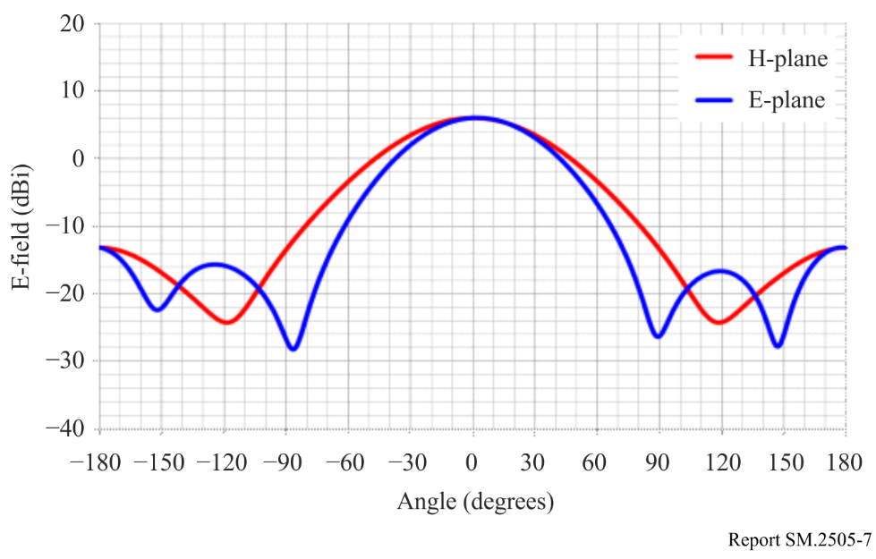

4.1.1.3 Incumbent services
The following table shows incumbent services in / adjacent / neighboring WPT frequency range in the 920 MHz band
TABLE 4.1.1-3
Incumbent radiocommunications services considered in the study in / around the 920 MHz band [2] [3]
System | Frequency  (MHz) | Protection criterion | References
Digital MCA Service | 930-940  (uplink) | -108.8 dBm/MHz  (in band)  -51 dBm (out of band) | ARIB⁽¹⁾ STD-T85  (Japan)
 | 940-945  (downlink) | -105.8 dBm/MHz  (in band)  -51 dBm (out of band)
Advanced MCA Service | 895-900  (uplink) | -100.8dBm/5MHz  (in band)  -44 dBm (out of band, 15 MHz separation) | MIC Land Radiocommunication Subcommittee, Response to inquiry No.2041(2018)
 | 850-860  (downlink) | 96.3dBm/5MHz (in band)  -43 dBm (out of band, modulation)  -15 dBm (out of band, CW) | 3GPP TS36 104 v8.3.0 (2008-9)
LTE-A (3GPP Band 8) | 900-915  (uplink) | -110.8 dBm/MHz  (in band)  -44 dBm (out of band, 12.5 MHz separation) | 3GPP TS36 104 v8.3.0 (2008-9)
 | 945-960  (downlink) | -119 dBm/MHz (in band)  -43 dBm (out of band, modulation)  -15 dBm (out of band, CW) | 3GPP TS36 101 v8.3.0 (2008-9)
RF-ID (Passive) | 916.7-923.5 | –81 dBm/MHz (in band)  -30 dBm (out of band, 2 MHz separation) | ARIB STD-T106  ARIB STD-T107  (Japan)
RF-ID (Active) | 915.9-929.7 | –127 dBm/MHz  (in band)  -80 dBm (out of band) | ARIB STD-T108  (Japan)
Radio astronomy | 1 400-1 427 | -189.5 dBm/MHz | Rec. ITU-R RA.769-2
⁽¹⁾ Association of Radio Industries and Businesses (https://www.arib.or.jp/english/)

4.1.1.4 Study results on the WPT using the 920 MHz band
For the WPT systems intended the operation in the 920 MHz band, the system parameters assumed for the impact study (see Table 4.1.1-2) were compliant with the radio regulation including transmission intervals for the RF-ID systems currently operated in the same frequency range. Minimum separation distances were derived in accordance with the beam WPT characteristics for the case geographical separation distance is necessary to regulate. In addition, Monte-Carlo system-level simulation was performed to assess interfering likelihood from radio frequency beam WPT to LTE and MCA mobile communication networks.
Results of the study including all simulations in the 920 MHz band demonstrated feasibility to coexist with the existing services. It should be noted that specifications of the WPT in the study were with almost the same provisions applied for a RF-ID operation study when building entry loss is not considered.
As the demand is increasing, further studies to mitigate the interference for coexistence are ongoing. Additional results will be reported in future revisions of the Report.
Below shows individual summaries of the study per incumbent system.

(1) Digital MCA service
The study referred to the examination methodologies and results on the past coexistence study when RF-ID system was introduced in 917-920 MHz. Beam WPT in the band was assumed almost the same technical conditions for assessment as RF-ID. Possibility of harmful impact is extremely low while keeping the given conditions and expecting additional propagation loss due to building entry loss. The technical conditions include the separation distance, adjustment of setting conditions and interference mitigation measures.
(2) Advanced MCA service
WPT can be operated in the band without causing harmful interference to the control station (base station: downlink) by considering vertical directivity.
The mobile station (uplink) operation is not affected by the WPT when both systems do not exist in the same room, which was shown by Monte-Carlo simulation using the extended Hata formula (300 m or less).
In the case of the same room, the interference should be reduced by approx. 10 dB, but operation without service quality degradation deems possible because the emission is expected to be attenuated by obstacles and the human body in the room.
However, regarding the use with the WPT system in the same room, the WPT users will be alerted the possibility of interference to MCA stations.
(3) LTE-A (in 3GPP Band 8)
The WPT system can be operated in the proposed band in a WPT general environment even when there is no transmission time limit. On the other hand, the WPT system can be operated in the management environment by limiting the transmission time (stopping transmission for 50 ms within 4 seconds of the transmission).
(4) RF-ID (Passive)
The WPT system can be operated with RF-ID system on the same channel if a separation distance of about 6 m is secured. If the separation distance cannot be secured, those system can maintain operation without service quality degradation by changing the WPT transmit channel and/or RF-ID channel, or shield with a wall.
(5) RF-ID (Active)
The passive RF-ID system is assumed to coexist with the active RF-ID system. The WPT system can be operated with active RF-ID system because the specification of WPT system is almost same as passive RF-ID interrogator.
(6) Radio astronomy
The minimum separation distance at the same altitudes was calculated with the free space loss model to be 37.5 km using the measured spurious emission level of –60.5 dBm/MHz. A WPT system shall be located outside a restricted area with the minimum separation distance from a radio astronomy station. When a WPT system or a radio astronomy station are located with different altitude, the minimum separation distance could be different from that calculated above.

4.2 2.4 GHz band

One case study taken in Japan [2] is shown below [3] [5].

4.2.1 2.4 GHz band - case study 1

4.2.1.1 Use case scenario
TABLE 4.2.1-1
Use case scenarios and conditions for radio frequency beam WPT systems using 2.4 GHz band [2] [3]
Use case scenarios, applications, and conditions | Descriptions
Usage environment | Factory (indoor), plant (indoor), warehouse, etc.
Application | Power supply to sensors, display and information devices including:  - Infrastructure sensor network  - Factory Automation  - Building Management  - Retail (e.g. Electronic shelf label) -
Number of receiving devices per one WPT transmitter | 1 to several dozen devices  (Successive or sequential reception)
Power range | 50 mW to 2 W
Power transfer distance | Less than 10 m
Coexistence with other wireless systems | WPT shall take appropriate interference mitigation measures to meet the protection criteria.
Power transfer while human bodies exist | WPT shall turn off the power transmission.

4.2.1.2 Specification of WPT
Expected specifications and system parameters used for the study are shown in Table 7 and in Figs 7 to 9.
TABLE 4.2.1-2
Specifications of radio frequency beam WPT using the 2.4 GHz band for the study [2] [3]
Transmitter antenna output power | 15 W (41.8 dBm)
Frequency channels | 2 412, 2 437, 2 462, 2 484 MHz  (4 channels)
e.i.r.p | 65.8 dBm Max.
Tolerance of occupied bandwidth | Not specified
Transmitter antenna directive gain | 24.0 dBi
Location and height of transmitter antenna | Located indoor area and set on ceiling to look down
 | 4.5 m above floor
Transmitter antenna radiation pattern | Beam forming. See Figure 8
Usage environment | Indoor
 | WPT controlled environment
Modulation | CW
Building entry loss | 14.0 dB
NOTE 1: ‘WPT controlled environment’ and ‘WPT general environment’ define environmental conditions for WPT operation in Japanese regulation.
‘WPT controlled environment’ is defined as:
– Indoor and closed space;
– Environment where RF exposure satisfies the limit of the controllable environment stipulated in the Radio Protection Guidelines of Japan (The manager/administrator stops power transmission when a person enters the range where RF exposure exceeds the limit of the controllable environment; and
– Environment where the manager/administrator can centrally manage and control operation both of WPT and incumbent radio communication services in order to avoid or mitigate harmful interference from WPT.
‘WPT general environment’ are defined as the other environment where the management conditions based on the definition above is not necessary.

NOTE 2: The technical specifications contained in this Table describe some of the characteristics used in the respective studies and are not meant to be interpreted as regulatory limits. Technical conditions of devices for commercialization must be set by each Administration.

FIGURE 4.2.1-2
Transmitter antenna radiation pattern for the 2.4 GHz band [2] [3]
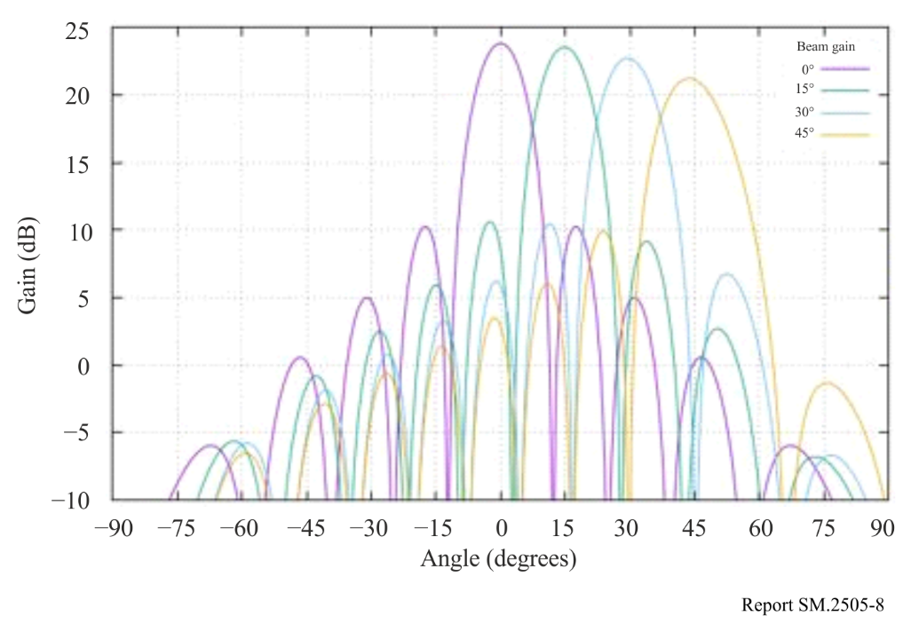

4.2.1.3 Incumbent services
TABLE 4.2.1-3
Incumbent radiocommunications services considered in the study in / around the 2.4 GHz band [2] [3]
System | Frequency  (MHz) | Protection criterion | References
Wireless LAN | 2 400-2 497 | –92 dBm (co channel)  –66 dBm (adjacent channel),  –50 dBm (alternate adjacent channel) | IEEE Std.802.11-2016
Premises radio | 2 400-2 483.5 | –98 dBm  (including 11 dBi  antenna gain) | ARIB RCR STD-1  ARIB RCR STD-29  (Japan)
Unmanned mobile image transmission system (Wireless system for drones and other unmanned vehicles) | 2 483.5-2 494 | –98 dBm (co channel)  –72 dBm (adjacent channel),  –56 dBm (alternate adjacent channel)  (including 6 dBi  antenna gain) | Report MIC Advisory No. 2034  (Japan)
Geostationary Mobile Satellite Service | 2 500-2 535 | –124.9 dBm/MHz  (in band)  –41 dBm  (out of band,  10-25 MHz separation) | Report MIC Advisory No. 2032  (Japan)
Non-Geostationary Mobile Satellite Service | 2 483.55-2 500 | –119.4 dBm/MHz | Report MIC Advisory No. 82  (Japan)
Broadcasting Service: Field Pickup (FPU) | 2 330-2 370 | –102 dBm/MHz  (mobile relay Uplink) | Report MIC Advisory No. 2024  (Japan)
Radio astronomy | 2 695 | –187 dBm/MHz | Rec. ITU-R RA.769-2
Amateur radio | 2 400-2 450 | –110.83 dBm/MHz | JARL⁽¹⁾ requirement
⁽¹⁾ The Japan Amateur Radio League, Inc. (https://www.jarl.org/English/0-2.htm)

4.2.1.4 Study results on the WPT using the 2.4 GHz band
For the beam WPT systems intended for the operation in the 2.4 GHz band, the study was conducted with the system parameters (see TABLE 4.2.1-2) to determine required technical requirements and operational conditions under the current radio regulation including frequency allocation and operational conditions. Study results in the 2.4 GHz band are summarized as follows:
- Clear Channel Assessment (CCA) mechanism shall be adopted to coexist with Wireless LAN systems and / or Specified Low Power Radio Stations. It turned out that Wireless LAN system performance such as throughput can be maintained without harmful interference by adding CCA mechanism.
- For radioastronomy, minimum separation distances were specified.
- For broadcasting systems and mobile satellite communication systems, minimum separation distances were specified. In addition, operational coordination was addressed for the case the beam WPT causes harmful interference.
- For unmanned mobile image transmission system (i.e. a wireless communication system for drones and other unmanned vehicles), studies assuming practical use cases showed that spectrum sharing without causing harmful impact was possible by operational coordination as needed between WPT systems and unmanned mobile image transmission systems.
- For amateur radio services, beam WPT installation conditions for spectrum sharing were specified. In addition, beam WPT systems shall not use the frequency band for Earth-Moon-Earth (EME) systems and repeater systems. Operational coordination is undertaken between WPT systems and amateur radio systems.
Furthermore, a comprehensive beam WPT management rule regarding WPT operation environment and WPT radio frequency EMFs was defined and can be applied specific use cases using the frequency bands to abide by the Radio Radiation Protection Guidelines. Thus, required technical requirements and operational conditions not to cause harmful impact to the existing systems and services were determined.
As the demand is increasing, further studies to mitigate the interference for coexistence are ongoing, which will be reported in future revisions of the Report.
Below shows individual summaries of the study per incumbent system.
(1) Wireless LAN
Simulations using the CCA mechanism on the radio frequency beam WPT system were conducted to study the impact to the Wireless LAN devices located within 10 meters outside of the WPT controlled environment. The decline of the throughput of those Wireless LAN devices could be suppressed with appropriate parameters of the CCA mechanism by setting the WPT idle time and the WPT transmission time equal, regardless of the transmission time, compared with the case when another Wireless LAN Access Point was operated at the same location instead of the beam WPT inside the WPT controlled environment. Antenna directions should be adjusted not to directly face each other to prevent the device being damaged.
(2) Premises radio
Within the beam WPT controlled environment the operation of the premises radio can be managed and controlled by the same operator as for the beam WPT. Moreover, within the 84.9 m from the beam WPT location it can be suppressed the transmission with the CCA mechanism when premises radio is transmitting. Antenna directions should be adjusted not to directly face each other to prevent the device being damaged.
(3) Unmanned mobile image transmission system
Separation distance was calculated with extended Hata model and it is 3.6 km on co channel from the beam WPT to the Unmanned mobile image transmission system outdoor. However, since the system is usually operated outside the cities and the usage time and places are planned, the harmful interference can be avoided by the coordination procedure.
(4) Geostationary mobile satellite service
Separation distance was calculated with worst case scenario of out of band interference, where antenna directivity direction of the GEO MSS receiver was perfectly matched to the beam direction of the radio frequency beam WPT. The calculated distance was 30 m in the northern part of Japan. Such site-specific engineering coordination procedures with the separation distance mitigate harmful interference. If necessary, the operational coordination is performed between WPT systems and mobile satellite communication systems.
(5) Non-geostationary mobile satellite service
Separation distance was calculated of in band interference with extend Hata model and it was 0.96 km. Since Non-Geostationary Mobile Satellite Service is generally used in the location where cellular mobile system cannot be reached in Japan and the beam WPT does not possibly exist, the harmful interference can be avoided. If necessary, the operational coordination is performed between WPT systems and mobile satellite communication systems.
(6) Broadcasting service: Field Pickup Unit (mobile Electronic News Gathering)
Separation distance was calculated in various scenarios and systems and with the antenna directivity it does not cause harmful interference when satisfying 10 m separation distance outside the WPT controlled environment. Radio frequency beam WPT systems shall abide by the condition of the necessary separation distance and installation.
(7) Radio astronomy
Separation distance was calculated for each radio astronomy station operating 2 695 MHz considering clutter loss. The minimum separation distances at the same altitudes are 5.7 km or 1.6 km depending on the environment of the site. To avoid harmful interference to a radio astronomy station a restricted area with these separation distances around the radio astronomy station will be established. The radio frequency beam WPT antenna is installed on the ceiling and radiates primarily downward. The horizontal radiation limit is defined in terms of e.i.r.p.. For this reason, horizontal radiation from inside the building to the outside will be the worst-case scenario when both a WPT station and a radio astronomy station have the same altitudes.
When the altitude of the radio astronomy station is higher than the WPT station, the directivity gain becomes lower and the separation distance becomes shorter. On the other hand, when the altitude of the radio astronomy station is lower than the WPT station, the directivity gain becomes higher and the separation distance becomes longer.
(8) Impact study for Radio Amateur
Separation distance was calculated considering clutter loss. Two out of four frequencies of beam WPT are co-channel with Radio Amateur, which need 4.4 km separation distance with 18 dBi Radio Amateur antenna. Considering antenna directive loss and using adjacent band if necessary, the harmful interference can be avoided. If necessary, the operational coordination is performed between WPT systems and amateur radio systems.

4.3 5.7 GHz band

One case study taken in Japan [2] is shown below.

4.3.1 5.7 GHz band - case study 1

4.3.1.1 Use case scenario
TABLE 4.3.1-1
Use case scenarios, applications, and conditions for radio frequency beam WPT using the 5.7 GHz band [2] [3]
Use case scenarios, applications, and conditions | Descriptions
Usage environment | Factory (indoor), plant (indoor), warehouse, etc.
Application | Charging mobile devices and power supply to sensors, display and information devices including:  - Infrastructure sensor network  - Factory Automation(e.g. Sensors, Electronic shelf label)  - Building Management  - Drones / robots  - Automotive devices  - Retail (e.g. Electronic shelf label)
Number of receiving devices per one WPT transmitter | 1 to several dozen devices  (Successive or sequential reception)
Power range | Several mW to hundreds of mW
Power transfer distance | Less than 10 m
Coexistence with other wireless systems | WPT shall take appropriate interference mitigation measures to meet the protection criteria.
Power transfer while human bodies exist | WPT shall turn off the power transmission.

4.3.1.2 Specification

Specifications and system parameters used for the study are shown in Table 4.1.1-2 and in Figure 4.1.1-1.
TABLE 4.3.1-2
Specifications of beam WPT using the 5.7 GHz band for the study [2] [3]
Transmitter antenna output power | 32 W (45.0 dBm)
Frequency channels | 5 740, 5 742, 5 744, 5 746, 5 748, 5 750, 5 752, 5 758, 5 764 MHz  (9 channels)
e.i.r.p | 70.0 dBm Max.
Tolerance of occupied bandwidth | Not specified
Transmitter antenna directive gain | 25.0 dBi
Location and height of transmitter antenna | Located indoor area and set on ceiling to look down
 | 5 m above floor
Transmitter antenna radiation pattern | Beam forming. See Figure 4.3.1-1
Usage environment | Indoor
 | WPT controlled environment (See NOTE 1)
Modulation | CW
Building entry loss | 16.0 dB
NOTE 1: ‘WPT controlled environment’ and ‘WPT general environment’ define environmental conditions for WPT operation in Japanese regulation.
‘WPT controlled environment’ is defined as:
– Indoor and closed space;
– Environment where RF exposure satisfies the limit of the controllable environment stipulated in the Radio Protection Guidelines of Japan (The manager/administrator stops power transmission when a person enters the range where RF exposure exceeds the limit of the controllable environment.
– Environment where the manager/administrator can centrally manage and control operation both of WPT and incumbent radio communication services in order to avoid or mitigate harmful interference from WPT.
‘WPT general environment’ are defined as the other environment where the management conditions based on the definition above is not necessary.

NOTE 2: The technical specifications contained in this Table describe some of the characteristics used in the respective studies and are not meant to be interpreted as regulatory limits. Technical conditions of devices for commercialization must be set by each Administration.

FIGURE 4.3.1-1
Transmitter antenna radiation pattern for 5.7 GHz band [2] [3]
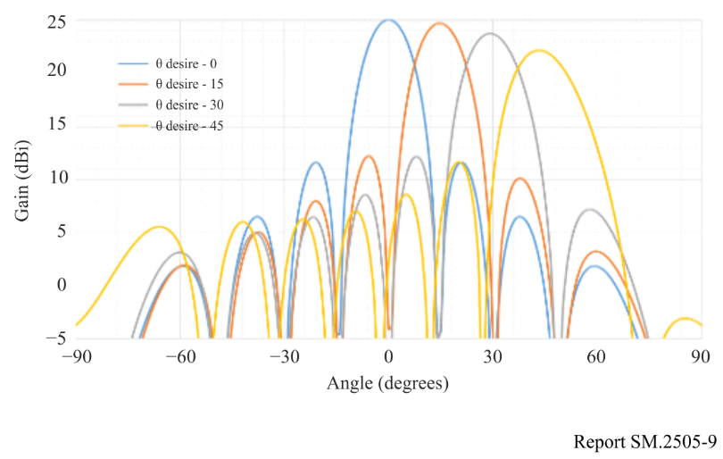

4.3.1.3 Incumbent services
TABLE 4.3.1-3
Incumbent radiocommunications services considered in the study in / around the 5.7 GHz band [2] [3]
System | Frequency  (MHz) | Protection criterion | References
Wireless LAN (W56) | 5 470-5 730 | –63 dBm (adjacent channel),  –47 dBm (alternate adjacent channel) | IEEE Std.802.11-2016
Dedicated Short Range Communication (DSRC) | 5 770-5 850 | –42 dBm  (class-2, spurs response rejection),  –100 dBm (class-2) | ARIB STD-T75  (Japan)
Broadcasting Service: Studio to Transmitter Link (STL) and Transmitter to Transmitter Link (TTL) | 5 850-5 925 | –101.6 dBm  (equivalent thermal noise level) | ARIB_STD-B22  (Japan)
Broadcasting Service: Field Pickup (FPU) and Transmitter to Studio Link (TSL) systems | 5 850-5 925 | –89.4 dBm  (FPU fixed relay station) | ARIB STD-B33  (Japan)
Unmanned mobile image transmission system (Wireless system for drones and other unmanned vehicles) | 5 650-5 755 | –98 dBm (in-band),  –72 dBm (adjacent channel),  –56 dBm (alternate adjacent channel) | Report on MIC Advisory No. 2034  (Japan)
Weather radar | 5 250-5 372.5 | –120 dBm (noise),  –40 dBm (CW) | Rec. ITU-R M.1849-2
Radio astronomy | 4 700-5 140,  3 000-14 000 | –187 dBm/MHz | Rec. ITU-R RA.769-2
Amateur radio | 5 650-5 850 | –110.83 dBm/MHz | JARL requirement

4.3.1.4 Study results on the WPT using the 5.7 GHz band
For the beam WPT systems intended for the operation in the 5.7 GHz band, the study was conducted with the system parameters (see TABLE 4.3.1-2) to determine required technical requirements and operational conditions under the current radio regulation including frequency allocation and operational conditions. Study results in the 5.7 GHz band are summarized as follows:
1) Clear Channel Assessment (CCA) mechanism shall be adopted to coexist with Wireless LAN systems and / or Specified Low Power Radio Stations. It turned out that Wireless LAN system performance such as throughput can be maintained without harmful interference by adding CCA mechanism.
2) For radio astronomy and weather radar, minimum separation distances were specified.
3) For broadcasting systems and Dedicated Short Range Communication (DSRC) system, minimum separation distances were specified. In addition, operational coordination was addressed for the case beam WPT causes harmful interference.
4) For unmanned mobile image transmission system (i.e. a wireless communication system for drones and other unmanned vehicles), studies assuming practical use cases showed that spectrum sharing without causing harmful impact was possible by operational coordination as needed between WPT systems and unmanned mobile image transmission systems.
5) For amateur radio services, radio frequency beam WPT installation conditions for spectrum sharing were specified. In addition, radio frequency beam WPT systems shall not use the frequency band for Earth-Moon-Earth (EME) systems and repeater systems. Operational coordination is undertaken between WPT systems and amateur radio systems.
Furthermore, a comprehensive radio frequency beam WPT management rule regarding WPT operation environment and WPT radio frequency EMFs was defined and can be applied specific use cases using the frequency bands to abide by the Radio Radiation Protection Guidelines. Thus, required technical requirements and operational conditions not to cause harmful impact to the existing systems and services were determined.
As the demand is increasing, further studies to mitigate the interference for coexistence are ongoing, which will be reported in future revisions of the Report.
Below shows individual summaries of the study per incumbent system.

(1) Wireless LAN
Simulations were conducted to study the impact of the radio frequency beam WPT system to the Wireless LAN system that operates in the shared environment simulating actual use cases (e.g., a factory with ceiling hight of 5 meters). Assuming multiple Wireless LAN Access Poins, each with 10 Wireless LAN client devices connected a few meters apart, Wireless LAN system throughput was calculated; and then, it was compared with the case that a beam WPT transmitter with a receiver is in the shared environment. Results of various cases were compared. When CCA mechanism of the beam WPT with the appropriate ratio of the WPT transmission time and the CCA time, the impact to the Wireless LAN throughput could be negligible. Antenna directions should be adjusted not to directly face each other to prevent the device being damaged.
(2) Dedicated Short Range Communication (DSRC)
Study on separation distance was made for the worst-case scenario, where antenna directivity of the DSRC system perfectly matched to the beam direction of the radio frequency beam WPT system. The separation distance was calculated with free space loss model to be 2.6 km from the WPT system to the DSRC Class 2 base station. Additional propagation loss due to building entry loss and directivity loss of DSRC antenna can be expected to further avoid harmful interference.
(3) Broadcasting service: Studio to Transmitter Link (STL) and Transmitter to Transmitter Link (TTL)
Separation distance was calculated with free space loss model to be 836 m for out band noise signal from the radio frequency beam WPT to the STL/TTL base station. When difference in height is more than 5 m, 20 dB of directivity loss of STL/TTL antenna can be expected to further avoid harmful interference.
(4) Broadcasting service: Field Pickup (FPU) and Transmitter to Studio Link (TSL) systems
Separation distance was calculated to be 80 m for out band noise signal from the radio frequency beam WPT to the FPU base station. When difference in height is more than 25 m, more than 14 dB of directivity loss of FPU antenna can be expected to further avoid harmful interference.
Separation distance was calculated with free space loss model to be 1 485 m for out band noise signal from the WPT system to the TSL base station. When difference in height is more than 7 m, 20 dB of directivity loss of STL/TTL antenna can be expected to further avoid harmful interference.
(5) Unmanned mobile image transmission system
Separation distance was calculated with free space loss model to be 23 km on co-channel and 185 m on the alternate adjacent channel from the radio frequency beam WPT system to the unmanned mobile image transmission system outdoor, respectively. However, since the system is usually operated outside the cities and the usage time and places are scheduled, harmful interference can be avoided by such as coordination procedure.
(6) Weather radar
Separation distance was calculated with free space loss model to be 3 308 m for out band noise signal from the radio frequency beam WPT system for each weather radar site. To avoid the harmful interference, separation distance should be kept.
(7) Radio astronomy
The minimum separation distances at the same altitudes were calculated with the free space loss model to be 1.1 km or 1.7 km for 4 995 MHz and 10 650 MHz radio astronomy stations. To avoid the harmful interference to a radio astronomy station, the minimum separation distance should be kept. The radio frequency beam WPT antenna is installed on the ceiling and radiates primarily downward. The horizontal radiation limit is defined in terms of e.i.r.p. For this reason, horizontal radiation from inside the building to the outside will be the worst-case scenario.
When the altitude of the radio astronomy station is higher than the WPT station, the directivity gain becomes lower and the separation distance becomes shorter. On the other hand, when the altitude of the radio astronomy station is lower than the WPT station, the directivity gain becomes higher and the separation distance becomes longer.
(8) Impact study for Radio Amateur
Separation distance was studied considering clutter loss. The calculated separation distance with free space loss model was 1.5 km and 262 m for 30 dBi and 15 dBi Radio Amateur antennas, respectively. Antenna directivity and coordination procedure can avoid harmful interference. The operational coordination will be undertaken between the WPT systems and amateur radio systems.

4.4 24 GHz band

The study results will be provided in future revisions.

4.4.1 24 GHz band - case study 1
4.4.1.1 Use case scenario
4.4.1.2 Specification of WPT
4.4.1.3 Incumbent services
4.4.1.4 Study results

4.5 61 GHz band

The study results will be provided in future revisions.

4.5.1 61 GHz band - case study 1
4.5.1.1 Use case scenario
4.5.1.2 Specification of WPT
4.5.1.3 Incumbent services
4.5.1.4 Study results

5. Summary

As we see increasing demand of radio frequency beam WPT, its frequency assignment and spectrum sharing with incumbent services are key challenges for radio administrators in each country. Currently, a few APT member countries completed new rulemaking for commercialization of radio frequency beam WPT. One country completed its first study on the impact and the next development phase is ongoing. Other few countries launched commercial services, and some others intend to develop new rules. While preparations for its rulemaking are completed, in progress, or yet to come, this Report shares study results for 920 MHz band, 2.4 GHz band, and 5.7 GHz band, as case studies reflecting national experience and regulation at the time of completion of the document. The Report will contribute to the discussion on the proposed study regarding the frequency Recommendation development of radio frequency beam WPT for regional and / or international frequency harmonization.

In brief of the impact study results, it is worth mentioning a couple of outcomes as follows.

For radio frequency beam WPT operating in 920 MHz band in one country, the study results demonstrated feasibility in most proposed use cases to operate without harmful interference to the incumbent radiocommunication services including radio astronomy services. In the study, the WPT specification was compliant to the existing RF-ID technical requirements in the band.

Other results in 2.4 GHz and 5.7 GHz bands taken in one country addressed provisions on necessary separation distances and adoption of an interference mitigation mechanism to ensure that any radio frequency beam WPT device does not transmit while a Wireless LAN device is already transmitting in the concerned band. For the WPT operational environmental condition with EMFs, a comprehensive operating management rule for radio frequency beam WPT is provided as a regulatory guideline. Further study to mitigate interference for coexistence is addressed and ongoing. The study result will be reported in future revisions.

Finally, the Report will be revised with a new study result on the impact of WPT and regulatory status update in APT member countries in the future.

References

[1] Report ITU-R SM.2505-0 “Impact studies and human hazard issues for wireless power transmission via radio frequency beam”

[2] MIC Advisory Report No.2043 (Japan), July 2020

[3] APT/AWG/REP-133 “APT Report on radio frequency beam Wireless Power Transfer/Transmission (WPT)” May 2023

[4] APT/AWG/REP‑122 “APT Survey Report on radio frequency beam WPT”

[5] Report ITU-R SM.2392-1 “Applications of wireless power transmission via radio frequency beam”

[6] Recommendation ITU-R SM.2151-0 “Guidance on frequency ranges for operation of wireless power transmission via radio frequency beam for mobile/portable devices and sensor networks”

