**APT REPORT ON**

**DEPLOYMENT APPROACHES AND SOLUTIONS FOR**

**IMT-2020/5G USE CASE**

**Edition: April 2025**

**The 34th Meeting of APT Wireless Group**

**31 March – 4 April 2025**

**Kathmandu, Nepal**

***(Source: AWG-34/OUT-05)***

**No. APT/AWG/REP-146**

**APT REPORT ON**

**DEPLOYMENT APPROACHES AND SOLUTIONS FOR IMT-2020/5G USE CASE**

# Introduction

Mobile network operators require access to spectrum in various frequency bands—low, mid, and high—in order to establish cost-effective networks and ensure the availability and speed of 5G services. Lower frequency bands are essential for extensive mobile broadband deployment, especially in rural areas where the digital divide is most pronounced. Mid-band spectrum plays a crucial role in the launch and continued development of 5G, while mmWave spectrum is vital for high-density urban areas to ensure reliable, low-latency performance.

Meanwhile, coverage and capacity implementation with multi frequency bands considering each characteristic is a very complicated and time-consuming process. It tends to directly relate to user experience, therefore, deployment strategy of multi frequency bands has become more big business issue for MNOs.

Under this circumstance, in order to alleviate this difficulty and burden related to 5G deployment, various technical and operational measures have studied and already standardized. It is important to have as much as knowledge about the latest deployment approaches and solutions and put it into practice considering each use case.

Moreover, the success of 5G deployment heavily relies on strong licensing and regulatory frameworks with timely spectrum provision. Some deployment solutions such as infrastructure sharing and integrated access backhaul associate with regulatory aspects, so it may be necessary to review and update some regulations.

This report provides various deployment approaches and some regulatory consideration together with case studies and assists APT members for 5G deployment to revolutionize digital economies, bridge the digital divide, and foster digital inclusivity.

# Scope

The scope of this report is to provide comprehensive information on global trends in 5G deployments and technical, operational, and regulatory solutions for IMT-2020/5G use cases, considering the diverse propagation characteristics and coverage capabilities of different frequency bands, including low bands, midbands, and mmWave bands.

This report focuses on introducing and updating the implementation of IMT-2020/5G, which has the capability to deliver various usage scenarios such as enhanced Mobile Broadband (eMBB), massive Machine-Type Communications (mMTC), and ultra-reliable low-latency communications (URLLC) across different frequency ranges. It includes detailed aspects like spectrum utilization, throughput, and usage scenarios realized in various environments such as dense urban areas, hotspots, and indoor settings.

Additionally, the report covers technical and operational solutions utilized in deploying IMT-2020/5G across various APT countries, such as infrastructure sharing, RAN sharing, multi-RAT, dual carrier, multi-layer solutions, wireless backhaul links (complementary to optical fiber), and coverage extensions. It addresses the need for use case-specific technology components, spectrum allocation, and regulatory frameworks to fully leverage the capabilities of 5G.

Moreover, the report facilitates the sharing of experiences and solutions among various administrative bodies globally, highlighting the importance of collaboration between regulatory bodies and operators to overcome deployment challenges and ensure successful implementation of 5G technologies.

# Vocabulary of terms

eMBB enhanced Mobile Broadband

mMTC enhanced Machine-Type Communication

URLLC Ultra-Reliable Low Latency Communications

RAN Radio Access Network

RAT Radio Access Technology

ISD Inter-site Distance

MIMO Multiple Input Multiple Output

NR New Radio

TDD Time Division Duplexing

FR1 Frequency Range (410 - 7125MHz)

FR2 Frequency Range (24.25 - 71GHz)

NCR Network Control Repeater

gNB Next Generation Node B

UE User Equipment

DFT-S Discrete Fourier Transform Spread

CP Pre-coded

UL Uplink

DL Downlink

VR Virtual Reality

V2V Vehicle-to-Vehicle

V2X Vehicle-to-Everything

PARR Peak to average Power Ratio

MMTC Massive Machine-type Communication

LTE Long-Term Evolution

# Global trends on 5G deployments

From GSA’s report[1], by the start of February 2025, 619 operators in 184 countries and territories had been identified investment in 5G, including trials, acquisition of licences, planning, network deployment and launches. This number excludes nearly 200 additional companies awarded priority access licences in the US auction of CBRS spectrum, which could potentially be used for 5G.

* Of those, 341 operators in 127 countries and territories had launched or soft-launched at least one 3GPP-compliant 5G service.
* 333 operators in 122 countries had launched 5G mobile services.
* 169 operators in 74 countries and territories had launched or soft-launched 3GPP-compliant 5G fixed wireless access services — just over 49% of those with launched 5G services.
* 8 operators had announced soft launches of 5G networks.
* 156 operators are identified as investing in 5G standalone (including those evaluating, testing, piloting, planning and deploying as well as those that have launched 5G standalone networks). GSA has catalogued 70 operators as having launched or soft-launched 5G standalone in public networks.
* Since 2019, the number of global operators investing in and deploying 5G has gradually increased. The global trends and current status on 5G deployment can be seen in the following figures.

グラフ, 棒グラフ

AI によって生成されたコンテンツは間違っている可能性があります。

Figure 1. Operators investing in 5G and operating commercial 5G networks

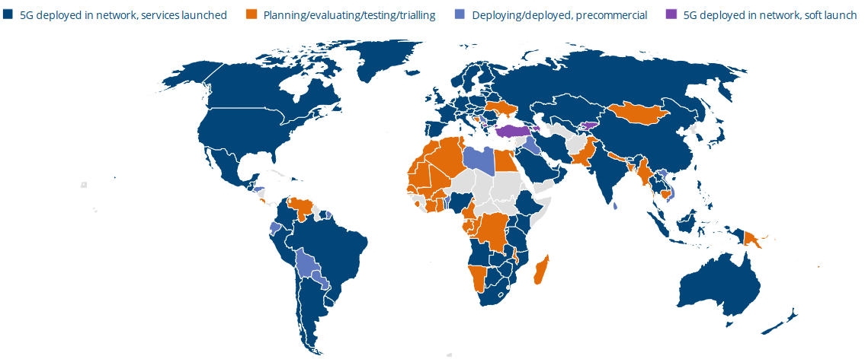

Figure 2. Status of 5G deployments (end of March 2024)

# Technical and operational solutions on IMT-2020/5G deployment

This section covers various technical and operational solutions being used for deploying IMT-2020/5G in various countries.

## Infrastructure Sharing

This section covers the solutions related to cell site procurement and deployment solutions related to infra sharing and use of street furniture.

### Sharing Sites

Mid-band and mmWave band are considered candidate spectrum band for 5G deployments to offer high capacity. Higher frequency ranges suffer from large propagation and penetration losses, which results in reduction of coverage area of the cells thus leads to denser deployment requirements. Dense deployment would eventually demand more cell sites within a geographic area. Additionally, demand for the number of cell sites would grow in proportion to operator’s peak hour traffic, etc. More number of cell sites in a given area, not only demands procurement of more cell sites but also creates stress on OPEX, e.g., electricity and base stations maintenance.

One of the candidate solutions is to enable site sharing among operators, which would reduce the demands of new cell sites for a collaborator set of operators. Sharing sites will not only minimize the number of cell sites but also ease the cost of maintenance of wireless infra nodes.

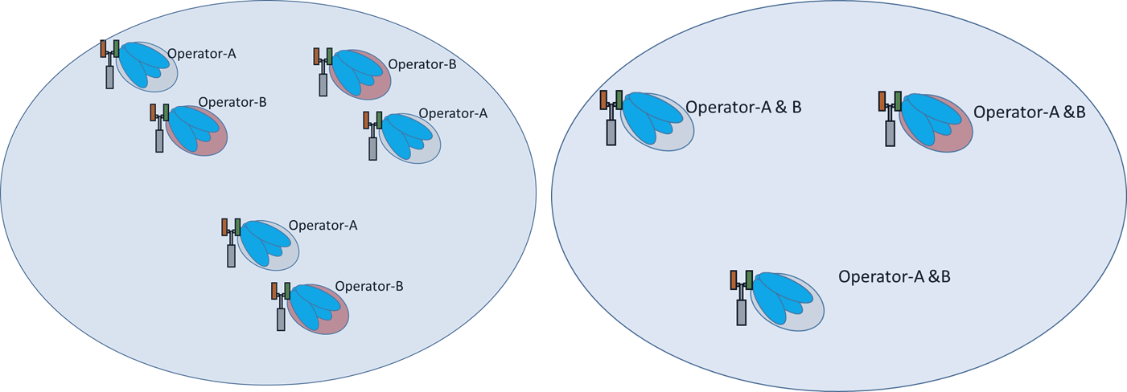

Figure-3A. No site sharing Figure-3B. Site sharing

**Observation:** Increasing demand for procurements of cell sites could be reduced proportionally by sharing of cell sites among operators. This eventually reduces procuring of cell sites, the cost of energy and maintenance of wireless infra nodes.

### Street furniture

In practical deployments, the number of cell sites in a geographical area is based on the coverage and capacity considering the number of active users. In general, the best site is not available due to geographic terrains or structural elements of the city, i.e., streets, hospitals, and apartments, etc. This results in sub optimal deployment based on the available cell site and eventually results in non-uniform deployments. In particular, cell transmit power, beam direction and height of the cells are adjusted to find optimal coverage and maximize area capacity.

Use of city street furniture, i.e., street poles, flyovers, utility buildings, etc for 5G deployment could be considered as one the candidate solution to minimize demand of procurements of cell site and strive to structured cell site deployment. One of the challenges with use of street furniture is that any enhancement/modification in street furniture needs to be coordinated among operators and concerned government agencies for interruption free coverage provided by deployed wireless nodes.

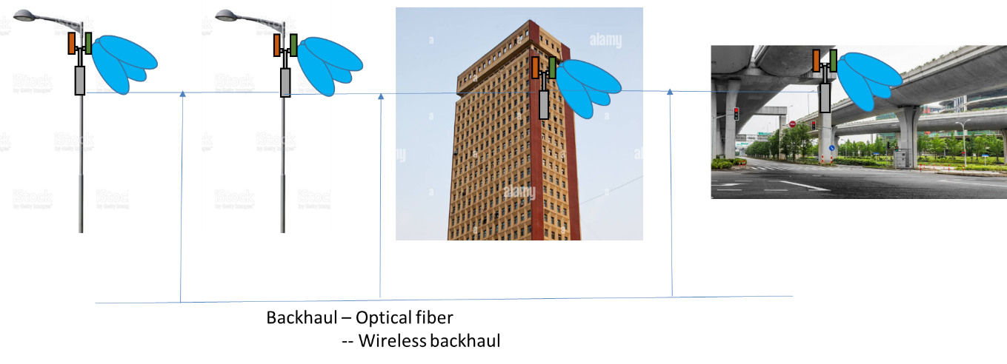

Figure 4 . Use of street furniture for deployment of wireless nodes

In countries, where street furniture’s are owned by different state government agencies and therefore needs a policy framework for coordination among government agencies and operators to ensure that deployment of wireless nodes is considered during planning of assets.

**Observation:** As a candidate solution, street furniture of the city could be used for the deployment of wireless infra and a policy framework is needed for coordination among various government agencies and operators to ensure uninterrupted coverage for a given area.

### RAN sharing

It is important to note that 5G has opened the door for traditional MNOs, new operators, and enterprises to provide private networks for a restricted geography. New operators may not have legacy RAT (i.e. LTE) and therefore, will be forced to deploy the standalone 5G. Moreover, in carrier aggregation mode, the number of carriers for aggregation would be restricted by the number of available carriers with an MNO.

In this regard, it is important to consider sharing active infra e.g. RAN, spectrum, and transmission resources among MNOs to control the cost and continue to push for 5G growth.

Sharing passive elements of the mobile network, like sites, towers has already address in this section .

Sharing active elements has also garnered attention among the operator’s community and administrations. The main objective for such cooperation between competitors is to economize on network costs while delivering faster rollout of new technologies and/or providing more robust network coverage and higher capacity.

Passive and the active forms of sharing carry obvious advantages to operators and consumers, however also raise concerns; since the parties are direct competitors, these agreements could potentially lead to a restriction of competition.

The traditional mobile telecommunication services have become simple commodity products. The investment required for the roll-out and the cost of operation of a new network is high. Even if the efficiency of service provision increases significantly with a new technology generation, and there is increasing consumer interest in new services, it will pose a challenge to operators to achieve adequate returns on the required new investments.

As a practical technical definition, we can say that mobile network sharing is a type of cooperation between competing mobile network operators to jointly use, manage and/or develop some of the network inputs required for their operations. The more network inputs are shared, the deeper the cooperation between the parties.

Three main levels of sharing can be distinguished by depth according to the type of main network elements involved: sharing passive network elements, sharing the radio access network and core network sharing.

* Passive network sharing means the common use of sites to avoid the duplication of the passive infrastructure.
* Radio access network (RAN) sharing implies that in addition to the passive elements, Antenna’s, radio equipment and controllers are also shared in some way.

Two main types of RAN sharing are used in practice:

* Only the radio equipment is used jointly, but each operator uses its own spectrum with a common RAN.
* Beside the common RAN some or all spectrum bands are also shared and used jointly by the parties.
* Under core network sharing some core elements and functions are shared by the parties. Currently no such network has sharing agreements.

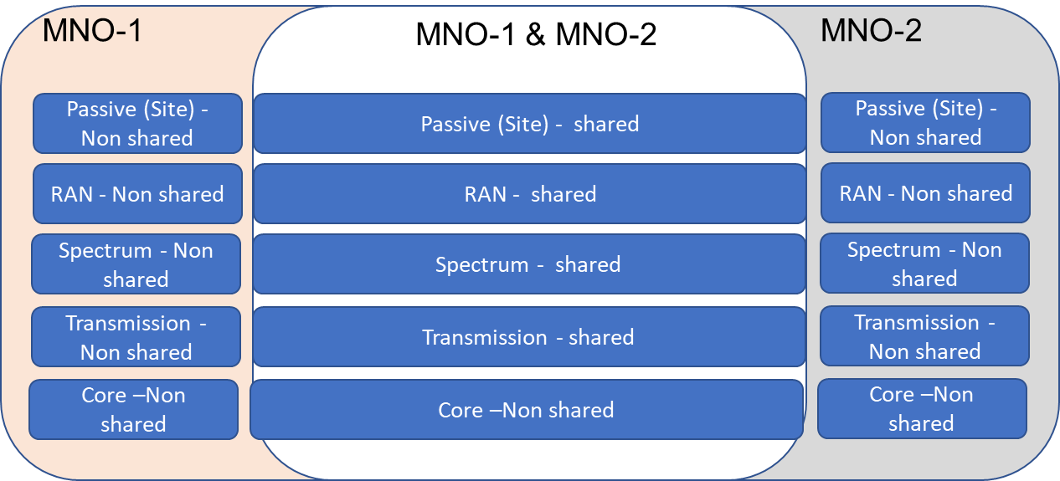

Figure 5. Network Sharing levels

The deeper the cooperation, the larger the decrease in network independence. However, the decrease of independence is not linear from one level to the next. From service independence point of view, the core is the most important part of the network. While the core network is separate, the competitive independence of the parties does not diminish significantly compared to the standalone operation.

Moreover, deeper the sharing, the greater the need for and frequency of coordination as well as information exchange between the parties.

**Observation:**

While deep cooperation at various level among operators could bring operation cost down for a cooperative operator, however it will impact the competitiveness among operators and differentiation factor to bring valued service for the users by an operator. It is therefore, we need a good policy framework from administration, which could encourage active and passive sharing among operators at the same time offer sufficient independence to the operators to stay competitive and provide operator specific value services.

## Multi-layer solutions

This section deals with the solutions related to deployment of cells in private or public local areas.

### Hierarchical deployment

Ubiquitous coverage in a given area would call for the availability of adequate cell sites. As mentioned above that procuring cell sites in a city is challenging; compounded to that, deployment of cell sites inside apartment buildings, office campus, and heritage sites, often face challenges, due to overlapping plans of agencies maintaining the premises. It becomes challenging for an operator to find a good and available site to deploy wireless nodes in a local premises.

Agencies maintaining the local area are better equipped to identify sites for wireless nodes and also entitle for possible modifications to make the best site available for deployment of wireless nodes. Agencies governing local areas could be leveraged by the operator for the deployment and maintenance of wireless nodes in local premises.

Aforementioned hierarchical deployment would demand a policy framework for operators leasing deployment and maintenance of nodes inside the local campus.

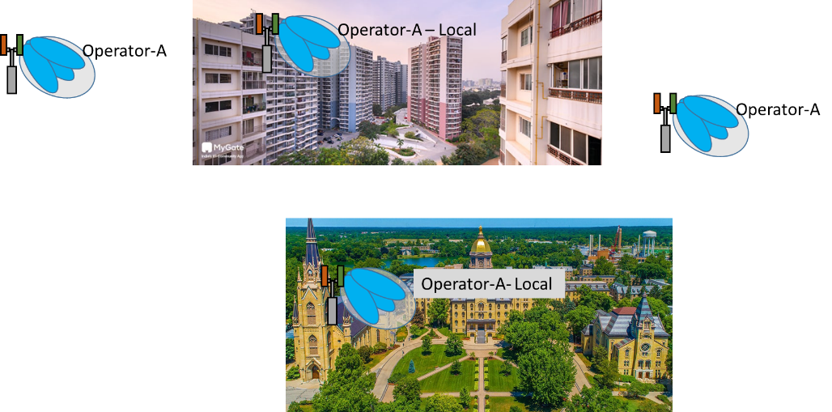

Figure 6. Hierarchical deployment

**Observation**: Deployment of wireless nodes in local area within a city generally find challenges by private owners or government agencies. It’s often hard for an operator to find suitable area within premises from coverage perspective. Local agencies could be leveraged for deployment and maintenance of wireless nodes in a local area.

## Backhaul link

This section indicates the importance of wireless backhaul link as complementary solution to optical fiber considering deployment issues in urban and rural areas.

### Wireless backhaul

Shrinking of inter site distance (ISD) either due to capacity limits in dense urban area or due to high propagation/penetration losses, would result in increasing the number of wireless nodes in a given area to ensure desired quality of service (QoS). Increasing the number of wireless nodes would also demand backhaul links, thereby, creating stress on the number of backhaul links among wireless nodes.

Urban and rural terrains find different challenges to providing backhaul links; for example, in urban areas the deployment of optical cables require digging through existing civil infrastructure, which often finds resistance from private owners or government agencies, since excavation requires very specific permission in certain areas of the city. In the rural areas, it’s rather easy to deploy optical cables among wireless nodes due to limited civil infrastructure, however, maintaining optical cables in the rural area demands additional cost due to fleet and availability of resources in rural areas.

Administrations could explore more high-capacity wireless backhaul links to support growing deployment on need basis replacement of optical fiber backhaul link.

**Observation:** Deployment of wireless nodes with small ISD either due to capacity or coverage limitation will bring additional stress on the backhaul links, therefore administration may explore high-capacity wireless backhaul and consider opening up higher frequency bands, such as E-band (71-76 GHz & 81-86 GHz) to satisfy the high-capacity backhaul requirements to complement optical fiber.

### Satellite backhaul

Sparse populations in rural and remote areas may result in practical and economical challenges. Additionally, when natural disasters occur, terrestrial infrastructure can be damaged, and immediate recovery can sometimes be challenging.

Satellite backhaul offers an effective way to overcome these challenges. By providing connectivity independent of ground-based links, satellite technologies can serve areas where fiber and microwave deployment are geographically unfeasible or where rapid recovery is essential. By connecting these base stations to the core network, satellite solutions can efficiently connect the isolated areas of population.

### Integrated access and backhaul (IAB)

Allocation of IMT spectrum to telecom service providers is typically done via auction or through administrative allocation. Typically, the license to access spectrum is in multiple regions/zones of the country. Cases, where the spectrum is allocated via auction, the spectrum prices in different zones are decided by the administration as per user density and economic growth in the zone. The operators may or may not have same amount of spectrum in all such zones and hence the requirement of backhaul spectrum also varies.

Backhaul spectrum are leased at different prices compared to access spectrum. Backhaul links include links among wireless nodes, between wireless nodes to the core network, and core network to the Satellite network. The price for a backhaul link is also leased based on the economic weights of the links in a given area.

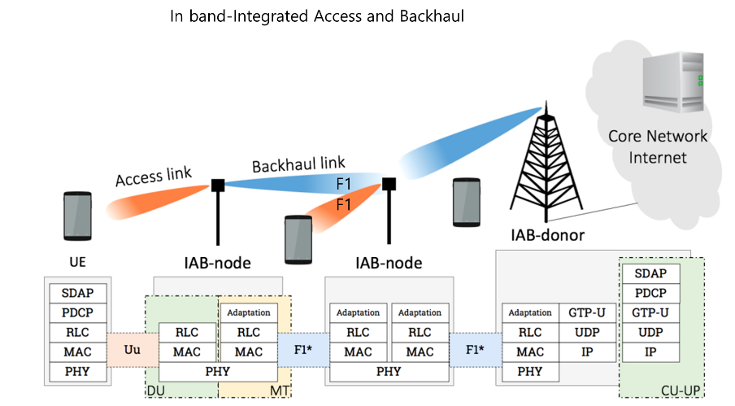

Figure 7. In-band IAB nodes

3GPP-NR has developed a new technology component called IAB (Integrated access and backhaul)[2], where the same spectrum could be used for backhaul and accesses spectrum. Generally IAB nodes could be categorized as out of band and In band IAB. Out of band IAB nodes do not share access link and backhaul link unlike in-band IAB deployment.

Especially in in-band IAB deployment, the same spectrum could be used between 5G base stations (gNB)-User Equipment (UE), IAB-IAB nodes, and gNB-IAB nodes. While such technology advancements enable efficient usage of spectrum, at the same time it also impacts the existing policy framework of allocating spectrum for backhaul. The administration may wish to revisit current licensing regime for IAB deployment.

**Observation:** In-band IAB technology offers a mechanism for the same spectrum to be used by accesses spectrum and backhaul spectrum concurrently. The traditionally independent policy framework was developed for accesses and backhaul spectrum, however, IAB has triggered the need to revisit spectrum allocation for IAB nodes considering the same spectrum will be used by backhaul and access links.

## Coverage extensions

This section deals with solutions related to coverage extensions and coverage issues due to obstacles in dense urban environments specific to mmWave 5G.

mmWave suffers from high penetration loss and such losses can be compensated by increasing base stations transmission power and/or implementing large antenna arrays using massive MIMO technology. Higher array gain offered by large antenna arrays is leveraged to compensate penetration loss in mmWave deployment. However, practical mmWave deployment is still experiencing occasional coverage holes and operators are addressing different solutions to fill such gaps. One could observe that it’s not always easy to keep adding number of wireless infra nodes to fill coverage holes, since additional wireless infra nodes will increase inter-cell interference and thereby reducing cell capacity.

Coverage is a fundamental aspect of cellular network deployments. Mobile operators continuously explore different types of network nodes to offer blanket coverage in their deployments.

One of the types of network node is the RF repeater. RF repeaters have been used in 2G, 3G and 4G deployments to supplement the coverage provided by regular cells. They constitute the simplest and most cost-effective way to improve network coverage. The main advantages of RF repeaters are their low-cost, their ease of deployment and the fact that they do not increase latency. Within RF repeaters, there are different categories depending on the power characteristics and the amount of spectrum that they are configured to amplify. RF repeaters are non-regenerative type of relay nodes and they simply amplify-and-forward everything that they receive. RF repeaters typically do not differentiate between UL and DL from transmission or reception standpoint.

As we move to higher frequencies (to mmWave (FR2) band) propagation conditions degrade compared to lower frequencies exacerbating the coverage challenges. As a result, further densification of cells may be necessary. Multi-antenna techniques consisting of massive MIMO and analog beamforming for FR2 assist in coping with the more challenging propagation conditions of these higher frequencies.

Note that all the frequency bands defined at this higher frequency regime are TDD and use of multi-beam operation with associated beam management.

Two important observations could be made (a) Many planned NR deployments are TDD and therefore simultaneous, bi-directional amplify-and-forward may not be necessary. (b) Beamformed transmissions to individual users is fundamental to coverage esp. in FR2 bands. A simple RF repeater that the network is agnostic to may be unable to achieve the requisite beamforming gain.

Given background of RF repeaters, another type of network node “Smart repeaters” was needed, to make use of some side control information and enable a more intelligent amplify-and-forward operation in a system with TDD access and multi-beam operation.

### A network-controlled repeater (NCR)

A network-controlled repeater (NCR) is an enhancement over conventional RF repeaters with the capability to receive and process side control information from the network. “Side control information” could allow a network-controlled repeater to perform its amplify-and-forward operation in a more efficient manner. Potential benefits are mitigation of unnecessary noise amplification, transmissions and receptions leveraging spatial information, and simplified network integration.

3GPP NR has considered smart repeaters as Network controlled repeaters (NCR) [3].In simple words, NCR is a repeater with beamforming capabilities that can receive and process side control information from the network. Such side control information could allow an NCR to perform its amplify-and forward operation in an efficient manner. In general, the NCR can be considered as a network-controlled “beam bender” relative to the gNB.

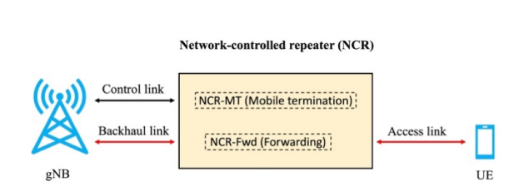 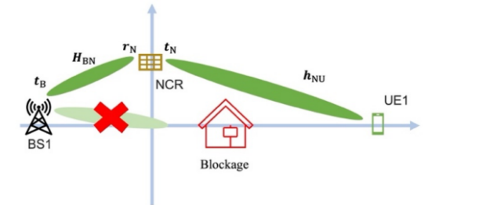

Figure 8a. Network controlled repeaters Figure 8b. NCR-assisted DL system

In this way, NCR is logically part of the gNB for all management purposes, i.e., it can be assumed that the NCR is deployed and under the control of the operator. NCR is based on amplify-and-forward relaying scheme.

Current 3GPP NR based NCR[4]makes the following assumptions,

* + NCRs are in-band RF repeaters used for extension of network coverage on FR1 and FR2 bands based on the NCR model as shown in figure 8a,8b.
  + For only single hop stationary NCRs.
  + NCR can maintain the gNB-repeater link and repeater UE link simultaneously.

**Observation:** mmWave generally suffers from high path losses and 5G Massive MIMO technology can compensate these losses. In addition, smart repeaters play an important role in the industry's mmWave deployment strategy by striking a balance between performance and cost. They facilitate faster and more efficient deployments, thus, continuous evolution of smart repeaters is very relevant to support the industry's needs effectively.

### High-Band Uplink Transmission Optimized for Coverage

Coverage stands as one of the key considerations for operators when rolling out cellular networks, given its direct influence on service quality and operational costs. In particular for mmWave bands, uplink (UL) performance can be a bottleneck, especially with the emergence of vertical use cases characterized by heavy UL traffic, such as video uploading. Poor uplink signal quality in mmWave poses significant challenges, including signal degradation due to attenuation and blockage. This leads to reduced throughput, increased latency, and potential service disruptions[5].

The 5G uplink utilizes two waveforms: precoded (DFT-S-) and non-precoded (CP-) OFDM. DFT-S-OFDM offers a relatively lower peak-to-average power ratio (PAPR), allowing the UE to operate its power amplifier closer to its maximum output power compared to CP-OFDM. This higher output power can enhance coverage, particularly for higher modulation orders. Moreover, it facilitates more efficient power amplifier operation, resulting in reduced power consumption for the UE.

UL waveform switching is supported in current mobile networks standards[6]. This functionality facilitates dynamic switching of waveforms in the uplink, thus improving cell coverage. The selection of the uplink waveform is dictated by measurements of uplink signal strength and is triggered when the UE is in poor coverage areas for a long period of time.

**Observation:** UL waveform switching provides better coverage for UEs on the cell edge in mmWave bands.

# Regulatory and policy measures to facilitate IMT-2020/5G deployment

This section includes some of the regulatory and policy measures in APT countries to accelerate 5G deployments.

## Cost of service and price elasticity

This section deals with the solutions related to relaxation in policy framework, which allows operators to assess the cost of 5G services.

As cited in the GSMA report [7], 5G deployment would encounter new challenges concerning to identify the "cost of providing new 5G services". We have noticed that 5G has transformed traditional broadband services into new use cases based on enhanced mobile broadband (eMBB), ultra-reliable low latency communications (URLLC), and enhanced machine-type communication (eMTC). Volume of applications envisaged to leverage new capabilities offered by 5G. eMBB is one of the traditional broadband services but the extremely high data rate offered by 5G has given rise to new applications and like augmented reality (AR), virtual reality (VR), 4K video. eMTC and URLLC has created a new ecosystem for Smart agriculture, Robotic industry, Smart cities, vehicle-to-vehicle (V2V), vehicle-to-everything (V2X), and Industry 4.0.

One of the important observations to make here is that, operators and users are still en route to find cost of 5G services. New infra would need new investments and operators would like to see returns on their investments. Users have to experience new services in order to find value and be ready to pay the extra subscription fees. Administration may seek to review deployment conditions and help operators for faster adoption of 5G.

**Observation:** For mid-bands, administrations could allow continuous 80-100MHz bandwidth in a timely manner for each operator in order to enjoy the full capability of 5G. Administrations could relax policies and allow operators to calibrate 5G services for making users ready to embrace new 5G services and let operators identify possible prices for new services. From a policy perspective, the government could allow some “warm-up time” (e.g., relax operators’ roll out obligations) for 5G services, where operators can explore, assess, and stabilize new 5G services.

## Case studies of Republic of Korea

IMT-2020/5G, which was commercialized in Korea in 2019, is a fifth-generation mobile communication technology featuring ultra-high speed (eMBB), ultra-low latency (URLLC), and ultra-connectivity (MMTC). The ultimate goal of 5G is to connect and integrate all devices and industries with 5G, bringing about digital transformation across industries. Not only does 5G surpass Wi-Fi in terms of data speed, capacity, and latency, but it also ensures security and mobility. Consequently, it offers the advantage of implementing diverse use cases that are unattainable with existing Wi-Fi networks. Local/private 5G networks are inherently more stable as they restrict unauthorized access from public network users.

Moreover, unlike public networks that provide universal services, Local/private 5G networks can optimize the number of users and traffic profiles according to use cases, enabling much more effective and flexible network operation. On October 28, 2021, the MSIT (Ministry of Science and ICT) started offering local/private frequencies (100MHz@4.7GHz, 600MHz@28GHz) to deploy local/private 5G network called ‘e-Um 5G[8]’, a crucial infrastructure for enterprises digital transformation, across a variety of industries in Korea.

### Spectrum and Regulation Policy

Spectrum for e-Um 5G network can be allowed to use over local area (e.g. terrestrial area/building) for special purpose use. Frequencies of 100MHz (4.72-4.82GHz) in the 4.7GHz band and 600MHz width (28.9~29.5GHz) in the 28GHz band are provided. The 4.7GHz band is allocated up to 10 blocks of 10MHz wide block, and the 28GHz band is allocated up to 12 blocks of 50MHz wide block. Frequency assignment applicants can apply for appropriate bandwidth according to their demand. The frequency applicant is allowed to choose the frequency use period of 2 to 5 years, and in order to prevent retention of frequencies without use, it is obliged to build a radio station within 1 year after frequency assignment.

Figure. 9. e-Um 5G frequency Arrangement in Korea

There are 3 types of e-Um 5G deployment according to service provider and service user.

Table 1. Types of e-Um 5G Introduction in Korea

Type 1: e-Um 5G frequencies are designated by the MSIT to user equipment (e.g. terminal, base station) in order to install and to use 5G private networks on their own. Typically, enterprises purchase 5G network equipment (base stations, cores, MECs) from SIs or vendors, and the equipment is the property of the company (purchase type).

Enterprises can only use the private 5G network for their own employees and not for other enterprises.

Type 2: Approved by the MSIT, and assigned Local 5G frequencies to provide e-Um 5G services to enterprise customers (excluding operators providing IMT services using assigned IMT frequencies).

Type 3: e-Um 5G operators build their 5G networks for enterprise customers and charge a fee for the service. Typically, 5G equipment is provided free of charge or at a minimal cost, and a monthly subscription fee may be charged to keep upfront costs down.

Below diagram shows e-Um 5G market structure example for type 1 and type 3 in Korea. The case of type 2 is very similar to type 1 other than the way of frequency licensing. In particular, MNOs having IMT spectrum are not allowed to be an e-Um 5G operator in order to facilitate 5G B2B service market competition.

Figure. 10. e-Um 5G Market structure example for Type 1 and 3

### Frequency Assignment Fee

Considering that e-Um 5G frequency is used in confined area so competitive demand for frequencies is limited, frequency assignment fee for e-Um 5G frequency is charged according to government-calculated method rather than auction. e-Um 5G frequency assignment fee is calculated according to service area, period and bandwidth as follows:

Assignment Fee = Base Cost x (5a1+a2+1) x Period x Number of Block,

where, Base Cost: \100,000/10MHz for 4.7GHz, \50,000/50MHz for 28GHz,

a1: service area (km2) of metropolitan area (city over 500,000),

a2: service area (km2) other than metropolitan area

Period: frequency use period (year).

In densely populated areas such as metropolitan cities, the demand for frequencies is high, and it is expected that more profits can be generated through the use of frequencies, so a regional coefficient (metropolitan area: other than metropolitan area = 5:1) is applied.

In particular, the assignment fee for the 28 GHz band was calculated as low as 1/10 of the 4.7 GHz band under the condition of using the same bandwidth, taking into account frequency characteristics, equipment and terminal ecosystem conditions, etc.

## Case studies of China

To facilitate 5G deployment and alleviate the economic burden of IMT operators, the National Development and Reform Commission (NDRC) and the Ministry of Finance (MoF) of China jointly issued a notice in April 2018, to lower the frequency usage fees of related communication systems . This notice includes several measures for different systems, and the first measure is to reduce the frequency usage fee of IMT systems[9] deployed nationwide in 3 GHz and above :

1. In the frequency band 3GHz-4GHz, the frequency usage fee has reduced from ¥8 million /MHz/year to ¥5 million/MHz/year;
2. In the frequency band 4GHz-6GHz, the frequency usage fee has reduced from ¥8 million /MHz/year to ¥3 million/MHz/year;
3. In the frequency band 6GHz and above, the frequency usage fee has reduced from ¥8 million/MHz/year to ¥0.5 million/MHz/year.

The second measure is the preferential policy of frequency usage fees for 5G mobile communication systems, to relieve MNO’s economic pressure of 5G network deployment. The proportion of frequency usage fee is increasing gradually since the date of 5G license:

1. For the first three years, the 5G system is exempt from frequency usage fees;
2. For the fourth to sixth year, the proportion of frequency usage fee of 5G system is 25%, 50% and 75% of the national fee standards, respectively;
3. For the seventh year and after, the proportion of frequency usage fee of 5G system is 100% of the national fee standards.

The third measure is to adjust the proportion of frequency usage fee of public communication systems with limited deployment scope (such as only used indoor) to 30% of the national frequency fees standards.

### 26GHz frequency band for 5G millimeter-wave trial

In January 2025, the Ministry of Industry and Information Technology (MIIT) of China approved the use of the 26 GHz frequency band for 5G millimeter-wave trial by basic telecommunications enterprises during the 9th Asian Winter Games (held February 7-14, 2025). This move aims to enhance communication support for the event and advance technological innovation[10]. This initiative supports technical verifications in areas such as 8K broadcasting, integrated sensing and communication (ISAC), and coordinated networking across high-, medium- and low-frequency bands. This marks the first-ever approval by China’s MIIT for basic telecommunications operators to conduct trials in the 26 GHz band, underscoring the commitment to advancing 5G millimeter-wave innovation.

Compared to widely used mid-band and low-band 5G frequencies, the 26GHz millimeter-wave band offers greater bandwidth, higher transmission rates, and lower latency, addressing the demands of public mobile networks and industrial private networks more effectively. Conducting relevant technical verifications during the 9th Asian Winter Games further enhances cloud broadcasting capabilities and immersive user experiences, better addresses communication demands in hotspot areas and elevates the technological sophistication of the Games. At the same time, it also plays a positive role in exploring 26 GHz frequency band 5G millimeter-wave technology, maturing the industry chain, promoting applications, and improving spectrum management.

# Case studies for IMT-2020/5G use cases

## Republic of Korea

e-Um 5G is a telecommunications network that utilizes the advantages of fifth-generation (5G) mobile communication, such as ultra-high speed, ultra-low latency, and ultra-connectivity, by deploying it in specific areas such as land and buildings. In December 2021, Naver Cloud announced the introduction of services as the first domestic operator to be allocated frequencies.

In 2022, it began to be used in 26 sites across 9 business sectors including manufacturing, healthcare, and logistics. By the end of 2024, e-Um 5G was deployed in 74 sites across 36 businesses, spanning various sectors including smart manufacturing, logistics, healthcare, and R&D for AI logistics automation and autonomous driving. To promote the spread of e-Um 5G, the MSIT has streamlined the submission documents and application procedures for e-Um 5G, as well as improved regulations by excluding restrictions on foreign ownership stakes when registering for telecommunications businesses. Additionally, to provide comprehensive information on the latest domestic and international deployment cases, equipment, and terminal supply status, they have opened a website (eum5gportal.kr) and organized seminars.

They have also provided year-round pre-consultation (consulting) for frequency application procedures and technical support. To enable the utilization of e-Um 5G in various fields, they have presented reference standards through 15 demonstration projects and pursued various policies to enhance e-Um 5G activation, including completing the development of technology to improve the speed of e-Um 5G small cells up to 3Gbps.

### Medical and Healthcare cases

The surgeon's operation room is captured utilizing high-definition immersive video such as AR glasses, an endoscope, and a 360-degree camera, and then streamed to a medical education platform through e-Um 5G network. In the professor's office, a specialist watches the video and guides the surgery (remote cooperative surgery). Students in the seminar room can see the live surgical video while also learning from the specialist's guidance (real-time remote surgical training).

* Customized surgical AR guide for each patient using augmented 3D reality
* Scanning and modeling of the patient's body
* Real-time non-face-to-face collaboration service: Sharing of medical
* Images in the limited operating room space to medical staff in the hospital

Figure. 11. e-Um 5G case of 5G-based remote surgical training in Samsung Medical Center

Autonomous self-driving electric wheelchair, AMR (unmanned transport of medical materials/drugs/linen), and Smart simulation (3D camera) were implemented. To ensure the safe transportation of patients, enhanced autonomous wheelchair systems were developed, equipped with safety features. These wheelchairs are capable of self-navigation, both when called to the patient and when returning autonomously to their designated positions. Additionally, a wheelchair control platform and a management app for summoning and overseeing wheelchairs were implemented.

Figure. 12. e-Um 5G case of Seoul National University Bundang Hospital

### Entertainment cases

In the Lotte World Atlantis attraction, an immersive and realistic virtual experience attraction were implemented using 28 GHz band 5G technology, which was previously impossible with conventional Wi-Fi. Real-time transmission of large-capacity videos (4k: uplink 40Mbps, 8k: 200Mbps) and motion data from the rides is enabled to indoor motion simulators, providing customers with an immersive experience identical to being on-site.

Figure. 13. e-Um 5G case of Lotte World’s Amusement Park

Atlantis is immersive parallel reality experience services enabling technology equipped with a 28GHz band 5G transmission module with built-in camera and motion sensor. The transmission module sends video and motion data to the motion simulator through e-Um 5G network. Visitors seated in the motion simulator can virtually experience the realistic attraction. The elderly, who were previously unable to enjoy offline attractions, can now ride, and children can ride without height restrictions.

### Energy Industry cases

Transformers and gas-insulated switchgear in substations are the core facilities of the power grid, and in the event of a breakdown or failure, large-scale power outages occur, causing national damage. KEPCO deployed private 5G in substations, and based on this, introduced wireless IoT sensors, quadruped robots, wireless CCTV, and AI servers to build a smart facility management system that monitors facilities in real time and predicts and prevents failures through AI analysis.

* IoT-based predictive maintenance (wired sensors -> wireless sensors)
* Maintenance inspection based on quadruped robot (human -> unmanned)
* Safety & access control through wireless CCTV and AI real-time analysis

Figure. 14. e-Um 5G case of Korea Electric Power Corporation (KEPCO)

### Manufacturing cases

Predictive maintenance of manufacturing facilities and industrial work-place safety services can be provided by e-Um 5G. In Banwolshihwa Industrial Complex, private 5G collects real-time monitoring data to predict malfunction or failure of manufacturing facilities. Video streaming through private 5G is used to prevent various accidents such as workers entering the workplace without protective gear, harmful gas leaks, and overloading or speeding of mobile equipment in the workplace.

Figure. 15. e-Um 5G case of Banwolshihwa Industrial Complex

### Logistics cases

Private 5G can reduce the labor load of warehouse workers engaged in the logistics industry and improve stability and productivity through automation and unmanned operation of high-intensity simple labor in the logistics system. In Korea National Food Cluster (Foodpolis), automated logistics solutions such as palletizing robot, self-driving forklifts, AMR are implemented. In case of palletizing robot, vision AI scans and identifies irregularly shaped and differently sized boxes on the conveyor with a 3D camera, calculates the path of the robot arm to move the boxes on the conveyor to the pallet, and delivers it to the robot. The 3D camera scan data and robot control commands are transmitted through a private 5G network.

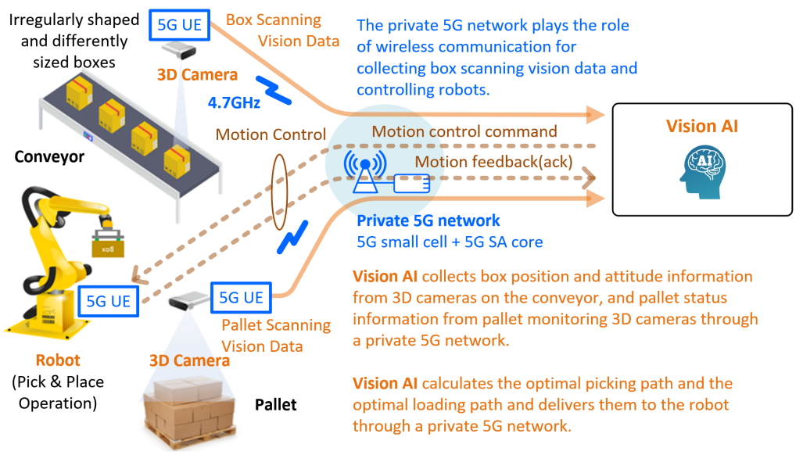

Figure 16. e-Um 5G case of Korea National Food Cluster (Foodpolis)

## India

### Introduction

In India, spectrum allocations at present are technology neutral. The spectrum bands or parts thereof for IMT services namely 600 MHz (APT600 MHz Band), 700 MHz; 800 MHz; 900 MHz, 1 800 MHz; 2 100 MHz; 2 300 MHz, 2 500‑2 690 MHz, 3 300-3 400 MHz and 3 400-3 600 MHz bands[11] are available for telecom services in India. To pave the way for 5G services in India, the Department of Telecommunications allocated spectrum in August 2022, to the three TSPs through auction, across a range of bands, including 700 MHz, 800 MHz, 900 MHz, 1 800 MHz, 2 100 MHz, 2 500-2 690 MHz, 3 300-3 670 MHz, and the 26 GHz band.

### Approach

Cellular telephony was opened up in 1992 with a Duopoly regime, GSM as the mandated technology (900 MHz band), Receiving Party Pays (RPP) system and with a 10-year license. The entire country was divided into 22 licensed service areas.

### Enhancing spectrum availability for IMT systems in India

Since 2010 onward, spectrum auctions have been regularly held for offering spectrum in a transparent manner through market related process. In the year 2010, spectrum in 2 100 MHz band (for 3G services) and 2 300 MHz band (for BWA services) were put to auction in 22 Licensed Service areas. Thereafter, spectrum auction for providing commercial telecom services have been held at least once each year during 2012‑2016. During this period, the spectrum in bands 700 MHz; 800 MHz, 900 MHz, 1 800 MHz, 2 100 MHz, 2 300 MHz and 2500 MHz bands had been put to auction.

In August 2022, spectrum in 600 MHz (APT600 MHz Band), 700 MHz, 800 MHz, 900 MHz, 1800 MHz, 2100 MHz, 2500 MHz, 3500 MHz, and the 26 GHz bands was auctioned with focus on 3500 MHz and 26 GHz bands for deployment of 5G services.

In June 2024, spectrum available in 800 MHz, 900 MHz, 1800 MHz, 2100 MHz, 2300 MHz, 2500 MHz, 3300 MHz, and 26 GHz bands was put to auction. The operators bidding in this auction focused on 900MHz, 1800MHz, 2100MHz and 2500 MHz bands only, to ensure continuity of their services.

### Subscriber base

The country witnessed exponential growth in subscriber base (wireless + wireline) since the onset of 3G and LTE services from 2010. The rate of Subscriber growth in India in the period of 2011 to March, 2024 is as shown below.

Figure 17. Subscribers base in India[12]

### Roll-out of 5G Network

India launched 5G services on 01st October 2022. Due to aggressive rolling out of the 5G network by the Telecom Service Providers, across the length and breadth of the country, India became as one of the fastest 5G rollouts in the world with the latest telecom technology. Within 15 months of time, 5G BTS deployments has crossed the 0.4 million mark, reaching 738 districts and more than 100 million users. Now, most of cities and towns are covered with 5G network.

Now the India has moved from the 5G rollout stage to 5G reach out stage.

Table 2. State/UT-wise 5G BTS Status[13]

|  |  |  |  |  |  |  |
| --- | --- | --- | --- | --- | --- | --- |
| S.No | State/UT | 31.03.2024 | 30.04.2024 | 31.05.2024 | 30.06.2024 | 31.07.2024 |
| 1 | Andaman & Nicobar | 115 | 115 | 117 | 129 | 129 |
| 2 | Andhra Pradesh | 18028 | 18193 | 18239 | 18375 | 18466 |
| 3 | Arunachal Pradesh | 552 | 573 | 580 | 587 | 592 |
| 4 | Assam | 8229 | 8561 | 8642 | 8676 | 8750 |
| 5 | Bihar | 21647 | 22511 | 22582 | 22616 | 22742 |
| 6 | Chandigarh (UT) | 741 | 743 | 744 | 746 | 748 |
| 7 | Chhattisgarh | 6332 | 6458 | 6462 | 6495 | 6527 |
| 8 | UT of Dadra and Nagar Haveli and Daman and Diu | 378 | 384 | 393 | 396 | 397 |
| 9 | Delhi | 11350 | 11417 | 11531 | 11680 | 11706 |
| 11 | Goa | 975 | 979 | 980 | 982 | 982 |
| 10 | Gujarat | 29232 | 29843 | 30045 | 30449 | 30851 |
| 12 | Haryana | 15604 | 15878 | 16040 | 16217 | 16279 |
| 13 | Himachal Pradesh | 3972 | 4043 | 4074 | 4101 | 4137 |
| 14 | Jammu & Kashmir (UT) | 6745 | 6827 | 6854 | 6878 | 6925 |
| 15 | Jharkhand | 9271 | 9474 | 9529 | 9546 | 9587 |
| 16 | Karnataka | 28675 | 29384 | 29979 | 29960 | 30214 |
| 17 | Kerala | 19152 | 19198 | 19261 | 19256 | 19258 |
| 18 | Laddakh | 226 | 230 | 238 | 240 | 244 |
| 19 | Lakshadweep (UT) | 2 | 2 | 2 | 2 | 2 |
| 20 | Madhya Pradesh | 18714 | 19111 | 19155 | 19322 | 19432 |
| 21 | Maharashtra | 45283 | 45548 | 45739 | 45913 | 45971 |
| 22 | Manipur | 909 | 968 | 1013 | 1067 | 1117 |
| 23 | Meghalaya | 662 | 696 | 714 | 717 | 720 |
| 24 | Mizoram | 423 | 445 | 455 | 458 | 465 |
| 25 | Nagaland | 695 | 722 | 731 | 735 | 739 |
| 26 | Odisha | 11860 | 12038 | 12175 | 12257 | 12315 |
| 27 | Puducherry (UT) | 535 | 563 | 569 | 584 | 586 |
| 28 | Punjab | 15159 | 15336 | 15606 | 15851 | 16014 |
| 29 | Rajasthan | 25496 | 25813 | 26118 | 26234 | 26958 |
| 30 | Sikkim | 304 | 309 | 310 | 313 | 314 |
| 31 | Tamil Nadu | 33841 | 34113 | 34233 | 34510 | 34726 |
| 32 | Telangana | 16816 | 16957 | 17082 | 17193 | 17314 |
| 33 | Tripura | 1171 | 1215 | 1225 | 1228 | 1235 |
| 34 | Uttar Pradesh | 48990 | 49689 | 50212 | 50444 | 50752 |
| 35 | Uttarakhand | 5444 | 5464 | 5537 | 5560 | 5563 |
| 36 | West Bengal | 28192 | 28616 | 28834 | 28992 | 29298 |
| **Grand Total** | | **435720** | **442416** | **446000** | **448709** | **452055** |

Department of Telecommunications of India proactively auctioned and allocated the spectrum in August 2022 to roll-out 5G services, to ensures that ample bandwidth for high-speed data transmission and diverse applications is available. Total 51.2 GHz of spectrum was allocated prior to roll-out of 5G services.

Department of Telecommunications of India again auctioned the spectrum in June, 2024 and total 141.4 MHz of spectrum was allocated in 900 MHz, 1800 MHz, 2100 MHz and 2500 MHz band.

### New Initiative to launch one hundred 5G Use-cases Labs

For enhancing the 5G Use cases, a new initiative has been taken to launch100 ‘5G Use Case Labs’ for educational institutions. This move aims to drive development of 5G applications tailored to local and global requirements.

### New Telecommunications Act, 2023:

The telecommunications sector in India has made significant strides over the last few years. Starting from the introduction of transformative reforms, the deployment of 5G, measures for consumer protection and ultimately the enactment and notification of provisions under the Telecommunications Act, 2023 (Telecom Act-2023) – this period marks a golden era in the history of telecommunications in India.

Main features of the act are:-

1. Simple regulatory framework; abolishes licence regime, replaces it with authorisation mechanism.
2. Effective right of way including common duct and RoW on public and private property.  
   Clearly defined framework for spectrum assignment, including efficient spectrum utilisation. The Act defines a framework for spectrum assignment through auction or administrative means.
3. Adjudication mechanism: A two-tier dispute resolution mechanism as an alternate dispute resolution prior to judicial forum. Proposes to reduce litigation load in the sector.
4. Provisions to take necessary measures for national security and public safety. The Act has power to take temporary possession of telecom networks during public emergencies, including natural disasters. Provides a framework for blocking and interception.

## China

### 5G application "sail" action plan

China published “5G application "sail" action plan” in 2021 which set up the targets for 5G deployment, including 5G subscriber rate, 5G applicability in industry, etc.

By the end of 2023, all the targets were met and even beyond. China had built 3.377 million 5G base stations. The 5G deployment is continuing to deepen the coverage in cities and urban areas, and gradually extended to the rural areas as needed. The continuous growth of 5G mobile phone users and the rapid increase of 5G traffic consumption have promoted the vigorous development of naked-eye 3D, cloud mobile phones and other emerging services, and effectively expanded the development space of the mobile communication market. The number of 5G subscriber reached 805 million, accounting for 47% of mobile subscriber. The penetration rate of 5G users has jumped from 11% to 54.6%, and the proportion of 5G network access traffic has increased from less than 10% to 53.8%. The average data flow per month (DOU) of mobile Internet users increased from 10GB to 18GB [14].

By the end of 2023, 5G industrial applications have been integrated into 71 national economic categories, with more than 94000 application cases and more than 29000 virtual private networks in 5G industry. The application of 5G is deeply promoted in industry, mining, electric power, port, medical and other industries.

For example, in the industrial field, 5G applications have steadily expanded from peripheral links such as video inspection to core links such as research and development design, production and manufacturing, operation and maintenance management, and product services, with 20 typical scenarios emerging, including machine vision quality inspection and on-site auxiliary assembly. In the medical field, 5G applications have extended from remote diagnosis to refined treatment for specialized diseases such as orthopedics, cardiology, and respiratory medicine. In the field of agriculture, 5G applications have expanded from single-point applications, mainly focusing on smart greenhouses, to key areas such as unmanned plant protection, smart agricultural machinery, and other areas of planting, breeding, and circulation. In the field of power, 5G applications have extended from unmanned inspection in the "transmission" link to the five links of "generation, transmission, transformation, distribution, and use". In other fields, the proportion of 5G applications in 25 major coastal ports across the country has reached 92%, and the proportion of applications in the top 20 coal and steel enterprises has reached 95% and 85% respectively. It is spreading from the leading enterprises to small and medium-sized enterprises in the upstream and downstream of the industrial chain [15].

More than 8000 "5G + Industrial Internet" projects have been invested and built across the country, creating a number of 5G fully connected factories. A list of “5G factories of 2023” was released in the end of 2023, covering 24 different categories [16] [17].

* 5G is widely used in mining, in which product capability was increased 11.7%;
* 5G is widely used in manufacturing, in which product capability was increased 24%;
* 5G is widely used in production and supply of electricity/heat/gas/water, in which product capability was increased 10.3%, and reduce the operating costs 18%;
* 5G is widely used in construction industry, in which product capability was increased 10%, and reduce the operating costs 20%;
* 5G is widely used in transportation, in which product capability was increased 20%, and reduce the operating costs 21.9%.

5G also contributed to increase the energy efficiency, and reduce the carbon emission at different level in different use cases.

### Upgraded Plan for the "Sail" Action on Large-Scale 5G Applications

In November 2024, China released the "Upgraded Plan for the 'Sail' Action on Large-Scale 5G Applications", outlining the development goals for 5G applications[18].

By the end of 2027, a development landscape characterized by "universal capabilities, widespread application, and inclusive empowerment" will be established, achieving comprehensive large-scale 5G deployment. Key Performance Indicators (KPIs) of this upgraded plan are summarized in Table 3.

Table 3 Key Performance Indicators (KPIs) of the upgraded plan for the "Sail" Action

|  |  |  |
| --- | --- | --- |
| **Index** | **KPI** | **Value** |
| 1 | 5G individual user penetration rate | 85% |
| 2 | 5G network traffic percentage of total traffic | 75% |
| 3 | Number of 5G IoT terminal connections | 100 million |
| 4 | 5G application penetration rate in large and medium-sized industrial enterprises | 45% |
| 5 | Number of 5G leading applications | 2,000 |
| 6 | Number of cities with large-scale 5G application development | 100 |
| 7 | Number of 5G base stations per 10,000 people | 38 |
| 8 | Number of 5G industry virtual private networks | 70,000 |

### Significant Achievements in 5G Empowerment

The penetration rate of 5G individual users will exceed 85%, with 5G network traffic accounting for over 75% of total traffic. New 5G-driven consumer experiences will continue to expand. A group of 5G application leaders will emerge in key fields such as factories, hospitals, and tourist attractions, driving digital transformation and upgrading across industries. The number of 5G IoT terminal connections will surpass 100 million, and the 5G application penetration rate in large and medium-sized industrial enterprises will reach 45%.

### Enriched 5G Industry Supply

Participation in 5G-Advanced (5G-A) international standards will deepen, while the domestic 5G industry standard system will be rapidly improved, with over 150 standards for integrated 5G applications. The industrial ecosystem for 5G integrated applications will become more robust, with deeper convergence between 5G and digital technologies. Key areas such as chip modules, industry-specific terminals, virtual private networks, and common capability platforms will see enhanced supply capabilities, leading to the development of over 1,000 innovative industry terminal module products.

### Significantly Enhanced 5G Network Capabilities

The breadth and depth of 5G coverage will expand, with the number of 5G base stations per 10,000 people reaching 38. The 5G network dwell rate will exceed 85%, with full support for IPv6 technology. The transition from 5G to 5G-A will be advanced as needed, achieving large-scale coverage of 5G-A ultra-wideband features in all prefecture-level and above cities. A total of 70,000 5G industry virtual private networks will be built, driving the construction of 5,000 edge computing nodes and establishing a new digital foundation that deeply integrates connectivity, sensing, computing, and intelligence.

### Accelerated Prosperity of the 5G Application Ecosystem

A number of cities will be promoted as hubs for large-scale 5G application development, nurturing 200 5G application solution providers and creating 50 distinctive 5G application innovation platforms. More than five 5G application security benchmarks will be established in key fields, building a security assurance system compatible with 5G development. A positive trend of integrated development and gradient growth among large, medium, and small enterprises will gradually take shape, with an increasingly robust global open cooperation ecosystem.

## 5G enterprise and industrial use cases provided by MNOs

The introduction of 5G is enabling connected industries and digital transformation across many sectors of the economy. Mobile network operators are actively developing 5G private networks and enterprise solutions in partnership with industry players. Some examples of the versatility of 5G technologies in supporting different industries are provided below. Further case studies on 5G-enabled connected industries can be found in [19] [20].

### Bharti Airtel supports Mahindra 5G manufacturing[21]

Mahindra’s Chakan car manufacturing facility, in partnership with Airtel and Tech Mahindra, has become India’s first 5G-enabled automotive plant. This transformation was made possible by deploying Airtel’s 5G network using the n78 3.5 GHz spectrum acquired in August 2022.

The facility’s existing 4G infrastructure was upgraded with 5G base stations, and a dedicated 5G core network was established to support standalone 5G services, focusing on factory operations while also planning public 5G access for employees and visitors. Sites are dedicated to the captive use cases and therefore slicing is not implemented. Future use cases may use slicing depending upon the solution model.

The introduction of 5G technology has significantly enhanced the plant’s operational efficiency. The network enables simultaneous firmware updates for multiple vehicles and supports automated, computerized inspections of production quality. These improvements have led to reduced production times and increased productivity, making the manufacturing process more streamlined and effective.

Covering over 700 acres, massive MIMO remote radio heads were installed at the customer premise and the 5G network delivers peak speeds exceeding 1 Gbps with latencies as low as 20ms. This infrastructure allows Mahindra to conduct parallel software flashing for approximately 1,000 vehicles simultaneously which resulted in reduced turn-around time for the operation. Previously, every semi-finished vehicle had to be brought into the factory floor from the parking yard to flash the ECU software over the LAN or Wi-Fi.

### Singtel supports National University Hospital Singapore on mixed-reality healthcare[22]

Singtel, in collaboration with the National University Health System (NUHS), has leveraged 5G technology to develop mixed reality (MR) and holographic solutions aimed at enhancing clinical capabilities and healthcare delivery. Singtel acquired 100 MHz in the 3.5 GHz band and 800 MHz of mmWave spectrum during the IMDA’s Call for Proposal process in June 2020. Using this spectrum, Singtel deployed a nationwide 5G Standalone network with over 95% coverage, including more than 1,300 outdoor locations and over 400 in-building and underground sites. At NUHS, Singtel implemented a private network comprised of 19 5G radio units across 10 operating theatres and 3 inpatient wards, including advanced facilities for robotic surgeries.

The 5G Standalone network at NUHS, equipped with edge cloud and network slicing capabilities, ensures that doctors and healthcare workers have access to reliable, high-bandwidth connectivity at all times. This network allows for real-time data monitoring and processing while maintaining the security and privacy of patient data. The bespoke network architecture also facilitates a secure hybrid connection between the hospital’s intranet and the internet, paving the way for innovative applications such as autonomous cloud robots and remote medical assistance.

The deployment of this private 5G network has significantly enhanced NUHS’s ability to innovate in healthcare. The network supports the development of mixed reality modules and solutions that improve patient outcomes and streamline healthcare delivery. Additionally, NUHS plans to extend 5G network slicing capabilities beyond the hospital, enabling remote patient monitoring and connected smart ambulances to enable real-time transmission of vital signs, remote diagnosis and quicker decision-making.

### China Mobile Hong Kong supports Airport Operations[23]

Hong Kong International Airport, in partnership with China Mobile Hong Kong (CMHK) and Huawei, has implemented a private 5G network to enhance its operations and provide a better experience for travellers by leveraging the transformative capabilities of 5G. This pilot project is part of Hong Kong International Airport’s strategy to incorporate a multitude of radio equipment, a cloud-based Core Network, and a complex redundant transport network. All this will help in the deployment of technologies such as V2X autonomous vehicles, robotics, and a wide range of IoT applications.

China Mobile Hong Kong deployed a secure and highly efficient 5G cloud-based network at Hong Kong International Airport, providing opportunities for the authority to deliver applications that were previously impossible or not cost-efficient to install. Simultaneously, the system also offered a superior 5G internet experience to passengers and staff using the public network.

### Telekom Malaysia supports PETRONAS for the Oil and Gas Industry[24]

PETRONAS and Telekom Malaysia (TM) have successfully implemented the first private 5G network for PETRONAS and its group of companies, marking a major advancement in the region's telecommunications landscape. Launched in December 2022, this deployment showcases the unique benefits of private 5G networks, such as enhanced security, higher service availability, and specialized services compared to public 5G networks.

The private 5G network, entirely segregated from public networks, offers enhanced security by ensuring that only authorized devices can access the network. This network also guarantees a 99.9% service level availability, far surpassing the typical 95% of public networks, which is crucial for critical operations like remote monitoring and high-definition live streaming. Additionally, the network includes a 5G backup for the Fiber Optic backbone, further boosting security and stability.

Designed as an on-premise solution, the private 5G network provides PETRONAS with greater control over network operations, enhancing reliability and supporting their production and operational excellence. Key features such as high upload throughput and wider transmission coverage, especially over water for offshore operations, further improve communication capabilities and overall operational efficiency.

### China Unicom

During the 9th Asian Winter Games, China Unicom utilized multiple network technologies such as 3D digital twin technology, indoor positioning augmentation, integrated sensing and communication (ISAC) base stations, and 8K broadcasting in competition venues. Those innovations ensured smooth event operations and addressed communication demands in high-density event zones.

Through 3D digital twin technology, competition venues were holographically reconstructed in virtual environment. The panoramic restoration of venues, engine rooms, and network equipment information, enables managers to monitor real-time network operations across venues. The indoor positioning augmentation embedded in venue communication systems enabled dynamic tracking of staff locations, ensuring rapid response during emergencies. In the Winter village, newly developed ISAC base stations provided low-altitude logistics transportation, as well as monitoring the trajectory of unauthorized unmanned aerial vehicle (UAV) intrusive into the competition venues. With the support of millimeter-wave technology, the network speed was improved significantly, with the peak downlink speed reaching 10 Gbps and the peak uplink speed reaching 1 Gbps.

# Summary

The deployment of IMT-2020/5G presents a multitude of opportunities and challenges for APT countries. The global trends in 5G deployments highlight the importance of adopting a multi-band approach to leverage the diverse propagation characteristics and coverage capabilities of different frequency bands.

Enhanced mobile broadband (eMBB), massive machine-type communication (mMTC), and ultra-reliable low-latency communications (URLLC) are key usage scenarios that can be delivered through IMT-2020/5G, supporting various applications such as virtual reality (VR), vehicle-to-vehicle (V2V) and vehicle-to-everything (V2X) communications.

Efficient 5G deployment requires infrastructure and ran sharing with the collaboration of operators under appropriate policy framework. Solutions related to deployment of cells in private or public local areas are also provided in this report.

To address the challenges associated with rural and remote areas, high-capacity wireless backhaul link as well as satellite link can be explored to complement optical fiber backhaul links. Integrated access and backhaul (IAB) solutions can also play a crucial role in optimizing network deployment and reducing costs.

Regulatory frameworks should be flexible and adaptive to accommodate the evolving needs of 5G technology, ensuring efficient spectrum allocation and management. This report contains the examples of technical, operational, regulatory solutions and use cases to assist APT members when they implement the terrestrial component of IMT-2020/5G.

1. GSA, “5G Market Snapshot February 2025,” 2025. Available: <https://gsacom.com/>
2. 3GPP TR 38.874 Study on Integrated Access and Backhaul.
3. H. Guo, C. Madapatha, B. Makki, B. Dortschy, L. Bao, M. Åström, and T. Svensson, “A Comparison between Network-Controlled Repeaters and Reconfigurable Intelligent Surface,” 2022, arXiv:2211.06974.
4. 3GPP TR 38.867 Study on NR network-controlled repeaters
5. 3GPP, RP-233558, “Revised WID on Further NR coverage enhancements,” 2023.
6. 3GPP, Technical Specification TS 38.212 V.18.0.0, 5G; NR; Multiplexing and channel coding, 2024.
7. GSMA, “Infrastructure Sharing: An Overview,” 2019. Available: https://www.gsma.com/futurenetworks/wiki/infrastructure-sharing-an-overview/
8. ‘e-Um 5G’ stands for the characteristic of 5G (eMBB (enhanced Mobile Broadband), URLLC (Ultra Reliable and Low Latency Communication), MMTC (massive Machine Type Communication)) and also means ‘connection’ among human or things in Korean language..
9. National Development and Reform Commission of the People's Republic of China Homepage (https://www.ndrc.gov.cn/xxgk/zcfb/tz/201804/t20180424_962716.html)
10. Ministry of Industry and Information Technology of the People's Republic of China Homepage (https://www.miit.gov.cn/jgsj/wgj/gzdt/art/2025/art_36b3a450b8b145409c7b618bff56649b.html)
11. https://dot.gov.in/sites/default/files/NFAP%202022%20Document%20for%20e-release.pdf?download=1
12. https://www.trai.gov.in/release-publication/reports/performance-indicators-reports
13. https://dot.gov.in/5g-bts-deployed
14. Ministry of Industry and Information Technology of the People's Republic of China Homepage (https://www.miit.gov.cn/xwdt/gxdt/ldhd/art/2024/art_fb1ca760af7c40578600f3a62cfcab22.html)
15. Ministry of Industry and Information Technology of the People's Republic of China Homepage (https://wap.miit.gov.cn/xwdt/gxdt/sjdt/art/2024/art_7b4cd11e5b0641b8baf524e498fd1222.html)
16. Ministry of Industry and Information Technology of the People's Republic of China Homepage (https://www.miit.gov.cn/zwgk/zcjd/art/2023/art_1741388b2be2476b819199c8b1127b5e.html)
17. Ministry of Industry and Information Technology of the People's Republic of China Homepage (https://ythxxfb.miit.gov.cn/ythzxfwpt/hlwmh/tzgg/xzxk/dxhhlwyw/art/2023/art_616e8f0c55574d2bb190921add57ce4a.html)
18. Ministry of Industry and Information Technology of the People's Republic of China Homepage (https://www.miit.gov.cn/zwgk/zcwj/wjfb/tz/art/2024/art_09998a0a0232403aad8ad6d150c96730.html)
19. GSMA, “How 5G is Enabling Connected Industries in APAC”, 2024 [Online]. Available: https://www.gsma.com/about-us/regions/asia-pacific/wp-content/uploads/2024/08/APAC-5G-ICT-Summit-case-study-booklet.pdf
20. GSMA, “5G Transformation Hub”, 2024 [Online]. Available: https://www.gsma.com/5GHub/case-studies
21. https://www.airtel.in/press-release/12-2022/airtel-partners-tech-mahindra-to-deploy-captive-private-network-at-mahindras-chakan-facility; https://www.gsma.com/connectivity-for-good/spectrum/wp-content/uploads/2023/06/Mobile-Private-Networks-Airtel-Mahindra.pdf
22. https://www.gsma.com/connectivity-for-good/spectrum/wp-content/uploads/2024/08/Set-asides_case-study_Singtel.pdf
23. https://www.gsma.com/about-us/regions/asia-pacific/wp-content/uploads/2024/08/APAC-5G-ICT-Summit-case-study-booklet.pdf
24. https://www.gsma.com/about-us/regions/asia-pacific/wp-content/uploads/2024/08/APAC-5G-ICT-Summit-case-study-booklet.pdf