APT REPORT ON

FREQUENCY USAGE OF THE BANDS 1 980-2 010 MHZ AND 2 170-2 200 MHZ IN ASIA-PACIFIC REGION

Edition: April 2018

The 16th Meeting of APT Wireless Group (AWG-16)
18 – 21 April 2014
Pattaya, Thailand

(Source: AWG-16/OUT-09)

No. APT/AWG/REP-46

Adopted by

16th Meeting of APT Wireless Group (AWG-16)
18 – 21 March 2014
Pattaya, Thailand
(Source: AWG-16/OUT-09)

First Revision at

21st Meeting of APT Wireless Group
3 – 7 April 2017
Bangkok, Thailand
(Source: AWG-21/OUT-23)

Second Revision at

23rd Meeting of APT Wireless Group
9 – 13 April 2018
Da Nang City, Socialist Republic of Viet Nam
(Source: AWG-23/OUT-19)

APT REPORT ON FREQUENCY USAGE of The Bands 1 980-2 010 MHz and 2 170-2 200 MHz in Asia-Pacific Region

Introduction

At the AWG-13 meeting, it was proposed to survey the usage of the bands 1980-2010 MHz and 2170-2200 MHz in Asia Pacific region. It was agreed that this task would address only the survey and not any sharing/co-existence studies.
According to the Table of Frequency Allocations of the Radio Regulations, the frequency bands 1 980-2 010 MHz and 2 170-2 200 MHz are allocated to fixed, mobile and mobile-satellite services on a co-primary basis in all regions. According to RR Nos. 5.388 and 5.351A and Resolution 212 (Rev.WRC-07), the frequency bands 1 980-2 010 MHz and 2 170-2 200 MHz may be used by administrations wishing to implement either the terrestrial or the satellite component of IMT, while it does not preclude the use of these bands by other services to which they are allocated.
With the purpose to share the information on the current usage and future plan of the 1 980-2 010 MHz and 2 170-2 200 MHz bands, it was agreed to conduct this survey in Asia Pacific region at the AWG-14 meeting.
Based on the survey result, whether to conduct the further studies or not could be considered in the future AWG meetings.

Scope

This survey is to collect information of current spectrum usage and future plan in the bands1 980-2 010 MHz and 2 170-2 200 MHz in Asia Pacific region. The survey result would not be associated with any sharing/co-existence studies. Based on the result of the survey, an APT Report on Frequency Usage of the bands 1 980-2 010 MHz and 2 170-2 200 MHz in Asia Pacific Region will be developed for APT Members’ informative purpose only and the collected data will be included into the APT Frequency Information System (AFIS) as well.

Vocabulary of terms
APT Asia Pacific Telecommunity
IMT International Mobile Telecommunications

APT member’s current usage status in this band
Question 1: What is/are current allocation(s) (e.g. mobile service, fixed service, mobile-satellite service), application(s) (e.g. CDMA, UMTS, LTE, GMR, EGAL, etc.) and assigned/licensed in the bands 1980-2010 MHz and 2170-2200 MHz in your country?
Question 2: If there are no services currently used in the bands 1980-2010 MHz and 2170-2200 MHz, what are main reasons for the difficulty to use the bands and/or obstacles to the use of the bands?

Australia
Answer (Q1): The bands 1 980-2 010 and 2 170-2 200 MHz are also allocated to the mobile-satellite service, however as of June 2013 no mobile-satellite service are currently licensed in Australia.
 | Service | Applications | Commercial  Operator | License duration
1 | Fixed service | Point to Point | Broadcast Australia | Expiring 2013
2 | Mobile/Fixed service | Television Outside Broadcasting | FOX Sports | 1 year
3 | Mobile/Fixed service | Television Outside Broadcasting | Thoroughbred Racing Productions | 1 year
4 | Mobile/Fixed service | Television Outside Broadcasting | RIEDEL Communications Australia | Expiring 2013
5 | Mobile/Fixed service | Television Outside Broadcasting | Rapid TV | 1 year
6 | Fixed service | Point to Point | Telstra | 1 year
Answer (Q2): N/A

Bangladesh
Answer (Q1):
 | Service | Applications | Commercial  Operator | License duration
1 | 1980-1985 | Guard band between 3G & CDMA | Auction on process
2 | 1985-1990 | CDMA | SA Tel
3 | 1990-2110 | Center Gap for 3G
4 | 2170-2200 | No service available
Answer (Q2): In our National Frequency Allocation Plan, 2170-2200 MHz is for unidirectional fixed links and IMT Satellite service. At this moment no such service is available in this band.

Cambodia
Answer (Q1): The current allocation is Fixed Service, Multichannel Multipoint Distribution Service (MMDS) Application and assigned frequency 1980-2100MHz
 | Service | Applications | Commercial  Operator | License duration
1 | Fixed | MMDS | Yes | Renew every year
Answer (Q2): There is no application

China
Answer (Q1): Chinese government has assigned these frequency bands for Mobile-Satellite Service (MSS). The first Chinese MSS satellite using these bands, named “TianTong-1”, was successfully launched in August, 2016, and has been providing services since then. The MSS system is now under commercial operation, with China Telecom as the main commercial operator.
 | Service | Applications | Commercial  Operator | License duration
1 | Mobile-Satellite Service | Personal Communication | China Telecom | N/A
Answer (Q2): N/A

Japan
Answer (Q1):
 | Service | Applications | Commercial  Operator | License duration
1 | MOBILE-SATELLITE | Disaster Relief
2 | MOBILE
Answer (Q2): N/A.

Republic of Korea
Answer (Q1): Korea allocates the bands 1980-2010 MHz and 2170-2200 MHz to the mobile and mobile satellite services.
 | Service | Applications | Commercial  Operator | License duration
1 | Mobile services | - | - | -
2 | Mobile satellite services | - | - | -
Answer (Q2): There are no commercial services currently used in the bands 1980-2010 MHz and 2170-2200 MHz in Korea.

Federated States of Micronesia
Answer (Q1): KARI (Korea Aerospace and Research Institute) antenna site in FSM is located in Weno, Chuuk to provide efficient and stable mission of KOMPSAT 2. TX:2034.747MHz AND RX: 2209.68 MHz.
 | Service | Applications | Commercial  Operator | License duration
1 | Satellite | VSAT | KARI | One Year  (Subject to renew)
Answer (Q2): No service in used in the band 1980-2010MHz other than what being assigned to KARI

Singapore
Answer (Q1):
 | Service | Applications | Commercial  Operator | License duration
1 | Mobile Satellite | Mobile satellite | No
Answer (Q2): N/A

Thailand
Answer (Q1):
 | Frequency | Allocations | Applications
1 | 1 980- 2 010 | FIXED  MOBILE  MOBILE-SATELLITE  (Earth-to-Space) | None
2 | 2 170-2 200 | FIXED  MOBILE  MOBILE-SATELLITE  (Space-to-Earth) | None
Answer (Q2): There is no international guidance on how the bands 1 980-2 010MHz and 2 170-2 200MHz should be arranged and used. While Footnote 5.388 and 5.351A identify these bands for IMT, to the best of our knowledge, there are currently no internationally harmonized band plan or widely recognized equipment standards for these bands. For example, ITU-R Recommendation M.1036-4, which provides guidance on spectrum arrangements for the terrestrial component of IMT systems, includes arrangements in only the portion 1 980-1 990MHz of the band 1 980-2 010MHz and no arrangements at all in the band 2 170-2 200MHz.
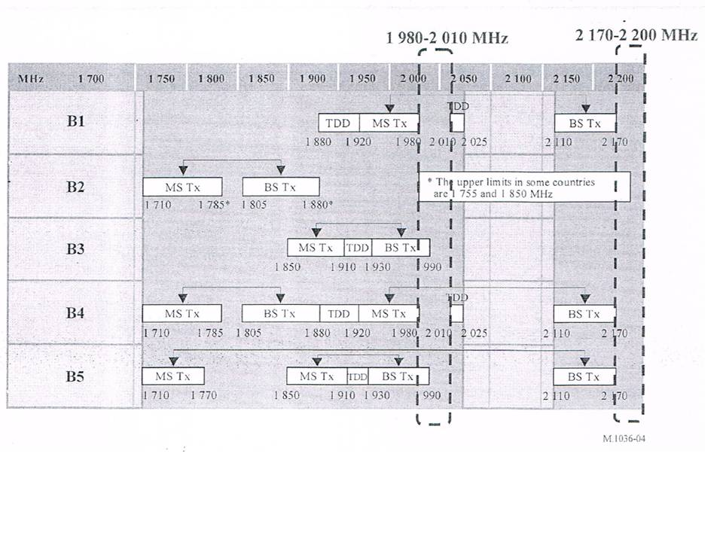

Tonga
Answer (Q1):
 | Service | Applications | Commercial  Operator | License duration
1 | Fix, Mobile, Satellite mob | Satellite Mobiles | 2x Operators | 10 years
2 | Fix, Mobile, Satellite Mob. | Satellite Mobiles | 2x Operators | 10 years
The above assignments are with respect to our National Spectrum Plan.
Answer (Q2): There are two carriers are utilizing these Bands

Vanuatu
Answer (Q1): Both spectrum bands were previously used by Telecom Vanuatu Limited (TVL) for fixed service. The two bands have since been vacated with TVL’s move to higher capacity spectrum band (7GHz band). One link remains in the 2170-2200 MHz band, which it advises, will be vacated soon.
 | Spectrum band MHz | Service | Applications | Commercial Operator | License duration
1 | 1980-2100 | None | NA | NA | NA
2 | 2170-2200 | Fixed | Backhaul | TVL | 2023
Answer (Q2): See answer to Question 1 above. Most of the spectrum in these bands was used by TVL prior to 2008 for fixed service. That spectrum was re-allocated/re-assigned to TVL in 2008 when its monopoly was broken, paving the way for competition. TVL was re-issued with an operator’s licence which expires in 2023. Whether TVL is planning to use the vacated spectrum for the deployment of next generation mobile broadband services or not is not clear, but they still have a legal right to that spectrum.
  - Viet Nam
Answer (Q1):
 | Frequency | Allocations | Applications
1 | 1 980- 2 010 | Fixed  MOBILE  MOBILE-SATELLITE  (Earth-to-Space) | Identified for IMT
2 | 2 170-2 200 | Fixed  MOBILE  MOBILE-SATELLITE  (Space-to-Earth) | Identified for IMT
Answer (Q2):
There are no commercial services currently in the bands 1980-2010 MHz and 2170-2200 MHz in Viet Nam.

APT member’s future plan in this band
Question 3: Do you have planned or potential future services and applications in the bands 1980-2010 MHz and 2170-2200 MHz? (Yes / No)
If you answered “Yes” to Question 3 above, please answer the Question 4.
Question 4: What is/are planned or potential future services and applications in the bands 1980-2010 MHz and 2 170-2 200 MHz?

Australia
Answer (Q3): Yes, the bands 1 980–2 010 MHz and 2 170–2 200 MHz are currently being used for television outside broadcasting (TOB) (see IFC 11/2012 ) while under consideration for mobile broadband services (see: IFC 13/2011).

Answer (Q4):
 | Planned/Future services and applications | Timeline
1 | Mobile broadband | No time frame set

Bangladesh
Answer (Q3): Yes
Answer (Q4):
 | Planned/Future services and applications | Timeline
1 | 1985-1990 MHz for CDMA | Existing
2 | 2170-2200 MHz for IMT Satellite | Not yet palnned.

Cambodia
Answer (Q3): No

China
Answer (Q3): Yes, the bands 1 980–2 010 MHz and 2 170–2 200 MHz are currently being used and planned for MSS application exclusively. Within several years, at least two more satellites using these bands are planned to be launched, and they are expected to work together with “TianTong-1”, providing service with larger coverage and better quality.
Answer (Q4):
 | Planned/Future services and applications | Timeline
1 | Mobile-Satellite Service | Existing

Japan
Answer (Q3): Yes.
Answer (Q4): Details of the usage for future services is under consideration/study in Japan.

Republic of Korea
Answer (Q3): Yes
Answer (Q4): Korean government announced the “K-ICT Spectrum Plan” on January 18, 2017. The purpose of the plan is to secure more than 4,440 MHz bandwidth for mobile broadband services by2026. The plan includes ensuring additional 60 MHz spectrum (2x30MHz) to provide terrestrial IMT services by utilizing the bands 1 980-2 010MHz and 2 170-2 200MHz.

 | Potential future services and applications | Timeline
1 | Mobile service (Terrestrial IMT) | TBD
2 | Mobile satellite services | TBD

The future plan for the bands 1 980-2 010MHz and 2 170-2 200MHz considered by Korean government is shown in following figure:

UL: 1980 – 2010MHz (30MHz)
DL: 2170 – 2200MHz (30MHz)
Tx-Rx Frequency Separation: 190MHz

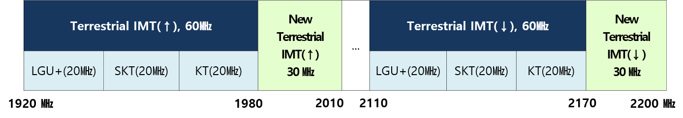
(Frequency bands for new 2.1GHz terrestrial operation in Korea)

HANSAT series satellite networks have been filed to the ITU in this band.

Federated States of Micronesia
Answer (Q3): No

Singapore
Answer (Q3): N/A

Thailand
Answer (Q3): No

Tonga
Answer (Q3): Yes, we are now assigning these two Bands
Answer (Q4):

Vanuatu
Answer (Q3): No, but we will monitor developments in the region and will consider and facilitate any plans that promote regional/international harmonization of services in these bands.

Viet Nam
Answer (Q3): Yes

Answer (Q4):

 | Potential future services and applications | Timeline
1 | IMT services | Has not decided yet.
In Viet Nam, the IMT-2000 core band (i.e. 1920-1980 MHz, 2110-2170 MHz) has been allocated to four mobile operators to deploy 3G WCDMA/HSPA systems for many years. It has been expected for Viet Nam to complete regulation on the permit of the implementation of 4G LTE, LTE-Advanced systems in t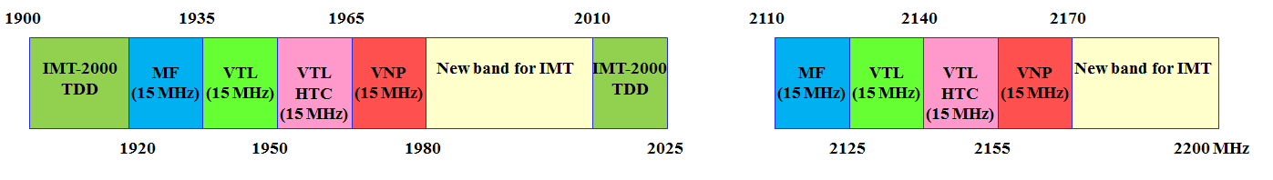he core band in the mid-year of 2017.

(Note: MF: MobiFone; VTL: Viettel; VNP: Vinaphone)
Band plan of 1900-2025 MHz, 2110-2200 MHz for IMT systems in Viet Nam
The adjacent bands (1980-2010 MHz, 2170-2200 MHz) are vacant for usage until now. Currently, Viet Nam government has identified this band to use for terrestrial IMT to facilitate and harmonize the efficient use of these bands in the updated revision of national frequency allocation table after WRC-15 conference.

Others (Issues to be considered for the use of this band)
Question 5: Do you have any issue to be considered for the use of the bands 1980-2010 MHz and 2170-2200 MHz? What is the issue?

Australia
Answer (Q5): The operation of television outside broadcasting (TOB) services in these bands is on a temporary basis while the band’s future use is considered. Licensees of TOB services will need advanced notice of any requirement to cease operation in these bands. This will require an appropriate relocation period to be given if the bands are to be made available for another use (such as mobile broadband).

Additionally, adjacent band sharing studies will need to be conducted with existing services and applications before the band could be allocated to another service.

Bangladesh
Answer (Q5): Potentiality of CDMA service needs to be considered.

Cambodia
Answer (Q5): None

China
Answer (Q5): Noting that there are FS, MS, and MSS for Primary allocation in the bands 1980-2010 MHz and 2 170-2 200 MHz in the Table of Frequency Allocations of Radio Regulations, an individual administration can decide whether or not these 2 GHz bands be used for FS, MS or MSS.

Satellite component of IMT is irreplaceable to provide global coverage and stable communication during disasters situation. The 1980–2010 MHz and 2170–2200 MHz frequency band is extremely important and known as “the golden band” for satellite component of IMT. Considering the important role and limited spectrum resource of satellite component of IMT, these bands are currently being used and planned for MSS application exclusively in China.

China supports to conduct ITU-R studies on possible technical and operational measures to ensure coexistence and compatibility between the terrestrial component of IMT and the satellite component of IMT in the frequency bands 1 980–2 010MHz and 2 170–2 200MHz in different countries. It should be noted that WP4C and WP5D are studying this issue, based on the result of these studies, WRC-19 may develop some technical, operational and regulatory measures to accomplish the co-operating between the satellite and terrestrial components of IMT in different countries. Thus, as stated clearly in the output meeting report of AWG 20, there is no necessity for AWG to duplicate similar compatibility studies being undertaken by other organizations especially the ITU-R, since APT countries would be well informed if information was received on the status of relevant studies being undertaken in ITU-R and also on the status of current and future usage of the bands. Moreover, the frequency arrangement of the bands 1 980-2 010 MHz and 2 170-2 200 MHz has been developed in Recommendation ITU-R M.1036-5, which may be further amended in accordance with the study results of WP4C and WP5D. Therefore, considering such compatibility and arrangement studies are still underway without definitive conclusions, it is not appropriate to develop any frequency arrangement of the bands 1980-2010 and 2170-2200 MHz in APT.

Japan
Answer (Q5):

Radio frequencies are limited natural resources and must be used efficiently in order to ensure that each APT Member could have equitable access to such frequencies. When handheld terminals with low gain antennas are deployed for mobile satellite systems in the 1 980-2 010 MHz and 2 170-2 200 MHz bands in different countries, it makes difficult to allow coexistence of these multiple satellite systems. In order to avoid such difficulties and to achieve co-existence, each APT Member should endeavor to minimize the use of these frequency bands and the coverage of its mobile satellite system for providing necessary services.
Japan believes that decision of frequency usage within its country made by each individual administration should be respected maximally. Thus, it should avoid such a situation that mobile satellite systems in these frequency bands by foreign entities not obtaining operational licences in a country impose undue constraints to provide other applications within that country. Coordination between those concerned administrations should be sought.
APT Members are invited to update their usages and/or plans of these bands annually for information sharing among the APT region.

Republic of Korea
Answer (Q5): It is noted that terrestrial IMT has been deployed or is being considered for further deployment within 1 980-2 010 MHz and 2 170-2 200 MHz frequency bands, as illustrated in Recommendation ITU-R M.1036-5. Regarding ITU-R and APG-19 activities, the Republic of Korea has a view that WRC-19 AI9.1 (issue 9.1.1) should be limited to possible technical and operational measures to ensure their coexistence, as addressed in Resolution 212 (Rev.WRC-15). Therefore the regulatory consideration in WRC is not required and satellite and terrestrial IMT in different countries could be coordinated through bilateral issue.

Federated States of Micronesia
Answer (Q5): None

Singapore
Answer (Q5): Yes, border coordination

Thailand
Answer (Q5): If there were guidance on spectrum arrangements and/or equipment standards for the bands, we could consider planning and implementing the use of the bands to utilize the spectrum efficiently, rather than leaving the bands vacant.

Tonga
Answer (Q5): None

Vanuatu
Answer (Q5): None

  - Viet Nam

Answer (Q5): The issues what need to be considered are ongoing sharing studies in APT/AWG meeting and ITU-R WP5D relating to these bands, especially international frequency coordination with neighboring countries in the cross border.

