

APT REPORT ON

APT FREQUENCY ARRANGEMENT ON 2300 – 2400 MHz FOR IMT/BMA

Edition: September 2012

The 8th APT Wireless Forum Meeting
29 March - 01 April 2010
Tokyo, Japan

No. APT/AWG/REP-12

Adopted at

The 8th APT Wireless Forum Meeting
29 March – 01 April 2010
Tokyo, Japan

First Revision at

The 13th APT Wireless Group Meeting
12 – 15 September 2012
Da Nang, Socialist Republic of Vietnam

(Source: AWG-13/OUT-22)

 | ASIA-PACIFIC TELECOMMUNITY
 | The APT Wireless Group (AWG-13)

Source: AWG-13/OUT-22(Rev.1)

PROPOSED REVISION TO APT REPORT ON APT FREQUENCY ARRANGEMENT ON 2 300 – 2 400MHz FOR IMT/BWA

TABLE OF CONTENTS

1 Introduction 1
2 Scope 1
3 Vocabulary of terms 1
4 References 1
5 Current usage and future plan of the band 1
5.1. ITU-R allocations 2
5.2. China 2
5.3. Malaysia 3
5.4. Republic of Korea 3
5.5. Viet Nam 4
5.6. Thailand 5
6 Consideration on the frequency arrangement in APT for IMT/BWA 5
6.1. Frequency arrangement 5
6.1.1. ITU-R WP-5D 5
6.1.2. APT Members 6
6.2. Duplex method 6
6.3. Channel bandwidth 6
6.4. Spectrum emission masks: 6
6.5. Licence conditions 6
7 Consideration of the frequency arrangement in Industry Views 7
7.1. View 1 7
7.2. View 2 8
8 APT Regional View 10

1 Introduction
The band, 2 300-2 400 MHz was globally identified for IMT at WRC-07 in accordance with the Footnote 5.384A. Consequent work was defined in the Resolution 223 (rev. WRC-07) indicated that ITU-R is invited to study the implications of sharing of IMT with other applications and services and the implementation, sharing and frequency arrangements of IMT in the band 2 300-2 400 MHz and to develop harmonized frequency arrangements for the 2 300-2 400 MHz band for operation of the terrestrial component of IMT, taking into account the results of the sharing studies. For those purpose, ITU-R Working Party 5D as the responsible group of IMT spectrum and standardization in ITU-R has initiated the update of frequency arrangements of bands identified for IMT at WRC-07 by modifying the Recommendation ITU-R M.1036-3 .

The band 2 300-2 400MHz is being used or is planned to be used for mobile broadband wireless access including IMT technologies in a number of Asia Pacific countries, and thus the frequency arrangements in the band need to be developed as a matter of urgency for Region 3 in order to maximize additional benefit from harmonized use of the band.

2 Scope
This Report covers aspects related to the use of the 2 300-2 400MHz band. The objective is to identify current usage and future plan of 2 300-2 400MHz in Asia Pacific countries including technical conditions and license conditions and based on such identification to develop possible harmonized frequency arrangement on 2 300-2 400MHz for IMT/BWA within this Region.

3 Vocabulary of terms
IMT International Mobile Telecommunications
WRC World Radiocommunication Conference
BWA Broadband Wireless Access

4 References
Recommendation ITU-R M.1036-4 – “Frequency arrangements for implementation of the terrestrial component of International Mobile Telecommunications-2000 (IMT-2000) in the bands 806-960 MHz, 1 710-2 025 MHz, 2 110-2 200 MHz and 2 500-2 690 MHz”;
Resolution 223 (Rev.WRC-12) – “Additional frequency bands identified for IMT”;
Recommendation ITU-R M.1580-4 – “Generic unwanted emission characteristics of base stations using the terrestrial radio interfaces of IMT-2000”;
Recommendation ITU-R M.1581-4 – “Generic unwanted emission characteristics of mobile stations using the terrestrial radio interfaces of IMT-2000”;
APT Report (APT/AWF/REP-10) – “Characteristics and requirements for Broadband Wireless Access Systems".5 Current usage and future plan of the band
In order to collect information on current usage and future plan, a Survey Questionnaire on APT Frequency Arrangement on 2300-2400 MHz band was used which includes the following questions:
Question 1: What is/are current allocations (e.g. Mobile service, Fix service, Radiolocation, etc.) in the band 2300-2400 MHz in your country?
Question 2: What application(s) (e.g. Microwave relay, Radiolocation radar, LTE TDD, WiMAX, etc.) are currently licensed in the 2300-2400 MHz band? Which frequency portion is used for each application?
Question 3: What is/are your future application(s) and corresponding frequency arrangement(s) planning on 2300-2400 MHz band (e.g., channel bandwidth, block size, guardbands, duplex method: TDD or FDD etc )?
Question 4: What are emission mask, in-band power constraints, block edge mask applicable to the future application(s)?
Question 5: What is license condition (e.g., service type, technology type, nationwide or regional license etc) applicable to the future application(s)?
Question 6: What is your transfer timetable for existing applications that will be refarmed?

The following summarize information on the current usage and future plan of the band:

5.1. ITU-R allocations
In the Radio Regulations, edition 2008, the frequency band 2300-2400 MHz is allocated in three Regions as follows:
Table 1: ITU-R allocations in 2300-2400 MHz
Allocation to services
Region 1 | Region 2 | Region 3
2 300-2 450  FIXED  MOBILE 5.384A  Amateur  Radiolocation | 2 300-2 450  FIXED  MOBILE 5.384A  RADIOLOCATION  Amateur
The provision 5.384A of Radio Regulations states :
“The bands, or portions of the bands, 1 710-1 885 MHz, 2 300-2 400 MHz and 2 500-2 690 MHz, are identified for use by administrations wishing to implement International Mobile Telecommunications (IMT) in accordance with Resolution 223 (Rev.WRC-07). This identification does not preclude the use of these bands by any application of the services to which they are allocated and does not establish priority in the Radio Regulations. (WRC-07)”.

5.2. China
In China, the whole band is is currently used by Radiolocation services. However, in 2002, China allocated the band 2 300- 2 400MHz to IMT system following traditional specific frequency arrangement.
Following this allocation, China Mobile plans to set up a network based on LTE TDD technology in this band and provide IMT services based on LTE TDD technology during the World Expo 2010 Shanghai China. Further activities are also being made to promote the IMT TDD application on this frequency band.
China believes that LTE TDD, the Long Term Evolution of TD-SCDMA, will provide the capability to operate in spectrum allocations of different bandwidth including wider spectrum allocations, for instance, up to 100 MHz, to achieve higher service-related and technical requirements, with high spectrum efficiency, reasonable BS and UE complexity. The advanced system will also support co-existence and interworking with legacy radio access technologies, and provide scalable, flexible and efficient usage of the spectrum, in this frequency band. The band 2 300 - 2 400 MHz had been introduced in LTE TDD industry standard in 3GPP, considering the future development of TDD systems.
With the support from Chinese communications industry, the Chinese government has been organizing the TD-LTE test and verification. It is hoped, via the test, to promote the TD-LTE R&D, to solve the important technical problems, to strengthen the industry chains, and to expand the international TD-LTE market. The test includes three stages: Phase 1 is the Proof of Concept (PoC), which has finished recently. Phase 2 is the R&D Technical Experiment. Phase 3 is the Scaled Trial. All the field tests are carried out in the 2300-2400MHz band. In addition, China Mobile has set up a TD-LTE demo network on 2300-2400MHz band and held successful performance demonstrations during the NGMN Board meeting held in Beijing in May 2009.

5.3. Malaysia
In Malaysia, the Malaysian Communications and Multimedia Commission (SKMM) has awarded, in March 2007, the spectrum to 4 companies via beauty contest tender. The spectrum is intended for Broadband Wireless Access (BWA) service. The spectrum holders has opted to deploy its broadband service using WiMAX technology (i.e. IEEE 802.16-2004 or IEEE 802.16e-2005) based on 10MHz channel bandwidth.
Currently, some of the spectrum holders are aggressively deploying the WiMAX networks and one of them is planning to commercialise WiMAX voice service after successfully launched and commercialised its WiMAX broadband service.
The frequency arrangement for 2300MHz-2400MHz band consists of 20 sub-blocks with the size of 5MHz per sub-block. The chosen duplexing method is TDD. The figure 1 below shows the channelling plan that has been adopted in Malaysia.
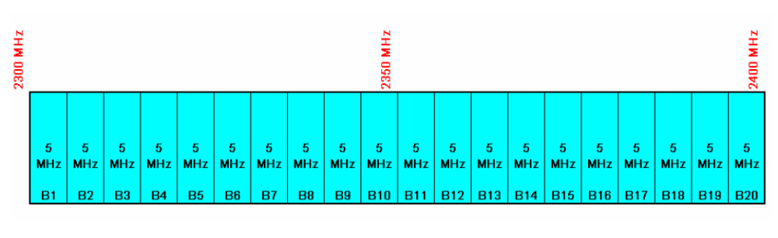
Figure 1. Channelling plan for 2300-2400 MHz in Malaysia
SKMM (Malaysian Communications and Multimedia Commission) encourages self-regulation on the usage of the spectrum and will assist the WiMAX operators if there is a need for interference resolution. As such, all operators are encouraged to coordinate among themselves to achieve optimum spectrum efficiency of their allocated spectrum. Such initiatives have been initiated such as to harmonise TDD UL/DL ratio and to synchronize their network.

5.4. Republic of Korea
In Korea, the band is currently allocated to MOBILE service and the portion 2300 MHz – 2358.5MHz is being used for Mobile WiMAX(IEEE 802.16e-2005), WiBro, systems. The frequency allocation as follow:
Table 2: Allocations in Korea in 2300-2400 MHz
Frequency Portion | Applications
2300 MHz – 2358.5MHz | Mobile WiMAX(IEEE 802.16e-2005)
2363 MHz – 2390 MHz | Reserved
2390 MHz – 2400 MHz | Guardband

In December 2009, Korean administration has revised the regulation to allow 10MHz bandwidth in addition to existing 9 MHz bandwidth, considering global roaming in this band. Therefore, WiBro service operators can deploy two profiles simultaneously. The frequency arrangement of 2300 – 2400MHz in Korea is illustrated in the Figure 2. 4.5MHz guard band between operators is required for the case of 9 MHz bandwidth. For the case of 10MHz bandwidth, no guard band is required as long as there is frame synchronization.To operate 9 MHz and 10MHz bandwidths simultaneously, additional technical condition for coexistence is necessary.

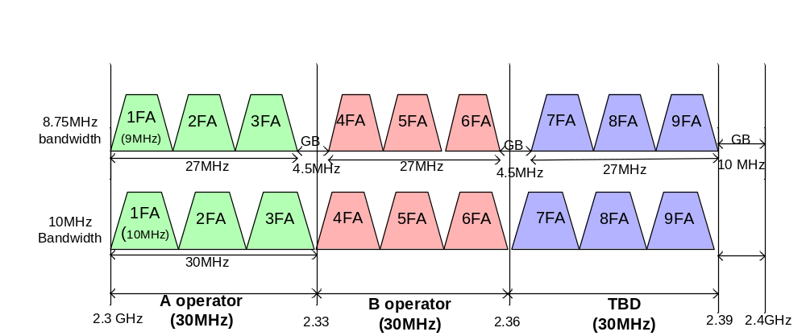
Figure 2. Frequency Arrangement of WiBro in Korea

Even though there are 100MHz available bandwidth for WiBro services, the spectrum of 90MHz are available for the eligibility of services since any portion of bandwidths are un-used to protect incumbent services next to this WiBro spectrum and to protect to different operators in WiBro spectrum block. Conservatively, the 10MHz are used for this guard band purpose between WiBro spectrum and 2.4GHz ISM band. Technical regulations of spectrum mask follow Recommendation ITU-R M.1580-3 for Base Station and ITU-R M.1581-3 for Mobile Station. APT Report (APT/AWF/REP-10) on “Characteristics and Requirements for Broadband Wireless Access Systems” also has information.

5.5. Viet Nam
In Viet Nam, the band is allocated to fixed, mobile and radiolocation services and is being used mainly for fixed and mobile services. Under the fixed service, microwave systems have been being used in rural areas. However, since 1996, microwave operators were encouraged to move to higher frequency bands that resulted in their usage is decreasing in the band 2300-2400 MHz. Under mobile service, 8 operators have been granted licenses to implement their trials of Mobile WiMAX across the country.
Following the WRC-07’s IMT identification, in its revised National Allocation Table which was approved by the Prime Minister in Oct 2009, the band 2300-2400 MHz will be used for IMT or Broadband Wireless Access systems. New deployments of system belonging to other services are not allowed.
On 24th November, 2010, MIC minister promulgated the frequency arrangement for the band 2300-2400 MHz, which enforce on 1st February, 2011 as below.
A
B
C
2300 MHz
2330
2360
2390
2400

Figure 3. Option 2 of frequency arrangement in Viet Nam
- The band 2300 – 2400 MHz is divided into 3 blocks A, B, C for 3 operators. Each block is 30 MHz.
- 10 MHz (from 2390 – 2400 MHz) guard band between BWA and other systems in the band 2400 – 2483.5 MHz.

5.6. Thailand

In Thailand, the fixed service is allocated in the band 2300-2400 MHz. Currently, microwave relay is licensed in that band. For future, Thailand is considering to use the band for WBA TDD systems.
Thailand is considering allocating this band for Broadband Wireless Access with technology neutrality. Duplex is TDD and channel bandwidth is based on 5 MHz cluster.

6 Consideration on the frequency arrangement in APT for IMT/BWA

6.1. Frequency arrangement

6.1.1. ITU-R WP-5D
In Recommendation ITU-R M.1036-4, frequency arrangements are recommended for the implementation of IMT in the band 2300-2400 MHz. . The details are shown in Table 3 and Figure 5 below:

Table 3. Frequency arrangements in the band 2 300-2 400 MHz in Recommendation ITU-R M.1036-4
Frequency arrangement | Paired Arrangements |  |  |  | Un-paired arrangements (e.g. for TDD) (MHz)
Frequency arrangement | Mobile station transmitter  (MHz) | Centre gap  (MHz) | Base station transmitter  (MHz) | Duplex separation  (MHz) | Un-paired arrangements (e.g. for TDD) (MHz)
E1 |  |  |  |  | 2 300 – 2 400 TDD

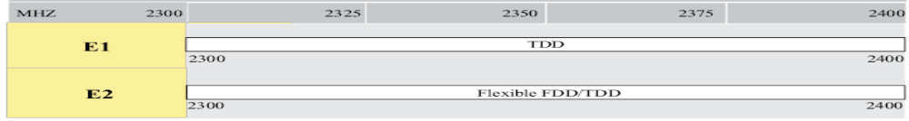
Figure 4. Frequency arrangement in 2300-2400 MHz

6.1.2. APT Members
Frequency arrangements for current or future usage of the band 2300-2400 MHz for IMT/BWA in some APT countries are summarized in table below:

Country | Frequency Portion | Applications | Dulplex method | Channel Bandwidth | Block Size | Guardband between adjacent blocks | Guardband at 2300 MHz edge | Guardband at 2400 MHz edge
 | (MHz) |  |  | (MHz) | (MHz) | (MHz) | (MHz) | (MHz)
Viet Nam | 2300-2400 | Mobile networks | TDD | 5, 10 | 30 | 2.5/5 (option 1)  0 (option 2) | 0 | 5 (option 1)  10 (option 2)
China | 2300-2400 | IMT | TDD | - | - | - | - | -
Korea | 2300-2400 | Mobile WiMAX | TDD | 9, 10 | 27, 30 | 4.5, 0 | 0 | 10
Malaysia | 2300-2400 | BWA | TDD | - | 5 | 0 | 0 | 0
Thailand | 2300-2400 | BWA | TDD | 5 | - | - | - | -
Table 4. 2300-2400MHz usage in APT countries

6.2. Duplex method
As shown in the table 4 above, the 2 300-2400MHz band is mostly used for TDD mode.

6.3. Channel bandwidth
Channel bandwidth can be summarized into 5MHz, 9MHz and 10MHz considering current usage of some Asia Pacific countries.

6.4. Spectrum emission masks

Vietnam and Thailand consider using emission masks based on Recommendations ITU-R M.1580-3 for base station and ITU-R M.1581-3 for mobile station. In addition, the Republic of Korea implements the spectrum emission mask specified in the Annex 6 to these Recommendations for WiBro technology.

6.5. Licence conditions

The band is considered to be used for IMT/BWA. Technology neutrality or specific technical conditions are defined as licence condition to suit local requirements. For example, Thailand is considering assigning licences with technology neutrality. On the other hand, Vietnam is planning to assign nationwide licences for IMT. In the case of Korea, nationwide WiBro licences were awarded with a 7 year term right after spectrum allocation in March 2005. It was also specified that the existing service in 2 300 – 2 400MHz, Subscriber Radio, should be moved to other bands if interference occurs.

7 Consideration of the frequency arrangement in Industry Views

7.1. View 1
The WiMAX Forum’s recommendation on frequency arrangement for the band 2300-2400 MHz is as follows:
Frequency Portion | Dulplex method | Channel Bandwidth | Block Size | Guardband between adjacent blocks | Guardband at 2300 MHz edge | Guardband at 2400 MHz edge
(MHz) |  | (MHz) | (MHz) | (MHz) | (MHz) | (MHz)
2300 -2390 | TDD | 10 or higher | Multiple of 10MHz, at least 30MHz is recommended. | Guardband between adjacent operators:  - for synchronized case,  - a single channel for unsynchronized case

Regulatory requirement for base station
For Base Station (BS), regulatory requirements such as spectrum mask are usually defined by local or regional regulations.
With the purpose of providing guidance to Administrations, the WiMAX Forum has defined a BS channel mask for 2300-2400MHz as in annex 6 of Recommendation ITU-R M.1580-3.
Regulatory requirement for Mobile Station
The WiMAX Forum has defined MS spectrum emission mask for 2300-2400MHz as defined in annex 6 of the Recommendation ITU-R M.1581-3 in order to facilitate global roaming and circulation guidance to Administration. The spectrum emission mask addresses all known applicable regional requirements to facilitate multi-regional roaming.
The WiMAX Forum supports the principle that frequency bands should be utilized in a technology and service neutral manner. This allows license holders to choose the most appropriate services and technologies for their business as long as those services and technologies meet the regulatory requirements. However, WiMAX Forum also notes that global standardisation is an important consideration for the cost-effective services and future proof of migration.
The WiMAX Forum also prefers a nation-wide license award as it leads to more spectrum efficient frequency planning for the deployment of networks. However, the WiMAX Forum understands the need to take into account specific local circumstances in frequency planning for such nation-wide license awards.
The WiMAX Forum supports initiatives to get spectrum to market in a timely manner to offer broadband service.

7.2. View 2

It is suggested that with the aspects below included in frequency arrangement on 2300-2400 MHz in APT:
- unpaired operations only should be considered, and no mixing of FDD and TDD access schemes in any country;
- a channel raster of 5 MHz should be considered for implementation; while utilizing 5 MHz, 10 MHz, 15 MHz and 20 MHz channel block bandwidths;
- a guard band may be needed between the usage in the band 2300 – 2400 MHz and other usages in the band 2400 – 2483.5 MHz due to the induced emissions below 2400 MHz from other systems, such as RLAN;
- however, a guard band may not be necessary if IMT usages are foreseen in situations where other usages, such as RLAN, in the band 2400 – 2483.5 MHz are not present;
- a possible need for guard band at or below the frequency 2300 MHz needs to be considered;
- the IMT base station Tx power should not be unreasonably low as this will multiply the need for base station sites, proposing that:
  - at the first adjacent channel the emissions should be limited to 4 dBm/MHz, and
  - at the second adjacent channel the emissions should be limited to - 45 dBm/MHz;
- carrier aggregation using TDD inter-band non-contiguous spectrum could be combining the bands 2.3 GHz and 2.5 GHz, for example, 20 MHz in the band 2300 – 2380 MHz, and 20 MHz in the band 2570 – 2620 MHz, that is two, or more, basic carriers are combined into a wider resulting channel, and
- from a spectrum efficiency point of view only a cell sector reuse one (1:1) factor should be considered as reuse factor of 1:1 is always more efficient than 1:3.
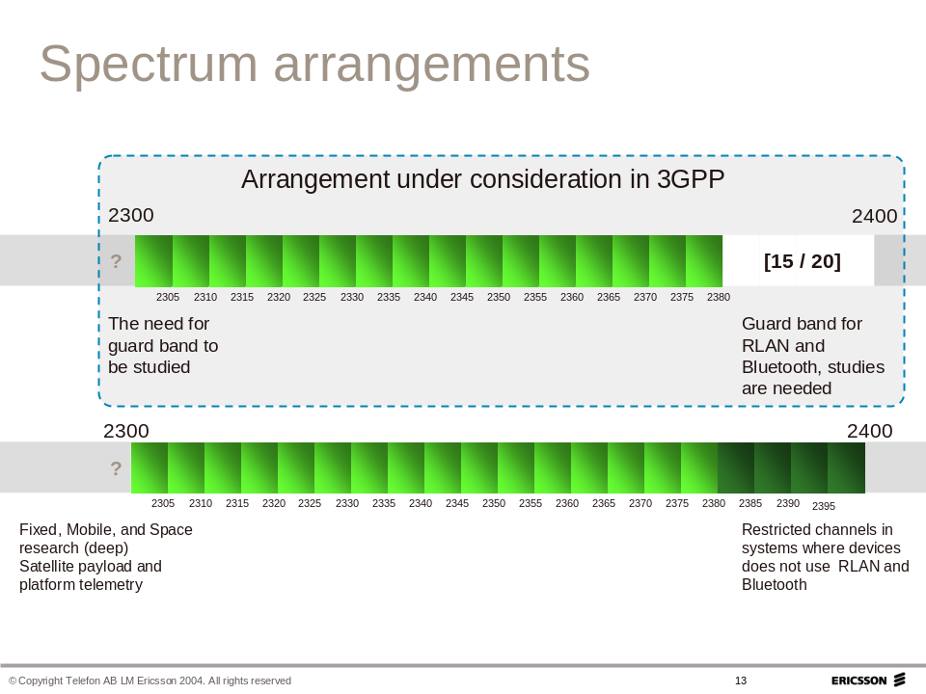

Figure 5. Frequency arrangements being considered in 3GPP

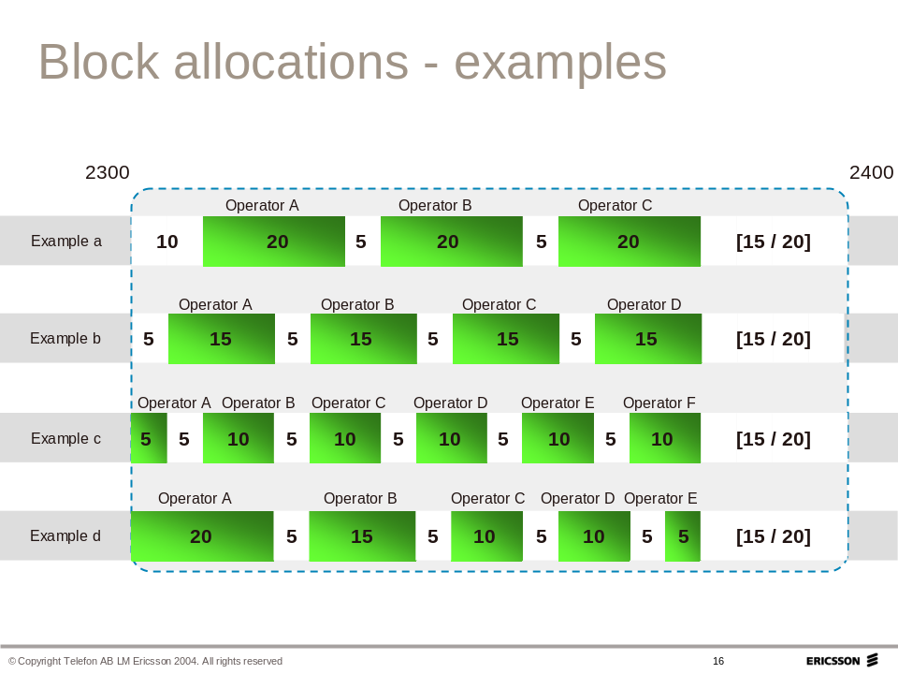
Figure 6. Example of frequency arrangementn in 2300-2400 MHz

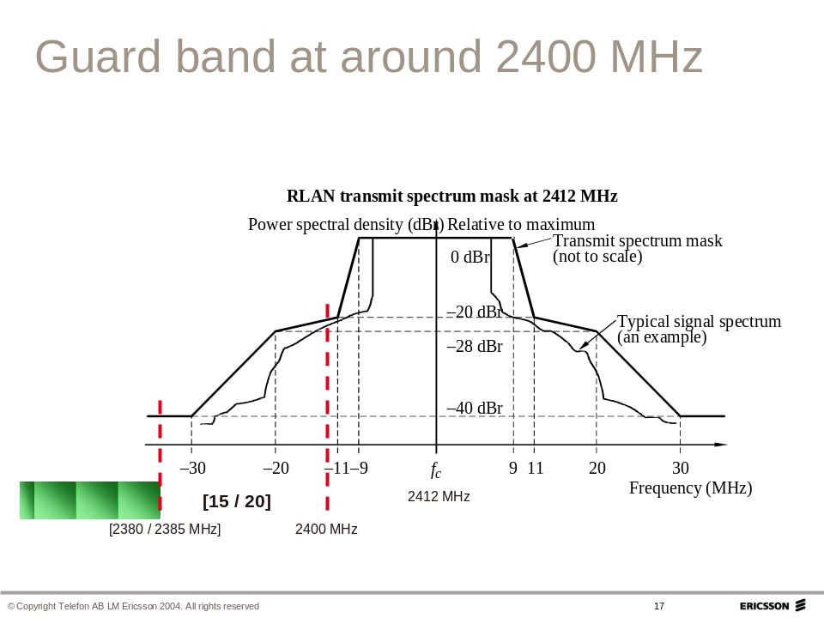
Figure 7. Guard band at 2400 MHz edge

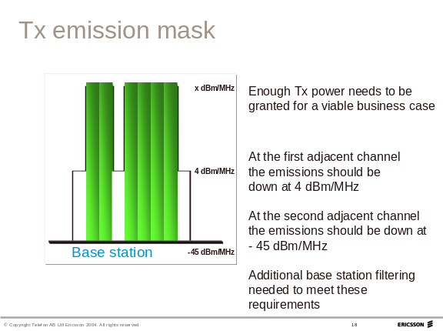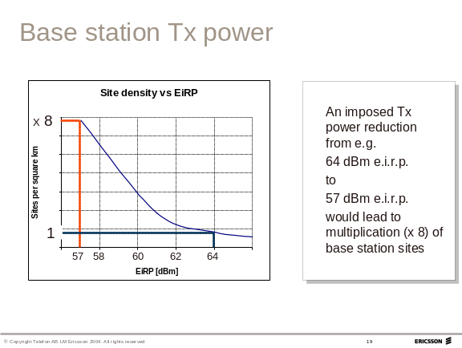

Figure 8. Base station transmitting power mask

8 APT Regional View
Considering the responses of 2300-2400 MHz Questionnaire from APT member countries, AWF recognizes the followings as APT Regional View on the frequency arrangement in the band 2300-2400MHz:
- Full TDD arrangement is preferred. However, flexible FDD/TDD arrangement is also considered for administrations that are required to meet local conditions.
- Channel raster of 5MHz and 9 MHz are used.
- 10MHz or wider/narrower guard band to 2.4GHz ISM band is considered.

Illustrations for band plan options based on the views are as follows:
- Option 1: Full TDD without specific arrangement
- Option 2 : implementation of 5MHz channel raster
It is noted that in Option 2, the guard band at 2400 MHz edge could be wider/narrower than 10 MHz.

- Option 3: implementation of 9 MHz channel raster
  - Case A : 9 MHz only
  - Case B : 9 MHz and 10MHz
    - Technical condition for coexistence between 9 MHz and 10MHz is being considered.
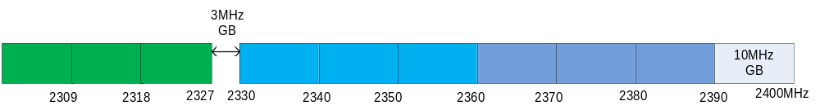
- Option 4: Flexible FDD/TDD

Specific references for footnotes can be found in the Radio Regulations, 2008 Edition
See invite ITU-R 1 and invite ITU-R 2 in the Resolution 223(rev. WRC-07)
Recommendation ITU-R M.1036-3: Frequency arrangements for implementation of the terrestrial component of IMT-2000 in the bands 806-960 MHz, 1 710-2 025 MHz, 2 110-2 200 MHz, and 2 500-2 690 MHz.
TDD clock and DL-UL ratio synchronizations among TDD operators
As a guard channel (or restricted use channel) between adjacent unsynchronised networks, it provides sufficient isolation to inter-network interference. Restricted use (e.g. power indoor use) can be included. This single channel can be included within overall assigned blocks increasing the flexibility without reducing overall spectrum utility.

