**APT REPORT ON**

**SPECTRUM MONITORING TECHNIQUES AND METHODS UNDER MULTIPATH ENVIRONMENT**

**Edition: September 2020**

**The 26th Meeting of APT Wireless Group**

**14 – 18 September 2020**

**Virtual Meeting**

***(Source: AWG-26/OUT-05)***

**No. APT/AWG/REP-102**

**APT REPORT ON**

**SPECTRUM MONITORING TECHNIQUES AND METHODS UNDER**

**multipath ENVIRONMENT**

1. **Introduction**

This report consolidated the technical studies on propagation phenomenon under multipath environment, the influence to the spectrum monitoring system and the technologies and techniques utilized to reduce or mitigate the multipath fading effect, as well as the case studies which described the features of specific spectrum monitoring system and also demonstrate the operation in the experimental or real environment, based on the input from APT members.

It aimed to provide fruitful information and technical solutions to the APT Members to meet the demands to deploy and operate spectrum monitoring facilities in the urban and suburban area, where mainly could be considered as the multipath environment.

1. **The studies on radio wave propagation under multipath environment**

**2.1 Concept of radio waves propagation in multipath environment**

The concept of multipath propagation of radio waves refers to the propagation of radio waves from the transmitter antenna along two or more paths to the receiver antenna.

**2.2 Formation principle of the multipath propagation of radio waves**

Normally, simulation and experimental statistics methods are used in studies on the characteristics of the radio waves reflection and diffraction by different media as well as multipath propagation in various frequency bands.

Space waves is the main propagation way for radio waves traveling in space, which could be categorized as direct wave, reflected wave, refraction wave, diffracted wave and the synthetic wave. When radio wave encountered the object or on the surface of different mediums, reflection, refraction or scattering phenomena could be seen, therefore, one point could receive multiple space waves emitted by one transmitter which went through different paths. This is the principle of multipath propagation.

The received signal under multipath environment could be considered as the vector synthesis of direct wave and multiple reflected waves. Due to atmospheric refraction changing with time, the difference of propagation path will also change with time and topography. For two signals, if they are in phase, the amplitude of combined signal will increase, and if the two signals are out of phase, the amplitude of combined signal will be reduced. Therefore, the amplitude changes of receiver signal caused by multipath will be called multipath fading.

**2.3 Characteristics of radio waves propagation in multipath**

In general, the impact to spectrum monitoring system under multipath environment was caused by radio wave fading, group delay and wave-front distortion.

The mainly influence to spectrum monitoring system under multipath environment is determined by the spectrum distortion of the received signal, which is relevant to time delay characteristics and could be described by the time delay spectrum or the multipath dispersion spectrum (that is, the spectrum composed of the average power of the signal components vs time delays). The frequency correlation function is equivalent to the time-delay spectrum. In fact, to simplify the expression, one characteristic quantity of time delay spectrum could be used. For example, the difference between the maximum delay and the minimum delay is used to characterize the sharpness of the delay spectrum and the channel permitted transmission bandwidth. When the difference is smaller, the permitted transmission channel band will be wider.

Multipath will cause amplitude fading and phase shifting of received signal. Usually, Rayleigh fading channel and Rice Fading channel were used to describe the radio wave environment. Rayleigh fading could be used in non-line of sight (non-LOS) condition and otherwise Rice Fading should be used.

The characteristics of multipath channels can be described by the following parameters: time dispersion parameters, bandwidth, Doppler spread, coherent time and fading.

* + **Time dispersion**: caused by the propagation path of reflection and scattering. The multipath effect will extend waveform of the digital signal in time domain.
  + **Correlation bandwidth**: a statistical measurement of frequency in a certain range, in which all spectral components pass through the channel with almost the same amplitude and linear phase. In other words, coherent bandwidth refers to a specific frequency range, in which the two frequency components have a strong amplitude correlation.
  + **Doppler broadening**: the broadening of spectral lines in frequency domain due to the Doppler effect, representing the rate of time variation in mobile wireless channels and could be expressed by the statistical measurement results.

**Coherent time**: the expression of Doppler broadening in time domain and could be used to describe the time-varying characteristics of channel frequency dispersion. It is inversely proportional to frequency domain.

1. **The influences to spectrum monitoring and radio location system**

**3.1 Influences to spectrum monitoring system**

*[Editor’s note: The multipath effect will cause error to the measurement of amplitude, including signal level, field strength and power flux density, measurement of frequency and bandwidth, as well as measurement of modulation parameters.]*

Under multipath environment, the monitoring station may receive the radio waves from different paths, such as the direct wave (line-of-sight path) from the transmitter, scattered waves and reflected waves, as well as reflected waves from the Fresnel zone. Some factors will influence the strength and phase of the scattered waves, including the shape of the scatterer, the characteristics of the medium, the polarization of the electric field, the angle of incidence. It also noted that multiple reflections exist in one propagation path under certain conditions.

In the receiver of monitoring station, the electric field strength being the vector synthesis of multiple multipath signals, could be expressed as the following equation:

$$\overset{⃑}{E_{Σ}}=\sum_{k=1}^{k}{ρ_{k}e^{-j\left(2π\frac{Δl_{k}}{λ}+ϕ_{rk}\right)}}cosα_{k}$$

Where is,

$ρ_{k}$: Rice Factor of the kth multipath incidence wave, $ρ_{k}=\frac{A^{2}}{{δ_{k}}^{2}}$, represents the direct wave energy divided by reflected wave energy. It is related to multipath wave length and reflection coefficient.

$Δl_{k}$: path difference of the kth multipath incidence wave and direct wave. $Δl_{k}=l_{k}-l_{1}$, $l_{1}$ is distance that direct wave went through, $l_{k}$ is the distance that kth wave went through;

$ϕ_{rk}$: the coefficient phase of kth multipath reflection wave.

$α_{k}$: the polarization angle between electric field of the kth multipath reflection wave and received antenna.

The accuracy and capability of spectrum monitoring system will be affected under multipath environment, because the multipath effect will cause fast fading, polarization rotation, delay spread, phase shift and random Doppler frequency modulation to the received signal. Therefore, the multipath influence should be considered in the course of determination of monitoring site, especially in the urban area, and usually, the monitoring site with good sight vision and less obvious obstacle in the horizon plane is suitable for the installation of the monitoring facilities, considering the influence of the multipath effect on the monitoring antenna will be reduced. However, even in this condition, if some objective exist in the Fresnel zone, then the multipath effect should be considered.

**3.2 Influences to radio location system**

**3.2.1 Direction finding system**

The distortion of isophase plane at the direction finding antenna array will be caused by the synthesis of multipath signals, which produces error of the phase difference between the array elements and lead to error of the direction finding. Considering that the incident angel and strength of multipath signals to each element of antenna array will be different, due to different position of the element in the antenna array, the phase of the synthesis signal received by the element will change. Therefore, the vector signal received by the antenna will related to the factors, including amplitude and delay of each single path, arrived angel and the structure of array antenna.

To simplify, the multipath environment could be categorized into four scenarios:

1. Scatterers near the transmitter and existing line-of-sight path

transmitter

Antenna

Array

Scatterer

Figure 1. Scenario 1 of multipath environment

The scatterers are near the transmitter and far away from the antenna array. The angle between the multipath signals and the direct wave is small and the Rice factor is large. Thus, each array element can receive the multipath signal of the same path and the result of direction finding is basically accurate, sometimes, there is disturbance in the direction finding results.

1. Scatterers near the monitoring antenna array and existing line-of-sight path.

transmitter

Antenna

Array

Scatterer

Figure 2. Scenario 2 of multipath environment

The angle between the multipath signals and direct wave is larger. The multipath signal paths received by array elements are different and some element may be significantly influence by the multipath effect, including large amplitude fading and phase deviation in the wavefront. In this condition, the result of direction finding is roughly accurate, and there is a large disturbance in the direction finding result. In some directions, the error of direction finding will be significant, due to the effect caused by Scatterers.

1. scatterers in Fresnel zone and existing line-of-sight path

transmitter

Antenna

Array

scatterers

Figure 3. Scenario 3 of multipath environment

The angle between the multipath signals and direct wave is larger. Each array element can receive both the direct wave signal and the reflected signal. If the reflection coefficient is big, the error of direction finding result may be considerable. In general, the direction finding result is basically accurate when the multipath medium has a reflection coefficient modulus lower than 0.7.

1. Scatterers in the Fresnel zone and no line-of-sight path

Transmitter

Antenna

Array

Scatterers

obstacle

Figure 4. Scenario 4 of multipath environment

The monitoring antenna array can only receive the reflected signals from the scatterers while the direct wave is blocked. In this condition, the result of direction finding is various in wide range and normally unreliable.

**3.2.2 TDOA system**

In urban or suburban areas and especially in the indoor environment, multipath signal propagation causes erroneous TDOA measurements. These TDOA measurements are usually calculated by the evaluation of cross correlating recorded signals from different receivers. Besides the line of sight signal, one or more reflected signals will arrive at the receiver with different time delay. This leads to wrong measurements for the distance between the emitter and the corresponding receiver pair, and thus results in errors to the emitter localization process.

TDOA measurements can be computed by looking at the maximum of the cross-correlation function of the signal received by a receiver pair. The discrete cross correlation function is defined as:

$$CCF\left(τ\right)=\sum_{n=-∞}^{+∞}{f^{*}\left(n\right)g(n-τ)}$$

where f(n) and g(n) are complex, discrete-time signals at sampling rate $f_{s}$ and $f^{*}(n)$ is the conjugate-complex of $f(n)$. By determining

$$\underset{τ}{argmax}{\sum_{n=-∞}^{+∞}{f^{*}\left(n\right)g(n-τ)}}$$

and by taking the sampling rate $f_{s}$ into account, the time difference of arrival of the signal between two receivers will be calculated (see Figure 5).

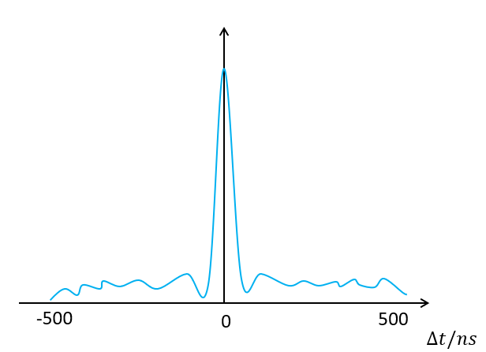

Figure 5. correlation function with maximum at $τ=0$

However, if one receiver receives not only a direct-path signal but also one or more multipath replicas of the signal, these multipath replicas will introduce multiple local maximum of the cross correlation function, Thus leads to wrong TDOA measurements (see Figure 6).

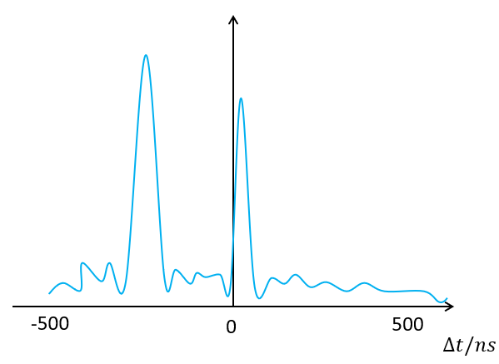

Figure 6. correlation function with multiple local maximum

1. **The studies on spectrum monitoring technologies**

**4.1 measures to be used in spectrum monitoring system**

Several measures may be used to reduce or mitigate the multipath effect.

**Diversity reception.** Several diversity reception technologies may be used, for example, polarization diversity technology, spatial diversity technology or the combination of diversity technologies. Polarization diversity technology is used to mitigate the effect caused by the polarization rotating of the signal and increase the capability of linear polarization monitoring antennas. Spatial diversity technology can reduce the large probability of fading caused by differential multipath at the monitoring point. To fully utilize the advantages of diversity reception technologies, it is also recommended to automatically select the appropriate monitoring antenna with highest signal to noise radio (S/I) from the antenna arrays in real time.

**Directional antennas.** Omnidirectional antenna was widely used in spectrum monitoring system for intercept, surveillance of interested signals with unknown directions and also suitable for the measurement of background noise, because it received the signals all directions in horizontal plane with almost same gains. However, under the multipath environment, the omnidirectional antenna can’t reduce the multipath signals. The directional antenna could be used to suppress the multipath signals if the main beam of the antenna is align with the direction of the interested signal. The effect to the suppress the multipath signals is directly proportion to the directivity of the receiving antenna. It should be noted that the efficiency of the spectrum monitoring may be reduced, because the directional antenna should be rotated to find out the arrival direction of interested signal.

**4.2 measures to be used in radio location system**

To conduct studies on direction finding and positioning techniques in multipath environment, it may include AOA, spatial spectrum estimation, TDOA and others. The multipath array processing techniques, such as array composition, array bandwidth, resolving capability, direction selectivity, arrays signal processing technology, multipath suppression technology, etc.

**Large aperture antenna array**: The advantages of large aperture antenna array are high direction resolution, high processing gain, wider working bandwidth and more spatial sampling points, which improve the capability of the direction finding system to resist multipath interference. Studies have shown that the larger the aperture, the better the array's ability to resist wave-front distortion.

**Directional antenna**: using the directionality of the antenna elements to reduce the multipath signals. For the regular direction finding antenna, the elements of antenna array is omnidirectional antenna, receiving the direct wave, and the multipath signals even they came from lateral and backward directions, which make it vulnerable in the multipath environment. The Directional antenna elements, including logarithmic dipole antenna, horn antenna, planar spiral antenna, Yagi antenna, dipole antenna with reflector, could be used to establish a direction finding antenna array, such as interferometer line array and L array. The directivity of antenna will suppress multipath signals, especially the multipath interference from the lateral and backward directions of the monitoring station antenna array.

**Digital array signal processing techniques**: the development of digital signal processing technologies make it usable to address the multipath effect in modern directing finding and location system. The super-resolution direction finding algorithm was used to process the received signals from uniform/non-uniform linear antenna array, area antenna array and uniform circular antenna array to perform the direction finding of the multipath signals, joint utilization with several technologies, such as beamforming, interference zeroing and interference cancellation, to determine the direction of arrival of direct wave and multipath signals and identify the number of multipath signals above the limit.

**Mobile locating method:** As mentioned above, high performance equipment and advanced technologies can help to solve the direction finding and positioning issues in multipath environment. However, if the technical conditions are limited and hard to improve at short notice, it’s necessary to experiment more with direction-finding methods, in order to enhance the effect of direction finding at a lower cost.

Mobile locating is a common method, by using a monitoring vehicle move in a large range, and doing the continuous direction-finding in the meantime, in order to estimate the direction of signal source and draw near it. In the absence of monitoring vehicle, a common vehicle with a set of portable direction-finding system also can be used. The purpose of moving in a large range is to seek out the sites with little or no multipath fading effect, and obtain the valid results at these places. As this method doesn’t make excessive demands on technical conditions, the advantage of this method is its strong operability and lower cost. On the other hand, the disadvantage is its unstable direction-finding effect, especially in complex urban environments with plenty of buildings. Even so, the mobile locating method is still worth trying in some cases. In order to break through the limitation of vehicle which can only move on the ground, it is significant to do direction finding with portable system on high places where may have fewer multipath fading effect.

It should be noted that the operation of this method requires a lot of experience, and the operator should be able to plan a reasonable move route quickly on the basis of direction-finding results. Furthermore, it's worth noting that the vehicle should move slowly at a uniform speed, 30 km/h, for example, in order to guarantee the accuracy of direction finding and ensure safety.

* 1. **The application of Time-difference-of-arrival method**

**4.3.1 Introduction**

With the rapid development of related digital technologies, including Digital Signal Processing (DSP) and calculation capabilities, the Time Difference of Arrival (TDOA) technology was introduced to in the spectrum monitoring system, which have been operated in some APT countries in the recent years. The APT Report on Grid Monitoring Network Using TDOA Technology was developed by AWG and published in 2017, which describes system key features, essential factors and experience in construction of grid monitoring network using TDOA technology and this report provide guidance to APT member states in establishing new monitoring facilities to fulfill the goal of national spectrum monitoring.

In general, The TDOA technique is one of the most promising position location techniques for radiocommunication systems, especially the broadband systems. TDOA techniques are based on estimating the difference in the arrival times of the signal from the source at multiple receivers. A particular value of the time difference between two receivers could define a hyperbola on which the radio transmitter may exist, assuming that the source and the receivers are in the same horizontal plane. If this procedure is done again with another receiver in combination with any of the previously used receivers, another hyperbola is defined and the intersection of the two hyperbolas will be considered as the estimated location of the source.



Figure 7. Schematic diagram of the TDOA localization techniques

However, due to the influence of multipath propagation, the receiver may receive not only a direct-path / Line-of-sight signal but also one or more multipath replicas of the signal. These multipath replicas will introduce a large error to measurement of relative arrival times, which deteriorating the location accuracy. The multipath effect could be mitigated or suppressed by applying array signal processing based on smart antennas in TDOA system. The field experiment was carried out in some practical scenarios to valid this method, in which the results showed that array signal processing based on smart antennas could improve the location accuracy greatly under multipath environment.

**4.3.2 Anti-multipath techniques in TDOA localization system**

Taking into account the performance of TDOA localization system without anti-multipath techniques will degrade in multipath environment, therefore, it is proposed to integrated anti-multipath techniques to improve accuracy of TDOA localization system. Methods have been developed to mitigate the effects of multipath, for example delay estimators using least mean squares techniques and extended Kalman filter, and identification line of sight signal in the multipath propagation environment. Based on 2nd method presented above, this report discussed the method of array signal processing based on smart antennas to suppress multipath effect.

**4.3.2.1 Array signal processing based on smart antennas**

Considering that the direction of direct signal arrival is different from the direction of received multipath signal, we proposed to use array signal processing method, which utilize the [radiation pattern](https://en.wikipedia.org/wiki/Radiation_pattern) of the antenna array which could strengthen the signals in the LOS direction, and decrease the signal strength in the NLOS direction, thus accordingly optimizing signal to interference ratio (S/I) and greatly reducing wrong measurements of relative arrival times. In order to apply the array signal processing method, smart antenna technology which can flexibly adjust the direction of its beam must be applied.

**4.3.2.2 Smart antennas**

Smart antenna consists of antenna array that could amplify the signal of interest and reduce the interfering signals by adjusting or adapting its beam pattern. This could be accomplished by varying the relative phases of the respective signals feeding into the antennas, in such a way that the effective radiation pattern of the array is reinforced in the desired direction and suppressed in undesired directions, which means to model desired radiation pattern. Smart antenna technology is wildly used in signal processing, RADAR, radio astronomy, and cellular systems like W-CDMA and UMTS. The smart antenna concept can be used in optical antenna technology also to produce rapid beam scanning. Spatial time multiplexing techniques and space time block code techniques also widely use in smart antenna. UWB communication also makes use of smart antennas with proper bandwidth allocated to it.

**4.3.2.3 Array signal processing**

The TDOA location system is one network consisted of multiple spectrum monitoring receivers. If the transmitter were inside the site coverage, the TDOA system can determine the emitter location. However, if the transmitter were outside of the site coverage, the TDOA system can only determine the direction of the emitter. So the report introduce the array signal processing method in location and direction-finding respectively.

**4.3.2.3.1 Array signal processing in location**

The signal processing flow is: firstly, the TDOA system determine emitter location. If the location is inside the site coverage, then each receiver of TDOA system conduct array signal processing.

Assuming the coordinates of the target signal are $\left(x_{T},y_{T}\right)$, the coordinate of each receiver is $\left(x_{B}^{i},y_{B}^{i}\right)$, Then, according to the known coordinates of each receiver, the direction of arrival $θ_{i}$ of the signal can be determined. Calculated as follows:

$$θ_{i}=atan2(x_{T}-x_{B}^{i} ,y_{T}-y_{B}^{i})$$

The necessary condition for array signal processing is that each receiver is armed with smart antennas. The coordinates of nth antenna of the ith receiver can be expressed as: $\left(x_{n}^{i},{ y}_{n}^{i}\right)$. The typical array distribution forms include line arrays, circular arrays, cross arrays, etc. Although there are many array forms, the array signal processing methods are identical.

The spatial form of the target signal can be expressed as:

$$S\left(t,r\right)=S\left(t\right)exp\left[jω\left(t-r^{T}α\right)\right]$$

Where $α$ is the direction of arrival of the signal and can be expressed as $α=\left[cosθ,sinθ\right]$.

The received signals of each array element can be expressed as:

$$S_{n}\left(t\right)=S\left(t\right)exp\left(jωt\right)exp\left[-jω\left(r^{T}α\right)\right]$$

Further expressed as:

$$S_{n}\left(t\right)=S\left(t\right)exp\left(jωt\right)exp\left[-jω\left(x_{n}^{i}cosθ_{i}+{ y}_{n}^{i}sinθ_{i}\right)\right]$$

Written in vector form:

$$SS\left(t\right)=\left[\begin{matrix}S\left(t\right) \\ S_{2}\left(t\right) \\ \begin{matrix}⋮ \\ S_{N}\left(t\right)\end{matrix}\end{matrix}\right]=S\left(t\right)exp\left(jωt\right)\left[\begin{matrix}exp\left[-jω\left(x_{1}^{i}cosθ_{i}+{ y}_{1}^{i}sinθ_{i}\right)\right] \\ exp\left[-jω\left(x_{2}^{i}cosθ_{i}+{ y}_{2}^{i}sinθ_{i}\right)\right] \\ \begin{matrix}⋮ \\ xp\left[-jω\left(x_{N}^{i}cosθ_{i}+{ y}_{N}^{i}sinθ_{i}\right)\right]\end{matrix}\end{matrix}\right]$$

Simplified to:

$$SS\left(t\right)=S\left(t\right)Θ\left(θ\right)$$

Where $Θ\left(θ\right)$ is the direction vector. In the case of narrowband signals, it depends only on the geometry of the array (and on the geometry) and the direction of propagation of the waves.

Beamforming is realized by adjusting the amplitude and phase of each antenna of smart antenna, thus to reinforce the power in the desired direction and suppress power in undesired directions, which can be expressed as:

$$y\left(t\right)=W^{H}SS\left(t\right)=S\left(t\right)W^{H}Θ\left(θ\right)$$

${P_{W}=W}^{H}Θ\left(θ\right)$ is the direction pattern.

Find the best W which makes the modulus of $P_{W}\left(θ_{0}\right)$ maximized, this can be realized only in the condition that signal in the direction $θ_{0}$ is added with the same phase, so W is,

$$W=Θ\left(θ_{0}\right)$$

**4.3.2.3.2. Array signal processing in direction-finding**

If the emitter is outside the site coverage, the TDOA system can only determine the direction of emitter.

If the emitter is far away from all sites, then the direction of arrival signal is the same for each site. This assumption simplifies the model of the incoming wave direction estimation. As shown below,

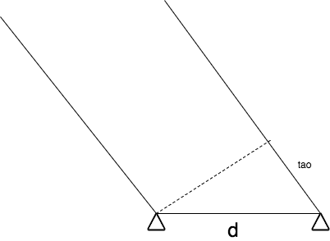

Figure 8. the arrival direction of emitter signal outside the site coverage

d is the baseline distance length of the two sites, and $d_{τ}$ is the signal difference distance between the two sites, the direction of the signal $θ$ can be obtained by the following formula.

$$θ=acos⁡\left(\frac{d_{τ}}{d}\right)$$

By combining different sites to establish different baselines, the arrival direction $θ_{i}$ can be acquired, and the average value can be taken as the final direction of arrival. After the final direction of arrival is obtained, the array signal processing can be conducted. The processing is the same with content in section 4.3.2.3.1.

Since the propagation of the signal in three-dimensional space is simplified to propagate in a two-dimensional plane, there is a certain error in the direction of the incoming wave obtained according to the above formula. But due to the small number of smart antenna elements, the main lobe of beam is not narrow, so it can cover the arrival direction of incoming signal.

**5. Conclusion**

The multi-path propagation will cause fast fading, polarization rotation, delay spread, phase shift and random Doppler frequency modulation to the received signal. And the resulting scattering will cause adverse effect to near, line-of-sight, no line-of-sight receiving end.

Spectrum monitoring and/or signal locating are different demands, and which to be adopted requires a combination considering of technical complexity, operational complexity and economic cost. Directional antenna costs less than antenna array, but its operation and complexity are higher. TDOA technology is suitable for both monitoring and locating ing demands. Digital array signal processing techniques may require higher technical complexity, while mobile positioning is more applicable with limited cost.

Multi-path propagation is inevitable in the complex electromagnetic environment, which will become more common in the future. With the spread trend of modern signals becoming spread spectrum, short duration, low energy, future monitoring technologies are required to be equipped with stronger digital signal processing technology. And monitoring facilities should be easy to deploy, convenient for establishing network.

**Annex 1**

**An experimental evaluation of the direction finding performance**

**in large-scale stadiums under severe multipath environment**

**1. Introduction**

Robust radio monitoring techniques are essential to maintain a sound radio environment around event venues to ensure the safe and undisrupted implementation of such large-scale events as the 2020 Tokyo Olympics and Paralympic Games. In large facilities like sports stadiums, it is necessary to deploy multiple units of small and lightweight direction finders and quickly estimate the rough location of the source whenever interference occurs, then hurry to the site with handheld radio monitoring equipment to identify the radio emission source and stop interference.

Large stadiums are often covered with roofs, and rows of spectator stands rise gradually outward from the event area, which make the radio propagation characteristics very complex. This kind of a stadium structure creates such a complex multipath environment that it is impossible to perform direction finding with conventional direction finders employing circular array antennas.

Here, we will report how the use of linear array antenna with a reflector is effective for radio monitoring in a multipath environment. We conducted an evaluation of direction finding measurements using our prototype linear array antenna at a stadium planned to be used in the 2020 Tokyo Olympics and Paralympic Games and demonstrated the effectiveness of the linear array antenna.

**2. Radio environment in the stadium**

We created a model of a stadium with a roof and analyzed the radio environment by electromagnetic field simulation taking multipath propagation into consideration. An example of the calculated distribution of electric field intensity at 100MHz is shown in Figure 1.

When the radio emission source is nearby, radio signals reflected by the surrounding spectator stands interfere with the emitted signals and seem to propagate through space with directionality. In addition, the distribution of electric field intensity becomes complex because of the effect of the roof.

When the radio emission source is distant, waves that can be approximated to plane waves are reflected by the cone-shaped stadium, creating a complex electric field intensity distribution. It can be inferred from the parallel standing waves observed above the playing field that nearly plane waves are being reflected from the stadium.

For comparative quantification, we calculated multipath components from the difference in electric field vectors between cases with and without the stadium structure, and then calculated the DU ratio (the ratio of desired signal power to undesired signal power). Figure 2 shows the DU ratios at 4 different reception points for radio signals transmitted from two transmission points (one near and one distant). While DU ratios differ by location and signal frequency, multipath effect is significant in general, and the DU ratio may become lower than 0dB depending on the conditions. Generally speaking, DU ratio above 10dB is desirable for performing high-accuracy direction finding. Lower DU ratios can cause significant azimuth errors and ambiguity in direction finding algorithm leading to misidentification of the direction.



(a) Signal transmitted from Tx-A (b) Signal transmitted from Tx-B

(Tx-A and Rx antennas are both (Tx-B is located at Back stand, Rx

located at Main stand.) antennas are located at Main stand.)

Figure 1: Simulation results of electric field at 100MHz in Stadium with roof (side view)

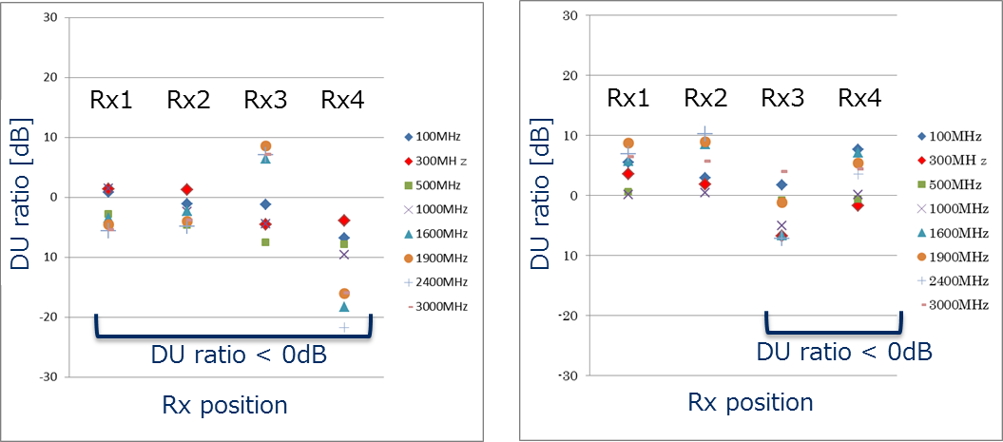

(a) Signal transmitted from Tx-A (b) Signal transmitted from Tx-B

Figure 2: Simulation results of DU ratio for each Rx position and frequency

**3. Array antennas for direction finding**

Figures 3 and 4 show the appearance of the prototype 5-element circular array antenna and 5-element linear array antenna, respectively. They both cover a frequency range of 100MHz to 3600MHz with a two-band configuration (high band and low band). The linear array antenna is equipped with a reflector. The low-band linear array antenna employs a reflection pole structure to reduce surface area (to reduce wind pressure) and weight.

Figure 5 shows the locations of the transmission points and reception points used in the measurement evaluation conducted at the actual stadium. The stadium size was approximately 300m x 250m x 50m with the seats on the second floor almost completely covered with a roof. Figure 6 shows the view of the stadium taken from location Rx-A. Some of the seats on the first floor were outside the line of sight of the antennas.

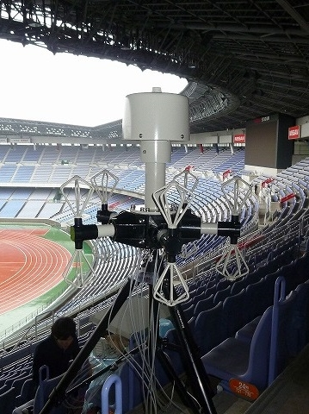The points for installing direction finding antennas are often chosen based on safety and aesthetic reasons rather than electric characteristics. We installed the antennas at the back of the highest spectator stand in consideration of various conditions.

Figure 3: 5-element circular array antenna

High-band / Low-band circular array antenna (Size: 0.6m x 0.6m）

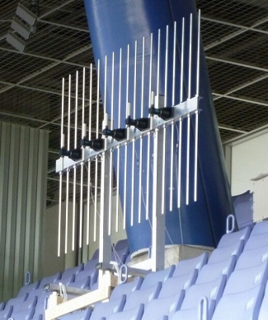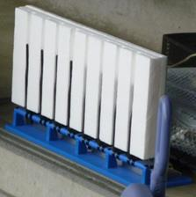

(a) High-band linear array antenna (b) Low-band linear array antenna

(Size: 0.3m x 0.6m) (Size: 1.5m x 2.0m)

Figure 4: 5-element linear array antenna

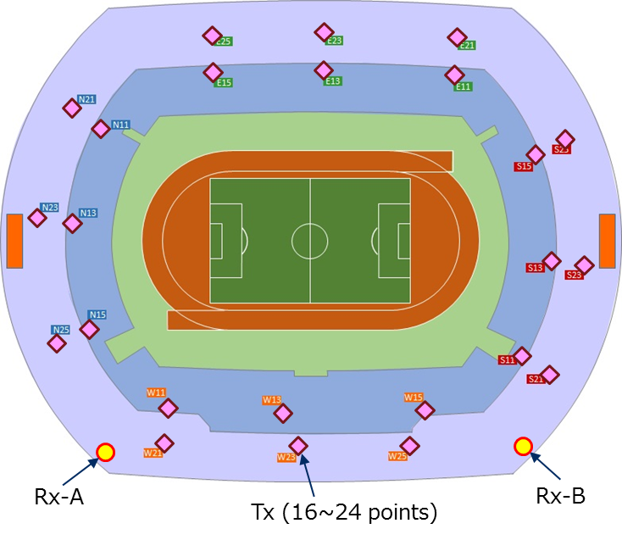

Figure 5: Antenna locations in the measurement evaluation at the stadium

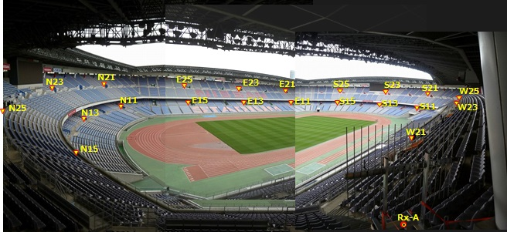

Figure 6: View from Rx-A point

**4. Results of direction finding measurements at the stadium**

The three frequencies of 154.45MHz, 351.2MHz and 2404MHz were used for the direction finding measurements. Signals were transmitted from 16-24 locations on the first and second floors. Figures 7 to 9 show the estimated direction of arrival (solid lines) when signals were transmitted from the second floor. The dotted lines show the error from the transmission points.

When using the circular array antennas, as shown in (a) of Figures 7 to 9, we could not estimate the correct direction for any of the three frequencies. This result accords with the results of the simulation that the DU ratio may fall to as low as 0dB inside the stadium as described in section 2.

On the other hand, when using the linear array antennas, as shown in (b) of Figures 7 to 9, we were able to estimate the direction, although the lower the frequency the larger the azimuth error grew. The evident azimuth errors are due to false recognition of the wave peak caused by ambiguity in direction finding algorithm. Table 1 summarizes direction finding accuracy calculated including these errors.

We think that the linear array antennas were able to reduce the impact of multipath reflections because the reflector served to block multipath components coming from behind and nearby, consequently improving the DU ratio.

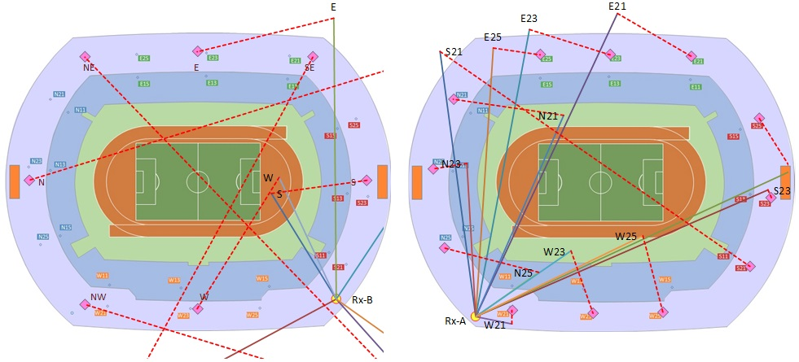

(a) Circular array antenna (b) Linear array antenna

Figure 7: Direction finding results at 154.45MHz

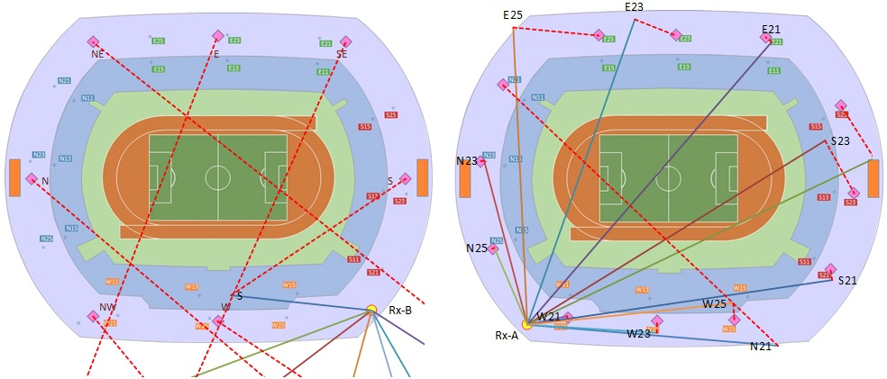

(a) Circular array antenna (b) Linear array antenna

Figure 8: Direction finding results at 351.2MHz

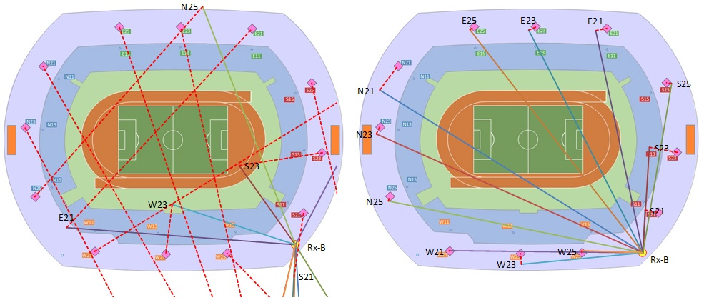

(a) Circular array antenna (b) Linear array antenna

Figure 9: Direction finding results at 2404MHz

Table 1: Summary of direction finding accuracy

|  |  |  |  |
| --- | --- | --- | --- |
| Band | Frequency [MHz] | DF accuracy of circular array antenna [deg(rms)] | DF accuracy of linear array antenna [deg(rms)] |
| Low | 154.45 | Not available | 40.6 |
| 351.2 | Not available | 23.4 |
| High | 2404 | Not available | 7.1 |

**5. Summary**

It was confirmed through simulation and actual measurement that the radio environment in large-scale stadiums covered with a roof is deteriorated by multipath reflection so badly that it is impossible to perform direction finding using conventional circular array antennas. We confirmed that the impact of multipath reflection can be reduced by blocking reflection from behind and nearby using linear array antennas with reflectors. The location of signal sources can be quickly estimated by installing linear array antennas at multiple locations in the stadium, thereby contributing to the smooth implementation of radio monitoring during games and events.

Linear array antennas with reflectors can be installed on the walls of a building, and it is expected that they will be useful for radio monitoring in multipath environments of urban areas.

____________