APT RECOMMENDATION ON

GUIDANCE FOR THE MIGRATION OF GSM TO MOBILE BROADBAND IMT SYSTEMS

Edition: December 2016

The 40th Session of the Management Committee of the APT
29 November – 2 December 2016
Nadi, Fiji

(Source: MC-40/OUT-09)

No. APT/AWG/REC-07

APT RECOMMENDATION ON ‘GUIDance FOR THE MIGRATION OF GSM
TO MOBILE BROADBAND IMT SYSTEMS’

The Asia-Pacific Telecommunity (APT),

considering
a) that GSM networks, also known as 2G networks, have been deployed globally in the frequency bands 900 and 1800 MHz;

b) that current mobile broadband IMT technologies offer much higher spectrum efficiency compared with GSM systems;

c) that newer systems may be deployed in higher frequency band, such as 2.1 GHz or 2.6 GHz, which are costly for operators to deploy nation wide mobile broadband services;

d) that re-farming GSM bands is a natural solution to both maintaining current 2G service and at the same time providing cost effective solution for mobile broadband coverage in buildings and rural areas;

e) that currently there is a main trend to migrate from GSM to UMTS in the 900MHz band with a large ecosystem and to LTE in the 1800 MHz band in most regions, but recognizing that LTE is also used in lower frequency bands in some countries already;

f) that 2G/GSM spectrum license duration in the frequency band 850/900 or 1800 MHz have different periods and expiry dates among licenses in some countries;

g) that GSM spectrum re-farming requires careful planning and management to guarantee a smooth transition to the mobile broadband IMT networks,

noting

that APT Report No. APT/AWG/REP-53 on MIGRATION STRATEGY OF GSM TO MOBILE BROADBAND analyses the status of 2G bands usage within the APT region, technical methods to re-arrange existing 2G spectrum, migration strategy,

recommends

1 that APT administrations re-farm parts of their 2G spectrum to allow new technology introduction, and align with the general trend to re-use the 850/900 and 1800 MHz bands for mobile broadband IMT systems;

2 that the technical and operational guideline shown in the Annex 1 should be taken into consideration while addressing the migration of GSM to mobile broadband IMT systems in the bands 900 and 1800 MHz in APT Member countries.
ANNEX 1
Guidance for the migration of GSM to mobile broadband IMT systems
in APT member states

1 Introduction
GSM networks, also known as 2G networks, have been deployed globally. With the current advancement of wireless communication technology, current mobile broadband networks offer much higher spectrum efficiency comparing with GSM systems. However, the newer systems are mainly deployed in higher frequency band, such as 2.1 GHz or 2.6 GHz. The high frequency bands make it costly for operators to deploy nation wide mobile broadband services. Therefore re-farming GSM bands is a natural solution to both maintaining current 2G service and at the same time provides cost effective solution for mobile broadband coverage in the rural areas.

In the nutshell re-farming is a strategy where telecom operators reuse their frequency resources to introduce new radio communication technologies to improve the spectral efficiency and data throughput. As users’ demand increases on data services, GSM is not sufficient to satisfy the users’ data need. For example, the mainstream 900 MHz re-farming solution is that operators free about 5 MHz of the GSM on the 900 MHz band and deploy UMTS on the 900 MHz frequency band.

GSM spectrum re-farming requires careful planning and management to guarantee a smooth transition to the mobile broadband networks. To serve this target, the following guidelines will look into the following areas:
- Migration strategy.
- Technical methods to re-arrange existing 2G spectrum.

2 General migration process
The spectrum migration consists of a solution which reduces the spectrum needed to a desired limit without compromising on performance of the existing network, which can be structured in five phases and activities as outlined below.

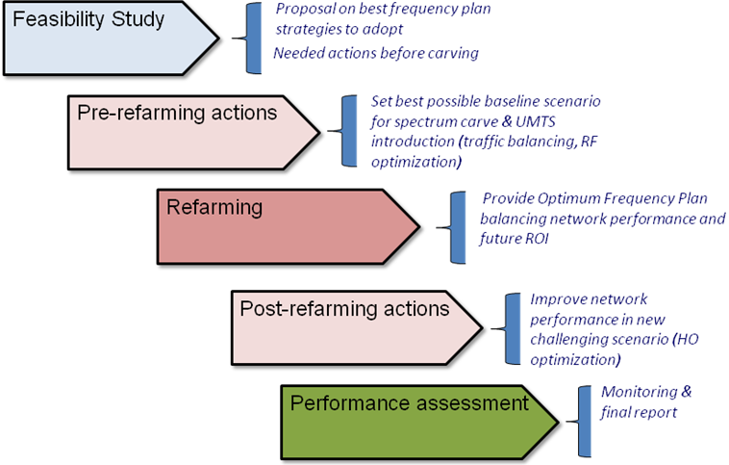
Figure 2.1 Spectrum migration solution overview

2.1 Feasibility study
The main target of this phase is to evaluate if the migration can be done within the acceptance criteria (i.e. agreed KPI levels for amount of spectrum to be released). The first task is to define the required spectrum reduction, typically dependent on the following factors:
- Operator restrictions
- Maturity of the network
- Expected traffic growth
- Network evolution

2.2 Pre re-farming actions
In this phase, using output from the feasibility study, a complete set of actions will be proposed in order to establish the best baseline scenario for the implementation of a new frequency plan after the spectrum carving. These actions are typically includes RF optimization and RRM optimization.
There are several functions which can be used to aid in the achievement of the objectives (capacity, interference and traffic management). These functions will reduce the interference levels or improve the network’s ability to cope with the increased interference.

2.3 Frequency plan elaboration & implementation
In this phase the final frequency will be implemented guided by the strategies defined in the previous phase. This phase includes the following parts:
- Frequency plan
- Updated neighbour list
- Fall-back plan
  - Fall back to the previous frequency plan
  - A fast reactive process to identify & troubleshoot the worst performing sectors

2.4 Post re-farming actions
A second round of optimization actions may be proposed after the implementation of the re-farmed frequency plan. In order to understand the real scope of this phase, a performance analysis must be carried for two main reasons:
- Ensure no severe degradation is present post-re-farming. If this is the case, then a fall-back plan will be auctioned.
- Acknowledge the necessary actions to be carried out in order to meet the agreed acceptance criteria.

2.5 Performance assessment
After implementation, the network will be monitored mainly through the OSS-based tool. Other tools may be also utilized for specific monitoring tasks.

3 Possible technology to support the migration / Technical methods to re-arrange existing 2G spectrum.

3.1 Multi-RAT frequency resource allocation
Two frequency allocation modes are available, depending on the operator’s spectrum resource usage: edge frequency allocation and sandwich frequency allocation. These schemes are depicted in Figure 3.1.

GSM BCCH

UMTS
GSM non-BCCH
UMTS
GSM
Other
Operator

UMTS
GSM
GSM
Other
Operator
Figure 3.1 Multi-RAT frequency allocations
- Edge frequency allocation
The UMTS/LTE and GSM systems are arranged side-by-side and maintain standard central frequency separation from the UMTS/LTE and GSM of other operators.
- Sandwich frequency allocation
Within the frequency band of an operator, the UMTS/LTE is arranged in the middle with the GSM on both sides. If the operator has abundant frequency resources, it may allocate a second UMTS carrier or bigger bandwidth LTE as network services expand. At this point, the UMTS/LTE can be arranged at one side of the operator's frequency band for asymmetric sandwich allocation. The GSM spectrum at the other side is as wide as possible, and thus the UMTS/LTE planned does not require adjustment, which facilitates smooth capacity expansion.

For the single sided method, only one additional guard band is needed while in the sandwich allocation two additional guard bands are needed. The sandwich allocation does not require the consideration of interference with the systems of other operators

3.2 Non-standard frequency separation planning
Due to limited frequency resources and high GSM capacity demand, non-standard frequency separation can be adopted to increase frequency efficiency.
In UMTS 900MHz network, the bandwidth may be less than 5MHz because of smaller frequency resource from GSM network. Thus, non-standard frequency separation is adopted. And UMTS 4.2MHz is the recommended solution for both UMTS network deployment feasibility and the benefit to GSM. Besides, UMTS 4.6MHz, 3.8MHz also is possible to be adopted, In the Figure 3.2 when using UMTS non-standard bandwidth 4.6MHz, 4.2MHz, 3.8MHz, 2, 4, 6 frequency channels can be saved for GSM correspondingly.
It is possible to operate UMTS with a carrier as low as 4.2 MHz. However it should be noted even though a bandwidth less than 5 MHz is not standardized for MS or RBS it only implies minimal loss of capacity for UMTS.
The sandwich allocation method is the preferred solution if 4.2 MHz is allocated for UMTS. In that case it is preferable to use UMTS carrier centered in own spectrum to avoid un-coordinated scenarios with other operators.

U4.6M

U4.2M

U3.8M
Figure 3.2 UMTS non-standard separation configuration

For 1800MHz bands which preferable re-farming direction is LTE, the similar issue exists. If 1800 MHz frequency resource owned by one operator is insufficient, Compact bandwidth can be enabled so that the deployed LTE1800 network can be re-farming from GSM networks.
GSM frequency resources are substantially reduced after re-farming. GSM traffic will not fall in the short term, however, and in some areas may even increase slightly. This may result in capacity issues of GSM system. This issue may be addressed through traffic migration and tight frequency reuse.

3.3 Bufferzone solution
In the case of GSM and UMTS/LTE co-channel interference, a space separation is required to reduce the co-channel interference. Areas with UMTS/LTE networks deployed and their peripheral areas form a band-type area. In this area, GSM networks cannot use frequencies overlapped in UMTS/LTE frequency spectrums and therefore GSM network capacity decreases. A large space separation for co-channel interference decreases impacts of GSM and UMTS/LTE co-channel interference on network performance. For space separation for co-channel interference, buffer zone planning solution is based on emulation and onsite traffic statistics to accommodate different scenarios.

3.4 Multi-RAT antenna solution
After GSM re-farming, UMTS/LTE networks deployed may use three antenna feeder solutions, as shown in Figure 3.3:
Separate antenna feeder solution
Four-port shared antenna feeder solution
Two-port shared antenna feeder solution

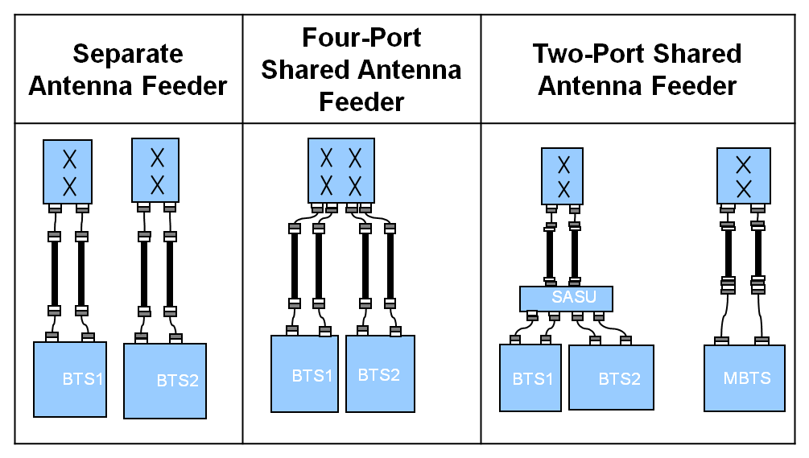
Figure 3.3 GSM and UMTS/LTE antenna feeder solutions

The three antenna feeder solutions are different in deployment scenarios and requirements for investment and performance. Here BTS1 and BTS2 are employed different RATs, and MBTS is the MSR BTS.

Whichever antenna feeder solution is used for UMTS/LTE deployment, RF planning is required. However, the three antenna feeder solutions have different requirements for RF planning and the RF planning complexity is also different.
- The separate antenna feeder solution uses a separate antenna and aims to achieve the optimal UMTS/LTE performance.
- The four-port shared antenna feeder solution aims to achieve the optimal LTE performance and minimize impacts on GSM services on the live network.
- The two-port shared antenna feeder solution aims to achieve a relatively optimal UMTS/LTE performance with acceptable impacts on GSM services on the live network. This solution costs the minimum among the three antenna feeder solutions because it allows that the newly deployed UMTS/LTE site reuses the original GSM antenna system. However, in preliminary planning, this solution requires emulation and onsite data for evaluating impacts of antenna feeder parameters on GSM and UMTS/LTE network performance.

More and more operators would like to use multi-port and multi-band antenna, there will be only one antenna in one cell. This modification recently becomes more and more popularly.

It could be better to modernization of the hardware if re-farming is performed. i.e. use multi-standard products able to operate in mixed mode, which can both improve receiver sensitivity at the BTS and remove the need for combiners, reducing the signal loss.

3.5 Power sharing between GSM/UMTS or GSM/LTE
With mixed mode GSM/UMTS or GSM/LTE base station, UMTS High Speed Downlink Packet Access (HSDPA)/LTE cells can share the idle carrier power provided by the GSM cells. Thanks to the intelligent power management, GSM power control features and behavior of GSM traffic bursts, the GSM cells can be configured with more total power than what is nominally available, without degrading KPIs. This means that UMTS/LTE can be configured to a higher power level, thereby letting GSM have a smaller portion of the total available power, while still keeping the GSM coverage and capacity. The power sharing and retrieval help improve the power usage efficiency and the UMTS/LTE network quality when busy hours of the GSM and UMTS/LTE networks fall in different periods or different positions.

3.6 Spectrum sharing between GSM/UMTS or GSM/LTE
In areas with both GSM and UMTS/LTE coverage, the spectral resources can be shared with GSM network and the UMTS/LTE network based on the service load on both networks. This sharing mechanism improves spectral efficiency. Some of the idle GSM spectral resources can be shared with the UMTS/LTE network when the service load on the GSM network is below a specific threshold. When the service load on the GSM network is above a specific threshold, the GSM network reclaims the shared spectral resources. UMTS/LTE has higher spectral efficiency than GSM. Therefore, the network throughput can be increased and the composite costs of data services can be reduced with spectrum sharing between GSM/UMTS or GSM/LTE.

3.7 Tight frequency reuse
The 1/1 or 1/3 RF hopping solution can be adopted to achieve a tighter frequency reuse. In this case, interference suppression technology should be applied in conjunction with conventional power control and DTX. Interference planning based on network synchronization can also be utilized.

________________________

