APT REPORT

THE GUIDANCE FOR 5G NETWORK SHARING
AND CO-CONSTRUCTION

Edition: May 2024

The 36th APT Standardization Program Forum (ASTAP-36)
20 – 24 May 2024, Bangkok, Thailand

(Source Document: ASTAP-36/OUT-16)

No. APT/ASTAP/REPT-57
APT REPORT ON THE GUIDANCE FOR 5G NETWORK SHARING AND CO-CONSTRUCTION

1. Scope 1
2. References 1
3. Abbreviations and acronyms 1
4. Introduction 2
4.1 Classification of mobile Network sharing and Co-construction 2
5. Practical Cases 3
5.1 China Telecom and China Unicom 5G Network sharing and Co-construction 3
5.2 5G Network sharing and Co-construction in Korea (SK Telecom, KT, LG Uplus) 3
6. Standardization Aspect of mobile network sharing and co-construction 5
7. Key technologies for 5G Network Sharing 5
7.1 Radio Access Network (RAN) sharing 5
7.1.1 Technical Solutions 5
7.1.2 Evolution from NSA Sharing to SA Sharing 6
7.2 5G Inter-network Roaming 9
7.3 Spectrum Sharing 10
7.3.1 Dynamic Spectrum Sharing (DSS) 10
7.3.2 Hybrid Dynamic Spectrum Sharing (HDSS) 10
7.3.3 Cluster DSS 11
7.4 Coverage enhancement 12
7.4.1 Super Uplink 12
7.4.2 FDD Assisted Super TDD 13
7.4.3 Inter-Carrier Dynamic Power Sharing 14
7.5 Capacity improvement 15
7.5.1 Super Frequency Fusion 15
7.5.2 Time-Frequency-Space 3D Beam Coordination 16
7.5.3 Sounding Reference Signal (SRS) Carrier Switching 17
7.6 Interference Suppression 18
8. Other Consideration of 5G Network Sharing 19
8.1 Operation and Dispatching 19
8.1.1 Blockchain-Based Operation and Dispatching Platform for Shared-Networks 19
8.1.2 AI-Based Full-Time Energy-Saving System for Shared Networks 20
8.2 B2B Private Sharing Network 21
8.2.1 Multi-Mode Resource Block (RB) Reservation Policy 21
8.2.2 Multi-logic Cell Management of Shared Carrier 22
8.2.3 5G-Advanced Super Time-Frequency Folding Solution 23
8.3 5G SA international roaming under core network sharing 24
9. Guidelines for implementation 25
9.1 Planning 26
9.2 Construction 26
9.3 Operation and optimization 26
9.4 Regulation and Accounting/Settlement 26
10. Prospect of Network Sharing and Co-construction 27
10.1 Deepening 5G network sharing and co-construction cooperation 27
10.2 Future technological evolution of sharing and co-construction 27

Scope
This document provides guidelines for those who develop or implement 5G network sharing and co-construction. The purpose of this document is to support a comprehensive understanding of 5G network sharing and co-construction.
The scope of this document is as follows:
- 5G network sharing and co-construction technologies, including standard evolution and classification of mobile network co-construction and sharing, technologies of multi-networking, scheduling and service aiming at different phases of NSA to SA; coverage enhancement, capacity improvement, interference suppression, dynamic spectrum sharing, management & scheduling strategies, B2B private network under a shared network, 5G SA international roaming technology under a shared network.
- Planning and construction of 5G network sharing, including joint working mode, supervision and settlement.
- Regulation and accounting/settlement, including inter-network settlement requirements, settlement principles, etc.
- Operation and optimization of 5G shared network, including operation and optimization strategies, network management sharing, unified KPI, etc.
- The future evolution of sharing and co-construction, involving mmWave sharing, indoor sharing, MEC sharing, 6G sharing, etc., analyzes how to deepen co-construction and sharing in terms of technology route, geographical range, number of partners, working frequency bandwidth, and technology systems.

References
[3GPP TS 23.501] System Architecture for the 5G System
[3GPP TS 23.251] Network Sharing; Architecture and functional description
[3GPP TS 32.130] Network sharing; Concepts and requirements
[3GPP TS 29.573] 5G System; Public Land Mobile Network (PLMN) Interconnection
[GSMA NG.113] 5GS Roaming Guidelines
[ITU-T F.743.15] Requirements for multi-operator core network enabled multimedia services
[ITU-R M. 2160] IMT-2030 Framework

Abbreviations and acronyms
AAU Active Antenna Unit
AI Artificial Intelligence
BBU Building Baseband Unit
CC Component Carrier
CA Carrier Aggregation
FDD Frequency Division Dual
GWCN GateWay Core Network
HPLMN Home Public Land Mobile Network
MOCN Multi-Operator Core Network
MORAN Multi-Operator RAN Network
NSA None StandAlone
PCC Primary Component Carrier
PIM Passive Inter-Modulation
RAN Radio Access Network
RRU Remote Radio Unit
SA StandAlone
SCC Secondary Component Carrier
SIC Self-Interference Cancellation
SRS Sounding Reference Signal
TDD Time Division Dual
URLLC Ultra-Reliable Low Latency Communication
VPLMN Visit Public Land Mobile Network

Introduction

4.1 Classification of mobile Network sharing and Co-construction
From the perspective of operation & management, there are two modes of co-construction and sharing. One is that the operators build their own networks and share network resources through commercial agreements. The other is that the operators set up a joint venture company for independent operation, especially responsible for wireless network construction or maintenance.
From the perspective of shared network resources, network sharing is divided into passive sharing and active sharing. Passive sharing refers to the sharing of physical infrastructure, excluding active devices. Active sharing refers to sharing part or all of the active equipment of the radio access network, including access network sharing, GateWay Core Network (GWCN) and core network roaming, etc.
The passive sharing is quite mature, while the active sharing requires closer coordination between operators, making technical solutions more complicated. Therefore, this guideline mainly analyzes the active sharing.

Practical Cases

5.1 5G Network sharing and Co-construction in China (China Telecom, China Unicom)
Large Bandwidth Standard and Industrial Promotion for 5G Sharing Between China Telecom and China Unicom are described in this section.
China Telecom and China Unicom share 45MHz spectrum on the 2.1G. Introducing 2.1G 50M FDD NR, 2.1G single-cell bandwidth are extended with 25M/30M/40M/50M on the basis of the original maximum bandwidth of 20M, significantly reducing common channel overhead and improving user experience and spectrum efficiency.
China Telecom and China Unicom, at the frequency band of 3.5G, have solved such difficulties as large-bandwidth shared network engineering technology breakthroughs, and large-bandwidth key device equipment lightweight implementation. Integrate the 100MHz frequency bandwidth of each party to realize a 5G network with 200MHz frequency bandwidth. The 100MHz frequency bandwidth of each side is integrated to realize the 200MHz frequency bandwidth 5G network. The peak user experience rate is up to 2.7Gbps, and the network capacity is multiplied.
5G is the driving force for leading technological innovation, promoting industrial digital upgrading and high-quality development. With the continuous development of digital economy, the industry and consumers are full of expectations for 5G life. The 5G network co-construction and sharing advocated by China coincides with the vision of the Internet of Everything pursued by the telecommunications industry, which helps to achieve high-speed mobile Internet, cloud games and other businesses for individual users, and provide enterprise users with automated driving, fully automated manufacturing plants, remote surgery and other businesses through robots and virtual reality.

5.2 5G Network sharing and Co-construction in Korea (SK Telecom, KT, LG Uplus)
The Ministry of Science and ICT (hereinafter referred to as MSIT) announced a “Rural 5G Network Sharing Plan” in April 2021 with three mobile network operators in Korea, SK Telecom, KT and LG Uplus. To implement the rural 5G network sharing plan, the three operators have signed an agreement to enable 5G users to access the 5G network in rural and remote areas regardless of which operator they subscribe to, with the aim of providing nationwide 5G service.
Following the launch of the world's first commercial 5G network service, discussions began on building a joint network to rapidly expand the nationwide 5G network and bridge the 5G divide between urban and rural areas. As 5G network is known to take longer to deploy nationally and require higher CAPEX compared to LTE, the MSIT and three operators agreed on a RAN sharing policy to accelerate the delivery of 5G coverage rapidly, not just in some metropolitan regions but in rural areas. This is the worldwide first case of a 5G RAN Sharing agreement involving all operators in a nation to accommodate all MNO and MVNO subscribers and global roamers without differentiating customer experience. It is designed to provide all subscribers with the same quality as their independent network when on a shared network.
Under the rural 5G network sharing plan, the three operators jointly built and shared 5G systems in 1342 rural areas across South Korea, and in April 2024, the construction of a nationwide 5G network was completed, covering all rural areas in addition to urban areas where the three MNOs had already independently built 5G networks. MSIT and three MNOs will continuously improve the network stability, quality, etc. in rural 5G network sharing areas.
The Multi-Operator Core Network (MOCN) radio access network sharing architecture is selected for this 5G network sharing plan, where only the RAN is shared in the 5G network. MOCN enables two or more operators with distinct core networks to use shared RAN and spectrum. Figure 4.1describes the MOCN implementation for the 5G network sharing system in Korea.
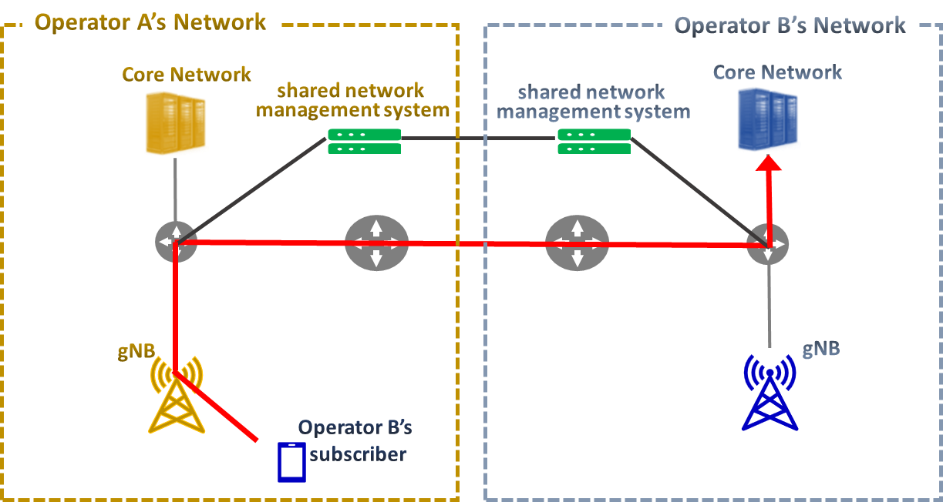
Figure 4.1 MOCN for Korea 5G Network Sharing System

The all information on each operator’s radio access networks, including coverage, parameters, etc. is shared by “shared network management system”. It is newly developed for shared network to integrate quality management through which three operators monitor and immediately address service performance, load, defects, errors etc. on the shared network. For interoperability between each operator’s own access network and the others’ core networks, the operators designated edge communication bases when connecting the backbone networks to ensure stability and reduce latency. The bases are configured to process traffic within the region and ensure stability by ensuring route redundancy between base data centers when interoperating between networks.

Standardization Aspect of mobile network sharing and co-construction
3GPP formulated the 3G network sharing standard in Release 6. From Release 8, 4G network sharing and 2G network sharing specifications are specified respectively in 3GPP TS 23.251. MOCN radio access network sharing is supported since Release 15, which standardized radio access network sharing in terms of network architecture, air interface, NG interface and Xn interface protocol. The operator-level IOC adaptation to multi-cell ID scenario is added in Release 17, and further research on co-construction and sharing management architecture is carried out in Release 18 to specify better O&M management.
[ITU-T F.743.15] specifies the requirements for MOCN enabled multimedia services, that is, using network sharing capabilities to improve the quality of conventional multimedia services.

Key technologies for 5G Network Sharing

7.1 Radio Access Network (RAN) sharing

7.1.1 Technical Solutions
The architecture of RAN network sharing shall allow different core network operators to connect to a shared radio access network, including two kinds of sharing mode, MOCN with shared carrier and Multi-Operator RAN Network (MORAN) with dedicated carrier. Figure 7.1 illustrates the scheme of MORAN and MOCN from left to right in sequence.
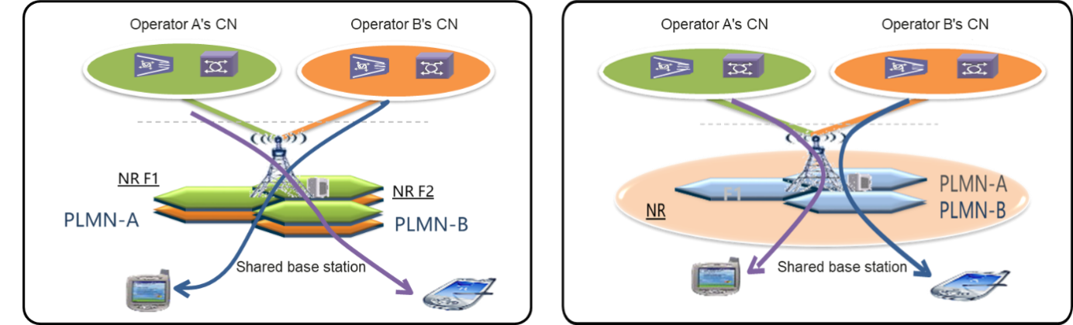
Figure 7.1 MORAN and MOCN
In MOCN, one or more carriers are configured to facilitate frequency sharing. Operators share their cells, and multiple PLMNs are broadcast in each cell, with the same QoS policy and cell-level feature parameters being used. These parameters, such as NR resource allocation parameters, need to be negotiated by all operators. UEs access shared cells by identifying PLMNs. Based on UE-carried PLMN information, gNodeBs connect UEs to core networks that they have registered with. The MOCN solution features deep sharing and high resource efficiency, and is applicable to operators that closely cooperate with each other.
In MORAN, multiple independent carriers are configured and the PLMN IDs of operators are broadcast on the carriers. BBUs are shared, and connected to RRUs and AAUs provided by the same vendor of BBUs. Each carrier is independently configured and managed. The gNodeBs on the RAN side provide logically independent cells for operators, UEs access their independent cells by identifying PLMNs, and gNodeBs connect UEs to their core networks based on operator-specific carriers. The MORAN solution features simple sharing and O&M, and is applicable to scenarios where operators need to maintain service independence in shared networks.

7.1.2 Evolution from NSA Sharing to SA Sharing
In NSA phase, the core network is deployed separately by operators, while the 5G NR carrier is shared and 4G anchor carrier is shared as required, resulting in relatively complicated architecture.
As shown in Figure 7.2, the X2 interface is required between the 4G base station(eNB) and 5G base station(gNB) for UE isolation and interoperation. To implement the co-construction and sharing solution, the following two difficulties must be tackled:
- 4G and 5G base stations must be provided by the same vendor.
- 4G anchor base stations and 5G base stations must be deployed at the same site.

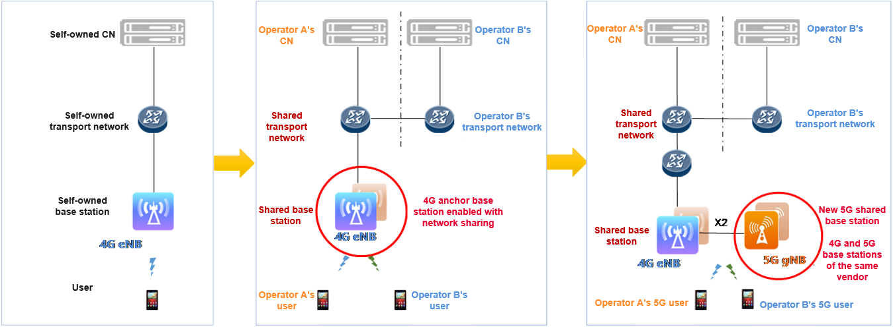
Figure 7.2 Evolution from 4G Sharing to NSA Sharing
There are two modes of anchor cell: two dedicated anchor cells or one shared anchor cell, see Figure 7.3.
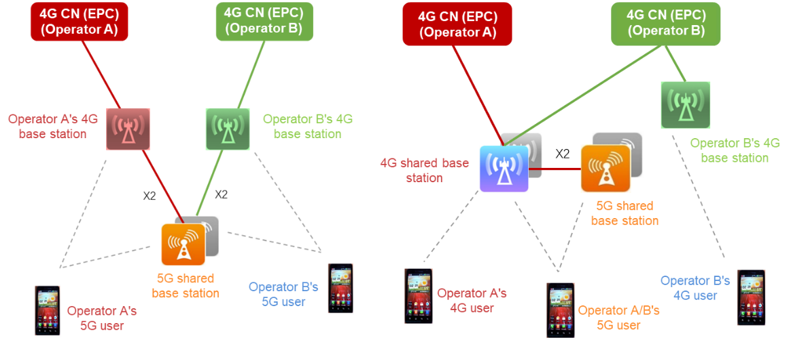
Figure 7.3 Implementation method of NSA Dual-anchor and Single-anchor
The dual-anchor solution is applicable to scenarios where the 4G base stations of all operators as well as the 5G base stations of the hosting operator are provided by the same vendor. Otherwise, X2 interface incompatibility problems may occur. The dual-anchor solution can quickly achieve 5G network co-construction and sharing with minor changes to existing 4G networks.
The single-anchor solution is applicable to scenarios where 4G base stations of operators are provided by different vendors. However, this solution requires a complex reconstruction of existing 4G networks or the establishment of a new 4G anchor. With this solution, 5G networks can be shared while 4G non-anchor base stations are not.
During the promotion phase from NSA to SA, the evolution path from NSA mode to NSA/SA dual mode and then to SA mode is generally recommended. Depending on the maturity of the industry chain and various constraints, four solutions are available for the evolution from NSA sharing to SA sharing:
- Two-step evolution (NSA sharing > dual-mode sharing > SA sharing)
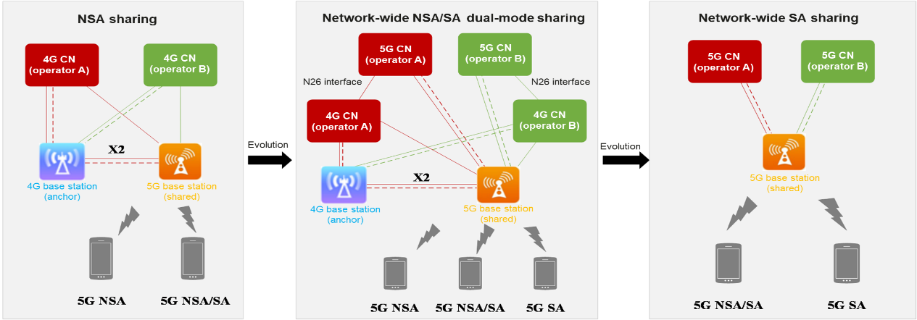
Figure 7.4
(2) Two-step evolution (NSA sharing > dual-mode sharing + SA sharing > SA sharing)
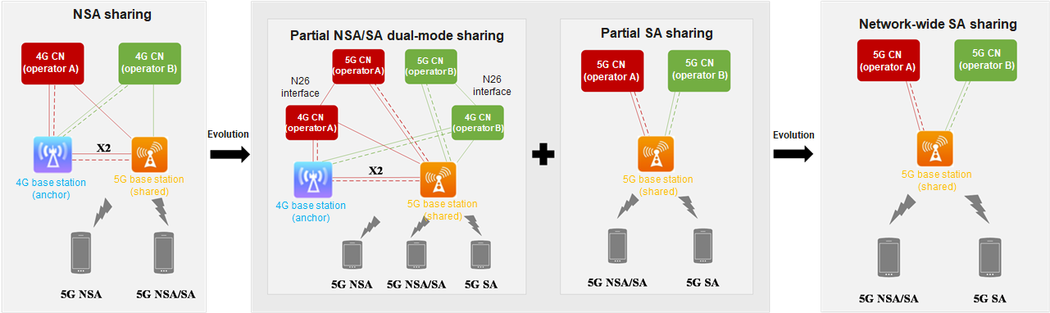
Figure 7.5
(3) Two-step evolution (NSA sharing > NSA sharing + SA sharing > SA sharing)
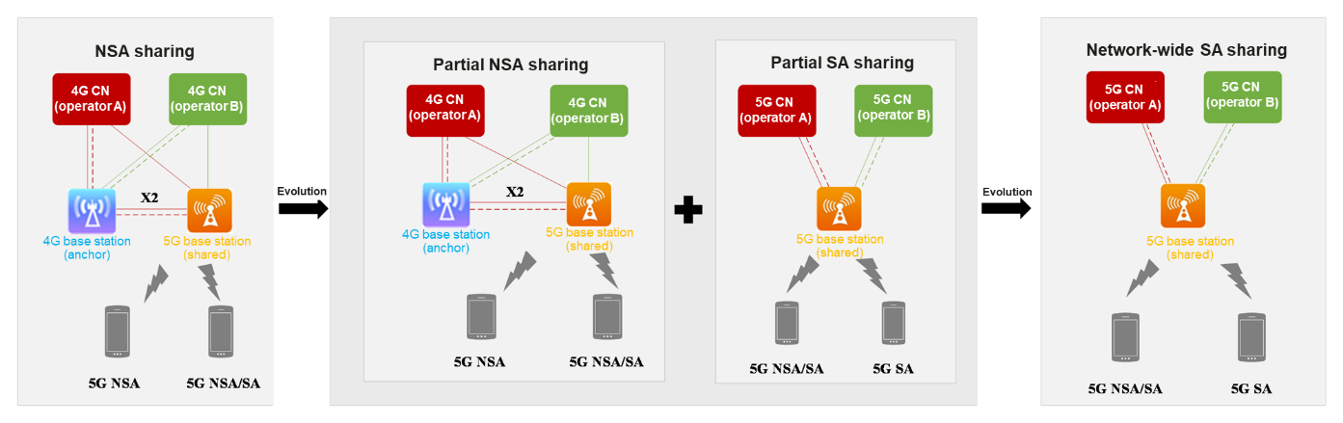
Figure 7.6
(4) One-step evolution (NSA sharing > SA sharing)

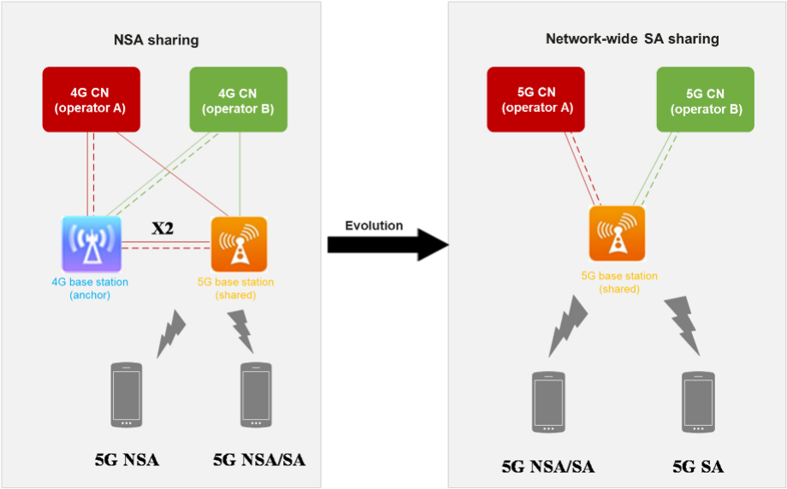
Figure 7.7
In SA phase, as shown in Figure 7.8, only the 5G base station(gNodeB) should be connected to both 5GC. Decoupled with 4G network, no anchor cell solution is needed. With standard processing of 4G and 5G mobility management, both 4G and 5G user experience can be guaranteed.
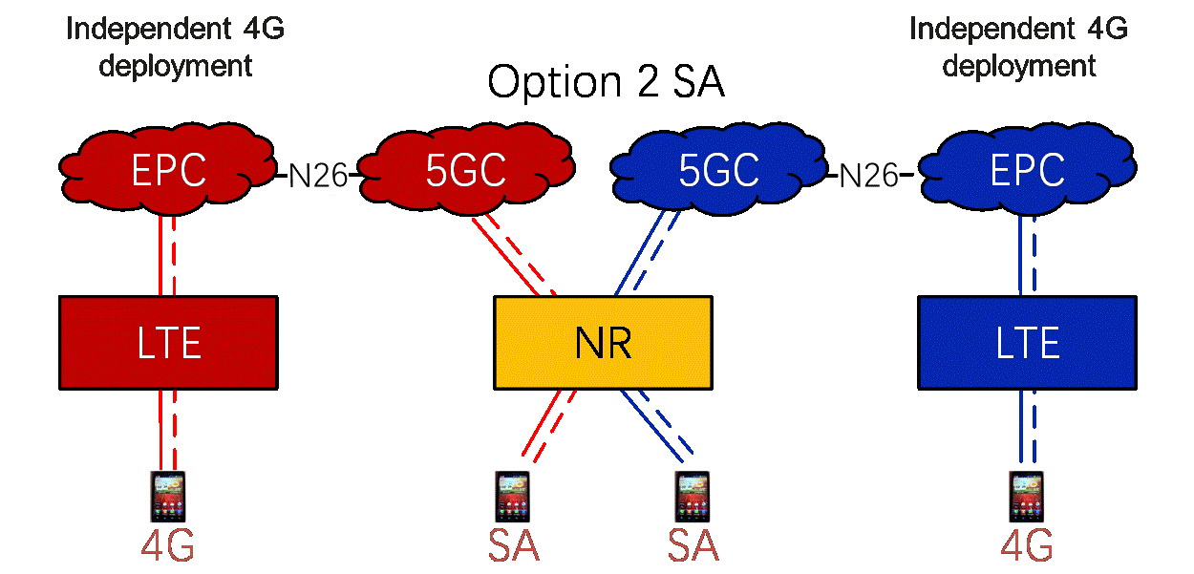
Figure 7.8 SA RAN Sharing

7.2 5G Inter-network Roaming
In 5G inter-network roaming scenario, the sharing base station only connects to the main operator’s core network. The core network for Home Public Land Mobile Network (HPLMN) and Visit Public Land Mobile Network (VPLMN) should be connected when the user service flow can pass both core network. The bearer network should also be connected each other.
In NSA phase, only 5G NSA users are roaming allowed while other subscribers will only access the home network through 4G EPC connected. The management of users, billing and strategy controlling are separated in both core network. The 5G network is constructed by the HPLMN with geographic separation. If operators have used national inter-CN roaming in the 4G phase, the same roaming policy is used for 4G and NSA UEs in the NSA sharing phase. If operators have not used national inter-CN roaming in the 4G phase and need to directly implement NSA sharing, different roaming policies need to be used for 4G and NSA UEs to ensure that NSA UEs roam to the coverage area of the shared NSA network and 4G UEs attach to 4G networks. To implement such roaming policies, on base stations, MMEs and other NEs, operators need to configure a mobility management policy and related information based on the RFSP, mobility restriction and other technologies to control inter-PLMN mobility.
In SA phase, with new 5GC deployed and connected, only SA users are roaming allowed. All 4G users will access to home network. The SA users of secondary operator can access the 5G network with new PLMN. The networks involved in national inter-CN roaming should provide IMS-based voice and video services (including emergency call services), SMS over IP (IMS), and data services for UEs, and the involved operators should provide services for roaming UEs based on an inter-network roaming protocol.

7.3 Spectrum Sharing

7.3.1 Dynamic Spectrum Sharing (DSS)
Convenient and fast 5G deployment is the main focus of operators at the beginning of 5G, and Dynamic Spectrum Sharing (DSS) enables low investment and fast 5G deployment with smooth evolution of Sub3G.
The DSS technology was proposed to promote the coordinated development of 4G and 5G based on the LTE 2.1 GHz frequency band that features strong penetrability. Figure 7.9 shows how the DSS solution works. For dynamic spectrum sharing, LTE and NR services use the same spectrum, and the interference between them can be prevented or reduced by using such technologies as CRS rate adaptation, MBSFN subframe, and ZP CSI-RS. The potential increase in the overhead of 4G and 5G PDCCHs after the DSS solution is used can be minimized through efficient PDCCH allocation.
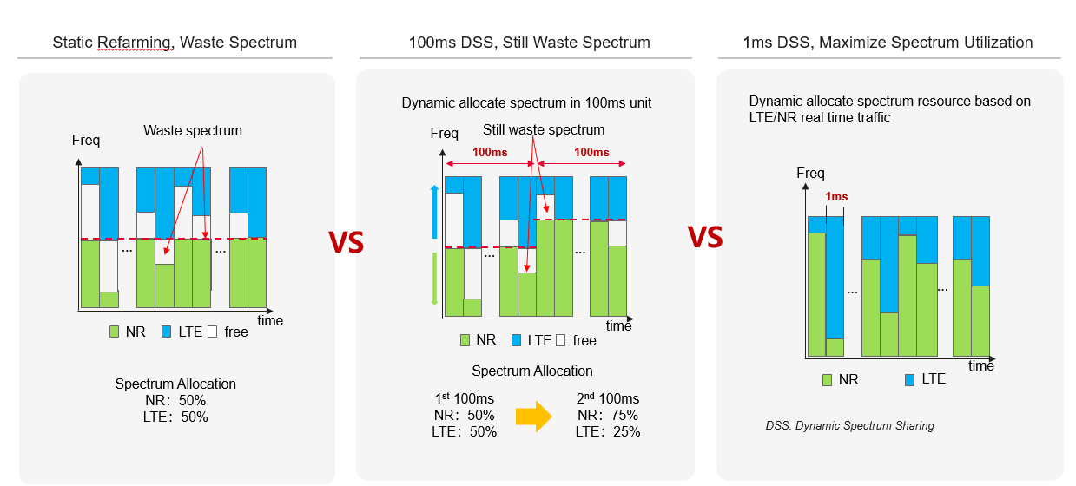
Figure 7.9 DSS Solution
The spectrum resources allocated for NR and LTE can be dynamically adjusted in accordance with the number of connected 4G and 5G UEs, thus ensuring the optimal uplink and downlink performance. In addition, 4G and 5G PDSCHs and PUSCHs can be shared in real time and scheduled at millisecond level based on service requirements to improve spectrum efficiency.

7.3.2 Hybrid Dynamic Spectrum Sharing (HDSS)
DSS performance is not as expected due to inter-RAT interference, an innovative spectrum sharing solution is required for higher NR performance, called Hybrid Dynamic Spectrum Sharing (HDSS), Figure 7.10 shows its implementation principle. Although the 40 MHz spectrum is allocated to NR FDD cells, 20 MHz can be used by LTE FDD cells, achieving 4G and 5G dynamic spectrum sharing.
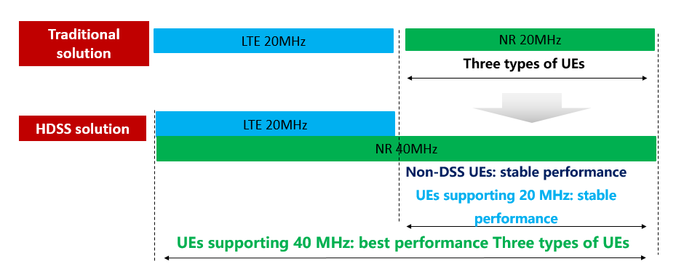
Figure 7.10 HDSS Solution
In this way, the UEs supporting 40 MHz NR can enjoy the 40 MHz bandwidth, and those supporting only 20 MHz NR can also access the 5G network through small Bandwidth Parts (BWPs). Based on current 20M LTE network, 5G carrier with large bandwidth can be fast deployed. The HDSS technology does not affect the UEs supporting 20 MHz NR, and can be directly used by the UEs supporting 40 MHz NR.

7.3.3 Cluster DSS
However, at present, the widely adopted DSS solution in the industry can only achieve the allocation and collaboration of 4G/5G resources at the collaborative single site level, and cannot coordinate the resource allocation between adjacent sites, resulting in the persistent 4G/5G non-standard interference, which affects the deployment progress and user experience of 5G co-constructed and shared networks. Cluster DSS solution, dynamic resource sharing at the base station cluster level, which limits inter-RAT interference at the cluster boundary, improving the 5G user experience and network efficiency without impact on 4G performance.
As shown in Figure 7.11, the base stations with the same traffic patterns are automatically found and aggregated into base station clusters. The base stations in each cluster use the same policy, so inter-RAT interference is minimized, greatly improving 5G user experience and network efficiency. This solution involves the following key technologies: intelligent traffic prediction, cluster self-generation, intra-cluster traffic shaping, and intelligent inter-cluster interference prevention.
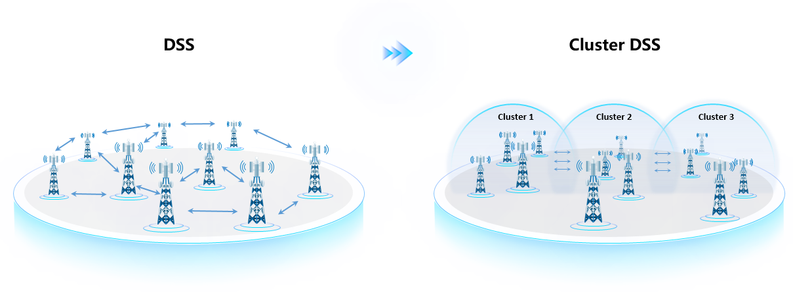
Figure 7.11 Cluster DSS Solution

7.4 Coverage enhancement

7.4.1 Super Uplink
Super Uplink (SUL) solution with decoupled uplink and downlink, which has been incorporated into 3GPP Release 16, solves the bottleneck of NR carrier uplink coverage. The uplink data is time-division transmitted over Time Division Dual (TDD) spectrum and SUL spectrum, which greatly increased the available uplink resources for 5G subscribers.
As shown in Figure 7.12, in downlink timeslots of the TDD band, the UEs close to or at a medium distance from the base station can use the SUL band to send uplink data. In uplink timeslots of the TDD band, the UEs switches back to the TDD band for uplink data transmission. This makes full use of the high bandwidth and dual uplink channels of TDD. The data from the UEs far from the base station can be totally transmitted on the SUL band to supplement the insufficient uplink coverage of the TDD band.
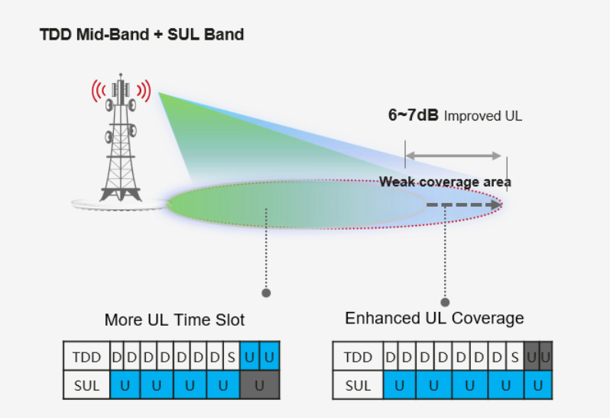
Figure 7.12 Super Uplink
The SUL solution completely decouples uplink bands from downlink bands. Uplink data is transmitted on TDD bands and SUL bands at different timeslots, greatly increasing available uplink time-frequency resources for 5G UEs.

7.4.2 FDD Assisted Super TDD
Innovative FDD Assisted Super TDD (FAST) solution combines the middle/low band carrier in accordance with the framework of carrier aggregation (CA), with the addition of the innovative Uplink (UL) TDM CA mode. By taking full consideration of the terminal implementing differentiation and the network strategies of operators, FAST can flexibly adapt to different capabilities of the terminal to maximize system performance.
Figure 7.13 shows the principles of NR FAST solution. In areas with weak uplink coverage by NR TDD (TNR) frequency bands, UEs can send data at a high rate by using NR FDD (FNR) frequency bands, and continue to enjoy an ultra-high downlink data rate delivered by the high bandwidth and Massive MIMO of TNR frequency bands. In areas where TNR frequency bands provide good uplink coverage, UEs can leverage both FNR and TNR frequency bands to send data (concurrent CA mode) and make full use of FDD uplink frequency bands in the time domain. In addition, having the characteristics of both FDD and TDD, the TDM CA mode is proposed, where uplink data can be sent by using multiple uplink carriers in TDD mode and fully using uplink timeslot resources. In this mode, a UE that supports only 2T can send data either through two transmit channels over TNR frequency bands or one transmit channel over FNR frequency bands, effectively using uplink resources of TNR and FNR frequency bands. FNR + TNR frequency band aggregation can improve downlink and uplink throughput. In this way, the optimal performance can be achieved in both the uplink and downlink in a complex radio environment.
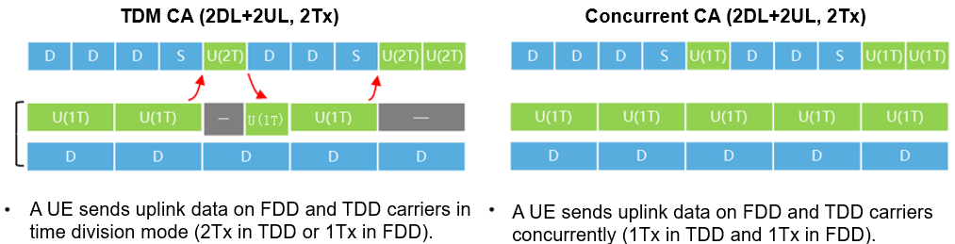
Figure 7.13 Principles of the FAST Solution (TNR + FNR)

7.4.3 Inter-Carrier Dynamic Power Sharing
Currently, the maximum transmit power of an AAU with Massive MIMO on the 3.5 GHz frequency band is 320 W, and the transmit power of each 100 MHz cell is 200 W. In the network sharing solution, the minimum bandwidth shall be 200 MHz on the 3.5 GHz frequency band. If a second carrier is enabled, the average power of each carrier is only 160 W, resulting in 1 dB lower in coverage. Therefore, how to enable the second carrier without deteriorating the coverage performance becomes an urgent issue.
Innovation
To address this issue, power resource pooling and dynamic power sharing are introduced. As shown in Figure 7.14, the power resource pooling technology allows dynamic power sharing between two carriers and flexible power allocation in a unified manner. The dynamic power sharing technology dynamically allocates power to two carriers based on service requirements. This ensures lossless coverage performance when the second carrier is enabled in lightly-loaded networks.

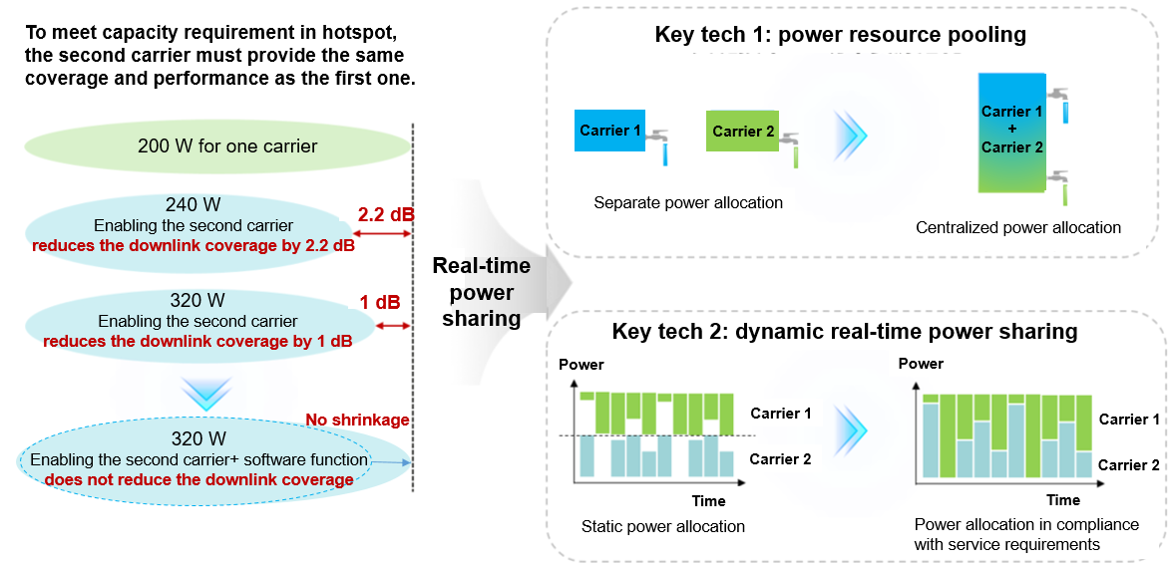
Figure 7.14 Dynamic Power Sharing
Power pooling and dynamic sharing have been introduced for unified and flexible scheduling of modules’ output power, which improves 5% to 20% downlink experience with lower carbon.

7.5 Capacity improvement

7.5.1 Super Frequency Fusion
Super frequency fusion technology, which has been incorporated into 3GPP Release 18 for 5G-advanced, greatly improves the spectrum efficiency, system capacity and user experience through simplified control channels for multi-carrier, spectrum pooling for multi-carrier and unified scheduling. Super Frequency Fusion uses simplified multi-carrier control channels and multi-carrier spectrum pooling for unified scheduling to address issues like low carrier spectrum efficiency and poor user experience in uplink and downlink rates.
As shown in Figure 7.15, simplified multi-carrier control channels can reduce the number of control channels. The control channel on one carrier schedules data channel resources on the 700 MHz, 800 MHz, and 900 MHz carriers, without occupying resources on the other two carriers for sending downlink control messages. This reduces overheads and improves spectrum efficiency and system capacity. As shown in Figure 7.16, multi-carrier spectrum pooling for unified scheduling aggregate the uplink and downlink spectra of multiple carriers to form an uplink spectrum pool and a downlink spectrum pool respectively. In the spectrum pools, frequency selective scheduling of multiple carriers can be implemented to allocate uplink and downlink time-frequency resources for optimal user experience and coverage.

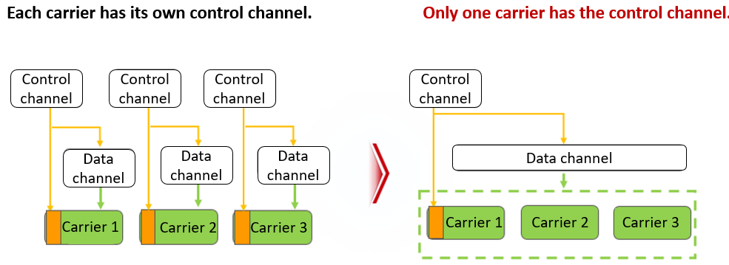
Figure 7.15 Super Frequency Fusion
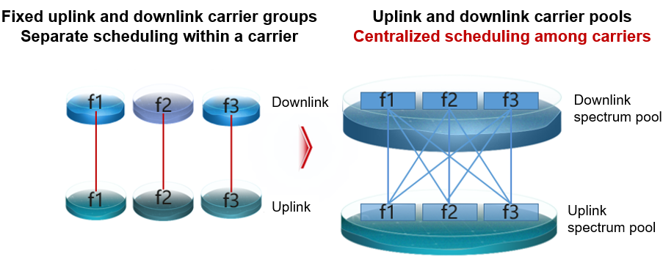
Figure 7.16 Super Frequency Fusion

7.5.2 Time-Frequency-Space 3D Beam Coordination
3D beam coordination with time, frequency and space domain, achieves the best average user experience in the whole network with scheduling of full band multi beam forming and collaboration of multi bands, solving the problem of unbalanced service/user distribution. As shown in Figure 7.17, this technology uses full-band multi-beam 3D coordinated scheduling on the shared network to efficiently coordinate multiple frequency bands. Specifically, UEs that can be paired in MU-MIMO are allocated to the same TDD frequency band, while UEs that cannot be paired, due to heavy load, poor coverage, or high interference, are allocated to FDD or idle TDD frequency bands. In this way, service distribution is optimized and optimal user experience is achieved.

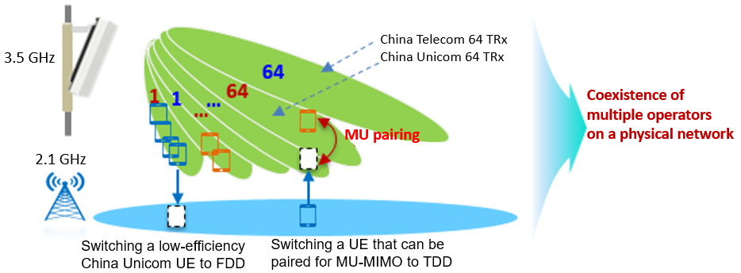
Figure 7.17 Time-Frequency-Space 3D Beam Coordination

7.5.3 Sounding Reference Signal (SRS) Carrier Switching
China Telecom and China Unicom share the 200 MHz bandwidth on the 3.5 GHz frequency band. When TDD + TDD CA and FDD + TDD CA (with a FDD CC serving as the PCC) are deployed, uplink transmission is only on the PCC. As a result, SRS-based beamforming cannot be used on the Secondary Component Carrier (SCC), decreasing the user-experienced data rate by 30%. Preventing the user-experienced data rate over the SCC from decreasing in high-bandwidth co-construction and sharing scenarios is an issue to be resolved.
SRS carrier switching improves 30% secondary carrier experience with SRS sending on secondary carrier for self-contained slots (S timeslots) and SRS sending on primary carrier for other timeslots. After SRS carrier switching is introduced, as shown in Figure 7.18, the uplink SRS transmission over the S slots on the PCC is switched to the S slots on the SCC, and the uplink transmission over other slots remains on the PCC. In this way, SRS-based beamforming can also be used on the SCC.
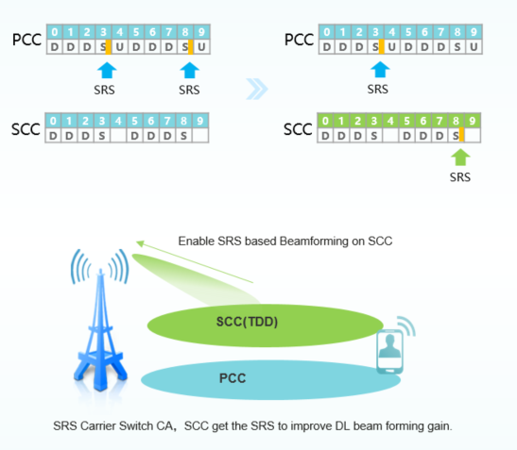
Figure 7.18 SRS Carrier Switching

7.6 Interference Suppression
In the antenna feeder system, passive interference of multi-frequency co-existence is a difficult problem in the industry. By new architecture of multi-level cancellation, both linear and non-linear passive interference can be counteracted. The coverage has been improved 20% with over 10dB Passive Inter-Modulation (PIM) cancellation. The technology is called ultra-wideband PIM Self-Interference Cancellation (SIC). As shown in Fig. 7.19, the new multi-level structure can cancel both linear and nonlinear passive interference, and suppress dual-frequency PIM interference through the cascading model.
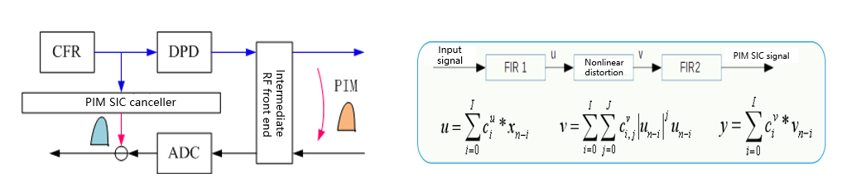
Figure 7.19 Structure of PIM SIC for Uplink

In macro-macro intra-frequency network, the interference between neighbor cells has been decreased with intelligent beam forming power coordination. About 15% user speed rate increased through coordination frequency scheduling of neighbor cells.

Other Consideration of 5G Network Sharing

8.1 Operation and Dispatching

8.1.1 Blockchain-Based Operation and Dispatching Platform for Shared-Networks
The shared operation and dispatching platform based on block chain technology, addresses three issues of operating: key parameters verification, configuration permissions of sharing NE and intelligent scheduling of contract resources.
There are mainly two schemes for the platform to realize cross-cloud deployment, cross-cloud blockchain creation, and heterogeneous cloud collaboration, which accelerates the network co-construction, sharing, maintenance, and optimization.
- Data Traceability, Improving Collaboration and Trust
With the blockchain technology, anti-tampering data storage, traceable data query, and trusted point-to-point transmission can be implemented. And thanks to decentralization, immutability, transparency, and security properties of the blockchain technology, each party can achieve credibility during cooperation.
- Smart Contract, Improving the O&M Efficiency
As a computer program running on a blockchain, a smart contract can be automatically executed and mutually recognized by participants, automating trusted and irreversible data transactions.
Compared with traditional technologies, the smart contract technology can save time, and reduce manpower and maintenance costs for customers.
Deployed on a private cloud in a distributed manner, the blockchain-based dispatching platform uses the cross-cloud networking technology to establish an end-to-end blockchain network with encrypted communication channels, implementing endorsement and accounting based on the pre-negotiated endorsement policy and smart contract. The upper-layer application capabilities support three application scenarios, which are credential saving and verification of key parameters, determination of responsibility for work orders, and resource scheduling based on smart contracts.
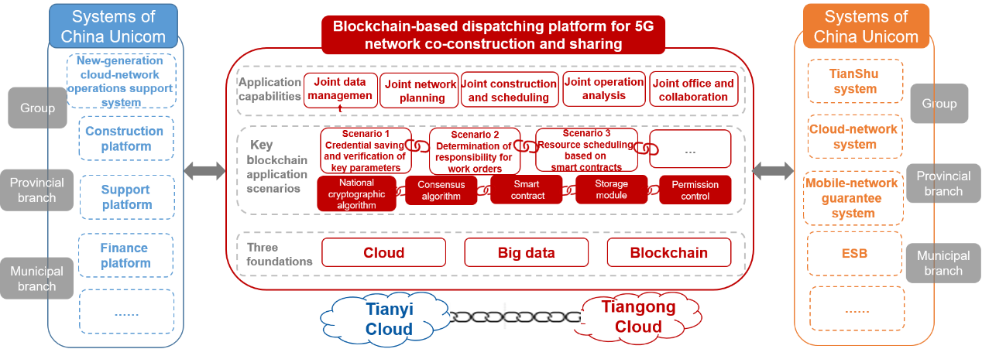
Figure 8.1 Blockchain-Based Dispatching Platform for Co-Construction and Sharing
The platform empowers the whole procedure of sharing network construction, application, operation and optimization with cloud-deployment, cloud-chain and heterogeneous-cloud-coordination. Till now, it has been applied for over 600,000 sites with operation efficiency doubled.

8.1.2 AI-Based Full-Time Energy-Saving System for Shared Networks
The energy-saving platform for shared networks, powered by AI, big data and network controlling technologies, has been deployed in 31 provinces in China with over 15% energy saving for 5G sharing network.
The traditional energy-saving technology for base stations is implemented by manually configuring timing energy-saving policies. However, difficulty in discovering energy-saving base stations, guaranteeing energy-saving security, and dealing with unexpected issues, as well as complicated deployment of massive base stations, and time-consuming evaluation and optimization make it hard to achieve elaborate energy-saving management because of large traffic differences between base stations.
To solve the above problems, a network-wide AI-based energy-saving platform for base stations is developed, as illustrated in Figure 8.2.
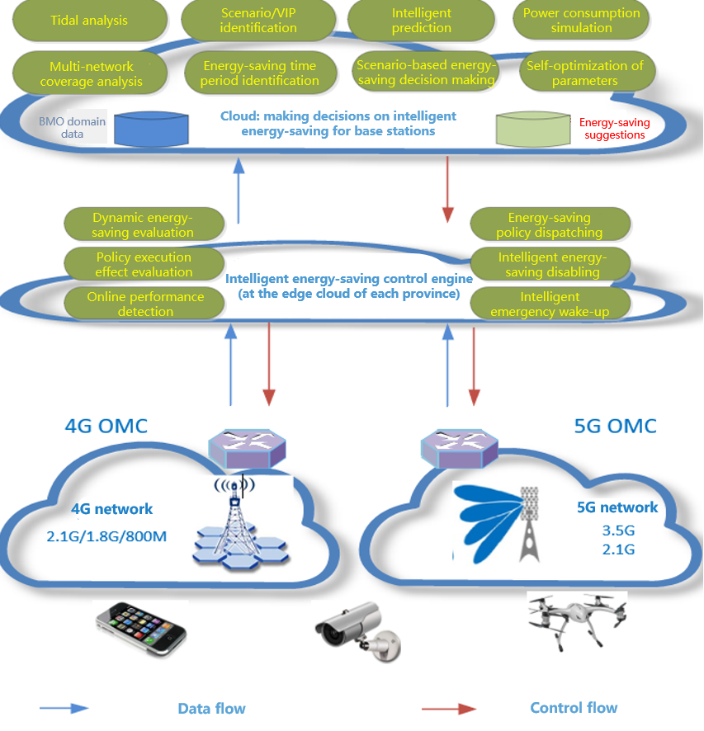
Figure 8.2 All-Time AI-Based Energy Saving Platform
By using AI, big data, and network control technologies, China Telecom and China Unicom have built a network-wide AI-based energy-saving platform for base stations. The energy-saving analysis capability and decision-making capability provide reference for the platform to make decisions. The energy-saving control engine converts the decisions into instructions, executes the instructions, and performs evaluation and feedback.

8.2 B2B Private Sharing Network

8.2.1 Multi-Mode Resource Block (RB) Reservation Policy
Multi-mode RB resource reserving strategy, with statistical level and TTI level RB reserving strategy, matches the differentiation requirements of services. Meanwhile, the 5G user speed rate, latency have been guaranteed especially for Ultra-Reliable Low Latency Communication (URLLC) scenarios with RB resource management and scheduling.
In B2B scenarios where URLLC services are provided, the inter-cell coordinated reservation of fixed RB positions can be introduced to greatly reduce intra-system interference. For each operator and its independent slice, the transmission between the AMF and UPF can be flexibly configured, enabling the independent and flexible configuration of slice transmission in multi-operator shared networks and meeting different service requirements of operators.
As illustrated in Fig 8.3, the multi-mode RB reservation policy assures two types of services:
1. B2B services requiring assured ratios: Through the average RB ratio configured for statistics-level slice groups, resources can be preferentially allocated to the services, such as video services.
2. B2B URLLC services: (1) Dedicated resources are configured for TTI-level slice groups, and statistics-level reservation is used to strictly isolate the resources, guaranteeing the availability of dedicated resources. (2) If there is strong interference from neighbor cells, the start fixed position for dedicated RBs can be configured to reduce the impact of other services on URLLC services.
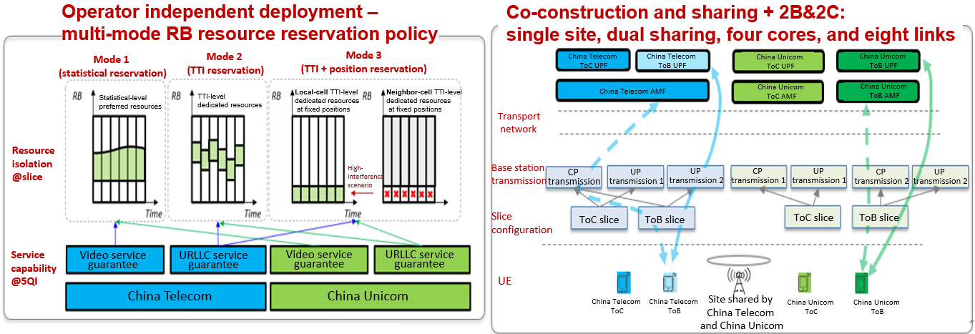
Figure 8.3 Multi-Mode RB Reservation Policy
The technology has been incorporated into 3GPP TS 28.541 and China Communications Standard Association (CCSA) industry standard.

8.2.2 Multi-logic Cell Management of Shared Carrier
Multi-logic cell management of shared carrier, innovative sharing solution which ensures the differentiated requirements of 5G verticals of different operators. Not only the independent operation of vertical applications, but the security of industry data can be guaranteed.
5G co-construction and sharing for private network deployment can greatly reduce construction costs, and multiple independent logical cells can ensure the independent operations of industry applications and the security of industry data. Figure 8.4 shows the network architecture.

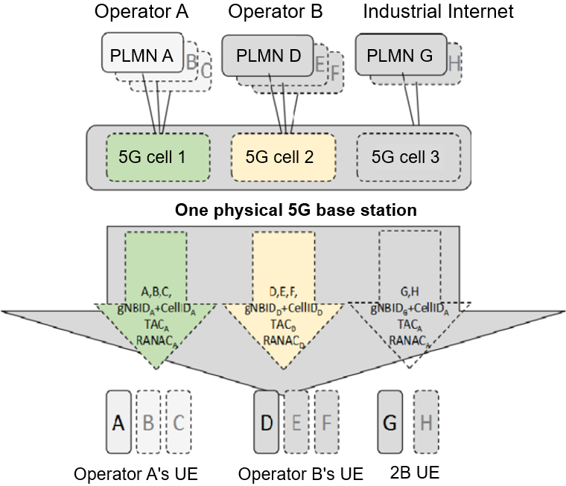
Figure 8.4 Network Architecture with Multiple Independent Logical Cells
The implementation scheme of the multi-logic cell management architecture is as follows:
1. Based on the two-layer architecture (carriers and physical cells) of the traditional wireless network, logical cells are created based on cell IDs and base station sectors and a three-layer architecture (carriers, physical cells, and logical cells) is constructed, forming a new 5G cell management model.
2. A cell ID is associated with an operator's PLMN and an enterprise PLMN, identifying the independent logical base station and logical cell for the operator and enterprise.
3. Cell IDs and location area information are planned independently. Functions can be activated based on the requirements of operators and enterprises and thresholds can be set independently, thus ensuring the independence of operators' networks and enterprise private networks.
With multiple independent logical cells, operators can improve resource efficiency by sharing spectrum, RAN, and power resources, and can meet the low latency, security, and high uplink bandwidth requirements of enterprise data services without the need to provide differentiated services and policies.

8.2.3 5G-Advanced Super Time-Frequency Folding Solution
To meet the requirements in the core scenarios of each industry, customized 5G networks must differ from traditional networks and have end-to-end deterministic networking capabilities. Therefore, 5G-Advanced super time-frequency folding solution is proposed, the comparison diagram of Typical 5G TDD Slot Solution and the proposed new solution are shown in Figure 8.5 and Figure 8.6.
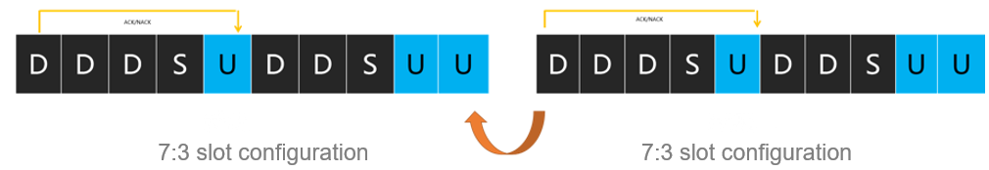
Figure 8.5 Typical 5G TDD (2.6/3.5/4.9 GHz...) Slot Solution
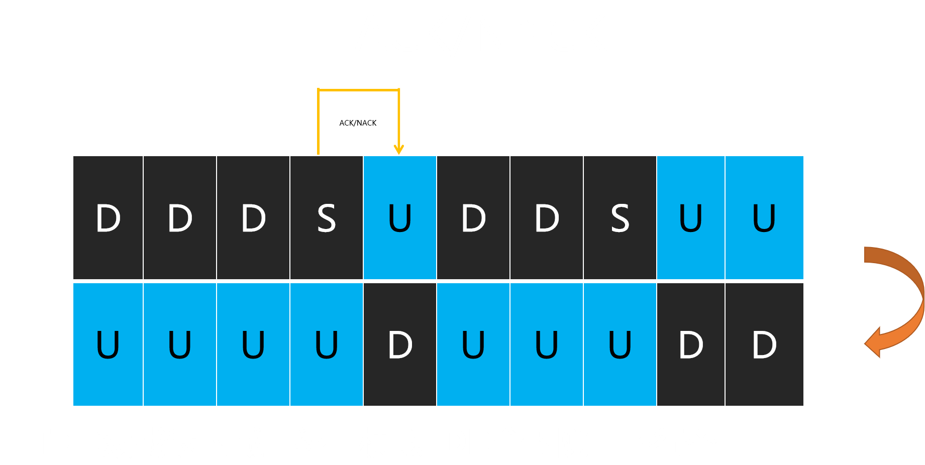
Figure 8.6 5G-Advanced Super Time-Frequency Folding Solution
The super time-frequency folding technology folds TDD time-domain information in the frequency domain, and adjusts the uplink and downlink resources on TDD half-duplex carriers to implement time-domain complementation on TDD dual carriers. In this way, FDD full-duplex mode is reconstructed based on TDD. Time-frequency folding leverages the high bandwidth of TDD and the low latency of FDD to implement deterministic networking that integrates low latency, large capacity, and high reliability, and endows TDD spectrum with multiple capabilities in one network.
5G-Advanced super time-frequency folding can meet the requirements for deterministic networking capabilities such as 4 ms latency, 100 MHz uplink bandwidth, and 99.9999% reliability.

8.3 5G SA international roaming under core network sharing
Currently, in Release 18, [3GPP TS 23.501] only supports the sharing architecture of 5G MOCN. It is necessary to increase the research on 5G SA international roaming technology under core network sharing. It is recommended to increase the research and standard support of long-term architecture.
In the 5G SA scenario, an operator can deploy a shareable network. For example, operator 1 (OP1) shares its RAN with operator 2 (OP2), and operator 3 (OP3) is a roaming partner of OP2. In this case, the UEs of OP3 can connect to the shared RAN of OP1 to access the services of OP2. Figure 8.6 illustrates the network architecture for national inter-CN roaming in the 5G SA scenario.
Figure 8.6 Scenario of International Roaming Users in national Inter-CN Roaming
As shown in the figure, three operators (OP1, OP2, and OP3) are involved in this scenario.
OP1 not only shares its RAN with OP2, but also makes its core network shareable.
OP2 signs a 5G network sharing agreement with OP1 for sharing the RAN of OP1.
OP3 is a roaming partner of only OP2 (that is, they have signed a roaming agreement).
Since OP2 has signed a 5G network sharing agreement with OP1, the UEs of OP2 can connect to the shared RAN of OP1 to access the services of OP2. In addition, OP3's UEs roaming in OP2's dedicated RAN or OP1's shared RAN can access the services of OP2 through the corresponding RAN.
3GPP SA1 finalized the study on the “Indirect Network sharing”, attaching greater importance to the feasibility of more sharing modes and initiated the normative work for TS 22.261. To meet the technical requirements of international roaming under national inter-CN roaming in the 5G SA scenario, [3GPP TS 29.573] needs to be reviewed to support the interconnection of long-term SEPP. In addition, [GSMA NG.113] is a guideline for 5G SA roaming, and it is recommended to add support for the long-term shared architecture as well.

Guidelines for implementation
To ensure the smooth implementation of sharing and co-construction, all parties should fully collaborate with each other in planning, construction, operation, and optimization to achieve common goals, it is recommended that cooperative operators establish a joint working mode.
The cooperative operators should establish an end-to-end co-construction and sharing long-term cooperation mechanism. Based on the information support platform, including the organization guarantee mechanism, the evaluation system of planning, construction, maintenance and optimization, and the mechanism of assessment and incentive.

9.1 Planning
In terms of joint network planning, the following are recommended.
Planning principles: The objectives, processes, plans, guidelines, templates and methods should be unified to accommodate the differences in network resources and planning and construction objectives. Furthermore, in shared network areas, the common quality criteria should be applied and consideration should be given to customizing the design of 5G equipment based on site characteristics such as tunnels/roads, etc.
Planning methodology: Joint clarification of the current situation, joint assessment of the trend, unified planning objectives, unified coordination of resources, and joint review of the planning.

9.2 Construction
In terms of joint network construction, the following are recommended.
Construction principle: Full sharing and information equivalence; joint planning review, unified construction priority evaluation criteria, joint acceptance of engineering projects, and regular management to ensure information equivalence and timely response to sudden and changing demands.
Construction step: Network construction is divided into four stages: solution review, infrastructure reconstruction, construction implementation, and engineering acceptance.

9.3 Operation and optimization
In terms of network operation and optimization, it is recommended to explore the strategies of cooperative operation, including service resource strategy, mobility strategy, operation data sharing, collaborative network ID, network management sharing, and unified KPI. In particular, it is important to address and manage the network switching in areas adjacent to each operator’s dedicated network and shared network areas.
To ensure fairness and equality among all parties involved in shared networks, it is essential for all parties to engage in pre-negotiation and align their business strategy, user strategy, and resource scheduling strategy. Here are the key aspects of this collaboration:
1. Business Strategy Collaboration: This involves aligning the business models of different operators to ensure consistency with the 5QI carrier, which refers to the relevant recommendations of 3GPP TS23.501
2. User Strategy Collaboration: This focuses on harmonizing user classes across operators to establish a mapping relationship between the user classes and the default carrier of 5QI within their respective 5G core networks.
3. Resource Scheduling Strategy Collaboration: This entails reaching agreements on QoS priority ranking for each 5QI carrier to ensure uniform QoS protection for all users in shared areas, which all operators must adhere to.
4. Slicing Strategy Collaboration: By defining SLA profiles corresponding to slice IDs in advance and managing them consistently across the network domains, businesses can have a clearer understanding of their operations and maintain consistency for the entire network.

9.4 Regulation and Accounting/Settlement
Regulatory aspects and security mechanisms should be considered.
On the regulatory side, close collaboration, in particular with the regulatory government, from the planning stage onwards, is expected to be the most important factor in the success of the network sharing implementation.
At the same time, it is necessary to study the inter-network accounting/settlement: Including inter-network settlement requirements, settlement principles, etc.
Inter-network settlement requirements are essential for operators engaged in co-building and sharing networks. These requirements involve settlement fees for access network sharing, where operators utilizing the shared networks are subject to corresponding fees. Additionally, for core network roaming, users accessing network from other telecommunications network will incur roaming settlement fees, similar to international roaming charges.
Inter-network settlement is crucial for enhancing network value, promoting resource sharing among operators, and facilitating cooperation in network construction and sharing. The settlement scope encompasses fees associated with macro base stations, indoor divisions, bearer networks and transmission networks.

Prospect of Network Sharing and Co-construction
In terms of the future development direction of sharing network with global partners, there are two aspects to consider.

10.1 Deepening 5G network sharing and co-construction cooperation
The future evolution direction of 5G network sharing and co-construction can be analyzed from multiple dimensions such as technology route, geographical range, number of partners, working frequency bandwidth, and technology systems.

10.2 Future technological evolution of sharing and co-construction
mmWave sharing and co-construction, MEC sharing and co-construction, and 6G network sharing and co-construction may be considered in the future.

10.2.1 Millimeter Wave
Featuring high bandwidth and low latency, millimeter Wave (mmWave) is crucial for both current and future 5G network development. The mmWave frequency bands will coexist with other frequency bands in the long term, as 5G networks need both high and low frequency bands. EN-DC, NR-DC and FR1 + FR2 CA enable optimal utilization of high and low frequency bands in different stages of 5G development, fully leverage the role of mmWave in 5G network co construction and sharing scenarios.
With the global popularity of 5G, mmWave frequency bands can be used as a supplement to the main frequency bands (medium and low frequency bands) of 5G networks. When using high-traffic services, a terminal can use mmWave to offload traffic. NR-DC/CA can be adopted to implement better inter-frequency coordination for the devices from the same vendor, and only the frequencies in FR2 are used for the devices of different vendors in 5G network co-construction and sharing. The priority-based carrier scheduling and load balancing help to maximize the utilization of medium and low frequency bands.

10.2.2 MEC
The Mobile Edge Computing (MEC) technology introduced in 5G networks supports a variety of industrial applications that impose high requirements on network latency and data security. In a shared network, the hosting operator and participating operators can share the computing power of the edge servers, which coordinate with the cloud servers and terminals to flexibly schedule and transfer computing resources. In this way, the QoS of edge computing applications as well as the coverage of edge computing is improved, thus attracting more third-party applications and ultimately providing better user experience.

10.2.3 6G Technologies
With the acceleration of 5G network construction, a variety of applications are flourishing in vertical industries. As a new generation of mobile communication systems emerge about every ten years, it is predicted that 6G will be commercially available around 2030.
At present, many countries have issued whitepapers on 6G visions. The expectations for next-generation networks, especially those for key technologies, are all incorporated into the 6G visions.
In terms of international standardization, ITU-R published a new Recommendation on the “IMT-2030 Framework” as known as 6G vision, which is Recommendation ITU-R M. 2160. The new recommendation "Framework and overall objectives for the future development of IMT for 2030 and beyond" can serve as a basis for standardization fora to develop the next generation of IMT standards.
This Recommendation addresses (1) ​​Trends of IMT-2030​, (2) Usage scenarios of IMT-2030, (3) Capabilities of IMT-2030, (4) Considerations of ongoing development ​.
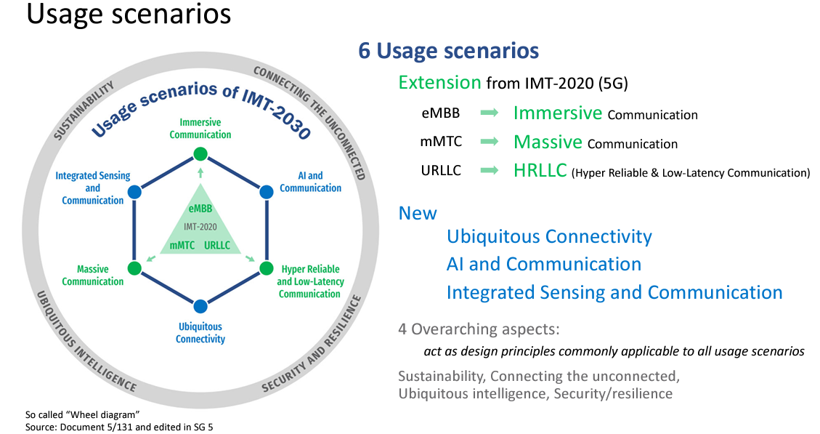
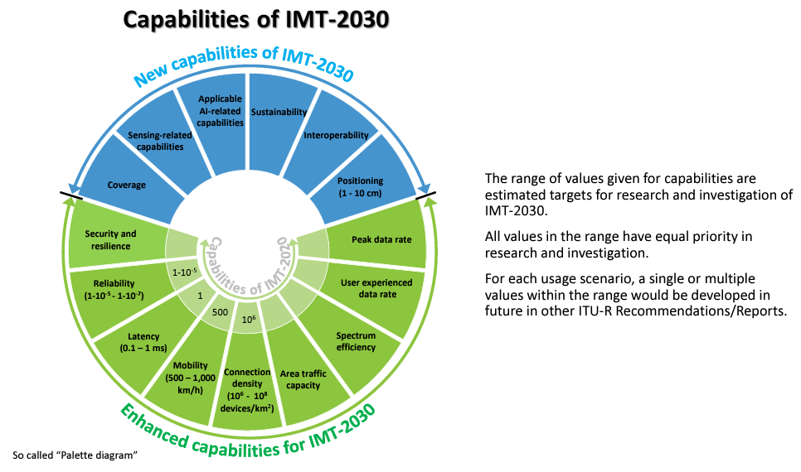
With the evolution of information and communications technologies, IMT-2030 is expected to support enriched and potential immersive experience, enhanced ubiquitous coverage, and enable new forms of collaboration. Furthermore, IMT-2030 is envisaged to support expanded and new usage scenarios compared to those of IMT-2020, while providing enhanced and new capabilities.​IMT-2030 is further expected to help address the need for increased environmental, social, and economic sustainability, and also support the goals of the Paris Agreement of the United Nations Framework Convention on Climate Change.​
Moreover, 3GPP is uniquely positioned to develop the standard for 6G. The organization’s consensus-based process delivers the critical technical specifications that provide a complete system description for the mobile networks that billions of users depend on. 3GPP is currently at work on Release 19 of its specifications, which relate to 5G-Advanced. However, delivery of a new mobile generation is a multi-year process. That is why the work for the 6G specifications is being planned well in advance. Further growth may be expected as the needs of 6G use cases are considered in the standards development process.
6G network co-construction and sharing is still in the research stage. With the development of key 6G technologies, the following three aspects are expected to become the focus in the next few years:
Data sharing: The future network will revolutionize the way humans and intelligent devices interact, adapting to evolving changes. Data sharing and interaction will shift from the device level to the application level, ushering in a new era of technological advancement.
Smart simplicity: In the face of massive service access and dynamic network requirements in the future, network design should be oriented towards simplicity and decentralisation, unifying basic interface protocols and access management modes. In co-construction and sharing, multiple operators can share network resources, thus providing seamless network access.
Network compatibility: The 6G network should be compatible with traditional networks. In co-construction and sharing, smooth voice and data services can be guaranteed during inter-PLMN or inter-RAT handover.
So far, many countries have started to promote research on 6G technologies, which will definitely drive the mobile communication industry to new heights. Unified international communication standards are essential for the success of 6G. The contributors of this report will further investigate the development for network co-construction and sharing of 6G, including advancements in network architecture and technologies, and unswervingly participate in the formulation and update of the standards, promoting 6G globalisation and the development of the community with a shared future for mankind.

____________

