APT REPORT ON

SMART SUSTAINABLE CITY USE CASES AND INFORMATION & COMMUNICATION TECHNOLOGIES IN ART REGION

Edition: May 2018

The 30th APT Standardization Program Forum (ASTAP-30)
21 – 25 May 2018
Bangkok, Thailand

(Source: ASTAP-30/OUT-11)

No. APT/ASTAP/REPT-31
aPT report on SMART SUSTAINABLE CITY USE CASES and INFORMATION & COMMUNICATION technologies
IN apt REGION

Contents
1. Scope 3
2. References 3
3. Terms and Definitions 3
3.1 Terms defined elsewhere 3
3.1.1 big data 3
3.1.2 device 3
3.1.3 Internet of things (IoT) 3
3.1.4 Smart Sustainable Cities (SSC) 4
3.1.5 thing 4
3.2 Terms defined in this Recommendation 4
3.2.1 Internet of Things Ecosystem 4
4. Abbreviations and Acronyms 4
5. Smart Sustainable City 4
5.1 The need for Smart Sustainable Cities 4
5.2 Smart Sustainable City Ecosystem 5
5.3 Convergence of Smart Sustainable City, IoT and Big Data 5
6. Smart Sustainable City Use Cases in APT Region 6
6.1 Smart Sustainable City Initiatives in China 6
6.1.1 Overview of Smart Sustainable Cities in China 6
6.1.2 Use cases 6
6.1.2.1 Urban Public Service 6
6.1.2.1.1 Ningbo Cloud Hospital 6
6.1.2.1.2 Internet+medical 6
6.1.2.1.3 Smart parking 7
6.1.2.2 Governmental Service 7
6.1.2.3 Urban Management 8
6.2 Smart Sustainable City Initiatives in Japan 8
6.2.1 Use cases 8
6.2.1.1 Smart Waste Management 8
6.2.1.1.1 Pilot projects: Kawasaki City, Kanagawa Prefecture, Japan 9
6.2.1.1.2 Organizations Involvement 9
6.2.1.1.3 Planning stages 9
6.2.1.1.4 Other use case on waste management in Japan 9
6.2.1.2 Pedestrian Monitoring 10
6.2.1.2.1 Framework 11
6.2.1.2.2 Pilot Project 11
6.2.1.2.3 Infrastructure 11
6.2.1.2.4 Organizations involvement 12
6.2.1.2.5 Security and Privacy 12
6.3 Smart Sustainable City Initiatives in Korea 12
6.3.1 Overview of Smart Sustainable Cities in Korea 12
6.3.2 Busan Smart City 12
6.3.3 Use cases 13
6.3.3.1 Traffic Management Service 13
6.3.3.2 Smart Parking Service 14
6.3.3.3 Safety Service 15
6.4 Smart Sustainable City Initiatives in Malaysia 15
6.4.1 Overview of Smart City Initiatives - Cyberjaya 15
6.4.2 Smart City Use Cases in Cyberjaya 17
6.4.3 Smart City Use Cases in Iskandar Malaysia 18
6.4.3.1 Low Carbon Lifestyle 19
6.4.4 Smart Selangor 19
6.4.4.1 Smart pothole repair 19
6.4.4.2 Smart waste management 20
6.5 Smart Sustainable City Initiatives Report by GSMA 21
6.5.1 India: Special purpose vehicles for smart cities project 21
6.5.2 Star Hub m360 –Transport Management (Singapore) 22
7. Summary of Smart Sustainable City Use Cases in APT region 22
7.1 Key recommendations 22
7.2 Challenges in deploying Smart Cities 24
7.3 Standardization activities related to Smart Sustainable Cities 24
8. Conclusions 24

Scope

This document is a compilation of report on Smart Sustainable City (SSC) use cases and Information and Communication Technologies (ICT) from various APT Member countries. The scope of the report is as follows:
- Introduction about SSC including the need and benefits for the SSC
- SSC use cases from APT Member countries focusing on the ICT
- Key success factors, best practices and use cases of Information and Telecommunication Technologies & Solutions in SSC
- Standardization activities related to SSC

References

The reference to a document within this Recommendation does not give it, as a stand-alone document, the status of a Recommendation.
- ITU-T Flipbook on Unleashing the potentials of the Internet of Things
- ITU-T Flipbook on Shaping smarter and more sustainable cities: Striving for sustainable development goals

Terms and Definitions

Terms defined elsewhere
    - big data [ITU-T Y.3600]: A paradigm for enabling the collection, storage, management, analysis and visualization, potentially under real-time constraints, of extensive datasets with heterogeneous characteristics.

NOTE – Examples of datasets characteristics include high-volume, high-velocity, high-variety, etc.

    - device [ITU-T Y.2060]: With regard to the Internet of things, this is a piece of equipment with the mandatory capabilities of communication and the optional capabilities of sensing, actuation, data capture, data storage and data processing.

    - Internet of things (IoT) [ITU-T Y.2060]: A global infrastructure for the information society, enabling advanced services by interconnecting (physical and virtual) things based on existing and evolving, interoperable information and communication technologies.
NOTE 1 – Through the exploitation of identification, data capture, processing and communication capabilities, the IoT makes full use of things to offer services to all kinds of applications, whilst ensuring that security and privacy requirements are fulfilled.
NOTE 2 – In a broad perspective, the IoT can be perceived as a vision with technological and societal implications.

    - Smart Sustainable Cities (SSC) [ITU-T Y.4900]: A smart sustainable city is an innovative city that uses information and communication technologies (ICTs) and other means to improve quality of life, efficiency of urban operation and services, and competitiveness, while ensuring that it meets the needs of present and future generations with respect to economic, social, environmental as well as cultural aspects.
NOTE - City competitiveness refers to policies, institutions, strategies and processes that determine the city’s sustainable productivity.

    - thing [ITU-T Y.2060]: With regard to the Internet of things, this is an object of the physical world (physical things) or the information world (virtual things), which is capable of being identified and integrated into communication networks.

Terms defined in this Recommendation

    - Internet of Things Ecosystem: a system that encompasses few components that ensures the implementation and operation of IoT solutions. These may consist of devices or things (device consist of both sensors and communication module), infrastructure (connectivity), a platform and application including big data analytics.

Abbreviations and Acronyms

LCCF Low Carbon Cities Framework
IoT Internet of Things
NB-IoT NarrowBand IoT
SSC Smart Sustainable Cities

Smart Sustainable City

Many Smart Cities have emerged in the recent years, thanks to the rapid evolution of technology and the initiatives to provide living environment for a better and sustainable future. Each city has their own theme and it is usually based on their need to provide better services to their people. Three key elements are required for a successful smart city implementation: applications, infrastructure and ecosystem. Cities need advanced applications to ensure the best use of urban assets, IoT data and sensor data to create a smart, safe and sustainable environment.

The need for Smart Sustainable Cities
According to ITU-T report on smart sustainable city [Ref; ITU-T Flipbook on Shaping smarter and more sustainable cities: Striving for sustainable development goals], modern cities are responsible for 80 percent of global economic output and 70 percent of global energy consumption and global greenhouse gases (GHG) emissions. It is also reported that by the year 2050, 66% of 9 billion world population will live in cities. In view of this, cities around the world must adopt sustainability.

Smart Sustainable City Ecosystem
Knowing the fact that cities must support large influx of people and to have a sustainable plan, United Nation (UN) General Assembly, in September 2015, has achieved consensus on a new set of 17 Sustainable Development Goals that are applicable for both developing and developed nations. Countries can use these sustainable development goals as a guide in creating a proper ecosystem to build a smart sustainable city.

It should be noted that most smart cities started with specific application such as smart transportation, smart street light and many other vertical applications. This silo approach holds risks of high integration and operation cost. Hence an open ecosystem is best to be used for any smart city implementation. In technical terminology, open ecosystem provides a common set of service capabilities, standardized interfaces, open APIs for application developers, device manufacturers and service providers. This will not only reduce development, deployment and operation costs, but also enable open innovation, and allow data to be easily exchanged between applications. An open ecosystem avoids vendor-lock in by establishing and adhering to appropriate standards and protocols, and nurturing continuous discussion among technology stakeholders, city leaders and citizens.

Convergence of Smart Sustainable City, IoT and Big Data
IoT applications involve collection and processing of data from various IoT sources such as sensors, wearables, and other Internet connected devices. Type of devices used for any IoT application must be used to solve the pain points identified. It includes healthcare, urban mobility, safety, security and etc. One of the large-scale application is the smart city. IoT is part of the smart city and it cannot be separated from it. Smart sustainable city usually consists of many IoT applications such as smart transportation, smart lighting, smart meters, smart grid, etc. These massive amounts of data generated in the smart city must be processed effectively and efficiently by using some domain specific processing tools. The technology for this is the big data analytics. All three, smart sustainable city, IoT and big data, have to be structured and integrated to get the best solution.
There are broad range of applications that have been associated with smart cities. Based on Machina Research Strategy Report, “The City Playbook: smart, safe, sustainable”, smart city applications can be grouped into three broad categories:
- Smart living: Applications that aimed at improving the quality of life of citizens. Some of the applications includes public wifi, event notifications and connected signages
- Smart safety: Applications that aimed at helping to prevent, or minimize the risks and impact of, adverse events such as crime, natural disasters and environmental pollution. This includes crowd monitoring and control, smart care and assisted living, emergency alerts and notifications, etc.
- Smart sustainable: Applications intended to reduce the environmental impact (especially energy consumption and carbon emission) of the city’s own operation. This includes, smart transportation, smart waste management, etc.

Smart Sustainable City Use Cases in APT Region

Smart Sustainable City Initiatives in China

Overview of Smart Sustainable Cities in China
Till to the end of 2016, China approved about 600 pilot cities from different departments and local governments, covering 100% of the provincial / sub-provincial cities, 89% of the prefecture-level cities, 47% of the county-level cities.
Nowadays, China has step into new phase called new-type smart city in China. The development goals of new-type smart city in China focus on two aspects, first is to improve public service performance and second is to enhance urban governance level. Comparing to the existing smart cities, new-type smart cities emphasis more on the information sharing, utilization of data resources and the construction and guarantee of urban security.

Use cases
There are three focus areas of smart cities in China which are urban public service, governmental service and urban management.

Urban Public Service
The development priorities are to provide high ICT penetration with high coverage and significant social benefits.

Ningbo Cloud Hospital
One of the typical use case is “Internet + Medical Service”. It is led and operated by Ningbo Municipal Government by establishing a telemedicine services using a collaboration platform with enterprises, called "Ningbo Cloud Hospital”.

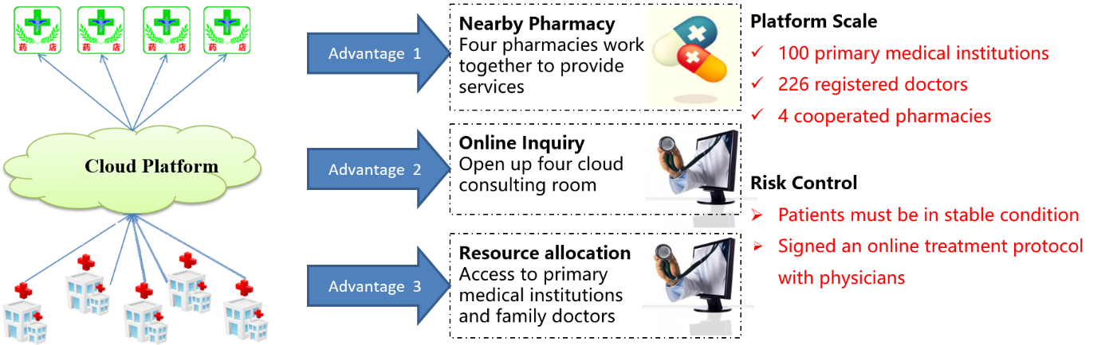
Figure 6.1: Ningbo Cloud Hospital

Internet+medical
Guangdong, Zhejiang, etc. initiated medical pilots such as Internet+ hospital, Internet+ medical services. i.e ant financial company cooperated with hospitals in Zhejiang province started inter-diagnosis medical expenses settlement, online payment services, patients only needs to sweep the two-dimensional code on the sheet to complete the medical costs with the support of Alipay, instead of queue up again and again.

Smart parking
Another typical use case is smart parking management, i.e. in Shanghai. Leading mobile operators globally, including China Unicom, Deutsche Telekom, Vodafone and Etisalat, are working with Huawei on smart parking trials employing a type of Mobile IoT technology, known as NB-IoT. Huawei and China Unicom have installed a smart parking demonstration in a parking lot of the Shanghai International Tourism and Resorts Zone. The parking lot has been equipped with 334 NB-IoT enabled sensors. With partners Fangle (the sensor supplier) and u-blox (the module supplier), Huawei provided the end-to-end smart parking solution, which includes terminals, base stations, servers, and mobile phone apps. The solution is designed to help tourists find parking spaces and relieve traffic pressure in the surrounding streets. Located in the Pudong district of Shanghai, the zone is one of Shanghai’s six key development areas, and is home to Shanghai Disneyland. The NB-IoT connectivity enables drivers to search for and book parking spaces, navigate their way to an allocated parking space, pay for the parking directly using a mobile handset, and manage their parking needs with mobile phone apps. The city can then see the parking allocation, and reduce the opportunity for missed payments, allowing revenue to be maximized. The smart parking demonstration is part of a wider smart city initiative by China Unicom following a strategic cooperation framework agreement signed with the Shanghai government in May 2016. This partnership includes the rollout of a dedicated NB-IoT network covering all of Shanghai to improve the operation management capabilities and efficiency of the city. China Unicom is already considering further cooperation with industry players to develop NB-IoT applications in new areas such as smart metering, crowd management and environmental monitoring.
Source:
https://www.gsma.com/iot/wp-content/uploads/2017/03/Traffic-Management-guide-webv2.pdf

Governmental Service
With the help of cloud computing, big data, “Internet Plus” etc., governments are trying to provide more and more services online, to promote and improve the service efficiency, convenience as well as the decision-making. Typical Use Case is “Internet + Government Affairs” by Guangdong province, by the end of 2014, there were 52 provincial units providing over 1600 online services on the website of http://www.gdbs.gov.cn/portal/home.

Another typical use case is climate change and extreme weather forecast, i.e. in Taiwan. Over the years, Taiwan has earned international recognition for its expertise in the forecasting of, and response to, extreme weather. As part of a government initiative to improve its extreme weather response, the national Water Resource Agency is working with the city of Tainan and mobile operator Far East Tone (FET) to develop capabilities to improve flood control and disaster recovery. The partners are using high availability LTE mobile communication services, coupled with advanced monitoring devices and surveillance technologies, to deliver a comprehensive state-of-the-art solution. The high data throughput and low latency characteristics of FET’s ubiquitous LTE network enable a range of low cost IoT technologies that can enable:
- Near real time, data collection, data analysis and dissemination of results;
- Water resource monitoring, through real time pumping station and water level monitoring;
- Disaster awareness planning, through water level monitoring, analysis and flood prediction warnings;
- Emergency information broadcasts, through real-time flood warnings and information sharing via mobile applications;
- Distributed data backup, through distributed replicated data stores to provide high data availability at all times.

Cross-agency integration of key data flows to deliver faster disaster response. With all this new data made available in real time, the Water Resource Agency and other agencies have better visibility of events as they unfold and are in a better position to plan and respond accordingly. Through this combination of advanced monitoring technology, high-bandwidth mobile communications and a dedicated, well-trained and well-managed workforce;
- Emergency assets can be deployed faster, to where they can be the most effective;
- Flood prevention equipment can be accessed remotely, enabling faster response times;
- Flooding can sometimes be avoided or minimized;
- Water supplies and other utilities can be restored faster;
- the risk of loss of life is reduced; the risk of property damage is reduced.

Sources:
https://en.wikipedia.org/wiki/Internet_Plus
http://www.gdbs.gov.cn/portal/home
GSMA smart cities guides: Water management http://www.gsma.com/iot/gsma-smart-cities-guide-water-management/

Urban Management
One of the use case is “Smart Kaifu” in Changsha province. Kaifu district has set up a city integrated management platform and district-street-community-grid four levels of city management. The whole district is divided into 17 streets, 130 communities, and 473 grids.
The services and Smart city integrating the resource of the city by using modern information technology, such as the big data and IoT, in order to perfecting the urban governance mechanism and innovative urban governance mode，achieving fine precision of urban governance. Typical use cases are “Platform of city integrated management”, that is, to set up information perception network and management platform and formulate urban comprehensive solution through big data analysis. Promote intelligent application level of urban infrastructure, such as city appearance, sewage drainage, construction site, pollution monitoring of urban facilities.

Smart Sustainable City Initiatives in Japan

Use cases

Smart Waste Management
Waste collection service by cities requires a lot of costs and carbon emission. It is preferable to reduce the costs and carbon emission by optimizing waste-collection operations.
The smart waste management system enables to optimize a route for waste collection by using IoT technologies. The process consists of the following two steps:
- The data from waste monitoring sensors are collected;
- An optimal route for waste collection is determined by analyzing the collected data. Route is optimized based on amount of garbage in the garbage bin.

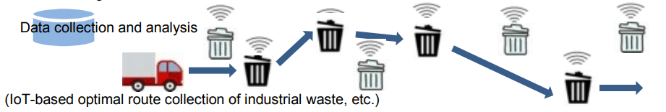
Figure 6.2: Smart waste management system

Pilot projects: Kawasaki City, Kanagawa Prefecture, Japan
The coastal area of Kawasaki City was designated as the first Eco-Town in Japan by the Ministry of Economy, Trade, and Industry of Japan. (http://www.meti.go.jp/policy/recycle/main/english/3r_policy/ecotown.html )

Organizations Involvement
- Kawasaki City (http://www.city.kawasaki.jp/en/index.html ): Main entity
- NEC Corporation (http://www.nec.com/ ): Provides IoT technologies including IoT platform.
- Nakasho, Inc.: An industrial waste disposer, provides a field for waste collection, etc.
- Resource Circulation Network: Consultant, verifies overall effects.

Planning stages
- Fiscal year 2016-2017: Verification of the use case.
- Fiscal year 2018-2019: Disseminating information for achievement of this use case and promotion of this use case to local industrial waste disposers.
- Fiscal year 2020: Promotion of the Kawasaki method to other Eco-Towns and overseas.

Other use case on waste management in Japan
Keio University is conducting a pilot project in Fujisawa city to reduce amount of garbage. In this project, sensors installed into garbage trucks calculate amount of garbage at each location. The city and citizens can compare the amount of garbage at each location.

Detailed information for this project can be seen at http://www.sfcity.jp/about/ (in Japanese).
Related information in English can be seen at the following papers.
- Makoto Kawano, Kazuhiro Mikami, Satoshi Yokoyama, Takuro Yonezawa and Jin Nakazawa, "Road Marking Blurs Detection with Drive Recorder", International Workshop on Smart Cities: People, Technology and Data in conjunction with IEEE BigData2017, page.4010-4015
- Yin Chen, Takuro Yonezawa, Jin Nakazawa and Hideyuki Tokuda, "Evaluating the spatio-temporal coverage of automotive sensing for smart cities," Tenth International Conference on Mobile Computing and Ubiquitous Network (ICMU), Toyama, Japan, 2017, pp. 1-5.

Pedestrian Monitoring
A pedestrian monitoring system for disaster control and for accident prevention is described in this use case.

Toshima city is one of the eight central administrative cities in Tokyo and has Japan’s second largest railway station “Ikebukuro”. Ikebukuro station has 2.59 million commuters a day. Control of pedestrians or commuters in the event of disasters are a big issue for the city. When the Great Earthquake hit the city in 2011, the city was not able to know the number of people in the city who had no way to get home.

From the experience of the Great Earthquake in 2011, Mayor and Officers of Disaster Prevention Section of Toshima city recognize that up-to-date and reliable information for evacuation sites and traffic condition is the most important in the event of a disaster. Following are the steps to monitor and provide evacuation information to the pedestrian.
- Surveillance cameras are installed throughout the city. The cameras capture images of the crowds without identifying any individuals. Existing surveillance cameras can be used. Installation of new cameras is not necessary.
- The image data are transmitted to a disaster control center via broadband network.
- At the disaster control center, the image data are analyzed to detect abnormal situations. Employing Deep Learning, this system can accurately estimate the crowd behavior even in a situation that people are overlapped in a captured image.
- The crowd behavior can be analyzed even if faces of pedestrians are not captured. It enables privacy protection.
- In the event of any abnormality, the disaster control center provides accurate information for evacuation or information of shelters. It also provides information to prevent accidents beforehand.
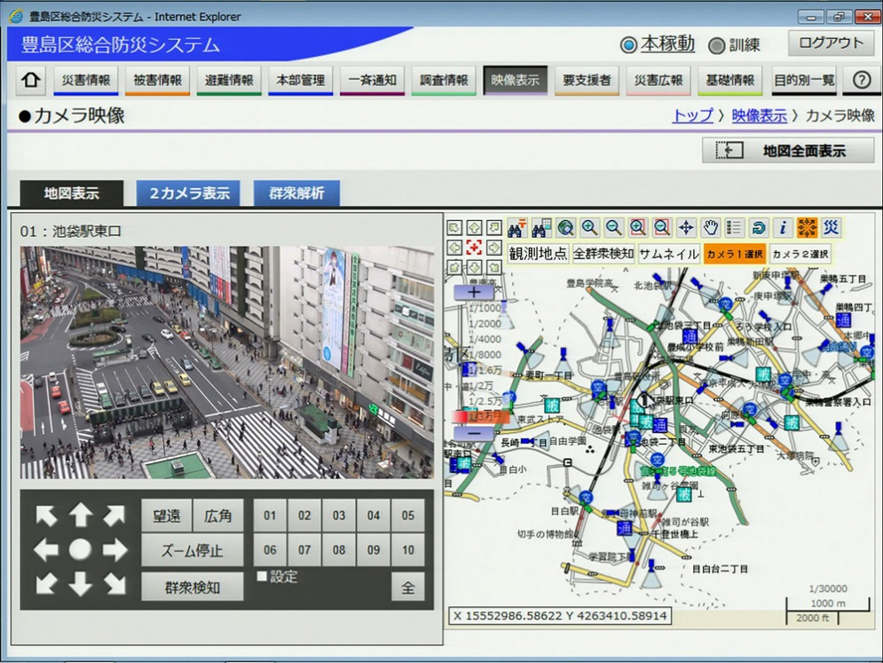
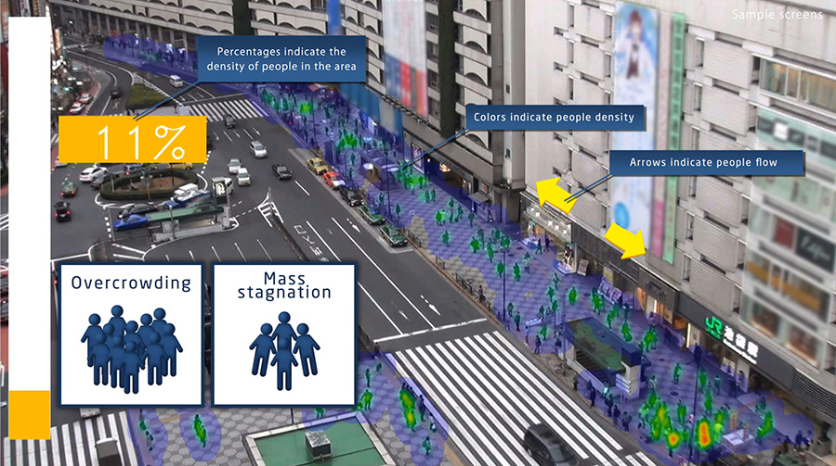

Figure 6.3: Pedestrian monitoring system
(Source: http://www.nec.com/en/case/toshima/index.html )

Framework
An area in a city with a lot of people, such as surrounding big stations, needs immediate action in the event of a disaster, and also needs to quickly detect abnormal situations for prevention of accidents. The pedestrian monitoring system enables to understand the behavior of crowds and to detect abnormal situations by analyzing images captured by surveillance cameras. In the event of any abnormality, the system automatically provides information or instructions for evacuation from the disaster site or for prevention of accidents.

Pilot Project
- Toshima city, Tokyo, Japan

Infrastructure
Broadband network is used in this use case. Captured image data are transmitted via the broadband network to a disaster control center in real time.

Organizations involvement
- Toshima city, Tokyo (http://www.city.toshima.lg.jp/)
- NEC Corporation (http://www.nec.com/)

Security and Privacy
Since the captured image may include face data of pedestrians, they should be stored and handled in secure environment. The crowd behavior can be analyzed even if faces of pedestrians are not captured. For privacy protection, the images can be captured without inclusion of pedestrians’ faces.

Smart Sustainable City Initiatives in Korea

Overview of Smart Sustainable Cities in Korea
The MSIT (Ministry of Science and ICT) of Korean government is running 3 major smart city pilot projects in Busan, Goyang and Daegu since 2015. While Busan and Goyang focus more on general smart city services such as transportation, Daegu is specialized for healthcare services. Those cities have been evolved with deployed smart city infrastructures and services. For the interoperability which is appointed as one of the biggest technical problem to build a smart city system is guaranteed by oneM2M (http://www.onem2m.org) global IoT platform standard.

Busan Smart City
Busan smart city pilot project (http://www.k-smartcity.kr) which was started in 2015 and will be finished by the end of 2017.
The figure below describes Busan smart city system having Open Smart City platform in the middle. The platform adopted oneM2M global IoT platform standard so it provides interoperability for devices and applications. The open source IoT device/gateway platform &Cube (http://developers.iotocean.org) and commercial IoT server platform ThingPlug (http://sandbox.sktiot.com) are deployed in the infrastructure. Both platforms are based on oneM2M standard.
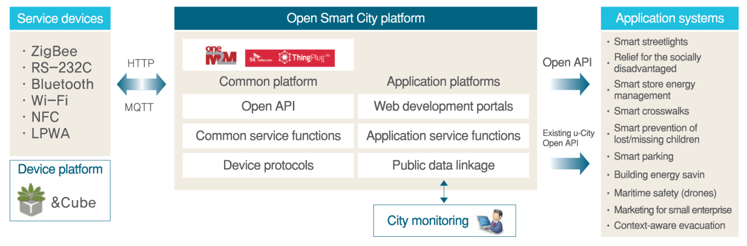
Figure 6.4: Busan smart city system

The following figure illustrates four (4) main service domains and individual services in Busan smart city. Mainly, the services are focused on community safety to provide security to citizens. Since the Busan is the second largest city in Korea, there are also the services for traffic improvement and energy management services.
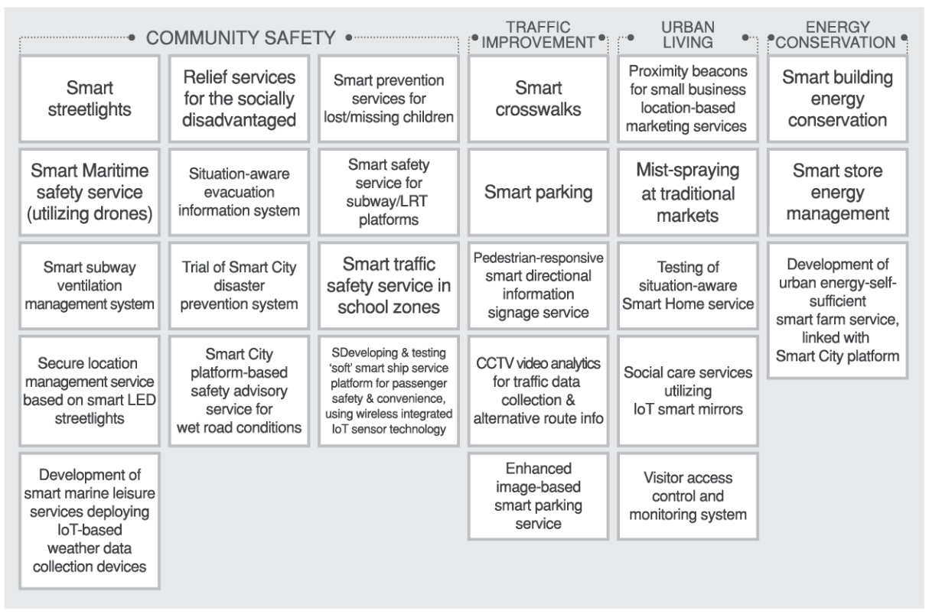
Figure 6.5: Busan smart city services

Use cases

Traffic Management Service
On top of existing traffic management system, the CCTV video analysis technology is adopted to provide further traffic information without any additional hardware installation in the city. Collected CCTV based traffic congestion information is periodically stored in the platform. An alternative route due to congestion is shown on the signage on the street.
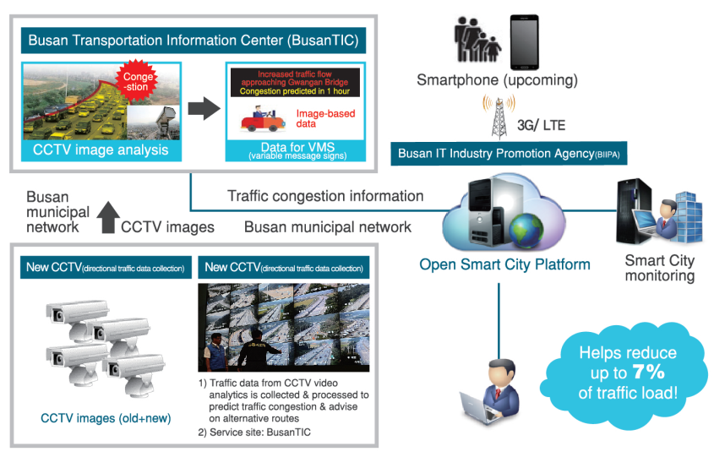
Figure 6.6: Traffic management service with CCTV video analysis

Smart Parking Service
Smart parking service, as the other smart cities globally have, is the mostly needed smart city service by citizens. Infrastructure for smart parking has been deployed since 2015 and in the next year CCTV and digital signage also deployed. By CCTV image recognition, the number of available parking spots are counted as well as by individual parking sensors and parking lot gate sensors. In 2017, information on electric vehicle (EV) charging stations is also provided by smart phone applications so if an user drives an EV he/she can find an empty parking spot that equips the charging station.
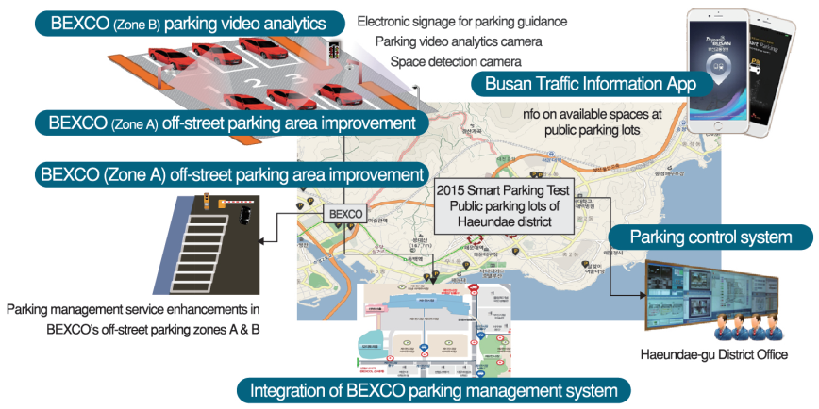
Figure 6.7: Smart parking service

Safety Service
The safety service for children in school zones is deployed. CCTVs detects pedestrians and vehicles so that signal and audio alarm can be generated to warn both of them to avoid accidents. Vehicles near cross walks severely reduces visibility for children when they cross streets. To avoid this, illegal parking is detected and by the CCTV and reported to control center in school zones.
In Korea, an apartment is the most common residence type. An advantage of living in an apartment is that security is provided by guards, however it cannot be always safe. This visitor access control and management system enables residents can see if a visitor to their home is secured by the system and guard can be notified if the visitor stays longer than its permitted time. Delivery service is really widely used for most of the daily service in Korea, so this service can provide assurance that anonymous delivery service person is verified for their identity and if something happens someone will come to help.

Smart Sustainable City Initiatives in Malaysia
Malaysia has actively planning and promoting smart city initiatives. Three of the most visible projects are Smart City initiatives in Cyberjaya, Smart Selangor and Iskandar Smart City in Johor. All three are focusing on different themes and are currently still in progress.

Overview of Smart City Initiatives - Cyberjaya
The completion of Cyberjaya Global Technology Hub (“GTH”) blueprint was finalised in 2014 with a strategic objective - to transform Cyberjaya from a premier ICT hub to a global technology hub and to elevate Cyberjaya into a global scale that would attract more foreign direct investments into the country including strengthening local technology firms and creating a high-value workforce. The document is available on the public domain at http://www.cyberjayamalaysia.com.my/.
In 2014, it was given a new mandate by the government to move to the next step of development, i.e. to become a Global Technoogy Hub, expanding beyond ICT to other areas of technology (while still maintaining its strengths in ICT). A strategic blueprint was designed last year to pave the way for Cyberjaya to achieve its ambitious mandate of becoming a Global Tech Hub. The blueprint identified 9 technology areas for Cyberjaya to focus on, of which 5 are ICT technologies (Cloud, Creative Content, Info Security, Mobile Internet and Big Data) while 4 are non-ICT (wearable/ IoT technology, Biotech, Green tech & Smart Grid).
In 2015, a 5-year plan of Smartcity Framework and Roadmap was developed by Cyberview to enable implementation of the GTH blueprint to support the innovation ecosystem for Cyberjaya.
The Smartcity Framework outlines strategic implementation roadmap supportive of Cyberjaya’s innovation ecosystem to realise the objectives of Cyberjaya Smart City which are:
- Increase efficiency of public service and city living
- Improving Quality of Life and creating a safe city
- Improving standard of Environment Sustainability in line with Cyberjaya’s Low Carbon Cities Framework (LCCF)

The 5-year smart city roadmap is as follows:
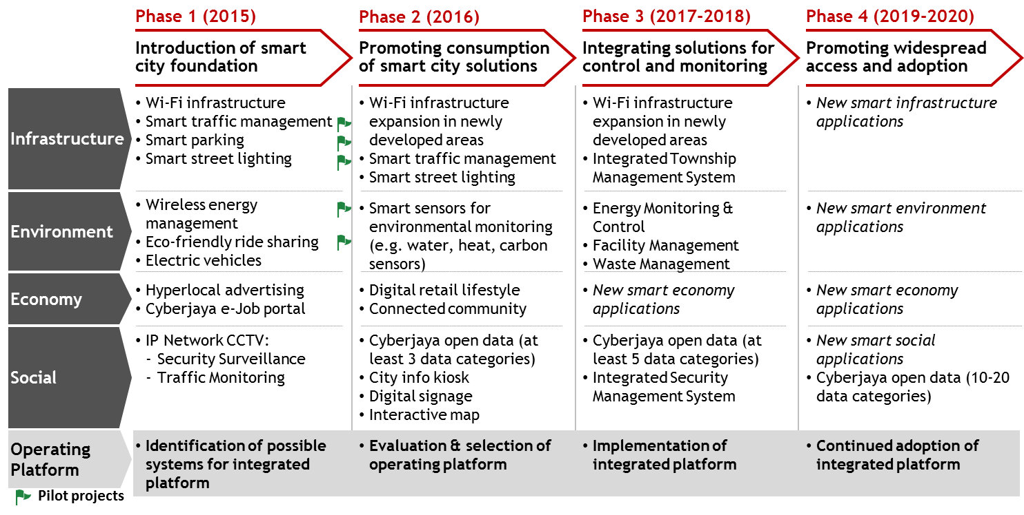
Figure 6.8: Cyberjaya Smart City Roadmap: 2015-2020

The Smart City Roadmap consists of 4 phases as follows:

- Phase 1 (2015): Introduction of Smart City Foundation
The purpose of Phase 1 is to ensure a solid foundation for Cyberjaya's Smart City. This includes setting out a clear framework to guide the smart city development. It also includes ensuring a strong network infrastructure to enable high level of digital connectivity throughout the Cyberjaya.

Under phase 1, priority is on Smart Infrastructure, as the infrastructure is closely linked to the foundation of the Smart City. As such, several key pilots under Phase 1 include Smart Traffic Management, Smart Parking and Smart Street Lighting under the infrastructure category.
Phase 1 also requires planning for the adoption of an integrated operating platform. This involves identification of suitable systems which could be considered and preliminary evaluation of various systems and their ability to meet the requirements for Cyberjaya.
- Phase 2 (2016): Promoting consumption of smart city solutions
Phase 2 focuses on the consumption of smart city solutions. This includes introduction of smart city solutions and subsequent consumption of such technologies across all 4 categories.
Under Phase 2, the integrated operating platform for use in Cyberjaya should be comprehensively evaluated and selected.
- Phase 3 (2017-2018): Integrating solutions for control and monitoring
Phase 3 involves the implementation of the integrated platform to enable technologies to be connected and integrated into a common platform. This will also enable development of new technologies using this open platform going forward.

- Phase 4 (2019-2020): Promoting widespread access and adoption
Once a fully integrated system is in place, Phase 4 focuses on enabling wider access to the open platform, such that different providers can more easily develop new technologies using the common platform. This will enable more widespread creation as well as use of smart city solutions across Cyberjaya.

Smart City Use Cases in Cyberjaya
Cyberjaya started by offering a Living Lab for start-ups and technology providers specifically for Internet of Things projects.

By offering Cyberjaya as a Living Lab for the Internet of Things (IoT), Cyberview has been able to bring in and pilot technologies that have both enriched its smart city ecosystem while offering sustainable living solutions for the residents and businesses based in Cyberjaya.

Cyberjaya became the first smart city in Southeast Asia equipped with a city-wide LoRa network – a long range, low power connectivity platform optimised for IoT applications. The first project to take off from this platform is a pilot on an air quality index measurement system.
While Malaysia is still using PM10 as a parameter to measure particulate pollution (detecting fine particulate matter that measure up to 10 micrometers or 10 microns), this state-of-the-art system monitors and provides near real-time readings for fine atmospheric particulate matter measuring equal to or less than 2.5 micrometers or 2.5 microns.

With the technological properties of LoRa being uniquely well-suited to other environmental monitoring applications, other sustainability technologies can also be piloted and validated out in a real-life smart city setting.

Cyberview has established a comprehensive centres that provides infrastructures and others need for the companies to deploy IoT solutions. Some of the centres are as follows:
- Coinnov8 - Smartcity Collaboration Centre
- CoCrea8 - Creative Content Collaboration Centre
- Cyberjaya Futurise Centre – Innovation Lab Collaboration Centre
- Cyberjaya Entrepreneurs Cluster (“CEC”)

Some of the use cases that are currently being deployed are in the following sections.
- Smart Infrastructure
  - Smart Traffic System
  - Smart Security
  - Smart Building
  - Smart Logistics
  - Smart Transport

- Smart Social
  - Citizen Engagement
  - Smart Recycling
- Smart Economy
  - Cashless payment
- Smart Environment
  - Smart Air Sensing
  - Electric Vehicles project
Source:
http://www.cyberview.com.my/industry/smartcity

Smart City Use Cases in Iskandar Malaysia
The smart city initiatives in Iskandar Malaysia comprises of 6 dimensions; smart governance, smart economy, smart mobility, smart environment, smart people and smart living.

Iskandar Malaysia smart city outlined as a city that integrates the economy, environment and social aspects through the widespread and innovative use of information and communication technologies (ICT) for better quality and sustainable living. To realize this goal, Iskandar Malaysia had chartered a smart city with 6 dimensions and 28 characteristics as depicted in the figure 6.9 below.
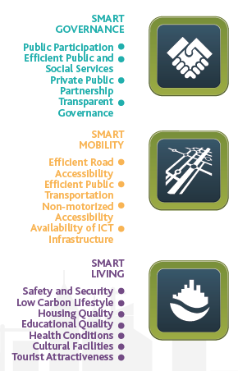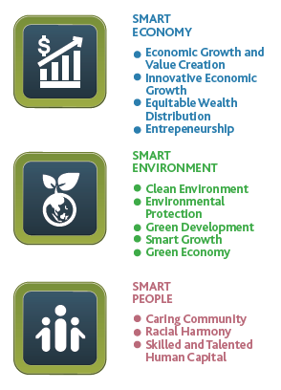

Figure 6.9: Iskandar Malaysia Smart City – 6 Dimensions and 28 Characteristics

Low Carbon Lifestyle
One of the use case is the low carbon generation. There are Five Actions advocated by the Blueprint to fulfill a green economy vision, i.e.:
- Integrated Green Transportation
- Green Industry
- Low Carbon Urban Governance
- Green Building and Construction
- Green Energy Systems and Renewable Energy

One of the main actions is to have an integrated public transportation system in Iskandar Malaysia, with the objective of increasing the public transport modal share in Iskandar Malaysia from the current 18% to 40% in 2025.

To facilitate the creation of a green industry, measures to encourage the creation of low carbon goods and services as well as ‘carbon-literate’ workers at all levels are being instituted. This involves replacing or upgrading existing equipment with better-performing low carbon-endorsed equipment. Under the Green Building and Constructions category, building industry stakeholders are encouraged to create a low carbon society through incentives and education. More than one-third of all new and existing buildings are to be green, sustainable and energy-efficient with 50% of the materials and equipment utilised to promote energy efficiency.

Sources:
http://iskandarmalaysia.com.my/SCIM/download/imsc_booklet.pdf
http://iskandarmalaysia.com.my/downloads/IM10%20Progress%20Report_V5.pdf

Smart Selangor
In 2016, the Selangor state government launched its vision to become a smart state by 2025 through the prioritisation of technology infrastructure with the ultimate objective being to improve quality of life for the citizen in the state. Smart Selangor has five aspirations; enhance quality of life, ensure environmental preservation, increase economic growth, create quality employment and strengthen fiscal position of the state. 12 domains have been created to achieve these aspirations.

Smart pothole repair
A collaboration with Waze (a community-based traffic and navigation application) allows citizen to report precise location of potholes for the authorities to have real time information of road conditions for maintenance. Following are the key benefits
- Encouraging more responsive, inclusive and participatory citizen engagement
- Improving roads to reduce the risk of traffic accidents and vehicle damage from potholes
- Enabling real time road condition monitoring for swifter road repair
- Ensuring effective, accountable and transparent road repair management
Table 6.1 below shows the impact assessments.

Table 6.1 : Smart pothole impact assessments
No. | Before | After
1 | Few capabilities to access and address repeat potholes repair works | The platform equips local authorities with the capabilities to identify repeat potholes incidents
2 | No real time visibility on pothole repair works at both municipal and state levels | Continuous visibility on the precise location of potholes to ensure improved road repair planning and execution works
3 | Absence of real time online pothole reporting solutions for citizens | Citizens can instantly report the location of potholes while authorities are able to monitor and manage repair works
4 | Low average pothole repair efficiency levels observed in Selangor | Overall pothole efficiency level for the 7 participating municipalities have improved by 22% over 5 months

Smart waste management
A smarter waste collection and management system initiatives, integrating technology, better processes and systems as well as increasing citizen engagement. It has 4 key benefits.
- Improving the cleanliness of Selangor
- Increasing waste collection efficiency inline with UN SDG 11.6
- Transforming waste collection through real time tracking of asset and personnel
- Increasing governance and transparency while incentivising waste collection operators
The smart waste pilot project is as shown in figure 6.10 below.

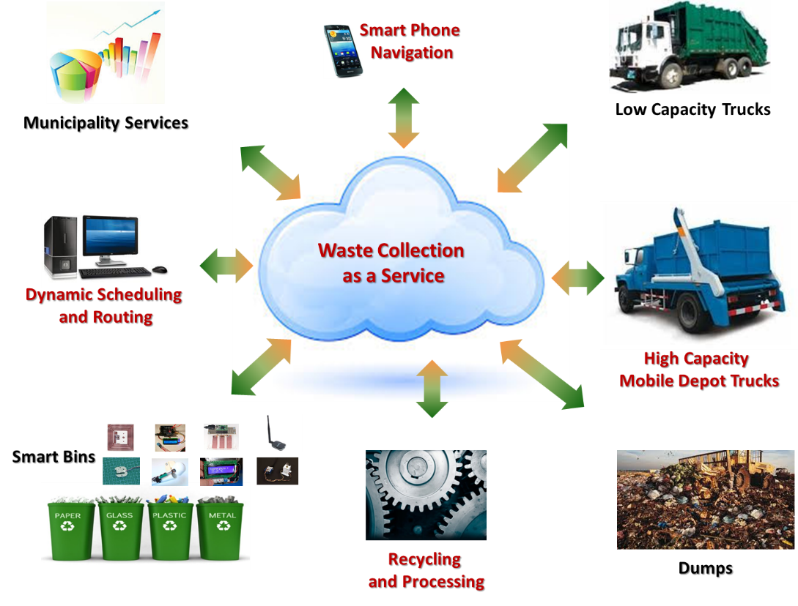
Figure 6.10: Smart Selangor Smart Waste Management Pilot Project

Table 6.2 shows the impact assessment.

Table 6.2 : Waste management impact assessments
No | Before | After
1 | Poor visibility on municipal-level waste collection operations | Lorries with GPS trackers allow local authorities to trace lorry movement for better waste collection planning
2 | Slow response to customers complaints, averaging over 4 days | All public complaints addressed within 4 days; complaints received via iClean app are verified and resolved within 24 hours
3 | Varying service levels of waste collectors due to poor condition of lorries | State-owned new compactors are leased to contractors; local authorities can terminate contracts of non-performing contractors
4 | High level dissatisfaction with 2,165 of complaints by residents across 3 municipalities | Average of 95% drop in complaints recorded in the 3 participating municipalities

Source:
http://mbiselangor.com/smart-selangor/

Smart Sustainable City Initiatives Report by GSMA

India: Special purpose vehicles for smart cities project
In 2015, India announced an ambitious smart city strategy; the government revealed plans to build 100 smart cities over the next five years. The Smart Cities Mission, a division of the Ministry of Urban Development, oversees the initiative and is responsible for the city selection process and the allocation of government funding. The Indian government has selected 97 smart cities to be developed over the next few years, after a rigorous 2 stage competition on various parameters and evaluated by experts. As part of the process, each selected city is obliged to set up a special purpose vehicle (SPv) to develop, manage and implement the smart city strategy as well as taking responsibility for the release of funds. As of now, it seems 59 SPvs have been formed. The national government releases smart city funding for the SPv, which must be matched by the state and urban local body (ULB) governments.

The state and the ULB must take an equal share in the SPV, and they may invite private or financial investors to take an equity stake so long as the state/ULB retains a majority shareholding. The SPv will become a limited company and be registered under the companies’ act. The SPv can be a more efficient vehicle than state or local government for driving a new venture. New ventures, such as smart city projects, require a different and more agile approach independent from traditional government operations to expedite the smart city project. The SPv enables innovative approaches to raising financing and more flexible procurement processes than state-owned structures, which can be notoriously bureaucratic and time consuming. A SPv can develop its own procurement methods aligned to the type and size of businesses that are typically involved in smart cities, many of which could be small start-ups.

Sources:
https://www.gsma.com/iot/wp-content/uploads/2017/05/Smart-Cities-Report-web.pdf
http://smartcities.gov.in
http://www.punesmartcity.in
http://www.makeinindia.com/article/-/v/internet-of-things http://indianexpress.com/article/cities/pune/pune-now-1250-eyes-to-watch-over-you/ http://www.urbanaworld.com/google-bags-first-city-station-wi-fi-deal-from-pune-smart-city-development-corporation/

Star Hub m360 –Transport Management (Singapore)
With a long history of focusing on innovation, StarHub in Singapore is now working on new big data initiatives to support Singapore’s Smart Nation ambitions.
A key area of focus is mobility. Singapore is investing heavily in new public transport networks, and wants to ensure that citizens travelling around Singapore are able to do so efficiently through new services, such as on-demand public transport and real-time journey planning. StarHub has deployed a service called Grid 360 that allows the city to examine different data sets as new transport options come online and routing options become more complex.
The data available includes aggregated and anonymous geo-location data to understand crowd densities, travel patterns and the group profile of the crowds traveling.
StarHub is offering these aggregated insights as an API service that both the government and public transport operators can use to understand how crowds move both through the transport network and the first mile and last mile – from their point of origin to eventual destination. Grid 360 works by overlaying a grid of small hexagonal tiles over Singapore, allowing areas of interest to be highlighted. This grid is tied to a database of points of interest and transport networks. The Grid 360 platform provides a function to overlay additional datasets for further analysis. It could overlay locations where there are higher density of elderly traveling and check if there are sufficient facilities, such as lifts at overhead bridges or extended traffic light timings, for the elderly. Through the combinations of different layers, the users could derive different insights into crowd movement through the city.
For example, flow analysis of people from point to point allows the choice of transport mode to be analysed. StarHub has also been working with public transport operator, SMRT, to analyse in depth all of the travel to and from areas of interest, such as the university campus. It explored how the flows of people can be improved to ensure people can efficiently get to and from the site, analysing the last mile of the journey, in particular.

Source:
https://www.gsma.com/iot/wp-content/uploads/2016/09/cl_singapore_cs_web_09_16.pdf

Summary of Smart Sustainable City Use Cases in APT region

7.1 Key recommendations
Following are the recommendations to develop a smart sustainable city.

- Adopt an agile institutional framework and governance mechanisms: A smart city needs an institutional framework that ensures co-ordination and support throughout the lifetime of each project. The smart city agency will have to be agile and, ideally, independent from traditional city departments. It should, however, be accountable to a governance body on which the city institutions are represented
- Appoint a CIO/smart city director with strategic vision: A strong vision and strategy is key to the success of smart city projects. A CIO/smart city director should be a project leader with cross-functional skills, capable of defining a long-term strategy. Rather than focusing on technology solutions, they will understand and analyse the city’s needs and requirements. They will require appropriate authority to act efficiently, will have concrete objectives, and will be capable of bringing along those departments resisting innovation and change.
- Communicate effectively smart city project objectives and benefits: Establishing a dialogue with the local community is essential to ensure effective smart city services design and functionality. Digital media can help involve citizens in each step of the service lifetime and highlight tangible benefits that a smart city project will deliver.
- Promote technology investment in open and scalable systems: A smart city should avoid relying on proprietary technologies tied to a single provider. Standards-based solutions are an essential foundation for the long-term evolution of a smart city. A city administration needs to think strategically and identify synergies: a new smart lighting system can be an opportunity to deploy additional services that use the same light poles, such as air pollution monitoring, the provision of Wi-Fi or security cameras.
- Comply with privacy and security best practice, rather than defining new service-specific rules: To safeguard privacy and security, smart cities need to draw on industry best practice and comply with national laws. Having worked extensively in these areas, the GSMA makes available privacy tools, security guidelines and check lists to policymakers and industry players. Local city managers should resist the temptation to define their own data privacy and security standards for services they launch and adopt in their own city
- Make city data available to promote transparency and stimulate innovation: Cities generate a wealth of data related to transport, to the environment, health, demographics, and services accessibility. While protecting individuals’ privacy, city managers should look to make data accessible to promote transparency and stimulate the creation of innovative services. Some cities already have portals that make data available in accessible formats.
- Explore new models of funding: Smart city projects require significant initial investment. Smart city managers should explore public private partnerships or alternative finance mechanisms, such as municipal bonds, development banks or vendor finance. Internet of Things technologies and smart city applications can generate substantial socio-economic benefits for citizens and businesses in Asia. Policymakers should make the most of this opportunity, by designing and implementing smart city projects with a long term vision, that are defined around citizens’ needs, are managed through agile governance structures, are based on open and scalable systems and promote a culture of openness, innovation and transparency

Source:
GSMA - https://www.gsma.com/iot/wp-content/uploads/2017/05/Smart-Cities-Report-web.pdf

  - Challenges in deploying Smart Cities
Challenges can be divided into two aspect, technology and management.
In general, there are few management dimensions that plays crucial role to the success of any smart cities. These are governance, people, economy, mobility, environment and living. For example, under the governance, all the different agencies within a city must agree with the deployment and operation of the smart city technologies. Failing to get consent from these agencies will stop and slows the progress of the deployment. Similarly, people are the users of the technologies being deployed. They must accept and use it in their daily life to complete the ecosystem. A good business case is another challenge in the economy dimension.

There are many technological challenges in deploying smart city solutions. Smart cities are based on data which are provided from sensors using different protocol and communication methods. One of the big hurdle in implementing a smart city solution is the interoperability which consists of different layers. Starting from device, communication and application. It is important to have a platform that can provide interoperability. The challenge in providing a good solution is the interdependent of various part of the ecosystem; device, connectivity, platform and analytics.

Standardization activities related to Smart Sustainable Cities
There are many organizations involve in creating standards and guideline documents for smart cities such as ITU-T SG20, ISO/IEC JTC1/SC41 and others. Some of smart city related documents under ITU-T SG20 are as follows.
- ITU-T Y.4900/L.1600: Overview of key performance indicators in smart sustainable cities
- ITU-T Y4901/L.1601: Key performance indicators related to the use of information and communication technology in smart sustainable cities
- ITU-T Y.4902/L.1602: Key performance indicators related to sustainability impacts of information and communication technology in smart sustainable cities
- ITU-T Y.4903/L.1603: Key performance indicators for smart sustainable cities to assess the achievement of sustainable development goals
ASTAP has also started the activities in this area by compiling feedback and input from member countries. This document will set a precedence for new standards and guidelines. One such project is Smart Waste Management & Pedestrian Monitoring (NEC, Japan). It is preferable to develop a standard for functional requirements and reference models on this use case.

Conclusions

There have been many countries adopting smart city concepts and each city is being designed based on the need. Some cities have sought to deploy stand-alone applications and slowly extend or integrate with other applications. Whereas other cities try to get the infrastructure or common platform in place first, and then sort out on the adding existing services and new applications.
Most of the cities stated in this document started with pilot projects to ensure the effectiveness and the benefits it could provide before being used in larger scale.
The approach taken by the cities can be grouped into three.
- A city that deploys applications in series starting with the important application and then add other application based on the priority and need
- A city that plans and deploys an infrastructure or platform first before applications and services can be deployed later
- A pilot city which experiments applications to test the technology and the benefits it provides in larger scale. Once the pilot project is verified, it will be implemented in full operational deployment
It is important that cities properly study the current need and plan on the smart city implementation in phases using a proper ecosystem that is scalable. Use cases described in this Report are applicable to other APT countries. This report will be updated from time to time with the input from APT member countries that have smart city solutions.
_______________

