**APT REPORT ON**

**REQUIREMENT OF TRANSMITTER IN COHERENT RADIO OVER FIBER SYSTEM**

**Edition: June 2021**

**The 33rd APT Standardization Program Forum (ASTAP-33)**

**7 – 15 June 2021**

**Virtual/Online Meeting**

***(Source: ASTAP-33/OUT-15)***

**No. APT/ASTAP/REPT-47**

**Table of Contents**

**Table of Contents**

1. **Introduction**
2. **Scope**
3. **References**
4. **Abbreviations and acronyms**
5. **Lightwave vector modulation**
   1. **Overview**
   2. **Configuration**
      1. **Lightwave vector modulation by external modulation**
      2. **Integrated coherent transmitter**
      3. **Example of transmitter configuration in digital coherent system**
6. **Coherent Receiver**
   1. **Laser characteristic**
      1. **Stability**
      2. **Amplitude and phase frequency response characteristics**
   2. **Modulator characteristic and measurement**
      1. **Direct measurement of modulator induced phase modulation**
      2. **Alternative method for measurement of modulator induced phase modulation**
7. **Experimental demonstration of vector lightwave modulation using directly modulated LD and EAM in an integrated modulator**
   1. **Measurement results using waveform with pre-equalization and pre-coding**
8. **Conclusion**
9. **Introduction**

In APT Report on wired and wireless seamless connections using millimeter-wave Radio over Fiber technology for resilient access networks [APT/ASTAP/REPT-11], it has been shown the benefit of seamless fiber and wireless communication employing spectrally efficient advanced modulation formats of lightwave such as quadrature-phase-shift-keying (QPSK) and quadrature-amplitude-modulation (QAM). Generation and transmission of vector modulated lightwave can be achieved traditionally by a low linewidth CW laser followed by a Mach Zehnder Modulator (MZM) based IQ modulator, at over 20 Gbaud. Alternatively, integrated laser and electroabsorption modulator may be used to directly modulate phase and amplitude of light in a cascade manner allowing low cost transmitter.

Optical coherent system has received much attention in recent years due to availability of high-speed analog to digital and digital processing technology. Several post-digital signal processing (DSP) techniques have been proposed to reduce the channel linear and non-linear impairments, for example, chromatic and polarization dispersions, carrier phase estimation algorithms, digital equalization, amplitude normalization, orthogonalization, timing recovery etc. Whilst the efforts have been on post-DSP to improve the performance at the receiving end, characterization, specification, and pre-DSP of transmitter used in optical digital coherent is also equally important, especially in direct vector modulation of lightwave. Frequency characterization techniques of phase and amplitude modulation of phase and intensity modulators are summarized in this report.

1. **Scope**

This report provides technical guidance and requirement of a transmitter unit to configure coherent radio over fiber system. Transmitter design, configuration, component and key parameters and specifications are also addressed as examples.

1. **References**

[APT/ASTAP/REPT-03(Rev.4)]: APT Report (2015), Characteristics and requirement of optical and electrical components for millimeter-wave Radio on Fiber systems

[APT/ASTAP/REPT-04]: APT Report (2011), Technology trends of telecommunications above 100 GHz

[APT/ASTAP/REPT-11]: APT Report (2013), Wired and wireless seamless connections using millimeter-wave Radio over Fiber technology for resilient access networks

[APT/ASTAP/REPT-19]: APT Report (2015), Integration of Radio over Fiber with WDM PON for seamless access communication system

[APT/ASTAP/REPT-20]: APT Report (2015), RoF relay link for indoor communication systems

[APT/ASTAP/REPT-25]: APT Report (2017), Fronthaul/backhaul using millimeter-wave radio over fiber technologies

[ITU-T G. Suppl.55]: ITU-T G-series Supplement RoF on Radio-over-fiber (RoF) technologies and their applications

[ITU-R F.2106] Fixed service applications using free-space optical links

[3GPP TS 36.104 version 10.9.0 release 10]: Evolved Universal Terrestrial Radio Access (E-UTRA); Base Station (BS) radio transmission and reception

1. **Abbreviations and acronyms**

This report uses the following abbreviations and acronyms:

CW Continuous Wave

DSP Digital Signal Processing

EAM Electro-Absorption Modulator

EML Electro-absorption Modulator integrated Laser

E/O Electrical-to-Optical

FSK Frequency Shift Keying

IQ In-phase and Quadrature

LD Laser Diode

MZM Mach Zehnder Modulator

MSK Minimum Shift Keying

O/E Optical-to-Electrical

QAM Quadrature-amplitude-modulation

QPSK Quadrature-phase-shift-keying

PD Photodetector

RoF Radio-over-fiber

1. **Lightwave vector modulation**

**5.1 Overview**

Signal generation in coherent radio over fiber system can be achieved by either Mach Zehnder Modulator (MZM) based IQ modulator or cascade directly modulated laser diode (LD) and electro-absorption modulator (EAM). Both methods are summarized in this section.

**5.2 Configuration**

**5.2.1 Lightwave vector modulation by external modulation**

Lightwave QAM and QPSK modulations may be achieved by nested Mach Zehnder Modulator [1, 2] as in Fig. 1. This is I-Q modulator where inphase and quadrature signals, and respectively. The voltage applied in the second MZM stage causes 90° phase difference between I and Q signals, before they are combined at the output. The modulator may be applied to FSK and MSK and predistorted waveforms, however there is associated insertion loss that impacts the power budget.

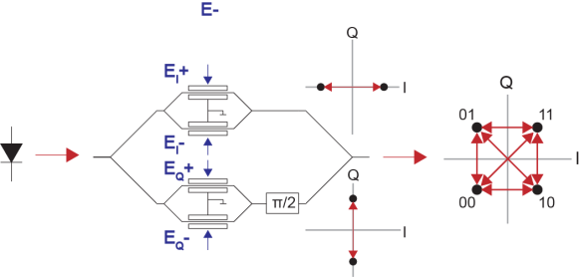

Fig. 1 IQ Mach Zehnder Modulator

**5.2.2.** **Integrated coherent transmitter.**

A small form factor transceiver may benefit from monolithically integrated laser and transmitter. Integrated laser and IQ modulator based on InP or GaAs has been developed, example shown in Fig. 2(a) using 16QAM format exerimented at 32 GSym/s [3].

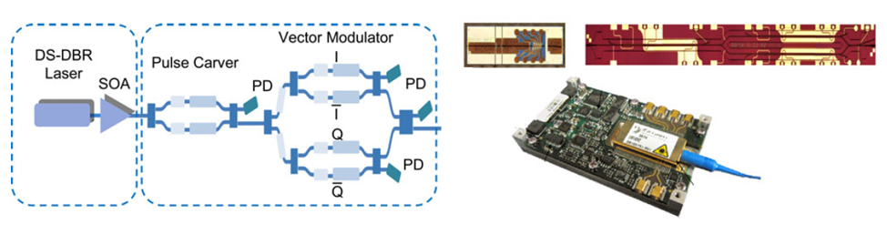

(a)

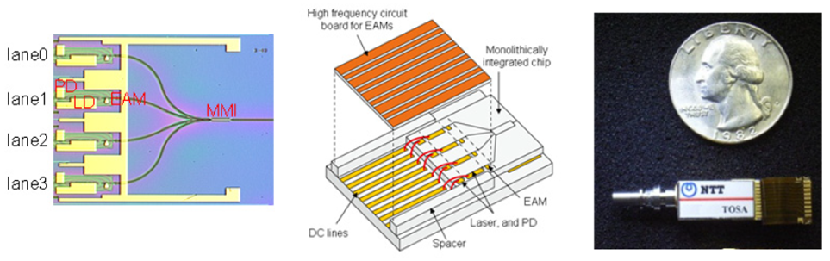

(b)

Fig. 2 Integrated modulator (a) LD+MZM type (b) LD+EAM type

In addition, electroabsorption modulator integrated laser (EML) is also available. In digital modulation where laser is used for CW light generation and EAM is used for intensity modulation, array of transmitters can be fabricated. For example in Fig. 2(b), the transmitter consists of 4×40 Gb/s transmitter and a multiplexer [4]. **EML may be used for lightwave vector modulation. In this case, light amplitude and phase are modulated by cascaded phase modulator, via direct laser modulation, and amplitude modulator, via EAM modulation, as detailed in section 5.2.3**

**5.2.3 Example of transmitter configuration in digital coherent system**

Fig. 3 shows a transmission configuration of vector lightwave modulation using dual-polarization quadrature-phase-shift-keying (DP-QPSK) modulator consisting of two QPSK modulators and a polarization beam combiner (PBC) in coherent RoF system as given in APT report APT/ASTAP/REPT-11.

setup

**Fig. 3 Lightwave vector modulation using IQ modulator and, transmission and detection of coherent RoF system as in** APT report APT/ASTAP/REPT-11

In a direct vector modulation setup using integrated LD and EAM (such as an integrated EML), the in-phase (I) and quadrature (Q) components are converted to phase and amplitude signals and are used to generate signals to modulate the laser (LD) and EAM sections, as shown in Fig 4(a). Firstly, then data sequence is generated. Then the selected coding is applied followed by symbol mapping and conversion from IQ symbols to lightwave phase and amplitude values,  and . Then phase and amplitude values are converted to the modulating LD current and EAM voltage,  and , respectively. The lightwave vector signal can be applied to a Radio over Fiber transmission system by combining the modulated signal with another CW source, LD2, at wavelength differing from LD1 by  (in the order of 10s of GHz), as in Fig 4(b). The signal is detected by a high-speed photodetector (PD) to give millimetre-wave band signal. A feedback control can be used to ensure stable RF frequency.

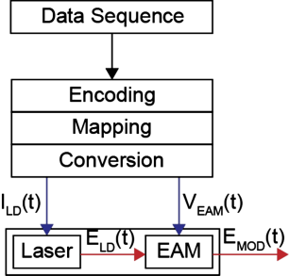 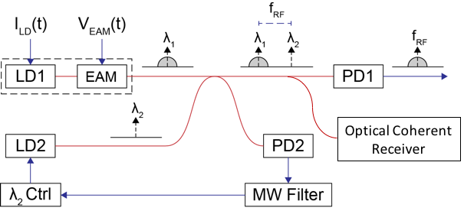

(a) (b)

Fig. 4 (a) Combined laser (phase) and EAM (amplitude) modulation

(b) application of EML vector modulator for Radio over Fiber.

**5.3 Coherent Receiver**

Optical coherent receiver consists of phase and polarization diverse optical coherent receiver. The receiver configuration consists of an optical local oscillator, a polarization beam splitter and a pair of 90° hybrids as in Fig.5. Electrical signals after photodiodes are obtained as the following for each polarization of light, where they will further be passed through analog to digital conversion. Once the signals have been digitized, a number of digital signal processing techniques can be performed.

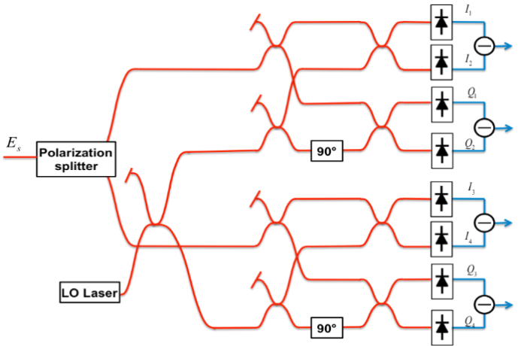

Fig. 5 Coherent receiver configuration

**5.4 Roles of Digital Pre-possessing and Post-processing**

Several post-digital signal processing (DSP) techniques have been proposed to reduce the channel linear and non-linear impairments, for example, chromatic and polarization dispersions, carrier phase estimation algorithms, digital equalization, amplitude normalization, orthogonalization, timing recovery etc. [5-7] In addition, pre-DSP can be beneficial to such as to pre-equalize the response of the transmitter. In the case that cascaded amplitude and phase modulation configuration is used instead of the IQ modulator where the laser is a direct phase modulator, pre-coding and pre-DSP may be used to pre-condition the modulating signals so that the processing burden is reduced in the receiver [8]. Fig. 6 shows the diagram of digital coherent system with pre-DSP and post-DSP.

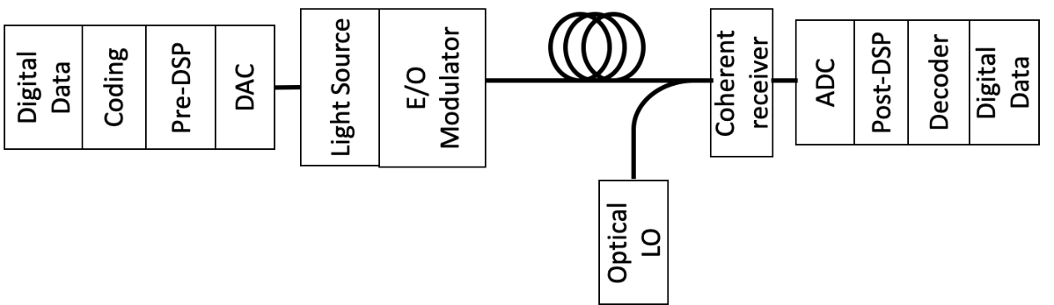

Fig. 6 Digital coherent system diagram with pre-DSP and post-DSP

1. **Characteristics of Transmitter**

In either I-Q or Amplitude-Phase modulation configuration, semiconductor laser and modulator characteristics must be defined to allow precise lightwave vector modulation.

**6.1 Laser characteristic**

**6.1.1** **Stability**

Stability of semiconductor laser used for a transmitter (and a local oscillator), such as low frequency drift and phase noise, is necessary in coherent system since the phase information must be extracted from the optical carrier. Phase instability of laser, or linewidth, will cause error in the extracted information, thus requiring DSP. Linewidth requirement depends on symbol rate and modulation formats. For example, at 40Gb/s and 1dB penalty for BER=10-4, QPSK, 8PSK, 16PSK and 16QAM formats require 4.4 MHz, 330 kHz, 50 kHz and under 12.5 kHz linewidth of laser transmitter respectively [9]. Laser technologies included Distributed Feed Back (DFB), Sampled Grating Distributed Bragg Reflector (SG-DBR), and External Cavity Lasers (ECL) feature laser linewidth in the order of 10 MHz down to sub 100kHz, where narrower linewidth is preferred. Device level stability technology is thus crucial in a compact transmitter, especially in a modulator integrated laser. In digital coherent system, it is feasible to employ DSP to ease the requirement of linewidth both at the receiver through better carrier phase estimation technique over the conventional Viterbi-Viterbi algorithm and at the transmitter to through waveform shaping and symbol coding [8].

**6.1.2** **Amplitude and phase frequency response characteristics**

The slope efficiency of laser amplitude and phase modulation responses affect the vector modulation performance when they are directly modulated in the cascaded phase and amplitude modulation configuration. Suitable signal pre-compensation may be applied to equalize the phase response of the laser. For example, a simple RC network inserted before laser bias can equalize the phase response across 5GHz bandwidth [10]. In addition, digital pre-equalization is an alternative method. Fig. 7 shows example of using FIR equiripple high pass filter (HPF) to equalize the response of the laser phase modulator in an EML [8]. In this particular case, the commercial EML package is designed for CW LD operation, the laser port bandwidth is lower than 1GHz. The same principle can be applied to higher data rate once the laser port is optimized for higher frequencies.

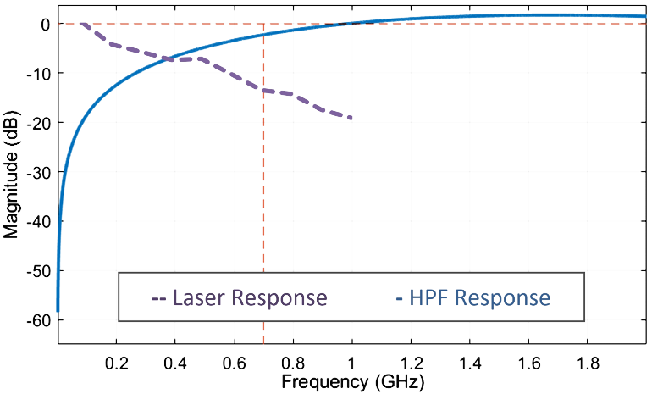

Fig. 7 LD frequency response and digital pre-equalization filter response.

**6.2 Modulator characteristic and measurement**

Amplitude modulation response of an E/O device may be conveniently measured by a lightwave component analyzer. An alternative method would be using a two-tone light technique generated by a high-ER MZM or a standard MZM to firstly obtain the response of an O/E device and subsequently of an E/O device. These methods have been shown already in a previous APT report [APT/ASTAP/REPT-03(Rev.4)]. Thus, in this report we present a method for measurement of induced phase modulation due to intensity modulation of a modulator, either external or integrated. The induced phase error due to amplitude response or chirp of a modulator may be measured by a vector space method using coherent detection with digital signal post-processing [11], or by optical spectrum analyzer measurement [12].

**6.2.1 Direct measurement of modulator induced phase modulation**

The next figure, Fig. 8, shows the setup of phase error measurement. The modulator is modulated by RF synthesizer which can vary frequency. The modulated light is analyzed using optical digital coherent receiver. Thus, the demodulated I – Q components represent the filed amplitude change due to RF intensity modulation as well as the induced phase change as,

 (1)

where  and  are time dependent electric field amplitude and phase of the modulated light after the modulator, which is demodulated and shown as a constellation plot in Fig. 9(a). This diagram shows amplitude and phase change of the modulated lightwave. For a true amplitude modulation, there should exist only change in magnitude () where phase change ( ) should be zero. Thus, we define the phase error or chirp parameter to be the normalized ratio of undesired phase change over the amplitude change, i.e. , where *E* is the average lightwave field amplitude. The alpha parameter can be estimated statistically through linear regression after converting the constellation plot in Fig.9(a) to phase versus amplitude plot in Fig. 9(b).

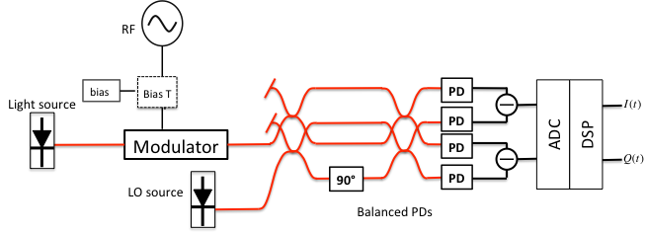

Fig. 8 Measurement setup

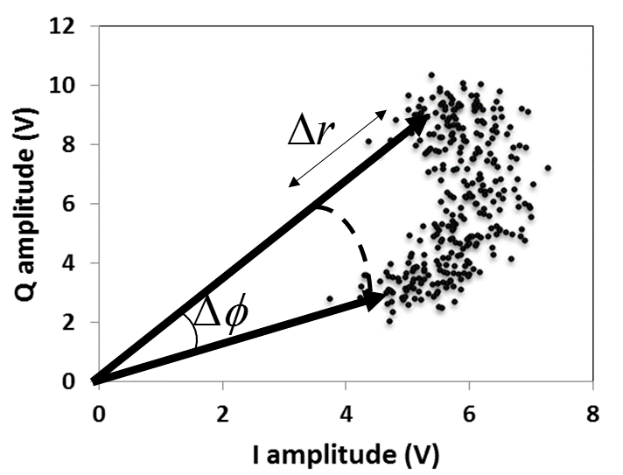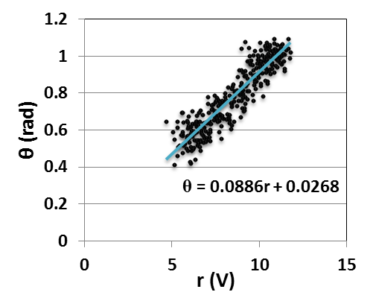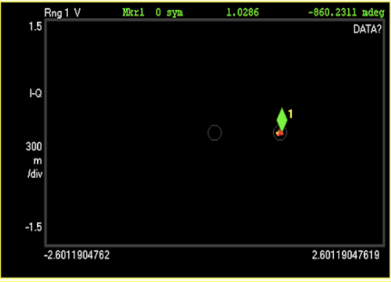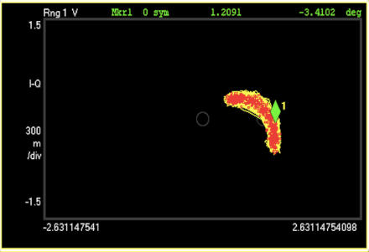

(a) (b)

Fig. 9 (a) constellation plot and (b) phase versus amplitude change plot and linear fitting

**Examples of modulator results**

Discrete external modulators, such as electroabsorption modulator (EAM) and Mach Zehnder Modualtor (MZM), may be characterized. For external modulator characterization, two separate light sources are used for the transmitter and the receiver local oscillator. Digital signal processing in the modulation analyser compensates for the phase errors between the two sources. The advantage of vector space method is that frequency characteristic of chirp can be measured by changing RF synthesizer frequency. The frequency characteristics of chirp parameter can be obtained as in Fig. 10 and Fig. 11 for EAM and MZM respectively, where the range of frequencies is limited by the receiver bandwidth. By using an instrument such as an optical modulation analyzer, which contains coherent receiver and digital signal processing within the same instrument the measurement can be readily carried out.

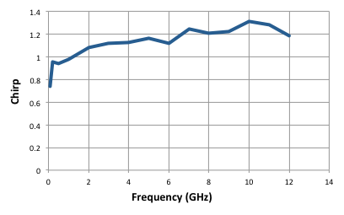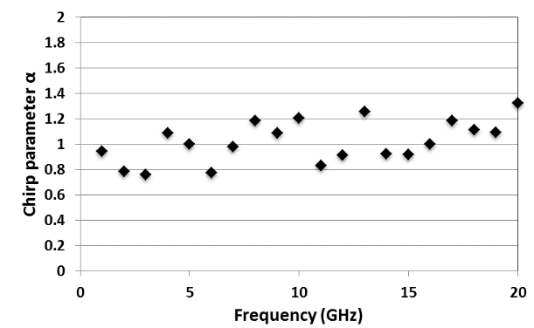

Fig. 10 Chirp frequency characteristic of EAM Fig. 11 Chirp frequency characteristics of MZM

(one arm of MZM is modulated)

In addition, an integrated transmitter can be characterized by this method, by using the laser in the integrated module itself as the transmitter light source. Fig. 12 shows chirp parameters of an electroabsorption modulator integrated laser (EML) at various bias conditions and modulating frequencies using the vector space method. This method is dependent on modulating frequency as shown. The results are compared with an indirect method, denoted by dispersive fiber method, where frequency dependence cannot be measured. In this case, the laser linewidth of the EML also affects the accuracy.

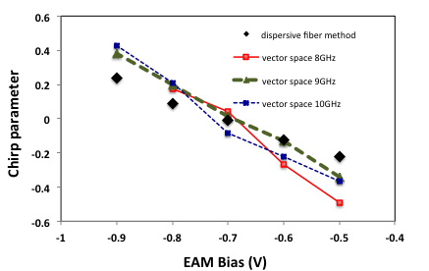

Fig. 12 Integrated EAM (in an EML) chirp parameter as a function of bias voltage

**6.2.2 Alternative method for measurement of modulator induced phase modulation**

The following setup in Fig. 13 shows an alternative method of chirp measurement for MZM using optical spectrum analyzer. The alpha parameter depends on three parameters including  which are the magnitudes of phase shifts in both arms of MZM due to modulating RF signals and , that is the phase delay difference between the two arms. The modulating frequency is . Then chirp parameter of MZM is given by [12],

 (2)

The three parameters and  of dual electrode MZM can be found by optical spectrum analyzer measurements of optical harmonics under different DC bias conditions. This method also allows the frequency dependence of chirp parameter to be estimated as shown in the result of Fig. 14. Since the theory of this method is based on MZM device, it cannot be applied to electroabsorption modulator.

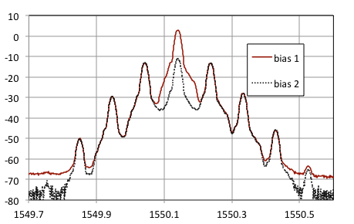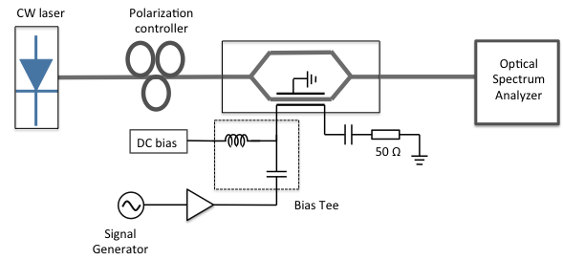 (a) (b)

Fig. 13 (a) Chirp parameter measurement setup using indirect optical spectrum analyser method (b) measured optical spectrum under two required bias conditions.

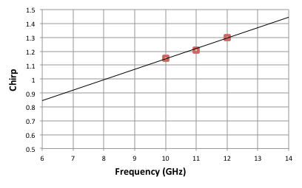

Fig.14 frequency dependence of MZM chirp parameter

**7.** **Experimental demonstration of vector lightwave modulation using directly modulated LD and EAM in an integrated modulator**

In this demonstration, lightwave vector modulation generated by cascaded direct phase (LD) modulation and amplitude (EAM) modulation by an EML is shown. The experimental setup is shown in Fig. 15. In the waveform generation stage, lightwave phase and amplitude signals are generated including phase-balanced encoding, symbol mapping and high pass filtering [13]. Digital FIR equiripple high pass filter (HPF) is used to equalize the response of the phase modulator. In addition, synchronization of  and  is applied during signal generation  is the LD to EAM sections delay time. Then the waveform sequences were imported to the arbitrary waveform generator (AWG) with two outputs, setting appropriate sampling rate and amplitude.

The next stage is the electrical signal optimization using RF attenuators and RF amplifiers before combining with DC bias signals via Bias-tees to modulate the laser and EAM ports of the EML. The receiver hardware in the optical modulation analyzer (OMA), that acts as the receiver, consists of polarization insensitive digital coherent receiver. The carrier phase estimation in the OMA is performed with free-running laser local oscillator using Viterbi-Viterbi phase estimation and extended Kalman filter technique for complex symbol demodulation. The LO laser of the OMA has good stability performance in the order of 100kHz. The commercial EML module consists of DFB laser diode was not intended for phase modulation, thus having rather large linewidth compared to the LO laser. The demonstration has shown the benefit of digital pre-coding, pre-DSP, and post-DSP. An integrated transmitter is suitable for low-cost access network such that dispersion compensation is not required, whereas an external IQ modulator would be better for long-range transmission at higher data rate.

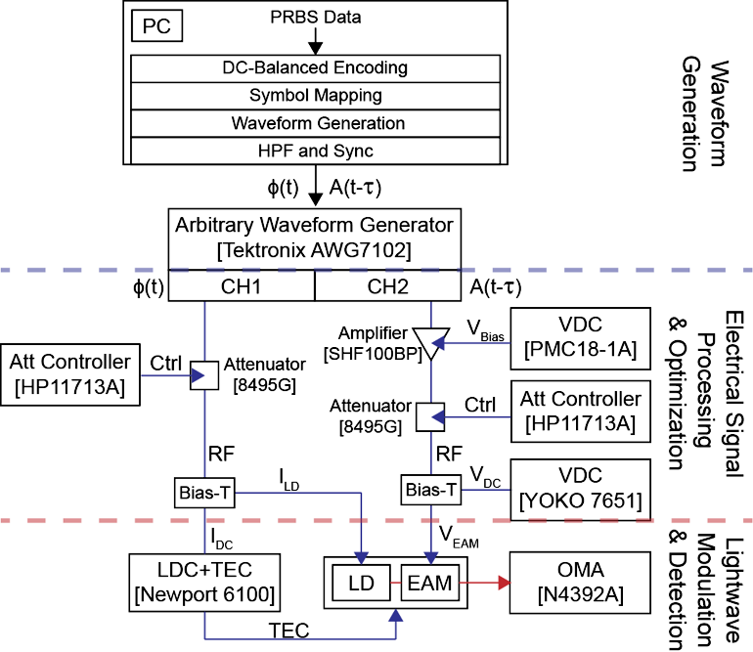

Fig. 15 Experimental setup of EML phase and amplitude modulation [13]

**7.1** **Measurement results using waveform with pre-equalization and pre-coding**

The results are compared between un-equalized and pre-equalized, by digital HPF, modulating waveforms. Fig. 16 (a) shows improved differential QPSK demodulation using pre-equalized waveform compared to un-equalized waveform in Fig. 16 (b). Thus, by compensating the LD frequency response in using a simple digital HPF, the demodulated light amplitude and phase are improved both at four symbol locations and the transitions between symbols. (Only LD response is pre-equalized here.) The average optical power is 4 dBm and the average error vector magnitude (EVM) of Fig. 16(a) is approximately 3-4%.

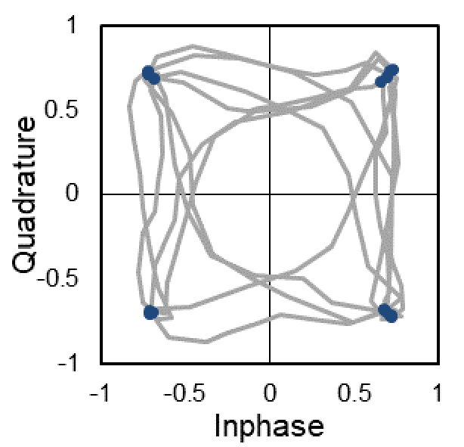 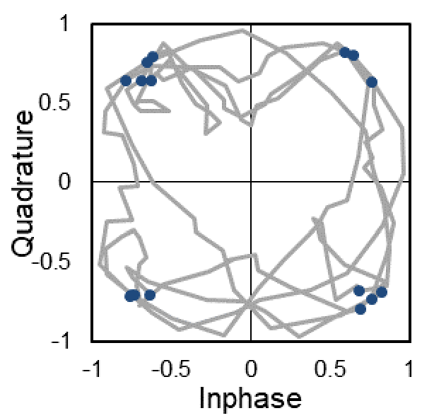

(a) (b)

Fig. 16 Demodulated DQPSK signal using (a) equalized and (b) un-equalized waveform

Another result in Fig. 17, the phase-balanced differential QPSK (PB-DQPSK) modulation, which is a pre-coding technique presented in [13], is compared with conventional differential (DQPSK) modulation. After carrier phase offset is removed, the demodulated signal is better in PB-DQPSK, not only at the symbol instants but also during the symbol transitions, as seen in both constellation and phase-time plots. For conventional DQPSK, the demodulated phase-time diverges from the original values over larger range and the constellations are incorrectly demodulated. The results confirm the benefit of the pre-coding and pre-compensation that the improvement is observed. If symbol rate increases to GHz range, the carrier phase is expected to be eliminated more efficiently.

|  |  |
| --- | --- |
| PB-DQPSK | BER~10-3 |
| (a) | |
| DQPSK | BER ~10-1 |
| (b) | |

Fig. 17 Demodulated constellations, phase-time plots compared with the inputs, and BERs in (a) PB-DQPSK and (b) DQPSK modulations

**8. Conclusion**

This report summarizes the two methods of lightwave vector signal generation in digital coherent system, i.e. IQ modulator and Amplitude-Phase modulator, and their required characteristics. The methods of amplitude and phase response characterization are included for integrated and discrete modulators. The use of digital pre-coding and pre-DSP in the transmitter, according to the device characteristics, are shown to complement post-DSP in the receiver and improve the performance.

**Bibliography**

1. T. Kawanishi, T. Sakamoto, and M. Izutsu, "High-Speed Control of Lightwave Amplitude, Phase, and Frequency by Use of Electrooptic Effect," *Selected Topics in Quantum Electronics, IEEE Journal of*, vol. 13, pp. 79-91, 2007.
2. R. A. Griffin and A. C. Carter, "Optical differential quadrature phase-shift key (oDQPSK) forhigh capacity optical transmission," in *Optical Fiber Communication Conference and Exhibit, 2002.* OFC 2002, pp. 367-368.
3. S. Chandrasekhar, L. Xiang, P. J. Winzer, J. E. Simsarian, and R. A. Griffin, "Compact All-InP Laser-Vector-Modulator for Generation and Transmission of 100-Gb/s PDM-QPSK and 200-Gb/s PDM-16-QAM," Lightwave Technology, Journal of, vol. 32, pp. 736-742, 2014.
4. T. Fujisawa et al., "Ultracompact, 160-Gbit/s transmitter optical subassembly based on 40-Gbit/s monolithically integrated light source," in *Optical Communications (ECOC),* 2012 38th European Conference and Exhibition on, 2012, pp. 1-3.
5. E. Ip and J. M. Kahn, “Digital equalization of chromatic dispersion and polarization mode dispersion,” *J. Lightw. Technol.*, vol. 25, no. 8, pp. 2033-2043, 2007
6. A. J. Viterbi and A. M. Viterbi, “Nonlinear estimation of PSK-modulated carrier phase with application to burst digital transmission,” *IEEE Trans. Inf. Theory*, vol. 29, no. 4, pp. 543–551, Jul. 1983.
7. S. J. Savory, “Digital coherent optical receivers: Algorithms and subsystems,” *IEEE J. Sel. Topics Quantum Electron.*, vol. 16, no. 5, pp. 1164–1179, Sep./Oct. 2010.
8. U. Mankong, P. Mekbungwan, K. Inagaki, and T. Kawanishi, “Vector Modulation by Laser and Electroabsorption Modulator With Digital Pre-coding and Pre-compensation,” *J. Lightw. Technol*., vol. 36, no. 19, October, 2018.
9. S. Zhang, P. Y. Kam, C. Yu, and J. Chen, “Laser linewidth tolerance of decision-aided maximum likelihood phase estimation in coherent optical M-ary PSK and QAM systems,” *IEEE Photon. Technol. Lett*., vol. 21, no. 15, pp. 1075–1077, Aug. 1, 2009.
10. I. N. Cano, A. Lerín and J. Prat, "DQPSK Directly Phase Modulated DFB for Flexible Coherent UDWDM-PONs," *IEEE Photon. Technol. Lett.,* vol. 28, no. 1, pp. 35-38, Jan, 2016.
11. U. Mankong, T. Tangmala, K. Inagaki, A. Kanno and T. Kawanishi, “Direct chirp measurement in vector space of electroabsorption modulator,” in *Proc. MWP/APMP* 2014, pp.127-130, 2014.
12. Kawanishi, K. Kogo, S. Oikawa, and M. Izutsu, "Direct Measurement of chirp parameters of high-speed Mach-Zehnder-type optica modulators," *Optics Communications*, vol. 195, pp. 399-404, 2001
13. P. Mekbungwan et.al, “Phase-Balanced Differential Vector Modulation by Laser and Electroabsorption Modulator,” in *2017 IEEE International Topical Meeting on Microwave Photonics (MWP)*, Beijing, China, October 23-26, 2017