APT REPORT ON

ICT STANDARDIZATION AND CONFORMITY ASSESSMENT SYSTEM IN ASIA-PACIFIC PACIFIC

Edition: March 2016

The 27th APT Standardization Program Forum (ASTAP-27)
7 – 11 March 2016
Pattaya, Thailand

(Source: ASTAP-27/OUT-10)

No. APT/ASTAP/REPT-23

ICT STANDARDIZATION AND CONFORMITY ASSESSMENT SYSTEM
IN ASIA PACIFIC

1. Introduction
The development of ICT industry in our region has obtained great achievement in recent years, but is still a major challenge for many countries. Many APT member countries are making huge efforts to bring ICT equipment and services to their population at high quality and reasonable price. Currently there are a lot of issues which developing countries have to deal with, such as policy and technological issues.
Standardization is known to play an important role in the development of ICT. Standards and/or technical regulations are critical in the interoperability, privacy and accessibility, which support market acceptance as well as the efficient and effective use of ICT applications and services.
This document intends to provide survey results on the current status of ICT Standardization and Conformity Assessment Systems in APT countries.
From the data collected, a database of ICT standardization and conformity assessment system will be created that will be used by some APT member countries and also offer some ideas for further effective coordination of these issues for the development of ICT in our region.
2. Standardization system in Asia Pacific
2.1. Questionnaire Responses from APT members
The 26th APT Standardization Program Forum (ASTAP-26) in Bangkok, Thailand from 09th – 13th September 2015 has approved a questionnaire that will be used to collect information on the current status of ICT Standardization and Conformity Assessment System in Asia Pacific region. Until now, 7 questionnaires was received from Japan, Papua New Guinea (PNG), Laos, Malaysia, Nepal, Thailand and Vietnam. The result of information collected is presented in 2.1 and Table 1.1 below.

Table 1.1. Responses from members by type

Regulator /Administration | Standard Developing Organization | Terminal or Network Equipment Manufacturer/Importer | University/ Institute/R&D Organization
Japan, Papua New Guinea (PNG),  Lao PDR, Malaysia, Nepal , Thailand and Viet Nam | None | None | None

2.2. Papua New Guinea
2.1.1. ICT Standardization system
The National Information and Communications Technology Authority (NICTA) is a government agency responsible for the regulation and licensing of Information Communication Technology (ICT) in Papua New Guinea.
NICTA regulates: broadcasting, the internet, radio communications and telecommunications.
NICTA was established on the 29th of October 2010, as the sole converged regulator and licensing authority of the ICT industry in PNG. This followed the adoption by the PNG Parliament in November 2009 of the National Information and Communications Technology Act 2009 (the NICT Act), a subsequent creation of the National Information and Communications Technology Authority or NICTA.
Figure 1. Standardization framework structure
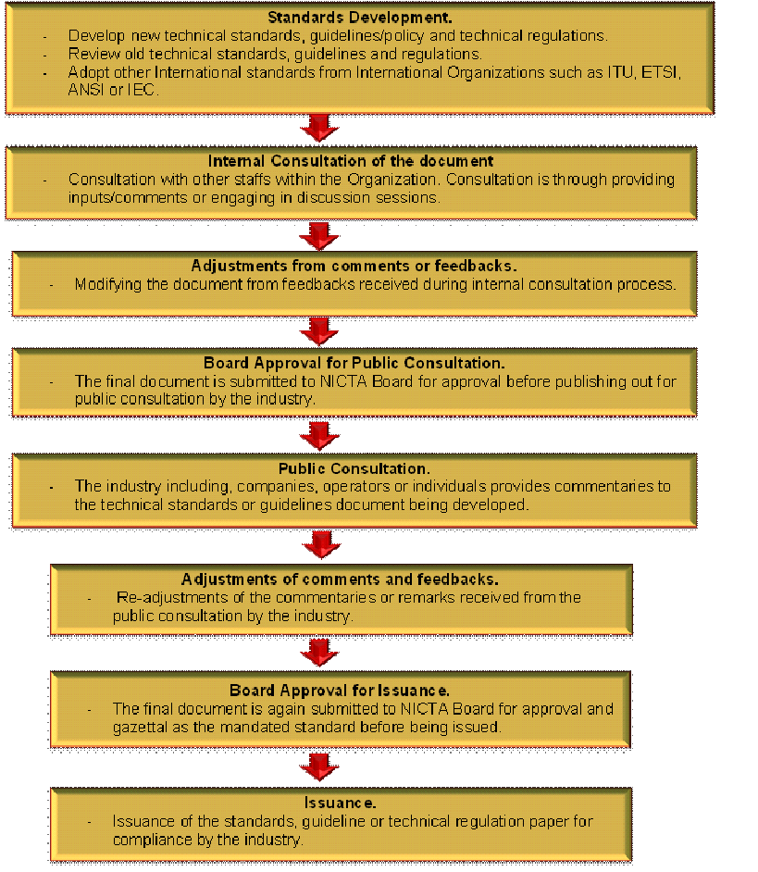

Figure 2. Procedures for Issuing a Standard or Technical Regulations - NICTA

Technical Requirements
All ICT equipment intended for use in Papua New Guinea shall comply with relevant local and International Technical Standards recognized by NICTA such as electrical safety, electromagnetic compatibility (EMC), electromagnetic radiation (EMR) and operational requirements for radio communication devices.
  - Technical standards for ICT equipment associate with:
- EMC and Safety Standards
- Technical Specification for Land Mobile Radios
- Technical Guideline
- Multi-Carrier Interconnection Technical Code of Practice
- Cabling Guideline
- GSM 900/1800 MHz
- Numbering Code of Practice
- Technical Policy for MMDS
- Regulatory Policy for MMDS
- Technical Standards for Cable Television
- Guidelines for Truck-Land Mobile
- Radio Dealers License Guidelines
- SMS Industry Standard
- Type Approval Guideline
- Type Approval Specification for various ICT equipment (DVB-T2, Wireless Broadband Access Equipment, Wireless Local Area Network Equipment etc.)
  - Standardized areas in priority:
- EMC
- Electrical safety
- SAR
- Quality of Service
- Health and Safety for End Users and the Networks.
- Interoperability of ICT equipment and Network Systems.
- Device Specifications for ICT equipment such as power limits and frequency of operation.
  - Objectives of standardization application:
- Quality control
- Compliance and Conformity with international best practices and standards.
- Protects consumer’s health and safety and also the environment.
- Protect the integrity of ICT networks.
- Interconnection/Interoperability among regional, national and international gateways or equipment.
- Control and Limit importation of unsafe, sub-standard and/or counterfeit ICT equipment through quality checks and conformity assessment.
- Promotes the image of the quality of ICT products to build customer confidence.
- Emphasizing cooperation with other regulators and international organizations such as accreditation and testing bodies.
  - Roles of ICT companies/enterprises in standardization (in developing, complying of standards/technical regulations):
- The regulator (NICTA) develops the ICT standards. The ICT companies involves in ICT standardization through public consultation by providing inputs and comments on the standards being developed by NICTA.
  - Challenges in standardization for ICT:
- Lack of understanding
- Lack of authority or legislative power
- Lack of resources
- Inadequate qualified human resources to interpret and identify appropriate international standards that are applicable to PNG industry.
- Lack of compliance to policies or guidelines/regulations by the ICT companies.
- There is low participation from the industry or private sector regarding feedbacks/comments during public consultation on standards, policies or technical guidelines being developed.
- No or inadequate funding for testing equipment and laboratories.
- Lack of institutional and legal framework to coordinate standardization activities among various institutions such as research centres, academia etc. within the country.
- No regulatory framework for standardization at present. The Standardization framework is still under-construction.
- Implementation issue in absence of proper standardization setup.
- Minimal internal collaboration between standard organizations (NISIT), research centres, colleges and universities for discussion on ICT standardization.
- Limited collaboration with other international organizations (such as ITU, APT) and regulators (such as ACMA, IDA) and learned from them the best practices into implementing ICT standardization in the country.
  - The harmonisation with the international and regional standards: Fully Harmonized and basically international standards organizations such as ITU standards and recommendations, ETSI standards, ANSI and IEC.

2.1.2. Conformity assessment (CA) system
  - CA procedures include: Certification and Declaration.
  - MRA implementation: The MRA is intended to streamline the conformity assessment procedures for a wide range of telecommunications equipment and therefore facilitate trade NICTA Type Approval Guideline among the countries in the APEC region. Papua New Guinea is a party to this arrangement. NICTA may plan to implement the MRA in the near future.
  - Market surveillance: NICTA does Market Surveillance (MS) process through Post Market activities such as complaints received from customers/users or competitors of the ICT equipment or service. Other Post Market activities includes reports of interference, visual inspection of ICT products in a retail outlet or inappropriate advertising or simple random checks.
NICTA is Regulatory Body to be in charge of market surveillance of telecommunications equipment. When non-compliant equipment is identified, NICTA have the legal authority to take action. The equipment testing for the purpose of market surveillance is subject to NICTA’s discretion.The criteria used to select an equipment for the purpose of Market Surveillance are based on complaints from users, consumers or competitors and potential harm to network or people due to non-compliance. MS exercise is conducted twice a year.

2.3. Lao PDR
2.3.1. The standardization framework in Lao
The establishment ICT Standardization Policy and Framework in Laos is based on Standardization policy of ASEAN, APT and ITU with the Department of Telecommunications being responsible for overseeing the telecom standards. Yet the procedure of issuing a standard/ technical regulation is still ongoing.
  - The objectives of standardization process in Lao include but not limit to:
- Administration of importation of Telecommunication equipment.
- Projectsto study the feasibility in theestablishment ofa Standard Verification and Certification Centre.
- Cooperation with International organizations to develop human resource and technologies which will be used in standard verification and measurement.
- Cooperate with domesticinstitutions, colleges and Universities to conduct research on standardization.
- Tariff on Radio Frequency charging rate based on Agreement number 848 of June 16th 1995 of the Ministry of Communication Transport Post and Construction.
- Fully acceptance of international/regional standards
- Focusing on EMC and SAR and quality control
  - Challenges in standardization:
- Lack of understanding
- Lack of authority or legislative power
- Lack of competent resources
2.3.2. Conformity assessment (CA) system
Conformity assessment (CA) system is not applicable at the moment and to be investigated in the coming time. Likewise, there is currently no MRA-CA being implemented in Lao. Regulation for this needs to be established first.

2.4. Standardization system in Malaysia
2.4.1. The standardization framework in Malaysia
For the purpose of ICT standardization, in 1998 a Commission was established with the responsibilities of overseeing the new regulatory framework for the converging communication and broadcasting industries and on-line activities, whichsince 2001 has also includedthe postal services and licensing of the Certification Authorities.
The overall goal is to obtain a global competitiveness, efficiency and increased self-regulating communications and multimedia industry to meet the economic and social needs of Malaysia.
The mission of the Commission is to promotethe access to communications and multimedia services, ensuring consumers enjoy their choice and a satisfactory level of services at affordable prices, providing transparent regulatory processes to facilitate fair competition and efficiency in the industry, ensuring the best use of spectrum and number resources and consulting regularly with consumers and service providers and facilitating industry collaboration.

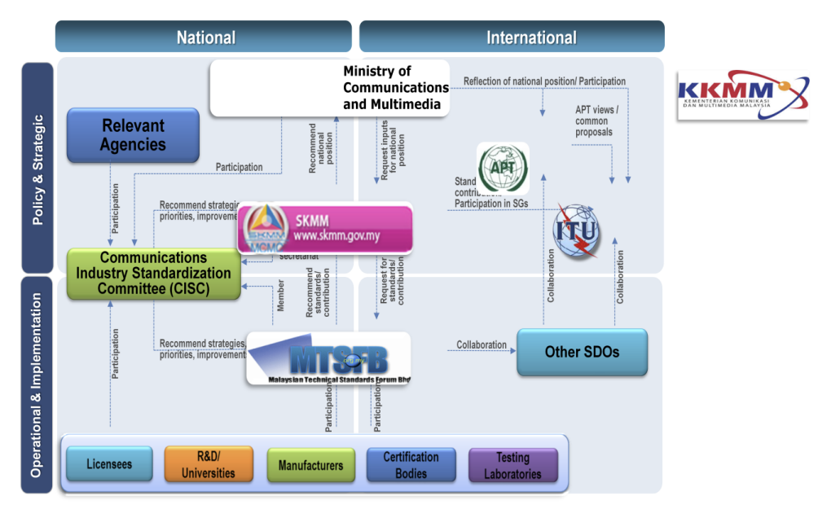
Figure 3. The standardization framework in Malaysia

  - MTSFB Standardization Work
The industry authorities are also members of the technical standard forum (MTSFB) which
develops the technical standards. They also have to comply with all of the mandatory standards and the technical codes for communications equipment.
The development process of standardization begins with the proposal of a new work item (NWIP). This may beinitiated by the Commission or MTSFB. NWIP needs to be deliberated by the Reference Panel & Board of Directors for approval. The NWIP is then assigned to a working group by the Board of Directors and a committee draft will be made. This draft then reaches the public for comments by means of advertising on the websites of MCMC & MTSFB and 2 mainstream newspapers (English and Malay) for at least one month. Once the comments are sufficiently received, the working group will finalize the draft taking into account the comments received. Once the final draft has been approved by the MTSFB’s Board of Directors, it will be submitted to the Commission. If the Commission neither registers nor refuses within 30 days, the Commission is deemed to have refused the registration unless otherwise notified by the Commission. The whole process takes from 1 to 3 years, depending on types of projects.
  - Standardized areas in priority:
- EMC
- Electrical safety
- SAR
- Green ICT
- Network Interoperability
- Wireless
- Light-wave Apparatus
- Cabling and Accessories with Propagation Methods
  - Challenges in standardization: The most significant challenge is the lack of resources. Membership and involvement of industry players in the technical forum (MTSFB) and technical standards development are based on a voluntary basis. Sometimes, the development of a standard is delayed purely because the experts have other priorities or are occupied with work commitments.
  - Fully acceptance of international/regional standards: All standards developed are based on International Standards and enhanced with appropriate local industry requirements.
2.4.2. Conformity assessment (CA) system
Section 186 and Regulation 10 state that:
  - The Commission may register certifying agencies or classes of certifying agencies, including agencies outside Malaysia, for the purposes of certifying compliance with codes or standards under this Part.
  - An approval by a registered certifying agency shall be deemed to be an approval by the Commission for the purposes of this Chapter.
  - The certification program carried on or operated by a registered certifying agency shall include:
- Evidence of the control of the certification mark or label, certificate or other indicators of compliance;
- Periodic monitoring and testing of the equipment;
- Quality control and quality assurance requirements;
- Procedures to review and re-establish certification status when revisions are made to standards, policies and procedures;
- Recording and reporting systems which demonstrate that procedures have been fulfilled;
- Procedures for the resolution of disputes between the persons who apply for certification and the registered certifying agency; and
- Any other matters as may be required by the Commission.
  - CA procedures in Malaysia include:
- Accreditation
- Designation
- Certification
Malaysia is currently implementing MRA, which was initiated with Malaysia entering into ATRC Phase 1 MRA with Singapore on 28 January 2005 for mutual recognition of test results issued by their recognized testing laboratories. It is also inthe progress of MRA- APECTEL Phase 1 MRA with the Unites States. Together with this, a Market Surveillance (MS) program for telecommunications equipment is being performed. Market surveillance activities are carried out by Regulatory Body, of which agency SIRIM QAS International Sdn Bhdhas been appointed by MCMC to carry out the Market Surveillance program. Regulatory Body also has the legal authority to take action when non-compliant equipment is identified.
Market surveillance also includes equipment testing (RF, Safety, EMC), which is done annually following three criteria:
- Complaints from users/consumers/competitors.
- Popularity of a product.
- Potential harm to network or people due to non-compliance

2.5. Standardization system in Nepal
2.5.1. Polices, regulations frameworks for standardization
  - Type Approval Working Procedure for Customer Premises Radio Telecommunication Equipments-2014 (TAP-03):
The Authority is established with a view to managing and regularizing the telecommunication services and making them reliable and easily available to the public by Telecommunication Act, 2053 (1997). The Authority determines and/or approves the standard and quality standard of the plant and equipment relating to the telecommunication and the telecommunication services. All the concerned manufacturers/authorized agents/representatives are required to apply and get typed approval for the radio telecommunication CPEs under the provisions of typed approval procedure from the Authority prior to import and/or sale in Nepal.
  - Telecommunication Act 1997 A. D.: Establishment of Telecommunications Authority: A Nepal Telecommunications Authority is established with a view to managing and regularizing the Telecommunications Service and making it reliable and easily available to the public.
  - Authority to be an Autonomous and Corporate Body:
- The Authority shall be an autonomous and corporate body with perpetual succession.
- The Authority shall have its own seal to carry out its functions.
- The Authority may, like an individual, acquire, use or otherwise manage movable and immovable property.
- The Authority may, like an individual, sue and be sued by its name.
  - Standardized areas in priority:
- EMC
- Electrical safety
- SAR
- Green ICT
  - Standard/technical regulation application:
- Objectives of standardization application is quality control.
- Roles of ICT companies/enterprises in standardization (in developing, complying of standards/technical regulations):
- During the formulation of standards/technical regulation ICT companies/enterprises should provide necessary feedback and suggestion.
- ICT companies/enterprises shall obey the rules and regulations to comply standards/technical regulations formulated by the Authority.
  - Challenges in standardization for ICT:
- Lack of understanding
- Lack of resources
  - Fully acceptance of international/regional standards: Document Verification Method is used. Nepal accept Radio, SAR, Safety and EMC Test reports/Certification by the manufascturer or the authorized representative of the manufacturer and/or Type Approval Certificate issued by at least one of the international/national/territorial standard bodies.
2.5.2. Conformity assessment (CA) system
Policies or legal frame work for CA in Nepal is based on typed Approval Working Procedure for Customer Premises Radio Telecommunication Equipments-2014 (TAP-03).
The CA procedure includes Certification and Declaration/Registration/Verification.
The fact that Nepal has no laboratory for the testing of telecommunication equipment so far has made them unready for implementing the MRA. However, NTA has completed the feasibility study on the establishment of laboratory for testing of radio telecommunication CPEs during type approval, which hopefully will soon lead to the implementation of MRA.
A Market Surveillance (MS) program for telecommunications equipment is in place. The mechanism on which MS is carried out is that during the submission of application for typed approval, the applicant submits the declaration of conformity to declare the product fully complies with the widely accepted standards and specifications of Radio, EMC, SAR and safety as well as warranty of at least One Year to that product. NTA is in charge of telecommunication equipment and carries out Market Surveillance if there is any complains.Market surveillance activities are mandated to Regulatory Body, which also has the legal authority to take action when non-compliant equipment is identified.
Conduct equipment testing for the purpose of market surveillance is not applicable.

2.6. Standardization system in Thailand
2.6.1. Polices, regulations frameworks for standardization
National polices, regulations:
  - NTC/NBTC (The National Broadcasting and Telecommunications commission) Technical Standards for Telecommunications Equipment.
  - Industrial Product Standards Act, B.E.2511 (1968).
  - National Standardization Act, B.E.2551 (2008).
  - Electronic Transaction Act B.E.2544 Amendment (No.2) B.E.255.1
- Thailand is a member of ISO and IEC and uses the International Standards in the certification of ICT product.
- Standardized areas in priority:
- EMC
- Electrical safety
- SAR
- Radio Frequency (RF) Characteristics
- Electronic Transaction Standard
- Objectives of standardization application:
- Quality control
- Interoperability
- Network interrity
- Health and safety
- Preventing harmful interference to telecom service
Companies/enterprises in standardizaton have roles to commit the standards.
- Challenges in standardization for ICT:
- Lack of understanding
- Lack of authority or legislative power
- Lack of resources
- Lack of technology expertise in local industries
- The harmonisation with the international and regional standards:
- Fully acceptance of international/regional standards
- Partially harmonized with international/regional standards
2.6.2. Conformity assessment (CA) system
The policies or legal frame work for CA in Thailand include:
NTC Notification on CA of telecommunication equipment, of which the procedure is also done by the Office of NTC; NTC Notification on rules, procedures and conditions on establishing testing laboratory for telecommunication equipment in Thailand and rules for recognizing telecommunication equipment test reports from foreign laboratory.
  - CA procedures include:
- Accreditation
- Designation
- Recognition
- Certification
- Declaration/Registration/VerificationDeclaration/Registration/Verification
MRA and MRA-CA is currently being implemented in Thailand, including ILAC MRA, APLAC MRA, IAF MLA and PAC MLA.
Market Surveillance program for telecommunication equipment is in place, which Regulatory Body is responsible for and mandated to its activities. Regulatory Body also has the authority to take action when non-compliant equipment is identified.
For the purpose of Market Surveillance, equipment testing is conducted based on complaints from users/consumers/competitors and potential harm to networkor people due to non-compliance. RF, Safety and EMC tests are performed every three months.

2.7. Standardization system in Japan
2.7.1. Polices, regulations frameworks for standardization:
Organisational structure for ICT standardization system in Japan and the relationships between them and the international standardization bodies is illustrated in Figure 4. All areas in the ICT standardization system are regarded as equally important.
The objectives of standardization application are:
To ensure proper and reasonable operations and promote fair competition of the telecommunication business in light of the public nature of such business, and thereby ensure that telecommunications services are smoothly provided and protect the interests of the users of such services, so as to ensure sound development of telecommunications and covenience for citizens and to promote the public welfare.
To promote public welfare by ensuring the fair and efficient utilization of radio waves.
The major challenge in the process of ICT standardization for Japan is to strengthern international competitiveness in the ICT industry, on the basis that Japan is in full harmony with the international and regional standards.
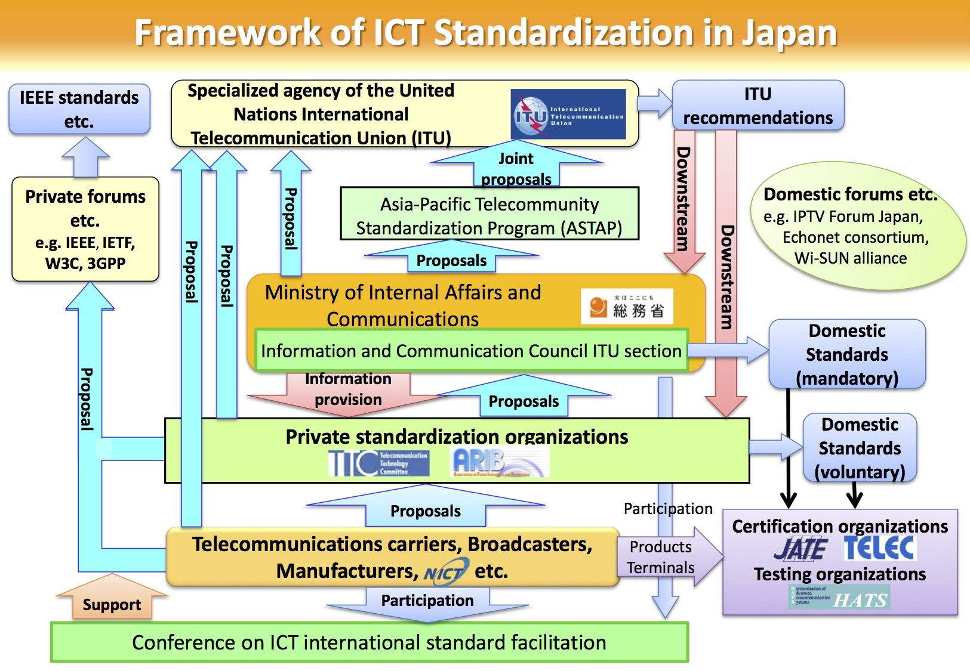
Figure 4. Framework of ICT Standardization

2.7.2. Conformity assessment (CA) system
CA system in Japan follows “Radio Law” and “Telecommunications Business Law”. The procedure includes certification and declaration/ registration/verification.
MRA and MRA-CA are currently being implemented in Japan, following “the agreement on Mutual recognition between Japan and the European community”, “Agreement between Japan and the Republic of Singapore For a new-age Economy Partnership” and “the agreement on Mutual recognition of Results of Conformity Assessment Procedures between Japan and the United States of America”.
Market serveillance (MS) program for telecommunication equipment is in place on an annual basis, whose activities are mandated to Regulatory Body (The Ministry of Internal Affairs and Communications). The Regulatory Body also has the legal authority to take action when non-compliant equipment is detected.
Equipment testing is conducted for the purpose of MS, which is based on each specific occasion. Testing includes RF and other (harmless to network).

2.8. Standardization system in Korea
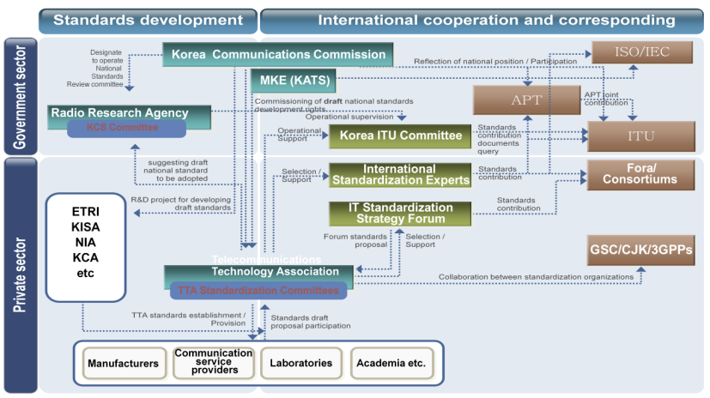
Figure 5. Standardization system in Korea
The making of the Korea standards is associated with participating in forums and international standards organizations including the Association of Telecommunications Technology ( TTA ) plays a central role .
In Korea, today’s important keywords are changing from the supplyment based standard to user or market oriented standards. In the past, they just only focused on the Bottome up approach, or independent issue, or closed participation for example, compatibility, convenience, and cost saving with following up the standardization strategy
But these-days, paradigm are shifting to user oriented standards with the Leading & advanced strategy.And in order to pre-occupy global market, Convergence Issues including Open Participation, middle-top-down apprach. So in order to get the interoperability, Standardization coordinating with R&D must be gvery important issue in the global market trade.
The standardization strategy in Korea are Product, People, Partnershipn and Promotion.

2.9. Standardization system in Vietnam
2.9.1. Polices, regulations frameworks for standardization
On the legal framework, we have Law on quality of products and goods (2007) and Decree No. 132/2008/ND-CP; Telecommunications Law (2009) and Decree No. 25/2011/ND-CP to implement Telecommunications Law, which in brief states that:
  - Ministry of Information and Communications (MIC) is responsible for quality control activities of ICT products including electronic, postal, telecommunication and IT products.
  - Standard system for telecommunications and radio frequency is including standards and technical regulations on ICT products, services and installations.
  - Technical regulations issued by Ministry of Information and Communications are for conformity assessment activities in ICT sector.
  - Ministry of Information and Communications is responsible for designating, recognising CABs in telecommunications, IT and radio frequency.
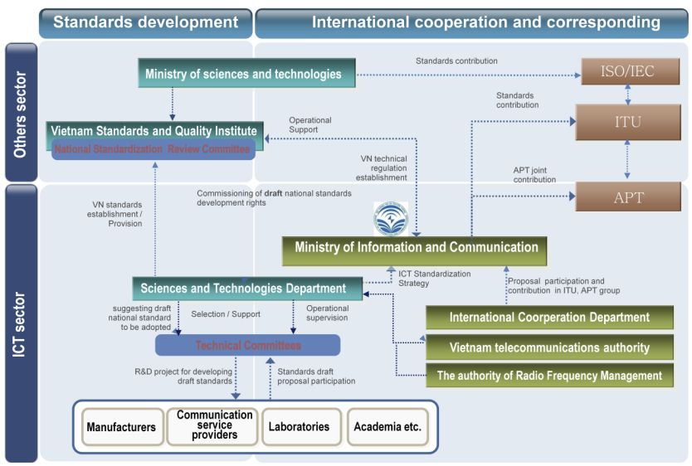
Figure 6. Standardisation organisation for ICT in Vietnam
In national standardization system, Vietnam have national standards (TCVN) and national technical regulations (QCVN):
  - National standards: Most are national standards for ICT products is editing by Ministry of Information and Communications, and some of national standards was forced to be mandatory under the regulation of Ministry of Information and Communications; more information about national standards can be found at http://new.ismq.vn/index.php?language=vi&nv=shops&op=TCVN&catid=1 (in Vietnamese) or http://arc.ismq.org.vn/en/ (in English)
  - Technical regulations: Technical regulations for ICT products is editing and issuing by Ministry of Information and Communications, and most of technical regulations are for conformity assessment of ICT products activities in Vietnam; more information can be found at http://english.mic.gov.vn/mra/mra_tech_list/Trang/Listoftechnicalregulations.aspx (list in English) and http://mic.gov.vn/mra/mra_qc/qcktqgdbh/Trang/Quychu%E1%BA%A9nk%E1%BB%B9thu%E1%BA%ADtqu%E1%BB%91cgiadoB%E1%BB%99TTTTbanh%C3%A0nh.aspx (full documents in Vietnamese)
In the application of standards and technical regulations: All technical regulations and some of standards are for specialized management by Ministry of Information and Communications by conformity assessment activities:
  - Declaration procedure for terminal equipment, IT equipment…
  - Certification procedure for RF equipment and RF application devices…
Training/workshops on ICT standard/technical regulation system are also organized annually for raising the awareness on ICT standardization activities and encouraging operators to develop/apply basic standards for their own activities.
Currently, Vietnam is still facing some challenges in standardization for ICT, such as limited capability for standardization in ICT sector (human resources, international standards…); limited capability for testing to comply with standards/technical regulations in ICT sector; lack of involvement of telecom operators in basic standards (for their own using)
2.9.2. Conformity assessment (CA) system
The policies or legal frame work for CA in Vietnam include:
  - CA procedures include:
- Accreditation
- Designation
- Recognition
- Certification
- Declaration/Registration/VerificationDeclaration/Registration/Verification
MRA and MRA-CA is currently being implemented in Viet Nam, including ILAC MRA, APLAC MRA, APECTEL MRA-CA and ATRC MRA.
Market Surveillance program for telecommunication equipment is in place, which Regulatory Body is responsible for and mandated to its activities. Regulatory Body also has the authority to take action when non-compliant equipment is identified.
At this time, equipment testing is not conducted for the purpose of Market Surveillance.

3. Conclusion
From the answers to the questionnaire by all countries, it can be seen that, although all countries appear to have the same or very similar concerns, goals and objectives, there is existing dissimilarities in the priorities, process and progress among the countries. Those differences can be attributed to the differences in economy, infrastructure and resources in different countries. While it can be anticipated to take a certain period until all countries in the region have a concordant development in the standardization, this process can be shortened by the tight collaboration and assistance among all countries.
In the region, there is currently a rather big gap in ICT development and in standardization system between well-developed countries like Japan and Korea and developing countries like VN, Lao.
Challenges shared by developing countries are Lack of understanding, lack of resources...
Standardization pathway in developing countries in a sense corresponds to the process of bridging the gap in standardization (BSG). Thus recommendations by ITU given during the development and improvement of standardization system in each countries can be applied.

