APT REPORT ON

GUIDANCE FOR GREEN ICT STANDARDS

Edition: August 2014

The 24th APT Standardization Program Forum (ASTAP-24)
27 – 29 August 2014
Bangkok, Thailand

No. APT/ASTAP/REPT-08
(Rev.3)

Table of Contents

1. Background 1
2. Study Items of ICT&Climate Change 1
3. Summary Template 4

Ⅰ. Study Item d
- Practice guidance for life cycle assessment to ICT products

Ⅱ. Study Item f
- End of life management (reuse, recycling, e-wastes management, etc.)
- Rare Metal Measurement in E-Waste
- Activities on ITU-T for rare metal & e-waste-

Ⅲ. Study Item p
- Power adapter and charger for hand held devices such as cell phones
- Practice guidance forDC power supply for notebook computer
- Introduction of Korean notebook adapter standard and compatibility study plan
- Introduction of common mobile adapter regulatory/standards environment summary
and current status of notebook charger standardization

1. Background
- In the meeting of ASTAP19 ICT&CC working group, the future work plan for ICT and climate change WG was discussed on the basis of the returned questionnaires from APT member countries. The WG agreed on the work items, deliverables and working methods. In the meeting of ASTAP20 ICTCC working group made a documentation template todevelop a practice guidance and summary document for each study item among 26 selected items in 2 pagesin order to help APT Members prepare their contributions easily. APT Members are invited to prepare their contributions to develop a 2-page practice guidance and summary document for each study item. In addition, the WG-ICT&CC Chair requested any contributor to contact him first before he/she starts the work, in order to avoid any duplicate documentation on the same item.

2. Study Items of ICT&Climate Change

The WG agreed to consider 26 study items for the future work of ICT and Climate change WG in the ASTAP19 meeting.
- Assessment methodology for environmental impacts of ICT to countries
- Using ICTs to enable countries to adapt to climate change
- Energy efficiency metrics and measurement for ICT equipment
- Practice guidance for life cycle assessment to ICT products
- Practice guidance for accounting guidelines for GHG reduction activities based on utilizing ICT goods, networks and services
- End of life management (reuse, recycling, e-wastes management, etc.)
- Energy consumption metrics and measurement for ICT equipment
- Declaration of environmental information of ICT equipment
- Setting up a low cost sustainable telecommunication infrastructure for rural communications in developing countries
- Energy consumption saving techniques
- Hazardous material management
- Assessment methodology for environmental impacts of ICT to cities
- Practice guidance for carbon foot printing guidelines to ICT products
- Basic guidelines for life cycle assessment
- Best practices for greening data centers
- Power adapter and charger for hand held devices such as cell phones
- Inventory guidelines especially for ICT organizations and ICT-based activities
- Carbon footprinting guidelines for products
- Power supply interfaces for data centers
- Inventory guidelines for organizations
- Accounting guidelines for GHG reduction activities
- Validation and verification
- Eco design for ICT goods
- Regulatory framework
- Best practices for energy efficiency improvements of ICT products
- Energy efficiency on cloud computing
_____________________

3.Summary Template

APT Members are invited to prepare their contributions to develop a 2-page practice guidance and summary document for each study item.

Documentation template for practice guidance and summary for Green ICT guidelines or standards

NOTE – The following skeleton is given as a documentation template. Any contribution for each study item (among the 26 future study items of WG-ICT&CC)on the practice guidance and summary for Green ICT guidelines or standards should follow the given structure.
_____________________

Title
(e.g. Assessment methodology for environmental impacts of ICT to countries)

1. Target document
NOTE – In this section, the following items should be described:
- Document number, if any (e.g. ITU-T L.1450)
- Full title of the topic (e.g. Methodology for environmental impact assessment of ICT within countries)
- Source of the target document (e.g. ITU-T SG 5)
2. Goal
NOTE – In this section, the following items should be described:
- What it is; definition; or general introduction
- Scope of documentation
3. Document skeleton
NOTE – In this section, an introduction to each top-level section, if needed, and the second-level section as well should be given.
4. Market needs
NOTE – In this section, the following items should be described:
- Motivation of the development
- Why it had to be developed
- What benefits can be obtained
5. Related topics
NOTE – In this section, the following items should be described:
- Competitive, complementary or supplementary references (e.g. standard and relevant practice guidance)
- Any activities working on the same or similar topics

_____________________

Ⅰ. Study Item d

Practice guidance for the life cycle assessment of ICT products

1. Target document
- ITU-T L.1410 (03/2012)
- Methodology for the assessment of the environmental impact of information and communication technology goods, networks and services
- ITU-T SG 5
2. Goal
- General introduction: ITU-T L.1410 deals with the assessment of the environmental impact ofICT goods, networks and services in terms of the life cycle assessment. It is organized intwo parts:
  - Part I (clause 5): ICT life cycle assessment: framework and guidance.
  - Part II (clause 6): Comparative analysis between ICT and a reference product system (baselinescenario): framework and guidance.
The Part I deals with the life cycle assessment (LCA) methodology applied to ICT goods, networks andservices (GNS), providing a quantification method for their first order effects (or called the environmental load of the ICT GNS) which mean the impacts created by the physicalexistence of ICT GNS and the processes involved, e.g., energy consumption and GHGemissions, e-waste, use of hazardous substances and use of scarce, non-renewableresources. The Part I of ITU-T L.1410, however, covers only GHG and energy aspects.
The Part IIof ITU-T L.1410 deals with a comparative analysis methodology based on LCA results between an ICT GNSproduct system and a referenced product system, providing a quantification method for the second order effects of the ICT GNS product system (or the environmental load reduction achieved by the ICT GNS product system)where the second order effects mean the impactsand opportunities created by the use and application of ICTs. That is, theyare environmentalload reduction effects which can be either actual or potential, such as travel substitution,transportation optimization, working environment changes, use of environmental controlsystems, use of e-business, e-government, etc.
An additional description is attached in the end of this document.
- Scope of documentation: ITU-T L.1410 aims to provide a methodology for evaluating the environmental impact ofICT objectively and transparently, and is based upon the Life Cycle Assessment (LCA)methodology standardized in ISO 14040 and ISO 14044.
This Recommendation can be read by anyone wanting to better understand the specific conditionsand requirements applicable for LCA of ICT Goods, Networks and Services (GNS). However theRecommendation is especially intended for LCA practitioners, with a prior knowledge in LCAstandards, i.e. ISO 14040 and ISO14044.
The purpose of this Recommendation is to:
  - Provide ICT specific requirements, in addition to those of [ISO 14040] and [ISO 14044], toensure a minimum quality of LCA studies of ICT GNS;
  - Ensure the credibility of LCAs of ICT GNS;
  - Increase the transparency and facilitate the interpretation of LCA studies of ICT GNS;
  - Facilitate communication of LCA studies of ICT GNS;
  - Provide a methodology for telecommunication operators and service providers to assess theenvironmental load of one or more services which are carried by their ICT networks.
While recognizing ISO 14040 and ISO 14044, including Annex A of ISO 14040 “Applicationof LCA”, as normative references, this Recommendation gives generic requirements for theLCA of ICT GNS. The Recommendation is valid for all types of ICT goods including end-userequipment, and also for ICT networks and services. It focuses on environmental load and impactstemming from energy consumption and GHG emissions of ICT GNS. Practitioners are howeverencouraged to also consider other environmental aspects in accordance withISO 14040 and ISO14044.
Comparisons between environmental assessments of ICT GNS, assessments which have beenperformed by different organizations are beyond the scope of this Recommendation, as suchcomparisons would require that the assumptions and context of each study are exactly equivalent.
3. Document skeleton
ITU-T L.1410 consists of the following table of contents:
- Scope
- References
- Definitions
Part I – ICT life cycle assessment: framework and guidance
I.1. General description of LCA for ICT goods, networks and services
I.2. Methodological framework
I.3. Reporting
I.4. Critical review
Part II –Comparative analysis between ICT and Reference Product System(baseline scenario): Framework and Guidance
II.1. General description of comparative analysis
II.2. Methodological framework of comparative analysis
II.3. Reporting
II.4. Critical review
Annex A: A method for assessing the environmental load of the working environment
Annex B: Details regarding handling of software
Annex C: Generic processes
Annex D: Part types of ICT goods
Annex E: ICT networks overview
Annex F: Specific ICT unit processes
Annex G: End of Life Treatment processes
Annex H: Modeling of unit processes
Annex I: Elementary flows (emissions and resources)
Annex J: Fuels
Appendix I: Life cycle stages overview
Appendix II: Applicable data types per life cycle stage/unit processes
Appendix III: Uncertainties of Life Cycle Assessments for ICT goods, networks and services
Appendix IV: Opportunities and limitations in the use of LCA for ICT goods, networksand services
Appendix V: Examples for calculating second order effects
Appendix VI: Energy mix
Appendix VII: Examples
4. Market needs
- Motivation of the development: ISO 14040 and ISO 14044 specify a general methodology to assess the environmental aspects and potential environmental impacts (e.g. use of resources andthe environmental consequences of releases) throughout a product's life cycle from raw material acquisitionthrough production, use, end-of-life treatment, recycling and final disposal (i.e. cradle-to-grave). They aim at supporting every type of products and ICT products also can be covered theoretically. They do not provide practical guidelines for ICT products because they are a general methodology. ITU-T L.1410 aims at providing specific guidance for assessment of the environmental impact of ICT products (i.e. goods, networks and services) in compliance to ISO 14040 and ISO 14044.
- Why it had to be developed: ISO 14040 and ISO 14044 may be enough as an environmental assessment methodology if ICT manufacturers use them for a self-evaluation purpose. ICT service providers are paying attention to reducing their environmental loads currently and want to buy eco-friendly ICT products. This situation requires a common methodology to be provided and practice guidance for assessment of the environmental impact of ICT goods, networks and services should be developed.
- What benefits can be obtained: ICT GNS manufacturers and providers can use a common methodology with detailed guidance from ICT perspectives.
5. Related topics
- Competitive, complementary or supplementary references (e.g. standard and relevant practice guidance):
  - ISO 14040 and ISO 14044: This is a basic and general LCA methodology for every product.
  - ILCD (International Reference Life Cycle Data System) Handbook: This is based on ISO 14040 and ISO 14044 and is practical guidance on how to conduct a Life Cycle Assessment, in order to calculate a product's total environmental impact in terms of GHG emissions, resources consumed and the pressures on the environment and human health that can be attributed to it
  - PAS 2050 (Specification for the assessment of the life cycle greenhouse gas emissions of goods and services): This builds on existing ISO LCA methods by specifying requirements for the assessment of GHG emissions within the life cycle of goods and services. These requirements further clarify the implementation of these standards in relation to the assessment of GHG emissions of goods and services, and establish particular principles and techniques, including: cradle-to-gate and cradle-to-grave GHG emissions assessment data as part of the life cycle GHG emissions assessment of goods and services;the scope of greenhouse gases to be included; criteria for global warming potential (GWP) data; treatment of emissions and removals from land use change and biogenic and fossil carbon sources;treatment of the impact of carbon storage in products and offsetting;requirements for the treatment of GHG emissions arising from specific processes; and data requirements and accounting for emissions from renewable energy generation.
  - GHG Protocol product accounting and reporting standard (called Product Standard): This standard provides requirements and guidance for companies and other organizations to quantify and publicly report an inventory of GHG emissions and removals associated with a specific product during its life cycle. The primary goal of this standard is to provide a general framework for companies to make informed choices to reduce GHG emissions from the products (goods or services) they design, manufacture, sell, purchase, or use. In the context of this standard, public reporting refers to product GHG-related information reported publicly in accordance with the requirements specified in the standard. This standard builds on the framework and requirements established in the ISO LCA standards and PAS 2050, with the intention of providing additional specifications and guidance to facilitate the consistent quantification and public reporting of product life cycle GHG inventories. In other words, this standard corresponds to an LCA methodology and is supplementary to ISO LCA standards.
  - ETSI TS 103 199 (Environmental Engineering; Life Cycle Assessment (LCA) of ICT equipment, networks and services; General methodology and common requirements): This aims toharmonize the LCAs of ICT equipment, networks and services; to increase the quality of the LCA by adding ICT specific requirements to those of ISO 14040 and ISO 14044; to facilitate communication of LCAs of ICT equipment, networks and services; andto increase the credibility of LCAs of ICT equipment, networks and services.
- Any activities working on the same or similar topics:
  - ISO 14067 (Carbon footprint of products -- Requirements and guidelines for quantification and communication): This standard specifies principles and requirements for the quantification and communication of greenhouse gases associated with the whole life-cycle (Carbon Footprint of a Product, CFP) or specific stages (partial CFP) of the life cycle of products, based on existing LCA (ISO 14040 series) and environmental claims, labels and declaration (ISO 14020 series) standards. ISO 14067 provides for the development of CFP-product category rules (CFP-PCR), or the adoption of PCRs that have been developed in accordance with ISO 14025 and that are consistent with ISO 14067. The carbon footprint may show quantitative comparisons between different products and affect consumers when they choose products with the lowest climate impacts.
  - Environmental footprint of products: This guideline was developed by the Institute for Environment and Sustainability (IES), a Joint Research Centre (JRC) of European Commission. It aims at providing a methodology for the calculation of the environmental footprint of products (including carbon footprint). This methodology will be developed building on the ILCD Handbook, as well as other existing methodological standards and guidance documents.
  - ICT sector guidance to support the GHG Protocol Product Standard: This guideline is sector guidance for the carbon footprinting of ICT products (including goods and services) based on the Product Standard. Focusing on the three areas of desktop managed services, telecommunications networks, and remote collaboration, this ICT sector guidance deals with: overview section providing general guidance; guidance related to ICT infrastructure (covering areas such as networks, data centers, hardware and software); guidance related to ICT Service Applications (this refers to a combination of infrastructure guidance and, in some cases, the enablement effect of the ICT application); and supporting default data, secondary emissions factors, references and glossary.

_____________________

ATTACHMENT: Brief introduction to ITU-T L.1410

Brief introduction to ITU-T L.1410 Part I
ITU-T L.1410 Part I intends to provide quantification of the first order effects and such quantification results have been presented as a carbon footprint of a product (e.g. goods, networks and services), for example, as shown as Figure 1 and Figure 2. Figure 3 shows portions of environmental loads of Galaxy Note 2 of Samsung in terms of energy consumption and GHG emissions through an LCA analysis.
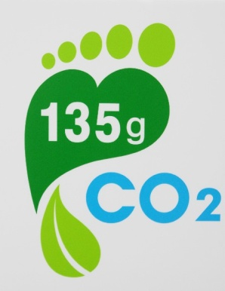
Figure 1 – Carbon footprint label of the EPA (Cabinet-level Environmental Protection Administration), Taiwan
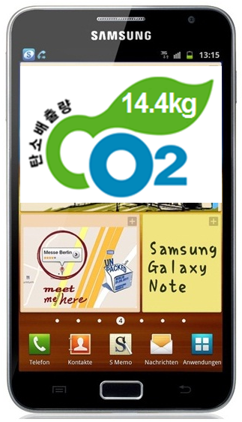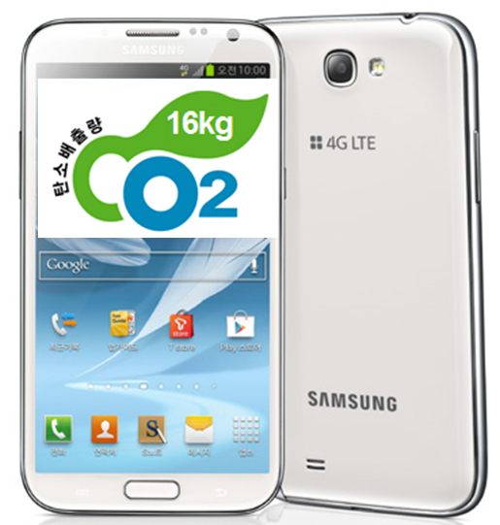
Figure 2 – A carbon footprint label for Galaxy Note and Galaxy Note 2 of Samsung in Korea (for 3-year use)
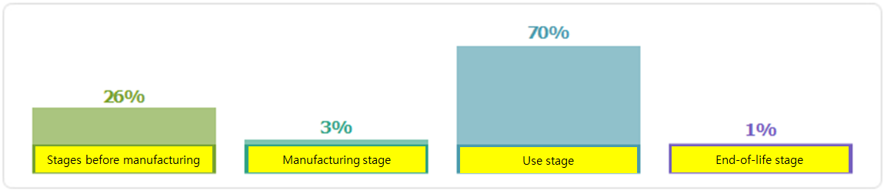
Figure 3 – Portions of environmental loads of Galaxy Note 2 of Samsung (for 3-year use)
Figure 3 indicates that the use stage is the major contributor to the environmental load of Galaxy Note 2.

Brief introduction to ITU-T L.1410 Part II
ITU-T L.1410 Part II aims at providing a methodology to quantify the second order effects produced by use and application of ICT products. The quantification is realized from a comparison viewpoint between “AS-IS” and “TO-BE” concepts, in other words, reference product system and ICT system, baseline scenario and ICT scenario, non-ICT case and ICT case, or old ICT case and new ICT case. It is a general methodology for the second order effects of ICT products and can apply to every use case of ICT in any industry and business sector.

Comparison method
Quantification of green effects of ICT functions for education, learning and training may be conducted by comparison between a use case of ICT functions and a non-use case of ICT functions for the same functionality. That is, two systems for comparison shall have the same functional unit. Figure 4 shows that the goal and scope of both systems shall be the same.
Any green effect such as energy consumption saving and GHG emission reduction are assessed in accordance with an assessment procedure. ITU-T L.1410 Part II specifies details for the assessment procedure through ICT-perspective considerations. It also specifies six green aspects: consumption of goods, energy consumption, movement of people, movement and storage of goods, improved work efficiency and waste.
ITU-T L.1410 Part II defines the following assessment procedure:
- definition of goal, functional unit and scenarios
- definition of system boundaries for each product system
- life cycle inventory including data collection for each product system
- life cycle impact assessment for each product system
- life cycle interpretation including comparison
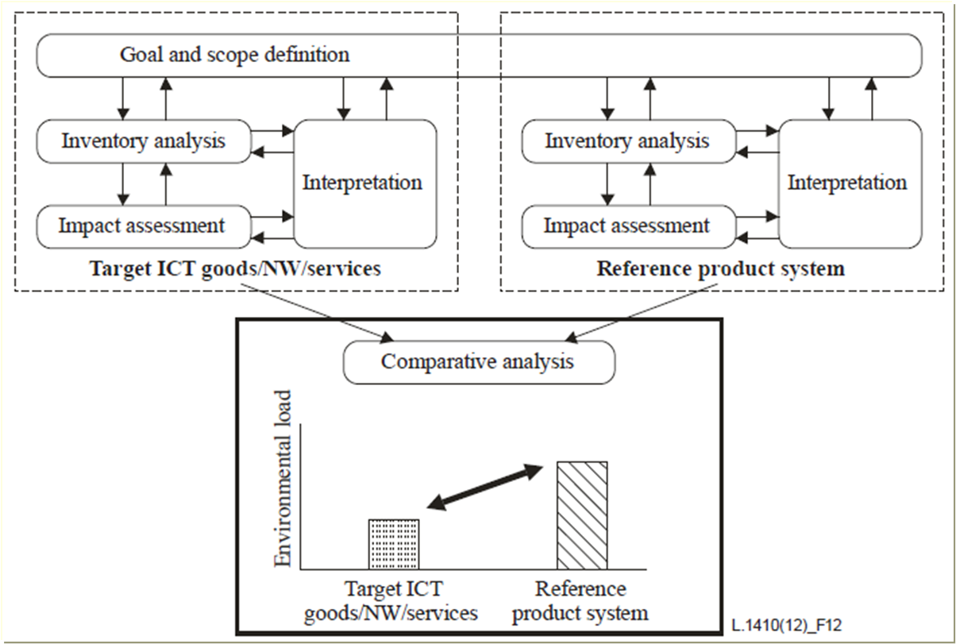
Figure 4 –Comparative assessment of a reference product systemand an ICT product system

Example for electric hand dryer
Figure 5 illustrates the electric hand dryer is compared with the paper towel:
Figure 5 – Example comparison between electric hand dryer and paper towel
The two systems shall have the same functional unit where drying hands may be a functional unit for both systems. The boundary of each system shall be defined and justified. In case of electric hand dryer, its system boundary shall define how much time is taken for drying hands. The system boundary of the paper towel shall define the size of a paper towel taken for drying hands and also decide a paper towel dispenser is included or not. Then technical assessment steps are conducted.

Example for e-education
Figure 6 illustrates a distance learning is compared with a physical learning:
Figure 6 – Example comparison between distance learning and physical learning
A functional unit for both systems may be one hour education for mathematics. The assessment boundary of the distance learning system may be the number of students, their study rooms with lights, lap top computers and involved S/W solutions. The assessment boundary of the physical learning system may be the number of students, transportation of the students, a class room with lights, a blackboard and chalks. Then technical assessment steps are conducted.

_____________________

Ⅱ. Study Item f

Practice guidance for end of life management
(reuse, recycling, e-wastes management, etc.)

1. Target document
- ITU-T L.1100 (02/2012)
- Procedure for recycling rare metals in information and communication technology goods
- ITU-T SG 5
2. Goal
Recommendation ITU-T L.1100 provides information on the recycling procedures of rare metals in information and communication technology (ICT) goods. It also defines a communication format for providing recycling information of rare metals contained in ICT goods.
- General introduction
As arising global awareness on the environmental problems, in the ICT industry, the concern on recycling of the electric and electronic goods is increasing. Recently, it is increasingly emphasized on recycling of rare metals in mobile phones, PCs and other ICT goods, and various researches on recycling methods of rare metals are being promoted.
Rare metals have been called “vitamins of industry” and their importance in industry has been recognized for some time. Recently, ICT industries have become dependent on components that cannot be produced without using rare metals, so that they are becoming “the lifeline of industry”.

- Scope of documentation
ITU-T L.1100 aims to provide a the recycling procedure for rare metals; and, the communication method with example of communication formats that may be used when providing recycling information of rare metals contained in ICT goods -

3. Document skeleton
ITU-T L.1100 consists of the following table of contents:
- Scope
- References
- Definitions
  - Terms defined elsewhere
  - Terms defined in this Recommendation
- Abbreviations and acronyms
- Conventions
- Introduction of rare metals in ICT industries
  - Rare metals in ICT goods
  - The importance of recycling of rare metals
- Recycling procedure of rare metals
  - Production stage
  - Collecting stage
  - Recycling stage
- Communication of recycling information
  - Method to provide recycling information
Appendix I: Rare metal examples of some countries
Appendix II: Example communication formats to provide recycling information

4. Market needs
- Motivation of the development
Considering the insufficient supply on one hand and the increasing demands for rare metals on the other hand, many countries are preparing policies to ensure a stable supply of rare metals such as overseas resource development, recycling promotion, alternative material development, saving rare metals for emergency, export control policy, etc. These countries consider that this stable supply of rare metal materials is significant for maintaining and strengthening the ICT industry’s competitiveness worldwide.
Over tens of millions of ICT goods are annually withdrawn from the market in ICT goods wastes, and recycling rare metals from this ICT goods wastes by urban mining gives huge opportunities to collect expensive rare metals.

- Why it had to be developed
Rare metals have a key role in ICT goods further functionalities developmently, but, amount of rare metals is not sufficient to satisfy the industrial demand. In order to ensure the appropriate provision of rare metals to the ICT industry, recycling of rare metals becomes a crucial objective. Therefore, it is important to estimate which quantity of rare metals is used in each ICT good to the extent this investigation is legally, technically and economically feasible.

- What benefits can be obtained
In case of gold, 5g of gold may be extracted from 1 ton of gold ore. On the other hand, 400g of Gold may be extracted from 1 ton of wasted mobile phones. Also, 200g of silver, 20g of Palladium and some of Copper, Tin, Nickel, Aluminum, Zinc, etc. are included in 1 ton of PCBs of wasted PCs.

5. Related topics
- Competitive, complementary or supplementary references (e.g. standard and relevant practice guidance):
  - ITU-T L.1400 (2011): Overview and general principles of methodologies for assessing the environmental impact of information and communication technologies.
  - IEC 62321(2009): Electrotechnical Products – Determination of levels of six regulated substances (lead, mercury, cadmium, hexavalent chromium, polybrominated biphenyls, polybrominateddiphenyl ethers)
- Any activities working on the same or similar topics:
  - In ITU-T has been developing related activities: “L.rareMetals-measurement (Korea)”, “The case for greater due diligence by the ICT Sector and the need to focus on the environment (Congo)”, “Environment Impact Reduction including E-Waste (Rwanda)”, and “Development of a handbook on life-cycle management of ICT equipment (UNEP)”

_____________________

Rare Metal Measurement in E-Waste
1. Target document
- ITU-T L.1101(03/2014)
- Measurement methods to characterize rare metals in information and communication technology goods
- ITU-T SG 5
2. Goal
Recommendation ITU-T L.1101 Measurement methods to characterize rare metals in information and communication technology (ICT) goods.It also defines a measurement method for providing recycling information of rare metals contained in ICT goods.
- General introduction
The ICT goods are constructed by many parts and modules, which also consist of a combination of major materials (ex. iron, nonferrous metal, plastic, glasses and engineering ceramics) and rare metals being a sort of additive. Compared with the major materials in quantity, the rare metals become depleted depending on the amount of natural reserves as well as the consuming rate. Though the many efforts of excavation of new mines, recycling is regarded as an efficient way of securing the rare metals.
In order to systemize the recycling process, it is important to produce reliable information on the quantity and composition of materials to be recycled, which will be provided to the recycler. There are various methods for measuring and characterizing the rare metals included in commercial products. For providing a unique information of rare metal recycling, however, it is necessary for categorizing or defining the method of measurement depending some factors such as composition, purity, pattern designed, etc. The aspect of accuracy and efficiency of measurement becomes another important factor.

- Scope of documentation
L.1101 explains the measurement methodsfor rare metals contained in Information and Communication Technology (ICT) goods. The measurement method may affect the interpretation of the results. This Recommendation specifies measurement methods to determine types and associated quantities of the rare metals of ICT goods.
3. Document skeleton
ITU-T L.1101consists of the following table of contents:
- Introduction
- Among many efforts for the stable supply of rare metals, recycling is regarded as an efficient way of securing the rare metals. However, there are no standardized measurement methods to define quantities and qualities of rare metals. This contribution is to specifiesmeasurement methods to determinetypes and associated quantities of the rare metals of ICT goods.

- Measurement methods to characterize rare metals
- A common measurement method can facilitate recycling information exchanges between producers and recyclers. Referring to [IEC 62321], this Recommendation recommends XRF and ICP-MS to characterize rare metals for homogeneous and non-homogeneous composition materials. This is because both XRF and ICP-MS can support simultaneous measurement of quantity and quality in appropriate accuracy and ease of use. On the other hand, XRF is for homogeneous composition materials while ICP-MS is for non-homogeneous composition materials.
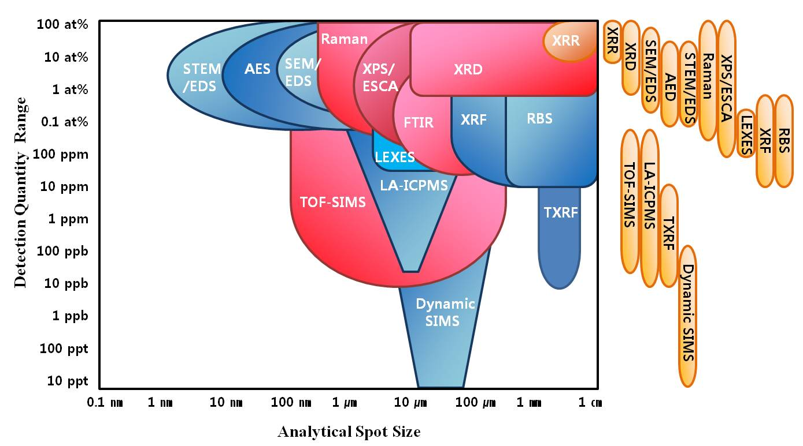

Figure 1 – Analytic resolution diagram of elements measurement systems

4. Market needs
- Motivation of the development
Rare metals are defined as metals which are rare in the earth crust and also are difficult to be extracted from ores. Even though the difficulties in accessibility to natural resources are similar to fossil fuels, requirements of rare metals have increased as theglobal economy grows. Recycling of rare metals from ICT wastes (e-wastes) will save energy consumption as well as natural resources.
- Why it has to be developed
For successful recycling, producers are required to provide detailed information on rare metals to recyclers. The provided information should be accurate for effective recycling. However, many measurement and characterization methods may be used to obtain this information on elements (rare metals). Moreover, each method has its intrinsic advantages and disadvantages for the analysis of these elements. Element separation abilities and quantitative resolutions are divergent in different measurement methods. It definitely needs to develop the rare metal measurement process appropriate for creating and providing the recycling information.

- What benefits can be obtained
The element separation abilities and quantitative resolutions are different according to measurement methods. However, there are no standardized measurement methods to define quantities andqualities of rare metals. This proposal suggested XRF and ICP-MS to understanding quality and quantity.

1) XRF (X-ray fluorescence)
2) ICP-MS (Inductively Coupled Plasma Mass Spectrometry)

XRF and ICP-MS measurement methods were analyzed to analysis qualitative and quantitative of unknown sample and harmful material from being used as a verification method in IEC 62321.

5. Related topics
- Competitive, complementary or supplementary references (e.g. standard and relevant practice guidance):
  - IEC 62321(2009): IEC 62321 ed1.0:2008, Electro technical Products –Determination of levels of six regulatedsubstances(lead, mercury, cadmium, hexavalent chromium, polybrominated biphenyls,polybrominateddiphenyl ethers).
  - ITU-T L.1100 (2011): A method to provide recycling information of rare metals in ICT product
  - ITU-T L.1101(2014):Measurement methods to characterize rare metals in information and communication technology goods
- Any activities working on the same or similar topics:
  - In ITU-T has been developing related activities: “Proposal for a new work item on a printinglabel format to provide rare metals information of ICT goods (C229,Korea)”,

_____________________

Activities on ITU-T for rare metal & e-waste

1. Target document
- ASTAP-23 INP-58: “Report of the Industry workshop on Rare Metal and e-waste related Issues”, 3-7 March 2014, Pattaya ThailandITU-T SG 5
- ITU-T Q13/5 TD0580: “Report of Question 13/5”, SG5 Meeting, 19-23May 2014, Geneva.
2. Goal
This contribution is introduced to share thecurrent activities of ITU-T on e-waste management and rare metal recycling managements and conflict minerals as well.Therefore, it is intended not only to promote information exchange on comparatively new issues on rare metal, e-waste and conflict minerals but also to increase possible involvement from industries in this APT region
- General introduction
The generation of rare metal, electronic waste (e-waste) and conflict minerals are becoming the main issue.The e-waste contains valuable precious metals (such as copper, silver, and rare metals). Disposal of e-waste raises serious environmental and health issues. Recycling the e-waste is one of viable solution to eliminate the harmful effects. To recycle e-waste,the elementsinformation contained in e-waste, rare metals and conflict minerals are required
Conflict minerals (in particular those that are smelted into tin, tantalum, tungsten and gold) are mineral resources produced illegally in the Democratic Republic of the Congo and neighboring countries.The metals described above are key components in many ICT products and in some cases the ICT industry is the largest consumer of these products. These mineral resources have become a global issue, because they are a source of funding for armed groups and fuel conflicts and violations of human rights.

- Scope of documentation
This Recommendation specifies to share the current activates of ITU-T on e-waste management, rare metals recycling managements and conflict minerals
3. Document skeleton
This contribution consists of the following table of contents:
- Introduction
- As one of the agenda of ASTAP-23 meeting, the 5thindustry workshop was held on the subject of rare metals and e-waste related issues on March 3-7, 2014at Pattaya, Thailand. At this workshop,5 experts from Korea, Thailand and Malaysia presented their strategies, R&D trend and recycling of rare metal and e-waste and got positive support from ASTAP members. Additionally, they were requested to exchange and share the information and continue to study for the development of rare metal & e-waste industry.

- Updated on ITU-T activities for Rare Metals &E-waste& Conflict minerals 4. Market needs
- Regarding rare metals, Korea proposed L.raremetal.labelformat, which is to describe the requirements of ITU-T L.1100 and ITU-T L.1101. this work will be summarized briefly to the QR code as the communication method among manufacturers, consumers and recyclers.
- Regarding e-waste, Rwanda proposed “Rwanda policy development on e-waste management (C222)”.Considering the contribution from Rwanda on case study on e-waste management policy development, and also basing to the challenges developing countries are facing, it is proposed that all African countries who are member of ITU are encouraged to contribute on current status on e-waste management and share the best practices on how e-wate
- Regarding Conflict minerals, Congo proposed“Conflict Minerals for supply chains of minerals from conflict areas (C221, Congo)” This contribution is part of the requirement to produce the Technical Paper on Conflict Minerals already in progress. This document aims at defining the guidelines to be followed when handling conflict minerals used in ICT and the environmental compliance. ETRI proposed “Implementation guidelines for ICT supply chain due diligence on conflict minerals(C258, ETRI)” and “Rationale for a new work item on Due Diligence System for Compliance to Conflict Mineral Regulation (C257,ETRI)” were proposed. It is proposed to establish a new work item on a conflict minerals system for compliance to conflict mineral regulation.
- Motivation of the development
The ICT industry is potentially facing a shortage of key minerals. While greater recycling efforts will be part of the solution, the ability to use all current sources are complicated due to the lack of formalizeddue diligence guidelines that would allow for the use of sources of certain minerals whose origins occur in so called ‘conflict zones (e.g. Democratic Republic of Congo)’.
- Why it has to be developed
With the arising global awareness on the environmental problems in the ICT industry, the concern on recycling of the electric and electronic goods has been increasing. Recently, it is getting more emphasizing recycling of rare metals in ICT goods and e-waste management various researches on recycling methods of rare metals are being promoted. In addition, Conflict minerals are a source of funding for armed groups and fuel conflicts and violations of human rights.

- What benefits can be obtained
It would help to let ITU-T members elevate the awareness of how serious this matter is and ask them their active participation.It would be required to share these kinds of activities and come up with good solutions to secure their supply in ASTAP.
5. Related topics
- Competitive, complementary or supplementary references (e.g. standard and relevant practice guidance):
  - ITU-T Q13/5 TD0531: “Proposal for a new work item on a printing label format to provide rare metals information of ICT goods”, SG5 Meeting, 19-23May 2014, Geneva.
  - ITU-T Q13/5 C222: “Case study: Rwanda policy development on e-waste management”, SG5 Meeting, 19-23May 2014, Geneva
  - ITU-T Q13/5 TD0560: “Feedback request for ICT Conflict Minerals Guideline for Responsible Supply Chains of Minerals from Conflict-Affected and High Risk Regions.”, SG5 Meeting, 19-23May 2014, Geneva
  - ITU-T Q13/5 TD0551: “Proposal for a new work item on ITU-T Technical Paper on “Implementation guidelines for ICT supply chains Conflict Minerals on conflict minerals”, SG5 Meeting, 19-23May 2014, Geneva
____________________

Ⅲ. Study Item p

Power adapter and charger for hand held devices such as cell phones

(Update the international standardization work on power supply for ICT devices)

1. Target document
Study item - Power adapter and charger for hand held devices such as cell phones
Source of document - ITU-T SG5, IEC TC 100, IEEE UPAMD

2. Goal

According to the result of ICT&CCWG meeting of the 20th ASTAP held in Bangkok, Thailand, 30July ~ 1 August 2012, it was welcomed and supported to lead the future study work of WG-ICT&CC on 26 items which include “power adapter and charger for hand-held devices such as cell phones” and the meeting appointed Mr. Munhwan Han, KTC, Korea, and Mr. ArtprechaRugsachart, NBTC, Thailand, as Rapporteurs to lead this study after ASTAP20/INP-54 (Introduction to power supply standardization for ICT) and ASTAP20/INP-94 (Summary of Recommendation ITU-T L.1000 universal power adapter and charger solution for mobile terminals and other hand-held ICT devices) were introduced.

Korea would like to update the status of standardization work on power supply for ICT devices in ITU-T and IEC TC 100 to share the information and to lead this study item in ICT&CC WG.

ITU-T SG5 WP3

Q.13 (Environmental impact reduction including e-waste, former Q.21)

At 2012 October meeting WP3/5 received two contributions T09-SG05-C-0516 and T09-SG05-C-0517 related to beginning work on an ITU-T Recommendation on Universal Power Adapter (UPA) for non-stationary (e.g. laptops …) use. ITU-T recognizedthat close collaboration is required among IEC PT 62700,IEEE P1823™/D201208290000 and hope to avoid any duplication in standards. Accordingly ITU-Thoped to receive updates before progressing work, in particular the scope (devices covered) of IEC and IEEE standards and informedIEC and IEEE that ITU-T have Consented L.1001 “External universal power adapter solutions for stationary use”.

During this year ITU-T SG5 meeting held from 29 January to 7 February 2013, following contributions are introduced and discussed for universal power supply adapter for portable use (L.UPA Portable).

L.UPA Portable

The proposal on the draft of universal power adapter solution (UPA) for portable ICT devices(Ministry of Industry and Information Technology - MIIT)

This contribution reported several proposals towards the draft of L.UPA portable, in particular concerning scope, basic configuration (setting four different types), voltage/current definitions (for each of the four different types), output DC plug and connectors, energy efficiency requirements (to be aligned with Energy Star), touch current requirement.Concerning safety, EMC and resistibility requirements, as well as Eco-environmental specifications, it was proposed to refer to the recommendation ITU-T L.1000, L.1001 and the relevant international standards. The contribution ended highlighting that a universal power adapter solution can provide a great benefit for the environment and end users worldwide.

Discussion: some participants expressed the need for analyzing the portability of the adapter itself. Moreover, some participants denied that products of the same manufacturer always have the same voltage. It was also stated that typically the portable devices can accept a wide range of voltages. 5V output DC plug with USB Micro-B plug could be outside the scope of L.UPA. Finally, the participants agreed on the need to further analyze the issue of the touch current.

Early draft for L.UPA portable (France Télécom Orange)

This document, containing the early draft for L.UPA portable, was presented

Discussion: it was requested to check whether the percentage reported in the introduction actually refers to portable or rather to all kind of devices. Some editing in the scope section has been made. The sentence on e-bike chargers has been deleted. Some participants expressed concerns that UPAMD could be too complex and therefore not suitable for low range products (for cost reasons). More in general, it was decided to take further time and to move to the Rapporteur meeting in May the key decision on whether describing L.UPA as single solution for a wide voltage range or rather to foreseeing in a first step different categories with different voltage/current values and only in a second step a universal solution. In the meantime, answers from EC TC 100 and IEEE Project 1823could help in driving the decision.

Comments on L.UPA portable (United States)

This contribution briefly summarized the outcome of previous meetings and reported the United States’ proposal to develop the recommendation for L.UPA portable from the ground up and deriving it from the power requirements of portable devices, assuming that such devices have unique characteristics that L.UPA portable will need to accommodate (e.g. common mode noise and voltage). The United States were concerned that the recommendation will harm design innovation and “green” innovation and will undermine the ITU’s goal of promoting “green” solutions. Finally, the request to align L.UPA with IEEE P1823 for universal power adapters and IEC PT 62700 was reported.

Discussion: the participants agreed that L.UPA can not have the same parameters of L.1001. A first discussion concerning whether starting the Recommendation from scratch or rather from the proposal (C51) sent by Orange for the Geneva meeting was made. The participants recognized the need for a Liaison Rapporteur for SG5 towards IEEE and IEC who should prepare a liaison on Collaboration with IEC TC 100 and IEEE Project 1823.

IEC TC 100 TA 14

PT (Project Team) 62700 (DC Power Supply for Portable Personal Computer)

Scope:To prepare draft International Standards for specifications on DC power supply used for portable personal computer. It includes general requirement and performance requirement.

Project team 62700 expert members including major PC manufactures have continued to have face to face meeting and electronic discussion to prepare good and right standard for notebook power supply and continues to discuss e-waste and resolution of technical challenges in order to move forward. Last year PT 62700 meeting decided to develop Technical Specification instead International Standard because remaining issues and required considerations are difficult to reach consensus in national members within program work time period.
PT 62700 have prepared technical specification document that specifies the minimum requirements such as electricalspecification (performance characteristics), ID pin method and connector for DC power output. Product safety and EMC requirements are also covered and the relevant references are included in order to ensure a minimum level of performance and user protection. And followings are considering aspects in project team 62700 to respect industry side.

-Technical Innovation / Advancement of technologies for PC system
Innovative technologies are actively under development to improve power efficiency of PC systems. IEC work should support continuing innovation

-Product development cost and maintenance cost
There may be Increase in implementation and support cost. Publication of International Standard should be carefully considered.

-Feasibility for the reduction of the resource and e-waste
Shipment of PC main body with AC adapter will be continued to meet regulatory and other market requirements.

-Risk in system reliability, Risk for consumers
Connection between PC and 3rd party AC adapter may cause unexpected problems and unknown business liability issues. Performance reliability and safety for consumers is important.

-Exploration and Resolution of Technical Challenges
Issues in safety and EMC are being addressed. Additionally relevant electro-mechanical characteristic issues have been identified and require further exploration.

IEEE UPAMD P1823

Specifically the project scope is:

“The Universal Power Adapter for Mobile Devices (UPAMD) standard defines a power delivery connection between a power adapter and a power using device greater than 10 W and up to, but less than 240 W. A communications link between the power adapter and the mobile power using device is also defined. The communications may be used to coordinate the power delivery and provide identification between the power adapter and the power using device. While intended for portable computing and entertainment devices, power adapters conforming to this standard may also be used with other devices.”
The “other devices” use is quite open to the many powered devices used around the home, office, or industry. We fit within the DOE (US Department of Energy) EPS (External Power Supply) classification.
This standard can also provide power for lower power, <20Watts, non-communicating, MUTE, devices. This includes items such as LED desk lamps and other desktop appliances.

3. Document skeleton

To lead “Power adapter and charger for hand held devices such as cell phones”, this section will be prepared by rapporteurs and study group in ICT&CC WG.

4. Market needs
Different types of power supplies and adapters for ICT devices on the market cause many inconveniences to consumers. There are requests from mass media such as newspapers to standardize these ICT adapters.The major complaints and opinions from consumers are inconveniences due to lack of interoperability, economic burdens from redundant purchase, environmental problem due to electronic wastes.Furthermore energy efficient universal adapter is needed to prevent global warming.

5. Related topics
Following activities are under progress at each standard development organization.
- ITU-T SG5 WP 3 Q.13 - L.UPA portable
- IEC TC 100 TA 14 PT 62700 - DC Power Supply for Portable Personal Computer
- IEEE UPAMD - The Universal Power Adapter for Mobile Devices (UPAMDTM)

Practice guidance for DC power supply for notebook computer

1. Target document
- DTS IEC 62700
- DC Power supply for notebook computer
- IEC TC 100

2. Goal
- General introduction
AC adapters are typically shared between many generations of OEM notebook computers, but for technical reasons have not generally been designed to interoperate with other brands of notebook computers. Thus there are many different types of notebook adapters on the market which may cause some inconvenience to consumers and potentially leading to e-waste.
On the other hand, hundreds of millions of notebook computers are shipped every year. A wide range of notebook computers are being shipped to meet unique customer requirements and specific purpose. Each AC adapter is tuned and designed to optimally satisfy the requirements and specifications of the notebook computer. Combinations of AC adapter and Computer are tested and guaranteed by the OEM. Arbitrary combinations of AC adapter and Computer are known to present functional or regulatory issues and failing combinations of these have been rejected by the OEM and not provided to the consumer.
DTS IEC 62700 is a technical specification for design considerations in implementing a common DC power supply for notebook computers. Such a common DC power supply is intended to address the concerns arising from lack of interoperability while maintaining the high standard of safety, compliance and performance expected by users of notebook computers.

- Scope of documentation
DTS IEC 62700 is a Technical Specification for a DC power supply for notebook
computer andspecifies the minimum requirements:
- electrical specification (performance characteristics)
- ID pin method
- connector forDC power output

3. Document skeleton

1. Scope
2. Normative references
3. Definitions
4. Electrical Specification (performance characteristics)
4.1 AC input rating
4.2 Inrush current
4.3 DC output load condition and voltage regulation
4.4 DC output ripple and noise
4.5 Output transient response and capacitor load
4.6 Power supply timing
4.6.1 Turn on delay time
4.6.2 Hold-up time
4.6.3 Rising time of output voltage
4.7 Protection
4.7.1 Over current protection
4.7.2 Short circuit protection
4.8 Over shoot
4.9 Customized specifications

5. DC power supply identification and communication method for Notebook computer (Informative)

6. Connectors for DC power supply for Notebook computer
6.1 General
6.2 Specification for DC Connector
6.3 Shape and dimension of DC connector
6.4 Voltage Polarity and Electrical Specification of DC Connector
6.5 Cable qualities
6.5.1 General
6.5.2 Special considerations for an AC adapter with replaceable cable

Annex A (informative) Summary of discussion in Project Team 62700
Annex B (informative) Ad-hoc activities
B.1 Measured Data for the Limited Combination between AC adapter and Notebook Computers
Annex C (informative) (informative) Areas of Consideration on AC adapter used with Notebook Computers
C.1 Safety
C.2 EMC
C.3 Future trends in connectivity and power delivery
Annex D (informative) Expected Issues when any Adapter is connected to any Host PC
D.1 Safety issues
D.2 EMC issues
D.3 Environment issues
D.4 Reliability and quality issues
D.5 Standards issues
D.6 Other issues
Annex E (informative) Electrical Specification
E.1 DC output load condition and voltage regulation
E.2 Over current protection
Annex F (informative) 2013 Korean Industrial Standard AC adapter
F.1 General
F.2 DC output load condition
F.3 Shape and dimension of DC connector

Bibliography

4. Market needs
- Motivation of the development
Together withrecent environmental challenges and climate change, the issue ofpower supply for ICT devices is getting more and more important.
In particular, it is important to develop basic requirements and design principles that facilitate the reduced use of energy and the minimized use of hazardous material for making ICTdevices such as mobile phones and routers.

- Why it had to be developed
About 30 different types of notebook adapters on the market cause many inconveniences to
consumers. There are strong requests from mass media such as newspapers to standardize thesenotebook adapters. The major complaints and opinions from consumers are inconveniences due tolack of interoperability, economic burdens from redundant purchase, environmental problem due toelectronic wastes. Furthermore, energy efficient universal adapter is needed to prevent global warming.

- What benefits can be obtained
Standardizing the methods of external power supplies forvarious ICT devices and equipmentsis important for users as well as vendors and service providers; and recentlythere are many on-going standardization activities in this field

5. Related topics
- Following activities are under progress at each standard development organization.
- ITU-T SG5 WP 3 Q.13 - L.UPA portable
- Under progress
- IEC TC 100 TA 14 PT 62700 - DC Power Supply for Portable Personal Computer
- Circulated the Draft Technical Specification(DTS) IEC 62700
- IEEE UPAMD - The Universal Power Adapter for Mobile Devices (UPAMDTM)
- Under progress

_____________________

Introduction of Korean notebook adapter standard and compatibility study plan

1. Target document
- DTS IEC 62700
- DC Power supply for notebook computer
- IEC TC 100
- KS C 4319

2. Goal
- Sharing updated information of international standardization activities in power supply for ICT devices and Korea standard KS C 4319 for notebook DC power supply.
- Introduce future plan to study the compatibility between notebooks and DC power supply by testing and research at the point of safety.

3. Document skeleton
Standard KS C 4319 – power supply for notebook computer
1) General
Index | Rated DC output power | Rated DC Output voltage | Rated DC Output  current | DC output  Plug diameter
Types | 40 W (± 5 W) | 19V | 1.84 ~ 2.36 A | 3 mm (barrel)
 | 65 W (± 5 W) | 19V | 3.16 ~ 3.73 A | 3 mm (barrel)

2) Structure
Structure specifies DC output connector, DC Output Jack and Device for the limitation of output power.

3) Safety requirement
DC power supply for the notebook computer shall be tested according to and fulfil the requirements of KS C IEC 60950-1.

4) Performance requirements
This requirements consist of AC Input Rating, Inrush Current, Efficiency, DC output voltage regulation, DC output load condition, DC output ripple and noise, Output transient response and Capacitor load, Power supply timing, Protection, Over shoot and No load operation.

5) EMC requirements
DC power supply for thenotebook computer shall be tested according to and fulfil the requirements of KS C IEC CISPR 22 and KS C IEC CISPR 24.

6) Method for identification of product name
Information of DC power supply for notebook such as model name, manufacture date, factory, electrical specification and contact phone number.

Compatibility study plan in Korea
1) 40W DC power supply with 65W notebooks
2) 65W DC power supply with 40W notebooks
3) Standard charger with old model notebooks
4) Non-approved charger with old model notebooks
5) Non-approved charger with new model notebooks
6) IEC TS 62700 Annex
7) ITU-T L.1002
8) Expected consumer`s mismatching between notebook and DC power supply

4. Market needs
- Uiversal power adapter solution for portable ICT devices
- Common charger for various portable notebook
- Convenient to reuse for consumers
- Reduce the e-waste and increase the usability

5. Related topics

Draft new Recommendation ITU-T L.1002 (ex L.UPA portable)

This Recommendation defines the requirements for a universal power adapter solution (UPA) designed for portable ICT devices. It is complementary to [ITU-T L.1000] and [ITU-T L.1001] and aims to cover the widest possible range of ICT devices for portable use within the defined voltage and power ranges. It firstly describes the UPA basic configuration, consisting of a power adapter block with a detachable input cable and a detachable output cable to the ICT device. Then, different general requirements for the UPA and their interfaces, including cables, connectors, voltage, current, ripple noise, energy efficiency, no load power, safety, electromagnetic compatibility, resistibility and eco-environmental specifications are defined. All the requirements have been set with the aim to reduce the e-waste and increase the usability. This Recommendation intends to complement and to make use, as far as possible, of what defined in IEC/Technical Specification 62700/Ed1.

The current status of the draft is “Last Call” and it will become L.1002 Recommendation in 2014.

IEC TC 100 TS 62700– DC power supply for notebook computers

The objective of a common DC power supply is to support global interoperability of adapters for a specific range of notebook computers. This technical specification describes design considerations for the common adapters and identifies technical areas that require further development for interoperability with existing notebook computer technologies.
This technical specification states the minimum requirements for DC power supply for notebook computers. Specifically it gives electrical specification (performance characteristics), ID pin method and connector for DC power output.

IEC TC 100 TA 14 submitted final draft and IEC 62700/TS Ed.1 will be published in 2014.

IEEE UPAMD/P1823 - Universal Power Adapter for Mobile Devices
The Universal Power Adapter for Mobile Devices (UPAMDTM) standard defines a power delivery connection between a power adapter and a power using device in the 10 Watt to <240 Watt range. A communications link between the power adapter and the mobile power using device is also defined. The communications may be used to coordinate the power delivery and provide identification between the power adapter and the power using device. While intended for portable computing and entertainment devices, this standard may also be used with other mobile devices in use around the office, home or vehicle.
There is no updated information at official website since August 2012.

introduction of comMon mobile adapter regulatory/standards environment summary
and current status of notebook charger standardization
1. Target document
- Common mobile adapterregulatory/standards environment summary
- IEC TS 62700
- KS C 4319
- ITU-T universal adapter recommendations
- IEEE Universal Power Adapter for Mobile Devices (UPAMD)
- USB related specifications

2. Goal
- To sharethe summary of common mobile adapter regulatory/standards environment and current status of notebook charger standardization.
- To update “Guidance for green ICT standards.

3. Document skeleton

1) Common mobile adapter regulatory/standards environment summary

•2001/2007rev (TTAS.KO-06.0028/R4): Korean Telecommunications Technology Association (TTA) voluntary standard for mobile device interfaces (USB 2.0, 20pin connector)
•2006/2009 rev (YD/T 1591): China MIIT, CCSA national standard for mobile phone charging; 2007 June: MIIT mandates USB battery charging interface on new smartphones (USB 2.0, USB connectors)
•Future regulations for public network access approval - expansion to other mobile devices under
consideration (tablets etc.)

•2007: OMTP common charging technical specifications (micro-USB). 2009: GSMA Universal Charging Solution standard
•2009 June: EC/Industry MoU “Harmonisation of a Charging Capability for Mobile Phones”, compliance for new devices from 2011 for EU market (USB 2.0/micro-B). MoU expiration 2012 end.
•2009 Oct (M/455 EN): EC standardization mandate to CEN, CENELEC and ETSI on common charging capability for smart mobile phones (USB 2.0/micro-B)
→ •EN 62684 (2010 Dec) IEC 62684 (2011 Jan)

•2013: EU parliament proposed amendment directives on radio equipment; 2014 Mar approved revision on R&TTE directive for EC to consider common charger development of other mobile devices beyond smartphones
• After EC approval process completion, member states will have 2 yrs for national law transposition,
followed by additional year for industry compliance

•2014 Mar: leading smartphone manufacturers sign LOI for continuing 2009 EC MoU support and stated intention to work towards harmonization of a charging capability for future generations of mobile phones through international/EU standards efforts, avoiding unnecessary regulations

•ITU-T universal adapter recommendations
•2011: L.1000 universal adapter mobile terminals and other ICT devices (mobile phone focus)
•In progress: L.1002 – universal adapter for portable devices (notebooks, tablets etc.)
•Country regulatory references to L.100x series (Brazil etc.)

•IEEE Universal Power Adapter for Mobile Devices (UPAMD)
•Under development: proposed standard for charging between 10 W and 240 W. e.g. Laptop PCs,
larger tablets and other mobile

•USB related specifications
•2012: USB power delivery spec (up to 60W for micro-USB connectors, up to 100W for USB A/B
connectors)
•2014 mid-year: USB Type-C connector (reversible, scalable power charging support etc.)

2) Current status of notebook charger standardization

•2014 Feb: IEC 62700 - technical specification DC Power supply for notebook computer

IEC/TS 62700, which was published in February 2014, includes areas to be considered and issues to be discussed on AC adapter in Annex of the Technical Specification. The areas and issues should be considered on the basis of an analysis in business environment and technical innovation trends.
At the IEC TC100 meeting which was held on 19th May 2014 in Seattle USA, the establishment of the maintenance team on IEC/TS 62700 was approved to keep up with technical progress and consider the revision of the Technical Specification. IECTC100 sets up the maintenance team of IEC 62700 and Mr. Munhwan Han (KR) was assigned as the project leader of the maintenance team.
IEC TC 100 also discussed to start a brand new project focus on industry supported technologies for example USB-IF PD and Identification/communication method for LOW and medium power category computing.
The objective for future IEC standard work will be to complete development of the technical specifications which incorporates considerations for consumer safety, product reliability, system performance, regulatory compliance and technical innovations.

•2014: Korean National Standard laptop (KS C 4319); D.C. Power Supply for Notebook Computer

KS C 4319, DC power supply for notebook computer will be enforced from 15th of December 2014 in Korea.

Index | Rated DC output power | Rated DC Output voltage | Rated DC Output  current | DC output  Plug diameter
Types | 40 W (± 5 W) | 19V | 1.84 ~ 2.36 A | 3 mm (barrel)
 | 65 W (± 5 W) | 19V | 3.16 ~ 3.73 A | 3 mm (barrel)

KS C 4319 will be updated to have high level performance requirement on adapter (DC power supply) such as temperature limit and touch current to ensure safety for notebook computer user.
Korea experts from PC industry, power supply, regulations, safety engineers concludedthe test method to check compatibility between standard adapter and various notebooks at the point of safety and the results will be the input for update and amendment of KS C 4319 in future.

4. Market needs
- Universal power adapter solution for portable ICT devices
- Common charger for various ICT devices include portable notebook
- Convenient to reuse for consumers
- Reduce the e-waste and increase the usability

5. Related topics

•ITU-T universal adapter recommendations
•2011: L.1000 universal adapter mobile terminals and other ICT devices (mobile phone focus)
•In progress: L.1002 – universal adapter for portable devices (notebooks, tablets etc.)
•Country regulatory references to L.100x series (Brazil etc.)

•IEEE Universal Power Adapter for Mobile Devices (UPAMD)
•Under development: proposed standard for charging between 10 W and 240 W. e.g. Laptop PCs,
larger tablets and other mobile

•USB related specifications
•2012: USB power delivery spec (up to 60W for micro-USB connectors, up to 100W for USB A/B
connectors)
•2014 mid-year: USB Type-C connector (reversible, scalable power charging support etc.)

•2014 Feb: IEC 62700 - technical specification DC Power supply for notebook computer
•2014: Korean National Standard laptop (KS C 4319); D.C. Power Supply for Notebook Computer

