APT REPORT ON

FIELD TRIAL OF WIRELESS ACCESS WDM-PON DEPLOYMENT BASED ON RADIO OVER FIBER TECHNOLOGY

Edition: June 2019

The 31st APT Standardization Program Forum (ASTAP-31)
11 – 15 June 2019
Tokyo, Japan

(Source: ASTAP-31/OUT-08)

No. APT/ASTAP/REPT-36

Table of Contents
1. Introduction 2
2. Scope 2
3. References 2
4. Abbreviations and acronyms 2
5. System Architecture 3
5.1 Overview 3
5.2 Approach & Research Methodology 5
6. System demonstration and discussion 8
6.1 OLT and RAU configuration 8
6.2 System on trial 10
7. Conclusion 12

Introduction
The aim of this contribution is to propose technical guidance, system design and configuration for field trial of wireless access WDM-PON deployment using Radio over Fiber (RoF) technology.

Scope
This Report provides the system design and configuration for wireless access WDM-PON field trial codenamed Green Collaboration on Optical Radio Network (GCORN) which is based on Radio over Fiber (RoF) technology. The whole design was contributed by TM, TM R&D and FibreHome (FH) in order to do field trial for Point to Multipoint (PtmP) wireless UniFi service distribution with Wavelength Division Multiplexing Passive Optical Network (WDN PON) system.

References
[APT/ASTAP/REPT-03(Rev.4)]: APT Report (2015), Characteristics and requirement of optical and electrical components for millimeter-wave Radio on Fiber systems
[APT/ASTAP/REPT-04]: APT Report (2011), Technology trends of telecommunications above 100 GHz
[APT/ASTAP/REPT-11]: APT Report (2013), Wired and wireless seamless connections using millimeter-wave Radio over Fiber technology for resilient access networks
[APT/ASTAP/REPT-19]: APT Report (2015), Integration of Radio over Fiber with WDM PON for seamless access communication system
[APT/ASTAP/REPT-20]: APT Report (2015), RoF relay link for indoor communication systems
[APT/ASTAP/REPT-25]: APT Report (2017) Fronthaul/backhaul using millimeter-wave radio over fiber technologies
[APT/ASTAP/REPT-26]: APT Report (2017) Multiservice signal transmission using radio over fiber technology
[ITU-T G. Suppl.55]: ITU-T G-series Supplement RoF on Radio-over-fiber (RoF) technologies and their applications
[ITU-T G.RoF] : Draft new Recommendation ITU-T G.RoF, Radio over fiber systems.

Abbreviations and acronyms
This Report uses the following abbreviations and acronyms:

CS Central station
DEMUX De-multiplexer
DWDM Dense wavelength-division multiplexing
EDFA Erbium-doped fiber amplifier
E/O Electrical-to-optical converter
FDC Fiber distribution cabinet
MUX Multiplexer
ODF Optical distribution frame
ODN Optical distribution network
ODU Outdoor unit
O/E Optical-to-electrical converter
PON Passive optical network
RoF Radio over fiber
RAU Remote antenna unit
SMF Single-mode optical fiber
WDM Wavelength division multiplexing

System Architecture

5.1 Overview
This system is a complementary to the FTTH deployment in Telekom Malaysia. Fig. 1 shows the block diagram for the Radio over Fiber (RoF) system compared with legacy FTTH.

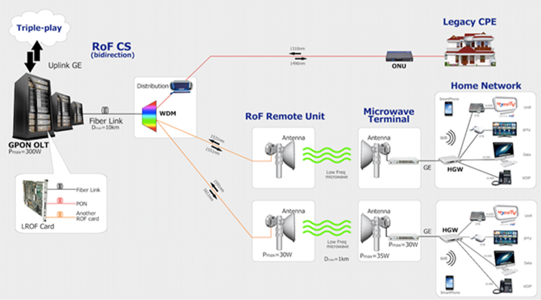

Fig. 1: System topology RoF Point to Multipoint 16/14GHz RoF WDM PON System

In some areas, fiber installation directly to the customer premise consumes higher installation cost due to challenging civil work and local authority regulation. This is called ‘non-standard’ installation. As a result, there are several important customers that cannot be served due to these issues. Fig. 2 shows this “non-standard” installation which need use the drop fiber to connect fiber to customer premise.

Fig. 2: “Non-standard” FTTH installation to the customer premise

In addition, there are also FTTH areas that have high Customer Trouble Ticket (CTT), which is due to the fiber drop cable, as reported by TM Operation and Maintenance group as reported in Fig. 3.
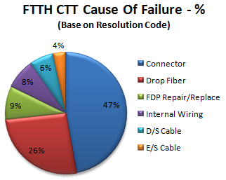

Fig. 3: FTTH CTT Cause of Failure

The objectives of this project are as follows:

- To deploy RoF-based WDM-PON wireless access with point to multipoint topology.
- To study capability, stability, capacity and practicality of the system.
- To demonstrate triple play services using RoF PON system in real field.

By deploying a wireless broadband service using RoF as the backbone of the transmission, TM would be able to deploy FTTH services in “non-standard” areas by eliminating drop fiber installation and introducing wireless transmission directly to customer premise. This as well will reduce CTT caused by drop fiber issues in standard FTTH deployment.

  - Approach & Research Methodology
Previously the RoF research was established using the P2P approach with collaboration between TM and one of the vendors.

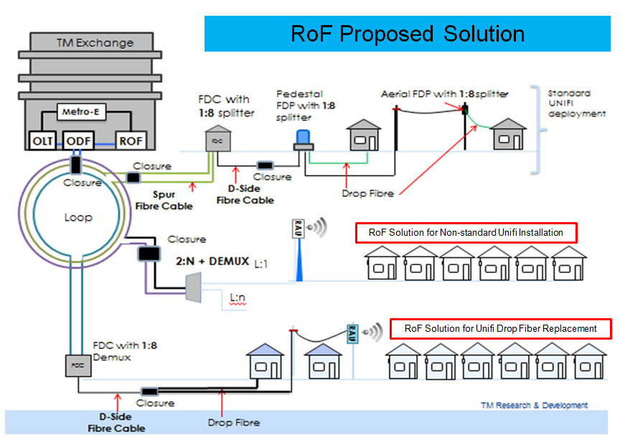

Fig. 4: RoF Infra solution

Fig. 5: Point to Multi Point RoF WDM-PON system

The results of this activity are documented in our Green Fiber Wireless (G-FiWi) final technical report. The majority of the study concentrated on Proof of concept (PoC) measurements on RoF P2P and also Network Efficiency and Power Consumption study. Fig. 4 and 5 shows the new RoF WDM-PON System as complimentary solution to the “non standard” UniFi installation which is focusing on the result for improvement RoF from P2P to PtmP.

Two location has been recognize for this trail:

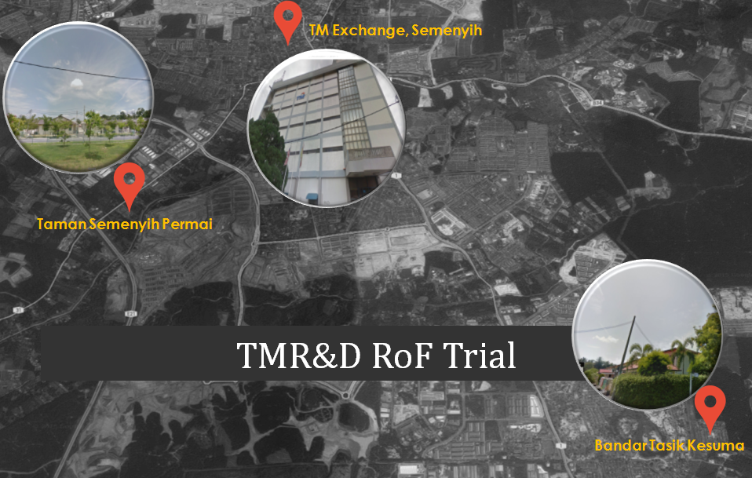

Fig. 6: Locations of deployment
SITE NO 1 | Location | Bandar Tasik Kesuma
 | TM ID | BTK
SITE NO 2 | Location | Taman Semenyih Permai
 | TM ID | TSP

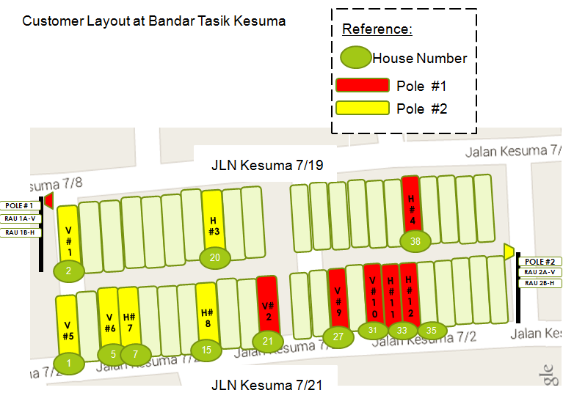
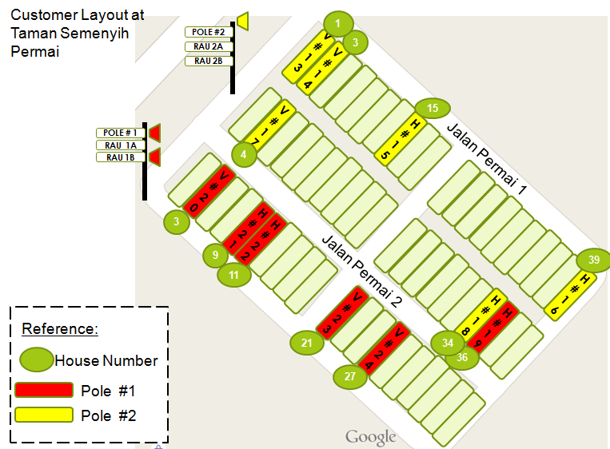

Fig. 7: Actual residential sites layout

System demonstration and discussion

6.1 OLT and RAU configuration

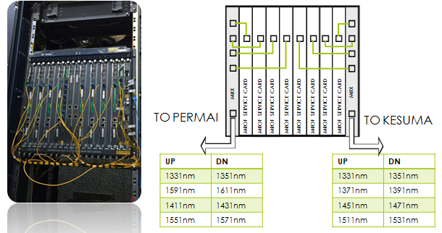

Fig. 8: OLT Layout diagram (Actual)

From Fig. 8, the following below is the detail about OLT card:
    - System designed based on WDM PON system architecture
    - Dedicated wavelength to single RAU.
    - Four wavelengths for Up stream and four wavelengths for down stream in single core fiber.
    - Up to 10km fiber distance between OLT to RAU including mux and de-mux at Fiber Distribution Cabinet (FDC).

For the RAU, placement is crucial to ensure that the wireless signal coverage can reach the designated customer premise. Since the system requires line-of-sight, RAU is designed to be located at the highest point which is visibly unblocked to the ODU. In this chapter we proposed 2 options for RAU placement at the residential areas as shown in Fig. 9 and 10:

- RAU placement at the residential area with pole in the center.
- RAU placement at the residential area with pole at the road side.

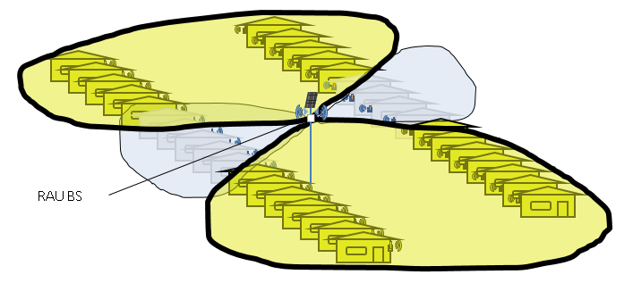

Fig. 9: Option 1: RAU placement at the residential area with pole in the center.

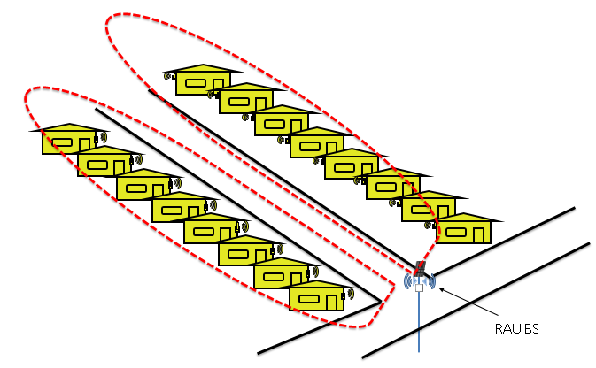

Fig. 10: Option 2: RAU placement at the residential area with pole at the road side.

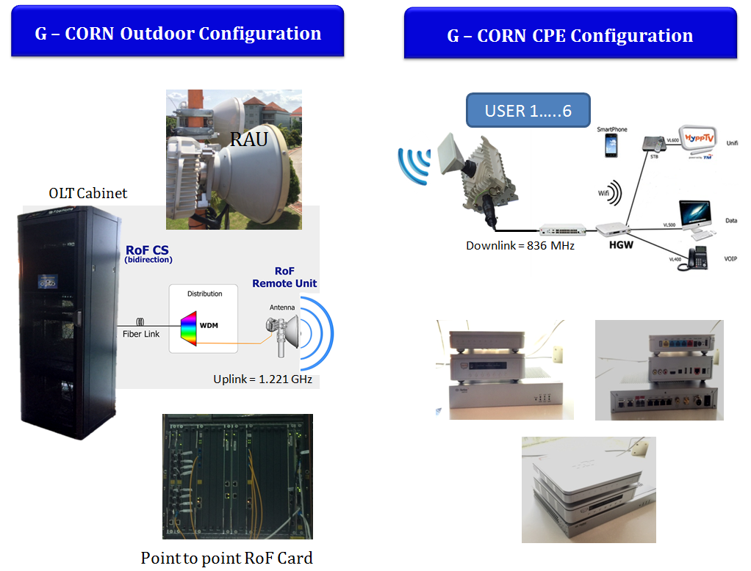

Fig. 11: Outdoor and indoor components and configurations

6.2 System on trial
For this field trial, the system specification has been agreed as shown in Table 1 and will exists as a standalone RoF system. Legacy PON services are also present in the card level for testing and benchmarking purpose. 8 MRoF cards are combined using a multiplexer (MUX) in the system before the optical distribution frame (ODF) as shown in Fig. 12.

Table 1: Trial system specification.
Item | Specifications
Optical fibre length | Fiber = 10km
Wireless transmission range | Wireless = 300m – 500m
Multiplexing | 4λs / fiber
Ratio | 8:1 WDM
No. of wireless user | 3 users / RAU  2 RAU / pole
Capacity | 30Mbps / user
RoF port per card | 1RoF port / card
No of RoF card per chasis | 8 cards / Chassis
Total number of user | Pilot users = 24 users
Uplink | 1Gbps Uplink to Metro-E
Power supply for RAU | TNB Power Cabinet

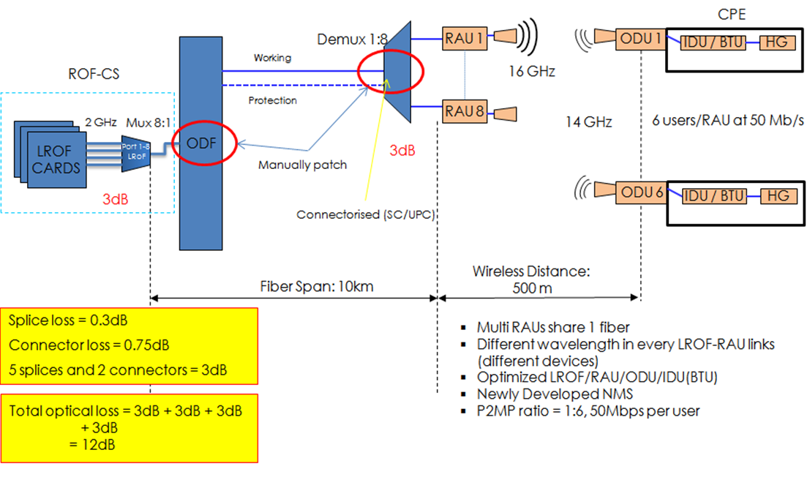

Fig. 12: Design for system trial.
Three (3) users are designated for each card that will be translated into RAU at the other end of the system closer to the end user premises. Therefore, a total of 24 users can be deployed using this system, where each user will enjoy 30Mbps experience. The combined signal from the ODF will be connected to the access network via optical fibre ring network and then to be first demultiplexed (DEMUX) close to customer or residential area. Once demuxed, 8 optical fibre links can be used to reach RAUs. The RAU is used to detect the optical signal with various wavelengths before converting it to RF frequencies.
The transmission from the RAU to ODU will take place using a frequency band of 14GHz (uplink) to 16GHz (downlink). As mentioned previously, each RAU will be used to serve 3 houses with up to 30Mbps performance each. From the calculation on a 10km system, it is found that total loss for the system in this nature is 12dB. This figure is specified by taking consideration of the uplink performance of the RF signal and EO conversion efficiency at RAU back to the MRoF card. Summary of the component parameters and specifications are shown in Table 2.

Table 2: Component specifications
Bil | Parameters | Specifications | Unit
 |  | Typ
 | RoF-CS
1 | RF Frequency in Fiber | 2.1 / 1.7 | GHz
2 | No. of RoF port (optical) | 1 RoF port per card
3 | Downlink Mod Scheme | OFDM
4 | Uplink Mod Scheme | DFTS-OFDM
5 | Channel Bandwidth | Up to 56 | MHz
 | RAU
6 | User/RAU | 6 users
7 | Bandwidth/User | 30 | Mbps
8 | Wireless Downlink | Ch. 1: 15.852  Ch. 2: 15.908  Ch. 3: 15.984  Ch. 4: 16.020 | GHz
9 | Wireless Uplink | Ch. 1: 13.795  Ch. 2: 13.851  Ch. 3: 13.907  Ch. 4: 13.963 | GHz
10 | Antenna | External (Vertical & Horizontal polarization)
 | BTU
11 | Upstream Mod Scheme | DFTS-OFDM
12 | Downstream Mod Scheme | OFDM
 | Antenna + ODU
13 | Antenna type | Directional/Array
14 | Wireless Distance | 300/500 | m

Conclusion
The system architecture, methodology, hardware configuration and site deployment topology for field trial of wireless access WDM-PON deployment based on RoF technology is presented. This system has been successfully deployed at two housing locations in Semenyih, Malaysia, providing 30Mbps Triple-Play service at 16 GHz downlink and 14 GHz uplink wireless frequencies at 32 QAM transmission. For future improvements, several key areas can be further studied to enhance the system such as placement of the RAU/ODU, signal line-of-sight (LOS), as well as wireless modulation techniques. Nonetheless, this field trial has proven to be a viable solution and has opened up many possibilities and opportunities for future fiber wireless systems based on RoF, in Malaysia and around the world.

