APT REPORT ON

DISASTER INFORMATION SHARING SYSTEM IN APT COUNTRIES

Edition: September 2015

The 26th APT Standardization Program Forum (ASTAP-26)
9 – 12 September 2015
Bangkok, Thailand

(Source: ASTAP-26/OUT-11)

No. APT/ASTAP/REPT-18

APT REPORT ON DISASTER INFORMATION SHARING SYSTEM IN APT COUNTRIES

Table of contents

1. Introduction
1.1 Background
1.2 Lessons learned from large scale disaster

2. References

3. Abbreviations and acronyms

4. Scope

5. Purpose and Function of DISS
5.1 Basic Concept and Merits of DISS
5.2 Collecting Information
5.3 Centralizing Information
5.4 Data Format Unification
5.5 Providing Information

6. Requirements for DISS

1. Introduction

1.1 Background
Along with the global warming, various kinds of natural disasters are occurring more frequently all over the world. Especially Asian-Pacific region is a disaster-prone area. Large scale of natural disasters such as typhoons, floods, tidal waves, draughts, earthquakes, tsunami, and volcanic eruptions are frequently hitting this region.

1.2 Lessons learned from large scale disaster
On the above occasions, it is most important to send out the disaster-related information most quickly and most accurately to the people in the concerned area so that they can be alert to the disaster and aware of instructions given by disaster-related agencies.

1.2.1 Sureness of information delivery
It is sometimes hard to hear the voice sound of the loudspeaker of municipal disaster management radio communication system in some areas due to weather conditions.
Phonetic isolation also occurs in a car and building, shutting out outside sound.
In such cases, mobile phone, TV and internet work well for information delivery.

1.2.2 Durability of information delivery
It is sometimes difficult to operate municipal disaster management radio communication system because of severe damages caused by the earthquake and tsunami.
In such cases, some local governments can use another communication means such as temporary FM broadcasting and internet website, etc.

1.2.3 Continuity of information delivery
It is sometimes hard to keep availabilities of municipal disaster management radio communication system due to power outages and fuel shortages.
In this case, remote control function should be introduced for safety of the operator.
In order to provide the solution for the mentioned necessity, this report describes the concept and requirements of the Disaster Information Sharing System (DISS).

2. References

- Report of Ministry of Internal Affairs and Communications (Japan) “Research meetings for the local safety and security information platform” (2 July,2008)
- Report of Foundation for Multimedia Communications (Japan) “Integrated Public Alert Platform” (28 Octorbaer,2013)

3. Abbreviations and acronyms

DISS Disaster Information Sharing System
TV Television
TVCML Television Common Markup Language

4. Scope

This report provides three major requirements for the DISS and describes the practical case of the operations and usage of the DISS. The outline and applications of the DISS are also described.

5. Purpose and Function of DISS

Disaster information dissemination consists of the following three phases.
- Information issuance
- Information transmission
- Information distribution
Information providers are to issue the information and transmit it to communicators which distribute the information to residents. From the lessons learned from the past serious disasters, it is required to establish a system that disseminate quickly and accurately the necessary information to each resident living in the disaster hitting area. The DISS has been introduced to satisfy such a necessity. In the following sections, the concept of the DISS and the function of each part are described.

5.1 Basic Concept and Merits of DISS
This section describes the basic concept of the DISS and the feature of the Common Platform which is a key component of the DISS, and also describes the merits of introducing the DISS.

The DISS consists of the three parts, e.g., Information Providers, Common Platform and Information Communicators. In the DISS, the information providers can provide the common platform with the disaster information immediately when it is obtained so that the information collection can be performed effectively. The information is centrally managed at the common platform so that the information communicators can take necessary information out of the common platform accurately and immediately and distribute the information to the residents through the media they operate.
Figure 1 shows a basic concept of the DISS. The most important part of the system is the information sharing common platform which transmits information related to local safety and security collectively to various media in a prompt and efficient way.

Figure 2 shows the merit of the DISS’ common platform. Without a common platform, information providers (e.g. local governments) and information communicators (e.g. broadcasters) need to create many 1-to-1 systems. On the other hand, with a common platform, Information Providers（Refer to Fig. 1） and Information Communicators can share the information simultaneously.（Refer to Fig.1.）

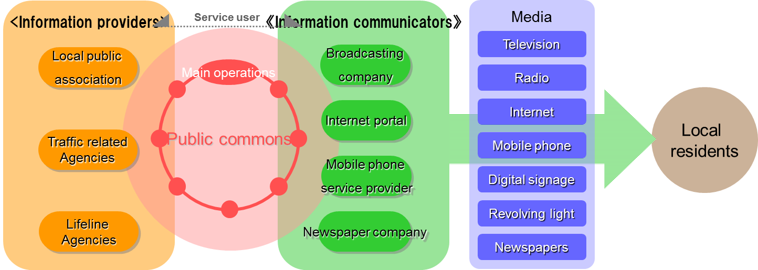
Common Platform

Figure 1 Basic concept of the DISS

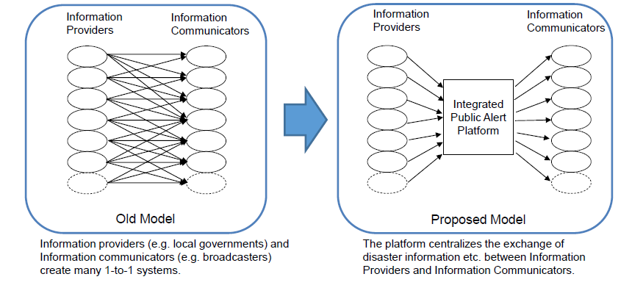
With Common Platform
Without Common Platform

Figure 2 Common platform

Disaster information sharing through the common platform proceeds in three functions of collecting information, centralizing information and providing information.
The benefits from using the DISS are as follows.
Local residents can obtain accurate information in the event of an emergency and receive emergency information no matter where they are.
Information providers can provide emergency information to local residents certainly and assess the damage across a wide area at the time of disaster.
Information communicators can not only transmit information without delay and gather information about a wide area, but also transmit localized information to each individual community.

5.2 Collecting Information
There are many information providers to issue alerts. The example of information provider and alert are as follows. （Refer to Fig.3.）

1) Municipality: Evacuation order and etc.
2) Prefecture: Disaster information, notification etc.
3) Central government: Weather information etc.
4) Utility companies: Restoration prospect

Information on alerts, orders, notifications and others is transmitted to the common platform of the DISS from various information providers. Each provider can use its own data format, but are required to use a transmission line with the security assured to prevent the false information from being inputted.

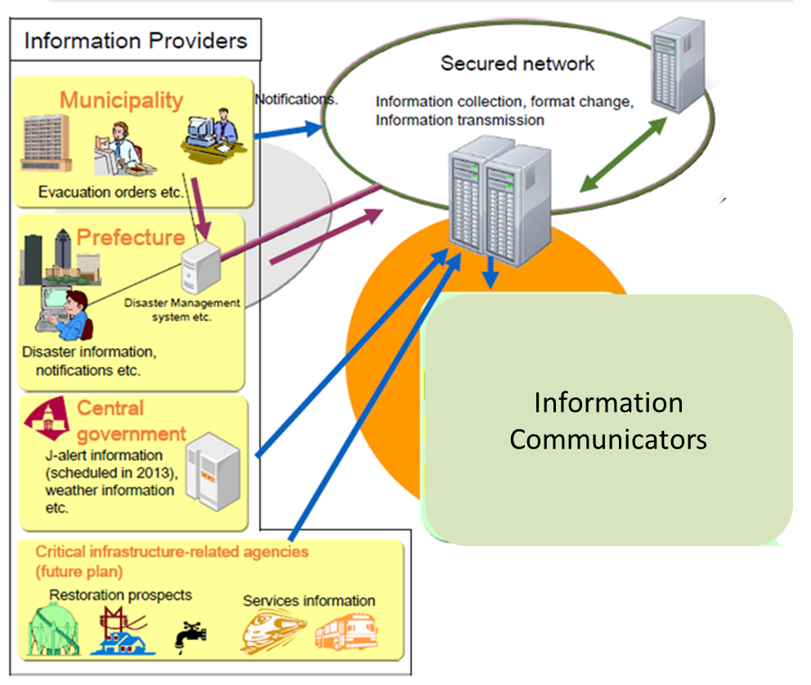

Figure 3 Collecting Information of DISS

5.3 Centralizing Information

As explained in Section 5.1, centralizing information is the most important function to collect the information from each provider and provide each communicator with necessary information. To realize this function, it is important that the information providers such as a local government establish a management organization in cooperation with the communicators such as broadcasters to introduce and manage the information network and server with the security assured. Using such a network and server, the following kinds of disaster information shall be shared with local residents.

Evacuation order / instruction
Information on evacuation centers
Information on disaster management centers
Property damage information such as bridge destruction information
Public events such as a disaster drill
Notifications such as an evacuation order
Water level in the river
Weather warning for rainfall etc.
Sediment disaster warning

5.4 Data Format Unification
Disaster information centralized at the common platform’s server is unified to the same information format so that information communicators can collect the information on the server easily. The most likely unified data format is TVCML（Refer to Section 3 “Abbreviation and acronyms”） so that information communicators can use it easily for their transmission.
Figure 4 shows centralization and data format exchange of disaster information.

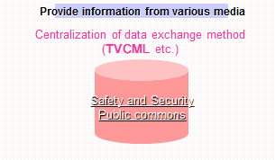

Figure 4 Data exchange

5. 5 Proving Information
The information communicators derive necessary information from the common platform when needed and distribute the information to the residents promptly whenever the information changes. The distribution structure which the information communicators operate is desired to be resilient and robust against disasters and plural medium shall distribute the information so that it will be surely distributed to the residents.

The likely information communicators are as follows among others.
- Broadcasting: TV, Radio
- Newspaper publishing company: Newspaper
- Internet: Disaster-related home pages
- Cellular phone: Disaster warning service

Figure 5 shows the routes providing public information to local residents through various media.

Media
Information communicators

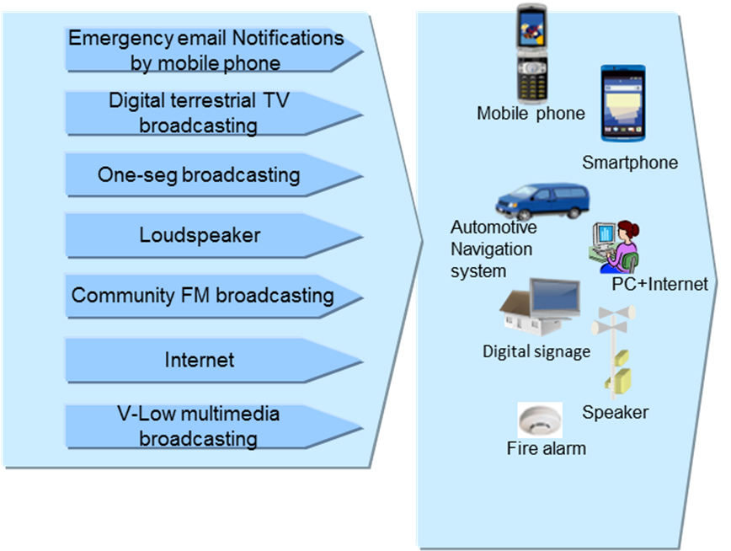
Common
Platform
Local
Residents

Figure 5 Providing information to local residents through various media

6. Requirements for DISS
The DISS has the following three functions.

- Collecting information
- Centralizing information
- Proving information

The requirements to realize these functions are as follows.

- A management organization to operate and utilize the DISS shall be created, and the information providers and the information communicators shall participate in the organization.
- The information from the information providers shall be centralized and administered at one common platform.
- The security of the network from the information providers to the information communicators shall be ensured.
- Plural medium shall participate in the organization to ensure the distribution of the information to the residents.
- The distribution structure of each media shall be well prepared for such events as power failure and flood so as not to interrupt the information distribution.

The disaster information can be distributed accurately, surely and promptly by satisfying these requirements.

APPENDIX 1
Examples of DISS

L-alert of Japan

One of concrete examples of the DISS is L-alert of Japan which local governments of Japan are introducing to effectively distribute the disaster information to the people in each area through various information communicators’ media. In case of disasters, the L-alert platform system collects disaster information issued by local government and various organizations such as utility companies. The L-alert platform system converts the information to convertible format by using data exchange method. So, those who acquire such information from the L-alert platform system can distribute the information to general citizen through various information communications media such as digital TV, internet, mobile phone, and so on.

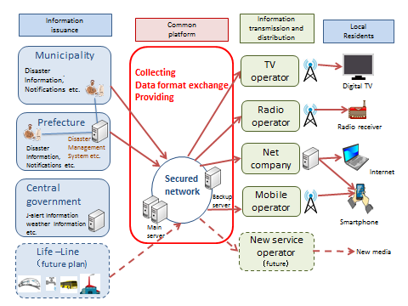

Figure 1 L-alert System

