APT REPORT ON

DIRECT SINGLE-MODE-FIBER COUPLED FREE-SPACE OPTICAL COMMUNICATIONS TO EXPAND THE FLEXIBILITY IN FIBER-BASED SERVICES

Edition: March 2013

The 21st APT Standardization Program Forum (ASTAP-21)
11 – 15 March 2013
Bangkok, Thailand

(Source: ASTAP-21/OUT-11)

No. APT/ASTAP/REPT-09

Table of Contents
- Introduction
- Scope
- Terms, definitions, abbreviations and acronyms
- References
- Overview of SMF-coupled FSO terminal
- Propagation characteristics
- Application examples
- Summary

- Introduction
A new category of free-space optical (FSO) communication system have been demonstrated in which diffraction limited laser beams are transmitted/received directly through a standard single mode fiber (SMF) to achieve multi-Gbps class point-to-point wireless links[1-5]. FSO links as shown in Figure 1 and 2, generally have several features of providing a flexible, easy to install, license-free link, and characterized as a line-of-sight wireless communication.
Although these FSO links are still limited to line-of-sight communications and link distance has been within about 1 km in typical terrestrial link conditions, the seamless FSO connection between a couple of SMF-based systems will enable us to provide broadband point-to-point wireless links not only for fixed terminals but also for mobile users, such as satellites, cars, trains, ships and aircrafts, who cannot be reached by means of optical fibers.
Using SMF-coupled FSO terminals, existing broadband fiber-optic communication technologies, such as dense wave division multiplexing (DWDM) technology using Er-doped fiber amplifiers (EDFAs), array waveguide grating (AWG) multiplexer/demultiplexer, etc., will be available without any modifications in the new FSO links.
However, FSO links are susceptible to adverse weather conditions, such as rain, snow and fog, and climate is very different from each countries and regions. Hence, it will be very important to understand the characteristics of broadband optical wireless links and to encourage the further weather compatibility study, in particular for outdoor use, and evaluations for various applications before considering the operational stage.

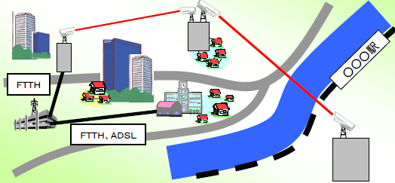
Figure 1 Application of typical FSO link in metropolitan area
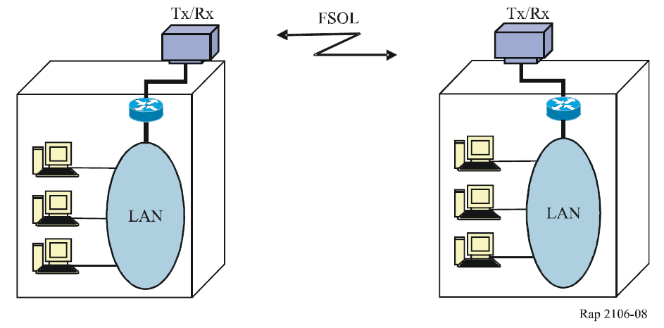
Figure 2 Application of FSO link to connect or extend the LAN within each building
This report will describe the performance of a new free-space optical (FSO) communication terminal which directly connects a pair of SMF networks through the air. It will also discuss the propagation characteristics on the SMF coupled free-space optical signal under various adverse weather conditions, such as weak-to-medium atmospheric turbulences obtained through indoor/outdoor demonstration experiments.

- Scope
This report provides the information on the characteristics and the performance of direct SMF coupled free-space optical communication system for future indoor/outdoor multi-gigabit wireless links. It includes FSO terminal design details already proven in the previous indoor/outdoor link experiments whose bit rates covers from 1.25 Gbps to 1.280 Tbps.

- Terms, definitions, abbreviations and acronyms
3.1 Terms and definitions
Beam divergence: The beam divergence is the angle between the lines at which the power density of an FSO beam falls to 1/e². The angle is always referred in full width.
FOV(field of view): The acceptance angle (of an FSO receiver) is the angle between the lines at which the power detected by the receiver falls to 1/e² in this report. There is some other definitions whose power levels fall to 1/e or 1/2. The angle is always referred in full width.
Optical antenna: Optical instrument, consist of at least two lens set or reflectors, to reduce or expand laser beam size to fit internal beam size into internal optical elements such as beam splitters, fiber couplers and narrow band optical filters. It is also called as telescope.
Visibility: The distance it is possible to see, especially when this is affected by weather conditions, such as rain, snow and fog.

3.2 Abbreviations and acronyms
AEL Accessible Emission Level
AOA Angle of Arrival
APC Automatic Power Control
CCD Charge Coupled Device
CDMA Code Division Multiple Access
CWDM Coarse Wavelength Division Multiplexing
DWDM Dense Wavelength Division Multiplexing
EDFA: Er-doped fiber amplifier
FSM: Fast steering mirror (actuator)
FSO: Free-space optics
FWHM: Full width at half maximum
LD: Laser diode
OFDM Orthogonal Frequency Division Multilexing
OTDR Optical Time Domain Reflectometry
PD: Photo diode
PID: Proportional integral derivative
QPD: Quadrant photo detector (or diode)
SI Scintillation Index
SMF: (Standard) single mode fiber
WDM: Wavelength division multiplexing

- References
4.1 ITU documents
ITU-R Report ITU-R F.2106 – Fixed service applications using free-space optical links
ITU-R Recommendation ITU-R P.1814 – Prediction methods required for the design of terrestrial free-space optical links
ITU-R Recommendation ITU-R P.1817 – Propagation data required for the design of terrestrial free-space optical links.
ITU-T Recommendation ITU-T G.640 – Co-location longitudinally compatible interfaces for free-space optical systems

4.2 Technical papers
- Y. Arimoto, “Multi-gigabit Free-space Optical Communication System with Bidirectional Beacon Tracking,” IEEJ Transactions on Fundamentals and Materials, 127, 7, 385-390, (2007).
- K. Sasaki, N. Minato, T. Ushikubo and Y. Arimoto, “First OCDMA Experimental Demonstration over Free Space and Optical Fiber Link,” OFC/NFOEC 2008 Conference, OMR8, (2008).
- E. Ciaramella, Y. Arimoto, G. Contestabile, M. Presi, A. D’Errico, E. Guarino and M. Matsumoto, “1.28 Terabit/s (32x40 Gbit/s) WDM transmission system for Free Space Optical Communications,” IEEE Journal on selected areas in communications, Vol.27, pp.1639-1645, (2009).
- Y. Arimoto, “Compact free-space optical terminal for multi-gigabit signal transmissions with a single mode fiber,” Proc. SPIE 7199, pp.719908, (2009).
- Y. Arimoto, “Operational condition for direct single-mode-fiber coupled free-space optical terminal under strong atmospheric turbulences,” Optical Engineering, Vol. 51, No. 3, pp. 031203, (2012).

- Overview of SMF-coupled FSO terminal
5.1 FSO terminal configuration
Figure 3 shows the optical configuration of the compact FSO terminal and the concept how to couple free-space laser beam into a standard single mode fiber (SMF). A refractive type telescope is used as an optical antenna to receive incoming signal laser beam in 1550-nm wavelength band and to convert it into a smaller collimated beam. As the current optical antenna is designed to be field replaceable, effective signal beam aperture outside of the telescope can be changed from 10 mm to 42 mm according to the link distance and atmospheric turbulence conditions, while internal beam diameter is fixed to 2 mm. At the exit pupil of the telescope, a two-axis fast steering mirror (FSM) is placed to stabilize the internal beam tilt caused by the vibration and the thermal deformation of the terminal support structures and the angle of arrival fluctuation caused by atmospheric turbulence in the propagation path. Stabilized beam is finally focused on the aperture of SMF in the fiber coupler.
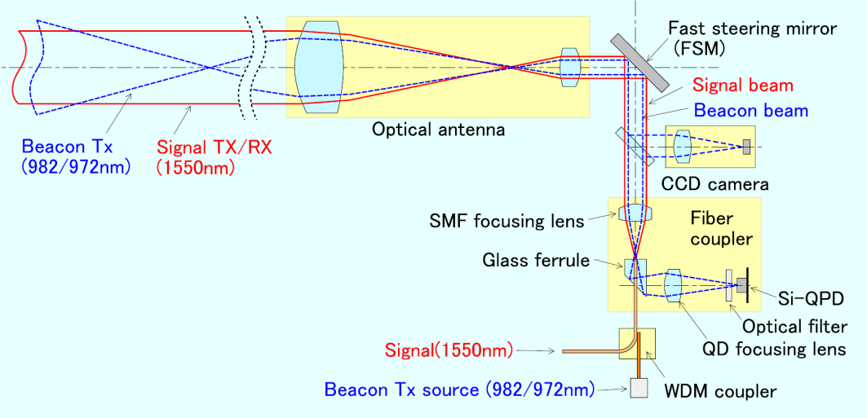
Figure 3 Basic configuration of SMF-coupled FSO terminal.

To detect the position of the beacon beam spot and the misalignment in horizontal and vertical directions, a tracking sensor using a Si quadrant photodetector (QPD) is installed within the fiber coupler module. According to the error signals from the QPD, an analog proportional integral derivative (PID) servo controller drives the fast steering mirror (FSM) to minimize the effect of angle-of-arrival fluctuations at the SMF fiber coupler. Once this tracking servo loop is established, transmitting signal beam multiplexed with a beacon beam by a WDM coupler will be transmitted from the fiber coupler and passed through the FSM and optical antenna to the opposite terminal.
5.2 Block diagram
Figure 4 shows the block diagram of current compact FSO terminal. For the purpose of bidirectional beacon tracking, compact FSO terminal has an internal near infrared laser source whose output power can be controlled from -20 dBm to +3 dBm using an automatic power control (APC) LD driver. The two wavelengths, 982 nm and 972 nm, are selected within the EDFA’s pump laser wavelength band and both LD wavelengths are stabilized by fiber Bragg gratings. The 10-nm wavelength difference is determined to assure enough margins to distinguish the opposite terminal’s beacon from the background lights including own beacon by using a multilayer dielectric optical filter, attached in front of the QPD. The bandwidth of the optical filter is 4 nm in FWHM. The effective sensitivity of the tracking sensor is -45 dBm measured at the receiving aperture of the optical antenna and the dynamic range for normal tracking operation is 17 dBs.
Overall internal signal attenuation from the exit aperture of the optical antenna to the SMF connector is less than 3.0 dB for all the operational field of view and the on-axis internal signal attenuation is less than 2.0 dB. An optical circulator is used to separate receiving and transmitting optical signal in the SMF. An acquisition and tracking controller always watches the beacon intensity at the QPD and the receiving optical signal intensity coupled into the SMF. When the beacon signal is not available at the QPD, it will search for the target beacon signal by tilting the FSM within the field-of-view of the beacon divergence. CCD camera is used for initial terminal setting only.
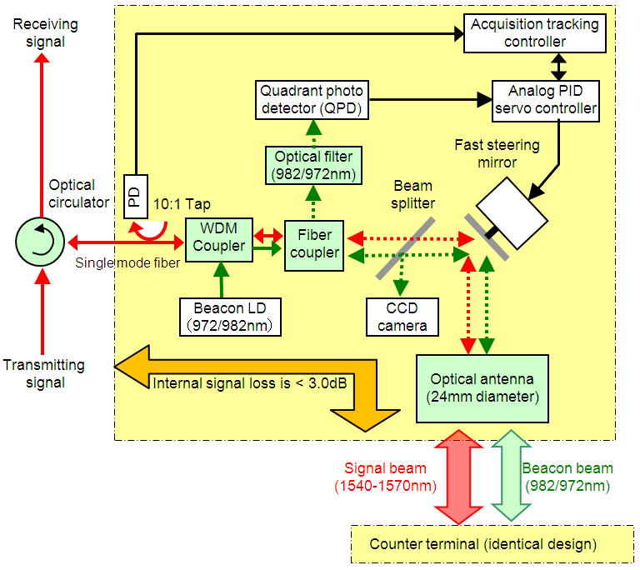
Figure 4 Block diagram of SMF-coupled FSO terminal

Figure 5 shows the internal view of compact FSO terminal developed at NICT with a largest optical antenna whose signal beam diameter is 42 mm. The size of the compact terminal is 12cm x 30 cm x 20cm and the weight is less than 1.2 kg. Electrical power required to operate the terminal is less than 1.2 W. For an outdoor operation, rain proof housing will be required separately.

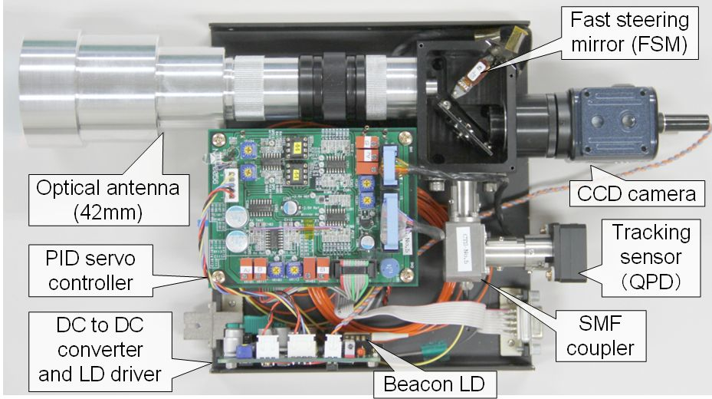
Figure 5 Internal layout of the compact FSO terminal

5.3 Link budget
Figure 6 shows the transmittance of infra red light over 1 km metropolitan link calculated using MODTRAN with an assumption of standard atmosphere (height: 0 m, temperature 15 deg-C, humidity 46%, atmospheric pressure: 1013.25 hPa) and metropolitan aerosol model. There are several preferable transmission wavelength windows at 0.85 μm, 0.98 μm, 1.31 μm and 1.55 μm. For example, the 1-km link attenuation at 1.55 μm is about 1.0 dB. This value corresponds to the clear air attenuation, not including the rain/fog attenuation and atmospheric turbulence effects.
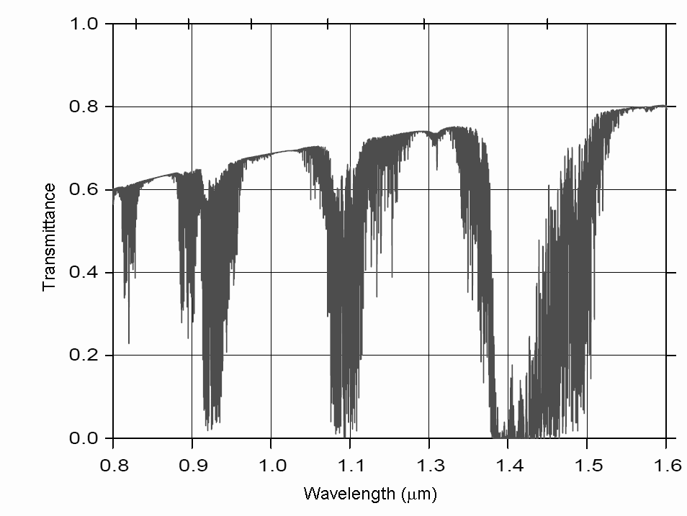
Water vapor absorption
Aerosol scattering
Figure 6 Calculated light transmittance over 1-km metropolitan link.
The rain/fog attenuation F_{W} (dB/km) can be roughly estimated by the following formula.
(1)
where V (km) is the Visibility defining the distance where it is possible to see. If the Visibility is 10 km, rain/fog attenuation will be 1.5 dB/km.
The atmospheric turbulence effect is typically observed as the fluctuation in receiving optical signal intensity (I) and angle of arrival (AOA) in FSO links. The fluctuations of I are always referred as the following parameters called as the Scintillation Index (SI);
, (2)
where denotes the average of I. The theory for calculating the SI’s in SMF-coupled FSO links are not established yet, but, the SI’s for ideal plain lightwave can be estimated by the following Rytov variance;
, (3)
where k is the wave number defined as , z is the distance from the receiving point and L (m) is the link distance. C_{n}² is the parameter to define the variation of refractive index of an atmosphere. Typical values for C_{n}² are C_{n}²=1.0 x 10⁻¹³ for daylight or high turbulence conditions and C_{n}²=1.0 x 10⁻¹⁵ or less for quiet atmospheric conditions. For example, the results of more accurate calculation of the SI’s over 1 km link for a Gaussian beam with 2.4 cm beam waist at 1.55 μm wavelength are SI_{max}=0.43 and SI_{min}=0.006 for the above two typical C_{n}² values. As the probability distribution of receiving optical signal intensities is roughly approximated as the log-normal distribution, SI_{max}=0.43 means that the fading events whose attenuation is more than 10.4 dBs will occur at the probability of 0.01%.
Figure 7 shows an example of theoretical calculations of the free-space link attenuation for the signal and beacon beam with the link distance from 100 m to 5 km. The geometrical attenuation due to the diffraction of a 2.4 cm diameter transmitting laser beam, whose intensity distribution is truncated Gaussian, is shown by a red solid line, the rain/fog attenuation assuming the link location to be in Tokyo, Japan is shown by blue broken line and the mean signal fade due to daylight atmospheric turbulence effect (scintillation) is shown by yellow broken line, respectively. We assumed C_{n}²=1.7 x 10⁻¹³ in this calculation. The worst-case link attenuation is the sum of the scintillation and the geometrical attenuation, because the rain/fog conditions and strong sunshine will not happen simultaneously. The beacon geometrical attenuation, assuming the beam divergence of 2.2 mrad., is also shown as the green solid line.
The maximum transmission distance will be determined by the margin of the optical transceiver, Accessible Emission Level (AEL) to keep eye-safety and this figure. If an optical transceiver has a 32 dB link margin, FSO link distance will be extended to 1 km considering the 2-dB terminal internal losses and a 28-dB link attenuation. Considering that the sensitivity of the tracking sensor is about −45 dBm and the beacon transmitting power is less than 1 mW, bidirectional beacon link will be critical in case of large rain/fog attenuation.
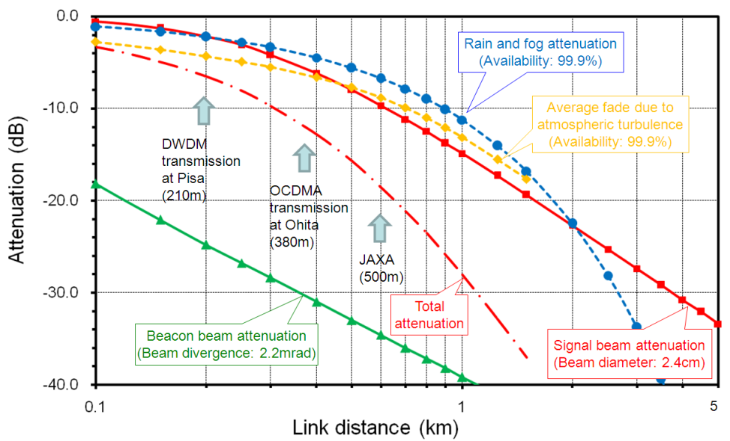
Figure 7 Link budget for SMF coupled signal at 1550nm and beacon beam at 980nm

  - Transmission performance
Figure 8 shows the example of optical signal attenuation in the previous indoor link experiment. A 1.5-μm optical signal was loop-backed at the opposite terminal over a 30-m indoor FSO link and loop-back attenuation in C-band was measured by an optical spectrum analyzer. The result shows that the one-way signal attenuation over 30-m link was 3.6 dB at the center of C-band and 3-dB bandwidth was more than 100 nm, which is effectively compatible to the real SMF components.
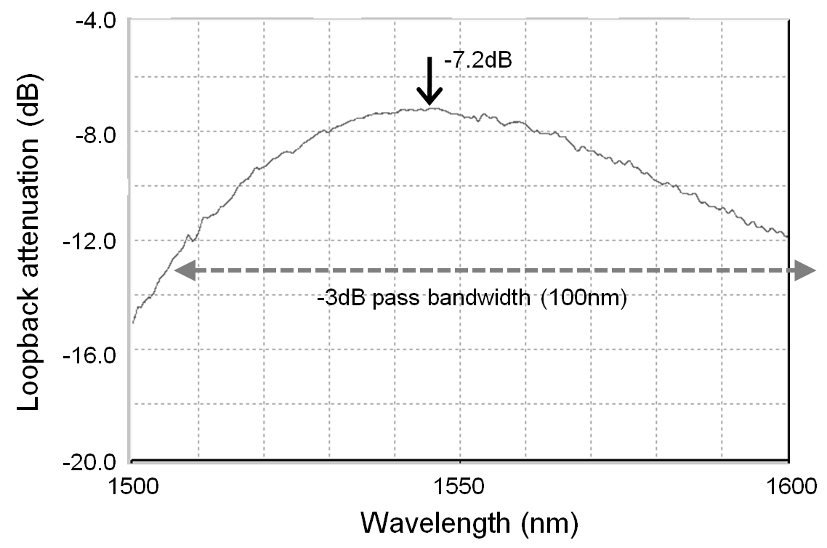
Figure 8 Loopback signal attenuation in C-band over 30-m indoor link

Figure 9 shows the result of an optical time-domain reflectmeter (OTDR) measurement for the same link. Free-space section and the reflection of mirror fiber can be remarkably identified. The overall back reflection within the FSO terminal was evaluated to be less than 25 dBs.

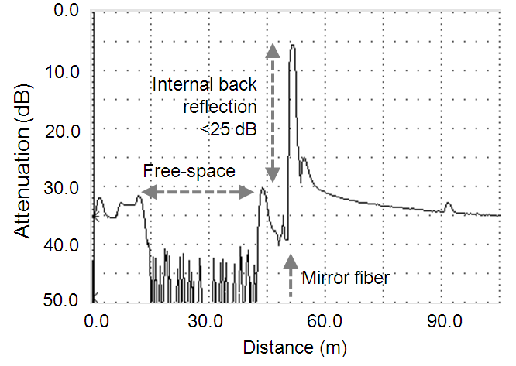
Figure 9 Optical time-domain reflectmeter measurement over 30-m indoor link

- Propagation characteristics
Figure 10 shows an example of propagation data in a 500-m outdoor link test experiment on January 7th, 2011. The two FSO terminals were transported at the laser beam transmission test site at JAXA Kakuta Space Center. Continuous data accumulation was performed for 3 days, including sunshine and rain/snow fall conditions and no particular degradation was observed except for a normal fading in the signal/beacon link. The transmitting signal beam whose aperture diameter was 24.5 mm was near diffraction limited in this experiment. Transmitting signal power was about 520 μW.
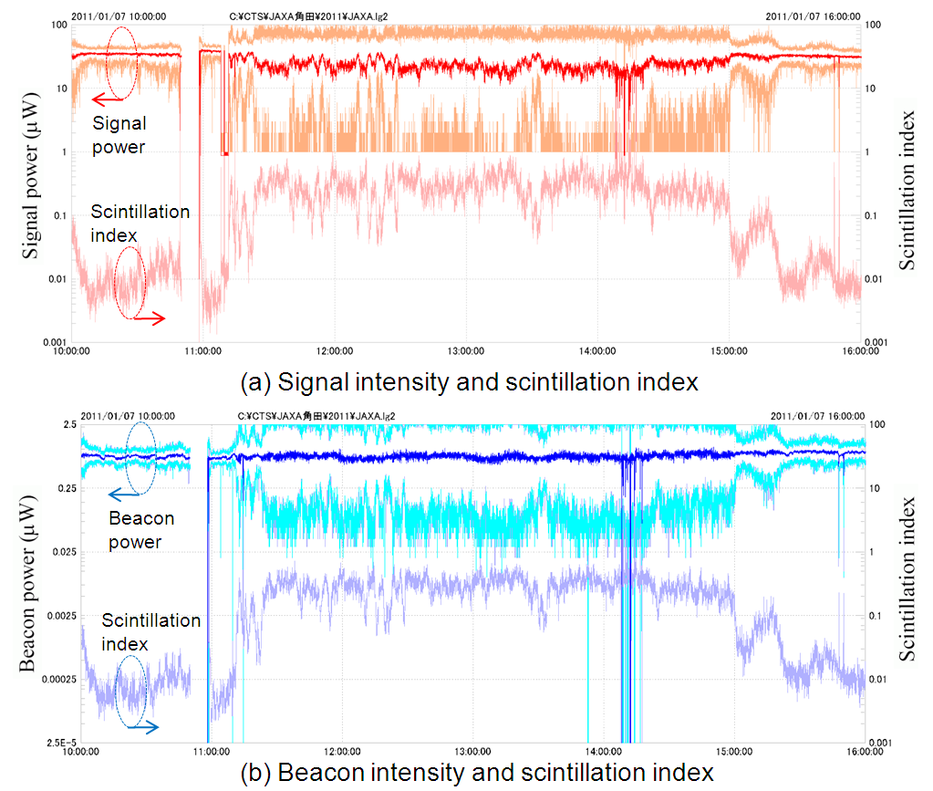
Figure 10 Six-hours propagation data over 500-m outdoor link.
Strong scintillation effect was observed in this case for both signal intensities and beacon intensities during sunshine. The scintillation index was almost same between the signal intensities and beacon intensities. The dropouts of the average intensities in the figure show intended realignment adjustment or calibration operation. Many deep asymmetric fading events in the signal intensities were observed frequently when the signal scintillation index became 0.1 or larger, while fade depth and surge height in the beacon intensities were symmetric. If the scintillation index during sunshine is 0.4 for this link condition, the corresponding C_{n}² will be 3.1x10⁻¹³. The expected aperture averaging effect for the beacon beam received by QPD was 0.37. This made the almost same scintillation index between beacon intensities and signal intensities. However, the ratio of surge height and fade depth is different; beacon intensity distribution looks like a log normal or gamma-gamma distribution, while signal intensity distribution is much like a Gaussian distribution and looks asymmetry with a logarithmic scale.

- Application Examples
Once the stable SMF-coupled FSO link is established, it is very easy to perform any kind of fiber optic based signal transmission demonstration, such as CDMA, CWDM, DWDM and OFDM. Figure 11 shows an example of uncompressed 4K2K (3840x2160, 60p) video transmission system using 4-channel CWDM optical transceiver, shown in Figure 11 (a). In the indoor link demonstration at IBC2012, Amsterdam, SMF fiber link between transmitter and receiver was replaced by FSO link. Optical spectra for both transmitted/received signal are shown in Figure 11 (c) and (d). The signal degradation is negligible for this indoor demonstration distance.
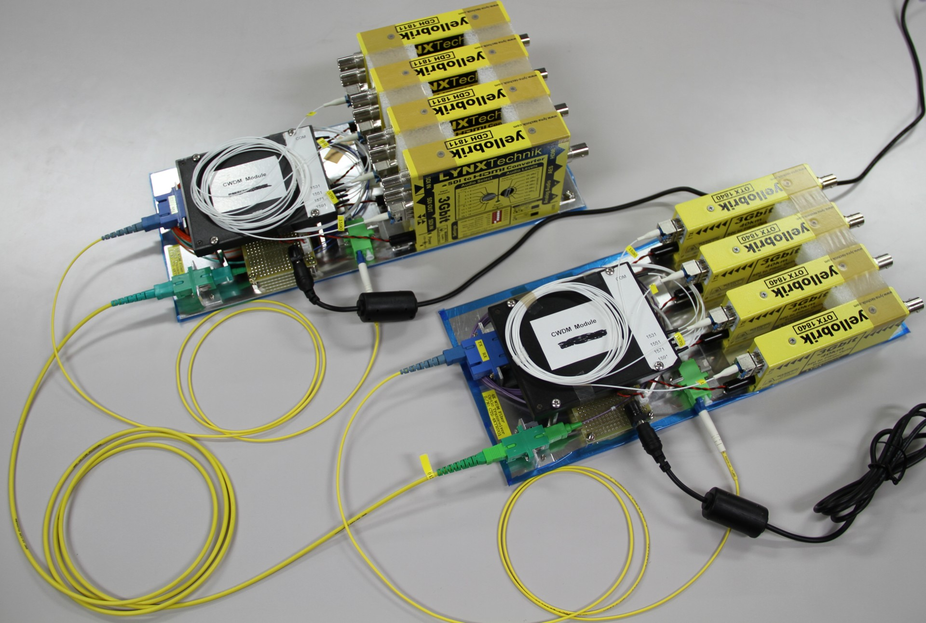
Receiver
Transmitter
- 4-ch DWDM video transceiver using off-the-shelf components
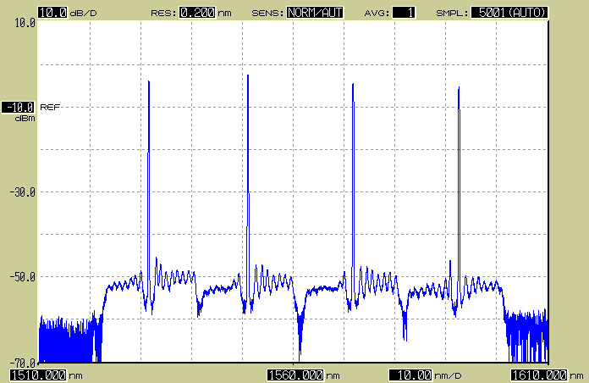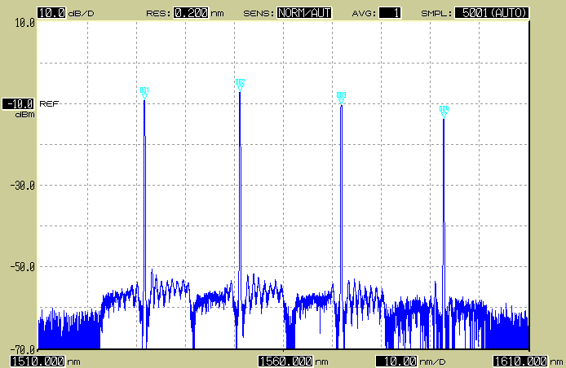
(b) Transmitting spectrum (c) Received spectrum over 30-m indoor FSO link
Figure 11 Uncompressed 4k video signal transmission using 4-channed CWDM technology.

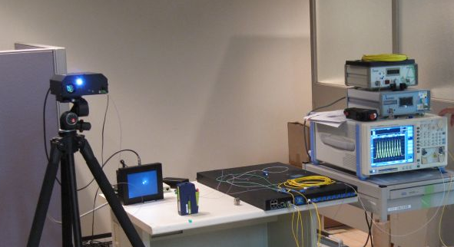
100G Ethernet switch
Tracking monitor
Optical singal spectrum
FSO terminal
Figure 12 100G Ethernet signal transmission using DWDM technology.

Figure 12 shows another demonstration of 100G-Ethernet signal transmission. Two commercially available 100G-Ethernet switch was connected over 30-m indoor FSO link and packet error was measured in this demonstration. The 100G-Ethernet switch used in this experiment uses 10-channel DWDM technology and 10-Gbps intensity modulation was applied at each wavelength. No particular degradation was observed in this demonstration.
- Summary
This report has described the characteristics and the performance of a new category of FSO terminal which can directly couple free-space laser beam to a standard single mode fiber without any further signal degradation compared with traditional FSO links. The new FSO system has realized virtual SMF connection by introducing high performance mutual beacon tracking system and diffraction limited optics in the wireless optical communications. The detail design of the compact FSO terminal has also described.
By using SMF coupled FSO terminals, it is very easy to introduce any kind of advanced fiber optic technology, such as DWDM, radio over fiber, CDMA, OFDM, etc., which allow us to make future resilient and agile broadband communication system.

