APT REPORT ON

COST-EFFECTIVE DISASTER MANAGEMENT COMMUNICATION SYSTEM

Edition: September 2015

The 26th APT Standardization Program Forum (ASTAP-26)
9 – 12 September 2015
Bangkok, Thailand

(Source: ASTAP-26/OUT-10)

No. APT/ASTAP/REPT-17
APT REPORT
ON COST-EFFECTIVE DISASTER MANAGEMENT COMMUNICATION SYSTEM

Table of contents

1. Introduction

2. Scope

3. Abbreviations and acronyms

4. References

5. Comparison between conventional disaster management communication system
and cost-effective disaster management communication system
5.1 Conventional disaster management communication system
5.2 Necessity of cost-effective disaster management communication system
5.3 Cost-effective disaster management communication system

6. Requirements for cost-effective disaster management communication system

7. Summary
1. Introduction

Disaster management communication systems will provide the last means of communication when a serious disaster destroys public communication systems. In many countries, such a disaster management communication system has been introduced, but is used limitedly by the public sectors so that the emergent communications between governmental organizations can be performed effectively even on the occasion of a serious disaster. For this purpose, the government spends a considerable amount of the cost to introduce and maintain the systems. On the other hand, not only individuals and private organizations but also public sectors which cannot afford to introduce the mentioned systems are supposed to be in a situation that they need to prepare their communication means against the circumstances that public communication systems are unusable or very congested because of a serious disaster. In order to satisfy such a necessity, it is recommended to introduce a cost- effective disaster management communication system to be shared at low cost by those wishing to have emergent communication means.
The purpose of this report is to consider functions and operations of the cost-effective disaster management communication system and provide requirements for it.

2. Scope
This report describes the functions and operations of the cost-effective disaster management communication system and the requirements for it.

3. Abbreviations and acronyms
MCA Multi Channel Access
SMR Specialized Mobile Radio
PPDR Public Protection and Disaster Relief

4. References
- Report of Ministry of Internal Affairs and Communications (Japan) “Research meetings for the local safety and security information platform” (2 July,2008)
2. ITU-R M.2033 ”Radiocommunication objectives and requirements for public protection and disaster relief”

5. Comparison between conventional disaster management communication system and cost-effective disaster management communication system

5.1 Conventional disaster management communication system

- PPDR
The PPDR is a typical radio communication system to be used for disaster management, and has superior characteristics as a disaster management communication system.
This system is exclusively used by public sectors such as local public entities and electric power companies. The infrastructure is to be constructed, operated and maintained by a single entity or a single group of plural entities. The definition of PPDR and its service outline is described in the following.
Definitions for PPDR are included in Report ITU-R M.2033 ”Radiocommunication objectives and requirements for public protection and disaster relief” as well as ECC Report 102.
It is defined to be a service or agency, recognized as such by the government, that provides immediate and rapid assistance in situations where there is a direct risk to life or limb, individual or public health or safety, to private or public property, or the environment but not necessarily limited to these situations (Source: Commission Recommendation C(2003)2657)).

(2) SMR
This is a simple mobile communication system to provide the private companies with business-use radio communication services in the U.S.A. It is so designed that various subscribers are provided with various services. The subscribers are mainly private companies, but occasionally public organizations. This system is usable only by paying the usage fee and so the economic burden on the subscribers is small. It is used mainly at ordinary times and less recognized as a disaster management communication system.

5.2 Necessity of cost-effective disaster management communication system
From experiences with major disasters, the following three activities are said to be necessary in the event of a serious disaster, i.e. (1) rescue and assistance, (2) cooperation, (3) self-help. Rescue and assistance is done by pubic bodies and has been recognized since a long time ago. Cooperation is done by the victims of the disaster themselves in the local communities to recover from the disaster. Self-help is done by individuals to try to eliminate dangers and risks habitually so that they can act as not a victim but a rescuer in the event of a disaster.
For the rescue and assistance, PPDR is used as a disaster management communication system. This usage is exactly the purpose of PPDR. As for the cooperation in the local communities, a handy communication system could be used, but it is not useful enough because its transmission length is not so long. The cost-effective disaster management communication system described in the following section is considered to be relatively suitable for this situation.

5.3 Cost-effective disaster management communication system
In this section, consideration is given to the cost-effective disaster management communication system to be utilized by not only individuals and private organizations but also public sectors. This system does not need to be of the latest technology, but to be a conventional cost-effective communication system like the above mentioned SMR which shall be realized by introducing the cost-effective utilization and operation methods while its function should be reinforced to suit to disaster management functions. The reinforcement should be made in consideration that the system will be used as a last resort of telecommunication within the disaster-hitting areas where power failure might be caused by a disaster such as flood and earthquake. The cost-effective utilization and operation methods shall be prescribed in consideration that the cost for each subscriber will be reduced by providing various subscribers with various communication services at ordinary times while as many subscribers as possible can use the system by limiting the communication time of each subscriber on the occasion of a disaster. Accordingly, in comparison with the conventional PPDR which is dedicated to a particular user, the system shall aim less financial burden for subscribers while maintaining an uninterrupted service and large coverage of communication at the occasion of a disaster. In Japan, MCA is introduced for such a purpose.

6. Requirements for cost-effective disaster management communication system
In the previous sections, the basic features of the cost-effective disaster management communication system are explained. From these, the requirements of the cost-effective disaster management communication system are considered below.
The system must satisfy the following two points. One is “robustness and reliability” because the system is used as a last resort for communication at the time of a disaster. The other is “cost-effectiveness” because it must be affordable for not only private but also public organizations with a weak financial base. Consequently, the system can’t be dedicated to one organization, but must be shared by plural organizations. In order to provide such a shared disaster management communication services using a robust and reliable system, it is most important to realize the communication system with the capability which enables many subscribers make good use of the system for their business and other purposes at ordinary times. In considerations of all of these features and key points, the requirements for cost effective disaster management communication system come to be as follows.

(1)Wide area wireless system
It is difficult to protect many base stations from disasters. Therefore, it is necessary to make the coverage of a base station as large as practically possible. Specifically, the coverage shall be as large as a large city or a county.

(2)Robust power supply
It is required that the base stations are provided with standby power source such as batteries and generation facilities to continue operation until power supply is restarted after occurrence of power failure due to a disaster. The operable time of the standby power source is desired to be at least 3 days in consideration of the critical time for saving the lives under debris.

(3)Stand-alone operability
Many base stations for mobile communication systems are connected via optical fiber cables which might be cut off by flood and earthquake. So it is important that the base stations are so designed to operate stand-alone even if the connection link between base stations is cut off. To economically secure stand-alone operability, the functions are desired to be limited to those (e.g., voice call) necessary on the occasion of a disaster, especially for the areas prone to flood and earthquake.

(4)Adequate call timers for prevention from suppressing call
On the occasion of a disaster, many subscribers need to use this service. Therefore, the utilization time of each call shall be limited, and communication opportunities shall be open for many subscribers. For example, if each call time is limited to be from 3 to 5 minutes which are long enough for concise communications, many subscribers are expected to be given communication opportunities.

7. Summary
This report considers characteristics of the cost-effective disaster management communication system. The benefits from using the communication system are as follows.
Not only Individuals, private organizations but also the public sectors which cannot afford to introduce the disaster management communication systems can secure communication opportunities in the event that public communication systems are unusable or very congested because of a disaster. It is important and so recommended that the disaster management capability for the entire society is enforced by introducing the cost-effective disaster management communication system in each country.

APPENDIX 1

1. MCA system in Japan

1. 1 The outline of MCA systems of Japan

In Japan, MCA is used as a cost-effective disaster management communication system. In this section, the outline of the MCA is explained as an example of the cost-effective radio system.
Multi-Channel Access (MCA) system is a two-way radio system in which two or more mobile/portable wireless transceivers are linked by a single repeater. The repeater is elevated above average terrain; this maximizes the area of coverage. Operating frequencies are in the UHF (ultra-high-frequency) range.
An MCA system consists of base station transmitters and end-user radio equipment. The system has a function of “trunking”, which means that several radio channels are pooled so that subscribers within an area have access to any free channel within the pool.
In some ways, MCA system is like a cellular telephone network. But there are important differences. MCA system is simpler than a cellular telephone network. There is only one repeater in a MCA system, and it links only the mobile/portable units for that system, not to other repeaters. In MCA, the range of each individual mobile/portable transceiver is greater than the range of a cell phone set. But total system coverage is usually far more limited than that of a cellular network; therefore MCA is very strong communication system against disaster.
The system served not only to interconnect mobile phones, but also provided connection to the public switched telephone network (PSTN)
MCA systems use channel pairs. Each transceiver has a transmitting frequency and a receiving frequency (FDD: Frequency Division Duplex). These frequencies differ by a fixed amount, called the offset. The transmitting and receiving frequencies are in the same band, that is, relatively close to each other in the radio spectrum. Transmitting and receiving frequencies of each mobile or portable transceiver in a system are all identical.

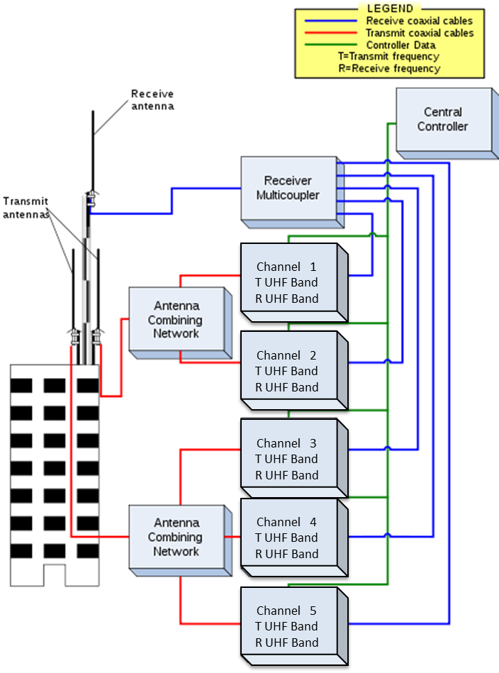

Figure 1 Block diagram of trunked system.
(Reference http://en.wikipedia.org/wiki/Specialized_Mobile_Radio)

MCA end users may operate in either an "interconnected" mode or a "dispatch" mode. Interconnected mode connects mobile radio units with the PSTN through the MCA base station. This allows the mobile radio unit to function as a mobile telephone. Dispatch mode allows two-way, over the air, voice communications between two or more mobile units (e.g., between a car and a truck) or between mobile units and fixed units (e.g., between the end user's office and a truck).
MCA largely has been supplanted by cellular service offerings, although it remains widely used in dispatch and fleet applications such as emergency vehicles, as well as taxi and utility fleets.

1. 2 Services of MCA systems
Services of MCA are similar to those of SMR in US. SMR provides radio communication services for private companies, state and local governments, and other organizations. MCA system is used in regions to provide radio communication services for not only business and public use but also personal use. By providing a variety of communication services for various users, a cost-effective disaster management communication system can be realized. Figure 2 shows services of MCA.

MCA SERVICES

PERSONAL USE
Non-public institutions
PUBLIC and BUSINESS USE
Local governments
Parcel delivery companies
Taxi Dispatchers

Figure 2 Services of MCA.

1.3 MCA applied as communication services for public institutions
In this section, services of MCA for public and business use are described. Those services are similar to services of SMR in US. As described below, users of the communication services have only to pay connection fees and can in this way offer various services economically to the institutions.

1.3.1 Bus Location System
Figure 3 shows the example of bus location system. Using MCA, bus location information is transmitted to base station from the terminal in travelling bus. The bus location information is reported to bus stops and displays a current bus position for bus users.

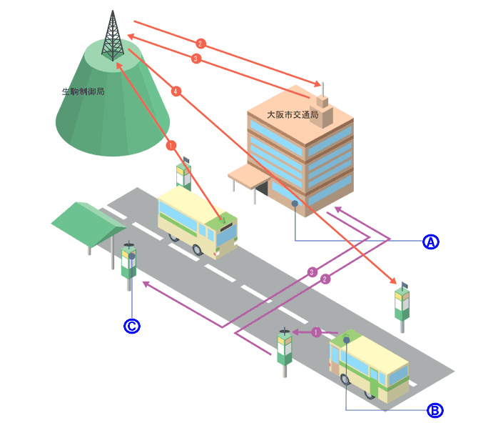

Figure 3 Example of Bus Location System

1.3.2 Disaster Management Communication
Figure 4 shows the example of disaster management communication system. Using MCA, disaster management information is transmitted from a control disk to speakers so that residents can obtain disaster information.

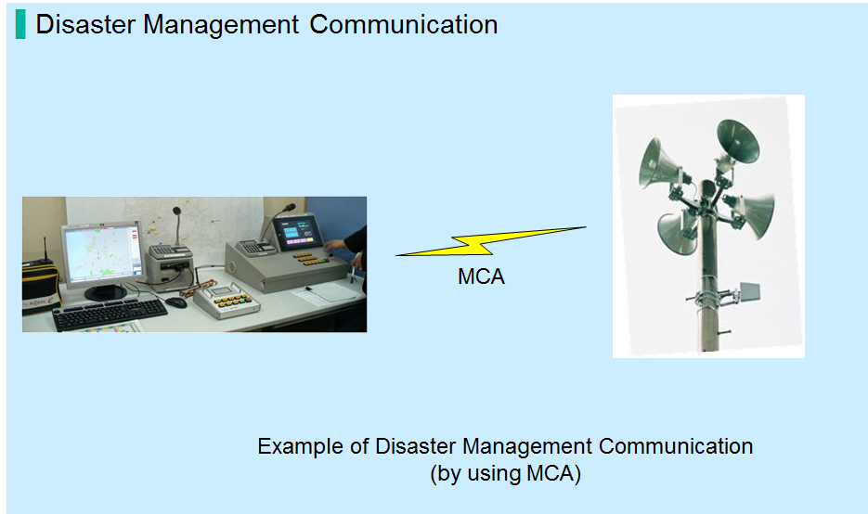

Figure 4 Example of Disaster Management Communication

1.4 MCA applied as disaster management communication for non-public institutions
MCA system is used in regions to provide radio communication services for non-public use. By using these services, non-public institutions that cannot use public mobile systems can use mobile radio services in stricken area. Actually, non-public institutions utilized these services when the following disasters occurred.

■The Mid Niigata Prefecture Earthquake in 2004
■The Great East-Japan Earthquake and Tsunami in 2011

Non-public institutions cannot use public mobile systems. Therefore, they bring MCA transceivers into stricken areas, and they communicate from the areas to their related places outside of the areas.
Moreover MCA system is able to support BCP (Business Continuity Plan) at a time of disaster.

