APT GUIDELINE ON

MANAGEMENT OF DEPLOYING ICT SOLUTIONS

Edition: March 2017

The 28th APT Standardization Program Forum (ASTAP-28)
6 – 10 March 2017
Bangkok, Thailand

(Source: ASTAP-27/OUT-12)

No. APT/ASTAP/REPT-27

CONTENTS

Page
Index of Figures 2
Archon 2
1. Overview of this GUIDELINE 3
1.1 Introduction 3
1.2 Background 3
2. Component of ICT deployment 4
2.1 Recommendation of procedure 4
2.1.1 Key Item by Layer 4
2.1.2 Plan-Do-Check-Act Cycle 4
2.1.3 Expense vs. Benefits 4
2.2 Key Items by layer 5
2.2.1 National Trend 5
2.2.2 Human Resource 5
2.2.2.1 Coordination and Management 5
2.2.2.2 Skill and Knowledge 5
2.2.3 Business Area 5
2.2.3.1 Service and Content 5
2.2.3.2 Application 5
2.2.4 Communication 6
2.2.5 Hardware and Software 6
2.3 Categorization of each component 8
2.4 Classification of key item by each layer model 9
2.5 Interface connection by Horizontal and Vertical 9
3. Process Methodology 10
3.1 Scope 10
3.2 PDCA Cycle Approach 10
4. Appropriate Technology 11
5. Development, Introduction and Deployment 12
6. Conclusion 12

Index of Figures

Figure 1 Categorization Table by Layer 7
Figure 2 Sample sheet of Key Item 8
Figure 3 Classification and structure 9
Figure 4 Interface between two key items 10
Figure 5 Implementation flow 11

Acronyms

APT Asia-Pacific Telecommunity
ASTAP APT Standardization Program
BDD Bridging Digital Divide
BSG Bridging the Standardization Gap
CSR Cooperated Social Responsibility
ICT Information Communication Technology
IoT Internet Of Things
M2M Machine to Machine
GPL GNU General Public License
GNU GNU's Not UNIX!

Overview
This guideline provides solution for managing ICT system in the rural areas. It provides “top-down” approach, same as systematic and semantic way to introduce application of ICT system in the rural areas.
This guideline shows the methodology of categorization of simple structure and coordination of interface among complicated structure of the application business solution with ICT.

1.1 Introduction
To date discussion regarding implementation of ICT service and/or system in rural areas and correcting case study of success stories and presenting them are the most focused theme. Bottom-up procedure has not been adequate to install in different areas or different countries. It requires top-down process in addition to the bottom-up procedure. This guideline is part of the top-down process developed after evaluation of failed stories as well as success stories and several case studies.
The guideline will assist and support you to make and coordinate the ICT project successfully with high performance, sustainability and reasonable expense in involving your thought and ideas, systematically and semantically in order to make the ICT project/proposal by yourself in a smooth progress, or to get the solution of the issues to resolve the problem or to improve the project.
This guideline shows the methodology of categorization of simple structures and coordination of interface among complicated structures of the application business solution with ICT. You will make the project with coordination of simple structure and its interface. You will understand, study and find problem and its solution easily without general consultant, deep expert and/or specialist along with you.

1.2 Background
Some decades ago, Information and Communication and Technology sector was growing fast and independently from other sectors. Nowadays, when more ICT systems are tightly interconnected, so called Information and Communication Technology (ICT) penetrates more and more into all areas of business and social life. Therefore, ICT business becomes bigger and bigger and plays an important role in general business market and it is now considered something like “magic wand”, that can be integrated into any product and system in different areas/sectors. Also, ICT has been radically innovating and penetrating into everyone and everything to increase quality of our life.
However, this drastically innovation and commoditization of ICT is no longer independent business area as people considered it to be. Today ICT is considered as a “TOOL”. Telecommunication business in most countries moved from governmental/public service to privatization. Broadband Internet connection has been deployed in most populated areas in the developing countries, providing easy access with low cost. Hence, people do not concern about the connection but the total usage payment. In unpopulated areas such as isolated rural area, people need the internet connection but they have difficulty with high cost of installation against revenue.
Secondly, performance of ICT is radically and aggressively being improved, developed and innovated. With issues of conformance and interoperability, one huge problem is interfacing in different systems, products and devices, including legacy/matured and latest/sophisticated, even within latest standard products, because the new standard specifications may not be matured and those products may have hidden parameter settings difference in design and not well discussed. For instance, if you decided to install the ICT system and designed the system a couple of years ago, you might have to review the deploying products and their specifications with the expense again and you will have to forcibly re-design and take courage for this change.
Thirdly, there are still many huge areas and many people away from ICT benefits in rural, unpopulated, isolated areas and poor people. People there has no connection of Internet with reasonable expense, therefore, they have difficulty to get any information and utilize any available opportunities by those information through the Internet.
“Digital Divide” and “Standard Gap” definitely exist at such situation in many places worldwide as well as nationwide.
Thus, in order to resolve the digital divide and bridging standard gap, administrations such as Information and Communication, and organization with Cooperated Social Responsibility (CSR) activities may try to introduce several kinds of ICT projects to improve the quality of public life. Of course, there are many case studies and success stories, but you have to change and modify such case studies to meet with your conditions and requirements. Also, in an application project, you have to go through the relevant ministries and organizations to coordinate and optimize the project achievement.
Furthermore, you are aware of lack of resources, skilled knowledge and professional/expertise in various business areas in addition to ICT area. You have to have the obligation to introduce and implement service/project with long term sustainability and high performance. You may need high level consultant or supporter.

This guideline will support you in producing, designing, installing, operating and maintaining the system that is affordable and sustainable.

2. Component of ICT deployment

2.1 Recommendation of procedure
This guideline does not give neither introduction nor any solution for the projects, but it recommends how to implement ICT project considerable success and sustainable, systematically, logically and less misunderstanding.

Recommendation of this Guideline consists of two components and one approach;
Key Item by Layer and PDCA Cycle with appropriate technology

2.1.1 Key Item by Layer
This guideline s distinguish and categorize each element of Key Items in studying and defining independent function and component from idea of proposal with jumble of many complicated requirements, demands, ideas, conditions and then various technologies. This will make it easy, simple and systematical coordination of interface among the functions in order to make the project in combination with simple structure, components and elements by layer for well and easy coordination, installation and operation.

2.1.2 Plan-Do-Check-Act Cycle
At the beginning in making proposal, you need to know the overall process with significant actions at distinct points. This process recommendation is referred and based on the famous methodology of Plan-Do-Check-Act Cycle (PDCA cycle).

This guideline proposes to use methodology of “appropriate technology”, which is selection of technology not only focused on latest and/or sophisticated technology but studying most appropriate applied technology without biased view (including studying of legacy technology).

2.1.3 Expense vs. Benefits
In order to keep sustainability, the expense and its benefits should have big impact to the sustainability in running as well as implementation. It is required that business plan includes the running expense and budget/income routine management, operation and maintenance, and keeping user’s skill/knowledge and motivation

2.2 Key Items by layer

In order not to get confuse and make wrong compromise, discussion should be done in an adequate category, which shows at “Key Item” and “by layer” in this guideline. This guideline suggests to define and analysis the following Key Items (Figure 1 Categorization Table by Layer) for categorization by layer;

2.2.1 National Trend

ICT policy, National ICT deploying strategy and plan, regulation, law, measure, fund/budget and policy operation for Utilization and Sustainability.

2.2.2 Human Resource

Human Resource has two components, Coordination/Management and Skill/Knowledge

2.2.2.1 Coordination and Management

Leadership, Coordination, interface and management are for Produce, Plan, Analysis, Design, Development and Schedule based on Skill and Knowledge of area and depth by each individual of the team.

Running and operation cost should be considered with expense under budget, continuous benefit, high motivation and sustainability. Also with Maintenance, Administration, Responsibility and Workflow/Role.

2.2.2.2 Skill and Knowledge

Relevant staffs / workers / organizations of the project
(Knowledge, Practice, Experience, Understanding, Evaluation/Analysis/Innovation/Management and Training/skill and etc.) Skill, Knowledge & etc. Coordination (leadership and each work), planning, design, development, installation, and technology (analysis, design, installation, operation, maintenance and administration/management), user and so on

2.2.3 Business Area

Business Area is categorized in two components as Service/Content and Application under business area such like;
Government, Agriculture, Education/Learning, Disaster Information, Medical, Health, Management, Commerce, Logistics, Tracking, Environment, Geometrical, Eco-system, Game and Telecommunication (text, voice/audio, video with presentation) in base

2.2.3.1 Service and Content

Services and Content: Input /Output data/information in various expressions for business area.

2.2.3.2 Application

Business Application (Software) for gathering/correcting/analysis/expression/control of data from business area. Interfacing Man-Machine, Machine-Machine, Application-Application.

2.2.4 Communication

Here, Communication same as Networking is divided it into 2 categories.
One is logical (Protocol) area and the other is physical (Media) layer

2.2.4.1 Logical (Protocol)
There are many specification in logical communication.
For Wire and Wireless
By Analog and Digital
Dedicate and Packet
Simplex and Duplex

Concern about
Speed (bandwidth)
Delay (Duration)
Traffic volume
Time lag/Packet order
Stability, efficiency, self-recovering, compensation

Topology in example
TCP/IP connection, Domain, Autonomous System, Internet Exchange and etc.

2.2.4.2 Physical (Media)

Fundamentally two major category is;
Wired and Wireless

Feature is
Intercontinental, Backhaul and Access (last one mile)
Transportation mode, Radio/light Spectrum
Single and Multi -Connection

Media is such like
Wired (Cupper, Optical fiber: Submarine, Aerial, Buried and Premises
Wireless (Space/Radio wave: Physical layer of WiFi/ WiMAX, Microwave, Mobile)
Technology: TDMA, FDMA, OFDM, MIMO and so on

2.2.5 Hardware and Software

Basically, component of those products for the system including Man-Machine Interface and Machine for Processing.

*Terminals: Personnel Computer (Desktop/Laptop), Smart Phone, Tablet, Dedicated terminals, Operational Software, and etc.
*Machine: Server, its Operational Software, Bindle, GPL and free application
*Middle process M2M, IoT, Cloud system
*Application Commercial base in market (GPL or Free, Proprietary Developing)
*Expression Contents: Data (Input, Analysis, Output), Man-Machine Interface and its Expression

 | Layer | Key Items
1 | National Trend | National policy, Strategy, law, regulation, measures, plan, Fund/Budget, Sustainability, Running issues and so on
2 | Human Resource  Coordination | Total management (producing, Planning, Analysis, Design, Development, implementation, operation, maintenance, Administration, work flow and role and so on
 | Skill, Knowledge  and Management | Coordination (leadership and each work), planning, design, development, installation, and technology (analysis, design, installation, operation, maintenance and administration/management), user and so on
3 | Business Area  Service and Content | Such as Government Education Agriculture, Commerce, Environment, Healthcare, medical,, Geometrical, Community and Telecommunication,  Service and content : from basic telecommunication to several Data and information of above
 | Application | Application : Gathering and accumulating, Analysis, Connection of data, browsing/monitoring and control, point-point/broadcast/Multi, Simplex/Duplex, interfacing with human/machine and etc.
4 | Communication  Logical Layer | Networking protocol and technologies, security, Dedicated and packet, bandwidth(speed)/traffic Volume, Delay and Time lag/Packet Order, TCP/IP(V4/V6), Domain, AS, IX, and etc.
 | Physical Media | Physical Media (wireless and wired), Backhaul and access, radio spectrum, management, transportation mode, connection(point ,multi), last one mile/between counties, satellite/submarine, radio/cupper/optical and etc.
5 | Hardware and Software | Man-Machine interface, M2M/IoT (Machine-Machine Interface)  Hardware : PC(desktop/laptop), Smart phone, Tablet and application dedicated terminal and servers  Software: OS, application software, software in market, proprietary, developing language

Figure 1 Categorization Table by Layer

2.3 Categorization of each component
Following the action (Sample: refer to Figure 2 Sample sheet of Key Item)/

1. Categorize each component/function of whole system by putting the information into each field (description, information, semantics, responsibility, decision/result and etc.; including idea and demand) of Key Item.
2. In addition, putting interface parameters between 2 layers
3. Review each filled input field and study of each blank input field
4. Refer to this sheet, check with whom this sheet will be completed
5. Study and research of expense/cost and human resource
6. Don’t make the system architecture mixed-up in discussion. Discussion should be within the same filed, not including other field matters. Along with this discussion, interface between neighbors’ fields may be able to extend the discussion by each expertise in the field.
7. Review: Business purpose and benefits is in priority, and ICT should be as tool.

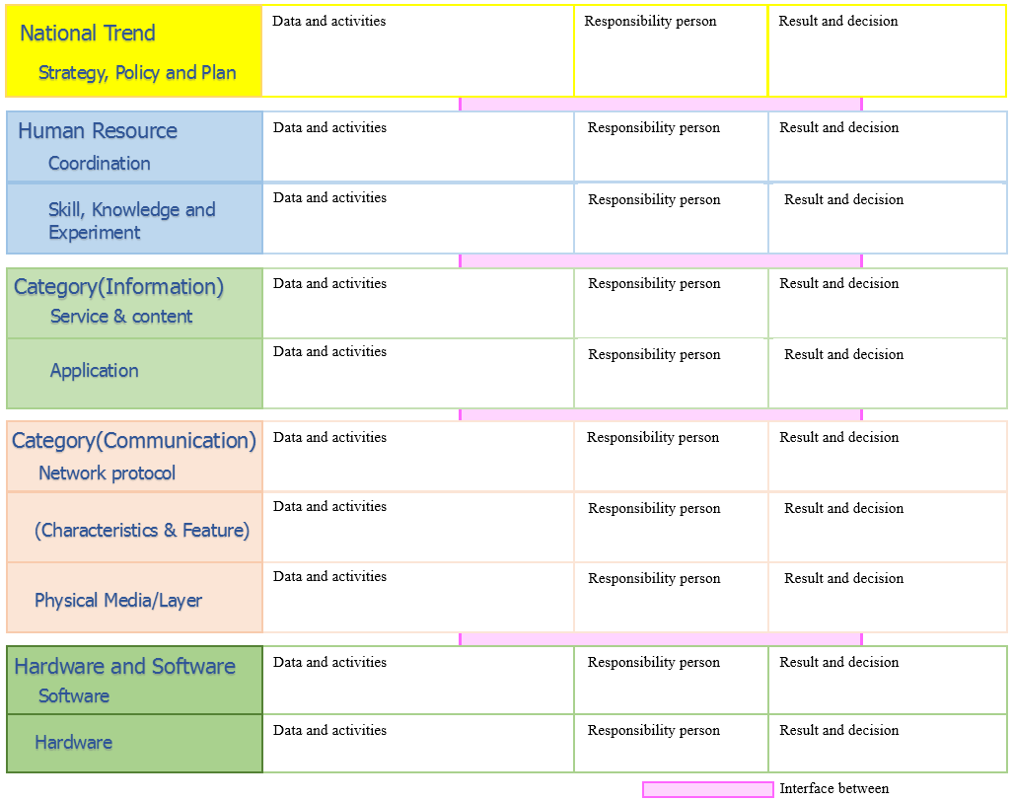
Figure 2 Sample sheet of Key Item

2.4 Classification of key item by each layer model

Grouping of Key Item by each system (Figure 3 Classification and structure) is to reveal the interface and share among those system.

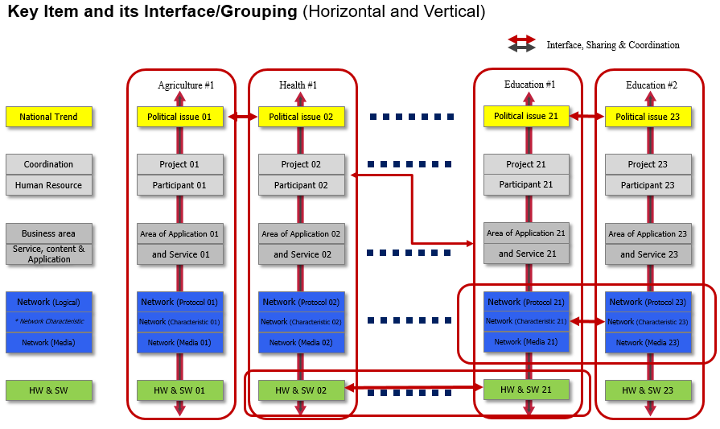
Figure 3 Classification and structure

2.5 Interface connection by Horizontal and Vertical

Interface has bridging with two Key Item boxes, horizontally within the category and vertically only one step up or down, neither two up/down (Figure 4 Interface between two key items).

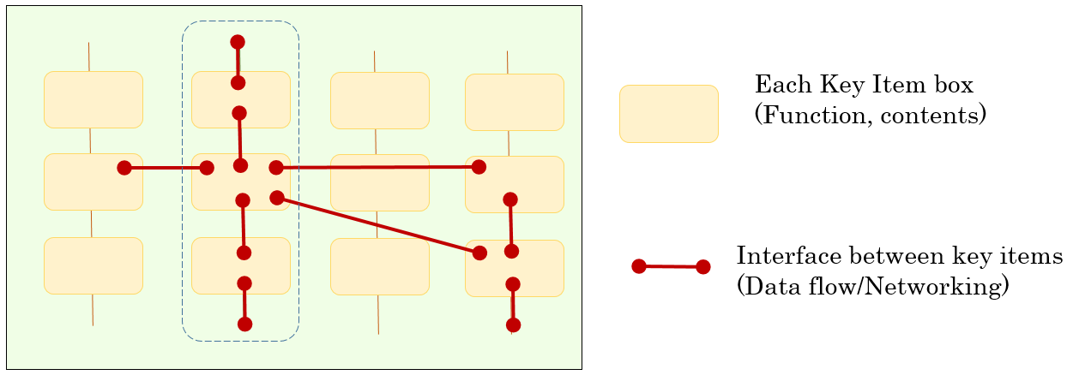
Figure 4 Interface between two key items

3. Process Methodology

3.1 Scope
To improve the plan and operation of ICT activities and solution, the improvement should be considered in the life cycle.

3.2 PDCA Cycle Approach

Based on famous methodology “PDCA methodology”, the Implementation flow of the project and improvement of quality (Figure 5 Implementation flow) is shown as revised “Plan Do Check Act (PDCA)” for ICT development project activities. This cycle is not originated from ICT technologies but oriented by essential issues and requirement, because we should consider ICT must be tool of the business not main business in most case.
In order to make the system suitable and affordable operation with sustainability, you shall choose best technology/operation by applying “Appropriately Technology” methodology.

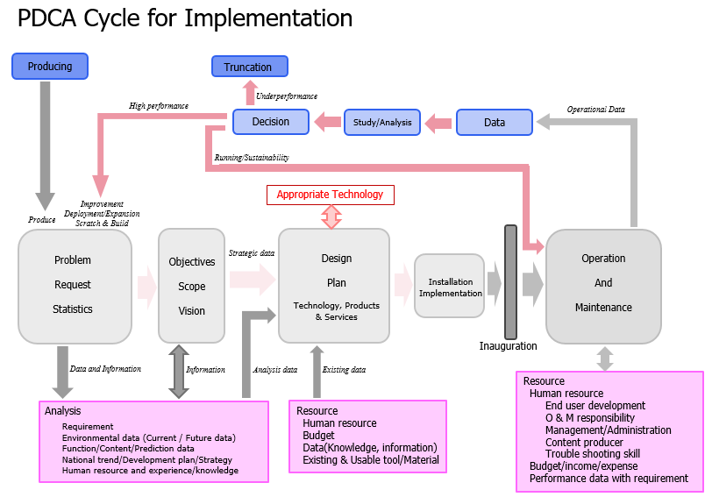
Figure 5 Implementation flow

4. Appropriate Technology

Appropriate Technology is not introduction of future, latest and sophisticated technology. Appropriate Technology means that, based on your determination of the quality of whole system and its operation, you should choose the most APPROPRIATE technology/method by evaluating potential products, technologies, methods, human resources and etc., refer to data and information of each Key Item from where you could get and study in design.

Following your determination of the location where you will install the ICT system;

- Determination of Quality and Reliability reckoned with human skill of person involved, of this system
Determination of Sustainability of installed equipment/product (Expected operation period, *not whole system sustainability)

- Evaluation of affordable operation (Budget for Installation and Running, Cash flow of income and expense)

For instance, Service Quality of telecom network in populated area is designed based on high performance and reliability such as not allowed even few second disturbance, thus, the cost of installation and operation has become too expensive, compared with its impact. On other hand, even usage charge of Internet would be hardly prepared the budget in rural areas. However, discussion with rural area people where there is no telecom network, people there can keep tolerance to wait according to their life style. That means issue of “existence or nonexistence”. Therefore, cost in rural is very important rather than quality because presence of ICT with their budget is significantly important rather than waiting installation of high reliable system in long time.

In addition, it is indeed that new and latest technology gives lots of benefit to community in advance and urban areas. However, in rural areas, relevant people may not know and may not have the skills and knowledge of design, installation, operation and troubleshooting. Even, lack of responsible management personnel.

Therefore, refer to local condition, parameter, and information from top to bottom at the installed area, you have to choose legacy and matured technology (product) as well as latest and sophisticated, after you determine the quality of the installed system. This way of designing project (effectively and affordably) is the main issue of appropriate technology.

5. Development, Introduction and Deployment

Following are considerations in design and development:

1. Categorization, study and analysis of Key Item, in parallel correcting data and information of demand, provision, seed/need and technology(product/service)
2. Line up possible, affordable and potential product/service/content/work flow/ regulation/etc. in each Key Item
3. Determination of quality and decision of affordable expense for sustainability
4. Selection, one of above line-ups by applying the Appropriate Technology Method

After analysis and design
5. Introduction of your designed system (not only focused on technology)
6. Inauguration including demonstration with several type of operation training
7. Applying PDCA cycle, to be checked performance of system and motivation of sustainability in some adequate interval.

Decision of deployment, sustain without change or discontinuation
8. At adequate interval, by evaluating the performance and motivation of sustainability, including the budgetary constraint, it should make decision of deployment/truncation and then announced this decision.

6. Conclusion

In this guideline, refer to your analysis and study in wide area beyond ICT including on-site statistics and condition (not imitate the case study at other place but only study), the quality of introducing system should be determined by leverage of expense and benefit to be sustained. This quality should not be determined by applying common sense of past ICT activities, but the design of the system should be determined by him/her self with responsibility.

Especially, the system in rural area will be required of the administrative social system with higher level of authorization (such like government or politics) as well as local leadership.

This guideline could be supportable in making the sustainable and valuable project with greater results, systematically, easily and less time, for the Bridging Standardization Gap (BSG) and Bridging Digital Divide (BDD)

It is pronounced g-noo, as one syllable with no vowel sound between the g and the n.
Plan–Do–Check–Act or Plan–Do–Check–Adjust (PDCA) is an interactive four-step management method used in business for the expansion and continuous improvement of processes and products.

