[Home (evident-thrush-whole.ngrok-free.app)](https://evident-thrush-whole.ngrok-free.app/apt/about-principal-management)

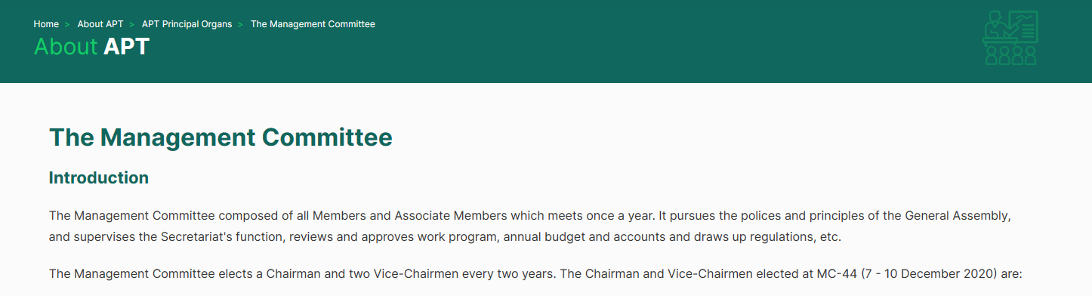

(List)Related Documents

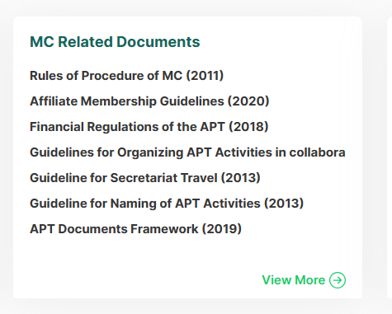

[work-satrc (evident-thrush-whole.ngrok-free.app)](https://evident-thrush-whole.ngrok-free.app/apt/work-policy-satrc)

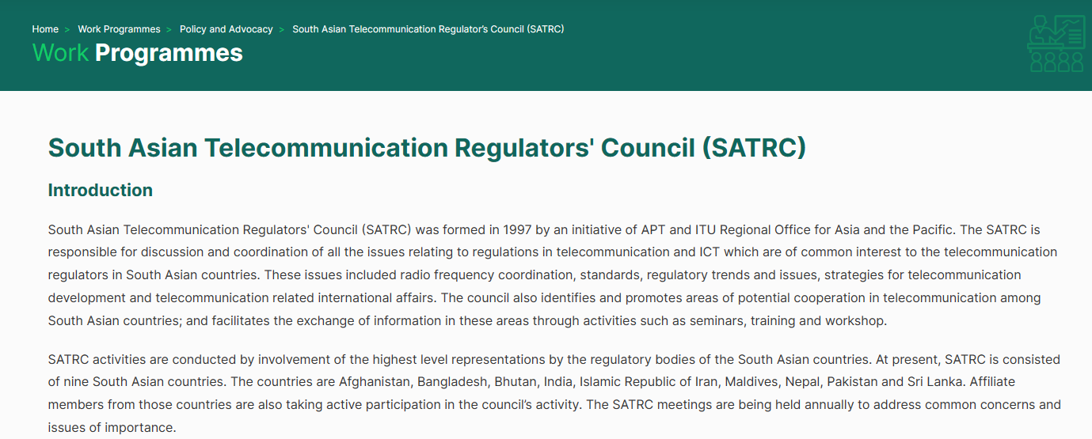

SATRC

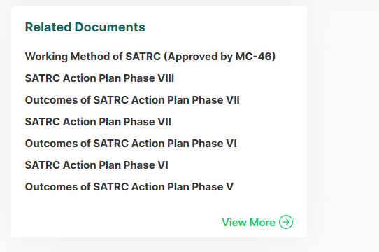

[work-prfp (evident-thrush-whole.ngrok-free.app)](https://evident-thrush-whole.ngrok-free.app/apt/work-policy-prfp)



Report prfp

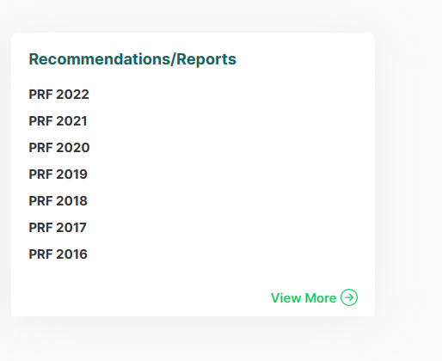

Relate prfp doc

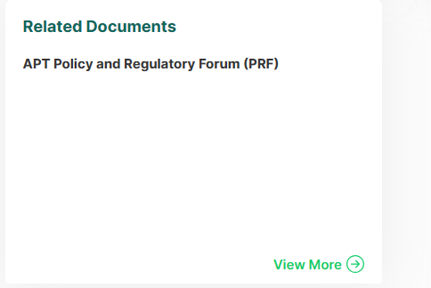

[Home (evident-thrush-whole.ngrok-free.app)](https://evident-thrush-whole.ngrok-free.app/apt/work-policy-prf)

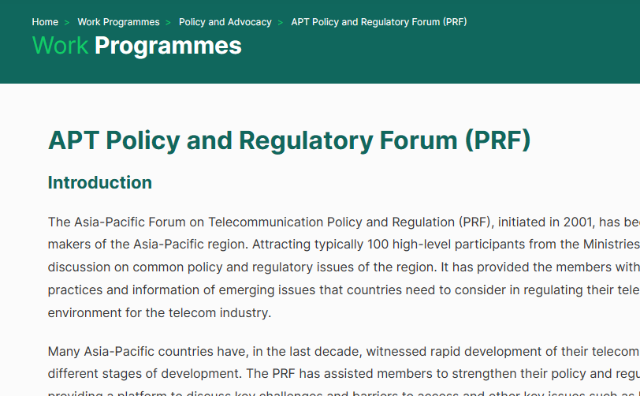

Prf report

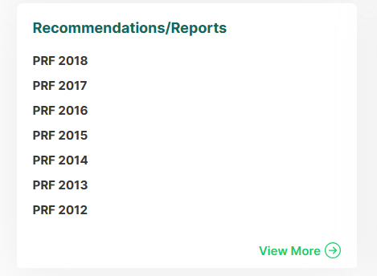

Relate prf doc

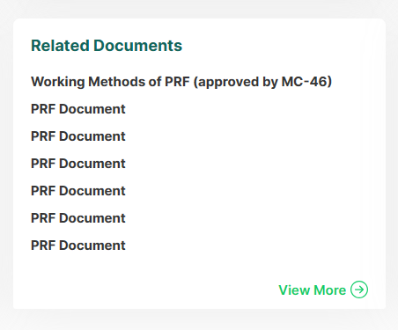

Prf circular letters

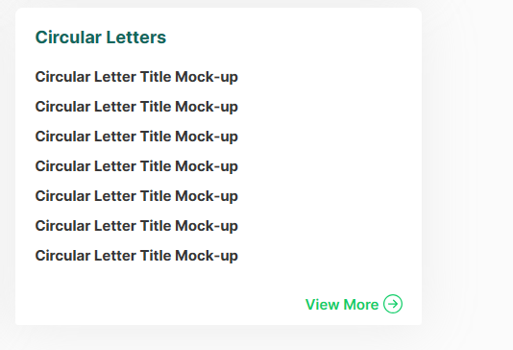

[Technical_ASTAP (evident-thrush-whole.ngrok-free.app)](https://evident-thrush-whole.ngrok-free.app/apt/work-technical-astap)

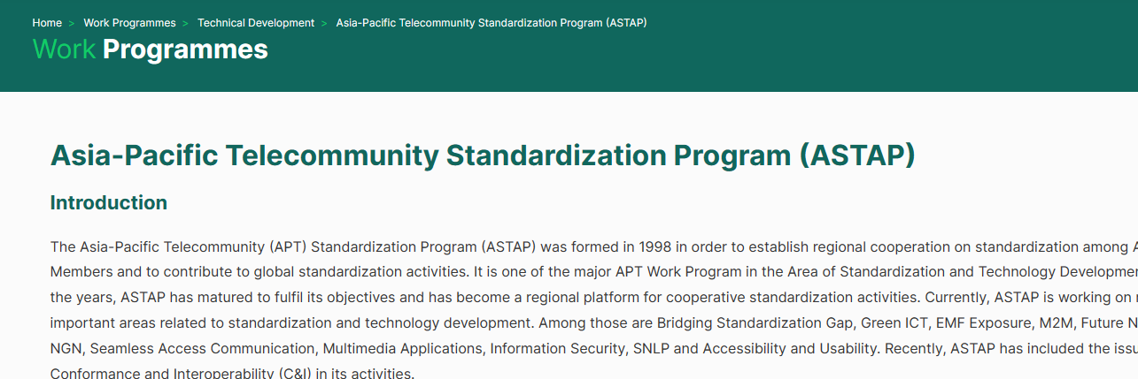

Relate astap doc

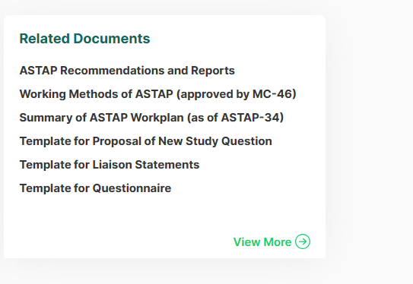

Circular astap letters

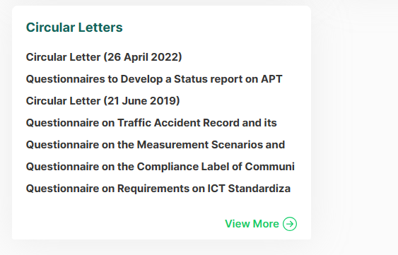

[Technical_AWG (evident-thrush-whole.ngrok-free.app)](https://evident-thrush-whole.ngrok-free.app/apt/work-technical-awg)

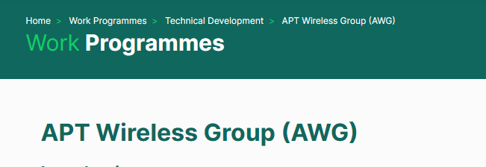

AWG doc

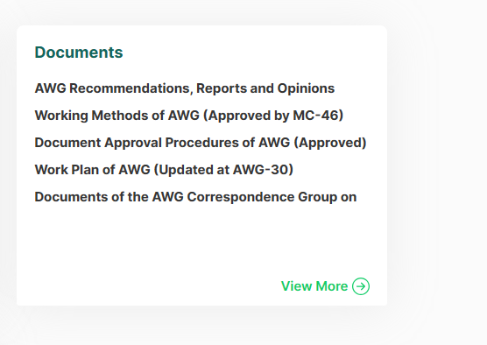

##### AWG Circular Letters

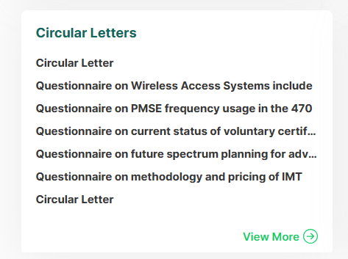

[Work-Capacity (evident-thrush-whole.ngrok-free.app)](https://evident-thrush-whole.ngrok-free.app/apt/work-capacity)

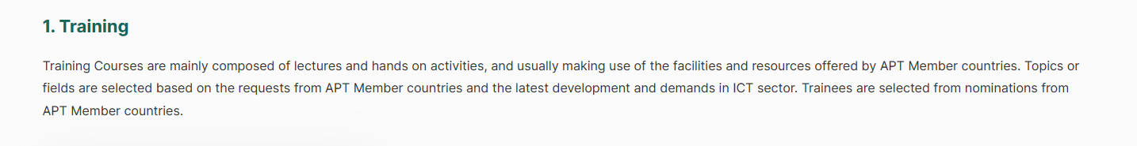

Training

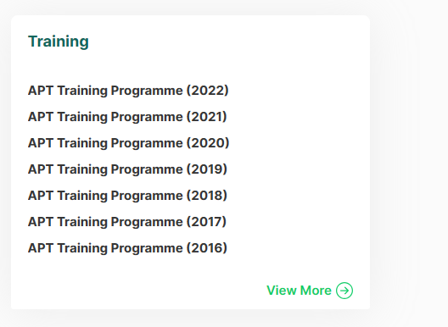

Misson

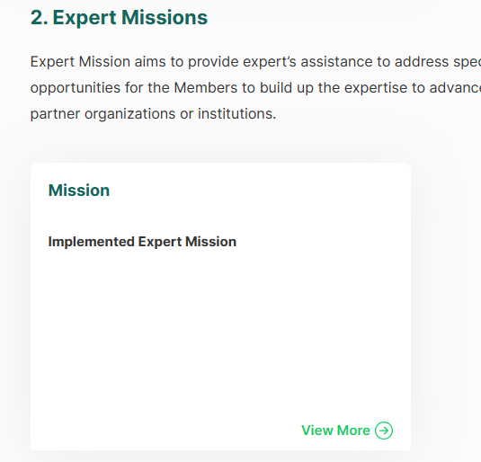

Aptyps

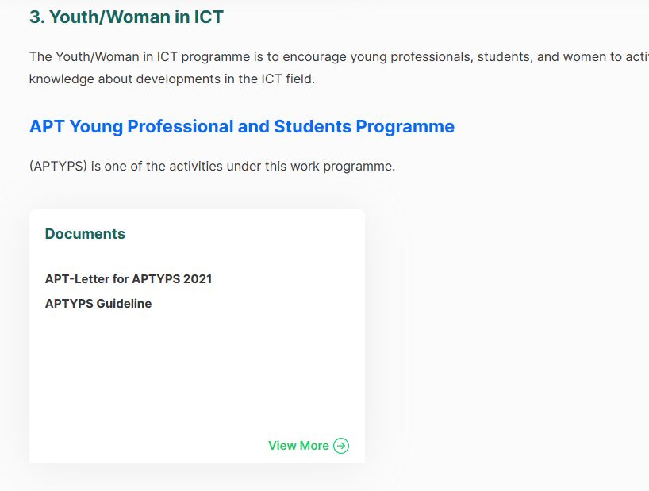

Scholarship

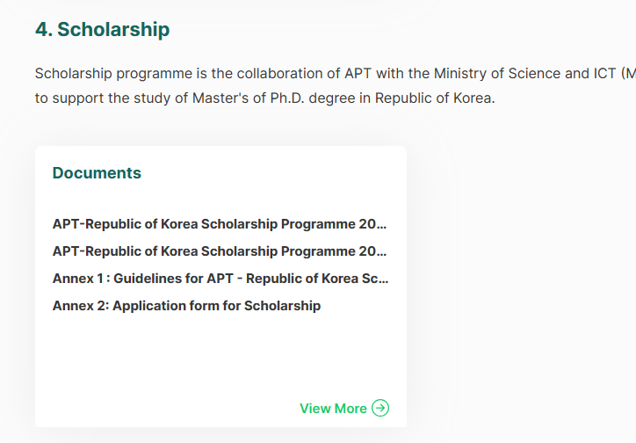

Volunteer

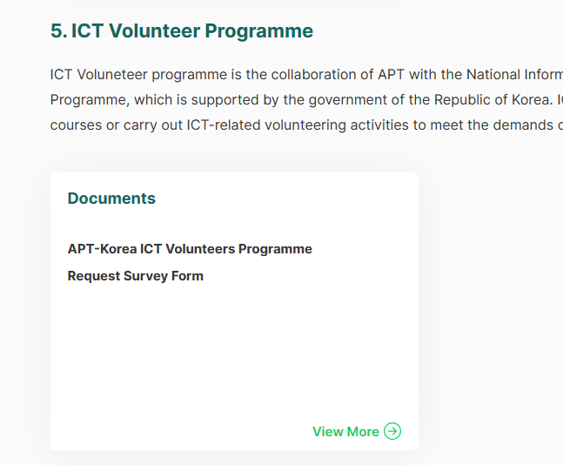

Relate doc workshop (loging user only)

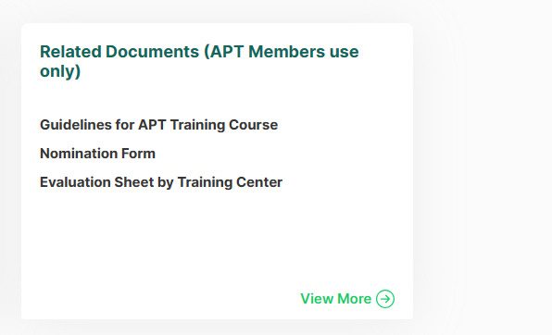

[Work-ICT (evident-thrush-whole.ngrok-free.app)](https://evident-thrush-whole.ngrok-free.app/apt/work-ict)



Apt regional workshop

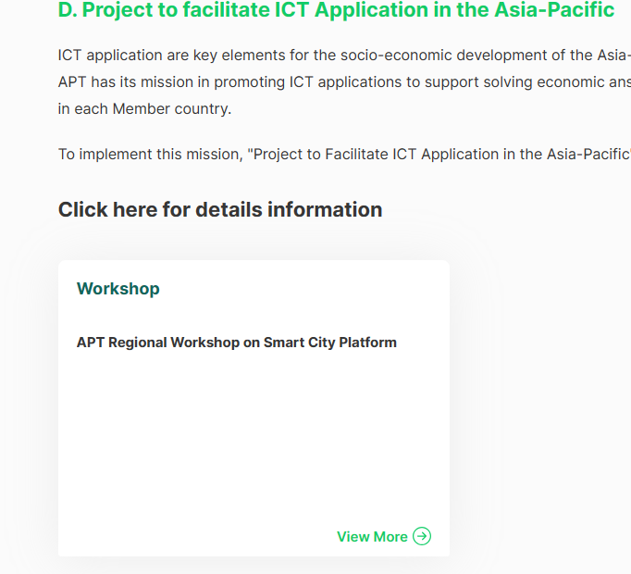

Implement project 2015

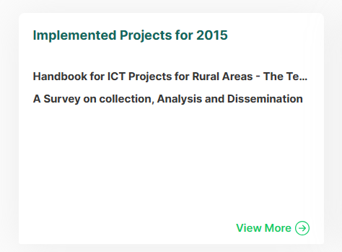

Implement project 2016



Adf doc



Work ict related link

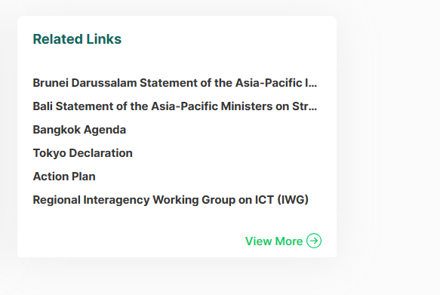

[Work-Activities (evident-thrush-whole.ngrok-free.app)](https://evident-thrush-whole.ngrok-free.app/apt/work-activities-pp)

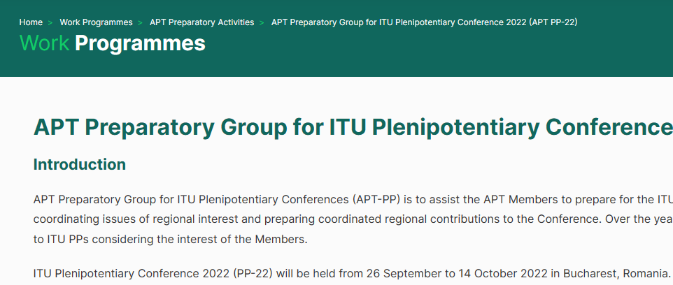

Pp relevant

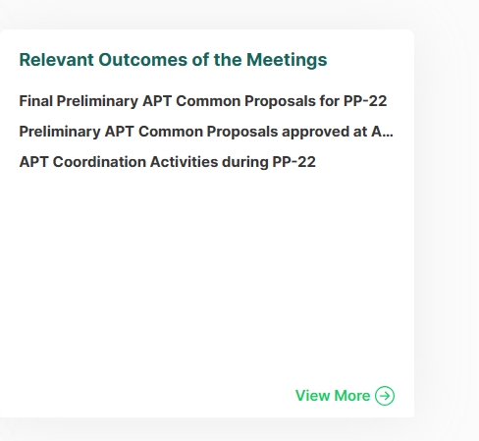

Pp circular doc

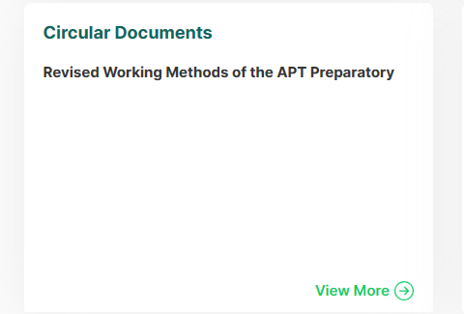

[Work-Activities (evident-thrush-whole.ngrok-free.app)](https://evident-thrush-whole.ngrok-free.app/apt/work-activities-wrc)

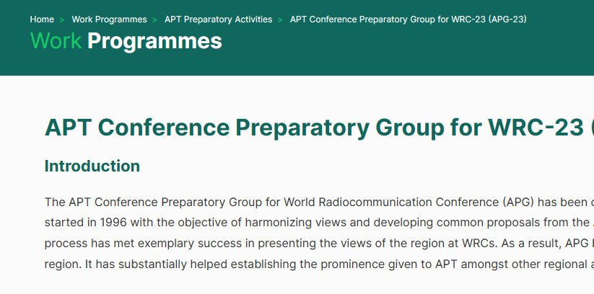

Wrc doc

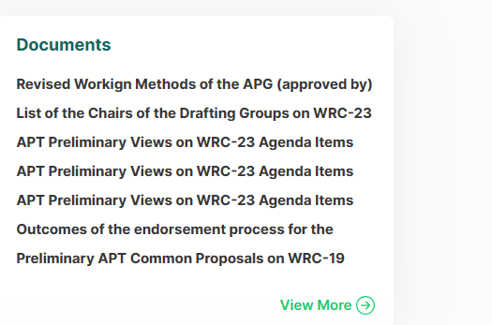

Apg circulars

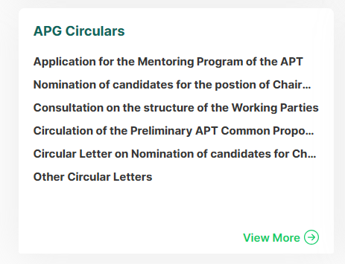

Wrc relate doc

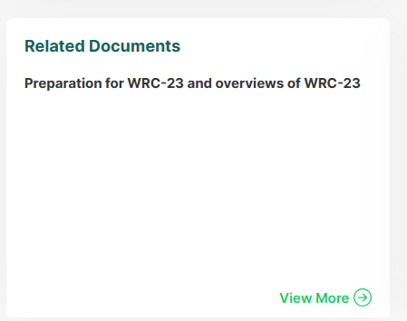

Wrc relate link

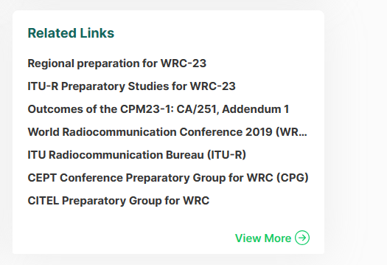

[Work-Activities (evident-thrush-whole.ngrok-free.app)](https://evident-thrush-whole.ngrok-free.app/apt/work-activities-wtdc)

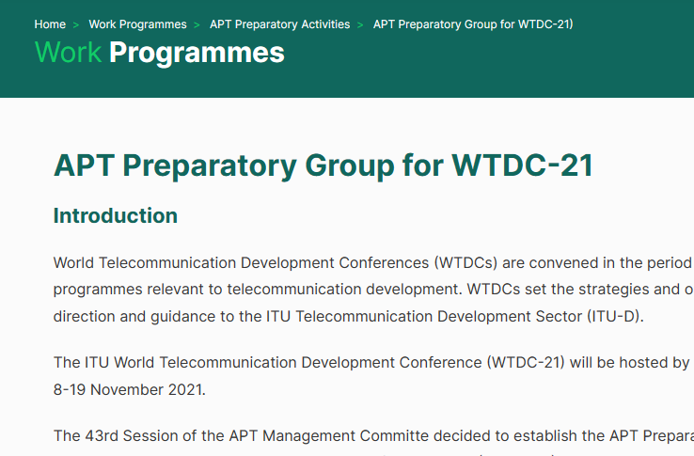

Wtdc ouycome

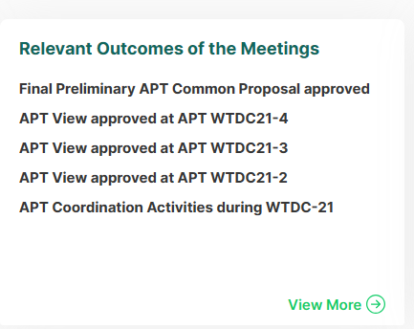

Wtdc working method

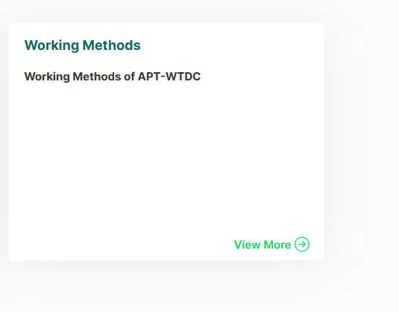

[Work-Activities (evident-thrush-whole.ngrok-free.app)](https://evident-thrush-whole.ngrok-free.app/apt/work-activities-wtsa)

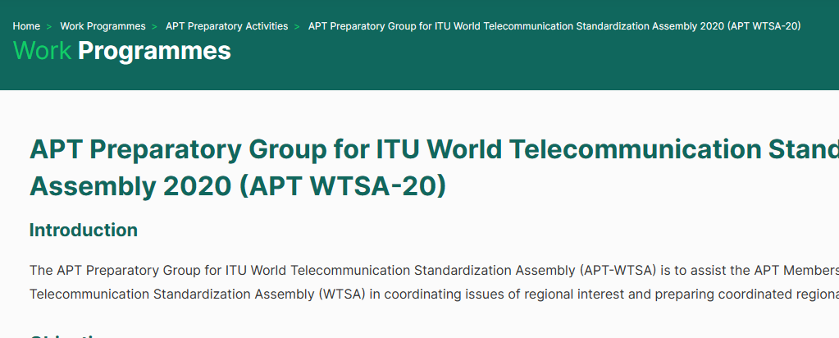

Wtsa doc

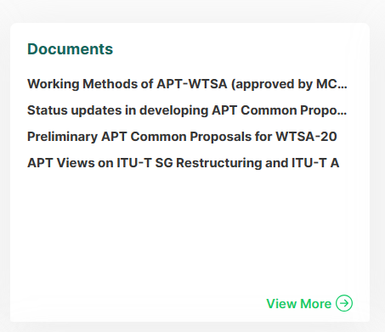

Wtsa outcome



Wtsa related link

