ASIA-PACIFIC TELECOMMUNITY
SOUTH ASIAN TELECOMMUNICATIONS REGULATOR’S COUNCIL (SATRC)

SATRC REPORT ON
POLICY, REGULATORY AND TECHNICAL ASPECTS OF OTT SERVICES IN SATRC COUNTRIES

Prepared by
SATRC Working Group on Policy, Regulation and Services

Adopted by
17th Meeting of the South Asian Telecommunications Regulator’s Council
4 - 6 October 2016, Dhaka, Bangladesh

Table of Content
Abbreviations
Executive Summary
Chapter-1: Introduction
  - Background
  - Objectives
  - Scope of work
  - Time frame
  - Deliverable
  - Methodology
  - Organization of the guideline/report
Chapter-2: Technical aspects of OTT services
- Definition of OTT services
- Classification of OTT services
- Technical aspects of OTT services
- Growth of OTT services
- Drivers of OTT services
- Benefits of OTT services
Chapter-3: Impact of OTT services
- Impact of OTT services on data traffic and associated demands on network infrastructure
- Impact of OTT services on traditional revenue stream (i.e. voice and SMS) of telecom/mobile operators
Chapter-4: Policy and regulatory aspects of OTT services
- The need to formulate regulatory framework for OTT services
- Level Playing field
- Regulatory imbalances created by OTT players offering real-time OTT communication services
  - Licensing
  - Operating area
  - Quality of service
  - Numbering and Interconnection
  - Infrastructure and investment
  - Provision of Legal intercept
  - Taxation
Chapter-5: Challenges in OTT service environment
- Security concerns associated with OTT services
- Privacy concerns associated with OTT services
- Copyright issues associated with OTT services
- Net neutrality
Chapter-6: Business models for TSPs/Mobile operators and OTT players
- OTT players paying to Telecom/mobile network operators
- Differential pricing for data access and OTT services
Chapter-7: Suggestions and Conclusion
References
Annex-1: Questionnaire
Annex-2 Response of the questionnaire
Abbreviations

CDN: Content Delivery Network
ISPs: Internet Service Providers
LTE: Long term evolution
OTT: Over-the-top
PSTN: Public switched telephone network
PLMN: Public land mobile network
TSPs: Telecommunication Service Providers
VoIP: Voice over internet protocol

Executive Summary
The proliferation of IP-based telecommunication networks has facilitated the decoupling of application and network layers and enabled OTT providers to deliver their content and applications directly to end users. Structural change always leads to the need for new business models, for a letting go of old practices and the welcoming of new opportunities. OTT providers are “free riders” on the internet access network. However, the telecom or mobile network operators are paid for the transport of the data- may be a flat rate or volume based charged from the users.
OTT providers create commercial as well as technical problems to Telecom/mobile operators and Internet service providers by using their flat rate tariff capacity to provide services, often free of charge, in direct competition to the telecom service providers (TSPs)/mobile/ISP services, thus eroding some of their most important revenue sources e.g. international telephony and SMS services etc.
While the competition provided by the OTT application providers does lead to disruption, a functional market should be able to adapt to the new situation. The TSPs or mobile operators should change their tariff plans in line with market demand. If this does not happening, then competition is apparently dysfunctional.
This study shows that similar situation is found throughout the world and for which there is not yet a patent solution. The root cause apparently lies in flat rate tariffs and non-sustainable competition from OTT players and regulatory obligations which make it impossible for the TSPs or mobile operators to react freely to the commercial changes demanded of them.
For the proliferation the broadband services and increase broadband penetration, there should not any banning approach, for at least in developing countries. The OTT services create value for the use of bandwidth to its users. The smart-phone penetration may still be in infancy in the developing countries. The study shows that, fixed and mobile broadband services and networks, SATRC member countries, are in growing stage and has not become ubiquitous. The broadband penetration is still very low. Therefore, some form of partnership will be required with OTT service providers taking into considerations of both security and privacy issues.

CHAPTER I- INTRODUCTION
  - Background
The 15th South Asian Telecommunication Regulator’s Council (SATRC-15) meeting held in Paro, Bhutan (from 05 to 07 August 2014) adopted SATRC Action Plan Phase V and identified “Policy, Regulatory and Technical Aspect of OTT Services in SATRC Countries”, as one of the work items to be studied under the Working Group on Policy, Regulation and Services.
“Incumbent” telecommunications operators that offer services such as fixed and mobile telephony, broadband and pay TV services, among others, are being invaded by online content, specifically those known as over-the-top (OTT) applications, services and content. The best known examples of OTT are Skype, Whatsapp, online video games and movies (Netflix, Pandora). A fundamental characteristic of OTTs is that the Internet Service Provider (ISP) does not profit nor is involved in the distribution of the OTT applications, services and content. Furthermore, in general, OTT suppliers, which need the ISP infrastructure to reach the user, offer products that compete with the services offered by the ISPs (voice, instant messaging, online TV).
OTT services are enabled by the de-layering of the industry. IP has separated carriage from content and allowed ‘over-the-top’ content and applications providers to deal directly with end users over networks whose owners and operators are excluded from these transactions. The move to LTE’s all-IP architecture will create a more open environment for these OTT providers and third party services.
It is not only telecommunications that is affected. Internet television over broadband fixed and mobile networks is de-stabilizing existing broadcasting industries.
Internet telephony, or “Voice over the Internet Protocol” (VoIP), is the first ‘over-the-top’ (OTT) service with major implications for the business models of both fixed and mobile network operators. More recently, text messages (SMS) have also been delivered OTT affecting the revenues of fixed and mobile operators.

  - Objectives
The objectives of the study include but not limited to the followings:
- To identify the definition for OTT services
- To identify and study different issues (policy, regulatory and technical aspects) related to OTT services
- To assess the status of the OTTs in the SATRC member countries
- To study the global trends in regards to OTT services
- To make recommendations based on this study

  - Scope of work
The scope of this study includes but not limited to the followings:
- Identify the different types of OTT services currently being offered in the international as well as SATRC countries
- Investigate the policy related issues associated with the OTT services
- Investigate the regulatory issues associated with the provisioning of OTT services
- Recommend how the operators can change or adapt to a different business models to deal with OTTs
- Recommend to Policy maker, regulators on issues pertaining to OTTs

  - Time frame
The Action Plan Phase V adopted by the 15th SATRC meeting in Paro, Bhutan has its implementation period from 2014 – 2016 and the same would be the time frame for the study of this work item.

  - Deliverables
The deliverable of this study is a guideline/report on policy, regulatory and technical aspects of OTT services useful for policy makers, regulators and the operators in SATRC member countries.

  - Methodology
To prepare this guideline/report, WG meetings and workshop was held and knowledge and experiences were shared among the domain experts. Also, a questionnaire was developed and circulated to member countries for their feedback on the various issues related to this work item. The literatures available in the internet and relevant ITU/APT reports/guidelines/regulations were studied.

  - Organization of the guideline/report
This guideline/report comprises of seven chapters. Chapter-1 is about the background of this work item of policy, regulation and services. Chapter-2 deals with technical aspects of OTT services whereas the impact of OTT is discussed in chapter-6. Policy and regulatory aspects of OTT are dealt in chapter-4 whereas chapter-5 discusses on challenges in OTT service environment. Chapter-6 describes the business models for sustainable OTT services and chapter-7 concludes the study along with necessary suggestions. In every chapter, the analysis of the response of questions is presented.

CHAPTER II- TECHNICAL ASPECTS OF OTT SERVICES
- Definition of OTT services
The term OTT refers to applications and services which are accessible over the internet and ride on operators’ networks offering internet access services. Viber, Skype, WhatsApp, GoogleTalk, Facebook, Instagram, Netflix are the few examples of OTT application and services.
OECD (Organization for Economic Co-operation and Development) Communications Outlook 2013, has described OTT services as “video, voice and other services provided over the Internet rather than solely over the provider’s own managed network”.
Due to Internet Protocol (IP), an underlying technology of the Internet, it has been possible to separate carriage from the content and this has allowed OTT content and application providers to deal directly with end users of networks whose owners and operators are excluded from these transactions. The move to Long Term Evolution (LTE) technology’s all-IP architecture will further facilitate this delinking and create more open environment for OTT providers and third party services.
Thus, we see OTT providers are not required to establish and do not establish, operate and own a network but dependent on the public or global internet and access network speed (ranging from several Kilobits per second to Megabits per second) of the users to provide messaging, voice, video or application services and reach users (riding on other network).
SATRC member countries status
The questionnaire circulated consists of a question regarding the definition of OTT services that whether it is defined by the SATRC member countries or not. The responses received shows that it has not been defined by the respective administrations. The member countries are planning to define it and will be following the ITU or industry definition. The member countries have suggested the following definition for OTT services:
“Over-the-Top (OTT) refers to applications and services which are accessible over the internet and ride on operators’ networks offering internet access services”.

- Classification of OTT services
A wide variety of OTT services are available and they can be broadly classified into three categories:
- OTT Voice and Messaging Services (Communication Services) e.g. Viber, Skype, WhatsApp, WeChat, GoogleTalk etc
- OTT Media Services (Video and Audio content) e.g. youtube, Netflix, Pandora, Spotify etc.
- OTT Applications (mainly non-real time) like social networking, e-commerce, e-health, e-education apps etc.
The characteristics of these OTT services also allow us to classify into two categories:
- Real-time OTT application and services or Communication Services (Voice, Video and Messaging)
- Non-real time OTT application and services (Social networking apps, e-commerce, e-health, e-education apps etc.)
OTT Communication refers to real time voice, video and messaging services which are primarily concerned with communication applications but use internet as the transport medium rather than the legacy telephony infrastructure.
SATRC member countries status
A question regarding the classification of OTT services has been circulated to SATRC member countries and the responses received shows that it has not been classified by the respective administrations. The member countries are planning to classify it and will be following the ITU or industry classification. The member countries, however, would consider the following classification for OTT services while formulating regulatory framework for OTT services:
- Real-time OTT Services or Communication Services like OTT voice, video and messaging services
- Non real-time OTT Services or Non-communication Services like social networking apps (Facebook, Twitter), Youtube, Netflix, e-commerce, e-health, content providers etc.

- Technical aspects of OTT services
There can be many national and international OTT service providers and hence the OTT service providers have distributed infrastructure around the globe. The Telecommunication Service Providers’ or Internet Service Providers’ network works as medium for OTT provider to connect end users for OTT services. OTT services are delivered and accessible through the internet access of such network or infrastructure providers.
OTT players can access customers or end-users in two different ways viz. utilizing (i) the TSPs or mobile operators’ network and (ii) ISPs or Wifi network operators. The Figure – 1, below shows that OTT services ride over the top of the telecom pipe which is connected to the user device through mobile networks or fixed line. In this case, the TSP also acts as an Internet Service Provider (ISP) providing last mile connectivity and bandwidth. The OTT service could also ride over the bandwidth provided by the Wi-Fi operator or a cable operator. The last mile connectivity in this case will be that of Wi-Fi hot spots or a cable TV connected to the customer. This Wi-Fi operator could also be a bandwidth provider connected to the internet via an ISP or through different technologies like TV white spaces.
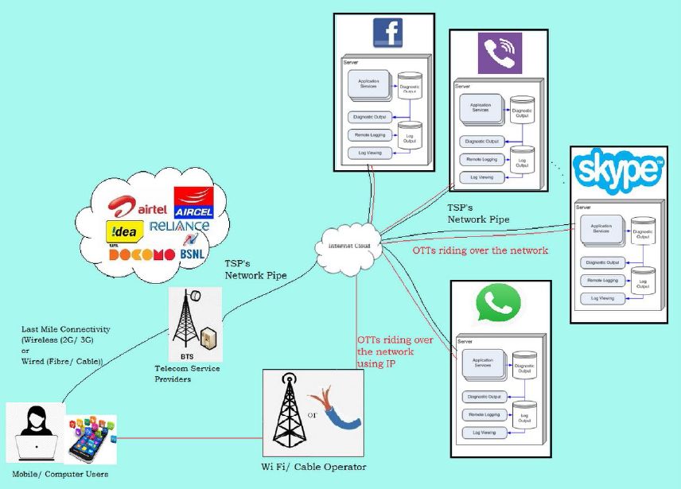
Figure –1, OTT services riding over TSPs/mobile operator/ISPs network
(Source: Consultation Paper on Regulatory Framework for Over-the-top (OTT) services, TRAI, India)
SATRC member countries response
There was one question targeted to identification of OTT service architecture and its implementation. The responses obtained shows that OTT services are implemented through over the top applications for which specific license or approval is not granted.
The OTT applications/services in Pakistan are delivered through using existing internet/data layer of mobile & fixed operators/bandwidth providers. Majority of the OTT services are foreign based, i.e. Whatsapp, Viber, Skype etc. Some of the operators are considering inclusion. PTCL has recently launched one app called Smart link which offers app to app call, IM, app to PSTN/PLMN & vice versa calling in addition to smart TV channels coupled with the some infotainment services such as flight inquiry...etc.
OTT runs on the existing 3G and 4G network which are mainly comprises of Microwave backbone and Optical fiber links. People gets access to OTT services through the mobile (user -> BTS/NodeB -> BSC/RNC -> SGSN -> GGSN – Internet cloud -> App server) or fixed operators broadband network.

- Growth of OTT services
2.4.1 OTT voice and video services
OTT voice and video services are becoming increasingly popular facilitated by flat rate data plans, free WiFi and a host of features available in Smartphone such as video calling. OTT voice and video, therefore, has been a popular alternative to the traditional phone call whether mobile or fixed which enhances user experience. The figure-2 and figure-3 below shows the growth of the OTT voice and video services.
Figure-2, Growth of OTT voice/video services
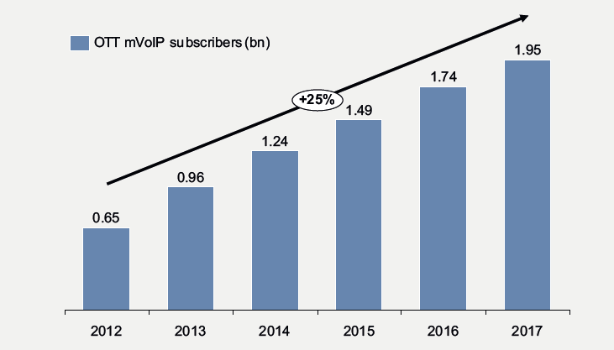
Figure-3, Global OTT mVoIP subscribers
2.4.2 OTT messaging services
OTT messaging services has shown even very strong growth compared to OTT voice. This is because of the low bandwidth requirement, better feature set (sending text, audio and graphical content) and very low cost or free messaging services. This growth is also driven by the younger generation, who prefer the rich text and graphic messaging. The figure-4 below shows the growth of the OTT messaging services.
Figure-4, Growth of OTT Messaging services
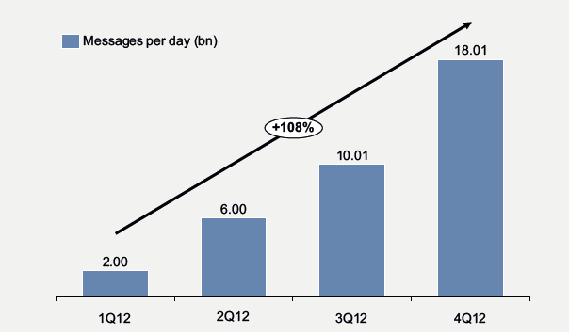
Figure-5, Total In-bound and Out-bound messages processed per day

Figure-5 above shows that a CAGR of 108% over four quarters has been observed while examining the total traffic (messages per day) of four players viz. iMessage, WhatsApp, Kakaotalk and WeChat.

2.4.3 OTT media services
OTT Media refers to video and audio content being streamed and/ or downloaded over the internet. IPTV is not considered as OTT media as it uses dedicated IP channels for content and is not characterized as best effort. OTT media can be broadly classified into
- Video
  - User generated video
  - Produced content

- Audio
An increasing amount of internet traffic will take a form of video traffic with the proliferation of mobile devices (Smartphones including larger forms such as tablets) and pervasiveness of fixed/mobile broadband networks. The figure-6 below shows the growth of the OTT media.
Figure-6, Growth of OTT Media
OTT Media has shown the strongest growth over the past few years as high speed broadband (in excess of 10 Mbps on fixed and >1 Mbps on mobile) has become a reality in many countries. This has not only been simple user generated content which continues to flourish, but also premium content being delivered over the internet from the likes of Netflix and Hulu. Over 30% of all internet traffic is now streaming media. In developed markets this is close to 50%.
Figure-7 below shows the growth in the hours of videos uploaded on Youtube per minute. This has resulted in telecom/mobile network providers investing heavily to be better able to carry this traffic.
Figure-7, Hours of video uploaded per minute in Youtube
- Drivers of OTT services
The growth of OTT services as discussed above over the past few years can be attributed to several factors including but not limited to the followings:
- Free services - attractive business models, peer-to-peer services such as Viber-to-Viber and Skype-to-Skype services.
- Continued increase in penetration of Smartphone – the penetration is expected to exceed 50% by 2016 globally and lower cost models/handsets are entering the market, thus reducing barriers to entry.
- Decreasing trend of data prices for both mobile and fixed services.
- Proliferation of broadband network and availability of WiFi hotspots (often ‘free’) allowing users to make and receive calls at no cost.
- Presence of single OS platform -The presence of a single OS platform with a large share of the population e.g. Android- this will facilitate to reach a large number of users in very short time and strengthen the OTTs specific to that OS.
- Scalability of services- OTT players can develop and launch new services without investing in or developing communication infrastructure.
- Cloud service also acts as driver for OTT services. The general idea of the ‘Cloud’ is to store content on a server that can be reached through the internet so that the content can be accessed from any device anywhere, as against leaving it on a hard drive. Apple, Google, Amazon, Microsoft and Dropbox offer various kinds of Cloud services.

- Benefits of OTT services
The internet is growing very rapidly. It has become pervasive and transforming the way people work, play and live. This change is not limited to the developed world, but can be seen in increasing in emerging markets as shown in Figure-8 below. The increased internet penetration is as a result of the rise of the mobile internet. The internet is now available to a large segment of people with growing availability of broadband networks, increased competition, and declining data charges. This growth of the internet has enabled the rise of various firms like Google, Facebook and Amazon, who have taken advantage of its ubiquity and reach to develop into global enterprises and become OTT service providers.
Figure-8, Global IP Traffic
If we consider the popularity and growth of the OTT services and its contribution in increasing the internet traffic, the following can be considered as benefits of OTT services:
- OTT is driving the growth of broadband.
- OTT is creating value for bandwidth or network (utilization).
- OTT is creating an environment for innovation and opened up new avenues for OTT applications like Cloud Services.
- E-Commerce, M-Commerce, E-Health, E-Education emerging in the form of OTT services.
- According to Ericsson, globally the number of smart phone subscriptions is expected to exceed 4 billion by 2018 while mobile broadband subscriptions are projected to reach 7 billion in 2018.
- OTT service results in growth of IP traffic and overall revenue.
CHAPTER III – IMPACT OF OTT SERVICES
- Impact of OTT services on data traffic and associated demands on network infrastructure
With ubiquitous presence of high speed broadband networks and the large number of Smartphone users, there will be greater and greater shift of subscribers from traditional telephony or mobile to OTT communications for voice and video calling. The figure-3 above shows that there is a growth trend of 25% increase of mVoIP subscribers each year. The growth and impact will be limited in developing countries as fixed and mobile broadband networks may be still evolving and Smartphone penetration may still be in its infancy.
The figure-5 described above shows an exponential growth of OTT messaging. This may not continue for an indefinite period. However, it is expected that OTT messaging will replace SMS to a large extent and impact severely in the SMS revenue of the mobile operators.
The primary and largest impact that OTT media has been in the sizeable portion of internet traffic, mainly concerned with streaming media. Infrastructure providers are have to invest massively in higher and higher capacity infrastructure (both access and core) to meet this demand. It impacts TSPs/mobile operators’ business models including flat rate data plans. Nowadays operators are therefore moving away from unlimited (flat rate) data plans to limited data volumes as well as limited data rates and tiered pricing.
Status in SATRC member countries
The responses from member countries for the impact of OTT services on data traffic and associated demands on network infrastructure show that there is significant increase in data traffic due to OTT services and putting demand on network infrastructure.
It is mentioned that in Pakistan the internet bandwidth has increased from 220Gbps in 2013 to 500Gbps in 2015. In case of Nepal, the majority of content consumed in Nepalese market is created or hosted outside Nepal. This demands for higher outbound international bandwidth and driving higher data cost. To reduce bandwidth requirement, TSPs use compressing and caching infrastructure, which is still limited due to encrypted traffic [HTTPS, FTPS] and real time contents (live streaming). This also causes higher requirement in network infrastructure including core network and radio resources. Similar is the situation in other SATRC countries where most of the content comes from developed world.
Due to unpredictable and uncontrollable nature of OTT services, it also impacts on Service Level Agreement (SLA) and Quality of Service (QoS) offered to the user. Additionally OTT services are designed without considering underlying network requirements which creates unnecessary traffic and load in the network.
- Impact of OTT services on traditional revenue stream (i.e. voice and SMS) of telecom/mobile network operators
The characteristics of OTT services are such that TSPs realise revenues solely from the increased data usage of the internet-connected customers. The TSPs do not realise any other revenues, be it for carriage or bandwidth. They are also not involved in planning, selling, or enabling OTT apps. On the other hand, OTT providers make use of the TSPs’ infrastructure to reach their customers and offer products/services that not only make money for them but also compete with the traditional services offered by TSPs.
OTT player who has a global presence will benefit from lower costs per MB for storage and hosting and be able to negotiate better content deals with providers in comparison to small specialized local players. OTT player’s business model is only possible using access provided by TSPs or mobile operators. This has resulted in a revenue loss to TSPs/mobile operator.
These messaging OTT apps have gained the most in countries where the SMS market is the weakest, i.e. the cost of messaging is relatively high rendering these apps attractive to users. According to a study, in Spain in 2012, 63% of Smartphone users were using OTT apps for messaging primarily because the SMS was too highly priced. The OTT apps are popular due to the additional value they add to traditional messaging. Sending videos and images through such messaging platforms has become easier and cheaper when compared with traditional messaging or MMS messaging messages. It is estimated that the worldwide amount of messaging revenue loss to TSPs because of OTT apps will be around $ 50 billion in 2016.
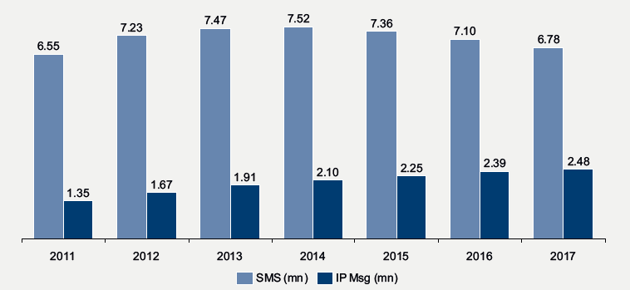
Figure-9, SMS versus OTT messaging
SMS is often quoted as the killer application – but now the “free” alternative is undermining revenues dramatically. In Figure-9 above, it can be seen that worldwide SMS traffic is forecasted to peak by 2014 and then decline. If the same analysis is limited to developed markets, the SMS/ IP substitution has already crossed 25%. A clear impact can be seen in the case of the Dutch operator KPN who analyzed this trend in the Netherlands. According to research, every 10% increase in smart-phone penetration reduces voice and messaging revenues by 0.5 – 0.6%

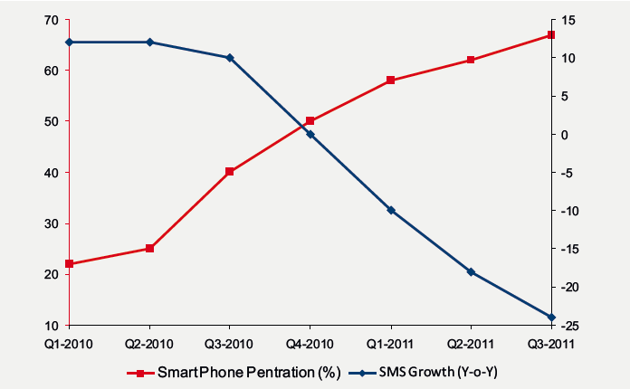

Figure- SMS deline with SmartPhone Growth

Status in SATRC member countries
The impact of growth of OTT services affecting the traditional revenue stream of telecommunication and mobile operators is studied. The revenue of voice and messaging services is referred to as traditional revenue stream of TSPs. The response from member countries shows that with the growth of the OTT services, the traditional revenue stream of TSPs are suffering.
Response received from Maldives shows that traditional streams such as voice (national and IDD) and text messaging has declined over the year and this decline in the past year has been about 10% on voice and 13% on texting (messaging).
However, some member countries also clarifies that this impact is not much significant due to low penetration of mobile and internet and low charging rates for mobile voice communication services. In consultation document from TRAI, India, it has been stated that the impact on voice services is not considerable, mainly, due to the three reasons; firstly, India has one of the lowest voice calling rates (at the rate of Rs.0.40 to 0.60 realised rates) in the world; secondly, the mobile internet penetration is only around 20%, and that too predominantly on 2G; thirdly, the Quality of Service (QoS) of such OTT apps is not as good as traditional voice services offered by TSPs. However, in case of messaging, the consultation document shows that there is declining trend of SMS traffic of the TSPs -the messaging traffic fell from 5346 million in June 2013 to 4367 million in June 2014, a decline of 18.3%. This decrease can be attributed almost entirely to an increase in traffic of OTT messaging apps.
The consultation document of India shows that in the fourth quarter of 2014, Bharti Airtel and Idea Cellular, both Indian TSPs, have shown a significant drop in their messaging and Value Added Service (VAS) revenues as a percentage of total revenues, as shown in Table below.
Table-1, Declining Non Data Revenue of TSPs
(Source: Consultation Paper on Regulatory Framework for Over-the-top (OTT) services, 27th March, 2015, TRAI, India)

CHAPTER IV – POLICY AND REGULATORY ASPECTS
- The need to formulate regulatory framework for OTT services
TRAI, India has published a consultation paper on “Regulatory Framework for Over-the-top (OTT) services” in March, 2015. Other member countries are planning for the same. Formulating a regulatory framework for OTT services requires a careful considerations and understanding of the policy, regulatory and technical issues. Stringent rules and regulations may stifle the growth of the broadband penetration and revenue of the data market revenue.
Status in SATRC member countries
There was a question to collect views of the member countries that whether there is the need to formulate regulatory framework for OTT services. The response of member countries indicates that some are in favour of formulating a regulatory framework whereas others are not at this moment. However, there seems to be consent in views of member countries that there should be some form of partnership or mutual agreements with OTT service providers and monetize the services.
- Level Playing field
OTT voice communication services such as Viber, Skype is becoming increasingly commoditized and is moving towards all IP. With growing implementation of 4G technologies (LTE and LTE-A) network, voice will be transported as packet switched IP-based traffic rather than circuit switched. In effect, both TSPs/mobile operators and OTT players will be offering Voice-over-IP (VoIP) services. The only possible distinction, that may remain, will be the QoS offered.
Status in SATRC member countries
There was a question to collect views of the member countries that whether OTT players offering real-time communication services e.g. voice, messaging and video call services competing in the same market segment as that of mobile operators/telecom operators. The response shows that the member countries agree that the OTT communication service providers are offering the same product as that of TSPs and competing in the same market segment.
There was a question to collect views of the member countries that whether OTT communication service providers’ i.e. OTT voice, video and messaging service providers’ (real-time) be treated similar as TSPs and be licensed. The response shows that the views of member countries are not same. Some have opined they should be licensed as TSPs for creating level playing field and for sustainability of TSPs in the long run whereas some has argued that OTT players would not come in small economies if provision for licensing is made.
- Regulatory imbalances created by OTT players offering real-time communication services
The response from the member countries shows that OTT players offering real-time communication services e.g. voice, messaging and video call services are competing in the same market segment as that of mobile and fixed line operators. Therefore, this has created regulatory imbalances between OTT providers and licensed TSPs.
The regulatory imbalances between OTT players and Telecom operators are identified as follows:
- Licensing: Telecom operators have to take license for running their operation whereas the OTT players are running the operation through telecoms infrastructure but they don’t need license for running their operations.

- Operating area: Telecom operators are only serving customers within the regulated jurisdiction whereas the OTT service providers are serving all over the globe.

- Quality of Services: Telecom operators have QoS bindings as per the license. But OTTs have no bindings to maintain certain level of QoS.

- Numbering and Interconnection: Interconnection is mandated for the operators for enabling any subscriber to any subscriber call or establishing and protecting consumer right. OTTs don’t have any interconnection requirements.

- Infrastructure/Investment: Telecom operators are investing huge amounts for building their network/infrastructures but OTTs are only riding over their network and running their business.

- Provision of Legal Intercept: Provision of legal intercept is a requirement of the licensing terms for the TSPs. But for OTT players it has not made mandatory.

- Taxation: Mobile operators are paying huge amount of corporate Tax whereas the OTT players are not obliged to any Taxes.
.
The response shows that recently Bangladesh Government has discussion with Facebook for having request basis information or a monitoring facility of Facebook activities against law and order to prevent them.
Status in SATRC member countries
The questionnaire circulated to member countries comprises a question regarding OTT communication service provider should be brought into licensing regime. The response shows that the OTT communication providers need to be brought into the licensing regime, with caution to its adverse impact in the broadband proliferation. It is also suggested that to resolve these imbalances, one would either need to ensure that traditional providers had certain benefits, unobtainable by over the top service providers, to counteract the regulatory imbalance.
Another question regarding the application of prevailing laws to the OTT players abroad was circulated for feedback. The response from member countries revealed that it is not possible to apply prevailing laws and regulations of the land to players operating from abroad, even though they are continuously encroaching into the others territory. This has created serious threat and challenges to national security. Therefore, this would require coordination among the concerned entities and converged regulation.

CHAPTER V- CHALLENGES
There were questions related to challenges posed by OTT services which can be discussed on following headings.
- Security Concerns associated with OTT services
The market dynamics driven by the proliferation of IP-based (including OTT services) services and increasing IP data traffic has a three-fold impact on a nation’s cyber security:
- The lack of visibility into internet traffic traversing different operator networks and international backbone links is a major security challenge for governments as this traffic flow can include any type of data, be it data containing legal or illegal content, applications with rightful or wrongful intent towards individuals, corporations or the government, or data generated in or outside of the country. All OTT content or traffic types are being transported in this massive information flow.
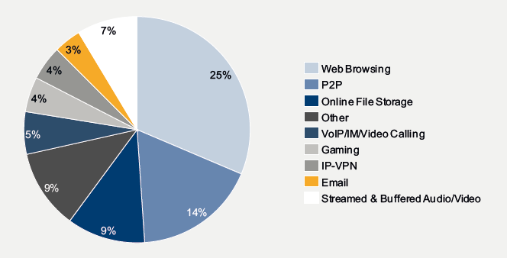
Figure- 10, User traffic share on operators’ internet network (source: Telegeography)
- With an ever-increasing amount and diversity of data and the continuous evolution of the underlying ICT platforms (wider coverage, more capacity and higher technical sophistication), the efforts and costs needed to regulate content through monitoring and control measures are increasing at a faster pace than the direct costs of the threats themselves.

- Technical, legal and regulatory measures introduced or enforced by Government entities, while addressing national online security issues and threats can easily also cause a multitude of controversial effects or public reactions, i.e. perceived impact on user privacy, or on ISP or content provider business models and operations as well as their competitive positioning in the OTT market.
Lawful Intercept (LI) is the legally approved surveillance of a telecom network. It is an important tool for investigating and prosecuting criminal (cyber) activities and terrorism. In terms of regulation, LI reposes an obligation on TSPs to grant Law Enforcement Agencies (LEAs) access to their network/services. However, no such provision exists for OTTs.
OTT VoIP or voice or Internet telephony does not follow standard protocol, as is essential in the traditional voice services through GSM. This is a cause of concern for security agencies since it is extremely difficult to trace the source of internet calls. For instance, during a terrorist attack, it becomes extremely complex to intercept such calls which appear to have originated from other countries from virtual numbers. In case of messaging, certain players indulge in special encryption, which becomes extremely difficult to intercept as these encryption keys are not made available easily to law enforcing agencies.

Also, service models in which data is made available only for a limited time-span such as Snapchat pose a new security challenge. All Messages (text, audio/ video or graphics) for Snapchat are automatically deleted from the server after delivery. This is a new challenge in the context of content regulation because of the real-time nature of the messages transmitted
SATRC member countries response
There was a question related to the security concerns with OTT services which was circulated to the member countries. The response shows that there is security concern related with OTT services. Majority of OTT players are global in nature and are not bound by national laws to comply with national security and data privacy policy. The user registration and verification may not be strictly followed, hence creating possibility of impersonation and fraud. For local OTT providers, regulatory requirements can be created on data storage and data book keeping. For Global service providers, regulators should work within the region so as to bring Global OTT service providers within regulatory framework. For this every state should lead or has to make an international code conduct arrangement on mutual basis.

- Privacy Concerns associated with OTT services
OTT communications and OTT media can pose a threat to privacy. The transfer of personal information on the internet is at risk because of the “open” architecture of the internet. It can result in loss of content privacy, compromised cyber security and lead to cybercrime. The ‘always online’ state of mobile phones exposes users to cybercrime. Most applications can trace the user’s location for underlying processes (such as GPS apps finding the nearest restaurants etc.). This information may be used to commit a crime, or the location itself may be the target of a crime. Such threats can impact the nation’s security and financial health. New age cybercrimes such as cracking, phishing, piracy, identity theft and child pornography and cyber-extortion have been gaining ground in recent years. There are related problems of loss of privacy when confidential information is lost or intercepted, lawfully or otherwise. However, use of these OTT apps for crowdsourcing of information that may impact the security of the country, could be of advantage to the LEAs in curbing and monitoring anti-national elements.
SATRC member countries response
The response related to privacy issue of OTT services, shows that there is need of privacy of users. For majority of OTT service providers, user data is used as source for revenue. In other words, for these providers, user data is product. The data is sold for advertising to third party where user may or may not be aware. There are very little regulation for OTT players on data privacy and user has very little or no control on user data.
Additionally OTT service providers normally have flexible End User License Agreement in foreign languages agreements which favours to OTT providers in regards with data privacy and such agreements are also controlled by other countries legislation where they have established their business.
Local OTT service providers should be liable for the national data privacy regulation and should be registered in regulatory framework. For Global service providers, the regulators need to work with regional regulators so as to bring Global OTT players within regulatory framework.

- Copyright Issues associated with OTT services
The World Intellectual Property Association (WIPA) has reported that the ICT sector now incurs the largest number of intellectual property disputes. Copyright infringement, facilitated by broadband service, is increasingly drawing regulators into the middle of the copyright debate, particularly in the area of enforcement and Internet intermediary liability. ICT regulators are increasingly being viewed as the appropriate authorities to implement copyright protection rules that encourage investment and service innovation within the digital economy. Meanwhile, the growth of costly litigation is affecting the development of a competitive environment and the eventual prices of products and services.
With respect to protecting intellectual property online, the United States has been quite active over the last couple of years. The Recording Industry Association of America (RIAA) and the Motion Picture Association of America (MPAA) have successfully pursued legal actions against suspected infringers. Prominent cases are Napster, PirateBay, Defense Distributor, and MegaUpload. Now the RIAA, MPAA and a few other associations have partnered with five major US ISPs to form the “Center for Copyright Information” with the aim of implementing a system to remove copyright infringing materials from the web. The organization’s so-called “Six-Strikes” plan was launched at the beginning of 2013. The ISPs circle in on peer-to-peer systems and traffic, monitoring their networks for activity that may involve copyrighted material. After five or six suspected instances, the ISPs may take action such as blocking a user’s access to some of the most frequently visited websites until they have completed a copyright education course, slowing down the connection speeds of repeated pirates, or temporarily interrupting the individual’s ability to browse the internet. So far the emphasis has been on educating the public and a number of different ISP enforced restrictions on access for suspected violators. In December 2012, Russia and the USA agreed on an action plan to jointly improve protection of Intellectual Property Rights. Key priorities are combating copyright piracy over the internet, enhancing IPR enforcement, and coordinating legislation.
SATRC member countries response
A question regarding the copyright issue was circulated to member countries. The response shows that Intellectual property right (IPR) laws should be in place to address this issue. Content transfer is an end to end experience between OTT service providers and users. TSPs are a media for the transfer and cannot control or observe the contents. Thus, the copyright protection should be addressed by IPR rules and made it applicable for OTT service provider.

- Net Neutrality
Net neutrality (NN) is generally construed to mean that TSPs must treat all internet traffic on an equal basis, no matter its type or origin of content or means used to transmit packets. All points in a network should be able to connect to all other points in the network and service providers should be able to deliver traffic from one point to another seamlessly, without any differentiation on speed, access or price. The principle simply means that all internet traffic should be treated equally.
In USA, FCC has defined Network, or "net" neutrality as another way to refer to open internet principles. The open internet is the internet where consumers can make their own choices about what applications and services to use, and where consumers are free to decide what content they want to access, create, or share with others. However, according to some economists, Net Neutrality has no widely accepted definition, but usually means that TSPs charge consumers only once for internet access without discriminating between content providers and content over the network.
In other words, Net Neutrality implies that there cannot be any price discrimination between suppliers of content and also among the customers that access such content. Yet other economists, and a majority, argue that price discrimination is legitimate especially in view of externalities i.e. if a video service demands more bandwidth it ought to pay more.
Currently, Net Neutrality is a topic of great debate across the world. At one level, it is being linked to the right to freedom of expression and the right to information. The underlying idea of an open internet is that all internet resources and the means to operate on it are easily accessible to all. It effectively renders the network carrier a dumb pipe i.e. intelligence of management and operation of communication must lie at the end points of the network and not in the network.
Status in SATRC member countries
The response from member countries regarding the discrimination between normal traffic and OTT application traffic indicates that there should not be discrimination in normal data traffic and OTT application traffic. This should go in line with the network neutrality principle.

CHAPTER VI- BUSINESS MODEL FOR TSPs/ MOBILE OPERATORS AND OTT PLAYERS
The questionnaire also includes the questions related to business models of OTT service providers which are discussed below in different headings.
- OTT Players paying to TSPs
One business model for TSPs or mobile network operators could be to play a role of a content delivery network (CDN). TSPs or mobile operators could offer local data storage to the OTT providers so that latency is reduced and the consumers’ satisfaction of service increased. OTT providers pay for these services, so the traditional network operators can monetize the relationship by providing this service – and the skills required are already available as CDNs are a natural extension of the transport business.
Content producers are also suffering from revenue loss due to the OTT media players. OTT media services provide flat rate music or video streaming: content which was previously supplied on a unit price basis. Following major legal battles concerning copyright issues, new services now seem to be emerging where the media industry is working together with the OTT providers in a way which is less destructive for the industry – offering streaming options and premium pricing for advertisement-free services. The share of illegally distributed music and video is going down.
SATRC member countries response
The views from member countries shows that OTT service providers need to share its revenue as it rides on TSP network. OTT providers have no investment in network side but TSPs are investing heavily in rollout and its backbone. It’s justifiable for OTT players to share the cost which will create a viable environment for investment and customer experience. Revenue sharing, volume based charging and QoS based charging can be few of the models that could be used.
- Differential pricing for data access and OTT services
The introduction of pricing for OTT-originated traffic opens up the possibility of price discrimination. Pricing OTT service too high can effectively lead to prohibition of the service; whereas pricing services too low may result in entry of inefficient apps into the market. OTT services provide a rich experience to consumers, and represent the forefront of innovation in technology and business.

SATRC member countries response
One question regarding the data access and OTT app was circulated to member countries. The responses received shows the differential pricing should be dependent on quality of the offered service. This allows operator to secure already established service levels to users who pay for their services.

CHAPTER VII- SUGGESTION AND CONCLUSION
Creating conducive environment for TSPs/mobile operators and OTT players (WIN-WIN)
The response from member countries regarding a question of how to create a conducive or win-win situation for TSPs/mobile operators as well as for OTT players indicates a consensus that there should be mutual agreement between OTT players and TSPs/mobile operators to provide service to users. Then, Telecom operators focus on network & infrastructure growth while OTT players are also encouraged to use their infrastructure and add value to the infrastructure utilization. The TSPs can generate additional revenue for the loss of forecasted due to OTT services. TSPs should create more and more network whereas OTT players create more and more market for the revenue and benefit of the both.
Based on the above response, discussions with domain experts, WG meetings and workshop deliberations, the followings can be the approaches or options available for the proliferation of broadband service and balancing any adverse impact of OTT services on TSPs or mobile operators:
Option -1: The TSPs or mobile operators can compete with copycat (similar) services such as the European “Rich Communications Suite” which provides IM, live video footage and files, and presence information across any mobile networks or “Joyn” which offers chat capabilities between partnering networks. Some of the operators in SATRC region has already started this approach to create a conducive environment for broadband service.
Option-2: TSPs or mobile operators can enter into commercial agreements with OTT providers, and provide value added packages to the customers with enhanced quality.
Many operators have adopted a symbiotic approach with partnerships with the OTT players e.g. Mobily in Saudi Arabia. In this case, the applications are natively installed on the device, and traffic from these applications is zero-rated when specific bundles are purchased. It offers the customers an attractive alternative which may increase their loyalty. We have also witnessed this form of arrangement being practiced in SATRC countries.
Option-3: Further alternatives for TSPs/mobile operators could be to enter into service agreements with OTT providers to provide QoS at a price – a possibility now that the concept of net neutrality has been less restricted – or to use Apps as a distribution channel for TSP services.

References
- Trends in telecommunication reform, special edition, 4th generation regulation: driving digital communications ahead, 2014, by ITU.

- “Regulating Over-the-top” services, http://www.ictregulationtoolkit.org/2.5

- Consultation Paper on Regulatory Framework for Over-the-top (OTT) services, March, 2015 by Telecom Regulatory Authority of India (TRAI)

- A Study “Policy and Regulatory Framework for Governing Internet Applications”, March 2014, by DETECON consulting

- A Consultative Document “Towards the Treatment of Over-The-Top (OTT) Services”, by Telecommunications Authority of Trinidad and Tobago June, 2015

- Relevant materials available in the APT/ITU/SATRC websites and previous deliberations by the domain experts

Annex-1
Questionnaire for work item-2: policy, regulatory and technical aspects of OTT services in SATRC countries
- Name of Country and Administration:

- Is OTT defined or classified by your administration?
  - If Yes, how is it defined and classified by your administration?
  - If No, give reasons and is there any future plan?

- Is it necessary to formulate regulatory framework for OTT services at present?
  - If Yes, what type of framework is developed or in the process of formulation by your administration?
  - If No, could you please give reasons and is there any future plan?

- Is there any impact of OTT services on data traffic and associated demands on network infrastructure?
  - If Yes, could you please justify/elaborate this with relevant data?
  - If No, what could be the reasons?

- Is the growth of OTT affecting negatively the traditional revenue stream of telecom operators/mobile operators i.e. voice and SMS revenue?
  - If Yes, how much is the loss (in percentage of gross income of operators)?
  - If No, what could be the reasons? Can increase in revenue due to increase in data traffic is sufficient to compensate for the loss?

- What is the network architecture of OTT applications/services and how it is implemented?

- Is the OTT players offering real-time communication services e.g. voice, messaging and video call services competing in the same market segment as that of mobile operators/telecom operators?
  - If yes, what are the regulatory imbalances and how this can be addressed?
  - If No, give reasons with justifications.

- Should OTT players providing communication services be licensed and treated similar as telecom/mobile operators?
  - If yes, what could be the licensing framework?
  - If No, give reasons with justifications.

- Is it possible to apply prevailing laws and regulations to OTT players who operate in the virtual world and usually from abroad?
  - If yes, please suggest how compliance can be enforced?
  - If No, what changes may be required in the law?

- Should the OTT players pay for using telecom/mobile operators’ infrastructure or network over and above the data charges paid by the customers?
  - If yes, what could be the pricing options or models?
  - If No, give reasons with justifications.

- Is there security concerns associated with OTT players providing communications services?
  - If yes, how can these been mandated such as keeping records, logs etc. as usually the OTT players reside outside of the country? Suggest.
  - If No, give reasons with justifications.

- Is there privacy concerns associated with OTT players providing communications services?
  - If yes, how the interest of consumer is protected?
  - If No, give reasons with justifications.

- Should the OTT players offering communication services i.e. voice, messaging and video call services (e.g. viber, skype) through applications (resident in the country or outside) be brought under licensing regime? Suggest with justifications.

- Should the telecom/mobile operators be allowed to discriminate between the normal data traffic and OTT application traffic?
  - If yes, give reasons with justifications. Also, is it needed that these network operators be mandated to publish traffic management techniques used for different OTT applications to ensure transparency?
  - If No, give reasons with justifications.

- Should the telecom/mobile operators be allowed differential pricing for data access and OTT communication services?
  - If yes, give reasons with justifications.
  - If No, clarify with comments.

- In terms of the content being transmitted/shared by OTT media/applications, how the issues of copyright can be addressed?

- How conducive and balanced environment can be created such that telecom/mobile network operators are able to invest in network infrastructure and OTT players can innovate and grow?

- Any other business or issues related to OTT services.

Annex-2

Response of the Questionnaire (Attached).

ITU Secretary General’s Report (WTPF-2013)
ICT Regulation Toolkit, “Regulating Over-the-Top Services’
A Study on Policy and Regulatory Framework for Governing Internet Applications by DETECON Consulting, March 2014
Cisco Visual Networking Index (VNI) 2013

