ASIA-PACIFIC TELECOMMUNITY
SOUTH ASIAN TELECOMMUNICATIONS REGULATOR’S COUNCIL (SATRC)

SATRC report on
IDENTIFYING WAYS TO LOWER International connectivity cost FOR THE PROVISION OF BROADBAND SERVICES

Prepared by
SATRC Working Group on Policy, Regulation and Services

Adopted by
17th Meeting of the South Asian Telecommunications Regulator’s Council
4 - 6 October 2016, Dhaka, Bangladesh

Executive summary

This report identifies the elements involved in the provision of international connectivity for the providing internet service. The report briefly describes the present situation of international connectivity including the related issues and challenges.

The main focus of the report is to examine the surrounding issues and recommend ways to overcome the challenges in providing the internet service at affordable prices. In studying the subject in detail, attempts were made to obtain country specific information from all the SATRC countries. This information was received from three countries of the region. Utilizing this limited information, efforts were made to understand the sub-regional issues and cost components involved in the provision of the international connectivity.

The report discusses the key technology options for infrastructure with emphasis on suitability factors.

In an effort to study the cost of internet services for consumers, the report briefly looked on the global digital index (IDI) and mobile communication usage in the Asia-Pacific region with a focus on Indian sub-region. The consumer information and mobile penetration level and digital index figures of SARC countries are obtained for ITU and relevant sources.

International connectivity cost and the key issues surrounding international connectivity are discussed in a limited manner due to unavailability of cost and country specific information.

In conclusion, further study is required in understanding many aspects (including internet interconnection and broadband with due consideration to global conditions in which the activity is developed) of international connectivity and suitable cost models for the region.

Finally, the report provides recommendations on best practices for developing broadband and ways to lower the cost of international connectivity.

Introduction
The main objectives of this tasks is identifying cost components and provide recommendations, matters related to international internet connectivity for provision of broadband services. The study look into the following aspects:
- Carry out an assessment of current situation in South Asian Telecommunication Regulator’s Council (SATRC) Countries regarding the cost of provision of internet service.
- Benchmark comparison of situation of SATRC Countries vis-à-vis countries from Asia- Pacific Region.
- To provide recommendations to make the access to Internet more affordable in the Region in line with the international best practices.
The study also covers the internet connectivity ecosystem, from ICT index, access, use and skill to the provision of global internet connectivity that can provide widespread affordable wireless broadband services

In order to carry out the study, a questionnaire was prepared and circulated (October 2015) to all lead expert of the SATRC countries (Afghanistan, Bangladesh, Bhutan, India, Iran, Nepal, Pakistan and Sri Lanka) for their inputs on the above topic. The questionnaire is attached Annex-I to this report.

Based on the inputs received from the experts of the following SATRC countries: Bangladesh, Nepal and Pakistan and other available literature on the matter, an analysis of various papers on the above mentioned areas has been carried out.

Finally, findings, challenges and recommendations are presented in this report which may be useful for countries in the region.

Issues and high cost around internet connectivity
- Costs
  - Extending and upgrading Infrastructure to rural areas
  - Local Internet Interconnection
- Competition in the international links (lack of competition for their international internet connectivity)
- Structure of economy
Figure 1: Main elements of international internet connectivity
Intermediary at regional node
Satellite

ISP Telco

Developing country

Global node

Global internet connectivity
Cable
International leased circuits

IBP

IBP

IBP
Overview of Technologies
The Technology options for International Connectivity include:
Satellite
Fiber
Radio Links

Countries choose suitable connectivity technology based on other influencing factors. The most common recurring costs involved in the connectivity links are:
Transport costs
Bandwidth cost (porting charges)
Management fees
The proportion of internet connectivity cost (bandwidth and transport costs) of the total cost of service provision is one key area to explore and make recommendations.

International Capacity of some of the SATRC countries
Most of the national access providers in the region operate at national or local level and do not have any international infrastructure except few cases. Hence, transit agreements with type I or type II providers are in place and pay transit fees. The majority of operators use a submarine cable for international Internet connection. However, landlocked countries E.g: Afghanistan, Bhutan and Nepal have to dependent on satellite or terrestrial network, which remains indispensable in the provision of international Internet connection. These countries have developed terrestrial optical fibre infrastructure to connect nearest submarine landing point in order to minimize the relatively high costs of satellite connection and ensure better quality of service with the submarine cable.

Figure 2: Shows international capacity of some SARC countries

It is believed that all national internet providers of sub regional countries purchase bandwidth from Tier I providers or regional internet providers. Please note that Indian region internet, Tier1 ISPs which include Bharti, Reliance, Tata, and VSNL, and I have no information received from India on international connectivity.
Tier 1 ISPs are large national or international ISPs. They are directly connected to the Internet backbone and can be considered as part of the backbone itself. They have the highest speed connections and very reliable networks. Tier I providers have a worldwide Internet network and peering agreements in several regions of the world. They therefore have the technical means to access all Internet networks without paying additional fees. This is a great challenge for many countries.
Main Challenges
Extending the high capacity infrastructure to rural areas
SATRC countries are at different level in broadband penetration. Countries need to invest to expand and enhance the infrastructure to reach end users.
Peering
Networks can connect with each other directly, in which case they are said to be “peered”, or they can connect via an intermediary network known as a “transit provider. Therefore, the more countries peer the less they pay for bandwidth. Peering also typically increases performance by cutting out intermediaries that may add latency.

Asia’s peering rates are similar to Europe. However, transit pricing is significantly more expensive. Compared with the benchmark of $10/Mbps in North America and Europe, Asia's transit pricing is approximately 7 times as expensive ($70/Mbps, based on the benchmark. When peering is taken into account, however, the effective price of bandwidth in the region is $32/Mbps.
 | Percentage peered | Effective Price/Mbps/Month/U$ | Relative to lowest price
Europe | 50 | 5 | 1*
North America | 20 | 8 | 1.6*
Asia | 55 | 32 | 6.4*
Latin America | 60 | 32 | 6.4*
Australia | 50 | 100 | 20*
The chart above (Fig:3) shows the relative cost of bandwidth assuming a benchmark transit cost of $10/Megabits per second (Mbps) per month (which we know is higher than actual pricing, it’s just a benchmark) in North America and Europe. 26 Aug 2014 by Matthew Prince. Cloudflare.

For now, the most promising option for most developing-country ISPs to connect to the global Internet is via a transit agreement signed with transit providers. However, because developing-country ISPs have a small customer base, the international Tier-1 and Tier-2 providers have no business incentive to enter shared-cost peering agreements with them. As a result, these ISPs have to bear the full costs of both outbound and inbound traffic exchange under the terms of the transit agreement, in addition to the leased line costs. The traffic is imbalance is different for developing and developed countries. Hence the international bandwidth cost proportion is higher accordingly.

Internet eXchange Point (IXP)
Inter ISP local traffic which use the international route may be change to a greater extent when regional countries form alliance and start regional initiative regarding internet bandwidth management. Such management improve the internet speed and optimize the use of international bandwidth. Countries like Bangladesh, India, Nepal, Pakistan and Sri Lanka have IXPs.
We can decide most suitable location in the sub region with due considerations to the availability of multiple landing points for submarine cables which can serve all countries in the sub region. The IXP can promote the development of activities by exchanging regional traffic and becoming a regional Internet access provider or even to be optimistic a global provider, through peering agreements. IXP model can contribute to reduced international bandwidth costs significantly. Perhaps, this an area to investigate possible cost savings for the Afghanistan, Bhutan and Maldives.
Other challenges
Other challenges which consume international bandwidth includes;
OTT services
Spam and Virus attacks
Internet content location

Figure 4: Shows the SEA ME WE 4 submarine cables route connecting Indian sub-regional countries.
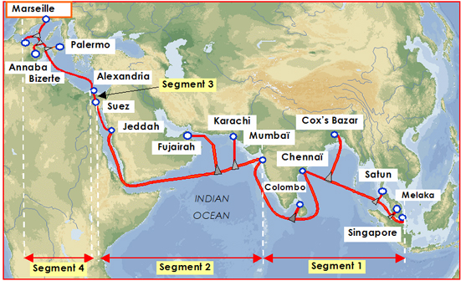
Figure 5: Shows global submarine cables passing Indian sub-region.
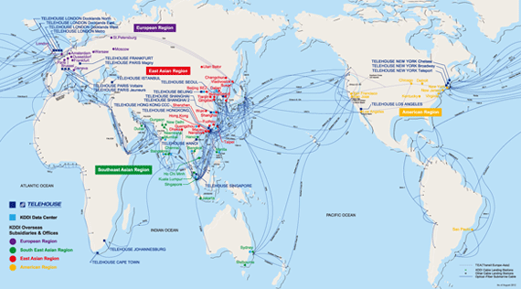

Global Perspective of ICT Development with Focus on Sub Region
ITU ICT Development Index (IDI)
The International Telecommunication Union (ITU), initiated the IDI development task in 2008
Main objectives are to measure:
  - the level and evolution over time of ICT developments in countries and relative to other countries;
  - progress in ICT development in both developed and developing countries;
  - the digital divide; and
  - the development potential of ICTs or the extent to which countries can make use of ICTs to enhance growth and development, based on available capabilities and skills.
ICT Development Index (IDI)
IDI is viewed in three aspects: access, use and skill sets of the consumers. Figure 2, below table provide detail break down of the above components.
This decade offers for countries an excellent opportunity to become users of widespread affordable wireless broadband services which is particularly suitable due to:
• its relatively lower shared costs and coverage of geographically separated areas which do not necessarily have high population density,
• its ease of penetration, and
• its ability to deploy and rollout rapidly.
.

Figure 6: ICT Index parameters
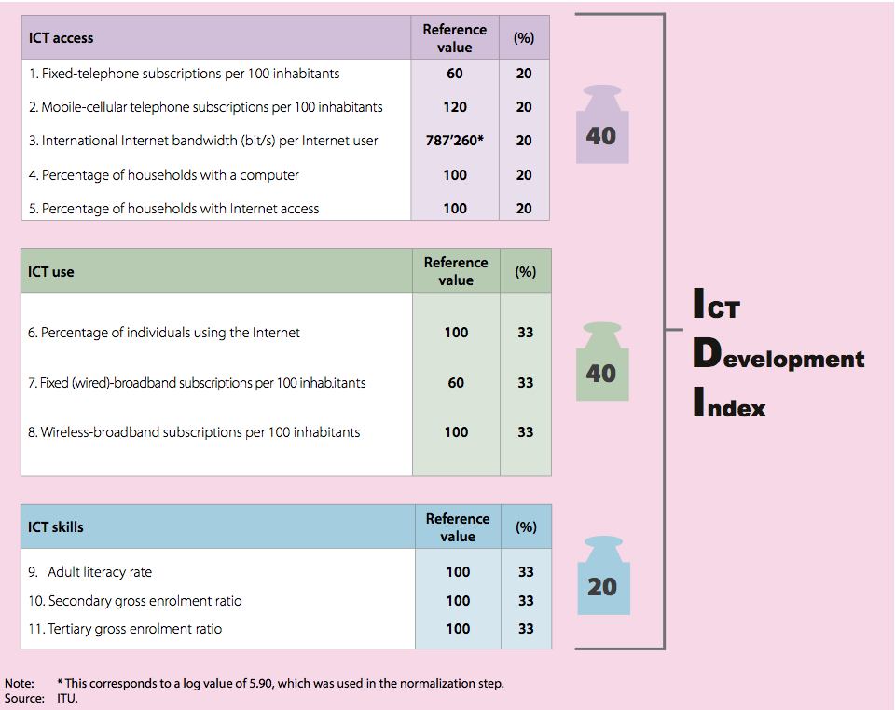

Figure 7: Asia Pacific Region IDI
IDI 2015  Rank | IDI 2015  Value | Economy | IDI 2010  Rank | IDI 2010  Value
1 | 1 | Korea (Rep.) | 1 | 8.93
2 | 9 | Hong Kong, China | 13 | 8.52
3 | 11 | Japan | 9 | 8.47
4 | 13 | Australia | 15 | 8.29
5 | 16 | New Zealand | 19 | 8.14
6 | 19 | Singapore | 11 | 8.08
7 | 24 | Macao, China | 14 | 7.73
8 | 64 | Malaysia | 61 | 5.90
9 | 71 | Brunei Darussalam | 53 | 5.53
10 | 74 | Thailand | 92 | 5.36
11 | 81 | Maldives | 82 | 5.08
12 | 82 | China | 87 | 5.05
13 | 84 | Mongolia | 97 | 5.00
14 | 91 | Iran (I.R.) | 99 | 4.79
15 | 98 | Philippines | 105 | 4.57
16 | 101 | Fiji | 102 | 4.33
17 | 102 | Viet Nam | 94 | 4.28
18 | 108 | Indonesia | 109 | 3.94
19 | 110 | Tonga | 111 | 3.82
20 | 115 | Sri Lanka | 115 | 3.64
21 | 119 | Bhutan | 128 | 3.35
22 | 122 | Samoa | 121 | 3.11
23 | 125 | Vanuatu | 124 | 2.93
24 | 130 | Cambodia | 131 | 2.74
25 | 131 | India | 125 | 2.69
26 | 136 | Nepal | 140 | 2.59
27 | 138 | Lao P.D.R. | 135 | 2.45
28 | 139 | Solomon Islands | 139 | 2.42
29 | 142 | Myanmar | 150 | 2.27
30 | 143 | Pakistan | 138 | 2.24
31 | 144 | Bangladesh | 148 | 2.22
32 | 156 | Afghanistan | 156 | 1.83

Figure 8: ICT Access SARC Region, 2015
Country | IDI Rank | Fixed. telephone subscriptions per 100 inhabitants | Mobile. cellular subscriptions per 100 Inhabitants | International Internet bandwidth  bits per Internet user | %age households with  computer | %age households with  Internet access
Afghanistan | 156 | 0.33 | 74.88 | 6942 | 2.7 | 2.29
Bangladesh | 144 | 0.68 | 75.92 | 5925 | 6.88 | 6.5
Bhutan | 119 | 3.11 | 82.07 | 2546 | 21.87 | 26.30
India | 131 | 2.13 | 74.48 | 5677 | 12.96 | 15.33
Iran (I.R.) | 91 | 38.98 | 87.79 | 6056 | 52.47 | 44.73
Maldives | 81 | 6.11 | 189.38 | 69077 | 65.93 | 44.51
Nepal | 136 | 2.98 | 82.49 | 3109 | 8.2 | 5.6
Pakistan | 138 | 2.64 | 73.33 | 5684 | 15.9 | 13.2
Sri Lanka | 115 | 12.49 | 103.16 | 12651 | 17.77 | 15.31

Figure 9: ICT Use Asia Pacific Region, 2015
Country | IDI Use Sub-Index | Percentage of individuals using the Internet | Fixed (wired)- broadband subscriptions per 100 inhabitants | Active mobile-broadband subscriptions per 100 inhabitants
Afghanistan | 0.32 | 6.39 | 0.0 | 3.2
Bangladesh | 0.6 | 9.6 | 1.19 | 6.41
Bhutan | 3.57 | 34.37 | 3.26 | 28.17
India | 3.13 | 18 | 1.24 | 5.52
Iran (I.R.) | 2.19 | 39.35 | 9.46 | 10.71
Maldives | 3.59 | 49.28 | 5.64 | 48.95
Nepal | 1.14 | 15.44 | 0.81 | 17.42
Pakistan | 0.69 | 13.8 | 1.08 | 5.06
Sri Lanka | 1.44 | 25.88 | 2.65 | 13.01

Figure 10: ICT Skill Asia Pacific Region, 2015
Country | IDI Skills Sub-Index | Gross enrolment ratio |  | Adult literacy  rate
 |  | Secondary | Tertiary
Afghanistan | 3.21 | 54.31 | 3.74 | 38.16
Bangladesh | 4.28 | 53.65 | 13.23 | 61.55
Bhutan | 5.07 | 77.7 | 9.43 | 64.89
India | 5.48 | 68.51 | 24.8 | 71.24
Iran (I.R.) | 7.61 | 86.28 | 55.16 | 86.85
Maldives | 6.16 | 72.3 | 13.18 | 99.31
Nepal | 4.85 | 66.99 | 14.49 | 63.95
Pakistan | 3.54 | 38.32 | 9.82 | 57.94
Sri Lanka | 6.96 | 80.72 | 16.97 | 92.63

Situation in the Asia- Pacific Region
Following chart (Figure 11) shows situation region with respect to global IDI. The Asia-Pacific region is close to world average.
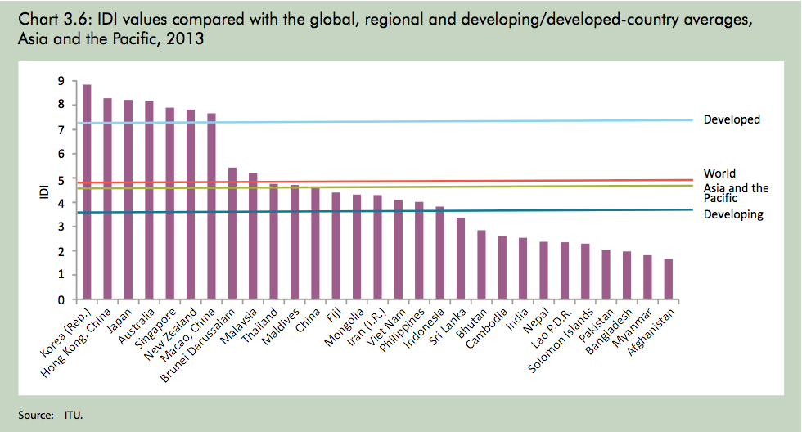
Figure 11: IDI values compared with global averages

Situation of the SARC region
Following table give rough estimate of end user costs. Break down of Telco and Internet Service Providers costs also need to examine. In addition to this international component of ISP costs local ISP cost need to examine and fully understand.
Mobile Broadband Prices Prepaid
Country | Rank | Mobile-broadband, prepaid computer-based (1GB) |  |  | GNI p.c.  US$ | Monthly  data GB
 |  | %age  GNI p.c. | US$ | PPP$
Afghanistan | 117 | 21.56 | 12.58 | 35.35 | 700 | 1
Bangladesh | 108 | 15.71 | 11.78 | 33.57 | 900 | 2
Bhutan | 57 | 2.62 | 5.37 | 16.18 | 2460 | 1
India | - | - | - | - | 1570
Iran (I.R.) | 115 | 20.18 | 97.21 | 208.98 | 5780 | 4
Maldives | 59 | 2.79 | 13.02 | 16.91 | 5600 | 2
Nepal | 106 | 13.87 | 8.44 | 26.61 | 730 | 1
Pakistan | 99 | 10.22 | 11.76 | 41.23 | 1380 | 5
Sri Lanka | 25 | 0.98 | 2.60 | 7.16 | 3170 | 1
Figure 12: Prepaid computer-based 1GB, Asia – Pacific, 2013
Mobile-Broadband Prices Postpaid
Country | Rank | Mobile-broadband, computer-based (1GB) |  | postpaid  GB) | GNI p.c.  US$ | Monthly  data 1 GB
 |  | %age  GNI p.c. | US$ | PPP$
Afghanistan | 126 | 21.56 | 12.58 | 35.35 | 700 | 1
Bangladesh | 114 | 11.78 | 8.83 | 25.18 | 900 | 1
Bhutan | 72 | 2.50 | 5.12 | 15.44 | 2460 | 1
India | 116 | 12.39 | 16.21 | 54.19 | 1570 | 6
Iran (I.R.) | - | - | - | - | 5780
Maldives | 84 | 3.49 | 16.27 | 21.14 | 5600 | 3
Nepal | 117 | 13.87 | 8.44 | 26.61 | 730 | 1
Pakistan | 115 | 12.26 | 14.10 | 49.43 | 1380 | 30
Sri Lanka | 50 | 1.15 | 3.04 | 8.38 | 3170 | 6
Figure 13: Postpaid–computer based, 1 GB, Asia- Pacific, 2013

Wireless Broadband Penetration Asia-Pacific Region
The fixed line penetration rates are expected to remain low, and modern day most consumers' first experience with the Internet is likely to be via mobile services. More than 90 percent of the Internet users got their access using mobile services. Though broadband Internet access is available, the charges for high speed connections are higher in many South Asian countries.
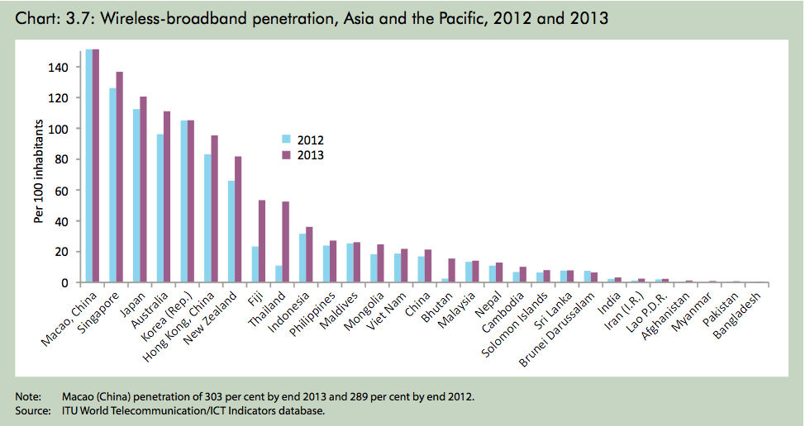
Figure 14: Wireless broadband penetration, Asia and the Pacific.
Figure 15:SARC INTERNET USE, POPULATION DATA AND STATISTICS - JUNE 2016
Country | Population | Internet users year 2000 | Internet Users June 2016 | Penetration % of population | Users % in Asia | Facebook Users
Afghanistan | 33,332,025 | 1,000 | 4,005,414 | 12.0 % | 0.2 % | 2,600,000
Bangladesh | 162,855,651 | 100,000 | 53,941,000 | 33.1 % | 3.0 % | 21,000,000
Bhutan | 750,125 | 500 | 289,177 | 38.6 % | 0.0 % | 250,000
India | 1,266,883,598 | 5,000,000 | 462,124,989 | 36.5 % | 25.8 % | 157,000,000
Iran | 82,801,633 | 250,000 | 56,700,000 | 68.5 % | 40.1 % | 17,200,000
Maldives | 392,960 | 6,000 | 270,000 | 68.7 % | 0.0 % | 270,000
Nepal | 32,111,345 | 50,000 | 6,400,000 | 19.9 % | 0.4 % | 6,400,000
Pakistan | 192,758,348 | 133,900 | 34,342,400 | 17.8 % | 1.9 % | 27,000,00
Sri Lanka | 22,235,000 | 121,500 | 6,087,164 | 27.4 % | 0.3 % | 4,200,000
Source: www.internetworldstats.com/stats3.htm#asia

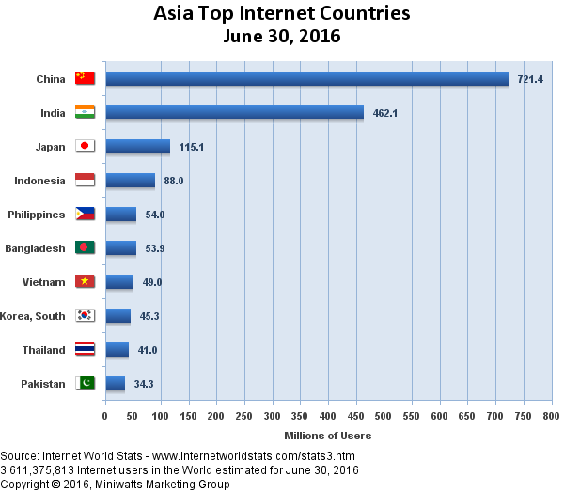
Figure 16: Bar chart shows top internet countries in Asia.

Maldives Compare Sri Lanka & Indonesia – 2015
IDI Access sub-index
Country | Rank | Fixed-  telephone  subscriptions  per 100  inhabitants | Mobile-  cellular  subscriptions  per 100  inhabitants | International  internet  bandwidth  Bit/s per  user | %age  households  with a  computer | %age  households  with  internet  access
Maldives | 81 | 6.11 | 189.38 | 69077 | 65.93 | 44.51
Sri Lanka | 115 | 12.49 | 103.16 | 12651 | 17.77 | 15.31
Indonesia | 108 | 11.72 | 126.18 | 6225 | 17.75 | 29.08

IDI Use sub-index
Country | Rank | %age  individuals  using internet | Fixed (wired)-  broadband  subscriptions  per 100  inhabitants | Wireless  broadband  subscriptions  per 100  inhabitants
Maldives | 3.59 | 49.28 | 5.64 | 48.95
Sri Lanka | 1.44 | 25.88 | 2.65 | 13.01
Indonesia | 1.79 | 17.4 | 1.19 | 34.72

IDI Skill sub-index
Country | Rank | Gross enrolment ratio |  | Adult literacy  rate
 |  | Secondary | Tertiary
Maldives | 6.16 | 72.3 | 13.18 | 99.31
Sri Lanka | 6.96 | 80.72 | 16.97 | 92.63
Indonesia | 6.93 | 82.54 | 31.51 | 93.88
Figure 14: Maldives Compare Sri Lanka & Indonesia – 2015
Comparing the cost of Internet access in the Maldives vis-à-vis other countries in the South Asia- Region, taking into account the ITU IDI Report and other relevant sources of data.
Above comparison Maldives in a favorable positions to provide widespread internet service still have to pays high price for international internet connectivity. Both Indonesia and Sri Lanka have local internet exchange points. How can internet access be made more affordable?
CONCLUSION
The concepts used by the ISPs around the world have been examined to identify international best practices. It is observed that majority of SATRC countries have robust global connectivity via submarine cables in place, while landlocked countries depends on the transit arrangement with their neighboring countries.
There are three primary reasons transit is so much more expensive in Asia. First, there is less competition and a greater number of large monopoly providers. Second, the market for Internet services is less mature. And finally, if you look at a map of Asia you will see a lot of running undersea cabling which is more expensive than running fiber optic cable across land so transit pricing offsets the cost of the infrastructure to move bytes.
Secondary reasons, such as poor telecommunication infrastructure at national and regional levels, fewer peering and exchange points than elsewhere, in the sub-region
These problems afflicting small developing economies have been the subject of research in a number of ITU Internet Case Studies (see http://www.itu.int/ITU-D/ict/cs/).
India has 4 major international connectivity ports along the coast with multiple landing stations operating with about a dozen of submarine cables. Further information on any other major submarine cable undertaking in progress, cannot be presented due to non-avail of country specific information. For the interest of the region it is necessary where possible to explore the opportunities to deploy traffic interexchange points (NAP/IXP) in the sub-region.
Some half-dozen fibre-optic submarine cables have been completed in the region over the last decade. For example, the SEA-ME-WE 4 fibre cable, which connects the countries around Indian sub-region and is interconnected to submarine cables heading to Europe, and other Asia-Pacific points.
The Bay of Bengal Gateway (BBG) is a new cable system that connects Middle East and Indian Sub-Continent and The India Cloud Xchange (ICX) subsea cable system is a private cable connecting Mumbai-Singapore are expected to be operational during 2016 according to Asian Correspondent, By Sriram Vadlamani, 13 July 2009. This could be one area which can be further examined on identifying ways to lower the international connectivity in the region.
Further study is required to understand the impact on developing countries of the international dimension of the internet market.

Recommendations
Ways to lower international bandwidth costs
- Allow ISPs to directly procure their own international capacity instead obtain it from the incumbent telecommunication operator. Some countries, although ISPs may be free to obtain international connectivity, it is only for a half circuit and they must obtain the other half from the incumbent operator.

- Reduce the volume of outgoing Internet traffic. Constrain the national traffic within the country. This can be addressed by the use of a national Internet exchange, whereby ISPs exchange information without routing traffic via international links. This would reduce the costs for international links.

In 2000, ITU offered its first sets of guidelines and criteria on IIC with the aim of assisting administrations with their bilateral negotiations. These guidelines and criteria were published as Recommendation ITU-T D.50, an international standard last updated in 2011, with a further supplement agreed in 2013.

We can also refer to ITU-T D.52 “Establishing and connecting regional Internet Exchange Points (IXPs) to reduce costs of international Internet connectivity” – to guide regional collaboration to establish central hubs (IXPs) that enable local Internet traffic to be routed locally, saving international bandwidth and reducing the costs of international Internet connectivity. Recommendation ITU-T D.

- It is also worth to explore any cost sharing methodology or principles in place. For countries with small markets to pool their bandwidth requirements in order to leverage lower connectivity costs.

In conjunction with these steps, other actions could be taken to ensure that geographically disadvantaged nations minimize cost of establishing international internet links. This might include applying the spirit of various resolutions that call for the cost of the Internet link between countries to be shared.

ANNEXURE – 1
Questionnaire
Questionnaire: International Connectivity for the Provision of Broadband in the Region

- Name of the Country/Administration
- Is your administration responsible for providing the international bandwidth?
  - If no please specify details of the concerned administration
- How many telecom operators have international connectivity?
- What are the connectivity methods for the international capacity? Please specify percentage
    - Fiber (under sea)
    - Fiber (land)
    - Satellite
- What is the international bandwidth usage (Gbps/ Tbps)?
- What are the connectivity routes? (Eg: SEAMEWE-3, SEAMEWE-4, FLAG FALCON, etc).
- Kindly provide rates for capacities ranges E1, STM-1, STM-4, STM-16 to Tier 1 pop server between you and other regions? Please specify by route and region.
- What is the annual growth rate/percentage?
- What capacity the operators get connectivity? (Eg : Own cable, consortium, etc)
- Does your administration have bilateral/multilateral agreement on International connectivity?
- If yes please specify the following:
Type of connection: Submarine cable, Terrestrial cable, etc
Upgradeable capacity
- Is there any plan or project for bilateral agreement for international connectivity? Please specify
- What sort of international connection arrangement does your country have with the other Member countries?
- What are the major challenges in relation to current international connectivity arrangement?
- What is the minimum data rate that the national authorities consider as constituting broadband service? (in kbps, Mbps or Gbps)
- Please indicate the percentage of physical subscriber network
  - Fibre-optic
  - Copper
  - Coaxial
  - Wireless %, including % terrestrial and % satellite

- What wire-line technologies are utilized to provide broadband services?
  - ____ xDSL
  - ____ Cable (excluding fiber)
  - ____ Fiber (FTTX)
  - Any other

- What wireless technologies are utilized to provide broadband services?
  - 3G
  - WiMax
  - ADSl technologies (WiFi)
  - Any other

- What is the average monthly price for broadband service (including Internet access)?
- Describe the most common usage/pricing plan for broadband. (Please specify per time unit or data unit)
- What are the major barriers to the deployment of broadband service?
- Is there a plan for coverage of those areas where broadband is not available? If yes, please explain.
- Which broadband technology is growing the most quickly? (Wireless, xDSL, cable modem or other)
- Are there regulatory incentives for operators to make investments in the infrastructure with a view to extending broadband to rural communities?
- Is there any roadmap prepared for broadband development or digitalization? please provide details.
- What are the initiatives taken for expanding international connectivity?

by the Government
by the Industry

- Kindly provide your view on the proposal of establishing International connectivity arrangement for broadband within our region.
- Is international connection charge higher in the region? If so, what could be the reasons for such high charges?
- What would be the cost involved in providing international broadband connection? Kindly explain
- Can the current international connectivity charges be lowered?
If so, kindly do provide how this could be done.

- Is there any study on assessment of the impact of international connectivity in terms of cost increase on the following components in your country?
  - penetration,
  - traffic volume,
  - investment
  - Consumer tariff
If yes please provide details in brief

- Any other relevant information that you want to provide.

