

**APT REPORT**

**ON**

**VOLTE INTEROPERABILITY**

**No. APT/ASTAP/REPT-46**

**Edition: June 2021**

**Adopted by**

**The 33rd APT Standardization Program Forum (ASTAP-33)**

**7 – 15 June 2021, Virtual/Online Meeting**

(*Source: ASTAP-33/OUT-13*)

1. Scope 5

2. Abbreviations and acronyms 5

3. Related International activities for standardizations 6

I. 3GPP 6

I.1. 3GPP TS 29.165 Inter-IMS Network to Network Interface (NNI) (Release 15) 6

1. Scope 6

2. Reference model for interconnection between IM CN subsystems 6

II. GSMA 7

II.1. GSMA IR.65 IMS Roaming and interworking Guideline (Version 22.0, 11 October 2016) 7

1 Overview 7

2 Scope 7

3 Roaming Guidelines 8

4 Introduction 8

5 3GPP Background 8

6 Operational Requirements for IMS Voice and Video and other IMS Services based on Local Breakout and P-CSCF in VPMN 10

Operational Requirements for IMS Voice and Video 10

7 IMS Roaming Architecture 12

VoIMS Roaming Architecture using LBO 12

IMS Roaming Architecture using S8HR 13

8 IMS Roaming Guidelines 14

II.2. GSMA IR.92 IMS Profile for Voice and SMS (Version 10.0, 19 May 2016) 15

1 Overview 15

2 Relationship to existing standards 16

3 Scope 16

III. ITU-T 16

III.1. ITU-T Recommendation Q.3640 “Framework of interconnection of VoLTE/ViLTE-based networks” 16

1 Scope 16

2 Rationale 17

3 Key issues of VoLTE interconnection 17

4 General principles of interconnection of VoLTE-based networks 17

5 E2E scenarios in terms of interconnection and roaming 18

6 IMS roaming and interworking guidelines 1

7 Services for e2e VoLTE/ViLE interconnection scenarios 3

8 Interconnection for Inter-IMS scenario 3

III.2. ITU-T Recommendation Q.3940 “NGN/IMS interconnection tests between network operators at the IMS ‘Ic’ interface and NGN NNI/SIP-I” 5

III.3. ITU-T Recommendation Q.3953 “VoLTE/ViLTE interconnection testing for interworking and roaming scenarios” 6

4. Related national activities for standardizations 6

4.1 TTC 6

I. JJ-90.30 Common interconnection interface between IMS operator’s networks (Version 4.1, June 5, 2017) 6

1 Introduction 6

2 Relationship to International Recommendations 6

3 Scope 6

4 Objective 7

5 Contents 7

6 Supported II-NNI traversal scenarios 7

7 SIP/SDP signalling requirements on non-roaming II-NNI 7

II. JJ-90.31 Common interconnection interface for carrier ENUM (Version 3.0 May 25, 2017) 8

1 Introduction 8

2 Relationship to International Recommendations 8

3 Scope 8

4 Objective 8

5 Contents 8

6 Architecture 8

7 ENUM interface 9

4.2 TTA 9

I. Specification of VoLTE Terminal for UICC Portability between Mobile Operators (TTAK.KO-06.0357/R4, June 2017) 9

1 Overview 9

2 Contents 9

3 Differences with GSMA IR Documents 10

II. VoLTE Interworking Specification among Korean MNOs (TTAK.KO-06.0338/R2, June 2016) 10

1 Overview 10

2 Contents 10

5. Use cases and the best practicies in APT member countries 13

5.1 Republic of Korea 13

5.2 Japan 15

6. References 17

# Scope

This report aims to provide information on the use cases and deployment scenarios for VoLTE Interoperability in APT members (focus on network and protocol aspects).

The report also intends to study a status of VoLTE interoperability on the following aspects:

1. To provide information on status of VoLTE services in APT member countries.
2. To facilitate maturity and interoperability of VoLTE service
3. To study possible common interfaces for the implementation of global VoLTE interoperability;

Section 3 and 4 of this report are extracted from related documents such as international and national standards to include the highlights of these activities. For a more detailed information, please see the original documents.

Section 5 of this report is country reports from APT member countries.

# Abbreviations and acronyms

This report uses the following abbreviations and acronyms:

This Recommendation uses the following abbreviations and acronyms:

ENUM telephone Number Mapping

GRX/IPX GPRS Roaming exchange / IP exchange

HPMN Home Public Mobile Network

IBCF Interconnection Border Control Functions

II-NNI Inter-IMS Network to Network Interface

IMS IP Multimedia Subsystem

LBO Local Breakout

LI Lawful Interception

LTE Long-Term Evolution

NNI Network Network Interface

PS Packet Switched

SIP Session Initiation Protocol

SDP Session Description Protocol

SLA Service Level Agreement

UE User Equipment

ViLTE Video over LTE

VoLTE Voice over LTE

VoPS IMS voice over PS Session

VPMN Visited Public Mobile Network

# Related International activities for standardizations

This chapter describes the summary of the international standards and activities related to VoLTE interoperability.

# 3GPP

# 3GPP TS 29.165 Inter-IMS Network to Network Interface (NNI) (Release 15)

# Scope

The objective of this document is to address the Inter-IMS Network to Network Interface (II-NNI) consisting of Ici and Izi reference points between IMS networks in order to support end-to-end service interoperability.

The present document addresses the issues related to control plane signalling (3GPP usage of SIP and SDP protocols, required SIP header fields) as well as other interconnecting aspects like security, numbering/naming/addressing and user plane issues as transport protocol, media and codecs actually covered in a widespread set of 3GPP specifications. A profiling of the Inter-IMS Network to Network Interface (II-NNI) is also provided.

Charging aspects are addressed as far as SIP signalling is concerned.

IMS emergency session establishment between IMS networks is addressed as far as SIP signalling is concerned.

SIP signalling traversing the NNI between a CSCF and MRB, e.g. for media control or Voice Interworking with Enterprise IP-PBX, and SIP signalling traversing the NNI on the Mr interface between the CSCF and the MRFC, or on the Mr' interface between the AS and MRFC, or on the Rc interface between AS and MRB is not considered in the present release of this specification.

SIP signalling traversing the NNI between an application server and the remaining IMS functional entities (e.g. for MCPTT interface SIP-2 in figure 7.3.1-2 in 3GPP TS 23.280 [200]) is not considered in the present release of this specification.

SIP signalling traversing the NNI between an ISC gateway and an AS in an enterprise network, e.g. for media control and voice interworking with enterprise IP-PBX, on the ISC interface between the ISC gateway and the enterprise network is not considered in the present release of this specification.

# Reference model for interconnection between IM CN subsystems

Figure 1 illustrates the architecture diagram given in 3GPP TS 23.228 [4] showing the Inter-IMS Network to Network Interface (II-NNI) between two IM CN subsystem networks.

NOTE: The TRF can reside in a stand-alone entity or can be combined with another functional entity.

Figure 1/3GPP TS 29.165: Inter-IMS Network to Network Interface between two IM CN subsystem networks

**Interconnection Border Control Function (IBCF)**

An IBCF provides application specific functions at the SIP/SDP protocol layer in order to perform interconnection between IM CN subsystem networks by using Ici reference point. According to 3GPP TS 23.228 [4], IBCF can act both as an entry point and as an exit point for the IM CN subsystem network.

**Transition Gateway (TrGW)**

According to 3GPP TS 23.002 [3], the TrGW is located at the network borders within the media path and is controlled by an IBCF. Forwarding of media streams between IM CN subsystem networks is applied over Izi reference point.

The TrGW provides functions like network address/port translation and IPv4/IPv6 protocol translation. NAT-PT binds addresses in IPv6 network with addresses in IPv4 network and vice versa to provide transparent routing between the two IP domains without requiring any changes to end points. NA(P)T-PT provides additional translation of transport identifier (TCP and UDP port numbers). The approach is similar to that one described also in 3GPP TS 29.162 [8].

Further details are described in 3GPP TS 23.228 [4].

This document also describes control plane interconnection, user plane inter connections, IP version, security, charging and supplementary services etc.

# GSMA

# GSMA IR.65 IMS Roaming and interworking Guideline (Version 22.0, 11 October 2016)

# Overview

The 3rd Generation Partnership Project (3GPP) architecture has introduced a subsystem known as the IP Multimedia Subsystem (IMS) as an addition to the Packet-Switched (PS) domain. IMS supports new, IP-based multimedia services as well as interoperability with traditional telephony services. IMS is not a service per se, but a framework for enabling advanced IP services and applications on top of a packet bearer.

3GPP has chosen the Session Initiation Protocol (SIP) [2] for control plane signaling between the terminal and the IMS as well as between the components within the IMS. SIP is used to establish and tear down multimedia sessions in the IMS. SIP is a text-based request-response application level protocol developed by the Internet Engineering Task Force (IETF). Although 3GPP has adopted SIP from IETF, many extensions have been made to the core SIP protocol (for example new headers, see 3GPP TS 24.229 [6]) for management, security and billing reasons, for instance. Therefore SIP servers and proxies are more complex in the 3GPP system (that is, in IMS) than they normally are in the Internet. However, all 3GPP extensions were specified by the IETF, as a result of collaboration between the IETF and 3GPP. Therefore the SIP protocol as used in the IMS is completely interoperable with the SIP protocol as used on the Internet or any other network based on IETF specifications.

# Scope

The goal of this document is to ensure that crucial issues for operators such as interworking and roaming are handled correctly following the introduction of IMS (IP Multimedia Subsystem).

This document introduces guidelines for the usage of inter-Service Provider connections in the IMS environment, and requirements that IMS has for the Inter-Service Provider IP Backbone network. Other issues discussed here include the addressing and routing implications of IMS.

In order to introduce successfully IMS services, roaming and interworking are seen as major issues. This document aims to increase the IMS interworking & roaming related knowledge level of operators, and to prevent non-interoperable and/or inefficient IMS services and networks. These aims concern especially roaming and interworking cases, because these issues could potentially hinder the deployment of IMS if not handled properly.

Please note that the document does not aim to give an elementary level introduction to IMS, even though Section 3 has a short introduction. Please see 3GPP TS 22.228 [5] document for this purpose.

This Permanent Reference Document (PRD) concentrates on network level roaming and interworking, therefore higher level issues like service interconnection are not discussed in detail. For protocol details of the interconnect see GSMA PRD IR.95 [50]. Furthermore, issues such as radio interface, Quality of Service (QoS) details, General Packet Radio Service (GPRS) backbone, interworking with Public Switched Telephone Network (PSTN) as well as layer 3 (IP) connections between IMS network elements and terminals/applications are not within the scope of this document. Connections to private networks, such as corporate networks, are also out of scope. Charging and billing related issues regarding IMS roaming and interworking are out of scope; these are managed by WAS (see for example GSMA PRD BA.27 [17]).

Throughout this PRD, the term "GPRS" is used to denote both 2G/GERAN GPRS and 3G/UTRAN Packet Switched (PS) service.

# Roaming Guidelines

## Introduction

It is very important to notice and understand the difference between IMS roaming and interworking. This Section handles roaming issues; for interworking please see the following Section.

## 3GPP Background

The roaming capability makes it possible to use IMS services even though the user is not geographically located in the service area of the Home Public Mobile Network (HPMN). 3GPP architecture specification defines three different deployment configurations. These configurations are shown in Figures 2 and 3 which are extracted from Section 5.4 of 3GPP TS 23.221 [20]. A short introduction is given here. For a more detailed explanation please see 3GPP TS 23.221 [20].

Figure 2 depicts a model where the User Equipment (UE) has obtained IP connectivity from the Visited Public Mobile Network (VPMN) and the Proxy-Call Session Control Function (P-CSCF) in the VPMN is used to connect the UE to the HPMN IMS.

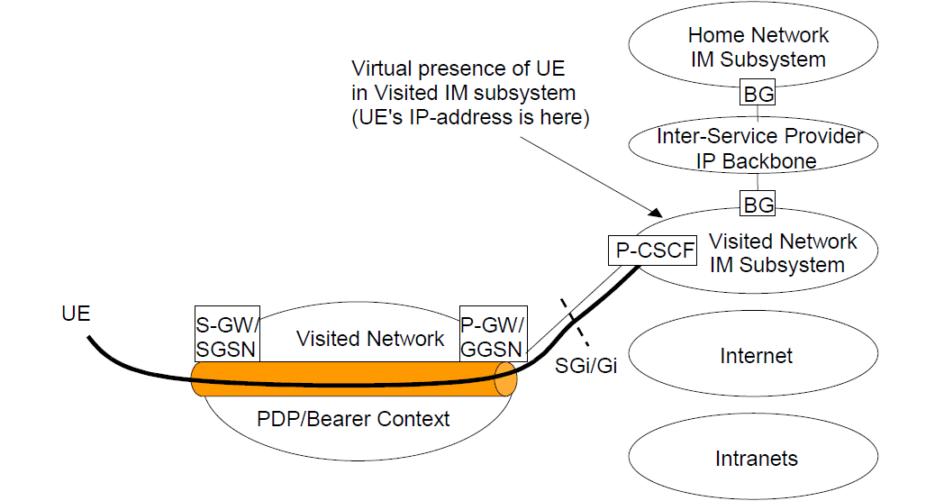

Figure 2/GSMA IR.65: UE Accessing IMS Services with P-GW/GGSN in the VPMN via VPMN IMS

Figure 3 depicts a model where the UE has obtained IP connectivity from the HPMN and the HPMN provides the IMS functionality, e.g. for S8HR.

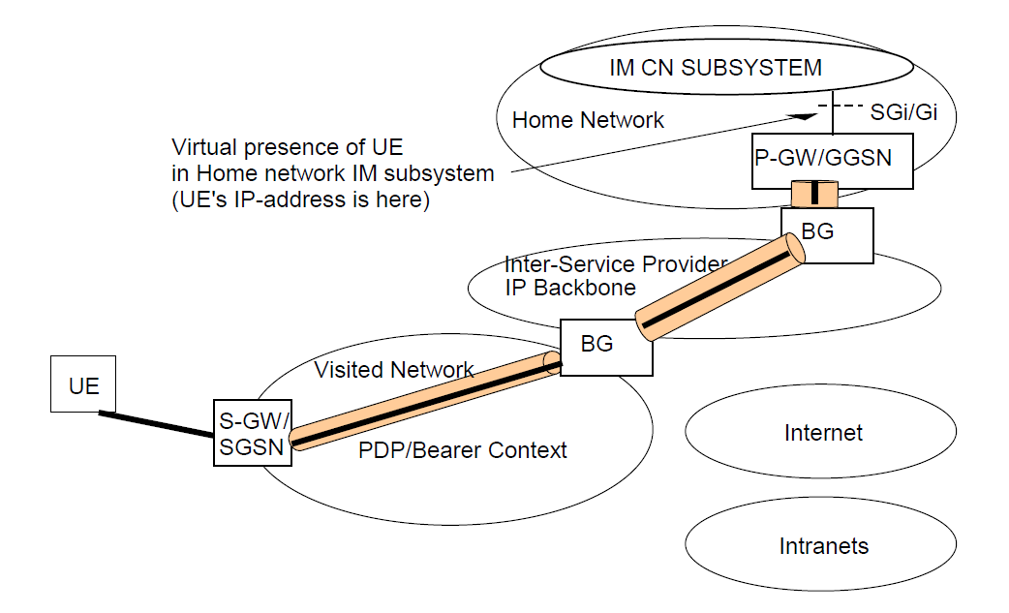

Figure 3/GSMA IR.65: UE Accessing IMS Services with P-GW/GGSN in the Home network

Figure 3 shows configuration options that do not require IMS interworking between the VPMN and HPMN IMS as the VPMN IMS is not used. When roaming is provided utilizing architecture shown in the Figure 2 the service providers need to deploy IMS interworking between the VPMN and HPMN IMS as defined in Section 3.

## Operational Requirements for IMS Voice and Video and other IMS Services based on Local Breakout and P-CSCF in VPMN

### Operational Requirements for IMS Voice and Video

Three key operational requirements have been identified:

* Routing of media for Voice & video over IMS (VoIMS; includes IR.92 [28] and IR.94 [36]) when call originator is Roaming should be at least as optimal as Circuit Switched (CS) domain.
* The charging model for roaming used in CS domain shall be maintained in VoIMS.
* Allow the HPMN to decide, based on service and commercial considerations & regulatory obligations, to enforce the routing of the originated traffic to itself (home routing).

A solution to the first requirement necessitates that the user plane is not routed towards the HPMN of the A party (unless so desired by HPMN A). When the GRX/IPX network is used as the interconnect network, the addressing requirements specified in IR.34 [1] and IR.40 [23] need to be followed. With this in mind, Local Breakout VPMN Routing (LBO-VR) architecture is illustrated in Figure 4.

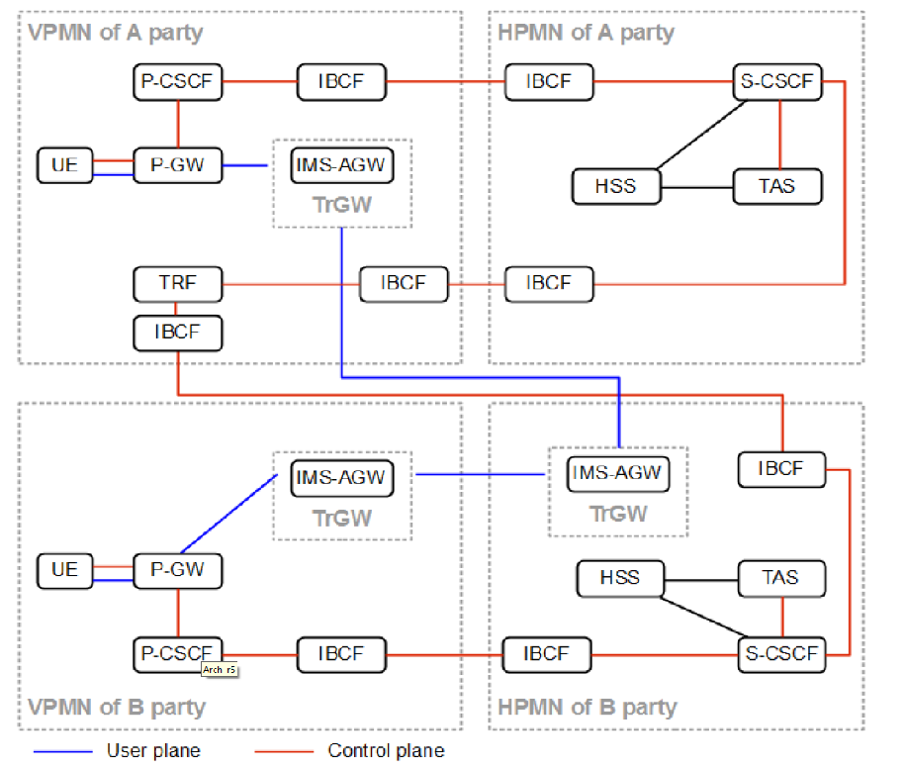

Figure 4/GSMA IR.65: Control and User Plane Routing – LBO-VR

The figure does not depict the Ut interface (between UE and the network).

The second requirement is met by deploying P-CSCF (Proxy-Call Session Control Function) and Transit and Roaming Function (TRF) within the VPMN. The TRF receives the originated call related signaling after it has been processed by the A party HPMN allowing the A party VPMN to send both control and user plane towards the destination (VPMN routing) and therefore replicate the current CS voice roaming model. By applying Optimal Media Routing (OMR) along the signaling loop from A party VPMN to A party HPMN and back to A party VPMN the media path of originated calls is optimized and not routed to A party HPMN. The TRF, P-CSCF, together with Packet Data Network Gateway (P-GW) and Billing Mediation, deliver the charging information needed for the VPMN to generate TAP3 records. 3GPP TS 23.228 [5], TS 32.260 [29] and 3GPP TS 32.275 [30] provide further details.

The last requirement is met by supporting home routing according to the LBO Home Routing (LBO-HR) as depicted in Figure 5 where the media paths of originated calls are not optimized and are routed through A party HPMN (Home Routing).

The use of LBO-VR requires OMR to be supported along the signaling from A party VPMN to A party HPMN, and then the A party HPMN should decide (e.g. based on the destination):

* To send the signaling back to the A party VPMN – and then, as described above, OMR will be required along the signaling from A party HPMN to A party VPMN (Figure 4) or;
* To bring media to the A party HPMN and send both the control and user plane from the A party HPMN A towards the destination in this case OMR is terminated in A party HPMN.

The above decision is performed by SCSCF (or the BGCF) in A party HPMN.

If only supporting LBO-HR and not LBO-VR then the support of OMR is not needed along the signaling from A party VPMN to A party HPMN.

Routing from B party HPMN to B party VPMN is not affected by LBO-HR or LBO-VR.

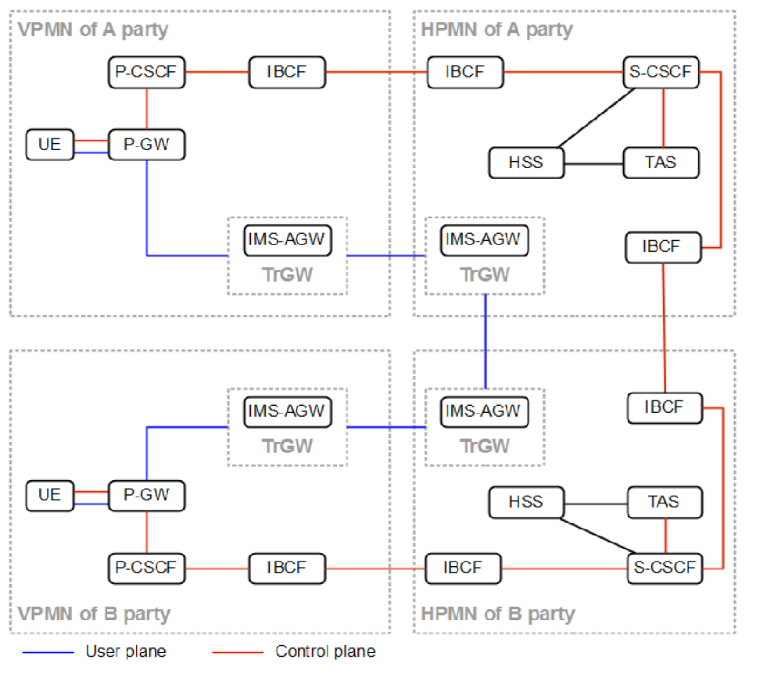

Figure 5/GSMA IR.65: Control and User Plane Routing – LBO-HR

## IMS Roaming Architecture

There are three IMS roaming architecture alternatives described in this document, namely:

* LBO-VR (Local Breakout VPLMN routing) and LBO-HR (Local Breakout HPLMN routing), as described in Section 3.4.1; and
* S8HR (S8 Home routed), as described in Section 3.4.2

Which of these alternatives is used is decided per roaming agreement. The following Sections describe the IMS roaming architecture alternatives in more detail.

### VoIMS Roaming Architecture using LBO

The target IMS Roaming Architecture is shown below in Figure 6 for EPC (see also IR.88 [26]). For IMS Roaming the S9 interface between V-PCRF and H-PCRF is not needed (see also IR.88 [26]). For routing of media when roaming, see Section 3.3.

For IMS roaming to work, the P-CSCF and S-CSCF exchange and record each other’s Uniform Resource Identifiers (URIs) during IMS registration as specified in 3GPP TS 24.229 [6]. The recorded S-CSCF URI is added as SIP route header during session setup by P-CSCF to route originated sessions to the S-CSCF and similarly the S-CSCF adds the recorded P-CSCF URI as a SIP route header to route terminated sessions to the P-CSCF as specified in 3GPP TS 24.229 [6].

If using SMSoIP, then the recorded S-CSCF URI is added by P-CSCF as SIP route header to route originating stand-alone SIP signaling requests to the S-CSCF and similarily the S-CSCF adds the recorded P-CSCF URI as a SIP route header to route terminating stand-alone SIP signaling requests to the P-CSCF.

The IPX network performs routing based exclusively upon the topmost SIP Route header that must contain the address of the destination network e.g. the A party HPMN address when roaming or the B party VPMN address when roaming for the SIP invite.

### IMS Roaming Architecture using S8HR

With S8HR IMS Roaming, the IMS well-known APN is resolved to the PGW in the HPLMN as shown in Section 2.2 (Figure 3) and in addition QoS level roaming support is required to support IMS Voice and Video telephony (VoIMS), i.e. service specific QoS other than the default QoS are supported on the home-routed PDN connection for the IMS well-known APN when roaming. IMS is supported by both the VPMN and the HPMN.

HPMN and VPMN must exchange information and agree, per roaming agreement, to the use of IMS roaming using S8HR taking into account local regulatory requirements in the VPMN.

The HPMN must ensure based on the roaming agreement that IMS layer signaling and media confidentiality protection is not activated in order to enable the VPMN to meet the local regulatory requirements.

If the HPMN uses IMS layer signaling and media confidentiality protection on its network (e.g. for the HPMN’s own subscribers, for inbound roaming LBO IMS subscribers), then based on the customer location and IMS Roaming agreement type, this protection may have to be deactivated in the HPMN.

Note: The behaviour that retrieves a subscriber’s location is currently not supported by 3GPP (i.e. it is implementation specific) and may require additional network capabilities in order to retrieve a subscriber’s location for all calls (both roaming and non-roaming cases).

This is addressed in 3GPP TR 23.749 [42].

A high level architecture diagram is represented in Figure 6 below.

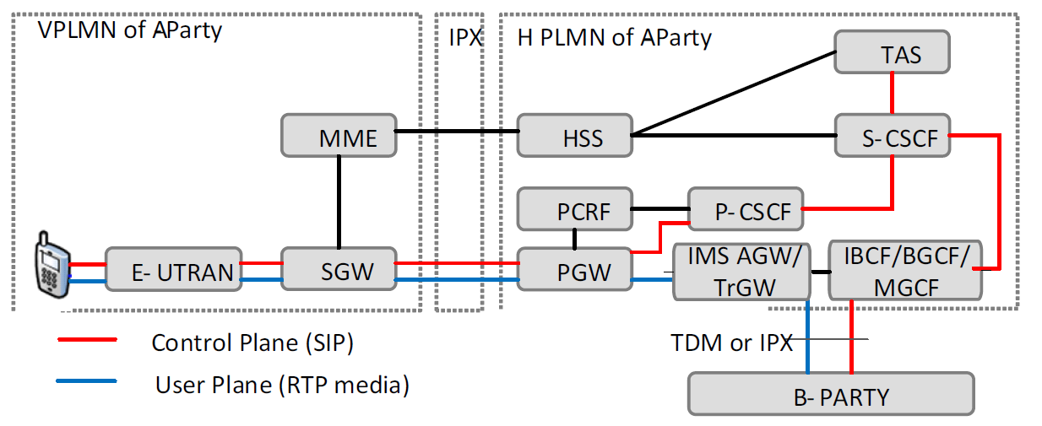

Figure 6/GSMA IR.65: S8HR IMS Roaming Architecture (VoIMS service shown)

The salient characteristics of the S8HR architecture for VoLTE Roaming (non-emergency services) are:

* VoIMS calls are home routed using IMS well-known APN via S8 interface; i.e. the IMS UNI is provided directly between UE and the HPMN for non-emergency calls.
* The IPX only differentiates the signalling and media traffic based on the requested QoS levels.
* The HPMN has full control over the VoIMS (non-emergency) call routing.
* The VPMN is not service aware, but it is QoS and APN aware.
* The VPMN supports all E-UTRAN and EPC capabilities to serve IMS inbound subscribers, e.g., IMS voice over PS support indication to the UE, QCI=1 bearer for conversational voice; QCI=2 bearer for conversational video, and QCI=5 bearer for IMS signalling in EPC and E-UTRAN.
* The PCC framework of the HPMN is used. QoS rules are generated in the HPMN and enforced by the VPMN as per roaming agreement.
* VPMN has the ability to downgrade requested QoS, or reject the requested bearer, in case QoS values are outside the ranges configured in the MME per roaming agreement. Please refer to GSMA PRD IR.88 [26], Section 7, for more details

## IMS Roaming Guidelines

LBO-VR (Figure 4), LBO-HR (Figure 5) and S8HR (Figure 6) for IMS roaming support different functionality, regulatory requirements and needs as follows:

* S8HR for IMS roaming used for VoIMS can be seen as an VoIMS and QoS extension of (existing) EPC data roaming. As depicted in Figure 6, it does not require the use of IMS interconnect for roaming flows (IMS interconnect may still be required for terminating calls between HPMNs) and it does not require inter-operator testing (P-CSCF with I/S-CSCF and of home operator terminals with P-CSCF). It is suitable for operators that wish to have IMS roaming services without, or before, deploying IMS interconnect services. However, operators also must accept the limitations (no service aware in VPMN, no SRVCC support, no geo-local services in VPMN, no media path optimization possible for originated calls, no authenticated IMS emergency call, no VoIMS Calls and SMS Lawful Interception or data retention in the VPMN) and new functionalities (e.g. QoS bearer charging, see GSMA PRD BA.27 [17], and network protection mechanisms) based on their local regulatory requirements. In addition, it may require the IPX providers that are connecting to those operatorso support QoS bearer charging.
* LBO-HR for IMS roaming requires an IMS interconnect for roaming and inter-operator testing (P-CSCF with I/S-CSCF and home operator terminals with P-CSCF in VPMN). It fully supports voice charging for mobile originated and terminated calls (see GSMA PRD BA.27 [17]), IMS emergency calls, SR-VCC, operational requirements and QoS over the GRX/IPX. It is suitable for operators that need LBO capabilities to meet their local regulatory requirements but can accept limitations such as lack of geo-local service support in VPMN and no media path optimization for originated calls.
* LBO-VR for IMS roaming extends LBO-HR by adding support for geo-local services in the VPMN and media path optimization for originated calls. Media path optimization relies on OMR support by HPMN, VPMN and interconnected IPX providers. LBO-VR is suitable for operators that need all the support provided by LBO-HR for IMS roaming but also require support for geo-local services in VPMN and media optimization for originated calls.

Operators that have to support more than one IMS roaming architecture, i.e., support S8HR in combination with LBO-HR, LBO-VR or both, also have to support the functionality for more than one IMS roaming architecture.

The IMS roaming architecture in use for a specific terminal can be used for all IMS services on the IMS well-known APN.

# GSMA IR.92 IMS Profile for Voice and SMS (Version 10.0, 19 May 2016)

# Overview

The IP Multimedia Subsystem (IMS) Profile for Voice and SMS, documented in this Permanent Reference Document (PRD), defines a profile that identifies a minimum mandatory set of features which are defined in 3GPP specifications that a wireless device (the User Equipment (UE)) and network are required to implement in order to guarantee an interoperable, high quality IMS-based telephony service and IMS-based and SGs-based Short Message Service (SMS) over Long Term Evolution (LTE) radio access. The scope includes the following aspects:

• IMS basic capabilities and supplementary services for telephony.

• Real-time media negotiation, transport, and codecs.

• LTE radio and evolved packet core capabilities.

• Functionality that is relevant across the protocol stack and subsystems.

• Additional features that need to be implemented for the UEs and networks that wish to support concurrent Circuit Switched (CS) coverage.

• Additional features that only a subset of the IMS telephony operators needs to support in certain markets.

The UE and network protocol stacks forming the scope of the IMS Profile for Voice and SMS are depicted in figure 7 below:



Figure 7/GSMA IR.92: Depiction of UE and Network Protocol Stacks in IMS Profile for Voice

The main body of this PRD is applicable for a scenario where IMS telephony is deployed over LTE in a standalone fashion without relying on any legacy infrastructure, packet or circuit switched. In order to be compliant with IMS Profile for Voice and SMS, the UEs and networks must be compliant with all of the normative statements in the main body.

Annex A defines the profile for an alternative approach where IMS telephony is deployed with a certain degree of reliance on an existing 3GPP circuit switched network infrastructure. Whenever there are additional requirements to the main profile, these are explicitly stated. In order to be compliant with the functionality described in Annex A, the UEs and networks must be compliant with all of the normative statements in Annex A as well as to all of the normative statements in the main body of the PRD that are unaltered by Annex A.

# Relationship to existing standards

This profile is solely based on the open and published 3GPP specifications as listed in the Section 1.5. 3GPP Release 8, the first release supporting LTE, is taken as a basis. It should be noted, however that not all the features mandatory in 3GPP Release 8 are required for compliance with this profile.

Conversely, some features required for compliance with this profile are based on functionality defined in 3GPP Release 9 or higher releases.

All such exceptions are explicitly mentioned in the following sections along with the relevant Release 8 or higher 3GPP release specifications, respectively.

Unless otherwise stated, the latest version of the referenced specifications for the relevant 3GPP release applies.

# Scope

This document defines a profile for voice over IMS over LTE, and for SMS over IMS and SMS over SGs, by listing a number of Evolved Universal Terrestrial Radio Access Network (E-UTRAN), Evolved Packet Core, IMS core, and UE features that are considered essential to launch interoperable services. The defined profile is compliant with 3GPP specifications. The scope of this profile is the interface between UE and network.

The profile does not limit anybody, by any means, to deploy other standardized features or optional features, in addition to the defined profile.

# ITU-T

# ITU-T Recommendation Q.3640 “Framework of interconnection of VoLTE/ViLTE-based networks”

# Scope

This Recommendation describes the framework and procedures that should be implemented by operators for establishing an interconnection between voice over long-term evolution / video over long-term evolution (VoLTE/ViLTE)-based networks to achieve worldwide interoperability.

This Recommendation identifies additional scenarios and requirements for VoLTE/ViLTE interconnection which have not been defined in existing 3GPP standards and GSMA guidelines, as follows:

* possible E2E scenarios in terms of interconnection and roaming;
* description of the EPC functions which should be supported;
* EPC configuration requirements;
* device and U/ISIM requirements;
* comparison of VoLTE roaming architecture;
* list of mandatory and optional services which should be supported by operators for interconnection and roaming scenarios;
* protocol implementation statement (PICS) needed for the service level agreement (SLA).

# Rationale

The LTE is a popular wireless technology used for providing customers access to IP core networks. By using broadband wireless technology such as LTE, telecommunication operators have finally reached the concept of "all over IP networks" and may provide with a wireless interface any telecommunication service using an all IP environment.

Among others, LTE may have been used for providing the most popular services such as real-time voice and video (e.g., telephony). However, the implementation of VoLTE/ViLTE poses some challenges to the operators, which aim to establish end-to-end connections between calling parties, because there is only a packet-switched (PS) network and the service control is provided by an IP multimedia subsystem (IMS).

Different VoLTE/ViLTE solutions are available for operators. However these solutions are not always interoperable and VoLTE/ViLTE roaming procedures are not agreed and therefore may not be implemented.

This Recommendation aims to specify common requirements to the interconnection of VoLTE/ViLTE-based networks.

# Key issues of VoLTE interconnection

There are the following key issues of interconnection among VoLTE/ViLTE-based networks:

* different options for signalling protocols used for Inter-IMS interconnection, which can support all existing services (basic call and supplementary services);
* different options for roaming scenarios (there are no strict requirements for operators and no default option);
* charging (e.g., roaming charges, calls using interconnection networks);
* numbering/addressing (e.g., ENUM resolution, ITU-T E.164 🡪 SIP-URI conversion);
* floating delay (problem of providing legacy services and applications, e.g., Fax/Modem over IP);
* lawful interception;
* data retention;
* emergency services (e.g., emergency call 112).

# General principles of interconnection of VoLTE-based networks

The reference architecture of IMS is shown in Figure 8/ Q.3640.

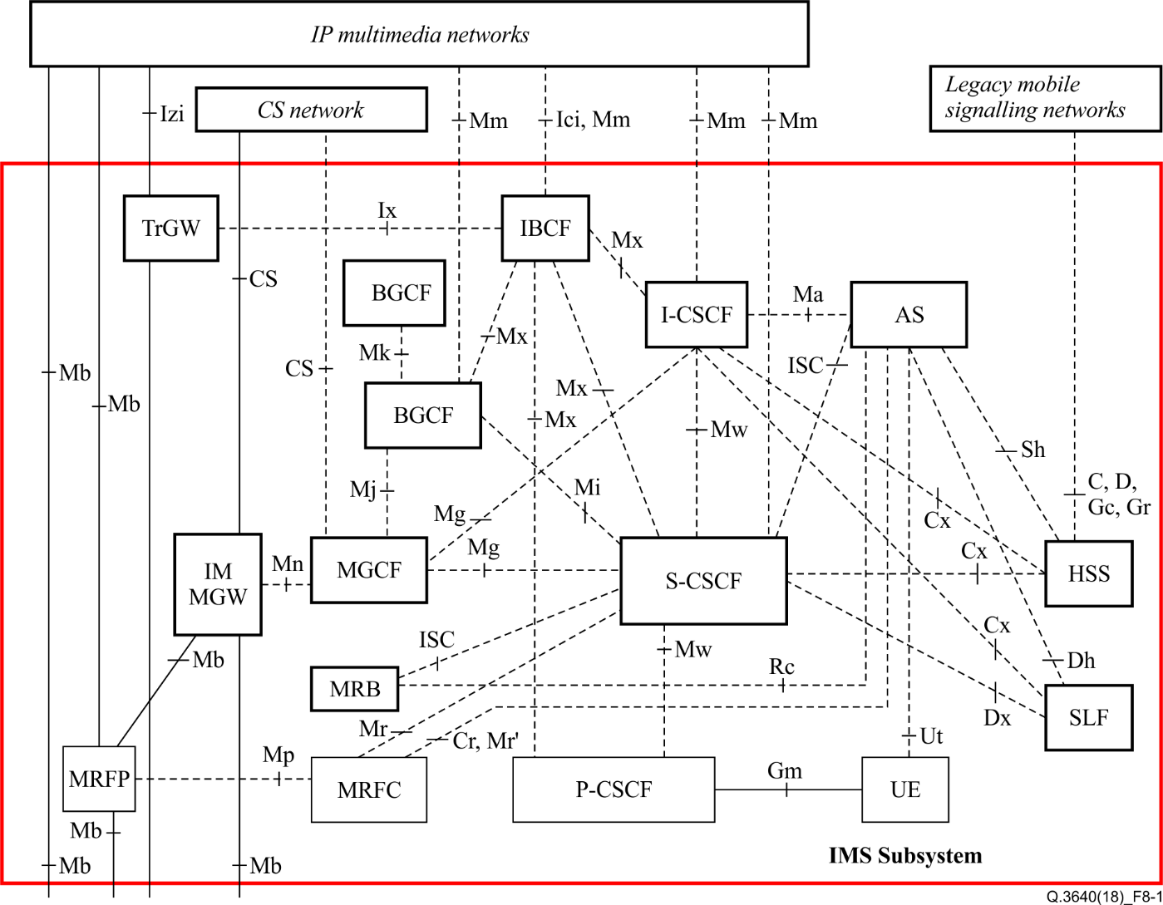

Figure 8/Q.3640 – Reference architecture of the IP multimedia core network subsystem [b‑ETSI TS 123 002]

# E2E scenarios in terms of interconnection and roaming

According to general principles there are the following key e2e scenarios:

1. E2E scenarios in terms of interconnection and roaming

According to general principles there are the following key e2e scenarios:

Interworking scenarios (established connection):

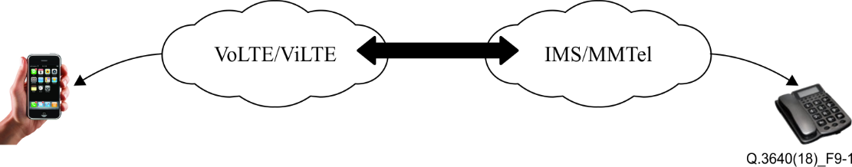

Figure 9-1 – VoLTE – IMS/MMTel interconnection scenarios

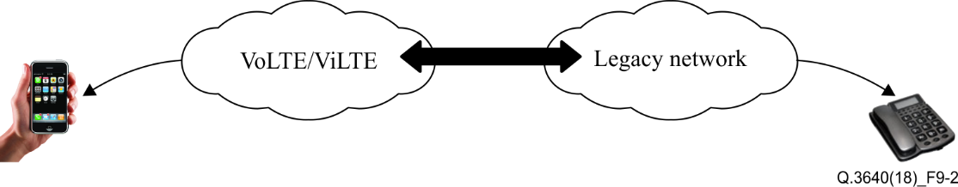

Figure 9-2 – VoLTE – Legacy network interconnection scenarios

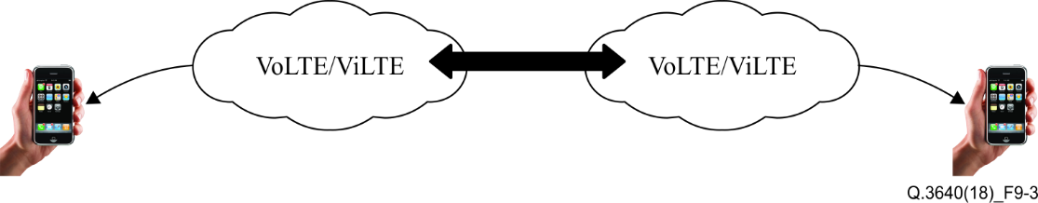

Figure 9-3 – VoLTE/ViLTE – VoLTE/ViLTE interconnection scenarios

| Table 9-1 /Q.3640– E2E scenarios in terms of interconnection and roaming | | | |
| --- | --- | --- | --- |
| No. | Scenario | Description | Roaming options |
| VoLTE – IMS interworking scenarios | | | |
| 1 | Scenario 1 | User UE1 (a) is in the IMS network A, UE2 (a) in HPMN (a) |  |
| 2 | Scenario 1A | User UE 1 (a) is in the IMS network A, UE2 (a) in HPMN (a) with CSFB (circuit switched fallback)  NOTE – Occurs only in the case if IMS voice over PS Session (VoPS) is not supported in the home public mobile network (HPMN)'s LTE networks |  |
| 3 | Scenario 1B | User UE1 (a) is in the IMS network A, UE2 (a) in HPMN (a) is moving from 4G to 3G coverage with SRVCC |  |
| 4 | Scenario 1C | User UE1 (a) is in the IMS network A, UE2 (a) roamed in VPMN (b) | – Local breakout VPMN routing architecture (LBO‑VR)  – LBO home routing architecture (LBO-HR)  – S8HR VoLTE roaming architecture |
| 5 | Scenario 1D | User UE1 (a) is in the IMS network A, UE2 (a) roamed in VPMN (b) moving from 4G to 3G coverage with SRVCC | – Local breakout VPMN routing architecture (LBO‑VR)  – LBO home routing architecture (LBO-HR)  – S8HR VoLTE roaming architecture |
| VoLTE – Legacy network scenarios | | | |
| 6 | Scenario 2 | User UE1 (a) is in the legacy network A, UE2 (a) is in HPMN (a) |  |
| 7 | Scenario 2A | User UE1 (a) is in the legacy network A, UE2 (a) is in HPMN (a), with CSFB (circuit switched fallback)  NOTE – occurs only in the case if VoPS is not supported in the HMPMN's LTE N/W |  |
| 8 | Scenario 2B | User UE1 (a) is in the legacy network A , UE2 (a) is in HPMN (a), roamed in VPMN (b) moving from 4G to 3G coverage with SRVCC |  |
| 9 | Scenario 3 | User UE1(a) is in the legacy network A , UE2 (a) is in VPMN (b) | – Local breakout VPMN routing architecture (LBO-VR)  – LBO home routing architecture (LBO-HR)  – S8HR VoLTE roaming architecture |
| VoLTE – VoLTE and ViLTE – ViLTE interconnection scenarios | | | |
| 10 | Scenario 4 | UE1 (a) is in HPMN (a), UE2 (b) is in HPMN (b) |  |
| 11 | Scenario 4A | UE1 (a) is in HPMN (a), UE2 (b) is in HPMN (b) with CSFB (circuit switched fallback).  NOTE – occurs only in the case if VoPS is not supported in HPMN. |  |
| 12 | Scenario 4B | UE1 (a) is in HPMN (a), UE2 (b) is in HPMN (b) moving from 4G to 3G coverage with SRVCC |  |
| 13 | Scenario 4C | UE1 (a) is in HPMN (a) with CSFB (circuit switched fallback). UE2 (b) is in HPMN (b). |  |
| 14 | Scenario 4D | UE1 (a) is in HPMN (a) moving from 4G to 3G coverage with SRVCC, UE2 (b) is in HPMN (b). |  |
| VoLTE – VoLTE and ViLTE – ViLTE roaming scenarios | | | |
| 15 | Scenario 5 | UE1 (a) is in HPMN (a), UE3 (a) roamed in VPMN (b) | – Local breakout VPMN routing architecture (LBO-VR)  – LBO home routing architecture (LBO-HR)  – S8HR VoLTE roaming architecture |
| 16 | Scenario 5A | UE1 (a) is in HPMN (a), UE3 (a) roamed in VPMN (b) with CSFB (circuit switched fallback).  NOTE – Occurs only in the case if VoPS is not supported in VPMN. |  |
| 17 | Scenario 5B | UE1 (a) is in HPMN (a), UE3 (a) roamed in VPMN (b) moving from 4G to 3G coverage with SRVCC | – Local breakout VPMN routing architecture (LBO-VR)  – LBO home routing architecture (LBO-HR)  – S8HR VoLTE roaming architecture |
| 18 | Scenario 5C | UE1 (a) in HPMN (a) with CSFB (circuit switched fallback), UE3 (a) roamed in VPMN (b) | Roaming options:  – Local breakout VPMN routing architecture (LBO-VR)  – LBO home routing architecture (LBO-HR)  – S8HR VoLTE roaming architecture |
| 19 | Scenario 5D | UE1 (a) is in HPMN (a) moving from 4G to 3G coverage with SRVCC, UE3 (a) roamed in VPMN (b) | Roaming options:  – Local breakout VPMN routing architecture (LBO-VR)  – LBO home routing architecture (LBO-HR)  – S8HR VoLTE roaming architecture |
| 20 | Scenario 6 | UE1 (a) calls UE3 (a), both roamed in VPMN (b) | – Local breakout VPMN routing architecture (LBO-VR)  – LBO home routing architecture (LBO-HR)  – S8HR VoLTE roaming architecture |
| 21 | Scenario 6A | UE1 (a) calls UE3 (a), both roamed in VPMN (b), UE1 (a) with CSFB (circuit switched fallback)  NOTE – occurs only in the case if VoPS is not supported in VPMN of UE1. | – Local breakout VPMN routing architecture (LBO-VR)  – LBO home routing architecture (LBO-HR)  – S8HR VoLTE roaming architecture |
| 22 | Scenario 6B | UE1 (a) calls UE3 (a), both roamed in VPMN (b), UE1 (a) is moving from 4G to 3G coverage with SRVCC | – Local breakout VPMN routing architecture (LBO-VR)  – LBO home routing architecture (LBO-HR)  – S8HR VoLTE roaming architecture |
| 23 | Scenario 6C | UE1 (a) calls UE3 (a), both roamed in VPMN (b), UE2 (a) is moving from 4G to 3G coverage with SRVCC | – Local breakout VPMN routing architecture (LBO-VR)  – LBO home routing architecture (LBO-HR)  – S8HR VoLTE roaming architecture |
| 24 | Scenario 7 | UE1 (a) roamed in VPMN (b), UE2 (b) roamed in VPMN (a) | – Local breakout VPMN routing architecture (LBO-VR)  – LBO home routing architecture (LBO-HR)  – S8HR VoLTE roaming architecture |
| 25 | Scenario 8A | UE1 (a) roamed in VPMN (b), UE2 (b) roamed in VPMN (a), UE1 (a) with CSFB (circuit switched fallback) | – Local breakout VPMN routing architecture (LBO-VR)  – LBO home routing architecture (LBO-HR)  – S8HR VoLTE roaming architecture |
| 26 | Scenario 7B | UE1 (a) roamed in VPMN (b), UE2 (b) roamed in VPMN (a) and UE2 (b) is moving from 4G to 3G coverage with SRVCC | – Local breakout VPMN routing architecture (LBO-VR)  – LBO home routing architecture (LBO-HR)  – S8HR VoLTE roaming architecture |
| 27 | Scenario 7C | UE1 (a) roamed in VPMN (b), UE2 (b) roamed in VPMN (a), and UE1 (a) is moving from 4G to 3G coverage with SRVCC | – Local breakout VPMN routing architecture (LBO-VR)  – LBO home routing architecture (LBO-HR)  – S8HR VoLTE roaming architecture |
| 28 | Scenario 8 | The VoLTE subscriber UE1 (a) in the HPMN (a) is calling the 2G/3G user UE2 (b) in HPMn (b) |  |
| 29 | Scenario 9 | The VoLTE subscribers UE1 (a) and UE 2(a) are subscribed in the HPMN (a). Subscribers UE1 (a) is roaming in 2G/3G VPMN (b). |  |
| 30 | Scenario 10 | The VoLTE subscribers UE1 (a) and UE 2(a) are subscribed in the HPMN (a). Subscribers UE1 (a) and UE2 (a) are roaming in 2G/3G VPMN (b). |  |

1. VoLTE consideration

This Recommendation includes various aspects which should be considered for VoLTE networks and devices.

Details of this part are omitted in this report.

# IMS roaming and interworking guidelines

GSMA PRD IR.65 describes three possible options for IMS interconnection.

**Option 1** – Target IMS roaming solution, IMS is required in both VPLMN and HPLMN

The UE has obtained IP connectivity from the visited network and is connected to the P-CSCF in the visited network which establishes connections using the home IMS platform; traffic is routed directly by the visited network.

**Option 2** – Data local breakout, but IMS home routed, IMS is not needed in VPLMN

The UE has obtained IP connectivity from the visited network and is connected to the P-CSCF in the visited network which itself is connected to the home IMS platform; traffic is routed via the home network.

**Option 3** – The UE has obtained IP connectivity from the home network and is directly connected to the home IMS platform; traffic is routed via the home network. Data and IMS are both home routed, IMS is not needed in VPLMN.

Table 10-1 – Comparison of VoLTE roaming architecture

|  |  |  |  |
| --- | --- | --- | --- |
| Item | Option 1 LBO-VR (target IMS roaming solution, IMS is required in both VPLMN and HPLMN) | Option 2, LBO-HR (data local breakout, but IMS home routed, IMS is not needed in VPLMN) | Option 3 S8HR  Data and IMS are both home routed, IMS is not needed in VPLMN |
| HPLMN with VoLTE implementation | Required | Required | Required |
| VPLMN with VoLTE implementation | Required | Not required | Not required |
| IMS service over GRX | Not required | Required | Required |
| Charging depending on evolved packet core (EPC) | Optional (charge on IMS service layer) | Required | Required |
| Policy and charging control mode | HPLMN hPCRF can control the VPLMN vPCRF via S9 Interface (S9 interface is optional) | HPLMN hPCRF controls VPLMN vPCRF via S9 Interface or via roaming agreement and support of common QCIs | HPLMN hPCRF controls HPLMN PGW, 2/3G and 4G (e.g., web browsing) data roaming via S8 |
| Single radio voice call continuity (SRVCC) support capability | Fully supported | Supported | Partially supported |
| VoLTE local emergency call | Supported | Supported | Not supported |
| VoLTE local LI | Supported | Supported | Not supported (LI will be possible at the S-GW (under development in Rel. 14 of 3GPP). |
| LBO with optimal media routing (OMR) | Supported | Not supported | Not supported |

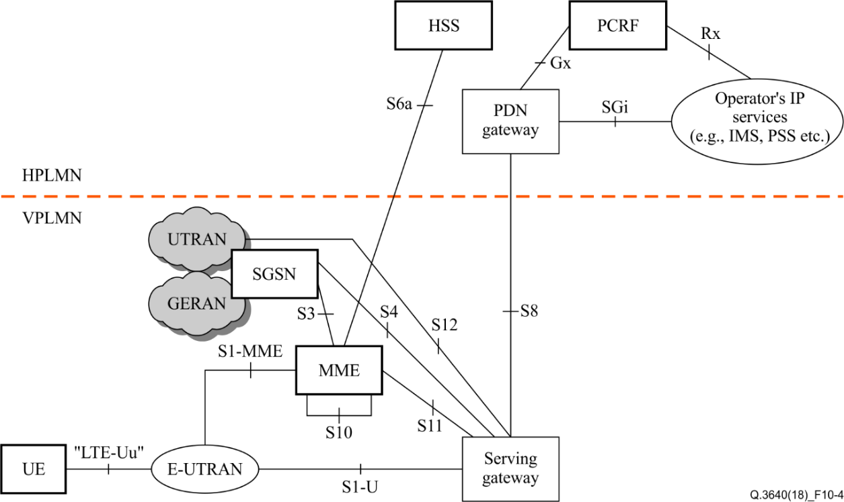

Figure 10 – Roaming architecture scenario with home routed traffic

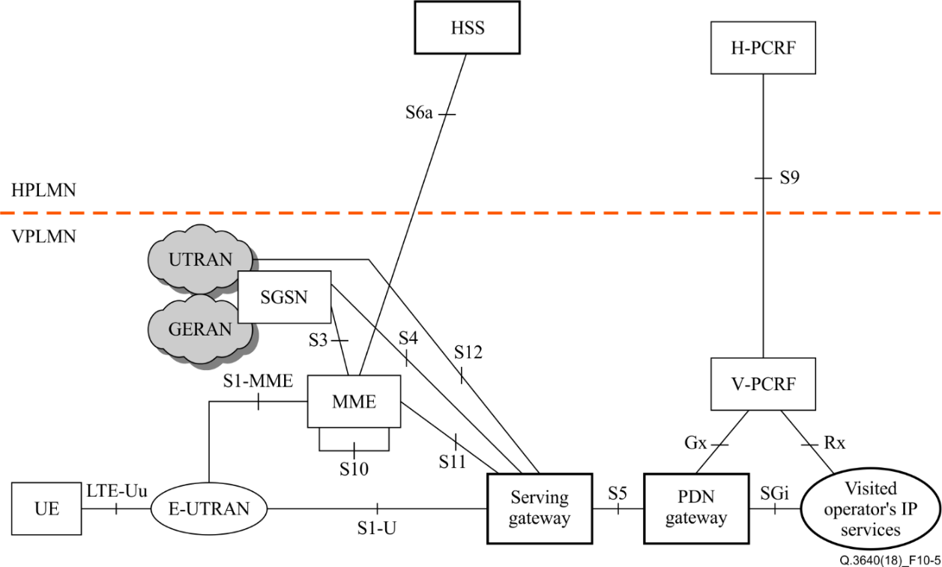

Figure 11 – Roaming architecture for local breakout, with home  
operator's application functions only

# Services for e2e VoLTE/ViLE interconnection scenarios

Table 11-1/Q.3640 specifies the list of mandatory and optional services which should be supported by operators for interconnection and roaming scenarios.

Table 11-1/Q.3640 – List of mandatory and optional services which should   
be supported by operators for interconnection and roaming scenarios

| # | Service | ITU-T Recommendation | Relevant standard developed by other SDO | Status |
| --- | --- | --- | --- | --- |
| 1 | Basic call (voice and video sessions) | Q.3403 v.1 | ETSI TS 124.229 | M |
| **Supplementary services** | | | | |
| 2 | TIP/TIR | Q.3617 v.1 | ETSI TS 124.608 | O |
| 3 | OIP/OIR | Q.3618 v.1 | ETSI TS 124.607 | M |
| 4 | HOLD | Q.3619 v.1 | ETSI TS 124.610 | O |
| 5 | CDIV | Q.3620 v.1 | ETSI TS 124.604 | O |
| 6 | CONF | Q.3621 v.1 | ETSI TS 124.605 | O |
| 7 | CW | Q.3622 v.1 | ETSI TS 124.615 | O |
| 8 | ECT | Q.3623 v.1 | ETSI TS 124.629 | O |
| 9 | MCID | Q.3624 v.1 | ETSI TS 124.616 | O |
| 10 | CC | Q.3625 v.1 | ETSI TS 124.642 | O |
| 11 | MWI | Q.3626 v.1 | ETSI TS 124.606 | O |
| 12 | CUG | Q.3627 v.1 | ETSI TS 124.654 | M |
| 13 | ACR-CB | Q.3628 v.1 | ETSI TS 124.611 | O |
| NOTE – M: mandatory; O: optional. | | | | |

# Interconnection for Inter-IMS scenario

1. Scenario

The Inter-IMS scenario is used for establishing service sessions between users of two IMS platforms (e.g., long distance call).

The reference configuration is depicted in Figure 12/Q.3640.

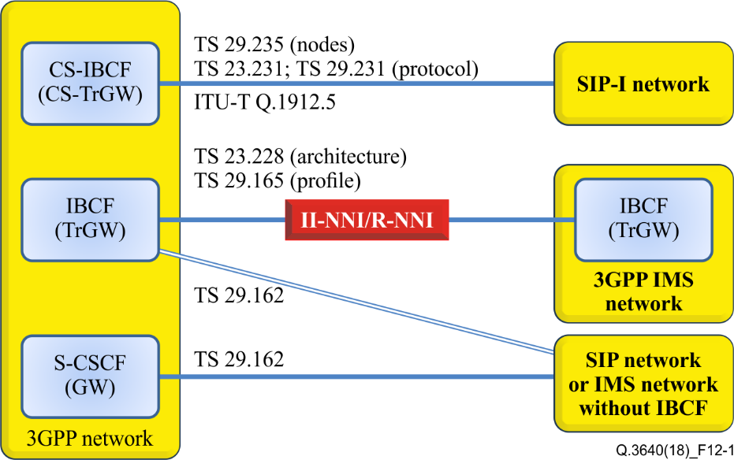

Figure 12/Q.3640 – Reference configuration for interconnection

The architecture of IMS interconnection for Inter-IMS scenario is shown in Figure 13/Q.3640.

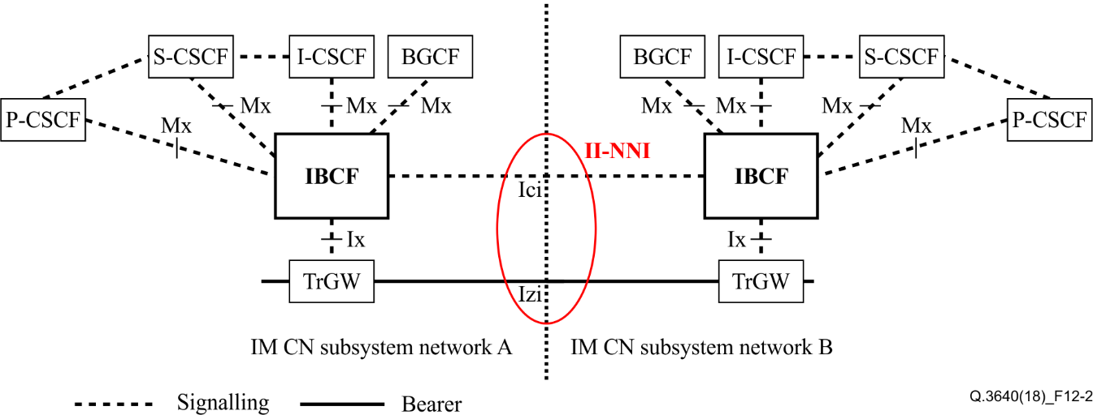

Figure 13/Q.3640 – Interconnection for inter-IMS scenario [b-ETSI TS 123.228]

Table 12-1/Q.3640 provides a list of signalling protocols and relevant standards used on both interfaces.

Table 12-1/Q.3640 – Protocols used on II-NNI interfaces

|  |  |  |
| --- | --- | --- |
| Interface | Type of protocol | Standard |
| Nc/Ici | SIP, SIP-I | – SIP-I [ITU-T Q.1912.5] (NOTE – ITU-T is trying to update it issuing a revision)  – II-NNI [ITU-T Q.3630] |
| Izi | RTP/RTCP | [b-IETF RFC 3550] |

1. Protocol implementation statement (PICS)

The protocol implementation statement depicted in Table 12-2/Q.3640 describes the scope between network operator A and network operator B. The table shall be filled out with a yes/no.

| Table 12-2 – Protocol implementation statement | | | |
| --- | --- | --- | --- |
| Selection expression | Support | Support | |
|  | Network A | Network B | |
| Network capabilities | | | |
| **SE 1:** The originating network (Network A) sends the P-Charging-Vector header? |  |  | |
| **SE 2:** The originating network (Network A) sends a subset of parameters in the P-Charging-Vector header? |  |  | |
| **SE 3:** The P-Early-Media header is supported? |  |  | |
| **SE 4:** Overlap procedure using multiple INVITE method is supported? |  |  | |
| **SE 5:** Overlap sending using in-dialog method is supported? |  |  | |
| **SE 6:** Network A supports the PSTN XML schema? |  |  | |
| **SE 7:** The resource reservation procedure is supported? |  |  | |
| **SE 8:** Does the network perform the "Fall back" procedure (PSTN or MGCF)? |  |  | |
| **SE 9:** The network is untrusted? |  |  | |
| **SE 10:** The originating network does not have a number portability data base, the number portability look up is done in the interconnected network? |  |  | |
| **SE 11:** The network supports the REFER method? |  |  | |
| **SE 12:** The network supports the 3 party call control procedure (REFER interworking)? |  |  | |
| **SE 13:** Number portability is supported? |  |  | |
| **SE 14:** Carrier selection is performed? |  |  | |
| **SE 15:** The network is a long distance carrier? |  |  | |
| **SE 16:** SIP support of charging is supported? |  |  | |
| **SE 17:** The interworking ISUP – SIP I is performed in the network? |  |  | |

Note: Table 12-2 above is excerpted only network capabilities parts from the original document.

# ITU-T Recommendation Q.3940 “NGN/IMS interconnection tests between network operators at the IMS ‘Ic’ interface and NGN NNI/SIP-I”

This Recommendation defines the tests purposes (TPs) for next generation network (NGN) IP multimedia subsystem (IMS) interconnection tests between national and international network operators, covered by ITU International Telecommunication Regulations, at the IMS interconnection (Ic) interface and NGN network-to-network interface (NNI)/SIP-I. Such tests have been developed to verify the overall compatibility of the session initiation protocol (SIP), the integrated services digital network (ISDN) and the non-ISDN (public switched telephone network (PSTN)) over the national or international NGNs, with regard to the use of end devices in the relevant networks (recommended by the network operator). The test specifications cover the procedures described in [ITU-T Q.1912.5] for Profile C (SIP-I).

The specified test purposes are the basis for bilateral tests between national or international network operators. If the test between network operators is agreed, the test purposes are performed as defined in the current Recommendation. Any modification of the requirements described in, and based on, national requirements, needs additional test purposes that are not described in the current Recommendation. Any additional test may be defined and agreed between the test staff of the network operators.

This Recommendation is technically equivalent to and compatible with [b-ETSI TS 101 585].

# ITU-T Recommendation Q.3953 “VoLTE/ViLTE interconnection testing for interworking and roaming scenarios”

This Recommendation aims to verify the various interconnections and ensure that interoperability, interworking and roaming will respect national and international requirements and the SLA agreed between operators.

# Related national activities for standardizations

This chapter describes national standards and activities of VoLTE interoperability.

## TTC

# JJ-90.30 Common interconnection interface between IMS operator’s networks (Version 4.1, June 5, 2017)

# Introduction

This document provides the TTC original standard formulated by TTC signalling working group. The working group translated JJ-90.30 Japanese version 4.1. (June 5, 2016) into English, and issued JJ-90.30 English version on June 5, 2016.

# Relationship to International Recommendations

This Standard conforms to TTC specification TS-3GA-29.165.

# Scope

[TS 29.165] specifies the Inter-IMS Network to Network Interface (II-NNI) between IMS networks. This Standard specifies the Network to Network Interface between the IMS networks commonly used within Japan.

Figure 14 illustrates the II-NNI-related architecture diagram given in Subclause 5.1 of [TS 29.165].

Figure 14 (JJ-90.30) : II-NNI between IMS networks

Figure 15 illustrates the II-NNI traversal scenario given in Clause 4 of [TS 29.165]. "IMS home network A" and "IMS home network B" represent the IMS home network on originating side and terminating side respectively. "IMS visited network X" and "IMS visited network Y" represent the IMS visited network on originating side and terminating side respectively.



Figure 15 / JJ-90.30: II-NNI traversal scenario

# Objective

This Standard is aimed to improve the interconnectivity between the IMS networks within Japan by providing a common interpretation of the interconnection conditions using the II-NNI.

The reference to the option item table relating to the selectable item as the interconnection conditions are enclosed in "{" and "}".

# Contents

This Standard specifies national supplementary specifications of [TS 29.165] within the scope described in scope.

This Standard distinguishes the specifications of the non-roaming II-NNI from those of the roaming II-NNI, as is the case with [TS 29.165]. Note that the term "II-NNI" is used in this Standard if a specification is common to the non-roaming II-NNI and roaming II-NNI.

# Supported II-NNI traversal scenarios

[TS 29.165] specifies the II-NNI between home networks (i.e. non-roaming II-NNI) and that between a visited network and a home network (i.e. roaming II-NNI).

The operator who implements an interconnection interface compliant to this Standard shall support the non-roaming II-NNI.

NOTE: The present version of this Standard does not specify any signalling requirements on the roaming II-NNI.

# SIP/SDP signalling requirements on non-roaming II-NNI

Details of this part are omitted in this report. It includes only the title of this part.

* Called party number settings
* Calling party number presentation and restriction
* Provision of talkie/announcement
* Maximum SIP message length
* Session Description Protocol (SDP)

# JJ-90.31 Common interconnection interface for carrier ENUM (Version 3.0 May 25, 2017)

# Introduction

This document provides the TTC original Standard formulated by TTC signalling working group. The working group translated JJ-90.31 Japanese version 3.0. (May 25, 2017) into English, and issued JJ-90.31 English version on May 25, 2017.

# Relationship to International Recommendations

This Standard is specified with reference to the international standards and national standards documents listed in clause 3.

# Scope

This Standard specifies the carrier ENUM interface standard to acquire the URI associated with E.164 numbers between domestic telecommunications carriers.

# Objective

The purpose of this Standard is to improve telecommunications carriers' inter-connectivity by unifying the domestic telecommunications carriers' interpretations about the specifications of the interface to acquire the URI information associated with E.164 numbers.

# Contents

To properly handle the URI acquisition from E.164 numbers by using ENUM, this Standard specifies the following mandatory items with which the domestic telecommunication carriers should comply.

1. Carrier ENUM interface

a) DNS-related items (Subclause 4.1)

b) ENUM-related items (Query/Answer) (Subclause 4.2)

Moreover, the following item is described as referential information.

1. Sequence and message encoding examples (Appendix i)

# Architecture

Figure 16 shows the architecture for the communication using carrier ENUM interface. This Standard specifies the messages (Query/Answer) exchanged over the carrier ENUM interface (NNI (ENUM/DNS) in Figure 16) for the communications using SIP among carriers networks such as IMS network.

Donor carrier network

Terminating carrier network

Originating carrier network

Initial INVITE

ENUM/DNS

Initial INVITE

ENUM Query

ENUM Answer

NNI (SIP / SDP)

NNI (ENUM / DNS)

Figure 16/JJ-90.31: Architecture for the communication using ENUM/DNS

# ENUM interface

Details of this part are omitted in this report. It includes only the title of this part.

## TTA

# Specification of VoLTE Terminal for UICC Portability between Mobile Operators (TTAK.KO-06.0357/R4, June 2017)

# Overview

This standard (as called TTA UNI specification) specifies the technical requirements of VoLTE terminals in providing UICC portability among Korean mobile operators. The core protocols and transmission specification to provide VoLTE voice call (including CID and voice supplementary services), video call, and SMS/MMS service are defined.

The minimum requirements for IMS based services in LTE networks are defined in this standard. All functions features excluding certain features described as recommendation should be considered for terminal development by referencing the Appendix I in this standard except those features stated as recommended.

# Contents

This standard specify the transmission protocols for VoLTE voice call modified from GSMA IR.92 and IR.94 considering all Korean mobile network operators’ deployment scenarios. The detailed contests are as follows;

1. IMS Features
   1. SIP Registration Procedure
   2. Authentication
   3. Addressing
   4. Call Establishment and Termination
   5. Forking
   6. Early-Media and Announcements
   7. SIP Session Timer
   8. Supplementary Services
   9. Call Set-up Considerations
   10. Management Object
2. IMS Media
   1. Voice Media
   2. Video Media
   3. DTMF Event
3. Radio and Packet Core Feature Set
   1. Robust Header Compression
   2. LTE Radio Capabilities
   3. Bearer Management
4. Common Functionalities
   1. IP version
   2. Emergency Service
5. SMS/MMS

# Differences with GSMA IR Documents

This TTA UNI Specification tries to focus as much as possible on UE’s requirement and hence the descriptions related to IMS Core network in GSMA IR.92 is not adopted in this standard.

The XCAP is not used in this standard. The mechanism to enable/disable preconditions is also not adopted (i.e. no preconditions mechanism is adopted). SIP URI in alphanmueric format is used in this standard.

The technical report “Comparison analysis between VOLTE Terminal Specification for UICC Portability(R4) and GSMA IR Documents (Technical Report) ” (TTAR-06.0171, August 2016) is provide the contents of GSMA IR.92 / IR.94 selected by the 4th revision of “Specification of VoLTE Terminal for UICC Portability between Mobile Operators(TTAK.KO-06.0357)” and to indicate the additions and modifications made. The color label is used to indicate the difference between TTA standard and GSMA IR documents; the blue characters for modifications and the red characters for additions. The removed contents of GSMA IR.92 and IR.94 are separately listed in Appendix II of the technical report.

# VoLTE Interworking Specification among Korean MNOs (TTAK.KO-06.0338/R2, June 2016)

# Overview

This standard is to describe techniques for Voice Over LTE(hereinafter referred to as “VoLTE”) service interworking among Korean mobile network operators(SKT, KT, LGU+). It is defined that the server functions and the flow of information related to VoLTE service interworking section. Also, the core protocols and the transmission specifications to provide VoLTE service interworking and operator interworking functionalities are defined in the standard. Furthermore, the standard ensures interoperability with international standards and specifications.

# Contents

IMS standard technologies are based on the general guidelines for the VoLTE service and the general guidelines for roaming and interworking between IMS networks / services.

Because these guidelines only define the VoLTE basic call processing, there is no specifications for key supplementary services for domestic service providers. It is also required to additionally define the domestic environment for interworking structure between networks.

VoLTE supplementary services defined in this standard are as listed in the following table.

<Table 4.2-1> VoLTE Supplementary Services

| Category | Service | Description |
| --- | --- | --- |
| Early media | Changed number notification | The termination service that notifies the caller of the changed number and connects calls to the changed number. |
| Conditional call forward announcement | The service that automatically forwards incoming calls to the designated number under a given condition (busy, not-registered, no reply, not-reachable). |
| Call rejection | The termination service that rejects any voice, video or message (SMS/MMS) incoming from a registered number. |
| Voice mail box | The service that provides the voice message of the calling party if the called party fails to receive the call because the power is off, the battery is low, or the call is not reachable. |
| Incoming call barring | The termination service that bars all the incoming calls |
| Ring back tone | The service that plays the tone registered by the called party for the calling party. |
| Biz ring | The service that plays the ring back tone requested by the advertiser for the parties who call the employees of the company. |
| Anonymous call rejection | The termination service that rejects the incoming call from anonymous caller. |
| T-ring | The service that plays the jingle sound before the ring back tone. |
| CID | Calling Number Identification Presentation | The termination service that displays the calling number on the called party UE. |
| Calling Number Presentation | The termination service that displays the calling number of the CNIR user on the called party UE. |
| Calling Number Identification Restriction | The origination service that prevents the calling number from being displayed on the called party UE. |
| Others | Call Forwarding | The unconditional call forwarding service forwards all the incoming calls to the designated number, while the conditional call forwarding service forwards the call failed due to busy/not-registered/no reply/not-reachable to the preset number. |
| Virtual number | The service that provides a virtual number in addition to the original number for the subscriber to receive calls and messages. |
| Call waiting | The service that notifies the user during a call of a new incoming call, enabling the user to receive all calls. |
| Video Call | Video call service |
| Voice-video call switch | The service that switches voice/video calls in real time. |

MNOs must support the following media codecs.

<Table 4.2-2> Media Codecs

|  |  |
| --- | --- |
| Classification | Codec |
| Voice codec | AMR-WB |
| AMR-NB |
| EVS |
| Video codec | H.264 |
| H.265 |
| H.263 |

For an initial session setup, such as Initial INVITE, the global number Tel URI is used between IBCFs. The wideband or the narrowband telephone-event method specified in Annex G of ‘3GPP TS 26.114’ must be supported.

This standard defines the session protocol SDP for voice calls and video calls.

<Figure 17> shows the configuration of VoLTE network between MNOs. The SIP signal between MNOs is IBCF, and RTP/MSRP is interworked through TRGW.

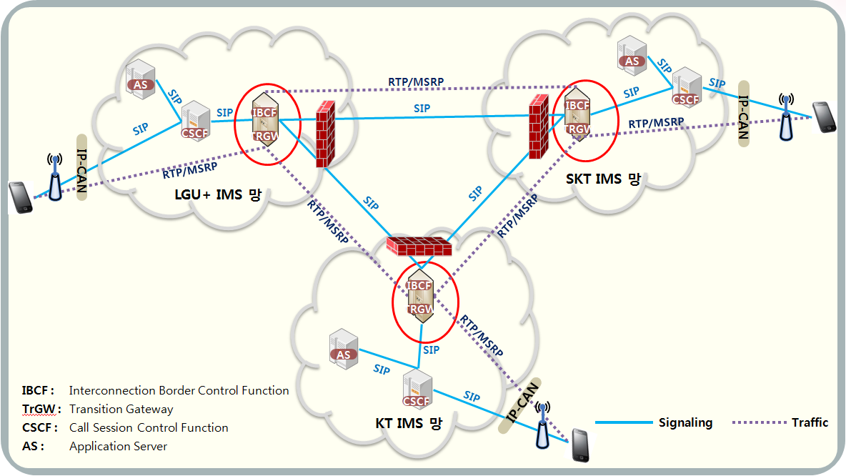

(Figure 17) Configuration of VoLTE Network

The IBCF requirements are defined as follows.

1) IBCF state between MNOs must be performed with the Options Method.

2) Even when the remote office sends options, if no 200 OK for the options is received from the remote office, the remote is considered to be down.

3) When IBCF receives the Options message, it checks and responds to the state check options in reference to the SIP URI included in the Request URI.

4) (e.g., OPTIONS sip:ibcf01.sktims.net;lr SIP/2.0)

5) The Max-Forward value in the Options message for BCF state check must be ‘0’.

6) The Options transfer function for BCF state check must be On/Off selectable. (Optional. It must be controlled as Active in the Off state.)

7) IBCF must support the multi-peer interworking (at least 10 peers).

8) IBCF must support routing for each service during the multi-peer interworking.

9) IBCF must support the weighted load balancing function during the multi-peer interworking.

10) For the above weighted load balancing function, weight setting to '0' must be possible. Messages from a '0' weighted peer must be processed normally.

11) For the above weighted load balancing function, after a session is connected with a request sent to the "1" weighted peer, any subsequent request or response from "0" weighted peer must be processed normally.

12) (The R/R header and the Via header of the request message and the response message must include the address of the '0' weighted peer. Refer to the following call flow.)

13) In case of TCP/IP interworking for the SIP call flow between IBCFs, messages of all sizes must be processed in the receiving side.

14) All the media packets for the VoLTE service must be processed through TrGW.

15) In case of failure in the IBC interworking, calls must be established via the existing 3G interworking section.

16) No SDP candidate attribute must be delivered in the interworking section.

17) SDP imageattr attributes compliant with the UICC standard received in the interworking section must be processed.

18) No MNO's private header must be transferred in the interworking section.

This standard describes the call creation/update/end flow between VoLTE networks, and the voice/video call announcement. Also the call processing flow and scenario for each VoLTE supplementary service,which are defined in Table aaa, are descirbed in this standard.

# Use cases and the best practicies in APT member countries

## Republic of Korea

In the Republic of Korea, LTE was launched in July 2011 and national coverage was established in September 2012. Unilateral launches of VoLTE took place in August 2012 and operators soon got together to start discussion on interconnect. The first release of UNI (User-Network Interface) and NNI (Network-Network Interface) standards were complete on December and October of 2013 respectively, and there was a successful VoLTE interconnect call demo on October 2014 indicating that the operators were technically ready to interconnect. Due to some regulatory issues, however, the interconnection was not realized until June 2015 and complete migration of subscribers with VoLTE enabled handset from 3G to VoLTE was complete on November 2015.

In regard to standards development, TTA (Telecommunications Technology Association) mediated between the operators and the device vendors in the coordination activity and facilitated the interconnect standardization process.

Realizing that interworking was complex due to the lack of a common UNI specification, the operators developed a Korean domestic standard “Specification of VoLTE Terminal for UICC (Universal Integrated Circuit Card) Portability between Mobile Operators” in TTA. This standard was based on GSMA IR.92, where the first version of the profile was issued in December 2013. Furthermore, the Korean operators added more details in order to reduce ambiguity and clarify important details such as SDP (Session Description Protocol) mandatory parameters.

(See Figure 18 for visualization of the issue with fragmented UNI specification and the benefit of common UNI specification).

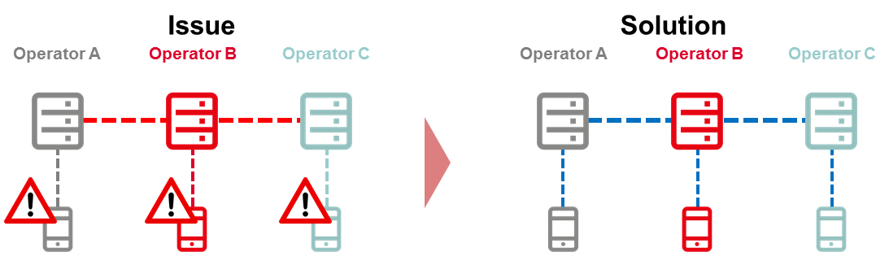

(Figure 18) Issues from Fragmented UNI specification resolved with common UNI specification

(Source: GSMA Report)

It can be observed that having an unambiguous and common UNI specification to follow will enable two things.

Firstly, it will reduce time-to-market by minimizing the possible combinations of test cases. With less fragmentation in devices, there is less chance of service disruption. It will also simplify the interworking process in interconnection and roaming as there will be less test cases to consider and less translation of SIP (Session Initiation Protocol) messages among networks to be done.

The common UNI profile greatly simplified interworking among operators. For example, before the UNI profile was agreed, implementation of DTMF (Dual-Tone Multi-Frequency signalling) was different from one operator to another, which caused the IVR (Interactive Voice Response) systems from one operator to not respond to a group of devices in another operator. After the UNI profile was agreed, however, DTMF event values were designated and this resolved IVR system interworking issues. Besides tightening IR.92 by eliminating all optionality, the Korean operators also added some features that were not considered part of the minimum set by GSMA, but that were very important for the Korean market such as Customised Alerting Tones (CAT).

Secondly, the UNI specification with clarification of details will minimize incorrect implementation cases for devices and the network. Again, this will reduce the necessary work for ensuring interoperability.

The Korean operators went a step further and clarified important details such as SDP mandatory parameters (specifically, b=AS). Since confusion could arise in determining the value of b=AS in SDP offer and answer, the specification outlined the values of b=AS according to the different profiles of voice (Adaptive Multi-Rate Narrowband and Adaptive Multi-Rate Wideband) and video (H.263 and H.264). This is a very important clarification because Korean operators are offering both VoLTE and ViLTE over GBR (Guaranteed Bit Rate) bearers. If there is no reference number to guarantee the quality against, then it is impossible to provide guaranteed bit rate bearer that optimises the given radio resource.

In addition, there are many details additional to GSMA IR.92 and IR.94 in TTA UNI specification which do not deviate from GSMA IR.92 but simply provide more description. The following list gives two examples:

• Identity during emergency: The first URI (Uniform Resource Identifier) in the P-Associated-URI from current SIP registration must be used as “From” and “P-Preferred-Identity” values in emergency.

• IPSec: UE (User Equipment)’s default value for Security-Client are “alg=hmac-sha-1-96, prot=esp, ealg=aes-cbc” and ‘esp’ should be the default value for ‘prot’ when ‘prot’ is absent.

These are not new and they do not deviate from GSMA IR.92 and IR.94, but they are given as a reference for both device vendors and operators so that incorrect implementation can be avoided. Minimising incorrect implementation cases will reduce disruption to the service and enhance interoperability.

Korean operators planned to expand this experience to all mobile communication subscribers, nationally and internationally. Firstly, they will be migrating the legacy infrastructure to all-IP infrastructure to resolve issues found with VoLTE-3G interconnection. As VoLTE is now nationally available across all operators, there is less incentive to maintain 3G as a backup solution. Secondly, they will be focusing on VoLTE international interconnect and roaming agreements using IPX (IP eXchange)-based interconnection model and S8HR roaming model. Indeed the world’s first bilateral VoLTE roaming agreement was established between KT and NTT DoCoMo in October 2015 and the world’s first unilateral VoLTE roaming was offered by LG U+ in Japan (KDDI, April 2015) and Hong Kong (Smartone, November 2015). Lastly, the operators will keep working to reflect revisions in GSMA IR documents in their specifications and TTA endorsed GSMA IR.92, showing their strong intention to comply with global specification.

As mentioned previously, the discussion on VoLTE interconnect started by the operators in September 2012. Government intervened in 2013 and decreed by law that interconnection be ready by July 2014. Such a mandate accelerated the process. Furthermore, TTA coordinated the standardization for VoLTE interworking and common UNI specification.

TTA brought the key stakeholders in VoLTE interconnect together in the standardisation process. Initially, there were the three operators (KT, LGU+, SKT), three device vendors (Samsung electronics, LG electronics, Pantech) and a local core network equipment vendor (Telcoware) involved in the discussion of UNI and NNI specifications. These were the key companies in Korean mobile industry and the inputs from them were enough to realise VoLTE interconnect standard. This shows that the government could accelerate the interconnect process by facilitating an official discussion.

## Japan

VoLTE with high quality audio[1] between mobile carriers in Japan was originally provided only their own networks. Since October 2018, VoLTE interconnection between the different network operators has begun, and the number of calls is currently increasing.

Although the conventional voice communication service which is provided by the existing public switched telephone networks is supported through a synchronous transfer mode (STM) circuit. The call processing method (common channel signaling system SS No.7) used for set up a call does not support the VolP interconnection, so the high quality audio call of the VoLTE cannot be realized.

Japanese mobile operators have developed and implemented the switches and peripheral devices that can handle the VoIP signal in order to communicate with the different network operators. In addition, the interfaces including the various parameters of SIP (Session Initiation Protocol), which are call processing control signals necessary for realizing VoIP, are established as interconnection terms in accordance with the technical specifications which are conforming to the international standards.

1. POI Selection

Conventional voice interconnection is carried out through a MGW (Media Gate Way: converts media and formats) located at an STM-POI (Point Of Interface). On the other hand, the interworking of the VoLTE using SIP is performed by an IBCF (Inter-connection Border Control Function) at an IP-POI. Therefore, it is necessary to determine which POI is to be connected to a destination operator at the time of call originating. For the determination, firstly, an operator network identifies whether the originating call is transmitted over VoLTE or 3G and an AS (Application Server) in the network add information on VoLTE. Continuously, a CSCF (Call State Control Function) select a proper POI based on the information.

1. MNP support

MNP (Mobile Number Portability) means the ability to move a mobile phone number in use to another mobile operator’s service, and the MNP are realized in Japan. Consequently, it is impossible to determine to which destination operator should be connected based on only the incoming phone number. In the VoLTE interconnection via IP-POI, the destination is determined by the number resolution of ENUM (E.164 Number Mapping) before sending a SIP connection signal, and then sends the SIP signal to the destination operator.

Each mobile operator has an ENUM server. The ENUM server holds phone numbers, which are managed by an operator owning the server, and manages their corresponding destination operators. An ENUM client in an origination operator network determines which ENUM server should be used according to the range of a phone number, and then requests the server to resolve the phone number. The ENUM server responds with a destination SIP_ URI (Uniform Re-source Identifier) of the destination operator for SIP signaling. In the origination operator network, the CSCF selects an appropriate IBCF based on the responded SIP_ URI and sends a connection request to the IBCF. The originating IBCF determines the destination operator based on the SIP_ URI, and eventually sends the request of connection establishment for exact SIP signaling to the correct IP address of an IBCF in the destination operator network through another address resolution process (3) described below.

1. Address resolution of destination IBCF

The originating operator can determine which destination operator should be connected for SIP signaling based on SIP_URI. However, in order to start actual communication with the SIP signal, it is necessary to get the IP address of the destination IBCF associated with the SIP _ URI. The VoLTE interconnect in Japan employs a DNS (Domain Name System) to give the dynamically assigned IP address of the destination IBCF to the originating operator, and the method enables the selection of the destination IBCF to be controlled by the destination operator. This procedure complies with IR. 67 of GSMA (GSM Association).

# References

* 3GPP TS 29.165 Inter-IMS Network to Network Interface (NNI) (Release 15)
* GSMA IR.65 IMS Roaming and interworking Guideline (Version 22.0, 11 October 2016)
* GSMA IR.92 IMS Profile for Voice and SMS (Version 10.0, 19 May 2016)
* ITU-T Recommendation Q.3640 “Framework of interconnection of VoLTE/ViLTE-based networks”
* ITU-T Recommendation Q.3940 “NGN/IMS interconnection tests between network operators at the IMS ‘Ic’ interface and NGN NNI/SIP-I”
* ITU-T Recommendation Q.3953 “VoLTE/ViLTE interconnection testing for interworking and roaming scenarios”
* TTA Specification of VoLTE Terminal for UICC Portability between Mobile Operators (TTAK.KO-06.0357/R4, June 2017)
* TTA VoLTE Interworking Specification among Korean MNOs (TTAK.KO-06.0338/R2, June 2016)
* TTC JJ-90.30 Common interconnection interface between IMS operator’s networks (Version 4.1, June 5, 2017)
* TTC JJ-90.31 Common interconnection interface for carrier ENUM (Version 3.0 May 25, 2017)

1. Call with high quality audio means voice calls covering a wide range of voice frequencies by using AMR - WB (Adaptive Multi-Rate Wideband) and EVS (Enhanced Voice services) in the voice codec.