APT REPORT

ON

MULTISERVICE SIGNAL TRANSMISSION
USING RADIO OVER FIBER TECHNOLOGY

No. APT/ASTAP/REPT-26
Edition: March 2017

Adopted by
The 28th APT Standardization Program Forum (ASTAP-28)
6 – 10 March 2017, Bangkok, Thailand

(Source: ASTAP-28/OUT-07)

Contents
1. Introduction 3
2. Scope 3
3. References 3
4. Abbreviations and acronyms 3
5. System architecture 4
6. System demonstration and discussion 6
7. Conclusion 10

Introduction
The aim of this contribution is to propose a multiservice transmission system, which uses using multiple microwave signals on a millimeter-wave carrier over optical fiber network. The system combines multiple telecommunication services, namely Triple-play, WiFi, and LTE into one infrastructure by using high frequency wireless signals that are distributed through optical fiber, with last mile and indoor connectivity are completely wireless. This contribution focuses on the proof-of-concept and application of multi radio signal delivery over optical fiber and radio transmission links based on Radio-over-Fiber (RoF) technology.

Scope
This Report provides the technical guideline of the access networks for multiservice system via RoF technology in the wired and wireless seamless access communication systems. Experimental demonstration and deployment scenario of these technologies for future access networks based on seamless access communication systems are also addressed as examples.

References
[APT/ASTAP/REPT-03(Rev.4)]: APT Report (2013), Characteristics and requirement of optical and electrical components for millimeter-wave Radio on Fiber systems
[APT/ASTAP/REPT-04]: APT Report (2011), Technology trends of telecommunications above 100 GHz
[APT/ASTAP/REPT-11]: APT Report (2013), Wired and wireless seamless connections using millimeter-wave Radio over Fiber technology for resilient access networks
[APT/ASTAP/REPT-19]: APT Report (2015), Integration of Radio over Fiber with WDM PON for seamless access communication system
[APT/ASTAP/REPT-20]: APT Report (2015), RoF relay link for indoor communication systems
[ITU-T G. Suppl.55]: ITU-T G-series Supplement RoF on Radio-over-fiber (RoF) technologies and their applications
[ITU-R F.2106-1] Fixed service applications using free-space optical links
[3GPP TS 36.104 version 10.9.0 release 10]: Evolved Universal Terrestrial Radio Access (E-UTRA); Base Station (BS) radio transmission and reception

Abbreviations and acronyms
This Report uses the following abbreviations and acronyms:
BER Bit error rate
CS Central station
DP Distribution point
EVM Error vector magnitude
EDFA Erbium-doped fiber amplifier
FDD Frequency division duplexing
FTTH Fiber to the home
LNA Low noise amplifier
LTE Long Term Evolution
MBH Mobile backhaul
MFH Mobile fronthaul
MMW Millimeter-wave
MsW-IDU Multiservice wireless indoor unit
MsW-ODU Multiservice wireless outdoor unit
MW Microwave
MZM Mach–Zehnder interferometer-type optical modulator
OBEF Optical band-elimination filter
OBPF Optical bandpass filter
OLT Optical line terminal
PA Power amplifier
PD Photodiode
PolMux Polarization division multiplexing
QAM Quadrature amplitude modulation
QPSK Quadrature phase-shift keying
RAU Remote antenna unit
RoF Radio over fiber
TLS Tunable laser source
VSA Vector signal analyzer
VSG Vector signal generator
WiFi Wireless Fidelity
W-IDU Wireless indoor unit
W-ODU Wireless outdoor unit

System architecture
5.1 System overview
Typical high speed broadband internet access using FTTH network requires fiber to be installed from the exchange to the customer's premises. However, delivering the optical fiber capacity wholly to end users is the primary challenge due to the complication in optical fiber deployment, namely geographical, building, and/or structural barriers. Moreover, the bandwidth of single service transmission such as FTTH alone would be exhausted due to the ever increasing demands for high speed broadband services all around the world.

As shown in Figure 1, a system based on multiservice radio transmission over RoF technology is proposed to address the aforementioned problems. Using the system, FTTH is converted into a wired and wireless solution. This solution combines telecommunication services (triple-play, LTE FDD and, WiFi) into one infrastructure at the operator side and one single integrated Outdoor/Indoor unit at customer side. With this system, high frequency wireless signals are distributed through optical fiber, therefore wireless impairments are negligible. The wireless extension as the fiber drop cable replacement by using this system may become a handy solution with less hassle, nevertheless still maintaining high speed gigabit connectivity to the commercial and home users. Additionally, multiple wireless services and as well as indoor wireless distribution are crucial requirements for medium to large sized premises that demand ubiquitous connectivity.

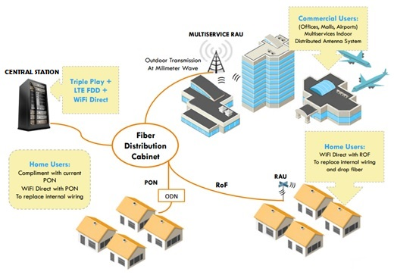
Figure 1: Conceptual diagram of multiservice radio transmission over RoF system

5.2 Concept of Polarization-Division-Multiplexed Radio over Fiber
Figure 2 shows the overall system architecture of the proposed system, which demonstrates the combinations of telecommunication services (triple-play/UniFi, LTE FDD, and WiFi) into one infrastructure and one outdoor/indoor unit. The system operates at 24.5–26.5 GHz RoF technology whereby all the transmitter equipment are placed at the central station (CS) / optical line terminal (OLT), and signals will be distributed to RAUs via optical fibers within the existing FTTH infrastructure, where RAUs act as a simple wireless repeater.

For typical home users that mainly require Triple-play connectivity, this technology offers single FTTH-ROF service through a single infrastructure with consistent quality-of-service to end-users. At the indoor scenario, the Triple-play service connects to a wireless indoor unit (W-IDU) that transmits via wireless connectivity.

For medium to large sized premises, especially in commercial areas such as shopping malls or airport, multiservice radio transmissions over RoF are used. The additional demands of high-capacity broadband access can be addressed with this system by sparsely deploying RAUs due to its simplicity. Here, multiservice RAUs are located at the optical fiber distribution point (DP) where FTTH signal is extended via microwave wireless signal. At the large premises or buildings, multiservice wireless outdoor units (MsW-ODU) are placed at the building to receive/transmit signals from the multiservice RAUs. The MsW-ODU then connects to the multiservice indoor distributed antenna system consisting of multiservice indoor unit (MsW-IDU) for LTE FDD, Triple-play and WiFi services delivery.

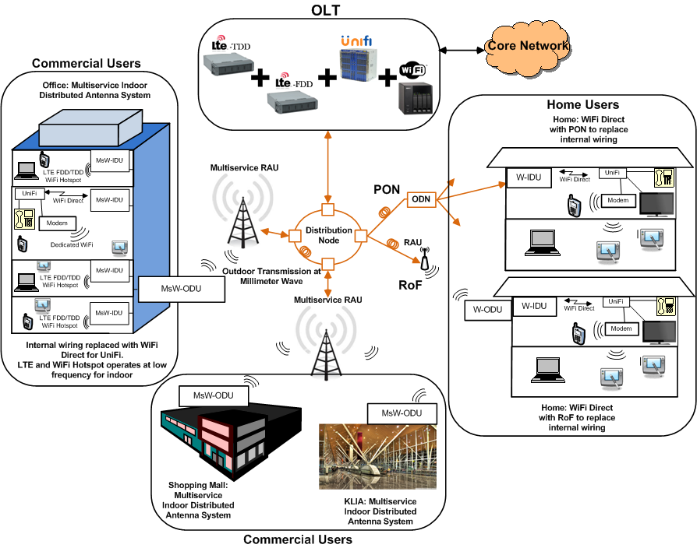
Figure 2: Multiservice radio transmission on RoF system architecture

System demonstration and discussion
6.1 Configuration of PolMux-RoF transmission with multiple microwave radio systems
Figure 3 shows an example of multiservice radio transmission at a frequency between 25.5 to 26.5 GHz. In an optical MMW generator, a tunable laser source (TLS) connected with a Mach-Zehnder modulator (MZM) provides an optical two-tone signal with a separation of twice the frequency of the input signal (12.75 GHz). The RF signal is coupled into a power divider, where one of the outputs goes directly into the first MZM arm while the other output is phase shifted at 180 degrees and propagates into the second MZM arm.

The generated optical signal is then split into two states of polarizations, X-axis polarization and Y-axis polarization, before each being modulated by respective MZMs with WiFi and LTE signals from two vector signal generators. On the X-Pol, the signal waveform of the vector signal generator (VSG) is based on WiFi 802.11a/g standards at a center frequency of 200 MHz. On the Y-axis polarization, the signal waveform of the VSG is based on LTE FDD signal compliant to the 3GPP standard at a center frequency of 875 MHz. Figure 4 shows the WiFi bandwidth illustrated at 20MHz with center frequency of 200MHz and LTE bandwidth illustrated at 10MHz with 875MHz center frequency.

The modulated signals are then combined, transmitted over 10km optical fiber, amplified by an EDFA, before being split again to attain their original signals. At each branch, a PD converts the optical signal into the respective RF signal, subsequently a power amplifier (PA) connected to an antenna amplifies the signal before being radiated over the air. After 1-meter of transmission over the air, an antenna followed by a down-converter module regenerates the WiFi and LTE signals from the 25.5 GHz carrier signal. The electrical signals before being down-converted into baseband carrier are shown in Figure 5. The down-converted signals are then demodulated and analyzed using VSA signal quality evaluation.

Figure 3: Multiservice radio (WiFi and LTE) signals transport on 25.5 GHz carrier

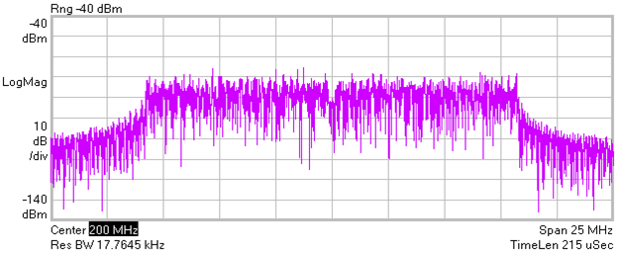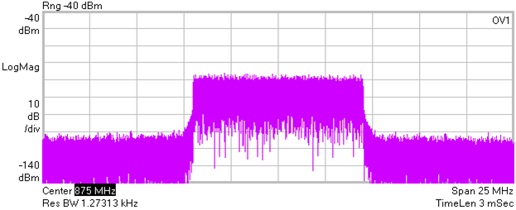
(a) (b)

Figure 4: Bandwidth for (a) WiFi: 20MHz and (b) LTE: 10MHz

(a) (b)

Figure 5: Electrical signal before down conversion for (a) WiFi and (b) LTE

6.2 Discussion of PolMux-RoF transmission with multiple microwave radio systems
Figure 6(a) shows 25.5 GHz optical carrier whereby sidebands spacing correspond to 25.5 GHz RF frequency, with a total output power of 9.35 dBm. The 2 sidebands with a suppressed signal, forms a difference of 25.5GHz in between them with the difference between sideband peak power and the suppressed signal achieved is 45 dB. Thus, a clean optical carrier is obtained for the polarization multiplexing process. The heterodyned optical signals can be observed in Figure 6(b) with a power level of -38.51 dBm.

To determine the optimum RF Input Power, EVM measurements for setup in Figure 3 were taken; without the wireless transmission part. Figure 7 demonstrates the observed EVM dependence on the input power level to the MZM for both WiFi and LTE signals. The observed behaviour of the EVMs has a so-called bathtub curve due to the nonlinear response of the MZMs. In general, a transfer function of the MZM has a squared sinusoidal behaviour to the input power level, so the saturation of the input signal causes the nonlinear effect that degrades the signal quality. The figure shows that the optimum RF Input Power to achieve the best EVM percentage is 2 dBm (EVM: 2.0475%) for WiFi and 5dBm (EVM: 2.461%) for LTE. The next measurement follows this fixed RF Input Power.

Subsequently, simultaneous multiservice WiFi and LTE transmissions with 1-meter wireless were carried out as depicted in Figure 3. The EVM measurements was then taken against the Received Optical Power as shown in Figure 8. The results show that the decrease in EVM became exponential as the received optical power is further increased. The observed EVMs are within 5.62% (WiFi 802.11a/g 64QAM standard limit) for received power higher than -18.5 dBm for WiFi; and within 8% (LTE 64QAM standard limit) for received power higher than -21.1 dBm for LTE. Thus, the multiservice transmission is successfully demonstrated with EVMs that are meeting the standard requirements.

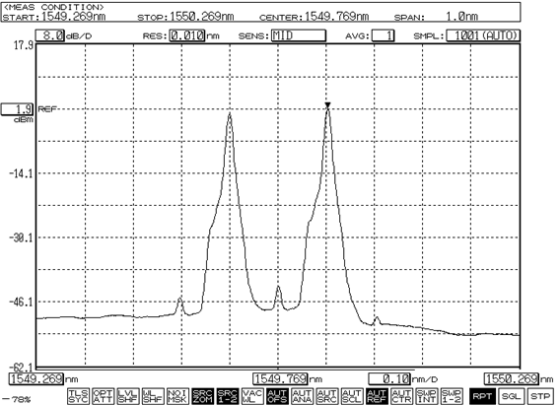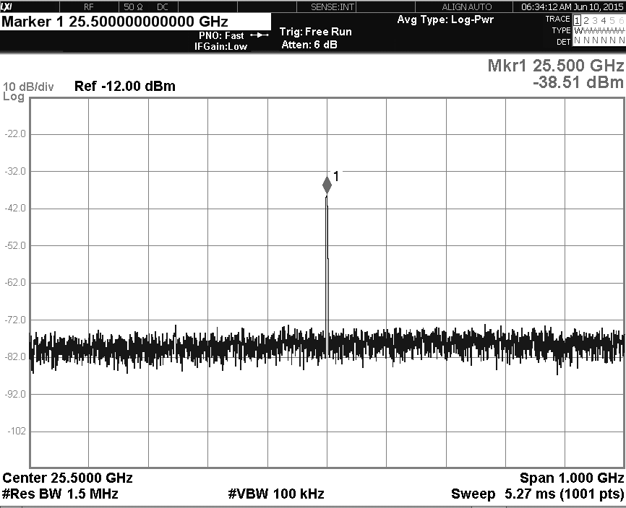
- (b)

Figure 6: 25.5 GHz optical carrier.

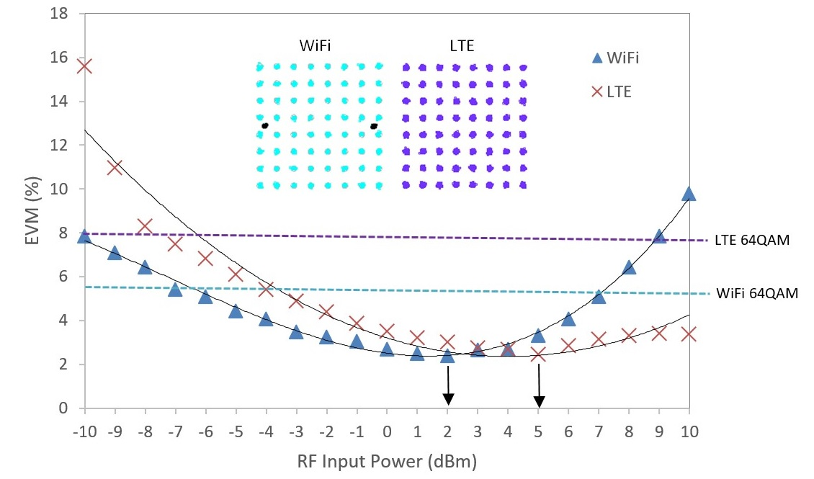

Figure 7: Graph EVM vs. RF Input Power

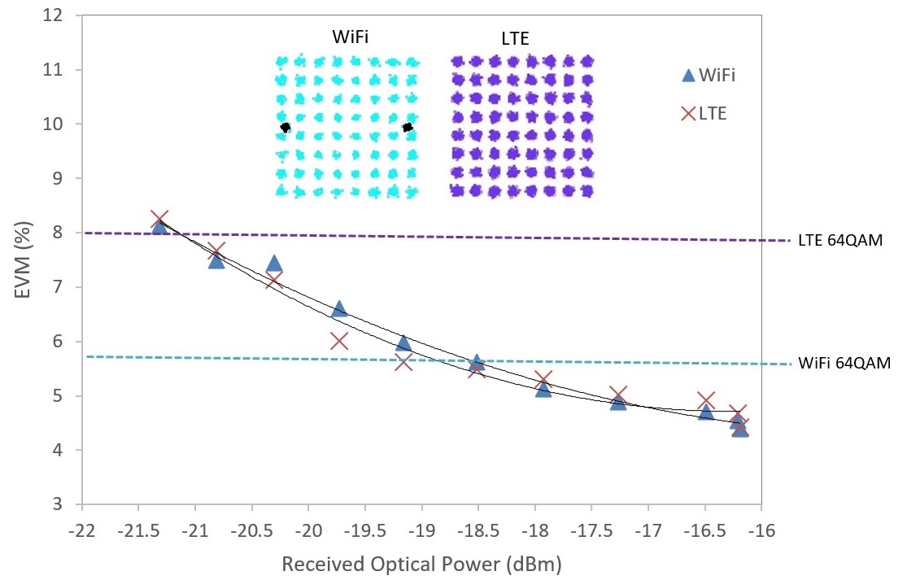

Figure 8: Graph EVM vs. Received Optical Power

Conclusion

The configuration and proof-of-concept demonstration of the RoF technologies for application of multiservice signals delivery were shown. The PolMux RoF has the capability to carry multiple signals via optical fiber network for the applications of Fixed and Mobile services. This report shows the technical guidance of the RoF technology for the application of multi radio signal deliveries over optical fiber and radio links.

