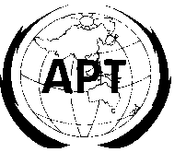 | ASIA-PACIFIC TELECOMMUNITY
 | APT Coordination Meetings During RA-12 and WRC-12

Date:26, Jan.

REPORT OF THE WRC-12 AGENDA ITEM COORDINATOR

Agenda Item No.:1.22

Name of the Coordinator ( with Email):

Meng Dexiang (mengdexiang@cmdi.chinamobile.com)

Issues:

to examine the effect of emissions from short-range devices on radiocommunication services, in accordance with Resolution 953 (WRC-07).

APT Proposals:

For WRC-12 Agenda item 1.22, no modifications to the RR are proposed except for the suppression of Resolution 953 (WRC-07). (ASP/26A22)

Status of the APT Proposals:

The proposals were introduced on the first session meeting of 6A and the issues are still under discussion at current stage.

Issues to be discussed at the Coordination Meeting:

None.

Comments/Remarks by the Coordinator:

It is expected that agreements on NOC. to RR and SUP of RES 953 will be reached, and the agreement on whether making a new WRC resolution or not is still to be discussed.

