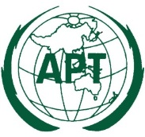 | ASIA-PACIFIC TELECOMMUNITY
 | Coordination Meetings of APT during WRC-19
 | 28 October – 22 November 2019, Sharm-el Sheikh, Egypt

agenda of the 10th coordination meeting for WRC-19

Room: SUEZ CANAL
Time: 13:00 – 13:50 Hours, 13 November 2019

- Opening remarks
- Informal inter-regional meeting on the status of work under Agenda Item 10 and develop a strategy on how to proceed toward the establishment of the draft and preliminary agendas of WRC-23 and WRC-27, respectively
- Adoption of agenda

- Consideration of the matters associated with Agenda Item 10

  - Discussion on general principles to establish agenda items for WRC-23
  - How to prepare APT priority among the ACP on WRC-23 agenda items
  - Any concerns on the proposed AI from other regional groups

- Next APT Coordination Meetings
    - Thursday, 14 November 2019 (12:30 – 13:50)

- Any other issues

__________

