Report of the Agenda Item 9.1 (Issue 9.1.2) Coordinator during WRC-19
Daesub Oh (trap@etri.re.kr)
Report Date: 12 Nov. 2019

- Agenda Item
9 to consider and approve the Report of the Director of the Radiocommunication Bureau, in accordance with Article 7 of the Convention:
9.1 on the activities of the Radiocommunication Sector since WRC-15;
9.1 (9.1.2) Resolution 761 (WRC-15) - Compatibility of International Mobile Telecommunications and broadcasting-satellite service (sound) in the frequency band 1 452-1 492 MHz in Regions 1 and 3APT Common Proposals and APT Views for WRC-19 (which has been submitted to WRC-19)

- APT Common Proposals and APT Views for WRC-19 (which has been submitted to WRC-19)
None

- Topics proposed by other regional Groups or ITU Members which are not included in no. 2 above
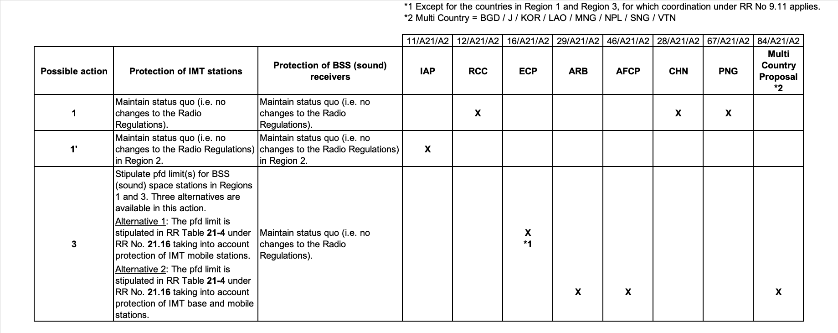

- Progress of discussion during WRC-19 on the Agenda Item
SWG 4A3 dealing with issue 9.1.2 met 7 times and made efforts to reach consensus on creating the solution for the issue 9.1.2, however, consensus was not reached so far during the SWG 4A3 meetings. As a result of the discussions, 6 solutions were proposed based on the contribution documents to WRC-19.
SWG 4A3 developed its report in which there are 6 solutions developed during the meetings, and the original positions submitted to WRC-19.

- Issues which require discussion at APT Coordination Meetings and seek guidance thereafter
None

Note: Coordinators are encouraged to conduct informal consultation with interested APT Members on the issues/topics under no. 3 and inform the outcomes of consultation to the Coordination Meeting. Coordinators can also organize coordination meetings on the respective agenda items whenever necessary.

