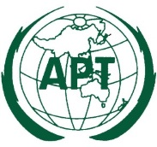 | ASIA-PACIFIC TELECOMMUNITY
 | APT Conference Preparatory Group for WRC-15 (APG-15)

Date:

APT Coordination Meetings during WRC-15

REPORT OF THE AGENDA ITEM COORDINATOR

Agenda Item No.:

Name of the Coordinator ( with Email):

Issues:

APT Proposals:

Status of the APT Proposals:

Issues to be discussed at the Coordination Meeting:

Comments/Remarks by the Coordinator:

