VII MEETING OF PERMANENT  CONSULTATIVE COMMITTEE II:  RADIOCOMMUNICATIONS  INCLUDING BROADCASTING  June 20 to 23, 2006  Lima, Peru |  | OEA/Ser.L/XVII.4.2  CCP.II-RADIO/doc. 1022/06  12 June 2006  Original: English
 | TECHNICAL ANALYSIS OF THE POTENTIAL FOR INTERFERENCE FROM TERRESTRIAL BROADBAND WIRELESS ACCESS (“BWA”) TRANSMITTERS TO FIXED-SATELLITE SERVICE (“FSS”) RECEIVE EARTH STATIONS IN THE BAND 3,400-4,200 MHz
 | (Item on the Agenda: 4.3)
(Document submitted by the Hispamar Ltda.; Intelsat Global Services Corporation; Loral Skynet; New Skies Networks, Inc.;
PanAmSat Corporation; Star One; Satelites Mexicanos S.A. de C.V.; Telesat Canada and The Boeing Company)

- Introduction

Many CITEL member administrations have already defined or are currently in the process of defining frequencies below 6 GHz to be used for BWA systems. Taking this into consideration, PCC.II/Dec.37(VI-05) established a discussion group on this topic in the electronic forum of CITEL, and requested information on BWA systems currently operating in frequencies below 6 GHz as well as on systems planned to operate in the future.

This document presents a technical analysis of the potential for interference from BWA transmitters to FSS earth stations operating in the band 3,400-4,200 MHz. It concludes that co-frequency operation of FSS earth stations and transmit fixed or mobile stations in BWA systems would impose severe constraints on both FSS and BWA. Moreover, deployment of BWA systems without due consideration of FSS receive earth stations can actually cause interference that is severe enough to interrupt the FSS links terminating at these earth stations. FSS concerns with this kind of interference are compounded by the fact that many of these earth stations are receive-only, and often are not registered with the national telecommunication authorities.

The technical analysis considers the different interference mechanisms and shows that unacceptable interference can be caused even by BWA transmitters that are located several kilometers away from the affected FSS earth station. In addition to this analysis, specific interference events that have occurred and have been documented are reported here in order to corroborate through specific examples the concerns being raised in this document.

- Background

In the ITU Table of Frequency Allocations, the FSS, in the space-to-Earth direction, and the fixed service (“FS”) are co-primary in the band 3,400-4,200 MHz. In some national tables of frequency allocations, the FSS is not primary in the band 3,400-3,700 MHz or over a portion of this 300 MHz range. There is currently FSS use over the whole 800 MHz range, but the utilization of the upper 500 MHz (3,700-4,200 MHz) is much more intense, followed by the utilization of the band 3,625-4,200 MHz.

An analysis on the sharing between FSS receive earth stations and Fixed Wireless Access (“FWA”) systems can be found in Recommendation ITU-R SF.1486 (“Sharing Methodology Between Fixed Wireless Access Systems in the Fixed Service and Very Small Aperture Terminals in the Fixed-Satellite Service in the 3 400-3 700 MHz Band”). It is interesting to note that, although the technical analysis would be equally applicable to the band 3,700-4,200 MHz, this ITU-R Recommendation focuses on the range 3,400-3,700 MHz. In light of the fact that Recommendation ITU-R SF.1486 concludes that coordination distances between FSS terminals and FWA systems would be of several kilometers (see Section 3 below for more details), the ITU studies are implicitly recognizing that co-frequency operation is not feasible and more so in the band 3,700-4,200 MHz -- where FSS deployment is more intense.

The fact that the band 3,400-4,200 MHz is currently shared between FSS receive earth stations and radio-relay systems in the FS does not mean that sharing between FSS and BWA (or FWA) is feasible. The density of BWA transmit stations will be much higher than that of radio-relay transmit stations. Moreover, transmit antenna patterns are much more directional for radio-relay stations than for BWA stations. Coordination distances of several kilometers may be compatible with light deployment of very directional FS transmit stations, but will severely constrain both FSS and BWA deployments. BWA deployment will be limited by the need to protect existing FSS earth stations, while future FSS deployment will be precluded around any area where BWA systems may be able to deploy.

In addition to these technical difficulties, there are licensing issues that would further complicate the situation. The massive deployment of BWA asks for a more liberal licensing regime, e.g., somewhere in between licensing of each individual transmit station and an unlicensed regime. This might generate difficulties in assessing the deployment feasibility of future FSS earth stations. Conversely, many FSS receive-only earth stations are not registered with the national authorities, and it would be difficult to ensure their protection form interference that may be caused by BWA transmit stations.

The Office of the Telecommunications Authority (“OFTA”) of Hong Kong has issued consultation papers on the possible deployment of BWA systems in the band 3,400-3,600 MHz (December 2004 and August 2005). More recently (February 2006), OFTA issued a document (“Assessment of Potential Interference between Broadband Wireless Access Systems in the 3.4 – 3.6 GHz Band and Fixed Satellite Services in the 3.4 – 4.2 GHz Band”) presenting preliminary conclusions on the associated interference issues. Two of the conclusions of this document are important enough to be reproduced here.

- “The 3.5 GHz BWA systems will cause interference to FSS stations operating in the 3.5 GHz band (if the operating frequencies of the BWA systems and FSS stations coincide). In order to avoid the interference problem, a separation distance of several kilometres between the BWA and FSS stations will generally be required even though there is no direct line of sight (18.5 dB clutter loss) and reasonable shielding arrangement (30 dB shielding loss) has been implemented by the user.”

- “[I]n order to avoid the in-band interference problem between a 3.5 GHz BWA station and 3.5 GHz FSS stations, a separation distance of several kilometres between the BWA and FSS stations is required. Due to the potentially massive deployment of BWA systems in the territory, it would be difficult in practice to ensure that such separation distance could be achievable in most of the cases in a small and densely populated place like Hong Kong. Co-primary allocation for both FSS and BWA in the 3.5 GHz band is therefore not feasible.”

Without endorsing all the assumptions made by OFTA in connection with (i) above, it is emphasized that even with a very conservative approach (48.5 dB loss above that of free space) the conclusion still is that separation distances of “several kilometers” are required. Even more significant is OFTA’s conclusion in (ii) above. It recognizes that BWA and FSS cannot be deployed in the same area and goes further in concluding that a co-primary allocation to FSS would not be compatible with the associated interference environment. As a minimum, this is equivalent to freezing FSS deployment in the band. Although a secondary allocation in the band 3,400-3,600 MHz in Hong Kong would be very undesirable to the FSS, any disruption to current and future FSS deployment in the band 3,625-4,200 MHZ would be much more serious to the FSS industry.

The OFTA interference assessment of February 2006 also addresses interference issues associated with possible saturation of the FSS receiver, and with interference caused by out-of-band emissions generated by BWA transmitters. These matters will also be considered in Section 3, below.

A similar conclusion with respect to co-frequency operation of BWA transmitters and FSS receive earth stations has been reached by the Federal Communications Commission (“FCC”) in the United States. The FCC has recently issued an Order addressing the use of the band 3,650-3,700 MHz by BWA. In this Order, it is also recognized that co-primary operation of BWA transmitters and FSS receive earth stations is not feasible in view of the large separation distances that are required. Moreover, in order to protect a certain number of existing FSS earth stations that already operate in the band 3,650-3,700 MHz, the FCC has established a protection distance of 150 km, i.e., no BWA transmit station can be deployed within 150 km from any of the grandfathered earth stations without coordination. Although the FCC leaves open the possibility of coordinating BWA stations that are within the 150 km radius, the nature of the BWA service is not compatible with site-by-site coordination and in most areas of the United States deployment will occur without coordination.

- Interference Mechanisms and Analytical Results

In-Band Interference

The impact on FSS earth stations of the interference generated by co-frequency BWA emissions is summarized in Table 1, below. This table calculates the minimum distance needed between a BWA transmitter and an FSS earth station operating in the 3,400–4,200 MHz band, for various arrival angles. For the purpose of these calculations, the e.i.r.p. of the BWA device was assumed to be 25 watts in 25 MHz (i.e., 14 dBW/25 MHz). Additionally, the minimum distance between the BWA device and the FSS earth station is calculated based on an I/N criterion of 3%.

Table 1 includes separation distances for propagation losses calculated by three different models: (i) free space; (ii) free space plus 48.5 dB (mirroring the assumptions contained in Recommendation IUT-R SF.1486 and in the OFTA document (i.e., 18.5 dB clutter loss and 30 dB of shielding); and (iii) a mixed model that assumes losses varying with d², d³ and d⁴ in different sections of the path. More specifically, the model in (iii) calculates path loss as:

20 log (4 π d / λ) for d ≤ A;

(Loss at A) + 30 log (d / A) for A < d ≤ B; and

(Loss at B) + 40 log (d / B) for d > B,

where d is the total propagation path (m), A is the first breakpoint distance, and B is the second breakpoint distance. The breakpoints for the propagation model were chosen according to the physical environment. In an urban environment, these values were set at 50 m and 1000 m respectively, while in a rural environment, these values are set at 100 m and 2000 m respectively.

Table 1
Required Separation Distances between BWA Transmitter (e.i.r.p.= 25 Watt/25 MHz or
14 dBW/25 MHz) and FSS Receive Earth Station (In-Band Interference)

Arrival angle of BWA signal at FSS E/S relative to boresight | 5° | 15° | 48°
FSS E/S antenna gain towards BWA transmitter (dBi) | 11.5 | 2.6 | -10.0
Total FSS E/S system noise temperature (°K) | 142.8 | 142.8 | 142.8
Thermal noise power (dBW/MHz) | -147.1 | -147.1 | -147.1
Allowable interference level for I/N = 3% (dBW/MHz) | -162.3 | -162.3 | -162.3
BWA e.i.r.p. density (dBW/1 MHz) | 0 | 0 | 0
Interference path loss required (dB) | 173.8 | 164.9 | 152.3
Frequency of operation (MHz) | 3675 | 3675 | 3675
Separation distance (km)  Model (i): free space loss | 3184.3 | 1139.2 | 266.2
Separation distance (km)  Model (ii): free space loss + 48.5 dB | 12.0 | 4.3 | 1.0
Separation distance (km)  Model (iii): urban environment | 26.7 | 17.0 | 7.7
Separation distance (km)  Model (iii): rural environment | 37.7 | 22.6 | 10.9

Despite the different assumptions, all results show that separation distances of several kilometers are required to ensure protection of FSS earth stations. This corroborates the conclusion from other studies that the BWA deployment would, on the one hand, be severely limited by the need for protecting existing FSS earth stations, and would, on the other hand, unduly constrain the deployment of future FSS earth stations.

Moreover, if short term effects are taken into consideration larger separation distances will result. Actually, the 150 km separation distance adopted by the FCC is consistent with the consideration of short-term effects. In addition, all these considerations refer to a single-entry interference model and the possibility of aggregation would only strength the case being made here.

Saturation of FSS Receiver

Basically, C-band receivers utilize Low Noise Block down-converters (“LNBs”). After a reflector intercepts the satellite signal, the LNB amplifies this signal and down-converts it from C-band to L-band, in order to facilitate transporting the signal using coaxial cable. Because LNBs are designed to receive at least the full 500 MHz of conventional C-band spectrum (3,700-4,200 MHz), their filter response characteristics around the 3,700-4,200 MHz band hardly exhibit any attenuation. Actually, most LNB manufacturers consider the pass band of LNBs to be 3,625-4,200 MHz, and therefore no rejection will typically occur within this band.

In order to have an idea of the order of magnitude of the signals involved, the case of a 3.7 m antenna used to receive a 36 MHz, fully saturated signal, is considered here. For a satellite saturation downlink e.i.r.p. of 40 dBW, a downlink free space loss of 196 dB and an antenna gain of 41 dBi, it follows that the desired signal within 36 MHz at the input of the LNB is:

40 -196 +41 = -115 dBW = -85 dBm

If 12 satellite transponders with the same polarization are active, the total power at the input of the LNB is:

-85 + 10log12 = -74.2 dBm

Typical LNBs have a range of operation that extends up to an input power of – 55 dBm. Beyond this level, saturation and non-linear effects start to occur. As expected, even in the case of a satellite where 12 transponders are saturated, the LNB is still operating well within its normal range.

Table 2 presents the total power at the input of the LNB including the power of the interfering signal. Conclusions are very similar to those reached in the OFTA document. LNB saturation may occur for BWA transmitters located a few hundred meters from the FSS earth station, whereas at least 3 dB of LNB input back off would be required for the adequate transmission of digital carriers and moreover, depending on the specific LNB under consideration, the saturation level can be lower than the -55 dBm assumed here.

Table 2
Comparison of Total Power at LNB Input (Including BWA Interference)
with LNB Saturation Level

Distance (m) /  Free Space Loss (dB) | Interfering Power at FSS Antenna  (dBm) (Note 1) | FSS Antenna Off-Axis Angle (º) / Gain (dBi) (Note 2) | Interfering Power (dBm) / Total Power (dBm) at Output of Antenna (Note 3) | Excess Over LNB Saturation Level of -55 dBm (dB)
50 / 77.7 | -33.7 | 5 / 11.5 | -22.2 / -22.18 | 32.8
200 / 89.3 | -45.7 | 5 / 11.5 | -34.2 / -34.22 | 20.8
600 / 99.3 | -55.3 | 5 / 11.5 | -42.8 / -43.76 | 11.2
1000 / 103.7 | -59.7 | 5 / 11.5 | -48.2 / -48.19 | 6.8
50 / 77.7 | -33.7 | 15 / 2.6 | -31.1 / -31.11 | 23.9
200 / 89.3 | -45.7 | 15 / 2.6 | -43.2 / -43.15 | 11.9
600 / 99.3 | -55.3 | 15 / 2.6 | -52.7 / -52.66 | 2.3
1000 / 103.7 | -59.7 | 15 / 2.6 | -57.1 / -57.05 | -2.0
50 / 77.7 | -33.7 | 30 / -4.9 | -38.6 / -38.63 | 16.4
200 / 89.3 | -45.7 | 30 / -4.9 | -50.7 / -50.66 | 4.3
600 / 99.3 | -55.3 | 30 / -4.9 | -60.2 / -60.05 | -5.0
1000 / 103.7 | -59.7 | 30 / -4.9 | -64.7 / -64.20 | -9.2
Note 1: e.i.r.p. of BWA interfering signal is 44 dBm (e.g., a 25 MHz signal with e.i.r.p. density of 1 W per MHz).
Note 2: Antenna gain of 29-25logθ for an off-axis angle of 5º, and 32-25logθ for off-axis angles of 15º and 30º.
Note 3: Total power is interfering power plus -74.2 dBm.

Several possible mitigation techniques are mentioned in the OFTA document, including the use of a bandpass filter at the front end of the FSS earth station and reduction of the BWA transmitter power levels.

As an example, installation of a bandpass filter at the front end of an earth station intended to receive in the band 3,700-4,200 MHz is considered here. The frequency response of a typical filter is shown in Figure 1.

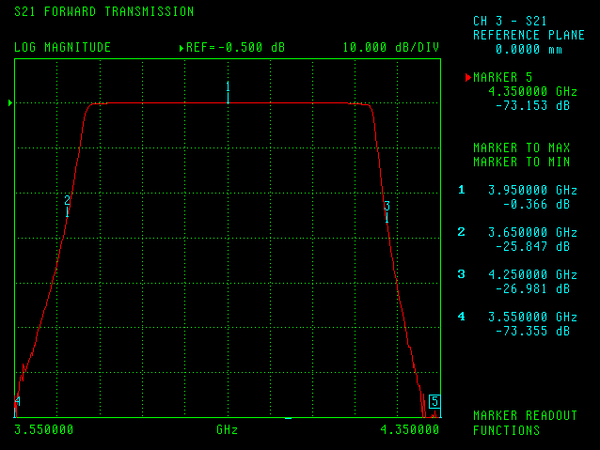

Figure 1
Typical Frequency Response of a Bandpass Filter in the Band 3,700-4,200 MHz

Table 3 compares the situation analyzed in Table 2 (i.e., out-of-band signal of 25 dBW/25 MHz and no filtering) with two scenarios in which a filter is used. In the first scenario, the 25 dBW/25 MHz signal is in the band 3,675-3,700 MHz, while in the second scenario the same interfering signal is in the band 3,650-3,675 MHz. In both cases the interfering signal is assumed to have uniform power spectral density.

Since it is not possible to effectively suppress an interfering signal that is adjacent to the edge of the filter passband, the results in Table 3 confirm that for a 25 dBW / 25 MHz interfering signal in the band 3,675-3,700 MHz saturation of the LNB may still occur. However, if the interfering signal is in the band 3,650-3,675 MHz saturation of the LNB becomes significantly less likely.

It is concluded from Table 3 that BWA systems operating outside the band used by FSS should accommodate signals with higher power as far as possible from the edge of the FSS band, leaving spectrum closer to the FSS band for the use of BWA signals with lower power. With this arrangement, any filter that may have to be installed at the front end of the FSS earth station will become more effective.

If the FSS earth station is intended to receive in the band 3,625-4,200 MHz, the filter pass band would have to be 575 MHz and not 500 MHz as shown in Figure 1. Similar calculations would then show that LNB saturation would be still likely if higher power BWA transmitters operate in the band 3,600-3,625 MHz. If BWA is to operate in the band immediately below 3,625 MHz then lower power BWA signals should be placed in this frequency range while higher power signals would be assigned spectrum as far as possible from 3,625 MHz.

Table 3
Effect of Filtering on the Total Power at LNB Input (Including BWA Interference)

Distance (m) /  Free Space Loss (dB) | FSS Antenna Off-Axis Angle (º) / Gain (dBi) (Note 1) | Excess Over LNB Saturation Level of -55 dBm (dB)
Distance (m) /  Free Space Loss (dB) | FSS Antenna Off-Axis Angle (º) / Gain (dBi) (Note 1) | No Filter | With Filter  (Interfering Signal in 3675-3700 MHz) | With Filter  (Interfering Signal in 3650-3675 MHz)
50 / 77.7 | 5 / 11.5 | 32.8 | 27.9 | 15.4
200 / 89.3 | 5 / 11.5 | 20.8 | 15.9 | 3.4
600 / 99.3 | 5 / 11.5 | 11.2 | 6.3 | -6.0
1000 / 103.7 | 5 / 11.5 | 6.8 | 1.9 | -10.0
50 / 77.7 | 15 / 2.6 | 23.9 | 19.0 | 6.5
200 / 89.3 | 15 / 2.6 | 11.9 | 7.0 | -5.4
600 / 99.3 | 15 / 2.6 | 2.3 | -2.5 | -13.7
1000 / 103.7 | 15 / 2.6 | -2.0 | -6.8 | -16.4
50 / 77.7 | 30 / -4.9 | 16.4 | 11.5 | -1.0
200 / 89.3 | 30 / -4.9 | 4.3 | -0.5 | -12.1
600 / 99.3 | 30 / -4.9 | -5.0 | -9.6 | -17.6
1000 / 103.7 | 30 / -4.9 | -9.2 | -13.3 | -18.5
Note 1: Antenna gain of 29-25logθ for an off-axis angle of 5º, and 32-25logθ for off-axis angles of 15º and 30º.

As for the in-band interference analysis above, the saturation effects considered here were based on a single-entry interference scenario. Especially for mobile terminals the likelihood of aggregation becomes significant and therefore saturation effects can be expected to be even more severe than what has been presented here.

Out-of-Band Interference

Out-of-band emissions from BWA transmitters, if not properly limited, may cause unacceptable interference to FSS earth stations. As an example, if the out-of-band emission e.i.r.p. is limited to -72 dBW/MHz, Table 4 gives the minimum distances that transmitters would have to be from the FSS earth station in order for the allowable interference level of -162.3 dBW/MHz not to be exceeded assuming free space loss.

Table 4
Required Separation Distances between BWA Transmitter and
FSS Receive Earth Station (Out-of-Band Interference: -72 dBW/MHz)

Arrival angle of BWA signal at FSS E/S relative to boresight | 5° | 15° | 48°
FSS E/S antenna gain towards BWA transmitter (dBi) | 11.5 | 2.6 | -10.0
Total FSS E/S system noise temperature (°K) | 142.8 | 142.8 | 142.8
Thermal noise power (dBW/MHz) | -147.1 | -147.1 | -147.1
Allowable interference level for I/N = 3% (dBW/MHz) | -162.3 | -162.3 | -162.3
BWA e.i.r.p. density (dBW/1 MHz) | -72 | -72 | -72
Interference path loss required (dB) | 101.8 | 92.9 | 80.3
Frequency of operation (MHz) | 3700 | 3700 | 3700
Separation distance (m)  free space loss | 788 | 283 | 67

Again, the results in Table 4 are based on a single-entry model. On one hand, the interference effects summarized in Table 4 can become more severe due to the aggregation from out-of-band emissions generated by several transmitters. On the other hand, it is expected that any out-of-band emission limit will be constraining peaks of the out-of-band signal. Therefore, contrary to what has been assumed when generating Table 4, it is unlikely that the interfering signal will have a uniform power spectral density over the bandwidth of the desired signal. In summary, it can be tentatively concluded from Table 4 that an out-of band limit of the order of -72 dBW/MHz is expected to be appropriate to protect FSS earth stations operating in an adjacent band.

- Specific Interference Events

Recent interference events have occurred in the Bolivian cities of Cochabamba and Santa Cruz. Interference to FSS earth stations operating in the band 3,700-4,200 MHz was severe enough to interrupt reception of at least three TV channels.

BWA licenses have been recently awarded in both of these cities for frequencies both above and below 3,700 MHz. In this particular instance, the interfering signal is located above 3,700 MHz as shown in Figure 2, below. It can be concluded from Figure 2 that the interfering signal (the high spike to the right) is located around 3,720 MHz. This event occurred during tests that the BWA licensees were conducting before the start of commercial operation.
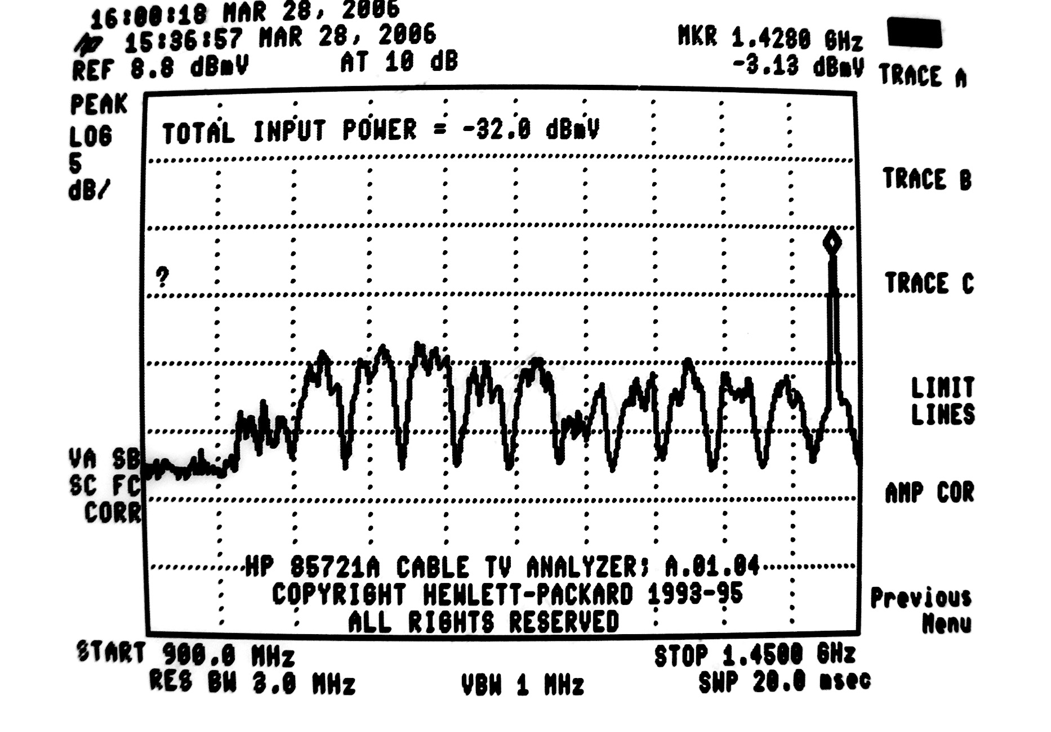
Figure 2
In-band Interference around 3,725 MHz

It is noted that this is an in-band interference event, and therefore the analysis summarized in Table 1, above, is applicable. In one particular interference event in Bolivia, the BWA transmit station was relatively close to the FSS receive earth station (approximately 600 m) but there was no line of sight path since the earth station is surrounded by walls. The BWA transmitter e.i.r.p. is likely to be in the range -2 to 10 dBW/MHz. The fact that such interfering signal at 600 m is strong enough to completely wipe out the desired signal is consistent with the larger distances that according to the results in Table 1 are required to keep interference at 3% of the noise floor for an e.i.r.p. density of the same order of magnitude.

Recognizing that co-frequency operation of BWA transmitters and FSS receive earth stations in the same geographic area has led to harmful interference to FSS earth stations, and further taking into consideration that the affected FSS operators had been previously authorized to provide space station service in the territory of Bolivia using C-band frequencies, the Superintendencia de Telecomunicaciones (“SITTEL”) in Bolivia has recently issued a Resolution suspending BWA operations in the band 3,700-3,800 MHz for a period of 90 days. During this period of time SITTEL expects to develop a channeling plan for the band 3,400-3,800 MHz that may be able to prevent the occurrence of the harmful interference events that have been observed in the band 3,700-3,800 MHz.

- Conclusions

It can be conclude from the above that co-frequency operation of BWA systems and FSS receive earth stations in the same geographic area is not feasible. Separation distances of several kilometers, probably as high as 150 km, are required to ensure protection of FSS earth stations. Therefore, BWA deployment would, on the one hand, be severely limited by the need for protecting existing FSS earth stations, and would, on the other hand, unduly constrain the deployment of future FSS earth stations.

Operation of BWA in a band adjacent to that used by FSS may cause interference to receive earth stations through two different mechanisms: (i) LNB saturation; and (ii) out-of-band emissions from BWA transmitters that fall within the FSS band.

Mitigation techniques may be employed to reduce the likelihood of LNB saturation, e.g., installation of a passband filter at the front end of the FSS earth station and/or reduction of the BWA power. It has been verified that when a BWA system operates in a band immediately next to the FSS band, the effectiveness of the passband filter is very limited. In this scenario, it will be essential that higher power BWA signals be accommodated as far as possible from the edge of the FSS band, leaving spectrum closer to the FSS band for the use of BWA signals with lower power.

The potential for interference caused by out-of band emissions generated by BWA transmitters can be appropriately reduced by limiting the level of such emissions. It has been tentatively concluded that a limit of approximately -72 dBW/MHz for the out-of-band e.i.r.p. density generated by a BWA transmitter would provide adequate protection.

The 3,700-4,200 MHz band is commonly referred to as the “standard” or “conventional” C-band.
In the Matter of Wireless Operations in the 3650-3700 MHz Band, Rules for Wireless Broadband Services in the 3650-3700 MHz Band, Additional Spectrum for Unlicensed Devices Below 900 MHz and in the 3 GHz Band, Amendment of the Commission’s Rules With Regard to the 3650-3700 MHz Government Transfer Band, Report and Order and Memorandum Opinion and Order, 20 FCC Rcd 6502 (2005).
According to Recommendation ITU-R S.1432 (“Apportionment of the Allowable Error Performance Degradations to Fixed-Satellite Service (FSS) Hypothetical Reference Digital Paths Arising From Time Invariant Interference For Systems Operating Below 15 GHz”), interference to FSS earth stations from other systems having co-primary status is limited to 6% of the total interference plus noise of the link. The 3% allowance considered here is assuming that another co-primary source (e.g., a radio-relay system in the FS) is using the remaining 3%.
Note that the upper frequency in the graph (1,450 MHz) corresponds to 3,700 MHz, while the lower frequency (900 MHz) corresponds to 4,250 MHz.
Regulatory Administrative Resolution No. 2006/1021, La Paz, 16 May 2006.
BWA authorizations have been granted in Bolivia in the band 3,400-3,800 MHz.

