The 3rd Meeting of the Correspondence Group on the Strategic Plan
of the Asia-Pacific Telecommunity for 2024 – 2026 (CGSP-3)

3 to 4 August 2023, Bangkok, Thailand

INFORMATION FOR PARTICIPANTS

The 3rd Meeting of the Correspondence Group on the Strategic Plan of the Asia-Pacific Telecommunity for 2024 – 2026 (CGSP-3) is scheduled to be held from 3 to 4 August 2023 at the APT Headquarters in Bangkok, Thailand. Please find the following information for the convenience of the participants.

- VENUE

The Meeting will be held at APT Headquarters, Bangkok, Thailand. The contact details of the APT Secretariat are as follows:

ASIA-PACIFIC TELECOMMUNITY
Address: 12/49 Soi 5, Chaeng Watthana Road, Lak Si, Bangkok 10210, Thailand
Telephone: +66 2 5730044
Telefax: +66 2 5737479
E-mail: aptcgsp@apt.int

- PARTICIPATION

APT Members and Associate Members may participate in the work of the CGSP. APT Affiliate Members may participate as an observer capacity. The Chair may invite non-APT Members in an advisory capacity upon consultation with the Secretary General of the APT. Only registered participants are entitled to attend the meeting.

- REGISTRATION AND NAME BADGES

Registration of delegates can be done online at http://www.apt.int/content/online-registration. Preferred date to receive your registration by APT Secretariat is 5 July 2023 for making necessary arrangements. On-site registration and distribution of badges will commence from 08:30 hours on Thursday, 3 August 2023. The registration desk will be located outside the meeting room. Participations are required to bring their passports or other photo identification to receive their badges.

Virtual participation will be arranged by using Zoom meeting platform. Detail information for virtual participation will be sent to the registered delegates who wish to attend virtually.

- HOTEL ACCOMMODATION AND RESERVATION

The following hotels are recommended for participants to stay during the Meeting.

4.1 MIDA HOTEL DON MUENG AIRPORT

Address: 99/401 – 486, Soi Chaeng Wattana 10, Thung Song Hong,
Laksi, Bangkok 10210
Telephone: +66 2 574 1648
Website: https://www.midahoteldonmueangairport.com/
E-mail: dos_mhap@mhg.co.th; rsvn_mhap@mhg.co.th

Room Type | Room Rate
Deluxe Single | THB 1,700 net/room/night  (included breakfast and internet access)
Deluxe Twin | THB 1,700 net/room/night  (included breakfast and internet access)
*The prices are net inclusive of 10% service charge and 7% VAT

For hotel reservation at Mida Hotel Don Mueng Airport, please send the hotel reservation form directly to e-mail address: dos_mhap@mhg.co.th and rsvn_mhap@mhg.co.th mailto: with a copy to APT Secretariat, warrawan@apt.int by 5 July 2023.

Please double-click the below hotel reservation form of the Mida Hotel Don Mueng Airport. Cancellation and no show policies are as mentioned in the hotel reservation form.

Rounds trip transportation from the Mida Hotel Don Mueng Airport to the APT Headquarters will be provided by the hotel.

In order to be eligible for the special rates given above, please make your hotel booking at the earliest possible date.

4.2 CENTRA BY CENTARA GOVERNMENT COMPLEX HOTEL & CONVENTION CENTRE CHAENG WATTHANA

Address: 120 Mu 3 Convention Centre Building, Government Complex,
Chaeng Watthana Road, Laksi, Bangkok 10210, Thailand
Telephone: +66 2 143 1234
Website: https://www.centarahotelsresorts.com/centra/cgc
E-mail: rsvncgc@chr.co.th

The rates are:
Room Type | Room Rate
Centra Superior Single | THB 1,800 net/room/night  (included breakfast and internet access)
Centra Superior Twin | THB 2,000 net/room/night  (included breakfast and internet access)
Centra Deluxe Single | THB 2,300 net/room/night  (included breakfast and internet access)
Centra Deluxe Twin | THB 2,500 net/room/night  (included breakfast and internet access)
*The price is net inclusive of 10% service charge and 7% VAT

Please send the Hotel Reservation form to e-mail address: rsvncgc@chr.co.th with a copy to warrawan@apt.int.

Please double-click the below hotel reservation form of the Centra Government Complex Hotel Chaeng Watthana. Cancellation and no show policies are as mentioned in the hotel reservation form.

Rounds trip transportation from the Centra Government Complex to the APT Headquarters will be provided by the hotel.

In order to be eligible for the special rates given above, please make your hotel booking at the earliest possible date.

4.3 CENTARA GRAND AT CENTRAL PLAZA LADPRAO BANGKOK

Address: 1695 Phaholyothin Road, Chatuchak, Bangkok 10900, Thailand
Telephone: +66 2 5411234
Website: https://www.centarahotelsresorts.com/centaragrand/cglb
E-mail: nattakarnth@chr.co.th; rinpaphatpa@chr.co.th
(Ms. Nattakarn Thepnarong, Assistant Director of Sales)

The rates are:

Room Type | Room Rate
Deluxe Single | THB 2,800 net/room/night  (included breakfast and internet access)
Deluxe Twin | THB 3,200 net/room/night  (included breakfast and internet access)
*The prices are net inclusive of 10% service charge and 7% VAT

For hotel reservation at Centara Grand at Central Plaza Ladprao, please send the hotel reservation form to e-mail address: nattakarnth@chr.co.th; rinpaphatpa@chr.co.th with a copy to APT Secretariat, warrawan@apt.int by 11 July 2023.

Please double-click the below hotel reservation form of the Centara Grand at Central Plaza Ladprao.

Please be advised that participants staying at the Centara Grand at Central Plaza Ladprao are requested to arrange their own transportation (own expense) from the hotel to the APT Headquarters and return back to the hotel.

The options of transportation from Centara Grand at Central Plaza Ladprao to the APT Headquarters are as follows.

1. Taxi meter: approximately 150-200 baht, 30-60 minutes (depending on the traffic).
2. Subway (MRT Blue Line): From Phahon Yothin Station to Bang Sue station and change to Sky Train (SRT Dark Red Line) to Laksi Station. Then walk around 5-7 minutes to the APT HQ.
3. Sky Train (BTS Green Line): From Ha Yaek Lat Phrao (Lat Phrao Intersection) Station to Wat Phra Sri Mahathat station and get off, then take a taxi around 50-80 baht, 15-30 minutes (depending on the traffic).

Subway and Sky Train lines map is attached as an Annex.

- DOCUMENTS AND INTERNET FACILITIES

Meeting documents will be available at the APT website, https://www.apt.int/2023-CGSP3 Internet Access over wireless network will be available during the meeting. Participants are kindly requested to bring their own laptop computers with Wi-Fi capability.

- TRANSPORTATION FROM THE AIRPORT TO THE HOTEL

Physical participants are requested to use public transportation facilities of the Suvarnabhumi International Airport, Thailand. For more information, please visit website: http://www.bangkokairportonline.com/.

For your general information, the following transportations are available from Suvarnabhumi International Airport to the Hotel:

- Public Meter Taxi is located on 1st floor of the Arrival Hall, entrance 4 and 7. Fare shown on meter, plus THB 50 surcharge for boarding at the airport.

- Airport Limousine Service, the limousine service to various destinations in the city, is located at the arrival floor of the airport.

- Hotel Limousine: Please contact the hotels directly.

It takes about 50 minutes by car from Suvarnabhumi International Airport to the hotels via express way.

- VISA AND IMMIGRATION INFORMATION

Thailand’s visa requirements may vary for the citizens of different countries. Please check the visa requirements with a Royal Thai Embassy or a Royal Thai Consulate-General in your respective country in advance. Kindly visit https://consular.mfa.go.th/th/page/cate-7393-general-information?menu=5d68c88d15e39c160c00827e for more details.
If you require a visa supporting letter from the APT, please contact aptadmin@apt.int.

- INSURANCE

APT will not be able to bear any cost of medical or travel insurance for the participant including any measures for Covid-19 such as quarantine, PCR test, etc. APT requests Administrations/Organizations to kindly make necessary arrangements for medical, travel insurance and others covering the whole period of the event and overseas travel for the participant.

- PRACTICAL INFORMATION

Bangkok: There are a great variety of tourist places in Bangkok, mostly historical attractions and temples with elaborate architecture and art. Famous temples are Wat Phra Kaew, Wat Pho, Wat Arun, Wat Phu Khao Thong, Wat Ratchanadda, Wat Traimit, Wat Benchamabophit, Wat Bowon, and Wat Sutat.

There are also palaces, museums, parks, and a big array of shopping places, from luxury malls to flea and street markets like Chatuchak Weekend Market, Sampeng Market, and Pahurat Textile Market. Bangkok nightlife is another highlight that has attracted many of tourists from all over the world.

Bangkok is also surrounded by many interesting provinces worth visiting.
- North - borders Nonthaburi and Pathum Thani Provinces, with tourist attractions like Koh Kret and Lotus Museum.
- East - is next to Chachoengsao, a small province which is full of interesting places and activities. Tourists can pay homage to Luang Pho Sothon Buddha Image at Wat Sothon Wararam Worawihan, watch flying foxes or fruit bats at Wat Pho, see the golden church at Wat Paknam Jolo, and pray to the giant reclining Ganesh statue at Wat Saman Rattanaram. There are also old markets for you to visit and shop such as Ban Mai Market, Nakhon Nuang Khet Market, and Khlong Suan Market.
- South - borders Samut Prakan Province and the Gulf of Thailand, with tourist attractions like Bang Pu, Ancient City, and Samut Prakan Crocodile Farm and Zoo.
- West - is next to Samut Sakhon and Nakhon Pathom Provinces. Tourist attractions include Don Kai Dee Benjarong Village, Phra Pathom Chedi, Sanam Chandra Palace, Don Wai Floating Market, Sampran Riverside, and Thai Human Imagery Museum.

Weather: Average temperature in August is between 30 and 35 degree Celsius.
Time Zone: GMT + 7 hours.
Banks & Currency: The unit of Thai currency is Thai Baht (THB). The UN exchange rate as of June 2023 is THB 34.56 to USD 1.
Electricity: Supply voltage is 220V, 50Hz. A standard grounded Thai outlet supports European 2-pin plugs and earthed and unearthed American plugs (see picture). Please bring the right adapter for your equipment.

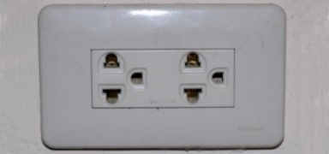

- CONTACT INFORMATION:

APT Secretariat
Asia Pacific Telecommunity (APT)
12/49 Soi 5 Chaeng Watthana Road
Bangkok 10210, Thailand
Telephone: +66 2 5730044
Telefax: +66 2 5737479
E-mail: aptcgsp@apt.int

- MAPS:

MAP TO APT HEADQUARTERS

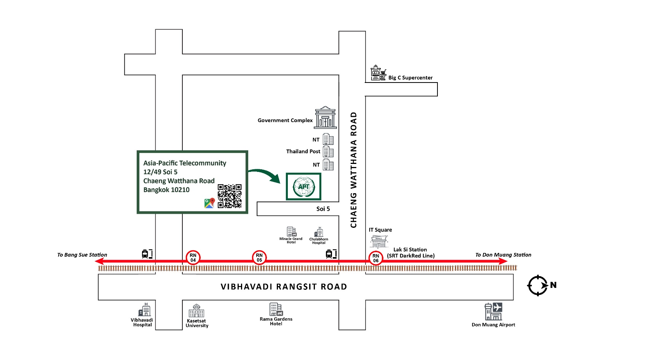

MAP TO MIDA HOTEL DON MUENG AIRPORT

For map of MIDA HOTEL DON MUENG AIRPORT: please click Contact us – MIDA HOTEL DON MUEANG AIRPORT

Address: 99/401-486 ซ.แจ้งวัฒนะ 10, Chaeng Watthana 10 Alley,
Lane 2, Thung Song Hong, Lak Si, Bangkok 10210, Thailand

Map to Centra by Centara Government Complex Hotel & Convention Centre Chaeng Watthana

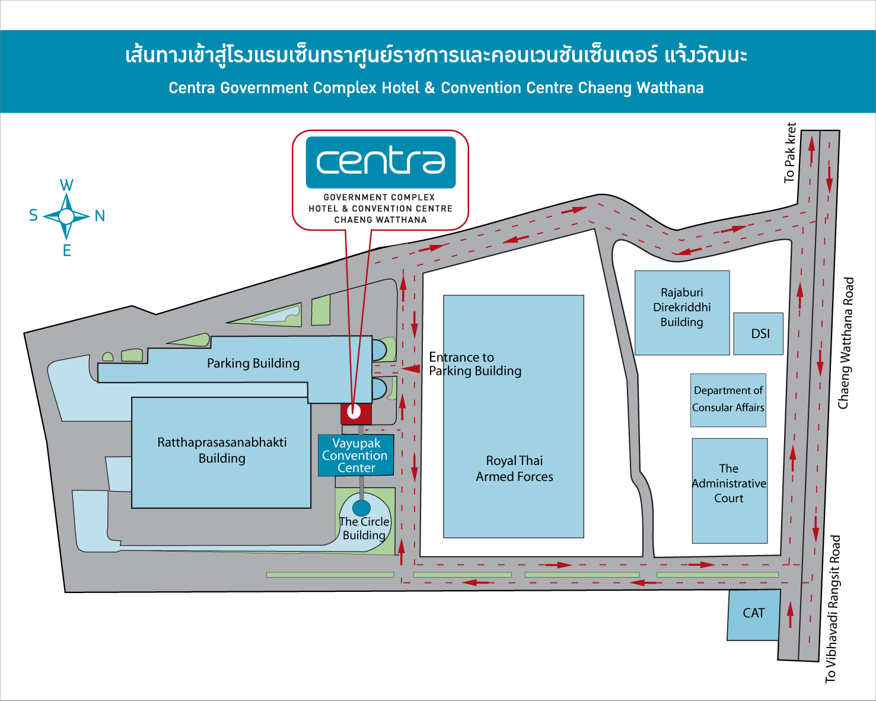
NT

MAP TO CENTARA GRAND AT CENTRAL PLAZA LADPRAO BANGKOK
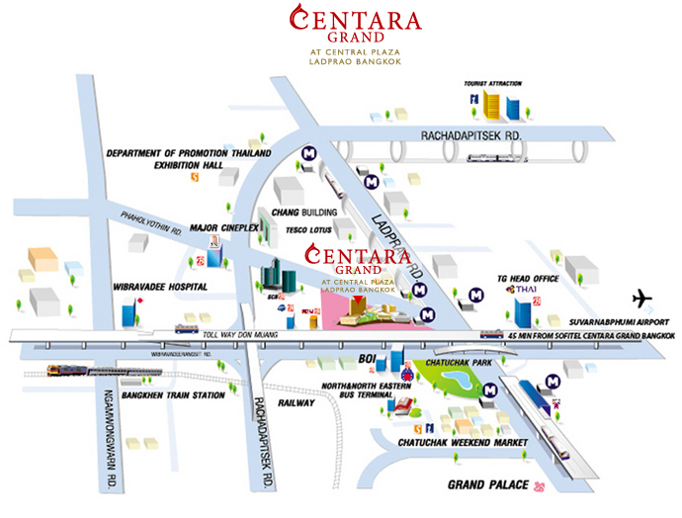

Annex
2023 MAP OF BANGKOK MASS RAPID TRANSIT
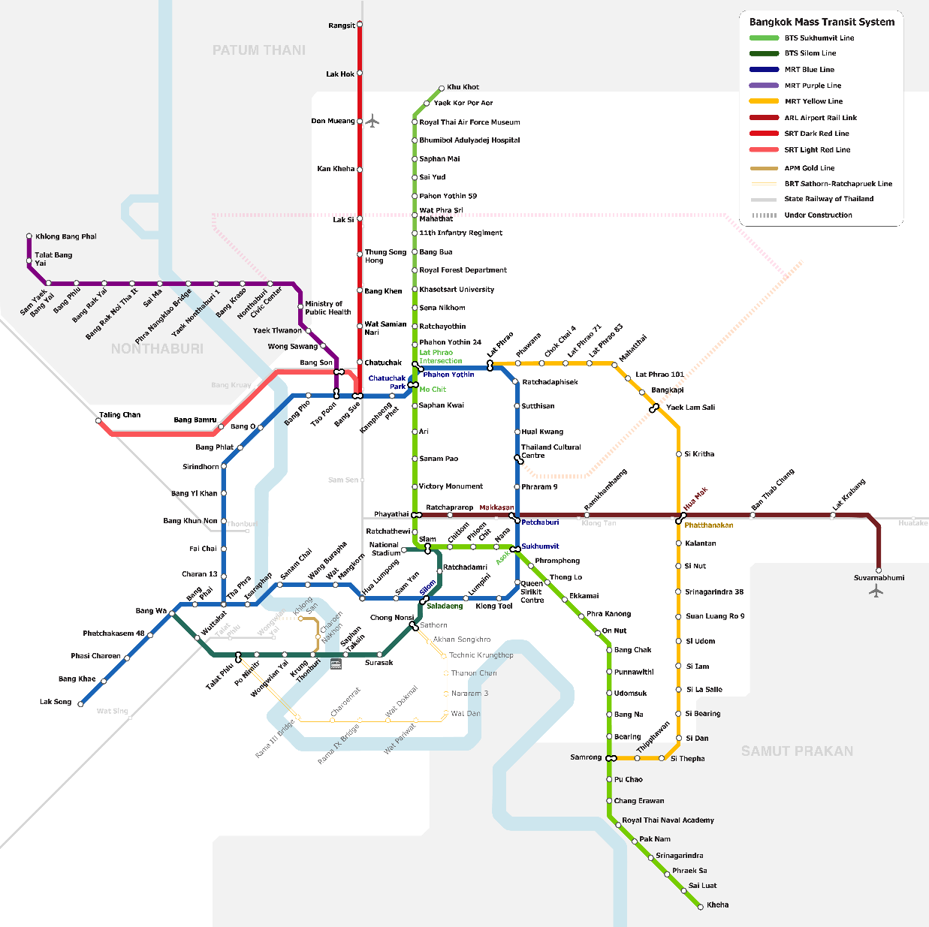

_______________________

Source: Tourism Authority of Thailand

