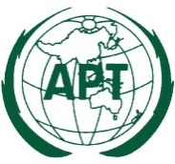 | ASIA-PACIFIC TELECOMMUNITY | Document No:
 | The Meeting of the SATRC Working Group on  Policy, Regulation and Services | SAPVIII-PRS2/ ADM-01
 | 4 – 6 July 2023, Maldives | 18 April 2023

Chair, SATRC Working Group on Policy, Regulation and Services

Provisional Agenda

- Opening

- Adoption of the agenda

- Review of the Outcomes of the 23rd Meeting of SATRC (SATRC-23) and SATRC Workshop on Policy, Regulation and Services.

- Discussion and finalization of the Report on the Work Items:

- Work Item 1: Development of enabling policy and regulatory environments, in the context of SATRC, to embrace the new ecosystem brought by 5G.
- Work Item 2: Telecom active infrastructure sharing.
- Work Item 3: Regulatory issues related to OTT services and application.
- Work Item 4: NGSO Satellite Constellations: Requirements, Challenges, and Impact in South Asia.

- Discussion on the proposal of new Work Items for SATRC Action Plan Phase IX

- Review draft report on Work Items

- Any other matters

- Closing

