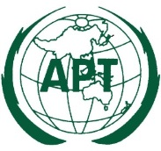 | ASIA-PACIFIC TELECOMMUNITY | Document No.:
 | The 10th Meeting of the Working Group of Management Committee on APT Legal Instruments (WGMC-10) | WGMC-10/ADM-01
 | 7-8 November 2022, Virtual/Online Meeting | 16 September 2022

Chairman, Working Group of Management Committee on
APT Legal Instruments (WGMC)

PROVISIONAL AGENDA

- Opening

- Adoption of the Agenda

- Outcomes of the 45th Session of Management Committee of the APT relevant to the WGMC

- Issue on the Selection of External Auditor

- Date and Venue of WGMC-11

- Any other matters
- Memorandum of Understanding (MoU) between the Asia-Pacific Telecommunity and other Organizations

- Closing

