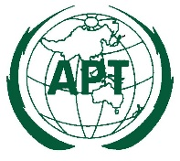
The 22nd APT Policy and Regulatory Forum (PRF-22)
19 - 21 July 2022, Bangkok, Thailand (Hybrid)

INFORMATION FOR PARTICIPANTS

The 22nd APT Policy and Regulatory Forum is scheduled to be held from 19 to 21 July 2022 in Bangkok, Thailand with hybrid format (both physical and virtual/online attendance through APT Zoom meeting). The event will be organized by the Asia-Pacific Telecommunity (APT) and take place at Millennium Hilton Bangkok.

Please find the following information for the convenience of participants.

MEETING PLATFORM

The Introduction to APT Zoom Meeting is attached. Detailed information to access the virtual meeting will be sent directly to registered participants in due course.

VENUE
The Forum will be held at the Ballroom BC, Level 2, Millennium Hilton Bangkok. The APT Secretariat room will be at Maya 21 Room, Level 2, Millennium Hilton Bangkok. The contact details of the hotel are as follows:

MILLENNIUM HILTON BANGKOK
Address: 123 Charoennakorn Road,
Klongsan, Bangkok
Tel: +66 2 442 2000
URL: APTHiltonLink

PARTICIPATION

All APT Members, Associate Members and Affiliate Members may participate in the meeting. The Organizations which have a Memorandum of Understanding (MoU) with the APT or other relevant international or regional organizations may send representatives to attend the meeting.

For Members, Associate Members and International/Regional Organizations, it is kindly requested to send the official list of members in your delegation.
Participation of Non-Members: Non-APT members may be invited to participate in the activities of the Forum as Guest at the discretion of the Chair of the PRF and the Secretary General in consultation with the relevant Member administration as appropriate.

Other non-APT members may participate as observer with the payment of the participation fee and subject to consultation between the Secretary General and the relevant Member Administrations, as appropriate.

For physical attendance, the Attachment 1 provides some relevant information as of 29 April 2022. Please check the latest information with relevant authorities and organizations as the conditions may change.

Since the number of physical attendances influences some preparations for the meeting venue and other arrangements, your administration/organization is kindly requested to register delegates for physical attendance preferably by the date specified in the following section.

REGISTRATION

For both physical and virtual/online attendance, registration can be done online at https://www.apt.int/content/online-registration, preferably by 18 June 2022 for physical attendance and by 28 June 2022 for virtual/online attendance, for making necessary arrangements. Please indicate in the registration form whether your delegate will attend in person or virtually. Only the registered participants are entitled to join the meeting. APT Secretariat will provide detail information to the registered participants prior to the meeting.

HOTEL ACCOMMODATION RATE & RESERVATION

Millennium Hilton Bangkok is recommended for all participants to stay during the meeting. Please make your hotel booking in order to be eligible for the special rates given below at the earliest possible date or not later than 19 June 2022. The Millennium Hilton Bangkok has created hotel reservation online for this meeting.

Please make hotel reservation online at APTHiltonLink.

Room Type | Room Rate
Deluxe Room (Single) | THB 3,000
Deluxe Room (Double/Twin) | THB 3,400
Executive River view (Single) | THB 4,100
Executive River view (Double) | THB 4,500
** Room rates are inclusive of buffet breakfast, internet access in guest room, 17.7% service charge and prevailing government taxes.

The above-mentioned types of room are available on a first come first served basis. Participants are recommended to make early reservations in order to get the rooms of their choice. The hotel cancellation policy is as follows:

- Before 30 June 2022 Waive for cancellation charge
- 1 July 2022 onwards Cancellation fee equal to 100% of total room charge

Check in at 15:00 hours; check out before 12:00 hours.
All bookings must be secured by a major credit card.

Due to the limited availability of rooms, APT Secretariat may not be able to guarantee hotel reservation and special rates after 19 June 2022.

CONDITIONS FOR TRAVELING TO THAILAND (From 1 July 2022)

Please refer to Attachments:
Attachment 1: Conditions for traveling to Thailand (From 1 July 2022)
Attachment 2: Vaccines Approved by Thailand and recommended timeframe for each vaccine type

MEETING WEBSITE, MEETING DOCUMENTS AND CONTRIBUTION GUIDELINES

Related information about the meeting and provisional meeting documents will be available at the APT Website at: https://www.apt.int.

APT members who wish to submit contribution(s) to the Forum, should prepare their contribution(s) in Microsoft Word and/or PowerPoint, English Version and send it to aptpolicy@apt.int. The preferable deadline for submission of the contribution(s) is 12 July 2022.

WIRELESS LAN

Internet Access over wireless network will be available during the meeting. Physical participants who wish to utilize wireless facility are kindly requested to bring their own laptop computers with Wi-Fi capability.

TRANSPORTATION FROM THE AIRPORT TO THE HOTEL

Physical participants are requested to use public transportation facilities of the Suvarnabhumi International Airport, Thailand. For more information, please visit website: http://www.bangkokairportonline.com/.

For your general information, the following transportations are available from Suvarnabhumi International Airport to the Hotel:

- Public Meter Taxi is located on 1st floor of the Arrival Hall, entrance 4 and 7. Fare shown on meter, plus THB 50 surcharge for boarding at the airport.

- Airport Limousine Service, the limousine service to various destinations in the city, is located at the arrival floor of the airport.

- Hotel Limousine (HOTEL/Suvarnabhumi Airport/HOTEL - One Way):

Toyota Camry
THB 2,000 nett per car per way (3 seats / 2 pcs of luggage / 2 Bags)
BMW 5
THB 2,500 nett per car per way (3 seats / 2 pcs of luggage / 2 Bags)
BMW 7
THB 3,500 nett per car per way (3 seats / 2 pcs of luggage / 2 Bags)
Toyota Commuter (Van)
THB 2,500 nett per van per way (8 seats / 7 pcs of luggage / 7 Bags)
Volkswagen Van
THB 4,000 nett per car per way (5 seats / 5 pcs of luggage / 5 Bags)

The above rates are quoted in Thai Baht and inclusive of 17.7 % applicable government taxes and service charge and non-commission.

It takes about 50 minutes by car from Suvarnabhumi International Airport to the hotel via express way.

There are good public transportation facilities at the Suvarnabhumi International Airport, Thailand. For more information, please visit website: http://www.bangkokairportonline.com/.

VISA AND IMMIGRATION INFORMATION
Thailand’s visa requirements may vary for the citizens of different countries. Please check the visa requirements with a Royal Thai Embassy or a Royal Thai Consulate-General in your respective country in advance. Kindly visit https://consular.mfa.go.th/th/page/cate-7393-general-information?menu=5d68c88d15e39c160c00827e for more details. If you require a visa supporting letter from the APT, please contact aptadmin@apt.int.

INSURANCE

APT will not be able to bear any cost of medical or travel insurance for the participant including any measures for Covid-19 such as quarantine, PCR test, etc. APT requests Administrations/Organizations to kindly make necessary arrangements for medical, travel insurance and others covering the whole period of the event and overseas travel for the participant.

Contact Information

For any further information about PRF-22, please contact to:

Mr. Tawhid Hussain, Project Coordinator (Email: tawhid@apt.int)
Ms. Pornpan Sirayathorn, Secretary to DPD (Email: pornpan@apt.int)

APT Secretariat
12/49, Soi 5, Chaeng Watthana Road, Lak Si, Bangkok 10210, Thailand
Phone: +66 2 573 0044
Fax: + 66 2 573 7479
Email: aptpolicy@apt.int

Attachment 1

Conditions for traveling to Thailand (From 1 July 2022)

Updates on Thailand Pass

• The CCSA agreed to discontinue/lift Thailand Pass registration for all travellers, both Thais and foreigners. This is welcome news and we do hope it will promote tourism, facilitate international arrivals and bring us closer to normalcy.

• The current USD 10,000 insurance requirements for COVID treatment for foreign travellers will no longer be mandatory but is highly recommended.

• Travellers still need to show proof of either a vaccine certificate OR COVID-Free test results. Vaccine certificate or Pro-ATK/RT-PCR results (within 72 hours) will be checked by airline staff at check-in and once again when travellers arrive in Thailand.

• Please note that this new Thailand Pass measure will be effective from 1 July onwards.

source: Center for COVID-19 Situation Administration (CCSA), Thailand

Attachment 2

Vaccines Approved by Thailand and recommended timeframe for each vaccine type

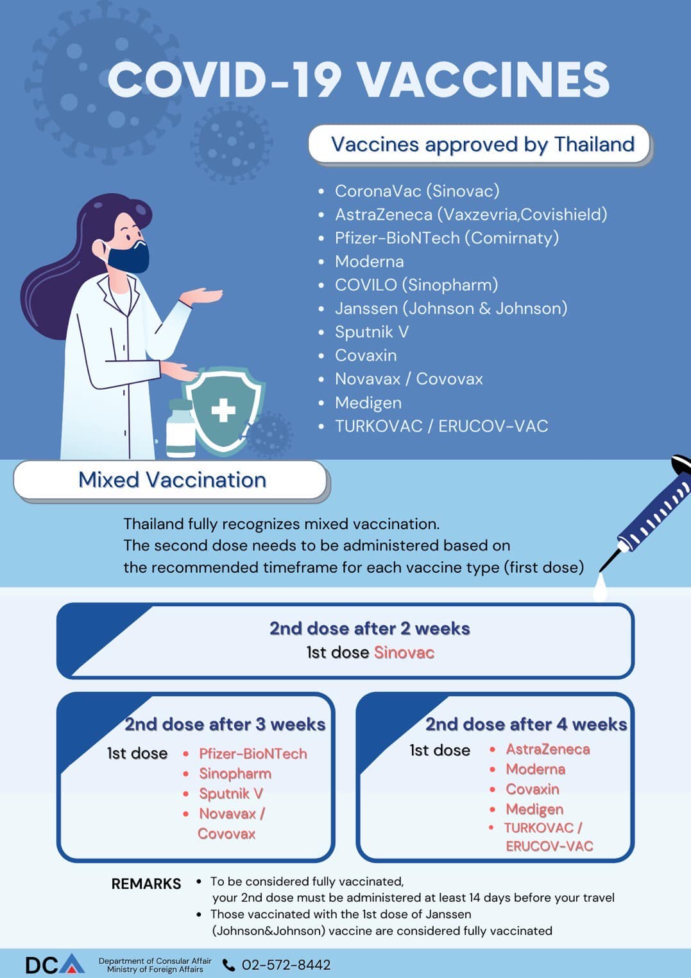
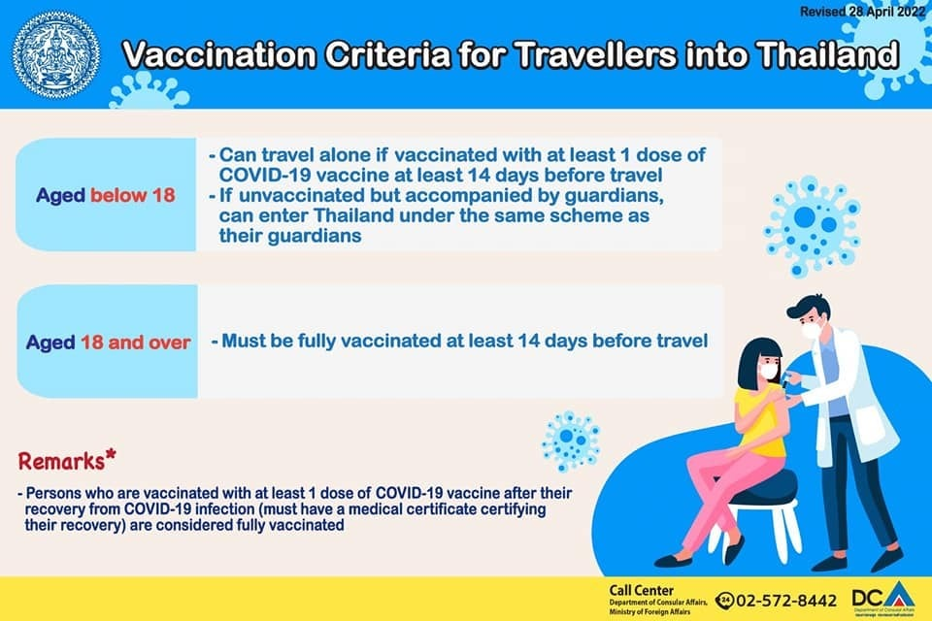

MAP OF THE HOTEL
Hotel Address in Thai language to be shown to the Taxi:
“โรงแรมมิลเลนเนียม ฮิลตัน กรุงเทพ”
Note: Many taxi drivers do not have a clear understanding of English. Therefore, please collect the hotel card and show to the taxi driver on your return to the hotel.


